Name of Journal: World Journal of Clinical Cases
Manuscript NO: 70576
Manuscript Type: CASE REPORT

Disseminated peritoneal leiomyomatosis with malignant transformation involving right ureter: A case report

Wen CY et al. DPL with malignant transformation involving right ureter

Chen-Yueh Wen, Herng-Sheng Lee, Jen-Tai Lin, Chia-Cheng Yu

Chen-Yueh Wen, Jen-Tai Lin, Chia-Cheng Yu, Division of Urology, Department of Surgery, Kaohsiung Veterans General Hospital, Kaohsiung 81346, Taiwan

Herng-Sheng Lee, Department of Pathology and Laboratory Medicine, Kaohsiung Veterans General Hospital, Kaohsiung 81346, Taiwan

Chia-Cheng Yu, School of Medicine, National Yang-Ming University, Taipei 814, Taiwan

Chia-Cheng Yu, Department of Pharmacy, Tajen University, Pingtung 900, Taiwan

Author contributions: Wen CY and Yu CC were involved in case management; Lee HS helped with the pathological interpretation; The images were collected and the main text was written by Wen CY; and all authors helped with data collection and preparation for submission of the final article.

Corresponding author: Chia-Cheng Yu, Doctor, Professor, Division of Urology, Department of Surgery, Kaohsiung Veterans General Hospital, 386 Ta-Chung 1st Rd, Kaohsiung 81346, Taiwan. mlee0857@gmail.com

Received: August 7, 2021
Revised: November 14, 2021
Accepted: January 11, 2022
Published online: February 16, 2022

Abstract
BACKGROUND
Disseminated peritoneal leiomyomatosis (DPL) with myxoid leiomyosarcoma is a rare variant of leiomysosarcoma, and hematuria as a presenting symptom has never been reported. Through this case report, we emphasize the investigation of the etiology, clinical presentation, diagnosis, treatment, and prognosis of DPL with malignant changes mimicking metastatic urinary tract cancer and to help develop further clinical management.

CASE SUMMARY
We describe a case of DPL with malignant transformation involving the right ureter after laparoscopic hysterectomy. An exploratory laparotomy was performed and all visible nodules were surgically removed. DPL with focal malignant transformation to myxoid leiomyosarcoma was confirmed based on pathology results.

CONCLUSION
Professionals who preoperatively diagnose DPL with malignant change to myxoid leiomyosarcoma involving the genitourinary tract should consider symptoms of abdominal pain, hematuria, and imaging of disseminated pelvic tumors in women, especially those with prior history of laparoscopic hysterectomy. Early complete removal of all tumors is the cornerstone to prevent DPL from malignant changes.

Key Words: Disseminated peritoneal leiomyomatosis; Leiomyosarcoma; Laparoscopic hysterectomy; Hematuria; Ureteroneocystostomy; Case report

©The Author(s) 2022. Published by Baishideng Publishing Group Inc. All rights reserved.

Citation: Wen CY, Lee HS, Lin JT, Yu CC. Disseminated peritoneal leiomyomatosis with malignant transformation involving right ureter: A case report. World J Clin Cases 2022; 10(5): 1639-1644
URL: https://www.wjgnet.com/2307-8960/full/v10/i5/1639.htm
DOI: https://dx.doi.org/10.12998/wjcc.v10.i5.1639

Core Tip: Disseminated peritoneal leiomyomatosis (DPL) is a rare disease characterized by the presence of multiple nodules composed of smooth muscle cells located in both peritoneal and extraperitoneal spaces of the abdomen. Malignant changes in DPL correspond to a rare variant of leiomyosarcoma characterized by aggressive behavior. We describe a case of DPL with malignant transformation involving the right ureter after laparoscopic hysterectomy, mimicking urothelial carcinoma with peritoneal carcinomatosis. The aim of our case report is to investigate the etiology, clinical presentation, diagnosis, treatment, and prognosis of DPL and to help develop further clinical management of this disease.
INTRODUCTION
Disseminated peritoneal leiomyomatosis (DPL) is a rare disease characterized by the presence of multiple nodules composed of smooth muscle cells located in both the peritoneal and extraperitoneal spaces of the abdomen^{[1]}. This disease is usually observed in women of reproductive age. To date, hundreds of cases have been reported^{[2,3]}. However, malignant changes in DPL with myxoid leiomyosarcoma are rare, and hematuria as a presenting symptom has never been reported^{[4,5]}. Herein, we present a case of DPL with malignant transformation involving the right ureter after laparoscopic hysterectomy. The aim of our case report is to investigate the etiology, clinical presentation, diagnosis, treatment, and prognosis of DPL with malignant changes mimicking metastatic urinary tract cancer and to help develop further clinical management.

CASE PRESENTATION
Chief complaints
A 72-year-old woman presented with gross hematuria one month before visiting our hospital.

History of present illness
This patient also noted intermittent abdominal cramping pain for half a year. The patient reported no urinary urgency, dysuria, flank pain, or fever.

History of past illness
The patient had undergone laparoscopic hysterectomy for uterine leiomyoma at another institution 2 years ago prior to her visit. Prior medical histories of hypertension, diabetes mellitus, and gout were noted.

Personal and family history
The patient had no relevant personal or family history.

Physical examination
Physical examination revealed multiple painful hard subcutaneous nodules in the lower abdomen.

Laboratory examinations
Laboratory examination revealed an elevated leukocyte count of 15109/mL, hemoglobin count of 12.9 g/dL, and C-reactive protein count of 3.72 mg/dL. Urine cytology, urinalysis, blood coagulation, kidney function, and liver function were all within normal range.

Imaging examinations
Abdominal computed tomography (CT) suggested urothelial carcinoma of the right lower third ureter with hydronephrosis and multiple seeding lesions at the anterior abdominal wall, subcutaneous fat, and bilateral inguinal areas (Figure 1).

FINAL DIAGNOSIS
Percutaneous ultrasound-guided biopsy of the most superficial lesion in the right lower quadrant of the abdomen was performed first. The tumor cells showed smooth muscle cell differentiation, which was compatible with leiomyoma as evidenced by pathology results.

TREATMENT
Because of persistent lower abdominal pain, the patient requested all tumors to be removed. An exploratory laparotomy was conducted with a lower midline incision, and multiple tumors of different sizes were found attached to the rectus muscle, bilateral inguinal areas, right ureter, and sigmoid colon (Figure 2). All nodules were meticulously dissected and resected with margins. Segmental resection of the right ureter, ureteroneocystostomy, partial resection of the sigmoid colon wall with primary closure, and transverse colostomy were also performed. The postoperative convalescence was uneventful. Final pathology revealed DPL with focal malignant transformation to myxoid leiomyosarcoma. Microscopically, the tumor was composed of malignant spindle cells with moderate to abundant eosinophilic cytoplasm arranged in interlacing fascicles (Figure 3).

OUTCOME AND FOLLOW-UP
Abdominal discomfort and pain improved significantly postoperatively. The transverse colostomy was closed after 3 mo. Adjuvant systemic chemotherapy was recommended, with periodic follow-up imaging; however, the patient opted for active surveillance only. The patient was doing well without evidence of recurrence 24 mo after the operation.

DISCUSSION
The etiology and pathophysiology of DPL are not yet well-established. Most reported cases are related to a history of laparoscopic hysterectomy or uterine myomectomy. Iatrogenic contamination after morcellation of myoma during laparoscopic surgery is considered to be a possible cause of DPL^{[1]}. In the current case, the patient underwent laparoscopic hysterectomy 2 years ago; the use of a power morcellator may enhance potential for tumor implantation and dissemination^{[6,7]}.
Most patients with DPL are asymptomatic. In these patients, DPL is found incidentally through imaging. Several non-specific symptoms, including abdominal pain, distension, menostaxis, and bleeding from the rectum or vagina have been reported^{[7-9]}. In the present case, the patient reported abdominal pain for one month, which is the most common manifestation of DPL. In addition, she first complained of gross hematuria and was referred to our urology outpatient department. To the best of our knowledge, this is the first report of DPL with hematuria as an initial presentation that could mimic urothelial cancer with peritoneal carcinomatosis^{[10,11]}. Preoperative diagnosis of DPL is challenging, and only histopathologic examination can discriminate DPL from peritoneal metastatic malignancies or benign metastasizing leiomyoma^{[9,12]}. Hence, we performed percutaneous ultrasound-guided biopsy of the abdominal wall lesion to delineate the nature of these tumors, and pathology showed a smooth muscle tumor compatible with leiomyoma.
DPL is histologically benign but can transform into a malignant leiomyosarcoma. The duration between the initial diagnosis of DPL and malignant changes varies from 1 mo to 8 years^{[4,13]}. This duration can be under- or overestimated because malignant change may occur focally and insidiously, which makes histological sampling difficult. In the current case, the duration of malignant transformation was speculated to be less than 2 years according to the patient’s operative history. Nevertheless, the focal tumor specimen involving the right ureter revealed a smooth muscle tumor with infiltrative borders, rich myxoid matrix, spindled neoplastic cells arranged in interlacing fascicles, mitotic activity up to 4 mitoses in 10 high-power fields, and foci of tumor necrosis. These findings are compatible with DPL with focal malignant transformation to myxoid leiomyosarcoma.
Standard treatment for DPL is debated. Since most DPLs are found in women of reproductive age, conservative treatment should be considered. Treatment of DPL includes a variety of treatments, such as active surveillance, hormone therapy, debulking surgery, chemotherapy, and radiation therapy, while surgical removal remains the mainstay because of its malignant potential^{[13,14]}. In our case, no adjuvant chemotherapy or radiotherapy was administered.

CONCLUSION
In conclusion, we present a case of DPL with focal malignant transformation involving the right ureter, mimicking urothelial carcinoma with peritoneal carcinomatosis. Preoperative diagnosis of malignancy is usually challenging. DPL with malignant change to myxoid leiomyosarcoma involving the genitourinary tract should be weighed against differential diagnoses in women presenting with abdominal pain and hematuria with imaging of disseminated pelvic tumors, especially those with prior history of laparoscopic hysterectomy. Early complete surgical resection of all tumors is the most important factor in preventing malignant transformation of DPL, even though it has a relatively favorable outcome.

REFERENCES
1 Al-Talib A, Tulandi T. Pathophysiology and possible iatrogenic cause of leiomyomatosis peritonealis disseminata. Gynecol Obstet Invest 2010; 69: 239-244 [PMID: 20068330 DOI: 10.1159/000274487]
2 Bekkers RL, Willemsen WN, Schijf CP, Massuger LF, Bulten J, Merkus JM. Leiomyomatosis peritonealis disseminata: does malignant transformation occur? A literature review. Gynecol Oncol 1999; 75: 158-163 [PMID: 10502446 DOI: 10.1006/gyno.1999.5490]
3 Nappi L, Sorrentino F, Angioni S, Pontis A, Barone I, Greco P. Leiomyomatosis Peritonealis Disseminata (LPD) ten years after laparoscopic myomectomy associated with ascites and lymph nodes enlargement: a case report. Int J Surg Case Rep 2016; 25: 1-3 [PMID: 27280492 DOI: 10.1016/j.ijscr.2016.05.017]
4 Sharma P, Chaturvedi KU, Gupta R, Nigam S. Leiomyomatosis peritonealis disseminata with malignant change in a post-menopausal woman. Gynecol Oncol 2004; 95: 742-745 [PMID: 15581996 DOI: 10.1016/j.ygyno.2004.09.007]
5 Raspagliesi F, Quattrone P, Grosso G, Cobellis L, Di Re E. Malignant degeneration in leiomyomatosis peritonealis disseminata. Gynecol Oncol 1996; 61: 272-274 [PMID: 8626146 DOI: 10.1006/gyno.1996.0138]
6 Lu B, Xu J, Pan Z. Iatrogenic parasitic leiomyoma and leiomyomatosis peritonealis disseminata following uterine morcellation. J Obstet Gynaecol Res 2016; 42: 990-999 [PMID: 27125448 DOI: 10.1111/jog.13011]
7 Psathas G, Zarokosta M, Zoulamoglou M, Chrysikos D, Thivaios I, Kaklamanos I, Birbas K, Mariolis-Sapsakos T. Leiomyomatosis peritonealis disseminata: A case report and meticulous review of the literature. Int J Surg Case Rep 2017; 40: 105-108 [PMID: 28965085 DOI: 10.1016/j.ijscr.2017.09.016]
8 Huang SF, Wen CY, Liao CI, Lin JC, Tsai CC. Leiomyomatosis peritonealis disseminata mimicking peritoneal carcinomatosis 13 years after laparoscopic uterine myomectomy: A case report. Int J Surg Case Rep 2021; 81: 105745 [PMID: 33743252 DOI: 10.1016/j.ijscr.2021.105745]
9 Li J, Dai S. Leiomyomatosis Peritonealis Disseminata: A Clinical Analysis of 13 Cases and Literature Review. Int J Surg Pathol 2020; 28: 163-168 [PMID: 31615319 DOI: 10.1177/1066896919880962]
10 Morita J, Naoe M, Fuji K, Hiramatsu A, Unoki T, Matsui Y, Shimoyama H, Nakasato T, Oshinomi K, Saito K, Maeda Y, Ogawa Y. Indications for ureteropyeloscopy in the detection of upper urinary tract tumors. Urol Sci 2018; 29: 186-192 [DOI: 10.4103/UROS.UROS_55_18]
11 Sharma S, Ksheersagar P, Sharma P. Diagnosis and treatment of bladder cancer. Am Fam Physician 2009; 80: 717-723 [PMID: 19817342]
12 Patton KT, Cheng L, Papavero V, Blum MG, Yeldandi AV, Adley BP, Luan C, Diaz LK, Hui P, Yang XJ. Benign metastasizing leiomyoma: clonality, telomere length and clinicopathologic analysis. Mod Pathol 2006; 19: 130-140 [PMID: 16357844 DOI: 10.1038/modpathol.3800504]
13 Yamaguchi T, Imamura Y, Yamamoto T, Fukuda M. Leiomyomatosis peritonealis disseminata with malignant change in a man. Pathol Int 2003; 53: 179-185 [PMID: 12608900 DOI: 10.1046/j.1440-1827.2003.01452.x]
14 Grimer R, Judson I, Peake D, Seddon B. Guidelines for the management of soft tissue sarcomas. Sarcoma 2010; 2010: 506182 [PMID: 20634933 DOI: 10.1155/2010/506182]

Footnotes
Informed consent statement: Informed written consent was obtained from the patient for publication of this report and any accompanying images.

Conflict-of-interest statement: The authors declare that they have no conflict of interest.

CARE Checklist (2016) statement: The authors have read the CARE Checklist (2016), and the manuscript was prepared and revised according to the CARE Checklist (2016).

Open-Access: This article is an open-access article that was selected by an in-house editor and fully peer-reviewed by external reviewers. It is distributed in accordance with the Creative Commons Attribution NonCommercial (CC BY-NC 4.0) license, which permits others to distribute, remix, adapt, build upon this work non-commercially, and license their derivative works on different terms, provided the original work is properly cited and the use is non-commercial. See: https://creativecommons.org/Licenses/by-nc/4.0/

Provenance and peer review: Unsolicited article; Externally peer reviewed.
Peer-review model: Single blind

Peer-review started: August 7, 2021
First decision: November 6, 2021
Article in press: January 11, 2022

Specialty type: Medicine, research and experimental
Country/Territory of origin: Taiwan
Peer-review report’s scientific quality classification
Grade A (Excellent): 0
Grade B (Very good): 0
Grade C (Good): C, C
Grade D (Fair): 0
Grade E (Poor): 0

P-Reviewer: Govindarajan KK, Park SB S-Editor: Wang JJ L-Editor: A P-Editor: Wang JJ

Figure Legends
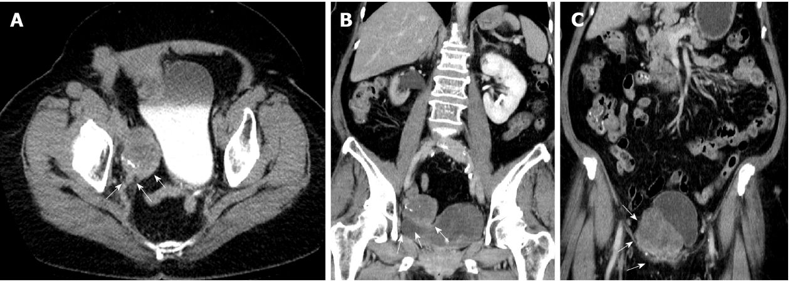
Figure 1 Abdominal computed tomography demonstrated that the tumor extended from the right distal third ureter to the ureterovesical junction. A: White arrowhead in the axial view; B and C: Coronal view.

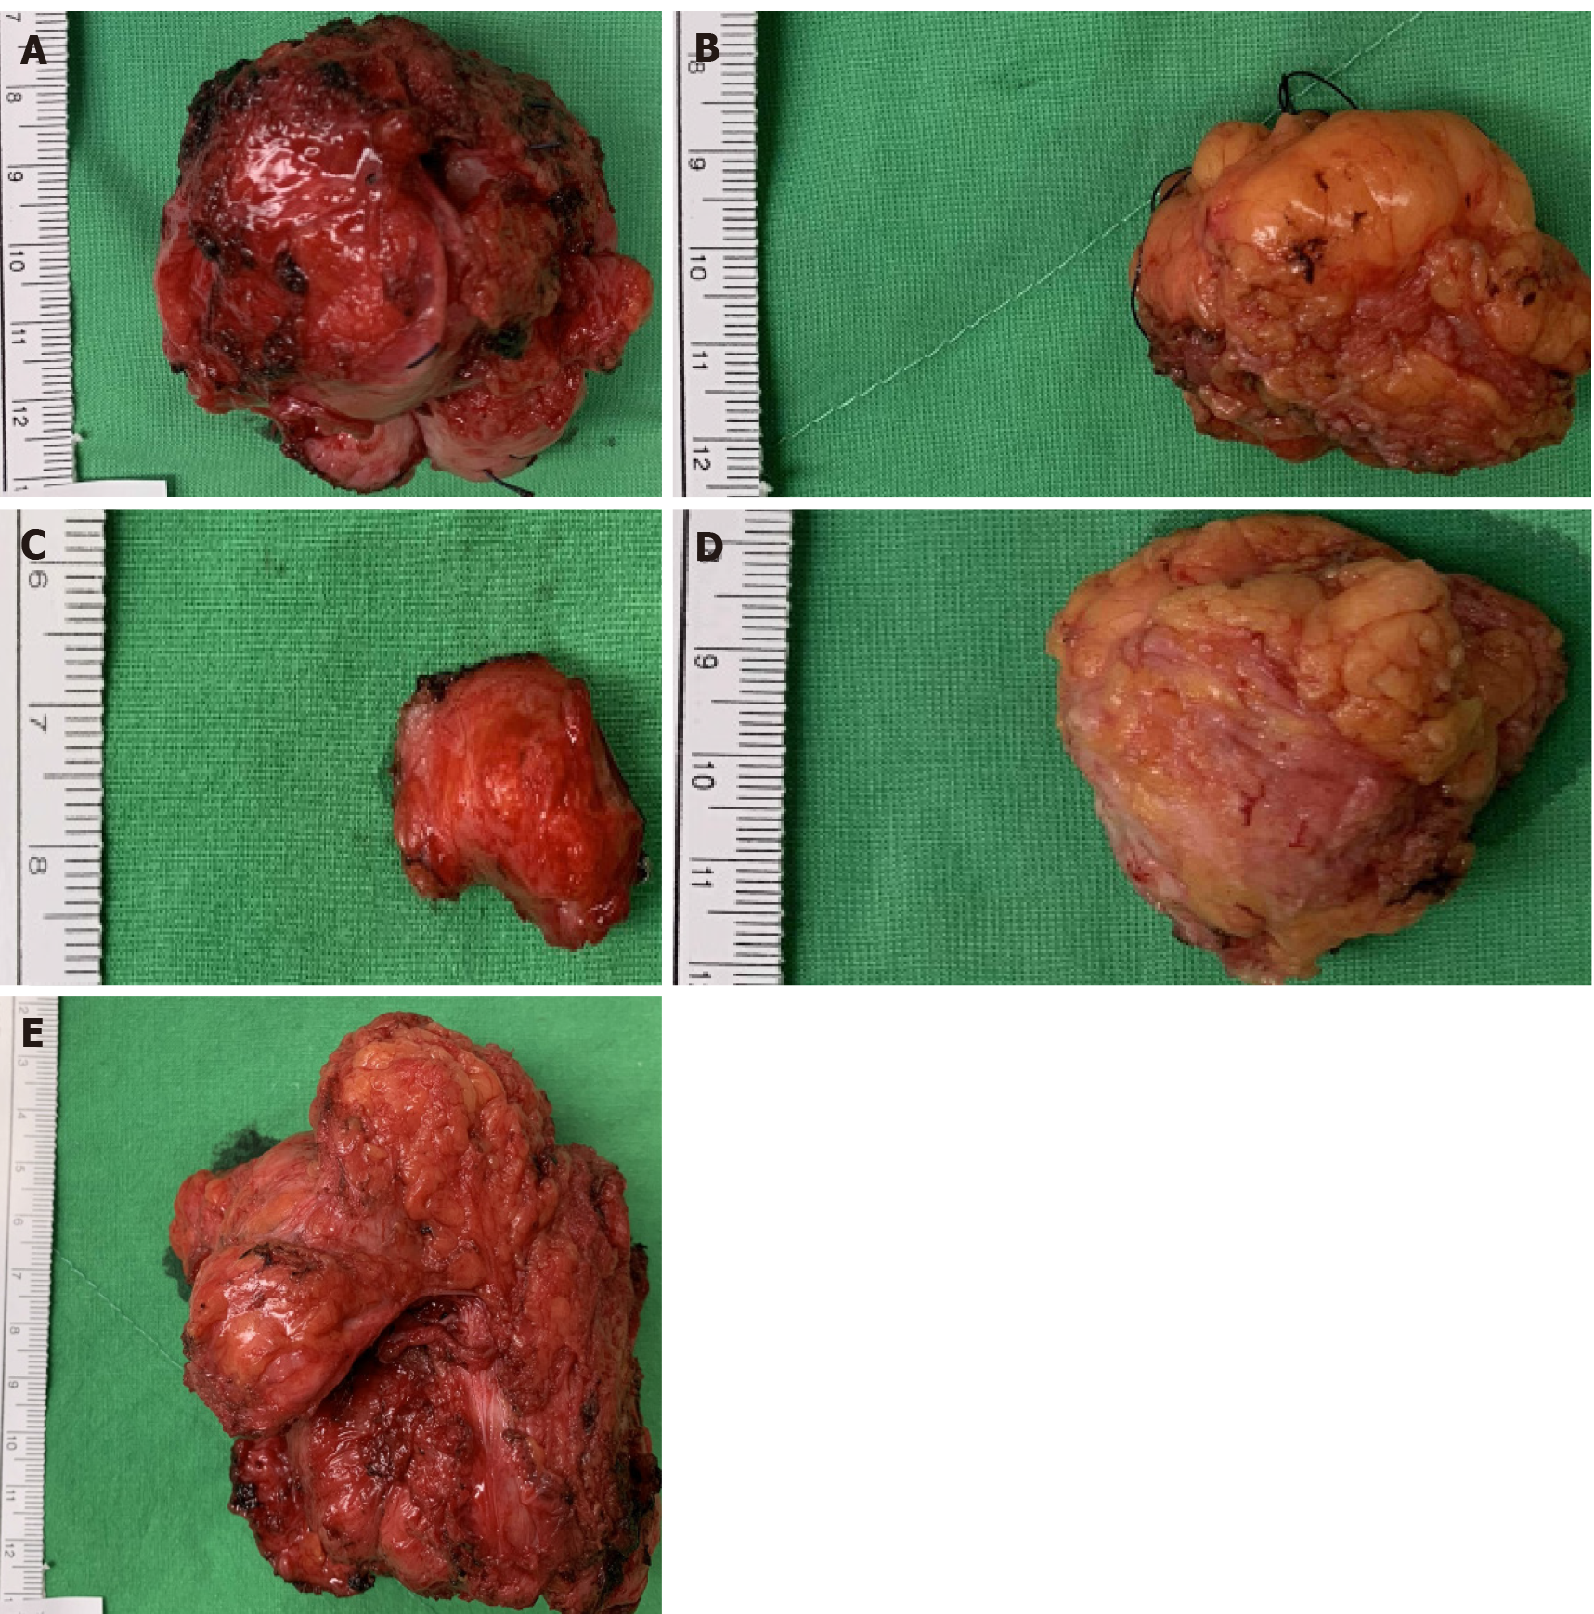
Figure 2 Intraoperative images of firm gray-whitish tumors. A: Located at right distal ureter; B: Located at right inguinal area; C: Located at left inguinal area; D: Located at abdominal wall; E: Located at sigmoid colon.

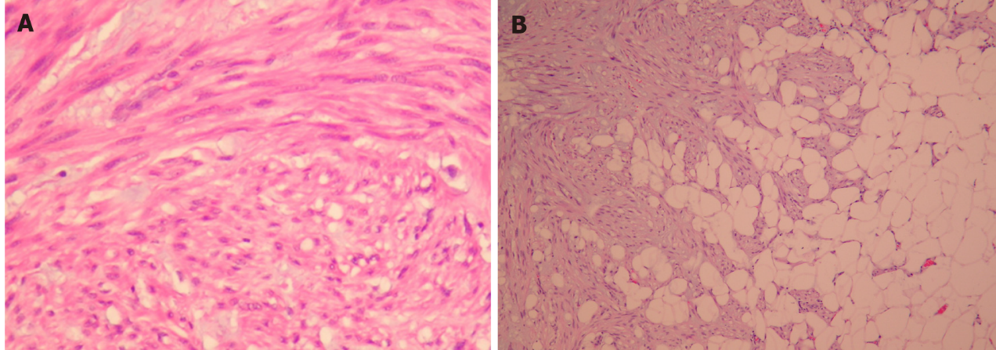
Figure 3 Histological appearance of disseminated peritoneal leiomyomatosis tumor. A: The tumor has hypercellular areas with focal myxoid matrix, composed of spindled-shape neoplastic cells arranged in interlacing fascicles and storiform growth pattern (original magnification, 200 ×); B: Myxoid matrix infiltrated into adipose tissue (original magnification, 100 ×).

Published by Baishideng Publishing Group Inc
7041 Koll Center Parkway, Suite 160, Pleasanton, CA 94566, USA
Telephone: +1-925-3991568
E-mail: bpgoffice@wjgnet.com
Help Desk: https://www.f6publishing.com/helpdesk
https://www.wjgnet.com

© 2022 Baishideng Publishing Group Inc. All rights reserved.

