Name of Journal: World Journal of Gastroenterology
Manuscript NO: 59713
Manuscript Type: CASE REPORT

Endoscopic mucosal ablation - an alternative treatment for colonic polyps: Three case reports

Ladd AM et al. EMA for colon polyps

Antonio Mendoza Ladd, Joaquin Espinoza, Cesar Garcia

Antonio Mendoza Ladd, Department of Internal Medicine, Division of Gastroenterology, Texas Tech University Health Sciences Center, Paul L Foster School of Medicine, El Paso, TX 79905, United States

Joaquin Espinoza, Escuela de Medicina Luis Razetti, Universidad Central de Venezuela, Caracas 999188, Venezuela

Cesar Garcia, Department of Endoscopy, University Medical Center of El Paso, El Paso, TX 79905, United States

Author contributions: Ladd AM performed all the procedures, edited the video, drafted, edited and approved the final manuscript; Espinoza J and Garcia C drafted, edited and approved the final manuscript.

Corresponding author: Antonio Mendoza Ladd, FACG, FASGE, Assistant Professor, Department of Internal Medicine, Division of Gastroenterology, Texas Tech University Health Sciences Center, Paul L Foster School of Medicine, 4800 Alberta Avenue, El Paso, TX 79905, United States. dr_ladd25@yahoo.com

Received: September 26, 2020
Revised: November 9, 2020
Accepted: November 21, 2020
Published online:

Abstract
BACKGROUND
Endoscopic resection of non-invasive lesions is now the standard of care for lesions in the GI tract. However, resection techniques require extensive training, are not available in all endoscopy centers and are prone to complications. Endoscopic mucosal ablation (EMA) is a combination of resection and ablation techniques and it may offer an alternative in the management of such lesions.

CASE SUMMARY
In this case series we report the successful treatment of three flat colonic polyps using the EMA technique. Two lesions were treatment naïve and 1 was a recurrence after an endoscopic mucosal resection. The sizes ranged from 2 to 4 cm. All three polyps were ablated successfully with no immediate or delayed complications. The recurrence rate at 1 year of follow up was 0%.

CONCLUSION
Based on this initial experience, we conclude that EMA is a safe and effective technique for the treatment of non-invasive colonic polyps when endoscopic resection techniques are not available.

Key Words: Endoscopy; Mucosal ablation; Colon polyp; Argon plasma coagulation; Alternative; Safe; Case report

Ladd AM, Espinoza J, Garcia C. Endoscopic mucosal ablation - an alternative treatment for colonic polyps: Three case reports. World J Gastroenterol 2020; In press

Core Tip: Endoscopic resection via endoscopic mucosal resection or endoscopic submucosal dissection is currently the standard of care for non-invasive colonic polyps. However, these resection techniques require extensive training, are not available in all endoscopy centers, and are prone to adverse events such as perforation and bleeding. Endoscopic mucosal ablation appears to be a safe and effective alternative in the treatment of colonic polyps without invasive features.

INTRODUCTION
Endoscopic mucosal resection (EMR) and/or endoscopic submucosal dissection (ESD) is now the standard of care for non-dysplastic, dysplastic and early malignant lesions of the gastrointestinal tract. The sine qua non of these techniques is the adequate formation of a submucosal cushion prior to resection, in order to avoid damage of the muscularis propria and hence, perforation. However, these resection techniques require rigorous training, are prone to complications and are not always available at all centers. Recently the submucosal cushion principle has been adopted in the management of dysplastic Barrett’s esophagus (BE) prior to ablation with argon plasma in a technique called Hybrid APC^{[1]}. We explored this concept in the management of 3 flat colonic polyps.

CASE PRESENTATION
Chief complaints
All patients presented in this case series had colon polyps requiring treatment.

History of present illness
All three patients originally presented to their gastroenterology providers for routine colon cancer screening or surveillance and were referred to our endoscopy center.

History of past illness
Case 1: Hypertension (HTN), DM2.

Case 2: DM2, HTN, hypercholesterolemia and treated tuberculosis.

Case 3: Hypercholesterolemia and osteoarthritis.

Imaging examinations
Case 1: An 85 y/o M with previous medical history (PMH) described above was referred for evaluation of a cecal polyp. Colonoscopy revealed a 4 cm 0-IIa +Is lesion in the cecum that involved the IC valve (Figure 1A). Due to morphology of the lesion and the risk of incomplete resection via EMR (we did not perform ESD at our center at the time), removal was not attempted. The lesion was biopsied and pathological analysis established it was a tubular adenoma with no dysplasia. The patient was offered referral to an outside facility for ESD. However due to his lack of medical insurance, referral was not a possibility. Therefore, endoscopic mucosal ablation (EMA) was offered. After detailed explanation of the potential risks and benefits, he agreed to the procedure. The colonoscopy was repeated 2 mo later. The lesion was injected with a mix of O’rise gelTM (Boston Scientific, Natick, MA) + epinephrine at 1:10000 to create the submucosal cushion. The lesion raised easily. Once raised, ablation of the lesion was performed using Argon Plasma Coagulation in forced coagulation mode at 1 L/min, 60 W, effect 2 (Video). The patient did well and was discharged the same day of the procedure. Colonoscopy 1 year later showed a scar with no evidence of polyp recurrence (Figure 1B). Biopsies of the scar confirmed eradication of the lesion.

Case 2: This was a 69 y/o M with PMH described above who was referred for removal of polyp recurrence after a previous EMR. Colonoscopy showed a 0-IIa lesion of approximately 3 cm at the previous EMR scar in the hepatic flexure (Figure 2A). The lesion was biopsied prior to ablation. After the biopsy, EMA was performed in a similar manner as in case 1 (video). The biopsy of the lesion revealed a tubular adenoma with no dysplasia. Colonoscopy at 11 mo showed a healthy scar with no signs of polyp recurrence (Figure 2B). Biopsy of the scar confirmed eradication.

Case 3: A 79 y/o F with a PMH described above was referred for evaluation of a flat polyp. Colonoscopy revealed a 2 cm 0-IIa lesion in the hepatic flexure (Figure 3A). The lesion was biopsied prior to ablation. Ablation ensued as described above (video). Biopsy of the lesion revealed tubular adenoma features with no dysplasia. Colonoscopy 13 mo later revealed a healthy scar with no polyp recurrence (Figure 3B). Biopsy of the scar confirmed eradication.

FINAL DIAGNOSIS
All patients were diagnosed with TA with no dysplasia.

TREATMENT
All patients were treated with the EMA technique.

OUTCOME AND FOLLOW-UP
All patients had follow-up colonoscopy at 1 year and biopsy of the ablation site revealed no evidence of recurrence.

DISCUSSION
EMA is a combination of established resection and ablation techniques already utilized in different sections of the GI tract. The EMA technique has been previously applied successfully in gastric lesions. Kothari et al^{[2]} successfully treated a flat dysplastic lesion at the GJ anastomosis of a patient with a previous Roux-en-Y gastric bypass^{[2]}. Estifan et al^{[3]} also obtained adequate results using EMA to treat lesion recurrence after an ESD for intestinal metaplasia in the incisura^{[3]}. The only available report of the application of this technique in the colon was published by Tsiamoulos et al^{[4]}. In contrast to ours, this case series included only recurrent lesions after prior endoscopic resection. They reported no complications and a recurrence rate of 82% at one year.
When utilizing EMA, a natural concern is the risk of complications such as perforation. However, studies in porcine models have demonstrated that ablation with argon plasma does not cause injury to the musclularis propria when a submucosal cushion is created^{[5,6]}. This finding led to the novel technique of Hybrid APC. In this technique, a submucosal cushion is created and the affected mucosa is ablated. This technique has been applied in the treatment of BE and has shown promising results^{[1]}.
The advantages of EMA include its simplicity, safety and its availability in most community endoscopy centers. The main disadvantage is that it does not produce a surgical specimen for pathological analysis. Although previous biopsy of the lesion can give preliminary information about the histology, it may not reflect that of the entire lesion. Therefore, endoscopists should only use EMA in colonic polyps when endoscopic resection via EMR or ESD is not available. Furthermore, this technique should not be utilized when the preparation of the colon is poor due to the risk of colonic explosion^{[7,8]}.

CONCLUSION
To our knowledge, this is the first report of the use of EMA in treatment naïve colonic lesions. We encountered no complications and our recurrence rate at 1 year was 0% with biopsies of the scars confirming eradication in all cases. Our results suggest that EMA is safe and effective in the treatment of colonic polyps when endoscopic resection is not possible or available.

REFERENCES
1 Manner H, May A, Kouti I, Pech O, Vieth M, Ell C. Efficacy and safety of Hybrid-APC for the ablation of Barrett's esophagus. Surg Endosc 2016; 30: 1364-1370 [PMID: 26104794 DOI: 10.1007/s00464-015-4336-1]
2 Kothari TH, Kothari S, Kaul V. Hybrid argon plasma coagulation: a new modality for treatment of a diffuse foregut anastomotic dysplastic lesion. VideoGIE 2019; 4: 209-210 [PMID: 31061940 DOI: 10.1016/j.vgie.2019.02.002]
3 Estifan E, Cavanagh Y, Grossman MA. Hybrid Argon Plasma Coagulation for Treatment of Gastric Intestinal Metaplasia. Cureus 2020; 12: e7427 [PMID: 32337147 DOI: 10.7759/cureus.7427]
4 Tsiamoulos ZP, Bourikas LA, Saunders BP. Endoscopic mucosal ablation: a new argon plasma coagulation/injection technique to assist complete resection of recurrent, fibrotic colon polyps (with video). Gastrointest Endosc 2012; 75: 400-404 [PMID: 22154411 DOI: 10.1016/j.gie.2011.09.003]
5 Fujishiro M, Yahagi N, Nakamura M, Kakushima N, Kodashima S, Ono S, Kobayashi K, Hashimoto T, Yamamichi N, Tateishi A, Shimizu Y, Oka M, Ichinose M, Omata M. Submucosal injection of normal saline may prevent tissue damage from argon plasma coagulation: an experimental study using resected porcine esophagus, stomach, and colon. Surg Laparosc Endosc Percutan Tech 2006; 16: 307-311 [PMID: 17057569 DOI: 10.1097/01.sle.0000213739.85277.3d]
6 Goulet CJ, Disario JA, Emerson L, Hilden K, Holubkov R, Fang JC. In vivo evaluation of argon plasma coagulation in a porcine model. Gastrointest Endosc 2007; 65: 457-462 [PMID: 17321247 DOI: 10.1016/j.gie.2006.09.005]
7 Manner H, Plum N, Pech O, Ell C, Enderle MD. Colon explosion during argon plasma coagulation. Gastrointest Endosc 2008; 67: 1123-1127 [PMID: 18513555 DOI: 10.1016/j.gie.2008.02.035]
8 Pichon N, Maisonnette F, Cessot F, Sodji M, Sautereau D. Colonic perforations after gas explosion induced by argon plasma coagulation. Endoscopy 2004; 36: 573 [PMID: 15202067 DOI: 10.1055/s-2004-814431]

Footnotes
Informed consent statement: The study was considered exempt from needing to obtain informed consent. The IRB acknowledges that this project meets the criteria for exemption from formal IRB review in accordance with 45 CFR46.104 (d)(4)(iii). A Waiver of HIPAA Authorization for Research approved under 45 CFR164.512 (i)(2)(ii).

Conflict-of-interest statement: Antonio Mendoza Ladd has received fees for serving as a consultant for CONMED; Joaquin Espinoza and Cesar Garcia no conflicts of interest to disclose.

CARE Checklist (2016) statement: The authors have read the CARE Checklist (2016), and the manuscript was prepared and revised according to the CARE Checklist (2016).

Open-Access: This article is an open-access article that was selected by an in-house editor and fully peer-reviewed by external reviewers. It is distributed in accordance with the Creative Commons Attribution NonCommercial (CC BY-NC 4.0) license, which permits others to distribute, remix, adapt, build upon this work non-commercially, and license their derivative works on different terms, provided the original work is properly cited and the use is non-commercial. See: http://creativecommons.org/Licenses/by-nc/4.0/

Manuscript source: Unsolicited manuscript

Corresponding Author's Membership in Professional Societies: American Society for Gastrointestinal Endoscopy, No. 136083; and American College of Gastroenterology, No. 35849.

Peer-review started: September 26, 2020
First decision: November 8, 2020
Article in press:

Specialty type: Gastroenterology and hepatology
Country/Territory of origin: United States
Peer-review report’s scientific quality classification
Grade A (Excellent): 0
Grade B (Very good): B, B, B
Grade C (Good): 0
Grade D (Fair): 0
Grade E (Poor): 0

P-Reviewer: Fu TL, Inal V, Protopapas A S-Editor: Fan JR L-Editor: P-Editor:
Figure Legends
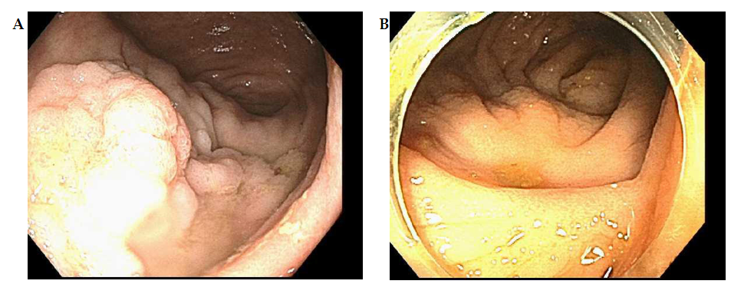
Figure 1 Colonoscopy. A: 0-IIa +Is lesion in the cecum involving the IC valve; B: Post endoscopic mucosal ablation scar.

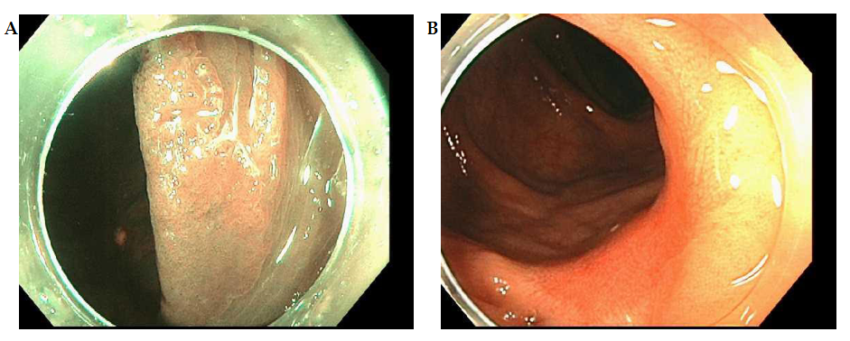
Figure 2 Colonoscopy. A: 0-IIa lesion in previous endoscopic mucosal resection site in hepatic flexure; B: Post endoscopic mucosal ablation scar.

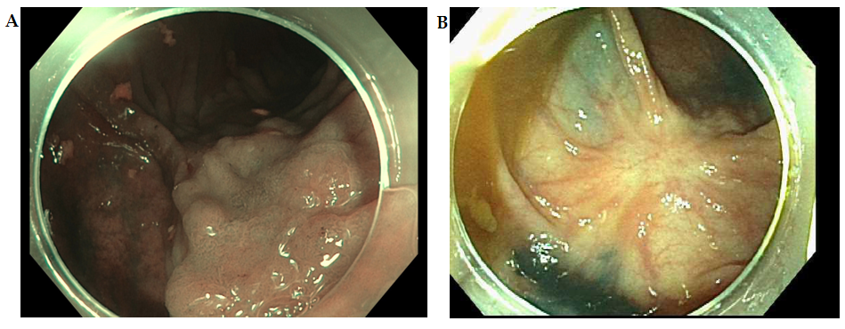
Figure 3 Colonoscopy. A: 0-IIa lesion in the hepatic flexure; B: Post endoscopic mucosal ablation scar.

