Name of Journal: World Journal of Clinical Infectious Diseases
Manuscript NO: 65056
Manuscript Type: META-ANALYSIS

Lymphocyte count predicts the severity of COVID-19: Evidence from a meta-analysis

Zhao YS et al. Lymphocyte count and COVID-19

Yi-Si Zhao, Ying-Xi Yu

Yi-Si Zhao, Ying-Xi Yu, Department of Critical Care Medicine, The First Affiliated Hospital of Chongqing Medical University, Chongqing 400016, China

Author contributions: Zhao YS wrote and revised this manuscript; Zhao YS and Yu YX participated in discussion the research; Zhao YS searched and collected bibliography.

Corresponding author: Yi-Si Zhao, MM, Doctor, Department of Critical Care Medicine, The First Affiliated Hospital of Chongqing Medical University, No. 1 Youyi road, Yuzhong District, Chongqing 400016, China. 476663973@qq.com

Received: February 27, 2021
Revised: April 3, 2021
Accepted: September 10, 2021
Published online:

Abstract
BACKGROUND
In December 2019, COVID-19 was reported firstly in Wuhan, China. COVID-19 is currently a global pandemic.

AIM
To assess the suitability of lymphocyte count as a biomarker of COVID-19 severity.

METHODS
Five literature databases (PubMed/Medline, Web of Science, Google Scholar, Embase, and Scopus) were searched to identify eligible articles. A meta-analysis was performed to calculate the standard mean difference (SMD) and 95% confidence interval (CI) of lymphocyte counts in coronaviral pneumonia cases.

RESULTS
Eight studies, including 1057 patients, were integrated in the meta-analysis. Lymphocyte counts were associated with severe coronavirus (CoV) infection (SMD = −1.35, 95% CI: −1.97 to −0.37, P < 0.001, I² = 92.6%). In the subgroup analysis stratified by prognosis, lymphocytes were associated with CoV infection mortality (n = 2, SMD = −0.42, 95% CI: −0.66 to −0.19, P < 0.001, I² = 0.0%), severity (n = 2, SMD = −0.93, 95% CI: −1.20 to −0.67, P < 0.001, I² = 0.0%), and diagnostic rate (n = 4, SMD = −2.32, 95% CI: −3.60 to −1.04, P < 0.001, I² = 91.2%).

CONCLUSION
Lymphocyte count may represent a simple, rapid, and commonly available laboratory index with which to diagnosis infection and predict the severity of CoV infections, including COVID-19.

Key Words: COVID-19; Lymphocyte count; Coronavirus; Severe of disease; Meta-analysis

Zhao YS, Yu YX. Lymphocyte count predicts the severity of COVID-19: Evidence from a meta-analysis. World J Clin Infect Dis 2021; In press

Core tip: Lymphocyte count reflects immune function and inflammatory state in infectious disease. SARS-CoV-2 spreads and invades through respiratory mucosa, triggers a series of immune responses and induces a cytokine storm, resulting in changes in immune components such as lymphocytes. Previous studies have shown that the decrease in lymphocyte count can be used as an indicator of severity for both severe acute respiratory syndrome and Middle East respiratory syndrome; both of which are coronavirus (CoV) infections. Therefore, this systematic review and meta-analysis evaluate the diagnostic and prognostic utility of the lymphocyte count in patients with viral pneumonia by CoV infections.

INTRODUCTION
In December 2019, in Wuhan, China, a novel CoV was identified as the causative agent of a novel pneumonia. The disease and the virus were subsequently termed COVID-19 and SARS-CoV-2, respectively, by the World Health Organization (WHO)^{[1,2]}. To date, COVID-19 has infected over 465 000 people in 199 countries, with nearly 21 000 deaths^{[3]}. These numbers continue to increase. As a CoV hypotype, SARS-CoV-2 is similar to the CoVs causing severe acute respiratory syndrome (SARS) and Middle East respiratory syndrome (MERS)^{[4,5]}. Both SARS and MERS spread rapidly worldwide, and have led to more than 10 000 human infections and 1000 deaths^{[4,6]}. The largest epidemiological study of COVID-19 performed by the Chinese CDC showed that 13.8% of all COVID-19 cases were severe, and 4.7% were critical^{[7]}. Critical patients, with a 49% case fatality rate, are at the most risk of death from COVID-19^{[7]}. Therefore, it is important to develop a rapid, simple clinical method to identify severe COVID-19 cases.
Lymphocytes play a decisive role in the maintenance of immune homeostasis and the inflammatory response^{[8]}. During the progression of an infectious disease, lymphocyte count reflects immune function and inflammatory state. SARS-CoV-2 invades via the respiratory mucosa, triggering a series of immune responses, including a cytokine storm, and affecting immune components, such as peripheral blood leukocytes and lymphocytes^{[9]}. Consistent with this, studies have shown that lymphopenia, particularly the depletion of CD4 and CD8 lymphocytes, is a clinical characteristic of COVID-19 patients, especially those with severe infections^{[10-12]}. Indeed, previous studies have shown that the decrease in lymphocyte count can be used to indicate the severity of SARS and MERS, both of which are CoV infections^{[13,14]}. However, due to the lack of analytical data, as might be provided by case–control or cohort studies, it is unclear whether lymphocyte count can also be used to reflect COVID-19 severity. Although Tan et al^{[15]} had reported that lymphocyte count predicted the severity of COVID-19, this study had too few samples. However, relying on the association of CoV infection, we found some evidence in a small number of observational studies of COVID-19. Here, we performed a systematic review and meta-analysis to evaluate the diagnostic and prognostic utility of lymphocyte count in patients with viral pneumonia caused by CoVs. Our aim was to explore the possibility that lymphocyte counts can predict COVID-19 severity and provide associated evidence.

MATERIALS AND METHODS
Search strategy and selection criteria
This protocol was registered with the PROSPERO international prospective register of systematic reviews (CRD42020177132, available from: https://www.crd.york.ac.uk/prospero/display_record.php?RecordID=177132) and followed the recommendations established by the Preferred Reporting Items for Systematic Reviews and Meta-Analyses (PRISMA) statement^{[16]}. We conducted a systematic review across five literature databases: PubMed/Medline, Web of Science, Google Scholar, Embase, and Scopus. The search terms used were as follows: “lymphocyte count,” and “pneumonia, viral” or “SARS” or “MERS” or “COVID-19”. All of the searches were concluded by March 21, 2020, and two researchers independently evaluated the search results.

Eligibility criteria
We included published peer-reviewed articles describing case–control, cohort, or cross-sectional studies, where lymphocyte counts were measured in peripheral blood samples from humans of any age with CoV infections. Case reports, conference abstracts, and review articles were excluded.
COVID-19 infections were diagnosed using next-generation sequencing or real-time reverse transcription polymerase chain reactions (RT-PCRs)^{[17]}. MERS-CoV was diagnosed according to the WHO criteria: a confirmed case was defined as a suspected case that was positive for MERS-CoV based on RT-PCR results^{[18]}. SARS infections were confirmed based on a definite exposure history, as well as either a positive RT-PCR test during acute infection or detectable CoV-specific antibodies during convalescence^{[19]}. We excluded studies conducted exclusively in patients with active cancer, chronic liver disease, HIV, or immunosuppression. When an article reported duplicate information from the same patient, the reports were combined to obtain complete data, but the case was only counted once.

Study selection
All of the titles and abstracts returned by the database search (Figure 1) were reviewed by first author (Zhao YS) independently to assess the need for a full-text review. Any disagreements were resolved through discussion between the same author and another author (Yu YX). Reasons for exclusion were recorded.

Assessment of risk of bias
Publication bias was assessed using a funnel plot, Begg’s test and Egger’s test.

Statistical analysis
According to a study by Hozo et al^{[20]}, we estimating the mean and standard deviation from the median and range, and the size of a sample as data extrapolation. When sample size was small (n < 25), we used a simple formula: x = (a + 2m + b)/4 to estimate the mean (x) using the values of the median (m), low and high end of the range (a and b, respectively). As soon as sample size exceeded 25, the median itself was the best estimator. When sample size was small (n < 15), we used the formula: S² = 1/12 × (((a − 2m + b)2)/4 + (b − a) 2) to estimate the standard deviation (S²). When the sample size increased (15 < n < 70), Range/4 was the best estimator for S². For large samples (n > 70) Range/6 was the best estimator for S^{2[20]}. To indicate the severity of CoV infection, we designed a cohort that combined three different measures of prognosis with respect to the control group: diagnosed versus nondiagnosed, severe versus nonsevere, and death versus survival. The control group included nondiagnosed, nonsevere and survival groups. The case group was severe, including diagnosed, severe and death groups.
We used the random-effects model to calculate the standard mean difference (SMD) and 95% confidence interval (CI) for lymphocyte count in the CoV-infection patients and to draw a forest plot. Subgroup analysis was performed based on the study definition of severity. Heterogeneity between pairs of studies was quantified using the I² statistic. We investigated potential sources of heterogeneity, including prognosis and data source (original data vs extrapolated data), by performing subgroup analyses. One was prognosis subgroup that was divided into mortality, severity and diagnostic rate subgroups according to different prognosis investigated in included studies. One was data source subgroup that was divided into original data and extrapolated data subgroups. The criterion was whether the data extrapolated according to the study by Hozo et al^{[20]}. All of the analyses were performed using Stata version 14 (Stata Corp., College Station, TX, USA).

RESULTS
Results of the electronic search
We identified 609 articles using database searches. After screening, 16 articles remained. After examination of the full-text articles, we excluded eight of these articles: three contained duplicate information from same patient; four articles had insufficient data on lymphocyte count; and one article chose a patient with community-acquired pneumonia as a control group. Therefore, eight studies were included in our meta-analysis^{[10,13,14,19,21-24]}.

Characteristics of the included studies
The characteristics of the eight included studies are summarized in Table 1. All of the studies included were prospective or retrospective case–control studies, cohort studies, or cross-sectional studies. The patient population in each study ranged from 30 to 346 (1057 patients in total). The earliest publications were from 2003^{[22,24]}, and the most recent article was published in 2020^{[10,21,23]}. Most studies were based in China (n = 7), including Taiwan (n = 3)^{[13,19,24]}, Wuhan (n = 2)^{[10]}, Beijing (n = 1)^{[22]}, and Shanghai (n = 1)^{[23]}. One study was based in Saudi Arabia^{[14]}. The CoV diseases studied were COVID-19 (n = 3; 37.5%)^{[10,21,23]}, MERS (n = 1; 12.5%)^{[14]}, and SARS (n = 4; 50%)^{[13,19,22,24]}. Four studies (50%) investigated prognosis with respect to diagnostic rate (diagnosed vs nondiagnosed)^{[19,22-24]}, two studies (25%) investigated prognosis with respect to severity (severe vs nonsevere)^{[10,21]}, and two studies (25%) investigated prognosis with respect to mortality (death vs survival)^{[13,14]}.

Characteristics of lymphocyte count
The means and standard deviations of lymphocyte counts from four studies^{[10,14,21,23]} were extrapolated from sample size, median, and IQR (Table 1). In the forest plot, if the SMD (95%CI) was < 0, it showed that the mean and standard deviation of lymphocyte counts in the case group were less than those in the control group. That meant lymphocyte counts were less in severe CoV infection. Analysis showed that lymphocyte counts were associated with severe CoV infection (SMD = −1.35, 95% CI: −1.97 to −0.37, P < 0.001, I² = 92.6%) (Figure 2). There was heterogeneity among studies. Therefore, subgroup analysis, stratified by prognosis and data source, was performed. In the subgroup analysis stratified by prognosis, lymphocytes were associated with mortality due to CoV infection (n = 2, SMD = −0.42, 95% CI: −0.66 to −0.19, P < 0.001, I² = 0.0%), with severity of CoV infection (n = 2, SMD = −0.93, 95% CI: −1.20 to −0.67, P < 0.001, I² = 0.0%), and with the diagnostic rate of CoV infection (n = 4, SMD = −2.32, 95% CI: −3.60 to −1.04, P < 0.001, I² = 91.2%) (Figure 3). In the subgroup analysis stratified by data source, lymphocytes were associated with both the extrapolated data (n = 4, SMD = −0.92, 95% CI: −1.33 to −0.51, P < 0.001, I² = 64.0%) and the original data (n = 4, SMD = −1.97, 95%CI: −3.35 to −0.60, P < 0.001, I² = 96.5%) (see Supplementary Figure 1, which illustrates the forest plot of subgroup analysis stratified by data source), explaining the observed overall heterogeneity among studies. In addition, because few studies were included in our analysis, it was unclear whether the funnel plot was symmetrical (Figure 4), but Begg’s test and Egger’s test showed that publication bias had no significant effects on the results of the meta-analysis (P = 0.174).

DISCUSSION
COVID-19 is rapidly infectious and highly severe, with a high mortality rate ^{[3]}. Patients with COVID-19 exhibit a wide range of variability in disease severity. In clinical practice, we believe that low levels of lymphocytes are disadvantageous for COVID-19 patients. Because lymphocyte count reflects disease characteristics, it might potentially help in the evaluation of COVID-19 severity. Usefully, this measure is easily available in laboratory tests.
Lymphocytes are vital cells that maintain immune function and execute the immune response in the body^{[8]}. In the best-case scenario, the cellular immune response rapidly clears CoV with little or no clinical signs of infection. Alternatively, the virus causes a state of immunosuppression, which debilitates and sometimes overwhelms the host’s defenses^{[25]}. Currently, no detailed study of the immunological response to SARS-CoV-2 is available. Thus, we must rely on previous studies of other CoVs, especially SARS-CoV and MERS-CoV^{[26]}. Based on other CoVs, SARS-CoV-2 might induce a T-lymphocyte-mediated protective immune response^{[25]}. However, lymphopenia is associated with many types of infections, including coronavirus^{[14,27]}. Studies have shown that lymphopenia is related to cell apoptosis in SARS patients^{[19,28]}. In addition, hospitalized patients infected with SARS-CoV-2 frequently manifest lymphopenia, suggesting that cellular immune responses may be suppressed^{[10,21]}. However, lymphopenia in MERS but not SARS cases could be a result of direct infection of T cells and infection-induced apoptosis^{[29]}. Although the lymphopenia in patients with SARS and those with MERS may have different mechanisms, they forecast similar outcome. Furthermore, lymphocyte count as a biomarker to predicting severity in other non-CoV diseases (such as measles, herpes and vaccinia) is effective^{[19]}. Therefore, the hypothesis which predictive role of lymphopenia in COVID-19 is reasonable, and some recently study also provide some evidence to prove this hypothesis^{[15]}. However, studies of the role of lymphocytes in COVID-19 are rare.
In this study, we designed a meta-analysis to explore the feasibility of using lymphocyte count to predict COVID-19 severity. All of the eight studies included in our meta-analysis involved SARS, MERS or COVID-19, and were prospective or retrospective case–control, cohort or cross-sectional studies (Table 1). Existing research results do not always rank the severity of COVID-19 infections using the same criteria. Even during the earliest part of the Chinese outbreak, the guidelines for COVID-19 diagnosis and treatment issued by the Chinese National Health Commission were revised seven times based on clinical experiences^{[30]}. Therefore, we roughly evaluated disease severity using paired concepts: diagnosed versus nondiagnosed ^{[19,22-24]}; severe versus nonsevere^{[10]}, and death versus survival^{[13,14]}.
We found that lymphocyte count was associated with severe CoV infection (Figure 2). Lymphocytes were also associated with CoV mortality, severity and diagnostic rate (Figure 3). Thus, lymphocyte count may represent a simple, rapid, and commonly available diagnostic and severity-prediction tool for CoV infections, including COVID-19. Because we included studies of SARS-CoV-2 infections, our results indicate the value of lymphocyte count for the assessment of COVID-19 severity. A recent related study suggested that lymphocyte percentage might be a reliable indicator of moderate, severe or critical infections, independent of auxiliary indicators^{[15]}. However, this study included few severe (n = 39) and critical (n = 28) cases^{[15]}. In combination, our analysis and the most recent research results suggested that lymphocyte counts potentially reflect COVID-19 severity. Meanwhile, some research has shown that the viral load of SARS-CoV-2 is associated with the lymphocyte count: A study of interleukin (IL)-3 (a cytokine produced by T lymphocytes) discovered that patients with high viral load presented had lower plasma IL-3 levels than low viral load^{[31]}. CD4:CD8 ratio and T regulatory cells significantly decrease in mice with high viral load^{[32]}. Not only T cells, but also B cells and natural killer cells in patients with severe COVID-19 were significantly lower than those in patients with the mild form^{[33,34]}. Lymphopenia in COVID-19 may have several underlying causes, including the destruction of lymphatic organs, the direct attack on lymphocytes by SARS-CoV-2^{[35]}, lymphocyte apoptosis due to the continual release of inflammatory cytokines, or, in severe cases, the inhibition of lymphocytes by hyperlactacidemia^{[36]}. It is clear that hyperlacticacidemia- and cytokine-storm-related acute respiratory distress syndrome is the primary presentation of patients with critical COVID-19^{[30]}. Thus, lymphocyte count is an important indicator of severe or critical COVID-19.
For the acute outbreak of COVID-19, the meta-analysis has limitations. We faced a shortage of data sources during the research. Even now, the data on COVID-19 are insufficient. The research results in the previous response to CoVs should be used for reference. The most mainstream of these were SARS and MERS. As other important CoV diseases, they have similarities to COVID-19. From the perspective of the important characteristics of respiratory infections, SARS and MERS could be included in the reference category. The prevention and treatment methods of COVID-19 all often refer to methods of SARS and MERS. A meta-analysis about prevention of person-to-person transmission of COVID-19 also included SARS and MERS coincidentally^{[37]}. Studies have shown that lymphopenia is related to apoptosis in SARS^{[28]}. Lymphopenia is the result of direct T cell infection and infection-induced apoptosis in MERS^{[29]}. Although we think that this conclusion is insufficient, because there are some treatments (for example: hormone use, antibody titer, etc.) that affect the lymphocyte count in the clinic. However, from the current situation of prevalence, spread and treatment, it is of reference value. In studies that were included in the meta-analysis, five referred to lymphocyte counts that were obtained on the day of hospital admission, and two studies did not report clearly the time that lymphocyte counts were obtained. In clinical research, because it is difficult to make a complete review of the course of disease admission, it is generally accepted to choose the day/time of hospital admission as the sampling point^{[10]}. It has been shown that the degree of lymphopenia is steady during the first week^{[38]}, and lymphocyte counts progressively decrease and reach their lowest point on day 14 in most cases^{[38]}. Therefore, our analysis did not divide these studies by time of lymphocyte count acquisition. One week of hospital admission could be recognized as a stable interval for lymphocyte counts. However, a recent study showed that lymphocyte count varied at different times of hospitalization^{[39]}. Thus, further study of lymphocyte counts at varied times could increase the predicted efficiency in COVID-19.

CONCLUSION
Our meta-analysis provides information on three simple and common interventions to combat the immediate threat of COVID-19, while new evidence on pharmacological treatments, vaccines, hematology monitoring and other personal protective strategies is being generated^{[37]}. It showed that lymphocyte count may represent a simple, rapid and commonly available laboratory index with which to diagnosis infection and predict the severity of CoV infections, including COVID-19. However, our study was limited by the lack of COVID-19 studies, especially those with homogeneous or uniform standards. Therefore, it was necessary to include SARS and MERS in our study; both of which can lead to coronaviral pneumonia. Thus, these diseases might represent a reference for COVID-19. During the current severe COVID-19 pandemic, we hope to provide a framework for the future predictions of COVID-19 severity. Indeed, if critical infections could be predicted and treated earlier, mortality would be lower. Lymphocyte count is a potential indicator of COVID-19 severity and deserves further examination. However, the high heterogeneity among studies suggests that additional research, including case–control and cohort studies, is required for detailed analyses of the relationship between lymphocyte count and COVID-19 severity.

ARTICLE HIGHLIGHTS
Research background
In December 2019, COVID-19 was reported first in Wuhan, China. COVID-19 is currently a global pandemic.

Research motivation
COVID-19 with high morbidity is a life-threatening disease globally. It is important to develop a rapid, simple clinical method to identify severe COVID-19 cases.

Research objectives
The aim of this study was to assess the suitability of lymphocyte count as a biomarker of COVID-19 severity.

Research methods
We searched five literature databases (PubMed/Medline, Web of Science, Google Scholar, Embase, and Scopus) to identify eligible articles. A meta-analysis was performed to calculate the standard mean difference (SMD) and 95% confidence interval (CI) of lymphocyte counts in coronaviral pneumonia cases.

Research results
Our research integrated eight studies, including 1057 patients. Lymphocyte counts were associated with severe coronavirus (CoV) infection (SMD = −1.35, 95%CI: −1.97 to −0.37, P < 0.001, I² = 92.6%). In the subgroup analysis stratified by prognosis, lymphocytes were associated with coronavirus infection mortality (n = 2, SMD = −0.42, 95% CI: −0.66 to −0.19, P < 0.001, I² = 0.0%), severity (n = 2, SMD = −0.93, 95%CI: −1.20 to −0.67, P < 0.001, I² = 0.0%), and diagnostic rate (n = 4, SMD = −2.32, 95%CI: −3.60 to −1.04, P < 0.001, I² = 91.2%).

Research conclusions
Lymphocyte count may represent a simple, rapid and commonly available laboratory index with which to diagnosis infection and predict the severity of CoV infections, including COVID-19.

Research perspectives
As a CoV hypotype, SARS-CoV-2 is similar to the CoVs causing severe acute respiratory syndrome and Middle East respiratory syndrome. Hence, we performed a systematic review and meta-analysis of the literature to evaluate the diagnostic and prognostic utility of lymphocyte count in patients with viral pneumonia caused by CoV infections. Our aim was to explore the possibility that lymphocyte counts predict COVID-19 severity and provide associated evidence.

ACKNOWLEDMENTS
This article also commemorates the Chinese medical staff who gave their lives in the fight
against COVID-19.

REFERENCES
1 Zhu N, Zhang D, Wang W, Li X, Yang B, Song J, Zhao X, Huang B, Shi W, Lu R, Niu P, Zhan F, Ma X, Wang D, Xu W, Wu G, Gao GF, Tan W; China Novel Coronavirus Investigating and Research Team. A Novel Coronavirus from Patients with Pneumonia in China, 2019. N Engl J Med 2020; 382: 727-733 [PMID: 31978945 DOI: 10.1056/NEJMoa2001017]
2 Sohrabi C, Alsafi Z, O'Neill N, Khan M, Kerwan A, Al-Jabir A, Iosifidis C, Agha R. World Health Organization declares global emergency: A review of the 2019 novel coronavirus (COVID-19). Int J Surg 2020; 76: 71-76 [PMID: 32112977 DOI: 10.1016/j.ijsu.2020.02.034]
3 World Health Organization. Coronavirus disease 2019 (COVID-19) Situation Report –66. 2020 [cited 20 December 2020]. Available from: https://www.who.int/docs/default-source/coronaviruse/situation-reports/20200326-sitrep-66-covid-19.pdf?sfvrsn=81b94e61_2
4 Peiris JS, Guan Y, Yuen KY. Severe acute respiratory syndrome. Nat Med 2004; 10: S88-S97 [PMID: 15577937 DOI: 10.1038/nm1143]
5 Zaki AM, van Boheemen S, Bestebroer TM, Osterhaus AD, Fouchier RA. Isolation of a novel coronavirus from a man with pneumonia in Saudi Arabia. N Engl J Med 2012; 367: 1814-1820 [PMID: 23075143 DOI: 10.1056/NEJMoa1211721]
6 Badawi A, Ryoo SG. Prevalence of Diabetes in the 2009 Influenza A (H1N1) and the Middle East Respiratory Syndrome Coronavirus: A Systematic Review and Meta-Analysis. J Public Health Res 2016; 5: 733 [PMID: 28083520 DOI: 10.4081/jphr.2016.733]
7 Epidemiology Working Group for NCIP Epidemic Response, Chinese Center for Disease Control and Prevention. The epidemiological characteristics of an outbreak of 2019 novel coronavirus diseases (COVID-19) in China. Zhonghua Liu Xing Bing Xue Za Zhi 2020; 41: 145-151 [PMID: 32064853 DOI: 10.3760/cma.j.issn.0254-6450.2020.02.003]
8 Jalkanen S, Salmi M. Lymphatic endothelial cells of the lymph node. Nat Rev Immunol 2020; 20: 566-578 [PMID: 32094869 DOI: 10.1038/s41577-020-0281-x]
9 Wu J, Liu J, Zhao X, Liu C, Wang W, Wang D, Xu W, Zhang C, Yu J, Jiang B, Cao H, Li L. Clinical Characteristics of Imported Cases of Coronavirus Disease 2019 (COVID-19) in Jiangsu Province: A Multicenter Descriptive Study. Clin Infect Dis 2020; 71: 706-712 [PMID: 32109279 DOI: 10.1093/cid/ciaa199]
10 Wang D, Hu B, Hu C, Zhu F, Liu X, Zhang J, Wang B, Xiang H, Cheng Z, Xiong Y, Zhao Y, Li Y, Wang X, Peng Z. Clinical Characteristics of 138 Hospitalized Patients With 2019 Novel Coronavirus-Infected Pneumonia in Wuhan, China. JAMA 2020; 323: 1061-1069 [PMID: 32031570 DOI: 10.1001/jama.2020.1585]
11 Chen N, Zhou M, Dong X, Qu J, Gong F, Han Y, Qiu Y, Wang J, Liu Y, Wei Y, Xia J, Yu T, Zhang X, Zhang L. Epidemiological and clinical characteristics of 99 cases of 2019 novel coronavirus pneumonia in Wuhan, China: a descriptive study. Lancet 2020; 395: 507-513 [PMID: 32007143 DOI: 10.1016/S0140-6736(20)30211-7]
12 Rodriguez-Morales AJ, Cardona-Ospina JA, Gutiérrez-Ocampo E, Villamizar-Peña R, Holguin-Rivera Y, Escalera-Antezana JP, Alvarado-Arnez LE, Bonilla-Aldana DK, Franco-Paredes C, Henao-Martinez AF, Paniz-Mondolfi A, Lagos-Grisales GJ, Ramírez-Vallejo E, Suárez JA, Zambrano LI, Villamil-Gómez WE, Balbin-Ramon GJ, Rabaan AA, Harapan H, Dhama K, Nishiura H, Kataoka H, Ahmad T, Sah R; Latin American Network of Coronavirus Disease 2019-COVID-19 Research (LANCOVID-19). Clinical, laboratory and imaging features of COVID-19: A systematic review and meta-analysis. Travel Med Infect Dis 2020; 34: 101623 [PMID: 32179124 DOI: 10.1016/j.tmaid.2020.101623]
13 Chang HL, Chen KT, Lai SK, Kuo HW, Su IJ, Lin RS, Sung FC. Hematological and biochemical factors predicting SARS fatality in Taiwan. J Formos Med Assoc 2006; 105: 439-450 [PMID: 16801031 DOI: 10.1016/S0929-6646(09)60183-2]
14 Das KM, Lee EY, Al Jawder SE, Enani MA, Singh R, Skakni L, Al-Nakshabandi N, AlDossari K, Larsson SG. Acute Middle East Respiratory Syndrome Coronavirus: Temporal Lung Changes Observed on the Chest Radiographs of 55 Patients. AJR Am J Roentgenol 2015; 205: W267-W274 [PMID: 26102309 DOI: 10.2214/AJR.15.14445]
15 Tan L, Wang Q, Zhang D, Ding J, Huang Q, Tang YQ, Wang Q, Miao H. Lymphopenia predicts disease severity of COVID-19: a descriptive and predictive study. Signal Transduct Target Ther 2020; 5: 33 [PMID: 32296069 DOI: 10.1038/s41392-020-0148-4]
16 Moher D, Liberati A, Tetzlaff J, Altman DG; PRISMA Group. Preferred reporting items for systematic reviews and meta-analyses: the PRISMA statement. Int J Surg 2010; 8: 336-341 [PMID: 20171303 DOI: 10.1016/j.ijsu.2010.02.007]
17 Huang C, Wang Y, Li X, Ren L, Zhao J, Hu Y, Zhang L, Fan G, Xu J, Gu X, Cheng Z, Yu T, Xia J, Wei Y, Wu W, Xie X, Yin W, Li H, Liu M, Xiao Y, Gao H, Guo L, Xie J, Wang G, Jiang R, Gao Z, Jin Q, Wang J, Cao B. Clinical features of patients infected with 2019 novel coronavirus in Wuhan, China. Lancet 2020; 395: 497-506 [PMID: 31986264 DOI: 10.1016/S0140-6736(20)30183-5]
18 Who Mers-Cov Research Group. State of Knowledge and Data Gaps of Middle East Respiratory Syndrome Coronavirus (MERS-CoV) in Humans. PLoS Curr 2013; 5 [PMID: 24270606 DOI: 10.1371/currents.outbreaks.0bf719e352e7478f8ad85fa30127ddb8]
19 Chen RF, Chang JC, Yeh WT, Lee CH, Liu JW, Eng HL, Yang KD. Role of vascular cell adhesion molecules and leukocyte apoptosis in the lymphopenia and thrombocytopenia of patients with severe acute respiratory syndrome (SARS). Microbes Infect 2006; 8: 122-127 [PMID: 16182592 DOI: 10.1016/j.micinf.2005.06.007]
20 Hozo SP, Djulbegovic B, Hozo I. Estimating the mean and variance from the median, range, and the size of a sample. BMC Med Res Methodol 2005; 5: 13 [PMID: 15840177 DOI: 10.1186/1471-2288-5-13]
21 Zhang JJ, Dong X, Cao YY, Yuan YD, Yang YB, Yan YQ, Akdis CA, Gao YD. Clinical characteristics of 140 patients infected with SARS-CoV-2 in Wuhan, China. Allergy 2020; 75: 1730-1741 [PMID: 32077115 DOI: 10.1111/all.14238]
22 Cui W, Fan Y, Wu W, Zhang F, Wang JY, Ni AP. Expression of lymphocytes and lymphocyte subsets in patients with severe acute respiratory syndrome. Clin Infect Dis 2003; 37: 857-859 [PMID: 12955652 DOI: 10.1086/378587]
23 Li YX, Wu W, Yang T, Zhou W, Fu YM, Feng QM, Ye JM. [Characteristics of peripheral blood leukocyte differential counts in patients with COVID-19]. Zhonghua Nei Ke Za Zhi 2020; 59: 372-374 [PMID: 32370466 DOI: 10.3760/cma.j.cn112138-20200221-00114]
24 Chen SY, Su CP, Ma MH, Chiang WC, Hsu CY, Ko PC, Tsai KC, Yen ZS, Shih FY, Chen SC, Chen WJ. Predictive model of diagnosing probable cases of severe acute respiratory syndrome in febrile patients with exposure risk. Ann Emerg Med 2004; 43: 1-5 [PMID: 14707932 DOI: 10.1016/s0196-0644(03)00817-5]
25 Jin W, Zhu X, Yao F, Xu X, Chen X, Luo Z, Zhao D, Li X, Leng X, Sun L. Corrigendum to "Cytoprotective effect of Fufang Lurong Jiangu capsule against hydrogen peroxide-induced oxidative stress in bone marrow stromal cell-derived osteoblasts through the Nrf2/HO-1 signaling pathway" [Biomed. Pharmacother. 121 (2020) 109676]. Biomed Pharmacother 2020; 122: 109808 [PMID: 31902541 DOI: 10.1016/j.biopha.2019.109808]
26 Hu H, Tao L, Wang Y, Chen L, Yang J, Wang H. Enhancing immune responses against SARS-CoV nucleocapsid DNA vaccine by co-inoculating interleukin-2 expressing vector in mice. Biotechnol Lett 2009; 31: 1685-1693 [PMID: 19579009 DOI: 10.1007/s10529-009-0061-y]
27 Chan MH, Wong VW, Wong CK, Chan PK, Chu CM, Hui DS, Suen MW, Sung JJ, Chung SS, Lam CW. Serum LD1 isoenzyme and blood lymphocyte subsets as prognostic indicators for severe acute respiratory syndrome. J Intern Med 2004; 255: 512-518 [PMID: 15049886 DOI: 10.1111/j.1365-2796.2004.01323.x]
28 O'Donnell R, Tasker RC, Roe MF. SARS: understanding the coronavirus: apoptosis may explain lymphopenia of SARS. BMJ 2003; 327: 620 [PMID: 12969939 DOI: 10.1136/bmj.327.7415.620-b]
29 Chu H, Zhou J, Wong BH, Li C, Chan JF, Cheng ZS, Yang D, Wang D, Lee AC, Li C, Yeung ML, Cai JP, Chan IH, Ho WK, To KK, Zheng BJ, Yao Y, Qin C, Yuen KY. Middle East Respiratory Syndrome Coronavirus Efficiently Infects Human Primary T Lymphocytes and Activates the Extrinsic and Intrinsic Apoptosis Pathways. J Infect Dis 2016; 213: 904-914 [PMID: 26203058 DOI: 10.1093/infdis/jiv380]
30 National Health Commission of China. The guidelines for diagnosis and treatment of novel coronavirus (2019-nCoV) infected pneumonia (the seventh edition draft). [cited 20 December 2020]. Available from: http://www.gov.cn/zhengce/zhengceku/2020-03/04/5486705/files/ae61004f930d47598711a0d4cbf874a9.pdf
31 Bénard A, Jacobsen A, Brunner M, Krautz C, Klösch B, Swierzy I, Naschberger E, Podolska MJ, Kouhestani D, David P, Birkholz T, Castellanos I, Trufa D, Sirbu H, Vetter M, Kremer AE, Hildner K, Hecker A, Edinger F, Tenbusch M, Mühl-Zürbes P, Steinkasserer A, Richter E, Streeck H, Berger MM, Brenner T, Weigand MA, Swirski FK, Schett G, Grützmann R, Weber GF. Interleukin-3 is a predictive marker for severity and outcome during SARS-CoV-2 infections. Nat Commun 2021; 12: 1112 [PMID: 33602937 DOI: 10.1038/s41467-021-21310-4]
32 Graham JB, Swarts JL, Leist SR, Schäfer A, Menachery VD, Gralinski LE, Jeng S, Miller DR, Mooney MA, McWeeney SK, Ferris MT, Pardo-Manuel de Villena F, Heise MT, Baric RS, Lund JM. Baseline T cell immune phenotypes predict virologic and disease control upon SARS-CoV infection in Collaborative Cross mice. PLoS Pathog 2021; 17: e1009287 [PMID: 33513210 DOI: 10.1371/journal.ppat.1009287]
33 Corrao S, Gervasi F, Di Bernardo F, Natoli G, Raspanti M, Catalano N, Argano C. Immunological Characteristics of Non-Intensive Care Hospitalized COVID-19 Patients: A Preliminary Report. J Clin Med 2021; 10: 849 [PMID: 33669527 DOI: 10.3390/jcm10040849]
34 Gao Y, Chen L, Chi J, Zeng S, Feng X, Li H, Liu D, Feng X, Wang S, Wang Y, Yu R, Yuan Y, Xu S, Li C, Zhang W, Li S, Gao Q. Development and validation of an online model to predict critical COVID-19 with immune-inflammatory parameters. J Intensive Care 2021; 9: 19 [PMID: 33602326 DOI: 10.1186/s40560-021-00531-1]
35 Xu H, Zhong L, Deng J, Peng J, Dan H, Zeng X, Li T, Chen Q. High expression of ACE2 receptor of 2019-nCoV on the epithelial cells of oral mucosa. Int J Oral Sci 2020; 12: 8 [PMID: 32094336 DOI: 10.1038/s41368-020-0074-x]
36 Fischer K, Hoffmann P, Voelkl S, Meidenbauer N, Ammer J, Edinger M, Gottfried E, Schwarz S, Rothe G, Hoves S, Renner K, Timischl B, Mackensen A, Kunz-Schughart L, Andreesen R, Krause SW, Kreutz M. Inhibitory effect of tumor cell-derived lactic acid on human T cells. Blood 2007; 109: 3812-3819 [PMID: 17255361 DOI: 10.1182/blood-2006-07-035972]
37 Chu DK, Akl EA, Duda S, Solo K, Yaacoub S, Schünemann HJ; COVID-19 Systematic Urgent Review Group Effort (SURGE) study authors. Physical distancing, face masks, and eye protection to prevent person-to-person transmission of SARS-CoV-2 and COVID-19: a systematic review and meta-analysis. Lancet 2020; 395: 1973-1987 [PMID: 32497510 DOI: 10.1016/S0140-6736(20)31142-9]
38 Wong RS, Wu A, To KF, Lee N, Lam CW, Wong CK, Chan PK, Ng MH, Yu LM, Hui DS, Tam JS, Cheng G, Sung JJ. Haematological manifestations in patients with severe acute respiratory syndrome: retrospective analysis. BMJ 2003; 326: 1358-1362 [PMID: 12816821 DOI: 10.1136/bmj.326.7403.1358]
39 Petrilli CM, Jones SA, Yang J, Rajagopalan H, O'Donnell L, Chernyak Y, Tobin KA, Cerfolio RJ, Francois F, Horwitz LI. Factors associated with hospital admission and critical illness among 5279 people with coronavirus disease 2019 in New York City: prospective cohort study. BMJ 2020; 369: m1966 [PMID: 32444366 DOI: 10.1136/bmj.m1966]

Footnotes
Conflict-of-interest statement: We not received any fees for serving as a speaker. We not received any research funding from.

PRISMA 2009 Checklist statement: The authors have read the PRISMA 2009 Checklist, and the manuscript was prepared and revised according to the PRISMA 2009 Checklist.

Open-Access: This article is an open-access article that was selected by an in-house editor and fully peer-reviewed by external reviewers. It is distributed in accordance with the Creative Commons Attribution NonCommercial (CC BY-NC 4.0) license, which permits others to distribute, remix, adapt, build upon this work non-commercially, and license their derivative works on different terms, provided the original work is properly cited and the use is non-commercial. See: http://creativecommons.org/Licenses/by-nc/4.0/

Manuscript source: Unsolicited manuscript

Peer-review started: February 27, 2021
First decision: March 31, 2021
Article in press:

Specialty type: Infectious diseases
Country/Territory of origin: China
Peer-review report’s scientific quality classification
Grade A (Excellent): 0
Grade B (Very good): B, B
Grade C (Good): 0
Grade D (Fair): 0
Grade E (Poor): 0

P-Reviewer: Shimizu Y S-Editor: Liu M L-Editor: Kerr C P-Editor:

Figure Legends
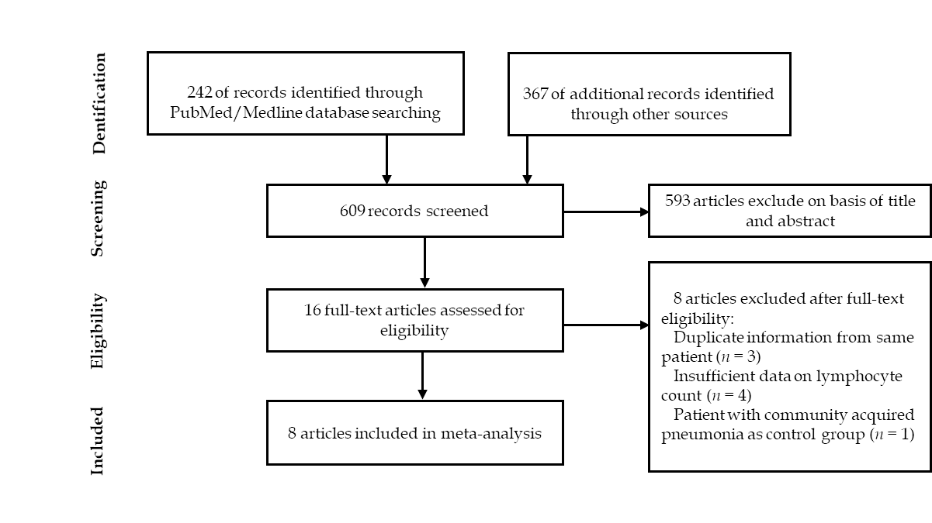
Figure 1 Article selection process.

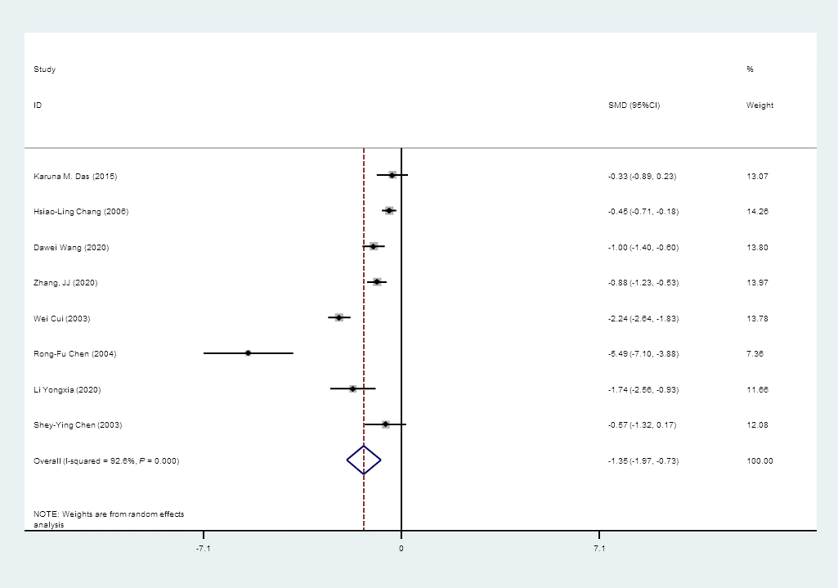
Figure 2 Forest plot: overall identification of lymphocyte count in patients with coronaviral pneumonia. P = 0.000 means P < 0.001. CI: Confidence interval.

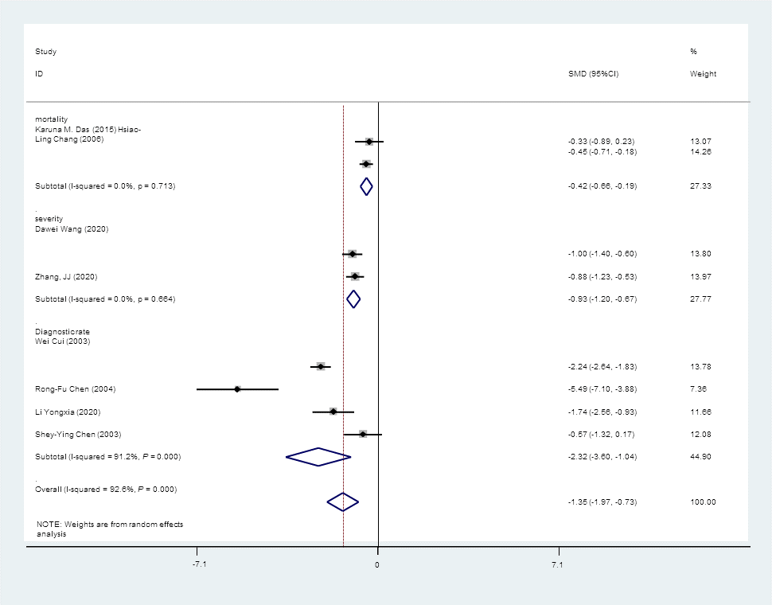
Figure 3 Forest plot: overall identification of lymphocyte count in patients with coronaviral pneumonia, subgroup analysis stratified by prognosis. P = 0.000 means P < 0.001. CI: Confidence interval.

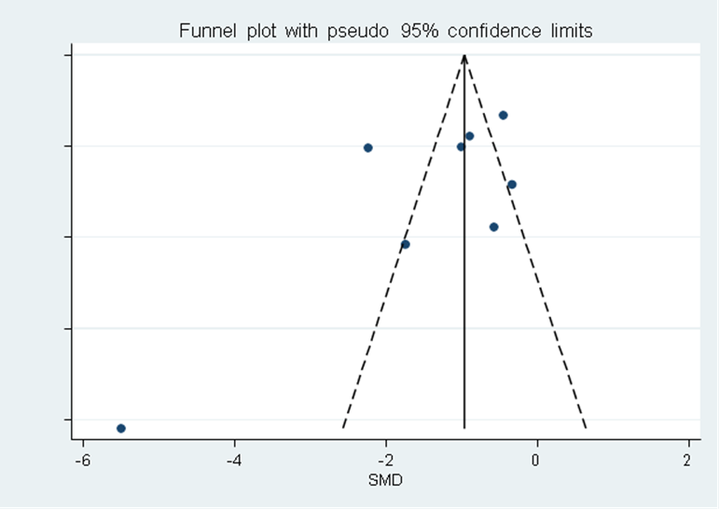
Figure 4 Funnel plot: publication bias of eight studies included.

Table 1 Characteristics of the included studies
Ref. | City, country | Coronavirus disease | Outcome | n (case) | Lymphocyte count of case, mean ± SD (*10⁹/L) | n (control) | Lymphocyte count of control, mean ± SD (× 10⁹/L)
Das et al^{[14]}, 2015 | Saudi Arabia | MERS | Mortality | 19 | 18.25 ± 11.75 | 36 | 24.00 ± 19.75
Chang et al^{[13]}, 2006 | Taiwan, China | SARS | Mortality | 73 | 0.81 ± 0.38 | 273 | 1.02 ± 0.48
Wang et al^{[10]}, 2020 | Wuhan, China | COVID-19 | Severity | 36 | 0.80 ± 0.10 | 102 | 0.90 ± 0.10
Zhang et al^{[21]}, 2020 | Wuhan, China | COVID-19 | Severity | 58 | 0.70 ± 0.13 | 82 | 0.80 ± 0.10
Cui et al^{[22]}, 2003 | Beijing, China | SARS | Diagnostic rate | 38 | 0.91 ± 0.44 | 200 | 3.00 ± 1.00
Chen et al^{[19]}, 2006 | Taiwan, China | SARS | Diagnostic rate | 15 | 0.60 ± 0.30 | 15 | 2.00 ± 0.20
Li et al^{[23]}, 2020 | Shanghai, China | COVID-19 | Diagnostic rate | 10 | 1.22 ± 0.20 | 30 | 1.75 ± 0.33
Chen et al^{[24]}, 2004 | Taiwan, China | SARS | Diagnostic rate | 8 | 0.90 ± 0.30 | 62 | 1.50 ± 1.10
SARS: Severe acute respiratory syndrome.

