Name of Journal: World Journal of Biological Chemistry
Manuscript NO: 66556
Manuscript Type: META-ANALYSIS

Remission is not maintained over 2 years with hematopoietic stem cell transplantation for rheumatoid arthritis: A systematic review with meta-analysis

Muthu S et al. Hematopoietic stem cell transplantation for rheumatoid arthritis

Sathish Muthu, Madhan Jeyaraman, Rajni Ranjan, Saurabh Kumar Jha

Sathish Muthu, Madhan Jeyaraman, Saurabh Kumar Jha, Department of Biotechnology, School of Engineering and Technology, Sharda University, Delhi 201306, Uttar Pradesh, India

Sathish Muthu, Department of Orthopaedics, Government Medical College and Hospital, Dindigul 624001, Tamil Nadu, India

Madhan Jeyaraman, Department of Orthopaedics, Faculty of Medicine, Sri Lalithambigai Medical College and Hospital, Chennai 600095, Tamil Nadu, India

Rajni Ranjan, Department of Orthopaedics, School of Medical Sciences and Research, Greater Noida 201306, Uttar Pradesh, India

Author contributions: Muthu S and Jeyaraman M provide the conceptualization; Muthu S, Jeyaraman M, and Ranjan R contributed to the data curation, formal analysis, investigations, methodology; Muthu S and Ranjan R contributed to the administration, resources, and supervision; Muthu S contributed to the validation and visualization; Muthu S and Jeyaraman M contributed to writing the original draft and reviewing the drafts.

Corresponding author: Sathish Muthu, MS, Research Scholar, School of Engineering and Technology, Sharda University, Greater Noida, Delhi 201306, Uttar Pradesh, India. drsathishmuthu@gmail.com

Received: March 30, 2021
Revised: May 21, 2021
Accepted: November 26, 2021
Published online: November 27, 2021

Abstract
BACKGROUND
Hematopoietic stem cell (HSC) transplantation (HSCT) is being accepted as a standard of care in various inflammatory diseases. The treatment of rheumatoid arthritis (RA) has been closely evolving with the understanding of disease pathogenesis. With the rising resistance to the traditional disease-modifying anti-rheumatic drugs and targeted biological therapy, researchers are in pursuit of other methods for disease management. Since the ultimate goal of the ideal treatment of RA is to restore immune tolerance, HSCT attracts much attention considering its reparative, paracrine, and anti-inflammatory effects. However, a systematic review of studies on HSCT in RA is lacking.

AIM
To investigate the role of HSCT in the management of RA.

METHODS
A detailed search of PubMed, Scopus, Embase, Cochrane, and the Web of Science databases was made to identify the relevant articles till September 2020 following Cochrane and PRISMA guidelines. We extracted data including the number of patients, source of hematopoietic stem cells, their mobilization and conditioning regimens, results, and complications from the eligible studies. Results were dichotomized into success (ACR 50/70) and failure (ACR 20) based on the improvement from baseline characteristics. The methodological quality of the included studies was also assessed. Analysis was performed using OpenMeta[Analysis] software.

RESULTS
We included 17 studies (1 randomized controlled trial, 11 prospective, and 5 retrospective studies) with 233 patients for analysis. HSCT provided a significantly beneficial overall improvement in the clinical grades of ACR criteria (Z = 11.309, p < 0.001). However, the remission was noted only till 24 mo and later on the significance of the result was lost (Z = 1.737, P = 0.082). A less than 1% treatment-related mortality was noted from the included studies. No major drug-related toxicities were noted in any of the included studies. All patients who underwent allogeneic HSCT received immunosuppression in the conditioning regimen to counteract the graft-vs-host reaction which made them vulnerable to infections. It is noted that the source of hematopoietic stem cells did not play a role in altering the functional outcome and both autologous (Z = 9.972, p < 0.001) and allogenic (Z = 6.978, p < 0.001) sources produced significant improvement in the outcome compared to the pre-operative state despite having a significant heterogeneity among the studies reporting them (I² = 99.4, p < 0.001).

CONCLUSION
Although the available literature is encouraging towards the use of HSCT in refractory cases with significant improvement from baseline till 2 years, the inclusion of HSCT into the standard of care of RA needs further exploration.

Key Words: Hematopoietic stem cell; Rheumatoid arthritis; Disease-modifying anti-rheumatic drug; Biological therapy; Systematic review; Meta-analysis

©The Author(s) 2021. Published by Baishideng Publishing Group Inc. All rights reserved.

Citation: Muthu S, Jeyaraman M, Ranjan R, Jha SK. Remission is not maintained over 2 years with hematopoietic stem cell transplantation for rheumatoid arthritis: A systematic review with meta-analysis. World J Biol Chem 2021; 12(6): 114-130
URL: https://www.wjgnet.com/1949-8454/full/v12/i6/114.htm
DOI: https://dx.doi.org/10.4331/wjbc.v12.i6.114

Core Tip: With the rising resistance to the traditional disease-modifying anti-rheumatic drugs and targeted biological therapy, we performed this systematic review and meta-analysis to evaluate the role of hematopoietic stem cell therapy in the management of rheumatoid arthritis. Literature on the effectiveness of the intervention is encouraging with significant improvement till 2 years post-therapy. We have explored the ambiguity in the current treatment methods in hematopoietic stem cell therapy that needs further exploration to optimize the results out of this treatment modality.
INTRODUCTION
Rheumatoid arthritis (RA) is an autoimmune disorder essentially triggered by the activation of fibroblast like synoviocytes which in turn triggers a series of inflammatory reactions leading to the disease process^{[1,2]}. The treatment of this disease has been closely evolving with an understanding of its pathogenesis. The key principle guidelines recommended in their routine management include: Disease-modifying anti-rheumatic drugs (DMARDs) is started as soon as possible after diagnosis, methotrexate remains the best drug of choice to start with, serial monitoring of disease activity is adopted, use of biologics is limited to patients with persistently active disease refractory to methotrexate, and the treatment target aims for remission or low disease activity^{[3]}. Hematopoietic stem cell (HSC) transplantation (HSCT) is a misnomer because the procedure involves the infusion of the patient’s stem cells. HSCT is being accepted as a standard of care in various inflammatory diseases such as multiple sclerosis, systemic sclerosis, aplastic anaemia, and various immune-mediated cytopenias^{[4–6]}. It is now being widely used for rheumatological diseases such as systemic lupus erythematosus and vasculitic conditions^{[7,8]}.
HSCT as a treatment option in the management of RA has been tried with contrasting results^{[9–13]}. With the introduction of biologic therapy for RA, HSCT was resorted only to refractory cases not responding to DMARD^{[14]}. Since the ultimate goal of the ideal treatment of RA is to restore immune tolerance, HSCT attracts much attention considering its reparative, paracrine, and anti-inflammatory effects. However, information on the implications of this therapy including their clinical response rate and complications is limited from the sources like European Group for Bone Marrow Transplantation (EMBT) data registry and Autologous Blood and Marrow Transplant Registry^{[15]}.
While many reviews are available evaluating the role of HSCT in various inflammatory disorders^{[6–8,16]}, this is the first systematic review article to analyze the effectiveness of HSCT in RA. In this review, we intend to summarize the available evidence on the role of HSCT in the management of RA and analyze whether it holds a future in the treatment spectrum, and discuss some of the potential queries that need further exploration for the applicability in the current scenario of disease management.

MATERIALS AND METHODS
We followed Cochrane guidelines and Preferred Reporting Items for Systematic Reviews and Meta-analysis (PRISMA) guidelines^{[17,18]} for the conduction and reporting of this systematic review. We included studies that satisfied the below mentioned PICOTS criteria: (1) Population: Patients with RA; (2) intervention: HSCT; (3) comparator: Placebo; (4) outcome: American College of Rheumatology (ACR) 20/50/70 criteria of improvement from baseline; (5) timeline: Minimum 6 mo follow-up period; and (6) study design: Any study design satisfying PICOT.

Search strategy
In September 2020, two reviewers (SM and MJ) performed an extensive independent search of electronic databases - PubMed, Scopus, Embase, Cochrane, and the Web of Science - to identify all the relevant studies using keywords: “Rheumatoid arthritis”, “RA”, “Inflammatory Arthritis”, “Stem Cell”, and “Hematopoietic Stem Cell”. The search strategy used for PubMed has been provided in Supplementary File 1. The reference list of the selected articles was also searched to identify studies not identified in the primary search. As per the inclusion and exclusion criteria, eligible studies were included in the systematic review. We utilised kappa statistics to analyse the level of agreement of the reviewers for the inclusion of studies in the review and any discrepancy between the authors was resolved through discussion until a consensus was obtained.

Data extraction
Two reviewers (SM and MJ) retrieved independently relevant data from articles included for analysis. The following data were extracted: (1) Study characteristics: Year of publication, authors, nature of the study, and number of patients involved; (2) baseline characteristics: age, source of HSC (autologous/allogenic), HSC mobilization regimen, HSC manipulation methods utilized, HSC characterization, HSC conditioning regimen, and follow-up period; (3) main outcome: ACR 20/50/70 criteria of improvement from baseline; and (4) secondary outcome: Complications.
We expected heterogeneity in the scales and scores utilized for reporting the functional outcome of HSCT in the included studies. Hence, we utilized the standard ACR 20/50/70 criteria to categorize the outcome of the patients undergoing HSCT for RA which was commonly used in the studies^{[19]}. In case of studies not reporting their outcome based on the ACR criteria, we utilized the description of recovery of the patient to categorize them under the ACR 20/50/70 criteria and if sufficient information was not available from the study, the corresponding authors were contacted for further information to categorize the patient into appropriate categories.
For ease of analysis, we dichotomized the results of HSCT into treatment success if the patients achieved a minimum of ACR50 criteria of improvement from the baseline as used by Nikolov et al^{[20]}. Moreover, we also expected the included studies to have a variable follow-up period. Hence, we grouped the studies based on their follow-up period to analyze the results of the studies on HSCT for RA at various time points following the procedure. We utilised kappa statistics to analyse the level of agreement of the reviewers in data extraction and any disagreements were resolved by discussion until a consensus was achieved.

Risk of bias and quality assessment
The methodological quality of the included studies was assessed independently by two reviewers using the risk of bias tool for case series and case reports given by Murad et al^{[21]}. Risk of bias of the randomized controlled trials was estimated using the RoB 2 tool of Cochrane Collaboration^{[22]}. To evaluate the methodological index of the prospective non-randomized studies, we utilized MINORS criteria^{[23]}.

Statistical analysis
Meta-analysis of the pooled data was performed in the R platform using the OpenMeta[Analyst] software^{[24]}. For dichotomous variables, we utilized proportions with 95% confidence intervals (CIs). We evaluated the heterogeneity of the pooled data using I² statistics. If I² < 50% and p > 0.1, a fixed-effects model was employed in meta-analysis and if I² > 50% and p < 0.1, a random-effects model was utilised. A p-value < 0.01 was considered significant. We performed sensitivity analysis and subgroup analysis to explore the source of heterogeneity when it existed.

RESULTS
Search results
The electronic database search resulted in 919 articles which after initial screening for duplicate removal gave a total of 714 articles. Title and abstract screening were done in those articles and 195 of them were excluded. Nineteen articles were qualified for full-text review. We noted that none of the studies utilized a dual-arm study design to compare the effectiveness of the therapy against control as intended. Instead, we found 17 single-arm studies which analyzed the results of HSCT for RA. Hence, we included those 17 studies into the systematic review and performed a single-arm meta-analysis of the reported results stratified based on their study design. PRISMA flow diagram of the study selection is given in Figure 1. The list of studies excluded from full-text screening with the reason for their exclusion is provided in Supplementary File 2. The inter-reviewer kappa agreement was strong in both study selection and data extraction process with kappa values 0.84 and 0.89, respectively.

Quality assessment
The methodological quality of the included studies was given in Table 1. The included studies did not show a high risk of bias to warrant exclusion. The included case reports satisfied all the criteria laid down by Murad et al^{[21]} to be eligible for consideration in systematic review and analysis. The range of MINORS score achieved by the prospective studies was from 12-15, which is acceptable for analysis. The randomised controlled trial (RCT) by Moore et al^{[13]} showed a low risk of bias among all five domains of assessment for inclusion into the analysis based on the RoB2 tool of Cochrane Collaboration.

General characteristics
Seventeen studies including one RCT^{[13]}, eleven prospective studies^{[9,11,15,25–32]}, and five retrospective studies^{[12,33–36]} involving 233 patients were qualified for this systematic review. The baseline characteristics of the included studies are shown in Table 2. Although the publication timeline showed a steady increase in the total number of publications since 1997 to 2005, it was followed by an abrupt cessation of studies owing to the introduction of biological therapy in the management spectrum of RA. However, the common indication for HSCT in RA in the included studies was patients who failed to respond to the traditional lines of management with classical DMARDs or biological therapy. The age of the population included for analysis ranged from 18–65 years. Of the 17 included studies, 14 utilized autologous HSCT, and 3 utilized allogeneic HSCT from compatible donors.

Mobilization regimen
Of the 14 studies that utilized autologous HSCT for RA, all utilized granulocyte colony stimulating factor (G-CSF) for progenitor cell mobilization at a dosage ranging from 5–10 µg/kg and cyclophosphamide (CYC) at a variable non-myeloablative dosage ranging from 1.5 g/m² to 4 g/m². Etoposide was also used along with CYC by Durez et al^{[34]} Similarly, all the studies utilized leukapheresis to remove the autoimmune inflammatory cells from the circulation. All the included studies manipulated the cells mobilized by selective isolation of CD 34+ cells. Two of them compared the effect of this selective manipulation in their study and did not find any substantial benefit out of the process^{[10,15]}. The complete HSCT protocol including the mobilization protocol followed by the individual studies is given in Table 3.

Conditioning regimen
The commonly employed drug in the conditioning regimen of the included studies to avoid rejection of HSCT in the RA patients was CYC at a dosage ranging from 100-200 mg/kg. In addition to CYC, anti-thymocyte globulin (ATG) was used in 5/17 included studies at a constant dose of 90 mg/kg^{[25,26,29,35]}, and busulfan in one of them at 4 mg/d dosage^{[34]}. Two studies utilized fludarabine and alemtuzumab in their conditioning regimen. The detailed list of drugs used by the individual studies in their conditioning regimen is given in Table 3.

Functional outcome
We noted significant heterogeneity among the scales used for the assessment of the functional improvement in the included studies such as ACR outcome improvement criteria, Visual Analog Scale, Health Assessment Questionnaire, Disease Activity Score, Larsen Score, C-reactive protein level, Erythrocyte Sedimentation Rate, and Rheumatoid Factor. However, ACR was the most commonly employed outcome measure in HSCT to assess the functional outcome post-procedure. Hence, we converted the outcome of all the studies included under ACR criteria based on the outcome characteristics reported. Significant heterogeneity existed in the ACR results among the included studies (I² = 81.86%, p < 0.001). Hence, a random-effects model was utilized for analysis.
We also found the follow-up period of the included studies to range from 6-60 mo. Hence, we grouped the studies based on their follow-up period to analyze the results at various time points following the procedure. Figure 2 shows the change in the grades of ACR criteria at various time points among the included studies using HSCT for RA. Figure 3A shows the forest plot of analysis of results of studies at various time points following HSCT in comparison to their pre-operative status of RA using a random binary effects model. HSCT provided a significantly beneficial overall improvement in the clinical grades of ACR criteria (Z = 11.309, p < 0.001). A significant difference in the preoperative state of ACR was noted till 24 mo and later on the significance of the result was lost (Z = 1.737, P = 0.082) as shown in Figure 3A.
We explored the heterogeneity among the included studies through subgroup analysis of the results based on the nature of HSCT (i.e., autologous and allogeneic types) and presented the results in Figure 3B. It was noted that the source of HSCT did not play a role in altering the functional outcome and both autologous (Z = 9.972, p < 0.001) and allogenic (Z = 6.978, p < 0.001) sources produced significant improvement in the outcome compared to the pre-operative state despite having a significant heterogeneity among the studies reporting them (I² = 99.4, p < 0.001). On exploring the heterogeneity, variability was noted in the follow-up period of the included studies despite maintaining the significance of the outcome results.

Complications
Despite using a non-myeloablative regimen in the HSCT protocol, the patients tended to undergo a spectrum of side effects. The routine side effects of chemotherapy such as nausea, vomiting, hair loss, skin rash, and fever were noted in most of the patients. We took into account the procedure-related mortality, drug-related major toxicities, and grade III/IV graft-vs-host reaction (GVHD) as significant complications due to the procedure and analyzed their prevalence among the included studies. One transplant-related death was noted by Tyndall et al^{[29]} and death due to sepsis was noted in a study by Snowden et al^{[15]}. We noted a < 1% (2/233) procedure-related mortality from the included studies. No major drug-related toxicities were noted in any of the included studies.
All patients who underwent allogeneic HSCT received immunosuppression in the conditioning regimen to counteract the GVHD which made them vulnerable to infections. High-grade GVHD was noted in patients undergoing allogeneic HSCT by Silva et al^{[12]} along with a higher prevalence of viral infections noted in them. It was noted from the forest plot that HSCT was not associated with a significant increase in the listed major complications (P = 0.015, 95%CI: 0.005-0.041) as shown in Figure 3C. However, it should be prudent to consider on a case-by-case basis whether these risks outweigh the benefits from the therapy.

Sensitivity analysis
A sensitivity analysis was performed in each analysis. The results of the outcomes analysed were not significantly altered by sequentially omitting each study in the meta-analysis within each study design. On the other hand, the consistency of the results was maintained after reanalysis by changing the random-effects model.

DISCUSSION
Despite the usage of both conventional DMARDs and newer biologicals, 40% of patients with RA continue to have frequent relapses with active and progressive disease^{[20,37]}. Autologous HSCT has been considered as an alternative modality of management of such resistant candidates^{[38]}. Although HSCs are multipotent stem cells with the potential to give rise to blood, endothelial cells, and immune cells, in the context of their role in autoimmune diseases they are viewed as immune stem cells^{[39]}. The major complication from the HSCT arises not from the HSC transfer itself but from the immunosuppressive conditioning regimens utilized to inhibit the autoreactive immune cells before the transfer^{[8]}. The rationale of using the immunosuppressive conditioning regimens is not to myeloablate the host immune system but to lymphoablate the autoimmune cells so that immune regeneration starts from the transferred HSCs^{[20]}. These non-myeloablative regimens used in the included studies commonly employed CYC as shown in Table 2. Special attention should be given to the regimen-related side effects particularly from the high dose CYC which forms the backbone of these regimens^{[40]}.
Response to the HSCT was shown by the reduction in the serum auto-antibody titers noted in the included studies^{[10–12]}. This shows a temporal relationship between the immune balance restoration and clinical response outcomes as a precondition to get immune tolerance in RA patients^{[41]}. However, to obtain optimal results from the HSCT patient selection is of key importance. Although HSCT is recommended for patients who failed conventional spectrum of management, good results from HSCT are obtained from patients presenting with an early aggressive disease with poor prognostic factors who also have enough residual functional capacity to benefit out of the procedure^{[14,42]}.
HSCT is also associated with considerable morbidity and treatment-related mortality (TRM). Based on the registry data, 1-year transplant-related mortality due to autologous HSCT for haematological malignancies was 2%-5%^{[43]}. However, from the included studies we noted a < 1% TRM from the HSCT procedure for RA. The most common complication encountered with HSCT from all the included studies is infection due to the immunosuppression that accompanies the conditioning protocol followed^{[44]}. Owing to the neutropenia, bacterial or fungal infections may occur and lymphopenia may lead to latent viral and opportunistic infections^{[45]}. This has been counteracted by the empirical use of broad-spectrum antibacterial, antiviral, and antifungal medication in this high-risk period post-transplantation.
The risk of TRM and toxicity depends not only on the HSCT protocol used but also on the source of the donor cells^{[46]}. Allogenic HSCT is associated with a higher risk of complications especially due to the GVHD associated with them. Most of the adverse events are associated with the conditioning regimens utilized following allogeneic HSCT^{[45]}. To clear the autoreactive inflammatory cells causing GVHD an array of conditioning regimens including drugs such as fludarabine, melphalan, alemtuzumab, and treosulfan along with CYC have been utilized in the included studies^{[9,12]}. To optimize the safety of the procedure, the treatment must be offered after preliminary screening for comorbidities and cardiopulmonary ailments and administration of the regimens in dedicated centres with appropriate supportive care to make the procedure successful and safe.

Cost-effectiveness
With due consideration to the selected group of patients who is eligible for HSCT, the impact of the disease on society is far from negligible^{[47]}. Although they are small in proportion, consumption of the health care services by these seriously ill patients remains significant^{[48]}. Compared to the lifetime costs incurred in the management of such resistant cases of RA utilizing biologically targeted therapies which are required in the long term without any guaranteed universal effectiveness^{[49]}, HSCT appears a promising cost-effective strategy although it is also an expensive treatment by itself. A complete remission out of HSCT would lead to significant cost savings in the long run^{[50,51]}. Apart from the economic benefits, complications of chronic immunosuppressive therapies with targeted biologicals could be avoided with the use of HSCT^{[50]}. So far, no cost-effectiveness analysis has been made for HCST in RA.

Future recommendations
Before the inclusion of HSCT into the routine management protocol for RA, certain questions need further exploration to standardize the treatment protocol to harness maximum benefits out of the procedure. The potential questions that need answering in the various stages of HSCT are enumerated in Figure 4.

Question 1: Is stem cell rescue necessary after high dose immune ablation?
With the studies reporting complete remission of severe cases of RA after a myeloablative dose of CYC without being followed by HSCT^{[52]}, a question arises as to whether the procedure needs firsthand. Regeneration of the marrow function similar to HSCT was noted but at a slower pace. Introducing the auto-immune lymphocytes into the host following a high dose of CYC may be a reason for noted failure in some of the cases of autologous HSCT^{[52]}. Although the concept appears appealing, whether it could be qualified to be investigated under a clinical trial poses ethical considerations. However, one could plan for a trial with and without immediate stem cell rescue following high dose CYC therapy for RA patients^{[53]}.

Question 2: What is the ideal source of HSCs?
There has been a shift in the source of autologous HSCT from bone marrow (BM) to peripheral blood stem cells (PBSC) because of the rapid haematological recovery especially platelet and neutrophil counts following reinfusion when PBSC are used as a source of HSCT^{[54]}. It also makes the procedure more cost-effective^{[55]}. But it is also noted that, when PBSC is used as a source of HSCT, an 11-fold increase in T cells and an 8-fold increase in B-cells were noted, thereby making them less likely to provide any sustained benefit compared to the BM source which has a less cellular load on re-infusion^{[56]}. It is also not evident whether the peripheral T cell counts have any temporal association with the damage caused by the disease. One other finding in allogenic HSCT is that patients who undergone HCST with PBSC source did not document any proportional increase in GVHD compared to BM source^{[57]}. Hence, comparative long-term clinical trials to explore the ideal source of HSCs are needed to further explore this issue.

Question 3: Autologous or allogeneic HSCT?
There is a theoretical concern in allogenic HSCT that the patient's immune cells could not be able to continue the disease process following intensive immunosuppressive therapy since the reconstituted immune progenitors belong to the donor. Moreover, the donor T cell elicits a GVHD which enables elimination or suppression of the residual autoimmune clones in the body. We do not have any evidence on this “graft-versus-autoimmune disease” effect, to state a correlation between the degree of GVHD and the resolution of the disease process to weigh one over the other.

Question 4: Should T cells be depleted from the harvested material?
Although phase I and phase II clinical studies have established the therapeutic potential, clinical safety, and efficacy of HSCT therapy^{[20]}, there is a paucity of literature to provide a consensus on whether the lymphocytes from the collected peripheral HSCs should be depleted before re-infusion. Although T-cell depletion (TCD) prevents the re-entry of autoimmune cells in the system, the procedure bears the risk of late opportunistic infections especially those by cytomegalovirus and Ebstein-Barr virus^{[44]}. There is a current understanding that complete lymphoablation may not be needed since the immune reset happens with the development of the immune regulatory networks and immune tolerance. Moreover, Joske et al^{[33]} in their study did not find any significant difference due to CD34+ selection either. Hence, the need for TCD has to be further explored with randomized controlled trials to arrive at a definite conclusion on this aspect of HSCT.

Question 5: What is an ideal conditioning regimen?
Most of the included studies utilized CYC based regimens to minimize the effect of residual autoreactive clones in the body. The effect of the conditioning regimen used on the results of the transplant remains unexplored although the intensity of the conditioning might play a role. Most of the included studies utilized CYC at a high dose of 200 mg/kg administered for 4 d. Such high dose chemotherapy has its side effects such as hemorrhagic cystitis. Further research to identify alternative conditioning regimens that are immunosuppressive without being myelosuppressive and also prolong the remission achieved in patients is needed. Other combinations such as regimens containing ATG were also tried in some of the included studies as shown in Table 2. Administration of G-CSF in the post-transplant state would shorten the recovery period but in some cases, G-CSF has been shown to trigger an exacerbation of arthritis which needs further exploration^{[58]}. Moreover, clinical trials are needed to evaluate the difference between regimens with enhanced immunoablative capacity where the greater toxicity is justified with prolonged remission and conventional regimens with added post-transplant immune suppression to prolong the remission.

Question 6: What is the ideal timing of HSCT?
The major challenge in utilizing HSCT for RA is the timing of initiation of the treatment in the course of the disease. If the patient is considered for HSCT after a trial of response to immunosuppressive therapy with DMARDs, the disease could have evolved beyond the point of maximum benefit from HSCT since they are less effective in patients with advanced organ damage and immune dysregulation. Since there are no specific guidelines to the timing and patient profile selection for enrolling into HSCT, the decision largely lies in the hands of the patients and their treating physicians. Clinicians should help the patients choose the right treatment by weighing their pros and cons together and provide clear information to aid in the decision-making process considering the prognostic factors associated with the disease process in the individual patients^{[59]}. Although the treatment seems promising, the guidelines drafted by the European League against Rheumatism (EULAR) and EMBT for patient selection for optimal response need further improvement on the above-mentioned areas.
The small sample size of the included studies with heterogeneity in their patient selection methods, HSCT protocols utilized, the reported results, and their definition of remission limits their utility in decision making. In the absence of large clinical trials, a Markov clinical decision analysis to compare the conventional therapy with HSCT could be utilized. The model predicted HSCT to be superior to conventional therapy if the TRM could be maintained < 3.3% or if the treatment results are sustainable for 5 years. Having done in the early era of biological therapy, these analyses emphasize that a subset of RA patients could also benefit from HSCT. The differences in the Quality Adjusted Life Years between the two groups involved in the model reinstate the role of the patients in the decision-making process^{[9]}. With the improvement in the treatment methods, the safety of the procedure has largely been improved. In selected cases, HSCT may remain the only effective method available making these risks acceptable. Yet, the decision lies in the hands of the patient, hence it needs careful discussion before making the treatment choice. With the rise in the resistance to traditional therapy for RA, earlier identification of those non-responders based on clinic-serological profile and prognostic markers remains a key element to reap the maximum benefit out of this modality.

CONCLUSION
Although the available literature is encouraging towards the use of HSCT in refractory cases with significant improvement from baseline till 2 years, the inclusion of HSCT therapy into the standard of care of RA needs further exploration. With the rising proportion of non-responders to conventional DMARDs and biologic therapy, HSCT therapy would find a place in the treatment spectrum of RA provided that large clinical trials with longer follow-up are conducted to establish the ideal treatment strategy to get optimal results out of this treatment modality.

ARTICLE HIGHLIGHTS
Research background
Hematopoietic stem cell (HSC) transplantation (HSCT) has been accepted as a treatment method in the management of various inflammatory diseases. With the evolution in the management of rheumatoid arthritis (RA), and the rising resistance to the traditional disease-modifying anti-rheumatic drugs, researchers are in pursuit of alternate methods for disease management. Having the ultimate goal of achieving systemic immune tolerance, HSCT has now been considered in the management of RA with respect to its reparative, paracrine, and anti-inflammatory properties.

Research motivation
Despite the understanding of the potential of HSCT towards immune reconstitution, considering RA to be an auto-immune disease, a systematic review of studies on utilization of HSCs in RA is lacking. If HSCT proves to be useful in refractory cases of RA, future studies to strengthen the evidence on the same could be recommended.

Research objectives
To investigate the role of HSCT in the management of RA.

Research methods
A detailed search of PubMed, Scopus, Embase, Cochrane, and the Web of Science databases was made to identify the relevant articles till September 2020 following Cochrane and PRISMA guidelines. All the studies included were analyzed to evaluate the role of HSCT in RA by dichotomizing their outcome based on American College of Rheumatology (ACR) criteria for success (ACR 50/70) and failure (ACR 20) based on the improvement from baseline characteristics. The methodological quality of the included studies was also assessed. Analysis was performed using OpenMeta[Analysis] software.

Research results
Upon meta-analysis of the 17 included studies on the use of HSCT for refractory cases of RA, it was noted that remission was maintained for 2 years. However, for the implementation of the intervention into routine clinical practice, further studies are needed to shed some light on the ideal source of the HSCs for transplantation, the ideal conditioning regimen to be utilized, and the ideal timing of transplantation to reap the maximum benefit it.

Research conclusions
Utilization of HSCT in RA cases that are refractory to the conventional line of management maintained remission to a maximum of 2 years. With the rise in the resistance to traditional therapy for RA, earlier identification of those non-responders based on clinic-serological profile and prognostic markers remains a key element to reap the maximum benefit out of this modality.

Research perspectives
Before the inclusion of HSCT into the routine management protocol for RA, certain questions need further exploration to standardize the treatment protocol to harness maximum benefits out of the procedure.

REFERENCES
1 McInnes IB, Schett G. The pathogenesis of rheumatoid arthritis. N Engl J Med 2011; 365: 2205-2219 [PMID: 22150039 DOI: 10.1056/NEJMra1004965]
2 Cooles FA, Isaacs JD. Pathophysiology of rheumatoid arthritis. Curr Opin Rheumatol 2011; 23: 233-240 [PMID: 21427580 DOI: 10.1097/BOR.0b013e32834518a3]
3 Mian A, Ibrahim F, Scott DL. A systematic review of guidelines for managing rheumatoid arthritis. BMC Rheumatol 2019; 3: 42 [PMID: 31660534 DOI: 10.1186/s41927-019-0090-7]
4 Khaddour K, Hana CK, Mewawalla P. Hematopoietic Stem Cell Transplantation. In: StatPearls. Treasure Island (FL): StatPearls Publishing, 2020
5 Tyndall A, Gratwohl A. Immune ablation and stem-cell therapy in autoimmune disease. Clinical experience. Arthritis Res 2000; 2: 276-280 [PMID: 11094441 DOI: 10.1186/ar102]
6 Gratwohl A, Passweg J, Bocelli-Tyndall C, Fassas A, van Laar JM, Farge D, Andolina M, Arnold R, Carreras E, Finke J, Kötter I, Kozak T, Lisukov I, Löwenberg B, Marmont A, Moore J, Saccardi R, Snowden JA, van den Hoogen F, Wulffraat NM, Zhao XW, Tyndall A; Autoimmune Diseases Working Party of the European Group for Blood and Marrow Transplantation (EBMT). Autologous hematopoietic stem cell transplantation for autoimmune diseases. Bone Marrow Transplant 2005; 35: 869-879 [PMID: 15765114 DOI: 10.1038/sj.bmt.1704892]
7 Tyndall A, van Laar JM. Stem cells in the treatment of inflammatory arthritis. Best Pract Res Clin Rheumatol 2010; 24: 565-574 [PMID: 20732653 DOI: 10.1016/j.berh.2010.01.008]
8 Spierings J, van Laar JM. Is There a Place for Hematopoietic Stem Cell Transplantation in Rheumatology? Rheum Dis Clin North Am 2019; 45: 399-416 [PMID: 31277752 DOI: 10.1016/j.rdc.2019.04.003]
9 Teng YK, Verburg RJ, Sont JK, van den Hout WB, Breedveld FC, van Laar JM. Long-term followup of health status in patients with severe rheumatoid arthritis after high-dose chemotherapy followed by autologous hematopoietic stem cell transplantation. Arthritis Rheum 2005; 52: 2272-2276 [PMID: 16052541 DOI: 10.1002/art.21219]
10 Sonoda Y. Immunophenotype and functional characteristics of human primitive CD34-negative hematopoietic stem cells: the significance of the intra-bone marrow injection. J Autoimmun 2008; 30: 136-144 [PMID: 18243660 DOI: 10.1016/j.jaut.2007.12.004]
11 Bingham SJ, Snowden J, McGonagle D, Richards S, Isaacs J, Morgan G, Emery P. Autologous stem cell transplantation for rheumatoid arthritis--interim report of 6 patients. J Rheumatol Suppl 2001; 64: 21-24 [PMID: 11642498]
12 M F Silva J, Ladomenou F, Carpenter B, Chandra S, Sedlacek P, Formankova R, Grandage V, Friswell M, Cant AJ, Nademi Z, Slatter MA, Gennery AR, Hambleton S, Flood TJ, Lucchini G, Chiesa R, Rao K, Amrolia PJ, Brogan P, Wedderburn LR, Glanville JM, Hough R, Marsh R, Abinun M, Veys P. Allogeneic hematopoietic stem cell transplantation for severe, refractory juvenile idiopathic arthritis. Blood Adv 2018; 2: 777-786 [PMID: 29618462 DOI: 10.1182/bloodadvances.2017014449]
13 Moore J, Brooks P, Milliken S, Biggs J, Ma D, Handel M, Cannell P, Will R, Rule S, Joske D, Langlands B, Taylor K, O'Callaghan J, Szer J, Wicks I, McColl G, Passeullo F, Snowden J. A pilot randomized trial comparing CD34-selected versus unmanipulated hemopoietic stem cell transplantation for severe, refractory rheumatoid arthritis. Arthritis Rheum 2002; 46: 2301-2309 [PMID: 12355477 DOI: 10.1002/art.10495]
14 Swart JF, Delemarre EM, van Wijk F, Boelens JJ, Kuball J, van Laar JM, Wulffraat NM. Haematopoietic stem cell transplantation for autoimmune diseases. Nat Rev Rheumatol 2017; 13: 244-256 [PMID: 28228650 DOI: 10.1038/nrrheum.2017.7]
15 Snowden JA, Passweg J, Moore JJ, Milliken S, Cannell P, Van Laar J, Verburg R, Szer J, Taylor K, Joske D, Rule S, Bingham SJ, Emery P, Burt RK, Lowenthal RM, Durez P, McKendry RJ, Pavletic SZ, Espigado I, Jantunen E, Kashyap A, Rabusin M, Brooks P, Bredeson C, Tyndall A. Autologous hemopoietic stem cell transplantation in severe rheumatoid arthritis: a report from the EBMT and ABMTR. J Rheumatol 2004; 31: 482-488 [PMID: 14994391]
16 Alexander T, Farge D, Badoglio M, Lindsay JO, Muraro PA, Snowden JA; Autoimmune Diseases Working Party (ADWP) of the European Society for Blood and Marrow Transplantation (EBMT). Hematopoietic stem cell therapy for autoimmune diseases - Clinical experience and mechanisms. J Autoimmun 2018; 92: 35-46 [PMID: 29934135 DOI: 10.1016/j.jaut.2018.06.002]
17 Higgins JP, Green S, editor. Cochrane Handbook for Systematic Reviews of Interventions. Publisher: John Wiley & Sons, 2008: 674
18 Moher D, Liberati A, Tetzlaff J, Altman DG; PRISMA Group. Preferred reporting items for systematic reviews and meta-analyses: the PRISMA statement. PLoS Med 2009; 6: e1000097 [PMID: 19621072 DOI: 10.1371/journal.pmed.1000097]
19 Ward MM, Guthrie LC, Alba MI. Brief report: rheumatoid arthritis response criteria and patient-reported improvement in arthritis activity: is an American College of Rheumatology twenty percent response meaningful to patients? Arthritis Rheumatol 2014; 66: 2339-2343 [PMID: 24838475 DOI: 10.1002/art.38705]
20 Nikolov NP, Pavletic SZ. Technology Insight: hematopoietic stem cell transplantation for systemic rheumatic disease. Nat Clin Pract Rheumatol 2008; 4: 184-191 [PMID: 18285764 DOI: 10.1038/ncprheum0756]
21 Murad MH, Sultan S, Haffar S, Bazerbachi F. Methodological quality and synthesis of case series and case reports. BMJ Evid Based Med 2018; 23: 60-63 [PMID: 29420178 DOI: 10.1136/bmjebm-2017-110853]
22 Sterne JAC, Savović J, Page MJ, Elbers RG, Blencowe NS, Boutron I, Cates CJ, Cheng HY, Corbett MS, Eldridge SM, Emberson JR, Hernán MA, Hopewell S, Hróbjartsson A, Junqueira DR, Jüni P, Kirkham JJ, Lasserson T, Li T, McAleenan A, Reeves BC, Shepperd S, Shrier I, Stewart LA, Tilling K, White IR, Whiting PF, Higgins JPT. RoB 2: a revised tool for assessing risk of bias in randomised trials. BMJ 2019; 366: l4898 [PMID: 31462531 DOI: 10.1136/bmj.l4898]
23 Slim K, Nini E, Forestier D, Kwiatkowski F, Panis Y, Chipponi J. Methodological index for non-randomized studies (minors): development and validation of a new instrument. ANZ J Surg 2003; 73: 712-716 [PMID: 12956787 DOI: 10.1046/j.1445-2197.2003.02748.x]
24 Wallace BC, Dahabreh IJ, Trikalinos TA, Lau J, Trow P, Schmid CH. Closing the Gap between Methodologists and End-Users: R as a Computational Back-End. J Stat Softw 2012; 49: 1–15 [DOI: 10.18637/jss.v049.i05]
25 Burt RK, Georganas C, Schroeder J, Traynor A, Stefka J, Schuening F, Graziano F, Mineishi S, Brush M, Fishman M, Welles C, Rosen S, Pope R. Autologous hematopoietic stem cell transplantation in refractory rheumatoid arthritis: sustained response in two of four patients. Arthritis Rheum 1999; 42: 2281-2285 [PMID: 10555021 DOI: 10.1002/1529-0131(199911)42:11<2281::AID-ANR4>3.0.CO;2-E]
26 Burt RK, Traynor AE, Pope R, Schroeder J, Cohen B, Karlin KH, Lobeck L, Goolsby C, Rowlings P, Davis FA, Stefoski D, Terry C, Keever-Taylor C, Rosen S, Vesole D, Fishman M, Brush M, Mujias S, Villa M, Burns WH. Treatment of autoimmune disease by intense immunosuppressive conditioning and autologous hematopoietic stem cell transplantation. Blood 1998; 92: 3505-3514 [PMID: 9808541]
27 Snowden JA, Biggs JC, Milliken ST, Fuller A, Brooks PM. A phase I/II dose escalation study of intensified cyclophosphamide and autologous blood stem cell rescue in severe, active rheumatoid arthritis. Arthritis Rheum 1999; 42: 2286-2292 [PMID: 10555022 DOI: 10.1002/1529-0131(199911)42:11<2286::AID-ANR5>3.0.CO;2-X]
28 van Laar JM, Verburg RJ, Fibbe WE, Breedveld FC. Intensive immunosuppression and autologous stem cell transplantation for patients with severe rheumatoid arthritis: the Leiden experience. J Rheumatol Suppl 2001; 64: 25-27 [PMID: 11642499]
29 Tyndall A, EBMT/EULAR International Data Base. European Group for Blood and Marow Transplantation and European League Against Rheumatism. Autologous hematopoietic stem cell transplantation for severe autoimmune disease with special reference to rheumatoid arthritis. J Rheumatol Suppl 2001; 64: 5-7 [PMID: 11642506]
30 Verburg RJ, Kruize AA, van den Hoogen FH, Fibbe WE, Petersen EJ, Preijers F, Sont JK, Barge RM, Bijlsma JW, van de Putte LB, Breedveld FC, van Laar JM. High-dose chemotherapy and autologous hematopoietic stem cell transplantation in patients with rheumatoid arthritis: results of an open study to assess feasibility, safety, and efficacy. Arthritis Rheum 2001; 44: 754-760 [PMID: 11315914 DOI: 10.1002/1529-0131(200104)44:4<754::AID-ANR131>3.0.CO;2-N]
31 Pavletic SZ, Klassen LW, Pope R, O'Dell JR, Traynor AE, Haire CE, Graziano F, Oyama Y, Barr W, Burt RK. Treatment of relapse after autologous blood stem cell transplantation for severe rheumatoid arthritis. J Rheumatol Suppl 2001; 64: 28-31 [PMID: 11642500]
32 Verburg RJ, Sont JK, van Laar JM. Reduction of joint damage in severe rheumatoid arthritis by high-dose chemotherapy and autologous stem cell transplantation. Arthritis Rheum 2005; 52: 421-424 [PMID: 15692989 DOI: 10.1002/art.20859]
33 Joske DJ, Ma DT, Langlands DR, Owen ET. Autologous bone-marrow transplantation for rheumatoid arthritis. Lancet 1997; 350: 337-338 [PMID: 9251643 DOI: 10.1016/s0140-6736(05)63388-0]
34 Durez P, Toungouz M, Schandené L, Lambermont M, Goldman M. Remission and immune reconstitution after T-cell-depleted stem-cell transplantation for rheumatoid arthritis. Lancet 1998; 352: 881 [PMID: 9742987 DOI: 10.1016/S0140-6736(05)60008-6]
35 Kim KC, Lee IH, Choi JH, Oh MR, Ahn MJ, Kim SY. Autologous stem cell transplantation in the treatment of refractory rheumatoid arthritis. J Korean Med Sci 2002; 17: 129-132 [PMID: 11850603 DOI: 10.3346/jkms.2002.17.1.129]
36 Burt RK, Oyama Y, Verda L, Quigley K, Brush M, Yaung K, Statkute L, Traynor A, Barr WG. Induction of remission of severe and refractory rheumatoid arthritis by allogeneic mixed chimerism. Arthritis Rheum 2004; 50: 2466-2470 [PMID: 15334459 DOI: 10.1002/art.20451]
37 Sokka T, Envalds M, Pincus T. Treatment of rheumatoid arthritis: a global perspective on the use of antirheumatic drugs. Mod Rheumatol 2008; 18: 228-239 [PMID: 18437286 DOI: 10.1007/s10165-008-0056-x]
38 Lowenthal RM, Graham SR. Does hemopoietic stem cell transplantation have a role in treatment of severe rheumatoid arthritis? J Clin Immunol 2000; 20: 17-23 [PMID: 10798603 DOI: 10.1023/a:1006634309251]
39 Morgan RA, Gray D, Lomova A, Kohn DB. Hematopoietic Stem Cell Gene Therapy: Progress and Lessons Learned. Cell Stem Cell 2017; 21: 574-590 [PMID: 29100011 DOI: 10.1016/j.stem.2017.10.010]
40 Openshaw H, Nash RA, McSweeney PA. High-dose immunosuppression and hematopoietic stem cell transplantation in autoimmune disease: clinical review. Biol Blood Marrow Transplant 2002; 8: 233-248 [PMID: 12064360 DOI: 10.1053/bbmt.2002.v8.pm12064360]
41 Petrovská N, Prajzlerová K, Vencovský J, Šenolt L, Filková M. The pre-clinical phase of rheumatoid arthritis: From risk factors to prevention of arthritis. Autoimmun Rev 2021; 20: 102797 [PMID: 33746022 DOI: 10.1016/j.autrev.2021.102797]
42 Hügle T, van Laar JM. Stem cell transplantation for rheumatic autoimmune diseases. Arthritis Res Ther 2008; 10: 217 [PMID: 18947373 DOI: 10.1186/ar2486]
43 Farge D, Labopin M, Tyndall A, Fassas A, Mancardi GL, Van Laar J, Ouyang J, Kozak T, Moore J, Kötter I, Chesnel V, Marmont A, Gratwohl A, Saccardi R. Autologous hematopoietic stem cell transplantation for autoimmune diseases: an observational study on 12 years' experience from the European Group for Blood and Marrow Transplantation Working Party on Autoimmune Diseases. Haematologica 2010; 95: 284-292 [PMID: 19773265 DOI: 10.3324/haematol.2009.013458]
44 Daikeler T, Tichelli A, Passweg J. Complications of autologous hematopoietic stem cell transplantation for patients with autoimmune diseases. Pediatr Res 2012; 71: 439-444 [PMID: 22430379 DOI: 10.1038/pr.2011.57]
45 Snowden JA, Saccardi R, Allez M, Ardizzone S, Arnold R, Cervera R, Denton C, Hawkey C, Labopin M, Mancardi G, Martin R, Moore JJ, Passweg J, Peters C, Rabusin M, Rovira M, van Laar JM, Farge D; EBMT Autoimmune Disease Working Party (ADWP); Paediatric Diseases Working Party (PDWP). Haematopoietic SCT in severe autoimmune diseases: updated guidelines of the European Group for Blood and Marrow Transplantation. Bone Marrow Transplant 2012; 47: 770-790 [PMID: 22002489 DOI: 10.1038/bmt.2011.185]
46 Snowden JA, Badoglio M, Labopin M, Giebel S, McGrath E, Marjanovic Z, Burman J, Moore J, Rovira M, Wulffraat NM, Kazmi M, Greco R, Snarski E, Kozak T, Kirgizov K, Alexander T, Bader P, Saccardi R, Farge D; European Society for Blood and Marrow Transplantation (EBMT) Autoimmune Diseases Working Party (ADWP); EBMT Paediatric Working Party (PWP); Joint Accreditation Committee of the International Society for Cellular Therapy (ISCT); EBMT (JACIE). Evolution, trends, outcomes, and economics of hematopoietic stem cell transplantation in severe autoimmune diseases. Blood Adv 2017; 1: 2742-2755 [PMID: 29296926 DOI: 10.1182/bloodadvances.2017010041]
47 Chaplin H, Carpenter L, Raz A, Nikiphorou E, Lempp H, Norton S. Summarizing current refractory disease definitions in rheumatoid arthritis and polyarticular juvenile idiopathic arthritis: systematic review. Rheumatology (Oxford) 2021; 60: 3540-3552 [PMID: 33710321 DOI: 10.1093/rheumatology/keab237]
48 Mahmood S, van Oosterhout M, de Jong S, Landewé R, van Riel P, van Tuyl LHD. Evaluating quality of care in rheumatoid arthritis: the patient perspective. RMD Open 2017; 3: e000411 [PMID: 28879044 DOI: 10.1136/rmdopen-2016-000411]
49 Santos-Moreno P, Valencia O. Experience of biological therapy units in rheumatoid arthritis and other autoimmune diseases. Reumatol Clin (Engl Ed) 2019; 15: 61-62 [PMID: 30709786 DOI: 10.1016/j.reuma.2018.12.006]
50 Bouffi C, Djouad F, Mathieu M, Noël D, Jorgensen C. Multipotent mesenchymal stromal cells and rheumatoid arthritis: risk or benefit? Rheumatology (Oxford) 2009; 48: 1185-1189 [PMID: 19561159 DOI: 10.1093/rheumatology/kep162]
51 Gabriel SE, Crowson CS, Luthra HS, Wagner JL, O'Fallon WM. Modeling the lifetime costs of rheumatoid arthritis. J Rheumatol 1999; 26: 1269-1274 [PMID: 10381041]
52 Brodsky RA, Petri M, Smith BD, Seifter EJ, Spivak JL, Styler M, Dang CV, Brodsky I, Jones RJ. Immunoablative high-dose cyclophosphamide without stem-cell rescue for refractory, severe autoimmune disease. Ann Intern Med 1998; 129: 1031-1035 [PMID: 9867758 DOI: 10.7326/0003-4819-129-12-199812150-00007]
53 Tyndall A, Millikan S. Bone marrow transplantation. Baillieres Best Pract Res Clin Rheumatol 1999; 13: 719-735 [PMID: 10652650 DOI: 10.1053/berh.1999.0056]
54 Schmitz N, Linch DC, Dreger P, Goldstone AH, Boogaerts MA, Ferrant A, Demuynck HM, Link H, Zander A, Barge A. Randomised trial of filgrastim-mobilised peripheral blood progenitor cell transplantation versus autologous bone-marrow transplantation in lymphoma patients. Lancet 1996; 347: 353-357 [PMID: 8598700 DOI: 10.1016/s0140-6736(96)90536-x]
55 Smith TJ, Hillner BE, Schmitz N, Linch DC, Dreger P, Goldstone AH, Boogaerts MA, Ferrant A, Link H, Zander A, Yanovich S, Kitchin R, Erder MH. Economic analysis of a randomized clinical trial to compare filgrastim-mobilized peripheral-blood progenitor-cell transplantation and autologous bone marrow transplantation in patients with Hodgkin's and non-Hodgkin's lymphoma. J Clin Oncol 1997; 15: 5-10 [PMID: 8996118 DOI: 10.1200/JCO.1997.15.1.5]
56 Snowden JA, Nink V, Cooley M, Zaunders J, Keir M, Wright L, Milliken ST, Brooks PM, Biggs JC. Composition and function of peripheral blood stem and progenitor cell harvests from patients with severe active rheumatoid arthritis. Br J Haematol 1998; 103: 601-609 [PMID: 9858207 DOI: 10.1046/j.1365-2141.1998.01073.x]
57 Ringdén O, Remberger M, Runde V, Bornhäuser M, Blau IW, Basara N, Hölig K, Beelen DW, Hägglund H, Basu O, Ehninger G, Fauser AA. Peripheral blood stem cell transplantation from unrelated donors: a comparison with marrow transplantation. Blood 1999; 94: 455-464 [PMID: 10397713]
58 Snowden JA, Biggs JC, Milliken ST, Fuller A, Staniforth D, Passuello F, Renwick J, Brooks PM. A randomised, blinded, placebo-controlled, dose escalation study of the tolerability and efficacy of filgrastim for haemopoietic stem cell mobilisation in patients with severe active rheumatoid arthritis. Bone Marrow Transplant 1998; 22: 1035-1041 [PMID: 9877264 DOI: 10.1038/sj.bmt.1701486]
59 Sullivan KM, Horwitz M, Osunkwo I, Shah N, Strouse JJ. Shared Decision-Making in Hematopoietic Stem Cell Transplantation for Sickle Cell Disease. Biol Blood Marrow Transplant 2018; 24: 883-884 [PMID: 29649619 DOI: 10.1016/j.bbmt.2018.04.001]

Footnotes
Conflict-of-interest statement: The authors declare no conflicts of interest for this article.

PRISMA 2009 Checklist statement: The authors have read the PRISMA 2009 Checklist, and the manuscript was prepared and revised according to the PRISMA 2009 Checklist.

Open-Access: This article is an open-access article that was selected by an in-house editor and fully peer-reviewed by external reviewers. It is distributed in accordance with the Creative Commons Attribution NonCommercial (CC BY-NC 4.0) license, which permits others to distribute, remix, adapt, build upon this work non-commercially, and license their derivative works on different terms, provided the original work is properly cited and the use is non-commercial. See: https://creativecommons.org/Licenses/by-nc/4.0/

Manuscript source: Invited manuscript; Externally peer reviewed.
Peer-review model: Single blind

Peer-review started: March 30, 2021
First decision: May 12, 2021
Article in press: November 26, 2021

Specialty type: Rheumatology
Country/Territory of origin: India
Peer-review report’s scientific quality classification
Grade A (Excellent): 0
Grade B (Very good): 0
Grade C (Good): C, C
Grade D (Fair): 0
Grade E (Poor): E

P-Reviewer: Tung TH, Wang G, Xiao T S-Editor: Ma YJ L-Editor: Wang TQ P-Editor: Ma YJ

Figure Legends
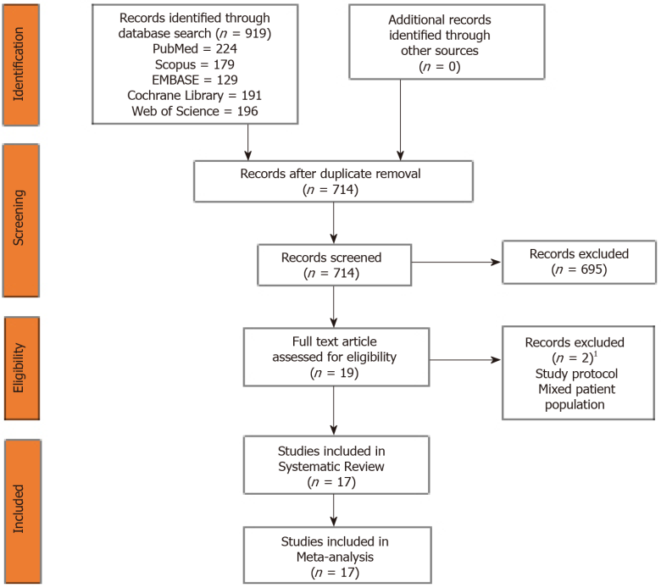
Figure 1 Preferred reporting items for systematic reviews and meta-analyses flow diagram of the included studies. ¹List of excluded studies given in Supplementary File 2.

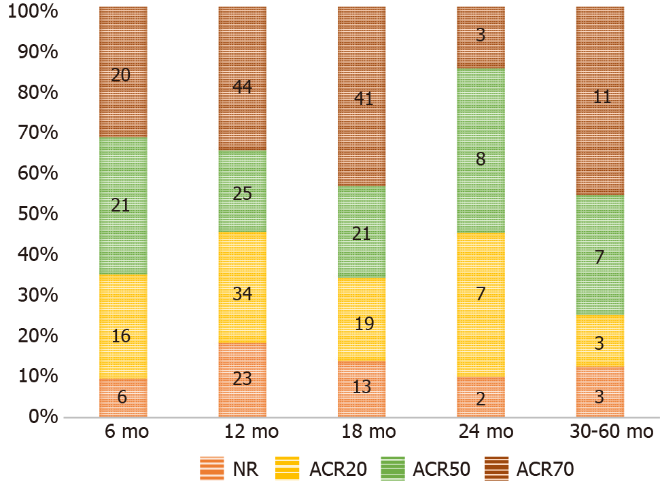
Figure 2 Transition trend of American College of Rheumatology criteria in the included studies across various time points.
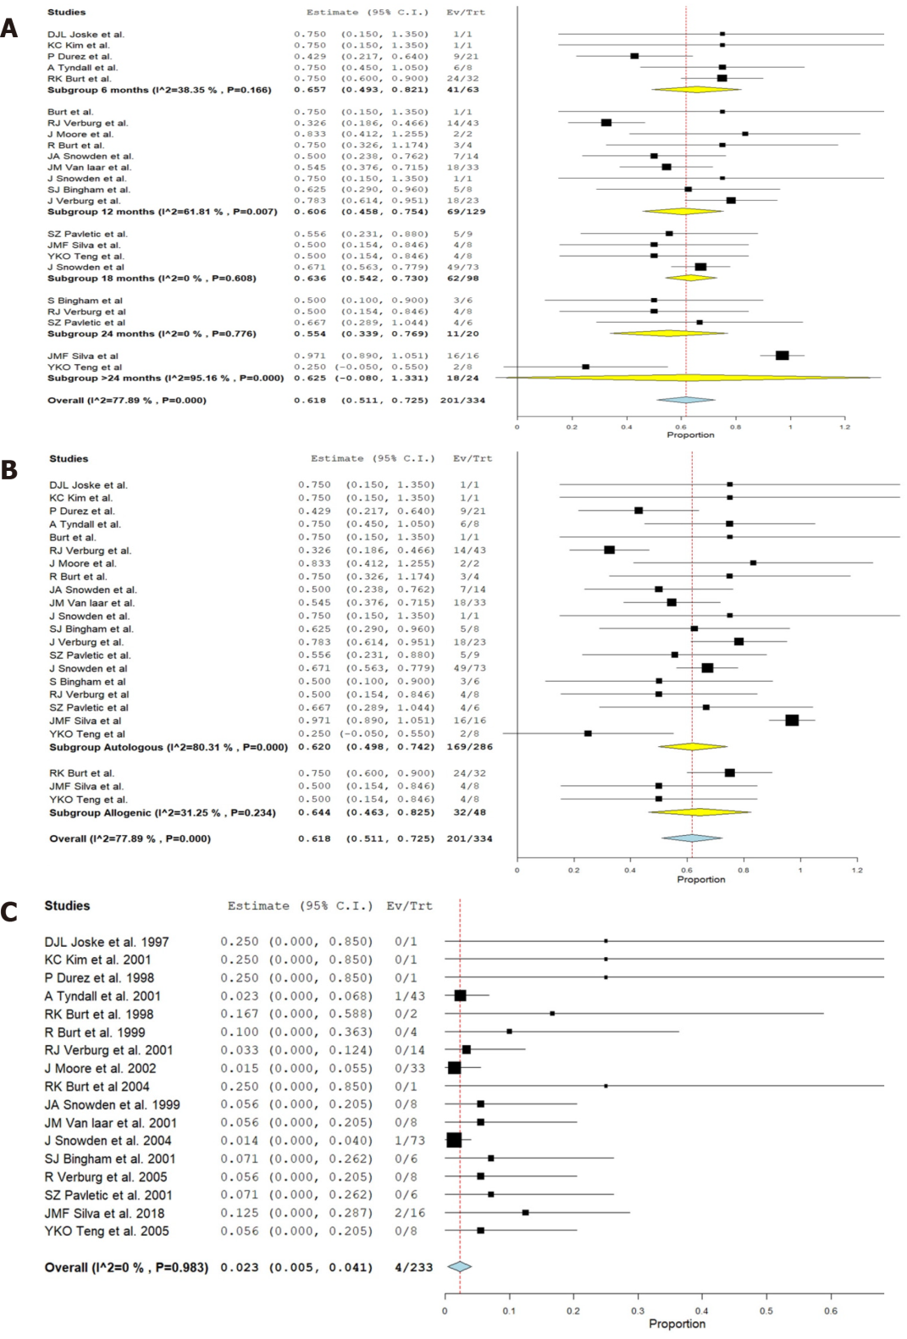
Figure 3 Forest plot. A: analysis of results of included studies at various time points following hematopoietic stem cell transplantation (HSCT) in comparison to their pre-operative status of rheumatoid arthritis using a random binary effects model; B: Sub-group analysis of the results based on the nature of HSCT (autologous and allogeneic types); C: major complications noted in the included studies.
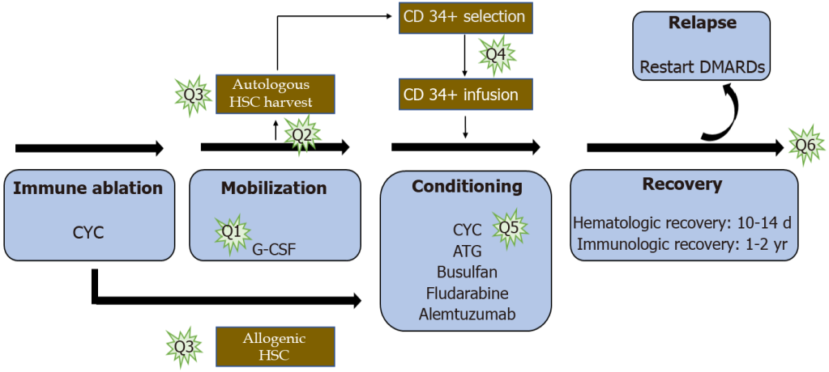
Figure 4 Potential areas of future research to optimize hematopoietic stem cell transplantation treatment for rheumatoid arthritis. Q1 is to evaluate whether stem cell rescue is necessary after high dose immune ablation; Q2 is to assess the ideal source of hematopoietic stem cells (HSCs); Q3 deals with either autologous or allogeneic source; Q4 deals with the need for T cell depletion from the harvested material; Q5 probes into the ideal conditioning regimen; and Q6 evaluates the ideal timing of HSC transplantation in the course of the disease. HSC: hematopoietic stem cell.

Table 1 Methodological quality and risk of bias assessment of the included studies (n = 17)
Randomized controlled trial
 |  |  | Ref. | Randomization process | Deviation from the intended interventions | Missing outcome data | Measurement of the outcome | Selection of the reported result | Overall Bias
 |  |  | Moore et al^{[13]} | Low risk | Low risk | Low risk | Low risk | Low risk | Low risk
Prospective studies
 | Ref. |  |  | A clearly stated aim | Inclusion of consecutive patients | Prospective collection of data | Endpoints appropriate to the aim of the study | Unbiased assessment of the study endpoint | Follow-up period appropriate to the aim of the study | Loss to follow up less than 5% | Prospective calculation of the study size
 | Tyndall et al^{[29]} |  |  | 1 | 1 | 2 | 2 | 2 | 1 | 2 | 1
 | Burt et al^{[26]} |  |  | 2 | 2 | 2 | 1 | 2 | 1 | 2 | 1
 | Burt et al^{[25]} |  |  | 2 | 2 | 2 | 1 | 2 | 1 | 2 | 1
 | Verburg et al^{[30]} |  |  | 2 | 2 | 2 | 2 | 2 | 2 | 2 | 1
 | Snowden et al^{[27]} |  |  | 2 | 2 | 2 | 1 | 2 | 1 | 2 | 1
 | van Laar et al^{[28]} |  |  | 2 | 2 | 2 | 2 | 2 | 2 | 2 | 1
 | Snowden et al^{[15]} |  |  | 1 | 1 | 2 | 1 | 2 | 1 | 2 | 1
 | Bingham et al^{[11]} |  |  | 2 | 2 | 2 | 2 | 2 | 2 | 2 | 1
 | Teng et al^{[9]} |  |  | 2 | 2 | 2 | 2 | 2 | 2 | 2 | 1
 | Pavletic et al^{[31]} |  |  | 2 | 2 | 2 | 2 | 2 | 2 | 2 | 1
 | Verburg et al^{[32]} |  |  | 2 | 2 | 2 | 2 | 2 | 2 | 2 | 1
Case reports
 |  | Ref. |  | Selection score | Ascertainment score | Causality score | Reporting score | Total score
 |  | Silva et al^{[12]} |  | 1 | 2 | 1 | 1 | 5
 |  | Joske et al^{[33]} |  | 1 | 1 | 1 | 1 | 4
 |  | Kim et al^{[35]} |  | 1 | 2 | 1 | 1 | 5
 |  | Durez et al^{[34]} |  | 1 | 1 | 1 | 1 | 4
 |  | Burt et al^{[36]} |  | 1 | 2 | 1 | 1 | 5

Table 2 General characteristics of the included studies (n = 17)
Sl. No | Ref. | Year | Study design | Indication | Sample size | Age (yr) | Source (Autologous/allogenic) | Mean follow-up (mo)
1 | Joske et al^{[33]} | 1997 | Case report | Failed DMARDs | 1 | 46 | Autologous | 6
2 | Durez et al^{[34]} | 1998 | Case report | Failed DMARDs | 1 | 22 | Autologous | 10
3 | Burt et al^{[26]} | 1998 | Prospective Study | Failed DMARDs | 2 | 44 | Autologous | 12
4 | Snowden et al^{[27]} | 1999 | Prospective Study | Failed DMARDs | 8 | 18-65 | Autologous | 18
5 | Burt et al^{[25]} | 1999 | Prospective Study | Failed DMARDs | 4 | 46.2 | Autologous | 12
6 | Kim et al^{[35]} | 2002 | Case report | Failed DMARDs | 1 | 54 | Autologous | 6
7 | Tyndall et al^{[29]} | 2001 | Prospective Study | Primary treatment | 43 | NR | Autologous | 11
8 | van Laar et al^{[28]} | 2001 | Prospective Study | Failed DMARDs | 8 | 18-60 | Autologous | 18
9 | Verburg et al^{[30]} | 2001 | Prospective Study | Failed DMARDs | 14 | 43 | Autologous | 12
10 | Bingham et al^{[11]} | 2001 | Prospective Study | Failed DMARDs | 6 | 37.33 | Autologous | 20
11 | Pavletic et al^{[31]} | 2001 | Prospective Study | Failed DMARDs | 6 | 42.5 | Autologous | 26.5
12 | Moore et al^{[13]} | 2001 | RCT | Failed DMARDs | 33 | 18-65 | Autologous | 12
13 | Burt et al^{[36]} | 2004 | Case report | Failed DMARDs | 1 | 52 | Allogenic | 12
14 | Snowden et al^{[15]} | 2004 | Prospective Study | Failed DMARDs | 73 | 42 | Autologous | 18
15 | Verburg et al^{[32]} | 2005 | Prospective Study | Failed DMARDs | 8 | 35-55 years | Autologous | 24
16 | Teng et al^{[9]} | 2005 | Prospective Study | Failed DMARDs | 8 | 43 | Allogenic | 60
17 | Silva et al^{[12]} | 2018 | Retrospective study | Failed DMARDs (10), Failed autologous HSCT (1), Secondary Haemophagocytic Lymphohistiocytosis (5) | 16 | 12 | Allogenic | 29
DMARDs: Disease modifying anti-rheumatic drugs; HSCT: Haematopoietic stem cell transplant; NR: Not reported; RCT: Randomised controlled trial.

Table 3 Hematopoietic stem cell transplant protocol in the included studies (n = 17)
Sl. No | Ref. | Mobilization regimen | Graft manipulation | HSC selection | Conditioning regimen
1 | Joske et al^{[33]} | CYC 4 g/m², G-CSF 10 µg/kg | Leukapheresis | CD 34 +ve selection | CYC 200mg/kg
2 | Durez et al^{[34]} | CYC 1.5 g/m², Etoposide 300 mg/m², G-CSF 5 µg/kg | Leukapheresis | CD 34 +ve selection | CYC 60 mg daily and Busulfan 4 mg daily
3 | Burt et al^{[26]} | CYC, G-CSF | Leukapheresis | CD 34 +ve selection | CYC 200 mg/kg, ATG 90 mg/kg
4 | Snowden et al^{[27]} | CYC 100-200 mg/kg, G-CSF 5 µg/kg | Leukapheresis | CD34 +ve selection | CYC 100 mg/kg or 200 mg/kg
5 | Burt et al^{[25]} | CYC 2 g/m², G-CSF | Leukapheresis | CD34 +ve selection | CYC 200 mg/kg, ATG 90 mg/kg
6 | Kim et al^{[35]} | CYC 4 g/m², G-CSF 5 µg/kg | Leukapheresis | CD 34 +ve selection | CYC 200 mg/kg, ATG 90 mg/kg
7 | Tyndall et al^{[29]} | CYC, G-CSF | Leukapheresis | NR | CYC 200 mg/kg, ± ATG 90 mg/kg, ± Busulfan
8 | van Laar et al^{[28]} | CYC 4 g/m², G-CSF 10 µg/kg | Leukapheresis | CD34 +ve selection | CYC 200 mg/kg
9 | Verburg et al^{[30]} | CYC 4 g/m², G-CSF 10 µg/kg | Leukapheresis | CD 34 +ve selection | CYC 200 mg/kg
10 | Bingham et al^{[11]} | CYC 2 g/m², G-CSF | Leukapheresis | CD 34 +ve selection | CYC 200 mg/kg
11 | Pavletic et al^{[31]} | CYC 2 g/m², G-CSF | Leukapheresis | CD34 +ve selection | CYC 200 mg/kg, ATG 90 mg/kg
12 | Moore et al^{[13]} | CYC 200 mg/kg, G-CSF 10 µg/kg | Leukapheresis | CD34 +ve selection (18) /  No selection (15) | CYC 200 mg/kg
13 | Burt et al^{[36]} | NA | NA | CD 34 +ve selection | CYC 150 mg/kg, Fludarabine 125 mg/m², Alemtuzumab 20 mg
14 | Snowden et al^{[15]} | CYC 200 mg/kg,  G-CSF 5- 10 µg/kg | Leukapheresis | CD 34 +ve selection (45) /  No selection (28) | CYC 200 mg/kg
15 | Verburg et al^{[32]} | CYC 200 mg/kg,  G-CSF | Leukapheresis | CD 34 +ve selection | CYC 200 mg/kg
16 | Teng et al^{[9]} | NA | NA | CD 34 +ve selection | CYC 200 mg/kg
17 | Silva et al^{[12]} | NA | NA | CD 34 +ve selection | Fludarabine 30 mg/m²/d, Melphalan 140 mg/m²/d, Alemtuzumab 0.2 mg/kg/d or Fludarabine 30 mg/m²/d, Treosulfan 14 mg/m²/d, Alemtuzumab 0.2 mg/kg/d
ATG: Anti-thymocyte globulin; CD: Cluster differentiation: CYC: Cyclophosphamide; G-CSF: Granulocyte colony stimulating factor; HSC: Hematopoietic stem cell; NA: Not applicable; NR: Not reported.

Published by Baishideng Publishing Group Inc
7041 Koll Center Parkway, Suite 160, Pleasanton, CA 94566, USA
Telephone: +1-925-3991568
E-mail: bpgoffice@wjgnet.com
Help Desk: https://www.f6publishing.com/helpdesk
https://www.wjgnet.com

© 2021 Baishideng Publishing Group Inc. All rights reserved.

