Name of Journal: World Journal of Gastrointestinal Oncology
Manuscript NO: 89509
Manuscript Type: CASE REPORT

Comprehensive evaluation of rare case: From diagnosis to treatment of a sigmoid Schwannoma: A case report

Li JY et al. Sigmoid nerve sheath tumor

Jing-Yi Li, Xi-Zhuang Gao, Jian Zhang, Xiang-Zheng Meng, Yi-Xian Cao, Kun Zhao

Jing-Yi Li, Xi-Zhuang Gao, Xiang-Zheng Meng, Kun Zhao, Clinical Medical College of Jining Medical University, Jining Medical University, Jining 272000, Shandong Province, China

Jian Zhang, Yi-Xian Cao, Department of Gastroenterology, The First People's Hospital of Jining, Jining 272000, Shandong Province, China

Author contributions: Li JY wrote the manuscript and designed the study; Gao XZ and Zhang J supervised the study; Zhao K, Meng XZ, and Cao YX participated in the investigation and revision; All the authors read and approved the final manuscript.

Corresponding author: Jian Zhang, MD, Chief Doctor, Department of Gastroenterology, The First People's Hospital of Jining, No. 269 Mengzi Avenue, Jining Hi-Tech Zone, Jining 272000, Shandong Province, China. rmyyzj88@126.com

Received: November 4, 2023
Revised: December 6, 2023
Accepted: December 18, 2023
Published online: January 15, 2024

Abstract
BACKGROUND
Schwannomas are uncommon tumors originating from Schwann cells, forming the neural sheath. They account for approximately 2%-6% of all mesenchymal tumors and are most commonly identified in peripheral nerve trunks, with rarity in the gastrointestinal tract. Among gastrointestinal locations, the stomach harbors the majority of nerve sheath tumors, while such occurrences in the sigmoid colon are exceptionally infrequent.

CASE SUMMARY
This study presented a clinical case involving a 60-year-old female patient who, during colonoscopy, was diagnosed with a submucosal lesion that was later identified as a nerve sheath tumor. The patient underwent surgical resection, and the diagnosis was confirmed through immunohistochemistry. This study highlighted an exceptionally uncommon occurrence of a nerve sheath tumor in the sigmoid colon, which was effectively managed within our department. Additionally, a comprehensive review of relevant studies was conducted.

CONCLUSION
The preoperative diagnosis of nerve sheath tumors poses challenges, as the definitive diagnosis still relies on pathology and immunohistochemistry. Although categorized as benign, these tumors have the potential to demonstrate malignant behavior. Consequently, the optimal treatment approach entails the complete surgical excision of the tumor, ensuring the absence of residual lesions at the margins.

Key Words: Schwannoma; Gastrointestinal stromal tumors; Treatment; Sigmoid colon; Case report

©The Author(s) 2024. Published by Baishideng Publishing Group Inc. All rights reserved.

Citation: Li JY, Gao XZ, Zhang J, Meng XZ, Cao YX, Zhao K. Comprehensive evaluation of rare case: From diagnosis to treatment of a sigmoid Schwannoma: A case report. World J Gastrointest Oncol 2024; 16(1): 244-250
URL: https://www.wjgnet.com/1948-5204/full/v16/i1/244.htm
DOI: https://dx.doi.org/10.4251/wjgo.v16.i1.244

Core Tip: This study describes an uncommon nerve sheath tumor occurrence in the sigmoid colon, which was initially identified as a submucosal lesion and subsequently verified through histopathological and immunohistochemical analyses. The findings suggest that immunohistochemistry is the preferred diagnostic approach for this condition, and endoscopic surgery stands out as the optimal treatment modality.

INTRODUCTION
Schwannomas are uncommon tumors originating from Schwann cells that form the neural sheath. Accounting for approximately 2%-6% of all mesenchymal tumors^{[1]}, they predominantly occur in peripheral nerve trunks and are infrequently found in the gastrointestinal tract. The stomach hosts the majority of nerve sheath tumors within the gastrointestinal tract, whereas such tumors in the sigmoid colon are exceptionally rare^{[2]}. The majority of colonic nerve sheath tumors are typically discovered as submucosal tumors during routine colonoscopy, and their accurate diagnosis prior to surgery poses challenges, necessitating postoperative immunohistochemistry of the specimen for definitive diagnosis^{[3]}. The present study aimed to report a clinical case involving a 60-year-old female patient who was diagnosed with sigmoid nerve sheath tumor during colonoscopy. The patient subsequently underwent surgical resection, and histological diagnosis was made.

CASE PRESENTATION
Chief complaints
A 60-year-old female patient was admitted to our hospital for further diagnostic assessment and treatment regarding a submucosal bulge in the colon. This anomaly was identified during a colonoscopy performed at a nearby clinic two months earlier.

History of present illness
The patient did not report any abdominal pain, diarrhea, or bloating, and there were no changes in bowel habits. Furthermore, there were no signs of gastrointestinal symptoms, such as hematemesis or melena.

History of past illness
The patient had a documented medical history of hypertension, characterized by blood pressure readings as high as 18.67/13.33 kPa. However, this condition was effectively managed by administering plain oral medications, namely valsartan and amlodipine, normalizing blood pressure level. Additionally, it is noteworthy that the patient had undergone radical mastectomy to treat breast cancer approximately 12 years before her admission to our hospital.

Personal and family history
The patient did not disclose any family genetic or aggregation diseases. There was no evident cancer history among her other relatives.

Physical examination
The physical examination of the patient showed no abnormality.

Laboratory examinations
The post-hospitalization laboratory results were summarized as follows: White blood cell count of 4.99 × 10⁹/L, red blood cell count of 4.31 × 10¹²/L, platelet count of 215 × 10⁹/L, alpha-fetoprotein level of 7.11 ng/mL, cancer antigen 199 level less than 2.00 U/mL, and carcinoembryonic antigen level of 1.50 ng/mL.

Imaging examinations
Abdominal computed tomography (CT) displayed no abnormality. The colonoscopy of the patient revealed the presence of a submucosal bulge located 15 cm proximal to the anus, as depicted in Figure 1. The ultrasound endoscopy showed the presence of a hypoechoic mass in the lamina propria, exhibiting heterogeneous echogenicity and measuring approximately 1.0 cm in size (Figure 2).
Following the thorough exfoliation of the tumor, samples were procured and subsequently dispatched for pathological examination. Hematoxylin and eosin staining was conducted, revealing the presence of spindle cells exhibiting minimal nuclear heterogeneity (Figure 3).
To enhance the precision of the tumor diagnosis, immunohistochemical staining was conducted. The tumor cells exhibited negative results for CD117, CD34, Desmin, SMA, and Dog-1 (Figure 4), in which Ki-67 (+, 2%), SOX-10, S-100, and SDHB were all strongly positive (Figure 5). The immunohistochemical results aligned with the diagnosis of a nerve sheath tumor. The presence of a Ki-67 index, measuring 2%, additionally substantiates the classification of the tumor as benign.

FINAL DIAGNOSIS
According to the above-mentioned results, the patient was diagnosed with a nerve sheath tumor of the sigmoid colon.

TREATMENT
The patient underwent endoscopic submucosal dissection (ESD) to augment the sigmoid colon submucosally. A saline solution containing 1:10,000 epinephrine was injected post-mucosally. The positive lifting sign was noted, and a trapdoor was created to resect the surface mucosal layer. This procedure facilitated the exposure of the tumor, involving the removal of a segment of the muscular layer (Figure 6). The excision of the lesion was carried out utilizing a DUAL knife, employing repeated stripping with loopers and subsequent blunt separation. The trauma exhibited small perforations, which were adequately managed through hemostasis using hemostatic clips. A total of 11 hemostatic clips were applied to close the trauma.

OUTCOME AND FOLLOW-UP
The patient’s postoperative vital signs were stable, and the patient remained in satisfactory condition two months after the surgery.

DISCUSSION
Schwannomas are benign mesenchymal tumors derived from Schwann cells that form the neural sheath^{[4]}. When situated within the gastrointestinal tract, gastrointestinal stromal tumors encompass smooth muscle tumors, smooth muscle histiocytomas, smooth muscle sarcomas, and gastrointestinal nerve sheath tumors. Gastrointestinal nerve sheath tumors are most frequently identified in the stomach and small intestine, with occurrences in the colon and rectum being exceptionally rare. While nerve sheath tumors can manifest at any life stage, their prevalence is notably higher in cases aged 60 years and older, with similar occurrence rates observed in both genders^{[5]}.
The majority of patients typically do not exhibit symptoms, while a minority may manifest symptoms, such as intestinal obstruction, abdominal pain, constipation, or melena^{[6]}. Most patients are clinically detected by colonoscopy. The preoperative diagnosis of colorectal nerve sheath tumors has consistently posed challenges and necessitates differentiation from other mesenchymal tumors within the digestive system, particularly colorectal mesenchymal tumors. In clinical evaluations, magnetic resonance imaging and CT scan are frequently utilized to aid in diagnostic procedures. Nerve sheath tumors mainly present as clearly delineated homogeneous wall masses on abdominal CT scan and appear as well-defined transmural hypoechoic masses during ultrasound endoscopy^{[1]}. However, their current utility in clinical practice is constrained due to the shortage of specificity^{[7]}. A colorectal nerve sheath tumor can manifest as a submucosal mass or yellowish polypoid alterations during colonoscopy and as a hypoechoic mass originating from the lamina propria during ultrasonography. This poses a challenge in distinguishing it from other mesenchymal tumors^{[2,5–7]}. In Inagawa et al’s study, only 15% of the colon schwannomas were diagnosed on preoperative endoscopic biopsy^{[8]}. In Bohlok et al’s research, a preoperative diagnosis was made in 24% of cases with colorectal schwannomas^{[1]}.
Consequently, the definitive diagnosis still relies on pathology and immunohistochemistry. Nerve sheath tumors typically show positive staining for S-100 and SOX-10, with occasional instances of Vimentin staining. Conversely, immunohistochemical analysis typically yields negative results for DOG1, SMA, Desmin, CD117, p53, CD34, and c-kit^{[9–13]}.
On a macroscopic level, nerve sheath tumors typically exhibit lobulated and well-defined tumor characteristics, mainly displaying a cystic pattern^{[14,15]}. Nerve sheath tumors frequently display microscopic features characterized by spindle-shaped cells with light nuclear staining and a low mitotic rate. Apart from morphology and immunohistochemical staining, pathologists contribute to the diagnosis by classifying nerve sheath tumors into Antoni A and Antoni B, representing the two histological growth patterns. The primary histological characteristic of Antoni A is the notable existence of Verocay bodies, wherein spindle cells are tightly arranged within fenestrated structures. Conversely, the principal histological attribute of Antoni B entails elongated or circular nucleated spindle cells that are sparsely distributed amidst yellow verrucous histiocytes and myxoid stroma^{[5,14]}. The tumor observed in this case study is likely to be classified as Antoni type A, as evidenced by the histological presence of densely arranged spindle cells.
Despite being classified as benign, nerve sheath tumors have the potential to exhibit malignancy, with the Ki-67 index and the mitotic index serving as the primary diagnostic criteria for identifying such cases. A Ki-67 index exceeding 5% potentially indicates the presence of malignancy, while surpassing 10% tends to be indicative of malignancy. Additionally, the observation of more than 5 nuclear schizophrenic phases per high power field of view also suggests the likelihood of malignancy. A previous study revealed that out of 93 colorectal nerve sheath tumors, only 3 tumors were malignant^{[2]}. Therefore, the most appropriate treatment option is complete surgical removal of the tumor with no lesions at the margins^{[14,16]}. Refraining from radical resection is recommended once the clinical diagnosis is confirmed^{[5,17]}. Radiotherapy and adjuvant chemotherapy are not recommended due to the benign nature of the tumor. The selection of a surgical procedure is contingent upon factors, such as the tumor’s size, location, and pathological characteristics. In the context of treating colorectal nerve sheath tumors, endoscopic resection has emerged as a routine treatment modality alongside traditional surgical techniques, owing to advancements in endoscopic techniques. In the present case, the patient underwent ESD in the sigmoid colon, resulting in successful resection of the tumor. The patient exhibited favorable postoperative recovery and remained recurrence-free throughout the follow-up period.

CONCLUSION
In conclusion, a sigmoid colon nerve sheath tumor is exceedingly infrequent. Owing to its uncommon nature, there remains a lack of consensus regarding the appropriate diagnostic and therapeutic approaches, rendering it particularly prone to misdiagnosis during clinical evaluation. Immunohistochemistry is widely regarded as the definitive method for diagnosing colorectal nerve sheath tumors within the academic community. By conducting a thorough examination of clinical features, laboratory tests, imaging and pathological manifestations, as well as the treatment and prognosis of the case, the objective of this research was to provide a valuable framework for the diagnosis and management of this specific disease.

ACKNOWLEDGEMENTS
We express gratitude to Hong-Hao Zhang, Kun Zhao, Xiao-Yu Jiang, Long-Qing Yu, and Guang-Yi Qu for their valuable comments on drafts of this study. Additionally, we would like to extend our appreciation to Jian Zhang and Xi-Zhuang Gao for their significant contributions to the completion of this study through their encouragement, support, and research assistance.

REFERENCES
1 Bohlok A, El Khoury M, Bormans A, Galdon MG, Vouche M, El Nakadi I, Donckier V, Liberale G. Schwannoma of the colon and rectum: a systematic literature review. World J Surg Oncol 2018; 16: 125 [PMID: 29970075 DOI: 10.1186/s12957-018-1427-1]
2 Kim G, Kim SI, Lee KY. Case Report: Schwannoma of the sigmoid colon: a case report of a rare colonic neoplasm and review of literature. F1000Res 2019; 8: 652 [PMID: 31608147 DOI: 10.12688/f1000research.19110.1]
3 Pansari M, Lodin D, Gupta AK, Genuit T, Moseson J. Rare Case of a Transverse Colon Schwannoma. Cureus 2020; 12: e7604 [PMID: 32399338 DOI: 10.7759/cureus.7604]
4 Trivedi A, Ligato S. Microcystic/reticular schwannoma of the proximal sigmoid colon: case report with review of literature. Arch Pathol Lab Med 2013; 137: 284-288 [PMID: 23368873 DOI: 10.5858/arpa.2011-0386-CR]
5 Fotiadis CI, Kouerinis IA, Papandreou I, Zografos GC, Agapitos G. Sigmoid schwannoma: a rare case. World J Gastroenterol 2005; 11: 5079-5081 [PMID: 16124072 DOI: 10.3748/wjg.v11.i32.5079]
6 Kanneganti K, Patel H, Niazi M, Kumbum K, Balar B. Cecal schwannoma: a rare cause of gastrointestinal bleeding in a young woman with review of literature. Gastroenterol Res Pract 2011; 2011: 142781 [PMID: 21760773 DOI: 10.1155/2011/142781]
7 Qi Z, Yang N, Pi M, Yu W. Current status of the diagnosis and treatment of gastrointestinal schwannoma. Oncol Lett 2021; 21: 384 [PMID: 33777207 DOI: 10.3892/ol.2021.12645]
8 Inagawa S, Hori M, Shimazaki J, Matsumoto S, Ishii H, Itabashi M, Adachi S, Kawamoto T, Fukao K. Solitary schwannoma of the colon: report of two cases. Surg Today 2001; 31: 833-838 [PMID: 11686568 DOI: 10.1007/s005950170060]
9 Brandimarte G, Festa V, Balsamo G, Dezi A, Marzano C, Tursi A. Incidental Schwannoma of the Sigmoid. J Gastrointestin Liver Dis 2020; 29: 303 [PMID: 32830819 DOI: 10.15403/jgld-2671]
10 Miettinen M, Virolainen M, Maarit-Sarlomo-Rikala. Gastrointestinal stromal tumors--value of CD34 antigen in their identification and separation from true leiomyomas and schwannomas. Am J Surg Pathol 1995; 19: 207-216 [PMID: 7530409 DOI: 10.1097/00000478-199502000-00009]
11 Zhang K, Qu S, Li J, Cheng Y, Shi J, Liu T. A case report of rectal schwannoma treated with laparoscopic proctectomy. Medicine (Baltimore) 2018; 97: e9866 [PMID: 29443751 DOI: 10.1097/MD.0000000000009866]
12 González Ruiz Y, Reyes Delgado A, Gutiérrez Alonso C, Franco Rubio JI, González Herrero M. [Sigmoid intussusception as a clinical presentation of colonic schwannoma: Pediatric case]. Arch Argent Pediatr 2019; 117: e68-e71 [PMID: 30652460 DOI: 10.5546/aap.2019.e68]
13 Adlekha S, Chadha T. Cellular schwannoma arising from sigmoid mesocolon presenting as torsion. Ann Med Health Sci Res 2013; 3: S33-S34 [PMID: 24349845 DOI: 10.4103/2141-9248.121217]
14 Nonose R, Lahan AY, Santos Valenciano J, Martinez CA. Schwannoma of the Colon. Case Rep Gastroenterol 2009; 3: 293-299 [PMID: 21103244 DOI: 10.1159/000237736]
15 Çakır T, Aslaner A, Yaz M, Gündüz Ur. Schwannoma of the sigmoid colon. BMJ Case Rep 2015; 2015 [PMID: 25976197 DOI: 10.1136/bcr-2014-208934]
16 Zibert K, Richards S, Darwin P. A Patient With Rectal Schwannoma. Clin Gastroenterol Hepatol 2019; 17: A25-A26 [PMID: 29474967 DOI: 10.1016/j.cgh.2018.02.017]
17 Mokhtari M, Iranpour P, Golbahar Haghighi A, Ghahramani L. Schwannoma of the Rectosigmoid Colon. Adv Biomed Res 2022; 11: 5 [PMID: 35284347 DOI: 10.4103/abr.abr_91_21]

Footnotes
Informed consent statement: All study participants, or their legal guardian, provided informed written consent prior to study enrollment.

Conflict-of-interest statement: The authors declare that they have no conflict of interest to disclose.

CARE Checklist (2016) statement: The authors have read the CARE Checklist (2016), and the manuscript was prepared and revised according to the CARE Checklist (2016).

Open-Access: This article is an open-access article that was selected by an in-house editor and fully peer-reviewed by external reviewers. It is distributed in accordance with the Creative Commons Attribution NonCommercial (CC BY-NC 4.0) license, which permits others to distribute, remix, adapt, build upon this work non-commercially, and license their derivative works on different terms, provided the original work is properly cited and the use is non-commercial. See: https://creativecommons.org/Licenses/by-nc/4.0/

Provenance and peer review: Unsolicited article; Externally peer reviewed.

Peer-review model: Single blind

Peer-review started: November 4, 2023
First decision: November 22, 2023
Article in press: December 18, 2023

Specialty type: Oncology
Country/Territory of origin: China
Peer-review report’s scientific quality classification
Grade A (Excellent): 0
Grade B (Very good): 0
Grade C (Good): C, C
Grade D (Fair): 0
Grade E (Poor): 0

P-Reviewer: Dilek ON, Turkey; Vij M, India S-Editor: Fan JR L-Editor: A P-Editor: Zhang XD
Figure Legends
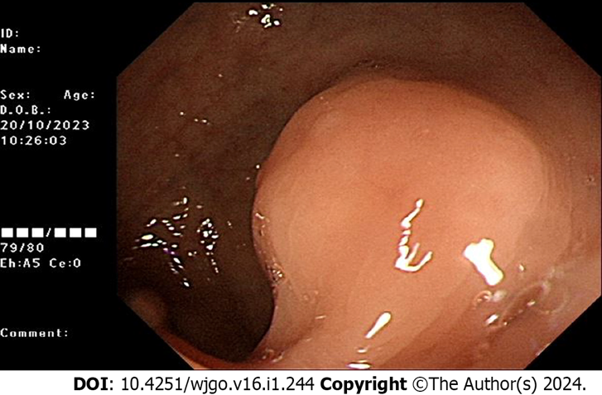
Figure 1 Colonoscopy reveals a submucosal protrusion located 15 cm from the anus.

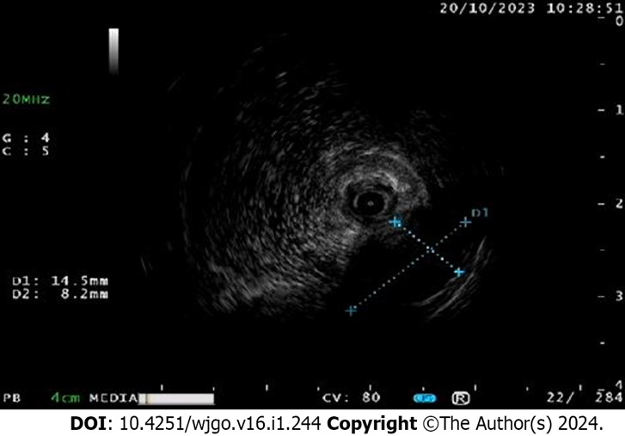
Figure 2 Ultrasound endoscopy displays a hypoechoic mass at the lesion, which is located in the lamina propria, with heterogeneous echogenicity, about 1.0 cm in size.
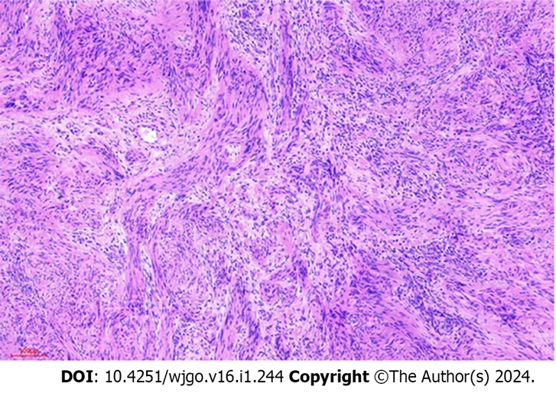
Figure 3 The Hematoxylin and eosin staining demonstrates the presence of spindle-shaped anisotropic cells exhibiting an intact peritoneum and the absence of extraperitoneal invasion.
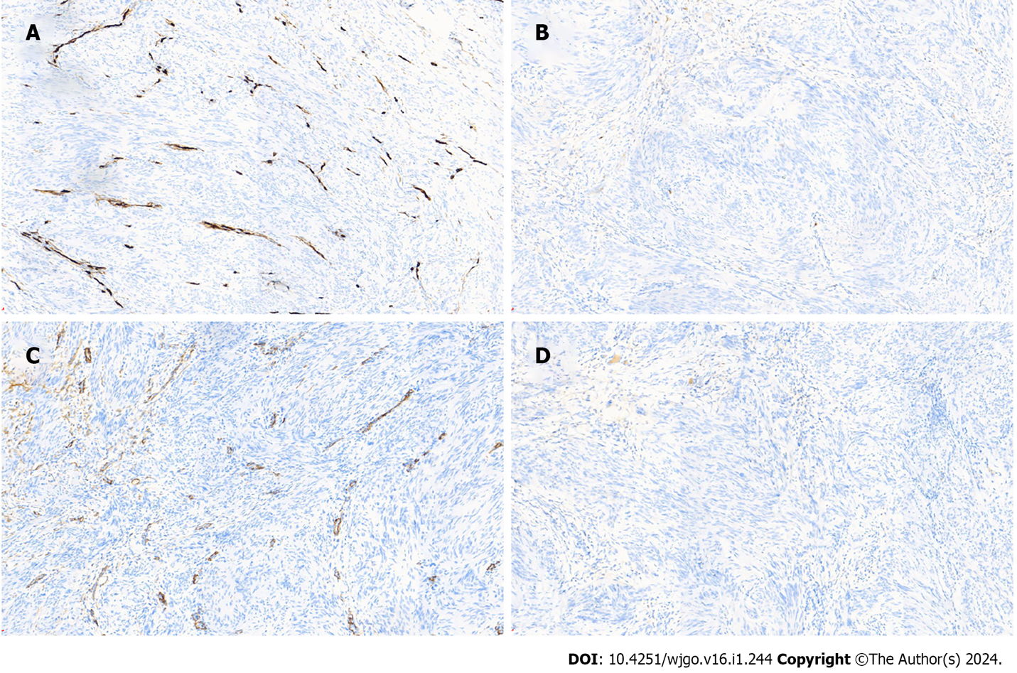
Figure 4 CD34, CD117, SMA, Dog-1 are negative in tumor cells. A: CD34 is negative in tumor cells, while normal vascular structures are stained; B: CD117 is negative in tumor cells; C: SMA is negative in tumor cells; D: Dog-1 is negative in tumor cells.
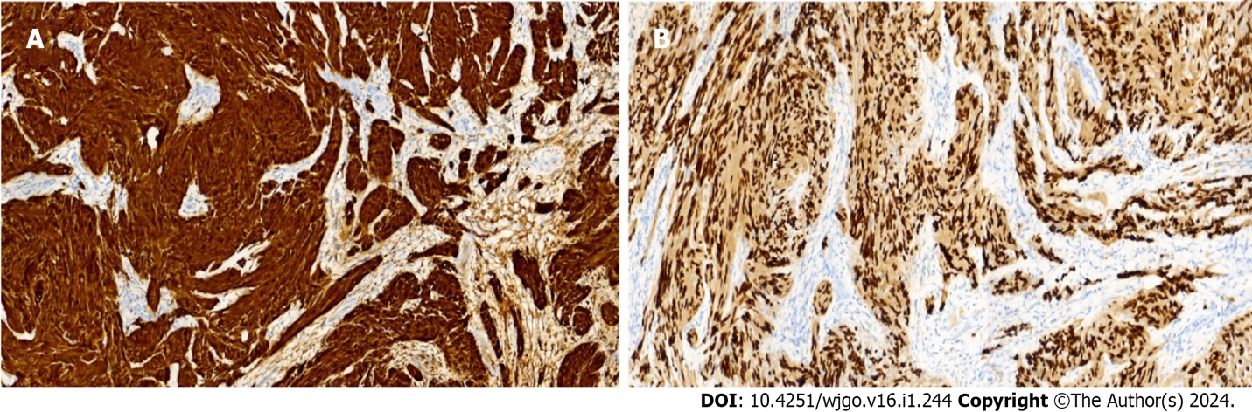
Figure 5 SOX10 and S100. A: S-100 is diffusely strongly positive in tumor cells; B: SOX-10 is strongly positive in tumor cells. SOX10 and S100 are positive. The immunohistochemical staining exhibits a consistent dark brown color.

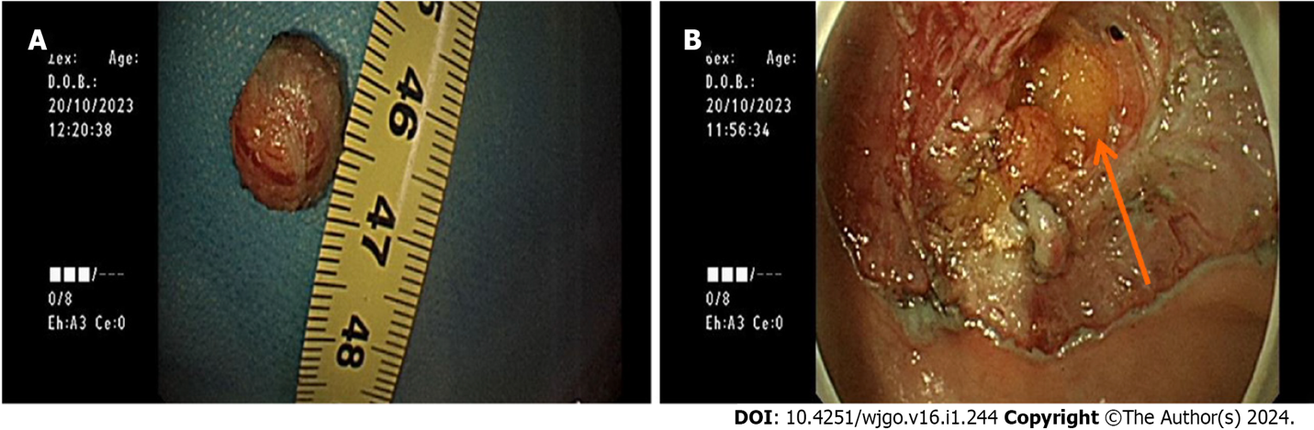
Figure 6 Tumor. A:Tumor of about 1.0 cm in size ; B: Tumor is observed as unencapsulated yellowish material.

Published by Baishideng Publishing Group Inc
7041 Koll Center Parkway, Suite 160, Pleasanton, CA 94566, USA
Telephone: +1-925-3991568
E-mail: bpgoffice@wjgnet.com
Help Desk: https://www.f6publishing.com/helpdesk
https://www.wjgnet.com

© 2024 Baishideng Publishing Group Inc. All rights reserved.

