Name of Journal: World Journal of Clinical Cases
Manuscript NO: 67330
Manuscript Type: CASE REPORT

Pancreatic cancer with synchronous liver and colon metastases: A case report

Dong YM et al. Pancreatic cancer with colon metastasis

Yuan-Mei Dong, Hong-Nian Sun, De-Cong Sun, Mu-Hong Deng, Yong-Gang Peng, Yan-Yun Zhu

Yuan-Mei Dong, De-Cong Sun, Yan-Yun Zhu, Division of Internal Medicine, Senior Department of Oncology, The Fifth Medical Center of PLA General Hospital, Beijing 100071, China

Hong-Nian Sun, Yong-Gang Peng, Department of Medicine, Berry Oncology Corporation, Beijing 102206, China

Mu-Hong Deng, Division of Internal Medicine, Senior Department of Oncology, The First Medical Center of PLA General Hospital, Beijing 100853, China

Author contributions: Zhu YY and Dong YM contributed to patient management and histological evaluation; Sun DC and Deng MH contributed to technical and material support; Dong YM wrote the manuscript; Sun HN and Peng YG reviewed and corrected the manuscript; all authors contributed to revision for important intellectual content and approved the final version of the manuscript.

Corresponding author: Yan-Yun Zhu, MD, Deputy Director, Division of Internal Medicine, Senior Department of Oncology, the Fifth Medical Center of PLA General Hospital, No. 100 Middle West Fourth Ring Road, Fengtai District, Beijing 100071, China. zhuyanyunmm@163.com

Received: April 21, 2021
Revised: June 23, 2021
Accepted: August 17, 2021
Published online:

Abstract
BACKGROUND
Metastasis of pancreatic cancer to the colon is rare and the features need to be further elucidated. Herein, we report a rare case of pancreatic cancer with simultaneous liver and colon metastases.

CASE SUMMARY
A 48-year-old man with intrahepatic space-occupying lesions based on a computed tomography scan was admitted to our hospital for further treatment. Abdominal magnetic resonance imaging revealed a 6.4 cm × 4.2 cm mass in the tail of the pancreas and multiple low-density masses in the liver parenchyma. In addition, a mass of 2.2 cm × 1.6 cm with surface congestive erosions in the sigmoid colon was detected by colonoscopy. Histopathological examination of biopsies from both the liver and colon lesions revealed a moderately to poorly differentiated adenocarcinoma. Immunohistochemical staining of the colon tumor was positive for cytokeratin (CK) 7 and CK, but negative for colorectal adenocarcinoma-related markers CK 20, CDX2, and SATB2, thus indicating that the metastasis originated from the pancreas. Next-generation sequencing for genomic profiling of the liver and colon metastases both found mutations in KRAS (p.G12D) and TP53 (c.376-1delG), with microsatellite stable and low tumor mutational burden without actionable or cancer-predisposing gene mutations detected. The patient was subsequently treated with 12 cycles of FOLFIRINOX which led to a sustainable response, followed by ongoing maintenance treatment with irinotecan plus fluorouracil.

CONCLUSION
For this rare case, careful evaluation of histopathological and immunohistochemical staining results are required. The genomic profiling of colon lesions was revealed for the first time, and FOLFIRINOX showed good treatment efficacy in this patient.

Key Words: Pancreatic cancer; Colonic metastasis; Immunohistochemical staining; Genomic profiling; Next-generation sequencing; Case report

Dong YM, Sun HN, Sun DC, Deng MH, Peng YG, Zhu YY. Pancreatic cancer with synchronous liver and colon metastases: a case report. World J Clin Cases 2021; In press

Core Tip: Metastasis of pancreatic cancer to the colon is rare. Herein, we present a rare case of pancreatic cancer with simultaneous liver and colon metastases. Histopathological examination and immunohistochemical staining of the colon tumor confirmed that the metastasis originated from the pancreas. Next-generation sequencing for genomic profiling of the liver and colon metastases from the primary pancreatic carcinoma were revealed for the first time, with no cancer-predisposing or actionable gene mutations detected. The patient was treated with 12 cycles of FOLFIRINOX, which yielded a sustainable response.

INTRODUCTION
Pancreatic cancer is reported to be the fourth most common cause of cancer-related death in the United States, with a low 5-year survival rate of 9%^{[1]}. Given the lack of early signs or symptoms of pancreatic cancer, the majority of patients are diagnosed at advanced stages (53%) with metastases to the liver, lungs, or peritoneum, and their 5-year survival is only 3%^{[2]}. However, colon metastasis from pancreatic cancer is extremely rare, with several cases reported in literature and the majority being metachronous^{[3,4]}. Herein, we report a case with synchronous liver and colon metastases of pancreatic cancer and review the literature regarding colon metastases of pancreatic cancer.

CASE PRESENTATION
Chief complaints
A 48-year-old man with intrahepatic space occupying lesions, as shown by abdominal computed tomography, was admitted to our hospital for further treatment in June 2020.

History of present illness
The patient visited a local hospital due to high blood sugar level and loss of appetite in October 2019. The local doctor administered metformin symptomatic treatment, but after three months of treatment, the patient lost four kilograms of weight and had poor blood sugar regulation. Subsequently, acarbose was administered and the blood sugar level was normalized. However, in April 2020, the patient developed anorexia and heartburn and continued to lose weight and this was followed by back pain and abdominal distension.

History of past illness
The patient had no previous medical history.

Personal and family history
The patient had a history of drinking, but had no family history of malignant tumors.

Physical examination
Upon arrival, physical examination of the patient revealed a body temperature of 36.3ºC, blood pressure of 129/77 mmHg, heart rate of 78 beats/min, and respiratory rate of 20 breaths/min. No jaundice or palpable masses were observed. The patient’s Karnofsky performance status (KPS) score was 90.

Laboratory examinations
Complete blood count of the patient showed a slight reduction in hemoglobin (116 g/L; normal range: 137-179 g/L) and red blood cells (3.72 × 10¹²/L; normal range: 4.3-5.9 × 10¹²/L). Blood chemistry tests showed an increase in total bilirubin (32.3 μmol/L; normal range: 0-21.0 μmol/L), direct bilirubin (19.9 μmol/L; normal range: 0-8.6 μmol/L), γ-glutamyltransferase (785.1 U/L; normal range: 0-50 U/L), alkaline phosphatase (380.7 U/L; normal range: 45-125 U/L) and lactate dehydrogenase (481.2 U/L; normal range: 40-250 U/L), but demonstrated normal values for alanine aminotransferase (20.6 U/L; normal range: 0-40 U/L), and aspartate aminotransferase (23.5 U/L; normal range: 0-40 U/L). The level of serum tumor marker was significantly elevated for carcinoembryonic antigen (CEA) (198 ng/mL; normal range: 0-5.0 ng/mL), CA125 (204.2 U/mL; normal range: 0.1-35 U/mL), CA15-3 (285.5 U/mL; normal range: 0.1-30 U/mL), CA72-4 (65.69 U/mL; normal range: 0.1-10 U/mL), CYFRA21-1 (18.35 ng/mL; normal range: 0.1-4.0 ng/mL), NSE (50.39 ng/mL; normal range: 0-24 ng/mL), and SCC (4.0 ng/mL; normal range: < 1.8 ng/mL). However, the values for CA19-9 (21.25 U/mL) and alpha fetoprotein (2.08 ng/mL) were normal (normal range: 0.1-37 U/mL and 0-20 ng/mL, respectively).

Imaging examinations
Abdominal magnetic resonance imaging (MRI) scan revealed a hypovascular lesion in the tail of the pancreas (6.4 cm × 4.2 cm in size) and multiple hypovascular nodules in the liver parenchyma (Figure 1A and B). Colonoscopy was performed due to the high CEA level and a mass 2.2 cm × 1.6 cm in size with surface congestive erosions in the sigmoid colon was found, which occupied a quarter of the intestinal cavity and was 33 cm from the anus (Figure 1C).

Further diagnostic work-up
Given the difficulty in performing endoscopic ultrasound-guided fine-needle aspiration of the pancreas mass, biopsy of the left lobe of the liver was obtained and pathologically presented as moderately to poorly differentiated degenerative adenocarcinoma within large areas of necrosis (Figure 2A). Histopathological examination of biopsies from the colon mucosal lesions revealed moderately to poorly differentiated adenocarcinoma, which was compatible with liver metastasis from the primary pancreas (Figure 2B). Immunohistochemical staining of the colon tumor was positive for cytokeratin (CK) 7 and CK, which were expressed particularly in epithelial cells, but negative for colorectal adenocarcinoma-related markers, such as CK 20, CDX2, and SATB2 (Figure 3). A targeted comprehensive genomic profiling assay was performed on the liver and colon metastases using a next-generation sequencing (NGS) panel containing 654 cancer-related genes (Berryoncology, Beijing, China), which detected KRAS p.G12D (27.04%), TP53 c.376-1delG (18.07%), EP300 p.R1462* (5.13%), and CD244 p.M299Sfs*17 (5.51%) in the liver lesion and KRAS p.G12D (6.49%), and TP53 c.376-1delG (5.91%) in the colon biopsy; In addition, microsatellite stable (MSS) and low tumor mutational burden (TMB) were seen in both liver and colon metastases.

FINAL DIAGNOSIS
The final diagnosis in this case was pancreatic cancer with synchronous liver and colon metastases.

TREATMENT
After comprehensive diagnostic evaluations, the patient was administered 12 cycles of FOLFIRINOX and subsequently maintained with ongoing irinotecan plus fluorouracil.

OUTCOME AND FOLLOW-UP
Abdominal MRI showed partial response in the pancreas and liver lesion after treatment with three cycles of FOLFIRINOX, thus the patient continued to receive this chemotherapy. Abdominal MRI scans showed that the tumor had shrunk in the tail of the pancreas (Figure 4A) and liver (Figure 4B) after receiving 12 cycles of FOLFIRINOX. Colonoscopy was performed after receiving nine cycles of FOLFIRINOX and no protuberant or new mucosal lesions were found (Figure 4C). Serum tumor markers, including CEA and CA125, all returned to normal levels. Since then, the patient has been receiving maintenance treatment with irinotecan plus fluorouracil. The patient’s KPS score was 90.

DISCUSSION
Metastasis of pancreatic cancer to the colon is extremely rare, with less than ten cases reported in the literature (Table 1), to the best of our knowledge. The median age of these cases was 70 years (range: 45-91 years; male: 4, female: 3). Lesions in the pancreas and colon were identified simultaneously in four of these cases, but only one pancreatic cancer patient presented with synchronous colon and liver metastases^{[5-8]}. However, our case is the only one reported with complete pathology, treatment, and follow-up data.
As the majority of metastases from pancreatic cancer occurs in the liver, lung, abdomen, regional lymph nodes, and peritoneum, such cases are easily misdiagnosed as primary colon cancer, which influences treatment decision-making. The presence of masses in both the colon and pancreas could be a result of metastasis from the pancreas to the colon, metastasis from the colon to the pancreas, or synchronous primary cancers. The majority of previously reported cases were identified by histological examination and immunohistochemical staining of colon biopsies, most of which were based on CK 7 and CK 20 expression (Table 1). Cytokeratins are proteins of keratin-containing intermediate filaments, which are found in epithelial tissues. The expression of CK 7 is observed in the majority of cases of carcinoma, except in those carcinomas derived from the colon, prostate, kidney, and thymus. Positive CK 20 was seen in virtually all cases of colorectal carcinomas and Merkel cell tumors; CK 20-positive staining has also been seen in some cases of pancreatic carcinomas (62%)^{[9]}. Besides these two tumor markers, CDX2 expression was demonstrated to be an exquisitely sensitive marker, but incompletely specific for intestinal adenocarcinomas^{[10]}. SATB2 was shown to be highly expressed in the epithelium of the lower gastrointestinal tract^{[11]} and CK was also included by us to further improve the diagnostic accuracy of the colon lesion. In this case, immunohistochemical staining of the colon tumor was positive for CK 7 and CK, but negative for CK 20, CDX2, and SATB2, thus suggesting that the lesion originated from the pancreas. Interestingly, KRAS p.G12D and TP53 c.376-1delG were detected in both the liver and colon lesions, thus indicating the same histopathological origin, which was typical of an advanced stage of pancreatic cancer^{[12]}. How the pancreatic cancer in the present case metastasized to the colon remains unclear. Since the lymph nodes near the colon lesion were negative, cancer cells from the pancreas may have traveled to the colon through the bloodstream and this was presumed to be the most probable pathway.
It has been reported that 5%-10% of all pancreatic cancers are estimated to be attributable to inherited risk factors and some patients who had no family history of this cancer harbor at least one known inherited pancreatic cancer-predisposing genetic alteration^{[13,14]}. Therefore, the American Society of Clinical Oncology and the National Comprehensive Cancer Network recommend that all patients diagnosed with pancreatic cancer should consider germline testing^{[14,15]}. Genomic profiling of our patient was performed using a 654 gene panel containing 102 cancer-susceptibility genes, and pathogenic or likely pathogenic gene mutations associated with increased risk for pancreatic cancer were not found, which was consistent with the fact that the pancreatic cancer patient had no family history of this cancer.
Furthermore, efforts to translate the latest advances in the molecular characterization of pancreatic cancer into targeted therapeutics are in progress. The Know Your Tumor program is a collaboration between industry and academia to determine whether targeted therapy based on actionable mutations can improve outcomes in pancreatic cancer patients^{[16,17]}. In addition to target therapy, immunotherapy has emerged as an exciting treatment alternative for patients with TMB-high or MSI-high tumors. Unfortunately, actionable mutations were not observed in the patient, which was accompanied by low TMB and MSS; thus, systemic chemotherapy was considered. FOLFIRINOX was compared with the previous standard-of-care (gemcitabine) in a randomized phase 3 trial of 342 patients as first-line therapy for patients with untreated metastatic disease and an Eastern Cooperative Oncology Group performance status score of 0 or 1^{[18]}. The median overall survival was improved from 6.8 mo in the gemcitabine group to 11.1 mo in the FOLFIRINOX group [hazard ratio for death: 0.57; 95% confidence interval (CI): 0.45 to 0.73; P < 0.001]. Two years later, the results of another first-line phase 3 trial of the efficacy and safety of gemcitabine plus nab-paclitaxel vs gemcitabine monotherapy were published, reporting a median overall survival of 8.5 mo in the nab-paclitaxel–gemcitabine group, as compared with 6.7 mo in the gemcitabine group (HR for death: 0.72; 95%CI: 0.62 to 0.83; P < 0.001)^{[19]}. Although first-line therapy with FOLFIRINOX and gemcitabine plus nab-paclitaxel have never been compared in a head-to-head clinical trial, real-world retrospective analyses indicate that FOLFIRINOX improved overall survival when compared with gemcitabine plus nab-paclitaxel or others among younger patients, with better performance status^{[20]}. However, gemcitabine monotherapy remains a standard treatment for patients with poor performance status or comorbidities that preclude combination chemotherapy. Considering that our patient showed a good performance status, he was administered FOLFIRINOX. The patient showed sustainable response during the treatment with FOLFIRINOX for a total of 12 cycles, thus suggesting that the regimen is a good option for pancreatic cancer with colon metastasis. Since then, the patient has been maintained with irinotecan plus fluorouracil.

CONCLUSION
Herein, we present a rare case of primary pancreatic cancer with synchronous liver and colon metastases. Immunohistochemical staining of CK, CK7, CK20, CDX2, and SATB2 on the colon biopsy distinguished the metastatic and primary tumors. Comprehensive NGS profiling of the liver and colon lesions at diagnosis was performed to identify cancer susceptibility gene variants and therapies. FOLFIRINOX, which was administered as first-line systemic therapy, improved the patient’s outcome. To the best of our knowledge, this is the first case report that reveals the genomic profiles of pancreatic cancer with colon metastasis using a multigene NGS panel, which is a step forward for clinical pathology.

REFERENCES
1 Siegel RL, Miller KD, Jemal A. Cancer statistics, 2020. CA Cancer J Clin 2020; 70: 7-30 [PMID: 31912902 DOI: 10.3322/caac.21590]
2 McGuigan A, Kelly P, Turkington RC, Jones C, Coleman HG, McCain RS. Pancreatic cancer: A review of clinical diagnosis, epidemiology, treatment and outcomes. World J Gastroenterol 2018; 24: 4846-4861 [PMID: 30487695 DOI: 10.3748/wjg.v24.i43.4846]
3 Kim W, Lee Y. Metachronous colonic metastasis from pancreatic cancer presenting as mechanical obstruction: a case report. Clin Imaging 2015; 39: 699-701 [PMID: 25735449 DOI: 10.1016/j.clinimag.2015.01.010]
4 Inada K, Shida D, Noda K, Inoue S, Warabi M, Umekita N. Metachronous colonic metastasis from pancreatic cancer seven years post-pancreatoduodenectomy. World J Gastroenterol 2013; 19: 1665-1668 [PMID: 23539549 DOI: 10.3748/wjg.v19.i10.1665]
5 Gizzi G, Santini D, Golfieri R, Fuccio L. Diffuse colonic metastases from primary pancreatic cancer. Gastrointest Endosc 2017; 85: 678-679 [PMID: 27118624 DOI: 10.1016/j.gie.2016.04.024]
6 Kahl R, George K, Patel K, Stawick L. Pancreatic Adenocarcinoma With Rare Sigmoid Colon Metastasis. ACG Case Rep J 2019; 6: e00132 [PMID: 31620529 DOI: 10.14309/crj.0000000000000132]
7 Park DY, Krishnamurthi S, Chahal P, Downs-Kelly E, Morris-Stiff G. Pancreatic metastases to the colon: an unusual cause of colonic obstruction. BMJ Case Rep 2019; 12 [PMID: 31776144 DOI: 10.1136/bcr-2018-228578]
8 Yewale R, Ramakrishna B, Vijaykumar K, Balasundaram P, Arulprakash S, Radhakrishna P, Ramakrishna BS. Pancreatic Adenocarcinoma With Synchronous Colonic Metastases. ACG Case Rep J 2020; 7: e00299 [PMID: 32309493 DOI: 10.14309/crj.0000000000000299]
9 Chu P, Wu E, Weiss LM. Cytokeratin 7 and cytokeratin 20 expression in epithelial neoplasms: a survey of 435 cases. Mod Pathol 2000; 13: 962-972 [PMID: 11007036 DOI: 10.1038/modpathol.3880175]
10 Werling RW, Yaziji H, Bacchi CE, Gown AM. CDX2, a highly sensitive and specific marker of adenocarcinomas of intestinal origin: an immunohistochemical survey of 476 primary and metastatic carcinomas. Am J Surg Pathol 2003; 27: 303-310 [PMID: 12604886 DOI: 10.1097/00000478-200303000-00003]
11 Berg KB, Schaeffer DF. SATB2 as an Immunohistochemical Marker for Colorectal Adenocarcinoma: A Concise Review of Benefits and Pitfalls. Arch Pathol Lab Med 2017; 141: 1428-1433 [PMID: 28968158 DOI: 10.5858/arpa.2016-0243-RS]
12 Wood LD, Yurgelun MB, Goggins MG. Genetics of Familial and Sporadic Pancreatic Cancer. Gastroenterology 2019; 156: 2041-2055 [PMID: 30660730 DOI: 10.1053/j.gastro.2018.12.039]
13 Solomon S, Das S, Brand R, Whitcomb DC. Inherited pancreatic cancer syndromes. Cancer J 2012; 18: 485-491 [PMID: 23187834 DOI: 10.1097/PPO.0b013e318278c4a6]
14 Stoffel EM, McKernin SE, Brand R, Canto M, Goggins M, Moravek C, Nagarajan A, Petersen GM, Simeone DM, Yurgelun M, Khorana AA. Evaluating Susceptibility to Pancreatic Cancer: ASCO Provisional Clinical Opinion. J Clin Oncol 2019; 37: 153-164 [PMID: 30457921 DOI: 10.1200/JCO.18.01489]
15 Tempero MA. NCCN Guidelines Updates: Pancreatic Cancer. J Natl Compr Canc Netw 2019; 17: 603-605 [PMID: 31117041 DOI: 10.6004/jnccn.2019.5007]
16 Pishvaian MJ, Bender RJ, Halverson D, Rahib L, Hendifar AE, Mikhail S, Chung V, Picozzi VJ, Sohal D, Blais EM, Mason K, Lyons EE, Matrisian LM, Brody JR, Madhavan S, Petricoin EF 3rd. Molecular Profiling of Patients with Pancreatic Cancer: Initial Results from the Know Your Tumor Initiative. Clin Cancer Res 2018; 24: 5018-5027 [PMID: 29954777 DOI: 10.1158/1078-0432.CCR-18-0531]
17 Pishvaian MJ, Blais EM, Brody JR, Lyons E, DeArbeloa P, Hendifar A, Mikhail S, Chung V, Sahai V, Sohal DPS, Bellakbira S, Thach D, Rahib L, Madhavan S, Matrisian LM, Petricoin EF 3rd. Overall survival in patients with pancreatic cancer receiving matched therapies following molecular profiling: a retrospective analysis of the Know Your Tumor registry trial. Lancet Oncol 2020; 21: 508-518 [PMID: 32135080 DOI: 10.1016/S1470-2045(20)30074-7]
18 Conroy T, Desseigne F, Ychou M, Bouché O, Guimbaud R, Bécouarn Y, Adenis A, Raoul JL, Gourgou-Bourgade S, de la Fouchardière C, Bennouna J, Bachet JB, Khemissa-Akouz F, Péré-Vergé D, Delbaldo C, Assenat E, Chauffert B, Michel P, Montoto-Grillot C, Ducreux M; Groupe Tumeurs Digestives of Unicancer; PRODIGE Intergroup. FOLFIRINOX vs gemcitabine for metastatic pancreatic cancer. N Engl J Med 2011; 364: 1817-1825 [PMID: 21561347 DOI: 10.1056/NEJMoa1011923]
19 Von Hoff DD, Ervin T, Arena FP, Chiorean EG, Infante J, Moore M, Seay T, Tjulandin SA, Ma WW, Saleh MN, Harris M, Reni M, Dowden S, Laheru D, Bahary N, Ramanathan RK, Tabernero J, Hidalgo M, Goldstein D, Van Cutsem E, Wei X, Iglesias J, Renschler MF. Increased survival in pancreatic cancer with nab-paclitaxel plus gemcitabine. N Engl J Med 2013; 369: 1691-1703 [PMID: 24131140 DOI: 10.1056/NEJMoa1304369]
20 Taieb J, Prager GW, Melisi D, Westphalen CB, D'Esquermes N, Ferreras A, Carrato A, Macarulla T. First-line and second-line treatment of patients with metastatic pancreatic adenocarcinoma in routine clinical practice across Europe: a retrospective, observational chart review study. ESMO Open 2020; 5 [PMID: 31958291 DOI: 10.1136/esmoopen-2019-000587]
21 Bellows C, Gage T, Stark M, McCarty C, Haque S. Metastatic pancreatic carcinoma presenting as colon carcinoma. South Med J 2009; 102: 748-750 [PMID: 19488001 DOI: 10.1097/SMJ.0b013e3181a8fad7]

Footnotes
Informed consent statement: Informed written consent was obtained from the patient for publication of this report.

Conflict-of-interest statement: The authors declare that they have no conflict of interest.

CARE Checklist (2016) statement: The authors have read the CARE Checklist (2016), and the manuscript was prepared and revised according to the CARE Checklist (2016).

Open-Access: This article is an open-access article that was selected by an in-house editor and fully peer-reviewed by external reviewers. It is distributed in accordance with the Creative Commons Attribution NonCommercial (CC BY-NC 4.0) license, which permits others to distribute, remix, adapt, build upon this work non-commercially, and license their derivative works on different terms, provided the original work is properly cited and the use is non-commercial. See: http://creativecommons.org/Licenses/by-nc/4.0/

Manuscript source: Unsolicited manuscript

Peer-review started: April 21, 2021
First decision: June 23, 2021
Article in press:

Specialty type: Gastroenterology and hepatology
Country/Territory of origin: China
Peer-review report’s scientific quality classification
Grade A (Excellent): 0
Grade B (Very good): B
Grade C (Good): 0
Grade D (Fair): 0
Grade E (Poor): 0

P-Reviewer: Grawish ME S-Editor: Wu YXJ L-Editor: Webster JR P-Editor:

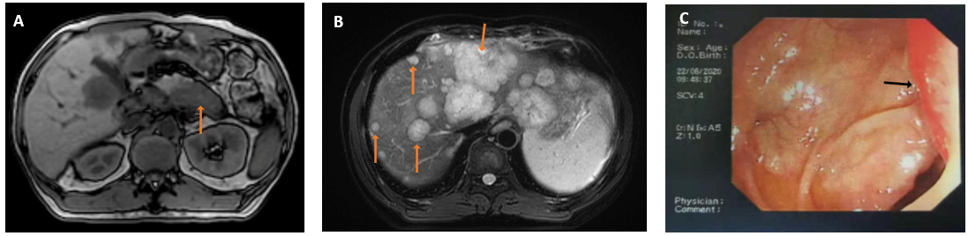
Figure 1 Radiological images at the time of diagnosis. A: Abdominal magnetic resonance imaging showed a hypovascular mass present in the tail of the pancreas 6.4 cm × 4.2 cm in size; B: Multiple hypovascular nodules of no more than 7.1 cm × 5.5 cm scattered in the liver parenchyma; C: Colonoscopy image showing a 2.2 cm × 1.6 cm mass with surface congestive erosions, which was 33 cm from the anus.

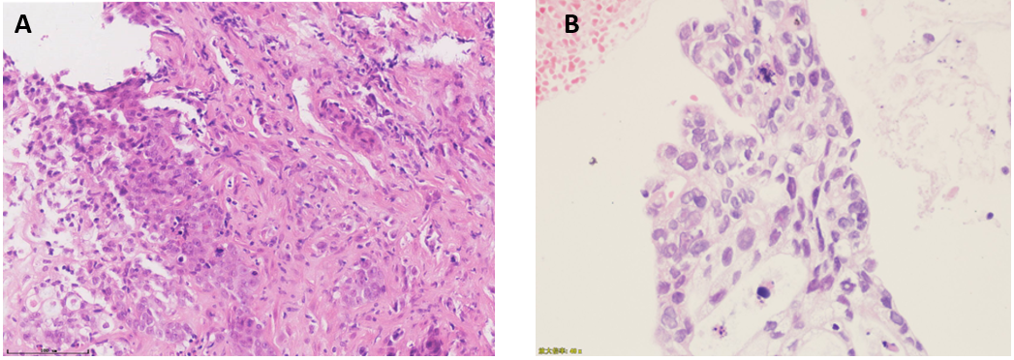
Figure 2 Results of pathologic diagnosis. A: Fine-needle aspiration biopsy of the left lobe of the liver; B: Biopsy from colonoscopy. Magnification: 40 ×; scale bar: 100 μm.

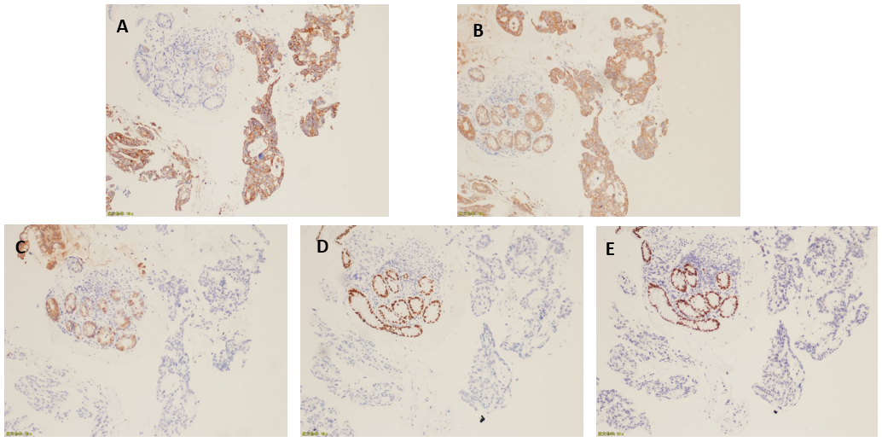
Figure 3 Histopathological analysis of biopsy from the colon lesion. A: CK 7 positive; B: CK positive; C: CK 20 negative; D: CDX2 negative; E: SATB2 negative. Magnification: 10 ×.

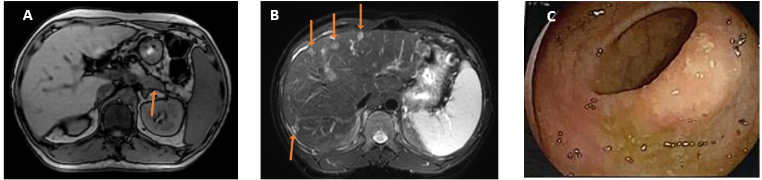
Figure 4 Radiological images of response assessment to FOLFIRINOX treatment. A: Abdominal magnetic resonance imaging after 12 cycles of FOLFIRINOX treatment showing the size of the hypovascular mass in the tail of the pancreas had shrunk to 4.2 cm × 2.0 cm; B: Multiple hypovascular nodules in the liver parenchyma were also reduced to less than 3.5 cm; C: A colonoscopy after 9 cycles of FOLFIRINOX showing that the mucosa of the original lesion site was slightly rough and red, and that no protuberant or new mucosal lesions were found.

Table 1 Literature review of the characteristics of pancreatic cancer patients with colon metastasis
Ref. | Age, yr | Sex | Metastatic site | Timing of metastasis | Immunohistochemical staining | Treatment | OS from CM Dx
Charles et al^{[21]} | 45 | Male | Colon | NA | CA19-9 (+), CK (+), EMA (+), CEA (+), CDX2 (-), CK20 (-), CK7 (-), CD10 (-), vimentin (-), TTF-1) (-) | NA | NA
Kentaro et al^{[4]} | 62 | Male | Colon | Metachronous | CK7 (+), CK20 (-) | Hemicolectomy | NA
Woogyeong et al^{[3]} | 64 | Male | Colon | Metachronous | CK7 (+), CK20 (-), CK19 (+) | Hemicolectomy + gemcitabine | 6+
Giuseppe et al^{[5]} | 70 | Female | Liver, colon | Synchronous | CK7 (+), CK20 (-) | NA | NA
Ryan et al^{[6]} | 91 | Female | Colon | Synchronous | CK7 (+), CK20 (-), CDX2 (-) | Palliative care | NA
Deborah et al^{[7]} | 73 | Female | Colon | Synchronous | CK7 (+), CK20 (-), CDX2 (-), SATB2 (-) | Gemcitabine + nab-paclitaxel | 7 mo
Rohan et al^{[8]} | 71 | Male | Colon | Synchronous | CK7 (+), CK20 (-) | Gemcitabine + nab-paclitaxel | NA
CM: Colon metastasis; NA: Not available; EMA: Epithelial membrane antigen; CEA: Carcinoembryonic antigen; TTF-1: Thyroid transcription factor-1; CK: Cytokeratin; OS: Overall survival.

