Name of Journal: World Journal of Clinical Cases
Manuscript NO: 38912
Manuscript Type: CASE REPORT

Mesenteric heterotopic pancreas in a pediatric patient: A case report and review of literature

Tang XB et al. Mesenteric heterotopic pancreas

Xiao-Bing Tang, Min-Yi Liao, Wei-Lin Wang, Yu-Zuo Bai

Xiao-Bing Tang, Min-Yi Liao, Wei-Lin Wang, Yu-Zuo Bai, Department of Pediatric Surgery, Shengjing Hospital, China Medical University, Shenyang 110004, Liaoning Province, China

ORCID number: Xiao-Bing Tang (0000-0002-6925-3204); Min-Yi Liao (0000-0001-8327-8064); Wei-Lin Wang (0000-0003-3062-4503); Yu-Zuo Bai (0000-0002-0647-6195).

Author contributions: Bai YZ and Wang WL designed the report; Tang XB and Liao MY wrote the paper; Tang XB and Bai YZ collected the patient’s clinical data; Wang WL and Bai YZ revised the manuscript.

Supported by the Outstanding Scientific Fund of Shengjing Hospital, No. m201502.

Informed consent statement: Informed consent to publish was obtained from the parents of the patient.

Conflict-of-interest statement: The authors declare that they have no conflicts of interest.

CARE Checklist (2016) statement: The authors have read the CARE Checklist (2016), and the manuscript was prepared and revised according to the CARE Checklist (2016).

Open-Access: This article is an open-access article which was selected by an in-house editor and fully peer-reviewed by external reviewers. It is distributed in accordance with the Creative Commons Attribution Non Commercial (CC BY-NC 4.0) license, which permits others to distribute, remix, adapt, build upon this work non-commercially, and license their derivative works on different terms, provided the original work is properly cited and the use is non-commercial. See: http://creativecommons.org/licenses/by-nc/4.0/

Manuscript source: Unsolicited manuscript

Correspondence to: Yu-Zuo Bai, MD, PhD, Full Professor, Pediatric Surgeon, Department of Pediatric Surgery, Shengjing Hospital, China Medical University, No. 36 Sanhao Street, Heping District, Shenyang 110004, Liaoning Province, China. baiyz@sj-hospital.org
Telephone: +86-24-9661557111
Fax: +86-24-23892617

Received: May 29, 2018
Peer-review started: May 29, 2018
First decision: July 8, 2018
Revised: July 20, 2018
Accepted: October 23, 2018
Article in press:
Published online:
Abstract
Heterotopic pancreas (HP) is a congenital anomaly defined as pancreatic tissue that has no contact with the orthotopic pancreas and its own duct system and vascular supply. The most common locations of HP are the upper gastrointestinal tract-specifically, the stomach, duodenum, and proximal jejunum. Involvement of the mesentery is rare. Here, we describe a rare case of mesenteric heterotopic pancreas (MHP) in a 12-year-old girl who presented with acute abdomen. The patient underwent emergency laparotomy, and the mass and adjacent small bowel were resected. Results of the postoperative histopathologic examination confirmed the diagnosis of MHP. Observation of the patient for 12 mo postoperatively showed no evidence of recurrence. Preoperative diagnosis of HP is difficult, even in a symptomatic patient. Increased awareness and understanding of the image characteristics of MHP will aid in correct preoperative diagnosis and appropriate patient management.

Key words: Heterotopic pancreas; Mesenteric; Acute abdomen; Computed tomography; Magnetic resonance imaging; Case reports

© The Author(s) 2018. Published by Baishideng Publishing Group Inc. All rights reserved.

Core tip: Heterotopic pancreas (HP) is a congenital anomaly defined as pancreatic tissue that has no contact with the orthotopic pancreas and its own duct system and vascular supply. The most common locations of HP are the upper gastrointestinal tract-specifically, the stomach, duodenum, and proximal jejunum. Involvement of the mesentery is rare. Here, we describe a rare case of mesenteric heterotopic pancreas (MHP) in a 12-year-old girl who presented with acute abdomen. MHP should be considered in the differential diagnosis of a mesenteric mass, especially when its morphology and enhancement are similar to those of orthotopic pancreas.

Tang XB, Liao MY, Wang WL, Bai YZ. Mesenteric heterotopic pancreas in a pediatric patient: A case report and review of literature. World J Clin Cases 2018; In press

INTRODUCTION
Heterotopic pancreas (HP) is most commonly found in the proximal gastrointestinal tract. Although the reported incidence of HP varies, the true incidence is difficult to determine because the patients are usually asymptomatic and the condition is usually found incidentally at autopsy or during laparotomy^{[1,2]}. Male preponderance is seen among adults, with the incidence of disease peaking during the fourth to sixth decades of life^{[3,4]}. The most frequent location of heterotopic pancreatic tissue is the stomach (47%), followed by the jejunum (35%), duodenum (11.7%), and ileum (5.8%)^{[5]}. Involvement of the mesentery is rare. Until now, no more than 10 cases of mesenteric heterotopic pancreas (MHP) have been described in the Medical literature^{[6-13]}. Here, we describe a case of MHP in a 12-year-old female patient.

CASE REPORT
A 12-year-old girl with no significant medical history was admitted to our department with intermittent vomiting and abdominal pain for 3 d. Her growth and development were normal. On admission, she was in a good general condition. Her temperature was 36.6 ℃, heart rate was 106 beats/min, and the blood pressure was 100/69 mmHg. Her physical examination showed abdominal tenderness with peritoneal irritation. The laboratory results were unremarkable. Abdominal ultrasonography revealed a well-defined, heterogeneous, medially echoic mass located at the margin of the intestinal mesentery in the abdominal cavity that measured approximately 4.9 cm × 2.6 cm. Contrast-enhanced computer tomography (CECT) of the abdomen showed an enhanced oval, soft-tissue mass (42 mm × 25 mm) in the mesentery at the level of the umbilicus (Figure 1). The clinical diagnosis of mesenteric mass was made. The differential diagnosis included intestinal duplication cyst, inflammated Meckel’s diverticulum and mesenteric lymphangioma.
Because of peritoneal irritation, the patient underwent emergency laparotomy 12 h after hospitalization. Laparotomy revealed a yellowish, soft-tissue mass measuring 4 cm in diameter that was located in the mesentery of the proximal jejunum and adhered to the serosal surface of the jejunum (Figure 2). The mass and the adjacent jejunum were resected, and end-to-end anastomosis was performed.
Gross pathology demonstrated a 4 cm × 3 cm mass in the jejunal mesentery that was adhered to the serosa of the jejunum. Postoperative histopathologic examination of the resected specimen revealed ectopic pancreatic tissue consisting of acini, islet cells, and pancreatic ducts, adjacent to the jejunal serosa (Figure 3). There was no evidence of malignant change in the ectopic pancreatic tissue. The pathologic diagnosis was MHP.
The patient’s postoperative course was uneventful, and she was discharged on postoperative day 8. Follow-up of the patient by abdominal ultrasonography for 12 mo postoperatively showed no evidence of relapse.

DISCUSSION
HP was first described by Jean Schultz in 1727, which is a congenital anomaly defined as pancreatic tissue that is anatomically separate from the main gland, without vascular or ductal continuity. No more than 10 cases of MHP have been described in the Medical literature^{[6-12]}. Including our case, only 4 cases of pediatric MHP have been reported in the Medical literature^{[6,7,9]}, with patients ranging in age from 12 to 15 years.
The embryologic basis of HP is controversial, but the most widely held theory is the misplacement theory (Figure 4). According to the misplacement theory, deposits of pancreatic tissue are “dropped” into the developing gastrointestinal system, in anatomic isolation from the main body of the pancreas^{[11,13]}. This theory accounts for the fact that heterotopic pancreatic tissue was mostly located in the upper gastrointestinal tract near the pancreas (derivatives of the primitive foregut).
HP is well differentiated and can’t be distinguished histologically from orthotopic pancreas^{[1]}. Gross specimens always show a firm intramural mass that has a lobular shape and a well-defined interface with surrounding tissues^{[14]}. Most lesions (80%) are solitary and smaller than 3 cm, but they can range in size from 0.2 cm to 5.0 cm^{[14,15]}. The first and most common histological type of heterotopic pancreatic tissue is composed of all the elements of the normal pancreas, including the acini, ducts, and islet cells^{[16]}. However, not all three of these components were identified in a single case. The morphologic feature of MHP closely resembled the orthotopic pancreas-a homogeneous, well-enhanced and enlongated mass with pancreas-like clefts or lobulations^{[17]}.
Uncomplicated HP is typically asymptomatic, which is always discovered incidentally during surgery, imaging examination or autopsy. Any complication that can occur in the orthotopic pancreas can also occur in HP. Associated complications include pancreatitis, pseudocyst formation, abnormal hormone secretion, bowel obstruction, common bile duct obstruction, gastrointestinal bleeding, intussusception, and malignant degeneration^{[3,4,18-20]}. Depending on its location and size, and involvement of the overlying mucosa, HP can cause symptoms. The most common findings were abdominal pain, abdominal distension, nausea and vomiting, malaise, anorexia, anemia, body weight loss, jaundice, and upper gastrointestinal bleeding according to the study by Zhang et al^{[1]}.
Because of its rarity and nonspecific clinical manifestation, accurate preoperative diagnosis of HP remains difficult^{[5,21]}. The definitive diagnosis has been always achieved after postoperative pathology. CECT and magnetic resonance imaging (MRI) may demonstrate the lesion that enhances similarly to the orthotopic pancreas^{[22-26]}. The most common CT manifestation of HP is a small intramural and endoluminal mass with microlobulated margins^{[22]}. On an MRI scan, the HP is isointense to the orthotopic pancreas, with characteristic T1-weighted high signal intensity and early avid enhancement after the administration of intravenous contrast material^{[17,22]}, which is particularly helpful for differentiating HP from other lesions. Heterotopic pancreatic tissue has a rudimentary ductal system. The existence of a central duct along the long axis of the mass is another key finding for the diagnosis of HP^{[8,17,22]}. Sometimes the duct can be confirmed as draining into the fourth portion of the duodenum by magnetic resonance cholangiopancreatography^{[8]}. Knowledge of the characteristic imaging appearances of MHP is key to confirming the diagnosis preoperatively. First, as with HP in other locations, MHP has morphologic and enhancement characteristics similar to the orthotopic pancreas, named “another pancreas in the mesentery”^{[17,22]}. Second, the mean long axis diameter/short axis diameter ratio of MHP was much greater than that of gastric HP (3.0 vs 1.4-1.5)^{[17]}. Third, a duct-like structure paralleling the long axis of MHP is seen more frequently than HP in other locations^{[17]}.
MHP should be considered in the differential diagnosis. A gastrointestinal stromal tumor, carcinoid tumor, lymphoma, and metastasis can manifest as a homogeneous and well-enhanced soft tissue mass located in the mesentery, and the enhancement pattern is unreliable to differentiate from MHP on an enhanced CT scan^{[17]}. Because of the potential serious complications and malignant change, local excision of MHP is the optimal treatment^{[2,26]}.
We list the cases of MHP in medical literature (Table 1) and found some characteristics of MHP. First, MHP was not seen in children younger than 10-year-old. Of the 8 cases of MHP, 50% (4/8) were teenagers aging from 12- to 15-year-old, 50% (4/8) were adults aging from 38- to 75-year-old. Second, there is a female preponderance (75%, 6/8) of MHP, which is opposite to the male preponderance of HP. Third, majority of MHP (75%, 6/8) located in jejunal mesentery. Fourth, CECT and MRCP were the most useful diagnostic method of MHP. These characteristics can be applied in clinical diagnosis of MHP.
In conclusion, MHP is very rare and an unusual cause of acute abdomen in patients older than 12 years. Preoperative diagnosis of MHP is difficult, even in a symptomatic patient. When a mesenteric mass has morphology and enhancement similar to the orthotopic pancreas, MHP should be considered in the differential diagnosis. Increased awareness and understanding of the imaging characteristics of MHP will aid in correct preoperative diagnosis and appropriate patient management.

ARTICLE HIGHLIGHTS
Case characteristic
A 12-year-old girl with intermittent vomiting and abdominal pain for 3 d.

Clinical diagnosis
Mesenteric mass.

Differential diagnosis
intestinal duplication cyst, inflammated Meckel’s diverticulum and mesenteric lymphangioma were considered.

Laboratory diagnosis
The laboratory results were unremarkable.

Imaging diagnosis
Contrast-enhanced computer tomography (CECT) of the abdomen showed an enhanced oval, soft-tissue mass (42 mm × 25 mm) in the mesentery at the level of the umbilicus.

Pathological diagnosis
Mesenteric heterotopic pancreas (MHP).

Treatment
Resection of the mass and adjacent small bowel.

Related reports
Two cases of pediatric MHP have been reported in the Medical literature from the University of Chicago Medical Center and Boston City Hospital.

Term explanation
Heterotopic pancreas of the mesentery.

Experiences and lessons
This case will contribute to increase clinicians’ awareness and understanding of the imaging features of MHP in order to help in making correct preoperative diagnosis and giving appropriate treatment.

REFERENCES
1 Zhang Y, Sun X, Gold JS, Sun Q, Lv Y, Li Q, Huang Q. Heterotopic pancreas: a clinicopathological study of 184 cases from a single high-volume medical center in China. Hum Pathol 2016; 55: 135-142 [PMID: 27195908 DOI: 10.1016/j.humpath.2016.05.004]
2 Lai EC, Tompkins RK. Heterotopic pancreas. Review of a 26 year experience. Am J Surg 1986; 151: 697-700 [PMID: 3717502 DOI: 10.1016/0002-9610(86)90045-0]
3 Tanaka K, Tsunoda T, Eto T, Yamada M, Tajima Y, Shimogama H, Yamaguchi T, Matsuo S, Izawa K. Diagnosis and management of heterotopic pancreas. Int Surg 1993; 78: 32-35 [PMID: 8473080]
4 Pang LC. Pancreatic heterotopia: a reappraisal and clinicopathologic analysis of 32 cases. South Med J 1988; 81: 1264-1275 [PMID: 3051429 DOI: 10.1097/00007611-198810000-00016]
5 Hsia CY, Wu CW, Lui WY. Heterotopic pancreas: a difficult diagnosis. J Clin Gastroenterol 1999; 28: 144-147 [PMID: 10078823 DOI: 10.1097/00004836-199903000-00012]
6 Ginsburg M, Ahmed O, Rana KA, Boumendjel R, Dachman AH, Zaritzky M. Ectopic pancreas presenting with pancreatitis and a mesenteric mass. J Pediatr Surg 2013; 48: e29-e32 [PMID: 23331836 DOI: 10.1016/j.jpedsurg.2012.10.062]
7 Fam S, O'Briain DS, Borger JA. Ectopic pancreas with acute inflammation. J Pediatr Surg 1982; 17: 86-87 [PMID: 7077488 DOI: 10.1016/S0022-3468(82)80338-2]
8 Silva AC, Charles JC, Kimery BD, Wood JP, Liu PT. MR Cholangiopancreatography in the detection of symptomatic ectopic pancreatitis in the small-bowel mesentery. AJR Am J Roentgenol 2006; 187: W195-W197 [PMID: 16861511 DOI: 10.2214/AJR.04.1756]
9 Tornóczky T, Kálmán E, Jáksó P, Méhes G, Pajor L, Kajtár GG, Battyány I, Davidovics S, Sohail M, Krausz T. Solid and papillary epithelial neoplasm arising in heterotopic pancreatic tissue of the mesocolon. J Clin Pathol 2001; 54: 241-245 [PMID: 11253140 DOI: 10.1136/jcp.54.3.241]
10 Canbaz H, Colak T, Düşmez Apa D, Sezgin O, Aydin S. An unusual cause of acute abdomen: mesenteric heterotopic pancreatitis causing confusion in clinical diagnosis. Turk J Gastroenterol 2009; 20: 142-145 [PMID: 19530049]
11 Shin SS, Jeong YY, Kang HK. Giant heterotopic pancreas in the jejunal mesentery. AJR Am J Roentgenol 2007; 189: W262-W263 [PMID: 17954622 DOI: 10.2214/AJR.05.1142]
12 Wong JC, Robinson C, Jones EC, Harris A, Zwirewich C, Wakefield R, Simons RK, Yoshida EM. Recurrent ectopic pancreatitis of the jejunum and mesentery over a 30-year period. Hepatobiliary Pancreat Dis Int 2011; 10: 218-220 [PMID: 21459732 DOI: 10.1016/S1499-3872(11)60036-2]
13 Kim DW, Kim JH, Park SH, Lee JS, Hong SM, Kim M, Ha HK. Heterotopic pancreas of the jejunum: associations between CT and pathology features. Abdom Imaging 2015; 40: 38-45 [PMID: 24934475 DOI: 10.1007/s00261-014-0177-y]
14 Park SH, Han JK, Choi BI, Kim M, Kim YI, Yeon KM, Han MC. Heterotopic pancreas of the stomach: CT findings correlated with pathologic findings in six patients. Abdom Imaging 2000; 25: 119-123 [PMID: 10675449 DOI: 10.1007/s002619910028]
15 Mortelé KJ, Rocha TC, Streeter JL, Taylor AJ. Multimodality imaging of pancreatic and biliary congenital anomalies. Radiographics 2006; 26: 715-731 [PMID: 16702450 DOI: 10.1148/rg.263055164]
16 Trifan A, Târcoveanu E, Danciu M, Huţanaşu C, Cojocariu C, Stanciu C. Gastric heterotopic pancreas: an unusual case and review of the literature. J Gastrointestin Liver Dis 2012; 21: 209-212 [PMID: 22720312]
17 Seo N, Kim JH. Characteristic CT features of heterotopic pancreas of the mesentery: "another pancreas" in the mesentery. Clin Imaging 2014; 38: 27-30 [PMID: 24176484 DOI: 10.1016/j.clinimag.2013.09.008]
18 Makhlouf HR, Almeida JL, Sobin LH. Carcinoma in jejunal pancreatic heterotopia. Arch Pathol Lab Med 1999; 123: 707-711 [PMID: 10420228 DOI: 10.1043/0003-9985(1999)123<0707:CIJPH>2.0.CO;2]
19 Halkic N, Nordback P. Soft-tissue images. Malignant degeneration of heterotopic pancreas. Can J Surg 2001; 44: 407 [PMID: 11764870]
20 Riccardo G, Valeria B, Giulia C, Alessia C, Luisa F, Elisabetta T, Alessandro M, Isabella M, Jürgen S. Heterotopic pancreas in Meckel's diverticulum in a 7-year-old child with intussusception and recurrent gastrointestinal bleeding: case report and literature review focusing on diagnostic controversies. Afr J Paediatr Surg 2014; 11: 354-358 [PMID: 25323189 DOI: 10.4103/0189-6725.143172]
21 Ogata H, Oshio T, Ishibashi H, Takano S, Yagi M. Heterotopic pancreas in children: review of the literature and report of 12 cases. Pediatr Surg Int 2008; 24: 271-275 [PMID: 18183407 DOI: 10.1007/s00383-007-2098-0]
22 Rezvani M, Menias C, Sandrasegaran K, Olpin JD, Elsayes KM, Shaaban AM. Heterotopic Pancreas: Histopathologic Features, Imaging Findings, and Complications. Radiographics 2017; 37: 484-499 [PMID: 28287935 DOI: 10.1148/rg.2017160091]
23 Cho JS, Shin KS, Kwon ST, Kim JW, Song CJ, Noh SM, Kang DY, Kim HY, Kang HK. Heterotopic pancreas in the stomach: CT findings. Radiology 2000; 217: 139-144 [PMID: 11012436 DOI: 10.1148/radiology.217.1.r00oc09139]
24 Megibow AJ, Balthazar EJ, Cho KC, Medwid SW, Birnbaum BA, Noz ME. Bowel obstruction: evaluation with CT. Radiology 1991; 180: 313-318 [PMID: 2068291 DOI: 10.1148/radiology.180.2.2068291]
25 Wang C, Kuo Y, Yeung K, Wu C, Liu G. CT appearance of ectopic pancreas: a case report. Abdom Imaging 1998; 23: 332-333 [PMID: 9569308 DOI: 10.1007/s002619900351]
26 Biswas A, Husain EA, Feakins RM, Abraham AT. Heterotopic pancreas mimicking cholangiocarcinoma. Case report and literature review. JOP 2007; 8: 28-34 [PMID: 17228130]

P-Reviewer: Amornyotin S, Nobile S, Pandey A, Sergi CM, Shaaban OM, Uwaezuoke SN S-Editor: Ji FF L-Editor: E-Editor:

Specialty type: Gastroenterology and hepatology
Country of origin: South Korea
Peer-review report classification
Grade A (Excellent): 0
Grade B (Very good): B, B
Grade C (Good): C, C, C, C
Grade D (Fair): 0
Grade E (Poor): 0

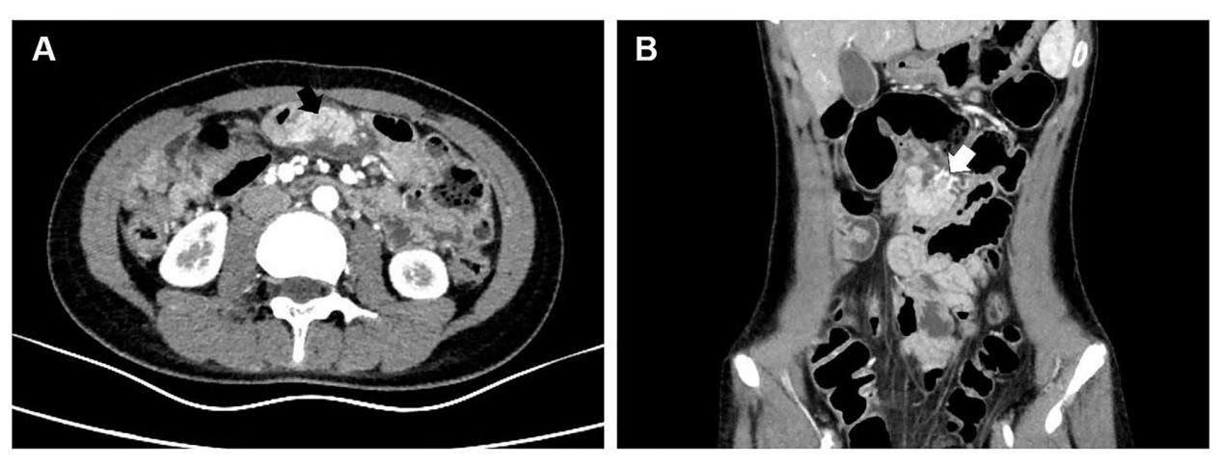
Figure 1 Contrast-enhanced computed tomography images of the abdomen. A: Axial contrast-enhanced computed tomography (CECT) image of the abdomen showing an enhanced oval, soft-tissue mass in the jejunal mesentery at the level of the umbilicus (black arrow); B: Coronal CECT image showing that the mass had its own blood supply (white arrow).

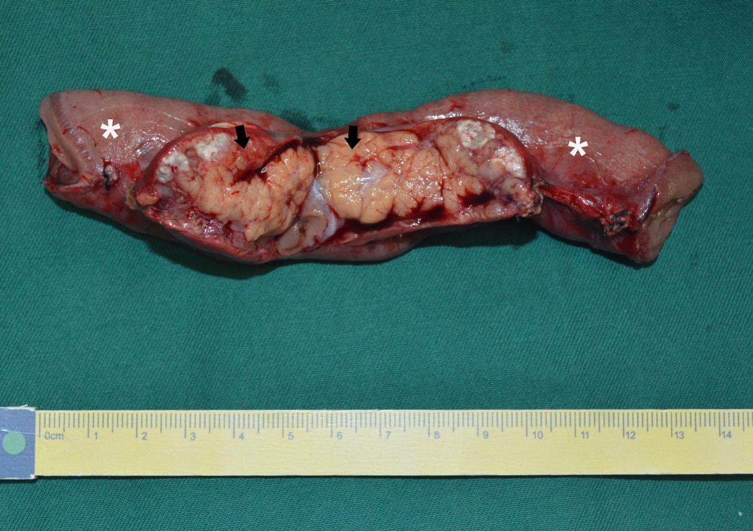
Figure 2 Photograph of the resected mass and the adjacent small bowel. Photograph of the gross specimen demonstrates a 4 cm × 3 cm, yellowish, soft-tissue mass (black arrows) located in the jejunal mesentery and adhered to the serosal surface of the jejunum (white asterisks).

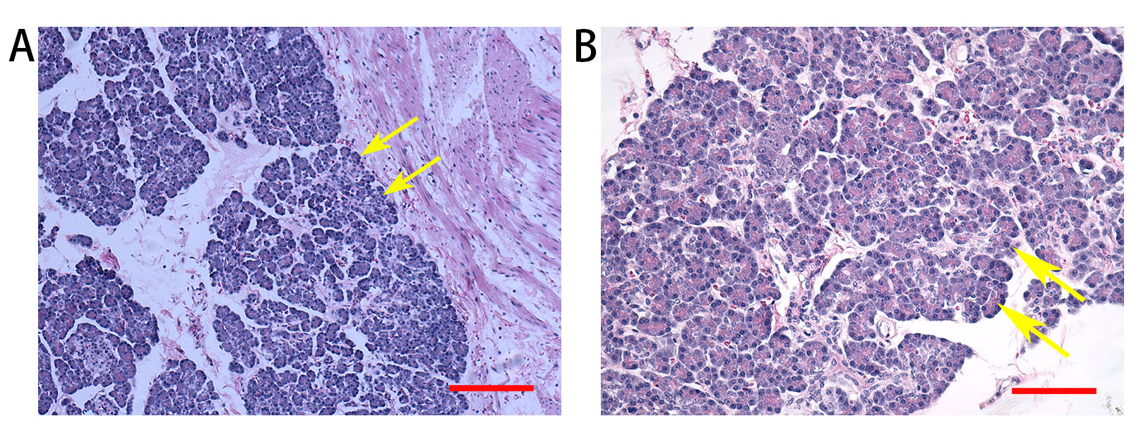
Figure 3 Histopathologic examination of the resected specimen. Microscopic appearance showing that the lesion consisted of heterotopic pancreatic tissue (yellow arrows), including acini, islet cells, and pancreatic ducts, extending to the jejunal serosa (H and E stain: A: Magnification, × 100; scale bar = 200 µm; B: Magnification, × 200; scale bar = 100 µm).

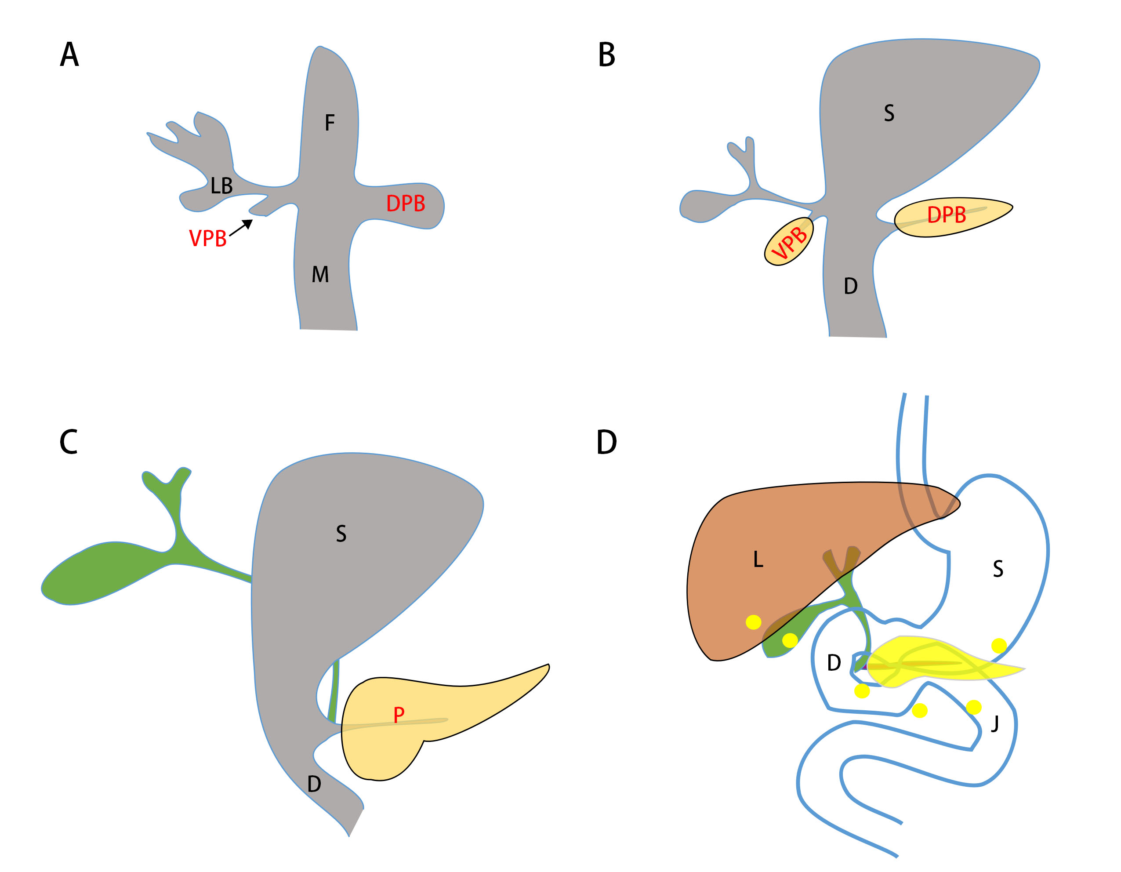
Figure 4 Schematic diagram of “misplacement theory”. A, B: The pancreas develops from the ventral and dorsal pancreatic buds, which develop at the junction of the foregut and midgut during the 4th week of gestation; C: As the foregut elongates, the developing ventral pancreas, gallbladder, and bile duct rotate clockwise posterior to the duodenum and join the dorsal pancreas in the retroperitoneum. The ventral pancreatic bud rotates clockwise and fuses with the dorsal bud at the 7th week of gestation; D: According to the misplacement theory, deposits of pancreatic tissue are “dropped” into the developing gastrointestinal system during rotation of the foregut when fragments of pancreas become separated and develop into mature elements. Yellow point in D indicates possible location of heterotopic pancreas. F: Foregut; M: Midgut; VPB: Ventral pancreatic bud; DPB: Dorsal pancreatic bud; LB: Liver bud; S: Stomach; D: Duodenum; P: Pancreas; L: Liver; J: Jejunum.

Table 1 List of cases of mesenteric heterotopic pancreas in medical literature

Ref. | Age (yr) | Sex | Clinical manifestation | Location | Imaging features | Operation
[6] | 15 | F | Right upper quadrant pain; Diffuse abdominal tenderness, most pronounced in the right upper quadrant and nonspecific guarding | Jejunal mesentery | CECT: A 3.3 cm × 2.3 cm soft tissue mass in the mesentery, with morphology and homogeneous enhancement characteristics similar to the pancreas | A 3 cm mass in the jejunal mesentery, adjacent to the  transverse colon and omentum  The mass and the adjacent small bowel were resected
[7] | 12 | M | Periumbiliacal abdominal pain, nausea and vomiting; Temperature of 100 °F  A rigid abdomen with absent bowel sounds | Jejunal mesentery | No imaging examination | A purulent node (1.5 cm × 1 cm × 0.7 cm) with fibrinous exudate at the base of the midjejunal mesentary  This node was excised
[8] | 57 | F | Pain in the right side of back, nausea, a similar episode of pain approximately 1 mo before  Mild, generalized abdominal tenderness and nonspecific guarding | Small bowel mesentery | CECT: An 3.7 cm × 1.7 cm soft tissue mass in the mesentery, enhancement similar to the pancreas  MRCP: A duct within the mesenteric mass, draining into the fourth portion of the duodenum | Treated conservatively
[9] | 15 | F | Abdominal pain of recent onset and abdominal distention of several years duration  A large tumour filling the left hypochondrium | Mesocolon | CT: A hypodense, intraperitoneal, circumscribed mass dislocating the spleen and left kidney | A spherical, encapsulated tumor mass (210 mm in the largest diameter) in the mesocolon  Resected of the mass with a segment of transverse colon
[10] | 75 | F | Acute periumbilical pain, nausea and vomiting  Acute abdomen with peritoneal irritation findings | Jejunal mesentery | US: Cholelithiasis and gallbladder wall thickening  US before the surgery: An abdominal tumoral mass, pseudokidney image, originating from the intestine or mesentery | An inflammatory mass in the mesentery, 15 cm × 8 cm × 5 cm  A great portion of the inflammatory mass was excised, and cholecystectomy
[11] | 38 | M | One episode of syncope, 2-d history of melena  The heart rate was 96 beats/min; no abdominal tenderness | Jejunal mesentery | CECT: An elongated soft-tissue mass in the jejunal mesentery, attenuation similar to orthotopic pancreas and extended to the periduodenal fat plane | A soft-tissue mass 20 cm in diameter in the jejunal mesentery, infiltrate the adjacent jejunal wall  The lesion was excised with part of the adjacent jejunum
[12] | 67 | F | Postprandial epigastric stabbing pain, nausea and vomiting  Similar episodes had recurred over the past 30 yr  Past medical history: A laparoscopic cholecystectomy;  Tenderness of epigastrium | Jejunal mesentery | CECT: A mass in the mesentery. A small ductal structure in the mass, communicate with the adjacent jejunal loop  MRCP: A mass in the mesentery isointense to the native pancreas, with a small duct draining into a proximal jejunal loop | A mass (6.5 cm × 2.5 cm × 1.6 cm indurated teardrop-shaped) mass in the jejunal mesentery  The mass with the overlying adherent jejunum was resected
This study | 12 | F | Intermittent vomiting and abdominal pain  Abdominal tenderness with peritoneal irritation | Jejunal mesentery | US: A well-defined, heterogeneous, medially echoic, 4.9 cm × 2.6 cm mass at the margin of the mesentery  CECT: An enhanced oval, soft tissue mass (42 cm × 25 mm) in the mesentery | A yellowish, soft-tissue mass 4 cm in diameter in the mesentery, adhered to the serosa of the jejunum  The mass and the adjacent small bowel were resected

CECT: Contrast-enhanced computer tomography; CT: Computer tomography; MRCP: Magnetic resonance cholangiopancreatography; US: Ultrasonography.

