Name of Journal: World Journal of Clinical Cases
ESPS Manuscript NO: 30581
Manuscript Type: Case Report

Unicentric Castleman’s disease associated with end stage renal disease by amyloidosis

Eroglu E. et al. Amyloidosis in unicentric Castleman’s disease

Eray Eroglu, Ismail Kocyigit, Aydin Unal, Murat Hayri Sipahioglu, Hulya Akgun, Leylagul Kaynar, Bulent Tokgoz, Oktay Oymak

Eray Eroglu, Ismail Kocyigit, Aydin Unal, Murat Hayri Sipahioglu, Bulent Tokgoz, Oktay Oymak, Division of Nephrology, Department of Internal Medicine, Erciyes University School of Medicine, Kayseri 38039, Turkey

Hulya Akgun, Department of Pathology, Erciyes University School of Medicine, Kayseri 38039, Turkey

Leylagul Kaynar, Division of Hematology, Department of Internal Medicine, Erciyes University School of Medicine, Kayseri 38039, Turkey

Author contributions: Eroglu E and Oymak O designed the report; Unal A and Sipahioglu MH performed the kidney biopsy; Eroglu E and Kaynar L collected the patient’s clinical data; Akgun H reported the biopsy specimens; Eroglu E and Kocyigit I analyzed the data and wrote the paper.

Institutional review board statement: Not applicable due the case report format.

Informed consent statement: Informed consent was obtained from the patient included in the case report.

Conflict-of-interest statement: All authors declare that there is no conflict of interest.

Open-Access: This article is an open-access article which was selected by an in-house editor and fully peer-reviewed by external reviewers. It is distributed in accordance with the Creative Commons Attribution Non Commercial (CC BY-NC 4.0) license, which permits others to distribute, remix, adapt, build upon this work non-commercially, and license their derivative works on different terms, provided the original work is properly cited and the use is non-commercial. See: http://creativecommons.org/licenses/by-nc/4.0/

Manuscript source: Invited manuscript

Correspondence to: Eray Eroglu, MD, Division of Nephrology, Department of Internal Medicine, Erciyes University School of Medicine, Köşk, Talas Blv., Kayseri 38039, Turkey. drerayeroglu@hotmail.com
Telephone: +90-530-9220517
Fax: +90-352-4375807

Received: October 9, 2016
Peer-review started: October 13, 2016
First decision: November 11, 2016
Revised: November 29, 2016
Accepted: January 16, 2017
Article in press:
Published online:

Abstract
Castleman’s disease (CD), also known as angiofoliculer lymph node hyperplasia, is a rare heterogenous group of lymphoproliferative disorder. Histologically, it can be classified as hyaline vascular, plasma cell type, or mixed types. Clinically two different subtypes of the CD are present, unicentric CD and multicentric CD. Unicentric CD is generally asymptomatic and it is generally associated with hyaline vascular type, diagnoses depend on the localized lymphadenopathy on examination or imaging studies. However, multicentric CD presents with generalized lymphadenopathy and systemic symptoms including malaise, fever, night sweats, weight loss, and it is associated with plasma cell type and mix type. Herein, we report of a patient with unicentric CD of plasma cell type without systemic symptoms, who developed end stage renal failure by amyloidosis 6 years after onset of CD.

Key words: Castleman’s disease; Plasma cell; Inflammation; Amyloidosis; End stage renal disease

© The Author(s) 2017. Published by Baishideng Publishing Group Inc. All rights reserved.

Core tip: Castleman’s disease (CD) as known angiofoliculer lymph node hyperplasia is a heterogeneous group of lymphoproliferative disorder. The clinically unicentric form is generally asymptomatic and is often associated with hyaline vascular type. The unicentric form of the disease often shows mild to moderate clinical prognosis, however the multicentric form is a more severe form of the disease. After the complete surgical removal of the lymph node, remission is achieved in many cases and complications are very rare. However, this case of unicentric CD and plasma cell type is unique due to the fact that it was presented with amyloidosis and end stage renal disease six years after the onset of the disease.

Eroglu E, Kocyigit I, Unal A, Sipahioglu MH, Akgun H, Kaynar L, Tokgoz B, Oymak O. Unicentric Castleman’s disease associated with end stage renal disease by amyloidosis. World J Clin Cases 2017; In press

INTRODUCTION
Castleman’s disease (CD), firstly described in 1956 by Castleman et al^{[1]} as giant lymphoid hyperplasia or angiofoliculer lymph node hyperplasia, is a heterogeneous group of lymphoproliferative disorder. It involves anatomically unicentric and multicentric forms and histologically plasma, hyaline vascular, and mixed cell types.
Unicentric Castleman's disease (UCD) is mostly asymptomatic and presented when an enlarged lymph node is determined on physical examination or by imaging studies^{[2,3]}. Conversely, multicentric Castleman's disease (MCD) is a systemic disease with generalized peripheral lymphadenopathy, hepatosplenomegaly, malaise, fevers, night sweats, and weight loss. Eighty percent to ninety percent of CD develops with the hyaline vascular histological type, it is commonly associated with UCD and clinically presents as a mediastinal or mesenteric mass. The plasma cell type (10%–20% of CD) is in the majority of cases multicentric and clinically presents with systemic symptoms due to increased inflammatory activity^{[3,4]}.
The pathogenesis of CD has not yet been completely clarifiedt. The histopathological changes in lymph nodes resemble to the reactive changes that can be seen in response to normal antigenic stimuli. It has been shown that increased production of IL-6 might be related with the systemic inflammatory symptoms of CD. Unlike UCD, MCD is strongly associated with immunosuppression and human herpes virus 8 (HHV-8) infection .The diagnosis is generally confirmed by excisional biopsy of the affected lymph node. Treatment of UCD is generally completed by resection of the lymph node; however some cases need chemotherapy or immunotherapy^{[4,5]}.
Herein, we present a case of a male patient with UCD with plasma cell type, which was diagnosed in 2010, with the excision of a paraaortic lymph node. Complete surgical resection was performed; the patient was followed in a remission state for 3 years. After three years lost due to lack of a follow-up period, the patient was admitted to hospital with increased creatinine levels, overt proteinuria, and increased inflammatory markers. A kidney biopsy showed AA type amyloidosis. The patient was initiated with hemodialysis due to end stage renal disease. Although, the disease was in remission in imaging studies, this case was presented with the sudden and rare complication of UCD with plasma cell type, amyloidosis, and kidney failure.

CASE REPORT
A 69 years old man was admitted to hospital with abdominal discomfort, tenderness, and dyspeptic complaints in August 2010. Abdominal ultrasonography revealed paraaortic lymphadenopathy and the patient was referred to the hematology department. He had no history of hypertension, diabetes mellitus, smoking, or alcohol use. The physical examination showed that there was no sign of peripheral lymphadenopathy and hepatosplenomegaly. Laboratory results showed hypochromic microcytic anemia with a hemoglobin level of 11.9 g/dL, MCV was 78 fl, the erythrocyte sedimentation rate was 66 mm/h, and the C-reactive protein level was 64 mg/L (normal range :0-6 mg/L). The reticulocyte count was normal. There were no iron, folic acid, and vitamin B12 deficiencies in the laboratory results. All biochemical parameters were within normal range. Serologic tests for hepatitis, HIV, Brucella, cytomegalovirus, Epstein-Barr virus, and HHV-8 were all negative. Serum immunoelectrophoresis demonstrated polyclonal hyperglobulinemia. Bone marrow aspiration and biopsy revealed as normocellular findings. Computerized tomography scans demonstrated a 6 cm paraaortic lymphadenopathy. Total lymph node excision was performed and the result of the pathologic specimen was reported as Castleman’s disease with plasma cell type (Figure 1). After operation, the patient was followed through to July 2013, in remission state according to laboratory and imaging studies. Follow up laboratory results in 2011 showed the erythrocyte sedimentation rate was 55 mm/h and the C-reactive protein was 25 mg/L. Follow up laboratory results in 2012 showed the erythrocyte sedimentation rate was 35 mm/h and the C-reactive protein level was 9.6 mg/l. During the patient’s last hematology visit in 2013, a physical examination revealed normal findings. Laboratory paramaters showed that hemoglobin level was 13.7 g/dL, the erythrocyte sedimentation rate was 33 mm/h, and the C-reactive protein level was 9.6 mg/L. All biochemical parameters were within normal range. Serum immunoelectrophoresis and protein electhroporesis were normal. Radiologically, there were millimetric lymph nodes in the paraaortic area. The patient stopped routine follow-up hematology visits after July 2013 and was not seen for three years due to lack of complaints. In June 2016, the patient was admitted to the hematology department with complaints of nausea, vomiting, abdominal pain, and edema in the distal extremities. A physical examination revealed pale skin and conjunctiva without hepatosplenomegaly. Laboratory examinations revealed normochromic normocytic anemia (Hct 25.7%, Hb 9.6 g/dL, MCV 87 fl), an elevated erythrocyte sedimentation rate (80 mm/h) and C-reactive protein (76 mg/L). The results of the laboratory findings were as follows: Glucose 95 mg/dL, BUN 75 mg/dL, creatinine 6.2 mg/dL, Na 139 mmol/L, K 5.0 mmol/L, Ca 8.2 mmol/L, phosphorus 5.2 mmol/L, uric acid 6.6 mg/dL, total cholesterol 223 mg/dL, LDL 126 mg/dL, GGT 15 U/L, ALP 97 U/L, AST 10 U/L, ALT 6 U/L, total protein 5.9 g/dL, albumin 2.4 g/dL, LDH 213 U/L, CPK 20 U/L, and serum iPTH levels 151 pg/mL (15-65). The urine stick test revealed a result of three positive for protein but there were no erythrocyte and leukocyte casts in the microscopic evaluation of the urine sediment. The 24-hour urine protein level was 10 g. ANA, anti-ds DNA, anti-GBM and ANCA profiles were all negative. The patient did not have any chronic inflammatory conditions such as tuberculosis, malaria, rheumatoid arthritis, or familial Mediterranean fever. The patient was referred to the nephrology department. An abdomen ultrasonography noted normal sized kidneys and a normal parenchymal thickness with increased grade 2 renal cortical echogenicity. All other findings were normal. A kidney biopsy was performed and results showed AA type amyloidosis (Figure 2). Metabolic acidosis and uremic symptoms had occurred, oliguria developed, and creatinine clearance was decreased to 10 mL/dk. The patient was admitted for veno-venous hemodialysis intervention via a double-lumen dialysis catheter in the jugular vein. Hematologic assessment demonstrated that CD was in remission according to imaging studies. PET-CT scan only reported multiple millimetric lymph nodes without FDG uptake in the paraaortic area. Hemodialysis intervention was continued three times a week due to progressive deterioration of kidney functions. The patient was discharged from hospital two weeks later with a hemodialysis catheter and followed up weekly. Two months later, he was considered to have end stage renal disease and underwent routine hemodialysis intervention via a created arteriovenous fistula.
DISCUSSION
Although renal involvement is a potential complication of CD, this rare case of UCD with plasma cell type and presenting with renal failure by amyloidosis, 6 years after the onset of the disease.
UCD is generally asymptomatic and sometimes comes to clinical attention if an enlarged lymph node is demonstrated on physical examination or in imaging studies. UCD more frequently affects one lymph node area. Systemic symptoms (i.e., malaise fever, night sweats, and weight loss) are generally limited to patients with the less common plasma cell type^{[2,3]}.Although, 10% to 20% of UCD are of the plasma cell type, MCD is generally associated with plasma cell type and closely linked to systemic inflammatory symptoms and renal complications^{[2,6]}. Interestingly, our patient with UCD and plasma cell type had no constitutional symptoms but was complicated by secondary amyloidosis 6 years after diagnosis and remission. This case illustrates the unexpected clinical course of CD.
Leung et al^{[7]} reported a patient with MCD of plasma cell type, who developed acute-on-chronic renal failure, caused by renal amyloidosis 15 years after onset of CD and resulted in end stage renal disease. In UCD, surgical resection of the tumor results in a resolution of systemic symptoms and normalization of laboratory abnormalities. However, repeated renal biopsies show no evidence of regression of amyloid deposits in cases with UCD^{[8]}. Androulaki et al^{[9]} described a patient with UCD complicated with systemic AA amyloidosis whom amyloidosis regressed with surgical resection. In contrast, Gaduputi et al^{[10]} reported a case with UCD in a submandibular mass that was complicated by systemic amyloidosis and surgical resection failed to regress the amyloidosis. Intriguingly, our patient presented with amyloidosis 6 years after surgical resection of the localized disease. However, his disease was in remission radiologically, and we believe low grade inflammation may be responsible for the amyloidosis in this patient. We speculate that low grade inflammation exists in patients with Castlemans’ Disease and plasma cell type .
Renal manifestations associated with CD are heterogeneous, including, minimal change disease, membranous, mesangio-proliferative, crescentic, membrano-proliferative glomerulonephritis, interstitial nephritis, and amyloidosis^{[11]}. El Karoui et al^{[12]} investigated the renal involvement by kidney biopsy of 19 French patients and found 20% of patients (4 of 19) had renal amyloidosis. They concluded that the most common renal histologic findings were small-vessel lesions. Xu et al^{[13]} recently reported the renal involvement of 76 Chinese patients with CD and they concluded that CD with multicentric type and plasma cell type or mixed types are often associated with renal complications. Although, previous case reports with patients with CD and renal manifestations 25 of 64 patients had amyloidosis according to the current English literature, they did not report any patients with CD and renal amyloidosis in their cohort. They also demonstrated that thrombotic microangiopathy-like lesions are the most common pathological characteristics^{[13]}. These findings suggest that amyloidosis may be histologically rare but clinical presentation of amyloidosis in patients with CD more severe than other renal involvements.
This UCD case with plasma cell type is unique due to renal failure by amyloidosis having occurred after 6 years of disease onset while the patient was in remission radiologically. In conclusion, physicians should be careful in terms of presence of an inflammatory state and amyloidosis although a patient may be in radiologically remission.

COMMENTS
Case characteristics
A 69-year-old man with Castleman's’ disease (CD) presented with nausea, vomiting, abdominal pain, and edema in the distal extremities.

Clinical diagnosis
There were pale skin and conjunctiva without hepatosplenomegaly and also, pitting edema in distal extremities.

Differential diagnosis
Nephrotic syndrome, lymphoma, congestive heart failure.

Laboratory diagnosis
Increased serum creatinine, erythrocyte sedimentation rate, C-reactive protein, decreased hemoglobin and albumin levels were revealed in laboratory examination.

Imaging diagnosis
PET-CT scan only reported multiple millimetric lymph nodes without FDG uptake in the paraaortic area.

Pathological diagnosis
AA type amyloidosis.

Related reports
Previous case reports with patients with CD and renal manifestations 25 of 64 patients had amyloidosis according to the current English literature. Amyloidosis may be histologically rare but clinical presentation of amyloidosis in patients with CD more severe than other renal involvements.

Term explanation
Castleman’s disease (CD) is a heterogeneous group of lymphoproliferative disorder which is described by Benjamin Castleman et al. Clinically two different subtypes of the CD are present, unicentric CD (UCD) and multicentric CD (MCD). UCD presents with localized lymphadenopathy. MCD However, presents with generalized lymphadenopathy and systemic symptoms. Positron-emission tomography –computerized tomography (PET-CT) is used to determine lesions and FDG (fluorodeoxyglucose) is a radiolabeled sugar molecule which is taken by lesion/lesions.

Experiences and lessons
UCD cases with plasma cell type may present with renal failure by amyloidosis while the disease is in remission radiologically. Physicians should be careful in terms of presence of an inflammatory state and amyloidosis development in patients with CD.

Peer-review
In this manuscript, the authors report on a case of unicentric Castleman’s disease associated with end stage renal disease by amyloidosis. This case report is clinically interesting.

REFERENCES
1 Castleman B, Iverson L, Menendez VP. Localized mediastinal lymphnode hyperplasia resembling thymoma. Cancer 1956; 9: 822-830 [PMID: 13356266 DOI: 10.1002/1097-0142(195607/08)9:4<822::AID-CNCR2820090430>3.0.CO;2-4]
2 Talat N, Belgaumkar AP, Schulte KM. Surgery in Castleman's disease: a systematic review of 404 published cases. Ann Surg 2012; 255: 677-684 [PMID: 22367441 DOI: 10.1097/SLA.0b013e318249dcdc]
3 Keller AR, Hochholzer L, Castleman B. Hyaline-vascular and plasma-cell types of giant lymph node hyperplasia of the mediastinum and other locations. Cancer 1972; 29: 670-683 [PMID: 4551306 DOI: 10.1002/10970142(197203)29: 3<670: : AIDCNCR2820290321>3.0.CO; 2-#]
4 Mylona EE, Baraboutis IG, Lekakis LJ, Georgiou O, Papastamopoulos V, Skoutelis A. Multicentric Castleman's disease in HIV infection: a systematic review of the literature. AIDS Rev 2008; 10: 25-35 [PMID: 18385778]
5 Leger-Ravet MB, Peuchmaur M, Devergne O, Audouin J, Raphael M, Van Damme J, Galanaud P, Diebold J, Emilie D. Interleukin-6 gene expression in Castleman's disease. Blood 1991; 78: 2923-2930 [PMID: 1954381]
6 Maslovsky I, Uriev L, Lugassy G. The heterogeneity of Castleman disease: report of five cases and review of the literature. Am J Med Sci 2000; 320: 292-295 [PMID: 11061358]
7 Leung KT, Wong KM, Choi KS, Chau KF, Li CS. Multicentric Castleman's disease complicated by secondary renal amyloidosis. Nephrology (Carlton) 2004; 9: 392-393 [PMID: 15663642]
8 Keven K, Nergizoğlu G, Ateş K, Erekul S, Orhan D, Ertürk S, Tulunay O, Karatan O, Ertuğ AE. Remission of nephrotic syndrome after removal of localized Castleman's disease. Am J Kidney Dis 2000; 35: 1207-1211 [PMID: 10845836]
9 Androulaki A, Giaslakiotis K, Giakoumi X, Aessopos A, Lazaris AC. Localized Castleman's disease associated with systemic AA amyloidosis. Regression of amyloid deposits after tumor removal. Ann Hematol 2007; 86: 55-57 [PMID: 17001479]
10 Gaduputi V, Tariq H, Badipatla K, Ihimoyan A. Systemic Reactive Amyloidosis Associated with Castleman's Disease. Case Rep Gastroenterol 2013; 7: 476-481 [PMID: 24348320 DOI: 10.1159/000356825]
11 Chan TM, Cheng IK, Wong KL, Chan KW. Resolution of membranoproliferative glomerulonephritis complicating angiofollicular lymph node hyperplasia (Castleman's disease). Nephron 1993; 65: 628-632 [PMID: 8302422]
12 El Karoui K, Vuiblet V, Dion D, Izzedine H, Guitard J, Frimat L, Delahousse M, Remy P, Boffa JJ, Pillebout E, Galicier L, Noël LH, Daugas E. Renal involvement in Castleman disease. Nephrol Dial Transplant 2011; 26: 599-609 [PMID: 20656751 DOI: 10.1093/ndt/gfq427.]
13 Xu D, Lv J, Dong Y, Wang S, Su T, Zhou F, Zou W, Zhao M, Zhang H. Renal involvement in a large cohort of Chinese patients with Castleman disease. Nephrol Dial Transplant 2012; 27 Suppl 3: iii119-iii125 [PMID: 21602182 DOI: 10.1093/ndt/gfr245]

P- Reviewer: Markic D, Tanaka H, Watanabe T, Yorioka N
S- Editor: Song XX L- Editor: E- Editor:

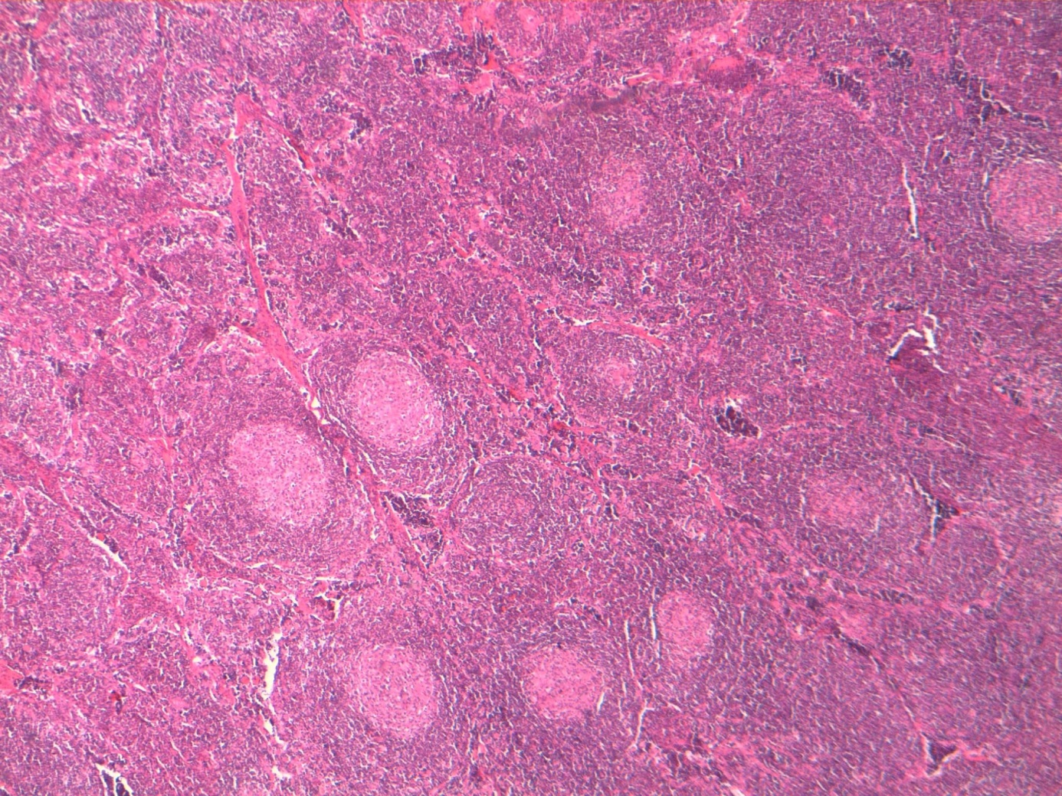
Figure 1 Light microscopy (HE × 400) demonstrates that reactive lymphoid follicles and the reactive germinal centers are radially penetrated by blood vessels in the lymph node specimen.

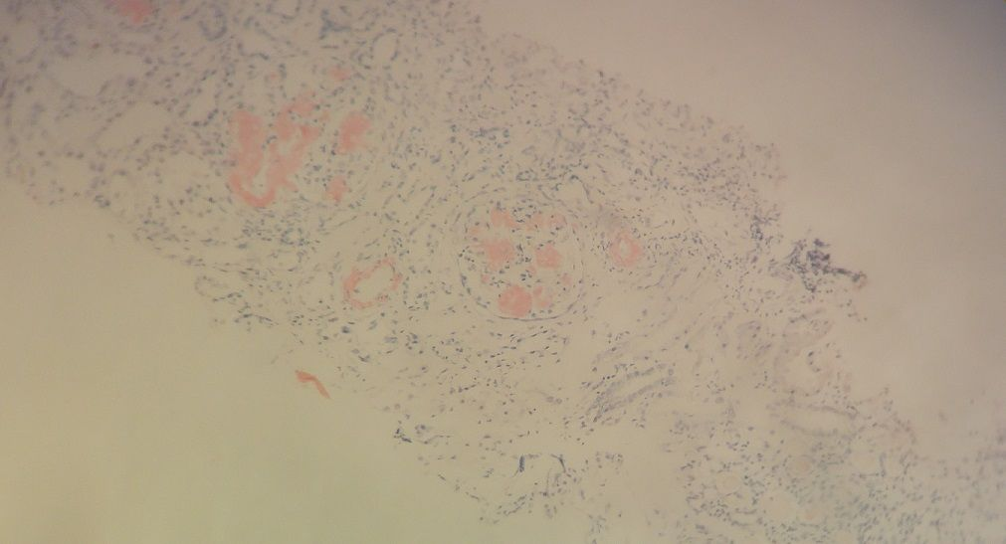
Figure 2 Light microscopy (HE × 400) demonstrates Congo red positive amyloid deposits in a glomerulus in the renal biopsy specimen.

