Institutional Review Board statement
The study was reviewed and approved by the Gastroenterology unit, university of Florence review board.
Informed Consent statement
All patients provided written informed consent to enrolment in the study and to the inclusion in this article of information that could potentially lead to their identification.
Conflict of interest disclosure
The authors (Maria Marsico MD, Tommaso Gabbani MD, Andrea Galli Prof, Maria Rosa Biagini MD, Lorenzo Livi Prof) have no conflict of interest.
Financial and competing interests disclosure
The authors have no relevant affiliations or financial involvement with any organization or entity with a financial interest in or financial conflict with the subject matter or materials discussed in the manuscript. This includes employment, consultancies, honoraria, stock ownership or options, expert testimony, grants or patents received or pending, or royalties.
Ethical Standards statement
The authors have no relevant affiliations or financial involvement with any organization or entity with a financial interest in or financial conflict with the subject matter or materials discussed in the manuscript. This includes employment, consultancies, honoraria, stock ownership or options, expert testimony, grants or patents received or pending, or royalties. All procedures followed were in accordance with the ethical standards of the responsible committee on human experimentation (institutional and national) and with the Helsinki Declaration of 1975, as revised in 2000.
Data Sharing statement
Technical appendix, statistical code, and dataset available from the corresponding author at ma.marsico@libero.it. Participants gave informed consent for data sharing, however the presented data are anonymized and risk of identification is low.
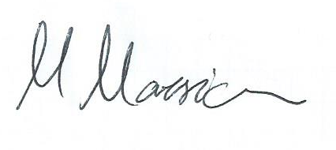
Maria Marsico MD,
(the Corresponding Author)

