Name of Journal: World Journal of Gastrointestinal Oncology
Manuscript NO: 51321
Manuscript Type: ORIGINAL ARTICLE

Retrospective Study
Surgical intervention for malignant bowel obstruction caused by gastrointestinal malignancies

Chen PJ et al. Surgery for malignant bowel obstruction

Peng-Ju Chen, Lin Wang, Yi-Fan Peng, Nan Chen, Ai-Wen Wu

Peng-Ju Chen, Lin Wang, Yi-Fan Peng, Nan Chen, Ai-Wen Wu, Key Laboratory of Carcinogenesis and Translational Research (Ministry of Education), Department of Gastrointestinal Cancer Center, Unit III, Peking University Cancer Hospital and Institute, Beijing 100142, China

Author contributions: Chen PJ, Wang L and Peng YF contributed equally to this work; Chen PJ and Wang L designed research; Peng YF performed research; Chen N analyzed data; Chen PJ, Peng YF and Wu AW wrote the paper.

Supported by National Natural Science Foundation of China, No. 81773214.

Corresponding author: Ai-Wen Wu, MD, PhD, Full Professor, Key laboratory of Carcinogenesis and Translational Research (Ministry of Education), Department of Gastrointestinal Cancer Center, Unit III, Peking University Cancer Hospital and Institute, No. 52 Fucheng Road, Haidian District, Beijing 100142, China. wuaw@sina.com

Received: September 27, 2019
Revised: November 27, 2019
Accepted: January 14, 2020
Published online:

Abstract
BACKGROUND
Malignant bowel obstruction (MBO) is a common event for end-stage gastrointestinal cancer patients. Previous studies had demonstrated manifestations and clinical management of MBO with mixed malignancies. There still lack reports of the surgical treatment of MBO.

AIM
To analyze the short-term outcomes and prognosis of palliative surgery for MBO caused by gastrointestinal cancer.

METHODS
A retrospective chart review of 61 patients received palliative surgery between January 2016 to October 2018 was performed, of which 31 patients underwent massive debulking surgery (MDS) and 30 underwent ostomy/by-pass surgery (OBS). The 60-d symptom palliation rate, 30-d morbidity and mortality, and overall survival rates were compared between the two groups.

RESULTS
The overall symptom palliation rate was 75.4% (46/61); patients in the MDS group had significantly higher symptom palliation rate than OBS group (90% vs 61.2%, P = 0.016). Patients with colorectal cancer who were in the MDS group showed significantly higher symptom improvement rates compared to the OBS group (overall, 76.4%; MDS, 61.5%; OBS, 92%; P = 0.019). However, patients with gastric cancer did not show a significant difference in symptom palliation rate between the MDS and OBS groups (OBS, 60%; MDS, 80%; P = 1.0). The median survival time in the MDS group was significantly longer than in the OBS group (10.9 mo vs 5.3 mo, P = 0.05).

CONCLUSION
For patients with MBO caused by peritoneal metastatic colorectal cancer, MDS can improve symptom palliation rates and prolong survival, without increasing mortality and morbidity rates.

Key words: Gastrointestinal neoplasms; Malignant bowel obstruction; Metastasis; Palliative surgery; Prognosis; Quality of life

Chen PJ, Wang L, Peng YF, Chen N, Wu AW. Surgical intervention for malignant bowel obstruction caused by gastrointestinal malignancies. World J Gastrointest Oncol 2020; In press

Core tip: Malignant bowel obstruction (MBO) is a frequent event for patients with end-stage gastrointestinal cancer. There is no consensus on the optimal treatment strategy for improving quality of life and prolonging survival. We performed a retrospective study at a single institution to determine the effects of palliative surgery for MBO in patients with gastrointestinal cancers. In this cohort, we observed higher symptom relief rates and prolonged survival after massive debulking surgery compared with ostomy/by-pass surgery in MBO patients. For select patients with MBO caused by metastatic colorectal cancer, massive debulking surgery can result in higher symptom palliation rates and prolonged survival without increasing mortality and morbidity rates compared with ostomy/by-pass surgery.

INTRODUCTION
Malignant bowel obstruction (MBO) is a frequent event for patients with end-stage cancer, especially in gastrointestinal (GI) and ovarian cancer^{[1-3]}. It had been reported that 10%-50% of patients with cancer will develop MBO during the preterminal stage^{[4]}. Patients with MBO suffered from an inability to eat, abdominal pain, distention, nausea, and vomiting, resulting in a poor quality of life (QOL), stress, and emotional problems.
The clinical management of MBO requires a specific and individualized approach based on the expected rest time of the disease, objectives of care, and the patient's preferences. The primary treatment objective in patients with MBO is to relieve symptoms, restore food intake, and improve nutrition^{[5]}. The most common treatment options for patients with MBO included nasogastric drainage, total parenteral nutrition, pain control, somatostatin, endoscopically placed stents, and palliative surgery^{[4]}. Due to the heterogeneity of MBO patients, there is no consensus on the optimal treatment strategy for improving QOL and prolonging survival. The decision making of the management of MBO should be individualized^{[6]}.
Surgical intervention is usually considered to be the last treatment option that may relieve the symptoms of MBO. However, the decision to proceed with palliative surgery is usually difficult, especially for patients who may only have a few weeks to live. Additionally, MBO patients suffering from malnutrition are not good candidates for surgical intervention because of the high postoperative mortality and morbidity rates. Previous studies included several types of malignancies in their analysis, and most focused on the treatment of ovarian cancer. At present, there is limited evidence on the effectiveness of surgical intervention for MBO^{[7]}.
The surgical treatments for MBO include percutaneous venting gastrostomy, stoma diversion and cytoreductive surgery, etc.^{[8-10]}. However, some patients with extensive peritoneal metastasis may have multiple obstruction sites, and an ostomy or by-pass surgery may not be feasible. Previous studies have shown that some selected patients with recurrent, unresectable colorectal cancer may benefit from cytoreductive surgery, massive tumor debulking surgery and hyperthermic intraperitoneal chemotherapy^{[11-14]}.
We performed a retrospective study at a single institution to determine the effects of palliative surgery for MBO in patients with GI cancers and analyzed symptom palliation rates, postoperative mortality, complications after surgery, and survival rates.

MATERIALS AND METHODS
Patient selection
Between January 2016 to October 2018, we enrolled 61 patients with MBO caused by peritoneal metastasis of gastric and colorectal cancer underwent surgical treatment at the Peking University Cancer Hospital.
Including criteria for patients are: (1) Clinical evidence of bowel obstruction; (2) Obstruction distal to the Treitz ligament; (3) The presence of primary gastric and colorectal cancer; (4) The absence of curable possibilities; (5) Ineffective conservative treatment for obstruction; (6) Expected survival of more than 2 mo; and (7) Patients and their families willing to undergo surgery^{[4]}.
All patients discussed their options with the Multiple Disciplinary Team before the operation, and a treatment plan was developed based on the patients' preferences. The surgical options included ostomy/by-pass surgery (OBS) and massive debulking surgery (MDS).

Indications for OBS: (1) Localized or single-site tumor obstruction; (2) Patients may benefit from further chemotherapy; and (3) Patients and their families do not receive aggressive tumor reductive surgery.

Indications for MDS: (1) Perioperative risk evaluation indicates that patients can tolerate surgery; (2) After imaging and physical examination, it is expected that the obstruction and symptoms can be effectively relieved after operation; (3) Patients can endure at least 2 months of oral feeding and non-obstructive survival; (4) It is expected that at least 2 meters of small intestine will remain after the operation; and (5) Patients and their families had a strong preference for surgery.

Evaluation of surgical effectiveness: (1) Solid food intake and symptom relief rates 60 d after surgery^{[15]}; (2) Postoperative complications and mortality rates within 30 d; and (3) Postoperative survival time.

Statistical analysis
Statistical analysis was performed by using the IBM-SPSS19 software package. The categorical variables were compared by the Pearson’s chi-square test. Overall survival rates were analyzed by the Kaplan-Meier method and the difference between the groups were evaluated by a log-rank test. P < 0.05 was considered as statistically significant. Significant prognostic factors were analyzed using the Cox proportional hazards regression model to determine the independent prognostic factors of MBO caused by colorectal cancer.

RESULTS
Clinicopathological features
A total of 61 patients with GI cancer were enrolled in this study. Of the 61 patients, 38 were male and 23 were female. Patient ages ranged from 19 to 88 years, with an average age of 59.6 ± 11.5 years and a median age of 61 years. The clinical and pathological data of all the patients in this study are shown in Table 1.

Evaluation of surgical effectiveness and survival analysis
In the MDS group, 3 patients showed no evidence of disease. The overall symptom improvement rate was 75.4% (46/51). The overall symptom improvement rate in the MDS group was significantly higher than in OBS group (90% vs 61.3%, respectively, P = 0.016). Re-obstruction occurred in 3 patients after the operation, including 2 in the OBS group and 1 in the MDS group.
Ten patients, including 4 patients in OBS group and 6 patients in the MDS group, continued medical treatment and radiotherapy after the operation. By the final follow-up in June 2019, 38 of the 61 patients had died. The median survival time of the whole group was 6.5 mo, and the 6-mo survival rate was 56.5% (Figure 1A). Patients with colorectal cancer had significant longer median survival than gastric cancer (10.6 mo vs 1.8 mo, P = 0.015, Figure 1B). Patients in MDS group had significant longer median survival than in OBS group (10.9 mo vs 5.3 mo, P = 0.05, Figure 1C). Patients with improvement of symptoms after operation had significant longer median survival than those without (10.9 mo vs 3.9 mo, P = 0.007, Figure 1D).

Postoperative mortality and morbidity
In this cohort, 32 patients had complications within 30-d of surgery. In the MDS group, 1 patient had secondary surgery due to wound infection.
The overall complication rates in the MDS and OBS groups were 48.4% (15/31) and 56.7% (17/30), respectively. There was no significant difference between the two groups (P = 0.611). The mortality rates within 30 days of the operation in the MDS and OBS groups were 19.4% (6/31) and 6.7% (2/30), respectively. There was no significant difference between the two groups (P = 0.255, Table 2).
Because of the short survival time of patients with gastric cancer, we conducted a univariate analysis of MBO in patients with colorectal cancer, and found that surgical approach [hazard ratio (HR) = 2.301, 95%CI: 0.999-5.299, P = 0.05], differentiation (HR = 8.509, 95%CI: 2.455-26.448, P= 0.001), greater omentum metastasis (HR = 7.718, 95%CI: 2.224-26.782, P = 0.001) and distant organ metastasis (HR = 2.375, 95%CI: 1.022-5.253, P = 0.044, Table 3) were independent prognostic factors for MBO caused by metastatic colorectal cancer (mCRC).

DISCUSSION
MBO patients represent a complex and heterogeneous population, and there are no evidence-based guidelines to help with the decision-making process for clinical management of the disease. Previous studies have reported on the effectiveness of palliative surgery for MBO, most of which focused on gynecologic and GI cancer populations^{[17-19]}. However, there is little data on palliative surgery for MBO in colorectal cancer patients and most of the literature that included colorectal cancer combined several types of malignancies.
In this cohort study focused on GI cancer, we observed higher symptom relief rates and prolonged survival after MDS compared with OBS in MBO patients. For select patients with MBO caused by peritoneal mCRC, MDS can result in higher symptom palliation rates and prolonged survival without increasing mortality and morbidity rates compared with OBS. However, because of the short survival time of GI cancer patients, no surgical intervention which may cause a patient to spend the remainder of their life in the hospital should be seriously considered.
The priority of care for inoperable and conservative MBO patients is to control their symptoms and improve their QOL. Medical treatment combining total parenteral nutrition, opioids, antiemetics, and somatostatin drugs is usually considered to be the preferred treatment^{[20]}. The primary goals in palliative surgery are symptom relief and the restoration of oral feeding. Single site obstructions can be resolved by endoscopic treatment and ostomy^{[21,22]}. However, some patients with complete obstructions may have multiple sites that are occlusive, and therefore, tumor reduction surgery becomes a necessity.
The overall symptom relief rate of all the patients included in this study was 76.1%. The MDS group achieved a higher symptom relief rate than the OBS group (91.3% vs 60.9%, respectively), which was higher than that reported in the literature^{[15]}. The re-obstruction rate was 6.5% in this group, which was lower than the 9% reported in the literature^{[23]}. In this group, although the obstructions were removed, the symptom improvement rate in the OBS group was not high, and 40% of these patients still needed parenteral nutritional support.
Previous studies reported that the median survival for MBO patients treated with conservative care was no longer than 4–5 wk^{[24]}. For some MBO patients, surgical intervention can prolong survival^{[1,4,25-27]}. In this study, the overall median survival time was 6.5 mo. The patients who underwent MDS had a longer survival time than those who underwent OBS (median survival time was 11.5 mo vs 5.1 mo, respectively), and a longer survival time than those reported in previous literature (4-9 mo)^{[28,29]}.
In this cohort, the patients that showed significant symptom improvement and good oral food intake had significantly longer survival times than those who did not. This indicates that palliative surgery, although aimed at relieving symptoms, has also prolonged survival, likely due to the improvement in nutrition and subsequent systemic treatment. These results were in accordance with the literature^{[26]}. However, due to the high heterogeneity of patients with malignant intestinal obstructions, it is usually difficult for surgeons to determine the best surgical approach before the operation is performed^{[5]}.
Although MDS and OBS can improve the QOL and potentially the survival time, these benefits are accompanied by high mortality and complication rates. In this study, the 30-d postoperative complication rates were as high as 54.3% and 13%, respectively, which are similar to those reported in previous literature (6%-40%) and 5%-15%, respectively^{[5,18,28,30]}. Notably, patients undergoing OBS had comparable complication rate and mortality after surgery as patients in the MDS group, suggesting that the short-term prognosis of patients cannot be overlooked.
Much of the literature defines surgical benefit as at least 60 d of survival after the operation. In this cohort, the median survival of gastric cancer patients was only 1.8 mo, suggesting surgery should not be routinely undertaken in patients with end-stage gastric cancer. However, MBO patients with colorectal cancer may benefit from surgical intervention especially for select patients that can withstand treatment with MDS. Previous studies have suggested candidate prognostic indicators that a patient has a low likelihood of benefiting from surgery for MBO. Age, surgical treatment, ascites, low albumin, hypoproteinemia, and primary tumors are reported to be the main prognostic factors. The number of combined risk factors determines survival rates and the incidence rates of short-term complications after surgery^{[6,18,27,28,31]}. Before any palliative surgical intervention is performed, the feasibility of surgery and the probability that a patient will benefit not only from an improvement in QOL but in terms of survival should be taken into consideration^{[32]}. In this cohort, survival analysis showed that the primary tumor site, differentiation, the surgical approach, the ECOG score and greater omentum metastasis were the prognostic factors for MBO patients with GI cancer. Whereas in mCRC, differentiation, surgical approach, greater omentum metastasis and distant organ metastasis were the most important independent prognostic factors.
The limitations of this study were the small sample size and the high heterogeneity of the patients. We lacked the data on the use of medical antineoplastic drugs and the patient KARS/BRAF status. There may also be selection bias that affects the conclusions. Although symptom relief and survival benefit were observed in this group, the risk of serious complications and mortality cannot be ignored. Surgeons should fully weigh the life-expectancy, potential benefits and risks, and the QOL of patients after the operation. The aim of surgical and other approaches must be considered and prioritized based on each patient’s and family’s goals and preferences. Although surgeons usually actively treat postoperative complications, it is may be unacceptable for some patients with end-stage diseases spending the rest life in hospital.
Because of the patient heterogeneity, it seems impossible to conduct a random study of malignant intestinal obstruction. In the future, registry studies may be needed to provide high-level evidence about the treatment of MBO and the QOL of patients should be taken into account.
In conclusion, because of the short expected-survival time for patients with gastric cancer and MBO, the high perioperative complication and mortality rates should be seriously considered before any surgical intervention is performed even for an ostomy. For select patients with MBO caused by peritoneal mCRC, MDS may result in high symptom palliation rates and prolonged survival compared with OBS, without increasing mortality and morbidity rates.

ARTICLE HIGHLIGHTS
Research background
Malignant bowel obstruction (MBO) is a frequent event for end-stage malignant cancers. There is no consensus on the optimal treatment strategy for improving quality of life and prolonging survival. There were fewer studies focused on the surgical intervention of MBO with gastrointestinal (GI) cancers.

Research motivation
We wanted to investigate the effects of palliative surgery for MBO in patients with GI cancers in order to guide treatment.

Research objectives
To define the surgical outcome difference between massive debulking surgery (MDS) and ostomy/by-pass surgery (OBS) for MBO patients with GI cancer.

Research methods
MBO patients with GI cancer receive palliative surgery were included MDS group and OBS group. This study mainly investigated the difference of short outcome and survival between the two groups.

Research results
This study reported that patients in the MDS group had significantly higher symptom palliation rate than OBS group, and the median survival time in the MDS group was significantly longer than in the OBS group.

Research conclusions
Massive debulking surgery can significantly improve symptom and prolong survival for MBO patients with colorectal cancer, without increasing mortality and morbidity rates compared with ostomy/by-pass surgery. However, MDS had no such advantage in gastric cancer.

Research perspectives
The treatment of MBO remained controversial and no well-evidenced. This small sample study demonstrates the effectiveness, safety and survival benefit of massive debulking surgery in colorectal cancer patients with MBO. It is difficult to carry out large sample randomized controlled study. In the future, it is necessary to establish a large sample registration study

REFERENCES
1 Anthony T, Baron T, Mercadante S, Green S, Chi D, Cunningham J, Herbst A, Smart E, Krouse RS. Report of the clinical protocol committee: development of randomized trials for malignant bowel obstruction. J Pain Symptom Manage 2007; 34: S49-S59 [PMID: 17544243 DOI: 10.1016/j.jpainsymman.2007.04.011]
2 Miller G, Boman J, Shrier I, Gordon PH. Small-bowel obstruction secondary to malignant disease: an 11-year audit. Can J Surg 2000; 43: 353-358 [PMID: 11045093]
3 Nelen SD, van Putten M, Lemmens VEPP, Bosscha K, de Wilt JHW, Verhoeven RHA. Effect of age on rates of palliative surgery and chemotherapy use in patients with locally advanced or metastatic gastric cancer. Br J Surg 2017; 104: 1837-1846 [PMID: 28791679 DOI: 10.1002/bjs.10621]
4 Tuca A, Guell E, Martinez-Losada E, Codorniu N. Malignant bowel obstruction in advanced cancer patients: epidemiology, management, and factors influencing spontaneous resolution. Cancer Manag Res 2012; 4: 159-169 [PMID: 22904637 DOI: 10.2147/CMAR.S29297]
5 Paul Olson TJ, Pinkerton C, Brasel KJ, Schwarze ML. Palliative surgery for malignant bowel obstruction from carcinomatosis: a systematic review. JAMA Surg 2014; 149: 383-392 [PMID: 24477929 DOI: 10.1001/jamasurg.2013.4059]
6 Bento JH, Bianchi ET, Tustumi F, Leonardi PC, Junior UR, Ceconello I. Surgical Management of Malignant Intestinal Obstruction: Outcome and Prognostic Factors. Chirurgia (Bucur) 2019; 114: 343-351 [PMID: 31264572 DOI: 10.21614/chirurgia.114.3.343]
7 Lilley EJ, Cooper Z, Schwarze ML, Mosenthal AC. Palliative Care in Surgery: Defining the Research Priorities. Ann Surg 2018; 267: 66-72 [PMID: 28471764 DOI: 10.1097/SLA.0000000000002253]
8 Dolan EA. Malignant bowel obstruction: a review of current treatment strategies. Am J Hosp Palliat Care 2011; 28: 576-582 [PMID: 21504999 DOI: 10.1177/1049909111406706]
9 Dastur JK, Forshaw MJ, Modarai B, Solkar MM, Raymond T, Parker MC. Comparison of short-and long-term outcomes following either insertion of self-expanding metallic stents or emergency surgery in malignant large bowel obstruction. Tech Coloproctol 2008; 12: 51-55 [PMID: 18512013 DOI: 10.1007/s10151-008-0399-5]
10 Thampy S, Najran P, Mullan D, Laasch HU. Safety and Efficacy of Venting Gastrostomy in Malignant Bowel Obstruction: A Systematic Review. J Palliat Care 2019: 825859719864915 [PMID: 31448682 DOI: 10.1177/0825859719864915]
11 Verwaal VJ, Boot H, Aleman BM, van Tinteren H, Zoetmulder FA. Recurrences after peritoneal carcinomatosis of colorectal origin treated by cytoreduction and hyperthermic intraperitoneal chemotherapy: location, treatment, and outcome. Ann Surg Oncol 2004; 11: 375-379 [PMID: 15070596 DOI: 10.1245/ASO.2004.08.014]
12 Kecmanovic DM, Pavlov MJ, Ceranic MS, Sepetkovski AV, Kovacevic PA, Stamenkovic AB. Treatment of peritoneal carcinomatosis from colorectal cancer by cytoreductive surgery and hyperthermic perioperative intraperitoneal chemotherapy. Eur J Surg Oncol 2005; 31: 147-152 [PMID: 15698730 DOI: 10.1016/j.ejso.2004.09.021]
13 Anwar S, Peter MB, Dent J, Scott NA. Palliative excisional surgery for primary colorectal cancer in patients with incurable metastatic disease. Is there a survival benefit? A systematic review. Colorectal Dis 2012; 14: 920-930 [PMID: 21899714 DOI: 10.1111/j.1463-1318.2011.02817.x]
14 Gootjes EC, Bakkerus L, Ten Tije AJ, Witteveen PO, Buffart TE, Bridgewater JA, Primrose JN, Verhoef C, Verheul HMW. The value of tumour debulking for patients with extensive multi-organ metastatic colorectal cancer. Eur J Cancer 2018; 103: 160-164 [PMID: 30243064 DOI: 10.1016/j.ejca.2018.07.012]
15 Blair SL, Chu DZ, Schwarz RE. Outcome of palliative operations for malignant bowel obstruction in patients with peritoneal carcinomatosis from nongynecological cancer. Ann Surg Oncol 2001; 8: 632-637 [PMID: 11569777]
16 Dindo D, Demartines N, Clavien PA. Classification of surgical complications: a new proposal with evaluation in a cohort of 6336 patients and results of a survey. Ann Surg 2004; 240: 205-213 [PMID: 15273542 DOI: 10.1097/01.sla.0000133083.54934.ae]
17 Tran E, Spiceland C, Sandhu NP, Jatoi A. Malignant Bowel Obstruction in Patients With Recurrent Ovarian Cancer. Am J Hosp Palliat Care 2016; 33: 272-275 [PMID: 25552305 DOI: 10.1177/1049909114566225]
18 Alese OB, Kim S, Chen Z, Owonikoko TK, El-Rayes BF. Management patterns and predictors of mortality among US patients with cancer hospitalized for malignant bowel obstruction. Cancer 2015; 121: 1772-1778 [PMID: 25739854 DOI: 10.1002/cncr.29297]
19 Chen JH, Huang TC, Chang PY, Dai MS, Ho CL, Chen YC, Chao TY, Kao WY. Malignant bowel obstruction: A retrospective clinical analysis. Mol Clin Oncol 2014; 2: 13-18 [PMID: 24649301 DOI: 10.3892/mco.2013.216]
20 Currow DC, Quinn S, Agar M, Fazekas B, Hardy J, McCaffrey N, Eckermann S, Abernethy AP, Clark K. Double-blind, placebo-controlled, randomized trial of octreotide in malignant bowel obstruction. J Pain Symptom Manage 2015; 49: 814-821 [PMID: 25462210 DOI: 10.1016/j.jpainsymman.2014.09.013]
21 Jang SH, Lee H, Min BH, Kim SM, Kim HS, Carriere KC, Min YW, Lee JH, Kim JJ. Palliative gastrojejunostomy versus endoscopic stent placement for gastric outlet obstruction in patients with unresectable gastric cancer: a propensity score-matched analysis. Surg Endosc 2017; 31: 4217-4223 [PMID: 28281127 DOI: 10.1007/s00464-017-5480-6]
22 Vashi PG, Dahlk S, Vashi RP, Gupta D. Percutaneous endoscopic gastrostomy tube occlusion in malignant peritoneal carcinomatosis-induced bowel obstruction. Eur J Gastroenterol Hepatol 2011; 23: 1069-1073 [PMID: 21975697 DOI: 10.1097/MEG.0b013e32834b0e2a]
23 Fiori E, Lamazza A, Schillaci A, Femia S, Demasi E, Decesare A, Sterpetti AV. Palliative management for patients with subacute obstruction and stage IV unresectable rectosigmoid cancer: colostomy versus endoscopic stenting: final results of a prospective randomized trial. Am J Surg 2012; 204: 321-326 [PMID: 22575396 DOI: 10.1016/j.amjsurg.2011.11.013]
24 Santangelo ML, Grifasi C, Criscitiello C, Giuliano M, Calogero A, Dodaro C, Incollingo P, Rupealta N, Candida M, Chiacchio G, Riccio E, Pisani A, Tammaro V, Carlomagno N. Bowel obstruction and peritoneal carcinomatosis in the elderly. A systematic review. Aging Clin Exp Res 2017; 29: 73-78 [PMID: 27837464 DOI: 10.1007/s40520-016-0656-9]
25 Jiménez-Pérez J, Casellas J, García-Cano J, Vandervoort J, García-Escribano OR, Barcenilla J, Delgado AA, Goldberg P, Gonzalez-Huix F, Vázquez-Astray E, Meisner S. Colonic stenting as a bridge to surgery in malignant large-bowel obstruction: a report from two large multinational registries. Am J Gastroenterol 2011; 106: 2174-2180 [PMID: 22085816 DOI: 10.1038/ajg.2011.360]
26 Goto T, Takano M, Aoyama T, Miyamoto M, Watanabe A, Kato M, Sasaki N, Hirata J, Sasa H, Furuya K. Outcomes of palliative bowel surgery for malignant bowel obstruction in patients with gynecological malignancy. Oncol Lett 2012; 4: 883-888 [PMID: 23162616 DOI: 10.3892/ol.2012.835]
27 Henry JC, Pouly S, Sullivan R, Sharif S, Klemanski D, Abdel-Misih S, Arradaza N, Jarjoura D, Schmidt C, Bloomston M. A scoring system for the prognosis and treatment of malignant bowel obstruction. Surgery 2012; 152: 747-56; discussion 756-7 [PMID: 22929404 DOI: 10.1016/j.surg.2012.07.009]
28 Abbas SM, Merrie AE. Resection of peritoneal metastases causing malignant small bowel obstruction. World J Surg Oncol 2007; 5: 122 [PMID: 17958911 DOI: 10.1186/1477-7819-5-122]
29 Krouse RS. Surgical management of malignant bowel obstruction. Surg Oncol Clin N Am 2004; 13: 479-490 [PMID: 15236730 DOI: 10.1016/j.soc.2004.03.006]
30 Miner TJ, Brennan MF, Jaques DP. A prospective, symptom related, outcomes analysis of 1022 palliative procedures for advanced cancer. Ann Surg 2004; 240: 719-26; discussion 726-7 [PMID: 15383799]
31 Cousins SE, Tempest E, Feuer DJ. Surgery for the resolution of symptoms in malignant bowel obstruction in advanced gynaecological and gastrointestinal cancer. Cochrane Database Syst Rev 2016; : CD002764 [PMID: 26727399 DOI: 10.1002/14651858.CD002764.pub2]
32 Ripamonti C, Bruera E. Palliative management of malignant bowel obstruction. Int J Gynecol Cancer 2002; 12: 135-143 [PMID: 11975672]

Footnotes
Institutional review board statement: This study was reviewed and approved by the Ethics Committee of Peking University Cancer Hospital and Institute, approval No. 2019YJZ46.

Informed consent statement: Patients were not required to give informed consent to the study because the analysis used anonymous clinical data.

Conflict-of-interest statement: The authors have nothing to disclose.

Data sharing statement: No additional data are available.

Open-Access: This is an open-access article that was selected by an in-house editor and fully peer-reviewed by external reviewers. It is distributed in accordance with the Creative Commons Attribution Non Commercial (CC BY-NC 4.0) license, which permits others to distribute, remix, adapt, build upon this work non-commercially, and license their derivative works on different terms, provided the original work is properly cited and the use is non-commercial. See: http://creativecommons.org/licenses/by-nc/4.0/

Manuscript source: Unsolicited manuscript

Peer-review started: September 27, 2019
First decision: November 18, 2019
Article in press:

Specialty type: Oncology
Country of origin: China
Peer-review report classification
Grade A (Excellent): 0
Grade B (Very good): B, B
Grade C (Good): C
Grade D (Fair): 0
Grade E (Poor): 0

P-Reviewer: Tokunaga Y, Majewski M, Nair KS S-Editor: Wang JL L-Editor: E-Editor:

Figure Legends

A
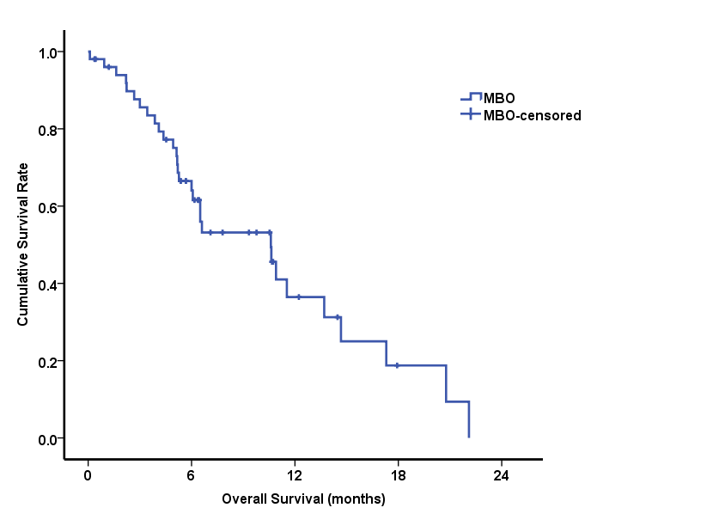
B
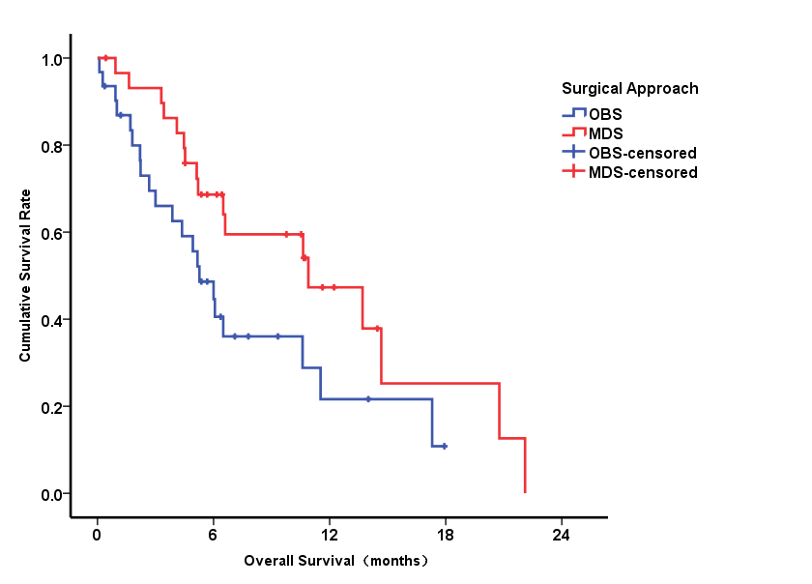
C
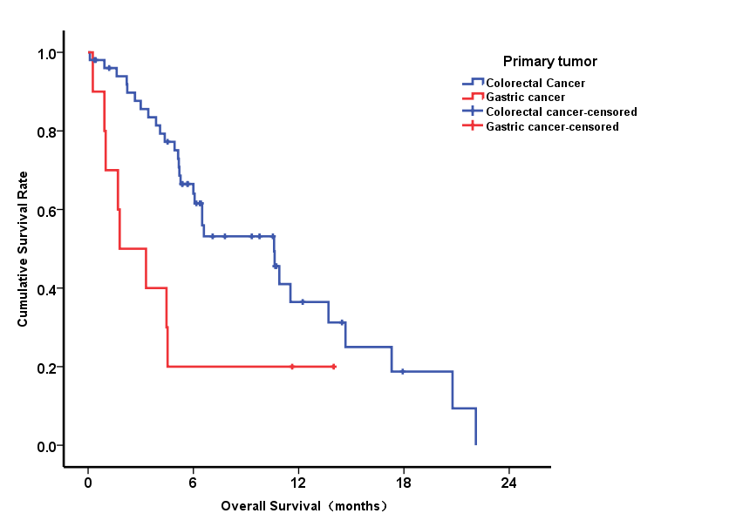
D
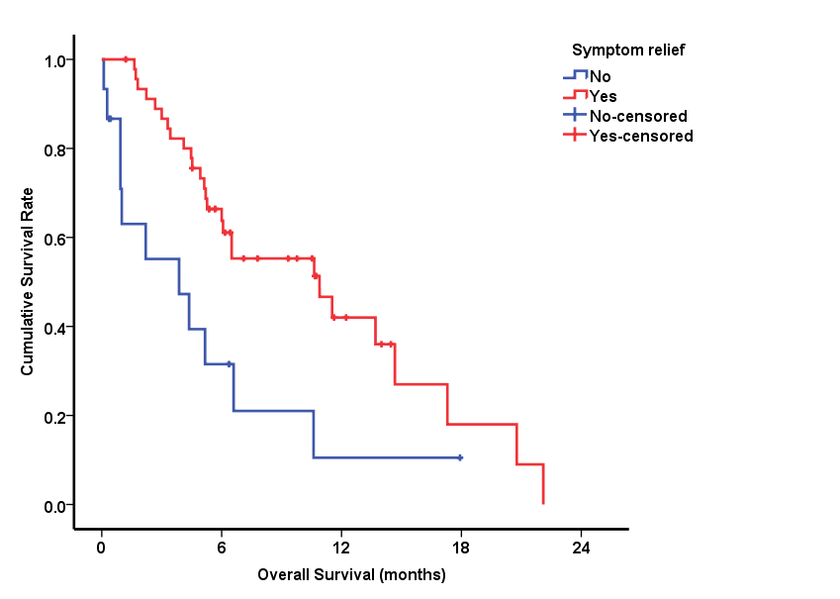
Figure 1 Kaplan-Meier curves of overall survival for patients. A: Overall survival for patients with 61 malignant bowel obstruction patients (median survival time of 6.5 mo); B: Overall survival for patients of ostomy/by-pass surgery group and massive debulking surgery group; C: Overall survival for patients with colorectal cancer and gastric cancer; D: Overall survival for patients of improvement of symptoms after operation. MBO: Malignant bowel obstruction; MDS: Massive debulking surgery; OBS: Ostomy/by-pass surgery.

Table 1 Clinicopathological features and survival of 61 malignant bowel obstruction cases
Clinicopathological features | n (%) | 6-mo OS | Median survival time (mo) | P value
Gender |  |  |  | 0.923
Male | 38 (65.2) | 54.7% | 6.6
Female | 23 (34.8) | 59.2% | 6.4
Age (yr) |  |  |  | 0.516
≥ 60 | 33 (54.1) | 50.4% | 6.5
< 60 | 28 (45.9) | 61.5% | 10.6
Primary tumor |  |  |  | 0.015
Colorectal | 51 (69.6) | 83.6% | 10.6
Gastric | 10 (30.4) | 16.4% | 1.8
Differentiation |  |  |  | 0.005
Well + Moderate | 41 (67.2) | 71.5% | 10.9
Poor | 20 (32.8) | 26.5% | 4.1
ECOG |  |  |  | 0.031
0-1 | 40 (65.6) | 64.4% | 10.6
>1 | 21 (34.4) | 42.9% | 5.1
Surgical approach |  |  |  | 0.053
OBS | 31 (50.8) | 44.6% | 5.3
MDS | 30 (49.2) | 68.6% | 10.9
Obstruction |  |  |  | 0.25
Single | 41 (67.2) | 57% | 6.6
Multiple | 20 (32.8) | 55% | 6.1
Intestinal obstruction |  |  |  | 0.084
Yes | 31 (50.8) | 53.2% | 6.1
No | 30 (49.2) | 60.1% | 10.9
Colon/rectum obstruction |  |  |  | 0.389
Yes | 37 (60.7) | 57.4% | 10.9
No | 24 (39.3) | 54.8% | 6.5
Ascites |  |  |  | 0.691
Yes | 15 (24.6) | 41.1% | 5.1
No | 46 (75.4) | 61.1% | 6.6
Greater omentum metastasis |  |  |  | 0.044
Yes | 42 (68.9) | 51.2% | 6.1
No | 19 (31.1) | 67.5% | 17.3
Distant metastasis |  |  |  | 0.13
Yes | 24 (39.3) | 50% | 5.2
No | 37 (60.7) | 60.4% | 10.9
Symptom relief |  |  |  | 0.007
Yes | 46 (75.4) | 63.7% | 10.9
No | 15 (24.6) | 31.5% | 3.9
OBS: Ostomy/by-pass surgery; MDS: Massive debulking surgery; ECOG: Eastern Cooperative Oncology Group; OS: Overall survival.

Table 2 Sixty–one cases of complications after surgery, n (%)
Complications | OBS group (n = 31) | MDS group (n = 30)
Pulmonary infection | 6 (19.4) | 4 (13.3)
Abdominal infection | 2 (6.5) | 4 (13.3)
Incision infection | 3 (9.7) | 4 (13.3)
Urinary tract infection | 1 (3.2) | -
Diarrhea | - | 1 (3.3)
Arrhythmia | 1 (3.2) | -
Hemorrhage | 1 (3.2) | 4 (13.3)
Cerebral infarction | - | 2 (6.7)
Short intestine | - | 2 (6.7)
Necrosis of ostomy mucosa | 2 (6.5) | -
Clavien-Dindo classification^{[16]}
I | - | 1(3.3)
II | 9 (29) | 13 (43.3)
III | - | -
IV | - | 1 (2.3)
V | 6 (19.4) | 2 (6.7)
OBS: Ostomy/by-pass surgery; MDS: Massive debulking surgery.

Table 3 Multivariable analysis prognostic factors of 51 malignant bowel obstruction colorectal cancer patients
Variables | HR | 95% CI | P value
Surgical approach (OBS vs MDS) | 2.301 | 0.999-5.299 | 0.05
Greater omentum metastasis (Yes vs No) | 7.718 | 2.224-26.782 | 0.001
Differentiation (Poor vs Well+ Moderate) | 8.059 | 2.455-26.448 | 0.001
Distant organ metastasis (Yes vs No) | 2.375 | 1.022-5.253 | 0.044
OBS: Ostomy/by-pass surgery; MDS: Massive debulking surgery; HR: Hazard ratio.

