Name of Journal: World Journal of Critical Care Medicine
Manuscript NO: 70812
Manuscript Type: MINIREVIEWS

Point-of-care ultrasound for critically-ill patients: A mini-review of key diagnostic features and protocols

Lau YH et al. POCUS for critically ill patients

Yie Hui Lau, Kay Choong See

Yie Hui Lau, Department of Anaesthesiology, Intensive Care and Pain Medicine, Tan Tock Seng Hospital, Singapore 308433, Singapore

Kay Choong See, Division of Respiratory & Critical Care Medicine, National University Hospital, Singapore 119074, Singapore

Author contributions: Lau YH wrote the manuscript; See KC provided supervision and revised the manuscript.

Corresponding author: Yie Hui Lau, MBBS, Doctor, Department of Anaesthesiology, Intensive Care and Pain Medicine, Tan Tock Seng Hospital, 11 Jalan Tan Tock Seng, Singapore 308433, Singapore. yie_hui_lau@ttsh.com.sg

Received: September 19, 2021
Revised: December 8, 2021
Accepted: February 10, 2022
Published online: March 9, 2022

Abstract
Point-of-care ultrasonography (POCUS) for managing critically ill patients is increasingly performed by intensivists or emergency physicians. Results of needs surveys among intensivists reveal emphasis on basic cardiac, lung and abdominal ultrasound, which are the commonest POCUS modalities in the intensive care unit. We therefore aim to describe the key diagnostic features of basic cardiac, lung and abdominal ultrasound as practised by intensivists or emergency physicians in terms of accuracy (sensitivity, specificity), clinical utility and limitations. We also aim to explore POCUS protocols that integrate basic cardiac, lung and abdominal ultrasound, and highlight areas for future research.

Key Words: Critical care; Echocardiography; Point-of-care testing; Sensitivity and specificity; Ultrasonography

©The Author(s) 2022. Published by Baishideng Publishing Group Inc. All rights reserved.

Citation: Lau YH, See KC. Point-of-care ultrasound for critically-ill patients: A mini-review of key diagnostic features and protocols. World J Crit Care Med 2022; 11(2): 70-84
URL: https://www.wjgnet.com/2220-3141/full/v11/i2/70.htm
DOI: https://dx.doi.org/10.5492/wjccm.v11.i2.70

Core Tip: Point-of-care ultrasound (POCUS) is increasingly being used by intensivists and emergency physicians for the care of critically-ill patients. This mini-review highlights key findings in basic cardiac, lung and abdominal ultrasound, and introduces several POCUS-based protocols, which have practical utility for patient management.

INTRODUCTION
Diagnostic errors in medicine and intensive care are prevalent, with autopsy studies showing substantial misdiagnoses^{[1]}. Point-of-care ultrasonography (POCUS) fills a void to reduce diagnostic uncertainty and some features may also guide prognosis and management. However, image acquisition and interpretation needs to be done with skill and caution to avoid inadvertent over- or underdiagnosis of abnormalities. POCUS misdiagnoses due to inexperience may lead to errors in the treatment that may worsen patients’ outcomes or even be fatal^{[2]}. Each POCUS practitioner must be mindful of this, and follow up or evaluate with alternatives where applicable. It is still important that any form of POCUS should be preceded by clinical examination, which provides complementary information for diagnosis and treatment.
There is an increase in the application of POCUS for managing critically ill patients, performed by intensivists or emergency physicians, who are neither radiologists nor sonographers. POCUS is inexpensive, non-invasive and can be readily available at the bedside. It is thus an important skill-set for anyone who takes care of critically ill patients.
POCUS may be too brief to have in depth interrogation of any pathology found and more detailed scanning is not practical in a busy intensive care unit (ICU) or emergency department. Excessive time taken for image acquisition and measurements may delay other clinical assessment or treatment. If abnormalities are found or if a comprehensive evaluation is required, a formal transthoracic echocardiogram or follow up computed tomography (CT) imaging can then be arranged at a more opportune time.
Results of needs surveys among intensivists reveal emphasis on basic cardiac, lung and abdominal ultrasound^{[3]}, which are the commonest POCUS modalities in the ICU. We thus aim to describe the key diagnostic features of basic cardiac, lung and abdominal ultrasound as practised by intensivists or emergency physicians in terms of accuracy (sensitivity, specificity), clinical utility and limitations. We also aim to explore POCUS-based protocols that integrate these ultrasound features.

Basic critical care echocardiography
Basic critical care echocardiography (CCE) typically involves obtaining 4 echocardiography views (parasternal long axis, parasternal short axis, apical four- chamber, subcostal views) to answer urgent questions at the bedside, regarding myocardial contractility, left ventricular filling, right ventricular dilatation, or the presence of other obvious abnormalities (e.g. large pericardial effusion). Myocardial contractility is usually described in terms of regional wall motion abnormalities such as hypokinesia, dyskinesia or akinesia. Image acquisition and interpretation requiring all 4 of these views require skill and competency in order to complete the assessment in a timely manner. CCE is most often used to evaluate causes of shock, cardiac arrest or acute cardiopulmonary failure. Some key features of basic CCE are summarised in Table 1; examples in Figure 1.

Basic lung ultrasound
Lung ultrasound has also gained popularity because of its relative portability. The added benefit compared to chest radiographs and CT imaging, is that the patient’s clinical course can be conveniently followed up over time with no radiation risk. Lung ultrasound has been shown to reduce the use of chest radiographs and CT scans in critically ill patients by 26% and 47% respectively^{[4]}. The diagnostic accuracy rates of lung ultrasound for cardiogenic pulmonary edema (94% vs 65%, P = 0.03) and for pneumonia (83% vs 66% P = 0.016) are better if paired with CCE, than compared to lung ultrasound alone^{[5]}. Some of the key features and the clinical utility of these features are described in Table 2, with examples in Figure 2.
General limitations to lung ultrasound include a large body habitus, presence of subcutaneous emphysema and thoracic dressings; these limit obtaining adequate windows^{[6]}. Lack of access to training and ultrasound machines also limit more widespread application of lung ultrasound. However, compared to CCE, competency in lung ultrasound can be achieved more quickly with a minimum of 10 scans^{[7]}.

Abdominal ultrasound
While basic cardiac and lung ultrasound features have generally been well-characterized individually, abdominal ultrasound features have instead been studied in the context of integrated protocols. The Focused Assessment with Sonography for Trauma (FAST) incorporates scanning the abdomen, heart, pericardial and pleural spaces in a trauma patient. This subsequently incorporated basic thoracic injury assessment in form of extended FAST (E-FAST). In FAST, abdominal sonography focuses on detecting free fluid in the abdominal cavity which indicates hemoperitoneum associated with significant abdominal injuries. The 4 sonographic views in the FAST exam are the 4 Ps: Pericardial, perihepatic, perisplenic, pelvic regions. The limitations of FAST are that it has low accuracy in the very early post-injury phase, and does not detect retroperitoneal bleeding well. It does not detect early solid organ injuries not accompanied by significant bleeding. It does not replace traditional imaging modalities if there are penetrating injuries^{[8]}. Extended FAST further incorporates basic lung ultrasound to detect pneumothoraces or hemothorax, which has a sensitivity of 78.6%-95.3% (68.1%-99.2%) and specificity of 98.2%-99.8% (97.0%-99.9%) compared to traditional clinical examination and radiological imaging with chest X-ray or CT^{[8]}. Other than FAST, abdominal POCUS in the critical care setting also includes assessing the bladder (to detect retention of urine), kidneys (for hydronephrosis etc.), gallbladder (for cholecystitis etc.), and abdominal aorta (for abdominal aortic aneurysms). Some examples are shown in Figure 3.

POCUS protocols
Since 2001, intensivists and emergency physicians have come up with protocols that integrate the key features of basic cardiac, lung and abdominal ultrasound. These protocols are used to confirm or eliminate certain diagnoses in a stepwise manner. Clinicians perform POCUS as an extension of the physical examination in a problem-oriented approach, and scans are often repeated post intervention.
As with all ultrasound procedures, POCUS is operator dependent. Some of the protocols described also require advanced CCE competencies. The more recent protocols tend to integrate multiple POCUS modalities, and have stepwise diagnostic questions to be answered depending on the clinical context. For lung ultrasound, different protocols have different number of points to assess, which is based on the clinical experience of the authors. Some other examples, which are used to explore causes of shock and cardiac arrest, are listed in Table 3. We also included some protocols which only involved one POCUS modality due to its integration in other protocols (BLUE protocol)^{[9]}, or the unique pathophysiological question it tries to answer (VeXUS)^{[10]}. The clinical benefits of the protocols described below are still pending further study.
The C.A.U.S.E. protocol^{[11]} aims to detect the common diagnoses that may explain a cardiac arrest, such as cardiac tamponade, severe hypovolemia, pulmonary embolism and pneumothorax. It involves 2 sonographic perspectives of the thorax: The 4 chamber view (the subcostal view is recommended), and the anteromedial views of the lung and pleura at the second intercostal space, at the midclavicular line.
The SESAME protocol^{[12]} was initially described for shock or cardiac arrest, aiming to identify the commonest causes, or easiest causes to diagnose or manage. It uses a single microconvex probe which is available on most ultrasound systems. The steps are as follows: (1) Lung ultrasound (BLUE followed by FALLS protocol), because of convenience and it quickly indicates if a fluid challenge is appropriate; (2) Lower femoral vein vascular ultrasound or abdominal ultrasound to detect deep vein thrombosis or free fluid in the abdomen respectively; and (3) This is followed by pericardial and cardiac ultrasound. The benefit of this protocol is that it uses a single “universal” probe which saves time in a crisis.
The PIEPEAR^{[13]} protocol is a 7-step protocol used in the setting of acute clinical deterioration of a critically ill patient. It describes a thought process, and incorporates POCUS assessments: (1) Identifying deranged physiological systems; (2) Screening for causes; (3) Focused ultrasound exam; (4) Making a presumptive diagnosis; (5) Exploring an etiology, including other investigations; (6) Initiating treatment; and (7) Repeating the focused ultrasound to assess the response to treatment, and titrating the treatment accordingly. It includes a 12-step lung and cardiac ultrasound sequence involving inferior vena cava (IVC), right ventricle (RV), left ventricle (LV) systolic and diastolic function, and afterload deduction/calculation.
Another protocol is the Global Ultrasound Check for the Critically Ill (GUCCI) protocol, which integrates multiple protocols^{[14]} and is organised based on 3 syndromes (acute respiratory failure, shock, cardiac arrest) and includes ultrasound-guided procedures. Compared to PIEPEAR, it has specific diagnostic questions to be answered, and has direct, specific management implications.
The ORACLE^{[15]} protocol was designed for ICU patients with coronavirus disease 2019 (COVID-19) infections (O: Left ventricular functiOn, R: Right ventricular disease, A: vAlve disease, C: PeriCardium, L: Lung ultrasound, E: hEmodynamic parameters). It was designed such that POCUS is performed in a structured way while reducing additional staff (e.g. sonographers) exposure to infection. Images were acquired during ward rounds and offline measurements were done outside patient rooms.

Future directions and research
POCUS has proven to be essential in triaging cases in the current COVID-19 pandemic, due to availability of relatively portable devices which are easy to disinfect. It reduces the logistical challenge of transporting patients to radiology suites or echocardiography units. The American Society of Echocardiographers (ASE) protocol combines cardiac, lung and vascular ultrasound and is an option for COVID-19 patients where cardiopulmonary disease requires evaluation. An added advantage of intensivists using POCUS is reducing exposure to other personnel and locations, permitting conservation of personal protective equipment^{[16]}.
Recently, POCUS has started to appear in the secondary survey of adult cardiac life support (ACLS) algorithm, and can be considered especially if it does not interfere with algorithm. This is to identify potentially reversible causes for cardiac arrest^{[17]} or to detect return of spontaneous circulation (ROSC). Depending on the type of shock or history preceding cardiac arrest, targeted CCE may identify clues to the underlying cause such as a plethoric IVC and absence of lung sliding associated with tension pneumothorax, or small/ normal ventricles and collapsed IVC due to hypovolemic shock. CCE may also identify tamponade, thrombus-in-transit, myocardial infarction as a cause of cardiac arrest^{[18]}. However, the International Liaison Committee on Resuscitation (ILCOR) task force recommends that the individual performing POCUS is trained to minimise interruptions to chest compressions. With regards to prognostication, ILCOR currently suggests against the use of POCUS for prognostication during cardiopulmonary resuscitation due to weak evidence for any CCE findings in predicting outcomes. Although a single small randomized controlled trial (RCT) found no improvement in outcomes with use of cardiac ultrasound during cardiopulmonary resuscitation, this result is not definitive and more research is required^{[19]}.
There are other modalities of POCUS, although less commonly performed, that can be useful in the ICU. These include airway ultrasound, screening for deep vein thrombosis (DVT), diaphragm ultrasound and ultrasound to assess the optic nerve sheath diameter. Pre-procedural airway ultrasound improves safety prior to a percutaneous tracheostomy^{[20]}. Diaphragm ultrasound can be used to detect diaphragm dysfunction with great accuracy^{[21]}. Optic nerve sheath diameter ultrasound allows detection of raised intracranial pressure at the bedside and can be used for prognostication post cardiac arrest^{[22]}. Evidence for utility of these POCUS modalities in changing patient-centred outcomes is still lacking. Additionally, the training requirements and learning trajectory remain areas for further development and research.
Currently, there has also been increasing interest in the use of artificial intelligence that provides real-time guidance for probe placement, aids acquisition of optimal images^{[23]}, and helps to reduce exposure of healthcare workers to highly infectious cases^{[24]}. Such technology has also been used to help users identify anatomy and do measurements of cardiac function^{[23]}. Whether these algorithms are able to replace a trained sonographer, improve scan durations and accuracy, and improve healthcare delivery or patient outcomes remain uncertain. Robot-assisted ultrasonography, with scans conducted by operators remotely, has also been described. These devices are 5G-powered with robotic arms manipulated by an operator in another room using a simulated robotic hand^{[25]}.
There are currently few studies evaluating if CCE or multi-organ POCUS has any effect on mortality, which might be confounded by many other factors. One retrospective study found that POCUS done on ED patients prior to interventions such as fluid boluses are associated with care delays and increased in-hospital mortality compared to critically ill patients with no POCUS^{[26]}. Also, being a diagnostic and monitoring tool, the therapies given are variable depending on the clinician so it will be hard to link POCUS’s utility directly with mortality. More studies are nonetheless needed to explore the effect of POCUS on patient-centred outcomes.
Given the multitude of POCUS protocols described, there will unlikely be head-to-head studies or standardization of included devices. Each medical unit needs to adopt POCUS protocols that are relevant to its clinical practice. This process must involve multi-disciplinary stakeholders and trainers so that it remains relevant during different parts of a patient’s hospitalisation. This then leads to standardised curricula so that there can be quality assurance and reduction of inter-operator differences. More importantly, the systemic adoption of POCUS protocols can allow patient-centric outcomes to be studied. Needless to say, access to a point-of-care ultrasound machine is critical in adoption of POCUS on a regular basis. Given how each patient’s critical illness, response to treatment and subsequent trajectory lie on a continuum, it would be useful if the unit has a picture archiving and communication system (PACS) to allow different healthcare providers involved in the care of the patient at different stages of the hospitalisation to compare the images. This system also can be used for POCUS education or competency assessment of POCUS learners by their supervisors. Even without a PACS system, this also can be achieved on ultrasound systems which allow storage of video or still clips. Such documentation may be increasingly important for oversight of POCUS practice, which is one of the concerns raised by the Joint Commission in naming POCUS as one of the top 10 health technology hazards in 2020^{[27]}.
Hand-held POCUS as an extension of physical exam (i.e. stethoscope) is becoming more popular. If POCUS is integrated with structured assessments such as ACLS (Advanced cardiac life support), advanced trauma life support (ATLS), CERTAIN (Checklist for Early Recognition and Treatment of Acute Illness and iNjury), and teams are equipped with ultrasound devices, it can provide additional information at the bedside which may change management. This includes right-siting of patients to the relevant medical disciplines (e.g. a dissecting aortic aneurysm sent to a hospital with cardiac surgery facilities), or pericardiocentesis in a patient who has shock due to tamponade. Pitfalls of incorporating POCUS to routine assessments include inappropriate use of this tool, misdiagnoses by inexperienced operators, excessive time taken, and distraction from clinical assessment and critical resuscitation tasks. POCUS was associated with longer pauses during cardio-pulmonary resuscitation especially comparing between ultrasound-fellowship trained vs non-fellowship trained operators^{[28]}. If it becomes integrated in such structured assessments, teams must be mindful of the caveats and ultrasound operators should be adequately trained, with safety mechanisms inbuilt (e.g. strict timekeeping for pulse-checks and interruptions in cardiopulmonary resuscitation). Such training may also need to focus on POCUS views which are more easily accessed during a resuscitation situation such as anterior lung, and subcostal echocardiography windows.
The quality of handheld devices is still lacking compared to traditional point-of-care- ultrasound systems, which may lead to poorer image quality or artefacts and misinterpretation. This is an area that is rapidly expanding with newer devices that are smaller coming out in the market, including probes that can be connected to smart devices, and recently artificial intelligence-integrated handheld devices.

CONCLUSION
Cardiac, lung and abdominal ultrasound should be part of the skillset of doctors managing critically ill patients. Being operator dependent, the accuracy of POCUS in detecting or excluding abnormalities may be influenced by the operator’s experience. The influence of POCUS findings on treatment also depends on clinician experience. Several protocols combining different POCUS modalities have been described but the validity of these protocols in different settings still needs to be studied. There is a growing body of evidence describing the accuracy of POCUS applications, and with growing experience and competency one hopes that the accuracy will improve. POCUS should be considered a tool to confirm a diagnosis, as an extension of physical examination. More evidence is needed to recommend it as standard of care.

REFERENCES
1 Winters B, Custer J, Galvagno SM Jr, Colantuoni E, Kapoor SG, Lee H, Goode V, Robinson K, Nakhasi A, Pronovost P, Newman-Toker D. Diagnostic errors in the intensive care unit: a systematic review of autopsy studies. BMJ Qual Saf 2012; 21: 894-902 [PMID: 22822241 DOI: 10.1136/bmjqs-2012-000803]
2 Blanco P, Volpicelli G. Common pitfalls in point-of-care ultrasound: a practical guide for emergency and critical care physicians. Crit Ultrasound J 2016; 8: 15 [PMID: 27783380 DOI: 10.1186/s13089-016-0052-x]
3 Lau YH, Loh CH, Fong WK, Siddiqui S, Tan CK, Tan JJ, See KC. Point-of-Care Ultrasound Training Among Intensivists in Singapore: A Multicentre Survey. Ann Acad Med Singap 2020; 49: 630-642 [PMID: 33241251]
4 Peris A, Tutino L, Zagli G, Batacchi S, Cianchi G, Spina R, Bonizzoli M, Migliaccio L, Perretta L, Bartolini M, Ban K, Balik M. The use of point-of-care bedside lung ultrasound significantly reduces the number of radiographs and computed tomography scans in critically ill patients. Anesth Analg 2010; 111: 687-692 [PMID: 20733164 DOI: 10.1213/ANE.0b013e3181e7cc42]
5 Bataille B, Riu B, Ferre F, Moussot PE, Mari A, Brunel E, Ruiz J, Mora M, Fourcade O, Genestal M, Silva S. Integrated use of bedside lung ultrasound and echocardiography in acute respiratory failure: a prospective observational study in ICU. Chest 2014; 146: 1586-1593 [PMID: 25144893 DOI: 10.1378/chest.14-0681]
6 Bouhemad B, Zhang M, Lu Q, Rouby JJ. Clinical review: Bedside lung ultrasound in critical care practice. Crit Care 2007; 11: 205 [PMID: 17316468 DOI: 10.1186/cc5668]
7 See KC, Ong V, Wong SH, Leanda R, Santos J, Taculod J, Phua J, Teoh CM. Lung ultrasound training: curriculum implementation and learning trajectory among respiratory therapists. Intensive Care Med 2016; 42: 63-71 [PMID: 26474994 DOI: 10.1007/s00134-015-4102-9]
8 Montoya J, Stawicki SP, Evans DC, Bahner DP, Sparks S, Sharpe RP, Cipolla J. From FAST to E-FAST: an overview of the evolution of ultrasound-based traumatic injury assessment. Eur J Trauma Emerg Surg 2016; 42: 119-126 [PMID: 26038031 DOI: 10.1007/s00068-015-0512-1]
9 Lichtenstein DA. BLUE-protocol and FALLS-protocol: two applications of lung ultrasound in the critically ill. Chest 2015; 147: 1659-1670 [PMID: 26033127 DOI: 10.1378/chest.14-1313]
10 Beaubien-Souligny W, Rola P, Haycock K, Bouchard J, Lamarche Y, Spiegel R, Denault AY. Quantifying systemic congestion with Point-Of-Care ultrasound: development of the venous excess ultrasound grading system. Ultrasound J 2020; 12: 16 [PMID: 32270297 DOI: 10.1186/s13089-020-00163-w]
11 Hernandez C, Shuler K, Hannan H, Sonyika C, Likourezos A, Marshall J. C.A.U.S.E.: Cardiac arrest ultra-sound exam--a better approach to managing patients in primary non-arrhythmogenic cardiac arrest. Resuscitation 2008; 76: 198-206 [PMID: 17822831 DOI: 10.1016/j.resuscitation.2007.06.033]
12 Lichtenstein DA. How can the use of lung ultrasound in cardiac arrest make ultrasound a holistic discipline. The example of the SESAME-protocol. Med Ultrason 2014; 16: 252-255 [PMID: 25110767 DOI: 10.11152/mu.2013.2066.163.dal1]
13 Yin W, Li Y, Wang S, Zeng X, Qin Y, Wang X, Chao Y, Zhang L, Kang Y, Ccusg CCUSG. The PIEPEAR Workflow: A Critical Care Ultrasound Based 7-Step Approach as a Standard Procedure to Manage Patients with Acute Cardiorespiratory Compromise, with Two Example Cases Presented. Biomed Res Int 2018; 2018: 4687346 [PMID: 29992144 DOI: 10.1155/2018/4687346]
14 Tavares J, Ivo R, Gonzalez F, Lamas T, Mendes JJ. Global Ultrasound Check for the Critically lll (GUCCI)-a new systematized protocol unifying point-of-care ultrasound in critically ill patients based on clinical presentation. Open Access Emerg Med 2019; 11: 133-145 [PMID: 31372068 DOI: 10.2147/OAEM.S199137]
15 García-Cruz E, Manzur-Sandoval D, Rascón-Sabido R, Gopar-Nieto R, Barajas-Campos RL, Jordán-Ríos A, Sierra-Lara Martínez D, Jiménez-Rodríguez GM, Murillo-Ochoa AL, Díaz-Méndez A, Lazcano-Díaz E, Araiza-Garaygordobil D, Cabello-López A, Melano-Carranza E, Bucio-Reta E, González-Ruiz FJ, Cota-Apodaca LA, Santos-Martínez LE, Fernández-de la Reguera G, Ramos-Enríquez Á, Rojas-Velasco G, Álvarez-Álvarez RJ, Baranda-Tovar F. Critical care ultrasonography during COVID-19 pandemic: The ORACLE protocol. Echocardiography 2020; 37: 1353-1361 [PMID: 32862474 DOI: 10.1111/echo.14837]
16 Johri AM, Galen B, Kirkpatrick JN, Lanspa M, Mulvagh S, Thamman R. ASE Statement on Point-of-Care Ultrasound during the 2019 Novel Coronavirus Pandemic. J Am Soc Echocardiogr 2020; 33: 670-673 [PMID: 32503704 DOI: 10.1016/j.echo.2020.04.017]
17 Long B, Alerhand S, Maliel K, Koyfman A. Echocardiography in cardiac arrest: An emergency medicine review. Am J Emerg Med 2018; 36: 488-493 [PMID: 29269162 DOI: 10.1016/j.ajem.2017.12.031]
18 Paul JA, Panzer OPF. Point-of-care Ultrasound in Cardiac Arrest. Anesthesiology 2021; 135: 508-519 [PMID: 33979442 DOI: 10.1097/ALN.0000000000003811]
19 Merchant RM, Topjian AA, Panchal AR, Cheng A, Aziz K, Berg KM, Lavonas EJ, Magid DJ; Adult Basic and Advanced Life Support, Pediatric Basic and Advanced Life Support, Neonatal Life Support, Resuscitation Education Science, and Systems of Care Writing Groups. Part 1: Executive Summary: 2020 American Heart Association Guidelines for Cardiopulmonary Resuscitation and Emergency Cardiovascular Care. Circulation 2020; 142: S337-S357 [PMID: 33081530 DOI: 10.1161/CIR.0000000000000918]
20 Osman A, Sum KM. Role of upper airway ultrasound in airway management. J Intensive Care 2016; 4: 52 [PMID: 27529028 DOI: 10.1186/s40560-016-0174-z]
21 Santana PV, Cardenas LZ, Albuquerque ALP, Carvalho CRR, Caruso P. Diaphragmatic ultrasound: a review of its methodological aspects and clinical uses. J Bras Pneumol 2020; 46: e20200064 [PMID: 33237154 DOI: 10.36416/1806-3756/e20200064]
22 Zhang YW, Zhang S, Gao H, Li C, Zhang MX. Prognostic Role of Optic Nerve Sheath Diameter for Neurological Outcomes in Post-Cardiac Arrest Patients: A Systematic Review and Meta-Analysis. Biomed Res Int 2020; 2020: 5219367 [PMID: 33426054 DOI: 10.1155/2020/5219367]
23 Akkus Z, Aly YH, Attia IZ, Lopez-Jimenez F, Arruda-Olson AM, Pellikka PA, Pislaru SV, Kane GC, Friedman PA, Oh JK. Artificial Intelligence (AI)-Empowered Echocardiography Interpretation: A State-of-the-Art Review. J Clin Med 2021; 10 [PMID: 33808513 DOI: 10.3390/jcm10071391]
24 Cheema BS, Walter J, Narang A, Thomas JD. Artificial Intelligence-Enabled POCUS in the COVID-19 ICU: A New Spin on Cardiac Ultrasound. JACC Case Rep 2021; 3: 258-263 [PMID: 33619470 DOI: 10.1016/j.jaccas.2020.12.013]
25 Yu RZ, Li YQ, Peng CZ, Ye RZ, He Q. Role of 5G-powered remote robotic ultrasound during the COVID-19 outbreak: insights from two cases. Eur Rev Med Pharmacol Sci 2020; 24: 7796-7800 [PMID: 32744706 DOI: 10.26355/eurrev_202007_22283]
26 Mosier JM, Stolz U, Milligan R, Roy-Chaudhury A, Lutrick K, Hypes CD, Billheimer D, Cairns CB. Impact of Point-of-Care Ultrasound in the Emergency Department on Care Processes and Outcomes in Critically Ill Nontraumatic Patients. Crit Care Explor 2019; 1: e0019 [PMID: 32166263 DOI: 10.1097/CCE.0000000000000019]
27 ECRI. Institute Top 10 health technology hazards for 2020. [cited 10 August 2021]. Available from: https://www.ecri.org/Landing-2020-top-ten-health-technology-hazards
28 Clattenburg EJ, Wroe P, Brown S, Gardner K, Losonczy L, Singh A, Nagdev A. Point-of-care ultrasound use in patients with cardiac arrest is associated prolonged cardiopulmonary resuscitation pauses: A prospective cohort study. Resuscitation 2018; 122: 65-68 [PMID: 29175356 DOI: 10.1016/j.resuscitation.2017.11.056]
29 Mandavia DP, Hoffner RJ, Mahaney K, Henderson SO. Bedside echocardiography by emergency physicians. Ann Emerg Med 2001; 38: 377-382 [PMID: 11574793 DOI: 10.1067/mem.2001.118224]
30 Casazza F, Bongarzoni A, Capozi A, Agostoni O. Regional right ventricular dysfunction in acute pulmonary embolism and right ventricular infarction. Eur J Echocardiogr 2005; 6: 11-14 [PMID: 15664548 DOI: 10.1016/j.euje.2004.06.002]
31 Pérez-Casares A, Cesar S, Brunet-Garcia L, Sanchez-de-Toledo J. Echocardiographic Evaluation of Pericardial Effusion and Cardiac Tamponade. Front Pediatr 2017; 5: 79 [PMID: 28484689 DOI: 10.3389/fped.2017.00079]
32 Gaspari R, Weekes A, Adhikari S, Noble VE, Nomura JT, Theodoro D, Woo M, Atkinson P, Blehar D, Brown SM, Caffery T, Douglass E, Fraser J, Haines C, Lam S, Lanspa M, Lewis M, Liebmann O, Limkakeng A, Lopez F, Platz E, Mendoza M, Minnigan H, Moore C, Novik J, Rang L, Scruggs W, Raio C. Emergency department point-of-care ultrasound in out-of-hospital and in-ED cardiac arrest. Resuscitation 2016; 109: 33-39 [PMID: 27693280 DOI: 10.1016/j.resuscitation.2016.09.018]
33 Alerhand S, Carter JM. What echocardiographic findings suggest a pericardial effusion is causing tamponade? Am J Emerg Med 2019; 37: 321-326 [PMID: 30471929 DOI: 10.1016/j.ajem.2018.11.004]
34 Himelman RB, Kircher B, Rockey DC, Schiller NB. Inferior vena cava plethora with blunted respiratory response: a sensitive echocardiographic sign of cardiac tamponade. J Am Coll Cardiol 1988; 12: 1470-1477 [PMID: 3192844 DOI: 10.1016/s0735-1097(88)80011-1]
35 Stone MB, Huang JV. Inferior Vena Cava Assessment: Correlation with CVP and Plethora in Tamponade. Glob Heart 2013; 8: 323-327 [PMID: 25690633 DOI: 10.1016/j.gheart.2013.11.004]
36 Fields JM, Davis J, Girson L, Au A, Potts J, Morgan CJ, Vetter I, Riesenberg LA. Transthoracic Echocardiography for Diagnosing Pulmonary Embolism: A Systematic Review and Meta-Analysis. J Am Soc Echocardiogr 2017; 30: 714-723.e4 [PMID: 28495379 DOI: 10.1016/j.echo.2017.03.004]
37 Rudski LG, Lai WW, Afilalo J, Hua L, Handschumacher MD, Chandrasekaran K, Solomon SD, Louie EK, Schiller NB. Guidelines for the echocardiographic assessment of the right heart in adults: a report from the American Society of Echocardiography endorsed by the European Association of Echocardiography, a registered branch of the European Society of Cardiology, and the Canadian Society of Echocardiography. J Am Soc Echocardiogr 2010; 23: 685-713; quiz 786-8 [PMID: 20620859 DOI: 10.1016/j.echo.2010.05.010]
38 Park JH, Kim JH, Lee JH, Choi SW, Jeong JO, Seong IW. Evaluation of right ventricular systolic function by the analysis of tricuspid annular motion in patients with acute pulmonary embolism. J Cardiovasc Ultrasound 2012; 20: 181-188 [PMID: 23346287 DOI: 10.4250/jcu.2012.20.4.181]
39 Kucher N, Rossi E, De Rosa M, Goldhaber SZ. Prognostic role of echocardiography among patients with acute pulmonary embolism and a systolic arterial pressure of 90 mmHg or higher. Arch Intern Med 2005; 165: 1777-1781 [PMID: 16087827 DOI: 10.1001/archinte.165.15.1777]
40 Orde S, Slama M, Yastrebov K, Mclean A, Huang S; College of Intensive Care Medicine of Australia and New Zealand [CICM] Ultrasound Special Interest Group [USIG] . Subjective right ventricle assessment by echo qualified intensive care specialists: assessing agreement with objective measures. Crit Care 2019; 23: 70 [PMID: 30845976 DOI: 10.1186/s13054-019-2375-z]
41 Atkinson PR, Beckett N, French J, Banerjee A, Fraser J, Lewis D. Does Point-of-care Ultrasound Use Impact Resuscitation Length, Rates of Intervention, and Clinical Outcomes During Cardiac Arrest? A Study from the Sonography in Hypotension and Cardiac Arrest in the Emergency Department (SHoC-ED) Investigators. Cureus 2019; 11: e4456 [PMID: 31205842 DOI: 10.7759/cureus.4456]
42 Stenberg Y, Wallinder L, Lindberg A, Walldén J, Hultin M, Myrberg T. Preoperative Point-of-Care Assessment of Left Ventricular Systolic Dysfunction With Transthoracic Echocardiography. Anesth Analg 2021; 132: 717-725 [PMID: 33177328 DOI: 10.1213/ANE.0000000000005263]
43 McKaigney CJ, Krantz MJ, La Rocque CL, Hurst ND, Buchanan MS, Kendall JL. E-point septal separation: a bedside tool for emergency physician assessment of left ventricular ejection fraction. Am J Emerg Med 2014; 32: 493-497 [PMID: 24630604 DOI: 10.1016/j.ajem.2014.01.045]
44 Johnson BK, Tierney DM, Rosborough TK, Harris KM, Newell MC. Internal medicine point-of-care ultrasound assessment of left ventricular function correlates with formal echocardiography. J Clin Ultrasound 2016; 44: 92-99 [PMID: 26179460 DOI: 10.1002/jcu.22272]
45 Caplan M, Durand A, Bortolotti P, Colling D, Goutay J, Duburcq T, Drumez E, Rouze A, Nseir S, Howsam M, Onimus T, Favory R, Preau S. Measurement site of inferior vena cava diameter affects the accuracy with which fluid responsiveness can be predicted in spontaneously breathing patients: a post hoc analysis of two prospective cohorts. Ann Intensive Care 2020; 10: 168 [PMID: 33306164 DOI: 10.1186/s13613-020-00786-1]
46 Preau S, Bortolotti P, Colling D, Dewavrin F, Colas V, Voisin B, Onimus T, Drumez E, Durocher A, Redheuil A, Saulnier F. Diagnostic Accuracy of the Inferior Vena Cava Collapsibility to Predict Fluid Responsiveness in Spontaneously Breathing Patients With Sepsis and Acute Circulatory Failure. Crit Care Med 2017; 45: e290-e297 [PMID: 27749318 DOI: 10.1097/CCM.0000000000002090]
47 Mohammad Abdelfattah W, Mohiedden O, Saad-eldeen Elgammal S, Mohammad Elsayed K, Said Mowafy SM, Mohammad Abdalla R. Distensibility index of inferior vena cava and pulse pressure variation as predictors of fluid responsiveness in mechanically ventilated shocked patients. J Emerg Med, Trauma Acute Care 2020 [DOI: 10.5339/jemtac.2020.2]
48 Lichtenstein DA, Mezière GA, Lagoueyte JF, Biderman P, Goldstein I, Gepner A. A-lines and B-lines: lung ultrasound as a bedside tool for predicting pulmonary artery occlusion pressure in the critically ill. Chest 2009; 136: 1014-1020 [PMID: 19809049 DOI: 10.1378/chest.09-0001]
49 Jiang L, Ma Y, Zhao C, Shen W, Feng X, Xu Y, Zhang M. Role of Transthoracic Lung Ultrasonography in the Diagnosis of Pulmonary Embolism: A Systematic Review and Meta-Analysis. PLoS One 2015; 10: e0129909 [PMID: 26076021 DOI: 10.1371/journal.pone.0129909]
50 Reissig A, Kroegel C. Transthoracic ultrasound of lung and pleura in the diagnosis of pulmonary embolism: a novel non-invasive bedside approach. Respiration 2003; 70: 441-452 [PMID: 14665764 DOI: 10.1159/000074195]
51 Chan KK, Joo DA, McRae AD, Takwoingi Y, Premji ZA, Lang E, Wakai A. Chest ultrasonography vs supine chest radiography for diagnosis of pneumothorax in trauma patients in the emergency department. Cochrane Database Syst Rev 2020; 7: CD013031 [PMID: 32702777 DOI: 10.1002/14651858.CD013031.pub2]
52 Lichtenstein D, Mezière G, Biderman P, Gepner A. The "lung point": an ultrasound sign specific to pneumothorax. Intensive Care Med 2000; 26: 1434-1440 [PMID: 11126253 DOI: 10.1007/s001340000627]
53 Blaivas M, Lyon M, Duggal S. A prospective comparison of supine chest radiography and bedside ultrasound for the diagnosis of traumatic pneumothorax. Acad Emerg Med 2005; 12: 844-849 [PMID: 16141018 DOI: 10.1197/j.aem.2005.05.005]
54 Lichtenstein DA, Mezière G, Lascols N, Biderman P, Courret JP, Gepner A, Goldstein I, Tenoudji-Cohen M. Ultrasound diagnosis of occult pneumothorax. Crit Care Med 2005; 33: 1231-1238 [PMID: 15942336 DOI: 10.1097/01.ccm.0000164542.86954.b4]
55 Lichtenstein D, Goldstein I, Mourgeon E, Cluzel P, Grenier P, Rouby JJ. Comparative diagnostic performances of auscultation, chest radiography, and lung ultrasonography in acute respiratory distress syndrome. Anesthesiology 2004; 100: 9-15 [PMID: 14695718 DOI: 10.1097/00000542-200401000-00006]
56 Yue Lee FC, Jenssen C, Dietrich CF. A common misunderstanding in lung ultrasound: the comet tail artefact. Med Ultrason 2018; 20: 379-384 [PMID: 30167593 DOI: 10.11152/mu-1573]
57 Hansell L, Milross M, Delaney A, Tian DH, Ntoumenopoulos G. Lung ultrasound has greater accuracy than conventional respiratory assessment tools for the diagnosis of pleural effusion, lung consolidation and collapse: a systematic review. J Physiother 2021; 67: 41-48 [PMID: 33353830 DOI: 10.1016/j.jphys.2020.12.002]
58 Lichtenstein DA. Lung ultrasound in the critically ill. Ann Intensive Care 2014; 4: 1 [PMID: 24401163 DOI: 10.1186/2110-5820-4-1]
59 Lichtenstein D. FALLS-protocol: lung ultrasound in hemodynamic assessment of shock. Heart Lung Vessel 2013; 5: 142-147 [PMID: 24364005]
60 Iranpour P, Lall C, Houshyar R, Helmy M, Yang A, Choi JI, Ward G, Goodwin SC. Altered Doppler flow patterns in cirrhosis patients: an overview. Ultrasonography 2016; 35: 3-12 [PMID: 26169079 DOI: 10.14366/usg.15020]
61 Lee JH, Lee SH, Yun SJ. Comparison of 2-point and 3-point point-of-care ultrasound techniques for deep vein thrombosis at the emergency department: A meta-analysis. Medicine (Baltimore) 2019; 98: e15791 [PMID: 31145304 DOI: 10.1097/MD.0000000000015791]
62 Lichtenstein D, Malbrain ML. Critical care ultrasound in cardiac arrest. Technological requirements for performing the SESAME-protocol--a holistic approach. Anaesthesiol Intensive Ther 2015; 47: 471-481 [PMID: 26578398 DOI: 10.5603/AIT.a2015.0072]

Footnotes
Conflict-of-interest statement: KCS has received honoraria from GE Healthcare and Medtronic, and has no other conflicts of interest to disclose. YHL has no conflict of interest to disclose.

Open-Access: This article is an open-access article that was selected by an in-house editor and fully peer-reviewed by external reviewers. It is distributed in accordance with the Creative Commons Attribution NonCommercial (CC BY-NC 4.0) license, which permits others to distribute, remix, adapt, build upon this work non-commercially, and license their derivative works on different terms, provided the original work is properly cited and the use is non-commercial. See: https://creativecommons.org/Licenses/by-nc/4.0/

Provenance and peer review: Unsolicited article; Externally peer reviewed.

Peer-review model: Single blind

Peer-review started: September 19, 2021
First decision: December 2, 2021
Article in press: February 10, 2022

Specialty type: Critical care medicine
Country/Territory of origin: Singapore
Peer-review report’s scientific quality classification
Grade A (Excellent): 0
Grade B (Very good): B, B
Grade C (Good): 0
Grade D (Fair): 0
Grade E (Poor): 0

P-Reviewer: Gajic O, Surani S S-Editor: Fan JR L-Editor: A P-Editor: Fan JR
Figure Legends
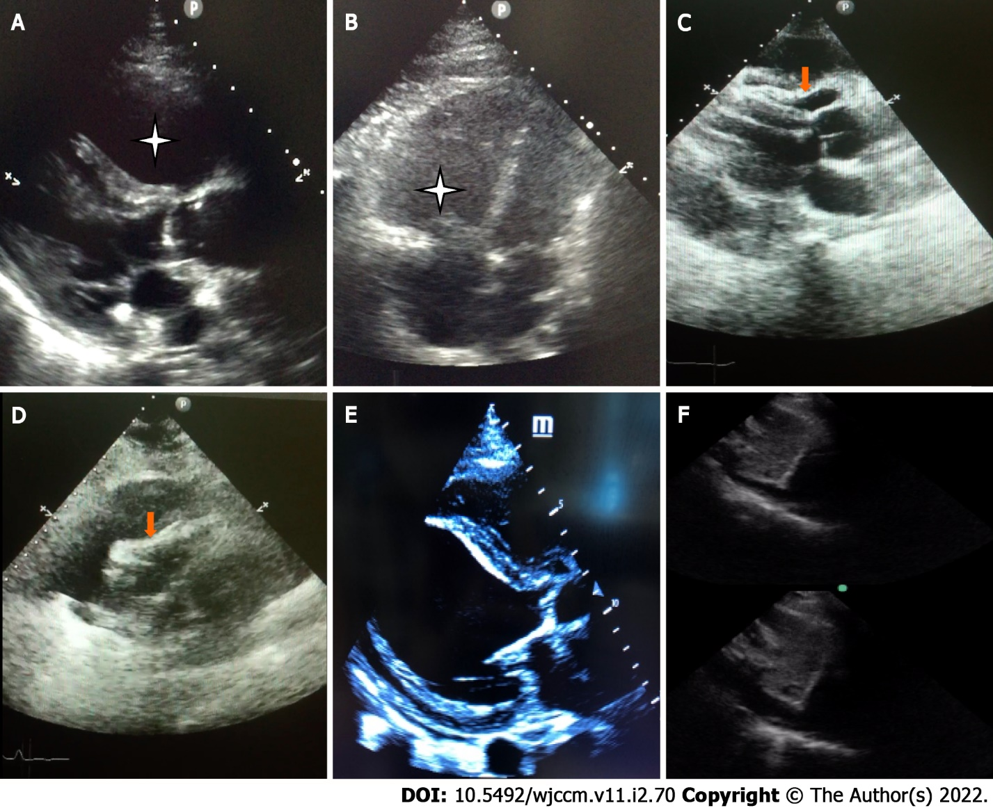
Figure 1 Key features in basic critical care echocardiography. A: Dilated right ventricle [Parasternal long axis (PLAX)]; B: Dilated right ventricle (Apical 4 chamber view); C: Pericardial tamponade-Pericardial effusion with diastolic collapse of right ventricle (PLAX view); D: Pericardial tamponade–Pericardial effusion with systolic collapse of right atrium [subcostal long axis (SLAX) view]; E: Left ventricular dysfunction-minimal thickening and contraction of basal anteroseptal and inferolateral wall with severe hypokinesia (PLAX view); F: Inferior vena cava variation of > 50% with foreceful spontaneous respiration-“sniff test” (SLAX view).
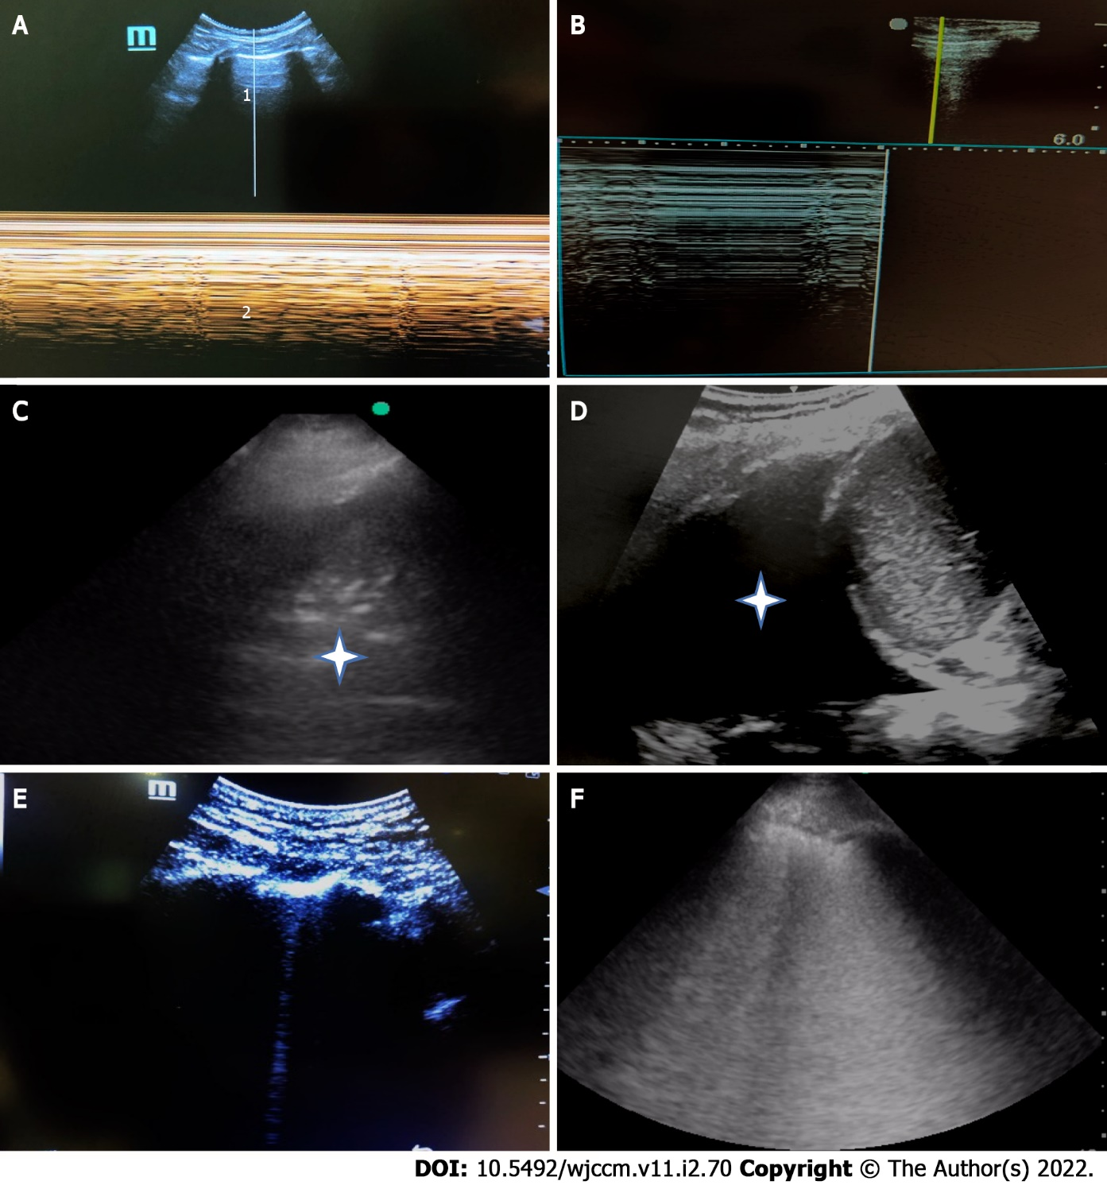
Figure 2 Key features in basic lung ultrasound. A: M-mode lung ultrasound-normal a lines (1), and seashore sign (2); B: M-mode lung ultrasound-pneumothorax Bar code/stratosphere sign; C: Consolidation with air bronchograms (Asterisk); D: Pleural effusion (large); E: 1 single B line-normal; F: B profile, > 3 B lines (confluent)-pathological.
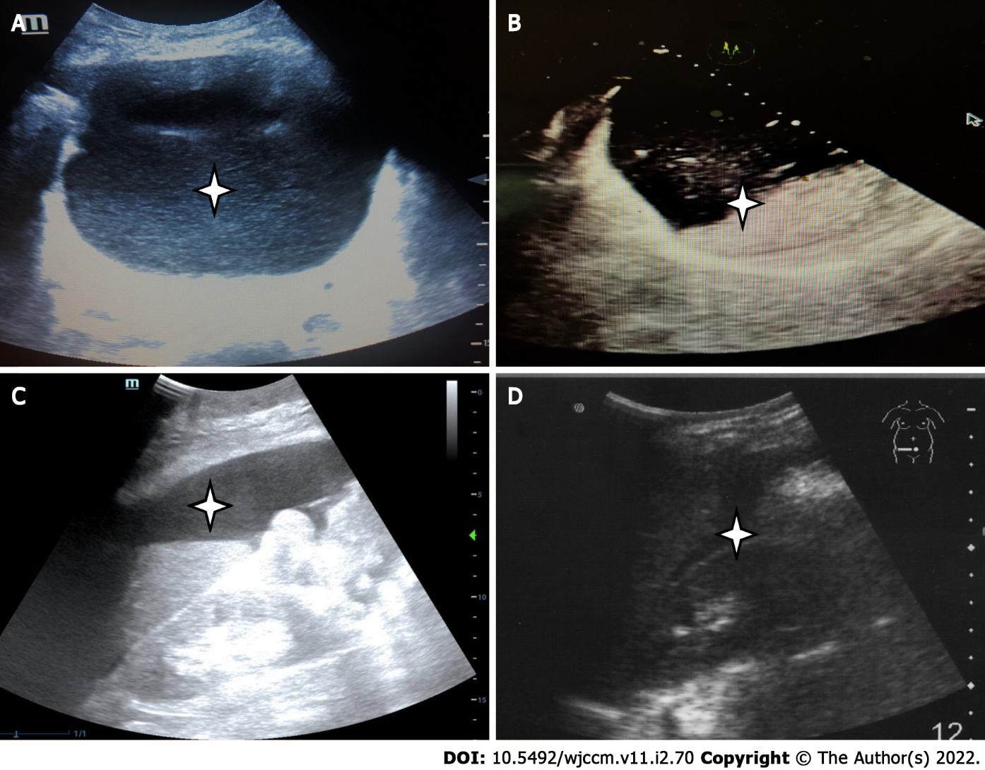
Figure 3 Key features in abdominal ultrasound. A: Bladder overdistension due to acute retention of urine (Asterisk); B: Incomplete gastric emptying (presence of semi-digested food in the stomach, Asterisk), which will indicate need for rapid sequence induction for intubation; C: Ascites (Asterisk); D: Free fluid in the hepato-renal pouch. In cases with abdominal trauma, this indicates intra-peritoneal bleeding (Asterisk).
Table 1 Characteristics of basic critical care echocardiography
 | Key features | Accuracy % (95%CI) | Clinical utility | Limitations
Pericardial effusion | Echo-free space between heart and the parietal layer of the pericardium. 15 mL: Minimum detectable by echocardiography; > 50 mL: Pathological. Nature of the fluid-non-echogenic space (serous fluid), echogenic fluid (blood, pus) | ED physicians using a combination of parasternal short and long axis, apical and subcostal views: (1) Sensitivity 96 (90.4-98.9); (2) Specificity 98 (95.7-98.7); (3) PPV 92.5 (85.8- 96.7); and (4) NPV 98.9 (97.3-99.7). Accuracy: 97.5 (95.7-98.7)^{[29]} | Diagnostic, as a cause of dyspnea; Characterisation of fluid; Estimate size of effusion; Guide approach for pericardiocentesis | Pleural effusion, pericardial fat pad may be mistaken as pericardial effusion. Limited echo windows may affect the sensitivity and specificity of CCE. 4 standard views should be done to assess if the effusion is localised or global^{[30]}
Pericardial tamponade | A pericardial effusion with: (1) Diastolic RV collapse; (2) Systolic RA collapse < 1/3 of cardiac cycle (earliest sign); (3) A plethoric IVC with minimal respiratory variation; and (4) Doppler: Exaggerated respiratory cycle changes in mitral and tricuspid valve in-flow velocities (peak E wave velocity will drop at least 25% (mitral) 40% (tricuspid) in expiration compared to inspiration (suggestive of pulsus paradoxus) | (1) Sensitivity 48-60; Specificity 75-90^{[31]} (sensitivity and specificity improves as the severity increases); (2) RA collapse. Sensitivity 55-97; Specificity 33-100^{[31]}. Absence of both RA systolic, RV diastolic collapse: NPPV 90; Sensitivity 95-97; Specificity 40; (3) Sensitivity 92% but not specific^{[32]}; and (4) Pulsus paradoxus itself: Sensitivity 82% (95%CI: 72%–92%); in the presence of pericardial effusion, positive LR 3.3 (95%CI: 1.8-6.3) and negative LR 0.03 (95%CI: 0.01-0.24)^{[31]} | Identifying tamponade as cause of shock. If found to be the cause of cardiac arrest, and had pericardiocentesis after diagnosis, survival to discharge increased by 15.4% (compared to 1.4% without POCUS)^{[33]} | (1) Plethoric IVC may be caused by chronic lung disease, congestive cardiac failure, tricuspid regurgitation; (2) Patients on mechanical ventilation will not demonstrate plethora because inspiration is generated by positive pressure and hence IVC expands rather than collapses^{[34]}; (3) Doppler techniques require more advanced practitioners of POCUS; and (4) Respiratory variation of the mitral and tricuspid inflows should not be used as a sole criterion for tamponade without the presence of chamber collapse, IVC dilation, or abnormal hepatic vein flows (blunting or reversal of diastolic flows in expiration)
Right ventricular dilation and dysfunction | (1) RV dilatation in PE: Diameter-> 42 mm (base), > 35 mm (mid-level). Longitudinal dimension > 86 mm^{[35]}; (2) RV dysfunction in PE, TAPSE < 17.5 mm, indicated abnormal, RV systolic, function^{[36]}; (3) RV hypokinesis; (4) Right heart thrombi; (5) Ventricular interdependence; (6) Leftward septal displacement; and (7) McConnell sign (Normal contraction or sparing of the RV apex with hypokinesis of midportion of the RV free wall) | (1) Enlargement of the RV compared to the LV. Sensitivity 55. Specificity 86^{[37]}; (2) RV dysfunction indicated by abnormal TAPSE Sensitivity 87. Specificity 91. AUC 0.96 (95%CI: 0.87-1.00)^{[36]}; (3) RV hypokinesis for diagnosis of PE. Sensitivity 70. Specificity 33. Predictor of 30-d mortality in PE. Sensitivity 52.4 (43.7-61.0). Specificity 62.7 (59.5-65.8). NPV 90.6 (88.1-92.7). PPV 16.1 (12.8-19.9)^{[38]}; (4) –; (5) –; (6) –; and (7) Sensitivity 70%. Specificity 33; PPV 67; NNV 36^{[30]} | To identify acute cor pulmonale or pulmonary embolism. Various echocardiographic signs can be used to rule in PE, but none can rule it out. This is due to the known variability of PE presentation, clot burden, and physiologic reserve that contribute to pulmonary vascular resistance and acute RH strain^{[36]}. RV dysfunction in PE found to be predictor of early mortality^{[38]}. Presence of right heart thrombi is associated with an increased risk of death in 30 d | Obtaining adequate RV views in critically ill patients may be challenging, especially post abdominal-surgery with a smaller subcostal window. There are numerous methods available to measure RV size and function, yet the parameter that is the most accurate in the critically ill is controversial^{[39]}. McConnell’s sign may also be present in RV infarct and not just PE (i.e. Not specific for PE)
Left ventricular dysfunction^{[40]} | (1) 2D Biplane; (2) Visual ejection fraction; (3) MAPSE < 12 mm; and (4) E-point septal separation > 7 mm | (1) -; (2) Predicts LVEF < 50%. AUROC 0.8 (0.70-0.90); (3) Predicts LVEF < 50%  AUROC 0.73 (0.62-0.84); and (4) Predicts EF < 30%. Sensitivity 100 (95%CI: 62.9-100). Specificity 51.6 (95% CI: 38.6-64.5)^{[41]} | (1) Allows more informed risk counselling, prognostication. Patients with no cardiac activity on PoCUS were much less likely to achieve ROSC, had shorter mean resuscitation times^{[42]}; and (2) Relatively easy and rapid. Internal Medicine physicians were able to identify normal versus decreased LVSF with high sensitivity, specificity, and "good" interrater agreement compared to formal echocardiography after completing a training program^{[43]} | (1) Requires optimal acquisition of endocardial borders, time consuming, requires training; (2) and (3) are rarely done
Variation of IVC diameter with respiration | (1) Collapsibility index, measured 4cm caudal to the right atrium, with a deep standardised inspiration; (2) Distensibility index during intermittent positive pressure ventilation; and (3) IVC collapse of > 50 % | (1) Fluid responsiveness: Depending on whether a standardised or non- standardised spontaneous breath was taken: Sensitivity 66-93 Specificity 99-98^{[44,45]}; (2) Comparable to pulse pressure variation in predicting fluid responsiveness (AUROC 0.75 ± 0.07); (3) Cut off value of 16.5%. Sensitivity 71.4; Specificity 76.5^{[46]}; and (4) In predicting CVP < 8 mmHg: PPV of 87, NPV of 96, AUROC 0.93 | Assessment of fluid responsiveness to avoid unnecessarily fluid boluses. The degree to which the CVP falls during spontaneous inspiration depends upon 3 variables: Cardiac function; The drop in pleural pressure; Venous return | Requires a spontaneously breathing patient, able to cooperate and perform a standardised breath. Accuracy affected by point of measurement along the IVC and the angle of insonation, given the cylindrical nature of the IVC and especially for the use of M-Mode measurements. IVC may be dilated in valvulopathies, pulmonary hypertension or in highly trained athletes^{[25]}. May not accurately indicate volume status because venous return can be affected by other factors e.g. vascular tone. IVC collapsibility may be confounded by pressure within the abdominal cavity e.g. Intra-abdominal hypertension, ascites, IPPV
AUROC: Area under receiver operating characteristic; CVP: Central venous pressure; ED: Emergency department; IPPV: Intermittent positive pressure ventilation; IVC: Inferior vena cava (plethoric IVC defined as diameter > 2.1 cm and < 50% inspiratory reduction); LR: Likelihood ratio; LV: Left ventricle; LVEF: Left ventricular ejection fraction; LVSF: Left ventricular systolic function; MAPSE: Mitral annular plane systolic excursion; NPV: Negative predictive value; PE: Pulmonary embolism; PPV: Positive predictive value; RA: Right atrial; ROSC: Return of spontaneous circulation; RV: Right ventricle; TAPSE: Tricuspid annular plane systolic excursion.
Table 2 Characteristics of basic lung ultrasound
 | Key features | Accuracy % | Clinical utility | Limitations
A-Pattern | Horizontal artifact indicating normal lung surface indicating PAOP ≤ 13 mmHg | Sensitivity 67; Specificity 90^{[47]} | Dry inter-lobular septa. Aeration, response to PEEP and recruitment. Diagnosis/exclusion of large PE | For diagnosis of PE, requires ability to perform DVT scans to support findings. A-pattern may manifest in large pulmonary embolism but not in cases of smaller pulmonary emboli in the peripheral lung parenchyma near the pleural surface may be detected by lung ultrasound^{[48]}, classical described as hypoechoic, pleural-based parenchymal alteration with > 85% of these lesions wedge-shaped^{[49]}. A-lines may be seen in cases of pneumothorax, COPD/asthma
Pneumothorax | May have A pattern due to reflection of air at the parietal pleura. During M-Mode: (1) “Stratosphere”/“Bar code” sign, instead of a seashore sign. During B-Mode; (2) Loss of lung sliding; and (3) Lung point-transition of normal lung sliding/B lines to a pneumothorax pattern (no lung sliding or B lines) at a critical point, during a respiratory cycle | (1) Sensitivity 86-91, Specificity 91-99^{[6,50]}; (2) Sensitivity 67, Specificity 100, PPV 100, NPV 91; and (3) Sensitivity 66. Specificity 100^{[51]} | Early detection in trauma in the emergency department, even for non-radiologists | Absence of "lung sliding" alone may not confirm the presence of pneumothorax. Small, apical pneumothoraces may be false negatives but usually do not require any intervention. False positives in non-trauma critically ill patients due to: (1) Dyspnea; (2) Single lung intubation or esophageal intubation; (3) Lung and pleura adhering together due to ARDS/chronic pleurodesis, cancer, phrenic nerve palsy, large infiltrates/pleural effusion, pulmonary contusions; and (4) Presence of several A lines in patients with asthma/COPD^{[52]}
Occult pneumothorax (detected on CT scan but missed on chest radiography) | (1) Abolition of lung sliding alone; (2) Absent lung sliding plus the A line sign. The A line sign is the presence of A-lines without associated B lines (In normal lung, A lines will be with artifacts such as B lines, and lung sliding); also known as the stratosphere sign; and (3) The lung point | (1) Sensitivity 100, Specificity 78; (2) Sensitivity 95, Specificity 94; and (3) Sensitivity 79, Specificity 100^{[53]} | Reduced need for CT scans, transportation, ionising radiation.  Earlier detection of pneumothorax. | Among controls without pneumothorax, some may have absent lung sliding (false positive)
B-profile | B-lines are vertical ring-down artifacts that do not fade with increasing depth, and move with lung sliding, and obliterate A lines. > 3 is considered pathological. Alveolar-interstitial syndrome. > 2 Comet-tails 7 mm apart, indicating thickened interlobular septa | Sensitivity 97-98, Specificity88-95^{[54]} | Diagnosis of acute hemodynamic pulmonary edema. Other differentials: Generalised–acute or chronic interstitial lung disease, acute lung injury/acute respiratory distress syndrome. Focal–related to pneumonia, pulmonary contusion, lung tumours, other pulmonary consolidating processes^{[55]}. May be due to Gravity-related dependent edema may be present in dependent areas. May be used with other POCUS modalities e.g. CCE to diagnose underlying cause of interstitial syndrome | Comet tails, which are short (1cm) reverberation artifacts, may be mistaken as B-lines. Unlike B-lines, comet tails do not obliterate A-lines, fades with increasing depth. They may be present in normal lung^{[55]}. Lacks utility in patient with known pre-existing interstitial syndrome unless there are prior scans for comparison. False positives: (1) Physiological B-lines may be present in 10% of healthy population; and (2) Older persons may have more B-lines and chest areas positive
Consolidation | Hypoechoic tissue with hyperechoic punctiform images (air-bronchograms). C-profile in the BLUE protocol: Anterior lung consolidation or thick, irregular pleural line^{[40]} | Sensitivity 92-93, Specificity 92-100^{[54,56]} |  | Atelectasis may appear similar and be misinterpreted as consolidation (false positive). This can be differentiated from consolidation by the lung pulse and dynamic air bronchogram^{[57]}
Pleural effusion | Fluid collection in pleural space, above diaphragm. Able to detect as little as 15 mm. Quantification of amount of pleural effusion: A pleural effusion ≥ 800 mL is predicted when interpleural distance was > 45 mm (right) or > 50 mm (left) | Sensitivity 91-93, Specificity 92-93^{[56]} (Right side) Sensitivity 94, Specificity 76 (Left side), Sensitivity 100, Specificity 67 | Non-invasive, radiation-free detection of pleural effusion which can also guide bedside drainage. Avoids need for transportation for CT-imaging. May show features which further characterises the type of effusion; septations, debris, heterogeneous fluid collections which are suggestive of an exudative effusion; anechoic, homogenous fluid which suggests transudative effusion. Guides location for thoracocentesis. At least 2 cm of interpleural distance required as a minimum indication for thoracocentesis | In patients with an elevated hemidiaphragm, inappropriate diaphragm visualization may lead to mistaking effusion for sub-diaphragmatic ascites. May be confused with pericardial effusion. Peri-procedure complications and injury may occur if the heart/subdiaphragmatic organs are overlooked thinking a pericardial/subdiaphragmatic effusion is a pleural effusion. Loculated effusions may be missed or misjudged with inadequate scanning especially in posterior areas
ARDS: Acute respiratory distress syndrome; COPD: Chronic obstructive pulmonary disease; CT: Computed tomography; DVT: Deep vein thrombosis PAOP: Pulmonary artery occlusion pressure; PE: Pulmonary embolism; PEEP: Positive end expiratory pressure; PLAPS: Posterolateral alveolar and/or pleural syndrome, a posterior continuation of the lower BLUE point.
Table 3 Point-of-care ultrasonography protocols in intensive care unit and emergency departments
Modalities used | Protocols (Year described) | Clinical utility | Limitations
Lung ultrasound only | BLUE protocol^{[9]} (2008). (1) Nude profile (No abnormalities, A-profile with no DVT); (2) B-profile: Anterior lung rockets with lung sliding. Causes: Acute pulmonary oedema; (3) Pulmonary embolism (A-profile with DVT); (4) Pneumothorax (A’-profile with lung point); and (5) Pneumonia, 4 profiles (B’ profile, A/B, C-profile, no-V-PLAPS profile) | Diagnosis in acute respiratory failure. A simple, dichotomous protocol which uses a single microconvex probe without need for advanced techniques (1) Accuracy 90.5%, Sensitivity 89%, Specificity 97%, PPV 87%, NPV 99%; (2) Sensitivity 97% (89%-100%), Specificity 95% (91%-98%)^{[9,58]}, LR+ 21.1, LR- 0.03; (3) Sensitivity 81% (58%-95%), Specificity 99% (98%-100%), LR+ 193, LR- 0.19; (4) Sensitivity 88% (52%-100%) Specificity 100% (99%-100%), LR+ (infinity), LR- 0.11; and (5) All 4 profiles: Sensitivity 89 (80%-95%), Specificity: 94 (90%-97%), LR+ (15.8), LR- (0.11) | Pneumonia can generate a B-profile without anterior consolidation. Initial publication excluded patients post hoc with multiple diagnoses
Abdominal ultrasound only | VExUS^{[10]} (2020). Evaluates IVC congestion and severity of congestion in 3 organs: Liver, gut, kidneys | (1) Indicates risk of post-cardiac surgery acute kidney injury related to venous congestion; (2) Potentially may guide fluid interventions to improve organ perfusion; and (3) Severe VExUS grade C and subsequent development of subsequent AKI after cardiac surgery. Sensitivity 27% (CI 15%-47%); Specificity 96% (CI 89%-99%) (+LR: 6.37 CI 2.19-18.5) | (1) Does not identify the source of venous congestion; (2) Currently not yet validated in other clinical settings or successful interventions to change outcomes; (3) Includes difficult and complex image acquisition and measurements; (4) Hepatic vein Doppler may be influenced by tricuspid regurgitation; pulsatile portal vein flow and IVC dilatation have been reported in healthy athletic volunteers (potential false positive)^{[10]}; and (5) Hepatic and portal vein Doppler waveforms may be abnormal in cirrhotics due to arterio-portal shunting, such as reversal of portal venous flow; pulsatile or helical portal venous flow^{[59]}
Cardiac and lung ultrasound | C.A.U.S.E^{[11]} (2008). 4 chamber view of the heart + lung ultrasound. Diagnosis of (1) Pericardial tamponade; (2) Tension pneumothorax; (3) Pulmonary embolus; and (4) Hypovolemia | Aims to detect the 4 leading causes of non-arrhythmogenic cardiac arrest without interfering with resuscitation (1) Poor to moderate sensitivity as routine screening in all patients suspected of pulmonary emboli, but good to excellent specificity; and (2) Collapsed IVC or < 5 mm should prompt fluid resuscitation. > 20 mm suggests pump failure (congestive heart failure, cardiac tamponade, PE)
 | FALLS (Fluid Administration Limited by Lung Sonography) protocol^{[60]} 2013. Combines CCE and BLUE-protocol lung ultrasound to assess causes of circulatory failure | (1) For expediting a diagnosis; (2) Guides fluid management in acute circulatory failure e.g. cessation of inappropriate fluid boluses; (3) Sequentially rules out obstructive, cardiogenic, then hypovolemic shock for expediting the diagnosis of distributive (usually septic) shock^{[60]}; and (4) Allows earlier fluid therapy before confirmation of sepsis | (1) Absence of cardiac windows will limit earlier parts of the protocol, requires lung ultrasound (PE section); (2) Presence of diffuse lung rockets (B-profile, B’ profile) on initial assessment will exclude patients from this protocol because fluid administration cannot be guided by transformation of A-lines to B-lines, but fluids can be given using other POCUS findings; and (3) Cardiogenic shock due to RV failure (with low wedge pressure) will not be easily diagnosed as it is usually associated with A-profile. Do ECG to rule out right sided myocardial infarction
 | ORACLE^{[15]} (2020). O: Left ventricular functiOn, R = Right ventricular disease, A = vAlve disease, C = periCardium, L = Lung ultrasound, E = hEmodynamic parameters | (1) ICU, COVID-19 patients; and (2) Cardiac and pulmonary evaluations | (1) Intermediate to advanced echo skills required with several measurements required; and (2) Requires at least 20 min in trained hands, may take longer for novices
 | PIEPIER (2018)^{[13]}. 12 step lung ultrasound + CCE: IVC, RV, LV systolic and diastolic function, and afterload deduction/calculation | A stepwise approach to diagnosing causes of cardio-respiratory failure, including consideration of etiology, interventions and reassessments | Requires experience for image interpretation, diagnosis and intermediate echocardiography
Cardiac, lung, venous | ASE POCUS protocol for COVID-19 pandemic^{[16]} (2020). (1) Cardiac (basic views); (2) Lung (8 or 12 point); and (3) Vascular [IVC, leg veins (optional)] | (1) Outlines structures to be imaged, parameters to assess and measure, and disease associations; (2) May assist in the initial cardiopulmonary assessment of patients with COVID-19; (3) Also includes device cleaning checklist; and (4) Mentions need for storing and documenting POCUS results to reduce the need for repeat examination | In the case of difficult image acquisition, and it may be more efficient for a skilled sonographer to rapidly scan the patient, rather than have a POCUS operator struggle with prolonged attempts
Cardiac, lung and abdominal ultrasound | SHoC-ED^{[42]} (2018). Combines ACES (abdominal and cardiothoracic evaluation with sonography in shock), and RUSH (rapid ultrasound in Shock and Hypotension) | Cardiac: Assess LV/RV function, size and presence of pericardial effusion. Lung: Base of lung-lung sliding. Abdominal-free fluid, AAA, IVC for size and collapsibility | An RCT in ED involving patients with undifferentiated hypotension did not detect significant difference in 30 d or hospital survival, media fluid administered, inotrope administration
Cardiac, lung, venous and abdominal | GUCCI (2019)^{[14]}. (1) Acute respiratory failure: Lung ultrasound + cardiac + vascular ultrasound; and (2) Shock: Cardiac + lung + vascular + abdominal ultrasound | Guide diagnosis and interventions in acute respiratory failure, shock and cardiac arrest (e.g. Defibrillation) | Needs competency in other modes of POCUS
 | SESAME (2015)^{[12]}. 5 steps: (1) Lung ultrasound (BLUE followed by FALLS protocol); (2) Lower femoral vein vascular ultrasound “V-point”: A distal, lower superficial femoral vein; (3) Abdominal ultrasound; (4) Pericardium; and (5) Cardiac ultrasound | Severe shock or cardiac arrest. Assess for tension pneumothorax, hypovolemia, pulmonary embolism, pericardial tamponade, free abdominal fluid as a cause of cardiac arrest | (1) Uses a single microconvex probe, which may not be available on all ultrasound systems; (2) Limitations due to body habitus; (3) Evaluates for VTE only at the “V-point”, which is different from other VTE POCUS protocols which require assessment of 2 or more points on the lower limb veins^{[61]}. 50% of patients with massive PE have DVT at the V-point, i.e. may be absent in 50%. Examining at one isolated point may not be as comprehensive as other protocols, but the author justifies this to avoid spending excessive time where there is low yield; and (4) Presence of DVT is used to “rule in” pulmonary embolism” as a cause of cardiac arrest^{[62]}
AAA: Abdominal aortic aneurysm; AKI: Acute kidney injury; A4C: Apical 4 chamber; CCE: Critical care echocardiography; DVT: Deep vein thrombosis; ED: Emergency department; FAST: Focused assessment with sonography for trauma; IVC: Inferior vena cava; LR+: Positive likelihood ratio; LR-: Negative likelihood ratio; LV: Left ventricle; PE: Pulmonary embolism; PLAPS: Posterolateral alveolar and/or pleural syndrome; PLax: Parasternal long axis; POCUS: Point-of-care-ultrasound; RCT: Randomised controlled trial; RUSH: Rapid Ultrasound in Shock and Hypotension; RV: Right ventricle; VEXus: Venous Excess Ultrasonography Score; VTE: Venous thromboembolism; ICU: Intensive care unit.

Published by Baishideng Publishing Group Inc
7041 Koll Center Parkway, Suite 160, Pleasanton, CA 94566, USA
Telephone: +1-925-3991568
E-mail: bpgoffice@wjgnet.com
Help Desk: https://www.f6publishing.com/helpdesk
https://www.wjgnet.com

© 2022 Baishideng Publishing Group Inc. All rights reserved.

