Name of Journal: World Journal of Orthopedics
Manuscript NO: 77564
Manuscript Type: SYSTEMATIC REVIEWS

Patient-reported dissatisfaction following second side in staged bilateral total knee arthroplasty: A systematic review

Gruenberger E et al. Patient dissatisfaction in staged bilateral TKA

Eric Gruenberger, Andrew S Bae, Tyler Kelly, Brent A Ponce, James McGrory

Eric Gruenberger, Tyler Kelly, Brent A Ponce, The Hughston Foundation, Columbus, GA 31909, United States

Andrew S Bae, Department of Orthopedic Surgery, Jack Hughston Memorial Hospital, Phenix City, AL 36867, United States

James McGrory, Department of Orthopedic Surgery, Hughston Foundation and Jack Hughston Memorial Hospital, Columbus, GA 31909, United States

Author contributions: Gruenberger E and Bae AS contributed to data collection, data analysis, and manuscript writing; McGrory J contributed to study design, manuscript writing, and revisions; Ponce BA contributed to study design; Kelly T contributed to data analysis and manuscript revisions.

Corresponding author: Eric Gruenberger, MD, Research Fellow, The Hughston Foundation, 6262 Veterans Parkway, Columbus, GA 31909, United States. ehgruenberger@gmail.com

Received: May 6, 2022
Revised: August 16, 2022
Accepted: October 5, 2022
Published online: November 18, 2022

Abstract
BACKGROUND
Around one third of patients who undergo total knee arthroplasty (TKA) will eventually have the contralateral knee replaced. Overall patient satisfaction after staged bilateral total knee arthroplasty procedures performed on different days is reportedly similar to unilateral TKA. Nevertheless, in our anecdotal experience patients often report less satisfying outcomes following the second side. A cursory review of available literature tended to confirm that observation. We sought therefore to consolidate all of the available data on this issue to further investigate this phenomenon.

AIM
To consolidate available published data revealing satisfaction scores among patients following staged bilateral TKA, and to evaluate the phenomenon of less satisfying results following TKA2.

METHODS
A systematic review of available literature reporting on satisfaction with TKA1 and TKA2 after staged bilateral knee arthroplasty was undertaken using PubMed, Google Scholar, and Embase. From 427 records, five full-length articles met criteria for inclusion in the meta-analysis. The data were then extracted and assessed on the basis of the Reference Citation Analysis (https://www.referencecitationanalysis.com/).

RESULTS
A total of 1889 patients with an average age of 68 (range: 38–92) underwent staged bilateral TKA with outcomes reported at 1 year following each TKA with a mean 21.9 mo between surgeries (range: 2 d to 14.5 years). Overall satisfaction with both knees was 83.70% (1581) and dissatisfaction with both knees was 2.75% (52). In the remaining 13.56% (256) who were dissatisfied with one side, 61.0% were dissatisfied with TKA2, and 39.0% were dissatisfied with TKA1. Patient-reported outcome scores for TKA2 were frequently lower than TKA1 even in patients reporting overall satisfaction with both knees.

CONCLUSION
At 1-year follow-up, there was a 50% greater risk of dissatisfaction with TKA2 among the 13.56% of patients reporting dissatisfaction in one knee after staged bilateral TKA. Whether the interval between procedures or long-term follow-up changes these results requires further investigation.

Key Words: Staged; Staggered; Sequential; Bilateral arthroplasty; Total knee arthroplasty; Patient-reported outcomes

©The Author(s) 2022. Published by Baishideng Publishing Group Inc. All rights reserved.

Citation: Gruenberger E, Bae AS, Kelly T, Ponce BA, McGrory J. Patient-reported dissatisfaction following second side in staged bilateral total knee arthroplasty: A systematic review. World J Orthop 2022; 13(11): 1029-1037
URL: https://www.wjgnet.com/2218-5836/full/v13/i11/1029.htm
DOI: https://dx.doi.org/10.5312/wjo.v13.i11.1029

Core Tip: Total knee arthroplasty (TKA) is one of the most popular and successful treatments for end stage arthritis worldwide. Around one third of patients who undergo TKA will eventually have the contralateral knee replaced. Anecdotal experience has shown that patients tend to report decreased satisfaction following the second TKA procedure (TKA2). The primary aim of this review article was to assess patient satisfaction following TKA2 after staged bilateral knee arthroplasty. Ideally, quantifying reported dissatisfaction as well as reporting associated factors.

INTRODUCTION
Total knee arthroplasty (TKA) is a highly effective procedure for the treatment of end stage arthritis and is the most common arthroplasty procedure performed worldwide^{[1,2]}. As such, it is important to investigate patient satisfaction and quality of life following surgery. Patient-reported outcomes and scoring systems have become essential measurement tools, particularly given the limited correlation that functional outcome scores and other direct measurement data have with patient satisfaction^{[3,4]}. Patient scoring systems were first introduced in the 1990’s to investigate function in the context of quality of life and have since been used clinically, and in research, to reaffirm patient wellness in surgical healthcare^{[4,5]}. Although a majority of patients report satisfactory outcomes following TKA, an estimated 10%-20% report being dissatisfied in the absence of clinical complications^{[1,2,6-8]}. Investigation into factors predicting dissatisfaction tend to revolve around failure to meet expectations, recall bias, and physiologic rationale for hypersensitivity to pain^{[3,5]}. Previous studies have also demonstrated associations with variables such as patient gender, patient age, history of rheumatoid arthritis, as well as patient personality traits^{[3]}. There is also evidence that a history of any previous arthroplasty - not necessarily a previous knee replacement - lowered the expectations for the outcome of TKA^{[9]}.
In patients who have undergone total knee replacement, 25% or more will go on to have the contralateral side replaced^{[2,6,10]}. Much of the literature on bilateral knee replacement focuses on pain improvement, functional outcomes, safety, efficiency, and cost-effectiveness of simultaneous bilateral TKA (one anesthesia event) compared to staged or staggered TKA (two anesthesia events)^{[2,7,11]}. Unlike unilateral TKA, there is very limited data on patient satisfaction following staged TKA, particularly comparing one side to the other. In our anecdotal experience, many patients who have undergone staged bilateral knee replacement report less satisfying results with the second side (TKA2). Review of available literature on this issue revealed some data that tended to confirm this observation^{[7,12]}. Reported reasons included failure to meet the anticipated improvements of pain and function compared to the first side (TKA1), slower return to activity, and inability to engage in full activity. Still, others provide no specific reasons for preferring TKA1 over TKA2, with some reporting uncertainty about their satisfaction with TKA2^{[7-9,11,13]}. To consolidate these data, and better understand the phenomenon of unilateral dissatisfaction following staged bilateral TKA, we performed a systematic review of available literature reporting on both patient-reported outcomes and satisfaction.

MATERIALS AND METHODS
We queried PubMed, Embase, and Google Scholar for articles using: “staged” or “staggered” or “sequential” and “bilateral arthroplasty” and “patient-reported outcomes.” PRISMA guidelines were followed for inclusion and exclusion of articles as shown in Figure 1. This review was submitted for registration with PROSPERO (ID: 299833). Only full-text articles with an English version available were included. Additional inclusion criteria were individually reported Oxford Knee Scores (OKS) as a patient reported outcome measure, and/or a satisfaction score for each knee, with follow-up of at least 1 year. Exclusion criteria included abstracts only, follow-up information missing, individual scores for each knee missing, and simultaneous knee replacement. The initial search returned 427 records; 397 had been excluded after screening, leaving 30 full-text articles. Of these, five articles explicitly reported information comparing outcome data between TKA1 to TKA2 for each patient. To determine the disparity in satisfaction between sides, we recorded the satisfaction scores of TKA1 and TKA2 or the OKS of TKA1 and TKA2 for patients that reported unequal satisfaction.
Patients who reported being uncertain about one knee and dissatisfied with the other were grouped according to the dissatisfied knee. Patients who reported being uncertain with one knee and satisfied with the other were grouped according to the uncertain knee. Patients with an OKS score difference below the minimal clinically important difference (MCID) for only one knee were considered dissatisfied with that knee; patients with an OKS score difference between knees that exceeded the MCID for the study, were considered dissatisfied with knee with the lower OKS. The use of the OKS to predict satisfaction was based on previous literature^{[14]}.

STATISTICS
Weighted values were used to calculate the average age and interval between surgeries.
The Q = W/S method was used to test for normality. Frequency data from each study were used to calculate the relative risk (RR) of TKA2 dissatisfaction in patients who reported unequal satisfaction after bilateral TKA. The RR was used under the assumption that unilateral dissatisfaction is relatively rare (< 10% of patients) and that using the odds ratio may result in an inflated rate of dissatisfaction with TKA2. Statistical significance was set at P < 0.05, chi-square analysis was used to determine the significance of the resultant RR. The Mann-Whitney U test was used to compare the RR of TKA2 dissatisfaction between studies. Calculations were performed using SPSS V.27 (IBM Corp., Armonk, NY, United States).

RESULTS
A total of 1889 patients from five studies underwent staged bilateral TKA with patient reported outcomes and satisfaction recorded at 1 year following each TKA. Two of the five studies (85% of patients) explicitly reported satisfaction. The most common PROMs used were the OKS, the Western Ontario and McMaster Universities Osteoarthritis Index, and short form 12 (SF-12). The average age was 68 years with a range of 38 to 92. The time interval between surgeries was not standardized; the largest study reported the widest interval range of 2 d to 14.5 years between sides, with an average interval of 21.9 mo. Table 1 summarizes the details of the five studies. The results of bias assessment with MINORS criteria are displayed in Table 2. Overall satisfaction with both knees across all studies was 83.70% (1581), and dissatisfaction with both knees was 2.75% (52). Two hundred fifty-six patients (13.56%) reported unequal satisfaction between knees. Assessing each study individually, two cohorts, Suzangar et al^{[4]} and Abram et al^{[5]}, demonstrated a significantly increased relative risk of dissatisfaction with TKA2 vs TKA1. Comparing frequencies between studies, chi-square N-1 comparison showed a difference between Clement et al^{[6]} and Abram et al^{[5]}, in the reported frequency of dissatisfaction with TKA1 and TKA2. No other differences were found within or among studies. The pooled data demonstrated a significant increase in the relative risk of dissatisfaction with TKA2 vs TKA1 among patients who reported unequal satisfaction (RR = 1.49, P < 0.01) shown below in Figure 2. Table 3 summarizes the results.

DISCUSSION
The goal of this review was to consolidate available published data revealing satisfaction scores among patients following staged bilateral TKA, and to evaluate the phenomenon of less satisfying results following TKA2. The overall satisfaction rate for unilateral TKA and bilateral staged TKA is reported at 80%-89% with minimum 2-year follow-up^{[5,15,16]}. Similar to previous reports, we calculated overall satisfaction with both sides of 83.70% after accounting for 52 patients (2.75%) who were dissatisfied with both sides (not included in tables). The remaining 13.56% of the included patients that were unilaterally dissatisfied varied widely by interval between surgeries, age, indications (osteoarthritis, inflammatory, and post-traumatic arthritis were all represented to unknown degrees) and inclusion/exclusion criteria. Although the studies included in this review reported significant differences in the rates of unilateral dissatisfaction, the proportion of patients reporting a preference for TKA1 over TKA2 was similar. Based on pooled data we found that the risk of an unsatisfying result with one side after staged bilateral TKA is about 50% greater for TKA2 (RR = 1.56) at the 1-year follow-up. We also predicted that the interval between TKA1 and TKA2, and the potential influence of recall bias based on the interval between surgeries and follow-up time, could be associated with unilaterally decreased satisfaction after staged bilateral TKA. Although we only included studies reporting results at 1 year, we could not account for the variation in surgical intervals. Therefore, there was not enough data shared among the included studies to determine additional variables associated with our results.

Correlation between Satisfaction and PROMs
Experience with shoulder arthroplasty literature has shown variable strengths of correlation to satisfaction using the Oxford Shoulder Score (moderate correlation, 0.311) and Quick DASH (weak correlation, -0.292)^{[17]}. Unlike the Oxford Shoulder Score, the OKS has been shown to be a reliable, reproducible proxy for detecting patient satisfaction. Clement and colleagues further demonstrated the OKS is a highly accurate model for predicting patient satisfaction (AUC = 0.86)^{[14]}. In patients with bilateral knee arthritis undergoing staged bilateral TKA, the most painful knee is typically replaced first. Unsurprisingly, TKA2 tends to have higher initial OKS scores, smaller gains postoperatively (often attributed to the ceiling effect, where the difference in the patient score and maximum score can be less than the minimum clinically important difference), followed by higher scores than TKA1 at 1 year and beyond^{[18-22]}. However, the differences in OKS scores and satisfaction are reported in the context of high overall satisfaction, and do not readily explain the differences among patients that are dissatisfied with one side, nor the preference for one side over the other in this subgroup. The OKS may be an accurate screening tool for satisfaction, but its use in determining individual reasons for dissatisfaction has not been validated.

Factors affecting satisfaction
Pain was perhaps the most consistently reported factor that strongly correlated with satisfaction after surgery, and there is evidence suggesting the surgical interval and follow-up interval may have a role in actual pain perceived and recall of perceived pain, respectively^{[3,13,18,22,23]}. An interval greater than 1 year has been associated with higher TKA2 satisfaction scores, while intervals less than 6 mo negatively impact TKA2 scores^{[12,13]}. An interval less than 6 mo has also been associated with increased post-operative pain in the first 48 h based on analgesic requirements, suggesting a physiologic rationale for the potential recall bias^{[3,18]}. Conversely, Gabr et al^{[8]} found no difference in TKA2 pain or function scores after stratifying patients by intervals greater than or less than 6 mo. However, they reported TKA2 pain scores gathered beyond 1 year continued to improve with time, even exceeding those of TKA1^{[11]}. Similarly, Clement et al^{[6]} reported an increased interval from TKA1 correlated with increased TKA1 dissatisfaction, along with higher unilateral dissatisfaction with TKA1 over TKA2. Although their findings are contrary to ours, they were similarly unable to determine consistency in factors related to the preferred side in cases of unilateral dissatisfaction. Expectations and perceptions are also associated with satisfaction to varying degrees^{[23]}. High rates of unmet postoperative expectations for activity and pain levels in TKA patients have been reported despite overall satisfaction (83% expected pain-free recovery, 43% met expectations, 52% expected to be fully active after surgery, and 20% achieved this)^{[22]}. Negative psychosocial factors are shown to exaggerate negative clinical predictors and independently influence surgical outcomes, while general perceptions of the hospital stay have been strongly correlated with TKA satisfaction at 1 year^{[3,20,21,24]}. In a study by Scott et al^{[9]}, expectations were lowered in younger individuals and those with high expectations before TKA1, and unilateral dissatisfaction occurred most frequently after TKA2^{[12]}. Above average satisfaction was reported for TKA1 (93%) and TKA2 (87%) in the patients, but satisfaction with either side did not correlate within individuals. These findings further display the multifactorial subjectivity of satisfaction, the difficulty in discerning modifiable risk factors for dissatisfaction, and corroborate our experience and the results of this review.

Limitations
This study was primarily limited by the amount of available evidence reporting individual satisfaction and associated patient-specific variables in those who underwent staged bilateral knee arthroplasties. TKA is the most common arthroplasty procedure worldwide^{[1]}. Considering that 25%–30% of patients undergoing TKA will also have a contralateral TKA within 5 years, there is a substantial portion of the population not accounted for in this review of only 1889 total patients^{[2,6]}. The article by Suzangar et al^{[4]} accounted for over half of the included patients and stochastically dominated the data. The second largest study, by Clement et al^{[6]}, was 50% smaller and showed no difference in dissatisfaction between sides while being appropriately powered. Unlike the larger studies, the smaller studies included here did not show a difference in the risk of dissatisfaction between TKA1 and TKA2. They might have found a difference had the study been powered to do so. Additionally, treatment of Likert data as categorical or continuous is arguable, as is the granularity and balance of the scale (how many points, and whether the mid-point of the scale should be neutral and balanced by equal-opposite positive and negative responses). We treated Likert scales as continuous data, and therefore patients who reported “uncertain” on a 4-point scale were classified as dissatisfied with the uncertain side. Finally, we acknowledge the inherent limitations in use of the OKS as a satisfaction proxy which likely added an element of error, albeit statistically insignificant^{[9,18]}. Nevertheless, the purpose of this review was to consolidate all of the available data to better study the phenomenon of unequal satisfaction following staged bilateral TKA. The OKS has been shown to be accurate for predicting satisfaction, and we believe including the study by Tucker et al^{[10]} improved the statistical power and potentially reduced the bias imparted by larger studies^{[3,9,12,14]}.

CONCLUSION
In patients undergoing staged bilateral TKA, we calculated a 50% increased risk of dissatisfaction with TKA2 compared to TKA1 (RR = 1.56) but could not establish risk factors causally linked to this phenomenon. Reasons for unilateral dissatisfaction appear to be multifactorial and are inconsistent between and within patients. Patient education preoperatively about the possibility and probability of differences in subjective outcomes may help temper expectations and could potentially improve overall patient satisfaction.

ARTICLE HIGHLIGHTS
Research background
Total knee arthroplasty (TKA) is a highly effective procedure for the treatment of end stage arthritis, and is the most common arthroplasty procedure performed worldwide. Although many patients report satisfaction with their outcomes, an estimated 10%–20% report being dissatisfied in the absence of clinical complications. This is significant given that in patients who have undergone total knee replacement, 25% or more will go on to have the contralateral side replaced in the future. Unlike unilateral TKA, there is very limited data on patient satisfaction following staged TKA, particularly comparing one side to the other.

Research motivation
Our motivation arose from the anecdotal experience that patients who have undergone bilateral knee replacement in a staged fashion indicate that the second side (TKA2) had a less satisfying outcome compared to the first side (TKA1). Our initial cursory reviews of the literature also seemed to confirm this experience. However, little is known about the factors associated with these reports. To better understand the phenomenon of unilateral dissatisfaction, the goal of this study was to perform a systematic review on currently available literature investigating patient reported outcomes and satisfaction following staged bilateral TKA.

Research objectives
The primary aim of this review article was to consolidate available published data revealing satisfaction scores among patients following staged bilateral TKA and to evaluate the phenomenon of less satisfying results following TKA2. Ideally, quantifying reported dissatisfaction as well as trending associated factors.

Research methods
A systematic review of available literature reporting on satisfaction with TKA1 and TKA2 after staged bilateral knee arthroplasty was undertaken using PubMed, Google Scholar, and Embase. Among 427 records, five articles meeting inclusion criteria were included in the meta-analysis. Statistical analysis was performed to calculate relative risk of TKA2 dissatisfaction and compare the relative risk of TKA2 dissatisfaction between studies.

Research results
In the five included studies, a total of 1889 patients with an average age of 68 years underwent staged bilateral TKA with patient reported outcomes and satisfaction recorded at 1 year following each TKA. Average time between surgeries was 21.9 mo. Overall satisfaction with both knees was 83.70 % (1581), and dissatisfaction with both knees was 2.75% (52). In the remaining 13.56% (256) who were dissatisfied with one side, 61.0% were dissatisfied with TKA2, and 39.0% were dissatisfied with TKA1. Patient-reported outcome scores for TKA2 were frequently lower than TKA1 even in patients reporting overall satisfaction with both knees.

Research conclusions
In patients undergoing staged bilateral TKA, we calculated a 50% increased risk of dissatisfaction with TKA2 compared to TKA1. Although we were unable to establish risk factors linked to this phenomenon, there is high suspicion that the factors are multifactorial and often patient specific.

Research perspectives
Future directions include investigating the effects of time between surgeries and scheduled long-term follow-up.

REFERENCES
1 Total knee replacement - orthoinfo - aaos. OrthoInfo. Accessed August 2022. https://orthoinfo.aaos.org/en/treatment/total-knee-replacement
2 Walmsley P, Murray A, Brenkel IJ. The practice of bilateral, simultaneous total knee replacement in Scotland over the last decade. Data from the Scottish Arthroplasty Project. Knee 2006; 13: 102-105 [PMID: 16481171 DOI: 10.1016/j.knee.2006.01.003]
3 Memtsoudis SG, Ma Y, Chiu YL, Poultsides L, Gonzalez Della Valle A, Mazumdar M. Bilateral total knee arthroplasty: risk factors for major morbidity and mortality. Anesth Analg 2011; 113: 784-790 [PMID: 21752942 DOI: 10.1213/ANE.0b013e3182282953]
4 Suzangar M, Esler C, Kennedy J, Chatterji U. Bilateral staged primary total knee arthroplasty: Are patients less pleased with their second side? Orthop Res Traumatol Open J 2019; 4: 1-5 [DOI: 10.17140/ORTOJ-4-114]
5 Abram SG, Nicol F, Spencer SJ. Patient reported outcomes in three hundred and twenty eight bilateral total knee replacement cases (simultaneous versus staged arthroplasty) using the Oxford Knee Score. Int Orthop 2016; 40: 2055-2059 [PMID: 26861830 DOI: 10.1007/s00264-016-3122-6]
6 Clement ND, Merrie KL, Weir DJ, Holland JP, Deehan DJ. Asynchronous Bilateral Total Knee Arthroplasty: Predictors of the Functional Outcome and Patient Satisfaction for the Second Knee Replacement. J Arthroplasty 2019; 34: 2950-2956 [PMID: 31331702 DOI: 10.1016/j.arth.2019.06.056]
7 Lizaur-Utrilla A, Serna-Berna R, Vizcaya-Moreno MF, Martinez-Mendez D, Marco-Gomez L, Lopez-Prats FA. Comparison of Functional Outcomes Between the First and Second Knee in Staged Bilateral Total Knee Arthroplasty With Diverse Intervals Between Stages. J Arthroplasty 2018; 33: 2863-2867 [PMID: 29776854 DOI: 10.1016/j.arth.2018.04.033]
8 Gabr A, Withers D, Pope J, Santini A. Functional outcome of staged bilateral knee replacements. Ann R Coll Surg Engl 2011; 93: 537-541 [PMID: 22004637 DOI: 10.1308/147870811X13137608454803]
9 Scott CE, Murray RC, MacDonald DJ, Biant LC. Staged bilateral total knee replacement: changes in expectations and outcomes between the first and second operations. Bone Joint J 2014; 96-B: 752-758 [PMID: 24891574 DOI: 10.1302/0301-620X.96B6.32793]
10 Tucker A, Warnock JM, Cassidy R, Napier RJ, Beverland D. Are patient-reported outcomes the same following second-side surgery in primary hip and knee arthroplasty? Bone Jt Open 2021; 2: 243-254 [PMID: 33881349 DOI: 10.1302/2633-1462.24.BJO-2020-0187.R1]
11 Sun J, Li L, Yuan S, Zhou Y. Analysis of Early Postoperative Pain in the First and Second Knee in Staged Bilateral Total Knee Arthroplasty: A Retrospective Controlled Study. PLoS One 2015; 10: e0129973 [PMID: 26068371 DOI: 10.1371/journal.pone.0129973]
12 Baker PN, van der Meulen JH, Lewsey J, Gregg PJ; National Joint Registry for England and Wales. The role of pain and function in determining patient satisfaction after total knee replacement. Data from the National Joint Registry for England and Wales. J Bone Joint Surg Br 2007; 89: 893-900 [PMID: 17673581 DOI: 10.1302/0301-620X.89B7.19091]
13 Scott CE, Howie CR, MacDonald D, Biant LC. Predicting dissatisfaction following total knee replacement: a prospective study of 1217 patients. J Bone Joint Surg Br 2010; 92: 1253-1258 [PMID: 20798443 DOI: 10.1302/0301-620X.92B9.24394]
14 Kim MH, Nahm FS, Kim TK, Chang MJ, Do SH. Comparison of postoperative pain in the first and second knee in staged bilateral total knee arthroplasty: clinical evidence of enhanced pain sensitivity after surgical injury. Pain 2014; 155: 22-27 [PMID: 23994101 DOI: 10.1016/j.pain.2013.08.027]
15 Elrich M, Yu D. The benefits of pre-surgery education. Gallup.com. Published May 20, 2015. Accessed August 2022. https://news.gallup.com/businessjournal/183317/benefits-pre-surgery-education.aspx
16 Daw RLC, Gibson J, Prescot D, Bonnett L, Smith M. What is the correlation between patient-reported outcome measure (PROM) scores and patient satisfaction following elective reverse total shoulder replacement? Shoulder Elbow 2019; 11: 42-47 [PMID: 31447944 DOI: 10.1177/1758573217744178]
17 Janse AJ, Gemke RJ, Uiterwaal CS, van der Tweel I, Kimpen JL, Sinnema G. Quality of life: patients and doctors don't always agree: a meta-analysis. J Clin Epidemiol 2004; 57: 653-661 [PMID: 15358393 DOI: 10.1016/j.jclinepi.2003.11.013]
18 Kennedy P, Joshi R, Dhawan A. The Effect of Psychosocial Factors on Outcomes in Patients With Rotator Cuff Tears: A Systematic Review. Arthroscopy 2019; 35: 2698-2706 [PMID: 31500758 DOI: 10.1016/j.arthro.2019.03.043]
19 Mannion AF, Kämpfen S, Munzinger U, Kramers-de Quervain I. The role of patient expectations in predicting outcome after total knee arthroplasty. Arthritis Res Ther 2009; 11: R139 [PMID: 19772556 DOI: 10.1186/ar2811]
20 Neuprez A, Delcour JP, Fatemi F, Gillet P, Crielaard JM, Bruyère O, Reginster JY. Patients' Expectations Impact Their Satisfaction following Total Hip or Knee Arthroplasty. PLoS One 2016; 11: e0167911 [PMID: 27977711 DOI: 10.1371/journal.pone.0167911]
21 Bourne RB, Chesworth BM, Davis AM, Mahomed NN, Charron KD. Patient satisfaction after total knee arthroplasty: who is satisfied and who is not? Clin Orthop Relat Res 2010; 468: 57-63 [PMID: 19844772 DOI: 10.1007/s11999-009-1119-9]
22 McMahon M, Block JA. The risk of contralateral total knee arthroplasty after knee replacement for osteoarthritis. J Rheumatol 2003; 30: 1822-1824 [PMID: 12913941]
23 Clement ND, Macdonald D, Burnett R. Predicting patient satisfaction using the Oxford knee score: where do we draw the line? Arch Orthop Trauma Surg 2013; 133: 689-694 [PMID: 23525559 DOI: 10.1007/s00402-013-1728-3]
24 Clement ND, Macdonald D, Burnett R, Simpson AHRW, Howie CR. A patient's perception of their hospital stay influences the functional outcome and satisfaction of total knee arthroplasty. Arch Orthop Trauma Surg 2017; 137: 693-700 [PMID: 28331990 DOI: 10.1007/s00402-017-2661-7]
25 Canovas F, Dagneaux L. Quality of life after total knee arthroplasty. Orthop Traumatol Surg Res 2018; 104: S41-S46 [PMID: 29183821 DOI: 10.1016/j.otsr.2017.04.017]

Footnotes
Conflict-of-interest statement: The authors report that they have no conflicting interests.

PRISMA 2009 Checklist statement: The authors have read the PRISMA 2009 Checklist, and the manuscript was prepared and revised according to the PRISMA 2009 Checklist.

Open-Access: This article is an open-access article that was selected by an in-house editor and fully peer-reviewed by external reviewers. It is distributed in accordance with the Creative Commons Attribution NonCommercial (CC BY-NC 4.0) license, which permits others to distribute, remix, adapt, build upon this work non-commercially, and license their derivative works on different terms, provided the original work is properly cited and the use is non-commercial. See: https://creativecommons.org/Licenses/by-nc/4.0/

Provenance and peer review: Unsolicited article; Externally peer reviewed.
Peer-review model: Single blind

Peer-review started: May 6, 2022
First decision: August 1, 2022
Article in press: October 5, 2022

Specialty type: Orthopedics
Country/Territory of origin: United States
Peer-review report’s scientific quality classification
Grade A (Excellent): 0
Grade B (Very good): B
Grade C (Good): 0
Grade D (Fair): D
Grade E (Poor): 0

P-Reviewer: Velázquez-Saornil J, Spain; Widmer KH, Switzerland S-Editor: Xing YX L-Editor: Filipodia P-Editor: Xing YX

Figure Legends
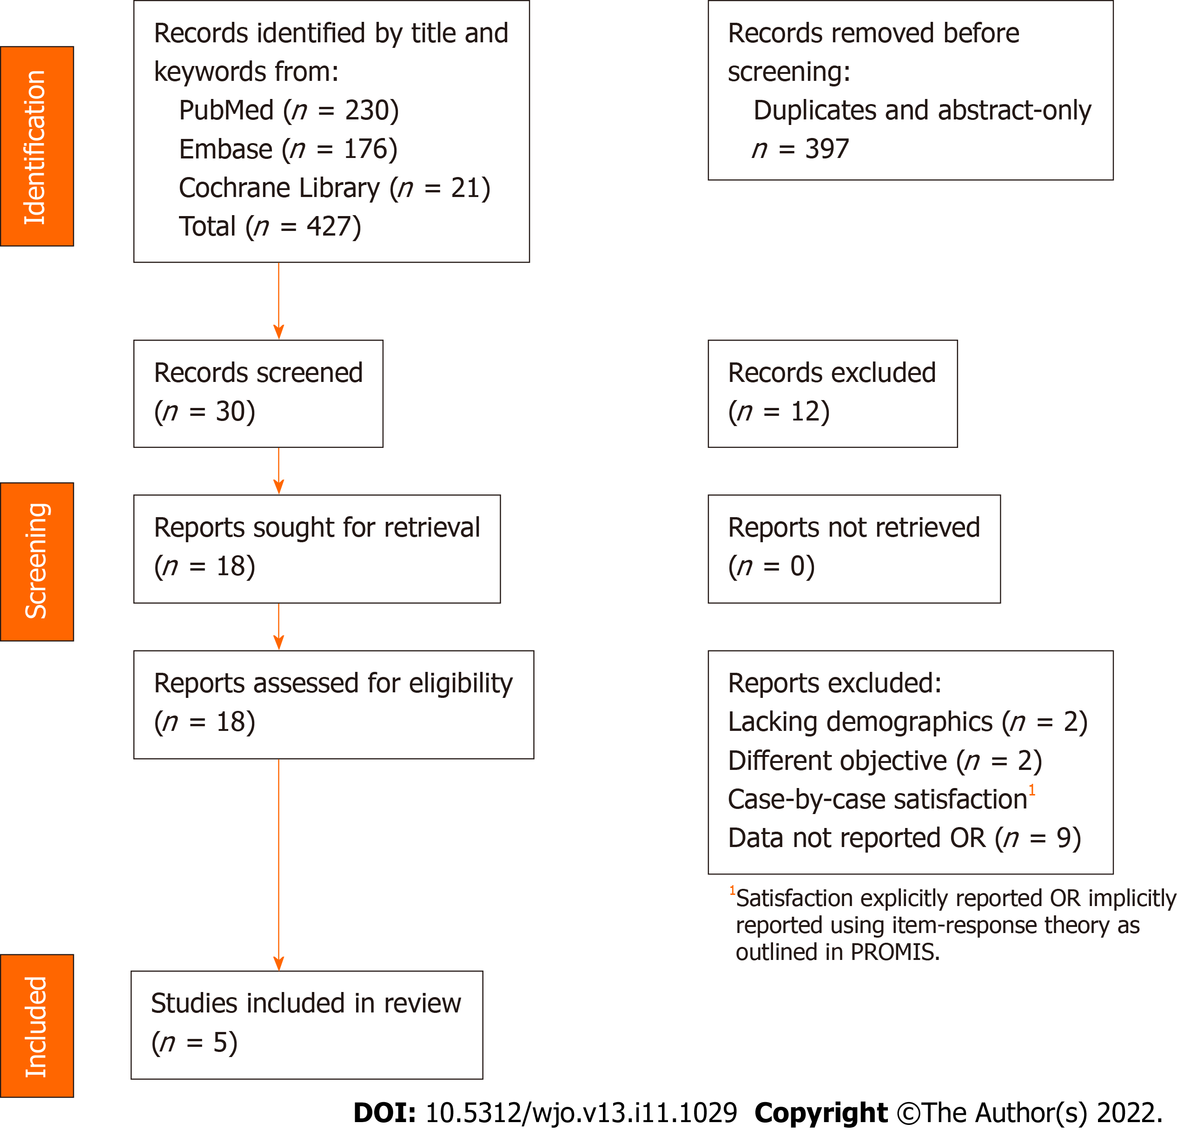
Figure 1 PRISMA flow chart.

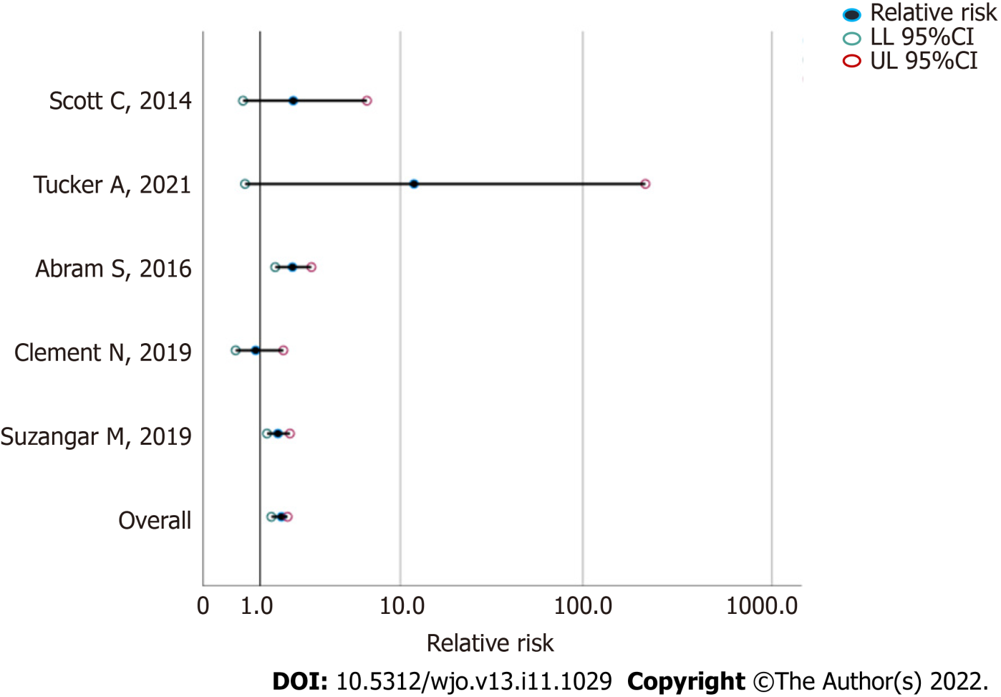
Figure 2 Relative risk of unsatisfactory outcome following total knee arthroplasty 2. The studies are ordered along the vertical axis according to power from least (top) to greatest (bottom); the relative risk is given in a log10 scale along the horizontal axis. LL: Lower limit; UL: Upper limit.

Table 1 Study information, all studies included for analysis had a minimum follow-up of 1 year after each total knee arthroplasty
Ref. | Participants, n (weight %) | Male, n | Female, n | Mean age, range | Interval between TKAs, mo (range) | PROMs | Conclusions
Suzangar et al^{[4]}, 2019 | 1001 (53.0%) | 459 | 542 | 68.7 | 25.6 (0.1-174.0) | Satisfaction | More dissatisfaction after TKA2
Clement et al^{[6]}, 2019 | 454 (24.0%) | 219 | 235 | 68.0 | 16.8 (7.2-44.4) | Satisfaction, OKS | No difference between knees
Abram et al^{[5]}, 2016 | 250 (13.2%) | 84 | 166 | 66.0 | 23.0 (2.0-74.0) | OKS, WOMAC | Lower TKA2 OKS
Scott et al^{[9]}, 2014 | 70 (3.7%) | 29 | 41 | 71.7 | 7.8 (2.0-25.0) | Satisfaction, OKS | No difference between knees
Tucker et al^{[10]}, 2021 | 114 (6.0%) | 31 | 83 | 66.5 | 16.2 (11.4-22.8) | OKS | Females less satisfied than males
Pooled | 1889 (100.0%) | 822 (43.5%) | 1067 (56.5%) | 68 (38 to 92) | 21.9 (0.1-174.1)
Age reported in years. OKS: Oxford knee score; TKA1: First side total knee arthroplasty; TKA2: Second side total knee arthroplasty; WOMAC: Western Ontario and McMaster universities.
Table 2 MINORS assessment
Ref. | A clearly stated aim | Inclusion of consecutive patients |  | Prospective collection of data | Endpoint appropriate to the aim of the study |  |  | Unbiased assessment of the study endpoint | Follow-up period appropriate to the aim of the study | Loss of follow-up less than 5% | Prospective calculation of the study size | Total
Suzangar et al^{[4]}, 2019 | 2 |  | 2 | 2 |  | 1 | N/A |  | 2 | 2 | 1 | 12
Clement et al^{[6]}, 2019 | 2 |  | 2 | 2 |  | 2 | N/A |  | 2 | 2 | 1 | 13
Abram et al^{[5]}, 2016 | 2 |  | 1 | 2 |  | 2 | N/A |  | 2 | 2 | 2 | 13
Scott et al^{[9]}, 2014 | 2 |  | 2 | 2 |  | 1 | N/A |  | 2 | 2 | 1 | 12
Tucker et al^{[10]}, 2021 | 2 |  | 2 | 2 |  | 2 | N/A |  | 2 | 2 | 1 | 13
The items are scored 0 (not reported), 1 (reported but inadequate) or 2 (reported and adequate). The global ideal score is 16 for non-comparative studies. N/A: Not applicable.

Table 3 Patients in each study reporting unequal satisfaction between knees after staged bilateral total knee arthroplasty
Ref. | Dissatisfied with TKA1, n | Dissatisfied with TKA2, n | Study RR | 95%CI LL | 95%CI UL | Study significance
Suzangar et al^{[4]}, 2019 | 61 | 91 | 1.49 | 1.18 | 1.88 | 0.025
Clement et al^{[6]}, 2019ª | 21 | 19 | 0.90 | 0.49 | 1.66 | 0.757
Abram et al^{[5]}, 2016ª | 15 | 32 | 2.0 | 1.11 | 3.61 | 0.021¹
Scott et al^{[9]}, 2014 | 4 | 8 | 2.0 | 0.63 | 6.34 | 0.239
Tucker et al^{[10]}, 2021 | 0 | 5 | 12.0 | 0.67 | 215.26 | 0.090¹
Pooled | 101 (39.5%) | 155 (60.5%) | 1.49 | 1.17 | 1.90 | 0.001
¹Based on number of patients with OKS score differences between knees exceeding MCID; calculation assumes skewness of distribution < 2.
ªPairwise comparison of proportions with Chi square N-1 statistic 17.847, P < 0.0001.
Those that more satisfied with TKA2 are classified as “Dissatisfied with TKA1”; those that preferred TKA1 over TKA2 are classified as “Dissatisfied with TKA2” (n = 256, 13.6%). LL: Lower limit; TKA1: First side total knee arthroplasty; TKA2: Second side total knee arthroplasty; UL: Upper limit. Significance of the RR of dissatisfaction with TKA2 for each study with significance value set at P < 0.05.

Published by Baishideng Publishing Group Inc
7041 Koll Center Parkway, Suite 160, Pleasanton, CA 94566, USA
Telephone: +1-925-3991568
E-mail: bpgoffice@wjgnet.com
Help Desk: https://www.f6publishing.com/helpdesk
https://www.wjgnet.com

© 2022 Baishideng Publishing Group Inc. All rights reserved.

