Name of Journal: World Journal of Orthopedics
Manuscript NO: 84119
Manuscript Type: SCIENTOMETRICS

Scientific publications on orthopedic surgery from three major East Asian countries (2012-2021)

Chen WY et al. Scientific publications in orthopedic surgery

Wei-You Chen, Xin Xiao, Cheng Pan, Fei-Hong Huang, Hong-Yuan Xu, Qing-Jun Wei, Hua Jiang

Wei-You Chen, Xin Xiao, Cheng Pan, Fei-Hong Huang, Hong-Yuan Xu, Hua Jiang, Division of Spine Surgery, The First Affiliated Hospital of Guangxi Medical University, Nanning 530021, Guangxi Zhuang Autonomous Region, China

Qing-Jun Wei, Hua Jiang, Department of Orthopedic Surgery, The First Affiliated Hospital of Guangxi Medical University, Nanning 530021, Guangxi Zhuang Autonomous Region, China

Author contributions: Jiang H conceived and designed the study; Chen WY was involved in data retrieval and data selection, analyzed the data, and wrote the manuscript; Xiao X was involved in statistical analysis and manuscript revision; Pan C, Xu HY, and Huang FH were involved in data search; Jiang H and Wei QJ were involved in the selection of data and contributed analysis tools; All authors read and approved the final manuscript.

Supported by National Natural Science Foundation of China, No. 81860406; Guangxi Natural Science Foundation, No. 2023GXNSFAA026339; and Medical Excellence Award Funded by the Creative Research Development Grant from the First Affiliated Hospital of Guangxi Medical University.

Corresponding author: Hua Jiang, MD, PhD, Full Professor, Division of Spine Surgery, The First Affiliated Hospital of Guangxi Medical University, No. 6 Shuangyong Road, Nanning 530021, Guangxi Zhuang Autonomous Region, China. drjianghua@163.com

Received: February 27, 2023
Revised: June 8, 2023
Accepted: July 7, 2023
Published online: August 18, 2023

Abstract
BACKGROUND
East Asia is the most dynamic region in the world and includes three major countries: Japan, South Korea and China. Due to rapid economic growth, orthopedics research in East Asia has achieved great advances during the past 10 years. However, the current status of orthopedic research in Japan, South Korea and China is still unclear.

AIM
To understand the current status of orthopedic research in Japan, South Korea, and China.

METHODS
Journals listed in the ‘‘Orthopedics’’ category of Science Citation Index Expanded subject categories were included. The PubMed and Web of Knowledge electronic databases were searched to identify scientific publications from the selected journals written by researchers from Japan, South Korea and China. A systematic analysis was conducted to analyze orthopedic research articles published in the three countries based on the number of articles, study design, impact factors (IFs) and citations. Furthermore, we also ranked the top 10 countries worldwide with the highest publications in the past 10 years. Additionally, we ranked the top 10 countries with the highest number of publications in the world in the past 10 years. Statistical analyses were performed using SPSS 20.0 software (SPSS Inc., Chicago, IL, United States), and statistical results are given in Tables and Figures. The Kruskal-Wallis test and the Mann-Whitney test were used to detect differences between countries. The tendency regarding the number of articles was analyzed by curvilinear regression. A two-tailed P < 0.05 was considered significant.

RESULTS
From 2012-2021, a total of 144518 articles were published in the 86 selected orthopedic journals. During this period, the number of worldwide published orthopedic articles has shown an annual increasing trend. A total of 27164 orthopedic research articles were published by Japan, South Korea and China during the past 10 years; 44.32% were from China, 32.98% were from Japan, and 22.70% were from South Korea. From 2012 to 2021, the annual number of articles markedly increased in each of the three countries. Over time, the worldwide share of articles increased substantially in South Korea (3.37% to 6.53%, P < 0.001) and China (5.29% to 9.61%, P < 0.001). However, the worldwide share of articles significantly decreased in Japan (5.22% to 3.80%, P < 0.001). The annual total IFs of articles from China were well above those of articles from Japan and South Korea (36597.69 vs 27244.48 vs 20657.83, P < 0.05). There was no significant difference among the articles in the top 10 high-IF orthopedics journals published from those three countries [South Korea (800) > China (787) > Japan (646), P > 0.05].

CONCLUSION
Over the past 10 years, China’s scientific publications in orthopedic journals have shown an increasing trend. Considering the relative scale of the populations, Japan and South Korea have outpaced China with respect to quality.

Key Words: Japan; South Korea; China; Medical publication; Orthopedics; Research

Citation: Chen WY, Xiao X, Pan C, Huang FH, Xu HY, Wei QJ, Jiang H. Scientific publications on orthopedic surgery from three major East Asian countries (2012-2021). World J Orthop 2023; 14(8): 641-650
URL: https://www.wjgnet.com/2218-5836/full/v14/i8/641.htm
DOI: https://dx.doi.org/10.5312/wjo.v14.i8.641

©The Author(s) 2023. Published by Baishideng Publishing Group Inc. All rights reserved.

Core Tip: Our study was the first to systematically analyze and compare the scientific publication trends of orthopedic surgery studies over the past 10 years in three major East Asian countries–i.e., Japan, South Korea, and China–and to summarize the current status of orthopedic science research in these three countries, thus providing useful information for orthopedic science research.

INTRODUCTION
Orthopedic disorders are a general health problem that affects people of all ages and demographic backgrounds. These disorders are a major burden for individuals, health systems, and social care systems, with indirect costs being the most dominant burden. In particular, the majority of the global burden of orthopedic disease occurs in low- and middle-income countries and is susceptible to neglect. China is the largest developing country in the world; it has more than 1.37 billion people, and it is facing the big challenge of reducing the burden of disease. For instance, more than 50000 hip or knee joint replacements are annually performed in China^{[1-3]}. Researchers have progressively focused more attention on this situation and are now trying to advance the understanding, treatment and prevention of musculoskeletal disorders^{[4,5]}.
East Asia is an important subregion of Asia and is also the most dynamic region in the world. The countries in East Asia include Japan, North Korea, South Korea, Mongolia, and China. Japan is a world leader in fundamental scientific research^{[6]}. South Korea is one of the new industrial economic countries as well as a leader in scientific research^{[7,8]}. Due to the rapid socioeconomic development that has occurred in China, scientific and medical fields have undergone tremendous changes in the past decade^{[9,10]}. Japan, South Korea and China are non-English-speaking countries that adhere to traditional East Asian cultural practices, and they are well-developed, developed and developing countries, respectively. Scientific publication provides a connection between the production and use of scientific knowledge and is a widely accepted method for evaluating public health and academic achievement. Nonetheless, little is known about the relative contributions of the three major East Asian countries to the field of orthopedics. The quantity and quality of scientific literature can be used to analyze the history and current status of science and technology and to forecast trends. Hence, it is crucial to accurately estimate global and regional productivity in ongoing orthopedic research. The present study was designed to investigate the characteristics and trends in orthopedic research studies from Japan, South Korea and China over the past 10 years.

MATERIALS AND METHODS
This retrospective study investigated 86 journals from the ‘‘Orthopedics’’ category of the Science Citation Index Expanded for 2021^{[11]}. Resources in this category include general orthopedics publications and specialized research on musculoskeletal disorders, spine diseases, injury, arthroplasty, arthroscopy, hand surgery, sport medicine, traumatology, foot and ankle surgery, connective tissue diseases, osteoarthritis and physical therapy. Based on the selection criteria, a total of 86 orthopedics journals were selected, and the journals included in the search are shown in Supplementary Table 1. The selection criteria, which were described in previous studies^{[12-14]}, were as follows: (1) The journal was indexed in the PubMed database; and (2) the journal had impact factors (IFs) in accordance with the Journal Citation Reports (JCR) for 2021^{[15]}. On September 1, 2022, the PubMed and Web of Knowledge databases were searched for articles published in the 86 selected journals between January 1, 2012, and December 31, 2021, and written by researchers from Japan, South Korea, and China^{[16]}. The databases were searched using the full journal titles or the ISSN numbers of the journals. The search terms used were “0001-5415 OR 1745-3674 OR 0001-6462 OR 1017-995X OR 1413-7852 OR 0363-5465 OR 0936-8051 OR 1862-3522 OR 0749-8063 OR 2049-4394 OR 2046-3758 OR 1413-3555 OR 1947-6035 OR 0268-0033 OR 1050-642X OR 0009-921X OR 2380-0186 OR 2005-291X OR 0891-8422 OR 0300-8207 OR 1935-973X OR 2396-7544 OR 1473-2262 OR 0940-6719 OR 1071-1007 OR 1083-7515 OR 1268-7731 OR 0966-6362 OR 2151-4585 OR 2192-5682 OR 0749-0712 OR 2468-1229 OR 1120-7000 OR 1556-3316 OR 0019-5413 OR 0020-1383 OR 0341-2695 OR 0959-3020 OR 2687-4784 OR 2572-1143 OR 0883-5403 OR 1053-8127 OR 0021-9355 OR 1863-2521 OR 1067-2516 OR 0363-5023 OR 1753-1934 OR 0894-1130 OR 2054-8397 OR 1538-8506 OR 0190-6011 OR 0736-0266 OR 0949-2658 OR 1022-5536 OR 1749-799X OR 2214-031X OR 0890-5339 OR 1590-9921 OR 0271-6798 OR 1060-152X OR 1836-9553 OR 2000-656X OR 1058-2746 OR 1067-151X OR 8750-7315 OR 0968-0160 OR 0942-2056 OR 0934-6694 OR 0085-4530 OR 0744-6020 OR 1757-7853 OR 1877-0568 OR 0030-5898 OR 0147-7447 OR 1063-4584 OR 0031-9023 OR 0091-3847 OR 0309-3646 OR 0364-2348 OR 0362-2436 OR 1529-9430 OR 0932-0555 OR 1864-6697 OR 2325-9671 OR 1757-1146 OR 1471-2474” AND “Japan [ad],” “South Korea [ad],” and “China [ad]”.
The author's institutional affiliation was used to identify the country of the scientific publication. The publication type categories in the PubMed database were used to compile clinical trials, randomized controlled trials (RCTs), and case reports. In accordance with previous studies^{[12-14]}, four methods were used to evaluate publication quality. First, the annual total and average IFs were determined according to JCR 2021^{[15]}. Second, the distribution and citation patterns of articles written by researchers from these three countries were analyzed using Reference Citation Analysis (https://www.referencecitationanalysis.com/)^{[17]}. Third, we calculated the number of clinical trials, RCTs, systematic reviews/meta-analyses and case reports. Fourth, we quantified the articles published in the top 10 high-IF orthopedic journals and identified the top 10 popular orthopedic journals in the three countries based on the number of articles published in each journal. Moreover, we assessed global trends in orthopedic publications and ranked the top 10 countries with the highest number of publications worldwide over 10 years. Two reviewers (WC and XX) independently extracted the articles. Disagreements between the two reviewers were resolved by consulting a third reviewer (HJ).

RESULTS
Global trends in orthopedic publications
A total of 144518 articles were published in 86 orthopedics journals from 2012 to 2021. The global number of annually published orthopedic research articles showed an increasing trend during the study period. The United States was the highest ranked country in terms of the number of published orthopedic research articles (39017 articles), followed by China (14939), Japan (11525), the United Kingdom (11203), Germany (10080), Canada (7887), South Korea (7664), France (7138), Australia (6849), and the Netherlands (5941). The top 10 countries in the world with the highest number of annual publications are shown in Table 1.

Number of articles in the orthopedic field in Japan, South Korea and China
A total of 27164 articles from Japan, South Korea and China were published in the 86 selected journals between 2012 and 2021 (Figure 1). 44.32% (12040/27164) were from China, 32.98% (8959/27164) were from Japan, and 22.70% (6165/27164) were from South Korea (P < 0.05). From 2012 to 2021, the annual number of articles published in the orthopedic field increased noticeably in South Korea (459 to 899, annual rate of increase = 6.95%, R² = 0.798, P < 0.001), China (552 to 2661, annual rate of increase= 17.03%, R² = 0.823, P < 0.001) and Japan (622 to 1620, annual rate of increase = 10.05%, R² = 0.728, P < 0.05) (Figure 2A).
The worldwide share of articles increased remarkably over time in South Korea (3.37% to 6.53%, annual rate of increase = 6.85%, R² = 0.988, P < 0.001) and China (5.29% to 9.61%, annual rate of increase = 6.16%, R² = 0.995, P < 0.001). However, the worldwide share of articles decreased dramatically in Japan (5.22% to 3.80%, annual rate of increase =-3.14%, R² = 0.878, P < 0.001) (Figure 2B). In 2021, China accounted for 11.20% of all articles in the orthopedics field, followed by Japan (6.82%) and South Korea (3.78%) (P < 0.05).

Clinical trials, RCTs and case reports
Researchers from China published more clinical trials than researchers from Japan and South Korea [China (634) > South Korea (426) > Japan (330), all P values were less than 0.05] (Figure 3). Between 2012 and 2021, Chinese researchers published 512 RCTs, South Korean researchers published 353 RCTs (P < 0.05). Compared to China and South Korea, Japan had a distinctly higher number of case reports (P < 0.05) (Figure 3).

IFs
During the past 10 years, the annual total IFs were ranked in the following order: China, Japan and South Korea (36597.69 vs 27244.48 vs 20657.83, P < 0.05) (36597.69 vs 27244.48 vs 20657.83, P < 0.05). The annual total IFs of articles from China were markedly higher than those from South Korea. For the past 10 years, there were no discernible variations in the annual total IFs between Japan and the other two countries (P > 0.05). The average IFs of articles from Japan or China were significantly lower than those of articles from South Korea. (2.81 vs 2.94 vs 3.21; all P values were less than 0.05) (Figure 4). However, there was no significant difference in the average IF between Japan and China (P > 0.05).

Citations of articles published in orthopedics journals
Articles from China had the highest number of citations (164175 citations), followed by those from Japan (117323 citations) and South Korea (83118 citations). There was a significant difference in the number of citations between China and the two other countries (P < 0.001), but there was no statistically significant difference in the number of citations between Japan and South Korea (P > 0.05) (Figure 2C).

Articles in the top 10 high-IF orthopedics journals
The top 10 high-IF orthopedic journals with 2642 articles from the three countries. Among them, 41.75% (1103/2642) were in the top three journals: Journal of Physiotherapy, Osteoarthritis and Cartilage, and American Journal of Sports Medicine. Researchers from Japan published 770 (29.14%) articles in the top 10 high-IF orthopedics journals, those from South Korea published 847 (32.06%) articles, and those from China published 1025 (38.80%) articles (Table 2).

Popular orthopedics journals
The journals with the highest number of articles published by researchers from these three countries are shown in Table 3. Over the past 10 years, most of the orthopedic research studies from China were published in the Journal of Orthopaedic Surgery and Research (1680), most of the articles from Japan were published in the Journal of Orthopedic Science (1427), and most of the articles from South Korea were published in Clinics in Orthopedic Surgery (492). Spine, BMC Musculoskeletal Disorders appeared among the top 10 popular journals for all three countries.

DISCUSSION
To the best of our knowledge, this is the first study to investigate the characteristics of and trends in orthopedic studies from Japan, South Korea and China. The number of worldwide orthopedic publications showed an upward trend from 2012 to 2021. Unquestionably, the United States ranks first in the world in terms of total and annual number of orthopedic publications. Over the past 10 years, there has been a steady increase in the number of articles published each year in highly developed countries, including the United Kingdom, Japan, Germany and France^{[18,19]}. Notably, there has been drastic growth in the annual number of articles published in China and Japan. Their articles disseminate a wealth of scientific knowledge and make significant contributions to the countries’ profound emphasis on academic research, as well as active global engagement. Therefore, these countries have contributed to the development of orthopedics over the past 10 years.
During the past 10 years, a considerable increase in the total number and percentage of articles in orthopedic journals from Japan has been observed. Despite substantial growth in the annual number of orthopedic research articles published in Japan (622 in 2012 to 1620 in 2021), the country’s worldwide share of articles decreased from 5.22% in 2012 to 3.80% in 2021. This decrease may be attributed to a decrease in government funding allocated for research endeavors^{[20]}. Nevertheless, Japan still has a considerable international impact on scientific research and is a leader in the field of orthopedics. The large amount of research funding and the vast number of well-trained researchers might account for the objective reality that Japan has attained a continuously dominant position. Furthermore, Japan enjoys an efficient and competitive system of scientific research, which may be considered a reference model for some developing countries in Asia.
In the past 10 years, the annual number and worldwide share of orthopedic publications from South Korea have also increased (annual number: 459 in 2012 to 899 in 2021; worldwide share: 3.37% in 2012 to 6.53% in 2021). The rise of scientific research may be ascribed to the aging population. As the population progressively ages, there is a pronounced increase in the prevalence of orthopedic disorders^{[21]}. In response, researchers have redirected their focus toward gaining a better understanding of this situation and advancing the treatment of orthopedic disorders. Consequently, South Korea has emerged as a noteworthy contributor to the development of orthopedic science, gradually gaining recognition for its prowess and innovative approaches.
There has been a strong positive trend in orthopedic publications from China. Our study suggests a 5-fold increase in the absolute number of articles from China in orthopedic journals (from 552 papers in 2012 to 2661 paper in 2021, P < 0.001), and the market share of articles in China has increased markedly (from 5.29% in 2012 to 9.61% in 2021, P < 0.001). In the orthopedics field, China’s scientific research has been growing rapidly in the past decade^{[14,18,19]}. In 2013, articles originating in China (629) surpassed those originating in Japan (627) and South Korea (548). Between 2012 and 2021, researchers from China published 634 orthopedic clinical trials, outpacing those from South Korea (n = 426, P < 0.05) and Japan (n = 330, P < 0.05). Only 1083 RCTs were found among all 27164 articles originating in these three countries (Japan 218 vs South Korea 353 vs China 512; P < 0.05). RCTs are considered to be a higher grade of scientific evidence that influences health care policy. Thus, researchers in East Asia should prioritize more RCTs and consider these findings.
The average number of citations to articles in the publications is indicated by the IF. Although the IF has many limitations^{[22,23]}, it remains one of the optimal tools for assessing the relative significance of scientific studies. Researchers from South Korea made the most qualitative contributions to orthopedic research, as evidenced by the number of papers they published in high-IF journals and the highest annual average IFs. Researchers from South Korea published more articles in high-IF journals and had the highest annual average IFs, indicating that they contributed the majority to orthopedic research in terms of quality. Throughout the past 10 years, there has been steady growth in the total annual IF of articles originating from China. However, the annual average IFs still lagged behind South Korea. Undoubtedly, the quality of the articles and the international presence from China requires improvement. Citations are another valuable indication of article quality, revealing the extent to which the article has been accepted by other authors in the same field. In this study, we revealed that articles from China had a fairly high number of citations, followed by those from Japan and Korea. The average number of citations for Chinese studies ranked behind Japan and South Korea. In fact, newly published articles have less time to be cited, and thus, old articles of high quality are usually more often cited. In the past 3 years, China published 6042 articles, accounting for 50.18% (6042/12040) of the total number of articles published from 2012 to 2021, which could explain this phenomenon.
Regarding the orthopedic journals with a top-ten IF, researchers from China (1025) and South Korea (847) published more articles in these journals than researchers from Japan (770), but there was no significant difference among the three countries (P > 0.05). It should be noted that IF is not always the optimum parameter for identifying the quality of journals. Sometimes, a high IF represents a journal with high visibility, prestige, and influence. Researchers with well-designed studies tend to submit their articles to journals with these characteristics. In this study, spine and BMC Musculoskeletal Disorders were considered the most popular journals, ranking among the top 10 popular journals in the three countries. The most popular journals in this study were Spine and BMC Musculoskeletal Disorders, which were ranked among the top 10 most popular publications in each of the three nations. These two journals mainly publish high-quality clinical and basic research articles, which results in their widespread international influence. However, there were differences in the most popular journals for authors among the three countries. Researchers from Japan publish most in Journal of Orthopedic Science. This journal is the official journal of the Japanese Orthopedic Association and has a lengthy and illustrious history of publishing outstanding scientific papers in the field^{[24]}. The top three popular journals for South Korea were Clinics in Orthopedic Surgery, Knee Surgery Sports Traumatology Arthroscopy and Arthroscopy-The Journal of Arthroscopic and Related Surgery, suggesting that arthroplasty surgery in South Korea is developing rapidly and has achieved great advances in recent years. On the other hand, the top three popular journals for China were Journal of Orthopaedic Surgery and Research, BMC Musculoskeletal Disorders and Orthopaedic Surgery, demonstrating that China has markedly improved its research in the field of orthopedic surgery during the past 10 years.
Orthopedic research in China is experiencing a period of immense growth, which is due to several factors. First, numerous newly established institutions and hospitals in China already conduct scientific research and surgical treatment in orthopedics, with recent advances in China’s economy^{[9,25,26]}. Second, the continual development of international cooperation might benefit Chinese orthopedic researchers to strengthen their clinical orthopedic practice and research abilities^{[27-29]}. Third, the number and IF of articles indexed in the SCIE database were recently regarded as important indicators to evaluate the performance and achievements of a researcher or an institution in China. Importantly, SCIE papers are tightly linked to authors' academic status, income, funding and other key benefits^{[30,31]}. However, these policies seem to have resulted in an increase in the number of articles and not in their quality, as indicated by the current citation rates for Chinese-authored articles.
There are some limitations to this study. First, only 86 orthopedic journals included in the SCIE database were analyzed. There were some orthopedic research articles published in general medical journals that were not included in our study. Second, the JCR database was restricted to include studies published in English, which may lead to publication bias. For that reason, we may have neglected the contribution of non-English publications.

CONCLUSION
In summary, some useful information about scientific research in orthopedics is provided in this study. China has maintained an increasing trend of scientific publication in orthopedics journals over the past 10 years and has exceeded Japan and South Korea in some aspects of orthopedics publications. Given the relative size of the populations, China still lags behind Japan and South Korea in terms of quality. Chinese orthopedic researchers must improve their research activities and produce high-quality research.

ARTICLE HIGHLIGHTS
Research background
Orthopedic research in East Asia has made significant strides over the past 10 years. However, the current status of orthopedic research in the three major East Asian countries of Japan, South Korea, and China remains uncertain.

Research motivation
To explore the current state of orthopedic research in Japan, South Korea, and China and provide informative findings in the field of orthopedic science.

Research objectives
To visualize the publication quantity, global share, publication types, impact factor (IF), and citation trends of orthopedic studies from Japan, South Korea, and China during the period of 2012-2021 and to analyze the developmental trends in orthopedic research in East Asia over the past decade.

Research methods
According to the selection criteria, which include: (1) The journal was indexed in the PubMed database; and (2) the journal had IFs in accordance with the Journal Citation Reports for 2021, a total of 86 orthopedic journals were included. The PubMed and Web of Knowledge databases were searched from January 1, 2012, to December 31, 2021, to retrieve articles published in the selected 86 journals by researchers from Japan, South Korea, and China. The publication quantity, global share, publication types, IF, and citation patterns of these papers were then analyzed and visualized. Statistical analyses were performed using SPSS 20.0 software.

Research results
Between 2012 and 2021, a total of 27164 orthopedic studies were published by Japan, South Korea, and China, showing a steady increase over the years. Among them, 44.32% were from China, 32.98% were from Japan, and 22.70% were from South Korea. Over time, the global share of articles significantly increased in South Korea (from 3.37% to 6.53%, P < 0.001) and China (from 5.29% to 9.61%, P < 0.001), while it decreased significantly in Japan (from 5.22% to 3.80%, P < 0.001). The annual total IFs of articles from China were well above those of articles from Japan and South Korea (36597.69 vs 27244.48 vs 20657.83, P < 0.05). There was no significant difference in the number of top 10 high-IF orthopedics journals published among these three countries [South Korea (800) > China (787) > Japan (646), P > 0.05].

Research conclusions
China's orthopedic publications have seen consistent growth in the past decade, but when considering their population scales, Japan and South Korea still outpace China with respect to quality.

Research perspectives
The authors aim for this article to contribute toward the assessment and enhancement of academic productivity in orthopedic research in East Asia. In the future, it is imperative to foster stronger international cooperation and increase financial support for orthopedic research to produce a high level of evidence research and foster the sustained development of orthopedic research.

REFERENCES
1 Wu D, Wong P, Guo C, Tam LS, Gu J. Pattern and trend of five major musculoskeletal disorders in China from 1990 to 2017: findings from the Global Burden of Disease Study 2017. BMC Med 2021; 19: 34 [PMID: 33536019 DOI: 10.1186/s12916-021-01905-w]
2 Liu S, Wang B, Fan S, Wang Y, Zhan Y, Ye D. Global burden of musculoskeletal disorders and attributable factors in 204 countries and territories: a secondary analysis of the Global Burden of Disease 2019 study. BMJ Open 2022; 12: e062183 [PMID: 35768100 DOI: 10.1136/bmjopen-2022-062183]
3 Feng B, Zhu W, Bian YY, Chang X, Cheng KY, Weng XS. China artificial joint annual data report. Chin Med J (Engl) 2020; 134: 752-753 [PMID: 33725711 DOI: 10.1097/CM9.0000000000001196]
4 Wu H, Wang Y, Tong L, Yan H, Sun Z. The Global Research Trends and Hotspots on Developmental Dysplasia of the Hip: A Bibliometric and Visualized Study. Front Surg 2021; 8: 671403 [PMID: 34760913 DOI: 10.3389/fsurg.2021.671403]
5 Wu H, Cheng K, Tong L, Wang Y, Yang W, Sun Z. Knowledge structure and emerging trends on osteonecrosis of the femoral head: a bibliometric and visualized study. J Orthop Surg Res 2022; 17: 194 [PMID: 35346273 DOI: 10.1186/s13018-022-03068-7]
6 Sheng G, Carninci P, Siomi MC, Suda T, Alev C. Japan: prize diversity, not conformity, to boost research. Nature 2021; 599: 201 [PMID: 34754091 DOI: 10.1038/d41586-021-03070-9]
7 Shon WY, Yoon BH, Jung EA, Kim JW, Ha YC, Han SH, Kim HS. Assessment of Korea's Orthopedic Research Activities in the Top 15 Orthopedic Journals, 2008-2017. Clin Orthop Surg 2019; 11: 237-243 [PMID: 31156778 DOI: 10.4055/cios.2019.11.2.237]
8 Kim HY, Kwon S, Um W, Shin S, Kim CH, Park JH, Kim BS. Functional Extracellular Vesicles for Regenerative Medicine. Small 2022; 18: e2106569 [PMID: 35322545 DOI: 10.1002/smll.202106569]
9 Wu Y, Yin D, Abbasi K. China's medical research revolution. BMJ 2018; 360: k547 [PMID: 29437660 DOI: 10.1136/bmj.k547]
10 The Lancet. China's research renaissance. Lancet 2019; 393: 1385 [PMID: 30967198 DOI: 10.1016/S0140-6736(19)30797-4]
11 Web of Science. Journal search. [cited 1 September 2021]. Available from: http://www.webofknowledge.com
12 Trikha R, Olson TE, Chaudry A, Ishmael CR, Villalpando C, Chen CJ, Hori KR, Bernthal NM. Assessing the academic achievement of United States orthopaedic departments. World J Orthop 2022; 13: 201-211 [PMID: 35317404 DOI: 10.5312/wjo.v13.i2.201]
13 Brennan C, Laubscher M, Maqungo S, Graham SM. Bibliometric analysis of research on the effects of human immunodeficiency virus in orthopaedic and trauma surgery. World J Orthop 2021; 12: 169-177 [PMID: 33816143 DOI: 10.5312/wjo.v12.i3.169]
14 Jiang H, Nong B, Yang L, Zong S, Zhan X, Wei Q, Xiao Z. Assessing the evolution of scientific publications in orthopedics journals from mainland China, Hong Kong, and Taiwan: a 12-year survey of the literature. J Orthop Surg Res 2016; 11: 69 [PMID: 27317092 DOI: 10.1186/s13018-016-0404-z]
15 ISI Journal Citation Reports. Institute for Scientific Information, 2014. [cited 1 September 2021]. Available from: http://isiknowledge.com
16 PubMed. [cited 1 September 2021]. Available from: http://www.ncbi.nlm.nih.gov/pubmed/
17 Reference Citation Analysis. [cited 1 September 2021]. Available from https://www.referencecitationanalysis.com/
18 Zhi X, Cui J, Gu Z, Cao L, Weng W, Li Q, Chen X, Su J. Orthopedics research output from China, USA, UK, Japan, Germany and France: A 10-year survey of the literature. Orthop Traumatol Surg Res 2016; 102: 939-945 [PMID: 27296711 DOI: 10.1016/j.otsr.2016.05.005]
19 Zou Y, Li Q, Xu W. Scientific research output in orthopaedics from China and other top-ranking countries: a 10-year survey of the literature. BMJ Open 2016; 6: e011605 [PMID: 27638493 DOI: 10.1136/bmjopen-2016-011605]
20 Sadoshima J, Tomoike H. What Should We Learn From the Recent Decline of Basic Cardiovascular Science in Japan? Circ Res 2017; 121: 314-316 [PMID: 28775005 DOI: 10.1161/CIRCRESAHA.117.311411]
21 Choi Y, Leigh JH, Jeon J, Lee GJ, Shin HI, Bang MS. Trends in the Incidence and Etiology of Non-Traumatic Spinal Cord Injury in Korea: A Nationwide Population-Based Study From 2007 to 2020. J Korean Med Sci 2023; 38: e158 [PMID: 37158777 DOI: 10.3346/jkms.2023.38.e158]
22 Durieux V, Gevenois PA. Bibliometric indicators: quality measurements of scientific publication. Radiology 2010; 255: 342-351 [PMID: 20413749 DOI: 10.1148/radiol.09090626]
23 Garner RM, Hirsch JA, Albuquerque FC, Fargen KM. Bibliometric indices: defining academic productivity and citation rates of researchers, departments and journals. J Neurointerv Surg 2018; 10: 102-106 [PMID: 28824008 DOI: 10.1136/neurintsurg-2017-013265]
24 Kawaguchi Y, Guarise da Silva P, Quadros FW, Merlin LH, Radaelli L, Guyot JP, Dozza D, Martins D, Scheverin N, Riew DK, Kimura T, Falavigna A. Analysis of scientific output by spine surgeons from Japan: January 2000 to December 2013. J Orthop Sci 2016; 21: 13-18 [PMID: 26671572 DOI: 10.1016/j.jos.2015.09.005]
25 Ouyang H. Innovations in Orthopedic Biomaterials and Regenerative Medicine in China. ACS Biomater Sci Eng 2021; 7: 804-805 [PMID: 33715370 DOI: 10.1021/acsbiomaterials.1c00214]
26 Li J, Zhang Y. History of orthopaedics in China: a brief review. Int Orthop 2018; 42: 713-717 [PMID: 29455346 DOI: 10.1007/s00264-018-3829-7]
27 Xu D, Xing BC. Quality over quantity: a necessary path for clinical research transformation in China. Hepatobiliary Surg Nutr 2020; 9: 684-686 [PMID: 33163526 DOI: 10.21037/hbsn-2020-5]
28 Miclau T, MacKechnie MC, Born CT, MacKechnie MA, Dyer GSM, Yuan BJ, Dawson J, Lee C, Ishmael CR, Schreiber VM, Tejwani NC, Ulmer T, Shearer DW, Agarwal-Harding KJ, Johal H, Khormaee S, Sprague S, Whiting PS, Roberts HJ, Coughlin R, Gosselin R, Rosenwasser MP, Johnson A, Babu JM, Dworkin M, Makhni MC, McClellan T, Nwachuku CO, Miclau E, Morshed S. International Orthopaedic Volunteer Opportunities in Low and Middle-Income Countries. J Bone Joint Surg Am 2022; 104: e44 [PMID: 34932526 DOI: 10.2106/JBJS.21.00948]
29 Huamaní C, González-Alcaide G. Surgical clinical trials--need for international collaboration. Lancet 2013; 382: 1875-1876 [PMID: 24315171 DOI: 10.1016/S0140-6736(13)62618-5]
30 Yuan HF, Xu WD, Hu HY. Young Chinese doctors and the pressure of publication. Lancet 2013; 381: e4 [PMID: 23374483 DOI: 10.1016/S0140-6736(13)60174-9]
31 Verret CI, Nguyen J, Verret C, Albert TJ, Fufa DT. How Do Areas of Work Life Drive Burnout in Orthopaedic Attending Surgeons, Fellows, and Residents? Clin Orthop Relat Res 2021; 479: 251-262 [PMID: 32858718 DOI: 10.1097/CORR.0000000000001457]

Footnotes
Conflict-of-interest statement: The authors declare that they have no conflict of interest.

PRISMA 2009 Checklist statement: The authors have read the PRISMA 2009 Checklist, and the manuscript was prepared and revised according to the PRISMA 2009 Checklist.

Open-Access: This article is an open-access article that was selected by an in-house editor and fully peer-reviewed by external reviewers. It is distributed in accordance with the Creative Commons Attribution NonCommercial (CC BY-NC 4.0) license, which permits others to distribute, remix, adapt, build upon this work non-commercially, and license their derivative works on different terms, provided the original work is properly cited and the use is non-commercial. See: https://creativecommons.org/Licenses/by-nc/4.0/

Provenance and peer review: Invited article; Externally peer reviewed.

Peer-review model: Single blind

Peer-review started: February 27, 2023
First decision: May 25, 2023
Article in press: July 7, 2023

Specialty type: Orthopedics
Country/Territory of origin: China
Peer-review report’s scientific quality classification
Grade A (Excellent): A
Grade B (Very good): B
Grade C (Good): 0
Grade D (Fair): 0
Grade E (Poor): 0

P-Reviewer: Kuroki H, Japan; Wu H, United States S-Editor: Fan JR L-Editor: A P-Editor: Xu ZH

Figure Legends
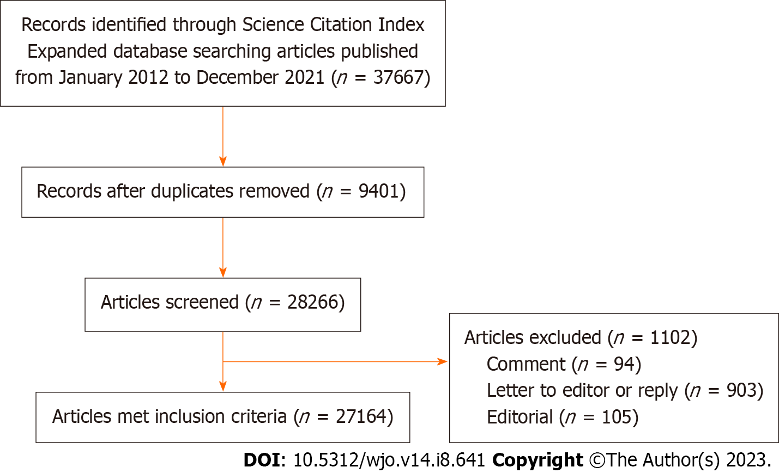
Figure 1 Flow chart for study selection.

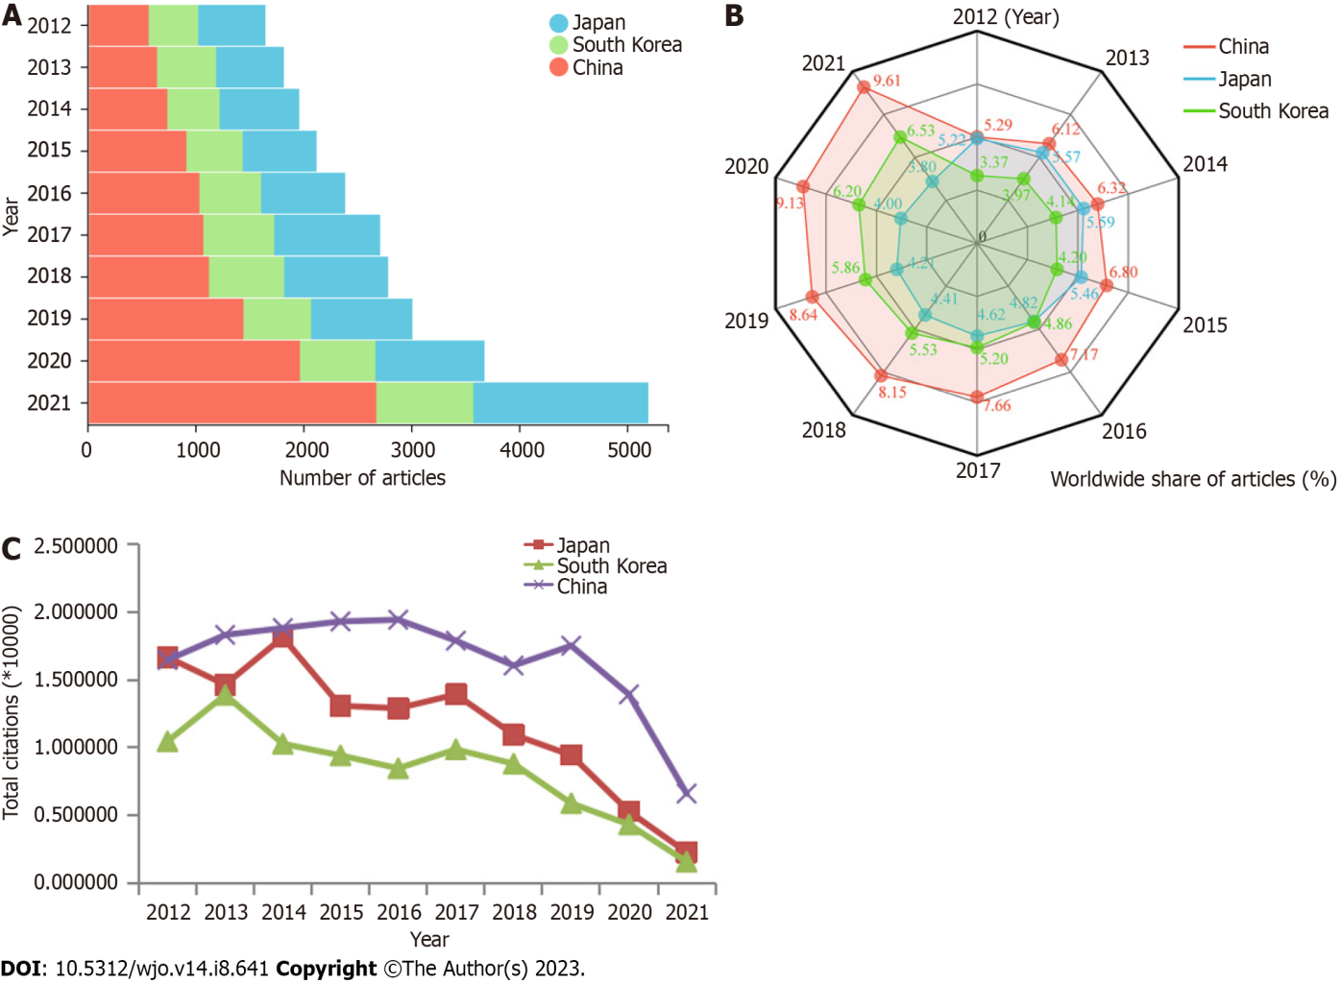
Figure 2 The articles published in the 86 orthopedics journals by researchers from Japan, South Korea and China (2012-2021). A: Annual numbers; B: Annual proportion; C: Annual citations.

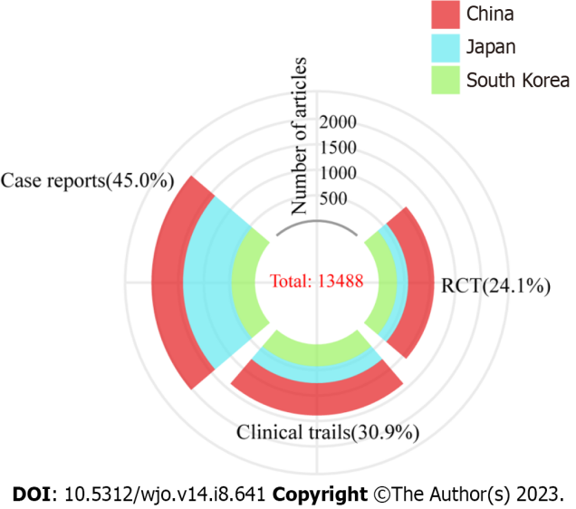
Figure 3 Number of clinical trials, randomized controlled trials and case reports published by researchers from Japan, South Korea and China from 2012 to 2021. RCT: Randomized controlled trials.

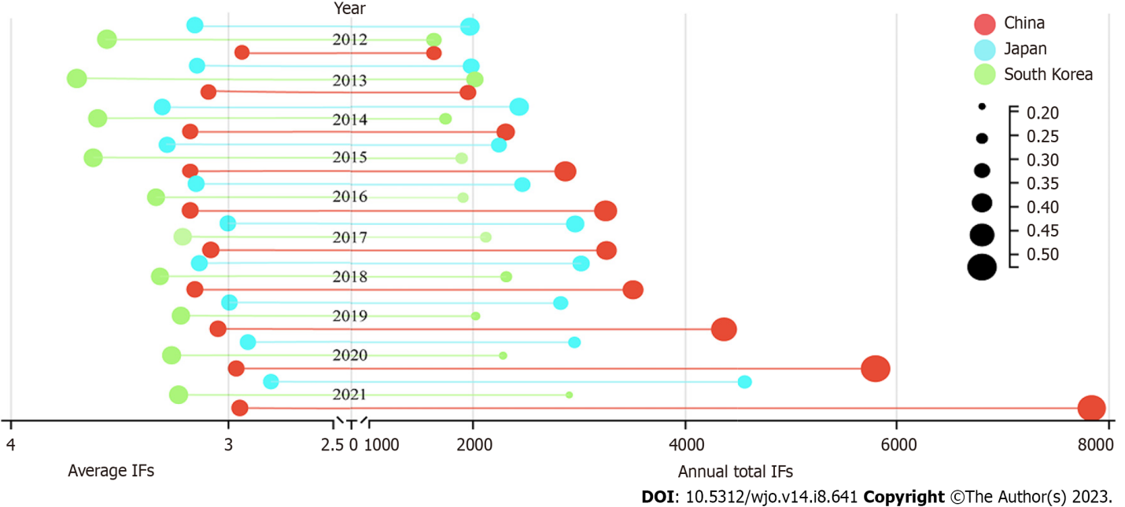
Figure 4 The average impact factors and annual total impact factors of articles published in the 86 orthopedics journals by researchers from Japan, South Korea and China from 2012 to 2021. IF: Impact factors.

Table 1 Top 10 countries according to the annual number of articles from 2012-2021
Year | 1 | 2 | 3 | 4 | 5 | 6 | 7 | 8 | 9 | 10
2012 | United States | United Kingdom | Japan | China | Germany | South Korea | Canada | France | Netherlands | Australia
2013 | United States | United Kingdom | Japan | China | Germany | South Korea | Canada | Netherlands | France | Australia
2014 | United States | United Kingdom | China | Japan | Germany | Canada | South Korea | France | Australia | Netherlands
2015 | United States | China | United Kingdom | Germany | Japan | Canada | South Korea | Australia | France | Turkey
2016 | United States | China | United Kingdom | Japan | Germany | France | Canada | Australia | South Korea | Netherlands
2017 | United States | China | Japan | United Kingdom | Germany | Canada | South Korea | France | Australia | Netherlands
2018 | United States | China | Japan | United Kingdom | Germany | Canada | South Korea | France | Australia | Netherlands
2019 | United States | China | Japan | United Kingdom | Germany | Canada | South Korea | France | Australia | Netherlands
2020 | United States | China | Japan | United Kingdom | Germany | Canada | South Korea | France | Australia | Switzerland
2021 | United States | China | Japan | United Kingdom | Germany | Canada | France | South Korea | Australia | Switzerland

Table 2 Articles published in the top 10 high IF orthopedics journals by researchers from Japan, South Korea and China from 2012 to 2021
Rank | Journal | 2021 JIF | Japan (%) | South Korea (% ) | China (%) | Total
1 | J PHYSIOTHER | 10.714 | 1 (33.33) | 0 (10.00) | 2 (66.67) | 3
2 | OSTEOARTHR CARTILAGE | 7.507 | 124 (30.31) | 47 (11.49) | 238 (58.20) | 409
3 | AM J SPORT MED | 7.01 | 234 (33.86) | 290 (41.97) | 167 (24.17) | 691
4 | J BONE JOINT SURG AM | 6.558 | 99 (32.57) | 112 (36.84) | 93 (30.59) | 304
5 | J ORTHOP SPORT PHYS | 6.276 | 5 (38.46) | 4 (30.77) | 4 (30.77) | 13
6 | ARTHROSCOPY | 5.973 | 166 (28.28) | 286 (48.72) | 135 (22.99) | 587
7 | BONE JOINT J | 5.385 | 122 (38.00) | 94 (29.28) | 105 (32.71) | 321
8 | J ORTHOP TRANSL | 4.889 | 13 (4.36) | 10 (3.36) | 275 (92.28) | 298
9 | EFORT OPEN REV | 4.775 | 2 (25.00) | 1 (12.50) | 5 (62.50) | 8
10 | BRAZ J PHYS THER | 7.507 | 4 (50.00) | 3 (37.50) | 1 (12.50) | 8
Total |  |  | 770 (29.14) | 847 (32.06) | 1025 (38.80) | 2642

Table 3 The top 10 popular orthopedics journals publishing the articles written by researchers from Japan, South Korea and China
Rank | Japan | IF | n | South Korea | IF | n | China | IF | n
1 | JOS | 1.805 | 1427 | COS | 2.503 | 492 | JOSR | 2.677 | 1680
2 | Spine | 3.269 | 622 | KSSTA | 4.114 | 394 | BMCMD | 2.562 | 1296
3 | KSSTA | 4.114 | 506 | AJSM | 5.973 | 290 | OS | 2.279 | 920
4 | BMCMD | 2.562 | 444 | ARTH | 7.01 | 286 | ESJ | 2.721 | 759
5 | ESJ | 2.721 | 421 | Spine | 3.269 | 261 | Spine | 3.269 | 691
6 | JA | 4.435 | 288 | JA | 4.435 | 241 | IO | 3.479 | 587
7 | JOR | 3.102 | 276 | BMCMD | 2.562 | 241 | Injury | 2.687 | 378
8 | JOSHK | 2.423 | 276 | JSES | 3.507 | 221 | TSJ | 4.297 | 326
9 | Knee | 1.482 | 242 | AOTS | 2.928 | 221 | JOT | 4.239 | 275
10 | AJSM | 7.01 | 234 | TSJ | 4.297 | 199 | AOTS | 2.928 | 272
AJSM: Am J Sports Med; AOTS: Arch Orthop Traum Surg; ARTH: Arthroscopy; BMCMD: BMC Musculoskelet Disord; COS: Clin Orthop Surg; ESJ: Eur Spine J; IO: Int Orthop; JA:J Arthroplasty; JOR: J Orthop Res; JOSHK: J Orthop Surg (Hong Kong); JOS: J Orthop Sci; JOSR: J Orthop Surg Res; JSES: J Shoulder Elbow Surg; JOT: J Orthop Translat; KSSTA: Knee Surg Sport Tr A; OS: Orthopaedic Surgery; TSJ: The Spine J.

Published by Baishideng Publishing Group Inc
7041 Koll Center Parkway, Suite 160, Pleasanton, CA 94566, USA
Telephone: +1-925-3991568
E-mail: bpgoffice@wjgnet.com
Help Desk: https://www.f6publishing.com/helpdesk
https://www.wjgnet.com

© 2023 Baishideng Publishing Group Inc. All rights reserved.

