Name of Journal: World Journal of Gastroenterology
ESPS Manuscript NO: 19809

Manuscript Type: meta-analysis

Supplementary material

Endoscopic stenting for inoperable malignant biliary obstruction: a systematic review and meta-analysis

Search Strategy

- MEDLINE strategy: ((prostheses and implants) OR SEMS OR ARMS OR prosthesis OR stent OR endoscopy OR endoscopic OR endobiliary OR deobstruction OR biliary drainage OR biliary reobstruction OR PBD OR endoscopic biliary stenting OR EBS OR endoscopic nasobiliary drainage OR enbd OR ercp OR drainage, methods OR endoscopy, methods OR endoscopy, adverse effects OR drainage, adverse effects) AND (klatskin OR hilar cholangiocarcinoma OR HC OR hca OR bile duct cancer OR bile duct neoplasms OR jaundice OR bismuth OR biliary tract neoplasms OR Carcinoma, Hepatocellular OR mbdo OR bile duct) AND random*
- EMBASE strategy: 'prostheses and implants'/exp OR 'prostheses and implants' OR sems OR arms OR 'prosthesis'/exp OR prosthesis OR 'stent'/exp OR stent OR 'endoscopy'/exp OR endoscopy OR endoscopic OR endobiliary OR deobstruction OR 'biliary drainage'/exp OR 'biliary drainage' OR 'biliary reobstruction' OR pbd OR 'endoscopic biliary stenting' OR ebs OR 'endoscopic nasobiliary drainage' OR enbd OR 'ercp'/exp OR ercp OR 'drainage, methods' OR 'endoscopy, methods' OR 'endoscopy, adverse effects' OR 'drainage, adverse effects' AND (klatskin OR 'hilar cholangiocarcinoma'/exp OR 'hilar cholangiocarcinoma' OR hc OR hca OR 'bile duct cancer'/exp OR 'bile duct cancer' OR 'bile duct neoplasms'/exp OR 'bile duct neoplasms' OR 'jaundice'/exp OR jaundice OR 'bismuth'/exp OR bismuth OR 'biliary tract neoplasms'/exp OR 'biliary tract neoplasms' OR 'carcinoma, hepatocellular'/exp OR 'carcinoma, hepatocellular' OR mbdo OR 'bile duct'/exp OR 'bile duct') AND ([controlled clinical trial]/lim OR [randomized controlled trial]/lim) AND [embase]/lim
- SCOPUS strategy: ALL((prostheses and implants) OR SEMS OR ARMS OR prosthesis OR stent OR endoscopy OR endoscopic OR endobiliary OR deobstruction OR biliary drainage OR biliary reobstruction OR PBD OR endoscopic biliary stenting OR EBS OR endoscopic nasobiliary drainage OR enb) AND ( LIMIT-TO(DOCTYPE,"ar" ) ) AND ( LIMIT-TO(SUBJAREA,"MEDI" ) )

Findings
The initial findings were as follows:
MEDLINE findings: 1576 studies, 1484 were excluded by title, non-randomized study, and/or no biliary stents comparison = 92 studies, 79 were excluded by abstract comparison between plastic and metallic stents, leaving 13 full texts selected.
Brazilian Master’s and Doctorate’s theses and dissertations findings: 42 theses – all were unrelated to the theme and mostly in interventionist cardiology, thus excluded
EMBASE findings: 1294 studies, 1236 were excluded by title, non-randomized study, and/or no biliary stents comparison = 60 studies, 49 were excluded by abstract comparison between plastic and metallic stents, leaving 12 full texts selected.
CINAHL findings: 13 studies, 2 were repeated and excluded, leaving 11; 4 were comparisons between other type stents; 7 was a non-biliary stent comparison study
LILACS and CENTRAL findings: 76 studies, 51 were excluded by title, non-randomized study, and/or no biliary stents comparison, leaving 25 studies that were all excluded by abstract: 13 repetitions; 1 no stent comparison, 2 reviews, 1 non-randomized trial study, and 7 comparisons between plastic stents. One search title didn’t reveal an article {Expandable (Strecker-) metal stent and plastic endoprothesis in distal malign bile duct stenosis - a prospective randomised study - Jung M; Wesner S; Hurst A; Caspary WF. CENTRAL - Registro de ensaios clinicos controlados | ID: coc-CN-00323193}.
SCOPUS findings: 659 studies, all were excluded by title or abstract, non-randomized study, repetition, and/or no biliary stents comparison.
Gray literature findings: 1 study selected – excluded after contacting author (partial results, published afterwards).

Supplementary Table 1 Pubmed and Embase repetitions: 8 among the studies selected
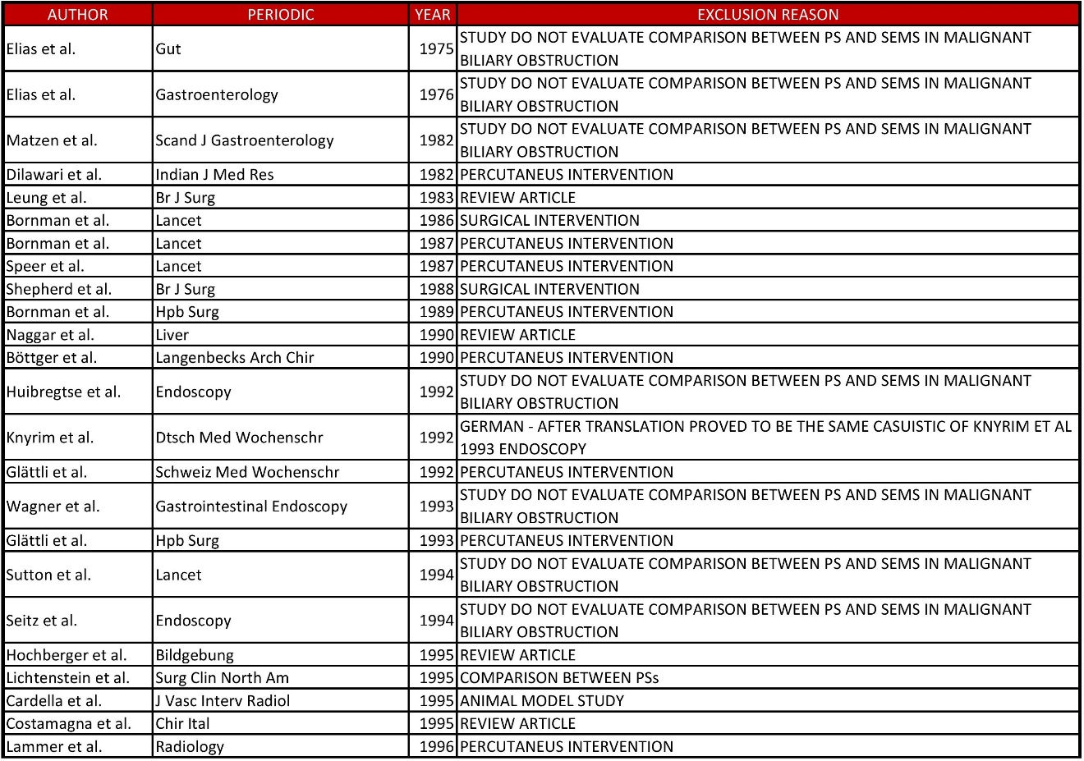
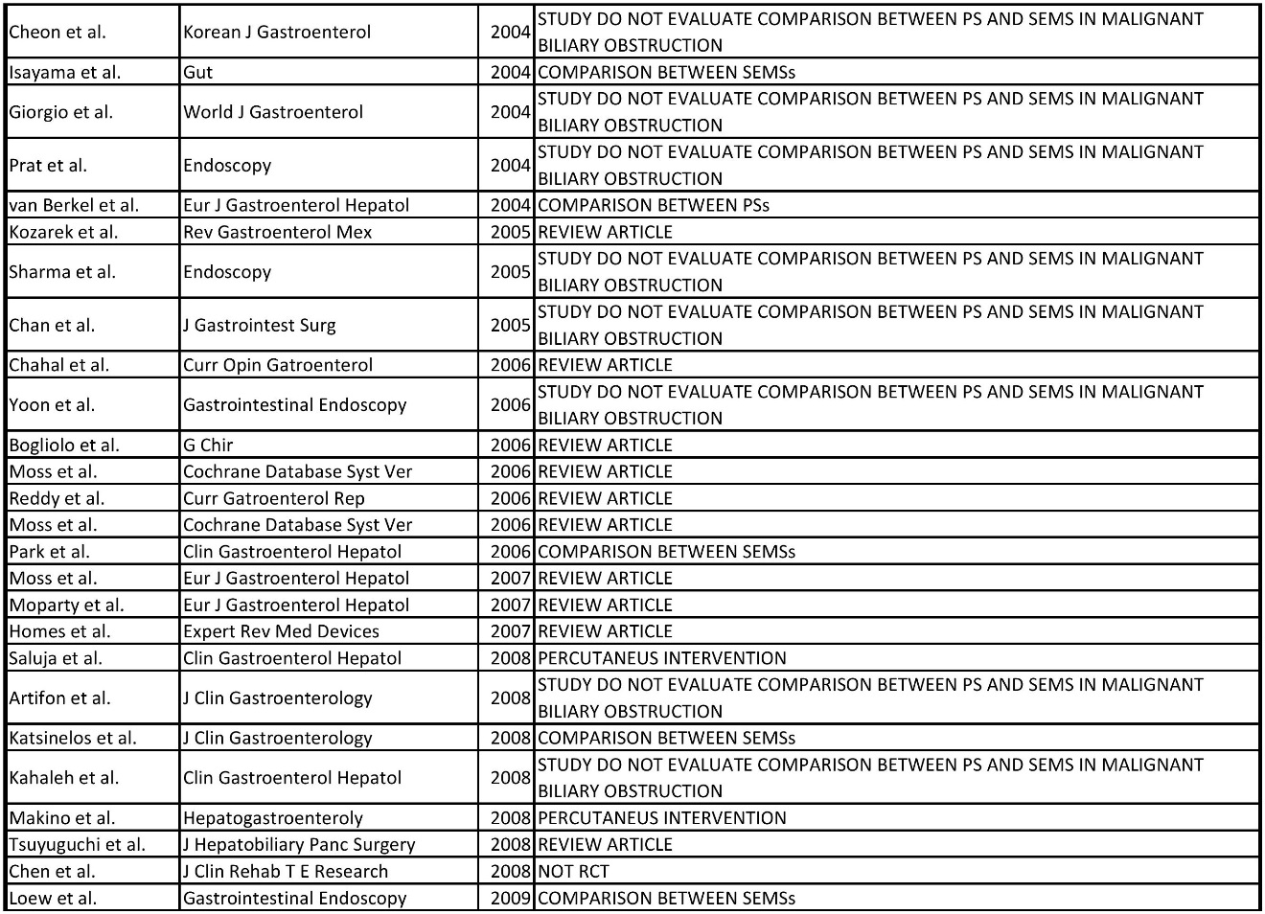
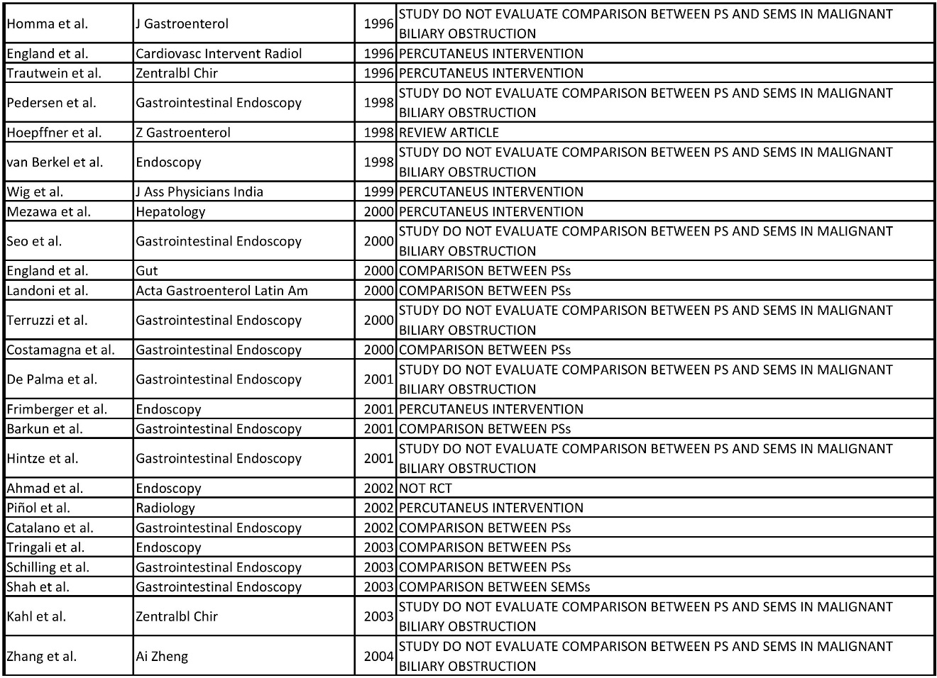

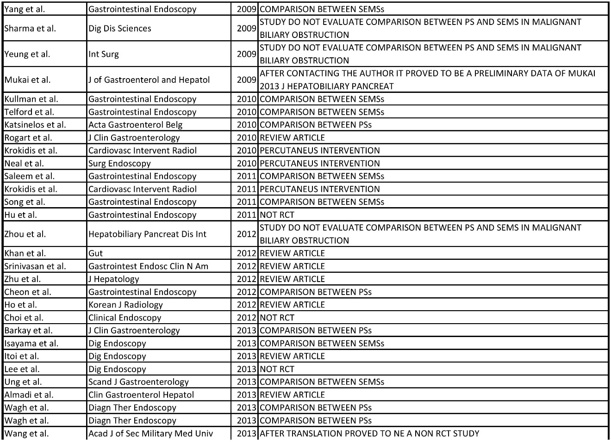

Supplementary Table 2 Outcomes of each study with the type of stent used (in parentheses are the number of stents used in each endoscopic retrograde cholangiopancreatography
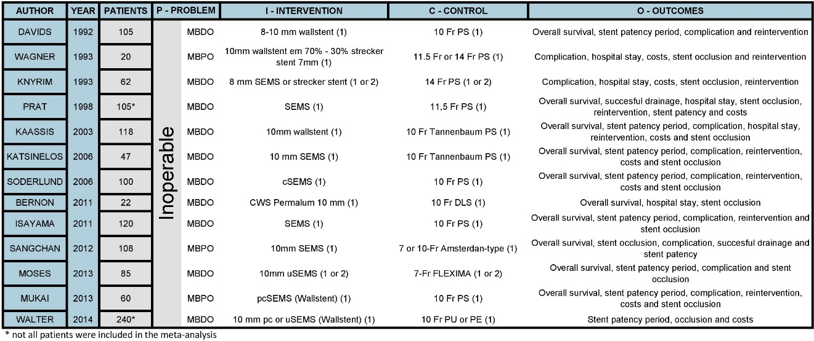

Supplementary Table 3 Distribution of usable outcomes between the studies is shown below
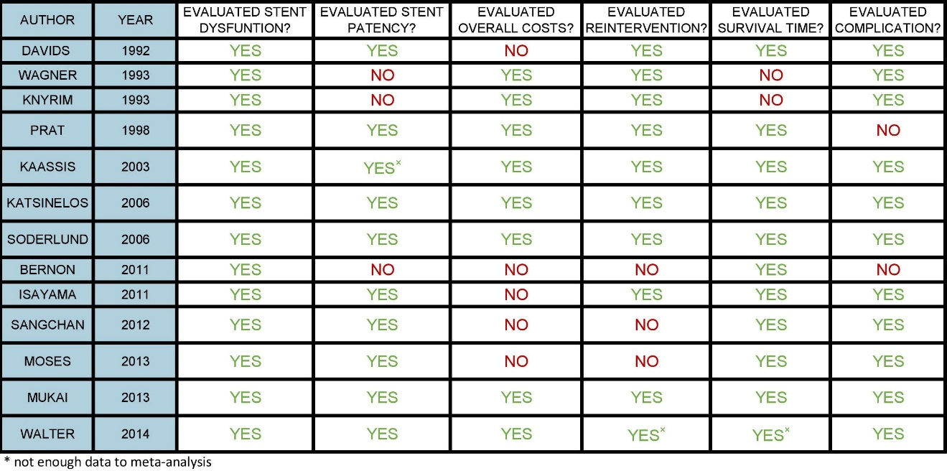

Supplementary Table 4 Individual results of the studies included
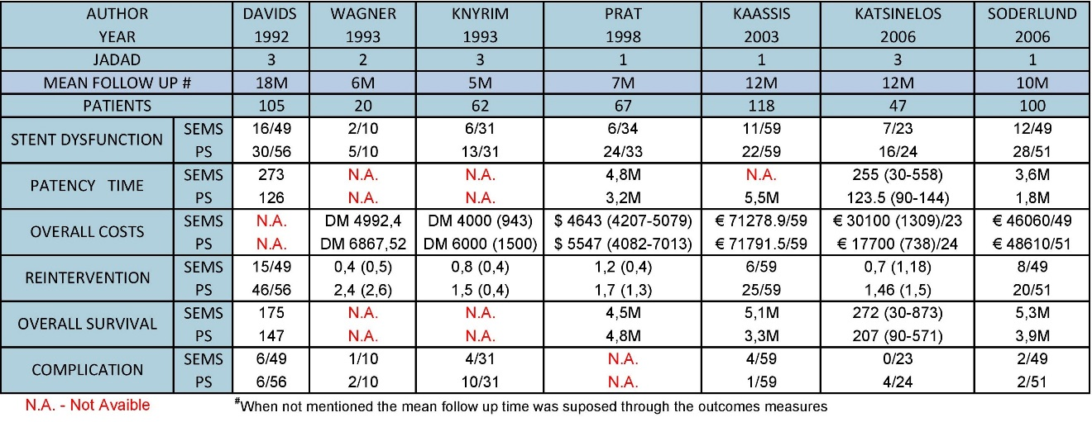
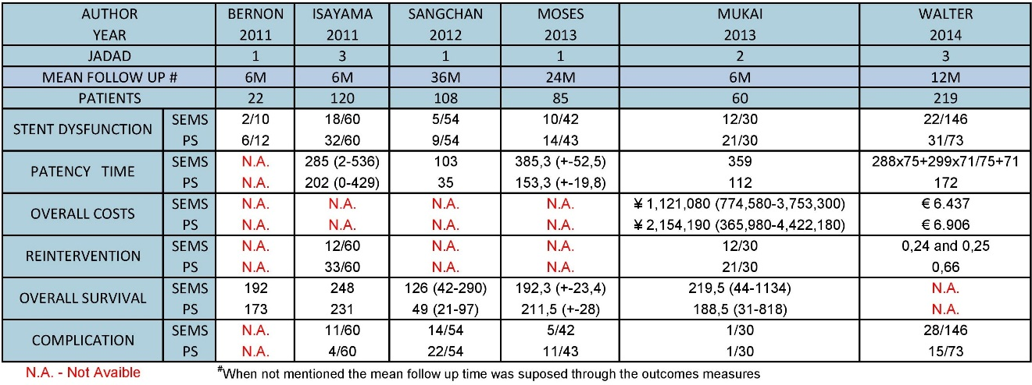

Supplementary Figure 1 Overall survival MPBO for each study.

Supplementary Figure 2 Overall survival MDBO for each study.

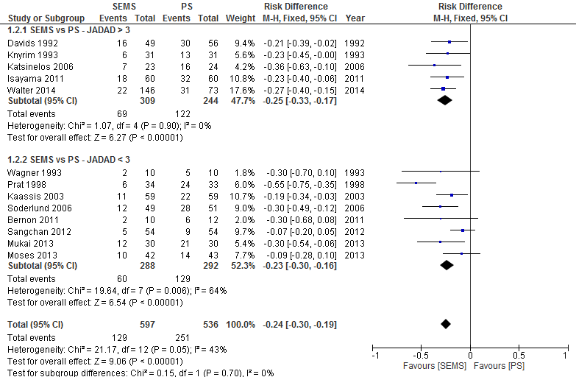
Supplementary Figure 3 Forest plot - stent dysfunction (JADAD).

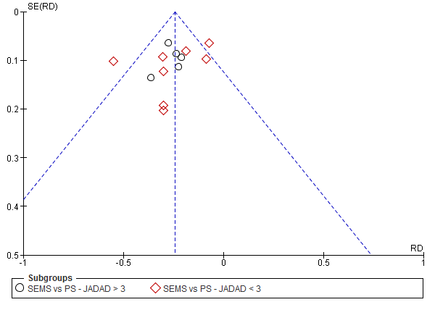
Supplementary Figure 4 Funnel plot - stent dysfunction (JADAD).

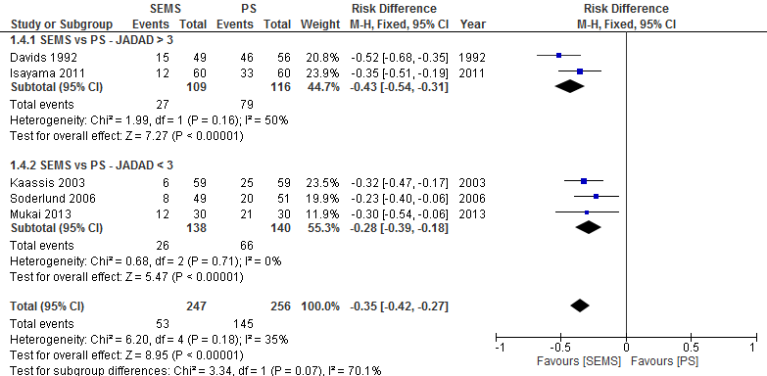
Supplementary Figure 5 Forest plot - reintervention (dichotomic) – JADAD.

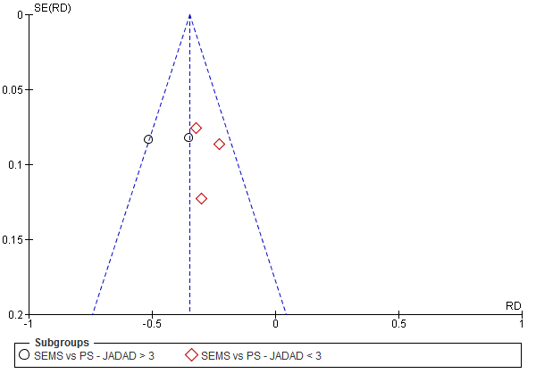
Supplementary Figure 6 Funnel plot - reintervention (dichotomic) – JADAD.

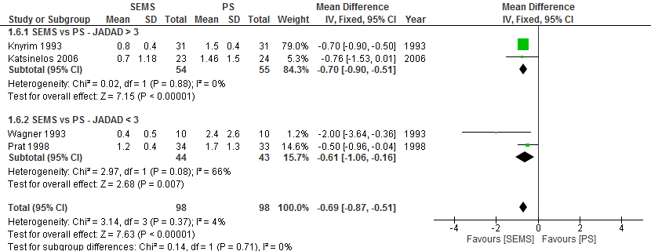
Supplementary Figure 7 Forest plot - reintervention (continuous) – JADAD.

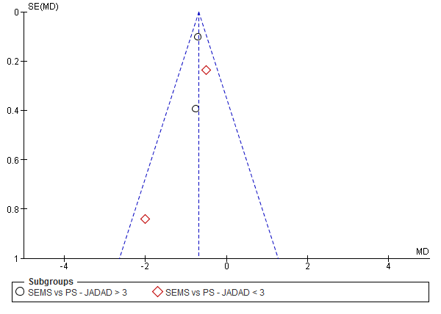
Supplementary Figure 8 Funnel plot - reintervention (continuous) – JADAD.

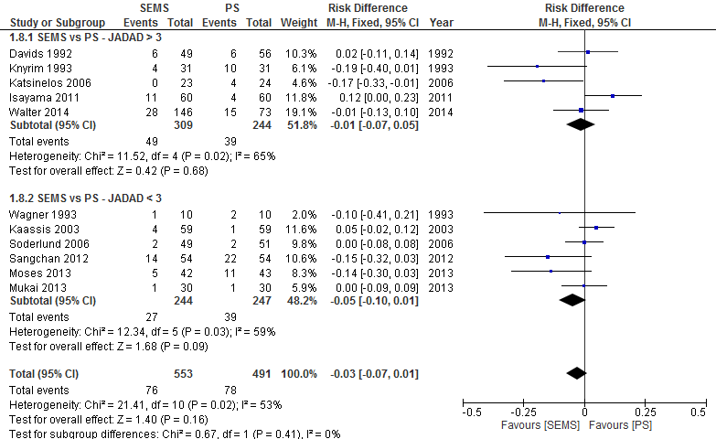
Supplementary Figure 9 Forest plot – complication (JADAD).

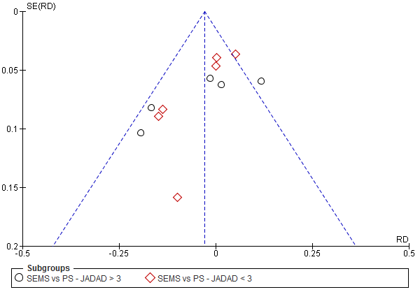
Supplementary Figure 10 Funnel plot - complication (JADAD).

