Name of Journal: World Journal of Clinical Cases
Manuscript NO: 59101
Manuscript Type: CASE REPORT

Paratesticular liposarcoma: Two case reports

Zheng QG et al. Cases of paratesticular liposarcoma

Qi-Gang Zheng, Zhao-Hui Sun, Jia-Jian Chen, Jia-Cheng Li, Xiao-Jun Huang

Qi-Gang Zheng, Zhao-Hui Sun, Jia-Jian Chen, Jia-Cheng Li, The Second Clinical Medical College, Zhejiang Chinese Medical University, Hangzhou 310011, Zhejiang Province, China

Xiao-Jun Huang, Department of Urology, The Second Clinical Medical College of Zhejiang Chinese Medical University, The Second Affiliated Hospital of Zhejiang Chinese Medical University, Hangzhou 310011, Zhejiang Province, China

Author contributions: Zheng QG and Huang XJ conceived and wrote this report; Zheng QG operated on the patients; Zheng QG, Sun ZH and Li JC organized the data; Huang XJ revised the paper; All authors have read and approved the final manuscript.

Corresponding author: Xiao-Jun Huang, Doctor, Department of Urology, The Second Clinical Medical College of Zhejiang Chinese Medical University, The Second Affiliated Hospital of Zhejiang Chinese Medical University, No. 318 Chaowang Road, Gongshu District, Hangzhou 310011, Zhejiang Province, China. hxj258111@163.com

Received: August 25, 2020
Revised: October 28, 2020
Accepted: November 13, 2020
Published online: January 16, 2021

Abstract
BACKGROUND
Paratesticular liposarcoma accounts for approximately 7% of scrotal tumors. They are rare lesions of the reproductive system with approximately 90% of the lesions originating from the spermatic cord. Surgery, with the goal of complete resection, is the mainstay for treatment of this disease. However, treatment consisting of extended resection to decrease local recurrence remains controversial.

CASE SUMMARY
We report the cases of two patients with paratesticular liposarcomas who were treated with radical testicular tumor resection without adjuvant therapy. Follow-up investigations at 9 mo showed no sign of recurrence.

CONCLUSION
Surgery is the first-line treatment, regardless of whether it is a recurrent or primary tumor. Extended resection carries a higher risk of complications and should not be performed routinely. Preoperative radiotherapy can reduce the local recurrence rate without affecting the overall survival.

Key Words: Case report; Paratesticular liposarcoma; Andrology; Radiotherapy; Surgery; Extended resection

©The Author(s) 2021. Published by Baishideng Publishing Group Inc. All rights reserved.

Citation: Zheng QG, Sun ZH, Chen JJ, Li JC, Huang XJ. Paratesticular liposarcoma: Two case reports. World J Clin Cases 2021; 9(2): 457-462
URL: https://www.wjgnet.com/2307-8960/full/v9/i2/457.htm
DOI: https://dx.doi.org/10.12998/wjcc.v9.i2.457

Core Tip: Atypical liposarcoma/well-differentiated liposarcoma is commonly distributed in the retroperitoneum, deep tissue of the extremities, and mediastinum, but rarely in the scrotum. We report the cases of two patients with paratesticular liposarcomas who were treated with radical testicular tumor resection without adjuvant therapy. The cases highlight surgery as the first choice of treatment, regardless of primary or recurrent liposarcoma, and show that extended resection is not beneficial for overall survival. Further, radiotherapy can provide a balance between the local recurrence rate and overall survival.
INTRODUCTION
Liposarcomas account for 5.75% of all tissue subtypes^{[1]}. Atypical liposarcoma/well-differentiated liposarcoma (ALT/WDLPS) is the most common type of liposarcoma. ALT/WDLPS is mostly distributed in the retroperitoneum and deep tissue of the extremities and mediastinum, but rarely in the scrotum^{[2]}, with fewer than 200 similar cases reported to date in the English literature^{[3]}. Surgery is currently the most effective treatment for patients with liposarcomas.
A retrospective multi-institutional study of 382 patients (including 106 WDLPSs) showed that the overall local recurrence rate was 49%^{[4]}. Because of the high local recurrence rate, patients have to undergo repeated operations. However, subsequent operations can be disturbed by the scar from previous operations, leading to distortion of the normal anatomy. Hence, the quality and scope of the first operation need to be assessed. During treatment, factors under the surgeon’s control (including tumor integrity and extent of resection) and those reflective of tumor biology (grade and multifocality) affect patient outcomes^{[5]}.
We describe two rare cases of paratesticular liposarcomas in which the patients were treated with radical testicular tumor resection. Considering the rarity of cases, we review the literature regarding the application of surgical treatment.

CASE PRESENTATION
Chief complaints
Case 1: A 57-year-old Chinese man was hospitalized in the Urology Department of The Second Affiliated Hospital of Zhejiang Chinese Medical University (Hangzhou, China) because of a painless mass in his left scrotum for 1 year.

Case 2: A 62-year-old man presented with a mass in his left scrotum close to the abdomen, and it had grown slowly over about 30 d.

History of present illness
Case 1: He reported that the mass grew from the size of a soybean to the size of a fist in 1 year.

Case 2: He reported that the mass grew from the size of a soybean to the size of an egg within 20 d.

History of past illness
Case 1: The patient had no history of other illness and had no known allergies.

Case 2: He underwent left radical orchiectomy in our hospital 10 years ago due to the presence of a left scrotal mass. The pathological analysis indicated malignant fibrous histiocytoma. He had no known allergies.

Personal and family history
Case 1: The patient did not smoke or drink, and had no relevant family history.

Case 2: The patient did not smoke or drink, and no relevant family history was reported.

Physical examination
Case 1: The mass was firm with no tenderness, and the testicles were away from the scrotum. The results of the light transmission test were negative.

Case 2: A firm and non-tender mass was found in the left scrotum close to the abdomen and the left testicle was absent.

Laboratory examinations
Case 1: Serum carcinoembryonic antigen (CEA) level was 4.2 ng/mL (normal range: 0-5 ng/mL), and alpha-fetoprotein level was 3.0 ng/mL (normal value 8.0 ng/mL).

Case 2: The serum CEA level was 5.4 ng/mL, and CYFRA21-1 cytokeratin 19 fragment level was 2.49 ng/mL (normal range: 0-2.08 ng/mL).

Imaging examinations
Case 1: Computed tomography (CT) did not show the left testicle; however, there were massive low-density foci (CT value: -80 U) in the left scrotal region; the maximum cross-sectional area was approximately 8.6 cm × 6.8 cm (Figure 1A). Mainly, mature lipid density was noted with spotted nodular calcification (Figure 1B). Initially, we considered this to be a teratoma.

Case 2: Ultrasonography (US) showed a heterogeneous echo mass in the median fat layer of the perineum. CT showed a nodular high-density shadow above the left scrotum in the lower abdomen, approximately 3.2 cm × 2.2 cm in size, and the boundary was unclear.

FINAL DIAGNOSIS
Case 1
Based on the findings of the examination and imaging, a provisional diagnosis of liposarcoma was made.

Case 2
Based on the above findings, a provisional diagnosis of liposarcoma was made.

TREATMENT
Case 1
He underwent radical resection of the left testicular tumor on the 4th d after admission. The surgeon dissociated the entire spermatic cord up to the inner ring at the epididymis muscle. The spermatic cord was severed at the inner ring and sutured separately. The entire tumor and left testis, outside of the sheath, were resected. The tumor was a 14 cm × 8 cm × 6 cm, soft, gray-yellow mass (Figure 1C and D) with its capsule was intact and close to the testis. Pathological analysis showed that the tumor was composed of relatively mature adipocytes, single vesicular adipoblasts in the focal area, fibrous tissue with mucus deformation in the stroma (Figure 2A and B), and an intact tumor capsule. Immunohistochemical analysis revealed S100+, cluster of differentiation 34 (CD34), CD34+, vimentin-positive (Vim+), smooth muscle actin-positive (SMA+), CD68, and Ki67 < 1%+, which supported the diagnosis of ALT/WDLPS.

Case 2
The patient underwent resection of the left inguinal tumor. The surgeon separated the tumor from the scrotum by 1 cm for R0 resection, and then resected it. The tumor measured about 7 cm × 5.5 cm × 2.5 cm, and we found a 3.5 cm × 3 cm × 2.5 cm gray-white mass in the middle with a clear boundary. Pathological analysis indicated that the tumor was an atypical liposarcoma (Figure 2C and D). Immunohistochemical analysis showed CD34+, S-100+, SMA-, VIM-, actin-negative (Act-), CD68 partial+, and KI67 30%+, supporting the diagnosis of ALT/WDLPS.

OUTCOME AND FOLLOW-UP
Case 1
The patient was discharged 4 d after the operation without drugs or adjuvant therapy. At 9 mo postoperatively, there was no signs of recurrence.

Case 2
The patient showed good postoperative recovery without any adjuvant therapy. His symptoms were relieved 9 mo postoperatively, and there were no signs of recurrence.

DISCUSSION
To date, surgeons believe that extended resection should be performed for liposarcomas to reduce the possibility of local recurrence. In a French retrospective multi-institutional study of 315 patients with retroperitoneal sarcomas who underwent complete gross tumor resection (R0/R1), 250 (79%) patients underwent compartmental organ resections including 120 (38%) patients who underwent compartmental complete resection. In the multivariate analysis, compartmental complete resection was associated with an improved 3-year cumulative incidence of local recurrence (10% compared with 47% after simple resection and 52% after non-compartmental organ resection)^{[4]}. On the basis of these results, Bonvalot et al^{[4]} recommended routine compartmental resection, regardless of histology. Nevertheless, this view is now being questioned. A retrospective analysis of 76 patients after complete resection (R0/R1) showed that 38 (46%) underwent organ resection; however, only 6 (7%) patients had organ invasion^{[6]}. The data demonstrated that organ resection was not associated with overall survival (OS) or disease-free survival (DFS), whereas organ preservation was associated with a reduced risk of postoperative complications^{[6]}. When analyzing relapsed patients undergoing secondary surgery, the same conclusion was reached^{[7]}.
If we only focus on the rate of local recurrence but not on patients’ postoperative survival time, this is a typical “analysis paralysis” situation. Patients undergoing extended resection have a higher risk of complications than those not undergoing extended resection. Bonvalot et al^{[4]} reported that 16% of patients who underwent extended surgery have complications, and half of them require a second operation. The above situation can be aggravated by malnutrition^{[8]}. Therefore, conservative resection is undoubtedly more suitable for patients with poor physical condition, such as elderly men. Thus, for the two patients described herein, considering their ages, only gross marginal negative resection (R1) was performed.
In the past, pathologists thought that chemotherapy and radiotherapy were limited with regard to the biological characteristics of liposarcomas. In a recent retrospective analysis of patients with liposarcomas who were mainly treated with an anthracycline-containing regimen, the objective response rate was 12%; additionally, there was no correlation between chemotherapy and OS or DFS; however, radiotherapy can reduce the local recurrence rate^{[9]}. An analysis of 261 patients with liposarcomas showed that local failure-free survival was significantly improved if adjuvant radiotherapy was performed preoperatively instead of simple surgery (hazard ration [HR] = 0.42, 95% confidence interval [CI]: 0.21-0.86, P < 0.05)^{[10]}. When performing radiotherapy for the same type of tumor, the required field of vision and dose are smaller preoperatively than postoperatively, and this modality is associated with fewer complications. Additionally, there is no evidence that radiotherapy has an effect on OS^{[10]}. Hence, surgeons should pay more attention to the positive effect of radiotherapy before performing surgery for liposarcomas; however, the two patients discussed herein did not undergo radiotherapy before surgery.

CONCLUSION
Surgery is the first choice of treatment, regardless of primary or recurrent liposarcoma. However, extended resection is not beneficial for OS and should not be performed routinely. We recommend selective resection of compartmental organs only if there is a clinical suspicion of invasion at the time of surgical resection. Radiotherapy can create a balance between the local recurrence rate and OS. Preoperative radiotherapy is a less harmful than extended resection to reduce the burden of marginal viable tumor.

ACKNOWLEDGEMENTS
The article was supported by the National Clinical Key Specialist.

REFERENCES
1 Vos M, Boeve WC, van Ginhoven TM, Sleijfer S, Verhoef C, Grünhagen DJ. Impact of primary tumor location on outcome of liposarcoma patients, a retrospective cohort study. Eur J Surg Oncol 2019; 45: 2437-2442 [PMID: 31493984 DOI: 10.1016/j.ejso.2019.08.026]
2 Jo VY, Fletcher CD. WHO classification of soft tissue tumours: an update based on the 2013 (4th) edition. Pathology 2014; 46: 95-104 [PMID: 24378391 DOI: 10.1097/PAT.0000000000000050]
3 Mouden K, Wakrim S, Semmar A. Paratesticular liposarcoma: a case report. Pan Afr Med J 2019; 33: 282 [PMID: 31692859 DOI: 10.11604/pamj.2019.33.282.19545]
4 Bonvalot S, Rivoire M, Castaing M, Stoeckle E, Le Cesne A, Blay JY, Laplanche A. Primary retroperitoneal sarcomas: a multivariate analysis of surgical factors associated with local control. J Clin Oncol 2009; 27: 31-37 [PMID: 19047280 DOI: 10.1200/JCO.2008.18.0802]
5 Keung EZ, Hornick JL, Bertagnolli MM, Baldini EH, Raut CP. Predictors of outcomes in patients with primary retroperitoneal dedifferentiated liposarcoma undergoing surgery. J Am Coll Surg 2014; 218: 206-217 [PMID: 24315890 DOI: 10.1016/j.jamcollsurg.2013.10.009]
6 Ikoma N, Roland CL, Torres KE, Chiang YJ, Wang WL, Somaiah N, Mann GN, Hunt KK, Cormier JN, Feig BW. Concomitant organ resection does not improve outcomes in primary retroperitoneal well-differentiated liposarcoma: A retrospective cohort study at a major sarcoma center. J Surg Oncol 2018; 117: 1188-1194 [PMID: 29228466 DOI: 10.1002/jso.24951]
7 Ikoma N, Roland CL, Torres KE, Chiang YJ, Wang WL, Somaiah N, Mann GN, Hunt KK, Cormier JN, Feig BW. Salvage Surgery for Recurrent Retroperitoneal Well-Differentiated Liposarcoma: Early Reoperation may not Provide Benefit. Ann Surg Oncol 2018; 25: 2193-2200 [PMID: 29520652 DOI: 10.1245/s10434-018-6417-6]
8 Kirov KM, Xu HP, Crenn P, Goater P, Tzanis D, Bouhadiba MT, Abdelhafidh K, Kirova YM, Bonvalot S. Role of nutritional status in the early postoperative prognosis of patients operated for retroperitoneal liposarcoma (RLS): A single center experience. Eur J Surg Oncol 2019; 45: 261-267 [PMID: 30174162 DOI: 10.1016/j.ejso.2018.07.001]
9 Italiano A, Toulmonde M, Cioffi A, Penel N, Isambert N, Bompas E, Duffaud F, Patrikidou A, Lortal B, Le Cesne A, Blay JY, Maki RG, Schwartz GK, Antonescu CR, Singer S, Coindre JM, Bui B. Advanced well-differentiated/dedifferentiated liposarcomas: role of chemotherapy and survival. Ann Oncol 2012; 23: 1601-1607 [PMID: 22039081 DOI: 10.1093/annonc/mdr485]
10 Sampath S, Hitchcock YJ, Shrieve DC, Randall RL, Schultheiss TE, Wong JY. Radiotherapy and extent of surgical resection in retroperitoneal soft-tissue sarcoma: multi-institutional analysis of 261 patients. J Surg Oncol 2010; 101: 345-350 [PMID: 20119974 DOI: 10.1002/jso.21474]

Footnotes
Informed consent statement: Informed written consent was obtained from the patient for publication of this report and any accompanying images.

Conflict-of-interest statement: The authors declare that they have no conflicts of interest.

CARE Checklist (2016) statement: The authors have read the CARE Checklist (2016), and the manuscript was prepared and revised according to the CARE Checklist (2016).

Open-Access: This article is an open-access article that was selected by an in-house editor and fully peer-reviewed by external reviewers. It is distributed in accordance with the Creative Commons Attribution NonCommercial (CC BY-NC 4.0) license, which permits others to distribute, remix, adapt, build upon this work non-commercially, and license their derivative works on different terms, provided the original work is properly cited and the use is non-commercial. See: http://creativecommons.org/Licenses/by-nc/4.0/

Manuscript source: Unsolicited manuscript

Peer-review started: August 25, 2020
First decision: October 27, 2020
Article in press: November 13, 2020

Specialty type: Medicine, research and experimental
Country/Territory of origin: China
Peer-review report’s scientific quality classification
Grade A (Excellent): A, A
Grade B (Very good): B
Grade C (Good): 0
Grade D (Fair): 0
Grade E (Poor): 0

P-Reviewer: Machairas N, Shimada S S-Editor: Gao CC L-Editor: Filipodia P-Editor: Xing YX
Figure Legends
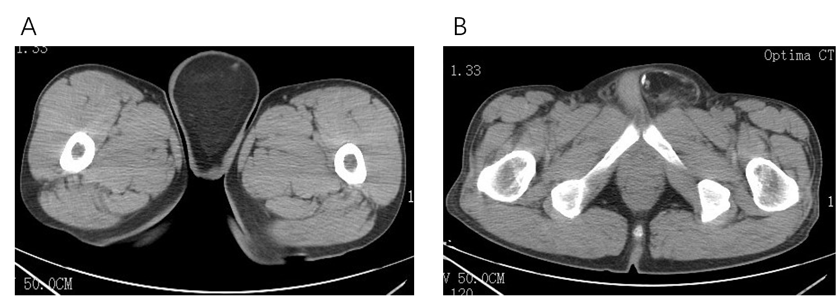
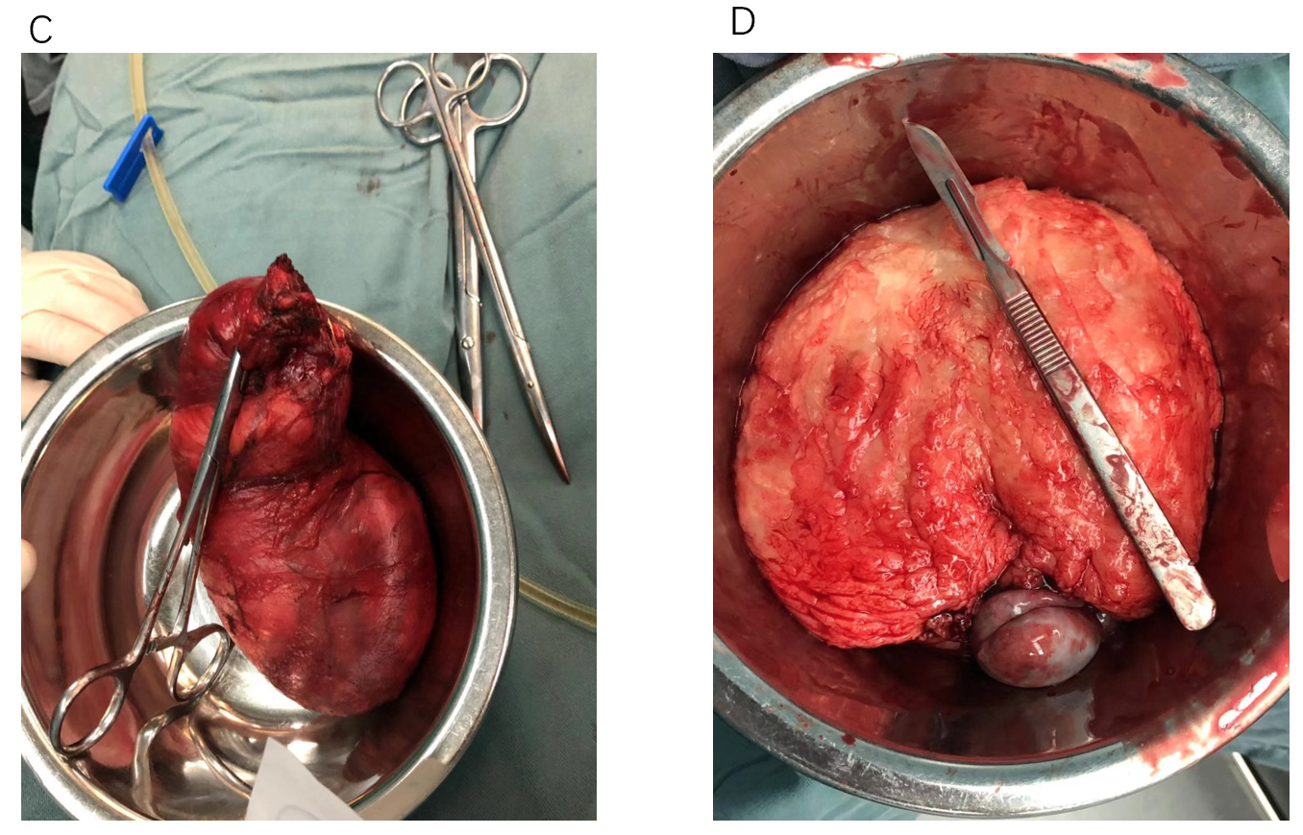
Figure 1 Computed tomography images. A: Computed tomography scan showing spotted and nodular calcification; B: The maximum cross-sectional area was about 8.6 cm × 6.8 cm; C: The giant tumor was a gray-yellow mass, measuring 14 cm × 8 cm × 6 cm, and its capsule was intact and close to the testis; D: The cut plane of the tumor was gray-yellow.

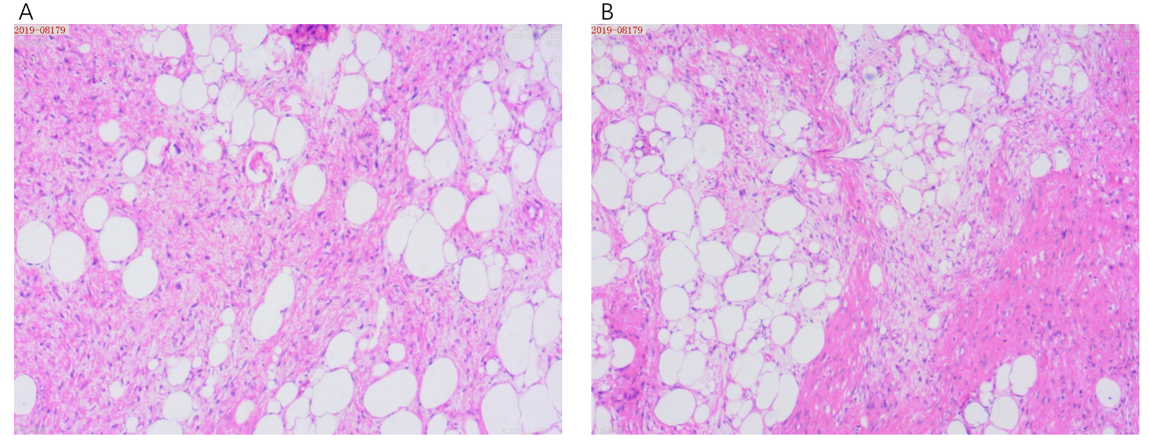
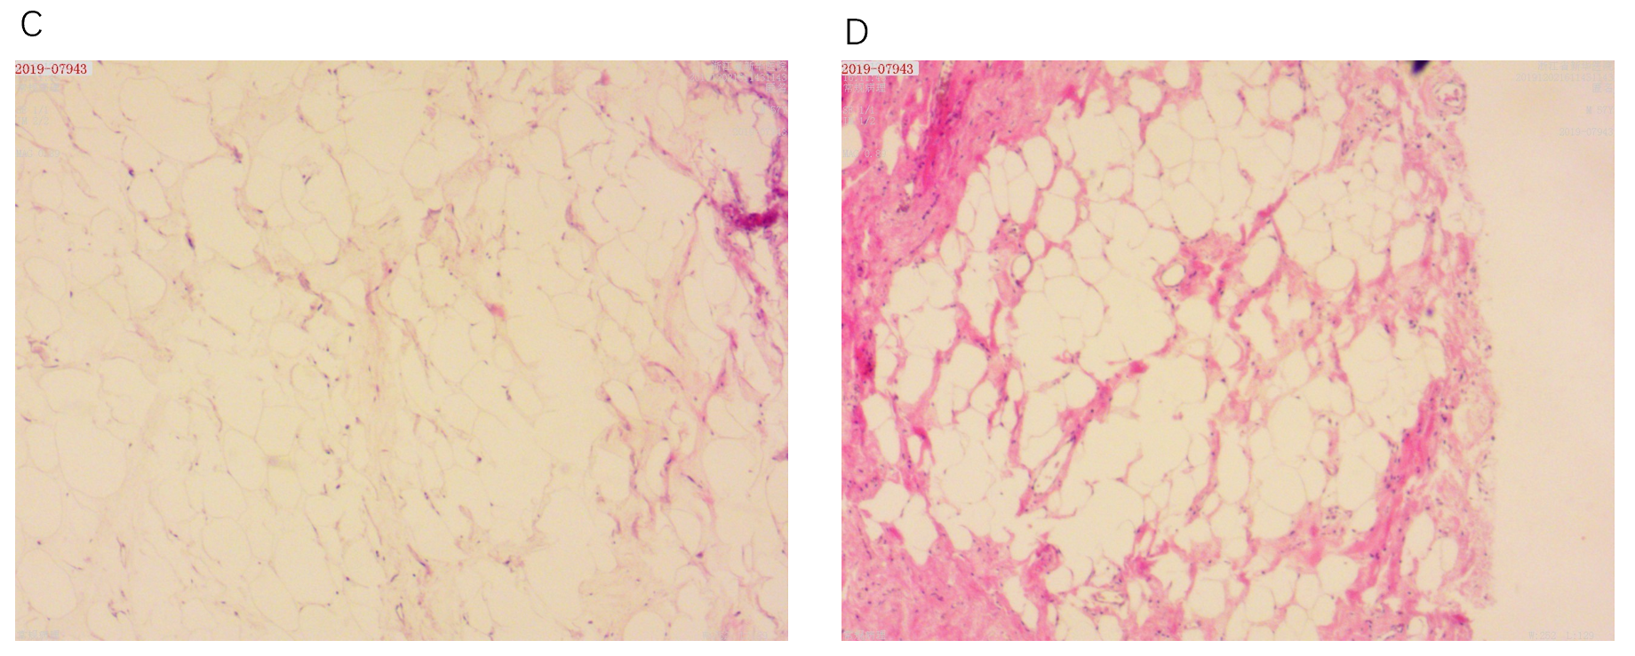
Figure 2 Results of the pathological examination. A: Fibrous tissue with mucus deformation is shown in the stroma; B: Single vesicular adipoblasts are visible in the focal area (scale bar = 100 μm); C and D: The pathological findings support the diagnosis of an atypical liposarcoma (scale bar = 100 μm).

Published by Baishideng Publishing Group Inc
7041 Koll Center Parkway, Suite 160, Pleasanton, CA 94566, USA
Telephone: +1-925-3991568
E-mail: bpgoffice@wjgnet.com
Help Desk: https://www.f6publishing.com/helpdesk
https://www.wjgnet.com

© 2021 Baishideng Publishing Group Inc. All rights reserved.

