Name of Journal: World Journal of Orthopedics
Manuscript NO: 55116
Manuscript Type: CASE REPORT

Treatment of a rotator cuff tear combined with iatrogenic glenoid fracture and shoulder instability: A rare case report

Chiang CH et al. Iatrogenic glenoid fracture in shoulder manipulation

Chen-Hao Chiang, Ting-Chien Tsai, Kuan-Kai Tung, Wei-Hsing Chih, Ming-Long Yeh, Wei-Ren Su

Chen-Hao Chiang, Ming-Long Yeh, Department of Biomedical Engineering, National Cheng Kung University, Tainan 70428, Taiwan

Chen-Hao Chiang, Ting-Chien Tsai, Wei-Hsing Chih, Department of Orthopaedic Surgery, Ditmanson Medical Foundation Chia-Yi Christian Hospital, Chia-Yi 60002, Taiwan

Kuan-Kai Tung, Department of Orthopaedic Surgery, Taichung Veterans General Hospital, Taichung 40705, Taiwan

Wei-Ren Su, Department of Orthopaedic Surgery, National Cheng Kung University Hospital, Tainan 70428, Taiwan

Author contributions: Chiang CH conceived the designed the study, acquired data, and wrote the original draft; Chiang CH, Tsai TC, and Tung KK analyzed and interpreted the data; Chiang CH, Tsai TC, and Chih WH provided the resources for the data; Yeh ML provided the methodology and validation of the case; Tsai TC, Chih WH, Yeh ML, and Su WR were supervisors for this draft; Tung KK reviewed and edited the draft; All authors have read and approved the final manuscript.

Corresponding author: Ting-Chien Tsai, MD, Surgeon, Department of Orthopaedic Surgery, Ditmanson Medical Foundation Chia-Yi Christian Hospital, No. 539 Zhongxiao Road, East District, Chia-Yi 60002, Taiwan. littlebo1005@gmail.com

Received: March 2, 2020
Revised: September 22, 2020
Accepted: October 9, 2020
Published online: November 18, 2020

Abstract
BACKGROUND
The brisement manipulation is an effective treatment for refractory shoulder stiffness. Rotator cuff tears can sometimes exist in combination with adhesive capsulitis. Arthroscopic capsular release combined with rotator cuff repair has achieved good outcomes in published reports.

CASE SUMMARY
We report the case of a patient with right shoulder pain for more than 1 year that was suspected to have adhesive capsulitis and a rotator cuff tear that was treated with brisement manipulation and arthroscopic management. An iatrogenic glenoid fracture with shoulder instability occurred during the manipulation. Arthroscopic treatment for fracture fixation, capsular release, and rotator cuff repair was performed, and the functional results are reported.

CONCLUSION
Arthroscopic fixation for iatrogenic glenoid fracture and repairing coexisting rotator cuff tear can provide the stability needed for early rehabilitation.

Key Words: Frozen shoulder; Bursitis; Arthroscopy; Fracture; Glenoid fracture; Manipulation; Iatrogenic; Case report

Chiang CH, Tsai TC, Tung KK, Chih WH, Yeh ML, Su WR. Treatment of a rotator cuff tear combined with iatrogenic glenoid fracture and shoulder instability: A rare case report. World J Orthop 2020; 11(11): 516-522 URL: https://www.wjgnet.com/2218-5836/full/v11/i11/516.htm DOI: https://dx.doi.org/10.5312/wjo.v11.i11.516

Core Tip: Manipulation under anesthesia is an effective treatment for refractory stiff shoulder, but some severe complications have been reported. We present a rare case of rotator cuff tear and antero-inferior glenoid rim fracture combined with shoulder instability after manipulation for shoulder stiffness. Arthroscopic repair of the glenoid fracture and concomitant rotator cuff tear was performed. A good outcome was achieved with this treatment in the 2-year postoperative follow-ups.

INTRODUCTION
Rotator cuff tears accompanied by adhesive capsulitis are common in clinical practice^{[1-3]}. Both problems are prevalent causes of shoulder pain and disability. Manipulation under anesthesia with or without arthroscopic capsular release is an effective operative treatment for a refractory stiff shoulder^{[3-6]}. Rotator cuff repair combined with capsular release can achieve a good functional outcome with a low retear rate^{[7]}. Some severe complications have been reported after the manipulation (e.g., humeral fracture, glenohumeral dislocation, and brachial plexus injury)^{[3,8]}. Therefore, performing an arthroscopic capsular release before a shoulder manipulation is suggested to decrease the incidence of complications^{[3,9,10]}. However, some surgeons still prefer to perform the manipulation before arthroscopy to facilitate the performance of the arthroscopy, and the use of an arthroscope after manipulation could increase the release and address any concomitant problems^{[9-12]}. Furthermore, a high rate of iatrogenic intraarticular damage may occur during the manipulation^{[13]}. The incidence of glenoid fracture after manipulation is rare, according to historical reports^{[8,14,15]}. We present a case of antero-inferior glenoid rim fracture combined with shoulder instability after manipulation for shoulder stiffness. Arthroscopic repair of the glenoid fracture and concomitant rotator cuff tear was performed. A good outcome was achieved with this treatment. Informed consent was obtained from the patient, and she gave permission for her case to be published.

CASE PRESENTATION
Chief complaints
A 58-year-old woman presented to our clinic with a history of right shoulder pain and decreased range of motion (ROM) for more than 1 year.

History of present illness
She had a history of diabetes mellitus and was treated with oral diabetic medication. Adhesive capsulitis was suspected, and a physical therapy program was arranged to increase passive motion. Unfortunately, the ROM and right shoulder function showed no improvement after 2 mo of rehabilitation (Table 1).

History of past illness
She denied history of trauma of the right shoulder. She had a history of diabetes mellitus and was treated with oral diabetic medication.

Personal and family history
The patient herself and her family had not suffer from this symptom before.

Physical examination
There were positive findings for the Hawkin’s and empty can tests. The decreased ROM function is described in Table 1.

Laboratory examinations
All laboratory tests revealed no significant result.

Imaging examinations
A magnetic resonance imaging assessment revealed a small-sized full-thickness supraspinatus tear and wall thickening at the inferior capsule of the shoulder. No fractures were identified in the preoperative image evaluation (Figure 1).

FINAL DIAGNOSIS
Before operation, the tentative diagnosis was small-sized full-thickness supraspinatus tear and adhesive capsulitis. After manipulation, the final diagnosis was shifted to small-sized full-thickness supraspinatus tear combined with the glenoid fracture and shoulder instability.

TREATMENT
She was given general anesthesia and placed in the supine position. Brisement manipulation was first performed and begun with forward flexion in internal rotation with light traction, which held the arm close to the axilla to decrease the lever effect. Continuous gentle pressure was applied, and a distinct clicking sound with a giving-way sensation was noted mid-way when the arm elevation was at 150 degrees. The X-ray was checked, and no proximal humeral fracture or dislocation was found. Then, manipulation for abduction, external rotation, and internal rotation was performed. After the manipulation, an examination revealed grade II laxity during anterior translation for the right shoulder^{[16]}.
Shoulder arthroscopy was then performed with the patient in the beach-chair position, starting from the standard posterior portal. A fresh fracture of the anteroinferior rim of the glenoid was noted (Figure 2). The size of the fragment was measured by a laser-marked device about 5 mm and 15 mm in the anterior-posterior and superior-inferior directions, respectively. Due to hypermobile anterior translation of the glenohumeral joint, fracture fixation was decided. Anteroinferior and accessory anterosuperior portals were established via an outside-in technique. Three 2.8-mm Twinfix Ti suture anchors (Smith & Nephew, Andover, MA, United States) were set in place at the lower edge, upper edge, and middle of the fractured glenoid for fixation of the fractured glenoid rim (Figure 2). After fracture fixation, the anterior translation test found no instability. Then, a complete capsular release was performed arthroscopically^{[8]}. Repeated examinations showed good stability with full ROM. The fixed glenoid fracture was checked again arthroscopically and showed good stability with no displacement. Arthroscopic rotator cuff repair was then performed by two 5.0-mm Twinfix Ti suture anchors (Smith & Nephew) as the double-row suture technique in the subacromial space (Figure 2).

OUTCOME AND FOLLOW-UP
After surgery, the patient was immobilized in a simple sling, and gentle passive pendulum exercise was allowed for 6 wk, followed by active-assisted ROM exercises coupled with a comprehensive strengthening program. A computed tomography scan revealed healing of the fracture 3 mo after surgery (Figure 3). More aggressive training for strengthening and overhead lifting began from month 4, in accordance with the recovery of ROM and strength.
At the 1-year and 2-year postoperative follow-ups, functional outcomes had improved beyond the baseline preoperative measures, and the patient was satisfied with the surgical outcome (Table 1 and Figure 4).

DISCUSSION
Manipulation under anesthesia or arthroscopic capsular release is effective in treating a refractory stiff shoulder. For cases with coexisting rotator cuff tears, arthroscopic capsular release for the stiff shoulder combined with repair for the rotator cuff tear can achieve a good result^{[7]}. Therefore, in cases of a stiff shoulder combined with a rotator cuff tear, surgeons can use an arthroscope to evaluate and address possible injuries and to perform additional capsular release, in addition to the manipulation procedure. Although there was no evidence to show that aggressive treatment for the coexisting problems could achieve a better outcome than manipulation only, it is reasonable to suggest that a better outcome can be achieved if all the problems can be treated in a minimally invasive manner, rather than with open surgery. This kind of aggressive treatment would be more suitable for patients with a strong motivation for rehabilitation and would result in a shorter treatment time than treating both of the problems separately or nonoperatively^{[1]}.
The management of the glenoid fracture remained controversial. Magnussen et al^{[17]} reported a case with glenoid fracture during manipulation. The fracture healed only after immobilization without any surgical treatment. On the other hand, glenoid rim fractures often lead to chronic shoulder instability, and avulsion fractures of more than 5 mm with the instability of the glenohumeral joint may require operative stabilization^{[18,19]}. Patients with glenoid fracture treated with arthroscopic anchor or screw fixation can also achieve uneventful healing and good functional results^{[20]}. Arthroscopic fixation for glenoid fracture can minimize soft tissue dissection and manipulation. Additionally, with stable fixation and a reduced glenoid fossa, early rehabilitation can be allowed, complications related to malunion can be avoided, and good functional outcomes are more likely.
The reported results for arthroscopic repair of rotator cuff tears only and of tears combined with Bankart lesions have been similar and good^{[21,22]}. The conditions in our case may be similar to those of a rotator cuff tear combined with a Bankart lesion. The treatment for both sites may have outcomes similar to those of rotator cuff repair only. Although the results are affected by capsule release, we would be more confident in allowing the patient to begin early motion rehabilitation if the glenoid fracture could be fixed together with the rotator cuff.

CONCLUSION
We would like to suggest that surgeons who experience a giving-way sensation after an obvious popping sound perform a radiographic check-up or an arthroscopic exam. Additionally, shoulder instability tests could be performed to evaluate possible instability. Arthroscopic fixation for an iatrogenic glenoid fracture and repair of a coexisting rotator cuff tear can provide stability needed for early rehabilitation. Fracture healing and good functional outcomes can be achieved.

ACKNOWLEDGEMENTS
We thank Huang HK, MD and Lin CH, MS (Department of Orthopaedics, Ditmanson Medical Foundation Chia-Yi Christian Hospital, Chiayi, Taiwan) for assistance with this case report.

REFERENCES
1 Le HV, Lee SJ, Nazarian A, Rodriguez EK. Adhesive capsulitis of the shoulder: review of pathophysiology and current clinical treatments. Shoulder Elbow 2017; 9: 75-84 [PMID: 28405218 DOI: 10.1177/1758573216676786]
2 Zhang K, de Sa D, Kanakamedala A, Sheean AJ, Vyas D. Management of Concomitant Preoperative Rotator Cuff Pathology and Adhesive Capsulitis: A Systematic Review of Indications, Treatment Approaches, and Outcomes. Arthroscopy 2019; 35: 979-993 [PMID: 30733032 DOI: 10.1016/j.arthro.2018.10.126]
3 Redler LH, Dennis ER. Treatment of Adhesive Capsulitis of the Shoulder. J Am Acad Orthop Surg 2019; 27: e544-e554 [PMID: 30632986 DOI: 10.5435/JAAOS-D-17-00606]
4 Uppal HS, Evans JP, Smith C. Frozen shoulder: A systematic review of therapeutic options. World J Orthop 2015; 6: 263-268 [PMID: 25793166 DOI: 10.5312/wjo.v6.i2.263]
5 Arce G. Primary Frozen Shoulder Syndrome: Arthroscopic Capsular Release. Arthrosc Tech 2015; 4: e717-e720 [PMID: 26870652 DOI: 10.1016/j.eats.2015.06.004]
6 Kraal T, The B, Boer R, van den Borne MP, Koenraadt K, Goossens P, Eygendaal D. Manipulation under anesthesia vs physiotherapy treatment in stage two of a frozen shoulder: a study protocol for a randomized controlled trial. BMC Musculoskelet Disord 2017; 18: 412 [PMID: 29020962 DOI: 10.1186/s12891-017-1763-2]
7 McGrath JP, Lam PH, Tan MT, Murrell GA. The effect of concomitant glenohumeral joint capsule release during rotator cuff repair--a comparative study. J Shoulder Elbow Surg 2016; 25: 714-722 [PMID: 26826766 DOI: 10.1016/j.jse.2015.10.005]
8 Hsu JE, Anakwenze OA, Warrender WJ, Abboud JA. Current review of adhesive capsulitis. J Shoulder Elbow Surg 2011; 20: 502-514 [PMID: 21167743 DOI: 10.1016/j.jse.2010.08.023]
9 Ogilvie-Harris DJ, Biggs DJ, Fitsialos DP, MacKay M. The resistant frozen shoulder. Manipulation vs arthroscopic release. Clin Orthop Relat Res 1995; 238-248 [PMID: 7554636 DOI: 10.1097/00003086-199510000-00026]
10 Celik H, Seckin MF, Akcal MA, Kara A, Kilinc BE, Akman S. Mid-long term results of manipulation and arthroscopic release in frozen shoulder. Acta Ortop Bras 2017; 25: 270-274 [PMID: 29375258 DOI: 10.1590/1413-785220172506174033]
11 Giuseffi S, Field LD, Giel TV 3rd, Brislin BT, Savoie FH 3rd. Arthroscopic Rotator Cuff Repair With Concomitant Capsular Release. Arthrosc Tech 2016; 5: e833-e837 [PMID: 27709045 DOI: 10.1016/j.eats.2016.04.002]
12 Grant JA, Schroeder N, Miller BS, Carpenter JE. Comparison of manipulation and arthroscopic capsular release for adhesive capsulitis: a systematic review. J Shoulder Elbow Surg 2013; 22: 1135-1145 [PMID: 23510748 DOI: 10.1016/j.jse.2013.01.010]
13 Loew M, Heichel TO, Lehner B. Intraarticular lesions in primary frozen shoulder after manipulation under general anesthesia. J Shoulder Elbow Surg 2005; 14: 16-21 [PMID: 15723009 DOI: 10.1016/j.jse.2004.04.004]
14 Koh KH, Kim JH, Yoo JC. Iatrogenic glenoid fracture after brisement manipulation for the stiffness of shoulder in patients with rotator cuff tear. Eur J Orthop Surg Traumatol 2013; 23 Suppl 2: S175-S178 [PMID: 23412222 DOI: 10.1007/s00590-012-1090-0]
15 Ji JH, Park SE, Kim WY, Min HK, Lee SW. Arthroscopic fixation of iatrogenic glenoid rim fracture caused by brisement manipulation: Two case reports. J Orthop Sci 2017; 22: 160-163 [PMID: 26740429 DOI: 10.1016/j.jos.2015.07.002]
16 Silliman JF, Hawkins RJ. Classification and physical diagnosis of instability of the shoulder. Clin Orthop Relat Res 1993; 7-19 [PMID: 8504616 DOI: 10.1097/00003086-199306000-00003]
17 Magnussen RA, Taylor DC. Glenoid fracture during manipulation under anesthesia for adhesive capsulitis: a case report. J Shoulder Elbow Surg 2011; 20: e23-e26 [PMID: 21397785 DOI: 10.1016/j.jse.2010.11.024]
18 van Oostveen DP, Temmerman OP, Burger BJ, van Noort A, Robinson M. Glenoid fractures: a review of pathology, classification, treatment and results. Acta Orthop Belg 2014; 80: 88-98 [PMID: 24873091]
19 Frich LH, Larsen MS. How to deal with a glenoid fracture. EFORT Open Rev 2017; 2: 151-157 [PMID: 28630753 DOI: 10.1302/2058-5241.2.160082]
20 Qu F, Yuan B, Qi W, Li C, Shen X, Guo Q, Zhao G, Wang J, Li H, Lu X, Liu Y. Arthroscopic Fixation of Comminuted Glenoid Fractures Using Cannulated Screws and Suture Anchors. Medicine (Baltimore) 2015; 94: e1923 [PMID: 26656324 DOI: 10.1097/MD.0000000000001923]
21 Godinho GG, Freitas JM, de Oliveira França F, Santos FM, de Simoni LF, Godinho PC. Evaluation of functional results from shoulders after arthroscopic repair of complete rotator cuff tears associated with traumatic anterior dislocation. Rev Bras Ortop 2016; 51: 163-168 [PMID: 27069884 DOI: 10.1016/j.rboe.2016.01.007]
22 Shields E, Mirabelli M, Amsdell S, Thorsness R, Goldblatt J, Maloney M, Voloshin I. Functional and imaging outcomes of arthroscopic simultaneous rotator cuff repair and bankart repair after shoulder dislocations. Am J Sports Med 2014; 42: 2614-2620 [PMID: 25261085 DOI: 10.1177/0363546514550993]
23 Richards RR, An KN, Bigliani LU, Friedman RJ, Gartsman GM, Gristina AG, Iannotti JP, Mow VC, Sidles JA, Zuckerman JD. A standardized method for the assessment of shoulder function. J Shoulder Elbow Surg 1994; 3: 347-352 [PMID: 22958838 DOI: 10.1016/S1058-2746(09)80019-0]
24 Amstutz HC, Sew Hoy AL, Clarke IC. UCLA anatomic total shoulder arthroplasty. Clin Orthop Relat Res 1981; (155): 7-20 [PMID: 7226634 DOI: 10.1097/00003086-198103000-00002]

Footnotes
Informed consent statement: Informed consent was obtained from the patient, and she gave permission for her case to be published.

Conflict-of-interest statement: The authors declared that they have no conflict of interest.

CARE Checklist (2016) statement: The authors have read the CARE Checklist (2016), and the manuscript was prepared and revised according to the CARE Checklist (2016).

Open-Access: This article is an open-access article that was selected by an in-house editor and fully peer-reviewed by external reviewers. It is distributed in accordance with the Creative Commons Attribution NonCommercial (CC BY-NC 4.0) license, which permits others to distribute, remix, adapt, build upon this work non-commercially, and license their derivative works on different terms, provided the original work is properly cited and the use is non-commercial. See: http://creativecommons.org/Licenses/by-nc/4.0/

Manuscript source: Unsolicited manuscript

Peer-review started: March 2, 2020
First decision: September 11, 2020
Article in press: October 9, 2020

Specialty type: Orthopedics
Country/Territory of origin: Taiwan
Peer-review report’s scientific quality classification
Grade A (Excellent): 0
Grade B (Very good): B, B, B
Grade C (Good): C
Grade D (Fair): 0
Grade E (Poor): 0

P-Reviewer: Halabchi F, Wang X, Zacharia B, Zhu SH S-Editor: Zhang H L-Editor: Filipodia P-Editor: Li X

Figure Legends
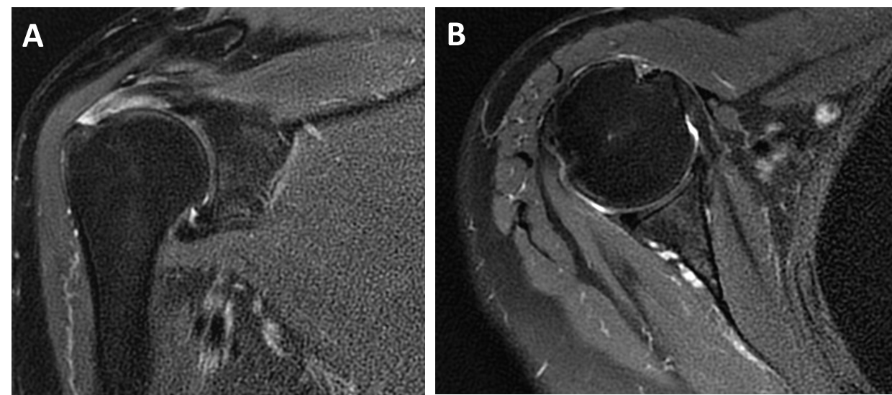
Figure 1 Magnetic resonance imaging of the right shoulder before surgery. A: The full-thickness rotator cuff tear; B: The intact glenoid of the right shoulder.
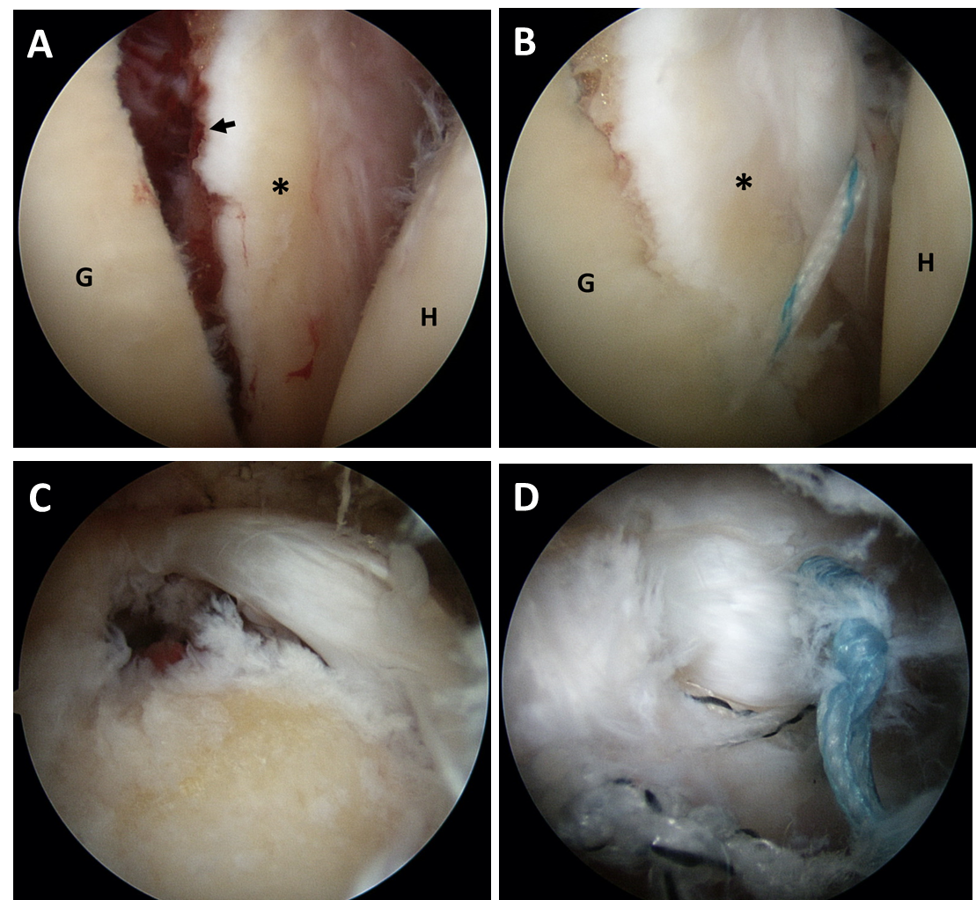
Figure 2 Intraoperative photographs. A: A fresh fracture with displacement at the anteroinferior glenoid rim. The size of the fragment was about 5 mm and 15 mm in the anterior-posterior and superior-inferior directions, respectively; B: The suture anchors for fixation of the fracture; C: The small-sized full-thickness supraspinatus tear; D: Torn rotator cuff was repaired by the double-row arthroscopic technique. G: Glenoid; H: Humeral head; Star: The fragment of anteroinferior glenoid with intact anterior joint capsule; Black arrow: Fresh fracture line.
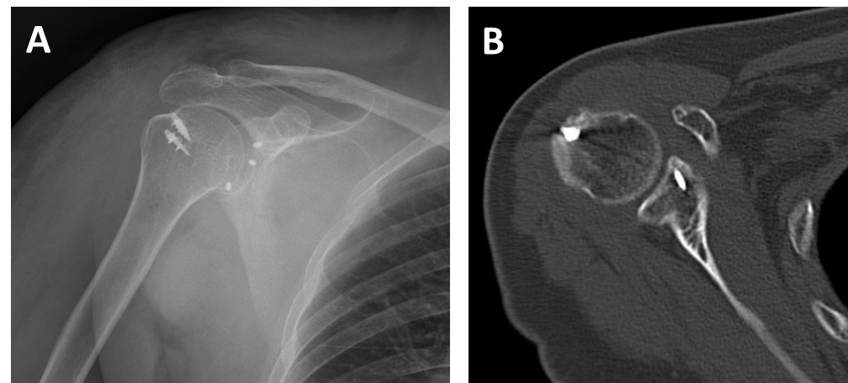
Figure 3 Radiograph at the 3-mo follow-up. A: The position of the anchors and the computed tomography scan are shown; B: Good healing of the fracture.
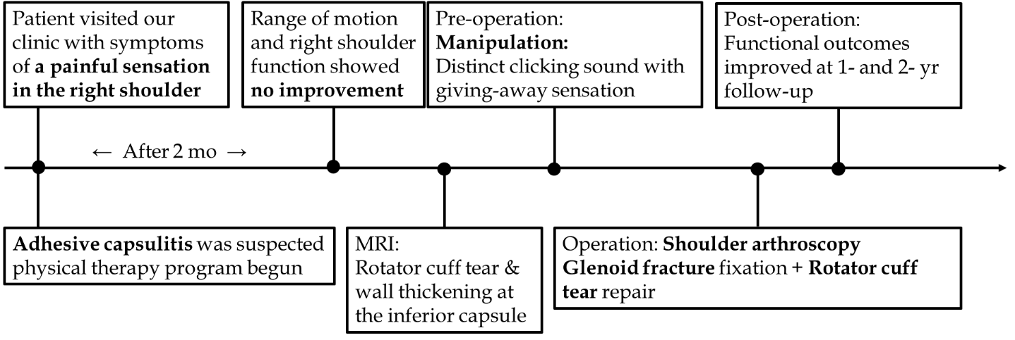
Figure 4 Timeline of the case. MRI: Magnetic resonance imaging.
Table 1 Functional result before surgery and at the postoperative 2-year follow-up
 | Before surgery | 1-yr follow-up | 2-yr follow-up
VAS at rest | 5 | 2 | 1
VAS during activity | 8 | 3 | 2
ASES score | 20.0 | 80 | 85.0
UCLA shoulder score | 10 | 30 | 31
Range of motion in º
FE | 130 | 160 | 175
ER, arm at side | 50 | 70 | 70
ER, arm at 90° abduction | 60 | 85 | 90
IR, arm at side | Buttock level | L1 level | T10 level
IR, arm at 90° abduction | 10 | 60 | 70
Abduction | 120 | 150 | 160

ASES: American shoulder and elbow surgeons^{[23]}; ER: External rotation; FE: Forward elevation; IR: Internal rotation; UCLA: University of California at Los Angeles^{[24]}; VAS: Visual analog pain scale (0, no pain; 10, worst pain).

