Name of Journal: World Journal of Gastrointestinal Endoscopy
Manuscript NO: 72330
Manuscript Type: CASE REPORT

Z-per-oral endoscopic myotomy as definitive prevention of a bleeding ulcer in Zenker’s diverticulum: A case report

Krutsri C et al. Bleeding Zenker’s diverticulum

Chonlada Krutsri, Pitichote Hiranyatheb, Preeda Sumritpradit, Pongsasit Singhatas, Pattawia Choikrua

Chonlada Krutsri, Pitichote Hiranyatheb, Preeda Sumritpradit, Pongsasit Singhatas, Pattawia Choikrua, Department of Surgery, Faculty of Medicine Ramathibodi Hospital, Mahidol University, Bangkok 10400, Thailand

Author contributions: Krutsri C and Hiranyatheb P designed, performed and wrote the paper; Sumritpradit P and Singhatas P wrote the paper and analysed the data; Choikrau P contributed analytic tools and analysed the data.

Corresponding author: Pitichote Hiranyatheb, FRCS, MD, Assistant Professor, Surgeon, Department of Surgery, Faculty of Medicine Ramathibodi Hospital, Mahidol University, Ramathibodi Hospital, 270 Praram VI Road, Ratchathewi, Bangkok 10400, Thailand. pitichotch@yahoo.com

Received: October 12, 2021
Revised: November 18, 2021
Accepted: February 12, 2022
Published online:

Abstract
BACKGROUND
Bleeding from Zenker’s diverticulum is extremely rare. At present, there are no guidelines for the management of bleeding Zenker’s diverticulum because of its rarity. Per-oral endoscopic myotomy (Z-POEM) is a precision myotomy technique and minimally invasive procedure for the treatment of Zenker’s diverticulum. We present a systematic review and a rare case of bleeding Zenker’s diverticulum that was effectively treated using Z-POEM.

CASE SUMMARY
A 72-year-old presented after 3 d of hematemesis. He had a 2-year history of progressive dysphagia and reported no antiplatelet, anticoagulant, or non-steroidal anti-inflammatory drug use. His vital signs were stable, and the hematocrit was 36%. Previous gastroscopy and barium swallow had revealed Zenker’s diverticulum before the bleeding occurred. We performed gastroscopy and found a 5-mm ulcer with a minimal blood clot and spontaneously resolved bleeding. Z-POEM for definitive treatment was performed to reduce accumulation of food and promote ulcer healing. He had no complications and no bleeding; at the follow-up 6 mo later, the ulcer was healed.

CONCLUSION
Z-POEM can be definitive prevention for bleeding ulcer in Zenker’s diverticulum that promotes ulcer healing, reducing the risk of recurrent bleeding. Z-POEM is also a definitive endoscopic surgery for treatment of Zenker’s diverticulum

Key Words: Zenker’s diverticulum; Bleeding Zenker’s diverticulum; Ulcer; Upper gastrointestinal bleed; Peroral endoscopic myotomy for Zenker's diverticulum; Peroral endoscopic myotomy

Krutsri C, Hiranyatheb P, Sumritpradit P, Singhatas P, Choikrua P. Z-per-oral endoscopic myotomy as definitive prevention of a bleeding ulcer in Zenker’s diverticulum: A case report. World J Gastrointest Endosc 2022; In press

Core Tip: Bleeding from ulcers in a Zenker’s diverticulum is extremely rare. Elderly patients with early symptoms of progressive dysphagia should be treated with a high index of suspicion. Risk factors include acidic pills, such as aspirin and non-steroidal anti-inflammatory drugs, that lodge themselves in the diverticulum creating an ulcer, and accumulation of food in the bottom of diverticulum leads to inflammation and subsequent ulcers. Per-oral endoscopic myotomy is a new definitive treatment for Zenker's diverticulum that can promote ulcer healing, decrease recurrent bleeding, and decrease dysphagia.

INTRODUCTION
Zenker’s diverticulum is a pouch of false diverticulum that forms at a point of weakness in the posterior pharyngeal wall, known as Killian’s triangle, within the upper esophageal sphincter^{[1,2]}. The overall prevalence of Zenker’s diverticulum in general population is 0.10%-0.11%^{[3]}. The typical presentation is progressive dysphagia of solid and liquid food, regurgitation, and aspiration in elderly patients. The average age of patients with Zenker’s diverticulum is 70-80 years old^{[4]}. Complications of Zenker’s diverticulum include choking and aspiration pneumonia; a large diverticulum more than 4 cm in size can compress the trachea or esophagus and cause obstruction^{[5]}. Rare complications include ulceration, bleeding, and malignant transformation (squamous cell carcinoma)^{[2,6]}. Bleeding from a Zenker’s diverticulum is rare and only six cases have been reported in the last 20 years^{[7-12]}. Patients typically present with hematemesis and/or sometimes hemoptysis. This can be fatal as result of hemodynamic instability following massive bleeding. The ulcer is one of the risk factors of bleeding Zenker’s diverticulum. To the best of our knowledge, this is the seventh reported case of a bleeding Zenker’s diverticulum in the past 20 years, and no standard treatment has been established for this condition. To date, minimally invasive third-space endoscopic surgery per-oral endoscopic myotomy (Z-POEM) plays an important role in the treatment of Zenker’s diverticulum^{[13]}. We present a case report of a patient who developed upper gastrointestinal bleeding (UGIB) from a rare Zenker’s diverticulum who was treated definitively using third-space endoscopic surgery, Z-POEM, and provide a systematic review of the available literature.
This case report follows the SCARE 2016 criteria. The systematic review of the literature followed the PRISMA guidelines (Figure 1). We searched the PUBMED and SCOPUS databases for articles published between 2000 and 2020 published in the English language, including case reports and original article. The search terms were “Zenker’s diverticulum” OR “esophageal diverticulum” AND “bleeding.” The first author screened the titles and abstracts of the identified studies to identify potentially relevant studies; full-text assessment was then performed to assess eligibility to be included. If the first author was uncertain whether a given study should be included, the corresponding author was consulted to reach a conclusion. The data were extracted and patient characteristics, such as the size of the Zenker’s diverticulum, management of bleeding, definitive management of Zenker’s diverticulum, follow-up length, and outcome, were collected.

CASE PRESENTATION
Chief complaints
A 72-year-old man was admitted to our hospital with a 3-day history of hematemesis.

History of present illness
The patient developed hematemesis 3 d before presenting at our hospital. The hematemesis was approximately 200 mL in volume 2 times. He was admitted to the nearest private hospital. His hematocrits was 25%. Esophagogastroduodenoscopy (EGD) under local anesthesia was performed on the first day in the previous hospital but failed because the patient choked and resisted scope insertion. He was reported to have anemia with a hematocrit 25% at the previous hospital, he received a 1-unit transfusion of red blood cells, intravenous fluids, and pantoprazole. On day 3 after admission, the patient had no hematemesis or anemia and had a hematocrit of 36%. He was then referred to our hospital. We performed gastroscopy and found a 5-mm ulcer with minimal blood clot.

History of past illness
The patient had diabetes mellitus and primary hypertension; he took 81 mg aspirin until almost 8 mo before he developed hematemesis. He had an approximately 2-year history of progressive dysphagia, which manifest as difficulty in swallowing solid foods then liquid foods, sometimes choking, and a non-significant decrease in body weight; there was no evidence of aspiration pneumonia. Barium swallow was performed and revealed a Zenker’s diverticulum that was 4 cm wide and 7.1 cm long, with a 1.1-cm-wide neck (Figure 2). Gastroscopy was performed and confirmed a large diverticulum 20 cm from the incisors without any ulcer in the diverticulum. He was diagnosed with Zenker’s diverticulum and put on the waiting list for Z-POEM before developing hematemesis.

Personal and family history
No family history of Zenker's diverticulum.

Physical examination
On the day of admission, the patient was not pale and had a stable blood pressure of 146/70 mmHg and heart rate of 62 beats per minute. On physical examination, the abdomen was soft with no tenderness. Rectal examination found an empty rectum without any gross masses.

Laboratory examinations
Laboratory investigation revealed a hematocrit of 36%.

Imaging examinations
Barium swallow was performed and revealed a Zenker’s diverticulum that was 4 cm wide and 7.1 cm long, with a 1.1-cm-wide neck (Figure 2B).

FINAL DIAGNOSIS
The final diagnosis was Zenker’s diverticulum with a bleeding ulcer that spontaneously resolved.

TREATMENT
Because the bleeding ulcer spontaneously resolved, we decided therapeutic endoscopy of the ulcer was not necessary; however, we performed Z-POEM as definitive treatment of Zenker’s diverticulum. This procedure aimed to improve dysphagia and to decrease food and drug retention in the diverticulum to reduce inflammation of the healed ulcer and prevent recurrent bleeding. Informed consent for the procedure was obtained from the patient after explaining the prognosis, results, and potential complications of the procedure, such as perforation. The Z-POEM technical process is shown in Figure 3. The operator was a surgical endoscopist in a university hospital. The patients underwent Z-POEM under general anesthesia with an endotracheal tube to prevent aspiration and end tidal CO₂ monitoring. CO₂ gas insufflation through the endoscope was required. The Z-POEM procedure was performed using a single-channel gastroscope (EG-760CT; Fuji-film Medical Co., Ltd. Tokyo, Japan). A triangle-tipped knife (KD-645; Olympus Corporation) was used for the mucosal incision, submucosal dissection, and myotomy. A small-caliber-tip transparent hood (ST hood) (DH-28GR; Fuji-film Medical Co., Ltd. Tokyo, Japan) was used to maintain and stabilize the operative field. Glycerol with a few drops of indigo carmine was used to lift the submucosal layer. The surgery was performed using a high-frequency electrosurgical energy generator (VIO 300 D; Erbe Elektromedizin, Tubingen, Germany) in endo cut mode (effect, 2.3 W) and spray coagulation mode (effect, 1,100 W). The procedure time was defined as the time from the insertion of the endoscope to application of the last through-the-scope clip (TTC). The septal muscle of Zenker’s diverticulum was located 20 cm from the incisors and was 1.1 cm wide (Figure 3A). The submucosa was lifted using glycerol and indigo carmine at the septum level, and a mucosal incision was made above the septal muscle using a triangle-tipped knife in endo cut mode (effect 2.3 W) (Figure 3B). Submucosal tunneling was performed with transparent hood assistance, and submucosal dissection was performed with coagulation along both sides of the septal wall using the spray coagulation mode (effect, 1,100 W) up to behind the ulcer (Figure 3C). The submucosal layer behind the ulcer had numerous inflamed small vessels; partial coagulation of these small vessels was achieved using a Coagrasper (Figure 3D). The picture 3E shows ulcer while checking mucosal integrity after performed submucosal tunneling before undergo myotomy. After checking the integrity of the mucosa in the ulcer region, myotomy of the septal muscle was performed using endo cut mode (effect, 2.3 W) to achieve complete septal myotomy (Figure 3E-G). TTCs were applied to achieve mucosal apposition (Figure 3H). Neither patient developed bleeding or perforation. The total procedure time was 65 min.

OUTCOME AND FOLLOW-UP
Water soluble contrast esophagography was performed on postoperative day 1 to confirm the absence of leakage, and the patients were able to resume an oral diet thereafter. He had no recurrent bleeding. EGD was repeated 6 mo postoperatively because inflammation might be subside to confirm that the ulcer had resolved and that there was no food retention as shown in Figure 4. He was better able to swallow soft foods but still had some degree of difficulty with solid food; he also reported a sensation of a foreign body in his neck but no pain, hematemesis, melena, or choking. Moreover, he had a 6-kg weight gain.

DISCUSSION
Our literature search only identified six published English language case reports^{[7-12]}. Including our present case, the average age of patients was 77.86 years, which is consistent with the average age of patients with Zenker’s diverticulum^{[2]}. The average size of Zenker’s diverticulum associated with UGIB is 6.325 cm as shown in Table. 1. Nowaday, there was not well established whether diverticulum size is related to the occurrence of UGIB but more bigger size is prone to have pills and food accumulation then more risk development of ulcer formation and UGIB. While the pathophysiology of a bleeding diverticulum is unclear, in our review, most cases were associated with chronic inflammation and ulceration of the diverticulum^{[7-10,12]}. Common causes of ulcer formation in the diverticulum include aspirin and non-steroidal anti-inflammatory drug tablets, which are acidic and can become lodged or trapped in the diverticulum; the prolonged contact induces direct and indirect mucosal injury. Chronic alcohol consumption, gastroesophageal reflux disease (GERD), and stimulation of acid secretion also induce ulcer formation^{[10,14]}. Anticoagulant use induces coagulopathy, which can lead to bleeding from diverticula, with or without ulceration, similar to other types of GI bleeding. Another assumed cause of bleeding Zenker’s diverticulum is chronic inflammation from food accumulation in the diverticulum inducing inflammation or infection, with or without ulceration. This assumption was confirmed by Sardana et al, who reported a case of bleeding Zenker’s diverticulum treated using diverticulectomy with a pathology report identifying chronic inflammation as the cause of mucosal bleeding^{[11]}. Therefore, larger diverticula are more likely to ulcerate and bleed, especially those larger than 4 cm.
Bleeding from Zenker’s diverticulum is rare and can be fatal, like other causes of UGIB. Elderly patients with previous progressive or intermittent dysphagia and regurgitation must be treated with a high index of suspicion. Currently, there are no guidelines regarding the management of bleeding Zenker’s diverticulum because of its rarity. Flicker et al and Eaton et al reported successfully stopping bleeding from the diverticulum using an endoscopic hemoclip^{[8,9]}. There are two case reports of failed endoscopic treatment due to blood pooling and hemodynamic instability, which prevented insertion of the endoscope; in this emergency setting, urgent open diverticulectomy was used as treatment^{[7,10]}. For successful endoscopic management, the neck of the diverticulum should be more than 1 cm wide so the endoscope can pass into the diverticulum for therapeutic management of bleeding at the bottom of diverticulum. There were two case reports of bleeding stopping spontaneously after withholding anticoagulant and aspirin treatment^{[11,12]}. As in our case, the bleeding from the ulcer in the diverticulum can stop spontaneously. Based on this evidence, endoscopic treatment may be the first choice, but if there is hemodynamic instable or endoscopic treatment fails or cannot identify the esophageal lumen, open diverticulectomy in an emergency setting is mandatory. Insertion of an endotracheal tube is recommended when endoscopic treatment is performed due to the high resistance and pooling of blood in the diverticulum leading to aspiration of blood into the pulmonary system.
After endoscopic treatment successfully stops the bleeding, definitive treatment of Zenker’s diverticulum is necessary to treat the ulcer and prevent rebleeding. In emergency situations when the patient is hemodynamically unstable or endoscopic treatment fails, open diverticulectomy is mandatory via left lateral neck incision to excise the bleeding diverticulum immediately. Therefore, patients and their relatives should be informed of the double set-up for endoscopic management and open surgery. Open diverticulectomy leads to a good outcome in 93% of cases, but there is a high rate of complications (10.5%-30%) and mortality (3%), respectively^{[15-17]}. Potential complications include pharyngocutaneous fistulas, mediastinitis, perforation, vocal cord paralysis, and transient recurrent laryngeal nerve paralysis^{[18-19]}.
A comparison of definitive treatment of Zenker’s diverticulum with per-oral endoscopic myotomy (Z-POEM), flexible endoscopic septostomy, stapler-assisted Zenker’s diverticulectomy, endoscopic harmonic scalpel, and standard open diverticulectomy found that Z-POEM allows the most precise myotomy because the operator can see until the last fiber of septal muscle^{[13]}. Z-POEM also has a lower complication rate (6.17%) because of the postoperative intact mucosal integrity, and with precision myotomy, the bottom of the diverticulum can be seen so perforation rarely occurs^{[3,13]}. While other procedure of treatment Zenker’s diverticulum such as standard open neck diverticulectomy and flexible endoscopic septotomy had more complication rate 10.5% and 11.3%, respectively^{[13]}. The recurrence rate following Z-POEM can be as low as 1.23%, compared with a recurrence rate of 11%-20% for other techniques^{[13,20-22]}. In our present case, Z-POEM was a minimally invasive definitive treatment that aimed to promote ulcer healing by decreasing the accumulation of food in the diverticulum. During Z-POEM, submucosal tunnelling can identify small vessels behind the ulcer and coagulate these vessels to stop the bleeding without any perforation. This patient experienced no perforation or rebleeding. After 6 mo of follow-up, the ulcer was healed.
In summary, bleeding Zenker’s diverticulum is rare and may be caused by ulceration due to acidic medications such as aspirin, NSAIDs or food retention-induced inflammation. Elderly patients with progressive dysphagia should be treated with a high index of suspicion. Therapeutic endoscopy is the first choice to manage bleeding Zenker’s diverticulum under general anesthesia with endotracheal intubation to prevent aspiration. Z-POEM is a definitive for Zenker’s diverticulum treatment that allows precision myotomy, which promotes ulcer healing and reduce the risk of rebleeding by decreasing the accumulation of drugs or food in the diverticulum with a low rate of complications.

CONCLUSION
Z-POEM can be definitive prevention for bleeding ulcer in Zenker’s diverticulum that promotes ulcer healing, reducing the risk of recurrent bleeding. Z-POEM is also a definitive endoscopic surgery for treatment of Zenker’s diverticulum.

REFERENCES
1 Balassone V, Pizzicannella M, Biasutto D, Di Matteo FM. Submucosal per-oral endoscopic myotomy for a large Zenker's diverticulum with use of a hydrodissector knife and an over-the-scope clip closure. VideoGIE 2018; 3: 373-374 [PMID: 30505998 DOI: 10.1016/j.vgie.2018.09.012]
2 Nehring P, Krasnodębski IW. Zenker's diverticulum: aetiopathogenesis, symptoms and diagnosis. Comparison of operative methods. Prz Gastroenterol 2013; 8: 284-289 [PMID: 24868270 DOI: 10.5114/pg.2013.38729]
3 Yang J, Novak S, Ujiki M, Hernández Ó, Desai P, Benias P, Lee D, Chang K, Brieau B, Barret M, Kumta N, Zeng X, Hu B, Delis K, Khashab MA. An international study on the use of peroral endoscopic myotomy in the management of Zenker's diverticulum. Gastrointest Endosc 2020; 91: 163-168 [PMID: 31082393 DOI: 10.1016/j.gie.2019.04.249]
4 Law R, Katzka DA, Baron TH. Zenker's Diverticulum. Clin Gastroenterol Hepatol 2014; 12: 1773-82; quiz e111-2 [PMID: 24055983 DOI: 10.1016/j.cgh.2013.09.016]
5 Siddiq MA, Sood S, Strachan D. Pharyngeal pouch (Zenker's diverticulum). Postgrad Med J 2001; 77: 506-511 [PMID: 11470929 DOI: 10.1136/pmj.77.910.506]
6 Dionigi G, Sessa F, Rovera F, Boni L, Carrafiello G, Dionigi R. Ten year survival after excision of squamous cell cancer in Zenker's diverticulum: report of a case. World J Surg Oncol 2006; 4: 17 [PMID: 16569226 DOI: 10.1186/1477-7819-4-17]
7 Haas I, Gutman M, Paran H. Massive upper GI bleeding: a rare complication of Zenker's diverticulum. J Postgrad Med 2008; 54: 209-210 [PMID: 18626170 DOI: 10.4103/0022-3859.41804]
8 Flicker MS, Weber HC. Endoscopic hemostasis in a case of bleeding from Zenker's diverticulum. Gastrointest Endosc 2010; 71: 869-871 [PMID: 19922922 DOI: 10.1016/j.gie.2009.09.021]
9 Eaton J, Limsui D, Grover M. A man with dysphagia, aspiration, and hematemesis. Diagnosis: Hematemesis from a bleeding vessel in a large Zenker's diverticulum. Gastroenterology 2011; 140: e11-e12 [PMID: 21530515 DOI: 10.1053/j.gastro.2010.05.096]
10 Bălălău C, Stoian S, Motofei I, Popescu B, Popa F, Scăunaşu RV. Zenker's diverticulum, a rare cause of upper gastrointestinal bleeding. Rev Med Chir Soc Med Nat Iasi 2013; 117: 297-301 [PMID: 24340507]
11 Sardana N, Wallace D, Agrawal R, Aoun E. Where's the ulcer? Spontaneous bleeding from Zenker's diverticulum. BMJ Case Rep 2014; 2014 [PMID: 24916983 DOI: 10.1136/bcr-2014-204677]
12 House T, Webb PD. Bleeding Zenker's Diverticulum Ulcer from Nonsteroidal Anti-Inflammatory Drugs. ACG Case Rep J 2016; 3: e148 [PMID: 27847834 DOI: 10.14309/crj.2016.121]
13 Krutsri C, Phalanusitthepha C, Hiranyatheb P, et al Successful advanced third-space endoscopic surgery by per-oral endoscopic myotomy (Z-POEM) for Zenker’s diverticulum: A case report and review of literature. Int J Surg Case Reports 2020; 74: 186-191 [DOI: 10.1016/j.ijscr.2020.08.012]
14 Vogelsang A, Schumacher B, Neuhaus H. Therapy of Zenker's diverticulum. Dtsch Arztebl Int 2008; 105: 120-126 [PMID: 19633762 DOI: 10.3238/arztebl.2008.0120]
15 Weissbrod PA, Merati AL. Open surgery for Zenker’s diverticulum. Oper Tech Head Neck Surg 2012; 23: 137-143 [DOI: 10.1016/j.otot.2011.11.010]
16 Payne WS. The treatment of pharyngoesophageal diverticulum: the simple and complex. Hepatogastroenterology 1992; 39: 109-114 [PMID: 1634177]
17 Bonafede JP, Lavertu P, Wood BG, Eliachar I. Surgical outcome in 87 patients with Zenker's diverticulum. Laryngoscope 1997; 107: 720-725 [PMID: 9185726 DOI: 10.1097/00005537-199706000-00004]
18 Zbären P, Schär P, Tschopp L, et al Surgical treatment of Zenker's diverticulum: transcutaneous diverticulectomy vs microendoscopic myotomy of the cricopharyngeal muscle with CO2 Laser. Otolaryngol Head Neck Surg 1999; 121: 482-487 [DOI: 10.1016/s0194-5998(99)70242-1]
19 Ishaq S, Hassan C, Antonello A, Tanner K, Bellisario C, Battaglia G, Anderloni A, Correale L, Sharma P, Baron TH, Repici A. Flexible endoscopic treatment for Zenker's diverticulum: a systematic review and meta-analysis. Gastrointest Endosc 2016; 83: 1076-1089.e5 [PMID: 26802196 DOI: 10.1016/j.gie.2016.01.039]
20 Maydeo A, Patil GK, Dalal A. Operative technical tricks and 12-month outcomes of diverticular peroral endoscopic myotomy (D-POEM) in patients with symptomatic esophageal diverticula. Endoscopy 2019; 51: 1136-1140 [PMID: 31614371 DOI: 10.1055/a-1015-0214]
21 Saetti R, Silvestrini M, Peracchia A, Narne S. Endoscopic stapler-assisted Zenker's diverticulotomy: which is the best operative facility? Head Neck 2006; 28: 1084-1089 [PMID: 16823869 DOI: 10.1002/hed.20431]
22 Fama AF, Moore EJ, Kasperbauer JL. Harmonic scalpel in the treatment of Zenker's diverticulum. Laryngoscope 2009; 119: 1265-1269 [PMID: 19399834 DOI: 10.1002/lary.20247]

Footnotes
Informed consent statement: Informed written consent was obtained from the patient for publication of this report and any accompanying images.

Conflict-of-interest statement: The authors declare that they have no conflict of interest.

CARE Checklist (2016) statement: The authors have read the CARE Checklist (2016), and the manuscript was prepared and revised according to the CARE Checklist (2016).

Open-Access: This article is an open-access article that was selected by an in-house editor and fully peer-reviewed by external reviewers. It is distributed in accordance with the Creative Commons Attribution NonCommercial (CC BY-NC 4.0) license, which permits others to distribute, remix, adapt, build upon this work non-commercially, and license their derivative works on different terms, provided the original work is properly cited and the use is non-commercial. See: https://creativecommons.org/Licenses/by-nc/4.0/

Provenance and peer review: Unsolicited article; Externally peer reviewed.
Peer-review model: Single blind

Peer-review started: October 12, 2021
First decision: November 17, 2021
Article in press:

Specialty type: Gastroenterology and hepatology
Country/Territory of origin: Thailand
Peer-review report’s scientific quality classification
Grade A (Excellent): 0
Grade B (Very good): B
Grade C (Good): C
Grade D (Fair): 0
Grade E (Poor): 0

P-Reviewer: Hu B, Ribeiro IB S-Editor: Wang LL L-Editor: A P-Editor: Wang LL

Figure Legends
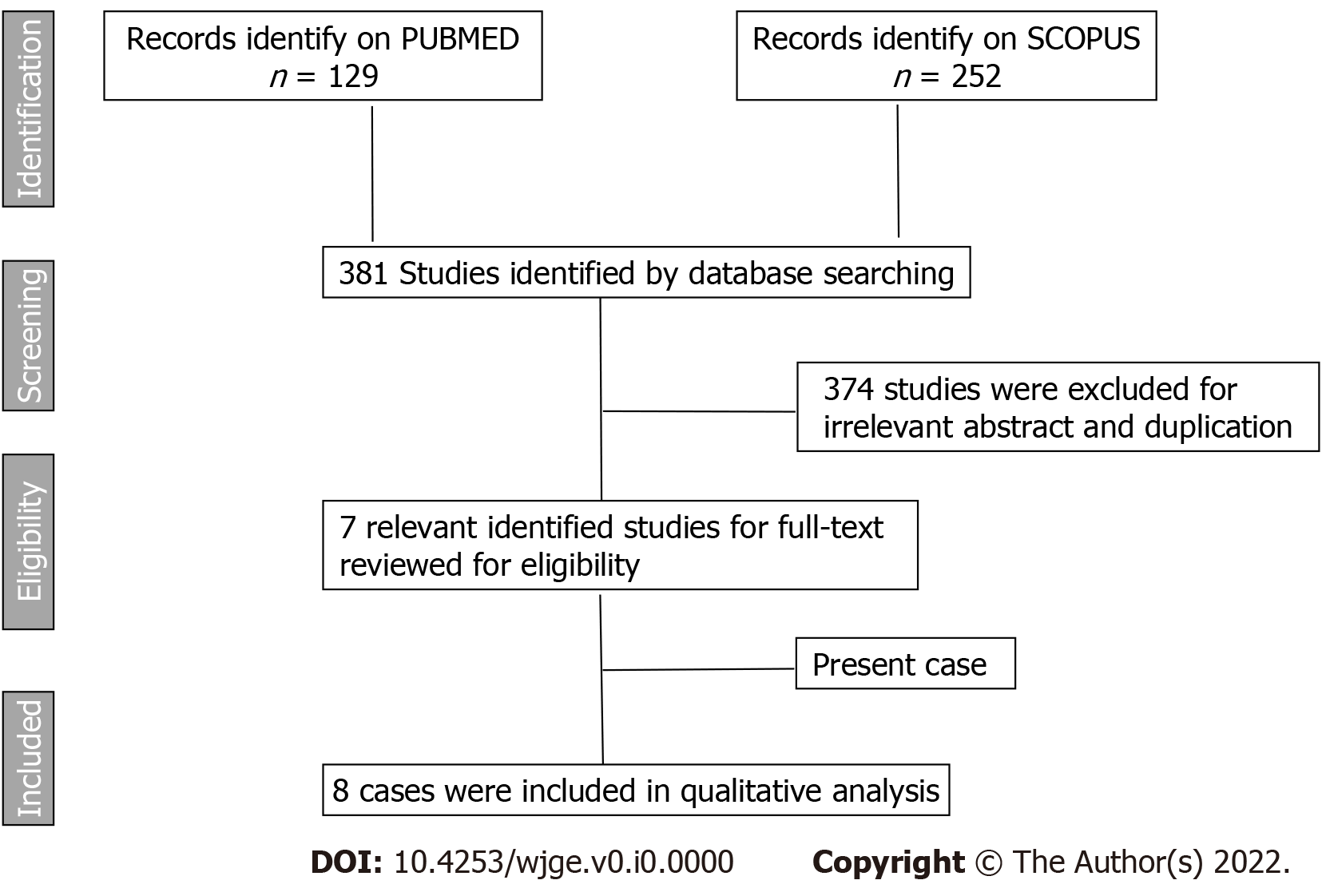
Figure 1 A study flowchart according to Preferred Reporting Items for Systematic reviews and Meta-analysis guidelines (PRISMA).

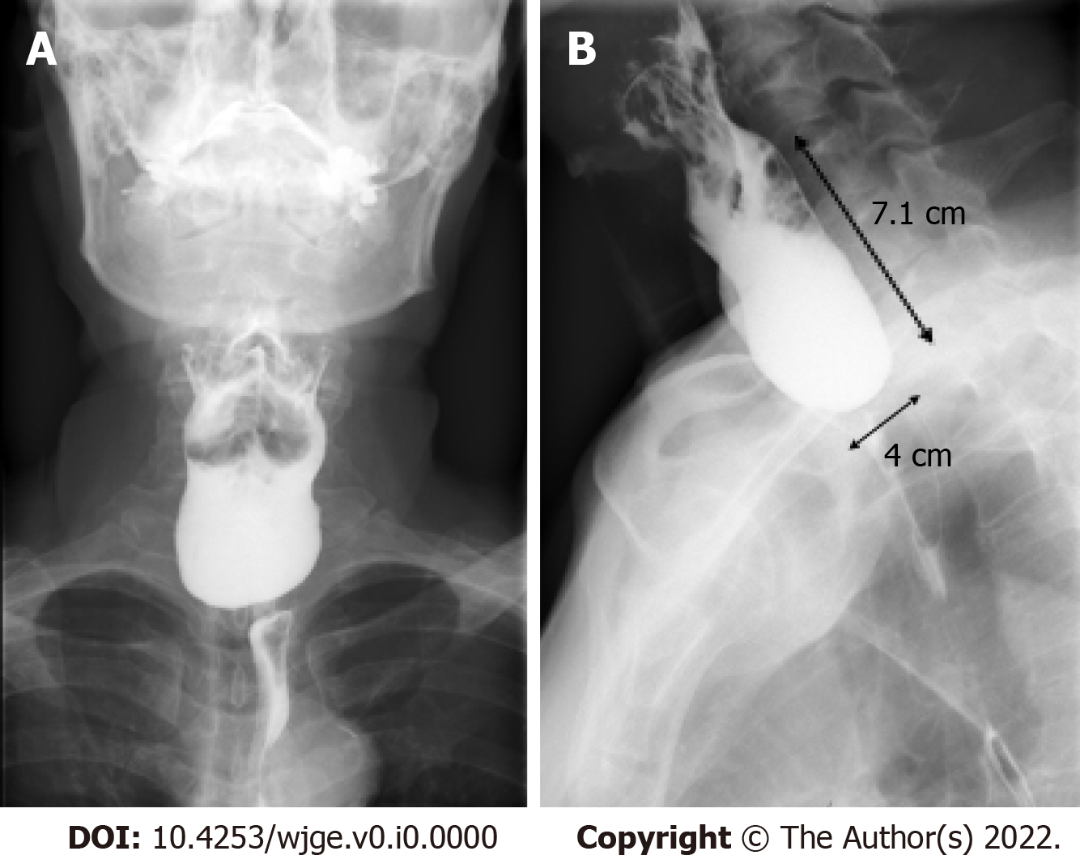
Figure 2 Preoperative barium swallow. A: Zenker’s diverticulum; B: Size 4 × 7.1 cm, widening 1.1 cm before develop upper gastrointestinal bleeding.

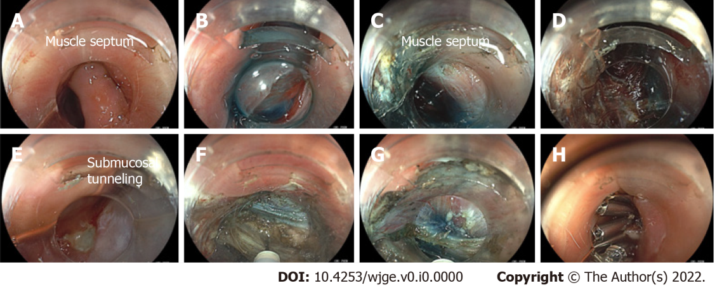
Figure 3 Per-oral endoscopic myotomy for Zenker’s diverticulum. A: Endoscopic view of the Zenker’s diverticulum with muscle septum, located 20 cm from the incisors; B: The mucosal incision was performed after lifted submucosa by using glycerol with a few drops of indigo carmine injected at the septum; C: Submucosal tunneling and dissection was performed along both sides of the septal wall; D: A submucosal tunnel behind the ulcer contain many small vessel, we partially coagulate by coagrasper to stop bleeding and also avoid mucosal perforation; E: The ulcer after submucosal tunneling: The picture shows ulcer while checking mucosal integrity after performed submucosal tunneling before undergo myotomy; F and G: The myotomy was performed until the last fibers of septal muscle; H: The mucosal defect closed by through-the-scope clip.

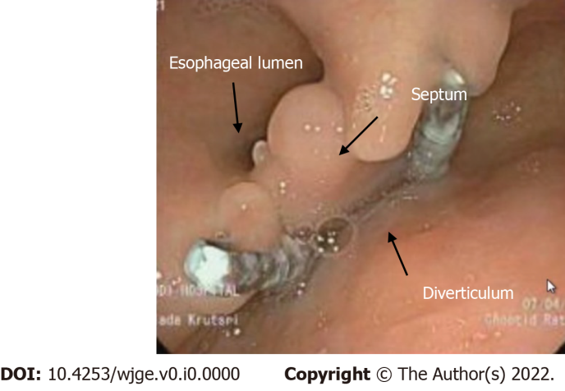
Figure 4 The esophagogastroduodenoscopy show no recurrent ulcer and no food retention after 6 mo follow up.

Table 1 Summary of previous case reports of bleeding Zenker’s diverticulum, including present case
Ref. | Age (yr) | Antiplatelet or coagulant use | NSAIDs | Ulcer in diverticulum | Diverticulum size (cm) | Technique to stop bleeding | Definitive surgical treatment | Follow up (months) | Recurrent bleeding
Haas et al^{[7]}, 2008 | 71 | Aspirin | No | Yes | Large | Urgent diverticulectomy  Stop aspirin | Diverticulectomy | N/A | No
Flicker et al^{[8]}, 2010 | 83 | Aspirin  Clopidogrel | No | Yes | Large | Hemoclip | Diverticulectomy | N/A | No
Eaton et al^{[9]}, 2011 | 85 | Aspirin | No | Yes | 5.2 | Hemoclip | Died after discharge home from heart failure | N/A | No
Bălălău et al^{[10]}, 2013 | 75 | No | No | Yes | 4 | Diverticulectomy | Diverticulectomy | 12 | No
Sardana et al^{[11]}, 2014 | 89 | Aspirin  Warfarin | No | No | 9 | FFP;  Stop aspirin and warfarin | Diverticulectomy and cricopharyngeal myotomy | N/A | No
House et al^{[12]}, 2016 | 70 | Aspirin, Clopidogrel | No | Yes | Large | IV pantoprazole;  Stop aspirin and clopidogrel | Diverticulectomy | N/A | No
Present case | 72 | Aspirin | No | Yes | 7.1 | IV pantoprazole | Z-POEM | 12 | No

N/A: Not available data; POEM: Per-oral endoscopic myotomy.

