Name of Journal: World Journal of Clinical Cases
Manuscript NO: 69670
Manuscript Type: CASE REPORT

Individualized treatment of breast cancer with chronic renal failure: A case report and review of literature

Cai JH et al. Treatment of breast cancer with CRF

Jie-Hui Cai, Jie-Hua Zheng, Xiao-Qi Lin, Wei-Xun Lin, Juan Zou, Yao-Kun Chen, Zhi-Yang Li, Ye-Xi Chen

Jie-Hui Cai, Jie-Hua Zheng, Xiao-Qi Lin, Wei-Xun Lin, Juan Zou, Yao-Kun Chen, Zhi-Yang Li, Ye-Xi Chen, Department of General Surgery, The Second Affiliated Hospital of Shantou University Medical College, Shantou 515041, Guangdong Province, China

Xiao-Qi Lin, Wei-Xun Lin, Juan Zou, Yao-Kun Chen, Breast Disease Research Center, The Medical Research Institute of Shantou Doctoral Association, Shantou 515041, Guangdong Province, China

Author contributions: Cai JH and Zheng JH are the patient’s doctors, and they reviewed the literature and contributed to manuscript drafting; Lin WX, Zou J, and Li ZY reviewed the literature, analyzed and explained the results of laboratory examinations, imaging examinations and pathological examinations; Lin XQ and Chen YK collected patient information and examination data, designed and produced the figures and tables; Chen YX reviewed the literature, contributed to manuscript drafting and revised the manuscript; all authors participated in the discussion and formulation of patient chemotherapy regimens and drug dosage adjustments, and issued final approval for the version to be submitted.

Corresponding author: Ye-Xi Chen, MD, Chief Doctor, Professor, Department of General Surgery, The Second Affiliated Hospital of Shantou University Medical College, No. 69 North Dongxia Road, Shantou 515041, Guangdong Province, China. yxchen3@stu.edu.cn

Received: July 8, 2021
Revised: September 5, 2021
Accepted: September 22, 2021
Published online:

Abstract
BACKGROUND
Studies have shown that patients with chronic renal failure (CRF) are more likely to suffer from breast cancer and other malignant tumors. To our knowledge, CRF can reduce drug excretion, thereby increase drug exposure and lead to increased toxicity, which will limit drug treatment and lead to tumor progression. Currently, there are few successful reports on the combination of docetaxel, trastuzumab, and pertuzumab (THP) as a neoadjuvant treatment regimen for breast cancer patients with CRF.

CASE SUMMARY
We report a breast cancer (cT2N2M0, Her-2+/HR-) patient with CRF. It was a clinical stage IIIA tumor on the left breast. The patient had suffered from uremia for 2 years, and her heart function was normal. Based on the pathological type, molecular type, and clinical stage of breast cancer, and the patient’s renal function, the clinician analyzed the pharmacological and pharmacokinetic characteristics of the antitumor drugs after consulting the relevant literature, and prescribed the neoadjuvant regimen of THP (docetaxel 80 mg/m², trastuzumab 8 mg/kg for the first dose, and 6 mg/kg for the maintenance dose with pertuzumab 840 mg for the first dose and 420 mg for the maintenance dose), once every 3 wk, for a total of 6 courses. The neoadjuvant treatment had a good effect, and the patient then underwent surgery which was uneventful.

CONCLUSION
CRF is not a contraindication for systemic treatment and surgery of breast cancer. The THP regimen without dose adjustment may be a safe and effective neoadjuvant treatment for HER-2 positive breast cancer patients with CRF.

Key Words: Breast cancer; Chronic renal failure; Neoadjuvant treatment; Dose adjustment; Pertuzumab; Case report

Cai JH, Zheng JH, Lin XQ, Lin WX, Zou J, Chen YK, Li ZY, Chen YX. Individualized treatment of breast cancer with chronic renal failure: A case report and review of literature. World J Clin Cases 2021; In press

Core Tip: Renal failure is an important factor limiting the treatment of breast cancer because of the nephrotoxicity of anticancer drugs. There are few successful case reports of the combination of docetaxel, trastuzumab and pertuzumab (THP), especially pertuzumab, as a preoperative neoadjuvant treatment regimen for breast cancer patients with chronic renal failure (CRF) and few pharmacokinetic studies are available on renal failure in these patients. This report describes a breast cancer patient with CRF, which shows the safety of pertuzumab and effectiveness of the THP preoperative neoadjuvant treatment regimen.

INTRODUCTION
Renal insufficiency is common in cancer patients, and the risk of impaired renal function increases with age and the appearance of comorbid diseases, such as diabetes. Breast cancer is the most common cancer in women^{[1-3]}, accounting for 30% of all newly diagnosed cancers^{[1]}. A large number of studies have confirmed that patients with chronic renal failure (CRF) have a higher incidence of malignant tumors and mortality^{[4,5]}. When the estimated glomerular filtration rate (GFR) drops to 10 mL/min/1.73 m², the mortality rate of cancer patients increases by 22%^{[6,7]}. Therefore, the reduction in GFR will not only lead to serious renal complications, but also limit the treatment of tumors, thereby promoting tumor progression. Renal failure is an important factor limiting the treatment of breast cancer patients as patients with impaired renal function often experience reduced renal excretion or metabolism and changes in absorption and drug distribution, which may lead to increased treatment-related toxicity^{[8,9]}. In hemodialysis patients, it is difficult to determine the safe and effective dosage and dosing schedule of anticancer drugs, as well as the best time for hemodialysis, which makes it difficult to develop an appropriate treatment regimen. Also, almost all clinical studies will exclude patients with CRF. Currently, apart from the case report by Modi et al^{[10]}, there are few studies on the treatment of breast cancer in patients with end-stage renal disease, and these patients rarely successfully complete a series of standard regimens of neoadjuvant therapy and surgery. This report describes the case of a breast cancer patient with CRF and the successful use of docetaxel, trastuzumab and pertuzumab (THP) as the preoperative neoadjuvant treatment regimen.

CASE PRESENTATION
Chief complaints
A 55-year-old female patient with a left breast mass attended our hospital on September 15, 2020.

History of present illness
The patient found a mass approximately 15 mm × 15 mm in size in the left breast 9 mo ago without any related symptoms. She did not undergo diagnosis and treatment; therefore, the mass has slowly increased over the past 9 mo, and it is now approximately 35 mm × 30 mm in size. This prompted her visit to our hospital.

History of past illness
The patient was diagnosed with uremia 2 years ago and started on regular hemodialysis treatment (hemodialysis every 48 h), and she did not produce urine.

Personal and family history
She had no history of food or drug allergies and no history of tumors or genetic diseases in her family.

Physical examination
At the time of admission, the patient’s temperature was 36.5 °C, heart rate was 85 bpm, respiratory rate was 20 breaths/min, blood pressure was 140/90 mmHg and oxygen saturation in room air was 99%. She was in an anemic state. A mass approximately 35 mm × 30 mm was palpable under the nipple of the left breast, with a hard texture, rough surface, no tenderness, poor mobility, unclear boundaries, and was not adhered to the nipple. No mass was observed on the right breast. In addition, no enlarged lymph nodes were palpable in the bilateral axillary and supraclavicular area.

Laboratory examinations
Laboratory examinations showed that the patient’s leukocyte, neutrophil, platelet, hemoglobin, creatinine, urea, cancer antigen 153 (CA153), and carcinoembryonic antigen (CEA) levels were 6.4 × 10⁹/L, 4.61 × 10⁹/L, 183 × 10⁹/L, 96 g/L, 581.9 μmol/L, 14.27 mmol/L, 26.20 U/mL, and 6.31 μg/L, respectively.

Imaging examinations
Breast ultrasound showed a 37 mm × 31 mm × 30 mm primary lesion under the nipple of the left breast and enlargement of multiple lymph nodes in the left axillary area, the largest measuring 16 mm × 10 mm × 10 mm (Figure 1). Histopathological examination of the left breast showed infiltrating ductal carcinoma (Level II according to the WHO classification) (Figure 2). Hormone receptors (HRs), including estrogen receptor (ER) and progesterone receptor (PR), were negative, C-erBb2 was 2+, and Ki-67 was expressed in the nuclei of approximately 40% of tumor cells. The results of fluorescence in situ hybridization revealed that HER-2 was positive. Histopathological examination of the left axillary lymph nodes showed metastatic cancer, which was consistent with the breast source. Magnetic resonance imaging (MRI) showed a 37 mm × 34 mm × 31 mm mass below the left nipple and peripheral satellite lesions, which was assessed as Category 6 by the Breast Imaging-Reporting and Data System, with multiple swollen lymph nodes in the left axillary area (Figure 3).

FINAL DIAGNOSIS
The patient was diagnosed with infiltrating ductal carcinoma of the left breast and uremia. Clinical stage of her left breast cancer was cT2N2aM0, stage IIIA, and the molecular classification was HER-2 positive (HR negative).

TREATMENT
According to the patient’s age, the pathological type of breast cancer, molecular classification, clinical stage, prognostic factors, and renal function, the THP neoadjuvant treatment regimen was formulated and started on September 27, 2020. Docetaxel 80 mg/m², trastuzumab 8 mg/kg for the first dose, and 6 mg/kg for the maintenance dose with pertuzumab 840 mg for the first dose and 420 mg for the maintenance dose were administered. The patient received a total of six cycles of the THP regimen, and hemodialysis was performed more than 12 h after the medication. The patient tolerated the drug treatment well, and no serious drug toxicity was noted.

OUTCOME AND FOLLOW-UP
No significant neutropenia or leukopenia, and no significant cytotoxicity were observed by clinical evaluation or cardiac function examination. During subsequent treatment and follow-up, the patient’s serum creatinine and urea levels did not change significantly compared with those pre-chemotherapy, suggesting that dose adjustment of the THP regimen had no significant effect on renal function.
Routine blood analysis (Table 1), liver and kidney function, CEA, and CA153 levels (Table 2) were determined before each chemotherapy cycle, and breast ultrasonography and breast MRI were performed approximately every 3 mo. Prior to surgery, the left breast tumor and left axillary lymph nodes had significantly reduced in size (Figure 1). No obvious abnormalities were observed in the right breast, and no abnormal enlarged lymph nodes were observed in the right axillary and bilateral supraclavicular areas.
In September 2020, the patient had above-normal levels of CEA and normal levels of CA153, but they remained normal during both neoadjuvant chemotherapy and targeted therapy. Due to the patient’s CRF, her hemoglobin level was significantly lower than normal. Other routine tests showed no obvious abnormalities. During the follow-up period, the patient was in good condition, and no evidence of disease progression or recurrence has been found.

DISCUSSION
The National Comprehensive Cancer Network and the Chinese Anti-Cancer Association Clinical Oncology Cooperative Professional Committee guidelines indicate that for cT2N2aM0 stage IIIA and HER-2+/ER-/PR- invasive breast cancer patients, the preoperative neoadjuvant treatment regimen of taxanes + trastuzumab + pertuzumab is recommended^{[11]}. After six cycles of neoadjuvant therapy, the clinical stage of left breast cancer in this patient was cT1N1aM0, stage IIa, and she underwent modified radical mastectomy for left breast cancer and left axillary lymph node dissection with clear surgical margins.
Based on the patient’s renal function, the pharmacokinetics, pharmacodynamics, and safety of various drugs, we chose the neoadjuvant treatment regimen of THP for this patient.
Docetaxel and paclitaxel are commonly used taxane chemotherapeutics. Both are rarely excreted by the kidneys, but the renal excretion rate of paclitaxel is higher than that of docetaxel. It has been reported that paclitaxel causes mild nephrotoxicity, while docetaxel does not cause nephrotoxicity^{[12]}; and the incidence and severity of allergic reactions to docetaxel are lower than those of paclitaxel^{[13]}. Docetaxel is a new anti-microtubule agent, which can promote the polymerization of tubulin and stabilize the microtubules by preventing their disintegration^{[14]}. Docetaxel enters the liver through the blood and binds to proteins under the action of the cytochrome P450 subtype enzyme type 3A4 enzyme (CYP3A4) in the liver. More than 70% of the drugs are transformed into inactive metabolites, which are then excreted in feces through transport by P-glycoprotein in the intestine and bile. Another 10% of the drugs are excreted in the urine, and only a few drugs are excreted as prototypes^{[15]}. Studies have shown that the pharmacokinetic parameters of docetaxel in hemodialysis patients are not affected, and its exposure is slightly increased, but no toxic effects have been observed in patients^{[16]}. Docetaxel was selected as a chemotherapeutic drug for this patient by comprehensive evaluation. Liu et al^{[17]} administered docetaxel in a patient with the same disease, and no obvious side effects were observed.
Trastuzumab is a recombinant humanized monoclonal antibody directed against HER-2^{[18]}. After trastuzumab binds to HER-2 on the surface of tumor cells, it can induce antibody-dependent cell-mediated cytotoxicity and has a killing effect on tumor cells overexpressing HER-2. It has been approved for the treatment of early^{[19,20]} and metastatic^{[20,21]} breast cancer. In the third phase of the study, the addition of trastuzumab to standard chemotherapy was associated with disease progression time (7.4 mo vs 4.6 mo), effective time (9.1 mo vs 6.1 mo), and overall survival (25.1 mo vs 20.3 mo). The renal excretion of trastuzumab is very low^{[22,23]}, and its main toxicity is cardiotoxicity^{[24]}, while renal toxicity is low. In a pivotal trial conducted by Slamon et al^{[19]}, 0.3% of patients receiving trastuzumab combined with chemotherapy developed severe (grades 3 and 4) renal damage. Micallef et al^{[25]} treated breast cancer in two hemodialysis patients using trastuzumab and achieved good clinical results.
Pertuzumab is a recombinant humanized monoclonal antibody directed against the extracellular dimerization domain (subregion II) of HER-2, thereby blocking the ligand-dependent heterodimerization reaction between HER-2 and other HER-2 family members, including epidermal growth factor receptor, HER-3, and HER-4^{[26]}. Pertuzumab has been approved for the neoadjuvant treatment of patients with HER-2-positive, locally advanced, inflammatory or high-risk early breast cancer^{[27]}, or for the first-line treatment in patients with advanced breast cancer overexpressing HER-2 in the European Union^{[28]}. The NEOSPHERE study confirmed that adding pertuzumab to TH can further increase the pathological complete response rate of HER-2 positive patients^{[29]}. The PEONY study verified the effectiveness and safety of the THP regimen in an Asian population^{[30]}. Studies on the potential effects of trastuzumab or docetaxel on the pharmacokinetics of pertuzumab have been carried out. An analysis showed that there was no evidence that trastuzumab or the combination of docetaxel and trastuzumab had an effect on the metabolism of pertuzumab^{[31]}.
To the best of our knowledge, a pharmacokinetic study of pertuzumab has not been conducted in patients with renal impairment, and there are few reports on the application of pertuzumab in breast cancer patients with CRF. However, nephrotoxicity of pertuzumab is uncommon, and the clinical trials CLEOPATRA, NEOSPHERE, TRYPHAENA, and APHINITY have not found any obvious renal adverse reactions. In addition, the monoclonal antibody is mainly cleared through a large-volume, non-specific Fc receptor-mediated immunoglobulin G (IgG) clearance mechanism and a specific targeted-mediated drug disposal pathway. The intact monoclonal antibody cannot be filtered by the glomerulus to be excreted through the kidney due to its large molecular weight. Monoclonal antibodies can be excreted by the kidneys after being broken down into peptide fragments and amino acids by the lysosomal pathway in the corresponding effector cells. At the same time, the peptide fragments and amino acids generated by decomposition can also participate in the body’s energy supply and in the synthesis of new proteins^{[32]}. The metabolism of endogenous IgG occurs in various tissues and plasma in the body. Using a physiologically based pharmacokinetic model, it is estimated that the contribution of skin, muscle, liver, and intestinal tissues to the clearance of endogenous IgG are 33%, 24%, 16%, and 12%, respectively^{[33]}. This shows that the kidney’s contribution to the elimination of endogenous IgG is low. In addition, based on a population pharmacokinetic analysis, renal impairment is not expected to affect exposure to pertuzumab. Based on limited clinical studies and reports, we conclude that renal excretion of pertuzumab is very low. The product description also does not regard renal damage as a contraindication to pertuzumab. Therefore, we preferred to use trastuzumab and pertuzumab dual target therapy. It is worth noting that there are few reports on pertuzumab in breast cancer patients with CRF, which may be a unique feature of this case.
In breast cancer patients with CRF, drug metabolism and dosage selection are issues that must be considered in order to avoid aggravation of systemic toxicity caused by renal failure. Considering the clearance of drugs during dialysis, appropriate timing of medication should be selected for hemodialysis patients. Docetaxel is rarely excreted by the kidneys. Limited data have shown that docetaxel can be safely used in patients with renal insufficiency without the need for dose adjustment^{[34]}. Docetaxel can be safely used in chronic peritoneal or hemodialysis patients at standard doses^{[35]}. Trastuzumab does not cause nephrotoxicity as a single agent, and relevant data indicate that treatment with trastuzumab is not affected by age or renal function. The product feature summary does not recommend adjusting the dose of trastuzumab in patients with mild to moderate chronic kidney disease. No information is provided on the dose adjustment of trastuzumab due to hemodialysis in the United States. Docetaxel and trastuzumab were used in this breast cancer patient with renal failure without dose adjustment, which is similar to the case report by Liu et al^{[17]}. There are similar considerations for these two drugs. There are no data on the use of pertuzumab for treating dialysis patients. The product feature summary recommends that in patients with mild or moderate renal insufficiency, the dose need not be adjusted, and there is no recommended dosage for patients with severe renal insufficiency. In the population pharmacokinetic analysis, renal damage did not affect drug disposal. There are few reports on pertuzumab nephrotoxicity, and population pharmacokinetic studies have found that covariates, such as renal function (serum creatinine), do not have a statistically significant effect on the pharmacokinetic parameters of pertuzumab^{[36]}.
Our patient was clinically diagnosed with CRF stage 5. Considering the rare renal toxicity of trastuzumab and pertuzumab, we did not adjust the drug dosage which consisted of docetaxel 80 mg/m², trastuzumab 8 mg/kg for the first dose, and 6 mg/kg for the maintenance dose with pertuzumab 840 mg for the first dose and 420 mg for the maintenance dose, every 3 wk. Hemodialysis was performed more than 12 h after chemotherapy.

CONCLUSION
The THP regimen has a minimal effect on renal failure, and as a neoadjuvant therapy for breast cancer patients with positive HER-2, it has a good effect in downstaging breast cancer. In this case, the drug dose was not adjusted, and the patient had no obvious nephrotoxicity or cardiotoxicity. Therefore, the THP regimen without dose adjustment may be a safe and effective neoadjuvant therapy for HER-2 positive breast cancer patients with CRF. CRF is not a contraindication for systemic treatment and surgery for breast cancer. Individualized treatment of these patients can be achieved by multidisciplinary collaboration and close monitoring of renal function.

ACKNOWLEDGEMENTS
The authors are very grateful to the data providers in the study.

REFERENCES
1 Siegel RL, Miller KD, Jemal A. Cancer statistics, 2020. CA Cancer J Clin 2020; 70: 7-30 [PMID: 31912902 DOI: 10.3322/caac.21590]
2 Mermer G, Turk M. Assessment of the effects of breast cancer training on women between the ages of 50 and 70 in Kemalpasa, Turkey. Asian Pac J Cancer Prev 2014; 15: 10749-10755 [PMID: 25605170 DOI: 10.7314/apjcp.2014.15.24.10749]
3 Leśniczak B, Krasomski G, Oszukowski P, Stetkiewicz T, Woźniak P. Incidence of and mortality from breast cancer among women in Poland in the years 2001-2010. Prz Menopauzalny 2014; 13: 344-347 [PMID: 26327877 DOI: 10.5114/pm.2014.47990]
4 Lowrance WT, Ordoñez J, Udaltsova N, Russo P, Go AS. CKD and the risk of incident cancer. J Am Soc Nephrol 2014; 25: 2327-2334 [PMID: 24876115 DOI: 10.1681/ASN.2013060604]
5 Malyszko J, Tesarova P, Capasso G, Capasso A. The link between kidney disease and cancer: complications and treatment. Lancet 2020; 396: 277-287 [PMID: 32711803 DOI: 10.1016/S0140-6736(20)30540-7]
6 Armstrong AE, Dargart J, Reichek J, Walterhouse DO, Matossian D, Cohn RA, Gosiengfiao Y. Irinotecan and temozolomide for treatment of neuroblastoma in a patient with renal failure on hemodialysis. Pediatr Blood Cancer 2014; 61: 949-950 [PMID: 24273036 DOI: 10.1002/pbc.24869]
7 Magee C. Kidney disease and death from cancer. Am J Kidney Dis 2014; 63: 7-9 [PMID: 24360223 DOI: 10.1053/j.ajkd.2013.10.003]
8 US Food and Drug Administration. Draft guidance for industry. Pharmacokinetics in patients with impaired renal function—study design, data analysis, and impact on dosing and labeling. 2014. [cited 19 September 2020]. Available from: http://www.fda.gov/downloads/Drugs/Guidances/UCM204959.pdf
9 US Food and Drug Administration. Pharmacokinetics in patients with impaired renal function—study design, data analysis, and impact on dosing and labeling. 1998. [cited 19 September 2020]. Available from: http://www.fda.gov/downloads/Drugs/GuidanceComplianceRegulatoryInformation/Guidances/ucm072127.pdf
10 Modi G, Madabhavi I, Patel A, Anand A. Treatment of breast cancer in a patient of Alport syndrome-induced chronic renal failure: A triumph story. J Cancer Res Ther 2018; 14: 462-464 [PMID: 29516942 DOI: 10.4103/0973-1482.180680]
11 Gradishar WJ, Anderson BO, Abraham J, Aft R, Agnese D, Allison KH, Blair SL, Burstein HJ, Dang C, Elias AD, Giordano SH, Goetz MP, Goldstein LJ, Isakoff SJ, Krishnamurthy J, Lyons J, Marcom PK, Matro J, Mayer IA, Moran MS, Mortimer J, O'Regan RM, Patel SA, Pierce LJ, Rugo HS, Sitapati A, Smith KL, Smith ML, Soliman H, Stringer-Reasor EM, Telli ML, Ward JH, Young JS, Burns JL, Kumar R. Breast Cancer, Version 3.2020, NCCN Clinical Practice Guidelines in Oncology. J Natl Compr Canc Netw 2020; 18: 452-478 [PMID: 32259783 DOI: 10.6004/jnccn.2020.0016]
12 Li YF, Fu S, Hu W, Liu JH, Finkel KW, Gershenson DM, Kavanagh JJ. Systemic anticancer therapy in gynecological cancer patients with renal dysfunction. Int J Gynecol Cancer 2007; 17: 739-763 [PMID: 17309673 DOI: 10.1111/j.1525-1438.2007.00847.x]
13 Kadari A, Pooja D, Gora RH, Gudem S, Kolapalli VRM, Kulhari H, Sistla R. Design of multifunctional peptide collaborated and docetaxel loaded lipid nanoparticles for antiglioma therapy. Eur J Pharm Biopharm 2018; 132: 168-179 [PMID: 30244167 DOI: 10.1016/j.ejpb.2018.09.012]
14 Kosmas C, Tsavaris N, Malamos N, Stavroyianni N, Gregoriou A, Rokana S, Polyzos A. Phase I-II study of docetaxel and ifosfamide combination in patients with anthracycline pretreated advanced breast cancer. Br J Cancer 2003; 88: 1168-1174 [PMID: 12698179 DOI: 10.1038/sj.bjc.6600887]
15 Kenmotsu H, Tanigawara Y. Pharmacokinetics, dynamics and toxicity of docetaxel: Why the Japanese dose differs from the Western dose. Cancer Sci 2015; 106: 497-504 [PMID: 25728850 DOI: 10.1111/cas.12647]
16 Yang L, Zhang XC, Yu SF, Zhu HQ, Hu AP, Chen J, Shen P. Pharmacokinetics and safety of cyclophosphamide and docetaxel in a hemodialysis patient with early stage breast cancer: a case report. BMC Cancer 2015; 15: 917 [PMID: 26582454 DOI: 10.1186/s12885-015-1932-3]
17 Liu W, Peng JF, Tang MJ. Individualized Treatment Analysis Of Breast Cancer With Chronic Renal Failure. Onco Targets Ther 2019; 12: 7767-7772 [PMID: 31571926 DOI: 10.2147/OTT.S223729]
18 Goldenberg MM. Trastuzumab, a recombinant DNA-derived humanized monoclonal antibody, a novel agent for the treatment of metastatic breast cancer. Clin Ther 1999; 21: 309-318 [PMID: 10211534 DOI: 10.1016/S0149-2918(00)88288-0]
19 Slamon D, Eiermann W, Robert N, Pienkowski T, Martin M, Press M, Mackey J, Glaspy J, Chan A, Pawlicki M, Pinter T, Valero V, Liu MC, Sauter G, von Minckwitz G, Visco F, Bee V, Buyse M, Bendahmane B, Tabah-Fisch I, Lindsay MA, Riva A, Crown J; Breast Cancer International Research Group. Adjuvant trastuzumab in HER2-positive breast cancer. N Engl J Med 2011; 365: 1273-1283 [PMID: 21991949 DOI: 10.1056/NEJMoa0910383]
20 Gianni L, Eiermann W, Semiglazov V, Manikhas A, Lluch A, Tjulandin S, Zambetti M, Vazquez F, Byakhow M, Lichinitser M, Climent MA, Ciruelos E, Ojeda B, Mansutti M, Bozhok A, Baronio R, Feyereislova A, Barton C, Valagussa P, Baselga J. Neoadjuvant chemotherapy with trastuzumab followed by adjuvant trastuzumab versus neoadjuvant chemotherapy alone, in patients with HER2-positive locally advanced breast cancer (the NOAH trial): a randomised controlled superiority trial with a parallel HER2-negative cohort. Lancet 2010; 375: 377-384 [PMID: 20113825 DOI: 10.1016/S0140-6736(09)61964-4]
21 Marty M, Cognetti F, Maraninchi D, Snyder R, Mauriac L, Tubiana-Hulin M, Chan S, Grimes D, Antón A, Lluch A, Kennedy J, O'Byrne K, Conte P, Green M, Ward C, Mayne K, Extra JM. Randomized phase II trial of the efficacy and safety of trastuzumab combined with docetaxel in patients with human epidermal growth factor receptor 2-positive metastatic breast cancer administered as first-line treatment: the M77001 study group. J Clin Oncol 2005; 23: 4265-4274 [PMID: 15911866 DOI: 10.1200/JCO.2005.04.173]
22 Kaufman B, Mackey JR, Clemens MR, Bapsy PP, Vaid A, Wardley A, Tjulandin S, Jahn M, Lehle M, Feyereislova A, Révil C, Jones A. Trastuzumab plus anastrozole versus anastrozole alone for the treatment of postmenopausal women with human epidermal growth factor receptor 2-positive, hormone receptor-positive metastatic breast cancer: results from the randomized phase III TAnDEM study. J Clin Oncol 2009; 27: 5529-5537 [PMID: 19786670 DOI: 10.1200/JCO.2008.20.6847]
23 Boekhout AH, Beijnen JH, Schellens JH. Trastuzumab. Oncologist 2011; 16: 800-810 [PMID: 21632460 DOI: 10.1634/theoncologist.2010-0035]
24 Babar T, Blomberg C, Hoffner E, Yan X. Anti-HER2 cancer therapy and cardiotoxicity. Curr Pharm Des 2014; 20: 4911-4919 [PMID: 24898245 DOI: 10.2174/1381612820666140604145037]
25 Micallef RA, Barrett-Lee PJ, Donovan K, Ashraf M, Williams L. Trastuzumab in patients on haemodialysis for renal failure. Clin Oncol (R Coll Radiol) 2007; 19: 559 [PMID: 17566724 DOI: 10.1016/j.clon.2007.04.008]
26 Harbeck N, Beckmann MW, Rody A, Schneeweiss A, Müller V, Fehm T, Marschner N, Gluz O, Schrader I, Heinrich G, Untch M, Jackisch C. HER2 Dimerization Inhibitor Pertuzumab - Mode of Action and Clinical Data in Breast Cancer. Breast Care (Basel) 2013; 8: 49-55 [PMID: 24715843 DOI: 10.1159/000346837]
27 Gianni L, Pienkowski T, Im YH, Roman L, Tseng LM, Liu MC, Lluch A, Staroslawska E, de la Haba-Rodriguez J, Im SA, Pedrini JL, Poirier B, Morandi P, Semiglazov V, Srimuninnimit V, Bianchi G, Szado T, Ratnayake J, Ross G, Valagussa P. Efficacy and safety of neoadjuvant pertuzumab and trastuzumab in women with locally advanced, inflammatory, or early HER2-positive breast cancer (NeoSphere): a randomised multicentre, open-label, phase 2 trial. Lancet Oncol 2012; 13: 25-32 [PMID: 22153890 DOI: 10.1016/S1470-2045(11)70336-9]
28 Baselga J, Cortés J, Kim SB, Im SA, Hegg R, Im YH, Roman L, Pedrini JL, Pienkowski T, Knott A, Clark E, Benyunes MC, Ross G, Swain SM; CLEOPATRA Study Group. Pertuzumab plus trastuzumab plus docetaxel for metastatic breast cancer. N Engl J Med 2012; 366: 109-119 [PMID: 22149875 DOI: 10.1056/NEJMoa1113216]
29 Gianni L, Pienkowski T, Im YH, Tseng LM, Liu MC, Lluch A, Starosławska E, de la Haba-Rodriguez J, Im SA, Pedrini JL, Poirier B, Morandi P, Semiglazov V, Srimuninnimit V, Bianchi GV, Magazzù D, McNally V, Douthwaite H, Ross G, Valagussa P. 5-year analysis of neoadjuvant pertuzumab and trastuzumab in patients with locally advanced, inflammatory, or early-stage HER2-positive breast cancer (NeoSphere): a multicentre, open-label, phase 2 randomised trial. Lancet Oncol 2016; 17: 791-800 [PMID: 27179402 DOI: 10.1016/S1470-2045(16)00163-7]
30 Shao Z, Pang D, Yang H, Li W, Wang S, Cui S, Liao N, Wang Y, Wang C, Chang YC, Wang H, Kang SY, Seo JH, Shen K, Laohawiriyakamol S, Jiang Z, Li J, Zhou J, Althaus B, Mao Y, Eng-Wong J. Efficacy, Safety, and Tolerability of Pertuzumab, Trastuzumab, and Docetaxel for Patients With Early or Locally Advanced ERBB2-Positive Breast Cancer in Asia: The PEONY Phase 3 Randomized Clinical Trial. JAMA Oncol 2020; 6: e193692 [PMID: 31647503 DOI: 10.1001/jamaoncol.2019.3692]
31 Quartino AL, Li H, Jin JY, Wada DR, Benyunes MC, McNally V, Viganò L, Nijem I, Lum BL, Garg A. Pharmacokinetic and exposure-response analyses of pertuzumab in combination with trastuzumab and docetaxel during neoadjuvant treatment of HER2+ early breast cancer. Cancer Chemother Pharmacol 2017; 79: 353-361 [PMID: 28074265 DOI: 10.1007/s00280-016-3218-0]
32 Keizer RJ, Huitema AD, Schellens JH, Beijnen JH. Clinical pharmacokinetics of therapeutic monoclonal antibodies. Clin Pharmacokinet 2010; 49: 493-507 [PMID: 20608753 DOI: 10.2165/11531280-000000000-00000]
33 Garg A, Balthasar JP. Physiologically-based pharmacokinetic (PBPK) model to predict IgG tissue kinetics in wild-type and FcRn-knockout mice. J Pharmacokinet Pharmacodyn 2007; 34: 687-709 [PMID: 17636457 DOI: 10.1007/s10928-007-9065-1]
34 Aronoff GR, Bennett WM, Berns JS. Drug Prescribing in Renal Failure: Dosing Guidelines for Adults and Children. 5th. Philadelphia, PA: American College of Physicians–American Society of Internal Medicine, 2007
35 Heijns JB, van der Burg ME, van Gelder T, Fieren MW, de Bruijn P, van der Gaast A, Loos WJ. Continuous ambulatory peritoneal dialysis: pharmacokinetics and clinical outcome of paclitaxel and carboplatin treatment. Cancer Chemother Pharmacol 2008; 62: 841-847 [PMID: 18204842 DOI: 10.1007/s00280-007-0671-9]
36 Garg A, Quartino A, Li J, Jin J, Wada DR, Li H, Cortés J, McNally V, Ross G, Visich J, Lum B. Population pharmacokinetic and covariate analysis of pertuzumab, a HER2-targeted monoclonal antibody, and evaluation of a fixed, non-weight-based dose in patients with a variety of solid tumors. Cancer Chemother Pharmacol 2014; 74: 819-829 [PMID: 25119184 DOI: 10.1007/s00280-014-2560-3]

Footnotes
Informed consent statement: Written informed consent was obtained from the patient for publication of this case report. A copy of the written consent is available for review by the editor of this journal.

Conflict-of-interest statement: The authors report no conflicts of interest in this work.

CARE Checklist (2016) statement: The authors have read the CARE Checklist (2016), and the manuscript was prepared and revised according to the CARE Checklist (2016).

Open-Access: This article is an open-access article that was selected by an in-house editor and fully peer-reviewed by external reviewers. It is distributed in accordance with the Creative Commons Attribution NonCommercial (CC BY-NC 4.0) license, which permits others to distribute, remix, adapt, build upon this work non-commercially, and license their derivative works on different terms, provided the original work is properly cited and the use is non-commercial. See: http://creativecommons.org/Licenses/by-nc/4.0/

Manuscript source: Unsolicited manuscript

Peer-review started: July 8, 2021
First decision: August 18, 2021
Article in press:

Specialty type: Oncology
Country/Territory of origin: China
Peer-review report’s scientific quality classification
Grade A (Excellent): 0
Grade B (Very good): 0
Grade C (Good): C, C, C
Grade D (Fair): 0
Grade E (Poor): 0

P-Reviewer: Al-Afandi N, Kamalabadi-Farahani M, Nath J S-Editor: Yan JP L-Editor: P-Editor:

Figure Legends
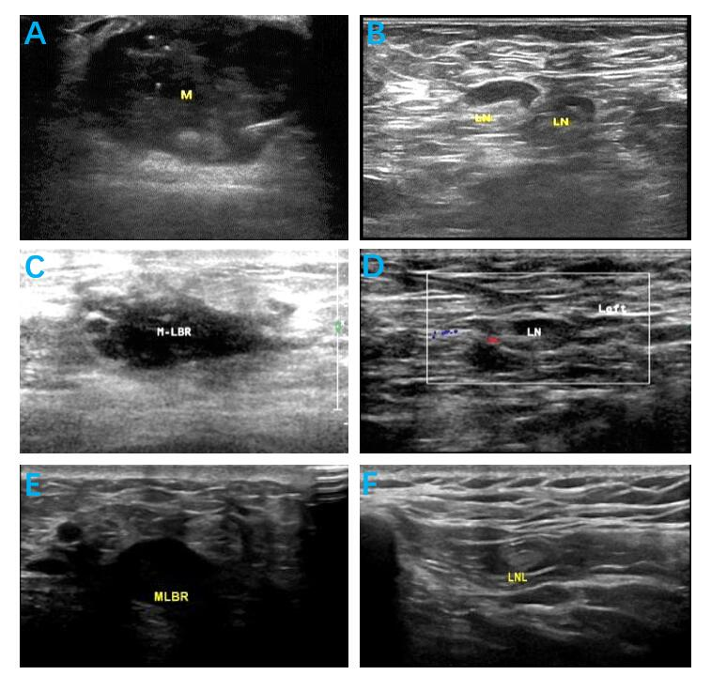
Figure 1 Breast ultrasound results of the patient obtained during preoperative neoadjuvant treatment. A and B: September 15, 2020. M: Left breast mass (37 mm × 31 mm × 30 mm) (A) and LN: Left axillary lymph node (the largest node was 16 mm × 10 mm × 10 mm) (B); C and D: December 21, 2020. M-LBR: Left breast mass (16 mm × 13 mm ×12 mm) (C) and LN: Left axillary lymph node (the largest node was 13 mm × 8 mm × 6 mm) (D); E and F: January 26, 2021. MLBR: Left breast mass (12 mm × 9 mm × 8 mm) (E) and LN: Left axillary lymph node (the largest node was 10 mm × 6 mm × 5 mm) (F).

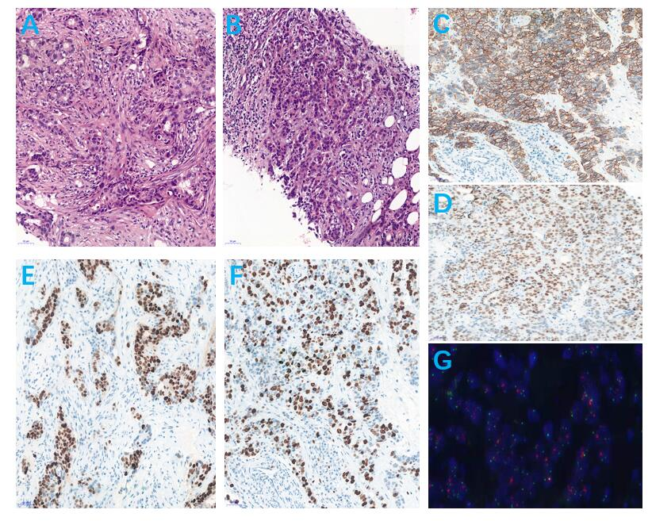
Figure 2 Pathological results of left breast tumor and left axillary lymph node biopsies. A: Hematoxylin and eosin-stained sections revealed that the tumor cells grew in a solid and patchy infiltrating manner (original magnification: 200 ×); B: Hematoxylin and eosin-stained sections revealed that the left axillary lymph node was metastatic carcinoma, which was consistent with the breast source (original magnification: 200 ×); C: C-erBb2 (2+) was uncertain in neoplastic cells by immunohistochemical analysis (original magnification: 200 ×); D and E: Estrogen receptor and progesterone receptor were negative in neoplastic cells by immunohistochemical analysis (original magnification: 200 ×); F: Ki-67 was expressed in the nuclei of approximately 40% of tumor cells (original magnification: 200 ×); G: HER-2 was amplified by fluorescence in situ hybridization (original magnification: 200 ×).
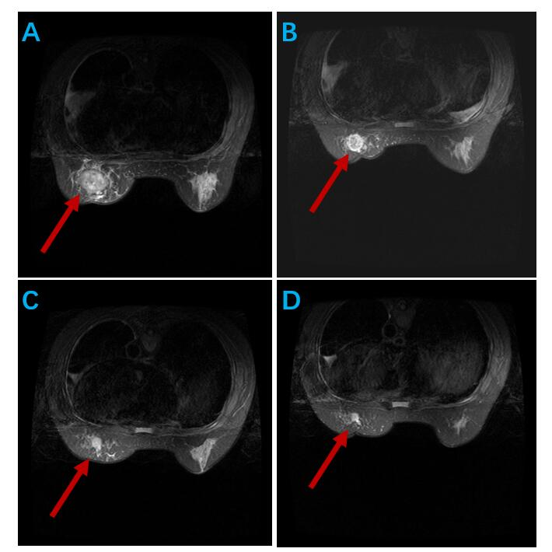
Figure 3 Magnetic resonance imaging of the patient obtained during preoperative neoadjuvant treatment. A: September 28, 2020: Left breast mass (37 mm × 31 mm × 34 mm); B: November 12, 2020: Left breast mass (22 mm × 21 mm × 25 mm); C: December 21, 2020: Left breast mass (16 mm × 13 mm × 12 mm); D: January 27, 2021: Left breast mass (12 mm × 9 mm × 8 mm). Red arrows indicate localization of masses.

Table 1 Peripheral blood analysis results
Date | Leukocytes (10⁹/L) | Neutrophils (10⁹/L) | Platelets (10⁹/L) | Hemoglobin (g/L)
September 22, 2020 | 6.4 | 4.61 | 183 | 96
October 17, 2020 | 7.5 | 6.23 | 300 | 81
November 8, 2020 | 8.3 | 6.4 | 206 | 65
November 29, 2020 | 9.1 | 7.34 | 234 | 60
December 20, 2020 | 9.6 | 7.69 | 220 | 63
January 11, 2021 | 7.7 | 6.22 | 329 | 72

Table 2 Renal function and serum tumor markers
Date | Creatinine (μmol/L) | Urea (mmol/L) | CA153 (U/mL) | CEA (μg/L)
September 22, 2020 | 581.9 | 14.27 | 26.2 | 6.31
October 17, 2020 | 384.5 | 8.96 | 32 | 6.77
November 8, 2020 | 575.5 | 17.07 | 28.6 | 4.64
November 29, 2020 | 678.6 | 21.97 | 27.8 | 3.42
December 20, 2020 | 710.9 | 20.46 | 34.3 | 3.9
January 11, 2021 | 331.2 | 8.43 | 35.4 | 3.53
CA153: Cancer antigen 153; CEA: Carcinoembryonic antigen.

