Name of Journal: World Journal of Clinical Cases
Manuscript NO: 55734
Manuscript Type: CASE REPORT

Diagnostic discrepancy between colposcopy and vaginoscopy: A case report

Li Q et al. Colposcopy combined with vaginoscopy

Qing Li, Hong-Wei Zhang, Long Sui, Ke-Qin Hua

Qing Li, Hong-Wei Zhang, Long Sui, Diagnosis and Treatment Center of Cervical Disease, OBG Hospital of Fudan University, Shanghai 200000, China

Ke-Qin Hua, Department of Gynecology, Obstetrics and Gyncology Hospital of Fudan University, Shanghai 200090, China

Author contributions: Li Q collected the clinical data and drafted the manuscript; Zhang HW performed colposcoy and vaginoscopy; Sui L conceived of the study; Hua KQ reviewed the manuscript; all authors read and approved the final manuscript.

Corresponding author: Ke-Qin Hua, MD, PhD, Chief Doctor, Professor, Department of Gynecology, Obstetrics and Gyncology Hospital of Fudan University, No. 128 Shenyang Road, Shanghai 200090, China. huakeqinjiaoshou@163.com

Received: February 2, 2021
Revised: May 7, 2021
Accepted: June 7, 2021
Published online: July 26, 2021

Abstract
BACKGROUND
Colposcopy currently plays a vital role in the diagnosis and treatment of lower genital diseases. Exposure and biopsy are two key steps in colposcopy. When the whole transformation zone or all lesions cannot be observed, we judge colposcopy as unsatisfactory. Unsatisfactory colposcopic examination may lead to the misdiagnosis of more severe diseases. The combination of colposcopy and vaginoscopy may contribute to accurate diagnosis and clinical decisions.

CASE SUMMARY
Here, we introduce a case of posthysterectomy deep vaginal apex not fully exposed by colposcopy, and the biopsy result was a vaginal precancerous lesion. We adopted vaginoscopy to extend the observed area and expose the lesion thoroughly, and the biopsy result was vaginal squamous cancer.

CONCLUSION
The patient received a precise diagnosis and early surgery due to the combination of colposcopy and vaginoscopy.

Key Words: Colposcopy; Yaginoscopy; Cervicoscopy; Hysteroscopy; Unsatisfactory; Discrepancy; Case report

©The Author(s) 2021. Published by Baishideng Publishing Group Inc. All rights reserved.

Citation: Li Q, Zhang HW, Sui L, Hua KQ. Diagnostic discrepancy between colposcopy and vaginoscopy: A case report. World J Clin Cases 2021; 9(21): 5943-5947
URL: https://www.wjgnet.com/2307-8960/full/v9/i21/5943.htm
DOI: https://dx.doi.org/10.12998/wjcc.v9.i21.5943

Core Tip: Combined with cervical screening, colposcopy greatly decrease the incidence of cervical cancer. Exposure and biopsy are two key steps in colposcopy. When the whole transformation zone or the entire lesions are not observed, we judge it as unsatisfactory. For type 3 transformation zone, some clinicians employ cervicoscopy as supplement. However, there were no related solutions for the dilemma caused by adhesion or obstruction. Here, we report a case of post hysterectomy deep vaginal apex not fully exposed in colposcopy, and the biopsy result was vaginal precancerous lesion. We adopted vaginoscopy to extend and expose the lesion thoroughly and the biopsy result was vaginal squamous cancer.

INTRODUCTION
Combined with cervical screening, colposcopy greatly decreases the incidence of cervical cancer^{[1]}. Exposure and biopsy are two key steps in colposcopy. For patients with a type 3 transformation zone (TZ), some clinicians employ cervicoscopy as a supplemental imaging technique^{[2]}. However, there were no related solutions for the dilemma caused by adhesions or obstructions. Here, we introduce a case in which precise diagnosis was achieved after using two detection methods.

CASE PRESENTATION
Chief complaints
A 61-year-old woman with cytologically determined high-grade squamous epithelial lesion (HSIL) visited the outpatient clinic of the Obstetrics and Gynecology Hospital of Fudan University on June 22, 2018.

History of present illness
In May 2018, the patient’s cytological examination still indicated HSIL. She came to our hospital for further treatment.

History of past illness
The patient underwent hysterectomy for a cervical HSIL in 2013 at a local hospital. She did not visit the hospital after surgery. In May 2017, she had slight vaginal bleeding and was cytologically diagnosed with HSIL. A vaginal low-grade squamous epithelial lesion (LSIL) was confirmed by colposcopy-directed biopsy. She was followed for one year.

Physical examination
A doctor at the clinic performed the gynecological examination and simultaneously took HPV samples. On June 29, 2018, the patient was referred to the colposcopic center in our hospital with a positive HPV 16 result. A colposcopy sample was taken and indicated HSIL. However, the left vaginal apex was too deep to be fully exposed.

Laboratory examinations
HPV16+.

Imaging examinations
Therefore, we performed curettage. The biopsy results suggested LSIL in the vaginal wall and HSIL with papillary growth in the curettage of the vaginal apex (Figure 1A). We telephoned the patient, but she did not visit until July 25, 2018. At this time, ultrasonography was performed, showing a mixed structure with a low-echo area at the top of the vagina of approximately 17 mm × 14 mm × 7 mm. One attending doctor performed another gynecological examination. She had two deep vaginal apexes (Figure 2A and 2B). Bimanual examination suggested a thickened area at the top of the vagina. To further evaluate the vaginal apex, vaginoscopy was performed on July 26, 2018. After the lens (OD 6.5 mm) entered the vagina, 3% acetic acid solution and Lugol's iodine solution were successively used as extension media. The left apex (Figure 2B) was nearly 20 mm deep, forming a cavity beyond the vaginal top. The cavity was occupied by multiple papillary lesions of approximately 15 mm × 10 mm (Figure 2C and D). Dense acetowhite lesions were observed, with atypical vessels, fragile vessels, and iodine-negative epithelium. Biopsy forceps were placed through the operating hole, and the tissue was biopsied under direct view.

FINAL DIAGNOSIS
The neoplasm was histologically confirmed to be an exogenous papillary squamous cell carcinoma (Figure 1B and C).

TREATMENT
Because the biopsy tissue was superficial, with no tumor pedicle, whether there was infiltration was uncertain. The patient underwent extensive paravaginal and partial vaginal resection on August 7, 2018. The paravaginal and vaginal walls showed HSIL with negative margins (Figure 1D), and abnormal lymph nodes were not found.

OUTCOME AND FOLLOW-UP
The patient was followed for 20 mo and obtained negative cytology and HPV results in October 2018 and October 2019. The colposcopy results were normal in March 2020.

DISCUSSION
The popularization of colposcopy technology has brought great progress to the diagnosis and treatment of lower genital tract diseases. For women who have abnormal cytological results, colposcopy-directed biopsy is considered the gold standard for determining the treatment modality^{[3]}.
Exposure and biopsy are the two key steps in colposcopy. What can we do when unsatisfactory colposcopy occurs because of, for example, incomplete exposure of the TZ, unexposed lesions due to adhesions or obstructions, or, as in our patient, deep vaginal apexes due to the suturing of the two ends to the cardinal ligament stump in hysterectomy, preventing observation?
Curettage might be a good method, but the sensitivity of traditional curettage ranges from 37.5% to 75%^{[4]}, and there does not appear to be a general consensus on curettage^{[5]}.
Some clinicians observe the cervical canal through cervicoscopy. After a pilot study, Rahimi et al concluded that cervicoscopy is a reliable method to detect the TZ in patients with a type 3 TZ^{[6]}. De Franciscis et al^{[7]} found high diagnostic effectiveness in cervicoscopy, which allowed conservative surgery to be performed. The cervicoscopic lens used is actually the lens of the hysteroscope. They observed the cervix without dilatation fluid or observed the uterine cavity with 0.9% normal saline dilatation.
In recent years, vaginoscopy has been widely used in adolescents or postmenopausal women without a speculum or cervical forceps. After a randomized controlled trial, Smith et al found vaginoscopy to be quicker to perform, less painful to patients, and more successful than standard hysteroscopy^{[8]}. Vaginoscopy, a “no-touch” approach, can be used not only to perform endometrial biopsy and remove foreign bodies in the vagina but also to meet the hopes of patients and their families of not damaging the hymen and reducing pain^{[9]}.
We for the first time report a case in which vaginoscopy was combined with colposcopy to discover lesions hidden behind the vaginal chamber. Because the exposure with colposcopy was insufficient, routine curettage could not obtain accurate material for analysis. Vaginoscopy was performed to further evaluate the vaginal apex. During the process, the vulva was covered with gauze to prevent the outflow of distended fluid.
By expanding the cavity and exposing the vaginal apex, we can use vaginoscopy to evaluate vaginal lesions; by using acetic acid and Lugol's iodine solution, we can assess anomalies and distinguish the severity of the lesion. After direct observation and biopsy, we can avoid misdiagnosis owing to traditional curettage.
In our hospital, we initially examined 16 patients with unsatisfactory colposcopy and auxiliary vaginoscopy. Biopsy samples were taken in both operations, and only nine (56.25%) had the same histology, two (12.5%) had serious histology, and five (31.25%) had mild histology via vaginoscopy compared with histology via colposcopy.

CONCLUSION
Our case suggested that vaginoscopy is essential for patients with unsatisfactory colposcopy. A study with larger sample size is urgently needed.

ACKNOWLEDGEMENTS
The authors would like to thank the patient for her kind cooperation during the treatment and follow-up. We also thank Ting Li from the pathology department of our hospital for providing pathological pictures.

REFERENCES
1 Khan MJ, Werner CL, Darragh TM, Guido RS, Mathews C, Moscicki AB, Mitchell MM, Schiffman M, Wentzensen N, Massad LS, Mayeaux EJ Jr, Waxman AG, Conageski C, Einstein MH, Huh WK. ASCCP Colposcopy Standards: Role of Colposcopy, Benefits, Potential Harms, and Terminology for Colposcopic Practice. J Low Genit Tract Dis 2017; 21: 223-229 [PMID: 28953110 DOI: 10.1097/LGT.0000000000000338]
2 Darwish AM, Kamel MA, Zahran K, Aboulela M. Office Cervicoscopy vs Stationary Colposcopy in Suspicious Cervix: A Randomized Controlled Trial. J Midlife Health 2019; 10: 115-122 [PMID: 31579194 DOI: 10.4103/jmh.JMH_135_18]
3 Nam K. Colposcopy at a turning point. Obstet Gynecol Sci 2018; 61: 1-6 [PMID: 29372143 DOI: 10.5468/ogs.2018.61.1.1]
4 Abu J, Davies Q. Endocervical curettage at the time of colposcopic assessment of the uterine cervix. Obstet Gynecol Surv 2005; 60: 315-320 [PMID: 15841025 DOI: 10.1097/01.ogx.0000160774.92271.48]
5 Johnson N, Brady J. Dilating the cervix medically to overcome an unsatisfactory colposcopy: 5 year follow up. Eur J Obstet Gynecol Reprod Biol 1996; 69: 125-127 [PMID: 8902445 DOI: 10.1016/0301-2115(95)02512-X]
6 Rahimi S, Marani C, Gardner F, Yeoh CC, Akaev I, Votano S. Endocervicoscopy and Biopsy to Detect Cervical Intraepithelial Squamous Neoplasia in Nonvisible Squamocolumnar Junction With Unsatisfactory Colposcopy: A Pilot Study. Technol Cancer Res Treat 2018; 17: 1533034617753811 [PMID: 29375019 DOI: 10.1177/1533034617753811]
7 De Franciscis P, La Manna V, Schiattarella A, Ambrosio D, Labriola D, Procaccianti R, Ammaturo FP, Morlando M, Torella M. [Diagnostic accuracy of endocervicoscopy as preoperative tool to improve the excisional treatment of cervical preneoplastic lesions]. Minerva Ginecol 2018; 70: 364-370 [PMID: 29388414 DOI: 10.23736/S0026-4784.18.04196-5]
8 Smith PP, Kolhe S, O'Connor S, Clark TJ. Vaginoscopy Against Standard Treatment: a randomised controlled trial. BJOG 2019; 126: 891-899 [PMID: 30801889 DOI: 10.1111/1471-0528.15665]
9 Jin L, Yi S, Wang X, Xu Y. Application of 'no-touch' hysteroscopy (vaginoscopy) for the treatment of abnormal uterine bleeding in adolescence. J Obstet Gynaecol Res 2019; 45: 1913-1917 [PMID: 31304654 DOI: 10.1111/jog.14063]

Footnotes
Informed consent statement: Written informed consent was obtained from the patient for publication of this case report and any accompanying images.

Conflict-of-interest statement: All authors have no conflicts of interest to report.

CARE Checklist (2016) statement: The authors have read the CARE Checklist (2016), and the manuscript was prepared and revised according to the CARE Checklist (2016).

Open-Access: This article is an open-access article that was selected by an in-house editor and fully peer-reviewed by external reviewers. It is distributed in accordance with the Creative Commons Attribution NonCommercial (CC BY-NC 4.0) license, which permits others to distribute, remix, adapt, build upon this work non-commercially, and license their derivative works on different terms, provided the original work is properly cited and the use is non-commercial. See: http://creativecommons.org/Licenses/by-nc/4.0/

Manuscript source: Unsolicited manuscript

Peer-review started: February 2, 2021
First decision: April 25, 2021
Article in press: June 7, 2021

Specialty type: Obstetrics and gynecology
Country/Territory of origin: China
Peer-review report’s scientific quality classification
Grade A (Excellent): 0
Grade B (Very good): B
Grade C (Good): 0
Grade D (Fair): 0
Grade E (Poor): 0

P-Reviewer: kumar D S-Editor: Ma YJ L-Editor: Wang TQ P-Editor: Liu JH

Figure Legends
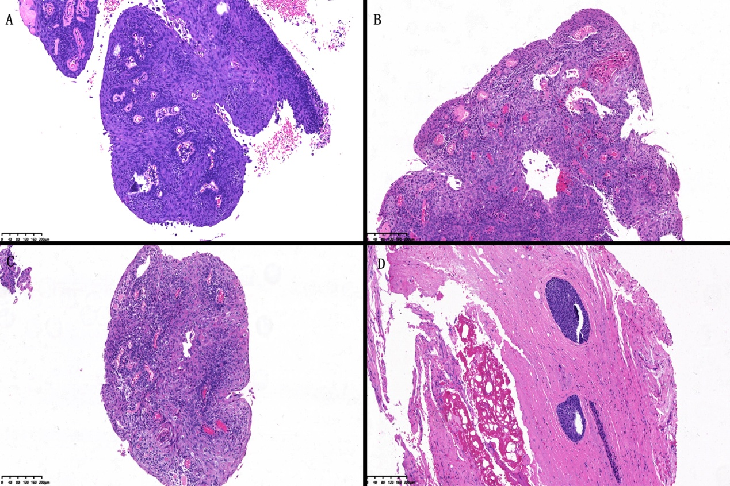
Figure 1 HE staining of lesions. A: Tissue from colposcopy biopsy; B: Tissue from vaginoscopy biopsy; C: Tissue from vaginoscopy biopsy; D: Tissues from extensive paravaginal and partial vaginal resection.
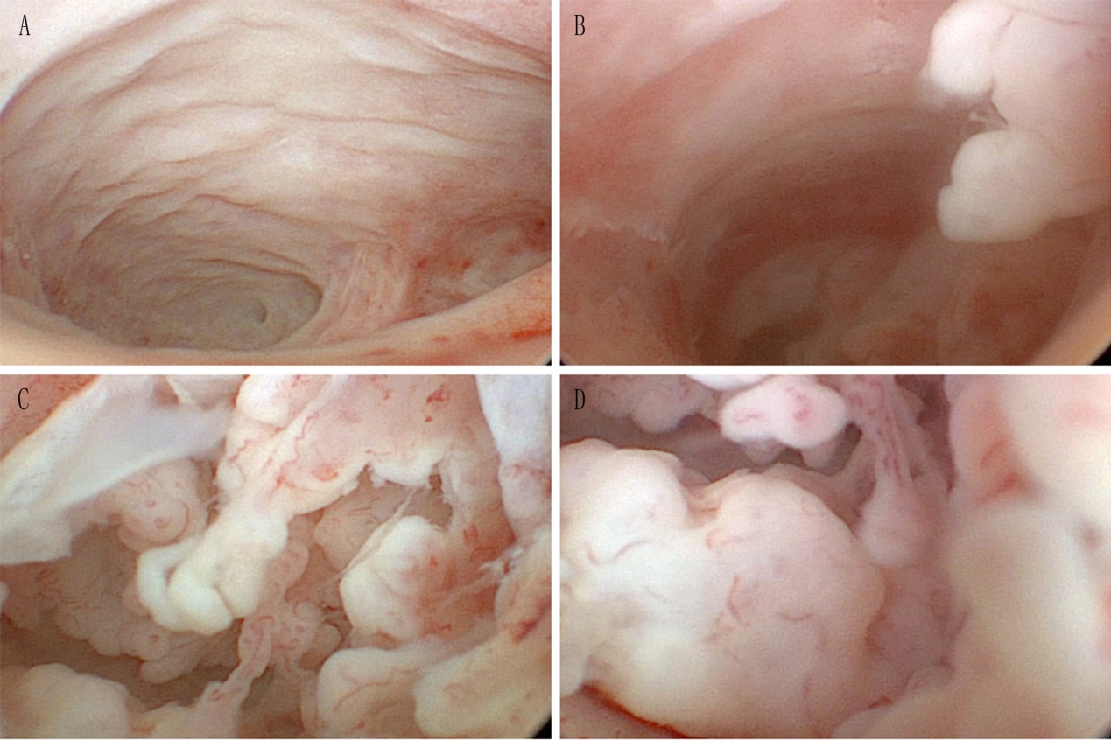
Figure 2 Images from vaginoscopy. A: Right vaginal apex; B: Left vaginal apex; C: Neoplasm in the cavity of the vaginal apex; D: Neoplasm in the cavity of the vaginal apex.

Published by Baishideng Publishing Group Inc
7041 Koll Center Parkway, Suite 160, Pleasanton, CA 94566, USA
Telephone: +1-925-3991568
E-mail: bpgoffice@wjgnet.com
Help Desk: https://www.f6publishing.com/helpdesk
https://www.wjgnet.com

© 2021 Baishideng Publishing Group Inc. All rights reserved.

