Name of Journal: World Journal of Clinical Cases
Manuscript NO: 61540
Manuscript Type: ORIGINAL ARTICLE

Prospective Study
Clinical outcomes and 5-year follow-up results of keratosis pilaris treated by a high concentration of glycolic acid

Tian Y et al. Keratosis pilaris treated by glycolic acid

Yan Tian, Xiao-Xin Li, Jiao-Jiao Zhang, Qing Yun, Si Zhang, Jia-Yi Yu, Xue-Jiao Feng, Ai-Ting Xia, Yang Kang, Feng Huang, Fang Wan

Yan Tian, Xiao-Xin Li, Jiao-Jiao Zhang, Qing Yun, Si Zhang, Jia-Yi Yu, Xue-Jiao Feng, Ai-Ting Xia, Feng Huang, Fang Wan, Department of Dermatology, Air Force Characteristic Medical Center, Beijing 100142, China

Yang Kang, Center of Medical and Health, Unit 71901 of PLA, Liaocheng 252000, Shandong Province, China

Author contributions: Tian Y and Li XX contributed equally to this work, and are co-first authors; Tian Y contributed to the conception of the study; Tian Y and Li XX contributed significantly to analysis and manuscript preparation; Li XX performed the data analyses and wrote the manuscript; Zhang JJ, Yu JY and Feng XJ are responsible for the treatment process; Yun Q, Zhang S, Xia AT, Kang Y, Huang F, and Wan F helped perform the analysis with constructive discussions.

Corresponding author: Yan Tian, MD, PhD, Chief Doctor, Professor, Department of Dermatology, Air Force Characteristic Medical Center, No. 30 Fucheng Road, Haidian District, Beijing 100142, China. tianyan311@126.com

Received: January 26, 2021
Revised: March 11, 2021
Accepted: April 22, 2021
Published online: June 26, 2021

Abstract
BACKGROUND
Keratosis pilaris is a hereditary abnormal keratosis of the hair follicle orifice. Gray-brown keratotic plugs in the pores and dark red keratotic papules at the openings of hair follicles can be seen, which contain coiled hair and are often accompanied by perifollicular erythema and pigmentation. Glycolic acid can correct the abnormalities of hair follicular duct keratosis and eliminate excessive accumulation of keratinocytes. It also promotes skin metabolism and accelerates the melanin metabolism. The therapeutic effect is related to the glycolic acid concentration.

AIM
To evaluate the efficacy and safety of a high concentration of glycolic acid in the treatment of keratosis pilaris, and to observe the outcomes at 5-year of follow-up.

METHODS
Twenty-five participants were recruited and areas with typical keratosis pilaris were selected as testing sites. High concentrations of glycolic acid (50% or 70%) were applied to a circular area (d = 8 cm, S = 50 cm²) and repeated four times, on days 0, 20, 40 and 60. Before each treatment and 20 d after the last treatment, on days 0, 20, 40, 60, and 80 and at a 5-year follow-up, The number of follicular keratotic papules were counted and the extent of perifollicular erythema and pigmentation was determined. At the same time, the participants provided subjective evaluations of treatment efficacy and safety.

RESULTS
Treatment effectiveness was indicated by the percentage of keratotic papules in the test site, on days 20, 40, 60 and 80, which were 8%, 12%, 36%, and 60%, respectively. Compared with day 0, each difference was significant (P < 0.05). Compared with day 0, differences in melanin content (M) in the skin and skin lightness (L) on days 40, 60 and 80, the were statistically significant (P < 0.05); skin hemoglobin content (E) on days 60 and 80 was statistically different as compared with before treatment (P < 0.05). There were no significant differences in the number of keratotic papules, M, L, and E in 9 participants at the 5-year follow-up compared with before treatment (P > 0.05%).

CONCLUSION
A high concentration of glycolic acid significantly improved skin roughness as well as follicular hyperpigmentation of patients with keratosis pilaris. The treatment was relatively safe, but there was no significant difference at the 5-year follow-up compared to before treatment.

Key Words: Keratosis pilaris; Glycolic acid; Keratotic papules; Follicular erythema; Melanin pigmentation

©The Author(s) 2021. Published by Baishideng Publishing Group Inc. All rights reserved.

Citation: Tian Y, Li XX, Zhang JJ, Yun Q, Zhang S, Yu JY, Feng XJ, Xia AT, Kang Y, Huang F, Wan F. Clinical outcomes and 5-year follow-up results of keratosis pilaris treated by a high concentration of glycolic acid. World J Clin Cases 2021; 9(18): 4681-4689
URL: https://www.wjgnet.com/2307-8960/full/v9/i18/4681.htm
DOI: https://dx.doi.org/10.12998/wjcc.v9.i18.4681

Core Tip: A high concentration of glycolic acid (50%, 70%) was applied to 25 subjects suffering from keratosis pilaris. The treatment was repeated every 20 d for a total of four times, 20 d after each treatment, perifollicular erythema, papules, and pigmentation were evaluated by spectrophotometry, counting and an Mexameter®. We found a high concentration of glycolic acid had a therapeutic effect on perifollicular erythema, papules and pigmentation, and as the number of treatments and the concentration of glycolic acid increased, the therapeutic effect improved further, but a long-term effect was not observed.

INTRODUCTION
Keratosis pilaris is a hereditary abnormal keratosis of the hair follicular orifice. Clinically, gray-brown keratotic plugs in the pores and dark red keratotic papules at the openings of hair follicles that contain coiled hair and are often accompanied by perifollicular erythema and pigmentation can be seen. As mild or severe manifestations are present in more than half of the population, the condition can be understood as a normal variant, as opposed to a disease. However, because keratosis pilaris tends to affect exposed areas such as the face, extremities, and shoulder blades, with the highest incidence in adolescence^{[1]}, young people have a strong desire for treatment. Glycolic acid can correct abnormal hair follicular duct keratosis and eliminate excessive accumulation of keratinocytes. It can also promote skin metabolism and accelerate the metabolism of melanin. The therapeutic effect is related to the concentration of glycolic acid. We used a high concentration of glycolic acid to evaluate the efficacy and safety of glycolic acid in the treatment of keratosis pilaris, with long-term follow-up of 5 years.

MATERIALS AND METHODS
Subjects
All 25 subjects were clinically confirmed cases treated at the Dermatology Clinic of our hospital. They had typical rashes on their limbs or trunk, 7 were men and 18 were women. The average age was 27.2 ± 2.5 years and the average medical history was 18 ± 3.1 years.

Inclusion criteria: The limbs or trunk of eligible subjects had typical keratosis pilaris, with perifollicular erythema, papules, and pigmentation. No other treatment had been received within the last 6 mo. All subjects was willing to complete the study process and signed the informed consent form.

Exclusion criteria: Patients with serious underlying diseases, pregnancy, women with expected pregnancy or lactating, allergic to alpha hydroxy acid or sugar cane, being treated for localized healing wounds or other skin conditions, unable to guarantee they will not be using other exfoliant products or other treatment methods (including phototherapy and others) were excluded.

Exclusion and termination criteria: Subject withdrawal of informed consent; severe adverse reactions during the trial and termination of the treatment.

Treatment method
This was an open trial with a planned enrollment of 25 participants. After the attending physician assessed the skin lesions, an area with typical skin lesions was selected and a circular area delineated (d = 8 cm, S = 50 cm²). A high concentration of glycolic acid (Kunming Botanee Biological Technology Co., Ltd., Yunnan Food and Drug Administration License No. 20150002) was used for treatment for a total of four times, with an interval of 20 d, on days 0, 20, 40, and 60. The concentration and treatment duration were, 50%, 5 min; 50%, 7 min; 70%, 5 min; 70%, 7 min. Following each treatment, a neutralizing solution was sprayed evenly onto the application area until no further irritation was found at the test site. Following the procedure, the patient was advised to avoid light exposure to the area for a week. Those who completed the entire trial were considered valid cases, and those who did not complete the entire trial process for any reason were considered invalid cases.

Evaluation criteria for improvement of symptoms
Determination of the number of follicular keratotic papules: Before each treatment and 20 d after the last treatment, that is, on day 0, 20, 40, 60 and 80, the same dermatologist examined the test sites and counted the number of follicular keratotic papules (overall, d = 8 cm, S = 50 cm², in a circular area). A 0%-25% reduction in the number of papules was considered ineffective. A 26%-50% reduction in the number of papules was considered an improvement. A 51%-75% reduction in the number of papules was considered as obvious improvement, and a 76%-100% reduction in the number of papules was considered as excellent improvement.

Standardized evaluation of noninvasive skin testing: Before each treatment, 20 d after the last treatment, and 5 year after treatment, that is, on days 0, 20, 40, 60, 80 at the 5-year follow-up, the melanin content (M) and skin hemoglobin of the erythema and pigmentation of the hair follicular orifice was determined by a pigment measuring instrument (Mexameter, CK, Germany), and a spectrophotometer (CM-2600d, Konica Minolta, Japan) was used to measure skin lightness (L). Measurements were repeated three times in each area and the average value was taken. The M value reflects the melanin content in the skin, the E value indicates the degree of redness of the skin, and the L value indicated the balance between white and black. Pure black is 0 and pure white is 100.

Global esthetic improvement scale: Before each treatment, 20 days after the last treatment, and at 5 years after treatment, that is, on days 0, 20, 40, 60, 80 at the 5-year follow-up, the Global aesthetic improvement scale (Table 1) was used by subjects for self-assessment.

Statistical analysis
Before and after comparison of the number of keratotic papules per unit area (S = 50 cm²), the M, E, and L values was carried out using the paired t-test.

RESULTS
Clinical evaluation
The number of follicular keratotic papules: The number of follicular orifice keratotic papules was monitored. On days 0, 20, 40, 60, and 80, the number of follicular keratotic papules was 53.12 ± 18.49, 43.04 ± 17.53, 36.92 ± 16.24, 28.72 ± 13.51, 22.16 ± 11.61, respectively. The differences in the numbers of keratotic papules of days 20, 40, 60 and 80, compared to before treatment were significant. Moreover, the differences between each treatment were significant. On day 20, there were 2 cases of obvious improvement in the tested sites, 5 cases of improvement, and 10 cases of no effect. On day 40 (20 d after the second round of treatment), there was excellent improvement in 3 cases, improvement in 12 cases, and no effect in 10 cases. On day 60 (20 d after the third round of treatment), there was complete improvement in 1 case, excellent improvement in 8 cases, improvement in 13 cases, but no effect in 3 cases. On day 80 (20 d after the third round of treatment), there was complete improvement in 2 cases, excellent improvement in 13 cases, improvement in 8 cases, and no effect in 2 cases (Table 2, Figures 1 and 2).
The rate of effectiveness was calculated by dividing the summed number of cases with complete improvement, excellent improvement, and those with improvement by the overall total number of cases. The paired t-test was used to compare the number of keratotic papules before and after treatment, and the differences in the number of keratotic papules with improvement on days 20, 40, 60, and 80 were significant (Table 2, P < 0.05).
The number of keratotic papules on days 20, 40, 60 and 80 were compared with the number on day 0 and whether the differences between each treatment (i.e. whether the differences between days 40, 60, 80 and day 20; between days 60, 80, and day 40; and between days 80 and 60) were significant.

Standardized evaluation of noninvasive skin testing
The M and E values at the hair follicle orifice of the test site were determined before treatment and on days 20, 40, 60, and 80. The L values were measured by a spectrophotometer, repeated three times at each site, and the average value was taken for statistical analysis. The M values on days 40, 60, and 80 were significantly different compared with the value before treatment (P < 0.05). The E values on days 60 and 80 were significantly different compared with the value before treatment (P < 0.05). The L values on days 40, 60, and 80 were significantly different compared with the value before treatment (P < 0.05, Table 3). Nine subjects were followed-up at 5 years. Some subjects had left Beijing for work or study and some had changed their contact information. Six subjects were able to return to the outpatient clinic for photographs and measurement of M, E, and L values. There were no significant differences compared with the pretreatment values (Table 3).

Subject self-assessment
After the first round of treatment, on day 20, 2 subjects reported significant improvement, 9 reported some improvement, and 12 reported no change. On day 40, 4 subjects reported significant improvement, 11 reported some improvement, and 10 reported no change. On day 60, 1 subject reported excellent improvement, 5 reported significant improvement, 12 reported some improvement, and 7 reported no change. On day 80, 1 case reported excellent improvement, 7 reported significant improvement, 11 reported some improvement, and 6 reported no change. There were no cases of deterioration during treatment. At the 5-year follow-up, 3 cases reported some improvement, 4 cases reported no change, and 2 cases reported a deterioration in their condition (Table 4).

Safety evaluation
The subjects were tolerant of high concentrations of glycolic acid. All 25 completed the 80-d study; no subjects dropped out. Only 1 subject experienced burning, itching, and discomfort when treated with 70% glycolic acid. The symptoms disappeared after treatment with the neutralizing solution. There was no irritation, skin sensitivity, or crusting after the procedure.

Follow-up at 5 years
After 5 years, we were only able to contact 9 of the subjects (6 males and 3 females). Six of them (3 males and 3 females) returned to the outpatient clinic for measurements and photographs, and the other 3 were followed-up by telephone. It was found that after 5 year, neither the number of follicular papules nor the M, E, and L values were significantly different from those before treatment (Table 3). Three patients (2 males and 1 female) reported that they felt less self-conscious than before. Two patients (1 male and 1 female) reported that they were worse than before treatment, and 4 patients (3 males and 1 female) did not notice any changes in the skin lesions (Table 4).

DISCUSSION
Keratosis pilaris is a chronic abnormal hair follicle keratosis. It is a cosmetic condition and does not affect physical health. Therefore, the need for treatment depends on the individual’s wishes. As part of traditional treatment, people with extensive and severe skin rashes can take large doses of vitamin A or isotretinoin to relieve symptoms, but long-term large amounts of oral vitamin A may be toxic, and oral isotretinoin is not suitable for women who are planning pregnancy soon because of the risk of teratogenicity. Topical tretinoin^{[2]} to regulate and control keratinization or topical exfoliants such as salicylic acid and lactic acid are often slow in their effects, and are associated with poor patient compliance, frequent relapse. Long-term use may lead to skin redness, desquamation, and itching. Apart from those therapies, laser treatment has also been used for the treatment of keratosis pilaris^{[3]}. However, it is generally only effective for erythema and pigmentation around the hair follicle and not effective for hair follicle papules. There are currently no laser therapies that can treat papules, erythema and pigmentation of keratosis pilaris at the same time. In addition, laser treatment has disadvantages of obvious pain, long recovery time, high cost, and long treatment cycles^{[4]}.
Glycolic acid is a weak acid that interferes with the binding force on the cell surface, reduces adhesion and keratin accumulation in keratinocytes, accelerates the renewal and shedding of epidermal cells, enables smooth flow in the hair follicle infundibulum^{[5]}, stimulates the production of collagen to increase the water content of the skin, brightens the complexion, and reduces skin spots. At present, most reports on the treatment of keratosis pilaris with alpha hydroxyl acid describe its use in combination with other treatments^{[6]}, and the methods of efficacy evaluation involves single elements^{[7,8]}. We evaluated efficacy from multiple perspectives, including papules, erythema, and pigmentation. In addition, a spectrophotometer was used innovatively for color analysis, and the L*a*b color system of the Commission Internationale de l’Eclairage was used to evaluate therapeutic effects^{[9,10]}. The L value is primarily affected by melanin content. The higher the melanin content, the smaller the L value. In that respect, it is similar to the M value, and consistent changes in both values confirms changes in melanin levels. The E value is primarily influenced by hemoglobin, and reflects the degree of redness in the skin around the hair follicle orifice. The redder the skin, the higher the E value. It is a quantitative measurement of color that is less affected by subjective factors, and has good comparability and repeatability.
In this study, it was found that the treatment of keratosis pilaris with a high concentration of glycolic acid alone had a therapeutic effect on keratotic papules after the first treatment. Treatment efficacy gradually improved with the increase in the number of treatments and the therapeutic concentration. A concentration of 70% glycolic acid achieved 92% effectiveness after four treatment cycles. A high concentration of glycolic acid had a therapeutic effect on perifollicular pigmentation after the second treatment, with a decrease in M value and an increase in L value. As the number of treatments and the treatment concentration increased, the therapeutic effect improved further. At the same time, a high concentration of glycolic acid was also effective in the treatment of perifollicular erythema, but the improvement appeared later than the reduction in the number of follicular keratotic papules and the improvement of perifollicular pigmentation, with the effects appearing after the third treatment. Once again, an increase in the number of treatments resulted in further improvement. The treatment was safe and well tolerated during the study period. Only 1 subject experienced burning and itching discomfort during the procedure. At the same time, the level of subjective satisfaction of the participants was high, with 76% of the subjects (19 of 25) reporting an improvement after completing four treatments.

CONCLUSION
The treatment process was simple and the effects were observed soon after application. After the first treatment, 44% of the subjects (11 of 25) reported improvement. There were no obvious adverse reactions, and the level of patient acceptance was high. This study proved that a high concentration of glycolic acid was a safe and efficacious treatment for keratosis pilaris, and that improvement was achieved rapidly. After 5 year, we conducted follow-up of the subjects who accepted the treatment, and a long-term therapeutic effect of a high concentration of glycolic acid in the treatment of keratosis pilaris was not observed.

ARTICLE HIGHLIGHTS
Research background
The incidence of keratosis pilaris is high, and although there are many treatments, the results usually do not persist.

Research motivation
Keratosis pilaris affects the appearance of patients; Glycolic acid can improve the texture and color of the skin.

Research objectives
We followed subjects for 5 year, which allowed evaluation of both short-term and long-term efficacy of high-concentration glycolic acid for treating periceratosis.

Research methods
We used spectrophotometry and the L*a*b color system as an innovative evaluation of both the treatment effects and the color and luster of the lesions.

Research results
Compared with pretreatment values, differences in the number of keratotic papules, melanin content, skin lightness, and skin hemoglobin on days 20, 40, 60, and 80 were significant. The differences were not significant at the 5-year follow-up.

Research conclusions
A high concentration of glycolic acid significantly improved skin roughness as well as follicular hyperpigmentation in patients with keratosis pilaris. The treatment was relatively safe, but there was no significant difference at the 5-year follow-up compared with pretreatment values.

Research perspectives
High-concentration glycolic acid can be used as a novel treatment for keratosis pilaris.

REFERENCES
1 Zhao B. Clinical Dermatology. Jiangsu: Jiangsu Science and Technology Press, 2012: 793-794
2 Zhao JB. Treatment of keratosis pilaris with tretinoin cream. Zhonghua Pifuke Zazhi 2004; 37: 631
3 Jiang L, Tu P, Tan YH, Shu XF, Zhang C, Li M, Han Y. Clinical efficacy of 810nm semiconductor laser in the treatment of keratosis pilaris. Zhonghua Yixue Meixu Meirong Zazhi 2015; 21: 226-228
4 Lee SJ, Choi MJ, Zheng Z, Chung WS, Kim YK, Cho SB. Combination of 595-nm pulsed dye laser, long-pulsed 755-nm alexandrite laser, and microdermabrasion treatment for keratosis pilaris: retrospective analysis of 26 Korean patients. J Cosmet Laser Ther 2013; 15: 150-154 [PMID: 23464682 DOI: 10.3109/14764172.2013.769276]
5 Yu RJ. Discover and development of alpha hydroxy1 acids and polyhydroxy acids for use in various dermatological condition. Inter Cong Dermatol 2004: 35
6 Zeng BB, Yang T, Li JJ, Lu WJ, Wang LM, Zhang J, Lin XX. Clinical observation of keratosis pilaris treated with glycolic acid and retinoid cream. Zhongguo Meirong Yixue 2014; 23: 1988-1989
7 Gao L, Chen Y, Gao TW, Wang G. Experience of tartaric acid in the treatment of keratosis pilaris. Zhongguo Jiguang Yixue Zazhi 2012; 21: 328
8 Feng KN. Outcomes of keratosis pilaris treated by glycolic acid. Zhongguo Meirong Yixue 2013; 22: 2220-2221
9 Li W, Li MS, Guo GZ. Quantitative measurement of skin color. Zhongguo Zhengxing Waike Zazhi 2002; 18: 111-113
10 Alaluf S, Atkins D, Barrett K, Blount M, Carter N, Heath A. The impact of epidermal melanin on objective measurements of human skin colour. Pigment Cell Res 2002; 15: 119-126 [PMID: 11936269 DOI: 10.1034/j.1600-0749.2002.1o072.x]

Footnotes
Institutional review board statement: The study was reviewed and approved by the Institutional Review Board of the Air Force Characteristic Medical Center (Approval No. 2020-160-PJ01).

Clinical trial registration statement: This study was not registered.

Informed consent statement: All study participants, or their legal guardian, provided written consent prior to study enrollment.

Conflict-of-interest statement: The authors declare that they have no conflicts of interest.

Data sharing statement: No additional data is available.

CONSORT 2010 statement: The manuscript was revised according to the CONSORT 2010 statement.

Open-Access: This article is an open-access article that was selected by an in-house editor and fully peer-reviewed by external reviewers. It is distributed in accordance with the Creative Commons Attribution NonCommercial (CC BY-NC 4.0) license, which permits others to distribute, remix, adapt, build upon this work non-commercially, and license their derivative works on different terms, provided the original work is properly cited and the use is non-commercial. See: http://creativecommons.org/Licenses/by-nc/4.0/

Manuscript source: Unsolicited manuscript

Peer-review started: January 26, 2021
First decision: February 28, 2021
Article in press: April 22, 2021

Specialty type: Dermatology
Country/Territory of origin: China
Peer-review report’s scientific quality classification
Grade A (Excellent): 0
Grade B (Very good): 0
Grade C (Good): C
Grade D (Fair): 0
Grade E (Poor): 0

P-Reviewer: Carroll G S-Editor: Wang JL L-Editor: Filipodia P-Editor: Yuan YY

Figure Legends
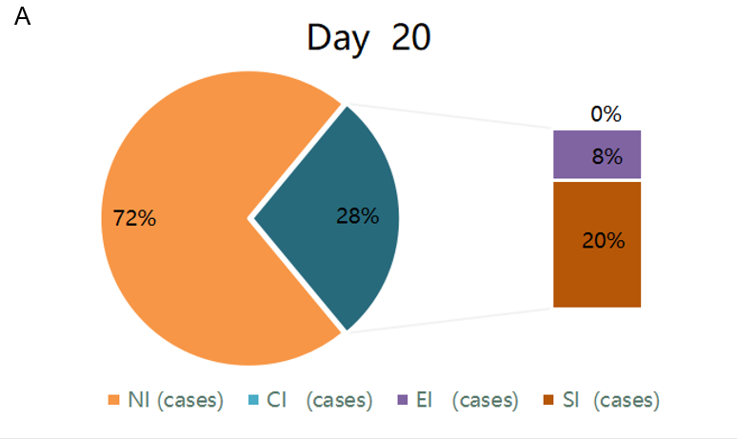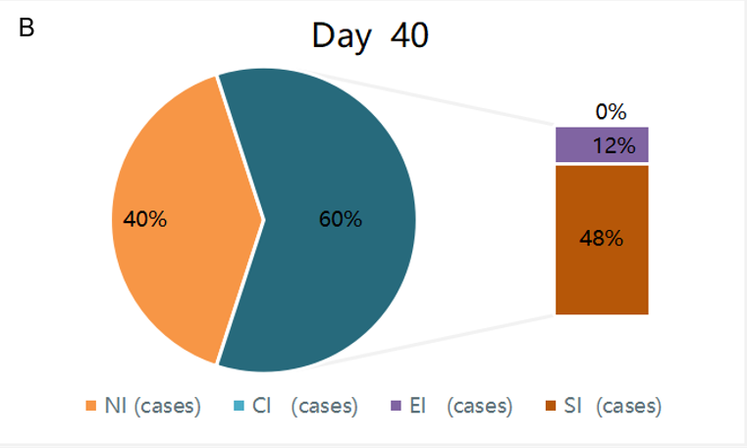
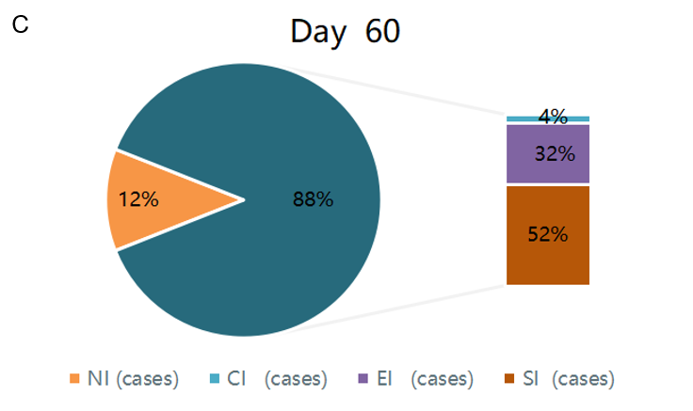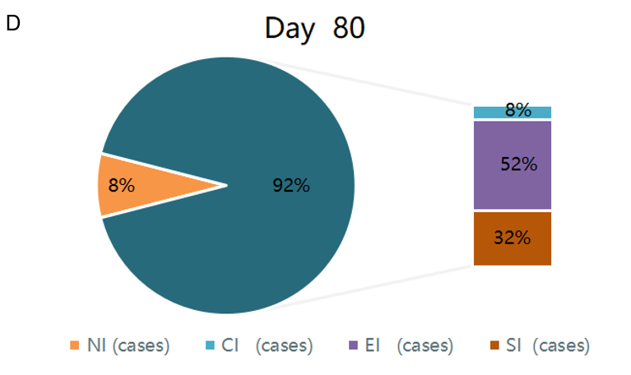
Figure 1 Effectiveness of keratotic papule treatment. A: Day 20 of treatment; B: Day 40 of treatment; C: Day 60 of treatment; D: Day 80 of treatment. CI: Complete improvement; EI: Excellent improvement; ER: Effective rate; NI: No improvement; SI: Some improvement.

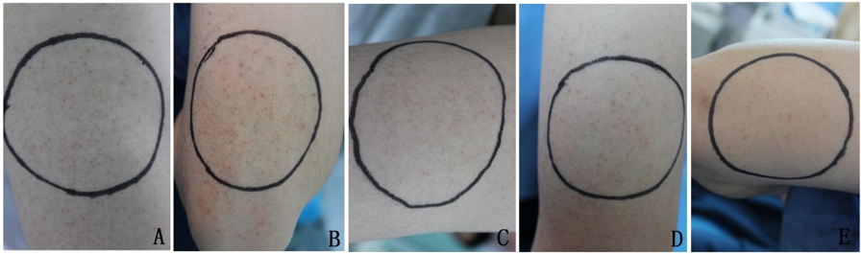Figure 2 Therapeutic outcomes of a representative subject. A: Pretreatment; B: Day 20 of treatment; C: Day 40 of treatment; D: Day 60 of treatment; E: Day 80 of treatment.

Table 1 Global esthetic improvement scale
Grading | Description
Excellent improvement | The best aesthetic results are achieved after treatment
Significant improvement | There is significant improvement in appearance compared to the initial situation
Some improvement | Compared with the initial situation, there is obvious improvement
No improvement | The appearance is essentially the same as the initial situation
Worse | The appearance is worse than the initial situation

Table 2 Changes in the number of keratotic papules before and after treatment of the 25 study cases
Case | Day 0 | Day 20 | Day 40 | Day 60 | Day 80
1 | 52 | 25 | 20 | 16 | 10
2 | 26 | 22 | 21 | 15 | 14
3 | 95 | 80 | 71 | 58 | 28
4 | 46 | 38 | 32 | 25 | 24
5 | 58 | 49 | 33 | 29 | 21
6 | 35 | 23 | 19 | 14 | 10
7 | 80 | 58 | 43 | 37 | 26
8 | 66 | 47 | 58 | 23 | 19
9 | 35 | 21 | 18 | 15 | 11
10 | 75 | 59 | 50 | 38 | 36
11 | 38 | 25 | 16 | 15 | 12
12 | 43 | 37 | 33 | 26 | 13
13 | 55 | 53 | 48 | 43 | 42
14 | 61 | 30 | 22 | 15 | 11
15 | 48 | 45 | 41 | 31 | 25
16 | 57 | 55 | 51 | 45 | 43
17 | 39 | 33 | 28 | 21 | 14
18 | 72 | 65 | 55 | 43 | 37
19 | 28 | 22 | 19 | 12 | 7
20 | 30 | 27 | 21 | 16 | 12
21 | 42 | 38 | 33 | 27 | 23
22 | 58 | 53 | 45 | 37 | 29
23 | 65 | 62 | 57 | 49 | 33
24 | 36 | 29 | 23 | 16 | 9
25 | 88 | 80 | 66 | 52 | 45
Average | 53.12 ± 18.49 | 43.04 ± 17.53 | 36.92 ± 16.24 | 28.72 ± 13.51 | 22.16 ± 11.61
Data are the number of keratotic papules before treatment and on days 20, 40, 60, and 80.

Table 3 Changes in melanin content, skin hemoglobin content, and skin lightness before and after treatment
Measurement index | Pretreatment | Day 20 | Day 40 | Day 60 | Day 80 | 5 yr
M value | 219.48 ± 64.09 | 215.80 ± 63.87 | 213.12 ± 60.42¹ | 203.92 ± 58.62¹ | 197.04 ± 59.23¹ | 223.56 ± 45.51
E value | 261.76 ± 60.31 | 256.16 ± 64.00 | 258.48 ± 67.86 | 248.36 ± 62.50¹ | 242.2 ± 66.39¹ | 255.13 ± 51.25
L value | 61.41 ± 4.23 | 61.94 ± 4.17 | 62.20 ± 3.94¹ | 62.57 ± 3.78¹ | 63.24 ± 3.60¹ | 61.89 ± 3.83
¹P < 0.05 vs pretreatment. E: Skin hemoglobin content; L: Skin lightness; M: Melanin content.

Table 4 Self-evaluation status of subjects
 | Day 20 | Day 40 | Day 60 | Day 80 | 5 yr
Excellent improvement | 0 | 0 | 1 | 1 | 0
Significant improvement | 2 | 4 | 5 | 7 | 0
Some improvement | 9 | 11 | 12 | 11 | 3
No change | 12 | 10 | 7 | 6 | 4
Worse | 0 | 0 | 0 | 0 | 2
Total | 25 | 25 | 25 | 25 | 9
Data are the number of subjects.

Published by Baishideng Publishing Group Inc
7041 Koll Center Parkway, Suite 160, Pleasanton, CA 94566, USA
Telephone: +1-925-3991568
E-mail: bpgoffice@wjgnet.com
Help Desk: https://www.f6publishing.com/helpdesk
https://www.wjgnet.com

© 2021 Baishideng Publishing Group Inc. All rights reserved.

