Name of Journal: World Journal of Gastrointestinal Oncology
Manuscript NO: 78999
Manuscript Type: CASE REPORT

Surgical management of monomorphic epitheliotropic intestinal T-cell lymphoma followed by chemotherapy and stem-cell transplant: A case report and review of the literature

Bissessur AS et al. Monomorphic epitheliotropic intestinal T-cell lymphoma

Abdul Saad Bissessur, Ji-Chun Zhou, Ling Xu, Zhao-Qing Li, Si-Wei Ju, Yun-Lu Jia, Lin-Bo Wang

Abdul Saad Bissessur, Ji-Chun Zhou, Ling Xu, Zhao-Qing Li, Si-Wei Ju, Lin-Bo Wang, Department of Surgical Oncology, Sir Run Run Shaw Hospital, Zhejiang University School of Medicine, Hangzhou 310006, Zhejiang Province, China

Yun-Lu Jia, Department of Medical Oncology, First Affiliated Hospital, Zhejiang University School of Medicine, Hangzhou 310006, Zhejiang Province, China

Author contributions: Bissessur AS and Zhou JC wrote this paper; Bissessur AS conducted literature review; Xu L, Li ZQ, Ju SW, and Jia YL contributed in data acquisition and manuscript preparation; Jia YL, Zhou JC, and Wang LB were responsible for patient care and data analysis; Zhou JC and Wang LB substantively reviewed the manuscript; all authors read and approved the final manuscript.

Corresponding author: Lin-Bo Wang, Doctor, MBBS, MD, PhD, Attending Doctor, Chief Doctor, Director, Professor, Surgical Oncologist, Department of Surgical Oncology, Sir Run Run Shaw Hospital, Zhejiang University School of Medicine, No. 3 Eastern Qingchun Road, Hangzhou 310006, Zhejiang Province, China. linbowang@zju.edu.cn

Received: July 26, 2022
Revised: August 22, 2022
Accepted: October 11, 2022
Published online:

Abstract
BACKGROUND
Monomorphic epitheliotropic intestinal T-cell lymphoma (MEITL) is a rare and rapidly progressive intestinal T-cell non-Hodgkin lymphoma associated with a very poor prognosis and a median survival of 7 mo. Advances in the identification of MEITL over the last two decades have led to its recognition as a separate entity. MEITL patients, predominantly male, typically present with vague and nonspecific symptoms and diagnosis is predominantly confirmed at laparotomy. Currently, there are no standardized treatment protocols, and the optimal therapy remains unclear.

CASE SUMMARY
We report a case of MEITL that was initially considered to be gastrointestinal stromal tumor (GIST) and Imatinib was administered for one cycle. The 62-year-old man presented with abdominal pain, abdominal distension, and weight loss of 20 pounds. Within 2 wk, the size of the mass considerably increased on computed tomography scans. The patient underwent surgery followed by chemotherapy with CHOP (cyclophosphamide, doxorubicin, vincristine, and prednisone) and stem-cell transplant. A correct diagnosis of MEITL was established based on postoperative pathology. Immunophenotypically, the neoplastic cells fulfilled the diagnostic criteria for MEITL as they were CD3⁺, CD4⁺, CD8⁺, CD56⁺, and TIA-1⁺.

CONCLUSION
Given that MEITL has no predisposing factor and presents with vague symptoms with rapid progression, the concomitant presence of abdominal symptoms and B symptoms (weight loss, fever, and night sweats) with hypoalbuminemia, anemia, low lymphocytic count and endoscopic findings of diffuse infiltrating type lesions should alert physicians to this rare disease, especially when it comes to Asian patients. Immediate laparotomy should then be carried out followed by chemotherapy and stem-cell transplant.

Key Words: Monomorphic epitheliotropic intestinal T-cell lymphoma; Gastrointestinal stromal tumor; Immunophenotypically; Chemotherapy; Stem-cell transplant; Case report

Bissessur AS, Zhou JC, Xu L, Li ZQ, Ju SW, Jia YL, Wang LB. Surgical management of monomorphic epitheliotropic intestinal T-cell lymphoma followed by chemotherapy and stem-cell transplant: A case report and review of the literature. World J Gastrointest Oncol 2022; In press

Core Tip: Monomorphic epitheliotropic intestinal T-cell lymphoma (MEITL) is a rare and rapidly progressive intestinal T-cell non-Hodgkin lymphoma. Currently, there is no standardized treatment or diagnostic protocols for MEITL. Chemotherapy followed by stem-cell transplant postoperatively has shown promising results in terms of remission and progression free survival. Since MEITL is associated with a poor prognosis and high recurrence, it is crucial that the oncologist should follow and monitor any relapsing signs.

INTRODUCTION
Monomorphic epitheliotropic intestinal T-cell lymphoma (MEITL), formerly known as enteropathy-associated T-cell lymphoma type II (EATL type II), is a rare non-Hodgkin primary lymphoma of the gastrointestinal tract arising from intraepithelial T-cells^{[1]}.
Previously, EATL was recognized as a single entity of small intestinal lymphoma and was termed as enteropathy-type T-cell lymphoma. But in 2008, the World Health Organization (WHO) classified the disease into two subtypes: (1) EATL type I, which comprises of 80%-90% of all cases; and (2) EATL type II, accounting for 10%-20% (a rather monomorphic variant)^{[2]}. EATL accounted for 5.4% of all lymphomas based on an international survey^{[3]}.
However, after 2008, studies revealed noteworthy and remarkable clinical and pathological differences between the two types of lymphoma aforementioned. As a result, the WHO redefined these lymphomas as distinct and separate entities: Type I EATL was then termed as enteropathy-associated T-cell lymphoma and type II, owing to its distinctive nature, was designated as MEITL^{[4]}. The nomenclature and classification are illustrated in Figure 1.
The geographic distribution of EATL and MEITL varies: EATL is seen more often in areas with a high prevalence of celiac disease (particularly Northern Europe) whereas MEITL has a broader geographic distribution and is seen in regions where celiac disease is rare, particularly in Asian countries^{[2,4]}. The findings of a study conducted in Asia which included 38 cases of MEITL suggested that intestinal T-cell lymphomas might be merely MEITL in Asian patients^{[5]}.
Male predominance (ratio 2.6:1.0) has been observed in MEITL and the median age of onset is 58 years old, with the small intestine as the most commonly involved site^{[6]}. Upon consultation, MEITL patients typically present with vague and nonspecific symptoms such as abdominal pain, fatigue, weight loss, small bowel perforation, diarrhea, and gastrointestinal (GI) obstruction^{[2,5,7]}. Low albumin, increased lactate dehydrogenase (LDH), and elevated C-Reactive protein (CRP) have been observed in most studies of MEITL cases^{[2,5]}.
Tumor cells with a monomorphic shape, an epitheliotropic pattern, CD8⁺, and CD56⁺ are the diagnostic criteria for MEITL and serve to distinguish them from other types of T-cell lymphoma^{[8]}.
The vagueness of symptoms and/or lack of all symptoms at presentation make the initial diagnosis of T-cell lymphoma challenging. In addition, primary diagnosis of MEITL can be delayed until further investigation due to the similar symptoms/imaging manifestations to those of other GI cancers. Another challenge that may be encountered is intestinal obstruction and perforation. Thus, diagnosis is predominantly confirmed at laparotomy^{[9]}.
Herein, we present a case of MEITL, the treatment approach, and follow-up result. This case report and literature review will provide an up-to-date insight into the management of MEITL. Because of a relatively poor prognosis and a median survival of only 7 mo^{[5]}, weight loss, elevated LDH and CRP, and low albumin should alert the physician especially when it comes to Asian patients. No standardized treatment is yet established for MEITL due to the rarity of the disease. However, surgical resection followed by chemotherapy and/or autologous stem cell transplantation has been demonstrated to have better outcomes compared to surgery alone. In addition, new clinical trials using novel regimen of IVE/MTX (ifosfamide, vincristine, etoposide/methotrexate) followed by autologous stem cell transplant have proven significantly better outcomes with a 65% complete remission and 60% 5-year survival rate^{[10]}.

CASE PRESENTATION
Chief complaints
A 62-year-old man visited our hospital with a 2-mo history of abdominal pain and distension.

History of present illness
The patient had persistent epigastric pain half an hour after eating, which alleviated after a few hours. The patient’s bowel habits varied between constipation and diarrhea. His symptoms gradually aggravated. He reported a weight loss of 20 pounds.

History of past illness
The patient had no history of other illnesses such as hypertension, diabetes, or heart disease. He had a full positron emission tomography (PET)/computed tomography (CT) scan in the previous year which revealed no abnormality, highlighting the rapid and aggressive progression of the disease.
At an outside hospital, the patient underwent a gastroscopy which showed chronic superficial gastritis and a colonoscopy which revealed multiple colorectal polyps and proctitis. Half a month later, he came to our hospital for further treatment and diagnosis.

Personal and family history
The patient had no significant personal and family history.

Physical examination
Physical abdominal examination revealed abdominal distension on inspection and decreased bowel sounds on auscultation. On palpation, a 15-cm mass could be felt. The mass had a clear boundary and an irregular shape. The abdomen was soft and deep palpation revealed left lower abdominal tenderness.

Laboratory examinations
Laboratory tests and blood workouts revealed an elevated level of CRP at 163.5 mg/L, normal lactate dehydrogenase at 180 IU/L, albumin at 36.2 g/L, lymphocytic percentage at 0.58%, and hemoglobin at 113 g/L. Other laboratory results are shown in Table 1. Tumor markers were all within the normal ranges (Table 2).

Imaging examinations
The patient had two CT scans 2 wk apart at our hospital. An increase in the size of the mass was observed on the second CT scan, with significant necrosis (Figure 2). The size of the mass on the first and second CT scans was estimated to be approximately 85 mm × 74 mm × 107 mm and 113 mm × 97 mm × 146 mm, respectively. Local mesenteric lymph nodes were enlarged.

Further diagnostic work-up
The patient was consulted at the General Surgery Department of our hospital and gastrointestinal stromal tumor (GIST) was initially considered due to the imaging presentation of the tumor (Figure 2) and the associated symptoms. Gleevec (Imatinib) was administered as empirical neoadjuvant targeting therapy. He had 5-8 times of diarrhea/d after oral administration of Gleevec.
While the patient was on Gleevec, his symptoms further aggravated, with a higher accumulation of pelvic fluid accompanied with fever (maximum of 37.9 °C). As intestinal perforation and peritonitis were suspected, and the patient underwent emergency surgery.
Postoperative immunohistochemistry findings revealed CD3 (+), CD20 (-), CD21 (residual FDC +), CD138 (-), Kappa (+), Lambda (+), Ki-67 (80%), CD117 (-), CD4 (+), CD5 (-), CD7 (+), CD8 (+), CD30 (-), CD10 (-), PD-1 (-), CK-PAN (-), GranzymeB (+), TIA-1 (+), and CD56 (+) (Figure 3). Epstein-Barr virus (EBV)-encoded RNA (EBER) in situ hybridization was negative. The results are listed in Table 3.

FINAL DIAGNOSIS
Based on postoperative immunohistochemistry findings, the final diagnosis was MEITL.

TREATMENT
The patient underwent surgery followed by chemotherapy and stem-cell transplant.

Intraoperative findings
The size of the mass was estimated to be 15 cm × 14 cm × 10 cm and the margin was not clear. The texture was hard. Superficial purulent exudation was observed. The tumor had inflammatory adhesions with the mesentery of the small intestine, descending colon, and transverse colon. The relationship between the tumor and left psoas major muscle and left ureter was unclear. Specimens were sent for further pathology diagnosis after tumor resection.

OUTCOME AND FOLLOW-UP
After surgery and before systemic treatment, ¹⁸F-fluorodeoxyglucose (FDG) PET/CT scan (Figure 4) revealed no remarkable abnormalities, no abnormal density focus, and no significant increase or decrease in radioactivity uptake. There was no significant thickening and increase of radioactivity uptake in the anastomotic intestinal wall. The metabolism of FDG was increased in the middle abdomen subcutaneously. Several large lymph nodes were spotted in the left abdominal mesenteric area, with the largest measuring 1.1 cm × 1.6 cm. The standardized uptake value (SUV) of the left mesentery was 1.6. An increase in the metabolism of FDG was also noted in the ascending colon.
In addition, the patient underwent a bone marrow biopsy, which showed no overt morphologic or flow cytometry evidence of T-cell lymphoma or metastatic malignancy (Figure 5).
A month after surgery, the patient was started on chemotherapy with CHOP (cyclophosphamide, doxorubicin, vincristine, and prednisone), scheduled for four cycles, every 3 wk. After chemotherapy, the patient underwent stem-cell transplant. Between surgery and the first cycle of CHOP chemotherapy, the patient developed an itchy rash on his hands which subsequently relieved after his first chemotherapy cycle.
Regarding the staging of MEITL, gastrointestinal lymphomas follow the Lugano staging system^{[11]}, which is tabulated in Table 4. Our patient was staged as having IIE disease.

DISCUSSION
Consistent with our case, it was reported that the most common site of involvement is the small intestine, particularly the jejunum followed by the ileum and duodenum; rarely it could also involve the colon and stomach^{[12]}. Metastasis to mesenteric lymph nodes is common^{[13]}. Our patient had several enlarged mesenteric lymph nodes observed on CT but they were due to lymphoid hyperplasia rather than metastasis. Regarding imaging modalities, obstruction is not common in the small bowel. Multifocal involvement and perforation are more prevalent^{[14]}. Necrosis, reported not to be usual in MEITL^{[6,8]}, was observed in our case (Figure 6).
The pattern of presenting symptoms greatly varied among previous studies, with abdominal pain being the most commonly reported symptom. Our patient presented with a 2-mo history of abdominal pain, abdominal distension, and weight loss. However, abdominal pain has a wide range of diagnoses which can pose a great challenge in diagnosing MEITL upon clinical presentation. Weight loss, despite being regarded as a B symptom, has not been found to be an exclusive symptom when it came to diagnosis of MEITL in Asian patients^{[5,6]}. In contrast to classic EATL which can be suspected in sudden worsening of abdominal pain and diarrhea in a previously diagnosed celiac disease patient, MEITL has not been found to have any predisposing factor and was rather known to be sporadic. Clinically, diagnosis of MEITL is more challenging and delayed because of the low index of clinical suspicion and a vague inconsistent display of symptoms that can be easily confused with other malignancies^{[15-17]}.
Low albumin, elevated LDH, abnormally high CRP, low hemoglobin, and abnormal lymphocyte count are common laboratory abnormalities detected^{[2,5,10,16]}. Our patient had all the listed laboratory abnormalities except for a normal LDH level.
In this case, based on postoperative pathology reports, other malignancies such as poorly differentiated adenocarcinoma, B-cell lymphoma, and GIST were easily excluded because of the expression of only T-cell markers by monoclonal tumor cells. In addition, negative staining for CD20^{[18,19]} and CD117^{[20]} excluded B-cell lymphomas and GIST, respectively. The positive staining for CD56 and CD8 led to the diagnosis of MEITL and not the classical EATL form^{[2,3,9,21]}. The panel of immunohistochemistry markers was consistent with MEITL. EBER in situ hybridization was negative, thus excluding the possibility of natural killer/T-cell lymphoma which most commonly presents as a facial mass, with a small percentage involving the GI tract^{[22,23]}.
Despite having been demonstrated to be negative in several papers and studies for the occurrence of MEITL^{[17,24]}, CD4 was found be positive in our case. One of the largest multicenter studies of MEITL analyzed 38 patients where CD4⁺CD8⁺ rate was as low as 19%^{[5]}. CD4⁺CD8⁺, however, supports the cellular origin of MEITL being type ‘A’ intestinal T-cells^{[6]}.
A literature review about the endoscopic findings of MEITL revealed a higher tendency of diffuse infiltrating type lesions compared to ulcerative and polypoid lesions. In a study of nine MEITL patients^{[25]}, the endoscopic examination findings were: Six (67%) diffuse infiltrating type lesions (colitis-like or proctocolitis-like); two (22%) polypoid type lesions; and one (11%) ulcerative type lesion. Another study of endoscopic findings of 15 cases of MEITL^{[26]} showed eight (53%) ulcero-infiltrative type lesions and two ulcerative type lesions.
Currently, there are no standardized treatment or diagnostic protocols for MEITL. Being a very rare entity, there exist very few trials and regimens in regards to MEITL, with some having more promising results in eligible patients. Historically, MEITL has been treated with surgery, chemotherapy, autologous stem cell transplant, or their combination. Several studies hypothesized that chemotherapy with or without surgery delivered better outcomes than surgery alone^{[21,27]}. Moreover, different chemotherapy regimens have been investigated over the last decade^{[3,10,16,28]}, resulting in different prognoses (Table 5)^{[29-64]}.
Despite anthracycline-based regimens being associated with better survival rates than other therapies or no therapy at all^{[3]}, Sieniawski et al^{[10]} compared a novel regimen with anthracycline-based regimen. The novel regimen begins with one course of CHOP (cyclophosphamide, doxorubicin, vincristine, and prednisone), followed by three courses of IVE/MTX (ifosfamide, vincristine, etoposide alternating with intermediate-dose methotrexate). Autologous stem-cell transplantation (ASCT) was then performed 3 wk after the last cycle of IVE/MTX. They found that the novel regimen had a better response (lower mortality and higher remission). Chiadamide combined with chemotherapy also slightly improved the survival time in two patients, with a mean survival time of 16 mo^{[45]}. The planned regimen for our patient was four cycles of CHOP every 3 wk, followed by stem cell transplant.
Given that (1) MEITL has no predisposing factor; (2) the diagnosis of MEITL is predominantly made at laparotomy; (3) a bulky tumor and elevated serum LDH and CRP levels are risk factors significantly associated with a worse prognosis, and (4) MEITL has no standardized treatment, the concomitant presence of abdominal pain and systemic symptoms (weight loss, fever, and night sweating) together with laboratory parameters indicative for hypoalbuminemia, anemia (low hemoglobin), increased CRP, and low lymphocytic count and endoscopic findings of diffuse infiltrating type lesions can be regarded as highly suspicious features of MEITL and should alert physicians to this rare disease and opt for immediate laparotomy.
Fluorine-2-fluorodeoxyglucose positron emission tomography (¹⁸F-FDG PET) has been proven to be the most useful diagnostic modality in the staging and follow-up for recurrence of aggressive lymphomas. A study of 12 MEITL cases^{[65]} examined by PET concluded that MEITL is not restricted to the gut; many different anatomical sites were involved at presentation or at relapse with the infiltration of thoracic structures in 50% of the cases and central nervous system involvement in 25% of the cases. Our patient, however, had no abnormalities, no abnormal density focus, and no significant increase or decrease in radioactivity uptake on his whole body ¹⁸F-FDG PET scan after surgery and before his chemotherapy. The increase in metabolism of FDG in the middle abdomen subcutaneously is considered to be postoperative changes. Inflammation was considered for the increase in metabolism of FDG in the ascending colon. An increase in uptake of FDG is not distinct for malignancy; benign infectious and inflammatory processes as well as treatment-induced inflammatory changes can also account for an increase in FDG uptake^{[66]}. In regards to uptake of FDG on PET scans in the setting of MEITL, clinicians must be careful as infectious and inflammatory processes can also lead to an increase.
As GIST was highly suspected as the primary diagnosis, no endoscopic biopsy was planned due to the risk of intraabdominal bleeding and tumor rupture (increasing risk of dissemination and metastasis). However, after the mass was found to be significantly enlarged within 2 wk while on Gleevec, emergency surgery after acute abdomen (perforation and acute peritonitis) was performed and specimens were sent for pathology examination. This is consistent with previous studies, which showed that EATL and MEITL have been preponderantly diagnosed at laparotomy^{[16,21]}. In the study by Sieniawski et al^{[21]}, 52 out of 57 patients underwent emergency laparotomy and Gale et al^{[16]} reported that diagnosis was made at laparotomy in 25 out of 31 patients.

CONCLUSION
Understanding MEITL as an entity can be dismaying for both patients and physicians. Diagnosis should be correlated to clinical symptoms while the final diagnosis is mainly based on the pathological features and immunophenotypes. Since MEITL is associated with a poor prognosis and high recurrence, it is crucial that the oncologist should follow and monitor any relapsing signs. In the occurrence of a rapidly growing malignant tumor in the small intestine (otherwise not explained by any other pathologic processes), vague gastrointestinal symptoms, and a poor suspicion of diagnosis due to lack of specific tests accompanied by elevated C-reactive protein, elevated LDH, hypoalbuminemia, anemia, and low lymphocytic count, we suggest emergent laparotomy and specimens to be sent for pathology. Based on our case’ relatively favorable prognosis and the cases reported in the literature, surgical resection followed by chemotherapy and stem-cell transplant leads to a better prognosis and should be recommended as the standard treatment protocol.

REFERENCES
1 Isaacson PG. Gastrointestinal lymphoma. Hum Pathol 1994; 25: 1020-1029 [PMID: 7927306 DOI: 10.1016/0046-8177(94)90060-4]
2 Campo E, Swerdlow SH, Harris NL, Pileri S, Stein H, Jaffe ES. The 2008 WHO classification of lymphoid neoplasms and beyond: evolving concepts and practical applications. Blood 2011; 117: 5019-5032 [PMID: 21300984 DOI: 10.1182/blood-2011-01-293050]
3 Delabie J, Holte H, Vose JM, Ullrich F, Jaffe ES, Savage KJ, Connors JM, Rimsza L, Harris NL, Müller-Hermelink K, Rüdiger T, Coiffier B, Gascoyne RD, Berger F, Tobinai K, Au WY, Liang R, Montserrat E, Hochberg EP, Pileri S, Federico M, Nathwani B, Armitage JO, Weisenburger DD. Enteropathy-associated T-cell lymphoma: clinical and histological findings from the international peripheral T-cell lymphoma project. Blood 2011; 118: 148-155 [PMID: 21566094 DOI: 10.1182/blood-2011-02-335216]
4 Swerdlow SH, Campo E, Pileri SA, Harris NL, Stein H, Siebert R, Advani R, Ghielmini M, Salles GA, Zelenetz AD, Jaffe ES. The 2016 revision of the World Health Organization classification of lymphoid neoplasms. Blood 2016; 127: 2375-2390 [PMID: 26980727 DOI: 10.1182/blood-2016-01-643569]
5 Tse E, Gill H, Loong F, Kim SJ, Ng SB, Tang T, Ko YH, Chng WJ, Lim ST, Kim WS, Kwong YL. Type II enteropathy-associated T-cell lymphoma: a multicenter analysis from the Asia Lymphoma Study Group. Am J Hematol 2012; 87: 663-668 [PMID: 22641357 DOI: 10.1002/ajh.23213]
6 Tan SY, Chuang SS, Tang T, Tan L, Ko YH, Chuah KL, Ng SB, Chng WJ, Gatter K, Loong F, Liu YH, Hosking P, Cheah PL, Teh BT, Tay K, Koh M, Lim ST. Type II EATL (epitheliotropic intestinal T-cell lymphoma): a neoplasm of intra-epithelial T-cells with predominant CD8αα phenotype. Leukemia 2013; 27: 1688-1696 [PMID: 23399895 DOI: 10.1038/leu.2013.41]
7 Chan JK, Chan AC, Cheuk W, Wan SK, Lee WK, Lui YH, Chan WK. Type II enteropathy-associated T-cell lymphoma: a distinct aggressive lymphoma with frequent γδ T-cell receptor expression. Am J Surg Pathol 2011; 35: 1557-1569 [PMID: 21921780 DOI: 10.1097/PAS.0b013e318222dfcd]
8 Tian S, Xiao SY, Chen Q, Liu H, Ping J. Monomorphic epitheliotropic intestinal T-cell lymphoma may mimic intestinal inflammatory disorders. Int J Immunopathol Pharmacol 2019; 33: 2058738419829387 [PMID: 30757928 DOI: 10.1177/2058738419829387]
9 Ferreri AJ, Zinzani PL, Govi S, Pileri SA. Enteropathy-associated T-cell lymphoma. Crit Rev Oncol Hematol 2011; 79: 84-90 [PMID: 20655757 DOI: 10.1016/j.critrevonc.2010.06.006]
10 Sieniawski M, Angamuthu N, Boyd K, Chasty R, Davies J, Forsyth P, Jack F, Lyons S, Mounter P, Revell P, Proctor SJ, Lennard AL. Evaluation of enteropathy-associated T-cell lymphoma comparing standard therapies with a novel regimen including autologous stem cell transplantation. Blood 2010; 115: 3664-3670 [PMID: 20197551 DOI: 10.1182/blood-2009-07-231324]
11 Rohatiner A, d'Amore F, Coiffier B, Crowther D, Gospodarowicz M, Isaacson P, Lister TA, Norton A, Salem P, Shipp M. Report on a workshop convened to discuss the pathological and staging classifications of gastrointestinal tract lymphoma. Ann Oncol 1994; 5: 397-400 [PMID: 8075046 DOI: 10.1093/oxfordjournals.annonc.a058869]
12 Lee HJ, Im JG, Goo JM, Kim KW, Choi BI, Chang KH, Han JK, Han MH. Peripheral T-cell lymphoma: spectrum of imaging findings with clinical and pathologic features. Radiographics 2003; 23: 7-26; discussion 26-8 [PMID: 12533636 DOI: 10.1148/rg.231025018]
13 Gopalakrishna H, Al-Abdouh A, Nair G, Bekele A. Incidental Diagnosis of Monomorphic Epitheliotropic Intestinal T-Cell Lymphoma: A Case Report. Cureus 2020; 12: e10084 [PMID: 33005508 DOI: 10.7759/cureus.10084]
14 Ghai S, Pattison J, Ghai S, O'Malley ME, Khalili K, Stephens M. Primary gastrointestinal lymphoma: spectrum of imaging findings with pathologic correlation. Radiographics 2007; 27: 1371-1388 [PMID: 17848697 DOI: 10.1148/rg.275065151]
15 Di Sabatino A, Biagi F, Gobbi PG, Corazza GR. How I treat enteropathy-associated T-cell lymphoma. Blood 2012; 119: 2458-2468 [PMID: 22271451 DOI: 10.1182/blood-2011-10-385559]
16 Gale J, Simmonds PD, Mead GM, Sweetenham JW, Wright DH. Enteropathy-type intestinal T-cell lymphoma: clinical features and treatment of 31 patients in a single center. J Clin Oncol 2000; 18: 795-803 [PMID: 10673521 DOI: 10.1200/JCO.2000.18.4.795]
17 Ondrejka S, Jagadeesh D. Enteropathy-Associated T-Cell Lymphoma. Curr Hematol Malig Rep 2016; 11: 504-513 [PMID: 27900603 DOI: 10.1007/s11899-016-0357-7]
18 Martelli M, Ferreri AJ, Agostinelli C, Di Rocco A, Pfreundschuh M, Pileri SA. Diffuse large B-cell lymphoma. Crit Rev Oncol Hematol 2013; 87: 146-171 [PMID: 23375551 DOI: 10.1016/j.critrevonc.2012.12.009]
19 Paro MM, Siftar Z, Kardum-Skelin I, Sustercić D, Nazor A, Flegar-Mestrić Z, Jaksić B. Flow cytometry immunophenotyping (FCI) of fine needle aspirates (FNAs) of lymph nodes. Coll Antropol 2010; 34: 359-365 [PMID: 20698103]
20 Hirota S, Isozaki K, Moriyama Y, Hashimoto K, Nishida T, Ishiguro S, Kawano K, Hanada M, Kurata A, Takeda M, Muhammad Tunio G, Matsuzawa Y, Kanakura Y, Shinomura Y, Kitamura Y. Gain-of-function mutations of c-kit in human gastrointestinal stromal tumors. Science 1998; 279: 577-580 [PMID: 9438854 DOI: 10.1126/science.279.5350.577]
21 Sieniawski MK, Lennard AL. Enteropathy-associated T-cell lymphoma: epidemiology, clinical features, and current treatment strategies. Curr Hematol Malig Rep 2011; 6: 231-240 [PMID: 21912848 DOI: 10.1007/s11899-011-0097-7]
22 Cai Q, Cai J, Fang Y, Young KH. Epstein-Barr Virus-Positive Natural Killer/T-Cell Lymphoma. Front Oncol 2019; 9: 386 [PMID: 31139570 DOI: 10.3389/fonc.2019.00386]
23 Wang L, Liu Y, Lin XY, Yu JH, Miao Y, Qiu XS, Wang EH. A case of enteropathy-associated T-cell lymphoma (type I) arising in stomach without refractory celiac disease. Diagn Pathol 2012; 7: 172 [PMID: 23217032 DOI: 10.1186/1746-1596-7-172]
24 Weindorf SC, Smith LB, Owens SR. Update on Gastrointestinal Lymphomas. Arch Pathol Lab Med 2018; 142: 1347-1351 [PMID: 30407861 DOI: 10.5858/arpa.2018-0275-RA]
25 Ishibashi H, Nimura S, Hirai F, Harada N, Iwasaki H, Kawauchi S, Oshiro Y, Matsuyama A, Nakamura S, Takamatsu Y, Yonemasu H, Shimokama T, Takeshita M. Endoscopic and clinicopathological characteristics of colorectal T/NK cell lymphoma. Diagn Pathol 2020; 15: 128 [PMID: 33087157 DOI: 10.1186/s13000-020-01044-5]
26 Kim DH, Lee D, Kim JW, Huh J, Park SH, Ha HK, Suh C, Yoon SM, Kim KJ, Choi KD, Ye BD, Byeon JS, Song HJ, Jung HY, Yang SK, Kim JH, Myung SJ. Endoscopic and clinical analysis of primary T-cell lymphoma of the gastrointestinal tract according to pathological subtype. J Gastroenterol Hepatol 2014; 29: 934-943 [PMID: 24325295 DOI: 10.1111/jgh.12471]
27 Nijeboer P, Malamut G, Mulder CJ, Cerf-Bensussan N, Sibon D, Bouma G, Cellier C, Hermine O, Visser O. Enteropathy-associated T-cell lymphoma: improving treatment strategies. Dig Dis 2015; 33: 231-235 [PMID: 25925928 DOI: 10.1159/000369542]
28 Daum S, Ullrich R, Heise W, Dederke B, Foss HD, Stein H, Thiel E, Zeitz M, Riecken EO. Intestinal non-Hodgkin's lymphoma: a multicenter prospective clinical study from the German Study Group on Intestinal non-Hodgkin's Lymphoma. J Clin Oncol 2003; 21: 2740-2746 [PMID: 12860953 DOI: 10.1200/JCO.2003.06.026]
29 Chen Y, Tan SY, Petersson BF, Khor YM, Gopalakrishnan SK, Tan D. Occult recurrence of monomorphic epitheliotropic intestinal T-cell lymphoma and the role of MATK gene expression in diagnosis. Hematol Oncol 2017; 35: 852-855 [PMID: 26948059 DOI: 10.1002/hon.2288]
30 Ishibashi H, Nimura S, Kayashima Y, Takamatsu Y, Aoyagi K, Harada N, Kadowaki M, Kamio T, Sakisaka S, Takeshita M. Multiple lesions of gastrointestinal tract invasion by monomorphic epitheliotropic intestinal T-cell lymphoma, accompanied by duodenal and intestinal enteropathy-like lesions and microscopic lymphocytic proctocolitis: a case series. Diagn Pathol 2016; 11: 66 [PMID: 27457239 DOI: 10.1186/s13000-016-0519-x]
31 Aiempanakit K, Amatawet C, Chiratikarnwong K, Auepemkiate S, Kayasut K, Suwiwat S, Apinantriyo B. Erythema multiforme-like cutaneous lesions in monomorphic epitheliotropic intestinal T-cell lymphoma: a rare case report. J Cutan Pathol 2017; 44: 183-188 [PMID: 27862162 DOI: 10.1111/cup.12864]
32 Antoniadou F, Dimitrakopoulou A, Voutsinas PM, Vrettou K, Vlahadami I, Voulgarelis M, Korkolopoulou P, Kafasi N, Mikou P. Monomorphic epitheliotropic intestinal T-cell lymphoma in pleural effusion: A case report. Diagn Cytopathol 2017; 45: 1050-1054 [PMID: 28681573 DOI: 10.1002/dc.23772]
33 Aoyama Y, Tsunemine H, Zushi Y, Maruoka H, Goto Y, Kodaka T, Itoh T, Takahashi T. Colonal monomorphic epitheliotropic intestinal T-cell lymphoma with novel phenotype of cytoplasmic CD3 expression. J Clin Exp Hematop 2018; 58: 102-106 [PMID: 29657256 DOI: 10.3960/jslrt.18002]
34 Pan ST, Ko YH, Tan SY, Chuang SS. Primary cutaneous peripheral T-cell lymphoma with a late relapse solely in the ileum mimicking monomorphic epitheliotropic intestinal T-cell lymphoma. Pathol Res Pract 2018; 214: 2106-2109 [PMID: 30477646 DOI: 10.1016/j.prp.2018.10.002]
35 Liu C, Feng L, Sun X. Monomorphic Epitheliotropic Intestinal T-Cell Lymphoma: A Rare Case of Diffuse Ulcers in the Intestine. Clin Gastroenterol Hepatol 2021; 19: e121-e122 [PMID: 32668339 DOI: 10.1016/j.cgh.2020.07.011]
36 Ozaka S, Inoue K, Okajima T, Tasaki T, Ariki S, Ono H, Ando T, Daa T, Murakami K. Monomorphic epitheliotropic intestinal T-cell lymphoma presenting as melena with long-term survival: A case report and review of literature. World J Gastroenterol 2021; 27: 6501-6510 [PMID: 34720538 DOI: 10.3748/wjg.v27.i38.6501]
37 Kasinathan G. Monomorphic epitheliotropic intestinal T-cell lymphoma of the duodenum: an aggressive disease. Hematol Transfus Cell Ther 2021; 43: 518-520 [PMID: 32536535 DOI: 10.1016/j.htct.2020.04.005]
38 Mago S, Mavilia M, Forouhar F, Vaziri H. Small bowel T-cell lymphoma: a MEITL-ing diagnosis. Clin J Gastroenterol 2021; 14: 1071-1083 [PMID: 33881752 DOI: 10.1007/s12328-021-01417-3]
39 Nato Y, Miyazaki K, Imai H, Nakano E, Kageyama Y, Ino K, Fujieda A, Matsumoto T, Tawara I, Tanaka K, Yamaguchi M, Katayama N. Early central nervous system relapse of monomorphic epitheliotropic intestinal T-cell lymphoma after cord blood transplantation. Int J Hematol 2021; 114: 129-135 [PMID: 33646526 DOI: 10.1007/s12185-021-03107-9]
40 Pan ST, Wang RC, Su YZ, Hsieh YC, Chuang SS. Lymphomatous effusion of monomorphic epitheliotropic intestinal T-cell lymphoma is characterized by azurophilic granules and is a dismal sign: Report of two new cases with literature review. Diagn Cytopathol 2021; 49: E247-E252 [PMID: 33387400 DOI: 10.1002/dc.24690]
41 Umino A, Kubota Y, Honda-Yoshigai M, Okazaki T, Yoshihara Y, Wakayama K, Kawasaki S, Kusaba K, Kimura S, Sueoka E. Monitoring of tumor cells by flow cytometry permits rapid evaluation of disease progression in monomorphic epitheliotropic intestinal T-cell lymphoma. Cytometry B Clin Cytom 2021; 100: 454-456 [PMID: 33259698 DOI: 10.1002/cyto.b.21977]
42 Olmos-Alpiste F, Vázquez I, Gallardo F, Sánchez-Gonzalez B, Colomo L, Pujol RM. Monomorphic Epitheliotropic Intestinal T-Cell Lymphoma With Secondary Cutaneous Involvement: A Diagnostic Challenge. Am J Dermatopathol 2021; 43: 300-304 [PMID: 33264131 DOI: 10.1097/DAD.0000000000001855]
43 Aoki Y, Sujino T, Takabayashi K, Mutakuchi M, Emoto K, Hosoe N, Ogata H, Kanai T. Various Endoscopic Features in Monomorphic Epitheliotropic Intestinal T-Cell Lymphoma. Case Rep Gastroenterol 2021; 15: 312-322 [PMID: 33790720 DOI: 10.1159/000513902]
44 Soardo G, Castaldo V, Donnini D, Uzzau A, Pizzolitto S, Sechi LA. Monomorphic Epitheliotropic Intestinal T Cell Lymphoma of the Appendix: a Case Report and Review of Literature. J Gastrointest Cancer 2020; 51: 688-694 [PMID: 31970655 DOI: 10.1007/s12029-020-00363-6]
45 Liu TZ, Zheng YJ, Zhang ZW, Li SS, Chen JT, Peng AH, Huang RW. Chidamide based combination regimen for treatment of monomorphic epitheliotropic intestinal T cell lymphoma following radical operation: Two case reports. World J Clin Cases 2020; 8: 1278-1286 [PMID: 32337203 DOI: 10.12998/wjcc.v8.i7.1278]
46 Samuel R, Krill T, Merwat S. Monomorphic Epitheliotropic Intestinal T cell Lymphoma: a Rare Cause of Chronic Diarrhea. J Gastrointest Cancer 2019; 50: 1051-1054 [PMID: 30761475 DOI: 10.1007/s12029-019-00210-3]
47 Ikeda C, Maruyama D, Oka H, Fujino T, Maeshima AM, Matsushita H. Bone marrow involvement by monomorphic epitheliotropic intestinal T-cell lymphoma. Br J Haematol 2019; 187: 10 [PMID: 31240703 DOI: 10.1111/bjh.16073]
48 Lenti MV, Biagi F, Lucioni M, Di Sabatino A, Paulli M, Corazza GR. Two cases of monomorphic epitheliotropic intestinal T-cell lymphoma associated with coeliac disease. Scand J Gastroenterol 2019; 54: 965-968 [PMID: 31361171 DOI: 10.1080/00365521.2019.1647455]
49 Broccoli A, Bertuzzi C, Fiorentino M, Morigi A, Stefoni V, Agostinelli C, Argnani L, Cavo M, Zinzani PL. BRAF V600E-positive monomorphic epitheliotropic intestinal T-cell lymphoma complicating the course of hairy cell leukemia. Onco Targets Ther 2019; 12: 4807-4812 [PMID: 31354304 DOI: 10.2147/OTT.S202061]
50 Tabata R, Tabata C, Okamura M, Takei Y, Ohshima K. Successful treatment of monomorphic epitheliotropic intestinal T cell lymphoma with pralatrexate. Ann Hematol 2019; 98: 1301-1303 [PMID: 30173289 DOI: 10.1007/s00277-018-3491-6]
51 Fisher A, Yousif E, Piper M. Truth lies below: A case report and literature review of typical appearing polyps yet with an atypical diagnosis. World J Gastrointest Endosc 2019; 11: 54-60 [PMID: 30705732 DOI: 10.4253/wjge.v11.i1.54]
52 Kubota Y, Kusaba K. Monomorphic epitheliotropic intestinal T-cell lymphoma involving the central nervous system. Blood 2018; 131: 1765 [PMID: 29650734 DOI: 10.1182/blood-2017-11-819136]
53 Gentille C, Qin Q, Barbieri A, Ravi PS, Iyer S. Use of PEG-asparaginase in monomorphic epitheliotropic intestinal T-cell lymphoma, a disease with diagnostic and therapeutic challenges. Ecancermedicalscience 2017; 11: 771 [PMID: 29062389 DOI: 10.3332/ecancer.2017.771]
54 Sato Y, Ono M, Sagawa T, Takimoto R, Hirakawa M, Ohnuma H, Sato T, Iyama S, Murase K, Miyanishi K, Kobune M, Kato J. Endoscopic findings of enteropathy-type T-cell lymphoma by double-balloon enteroscopy and capsule endoscopy. Dig Endosc 2010; 22: 243-245 [PMID: 20642619 DOI: 10.1111/j.1443-1661.2010.00989.x]
55 Kakugawa Y, Terasaka S, Watanabe T, Tanaka S, Taniguchi H, Saito Y. Enteropathy-associated T-cell lymphoma in small intestine detected by capsule endoscopy. Leuk Lymphoma 2012; 53: 1623-1624 [PMID: 22242819 DOI: 10.3109/10428194.2012.656633]
56 Felipe-Silva A, de Campos FPF, de Medeiros RSS, Lourenção RM, Zerbini MCN. Enteropathy-associated T-cell lymphoma (type II): a Brazilian case report. Autops Case Rep 2012; 2: 31-36 [PMID: 31528569 DOI: 10.4322/acr.2012.014]
57 Okumura K, Ikebe M, Shimokama T, Takeshita M, Kinjo N, Sugimachi K, Higashi H. An unusual enteropathy-associated T-cell lymphoma with MYC translocation arising in a Japanese patient: a case report. World J Gastroenterol 2012; 18: 2434-2437 [PMID: 22654438 DOI: 10.3748/wjg.v18.i19.2434]
58 Yang Y, Batth SS, Chen M, Borys D, Phan H. Enteropathy-associated T cell lymphoma presenting with acute abdominal syndrome: a case report and review of literature. J Gastrointest Surg 2012; 16: 1446-1449 [PMID: 22528568 DOI: 10.1007/s11605-012-1878-6]
59 Fukushima M, Kawanami C, Inoue S, Imai Y, Inokuma T. Enteropathy-associated T-cell lymphoma diagnosed and followed-up by using double-balloon enteroscopy. Gastrointest Endosc 2013; 78: 361-362, discussion 363 [PMID: 23541443 DOI: 10.1016/j.gie.2013.02.033]
60 Liong CC, Ravindran S, Gnana Kumar G, Chin EF, Koh PS, Chan WK. Enteropathy-associated T-cell lymphoma: An extremely rare cause of chronic diarrhoea. Med J Malaysia 2016; 71: 88-90 [PMID: 27326953]
61 Noh CK, Roh J, Lee KJ. Monomorphic epitheliotropic intestinal T cell lymphoma presenting in weblike feature. Gastrointest Endosc 2019; 89: 891-892 [PMID: 30576648 DOI: 10.1016/j.gie.2018.12.009]
62 Hashimoto R, Matsuda T. Gastrointestinal: Endoscopic findings of monomorphic epitheliotropic intestinal T-cell lymphoma. J Gastroenterol Hepatol 2019; 34: 311 [PMID: 30225983 DOI: 10.1111/jgh.14474]
63 Liu Z, He L, Jiao Y, Wang H, Suo J. Type II enteropathy-associated T cell lymphoma in the duodenum: A rare case report. Medicine (Baltimore) 2020; 99: e20050 [PMID: 32501967 DOI: 10.1097/MD.0000000000020050]
64 Fukushima M, Honda T, Komatsu N, Sasaki R, Ozawa E, Miuma S, Miyaaki H, Irie J, Okano S, Nakao K. Initial and advanced endoscopic findings of monomorphic epitheliotropic intestinal T-cell lymphoma in the duodenum: A case report. DEN open 2022; 2: e118 [PMID: 35873525 DOI: 10.1002/deo2.118]
65 Chan TSY, Lee E, Khong PL, Tse EWC, Kwong YL. Positron emission tomography computed tomography features of monomorphic epitheliotropic intestinal T-cell lymphoma. Hematology 2018; 23: 10-16 [PMID: 28581364 DOI: 10.1080/10245332.2017.1335979]
66 Rahman WT, Wale DJ, Viglianti BL, Townsend DM, Manganaro MS, Gross MD, Wong KK, Rubello D. The impact of infection and inflammation in oncologic ¹⁸F-FDG PET/CT imaging. Biomed Pharmacother 2019; 117: 109168 [PMID: 31334700 DOI: 10.1016/j.biopha.2019.109168]
Footnotes
Informed consent statement: Informed written consent was obtained from the patients for the publication of this report and any accompanying images.

Conflict-of-interest statement: The authors declare that they have no conflict of interest to disclose.

CARE Checklist (2016) statement: The authors have read the CARE Checklist (2016), and the manuscript was prepared and revised according to the CARE Checklist (2016).

Open-Access: This article is an open-access article that was selected by an in-house editor and fully peer-reviewed by external reviewers. It is distributed in accordance with the Creative Commons Attribution NonCommercial (CC BY-NC 4.0) license, which permits others to distribute, remix, adapt, build upon this work non-commercially, and license their derivative works on different terms, provided the original work is properly cited and the use is non-commercial. See: https://creativecommons.org/Licenses/by-nc/4.0/

Provenance and peer review: Unsolicited article; Externally peer reviewed.
Peer-review model: Single blind

Peer-review started: July 26, 2022
First decision: August 8, 2022
Article in press:

Specialty type: Oncology
Country/Territory of origin: China
Peer-review report’s scientific quality classification
Grade A (Excellent): A
Grade B (Very good): B, B
Grade C (Good): 0
Grade D (Fair): 0
Grade E (Poor): 0

P-Reviewer: Basson MD, United States; Paparoupa M, Deutschland; Piltcher-da-Silva R, Brazil S-Editor: Chen YL L-Editor: Wang TQ P-Editor:

Figure Legends
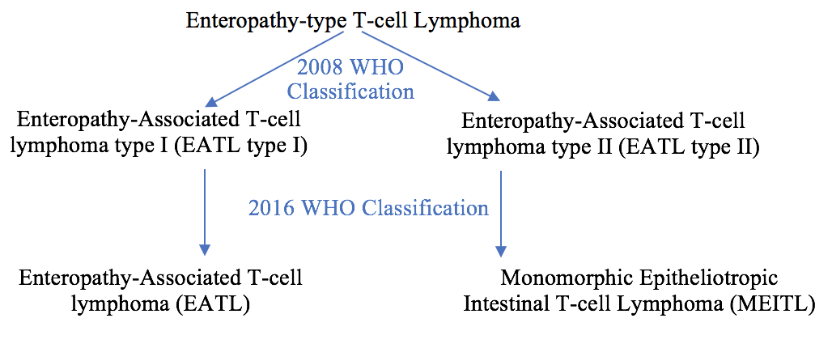
Figure 1 Evolution of classification of monomorphic epitheliotropic intestinal T-cell lymphoma.

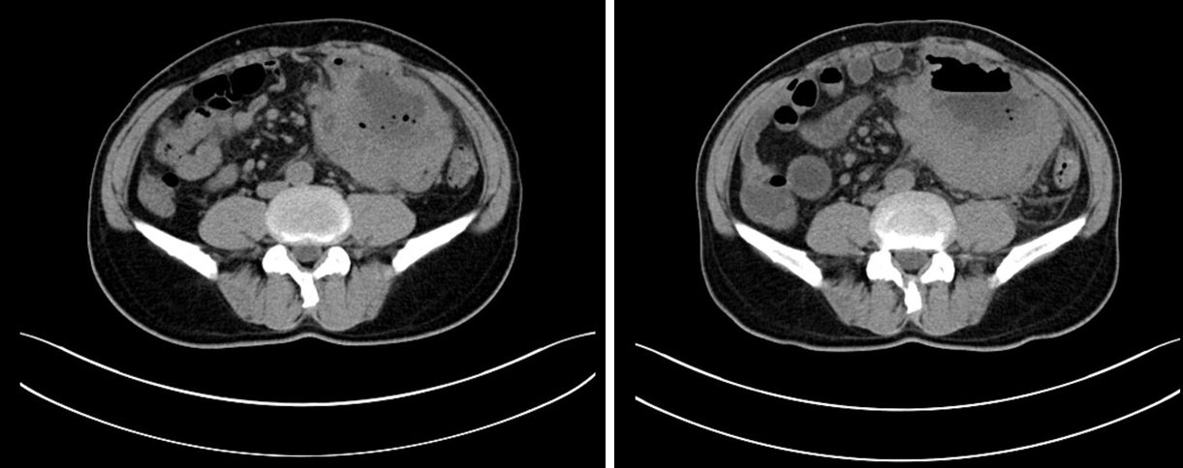
Figure 2 Computed tomography images. A: First computed tomography (CT) scan; B: Second CT scan 2 wk later. Multiple enlarged mesenteric lymph nodes and apparent necrosis were noted on the second CT scan.

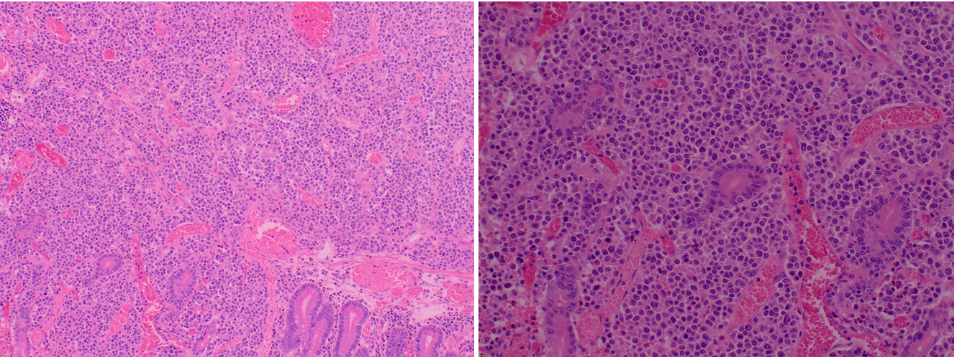
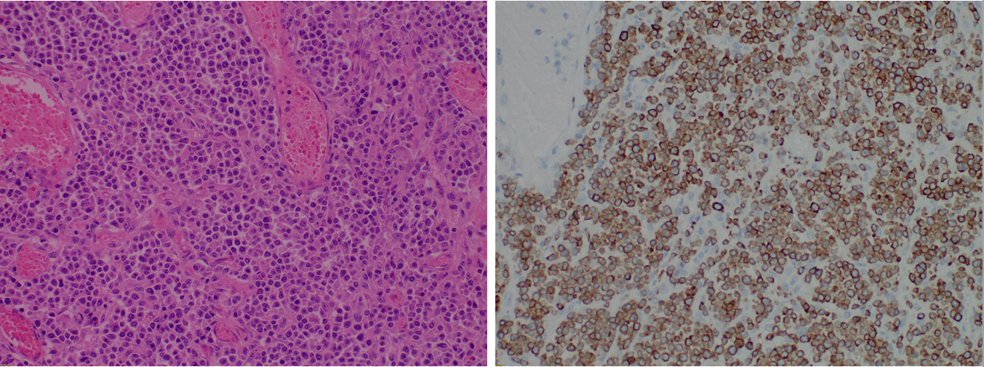
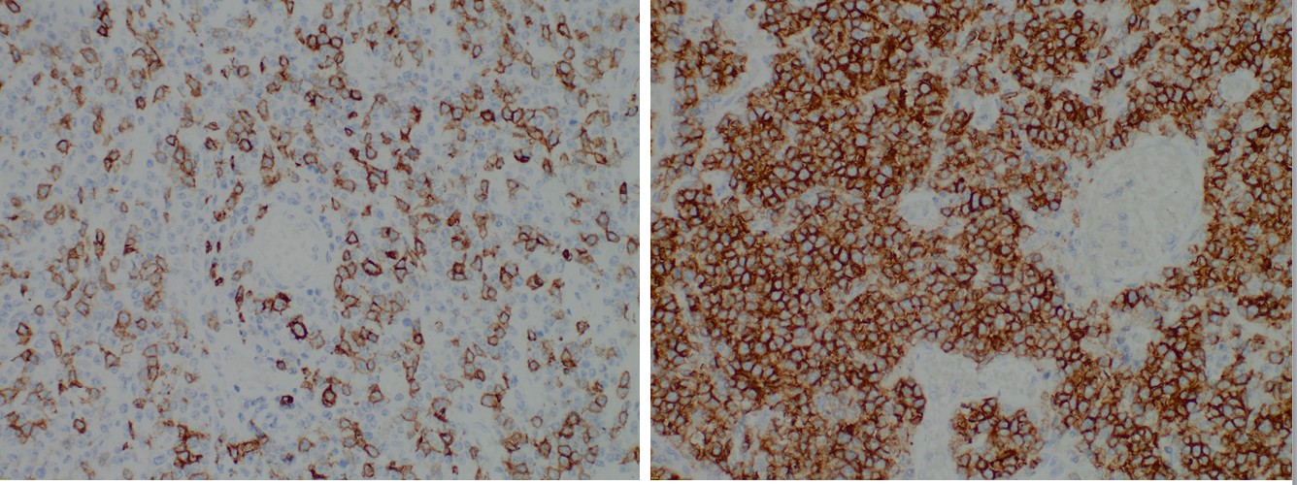
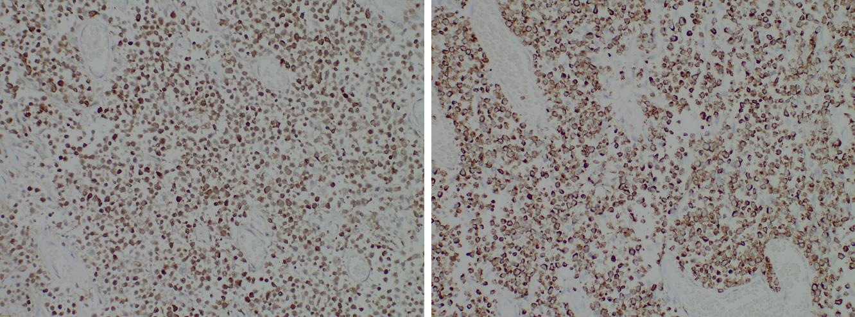
Figure 3 Pathologic and immunohistochemistry findings. A and B: Low magnification (A) (× 40, H&E) and high magnification (B) (× 200, H&E) images of lymphocytes demonstrating an epitheliotropic pattern; C: The shape of lymphoma cells is uniform throughout, emphasizing the monomorphism; D-H: The tumor cells were positive for CD3 (D), CD8 (E), CD56 (F), Granzyme B (G), and TIA-1 (H). (C-H, magnification × 200).

Figure 4 Postoperative positron emission tomography scan.

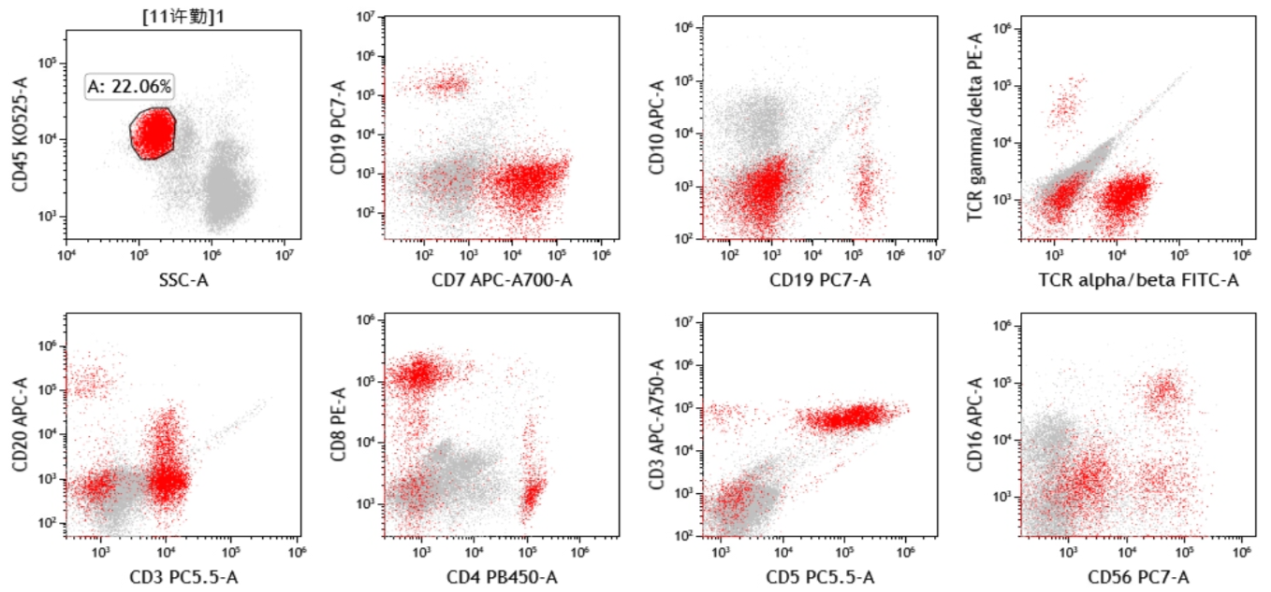
Figure 5 A (approximately 22.06% of non-erythroid cells) mature lymphocyte population (mainly T cells, with a small amount of B and NK cells).

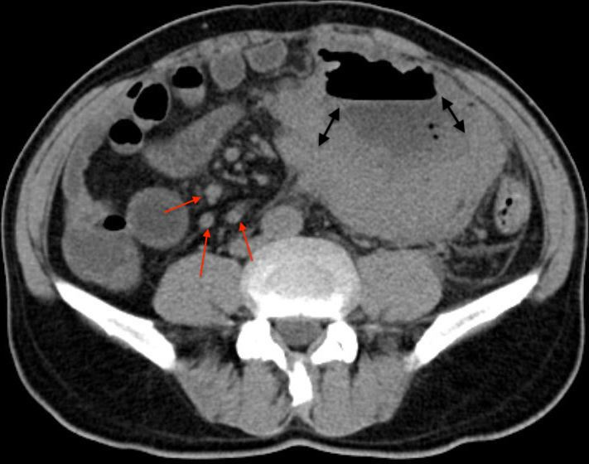
Figure 6 Computed tomography. Red arrows indicate enlarged mesenteric lymph nodes; double headed-arrows indicate necrosis.

Table 1 Patient’s laboratory results of blood chemistry
Item | Result | Reference value
White blood cell count (× 10⁹/L) | 7.8 | 3.5-9.5
Neutrophils (%) | 88.2 | 40.0-75.0
Eosinophils (%) | 0.6 | 0.4-0.8
Basophils (%) | 0.3 | 0.0-1.0
Lymphocytes (%) | 0.58 | 1.10-3.20
Monocytes (%) | 0.28 | 0.10-0.60
Red blood cell count (× 10¹²/L) | 3.87 | 4.30-5.80
Hemoglobin (g/L) | 113 | 130-175
Mean corpuscular volume (fL) | 88.6 | 82.0-100.0
Platelet count (× 10⁹/L) | 380 | 125-350
Hematocrit (%) | 0.34 | 0.11-0.28
Lactate dehydrogenase (IU/L) | 180 | 120-250
C-reactive protein (mg/L) | 163.5 | < 6.0
Direct bilirubin (umol/L) | 2.7 | 0.0-4.0
Indirect bilirubin (umol/L) | 7.90 | 0.00-22.00
Creatine kinase (U/L) | 45 | 50-310
Total protein (g/L) | 67.7 | 65.0-85.0
Albumin (g/L) | 36.2 | 40.0-55.0
Globulin (g/L) | 31.4 | 25.0-35.0
Glucose (mmol/L) | 6.34 | 4.30-5.90

Table 2 Tumor markers
Marker | Result | Reference value
CA211 | 1.05 | 0.0-3.3
SCC | 1.08 | 0.0-1.5
CA724 | 1.36 | 0.0-6.9
CA242 | 4.89 | 0.0-20.0
CA125 | 31.51 | < 35.0
CA-153 | 12.87 | < 25.0
CEA | 1.97 | 0.0-5.0
CA19-9 | 18.57 | < 37.0

Table 3 Panel of immunohistochemical stains
IHC stain | Result
CD3 | +
CD4 | +
CD5 | -
CD7 | +
CD8 | +
CD30 | -
CD56 | +
CD117 | -
CD138 | -
Ki-67 | 80%
Kappa | +
Lambda | +
PD-1 | -
CK-PAN | -
TIA-1 | +
Granzyme B | +
EBER ISH | -
IHC: Immunohistochemistry; EBER: Epstein-Barr virus-encoded RNA.

Table 4 The Lugano staging system
Stage |  | Features
I |  | Tumor confined to small bowel: Single or multiple primary lesions
II | II | Para-intestinal nodal involvement
 | II-1 | Involving mesenteric, aortic, caval, pelvic, or inguinal nodes
 | II-2 | With penetration of serosa involving adjacent organs or tissues
 | E (IIE, II-1E, II-2E) | Tumor extending into abdomen from primary small bowel site
III |  | NO stage III
IV |  | Disseminated extranodal sites or supra-diaphragmatic nodal involvement

Table 5 Details of previously published case reports
Case | Gender/age | Chief complaint | Treatment | Prognosis
Chen^{[29]} | M/60 | Abdominal pain | Emergency surgery followed by CHOP + IVE/MTX + SCT, followed by ASCT | CR; liver recurrence 2.5 years later refractory to GDP regimen. Passed away 2 wk after recurrence
Ishibashi^{[30]} | M/60 | Diarrhea and 10 kg weight loss in 17 mo | CHASE followed by SCT | 3 years
 | F/40 | Diarrhea and 6 kg weight loss in 3 mo | THP-COP followed by surgery 10 mo later | 2 mo after surgery
 | F/50 | Abdominal distension | CHOP + high-dose MTX + SCT | 9 mo
 | M/70 | Nausea | SMILE | 9 mo
Aiempanakit^{[31]} | M/67 | Diarrhea for 4 mo and 15 kg weight loss over 3 mo | Anthracycline-based regimen | 2 mo
Antoniadu^{[32]} | M/76 | Severe dyspnea | N/A | 5 d
Aoyama^{[33]} | M/85 | Fever and diarrhea | CHOP followed by DeVIC | Not stated but deceased subsequently due to progressive disease
Pan^{[34]} | F/67 | Abdominal pain | 1 cycle of CEOP | 3.7 mo
Liu^{[35]} | F/48 | Abdominal pain, distension, vomiting, watery diarrhea, weight loss | Unspecified chemotherapy | 1 mo after chemotherapy initiation
Ozaka^{[36]} | F/68 | Melena and mild anemia | 8 cycles of CHOP | Achieved complete remission and was still alive at the time of publication (68 mo after diagnosis)
Kasinathan^{[37]} | F/70 | Abdominal pain and vomiting for 4 wk | 2 cycles of CHOP, followed by 2 cycles of GDP | Developed gastrointestinal bleeding and succumbed 4 wk after initiation of GDP
Mago^{[38]} | M/59 | SOB for 1 mo, abdominal distension for 2 wk | 1 cycle of CHOEP | Passed away within few days after tumor lysis syndrome
Nato^{[39]} | F/43 | Abdominal distension, 2 mo history of early satiety and nausea | 4 cycles of GDP achieving a PR, CR was achieved after CBT conditioned with total body irradiation, cyclophosphamide, and cytarabine | Cognitive impairment (7 mo post transplantation) was improved after 3 cycles of MPV and whole brain radiotherapy and passed away 6 mo later
Pan^{[40]} | M/63 | Diffuse abdominal pain for 1 mo | Emergency surgery followed by 2 cycles of CHOP | 2 mo
 | M/47 | Diarrhea, dyspnea, orthopnea, weight loss for 1 year | 1 dose of L-asparaginase, etoposide, and decadron regimen followed by emergency surgery, adjuvant chemotherapy included etoposide, methylprednisolone, high-dose cytarabine, and cisplatin | 9 mo
Umino^{[41]} | M/41 | Diarrhea and epigastric pain for 1 mo | 3 neoadjuvant cycles of ICE followed by autologous SCT | 13 mo
Ferran^{[42]} | F/45 | Cutaneous lesions followed by abdominal perforation after chemotherapy initiation | 6 neoadjuvant cycles of CHOP and 1 cycle of SMILE followed by surgery. 1 adjuvant cycle L-GEMOX | 8 mo
Aoki^{[43]} | F/77 | Abdominal discomfort, night sweats, and fever for 1 mo | EPOCH for 6 mo | Still alive 1 year after diagnosis
Soardo^{[44]} | M/65 | 2-wk history of weight gain, increased abdominal volume with progressive mild dyspnea, and fever in the last 2 d | Emergency laparotomy | 1 mo postoperatively
Liu^{[45]} | M/61 | Upper abdominal pain and black stool for 2 mo | Partial excision of small intestine and chidamide-based combination regimen | 15 mo
 | F/35 | Abdominal distension for 1 mo | Sigmoid colostomy followed by chidamide-based combination therapy | 17 mo
Samuel^{[46]} | M/62 | Hypovolemic shock secondary to severe chronic diarrhea and 100 pounds lost over a year | Chemotherapy | 1 mo
Ikeda^{[47]} | M/61 | 3 episodes of ileal strangulation within 4 mo of gastrectomy | Ileal resection followed by 2 cycles of CHOP and 1 cycle of ICE | 3 mo
Lenti^{[48]} | F/63 | Diarrhea and 10 kg weight loss in 6 mo | Surgery followed by a single course of CHOP | 27 mo
 | M/58 | Diarrhea and 5 kg weight loss | Surgery | 4 mo
Broccoli^{[49]} | M/65 | Petechiae at both limbs, acute abdominal pain, diarrhea, and clinical signs of bowel perforation | Emergency resection of 9 cm of small bowel | 6 mo
Tabata^{[50]} | M/72 | Ileum perforation…severe constipation after 21 mo in CR | Emergency resection followed by anthracycline-based regimen chemotherapy (CR for 21 mo), paltrexate therapy was administered during recurrence | In CR after 52 mo
Fisher^{[51]} | F/60 | Abdominal pain, diarrhea, and 30 pounds of weight loss over 3 mo | EOCH chemotherapy (subsequently developing a large lymphoma 6 mo after therapy initiation) | N/A
Tian^{[8]} | M/58 | Abdominal pain, diarrhea, and weight loss over 3 mo | 1 course of CHOP | Died subsequently after the first cycle due to bone marrow suppression
 | F/64 | Abdominal pain and diarrhea for 5 years | 5 wk of adjuvant chemotherapy consisting of romidepsin with Revlimid followed by laparotomy involving small bowel bypass | 3 mo
Kubota^{[52]} | M/41 | Diarrhea for 1 mo and intermittent abdominal pain | Resection followed by CHOP and 3 cycles of ICE resulted in CR | Repeated intrathecal chemotherapy and high-dose chemotherapy followed by ASCT achieved CR
Gentille^{[53]} | F/70 | Intermittent abdominal pain, nausea, vomiting and diarrhea for 14 mo. 50 pounds of weight loss | Right hemicolectomy followed by 5 cycles of EPOCH (with PEG-asparaginase added in the last cycle) | Developed abdominal pain 15 mo after initial therapy, subsequently passing away around 20 mo after initial diagnosis
Sato^{[54]} | F/52 | Diarrhea and anorexia for 8 wk + 6 kg weight loss | CHOP followed by stem-cell transplant | Unknown
Kakugawa^{[55]} | M/65 | Watery diarrhea for 14 mo | 8 cycles of CHOP followed by 5 cycles of ESHAP | Still alive 67 mo post chemotherapy
Felipe-Silva^{[56]} | M/78 | Diarrhea for 2 mo + 20 kg weight loss | Surgical resection followed by 2 cycles of CHOP, which was changed to COP | 6 mo
Okumura^{[57]} | F/66 | Abdominal distension for 1 mo presenting with acute abdomen | Surgical resection followed by high dose chemotherapy and SCT | Still alive at the time of publication, in complete remission
Yang^{[58]} | M/39 | Acute onset of lower abdominal pain and diffuse peritonitis | Surgical resection | Unknown
Fukushima^{[59]} | M/60 | Severe diarrhea | CHOP | 1 year
Liong^{[60]} | M/50 | Diarrhea for 6 mo, presenting with acute abdomen due to intestinal perforation | Surgical resection followed by CHOP | 4 mo
Noh^{[61]} | M/68 | Nausea and vomiting for 6 mo + 25 kg weight loss | Surgical resection followed by chemotherapy (unspecified) | Unknown
Hashimoto^{[62]} | M/64 | Diarrhea for several months | Chemotherapy (unspecified) | Unknown
Liu^{[63]} | F/43 | Upper abdominal pain and weight loss for 3 mo | 4 cycles of CHOEP and 2 cycles of DHAP followed by surgery | 11 mo after diagnosis, 1 d after surgery due to septic shock
Fukushima^{[64]} | F/68 | Upper abdominal pain and nausea | Laparoscopic intestinal resection followed by auto-peripheral blood SCT | 22 mo without recurrence; passed away 1 mo after duodenal recurrence in 23rd mo
M: Male; F: Female; CHOP: Cyclophosphamide, doxorubicin, vincristine, prednisolone; IVE: Ifosfamide, vincristine, and etoposide; MTX: Methotrexate; SCT: Stem cell transplant; CHASE: Cyclophosphamide, cytarabine, etoposide, dexamethasone; GDP: Gemcitabine, dexamethasone and cisplatin; THP-COP: Pirarubicin, cyclophosphamide, vincristine and prednisolone; SMILE: Dexamethasone, methotrexate, ifosfamide, L-asparaginase and etoposide; DeVIC: Etoposide, ifosfamide, and carboplatin; CEOP: Cyclophosphamide, epirubicin, vincristine, and prednisolone; SOB: Shortness of breath; CHOEP: Cyclophosphamide, doxorubicin, vincristine, etoposide, and prednisone; PR: partial response; CR: Complete response; CBT: Cord blood transplantation; MPV: Methotrexate, procarbazine, vincristine; ICE: Ifosfamide, carboplatin, and etoposide; L-GEMOX: Gemcitabine, oxaliplatin, asparaginase, dexamethasone; EPOCH: Etoposide, prednisolone, oncovin, cyclophosphamide, hydroxydaunorubicin; ICE: Ifosfamide, carboplatin and etoposide; ESHAP: Etoposide, methylprednisolone, cytarabine, cisplatin; DHAP: Dexamethasone, high dose cytarabine, platinol.

