Name of Journal: World Journal of Gastroenterology
Manuscript NO: 91265
Manuscript Type: MINIREVIEWS

Fecal microbiota transplantation for treatment of non-alcoholic fatty liver disease: Mechanism, clinical evidence, and prospect

Qiu XX et al. Fecal microbiota transplantation for NAFLD

Xiao-Xia Qiu, Sheng-Li Cheng, Yan-Hui Liu, Yu Li, Rui Zhang, Nan-Nan Li, Zheng Li

Xiao-Xia Qiu, Research and Education Department, Shulan (Hangzhou) Hospital Affiliated to Zhejiang Shuren University Shulan International Medical College, Hangzhou 310022, Zhejiang Province, China

Sheng-Li Cheng, Anhui Provincial Hospital, The First Affiliated Hospital of University of Science and Technology of China, Hefei 230000, Anhui Province, China

Yan-Hui Liu, Department of Clinical Pharmacy, Anhui Provincial Children’s Hospital, Hefei 230000, Anhui Province, China

Yu Li, Department of Pharmacy, Taihe County People’s Hospital of Anhui Province, Fuyang 236600, Anhui Province, China

Rui Zhang, Department of Pharmacy, The Second People’s Hospital of Hefei, Hefei Hospital Affiliated to Anhui Medical University, Hefei 230000, Anhui Province, China

Nan-Nan Li, University of Science and Technology of China, The First Affiliated Hospital of University of Science and Technology of China, Hefei 230001, Anhui Province, China

Zheng Li, Jiangsu Engineering Research Center of Cardiovascular Drugs Targeting Endothelial Cells, College of Health Sciences, School of Life Sciences, Jiangsu Normal University, Xuzhou 221000, Jiangsu Province, China

Co-first authors: Xiao-Xia Qiu and Sheng-Li Cheng.

Co-corresponding authors: Nan-Nan Li and Zheng Li.

Author contributions: Qiu XX and Cheng SL contributed to the acquisition of data; Qiu XX, Cheng SL, Liu YH, Li Y, and Zhang R contributed to the analysis and interpretation of data; Qiu XX, Cheng SL, Liu YH, Li NN, and Li Z drafted the article; Liu YH, Li Y, Zhang R, Li NN, and Li Z revised the article; Li NN and Li Z contributed to the conception and design of the study, and critical revision; all authors contributed to the final approval of the article. Qiu XX and Cheng SL contributed equally to this work as co-first authors; Li NN and Li Z contributed equally to this work as co-corresponding authors. The reasons for designating co-first or co-corresponding authors are as follows: (1) The research was performed as a collaborative effort, and the designation of co-first/co-corresponding authorship accurately reflects the distribution of responsibilities and contribution to the study; (2) the designation reflects the diversity of expertise and skills of the overall research team; and (3) these authors contributed efforts of equal substance throughout the research process. In summary, we believe that this designation is fitting for our manuscript as it accurately reflects our team's collaborative spirit, equal contributions, and diversity.

Supported by the National Natural Science Foundation of China, No. 82104525; the Natural Science Foundation of the Jiangsu Higher Education Institutions of China, No. 21KJB360009; and Health Commission of Zhejiang Province Scientific Research Foundation, No. 2024KY247.

Corresponding author: Zheng Li, PhD, Pharmacist, Jiangsu Engineering Research Center of Cardiovascular Drugs Targeting Endothelial Cells, College of Health Sciences, School of Life Sciences, Jiangsu Normal University, No. 101 Shanghai Road, Xuzhou 221000, Jiangsu Province, China. lizhengcpu@163.com

Received: December 26, 2023
Revised: January 8, 2024
Accepted: January 23, 2024
Published online: February 28, 2024

Abstract
The population of non-alcoholic fatty liver disease (NAFLD) patients along with relevant advanced liver disease is projected to continue growing, because currently no medications are approved for treatment. Fecal microbiota transplantation (FMT) is believed a novel and promising therapeutic approach based on the concept of the gut-liver axis in liver disease. There has been an increase in the number of pre-clinical and clinical studies evaluating FMT in NAFLD treatment, however, existing findings diverge on its effects. Herein, we briefly summarized the mechanism of FMT for NAFLD treatment, reviewed randomized controlled trials for evaluating its efficacy in NAFLD, and proposed the prospect of future trials on FMT.

Key Words: Non-alcoholic fatty liver disease; Fecal microbiota transplantation; Randomized controlled trial; Mechanism; Efficacy

©The Author(s) 2024. Published by Baishideng Publishing Group Inc. All rights reserved.

Citation: Qiu XX, Cheng SL, Liu YH, Li Y, Zhang R, Li NN, Li Z. Fecal microbiota transplantation for treatment of non-alcoholic fatty liver disease: Mechanism, clinical evidence, and prospect. World J Gastroenterol 2024; 30(8): 833-842
URL: https://www.wjgnet.com/1007-9327/full/v30/i8/833.htm
DOI: https://dx.doi.org/10.3748/wjg.v30.i8.833

Core Tip: There are several reviews contributing to the role of gut microbiome in the pathophysiology, therapeutic potential and clinical trials for non-alcoholic fatty liver disease (NAFLD). However, no consensus is available in the literature about the clinical efficacy of fecal microbiota transplantation (FMT) on NAFLD. This is the first review to summarize recent randomized controlled trials for evaluating the effects of FMT on blood lipid profile, liver function, histological changes and other parameters in patients with NAFLD. We also discuss its therapeutic mechanism and propose the obstacles and prospect of FMT in future trials.

INTRODUCTION
Non-alcoholic fatty liver disease (NAFLD), recently proposed as metabolic dysfunction-associated fatty liver disease (MAFLD), is a chronic liver disease with a global prevalence of about 25% in adult population^{[1]}. NAFLD has a bidirectional association with components of obesity and metabolic syndrome. In view of the ongoing obesity epidemic worldwide, the rise in metabolic syndrome, and other factors, the population of NAFLD along with advanced liver disease is projected to sustain its growth^{[2]}. Although patients with NAFLD at early stages have no self-conscious symptoms, those with advanced NAFLD are at a markedly increased risk of adverse outcomes, such as an increased overall and liver-specific mortality^{[3]}. Due to its large population base, NAFLD is emerging as a rapidly increasing cause of liver-related mortality worldwide^{[4]} and an important cause of end-stage liver disease^{[5]}, thus leading to a substantial health economic burden.
The pathophysiology of NAFLD is extremely complicated and involves multiple pathogenic pathways that are not completely elucidated. On the other hand, there is currently no approved therapy for NAFLD, although several drugs are reserved for patients with biopsy-proven non-alcoholic steatohepatitis (NASH). In search of potential novel therapeutic options, the manipulation of the gut microbiome has attracted a lot of attention. Evidence from human observational studies and animal experiments have found the alterations in gut microbiome in NAFLD and indicated numerous pathophysiologic mechanisms relating the gut microbiome to NAFLD^{[6-9]}. In brief, gut dysbiosis damages the intestinal barrier integrity, leading to increased gut permeability to bacterial products and hepatic exposure to harmful substances, thus triggering fat accumulation, hepatic inflammation and fibrosis^{[10-12]}.
Considering the close link between the gut microbiome and NAFLD, many therapeutic approaches targeting gut microbiota, such as probiotic, prebiotic or fecal microbiota transplantation (FMT) have been tested for whether they could provide the clinical benefit of alleviation of NAFLD. FMT is the latest mode of gut microbiota manipulation for the treatment of NAFLD^{[13]}, which seems to be more effective than other existing approaches of microbiota manipulation. FMT from a healthy donor to the host is aimed to quickly re-establish a healthy gut microbial community, which can help treat gastrointestinal diseases. As evidenced by several animal-based studies, FMT could effectively improve the manifestations of NAFLD^{[14-16]}. On the other hand, there has been an increase in the number of clinical trials evaluating the role of FMT in NAFLD treatment^{[17-19]}. Herein, we briefly summarized the mechanism, randomized controlled trials (RCTs), and prospect of FMT in the treatment of NAFLD.

MECHANISM OF FMT FOR NAFLD
Structure and function of gut-liver axis
The functioning of the gut-liver axis is established on the interaction between the gut, along with its microbiota, and the liver, through the portal vein. The gut microbiota is a complex community consisting of over 100 trillion microbes, prevalently bacteria^{[20]}. The interface between the microbiome and intestinal epithelial cells is the gut mucus barrier, physically separating the microbiota from the epithelial lining, thus providing protection against an exaggerated inflammatory response^{[21]} (Figure 1). Thus, the mucus barrier serves as a first line of defense. Underneath the mucus layer is the intestinal barrier, which is formed by a monolayer of epithelial cells. Adjacent epithelial cells are sealed together by tight junctions^{[22]}, and they function as a physical shield preventing bacteria from crossing the gut into the portal circulation. In addition, some mucosal immune cells patrol the epithelium, and cooperate to protect against strikes arising from the microbiota and infectious agents^{[23]}. In case the epithelium is breached, there is another barrier, the gut vascular barrier that prevents bacteria from entering the portal circulation and disseminating systemically^{[24]}.
Due to the multiple barriers as mentioned above, most bacteria cannot directly interact with the host, but through the mediation by the bacterial products and metabolites. With the aid of this indirect mediation, the gut microbiota participate in nutrient digestion and absorption, host metabolism, and mucosal and systemic immunity^{[25]}. For instance, gut microbiota breaks down dietary fibers into short-chain fatty acids (SCFAs), which could provide energy support for the host cells. More notably, they also have been shown to regulate lipid metabolism, protect intestinal mucosal barrier, control the differentiation of several immune cells, and participate in the microbicidal activity of macrophages^{[26-28]}. In addition, gut microbiota transform the primary bile acids into secondary bile acids, which act as the natural agonists of intestinal farnesoid X receptor (FXR). FXR engagement can regulate its downstream defense genes to enhance epithelial barrier properties^{[29]}, reduce lipogenesis in the liver^{[30]}, and improve insulin sensitivity^{[31]}. In summary, the homeostasis constructed by the balance of gut microbiome and the intact physiological barriers is critical for controlling the reciprocal interaction between the gut and the liver to maintain health.

Disruption patterns of gut-liver axis in NAFLD
Current data indicate that altered gut microbiome, along with bacterial components, impair the intestinal barrier and vascular barrier, and facilitate the influx of bacterial products into the portal vein in NAFLD^{[11,29]}. Noticeably, the liver is especially vulnerable to the insults from these bacterial products, which consequently aggravate the hepatic metabolic abnormalities and inflammation (Figure 1).
Several clinical studies have shown that patients with NAFLD have remarkable gut dysbiosis, generally characterized by the over-growth of bacteria and changes in microbiota composition^{[32]}. For instance, recent research has found an increased abundance of Escherichia coli and Bacteriodes vulgatus in patients with NAFLD^{[9]}. Abnormalities in intestinal microbiota have established a link with the reduced thickness of the mucous layer, as well as the increased intestinal permeability, in patients with NAFLD^{[33,34]}. The damage of intestinal barriers loses control of the passage of bacterial components and metabolites, which can reach the liver via the portal vein. Some of these components are agonists of Toll-like receptor (TLR) signal pathway, which results in enhanced hepatic expression of inflammatory cytokines, such as tumor necrosis factor-α (TNF-α) and interleukin-1β (IL-1β), thus promoting inflammation and fibrosis^{[32,35]}. The altered gut microbiome has also likely contributed to a decreased production of SCFAs, which promotes lipogenesis and lipid deposition in NAFLD^{[36]}. In addition, gut dysbiosis reduces bioavailability of choline and increases the portal influx of trimethylamine, which also contributes to hepatic steatosis in NAFLD^{[37]}. Disruptive bile acid pool is another consequence of microbiota abnormalities, and it suppresses FXR-mediated signaling in the intestine and the liver, leading to increased lipid accumulation, oxidative stress and inflammation^{[38,39]}.

FMT for remoulding gut-liver crosstalk to treat NAFLD
Given these attacks induced by gut dysbiosis which promotes liver steatosis, inflammation and fibrosis, the manipulation of the gut microbiota is being explored as a therapeutic target for NAFLD. Probiotics, prebiotics and symbiotics have been explored for treating patients with NAFLD^{[40-42]}. However, it does not come to a clear and substantial conclusion whether these agents generate significant clinical improvement in NAFLD patients. Moreover, data on adverse effects links to the use of probiotics^{[43]}. These issues have paved the road for FMT application in NAFLD treatment, which is expected to yield better clinical efficacy and less side effects.
The fecal material for FMT contains distal gut microbiota from a healthy donor and is processed into an odorless and tasteless preparation. In clinical practice, the approaches for FMT include oral administration of microflora liquid or capsule, transplanting to the middle digestive tract by endoscopic biopsy hole, and threading through the colonic pathway to the lower digestive tract^{[44]}. FMT is used to replenish a healthy gut microbial environment and restore physiological colonization, leading to the recovery of microbial diversity and abundance^{[12]} (Figure 1). The repair of gut dysbiosis can elevate intestinal permeability through the rebuilding of physiological barriers (i.e. mucus barrier, epithelial barrier)^{[17]}, and suspending the uncontrolled influx of bacterial products to the liver. The restoration of intestinal structure and function can improve lipid metabolism, decrease insulin resistance, suppress inflammatory response, and consequently attenuate the symptoms of NAFLD (i.e. reduction of fat content, liver steatosis, serum transaminase levels and inflammatory infiltrates)^{[16,45,46]}. Finally, FMT has been demonstrated well tolerated and safe over long-term use^{[47,48]}.

EVIDENCE FROM RCTS ON FMT IN NAFLD TREATMENT
To review RCTs for NAFLD treatment using FMT, references indexed in databases (PubMed, EMBASE, the Cochrane Library, and Web of Science) were searched with the combination of the following keywords: ‘non-alcoholic fatty liver disease/NAFLD/fatty liver/non-alcoholic steatohepatitis/metabolic dysfunction-associated fatty liver disease/MAFLD/steatohepatitis/Liver steatosis/hepatic steatosis’, and ‘fecal microbiota transplantation/ fecal microbiota transplant/fecal microbiome transplantation/fecal microbiome transplant/FMT’. The eligibility criteria was determined based on PICOS principle (population, interventions, comparisons, outcomes, study designs). The inclusion criteria were as follows: (1) Study design was RCT; (2) participants were diagnosed with NAFLD by either liver histology or noninvasive imaging; and (3) study results included one of the following outcomes: serum cholesterol, triglycerides, alanine aminotransferase (ALT), aspartate aminotransferase (AST), low-density lipoprotein cholesterol (LDL), high-density lipoprotein cholesterol (HDL-C), homeostatic model assessment of insulin resistance (HOMA-IR), body mass index (BMI), or assessment of histological change by any of the following modalities: Liver biopsy, MRI or elastography. Specifically, liver biopsy outcomes included determination of NAFLD activity score (NAS), necro inflammation score, fibrosis score, or steatosis score. MRI outcomes included estimated fibrosis stage, and elastography outcomes included fat attenuation degree or fibrosis stage. The exclusion criteria were as follows: (1) Participants were under 18 years; (2) participants had severe diseases except NAFLD; and (3) study reported incomplete data. As a result, a total of 2778 references were initially identified, and finally, 3 published RCTs that had undergone full-text assessment were included in this review. The detail of study selection was recorded in Figure 2.

Evidence from Included RCTs
The three RCTs were conducted between 2013 and 2021, and were comprised of 117 adult participants with NAFLD. Two trials^{[17,18]} were double-blind while one^{[19]} was open-label. Regarding FMT intervention, two studies performed allogenic FMT through duodenal infusion, while one adopted colonic infusion. Among the outcomes, serum levels of cholesterol, triglycerides, HDL-C and LDL-C were reported in all trials, while only one trial^{[18]} reported the histological change (NAS score, necro inflammation score, fibrosis score, steatosis score) in patients between baseline and endpoint. In all trials, adverse effects of FMT were not reported. Details of the general characteristics of all included RCTs were given in Table 1.
A double-blind RCT conducted by Craven et al^{[17]} included 21 patients to compare allogenic with autologous FMT. As a result, no significant changes were found in total triglycerides, cholesterol, HDL-C, LDL-C, HOMA-IR, weight, waist-to-hip ratio, BMI or hepatic proton density fat fraction in patients after FMT. However, patients experienced a significant increase in small intestinal permeability after FMT. The changes in fecal microbiota composition varied by individuals in both groups after FMT. Moreover, a trend toward an increase in the fecal microbiota diversity was found in patients who had improvement in intestinal permeability, although changes in specific taxa were hardly discerned in allogenic transplant. It is noteworthy that the investigators only deployed FMT one time but evaluated its efficacy after 24 wk, and it was difficult to expect one session of FMT to achieve a long-lasting therapeutic effect, which could be one reason for the unsatisfactory results of most outcomes. In addition, this study was also limited by small sample size and lack of histological findings.
In another double-blind RCT conducted by Witjes et al^{[18]}, 21 participants with hepatic steatosis received either allogenic or autologous FMT. FMT administration was performed using duodenal infusion three times at 8-wk intervals, with a duration of 24 wk. The results indicated a trend toward improvement in the necro-inflammation score, but finally no significant improvement in liver histology following allogenic FMT. Similarly, there was no significant improvement in biochemical parameters. However, significant changes in the expression of some hepatic genes associated with inflammation and lipid metabolism were found in the allogenic FMT group, compared with autologous FMT. The findings from fecal microbiota analysis suggested no significant changes in fecal microbiota diversity and composition between baseline and endpoint, in either group.
Xue et al^{[19]} carried out an open-label 4-wk RCT including 75 patients with NAFLD. Participators randomly received allogenic FMT or oral probiotics. The fecal microbiota preparation was administered to patients by colonic infusion per day, for 3 d in total. The results showed no significant difference in blood lipid (i.e. triglycerides, cholesterol, LDL-C, HDL-C) and liver function tests before and after treatment in either group. However, a significant decrease in liver fat attenuation degrees was found in the FMT group, while a significant increase was found in the non-FMT group. Microbiota analysis indicated that certain bacterial contents had a trend toward healthy individuals after FMT. Furthermore, FMT had a greater impact on the microbial community structure in lean NAFLD than in obese NAFLD patients.

Pooled analysis of selected outcomes
The outcomes reported in more than two RCTs were selected for pooled analysis. The mean and/or standard deviation (SD) values of cholesterol, triglycerides, LDL-C, HDL-C, AST, ALT, BMI and HOMA-IR were extracted for assessment. Data were processed to obtain the changes between baseline and endpoint. The pooled effects were reported as weighted mean differences (WMD) with 95% confidence intervals (95%CI). Statistical analysis was performed using STATA 16.0 software (Stata Corp LLC, TX, United States) using a random-effects model. A P value of < 0.05 was considered significant for the test for overall effect.
All three included RCTs^{[17-19]} reported the changes of serum lipid profile (triglycerides, cholesterol, LDL-C and HDL-C) in patients between baseline and endpoint. The pooled results suggested that FMT failed to cause significant improvement of triglycerides (WMD -0.07, 95%CI: -0.47 to 0.33, P = 0.74; Figure 3A), cholesterol (WMD -0.27, 95%CI: -0.75 to 0.21, P = 0.27; Figure 3B), LCL-C (WMD 0.05, 95%CI: -0.31 to 0.42, P = 0.78; Figure 3C), and HDL-C (WMD -0.05, 95%CI: -0.22 to 0.15, P = 0.54; Figure 3D), as compared with control. There was no significant heterogeneity between studies. Two RCTs^{[18,19]} reported the outcomes of ALT and AST, and the pooled analysis suggested that FMT caused no significant reduction in ALT (WMD -0.51, 95%CI: -22.57 to 21.55, P = 0.96; Figure 3E) and AST (WMD -2.78, 95%CI: -10.26 to 4.71, P = 0.47; Figure 3F). Likewise, two RCTs^{[17,19]} reported the outcomes of HOMA-IR and BMI, and pooled analysis found no improvement in them after FMT (HOMA-IR: WMD -1.09, 95%CI: -2.43 to 0.25, P = 0.11, Figure 3G; BMI: WMD -0.64, 95%CI: -2.73 to 1.44, P = 0.54, Figure 3H).
Although these negative results might challenge the potential of FMT in the treatment of NAFLD, their reliability could be attenuated by several limitations. Firstly, only a very small number of RCTs was retrieved, as well as a very small sample size. Moreover, the available data of histological outcome which is the major prognostic index of NAFLD, was insufficient for pooled analysis. Finally, the management of FMT administration to patients varied among studies, which might influence the efficacy of FMT. Therefore, future studies including standardized FMT sessions in more patients with robust outcome measures are still needed.

PROSPECT
The only recommended treatment for NAFLD is weight loss. However, it is hard to adhere to lifestyle modifications for achieving it, making the need for effective and safe medications more urgent. In past years, numerous pharmacological therapies have been investigated, such as medications targeting the glucagon-like peptide-1 (GLP-1), peroxisome proliferator-activated receptors (PPARs) and intestinal microbiota. There is considerable evidence that the composition of the gut microbials in NAFLD patients changes significantly from control individuals^{[9,11,49]}, which contribute to obesity, insulin resistance and liver steatosis^{[12,16,50]}. FMT is an emerging tool for manipulating intestinal microbiota, which is considered as a potential therapeutic approach for NAFLD. Although current outcomes on FMT therapy for NAFLD vary between RCTs and most are gloomy, aforementioned RCTs still demonstrate that patients might benefit from FMT due to improvement of small intestinal permeability, alleviation of hepatic necro-inflammation, and liver fat attenuation. Furthermore, the results from the three RCTs and pooled analysis are hardly considered as robust due to apparent limitations. Therefore, FMT is still expected to be promising in NAFLD treatment, but there are a series of obstacles that still need to be resolved.
Firstly, the alterations of gut microbiota could be variable by each individual with NAFLD, or/and by the stage of NAFLD, and sometimes the results are contradictory^{[51,52]}. Thus, the significant heterogeneity lying in gut microbiota makes the restoring of varied gut microbiomes by a fixed FMT difficult to be achieved, and also hinders the transforming of the success of one FMT directly to another population. Moreover, the characteristics of donor feces, in particular fecal microbiota richness, diversity, and compatibility, have considerable influence on the efficacy of FMT, while the rigorous criteria for donor selection has not yet been determined. Furthermore, repetitive FMT should be required to maintain the improvement of the gut microbiome, however, the management of FMT is still casual across trials. Although the safety of FMT is evidenced, long-term consequences of FMT are unknown as FMT still has rare risks. Therefore, the practice guidelines of FMT still need to be extensively investigated. Finally, FMT combined with other pharmacological therapies are worth considering in future trials since NAFLD involves multiple pathogenic factors.

CONCLUSION
In summary, our work highlighted disruption patterns of the gut-liver structure and function in NAFLD, and how FMT remolds the homeostasis of the gut-liver crosstalk to alleviate NAFLD. Since FMT is suggested as a therapeutic of great potential, increasing the number of clinical trials that are carried out and evaluating its efficacy in NAFLD needs to be a priority. We reviewed the published RCTs to analyze the evidence on the clinical efficacy of FMT in NAFLD patients. FMT failed to yield clinical benefit in blood lipid (i.e. triglycerides, cholesterol, LDL-C, HDL-C), and liver function (i.e. ALT, AST) parameters. By contrast, the improvement of small intestinal permeability and the alleviation of hepatic necro-inflammation in patients after FMT could be encouraging. Whereas the reliability of the above results is challenged by several limitations, especially small sample size and casual FMT administration protocols, it is believed that some obstacles still need to be resolved before fully inspiring the potential of FMT in the treatment of NAFLD. Future high-quality trials in more patients adopting more scientific management of FMT are essential to further validate the clinical benefit of FMT.

ACKNOWLEDGEMENTS
Authors are grateful to the scholars who participated in this study for their contributions.

REFERENCES
1 Powell EE, Wong VW, Rinella M. Non-alcoholic fatty liver disease. Lancet 2021; 397: 2212-2224 [PMID: 33894145 DOI: 10.1016/S0140-6736(20)32511-3]
2 Cotter TG, Rinella M. Nonalcoholic Fatty Liver Disease 2020: The State of the Disease. Gastroenterology 2020; 158: 1851-1864 [PMID: 32061595 DOI: 10.1053/j.gastro.2020.01.052]
3 Chalasani N, Younossi Z, Lavine JE, Charlton M, Cusi K, Rinella M, Harrison SA, Brunt EM, Sanyal AJ. The diagnosis and management of nonalcoholic fatty liver disease: Practice guidance from the American Association for the Study of Liver Diseases. Hepatology 2018; 67: 328-357 [PMID: 28714183 DOI: 10.1002/hep.29367]
4 Paik JM, Golabi P, Younossi Y, Mishra A, Younossi ZM. Changes in the Global Burden of Chronic Liver Diseases From 2012 to 2017: The Growing Impact of NAFLD. Hepatology 2020; 72: 1605-1616 [PMID: 32043613 DOI: 10.1002/hep.31173]
5 Estes C, Razavi H, Loomba R, Younossi Z, Sanyal AJ. Modeling the epidemic of nonalcoholic fatty liver disease demonstrates an exponential increase in burden of disease. Hepatology 2018; 67: 123-133 [PMID: 28802062 DOI: 10.1002/hep.29466]
6 Hoozemans J, de Brauw M, Nieuwdorp M, Gerdes V. Gut Microbiome and Metabolites in Patients with NAFLD and after Bariatric Surgery: A Comprehensive Review. Metabolites 2021; 11 [PMID: 34072995 DOI: 10.3390/metabo11060353]
7 Jadhav K, Cohen TS. Can You Trust Your Gut? Implicating a Disrupted Intestinal Microbiome in the Progression of NAFLD/NASH. Front Endocrinol (Lausanne) 2020; 11: 592157 [PMID: 33193105 DOI: 10.3389/fendo.2020.592157]
8 Shen F, Zheng RD, Sun XQ, Ding WJ, Wang XY, Fan JG. Gut microbiota dysbiosis in patients with non-alcoholic fatty liver disease. Hepatobiliary Pancreat Dis Int 2017; 16: 375-381 [PMID: 28823367 DOI: 10.1016/S1499-3872(17)60019-5]
9 Loomba R, Seguritan V, Li W, Long T, Klitgord N, Bhatt A, Dulai PS, Caussy C, Bettencourt R, Highlander SK, Jones MB, Sirlin CB, Schnabl B, Brinkac L, Schork N, Chen CH, Brenner DA, Biggs W, Yooseph S, Venter JC, Nelson KE. Gut Microbiome-Based Metagenomic Signature for Non-invasive Detection of Advanced Fibrosis in Human Nonalcoholic Fatty Liver Disease. Cell Metab 2017; 25: 1054-1062.e5 [PMID: 28467925 DOI: 10.1016/j.cmet.2017.04.001]
10 Saltzman ET, Palacios T, Thomsen M, Vitetta L. Intestinal Microbiome Shifts, Dysbiosis, Inflammation, and Non-alcoholic Fatty Liver Disease. Front Microbiol 2018; 9: 61 [PMID: 29441049 DOI: 10.3389/fmicb.2018.00061]
11 Boursier J, Mueller O, Barret M, Machado M, Fizanne L, Araujo-Perez F, Guy CD, Seed PC, Rawls JF, David LA, Hunault G, Oberti F, Calès P, Diehl AM. The severity of nonalcoholic fatty liver disease is associated with gut dysbiosis and shift in the metabolic function of the gut microbiota. Hepatology 2016; 63: 764-775 [PMID: 26600078 DOI: 10.1002/hep.28356]
12 Le Roy T, Llopis M, Lepage P, Bruneau A, Rabot S, Bevilacqua C, Martin P, Philippe C, Walker F, Bado A, Perlemuter G, Cassard-Doulcier AM, Gérard P. Intestinal microbiota determines development of non-alcoholic fatty liver disease in mice. Gut 2013; 62: 1787-1794 [PMID: 23197411 DOI: 10.1136/gutjnl-2012-303816]
13 Kelly CR, Kahn S, Kashyap P, Laine L, Rubin D, Atreja A, Moore T, Wu G. Update on Fecal Microbiota Transplantation 2015: Indications, Methodologies, Mechanisms, and Outlook. Gastroenterology 2015; 149: 223-237 [PMID: 25982290 DOI: 10.1053/j.gastro.2015.05.008]
14 Soderborg TK, Clark SE, Mulligan CE, Janssen RC, Babcock L, Ir D, Young B, Krebs N, Lemas DJ, Johnson LK, Weir T, Lenz LL, Frank DN, Hernandez TL, Kuhn KA, D'Alessandro A, Barbour LA, El Kasmi KC, Friedman JE. The gut microbiota in infants of obese mothers increases inflammation and susceptibility to NAFLD. Nat Commun 2018; 9: 4462 [PMID: 30367045 DOI: 10.1038/s41467-018-06929-0]
15 García-Lezana T, Raurell I, Bravo M, Torres-Arauz M, Salcedo MT, Santiago A, Schoenenberger A, Manichanh C, Genescà J, Martell M, Augustin S. Restoration of a healthy intestinal microbiota normalizes portal hypertension in a rat model of nonalcoholic steatohepatitis. Hepatology 2018; 67: 1485-1498 [PMID: 29113028 DOI: 10.1002/hep.29646]
16 Zhou D, Pan Q, Shen F, Cao HX, Ding WJ, Chen YW, Fan JG. Total fecal microbiota transplantation alleviates high-fat diet-induced steatohepatitis in mice via beneficial regulation of gut microbiota. Sci Rep 2017; 7: 1529 [PMID: 28484247 DOI: 10.1038/s41598-017-01751-y]
17 Craven L, Rahman A, Nair Parvathy S, Beaton M, Silverman J, Qumosani K, Hramiak I, Hegele R, Joy T, Meddings J, Urquhart B, Harvie R, McKenzie C, Summers K, Reid G, Burton JP, Silverman M. Allogenic Fecal Microbiota Transplantation in Patients With Nonalcoholic Fatty Liver Disease Improves Abnormal Small Intestinal Permeability: A Randomized Control Trial. Am J Gastroenterol 2020; 115: 1055-1065 [PMID: 32618656 DOI: 10.14309/ajg.0000000000000661]
18 Witjes JJ, Smits LP, Pekmez CT, Prodan A, Meijnikman AS, Troelstra MA, Bouter KEC, Herrema H, Levin E, Holleboom AG, Winkelmeijer M, Beuers UH, van Lienden K, Aron-Wisnewky J, Mannisto V, Bergman JJ, Runge JH, Nederveen AJ, Dragsted LO, Konstanti P, Zoetendal EG, de Vos W, Verheij J, Groen AK, Nieuwdorp M. Donor Fecal Microbiota Transplantation Alters Gut Microbiota and Metabolites in Obese Individuals With Steatohepatitis. Hepatol Commun 2020; 4: 1578-1590 [PMID: 33163830 DOI: 10.1002/hep4.1601]
19 Xue L, Deng Z, Luo W, He X, Chen Y. Effect of Fecal Microbiota Transplantation on Non-Alcoholic Fatty Liver Disease: A Randomized Clinical Trial. Front Cell Infect Microbiol 2022; 12: 759306 [PMID: 35860380 DOI: 10.3389/fcimb.2022.759306]
20 Dabke K, Hendrick G, Devkota S. The gut microbiome and metabolic syndrome. J Clin Invest 2019; 129: 4050-4057 [PMID: 31573550 DOI: 10.1172/JCI129194]
21 Paone P, Cani PD. Mucus barrier, mucins and gut microbiota: the expected slimy partners? Gut 2020; 69: 2232-2243 [PMID: 32917747 DOI: 10.1136/gutjnl-2020-322260]
22 Groschwitz KR, Hogan SP. Intestinal barrier function: molecular regulation and disease pathogenesis. J Allergy Clin Immunol 2009; 124: 3-20; quiz 21-2 [PMID: 19560575 DOI: 10.1016/j.jaci.2009.05.038]
23 Kawano Y, Edwards M, Huang Y, Bilate AM, Araujo LP, Tanoue T, Atarashi K, Ladinsky MS, Reiner SL, Wang HH, Mucida D, Honda K, Ivanov II. Microbiota imbalance induced by dietary sugar disrupts immune-mediated protection from metabolic syndrome. Cell 2022; 185: 3501-3519.e20 [PMID: 36041436 DOI: 10.1016/j.cell.2022.08.005]
24 Pabst O, Hornef MW, Schaap FG, Cerovic V, Clavel T, Bruns T. Gut-liver axis: barriers and functional circuits. Nat Rev Gastroenterol Hepatol 2023; 20: 447-461 [PMID: 37085614 DOI: 10.1038/s41575-023-00771-6]
25 Maynard CL, Elson CO, Hatton RD, Weaver CT. Reciprocal interactions of the intestinal microbiota and immune system. Nature 2012; 489: 231-241 [PMID: 22972296 DOI: 10.1038/nature11551]
26 Rauf A, Khalil AA, Rahman UU, Khalid A, Naz S, Shariati MA, Rebezov M, Urtecho EZ, de Albuquerque RDDG, Anwar S, Alamri A, Saini RK, Rengasamy KRR. Recent advances in the therapeutic application of short-chain fatty acids (SCFAs): An updated review. Crit Rev Food Sci Nutr 2022; 62: 6034-6054 [PMID: 33703960 DOI: 10.1080/10408398.2021.1895064]
27 Park JH, Eberl G. Type 3 regulatory T cells at the interface of symbiosis. J Microbiol 2018; 56: 163-171 [PMID: 29492873 DOI: 10.1007/s12275-018-7565-x]
28 Schulthess J, Pandey S, Capitani M, Rue-Albrecht KC, Arnold I, Franchini F, Chomka A, Ilott NE, Johnston DGW, Pires E, McCullagh J, Sansom SN, Arancibia-Cárcamo CV, Uhlig HH, Powrie F. The Short Chain Fatty Acid Butyrate Imprints an Antimicrobial Program in Macrophages. Immunity 2019; 50: 432-445.e7 [PMID: 30683619 DOI: 10.1016/j.immuni.2018.12.018]
29 Albillos A, de Gottardi A, Rescigno M. The gut-liver axis in liver disease: Pathophysiological basis for therapy. J Hepatol 2020; 72: 558-577 [PMID: 31622696 DOI: 10.1016/j.jhep.2019.10.003]
30 Fiorucci S, Distrutti E. The Pharmacology of Bile Acids and Their Receptors. Handb Exp Pharmacol 2019; 256: 3-18 [PMID: 31201555 DOI: 10.1007/164_2019_238]
31 Han X, Cui ZY, Song J, Piao HQ, Lian LH, Hou LS, Wang G, Zheng S, Dong XX, Nan JX, Wu YL. Acanthoic acid modulates lipogenesis in nonalcoholic fatty liver disease via FXR/LXRs-dependent manner. Chem Biol Interact 2019; 311: 108794 [PMID: 31421115 DOI: 10.1016/j.cbi.2019.108794]
32 Kapil S, Duseja A, Sharma BK, Singla B, Chakraborti A, Das A, Ray P, Dhiman RK, Chawla Y. Small intestinal bacterial overgrowth and toll-like receptor signaling in patients with non-alcoholic fatty liver disease. J Gastroenterol Hepatol 2016; 31: 213-221 [PMID: 26212089 DOI: 10.1111/jgh.13058]
33 Kobayashi T, Iwaki M, Nakajima A, Nogami A, Yoneda M. Current Research on the Pathogenesis of NAFLD/NASH and the Gut-Liver Axis: Gut Microbiota, Dysbiosis, and Leaky-Gut Syndrome. Int J Mol Sci 2022; 23 [PMID: 36232990 DOI: 10.3390/ijms231911689]
34 Schroeder BO, Birchenough GMH, Ståhlman M, Arike L, Johansson MEV, Hansson GC, Bäckhed F. Bifidobacteria or Fiber Protects against Diet-Induced Microbiota-Mediated Colonic Mucus Deterioration. Cell Host Microbe 2018; 23: 27-40.e7 [PMID: 29276171 DOI: 10.1016/j.chom.2017.11.004]
35 Khanmohammadi S, Kuchay MS. Toll-like receptors and metabolic (dysfunction)-associated fatty liver disease. Pharmacol Res 2022; 185: 106507 [PMID: 36252773 DOI: 10.1016/j.phrs.2022.106507]
36 Park JH, Kotani T, Konno T, Setiawan J, Kitamura Y, Imada S, Usui Y, Hatano N, Shinohara M, Saito Y, Murata Y, Matozaki T. Promotion of Intestinal Epithelial Cell Turnover by Commensal Bacteria: Role of Short-Chain Fatty Acids. PLoS One 2016; 11: e0156334 [PMID: 27232601 DOI: 10.1371/journal.pone.0156334]
37 Jiao N, Baker SS, Chapa-Rodriguez A, Liu W, Nugent CA, Tsompana M, Mastrandrea L, Buck MJ, Baker RD, Genco RJ, Zhu R, Zhu L. Suppressed hepatic bile acid signalling despite elevated production of primary and secondary bile acids in NAFLD. Gut 2018; 67: 1881-1891 [PMID: 28774887 DOI: 10.1136/gutjnl-2017-314307]
38 Luck H, Tsai S, Chung J, Clemente-Casares X, Ghazarian M, Revelo XS, Lei H, Luk CT, Shi SY, Surendra A, Copeland JK, Ahn J, Prescott D, Rasmussen BA, Chng MH, Engleman EG, Girardin SE, Lam TK, Croitoru K, Dunn S, Philpott DJ, Guttman DS, Woo M, Winer S, Winer DA. Regulation of obesity-related insulin resistance with gut anti-inflammatory agents. Cell Metab 2015; 21: 527-542 [PMID: 25863246 DOI: 10.1016/j.cmet.2015.03.001]
39 Kuang J, Wang J, Li Y, Li M, Zhao M, Ge K, Zheng D, Cheung KCP, Liao B, Wang S, Chen T, Zhang Y, Wang C, Ji G, Chen P, Zhou H, Xie C, Zhao A, Jia W, Zheng X, Jia W. Hyodeoxycholic acid alleviates non-alcoholic fatty liver disease through modulating the gut-liver axis. Cell Metab 2023; 35: 1752-1766.e8 [PMID: 37591244 DOI: 10.1016/j.cmet.2023.07.011]
40 Mohamad Nor MH, Ayob N, Mokhtar NM, Raja Ali RA, Tan GC, Wong Z, Shafiee NH, Wong YP, Mustangin M, Nawawi KNM. The Effect of Probiotics (MCP(®) BCMC(®) Strains) on Hepatic Steatosis, Small Intestinal Mucosal Immune Function, and Intestinal Barrier in Patients with Non-Alcoholic Fatty Liver Disease. Nutrients 2021; 13 [PMID: 34579068 DOI: 10.3390/nu13093192]
41 Scorletti E, Afolabi PR, Miles EA, Smith DE, Almehmadi A, Alshathry A, Childs CE, Del Fabbro S, Bilson J, Moyses HE, Clough GF, Sethi JK, Patel J, Wright M, Breen DJ, Peebles C, Darekar A, Aspinall R, Fowell AJ, Dowman JK, Nobili V, Targher G, Delzenne NM, Bindels LB, Calder PC, Byrne CD. Synbiotics Alter Fecal Microbiomes, But Not Liver Fat or Fibrosis, in a Randomized Trial of Patients With Nonalcoholic Fatty Liver Disease. Gastroenterology 2020; 158: 1597-1610.e7 [PMID: 31987796 DOI: 10.1053/j.gastro.2020.01.031]
42 Escouto GS, Port GZ, Tovo CV, Fernandes SA, Peres A, Dorneles GP, Houde VP, Varin TV, Pilon G, Marette A, Buss C. Probiotic Supplementation, Hepatic Fibrosis, and the Microbiota Profile in Patients with Nonalcoholic Steatohepatitis: A Randomized Controlled Trial. J Nutr 2023; 153: 1984-1993 [PMID: 37225124 DOI: 10.1016/j.tjnut.2023.05.019]
43 Abenavoli L, Maurizi V, Rinninella E, Tack J, Di Berardino A, Santori P, Rasetti C, Procopio AC, Boccuto L, Scarpellini E. Fecal Microbiota Transplantation in NAFLD Treatment. Medicina (Kaunas) 2022; 58 [PMID: 36363516 DOI: 10.3390/medicina58111559]
44 Zheng L, Ji YY, Wen XL, Duan SL. Fecal microbiota transplantation in the metabolic diseases: Current status and perspectives. World J Gastroenterol 2022; 28: 2546-2560 [PMID: 35949351 DOI: 10.3748/wjg.v28.i23.2546]
45 Kelly CJ, Zheng L, Campbell EL, Saeedi B, Scholz CC, Bayless AJ, Wilson KE, Glover LE, Kominsky DJ, Magnuson A, Weir TL, Ehrentraut SF, Pickel C, Kuhn KA, Lanis JM, Nguyen V, Taylor CT, Colgan SP. Crosstalk between Microbiota-Derived Short-Chain Fatty Acids and Intestinal Epithelial HIF Augments Tissue Barrier Function. Cell Host Microbe 2015; 17: 662-671 [PMID: 25865369 DOI: 10.1016/j.chom.2015.03.005]
46 Vrieze A, Van Nood E, Holleman F, Salojärvi J, Kootte RS, Bartelsman JF, Dallinga-Thie GM, Ackermans MT, Serlie MJ, Oozeer R, Derrien M, Druesne A, Van Hylckama Vlieg JE, Bloks VW, Groen AK, Heilig HG, Zoetendal EG, Stroes ES, de Vos WM, Hoekstra JB, Nieuwdorp M. Transfer of intestinal microbiota from lean donors increases insulin sensitivity in individuals with metabolic syndrome. Gastroenterology 2012; 143: 913-6.e7 [PMID: 22728514 DOI: 10.1053/j.gastro.2012.06.031]
47 Bajaj JS, Salzman NH, Acharya C, Sterling RK, White MB, Gavis EA, Fagan A, Hayward M, Holtz ML, Matherly S, Lee H, Osman M, Siddiqui MS, Fuchs M, Puri P, Sikaroodi M, Gillevet PM. Fecal Microbial Transplant Capsules Are Safe in Hepatic Encephalopathy: A Phase 1, Randomized, Placebo-Controlled Trial. Hepatology 2019; 70: 1690-1703 [PMID: 31038755 DOI: 10.1002/hep.30690]
48 Bajaj JS, Fagan A, Gavis EA, Kassam Z, Sikaroodi M, Gillevet PM. Long-term Outcomes of Fecal Microbiota Transplantation in Patients With Cirrhosis. Gastroenterology 2019; 156: 1921-1923.e3 [PMID: 30664879 DOI: 10.1053/j.gastro.2019.01.033]
49 Hoyles L, Fernández-Real JM, Federici M, Serino M, Abbott J, Charpentier J, Heymes C, Luque JL, Anthony E, Barton RH, Chilloux J, Myridakis A, Martinez-Gili L, Moreno-Navarrete JM, Benhamed F, Azalbert V, Blasco-Baque V, Puig J, Xifra G, Ricart W, Tomlinson C, Woodbridge M, Cardellini M, Davato F, Cardolini I, Porzio O, Gentileschi P, Lopez F, Foufelle F, Butcher SA, Holmes E, Nicholson JK, Postic C, Burcelin R, Dumas ME. Molecular phenomics and metagenomics of hepatic steatosis in non-diabetic obese women. Nat Med 2018; 24: 1070-1080 [PMID: 29942096 DOI: 10.1038/s41591-018-0061-3]
50 Knudsen C, Neyrinck AM, Lanthier N, Delzenne NM. Microbiota and nonalcoholic fatty liver disease: promising prospects for clinical interventions? Curr Opin Clin Nutr Metab Care 2019; 22: 393-400 [PMID: 31219825 DOI: 10.1097/MCO.0000000000000584]
51 Aron-Wisnewsky J, Vigliotti C, Witjes J, Le P, Holleboom AG, Verheij J, Nieuwdorp M, Clément K. Gut microbiota and human NAFLD: disentangling microbial signatures from metabolic disorders. Nat Rev Gastroenterol Hepatol 2020; 17: 279-297 [PMID: 32152478 DOI: 10.1038/s41575-020-0269-9]
52 Lanthier N, Delzenne N. Targeting the Gut Microbiome to Treat Metabolic Dysfunction-Associated Fatty Liver Disease: Ready for Prime Time? Cells 2022; 11 [PMID: 36078124 DOI: 10.3390/cells11172718]

Footnotes
Conflict-of-interest statement: All the authors report having no relevant conflicts of interest for this article.

Open-Access: This article is an open-access article that was selected by an in-house editor and fully peer-reviewed by external reviewers. It is distributed in accordance with the Creative Commons Attribution NonCommercial (CC BY-NC 4.0) license, which permits others to distribute, remix, adapt, build upon this work non-commercially, and license their derivative works on different terms, provided the original work is properly cited and the use is non-commercial. See: https://creativecommons.org/Licenses/by-nc/4.0/

Provenance and peer review: Unsolicited article; Externally peer reviewed.
Peer-review model: Single blind

Peer-review started: December 26, 2023
First decision: January 4, 2024
Article in press: January 23, 2024

Specialty type: Gastroenterology and hepatology
Country/Territory of origin: China
Peer-review report’s scientific quality classification
Grade A (Excellent): 0
Grade B (Very good): B
Grade C (Good): 0
Grade D (Fair): 0
Grade E (Poor): 0

P-Reviewer: Snyder AM, United States S-Editor: Yan JP L-Editor: Filipodia P-Editor: Xu ZH
Figure Legends
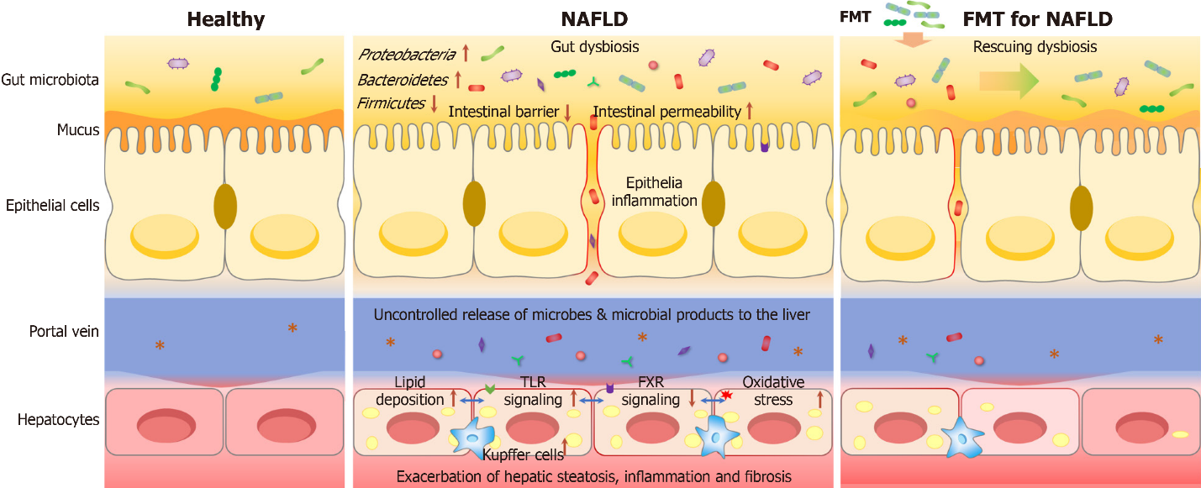
Figure 1 Homeostatic and disrupted gut-liver crosstalk, and mechanism of fecal microbiota transplantation for non-alcoholic fatty liver disease treatment. Left: Healthy/homeostatic condition; Middle: In non-alcoholic fatty liver disease (NAFLD), the intestinal barrier can be disrupted, which facilitates the translocation of microbes and microbial metabolites to the liver, thus promoting hepatic steatosis, inflammation and fibrosis; Right: Fecal microbiota transplantation is used to recover microbial diversity and abundance and restore homeostatic gut-liver crosstalk, and consequently attenuate the symptoms of NAFLD ; FMT: Fecal microbiota transplantation.

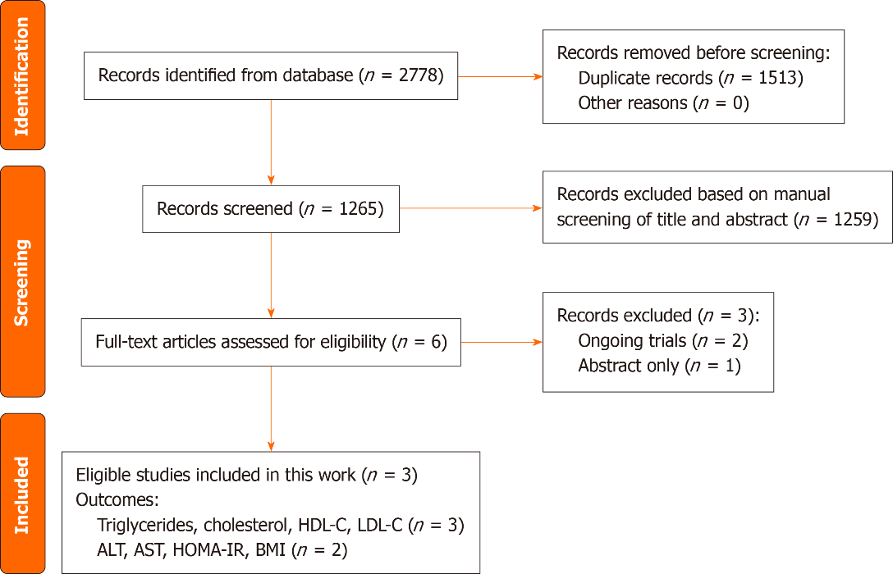
Figure 2 Flow diagram for the process of study selection. ALT: Alanine aminotransferase; AST: Aspartate aminotransferase; BMI: Body mass index; HDL-C: High-density lipoprotein cholesterol; HOMA-IR: Homeostatic model assessment of insulin resistance; LDL-C: Low-density lipoprotein cholesterol.

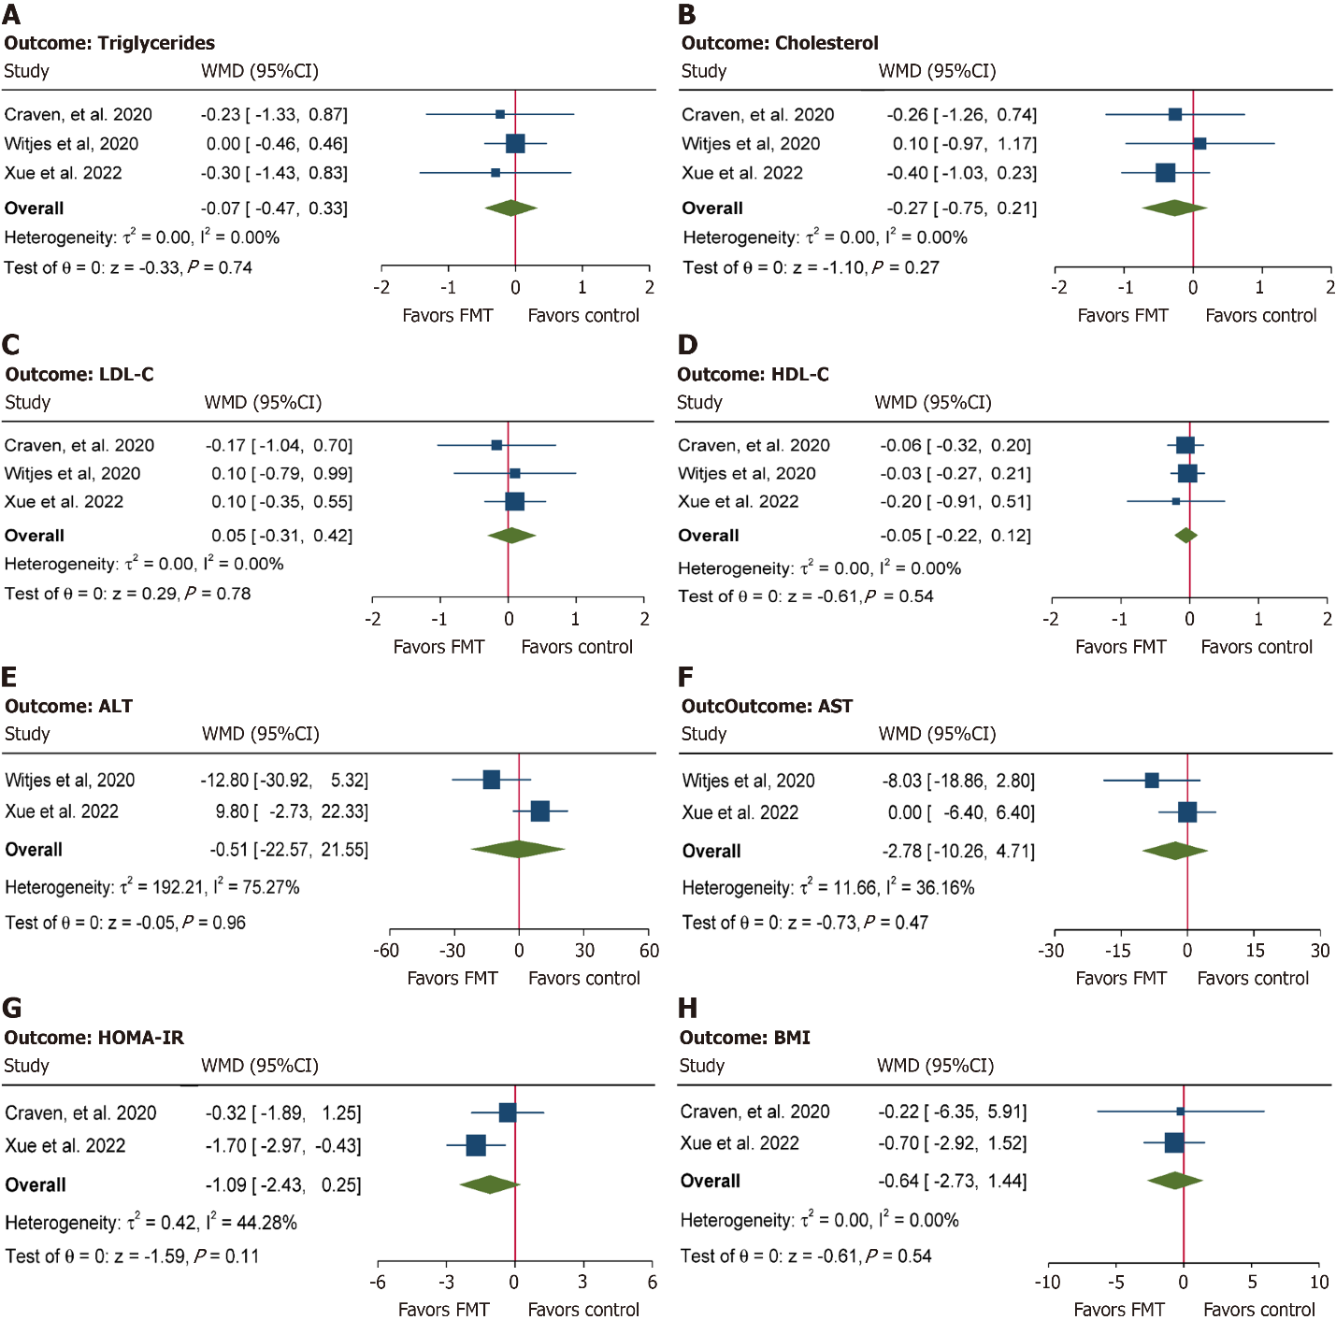
Figure 3 Pooled analysis depicting the effects of fecal microbiota transplantation on serum triglycerides, cholesterol, low-density lipoprotein cholesterol, high-density lipoprotein cholesterol, alanine aminotransferase, aspartate aminotransferase, homeostatic model assessment of insulin resistance and body mass index measured by weighted mean difference in patients with non-alcoholic fatty liver disease. A: Serum triglycerides; B: Cholesterol; C: Low-density lipoprotein cholesterol (LDL-C); D: High-density lipoprotein cholesterol (HDL-C); E: Alanine aminotransferase (ALT); F: Aspartate aminotransferase (AST); G: Homeostatic model assessment of insulin resistance (HOMA-IR); H: Body mass index (BMI). FMT: Fecal microbiota transplantation; NAFLD: Non-alcoholic fatty liver disease; WMD: Weighted mean difference.

Table 1 Characteristics of included randomized controlled trials
Ref. | Patient population | Diagnosis | Study design | Fecal donor | Intervention | Sample size | Duration in wk | Outcomes
Craven et al^{[17]}, 2020 | Adults, NAFLD | Biopsy, fibroscan, MRI | Double-blind, parallel, RCT | 3 donors, healthy, BMI < 25 kg/m² | Treatment: Allogenic FMT | 15 | 24 | HOMA-IR, hepatic PDFF, small intestine permeability, NEFA, cholesterol, HDL-C, LDL-C, triglycerides, glucose, BMI, weight, waist-to-hip ratio
 |  |  |  |  | Control: Autologous FMT | 6
 |  |  |  |  | FMT: Duodenal infusion
Witjes et al^{[18]}, 2020 | Adults, NAFLD | Ultrasound | Double-blind, parallel, RCT | 3 donors, healthy, BMI < 25 kg/m², 8-weekly vegan | Treatment: Allogenic FMT | 10 | 24 | Histological change (NAS score, necro inflammation score, fibrosis score, steatosis score), intestinal microbiota composition, plasma metabolites, cholesterol, HDL-C, LDL-C, triglycerides, glucose, ALT, AST, monocytes
 |  |  |  |  | Control: Autologous FMT | 11
 |  |  |  |  | FMT: Duodenal infusion
Xue et al^{[19]}, 2022 | Adults, NAFLD | Fibroscan | Open-label, parallel, RCT | Healthy undergraduate donors | Treatment: Allogenic FMT | 47 | 4 | ALT, AST, cholesterol, HDL-C, LDL-C, triglycerides, total bilirubin, Albumin, hepatic fat attenuation, changes in the gut microbiota, HOMA-IR, BMI
 |  |  |  |  | Control: Oral probiotics | 28
 |  |  |  |  | FMT: Colonic infusion
ALT: Alanine aminotransferase; AST: Aspartate aminotransferase; BMI: Body mass index; FMT: Fecal microbiota transplantation; HDL-C: High-density lipoprotein cholesterol; LDL-C: Low-density lipoprotein cholesterol; HOMA-IR: Homeostatic model assessment of insulin resistance; MRI: Magnetic resonance imaging; NAFLD: Non-alcoholic fatty liver disease; NAS score: NAFLD activity score; NEFA: Non-esterified fatty acids; PDFF: Proton density fat fraction; RCT: Randomized controlled trial.

Published by Baishideng Publishing Group Inc
7041 Koll Center Parkway, Suite 160, Pleasanton, CA 94566, USA
Telephone: +1-925-3991568
E-mail: office@baishideng.com
Help Desk: https://www.f6publishing.com/helpdesk
https://www.wjgnet.com

© 2024 Baishideng Publishing Group Inc. All rights reserved.

