Name of Journal: World Journal of Gastrointestinal Oncology
Manuscript NO: 88792
Manuscript Type: MINIREVIEWS

Targeting oxidative stress with natural products: A novel strategy for esophageal cancer therapy

Cao F et al. New strategies for the treatment of ESC

Fang Cao, Han-Ling Zhang, Cui Guo, Xue-Liang Xu, Qiang Yuan

Fang Cao, Xue-Liang Xu, Qiang Yuan, Department of Rehabilitation III, Hospital of Chengdu University of Traditional Chinese Medicine, Chengdu 610072, Sichuan Province, China

Han-Ling Zhang, Department of Rehabilitation, Chongqing Fuling District Maternal and Child Health Hospital, Chongqing 408000, China

Cui Guo, Department of Rehabilitation, Hospital of Chengdu University of Traditional Chinese Medicine, Chengdu 610072, Sichuan Province, China

Co-first authors: Fang Cao and Han-Ling Zhang.

Co-corresponding authors: Xue-Liang Xu and Qiang Yuan.

Author contributions: Cao F and Zhang HL jointly wrote the paper; Cao F and Guo C collected and reviewed the literature and made charts; Cao F and Zhang HL coordinated and jointly wrote and revised the paper; Xu XL and Yuan Q conceived the review and put forward core opinions and suggestions; Cao F and Zhang HL contributed equally substantial efforts throughout the entire research process. Because this study was conducted through collaboration, the entire research team included authors with various professional knowledge and skills from different fields. The designation of co-first authors accurately reflects the distribution of responsibilities and burdens related to the time and effort required to complete the research and synthesize the paper. Meanwhile, the designation of co-corresponding authors ensures the accuracy and professionalism of the article. All authors have read and approved the manuscript.

Corresponding author: Xue-Liang Xu, PhD, Doctor, Department of Rehabilitation III, Hospital of Chengdu University of Traditional Chinese Medicine, No. 39 Shierqiao Road, Chengdu 610072, Sichuan Province, China. 13408507171@163.com

Received: October 9, 2023
Revised: December 12, 2023
Accepted: January 12, 2024
Published online:

Abstract
Esophageal cancer (ESC) is a malignant tumor that originates from the mucosal epithelium of the esophagus and is part of the digestive tract. Although the exact pathogenesis of ESC has not been fully elucidated, excessive oxidative stress is an important characteristic that leads to the development of many cancers. Abnormal expression of several proteins and transcription factors contributes to oxidative stress in ESCs, which alters the growth and proliferation of ESCs and promotes their metastasis. Natural compounds, including alkaloids, terpenes, polyphenols, and xanthine compounds, can inhibit reactive oxygen species production in ESCs. These compounds reduce oxidative stress levels and subsequently inhibit the occurrence and progression of ESC through the regulation of targets and pathways such as the cytokine interleukins 6 and 10, superoxide dismutase, the NF-+ACY-kappa+ADs-B/MAPK pathway, and the mammalian Nrf2/ARE target pathway. Thus, targeting tumor oxidative stress has become a key focus in anti-ESC therapy. This review discusses the potential of Natural products (NPs) for treating ESCs and summarizes the application prospects of oxidative stress as a new target for ESC treatment. The findings of this review provide a reference for drug development targeting ESCs. Nonetheless, further high-quality studies will be necessary to determine the clinical efficacy of these various NPs.

Key Words: Oxidative stress; Natural products; Esophageal cancer; Reactive oxygen species

Cao F, Zhang HL, Guo C, Xu XL, Yuan Q. Targeting oxidative stress with natural products: A novel strategy for esophageal cancer therapy. World J Gastrointest Oncol 2024; In press

Core Tip: This paper reviews the role of oxidative stress in esophageal cancer (ESC) development. Natural products (NPs) have shown beneficial effects throughout ESC disease processes. This review reveals the potential mechanisms by which NPs regulate ESC development through oxidative stress pathway.

INTRODUCTION
Esophageal cancer (ESC) is a malignant tumor originating from the mucosal epithelium of the esophagus in the digestive tract^{[1]}. These tumors can be categorized into esophageal squamous cell carcinoma (ESCC) and esophageal adenocarcinoma based on histological classification^{[2]}. Globally, ESC ranks seventh in terms of incidence (3.1%) and sixth in mortality (5.5%)^{[3]}. Regional disparities in ESC incidence rates have been reported and are primarily concentrated in Central Asia, East Asia, South Asia, East Africa, and South Africa. The age-standardized incidence rates of ESC are 17.5/100000 individuals in high-incidence countries and less than 1/100000 individuals in low-incidence countries^{[1]}. The pathogenesis of ESC involves various factors, such as gene mutations, RNA interference, and inflammatory responses. Environmental–genetic–gene interactions are risk factors for esophageal carcinogenesis^{[4]}. Currently, clinical treatments for ESC mainly involve radiotherapy and surgery, but these approaches often lead to adverse reactions and poor patient prognosis^{[5]}.
Recently, targeted therapy has gained prominence in cancer treatment. However, molecular targets for digestive tract tumors are limited, impeding progress in precision treatment^{[6]}. Oxidative stress-targeting agents have shown significant efficacy in treating various solid tumors, including ESCs^{[7]}. Although the specific mechanisms underlying ESC development are unclear, the oxidative stress response plays a crucial role in the growth, invasion, and metastasis of ESC cells^{[8]}. During the occurrence and development of ESCs, cancer cells experience oxidative stress, which leads to excessive free radical production, damage to DNA fragments, or changes in the expression of certain genes, thereby promoting tumor cell proliferation, invasion, and metastasis^{[9]}. Accumulating evidence has increasingly suggested the close association between oxidative stress and ESCC, turning this relationship into a burgeoning research focus.
Natural products (NPs) are chemical compounds that exist in nature and are produced by living organisms. They originate from various biological sources, such as plants, animals, or microorganisms, and exhibit a diverse array of structures and functions^{[10]}. NPs have garnered considerable attention worldwide owing to their unique properties and potential medicinal value^{[11]}. In recent decades, these compounds have become integral to drug discovery and development, playing crucial roles in cancer treatment^{[12]}. Numerous active ingredients with anticancer activity have been discovered, and they act directly on tumor cells. These active compounds, including polyphenols (e.g., quercetin)^{[13]} and flavonoid compounds (e.g., alpinumisoflavone), reduce oxidative stress in cancer cells by inhibiting reactive oxygen species (ROS) production, increasing antioxidant enzyme activity, regulating related signaling pathways, and modulating mitochondrial function. They have also demonstrated anticancer effects against tumors of the digestive tract. The close association between cancer cells and oxidative stress has expanded the application of NPs in ESC treatment, attracting researchers' attention to their anticancer effects. This review is the first comprehensive study on the mechanisms by which NPs regulate oxidative stress responses in ESCs. These findings are expected to offer preclinical evidence for the use of NPs for preventing and managing ESC and facilitating their translation into clinical practice.

METHODOLOGY
We conducted a thorough literature review of the PubMed, Embase, Web of Science, Science Direct, and China National Knowledge Infrastructure databases spanning from the original publication date to July 2023 to explore the mechanisms by which NPs inhibit ESCs by targeting oxidative stress. The search criteria encompassed four types of subject words and keywords: (1) "ESC" and related synonyms such as "esophageal carcinoma", "esophageal tumor", and “esophagus tumor”; (2) “Oxidative stress” was also searched. To broaden the scope of the search process, we also included articles containing terms such as “ROS”, "superoxide dismutase (SOD)”, "malondialdehyde (MDA)", and "glutathione (GSH)"; and (3) "NPs" and its synonyms, including "phytonutrient", "herb", "biological", "plant-derived", "phytochemical", "medicinal plant", and "plant bioactive compound", were also included. The initial database search yielded 2942 records. After removing duplicates, 2446 unique studies were evaluated based on their titles and abstracts. Subsequently, 430 articles were excluded, and 22 full-text articles were ultimately assessed. A flowchart of the search process is depicted in Figure 1.

FEATURES OF ESC OXIDATIVE STRESS IN ESCS
ROS play pivotal roles in not only cell death and necrosis but also intercellular signal transduction and gene expression regulation, thereby contributing to tumorigenesis^{[14]}. Under normal physiological conditions, ROS maintain a balanced redox system and are vital for human physiological processes. However, excessive ROS can induce DNA damage, lipid peroxidation, enzyme activation or inactivation, and disruption of intracellular antioxidant defense systems^{[15]}. In their study on ESCs, Kong et al^{[16]} discovered that oxidative stress can cause DNA damage in esophageal cells and interfere with the DNA repair system. Among the modified products of DNA oxidative damage, 8-hydroxy-2'-deoxyguanosine has emerged as the most commonly used biomarker. Numerous studies have shown that most tumor cells possess impaired antioxidant stress systems, and ROS significantly influence both cell death and survival^{[17]}. Oxidative stress can lead to DNA base alterations, strand breaks, upregulation of proto-oncogenes, and downregulation of suppressor genes within cells, all of which are closely associated with the development of various tumors^{[12]}. An imbalance between oxidants and antioxidants in the body is believed to critically contribute to this process (Figure 2).
The interaction between ESC cells and oxidative stress is complex. On the one hand, ESC cells increase ROS production by enhancing their metabolic activity and altering energy metabolic pathways. On the other hand, high levels of ROS can cause DNA damage, abnormal protein folding, lipid peroxidation, and other cellular structural and functional abnormalities, thereby promoting and altering the proliferation, invasion, and metastasis of ESC cells^{[1]}. In ESC, the expression and activity of antioxidant enzymes are typically increased to help combat the overproduction of ROS^{[2]}. These antioxidant enzymes include SOD, glutathione peroxidase (GPx), and glutathione reductase (GR). SOD converts superoxide radicals into more stable molecular oxygen and peroxide anions, while GPx and GR participate in the GSH system, converting harmful peroxides into harmless substances by catalyzing reduction reactions^{[1,3]}. Hence, oxidative stress response plays a crucial role in the development of ESC. Simultaneously, effectively inhibiting oxidative stress in ESC cells holds potential as a promising research direction in the field of ESC prevention and treatment.

NPS REGULATE OXIDATIVE STRESS IN ESC
Triptolide
Triptolide (TP), an abietane-type diterpenoid isolated from Tripterygium wilfordii Hook. F, possesses potent antitumor, immunosuppressive, and anti-inflammatory properties^{[4]}. TP exerts its anticancer effect primarily through inducing apoptosis^{[5,6]}. TP can promote apoptosis in Eca-9706 cells by stimulating damage due to oxidative stress and inhibiting stress reduction reactions (Table 1 and Figure 3).

Deguelin
Deguelin, the most common rotenone compound in plants apart from rotenone itself, is found in the roots of Tephrosia toxicaria, Derris trifoliata, Piper cubeba, and the leaves of Tephrosia vogelii. Which has pharmacological effects such as antiviral and anti-tumor effects. In recent years, deguelin has been discovered to possess strong anticancer activity^{[7]}. Deguelin induces cell apoptosis by blocking anti-apoptotic pathways such as PI3K-Akt, IKK-IκBα-NF-κB, and AMPK-mTOR-survivin. Some results demonstrated that increasing deguelin concentration significantly inhibits the proliferation of ESC EC-109 cells and plays a crucial role in inducing apoptosis.

Doxofylline
Doxofylline is a novel methylxanthine derivative known for inhibiting phosphodiesterase and exerting effects on airway expansion, anti-bronchospasm, and improved ventilation function^{[8]}. Doxofylline is involved in the oxidative stress response of cancer cells and exhibits immune regulation, anticancer, and anti-inflammatory properties^{[9]}. Another study revealed that doxofylline reduces inflammatory response and oxidative stress in patients undergoing radical resection of ESC.

Naringin
Naringin (NR), also known as NR, citrin, and isohesperidin, is a dihydroflavonoid mainly found in the peel and pulp of grapefruit, tangerine, and orange in the Rutaceae family^{[10]}. NR is a dihydroflavonoid. Because no conjugation exists between ring A and ring B, NR has a strong ultraviolet absorption peak at 282 nm, which makes it display a variety of biological activities and pharmacological effects, including anti-inflammatory, anticancer, and immunomodulatory effects. Tajaldini et al^{[11]} showed that doxorubicin combined with NR resulted in reduced systemic toxicity and decreased fractional cycling of oxidative stress.

Astaxanthin
Astaxanthin (AST), a carotenoid present in various organisms such as red yeast, red algae, chlorella, shrimp, and crab shells. In addition to its carotenoid functions that alleviate visual fatigue and prevent light damage, it also has strong pharmacological properties such as antioxidant, anti-tumor, and immune enhancement. Cui et al^{[12]} revealed that AST inhibits NF-κB and COX expression, improves antioxidant capacity and anti-inflammatory ability, and significantly inhibits the occurrence of ESC. Another study by Cui et al^{[12]} demonstrated that AST inhibits oxidative stress by increasing the levels of SOD and total antioxidant capacity (TAOC) in serum while inhibiting the levels of MDA and increasing the protein expression of PPARγ, Bax/Bcl-2, and caspase-3 in esophageal tissues, thus providing protective effects against ESC.

Gypenosides
Gypenosides (GP), the effective components of Pentaphyllum japonica, a traditional Chinese medicine, exhibit significant pharmacological activities such as cancer inhibition, anti-inflammatory, and blood pressure lowering^{[13]}. GP plays a role in cellular self-repair, promotes cancer cell recovery, prevents tumor recurrence and metastasis, and inhibits the proliferation of nearly all cancer cells^{[14]}. Yan et al^{[15]} demonstrated that GP inhibits the proliferation and migration of ESC Eca-109 cells in a dose- and time-dependent manner. It increases intracellular ROS levels, reduces mitochondrial membrane potential, and induces apoptotic morphologies such as cell shrinkage and chromatin condensation, indicating that oxidative stress and mitochondria-dependent apoptosis are involved in GP-induced loss of cell viability in ESC Eca-109 cells.

Galangin
Galangin (3,5,7-trihydroxyflavone), a natural flavonol compound, is the main active ingredient in the rhizoma of galangal, a traditional Chinese medicine^{[16]}. It possesses anti-inflammatory, free radical scavenging, and anti-cancer effects^{[17]}. Available data suggest that galangin, as a free radical scavenger, exhibits various pharmacological activities and confers resistance against the growth of different tumors. Ren et al^{[18]} found that galangal plays a crucial role in inhibiting the proliferation of ESC cells by inhibiting the activity of cyclins and cyclin-dependent kinases. Additionally, galangin enhances the expression of P53 and its family members P21 and P27, further inhibiting the growth of cancer cells^{[19]}. Moreover, galangin exerts its influence by inhibiting the PI3K/JAK2/STAT3 signaling pathway, which becomes activated in the presence of ROS. Galangin reduces ROS levels and inhibits the activity of this signaling pathway, thereby effectively inhibiting the growth and survival of ESC cells^{[20]}.

Berberine
Berberine (BBR) is a quaternary ammonium bioactive base isolated from the traditional Chinese medicine Coptidis rhizoma, known for its various pharmacological effects such as anti-inflammatory and antibacterial effects and participation in cellular oxidative stress response^{[21,22]}. It inhibits cancer cell proliferation and induces cancer cell apoptosis^{[23]}. Moreover, BBR has shown potential in inhibiting cell proliferation, invasion, and metastasis in different cancers through cell cycle arrest, senescence, apoptosis, and autophagy of tumor cells, making it a promising anticancer drug. In the study by Jiang et al^{[24]}, the effects of BBR on ESCC line KYSE-70 and esophageal adenocarcinoma cell line SKGT4 were evaluated. The results showed that BBR inhibited EC cell growth by promoting cell cycle arrest and apoptosis in G2/M phase.

Echinatin
Echinatin (Ech), a compound extracted from licorice, a classic Chinese herbal medicine, demonstrated multiple biological activities, especially in terms of antitumor and anti-angiogenesis activities, garnering extensive attention in recent years^{[25]}. The results of Kwak et al^{[26]} showed that Ech induced apoptosis in human ESC cells by increasing ROS levels, endoplasmic reticulum (ER) stress, and p38 MAPK/JNK activation.

Thapsigargin
Thapsigargin (TG), derived from Thapsia garganica L., a plant known for its potential anticancer properties, has demonstrated promising activity against various types of tumor cells^{[27]}. It exerts its effects by inducing ER stress and apoptosis, thereby inhibiting cancer growth. CHOP, a key transcription factor, plays an important role during ER stress. In this context, forced expression of CHOP can upregulate the expression of death receptor 5 (DR5) and promote oxidative stress and cell death^{[28]}. TG effectively activates the ER stress response, while an increased protein folding load in the ER leads to ROS accumulation^{[28]}. Ma et al^{[29]} revealed that TG enhances the sensitivity of human ESC cells to TRAIL-induced apoptosis by depleting the cellular TAOC and increasing ROS levels in human ESCC cells.

Ziyuglycoside II
Ziyuglycoside II (ZYG II), derived from Sanguisorba officinalis L., is a triterpene saponin with good anti-inflammatory and anticancer properties^{[30]}. It exerts its pharmacological effects mainly by inducing ROS production and apoptosis^{[31]}. Zhong et al^{[32]} demonstrated that ZYG II significantly induces apoptosis of digestive tract tumor cells by regulating cell cycle progression, mediating oxidative stress, and blocking the epidermal growth factor receptor (EGFR) signaling pathway, thereby promoting the anticancer effect of 5-fluorouracil (5-FU).

α-Hederin
α-Hederin belongs to the monosaccharide chain pentacyclic triterpene saponins, and it is found in various plants such as Hedera helix L., Fructus Akebiae, and Nigella sativa L^{[33]}. It has been shown to possess various pharmacological effects, including antitumor, anti-inflammatory, antispasmodic, and anti-leishmaniasis properties^{[34]}. In the study by Wang et al^{[35]}, the antitumor effect of α-hederin was evaluated in vivo using the human ESC cell line Eca-109. The results demonstrated that α-hederin significantly inhibited ESCC cell proliferation, induced cell apoptosis, and arrested the cell cycle at the G1 phase. α-Hederin inhibits ESCC cell proliferation and induces apoptosis by dispersing mitochondrial membrane potential (MMP) and simultaneously generating ROS and activating the mitochondrial pathway.

Lycopene
Lycopene, a type of carotene found in plant foods, it has pharmacological effects such as enhancing the body's oxidative stress capacity, anti-inflammatory effects, antioxidant effects, and enhancing immunityis abundant. It can be found in ripe red plant fruits, particularly in tomatoes, carrots, and guavas^{[36]}. Unlike β-carotene, lycopene lacks the β-angelone ring structure, preventing its conversion into vitamin A in the body^{[37,38]}. Although it lacks the physiological activity of vitamin A, lycopene possesses a potent antioxidant function^{[38,39]}. Cui, Lingling et al revealed that an appropriate dose of lycopene effectively reduces the incidence of ESC induced by JV-nitrosomethylbenzylamine (NMBzA) in F344 rats. Lycopene significantly reduces the expression of PPARγ, NF-κB, COX-2, and caspase-3 proteins involved in oxidative stress, exhibiting anti-inflammatory and pro-apoptotic effects^{[40]}.

Daphnetin
Daphnetin (DAP) is an active ingredient extracted from Daphne Koreana Nakai, also known as Zushimazin^{[41]}. It is the first new drug in China and is chemically named 7,8-dihydroxycoumarin. Its pharmacological effects primarily involve triggering ROS-induced apoptosis and inhibiting the production of tumor necrosis factor-α, interleukin-1β, ROS, and MDA^{[42-44]}. Daphnetin demonstrates remarkable anti-inflammatory, antioxidant, and anticancer abilities. In vivo experiments have shown that DAP administration as a standalone treatment reduces tumor volume and slightly increases body weight in experimental mice. Furthermore, co-administration of Dox and DAP not only reduces tumor volume but also preserves body weight, indicating that DAP exerts a protective effect against oxidative stress in vivo^{[45]}.

Vitamin E
Vitamin E is an essential fat-soluble vitamin in the human body^{[46]}. It serves as a crucial nonenzymatic, chain-breaking antioxidant distributed in the cell membrane of aerobic organisms. Its pharmacological effects mainly include antioxidant, anticancer, vascular protection, and regulation of hormone levels in the body. Vitamin E effectively prevents and reduces nonenzymatic oxidative damage to DNA and lipids caused by free radicals or ROS and plays a protective role in biofilm^{[47,48]}. A study by Eskelson et al demonstrated that ethanol increased the incidence of NMBzA-induced esophageal tumors by 174%, while a vitamin E-supplemented diet reduced the incidence of ethanol-induced esophageal tumors by 32%. Mice supplemented with vitamin E also showed a reduced number of esophageal tumors, suggesting that vitamin E exerts a protective effect by interrupting the chain reaction of free radicals^{[49]}.

Isoalantolactone
Alantolactone is a perennial herb belonging to the genus Inula in the Asteraceae family. The root of Inula helenium L. contains a large amount of sesquiterpene lactones, mainly including alantolactone and isoalantolactone (IAL)^{[50]}. IAL possesses various biological activities such as anti-inflammatory, antioxidant, antitumor, and neuroprotective effects. It exhibits cytotoxic effects on a variety of cancer cells but has no significant toxicity on normal cells^{[51]}. Lu et al^{[52]} demonstrated that IAL induces apoptosis in human ESC cells by activating caspase-3, -7, and -10 and upregulating DR5 (an extrinsic pathway). This process involves upregulating DR5 and increasing ROS.

Morphine
Morphine is an NP extracted from the milk of the poppy plant (Papaver somniferum)^{[53]}. This plant is a perennial herb mainly found in the Mediterranean region and some parts of Asia. It is widely used in medicine to alleviate severe pain due to its powerful analgesic, sedative, and cough relieving pharmacological effects, especially after surgery or during cancer treatment or severe trauma^{[54]}. Morphine also plays an important role in ESC treatment^{[55,56]}. Zhang et al^{[57]} demonstrated that morphine activates the AMP-activated protein kinase (AMPK) pathway, induces epithelial-mesenchymal transition, and increases oxidative stress in ESC cells by upregulating Snail and Slug expression levels.

Quercetin
Quercetin is a natural flavonoid with a wide range of biological activities, found abundantly in flowers, leaves, and fruits of plants. Its effects include antioxidant, anti-allergic, anti-infective, and antiviral properties^{[58,59]}. Recent studies have also revealed its inhibitory effects on various cancers including ESC and thyroid cancer. Zheng et al^{[60]} reported that quercetin is considered a potential chemopreventive agent because of its involvement in inhibiting oxidative stress, proliferation, and metastasis throughout the cancer process.

Alpinumisoflavone
Alpinumisoflavone (AIF) is a flavonoid compound isolated from the stem bark of the tung tree. AIF exhibits anticancer properties against various cancer cells including colorectal, esophageal, renal, and hepatocellular carcinomas^{[61]}. AIF possesses multiple therapeutic effects, such as anti-osteoporotic, antioxidant, anti-inflammatory, antibacterial, anticancer, and neuroprotective properties^{[62]}. According to Zhang, Bin et al, AIF significantly enhances the radiosensitivity of ESCC cells in vitro and in vivo by targeting the pathways of DNA damage, apoptosis, and cell cycle arrest induced by radiation^{[63]}. Specifically, AIF inhibits the expression of nuclear factor Nrf2 and the NrF2-regulated antioxidant molecules NQO-1 and HO-1, thereby exacerbating the radiation-induced ROS production in ESCC cells.

Black raspberries
Raspberries, also known as Rubus idaeus L., are available in various varieties. Black raspberries (BRBs) are well known for their anticancer, antihypertensive, and antioxidant abilities^{[64]}. BRB are rich in anthocyanins, which are excellent natural antioxidants with the ability to scavenge ROS such as superoxide anion, oxygen (O₂), peroxide, and hydrogen peroxide (H₂O₂) free radicals, exhibiting stronger lipid peroxidation than other antioxidants. BRB counteracts oxidative stress and suppresses NFκB/MAPK pathways, contributing to the chemopreventive action against ESC in rats^{[65]}.

Moringa oleifera leaf extract
Moringa oleifera leaf extract (MOE) is a natural plant nutrient extracted from Moringa oleifera leaves. It contains a large amount of antioxidants and minerals and possesses anti-inflammatory, hypoglycemic, and metabolic effects. Compounds present in MOE can inhibit the growth and spread of cancer cells^{[66-68]}. Tiloke et al^{[69]} revealed that MOE administration significantly enhances the expression of Smac/DIABLO protein and cleavage of PARP-1, leading to a noticeable increase in the 24-kDa fragment. This extract exerts potent anti-proliferative effects on SNO EC cells through increased lipid peroxidation, DNA fragmentation, and induction of apoptotic cell death.

CRITICAL CONSIDERATIONS
Advantages of NPs for ESC therapy
This review highlights the beneficial effects of NPs in preventing ESC and treating cancer by targeting the antioxidant stress pathway. ESC prevention and treatment have significant clinical and societal importance, but current drug options are limited. Chemopreventive medications such as fluorouracil^{[70]}, cisplatin^{[71]}, and paclitaxel^{[72]} have shown efficacy in preventing ESC, but prolonged use may lead to undesirable effects such as gastrointestinal reactions, mucosal injury, and renal toxicity. By contrast, NPs offer multifaceted effects in ESC prevention and treatment, including reducing DNA damage, protecting normal tissues, inhibiting cancer cell proliferation, and even reversing carcinogenesis.
The complex pathogenesis of ESC requires a multi-target and multi-pathway approach for treatment. NPs possess various activities such as antioxidant, anti-inflammatory, and modulation of signaling pathways^{[73]}. These actions positively influence the development of ESC through various signaling pathways. NPs can directly or indirectly affect ESC by modulating pathways like PI3K/Akt, Wnt/β-catenin, NF-κB, and ROS/MAPK through their effect on oxidative stress. These findings demonstrate that NPs possess the ability to modulate ESC development through a multi-targeted and multi-pathway approach^{[74]}. These results establish a foundation for future investigations in cellular and animal studies, allowing for further exploration of the potential of NPs in regulating ESC development.

Clinical studies on NPs: practical and widespread use
Doxofylline has shown potential benefits as an effective adjunctive treatment for ESC in clinical trials. However, these treatment methods are still in the early stages and have limitations in their current application. The transformation of NPs into pharmaceuticals remains a significant challenge owing to factors such as chemical instability, rapid metabolism, and potential side effects^{[75]}. A major limitation of NPs is their low oral bioavailability, which restricts the clinical use of certain NPs containing beneficial bioactive ingredients including Ech and lycopene.

Toxic side effects of NPs
At present, NPs are not widely accepted by the clinical and mainstream pharmaceutical markets because their pharmacological theories are different from those of modern medicine and their mechanisms of action are unclear^{[76]}. Another important reason is that their pharmacological activities coexist with their toxicities, some of which are even greater than their pharmacological effects^{[77]}. Nephrotoxicity is the most common toxic side effect of NPs, including electrolyte abnormalities, acute kidney injury, chronic kidney disease and even death^{[78]}. For example, Tripterygium wilfordii has a variety of pharmacological effects^{[79]}. However, Tripterygium wilfordii has shown serious toxic and side effects in clinical use, such as liver and kidney toxicity, male infertility, leukopenia, and menstrual disorders, especially liver injury^{[80]}. More clinical trials and efficacy assessments are needed to develop strategies that minimize toxicity and adverse reactions when using NPs for treatment.

CONCLUSION
ESC is a disease that profoundly affects human health and quality of life, with high mortality primarily attributed to the lack of effective targeted therapeutic drugs^{[81]}. Oxidative stress plays a crucial role in ESC development, making targeted therapy against oxidative stress of significant importance. Currently, NPs have been extensively studied and shown to have the potential in regulating oxidative stress processes^{[82,83]}. These NPs can directly act on tumor cells, exerting anti-ESC effects by modulating multiple oxidative stress pathways. In this review, we identified various NPs capable of modulating oxidative stress in ESC and exhibiting anticancer effects. These NPs primarily include polyphenols, flavonoids, sulfur metabolites, terpenoids, and carotenoids. We classified the structures of these NPs and summarized their specific mechanisms by which they regulate the oxidative stress process. Among the polyphenolic compounds, deguelin and BRB have robust antioxidant and anticancer potential to alleviate oxidative stress injury in ESC cells by regulating PI3K/Akt, Keap1-Nrf2, and NF-κB/MAPK signaling pathways. For flavonoids, NPs such as quercetin and MOE demonstrated the ability to mitigate oxidative stress damage to ESC cells by inhibiting ROS generation, enhancing SOD and catalase activities, and regulating MAPK and HDAC-NF-κB signaling pathways. Terpenoids such as Ziyuglycoside II and α-hederin target oxidative stress in ESC by modulating the EGFR signaling pathway and the mitochondrial signaling pathway. Carotenoids such as AST and lycopene protect ESC cells by regulating oxidative stress-related proteins (NF-κB, COX2, and PPARγ proteins). Additionally, theophylline, carotenoid, and alkaloid NPs also exhibit significant inhibitory effects on oxidative stress, thereby protecting ESC cells from damage by enhancing the function of the intracellular antioxidant system (Figure 4). These NPs hold substantial potential in regulating oxidative stress and are highly valuable subjects of research. Compared with traditional treatment methods, targeted therapy utilizing NPs can reduce toxic side effects and enhance the sensitivity of ESC cells to radiotherapy and chemotherapy.

REFERENCES
1 Klaunig JE. Oxidative Stress and Cancer. Curr Pharm Des 2018; 24: 4771-4778 [PMID: 30767733 DOI: 10.2174/1381612825666190215121712]
2 Jelic MD, Mandic AD, Maricic SM, Srdjenovic BU. Oxidative stress and its role in cancer. J Cancer Res Ther 2021; 17: 22-28 [PMID: 33723127 DOI: 10.4103/jcrt.JCRT_862_16]
3 Reuter S, Gupta SC, Chaturvedi MM, Aggarwal BB. Oxidative stress, inflammation, and cancer: how are they linked? Free Radic Biol Med 2010; 49: 1603-1616 [PMID: 20840865 DOI: 10.1016/j.freeradbiomed.2010.09.006]
4 Gao J, Zhang Y, Liu X, Wu X, Huang L, Gao W. Triptolide: pharmacological spectrum, biosynthesis, chemical synthesis and derivatives. Theranostics 2021; 11: 7199-7221 [PMID: 34158845 DOI: 10.7150/thno.57745]
5 Liu H, Shen M, Zhao D, Ru D, Duan Y, Ding C, Li H. The Effect of Triptolide-Loaded Exosomes on the Proliferation and Apoptosis of Human Ovarian Cancer SKOV3 Cells. Biomed Res Int 2019; 2019: 2595801 [PMID: 31240207 DOI: 10.1155/2019/2595801]
6 Li F, Cui H, Jin X, Gong X, Wang W, Wang J. Triptolide inhibits epithelial-mesenchymal transition and induces apoptosis in gefitinib-resistant lung cancer cells. Oncol Rep 2020; 43: 1569-1579 [PMID: 32323848 DOI: 10.3892/or.2020.7542]
7 Lu G, Yao Y, Zhang X, Cui D, Zhou J. Deguelin Attenuates Non-Small-Cell Lung Cancer Cell Metastasis by Upregulating PTEN/KLF4/EMT Signaling Pathway. Dis Markers 2022; 2022: 4090346 [PMID: 35637651 DOI: 10.1155/2022/4090346]
8 Matera MG, Page C, Cazzola M. Doxofylline is not just another theophylline!. Int J Chron Obstruct Pulmon Dis 2017; 12: 3487-3493 [PMID: 29255355 DOI: 10.2147/COPD.S150887]
9 Alomar SY. Studying the Mechanism of Interaction of Doxofylline with Human Lysozyme: A Biophysical and In Silico Approach. Molecules 2023; 28 [PMID: 37110695 DOI: 10.3390/molecules28083462]
10 Stabrauskiene J, Kopustinskiene DM, Lazauskas R, Bernatoniene J. Naringin and Naringenin: Their Mechanisms of Action and the Potential Anticancer Activities. Biomedicines 2022; 10 [PMID: 35884991 DOI: 10.3390/biomedicines10071686]
11 Tajaldini M, Samadi F, Khosravi A, Ghasemnejad A, Asadi J. Protective and anticancer effects of orange peel extract and naringin in doxorubicin treated esophageal cancer stem cell xenograft tumor mouse model. Biomed Pharmacother 2020; 121: 109594 [PMID: 31707344 DOI: 10.1016/j.biopha.2019.109594]
12 Cui L, Li Z, Xu F, Tian Y, Chen T, Li J, Guo Y, Lyu Q. Antitumor Effects of Astaxanthin on Esophageal Squamous Cell Carcinoma by up-Regulation of PPARγ. Nutr Cancer 2022; 74: 1399-1410 [PMID: 34334076 DOI: 10.1080/01635581.2021.1952449]
13 Qi YS, Xie JB, Xie P, Duan Y, Ling YQ, Gu YL, Piao XL. Uncovering the anti-NSCLC effects and mechanisms of gypenosides by metabolomics and network pharmacology analysis. J Ethnopharmacol 2021; 281: 114506 [PMID: 34371113 DOI: 10.1016/j.jep.2021.114506]
14 Liu H, Li X, Duan Y, Xie JB, Piao XL. Mechanism of gypenosides of Gynostemma pentaphyllum inducing apoptosis of renal cell carcinoma by PI3K/AKT/mTOR pathway. J Ethnopharmacol 2021; 271: 113907 [PMID: 33556477 DOI: 10.1016/j.jep.2021.113907]
15 Yan H, Wang X, Wang Y, Wang P, Xiao Y. Antiproliferation and anti-migration induced by gypenosides in human colon cancer SW620 and esophageal cancer Eca-109 cells. Hum Exp Toxicol 2014; 33: 522-533 [PMID: 23900306 DOI: 10.1177/0960327113497771]
16 Kong Y, Feng Z, Chen A, Qi Q, Han M, Wang S, Zhang Y, Zhang X, Yang N, Wang J, Huang B, Zhang Q, Xiang G, Li W, Zhang D, Wang J, Li X. The Natural Flavonoid Galangin Elicits Apoptosis, Pyroptosis, and Autophagy in Glioblastoma. Front Oncol 2019; 9: 942 [PMID: 31612107 DOI: 10.3389/fonc.2019.00942]
17 Thapa R, Afzal O, Alfawaz Altamimi AS, Goyal A, Almalki WH, Alzarea SI, Kazmi I, Jakhmola V, Singh SK, Dua K, Gilhotra R, Gupta G. Galangin as an inflammatory response modulator: An updated overview and therapeutic potential. Chem Biol Interact 2023; 378: 110482 [PMID: 37044286 DOI: 10.1016/j.cbi.2023.110482]
18 Ren K, Zhang W, Wu G, Ren J, Lu H, Li Z, Han X. Synergistic anti-cancer effects of galangin and berberine through apoptosis induction and proliferation inhibition in oesophageal carcinoma cells. Biomed Pharmacother 2016; 84: 1748-1759 [PMID: 27876206 DOI: 10.1016/j.biopha.2016.10.111]
19 Huang H, Chen AY, Ye X, Guan R, Rankin GO, Chen YC. Galangin, a Flavonoid from Lesser Galangal, Induced Apoptosis via p53-Dependent Pathway in Ovarian Cancer Cells. Molecules 2020; 25 [PMID: 32235536 DOI: 10.3390/molecules25071579]
20 Zhang C, Luo CL, Shang GS, Jiang DX, Song Q. Galangin Enhances Anticancer Efficacy of 5-Fluorouracil in Esophageal Cancer Cells and Xenografts Through NLR Family Pyrin Domain Containing 3 (NLRP3) Downregulation. Med Sci Monit 2021; 27: e931630 [PMID: 34916479 DOI: 10.12659/MSM.931630]
21 Rauf A, Abu-Izneid T, Khalil AA, Imran M, Shah ZA, Emran TB, Mitra S, Khan Z, Alhumaydhi FA, Aljohani ASM, Khan I, Rahman MM, Jeandet P, Gondal TA. Berberine as a Potential Anticancer Agent: A Comprehensive Review. Molecules 2021; 26 [PMID: 34885950 DOI: 10.3390/molecules26237368]
22 Zhu C, Li K, Peng XX, Yao TJ, Wang ZY, Hu P, Cai D, Liu HY. Berberine a traditional Chinese drug repurposing: Its actions in inflammation-associated ulcerative colitis and cancer therapy. Front Immunol 2022; 13: 1083788 [PMID: 36561763 DOI: 10.3389/fimmu.2022.1083788]
23 Liu Q, Tang J, Chen S, Hu S, Shen C, Xiang J, Chen N, Wang J, Ma X, Zhang Y, Zeng J. Berberine for gastric cancer prevention and treatment: Multi-step actions on the Correa's cascade underlie its therapeutic effects. Pharmacol Res 2022; 184: 106440 [PMID: 36108874 DOI: 10.1016/j.phrs.2022.106440]
24 Jiang SX, Qi B, Yao WJ, Gu CW, Wei XF, Zhao Y, Liu YZ, Zhao BS. Berberine displays antitumor activity in esophageal cancer cells in vitro. World J Gastroenterol 2017; 23: 2511-2518 [PMID: 28465635 DOI: 10.3748/wjg.v23.i14.2511]
25 Wang Z, Xu G, Li Z, Xiao X, Tang J, Bai Z. NLRP3 Inflammasome Pharmacological Inhibitors in Glycyrrhiza for NLRP3-Driven Diseases Treatment: Extinguishing the Fire of Inflammation. J Inflamm Res 2022; 15: 409-422 [PMID: 35082510 DOI: 10.2147/JIR.S344071]
26 Kwak AW, Choi JS, Lee MH, Oh HN, Cho SS, Yoon G, Liu K, Chae JI, Shim JH. Retrochalcone Echinatin Triggers Apoptosis of Esophageal Squamous Cell Carcinoma via ROS- and ER Stress-Mediated Signaling Pathways. Molecules 2019; 24 [PMID: 31717502 DOI: 10.3390/molecules24224055]
27 Isaacs JT, Brennen WN, Christensen SB, Denmeade SR. Mipsagargin: The Beginning-Not the End-of Thapsigargin Prodrug-Based Cancer Therapeutics. Molecules 2021; 26 [PMID: 34946547 DOI: 10.3390/molecules26247469]
28 Kim EK, Kim Y, Yang JY, Jang HH. Prx1 Regulates Thapsigargin-Mediated UPR Activation and Apoptosis. Genes (Basel) 2022; 13 [PMID: 36360274 DOI: 10.3390/genes13112033]
29 Ma Z, Fan C, Yang Y, Di S, Hu W, Li T, Zhu Y, Han J, Xin Z, Wu G, Zhao J, Li X, Yan X. Thapsigargin sensitizes human esophageal cancer to TRAIL-induced apoptosis via AMPK activation. Sci Rep 2016; 6: 35196 [PMID: 27731378 DOI: 10.1038/srep35196]
30 Jang E, Inn KS, Jang YP, Lee KT, Lee JH. Phytotherapeutic Activities of Sanguisorba officinalis and its Chemical Constituents: A Review. Am J Chin Med 2018; 46: 299-318 [PMID: 29433389 DOI: 10.1142/S0192415X18500155]
31 Zhu X, Wang K, Zhang K, Zhu L, Zhou F. Ziyuglycoside II induces cell cycle arrest and apoptosis through activation of ROS/JNK pathway in human breast cancer cells. Toxicol Lett 2014; 227: 65-73 [PMID: 24680927 DOI: 10.1016/j.toxlet.2014.03.015]
32 Zhong Y, Li XY, Zhou F, Cai YJ, Sun R, Liu RP. Ziyuglycoside II inhibits the growth of digestive system cancer cells through multiple mechanisms. Chin J Nat Med 2021; 19: 351-363 [PMID: 33941340 DOI: 10.1016/S1875-5364(21)60033-X]
33 Cao L, Zhang Y, Mi J, Shi Z, Fang Z, Jia D, Pan Z, Peng P. α-Hederin inhibits the platelet activating factor-induced metastasis of HCC cells through disruption of PAF/PTAFR axis cascaded STAT3/MMP-2 expression. Pharmacol Res 2022; 178: 106180 [PMID: 35288308 DOI: 10.1016/j.phrs.2022.106180]
34 Zeng J, Zhao G. α-Hederin regulates macrophage polarization to relieve sepsis-induced lung and liver injuries in mice. Open Med (Wars) 2023; 18: 20230695 [PMID: 37251537 DOI: 10.1515/med-2023-0695]
35 Wang J, Wu D, Zhang J, Liu H, Wu J, Dong W. α-Hederin Induces Apoptosis of Esophageal Squamous Cell Carcinoma via an Oxidative and Mitochondrial-Dependent Pathway. Dig Dis Sci 2019; 64: 3528-3538 [PMID: 31273592 DOI: 10.1007/s10620-019-05689-1]
36 Khan UM, Sevindik M, Zarrabi A, Nami M, Ozdemir B, Kaplan DN, Selamoglu Z, Hasan M, Kumar M, Alshehri MM, Sharifi-Rad J. Lycopene: Food Sources, Biological Activities, and Human Health Benefits. Oxid Med Cell Longev 2021; 2021: 2713511 [PMID: 34840666 DOI: 10.1155/2021/2713511]
37 Grabowska M, Wawrzyniak D, Rolle K, Chomczyński P, Oziewicz S, Jurga S, Barciszewski J. Let food be your medicine: nutraceutical properties of lycopene. Food Funct 2019; 10: 3090-3102 [PMID: 31120074 DOI: 10.1039/c9fo00580c]
38 Marzocco S, Singla RK, Capasso A. Multifaceted Effects of Lycopene: A Boulevard to the Multitarget-Based Treatment for Cancer. Molecules 2021; 26 [PMID: 34500768 DOI: 10.3390/molecules26175333]
39 Khalaf RA, Awad M. Lycopene as a Potential Bioactive Compound: Chemistry, Extraction, and Anticancer Prospective. Curr Cancer Drug Targets 2023; 23: 634-642 [PMID: 36718971 DOI: 10.2174/1568009623666230131124236]
40 Cui L, Xu F, Wu K, Li L, Qiao T, Li Z, Chen T, Sun C. Anticancer effects and possible mechanisms of lycopene intervention on N-methylbenzylnitrosamine induced esophageal cancer in F344 rats based on PPARγ(1). Eur J Pharmacol 2020; 881: 173230 [PMID: 32553810 DOI: 10.1016/j.ejphar.2020.173230]
41 Javed M, Saleem A, Xaveria A, Akhtar MF. Daphnetin: A bioactive natural coumarin with diverse therapeutic potentials. Front Pharmacol 2022; 13: 993562 [PMID: 36249766 DOI: 10.3389/fphar.2022.993562]
42 Lv H, Zhu C, Wei W, Lv X, Yu Q, Deng X, Ci X. Enhanced Keap1-Nrf2/Trx-1 axis by daphnetin protects against oxidative stress-driven hepatotoxicity via inhibiting ASK1/JNK and Txnip/NLRP3 inflammasome activation. Phytomedicine 2020; 71: 153241 [PMID: 32454347 DOI: 10.1016/j.phymed.2020.153241]
43 Pei Q, Hu P, Zhang H, Li H, Yang T, Liu R. Daphnetin exerts an anticancer effect by attenuating the pro-inflammatory cytokines. J Biochem Mol Toxicol 2021; 35: 1-8 [PMID: 33749080 DOI: 10.1002/jbt.22759]
44 Zhang L, Gu Y, Li H, Cao H, Liu B, Zhang H, Shao F. Daphnetin protects against cisplatin-induced nephrotoxicity by inhibiting inflammatory and oxidative response. Int Immunopharmacol 2018; 65: 402-407 [PMID: 30380515 DOI: 10.1016/j.intimp.2018.10.018]
45 Deng Q, Wu L, Li Y, Zou L. Chemoprotective Effect of Daphnetin in Doxorubicin Treated Esophageal Cancer Stem Cell Xenograft Tumor Mouse. Dokl Biochem Biophys 2021; 499: 273-281 [PMID: 34426926 DOI: 10.1134/S1607672921040128]
46 Abraham A, Kattoor AJ, Saldeen T, Mehta JL. Vitamin E and its anticancer effects. Crit Rev Food Sci Nutr 2019; 59: 2831-2838 [PMID: 29746786 DOI: 10.1080/10408398.2018.1474169]
47 Miyazawa T, Burdeos GC, Itaya M, Nakagawa K, Miyazawa T. Vitamin E: Regulatory Redox Interactions. IUBMB Life 2019; 71: 430-441 [PMID: 30681767 DOI: 10.1002/iub.2008]
48 Lee GY, Han SN. The Role of Vitamin E in Immunity. Nutrients 2018; 10 [PMID: 30388871 DOI: 10.3390/nu10111614]
49 Eskelson CD, Odeleye OE, Watson RR, Earnest DL, Mufti SI. Modulation of cancer growth by vitamin E and alcohol. Alcohol Alcohol 1993; 28: 117-125 [PMID: 8471082]
50 Liu X, Bian L, Duan X, Zhuang X, Sui Y, Yang L. Alantolactone: A sesquiterpene lactone with diverse pharmacological effects. Chem Biol Drug Des 2021; 98: 1131-1145 [PMID: 34624172 DOI: 10.1111/cbdd.13972]
51 Cai Y, Gao K, Peng B, Xu Z, Peng J, Li J, Chen X, Zeng S, Hu K, Yan Y. Alantolactone: A Natural Plant Extract as a Potential Therapeutic Agent for Cancer. Front Pharmacol 2021; 12: 781033 [PMID: 34899346 DOI: 10.3389/fphar.2021.781033]
52 Lu Z, Zhang G, Zhang Y, Hua P, Fang M, Wu M, Liu T. Isoalantolactone induces apoptosis through reactive oxygen species-dependent upregulation of death receptor 5 in human esophageal cancer cells. Toxicol Appl Pharmacol 2018; 352: 46-58 [PMID: 29800641 DOI: 10.1016/j.taap.2018.05.026]
53 Wicks C, Hudlicky T, Rinner U. Morphine alkaloids: History, biology, and synthesis. Alkaloids Chem Biol 2021; 86: 145-342 [PMID: 34565506 DOI: 10.1016/bs.alkal.2021.04.001]
54 Gach K, Wyrębska A, Fichna J, Janecka A. The role of morphine in regulation of cancer cell growth. Naunyn Schmiedebergs Arch Pharmacol 2011; 384: 221-230 [PMID: 21800094 DOI: 10.1007/s00210-011-0672-4]
55 Ribeiro Pinto LF, Swann PF. Opium and oesophageal cancer: effect of morphine and opium on the metabolism of N-nitrosodimethylamine and N-nitrosodiethylamine in the rat. Carcinogenesis 1997; 18: 365-369 [PMID: 9054630 DOI: 10.1093/carcin/18.2.365]
56 Jatoi A, Thomas CR Jr. Esophageal cancer and the esophagus: challenges and potential strategies for selective cytoprotection of the tumor-bearing organ during cancer treatment. Semin Radiat Oncol 2002; 12: 62-67 [PMID: 11917287 DOI: 10.1053/srao.2002.31376]
57 Zhang J, Yao N, Tian S. Morphine Stimulates Migration and Growth and Alleviates the Effects of Chemo Drugs via AMPK-Dependent Induction of Epithelial-Mesenchymal Transition in Esophageal Carcinoma Cells. Biol Pharm Bull 2020; 43: 774-781 [PMID: 32378556 DOI: 10.1248/bpb.b19-00779]
58 Reyes-Farias M, Carrasco-Pozo C. The Anti-Cancer Effect of Quercetin: Molecular Implications in Cancer Metabolism. Int J Mol Sci 2019; 20 [PMID: 31261749 DOI: 10.3390/ijms20133177]
59 Qi W, Qi W, Xiong D, Long M. Quercetin: Its Antioxidant Mechanism, Antibacterial Properties and Potential Application in Prevention and Control of Toxipathy. Molecules 2022; 27 [PMID: 36235082 DOI: 10.3390/molecules27196545]
60 Zheng NG, Mo SJ, Li JP, Wu JL. Anti-CSC effects in human esophageal squamous cell carcinomas and Eca109/9706 cells induced by nanoliposomal quercetin alone or combined with CD 133 antiserum. Asian Pac J Cancer Prev 2014; 15: 8679-8684 [PMID: 25374189 DOI: 10.7314/apjcp.2014.15.20.8679]
61 Hong T, Ham J, Song G, Lim W. Alpinumisoflavone Disrupts Endoplasmic Reticulum and Mitochondria Leading to Apoptosis in Human Ovarian Cancer. Pharmaceutics 2022; 14 [PMID: 35335940 DOI: 10.3390/pharmaceutics14030564]
62 Ateba SB, Mvondo MA, Djiogue S, Zingué S, Krenn L, Njamen D. A Pharmacological Overview of Alpinumisoflavone, a Natural Prenylated Isoflavonoid. Front Pharmacol 2019; 10: 952 [PMID: 31551770 DOI: 10.3389/fphar.2019.00952]
63 Zhang B, Fan X, Wang Z, Zhu W, Li J. Alpinumisoflavone radiosensitizes esophageal squamous cell carcinoma through inducing apoptosis and cell cycle arrest. Biomed Pharmacother 2017; 95: 199-206 [PMID: 28843908 DOI: 10.1016/j.biopha.2017.08.048]
64 Shi N, Chen T. Chemopreventive Properties of Black Raspberries and Strawberries in Esophageal Cancer Review. Antioxidants (Basel) 2022; 11 [PMID: 36139889 DOI: 10.3390/antiox11091815]
65 Shi N, Chen F, Zhang X, Clinton SK, Tang X, Sun Z, Chen T. Suppression of Oxidative Stress and NFκB/MAPK Signaling by Lyophilized Black Raspberries for Esophageal Cancer Prevention in Rats. Nutrients 2017; 9 [PMID: 28441719 DOI: 10.3390/nu9040413]
66 Sreelatha S, Jeyachitra A, Padma PR. Antiproliferation and induction of apoptosis by Moringa oleifera leaf extract on human cancer cells. Food Chem Toxicol 2011; 49: 1270-1275 [PMID: 21385597 DOI: 10.1016/j.fct.2011.03.006]
67 Ibrahim EH, Alshahrani MY, Ghramh HA, Alothaid H, Kilany M, Morsy K, Taha R, Al Syaad KM, El-Mekkawy HI, El-Shaboury GA, Aziz El-Mansi AA, Alamri A, Sayed MA, Sayed Yahia I, Hussein Alshareef RM, Al-Shehri BM, Ahamed Mohammed ME. Potency of Moringa oleifera leaf extract and silver nanoparticles against immune, microbial and HT-29 colon cancer cells growth modulation. Pak J Pharm Sci 2022; 35: 827-834 [PMID: 35791483]
68 Berkovich L, Earon G, Ron I, Rimmon A, Vexler A, Lev-Ari S. Moringa Oleifera aqueous leaf extract down-regulates nuclear factor-kappaB and increases cytotoxic effect of chemotherapy in pancreatic cancer cells. BMC Complement Altern Med 2013; 13: 212 [PMID: 23957955 DOI: 10.1186/1472-6882-13-212]
69 Tiloke C, Phulukdaree A, Chuturgoon AA. The Antiproliferative Effect of Moringa oleifera Crude Aqueous Leaf Extract on Human Esophageal Cancer Cells. J Med Food 2016; 19: 398-403 [PMID: 27074620 DOI: 10.1089/jmf.2015.0113]
70 Futai R, Yoshie T, Sanuki T, Inoue Y, Abe T, Sasaki A, Iemoto T, Hayashi H, Ose T, Morikawa T. Folinic Acid, Fluorouracil, and Oxaliplatin Therapy for Recurrent Esophageal Cancer with Syndrome of Inadequate Antidiuretic Hormone Secretion (SIADH) After Preoperative Cisplatin/5-Fluorouracil Therapy. Am J Case Rep 2022; 23: e935121 [PMID: 35167511 DOI: 10.12659/AJCR.935121]
71 Li RY, Zheng ZY, Li ZM, Heng JH, Zheng YQ, Deng DX, Xu XE, Liao LD, Lin W, Xu HY, Huang HC, Li EM, Xu LY. Cisplatin-induced pyroptosis is mediated via the CAPN1/CAPN2-BAK/BAX-caspase-9-caspase-3-GSDME axis in esophageal cancer. Chem Biol Interact 2022; 361: 109967 [PMID: 35525317 DOI: 10.1016/j.cbi.2022.109967]
72 Al-Jumayli M, Choucair K, Al-Obaidi A, Park R, Bansal A, Baranda J, Sun W, Saeed A. Pre-operative Carboplatin/Paclitaxel Versus 5-Fluorouracil (5-FU)-based Chemoradiotherapy for Older Adults With Esophageal Cancer. Anticancer Res 2022; 42: 59-66 [PMID: 34969709 DOI: 10.21873/anticanres.15457]
73 Hu Q, Li Z, Li Y, Deng X, Chen Y, Ma X, Zeng J, Zhao Y. Natural products targeting signaling pathways associated with regulated cell death in gastric cancer: Recent advances and perspectives. Phytother Res 2023; 37: 2661-2692 [PMID: 37157181 DOI: 10.1002/ptr.7866]
74 An J, An S, Choi M, Jung JH, Kim B. Natural Products for Esophageal Cancer Therapy: From Traditional Medicine to Modern Drug Discovery. Int J Mol Sci 2022; 23 [PMID: 36362345 DOI: 10.3390/ijms232113558]
75 Ai Y, Zhao Z, Wang H, Zhang X, Qin W, Guo Y, Zhao M, Tang J, Ma X, Zeng J. Pull the plug: Anti-angiogenesis potential of natural products in gastrointestinal cancer therapy. Phytother Res 2022; 36: 3371-3393 [PMID: 35871532 DOI: 10.1002/ptr.7492]
76 Zhao N, Wang W, Jiang H, Qiao Z, Sun S, Wei Y, Xie X, Li H, Bi X, Yang Z. Natural Products and Gastric Cancer: Cellular Mechanisms and Effects to Change Cancer Progression. Anticancer Agents Med Chem 2023; 23: 1506-1518 [PMID: 37026490 DOI: 10.2174/1871520623666230407082955]
77 Lucchetti D, Luongo F, Colella F, Gurreri E, Artemi G, Desiderio C, Serra S, Giuliante F, De Maria R, Sgambato A, Vitali A, Fiori ME. Exploiting bioactive natural products of marine origin: Evaluation of the meroterpenoid metachromin V as a novel potential therapeutic drug for colorectal cancer. Biomed Pharmacother 2023; 162: 114679 [PMID: 37068332 DOI: 10.1016/j.biopha.2023.114679]
78 Radwan SM, Alqulaly M, Elsaeed MY, Elshora SZ, Atwa AH, Wasfey EF. L-carnitine reverses methotrexate-induced nephrotoxicity in experimental rat model: Insight on SIRT1/PGC-1α/Nrf2/HO-1 axis. J Appl Toxicol 2023; 43: 1667-1675 [PMID: 37312617 DOI: 10.1002/jat.4503]
79 Wang RX, Liao BQ, Chen W, Zhang YM, Tang XH, Xie FH. A meta-analysis of effects and safety of Tripterygium wilfordii polyglycoside in the treatment of IgA nephropathy. Eur Rev Med Pharmacol Sci 2022; 26: 8756-8770 [PMID: 36524494 DOI: 10.26355/eurrev_202212_30547]
80 Chen Y, Lu M, Feng Y, Gao Q. The effect and safety of low-dose Tripterygium wilfordii in patients with type 2 diabetic nephropathy: A meta-analysis. Medicine (Baltimore) 2022; 101: e32504 [PMID: 36596065 DOI: 10.1097/MD.0000000000032504]
81 Waters JK, Reznik SI. Update on Management of Squamous Cell Esophageal Cancer. Curr Oncol Rep 2022; 24: 375-385 [PMID: 35142974 DOI: 10.1007/s11912-021-01153-4]
82 Cardoso SM, Fassio A. The Antioxidant Capacities of Natural Products 2019. Molecules 2020; 25 [PMID: 33271992 DOI: 10.3390/molecules25235676]
83 Shiau JP, Chuang YT, Tang JY, Yang KH, Chang FR, Hou MF, Yen CY, Chang HW. The Impact of Oxidative Stress and AKT Pathway on Cancer Cell Functions and Its Application to Natural Products. Antioxidants (Basel) 2022; 11 [PMID: 36139919 DOI: 10.3390/antiox11091845]

Footnotes
Conflict-of-interest statement: All authors declare no potential conflicts of interest.

Open-Access: This article is an open-access article that was selected by an in-house editor and fully peer-reviewed by external reviewers. It is distributed in accordance with the Creative Commons Attribution NonCommercial (CC BY-NC 4.0) license, which permits others to distribute, remix, adapt, build upon this work non-commercially, and license their derivative works on different terms, provided the original work is properly cited and the use is non-commercial. See: https://creativecommons.org/Licenses/by-nc/4.0/

Provenance and peer review: Unsolicited article; Externally peer reviewed.

Peer-review model: Single blind

Peer-review started: October 9, 2023
First decision: December 5, 2023
Article in press:

Specialty type: Oncology
Country/Territory of origin: China
Peer-review report’s scientific quality classification
Grade A (Excellent): 0
Grade B (Very good): B
Grade C (Good): 0
Grade D (Fair): 0
Grade E (Poor): 0

P-Reviewer: Wozniak GE, Cyprus S-Editor: Qu XL L-Editor: A P-Editor:
Figure Legends
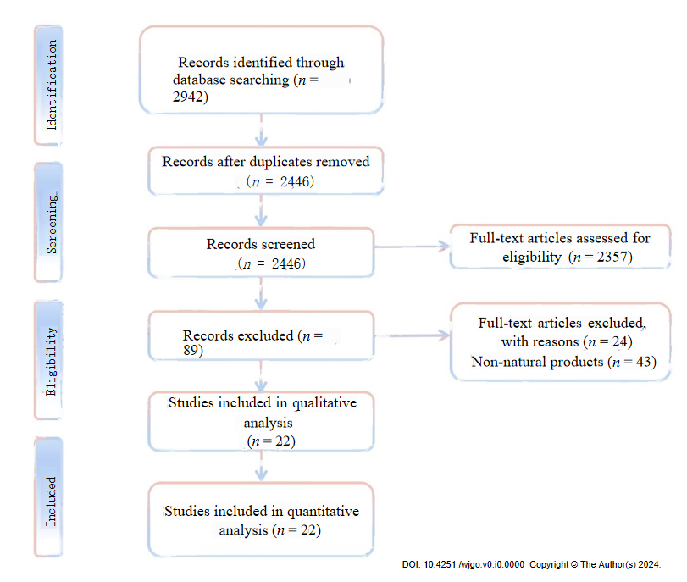
Figure 1 Flowchart of the literature search and study selection.
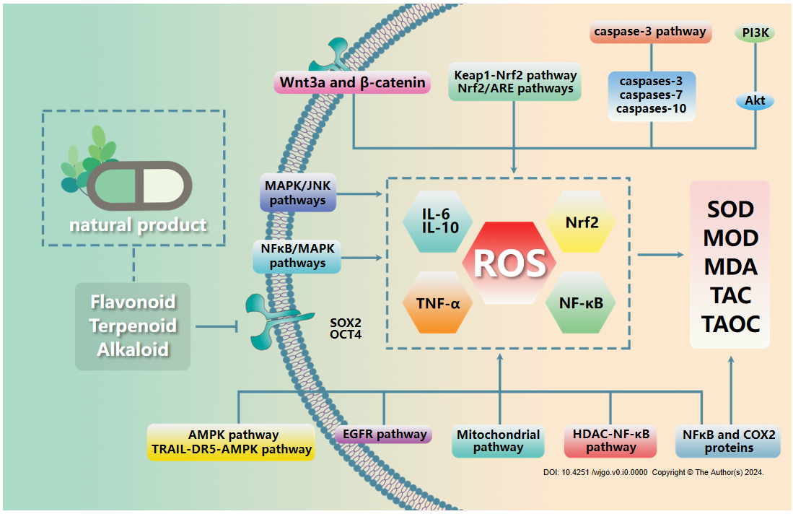
Figure 2 Features of esophageal cancer oxidative stress. SOD: Superoxide dismutase; MDA: Malondialdehyde; TAOC: Total antioxidant capacity; ROS: Reactive oxygen species; TNF-α: Tumor necrosis factor alpha.

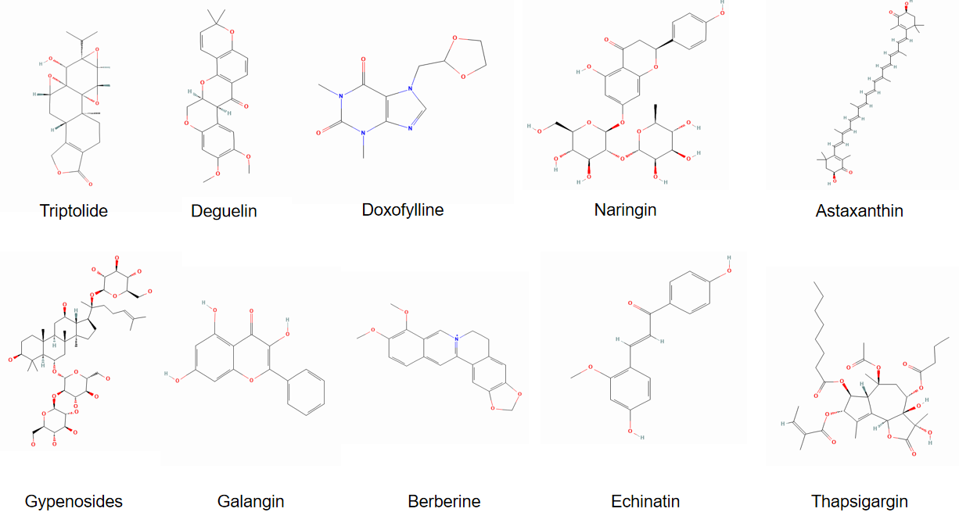
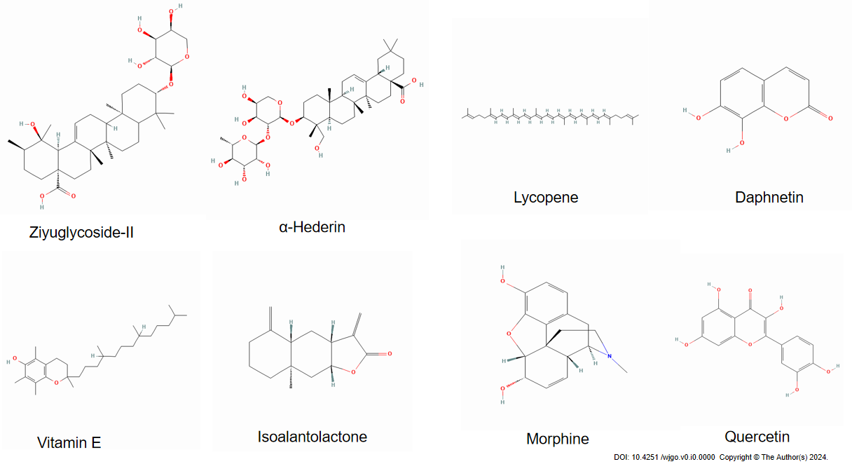
Figure 3 The structural formulae of natural products targeting oxidative stress.

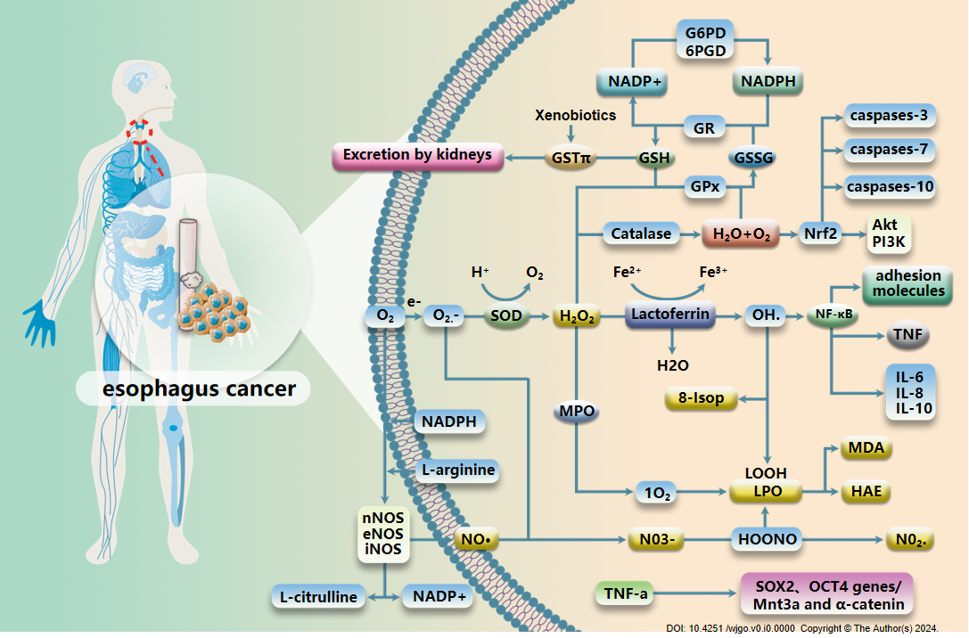
Figure 4 Actions of mechanism of natural products targeting the oxidative stress for the treatment of esophageal cancer. SOD: Superoxide dismutase; MDA: Malondialdehyde; TAOC: Total antioxidant capacity. TNF-α: Tumor necrosis factor alpha; LPO: Lipid peroxid; NADPH: Nicotinamide adenine dinucleotide phosphate hydrogen; GSH: Glutathione; GSSG: Oxidized glutathione.
Table 1 Natural compounds regulating oxidative stress in esophageal cancer therapy
Name | Source | Animal/cell model | Regulating oxidative stress mechanisms | Ref.
Triptolide | Tripterygium wilfordii | Eca-9706 esophageal cancer cells | Nrf2/ARE pathways | Liu et al^{[5]}
Deguelin | Tephrosia toxicaria， Derris trifoliata， Piper cubeba | EC-109 esophageal cancer cells | PI3K/Akt, Keap1-Nrf2 pathway | Lu et al^{[7]}
Doxofylline | Methyl xanthine | Chinese patients with esophageal cancer | TNF-α, IL-6, IL-10 | Chen et al^{[80]}
Naringin | Rutaceae | YM1 esophageal cancer stem cell xenograft tumor rats | SOX2 and OCT4 pluripotency genes | Tajaldini et al^{[11]}
Astaxanthin | Red yeast, red algae, Chlorella, shrimp, and crab shells | F344 rats | NF-κB and COX2 proteins/SOD, TAOC, MDA | Cui et al^{[12]}
Gypenosides | Pentaphyllum japonica | Eca-109 esophageal cancer cells | Inhibit the migration of SW620 and Eca109 cells | Yan et al^{[15]}
Galangin | Alpinia officinarum Hance | Eca-109，Eca9706，TE-1 esophageal cancer cells | Wnt3a and β-catenin proteins | Ren et al^{[18]}
Berberine | Coptidis rhizoma | Eca-109，Eca9706，TE-1 esophageal cancer cells | Wnt3a and β-catenin proteins | Ren et al^{[18]}
Echinatin | Liquorice | KYSE 30, KYSE 70, KYSE 410, KYSE 450, and KYSE 510 ESCC cells | MAPK/JNK pathways | Kwak et al^{[26]}
Thapsigargin | Thapsia garganica L. | EC109 and TE12 cells | TRAIL-DR5-AMPK pathway | Ma et al^{[29]}
Ziyuglycoside II | Sanguisorba officinalis L. | OE21 esophageal cancer cells | EGFR pathway | Zhong et al^{[32]}
α-Hederin | Hedera helix L., Fructus Akebiae | Human esophageal carcinoma cell line (Eca-109) | Mitochondrial pathway | Wang et al^{[35]}
Lycopene | Carotenoid | F344 rats | PPAR-γ and caspase-3 proteins | Cui et al^{[40]}
Daphnetin | Daphne Korean Nakai | YM1 esophageal cancer cells | TAC, MOD, SOD | Deng et al^{[45]}
Vitamin E | Fruits, vegetables, nuts | EAC rats | Inhibits FR activity | Abraham et al^{[46]}
Isoalantolactone | Inula helenium L. | ECA109 cell xenograft rats | Caspase-3, caspase-7, caspase-10 | Lu et al^{[52]}
Morphine | Papaver somniferum | KYAE-1， OE33 esophageal cancer cells | AMPK pathway | Zhang et al^{[57]}
Quercetin | Rutin, quercetin, hypericin, etc. | Eca109/9706 esophageal cancer cells | HDAC-NF-κB pathway | Zheng et al^{[60]}
Alpinumisoflavone | Stem bark of tung tree | Eca109， KYSE30 esophageal cancer cells | Nuclear factor erythroid 2-related factor 2 | Zhang et al^{[63]}
Black raspberries | Rosoideae | NMBA-induced esophageal squamous cell carcinoma rats | NF-κB/MAPK pathways | Shi et al^{[65]}
Moringa oleifera leaf extract | Moringa oleifera leaves | SNO cells | Smac/DIABLO protein and cleavage of PARP-1 | Tiloke et al[69]

