Name of Journal: World Journal of Gastrointestinal Oncology
Manuscript NO: 57063
Manuscript Type: ORIGINAL ARTICLE

Basic Study
Programmed death 1, ligand 1 and 2 correlated genes and their association with mutation, immune infiltration and clinical outcomes of hepatocellular carcinoma

Sheng QJ et al. PD-1, PD-L1 and PD-L2 in HCC

Qiu-Ju Sheng, Wen-Yue Tian, Xiao-Guang Dou, Chong Zhang, Yan-Wei Li, Chao Han, Yao-Xin Fan, Ping-Ping Lai, Yang Ding

Qiu-Ju Sheng, Wen-Yue Tian, Xiao-Guang Dou, Chong Zhang, Yan-Wei Li, Chao Han, Yao-Xin Fan, Ping-Ping Lai, Yang Ding, Department of Infectious Diseases, Shengjing Hospital of China Medical University, Shenyang 110022, Liaoning Province, China

Author contributions: Sheng QJ, Tian WY, and Dou XG designed the research study; Sheng QJ, Zhang C, and Ding Y performed the research; Li YW, Han C, and Fan YX contributed new reagents and analytic tools; Shen QJ, Ding Y, and Lai PP analyzed the data and wrote the manuscript; all authors have read and approved the final manuscript.

Supported by National Science and Technology Major Project, No. 2017ZX10201201 and No. 2017ZX10202202; and Liaoning Province Natural Science Foundation, No. 20180550096.

Corresponding author: Yang Ding, PhD, Professor, Department of Infectious Diseases, Shengjing Hospital of China Medical University, No. 39 Huaxiang Road, Tiexi District, Shenyang 110022, Liaoning Province, China. yding0903@sina.com

Received: June 12, 2020
Revised: August 6, 2020
Accepted: September 25, 2020
Published online: November 15, 2020

Abstract
BACKGROUND
The exact regulation network of programmed death 1 (PD-1), programmed death ligand 1 (PD-L1), and programmed death ligand 2 (PD-L2) signaling in immune escape is largely unknown. We aimed to describe the gene expression profiles related to PD-1 as well as its ligands PD-L1 and PD-L2, thus deciphering their possible biological processes in hepatocellular carcinoma (HCC).

AIM
To find the possible mechanism of function of PD-1, PD-L1, and PD-L2 in HCC.

METHODS
Based on the expression data of HCC from The Cancer Genome Atlas, the PD-1/PD-L1/PD-L2 related genes were screened by weighted correlation network analysis method and the biological processes of certain genes were enriched. Relation of PD1/PD-L1/PD-L2 with immune infiltration and checkpoints was investigated by co-expression analysis. The roles of PD-1/PD-L1/PD-L2 in determination of clinical outcome were also analyzed.

RESULTS
Mutations of calcium voltage-gated channel subunit alpha1 E, catenin beta 1, ryanodine receptor 2, tumor suppressor protein p53, and Titin altered PD-1/PD-L1/PD-L2 expression profiles in HCC. PD-1, PD-L1, and PD-L2 related genes were mainly enriched in biological procedures of T cell activation, cell adhesion, and other important lymphocyte effects. In addition, PD-1/PD-L1/PD-L2 was related with immune infiltration of CD8 T cells, cytotoxic lymphocytes, fibroblasts, and myeloid dendritic cells. Immune checkpoints of CTLA4, CD27, CD80, CD86, and CD28 were significantly related to the PD-1/PD-L1/PD-L2 axis. Clinically, PD-1 and PD-L2 expression was correlated with recurrence (P = 0.005 for both), but there was no significant correlation between their expression and HCC patient survival.

CONCLUSION
Mutations of key genes influence PD-1, PD-L1, and PD-L2 expression. PD-1, PD-L1, and PD-L2 related genes participate in T cell activation, cell adhesion, and other important lymphocyte effects. The finding that PD-1/PD-L1/PD-L2 is related to immune infiltration and other immune checkpoints would expand our understanding of promising anti-PD-1 immunotherapy.

Key Words: Programmed death 1; Programmed death ligand 1; Programmed death ligand 2; Immune; Hepatocellular carcinoma; Cancer

Citation: Sheng QJ, Tian WY, Dou XG, Zhang C, Li YW, Han C, Fan YX, Lai PP, Ding Y. Programmed death 1, ligand 1 and 2 correlated genes and their association with mutation, immune infiltration and clinical outcomes of hepatocellular carcinoma. World J Gastrointest Oncol 2020; 12(11): 1255-1271 URL: https://www.wjgnet.com/1948-5204/full/v12/i11/1255.htm DOI: https://dx.doi.org/10.4251/wjgo.v12.i11.1255

Core Tip: This study mainly investigated the relationship between programmed death 1 (PD-1)/programmed death ligand 1 (PD-L1)/programmed death ligand 2 (PD-L2) and hepatocellular carcinoma, and explored the possible mechanism of PD-1/PD-L1/PD-L2 in this malignancy.
INTRODUCTION
In the past decade, the tumor immunotherapy targeting critical immune checkpoints has tremendously changed the anti-cancer therapy^{[1]}. One of the most effective immune checkpoints is programmed death 1 (PD-1) and its ligand programmed death ligand 1 (PD-L1)^{[2]}. The interaction of PD-1 expressed on T cells with PD-L1 on the membrane of cancer cells leads to T cell exhaustion and inhibits subsequent immune reaction, thus bypassing immune surveillance^{[3,4]}. Besides, it has been found that programmed death ligand 2 (PD-L2) is another ligand that interacts with PD1, which suppresses T cell proliferation and cytokine release^{[5]}. Until now, the specific mechanism of PD-L1 and PD-L2 regulation in tumor immune escape remains largely elusive^{[6]}.
Hepatocellular carcinoma (HCC), one of the most frequent malignant tumor of the digestive tract, remains a leading cause of cancer-related death worldwide with limited therapeutic regimens^{[7,8]}. It has been proved that HCC is caused mainly by hepatitis virus infection, alcohol drinking, drug abuse, and unhealthy habits^{[9]}. In addition to surgery, chemical therapy, and liver transplantation, a number of molecular therapy regimens have been approved for treating advanced HCC, such as sorafenib and lenvatinib^{[10]}. Recently, immune checkpoint blockade therapy targeting essential immune markers including PD-1, PD-L1 and CTLA-4 has been approved for HCC in which chemotherapeutics are ineffective^{[11-13]}.
Previously, the effect and mechanisms of antibodies to PD-1 and its ligands have been investigated in HCC therapy by a number of studies. It has been reported that CD8 positive T cells promoted PD-L1 expression on HCC cells in a IFN-γ-dependent manner, which in turn leads to apoptosis of CD8(+) T cells^{[14,15]}. PD-1 expression was significantly elevated in CD8+ and CD4+ T cells obtained from HCC tissue compared with control tissue as well as blood. Antibodies to PD-L1, TIM3, or LAG3 elicit reactions of HCC-derived T cells against tumor antigens, which might become essential treatment strategies for HCC^{[16]}. In addition, PD-1 expression in HCC has also been suggested to increase tumor proliferation independently of adaptive immunity via interacting with downstream target of rapamycin effectors eukaryotic initiation factor 4E and ribosomal protein S6. Moreover, PD-1 checkpoint blockade in combination with rapamycin inhibitor resulted in more durable and synergistic tumor regression^{[17,18]}. For HCC prognosis, it was suggested that increased expression of PD-L1 instead of PD-L2 predicted an unfavorable survival in HCC patients^{[19]}.
Although satisfactory effect of anti-PD-1/PD-L1 therapy has been observed in several types of cancers, the potential complicated interaction network of PD-1/PD-L1/PD-L2 related genes in immune escape and immune surveillance remains unclear. In the present study, we analyzed the gene expression profiles associated with PD-1 and its ligands PD-L1 and PD-L2, deciphered the possible biological processes of the identified genes based on transcriptional data of HCC from The Cancer Genome Atlas (TCGA), explored the influence of PD-1 and its ligands on immune cell infiltration and other immune checkpoints, and investigated the prognostic potential of PD-1, PD-L1, and PD-L2 in HCC to explore their prognostic potential as predictors of survival.

MATERIALS AND METHODS
Analyzed datasets
The RNA expression, copy-number variants, and clinical information of HCC individuals of TCGA datasets were obtained via UCSC XENA (https://xena.ucsc.edu/). We marked gene expression data as transcripts per million reads (TPM). Clinical information included age, gender, tumor stage, recurrence, and survival time. We explored the association of PD-1, PD-L1, and PD-L2 expression with these clinical parameters.

Co-expression gene and enrichment analyses
Weighted correlation network analysis (WGCNA)^{[20]} represents a method to identify gene-gene interactions considering the weighted aspect. Co-expression genes identified by the WGCNA method can generate more specific and robust results. Through WGCNA exploration, we analyzed the genes co-expressed with PD-1, PD-L1, and PD-L2. Gene expression variation was evaluated via median absolute deviation (MAD). After identification of the interaction genes, protein-protein interaction investigation was performed to identify the interaction of genes with STRING (https://string-db.org)^{[21]}. Enrichment analysis is a method for analyzing gene expression information. It classifies genes based on the data of gene annotations to help understand the way that genes function. Using clusterprofiler, we adopted the Gene Ontology to perform enrichment analysis^{[22]}.

Association of immune regulators with PD-1/PD-L1/PD-L2
Multiple studies have reported that immune cell infiltration was related to tumor in many aspects. MCP-counter is a R package to evaluate immune infiltration of individuals^{[23]}. Considering the matrix of gene expression, it generates CD3 + T cells, B lymphocytes, cytotoxic lymphocytes, NK cells, CD8 + T cells, cells derived from monocytes, myeloid dendritic cells, neutrophils, endothelial cells, and fibroblasts for each sample. Thus, the relation of PD-1, PD-L1, and PD-L2 with immune infiltration was investigated. Since immune checkpoints were the key indicators of immune status, we then explored the relation of PD-1/PD-L1/PD-L2 with immune checkpoints.

Statistical analysis
In the present study, we performed statistical analyses via R language (https://www.r-project.org/) by using important packages. Rank sum test was adopted to assess the differential expression of PD-1, PD-L1, and PD-L2 in different groups. Spearman correlation analysis was adopted to investigate the associations of PD-1, PD-L1, and PD-L2 expression with immune infiltration and immune checkpoints. Survival analysis was then performed by Kaplan-Meier method and log-rank test. Other figures were plotted with several R packages, including ComplexHeatmap^{[24]}, circlize^{[25]}, and corrplot. The multiple tests were all corrected using BH method. P < 0.05 was considered significant.

RESULTS
PD-1/PD-L1/PD-L2 expression in different clinical subgroups
After the preliminary screening, we finally included 374 HCC patients from the TCGA database for the following analysis. Using TCGA datasets, we analyzed the PD-1/PD-L1/PD-L2 expression in different groups according to the clinical data. As shown in Figure 1A, PD-1 and PD-L2 expression was correlated with the recurrence events of HCC patients (P = 0.005), while the expression of PD-L1 showed no significant association with recurrence events (P = 0.155). Moreover, all of the three genes showed no correlation with clinical stage (P = 0.95, 0.97, and 0.475, respectively) (Figure 1B).
Survival of the HCC patients showed no significant difference in the overall survival (OS) analysis of patients with high PD-1/PD-L1/PD-L2 expression (defined as over median expression) or low PD-1/PD-L1/PD-L2 expression (defined as below median expression) with a hazard ratio (HR) of 1.01, 0.88, and 0.91, respectively (P > 0.05) (Figure 1C).

Copy number variation and mutation analysis
Copy number variants of 270 patients derived from the TCGA database were analyzed. A total of 20 mutations with high occurrence were selected (Figure 2). Expression of PD-1/PD-L1/PD-L2 was not directly correlated to the total mutation load of each patient (r = 0.02/0.07/0.04, respectively). However, after differential expression analysis, mutations of genes including calcium voltage-gated channel subunit alpha1 E (CACNA1E, P = 0.046), catenin beta 1 (CTNNB1, P = 0.020), ryanodine receptor 2 (RYR2, P = 0.030), tumor suppressor protein p53 (TP53, P = 0.016), and Titin (TTN, P = 0.014) could alter PD-1 expression; TP53 mutations (P = 0.003) correlated with high PD-L1 expression; TP53 (P = 0.041) and TTN mutations (P = 0.028) were associated with PD-L2 expression (Table 1).

Co-expression analysis of genes associated with PD-1, PD-L1, and PD-L2
Using WGCNA, we analyzed the co-expressed genes with PD-1, PD-L1, and PD-L2. The connectivity among genes had a scale-free network distribution when the value of soft thresholding power β equals to 14 (Figure 3A). Altogether 22 modules were obtained according to WGCNA analysis (Figure 3B). Among these modules, PD-1 belonged to the brown module while PD-L1 and PD-L2 belonged to the blue module. We finally obtained 371 genes that interacted with PD-1 and 747 PD-L1/PD-L2 related genes. Then, we verified the two module interaction in STRING datasets (Figure 3C). After verification, PD-L1/PD-L2 interacted with 7 genes while PD-1 showed co-expression with 39 genes (Supplementary Table 1). Finally, we selected the interacted genes for further enrichment analysis. PD-1 related genes were mainly enriched in biological processes of T cell activation, regulation of T cell activation, regulation of lymphocyte activation, leukocyte cell-cell adhesion, cytosolic calcium ion concentration, T cell receptor signaling pathway, calcium ion homeostasis, release of sequestered calcium ion into cytosol, and cellular defense response; PD-L1/PD-L2 related genes were enriched in cellular defense response, positive regulation of cell activation, regulation of cell-cell adhesion, interferon-gamma-mediated signaling pathway, negative regulation of activated T cell proliferation, interleukin-10 production, and response to hyperoxia (Figure 3D and Table 2).

PD-1/PD-L1/ PD-L2 expression and immune infiltration
Using MCP-counter, we evaluated the profiles of immune infiltration among various subtypes and stages of HCC (Figure 4). The heatmap in Figure 4 (middle) shows the associations of PD-1, PD-L1, and PD-L2 with immune cell populations according to analysis of the transcriptomic data. The results indicated that PD-1 was mainly related with CD8 T cells (r = 0.608) and cytotoxic lymphocytes (r = 0.60); PD-L1 was mainly related with fibroblasts (r = 0.671); PD-L2 showed a significant correlation with myeloid dendritic cells (r = 0.805). Moreover, we also presented the correlation among different infiltrated immune cell types. As shown in the right correlation heatmap in Figure 4, CD8 T cells were associated with cytotoxic lymphocytes (r = 0.93).

PD-1/PD-L1/PD-L2 expression and immune checkpoints
As previous reported, the immune checkpoints of the PD1/PD-L1/PDL2 regulatory axis mainly included CD28, CD80, CD86, CTLA4, RGMB, CD58, CD27, CD70, HLA-A, and CD74. We then analyzed the correlation between PD-1/PD-L1/PD-L2 expression and these important immune checkpoints. As shown in Figure 5 and Table 3, PD-1 was mainly associated with CTLA4 (r = 0.828) and CD27 (r = 0.855), PD-L1 correlated with CD80 (r = 0.675) and CD86 (r = 0.695), and PD-L2 correlated with CD86 (r = 0.797) and CD28 (r = 0.714).

DISCUSSION
Previous clinical trials indicated that immune checkpoint blockade therapies demonstrated satisfactory curative effect for multiple types of cancer, with persistent responses and acceptable toxicity^{[3]}. However, only part of individuals who received antibody immunotherapy greatly benefit from the treatment^{[26]}. It is therefore urgent to unravel the underlying signaling pathway of important immune checkpoints such as PD-1 and its ligands PD-L1 and PD-L2 to improve the therapeutic sensitivity. Here, we presented an integrative analysis of PD-1, PD-L1, and PD-L2 based on the HCC data from TCGA. We identified potential molecular and genetic alterations correlating with the PD-1/PD-L1/PD-L2 and revealed their biological functions. The relation of PD-1/PD-L1/PD-L2 with immune infiltration and HCC survival were also explored to elucidate their role as prognostic biomarkers.
We first described the PD-1/PD-L1/PD-L2 expression profiles in different clinical subtypes. The results indicated that PD-1 and PD-L2 expression was associated with the recurrence events of HCC patients. However, none of the three genes showed a significant correlation with clinical stage. In a previous research of 217 HCC patients, PD-L1 expression demonstrated a significant relation with multiple markers of cancer aggressiveness including satellite nodules, macrovascular invasion, microvascular invasion, and poor differentiation^{[27]}. Besides, PD-1 and PD-L1 expression was upregulated in HCC tissues compared with adjacent normal tissues, which was positively related with the clinical stage and lymph node metastasis, but negatively related with the survival of HCC patients^{[28]}. These results suggested that the PD-1/PD-L1/PD-L2 axis might correlate with multiple clinical parameters of HCC.
Prognostic analysis of the HCC patients showed no significant association between PD-1/PD-L1/PD-L2 expression and the OS of HCC patients. In a study of 85 HCC patients, PD-L1 or PD-L2 expression was associated with a poor survival according to immunohistochemical investigation^{[29-31]}. Elevated PD-L1 expression has been reported to be an independent adverse prognosis predictor of disease-free survival in addition to previously reported factors^{[32]}. One study performing immunohistochemical staining of 136 HCC tissues demonstrated that PD-L1 high expression exhibited a significant correlation with clinical and pathological parameters indicating worse HCC progression and prognosis^{[33]}. In another study of PD-L1 in HCC, however, PD-L1 expression was inversely correlated with P53 and associated with a longer survival of patients with HCC^{[34]}. There was also a study reporting that PD-L1 expression failed to have a markedly significant prognostic association with survival in 143 patients with HCC^{[35]}. According to the analysis of TCGA data and previous studies on PD-1/PD-L1/PD-L2, the relation of PD-1/PD-L1/PD-L2 expression with HCC prognosis still requires to be confirmed in future studies with large samples.
Based on the copy number variations and mutation analysis, a total of 20 mutations with high occurrence were selected. Expression of PD-1/PD-L1/PD-L2 was not directly correlated to the total mutation load of each patient. After differential expression analysis, however, mutations of genes including CACNA1E, CTNNB1, RYR2, TP53, and TTN could alter PD-1 expression; TP53 mutations correlated with high PD-L1 expression, and TP53 and TTN mutations were associated with PD-L2 expression. Interestingly, TP53 mutation significantly increased the expression of PD-1, PD-L1, and PD-L2, suggesting a probable molecular link between TP53 and PD-1 axis regulation. Admittedly, change of PD-1-PD-L1 immune regulator and p53 alternation promote cancer development in activated B-cell diffuse large B-cell lymphomas^{[36]}. In addition, the prognosis of Kras-p53-associated lung cancer is regulated by MEK and PD-1/PD-L1 immune checkpoint^{[37-40]}. The underlying mechanisms of critical mutations such as TP53, TTN, and CTNNB1 mutations in modulating PD-1 signaling might provide novel strategies for immunotherapies. In the future, we may be able to perform different immunotherapies by stratifying patients based on the mutation types of these genes.
Using WGCNA, we next analyzed the co-expressed genes with PD-1, PD-L1, and PD-L2. After verification, PD-L1/PD-L2 interacted with 7 genes while PD-1 showed co-expression with 39 genes. PD-1 related genes were mainly enriched in T cell activation, lymphocyte activation, leukocyte cell-cell adhesion, cytosolic calcium ion concentration, T cell receptor signaling pathway, calcium ion homeostasis, release of sequestered calcium ion into cytosol, and cellular defense response; PD-L1/PD-L2 related genes were enriched in cellular defense response, cell activation, cell-cell adhesion, interferon-gamma-mediated signaling pathway, negative regulation of activated T cell proliferation, interleukin-10 production, and response to hyperoxia. As indicated by the enrichment analysis, PD-1/PD-L1/PD-L2 signaling is a key regulator of T cell activation and other important lymphocyte functions, which was consistent with the results of multiple previous investigations^{[41-44]}. It is worthy elucidating the immune modulating mechanisms of PD-1 axis in the future to unravel its specific role in cancer immunity.
Immune cell infiltration reflects the immune microenvironment around the tumor tissues and is reportedly correlated with outcome of cancer progression. We subsequently evaluated PD-1/PD-L1/PD-L2 expression and immune infiltration in HCC, the results of which suggested that PD-1 was correlated with CD8 T cells and cytotoxic lymphocytes, PD-L1 was related with fibroblasts, and PD-L2 was significantly correlated with myeloid dendritic cells. It has been reported that CD8+ cytotoxic T lymphocytes greatly increase PD-L1 expression on cancer cell lines, and PD-L1 expression and CD8+ T-cell density showed a significant positive correlation in HCC patients^{[45]}. Besides, PD-1 and PD-L1 expression was suggested to be significantly related to high levels of CD8+ tumor-infiltrating lymphocytes (TILs)^{[32,44]}. In addition to T lymphocytes, PD-1 expression on dendritic cells has been found to restrict CD8+ T cell function and anti-cancer immunity^{[46]}. Understanding the correlation of PD-1/PD-L1/PD-L2 immune checkpoints with immune cell infiltration might greatly benefit the tumor immunotherapy targeting PD-1 signaling. After analyzing the immune checkpoints of PD1/PD-L1/PDL2 regulatory axis including CD28, CD74, CD86, CD58, CTLA4, RGMB, CD70, CD27, CD80, and HLA-A, we suggested that PD-1 was mainly associated with CD27 and CTLA4, PD-L1 related with CD86 as well as CD80, and PD-L2 related with CD28 and CD86. The combined inhibition of different immune checkpoints might generate more satisfactory clinical outcome. Thus, future studies focusing on PD-1/PD-L1/PD-L2 related immune checkpoints including CTLA4, CD27, CD80, CD86, and CD28 are required to obtain an optimal immunotherapy effect.

CONCLUSION
Mutations of CACNA1E, CTNNB1, RYR2, TP53, and TTN alter PD-1/PD-L1/PD-L2 expression profiles in HCC. The limitation on the effect of mutations on gene expression is that only statistical differences have been observed so far. We will conduct follow-up research on its detailed mechanism. PD-1/PD-L1/PD-L2 related genes are enriched in the biological processes of T cell activation, cell-cell adhesion, and other important lymphocyte effects. In addition, PD-1/PD-L1/PD-L2 is related to immune infiltration of CD8 T cells, cytotoxic lymphocytes, fibroblasts, and myeloid dendritic cells. Immune checkpoints CTLA4, CD27, CD80, CD86, and CD28 are significantly associated with PD-1/PD-L1/PD-L2 axis. Clinically, PD-1 and PD-L2 expression is correlated with recurrence, but there is no significant correlation between PD-1/PD-L1/PD-L2 expression and survival of HCC patients.

ARTICLE HIGHLIGHTS
Research background
The potential regulating network of programmed death 1 (PD-1)/programmed death ligand 1 (PD-L1)/programmed death ligand 2 (PD-L2) signaling in the immune escape is unclear. We aimed to describe the gene expression profiles related with PD-1 and its ligands PD-L1 and PD-L2 to decipher their possible biological processes in hepatocellular carcinoma (HCC).

Research motivation
Although satisfactory effect of anti-PD-1/PD-L1 therapy has been observed in several types of cancers, the potential complicated interaction network of PD-1/PD-L1/PD-L2 related genes in immune escape and immune surveillance still remains unclear.

Research objectives
The aim of the study was to explore the possible mechanism of function of PD-1, PD-L1, and PD-L2 in HCC.

Research methods
Based on transcriptional data of HCC from TCGA, PD-1/PD-L1/PD-L2 related genes were screened by weighted correlation network analysis and the biological processes of certain genes were enriched. The relation of PD1/PD-L1/PD-L2 expression with immune infiltration and checkpoints was investigated by co-expression analysis. The role of PD-1/PD-L1/PD-L2 in the determination of clinical outcome was also analyzed.

Research results
Mutations of calcium voltage-gated channel subunit alpha1 E (CACNA1E), catenin beta 1 (CTNNB1), ryanodine receptor 2 (RYR2), tumor suppressor protein p53 (TP53), and Titin (TTN) altered PD-1/PD-L1/PD-L2 expression profiles in HCC. PD-1/PD-L1/PD-L2 related genes were mainly enriched in biological processes of T cell activation, cell-cell adhesion, and other important lymphocyte effects. In addition, PD-1/PD-L1/PD-L2 was related with immune infiltration of CD8 T cells, cytotoxic lymphocytes, fibroblasts, and myeloid dendritic cells. Immune checkpoints CTLA4, CD27, CD80, CD86, and CD28 were significantly correlated with PD-1/PD-L1/PD-L2 axis. Clinically, PD-1 and PD-L2 expression was correlated with recurrence (P = 0.005 for both), but there was no significant correlation between PD-1/PD-L1/PD-L2 expression and HCC patient survival.

Research conclusions
Mutations of key genes influence PD-1/PD-L1/PD-L2 expression. PD-1/PD-L1/PD-L2 related genes participate in T cell activation, cell-cell adhesion, and other important lymphocyte effects. Correlation of PD-1/PD-L1/PD-L2 with immune infiltration and other immune checkpoints would expand our understanding of promising anti-PD-1 immunotherapy.

Research perspectives
Mutations of CACNA1E, CTNNB1, RYR2, TP53, and TTN altered PD-1/PD-L1/PD-L2 expression profiles in HCC. The limitation on the effect of mutations on gene expression is that only statistical differences have been observed so far. We will conduct follow-up research on its detailed mechanism. PD-1/PD-L1/PD-L2 related genes were enriched in biological processes of T cell activation, cell-cell adhesion, and other important lymphocyte effects. In addition, PD-1/PD-L1/PD-L2 was related with immune infiltration of CD8 T cells, cytotoxic lymphocytes, fibroblasts, and myeloid dendritic cells. Immune checkpoints CTLA4, CD27, CD80, CD86, and CD28 were significantly correlated with PD-1/PD-L1/PD-L2 axis. Clinically, PD-1 and PD-L2 expression was correlated with recurrence, but there was no significant correlation between PD-1/PD-L1/PD-L2 and survival of HCC patients.

REFERENCES
1 Yang Y. Cancer immunotherapy: harnessing the immune system to battle cancer. J Clin Invest 2015; 125: 3335-3337 [PMID: 26325031 DOI: 10.1172/JCI83871]
2 Zak KM, Grudnik P, Magiera K, Dömling A, Dubin G, Holak TA. Structural Biology of the Immune Checkpoint Receptor PD-1 and Its Ligands PD-L1/PD-L2. Structure 2017; 25: 1163-1174 [PMID: 28768162 DOI: 10.1016/j.str.2017.06.011]
3 Alsaab HO, Sau S, Alzhrani R, Tatiparti K, Bhise K, Kashaw SK, Iyer AK. PD-1 and PD-L1 Checkpoint Signaling Inhibition for Cancer Immunotherapy: Mechanism, Combinations, and Clinical Outcome. Front Pharmacol 2017; 8: 561 [PMID: 28878676 DOI: 10.3389/fphar.2017.00561]
4 Iwai Y, Hamanishi J, Chamoto K, Honjo T. Cancer immunotherapies targeting the PD-1 signaling pathway. J Biomed Sci 2017; 24: 26 [PMID: 28376884 DOI: 10.1186/s12929-017-0329-9]
5 Keir ME, Butte MJ, Freeman GJ, Sharpe AH. PD-1 and its ligands in tolerance and immunity. Annu Rev Immunol 2008; 26: 677-704 [PMID: 18173375 DOI: 10.1146/annurev.immunol.26.021607.090331]
6 Dyck L, Mills KHG. Immune checkpoints and their inhibition in cancer and infectious diseases. Eur J Immunol 2017; 47: 765-779 [PMID: 28393361 DOI: 10.1002/eji.201646875]
7 Sia D, Villanueva A, Friedman SL, Llovet JM. Liver Cancer Cell of Origin, Molecular Class, and Effects on Patient Prognosis. Gastroenterology 2017; 152: 745-761 [PMID: 28043904 DOI: 10.1053/j.gastro.2016.11.048]
8 Yu LX, Schwabe RF. The gut microbiome and liver cancer: mechanisms and clinical translation. Nat Rev Gastroenterol Hepatol 2017; 14: 527-539 [PMID: 28676707 DOI: 10.1038/nrgastro.2017.72]
9 Allaire M, Nault JC. Advances in management of hepatocellular carcinoma. Curr Opin Oncol 2017; 29: 288-295 [PMID: 28509806 DOI: 10.1097/CCO.0000000000000378]
10 Hartke J, Johnson M, Ghabril M. The diagnosis and treatment of hepatocellular carcinoma. Semin Diagn Pathol 2017; 34: 153-159 [PMID: 28108047 DOI: 10.1053/j.semdp.2016.12.011]
11 Iñarrairaegui M, Melero I, Sangro B. Immunotherapy of Hepatocellular Carcinoma: Facts and Hopes. Clin Cancer Res 2018; 24: 1518-1524 [PMID: 29138342 DOI: 10.1158/1078-0432.CCR-17-0289]
12 Kudo M. Immune Checkpoint Inhibition in Hepatocellular Carcinoma: Basics and Ongoing Clinical Trials. Oncology 2017; 92 Suppl 1: 50-62 [PMID: 28147363 DOI: 10.1159/000451016]
13 Abad-Belando R, Varas-Lorenzo MJ, Pons-Vilardell C, Puig-Torrus X, Pla-Alcaraz M, Monleón-Getino A, Sánchez-Vizcaíno-Mengual E. Canalization technique to obtain deep tissue biopsy of gastrointestinal subepithelial tumors as an alternative to conventional known techniques. Endosc Ultrasound 2018; 7: 184-190 [PMID: 28707653 DOI: 10.4103/eus.eus_13_17]
14 Shi F, Shi M, Zeng Z, Qi RZ, Liu ZW, Zhang JY, Yang YP, Tien P, Wang FS. PD-1 and PD-L1 upregulation promotes CD8(+) T-cell apoptosis and postoperative recurrence in hepatocellular carcinoma patients. Int J Cancer 2011; 128: 887-896 [PMID: 20473887 DOI: 10.1002/ijc.25397]
15 Adler DG. Single-operator experience with a 20-mm diameter lumen apposing metal stent to treat patients with large pancreatic fluid collections from pancreatic necrosis. Endosc Ultrasound 2018; 7: 422-423 [PMID: 30531025 DOI: 10.4103/eus.eus_39_18]
16 Zhou G, Sprengers D, Boor PPC, Doukas M, Schutz H, Mancham S, Pedroza-Gonzalez A, Polak WG, de Jonge J, Gaspersz M, Dong H, Thielemans K, Pan Q, IJzermans JNM, Bruno MJ, Kwekkeboom J. Antibodies Against Immune Checkpoint Molecules Restore Functions of Tumor-Infiltrating T Cells in Hepatocellular Carcinomas. Gastroenterology 2017; 153: 1107-1119.e10 [PMID: 28648905 DOI: 10.1053/j.gastro.2017.06.017]
17 Li H, Li X, Liu S, Guo L, Zhang B, Zhang J, Ye Q. Programmed cell death-1 (PD-1) checkpoint blockade in combination with a mammalian target of rapamycin inhibitor restrains hepatocellular carcinoma growth induced by hepatoma cell-intrinsic PD-1. Hepatology 2017; 66: 1920-1933 [PMID: 28732118 DOI: 10.1002/hep.29360]
18 Adler DG. EUS-guided gallbladder drainage: Current status and future prospects. Endosc Ultrasound 2018; 7: 1-3 [PMID: 29451163 DOI: 10.4103/eus.eus_3_18]
19 Ma LJ, Feng FL, Dong LQ, Zhang Z, Duan M, Liu LZ, Shi JY, Yang LX, Wang ZC, Zhang S, Ding ZB, Ke AW, Cao Y, Zhang XM, Zhou J, Fan J, Wang XY, Gao Q. Clinical significance of PD-1/PD-Ls gene amplification and overexpression in patients with hepatocellular carcinoma. Theranostics 2018; 8: 5690-5702 [PMID: 30555574 DOI: 10.7150/thno.28742]
20 Langfelder P, Horvath S. WGCNA: an R package for weighted correlation network analysis. BMC Bioinformatics 2008; 9: 559 [PMID: 19114008 DOI: 10.1186/1471-2105-9-559]
21 Szklarczyk D, Morris JH, Cook H, Kuhn M, Wyder S, Simonovic M, Santos A, Doncheva NT, Roth A, Bork P, Jensen LJ, von Mering C. The STRING database in 2017: quality-controlled protein-protein association networks, made broadly accessible. Nucleic Acids Res 2017; 45: D362-D368 [PMID: 27924014 DOI: 10.1093/nar/gkw937]
22 The Gene Ontology Consortium.. Expansion of the Gene Ontology knowledgebase and resources. Nucleic Acids Res 2017; 45: D331-D338 [PMID: 27899567 DOI: 10.1093/nar/gkw1108]
23 Becht E, Giraldo NA, Lacroix L, Buttard B, Elarouci N, Petitprez F, Selves J, Laurent-Puig P, Sautès-Fridman C, Fridman WH, de Reyniès A. Estimating the population abundance of tissue-infiltrating immune and stromal cell populations using gene expression. Genome Biol 2016; 17: 218 [PMID: 27765066 DOI: 10.1186/s13059-016-1070-5]
24 Gu Z, Eils R, Schlesner M. Complex heatmaps reveal patterns and correlations in multidimensional genomic data. Bioinformatics 2016; 32: 2847-2849 [PMID: 27207943 DOI: 10.1093/bioinformatics/btw313]
25 Gu Z, Gu L, Eils R, Schlesner M, Brors B. circlize Implements and enhances circular visualization in R. Bioinformatics 2014; 30: 2811-2812 [PMID: 24930139 DOI: 10.1093/bioinformatics/btu393]
26 Curry WT, Lim M. Immunomodulation: checkpoint blockade etc. Neuro Oncol 2015; 17 Suppl 7: vii26-vii31 [PMID: 26516223 DOI: 10.1093/neuonc/nov174]
27 Calderaro J, Rousseau B, Amaddeo G, Mercey M, Charpy C, Costentin C, Luciani A, Zafrani ES, Laurent A, Azoulay D, Lafdil F, Pawlotsky JM. Programmed death ligand 1 expression in hepatocellular carcinoma: Relationship With clinical and pathological features. Hepatology 2016; 64: 2038-2046 [PMID: 27359084 DOI: 10.1002/hep.28710]
28 Long J, Qu T, Pan XF, Tang X, Wan HH, Qiu P, Xu YH. Expression of programmed death ligand-1 and programmed death 1 in hepatocellular carcinoma and its clinical significance. J Cancer Res Ther 2018; 14: S1188-S1192 [PMID: 30539869 DOI: 10.4103/0973-1482.204850]
29 Jung HI, Jeong D, Ji S, Ahn TS, Bae SH, Chin S, Chung JC, Kim HC, Lee MS, Baek MJ. Overexpression of PD-L1 and PD-L2 Is Associated with Poor Prognosis in Patients with Hepatocellular Carcinoma. Cancer Res Treat 2017; 49: 246-254 [PMID: 27456947 DOI: 10.4143/crt.2016.066]
30 Adler DG, Mallery S, Amateau S, Nieto J, Taylor LJ, Siddiqui A. A pilot study of a 20-mm lumen-apposing metal stent to treat pancreatic fluid collections: First reported multicenter use of a new device. Endosc Ultrasound 2019; 8: 136-138 [PMID: 31006708 DOI: 10.4103/eus.eus_58_18]
31 Adler DG, Muthusamy VR, Ehrlich DS, Parasher G, Thosani NC, Chen A, Buscaglia JM, Appannagari A, Quintero E, Aslanian H, Taylor LJ, Siddiqui A. A multicenter evaluation of a new EUS core biopsy needle: Experience in 200 patients. Endosc Ultrasound 2019; 8: 99-104 [PMID: 29623911 DOI: 10.4103/eus.eus_53_17]
32 Chang H, Jung W, Kim A, Kim HK, Kim WB, Kim JH, Kim BH. Expression and prognostic significance of programmed death protein 1 and programmed death ligand-1, and cytotoxic T lymphocyte-associated molecule-4 in hepatocellular carcinoma. APMIS 2017; 125: 690-698 [PMID: 28493410 DOI: 10.1111/apm.12703]
33 Hu K, Wang ZM, Li JN, Zhang S, Xiao ZF, Tao YM. CLEC1B Expression and PD-L1 Expression Predict Clinical Outcome in Hepatocellular Carcinoma with Tumor Hemorrhage. Transl Oncol 2018; 11: 552-558 [PMID: 29525632 DOI: 10.1016/j.tranon.2018.02.010]
34 Kan G, Dong W. The expression of PD-L1 APE1 and P53 in hepatocellular carcinoma and its relationship to clinical pathology. Eur Rev Med Pharmacol Sci 2015; 19: 3063-3071 [PMID: 26367730]
35 Pei R, Zhang W, Wang S, Huang X, Zou Y. Prognostic Value of PD-L1 in Patients with Hepatocellular Carcinoma. Clin Lab 2019; 65: [PMID: 31115210 DOI: 10.7754/Clin.Lab.2018.180839]
36 Pascual M, Mena-Varas M, Robles EF, Garcia-Barchino MJ, Panizo C, Hervas-Stubbs S, Alignani D, Sagardoy A, Martinez-Ferrandis JI, Bunting KL, Meier S, Sagaert X, Bagnara D, Guruceaga E, Blanco O, Celay J, Martínez-Baztan A, Casares N, Lasarte JJ, MacCarthy T, Melnick A, Martinez-Climent JA, Roa S. PD-1/PD-L1 immune checkpoint and p53 Loss facilitate tumor progression in activated B-cell diffuse large B-cell lymphomas. Blood 2019; 133: 2401-2412 [PMID: 30975638 DOI: 10.1182/blood.2018889931]
37 Lee JW, Zhang Y, Eoh KJ, Sharma R, Sanmamed MF, Wu J, Choi J, Park HS, Iwasaki A, Kaftan E, Chen L, Papadimitrakopoulou V, Herbst RS, Koo JS. The Combination of MEK Inhibitor With Immunomodulatory Antibodies Targeting Programmed Death 1 and Programmed Death Ligand 1 Results in Prolonged Survival in Kras/p53-Driven Lung Cancer. J Thorac Oncol 2019; 14: 1046-1060 [PMID: 30771521 DOI: 10.1016/j.jtho.2019.02.004]
38 Ang TL, Li JW, Kwek ABE, Thurairajah PH, Wang LM. The difference in histological yield between 19G EUS-FNA and EUS-fine-needle biopsy needles. Endosc Ultrasound 2019; 8: 255-260 [PMID: 31115385 DOI: 10.4103/eus.eus_12_19]
39 Antonini F, Delconte G, Fuccio L, De Nucci G, Fabbri C, Armellini E, Frazzoni L, Fornelli A, Magarotto A, Mandelli E, Occhipinti P, Masci E, Manes G, Macarri G. EUS-guided tissue sampling with a 20-gauge core biopsy needle for the characterization of gastrointestinal subepithelial lesions: A multicenter study. Endosc Ultrasound 2019; 8: 105-110 [PMID: 29770781 DOI: 10.4103/eus.eus_1_18]
40 Bhatia V, Dhir V. Radial EUS imaging of the liver: A pictorial guide. Endosc Ultrasound 2019; 8: 76-81 [PMID: 31006705 DOI: 10.4103/eus.eus_17_19]
41 Cubillos-Zapata C, Avendaño-Ortiz J, Hernandez-Jimenez E, Toledano V, Casas-Martin J, Varela-Serrano A, Torres M, Almendros I, Casitas R, Fernández-Navarro I, Garcia-Sanchez A, Aguirre LA, Farre R, López-Collazo E, García-Rio F. Hypoxia-induced PD-L1/PD-1 crosstalk impairs T-cell function in sleep apnoea. Eur Respir J 2017; 50: [PMID: 29051270 DOI: 10.1183/13993003.00833-2017]
42 Hui E, Cheung J, Zhu J, Su X, Taylor MJ, Wallweber HA, Sasmal DK, Huang J, Kim JM, Mellman I, Vale RD. T cell costimulatory receptor CD28 is a primary target for PD-1-mediated inhibition. Science 2017; 355: 1428-1433 [PMID: 28280247 DOI: 10.1126/science.aaf1292]
43 Seifert AM, Zeng S, Zhang JQ, Kim TS, Cohen NA, Beckman MJ, Medina BD, Maltbaek JH, Loo JK, Crawley MH, Rossi F, Besmer P, Antonescu CR, DeMatteo RP. PD-1/PD-L1 Blockade Enhances T-cell Activity and Antitumor Efficacy of Imatinib in Gastrointestinal Stromal Tumors. Clin Cancer Res 2017; 23: 454-465 [PMID: 27470968 DOI: 10.1158/1078-0432.CCR-16-1163]
44 Adler DG, Gabr M, Taylor LJ, Witt B, Pleskow D. Initial report of transesophageal EUS-guided intraparenchymal lung mass core biopsy: Findings and outcomes in two cases. Endosc Ultrasound 2018; 7: 413-417 [PMID: 29786035 DOI: 10.4103/eus.eus_13_18]
45 Huang CY, Wang Y, Luo GY, Han F, Li YQ, Zhou ZG, Xu GL. Relationship Between PD-L1 Expression and CD8+ T-cell Immune Responses in Hepatocellular Carcinoma. J Immunother 2017; 40: 323-333 [PMID: 29028787 DOI: 10.1097/CJI.0000000000000187]
46 Lim TS, Chew V, Sieow JL, Goh S, Yeong JP, Soon AL, Ricciardi-Castagnoli P. PD-1 expression on dendritic cells suppresses CD8⁺ T cell function and antitumor immunity. Oncoimmunology 2016; 5: e1085146 [PMID: 27141339 DOI: 10.1080/2162402x.2015.1085146]

Footnotes
Institutional review board statement: This research did not involve any human or animal experiments.

Conflict-of-interest statement: All of the authors declare that there is no conflict of interest to disclose.

Data sharing statement: No additional data are available.

Open-Access: This article is an open-access article that was selected by an in-house editor and fully peer-reviewed by external reviewers. It is distributed in accordance with the Creative Commons Attribution NonCommercial (CC BY-NC 4.0) license, which permits others to distribute, remix, adapt, build upon this work non-commercially, and license their derivative works on different terms, provided the original work is properly cited and the use is non-commercial. See: http://creativecommons.org/Licenses/by-nc/4.0/

Manuscript source: Unsolicited manuscript

Peer-review started: June 12, 2020
First decision: July 21, 2020
Article in press: September 25, 2020

Specialty type: Oncology
Country/Territory of origin: China
Peer-review report’s scientific quality classification
Grade A (Excellent): A
Grade B (Very good): B
Grade C (Good): 0
Grade D (Fair): 0
Grade E (Poor): 0

P-Reviewer: Emi M, Lucchesi A S-Editor: Gao CC L-Editor: Wang TQ P-Editor: Li JH

Figure Legends
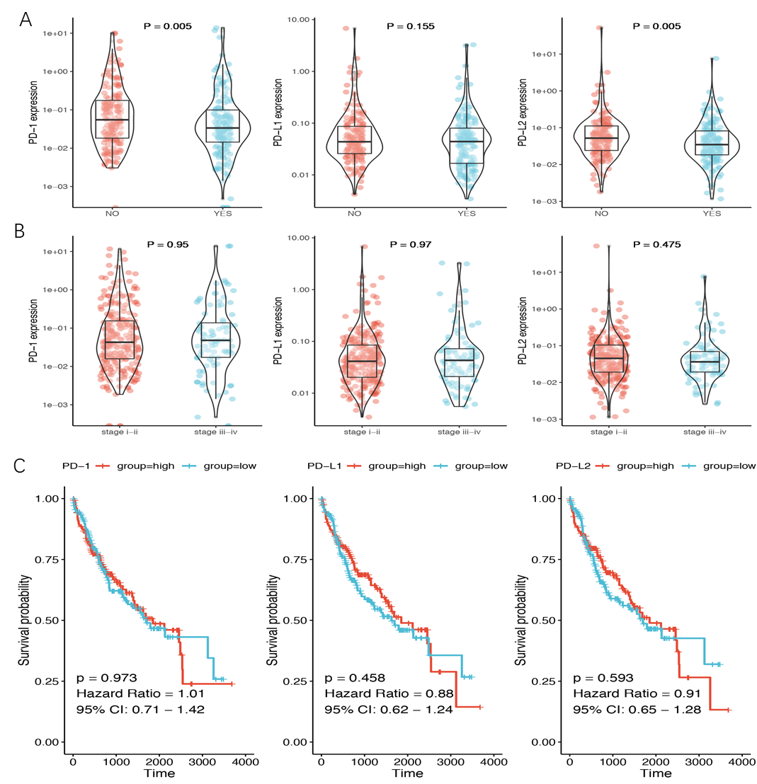
Figure 1 Relationship between gene expression and clinical data. A: Programmed death 1 (PD-1)/programmed death ligand 1 (PD-L1)/programmed death ligand 2 (PD-L2) expression in recurrence and non-recurrence groups; B: PD-1/PD-L1/PD-L2 expression in stage I-II and stage III-IV groups; C: Prognostic analysis of PD-1/PD-L1/PD-L2 in hepatocellular carcinoma. The median of the expression value was selected as the cut-off point. KM plotter was used for prognosis analysis. PD-1: Programmed death 1; PD-L1: Programmed death ligand 1; PD-L2: Programmed death ligand 2; CI: Confidence interval.
Figure 2 Co-mutation plot of highly frequent mutations in liver cancer. Mutational frequencies are given in a bar plot beside the co-mutation plot. Overall mutation load as the total number of mutations in each patient is presented in the top barplot. Programmed death 1/programmed death ligand 1/programmed death ligand 2 expression is illustrated in a heatmap in the panel below. Clinical data including age, stage, and recurrence event are shown in the top panel. TP53: Tumor suppressor protein p53; CTNNB1: Catenin beta 1; TTN: TITIN; CACNA1E: Calcium voltage-gated channel subunit alpha1 E; RYR: Ryanodine receptor; PD-1: Programmed death 1; PD-L1: Programmed death ligand 1; PD-L2: Programmed death ligand 2.
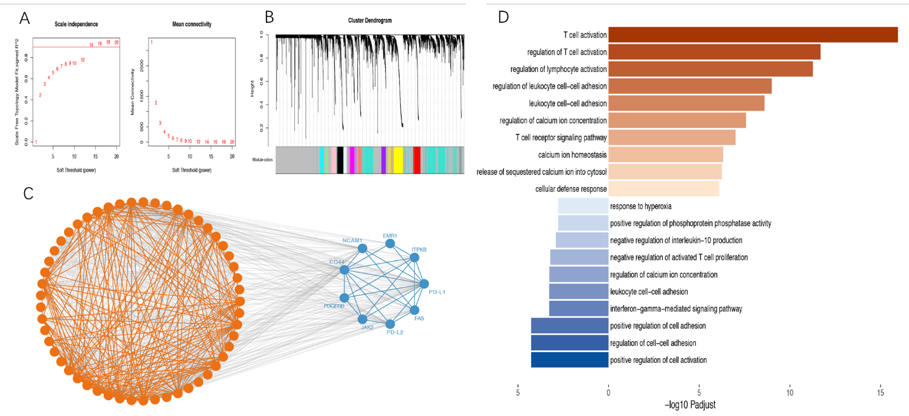
Figure 3 Co-expression analysis of genes associated with programmed death 1, programmed death ligand 1, and programmed death ligand 2. The weighted correlation network analysis (WGCNA) and string datasets were used to select the co-expressed genes. We used WGCNA to identify gene-related modules, and then used STRING database to determine the true interaction of genes. A: Soft threshold selected in the WGCNA analysis. We selected the threshold for R2 to exceed 0.9 for the first time as the soft threshold, and for subsequent analysis 14 was selected as the threshold; B: Distribution of genes in WGCNA; C: Protein-protein interaction of the co-expression genes in the STRING datasets. We put the module genes obtained by WGCNA analysis into the STRING database for protein interaction analysis; D: Biological processes of Gene Ontology (GO) analysis in the co-expression gene. The top ten enrichment results are used for visualization. PD-L1: Programmed death ligand 1; PD-L2: Programmed death ligand 2.
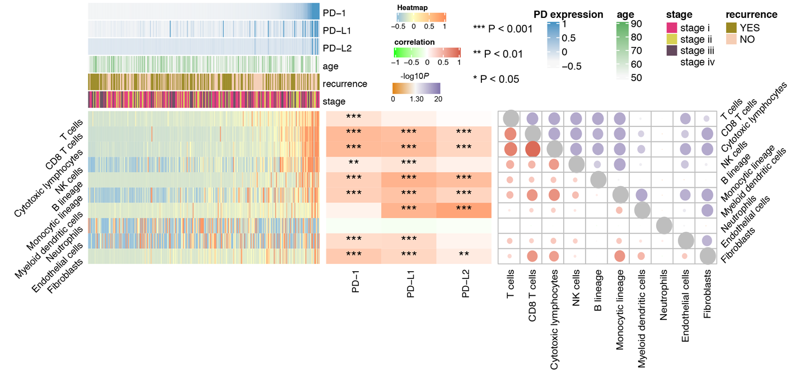
Figure 4 Programmed death 1/programmed death ligand 1/programmed death ligand 2 expression and immune infiltration. The score of immune infiltration is calculated based on the MCP-counter algorithm. The left heatmap shows the immune infiltration score in hepatocellular carcinoma. The lower part is the immune infiltration score in each sample. The upper part is the gene expression of each sample and some common clinical features. The middle heatmap shows the relationship between gene expression and immune infiltration, and the right heatmap shows the relation among immune infiltration. The lower part is the interaction coefficient, and the upper part is the -log10 (P value) of the correlation analysis. PD-1: Programmed death 1; PD-L1: Programmed death ligand 1; PD-L2: Programmed death ligand 2; NK: Natural killer.
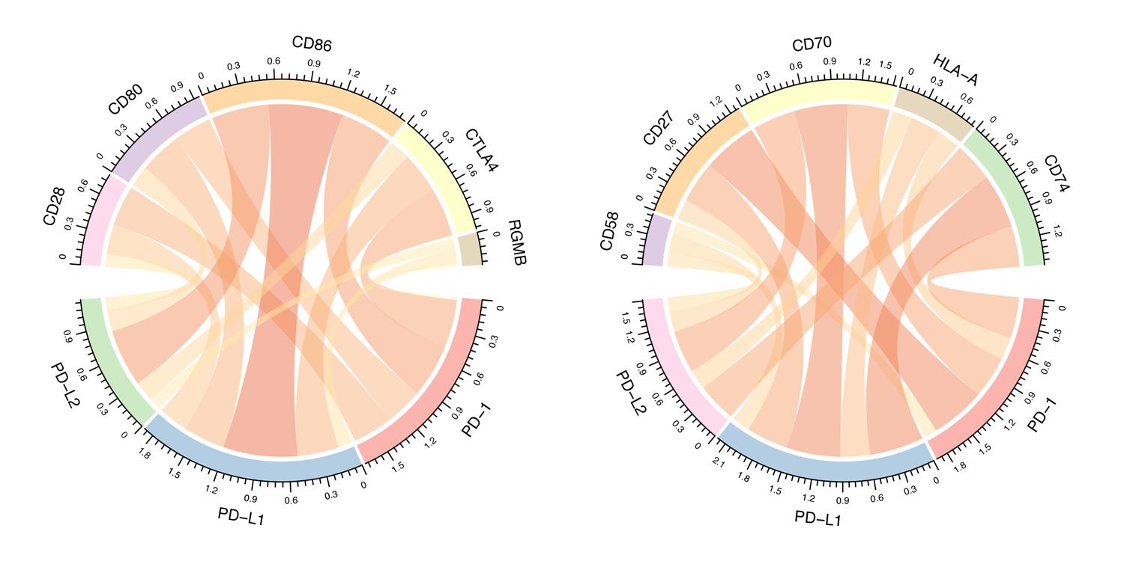
Figure 5 Correlation between programmed death 1/programmed death ligand 1/programmed death ligand 2 expression and immune checkpoint genes. In the correlation diagram, each bar represents the interaction between two genes. The width of the strip represents the size of the correlation coefficient. PD-1: Programmed death 1; PD-L1: Programmed death ligand 1; PD-L2: Programmed death ligand 2.

Table 1 Co-mutation analysis for programmed death 1/programmed death ligand 1/programmed death ligand 2
Gene | Mutation | PD-1 (mean ± SD) | PD-1 P value | PD-L1 (mean ± SD) | PD-L1 P value | PD-L2 (mean ± SD) | PD-L2 P value
ABCA13 | NO | 0.38 ± 1.47 |  | 0.14 ± 0.54 |  | 0.34 ± 3.31
 | Yes | 0.3 ± 0.69 | 0.675 | 0.1 ± 0.21 | 0.431 | 0.08 ± 0.1 | 0.705
ALB | NO | 0.38 ± 1.46 |  | 0.14 ± 0.53 |  | 0.33 ± 3.26
 | Yes | 0.11 ± 0.23 | 0.242 | 0.12 ± 0.27 | 0.545 | 0.11 ± 0.27 | 0.121
APOB | NO | 0.39 ± 1.46 |  | 0.14 ± 0.53 |  | 0.34 ± 3.27
 | Yes | 0.04 ± 0.05 | 0.102 | 0.05 ± 0.03 | 0.858 | 0.05 ± 0.04 | 0.835
ARID1A | NO | 0.37 ± 1.43 |  | 0.14 ± 0.52 |  | 0.33 ± 3.22
 | Yes | 0.59 ± 1.03 | 0.316 | 0.1 ± 0.14 | 0.699 | 0.13 ± 0.17 | 0.495
AXIN1 | NO | 0.37 ± 1.43 |  | 0.14 ± 0.52 |  | 0.32 ± 3.2
 | Yes | 0.16 ± 0.08 | 0.206 | 0.06 ± 0.02 | 0.418 | 0.03 ± 0 | 0.741
CACNA1E | NO | 0.39 ± 1.48 |  | 0.14 ± 0.53 |  | 0.34 ± 3.32
 | Yes | 0.13 ± 0.44 | 0.046 | 0.09 ± 0.26 | 0.083 | 0.07 ± 0.17 | 0.076
CSMD3 | NO | 0.35 ± 1.42 |  | 0.14 ± 0.53 |  | 0.34 ± 3.29
 | Yes | 0.67 ± 1.49 | 0.286 | 0.07 ± 0.09 | 0.981 | 0.12 ± 0.14 | 0.633
CTNNB1 | NO | 0.43 ± 1.61 |  | 0.17 ± 0.6 |  | 0.42 ± 3.75
 | Yes | 0.22 ± 0.75 | 0.02 | 0.06 ± 0.1 | 0.428 | 0.07 ± 0.09 | 0.554
FLG | NO | 0.39 ± 1.48 |  | 0.1 ± 0.27 |  | 0.13 ± 0.55
 | Yes | 0.22 ± 0.52 | 0.78 | 0.49 ± 1.53 | 0.893 | 2.34 ± 10.8 | 0.204
LRP1B | NO | 0.39 ± 1.48 |  | 0.14 ± 0.54 |  | 0.34 ± 3.32
 | Yes | 0.2 ± 0.41 | 0.519 | 0.1 ± 0.17 | 0.554 | 0.12 ± 0.3 | 0.886
MUC16 | NO | 0.32 ± 1.31 |  | 0.14 ± 0.55 |  | 0.35 ± 3.47
 | Yes | 0.64 ± 1.93 | 0.697 | 0.13 ± 0.3 | 0.521 | 0.18 ± 0.53 | 0.997
MUC4 | NO | 0.38 ± 1.44 |  | 0.14 ± 0.52 |  | 0.33 ± 3.23
 | Yes | 0.13 ± 0.3 | 0.196 | 0.1 ± 0.11 | 0.641 | 0.08 ± 0.1 | 0.753
OBSCN | NO | 0.4 ± 1.49 |  | 0.1 ± 0.27 |  | 0.14 ± 0.55
 | Yes | 0.15 ± 0.42 | 0.267 | 0.46 ± 1.46 | 0.087 | 2.13 ± 10.37 | 0.518
PCLO | NO | 0.33 ± 1.3 |  | 0.14 ± 0.54 |  | 0.35 ± 3.36
 | Yes | 0.75 ± 2.29 | 0.712 | 0.1 ± 0.22 | 0.422 | 0.1 ± 0.17 | 0.974
RYR1 | NO | 0.34 ± 1.29 |  | 0.14 ± 0.54 |  | 0.34 ± 3.31
 | Yes | 0.74 ± 2.59 | 0.101 | 0.05 ± 0.04 | 0.872 | 0.06 ± 0.05 | 0.705
RYR2 | NO | 0.36 ± 1.41 |  | 0.13 ± 0.5 |  | 0.34 ± 3.34
 | Yes | 0.47 ± 1.58 | 0.03 | 0.24 ± 0.67 | 0.113 | 0.12 ± 0.2 | 0.321
SPTA1 | NO | 0.39 ± 1.48 |  | 0.14 ± 0.54 |  | 0.33 ± 3.31
 | Yes | 0.18 ± 0.4 | 0.737 | 0.1 ± 0.21 | 0.201 | 0.15 ± 0.36 | 0.384
TP53 | NO | 0.3 ± 1.22 |  | 0.08 ± 0.18 |  | 0.1 ± 0.28
 | Yes | 0.65 ± 2.04 | 0.016 | 0.35 ± 1.08 | 0.003 | 1.19 ± 7.04 | 0.041
TTN | NO | 0.45 ± 1.62 |  | 0.15 ± 0.59 |  | 0.4 ± 3.66
 | Yes | 0.14 ± 0.38 | 0.014 | 0.08 ± 0.18 | 0.291 | 0.08 ± 0.2 | 0.028
XIRP2 | NO | 0.31 ± 1.12 |  | 0.13 ± 0.51 |  | 0.31 ± 3.31
 | Yes | 1.02 ± 3.15 | 0.26 | 0.19 ± 0.63 | 0.235 | 0.39 ± 1.54 | 0.329
PD-1: Programmed death 1; PD-L1: Programmed death ligand 1; PD-L2: Programmed death ligand 2; SD: Standard deviation.
Table 2 GO analysis for programmed death 1/programmed death ligand 1/programmed death ligand 2 co-expression gene
ID | Description | Gene ratio | P value | P adjust | Gene ID | Count
GO: 0042110 | T cell activation | 16/27 | 1.23 × 10⁻¹⁹ | 1.10 × 10⁻¹⁶ | PTPN6/CD3E/LCK/PDCD1/CD3G/IDO1/TNFRSF4/TIGIT/PTPRC/  CD40LG/PRDM1/EOMES/CD2/CD5/CD8A/IRF4 | 16
GO: 0050863 | Regulation of T cell activation | 12/27 | 4.55 × 10⁻¹⁵ | 2.05 × 10⁻¹² | PTPN6/CD3E/LCK/PDCD1/IDO1/TIGIT/PTPRC/CD40LG/  PRDM1/CD2/CD5/IRF4 | 12
GO: 0051249 | Regulation of lymphocyte activation | 13/27 | 2.40 × 10⁻¹⁴ | 5.40 × 10⁻¹² | PTPN6/CD3E/LCK/PDCD1/IDO1/TNFRSF4/TIGIT/PTPRC/  CD40LG/PRDM1/CD2/CD5/IRF4 | 13
GO: 1903037 | Regulation of leukocyte cell-cell adhesion | 10/27 | 5.69 × 10⁻¹² | 1.02 × 10⁻⁹ | PTPN6/CD3E/LCK/PDCD1/IDO1/TIGIT/PTPRC/CD40LG/CD5/ITGA4 | 10
GO: 0007159 | Leukocyte cell-cell adhesion | 10/27 | 1.68 × 10⁻¹¹ | 2.53 × 10⁻⁹ | PTPN6/CD3E/LCK/PDCD1/IDO1/TIGIT/PTPRC/CD40LG/CD5/ITGA4 | 10
GO: 0007204 | Positive regulation of cytosolic calcium ion concentration | 9/27 | 3.25 × 10⁻¹⁰ | 2.66 × 10⁻⁸ | PTPN6/LCK/CD19/PTPRC/CXCR3/FASLG/CXCR4/CD52/CXCL9 | 9
GO: 0050852 | T cell receptor signaling pathway | 9/27 | 1.56 × 10⁻⁹ | 1.00 × 10⁻⁷ | PTPN6/CD3E/LCK/HLA-DQB1/CD3G/PTPRC/CD247 | 7
GO: 0055074 | Calcium ion homeostasis | 9/27 | 1.08 × 10⁻⁸ | 4.87 × 10⁻⁷ | PTPN6/LCK/CD19/PTPRC/CXCR3/FASLG/CXCR4/CD52/CXCL9 | 9
GO: 0051209 | Release of sequestered calcium ion into cytosol | 6/27 | 1.42 × 10⁻⁸ | 5.81 × 10⁻⁷ | PTPN6/LCK/CD19/PTPRC/FASLG/CXCL9 | 6
GO: 0006968 | Cellular defense response | 5/27 | 2.52 × 10⁻⁸ | 8.11 × 10⁻⁷ | TNFRSF4/CD19/PRF1/CXCL9/SH2D1A | 5
GO: 0050867 | Positive regulation of cell activation | 5/8 | 2.00 × ¹⁰⁻⁷ | 5.23 × 10⁻⁵ | PDCD1LG2/JAK2/CD274/ITPKB/PDGFRB | 5
GO: 0022407 | Regulation of cell-cell adhesion | 5/8 | 2.11 × 10⁻⁷ | 5.23 × 10⁻⁵ | PDCD1LG2/JAK2/CD44/CD274/ITPKB | 5
GO: 0045785 | Positive regulation of cell adhesion | 5/8 | 2.36 × 10⁻⁷ | 5.23 × 10⁻⁵ | PDCD1LG2/JAK2/CD44/CD274/ITPKB | 5
GO: 0060333 | Interferon-gamma-mediated signaling pathway | 3/8 | 6.13 × 10⁻⁶ | 0.000528087 | JAK2/CD44/NCAM1 | 3
GO: 0007159 | Leukocyte cell-cell adhesion | 4/8 | 6.35 × 10⁻⁶ | 0.000528087 | PDCD1LG2/CD44/CD274/ITPKB | 4
GO: 2001269 | Positive regulation of cysteine-type endopeptidase activity involved in apoptotic signaling pathway | 2/8 | 7.36 × 10⁻⁶ | 0.000543547 | JAK2/FAS | 2
GO: 0046007 | Negative regulation of activated T cell proliferation | 2/8 | 8.99 × 10⁻⁶ | 0.000597772 | PDCD1LG2/CD274 | 2
GO: 0032693 | Negative regulation of interleukin-10 production | 2/8 | 2.22 × 10⁻⁵ | 0.001230174 | PDCD1LG2/CD274 | 2
GO: 0032516 | Positive regulation of phosphoprotein phosphatase activity | 2/8 | 3.42 × 10⁻⁵ | 0.001626763 | JAK2/PDGFRB | 2
GO: 0055093 | Response to hyperoxia | 2/8 | 3.42 × 10⁻⁵ | 0.001626763 | FAS/PDGFRB | 2
P < 0.05 was considered significant.
Table 3 Correlation analysis for immune checkpoints and programmed death 1/programmed death ligand 1/programmed death ligand 2
 | PD-1 r | PD-1 padj | PD-L1 r | PD-L1 padj | PD-L2 r | PD-L2 padj
CD28 | 0.57465488 | 4.28 × 10⁻³⁴ | 0.6660232 | 9.08 × 10⁻⁴⁹ | 0.71414661 | 6.86 × 10⁻⁵⁹
CD80 | 0.63623359 | 1.59 × 10⁻⁴³ | 0.67510422 | 2.19 × 10⁻⁵⁰ | 0.70070417 | 4.16 × 10⁻⁵⁶
CD86 | 0.72311298 | 2.38 × 10⁻⁶¹ | 0.69521618 | 2.70 × 10⁻⁵⁴ | 0.79715204 | 1.59 × 10⁻⁸²
CTLA4 | 0.82827652 | 6.53 × 10⁻⁹⁵ | 0.53400839 | 9.77 × 10⁻²⁹ | 0.62325084 | 2.09 × 10⁻⁴¹
RGMB | 0.08079832 | 0.11878686 | 0.31356282 | 5.62 × 10⁻¹⁰ | 0.15655839 | 0.00239497
CD58 | 0.4020193 | 6.49 × 10⁻¹⁶ | 0.44699953 | 1.00 × 10⁻¹⁹ | 0.34510312 | 7.46 × 10⁻¹²
CD27 | 0.8554091 | 2.51 × 10⁻¹⁰⁷ | 0.564041 | 1.70 × 10⁻³² | 0.70361681 | 1.23 × 10⁻⁵⁶
CD70 | 0.73757481 | 6.84 × 10⁻⁶⁵ | 0.49791513 | 1.14 × 10⁻²⁴ | 0.5810653 | 5.35 × 10⁻³⁵
HLA-A | 0.49005962 | 6.82 × 10⁻²⁴ | 0.45628329 | 1.56 × 10⁻²⁰ | 0.47535158 | 2.20 × 10⁻²²
CD74 | 0.62377393 | 1.71 × 10⁻⁴¹ | 0.57693716 | 3.59 × 10⁻³⁴ | 0.68544635 | 6.61 × 10⁻⁵³
PD-1: Programmed death 1; PD-L1: Programmed death ligand 1; PD-L2: Programmed death ligand 2.

