Name of Journal: World Journal of Clinical Cases
Manuscript NO: 83954
Manuscript Type: CASE REPORT

Purpura annularis telangiectodes of Majocchi: A case report

Pu YJ et al. PATM: A case report

Yun-Jing Pu, Hong-Jing Jiang, Li Zhang

Yun-Jing Pu, Hong-Jing Jiang, Li Zhang, Department of Dermatology, Kunming Children's Hospital, Kunming 650034, Yunnan Province, China

Author contributions: Pu YJ and Jiang HJ contributed to the work equally; Pu YJ carried out the studies and drafted the manuscript; Jiang HJ and Zhang L participated in its design and helped to draft the manuscript; All authors read and approved the final manuscript.

Supported by the Scientific Research Foundation of the Education Department of Yunnan Province, No. 2023J0293.

Corresponding author: Li Zhang, MS, Doctor, Department of Dermatology, Kunming Children's Hospital, No. 288 Qianxing Road, Kunming 650034, Yunnan Province, China. etyyzhangli@sina.com

Received: February 20, 2023
Revised: April 3, 2023
Accepted: May 6, 2023
Published online:

Abstract
BACKGROUND
Purpura annularis telangiectodes of Majocchi (PATM), also known as Majocchi, is a rare subclass of pigmented purpuric dermatoses. The etiology of PATM is unknown, but it seems more common in children and young women. The skin lesions are mostly symmetrical ring-shaped reddish-brown macules on the lower limbs.

CASE SUMMARY
A 9-year-old girl, who has received treated in our department, presented with reddish-brown ring-shaped rash on both lower limbs that had been present for 6 mo. These lesions, red brownish annular or petaloid patches, were mostly found on ankles and lower limber, which do not fade when adding pressure and no feel of infiltration and no atrophy when touching those lesions. Pathological examination showed deposition of hemosiderin in papillary dermis. However, dermoscopy showed the pigmentation in the center as well as the lavender patches on the edge of lesion. The child was thus diagnosed with PATM. After diagnosis, we suggested the patient avoid strenuous exercise. she was given vitamin C tablets for oral and mometasone furoate cream for external use. Follow-up examinations and treatment continue to support the clinical diagnosis to date.

CONCLUSION
This is the first report of investigating PATM using dermoscopy, which can differentiate PATM from other diseases due to its unique microscopic feature under dermoscopy. Although PATM is harmless, it still requires long-term follow-up. Moreover, dermoscopy technique can be applied for observation of multi-site lesions and correlated with histopathology. Thus, we believe this approach could be generalized for future diagnosis of PATM.

Key Words: Pigmented purpuric dermatoses; Majocchi's disease; Dermatoscope; Histology; Case report

Pu YJ, Jiang HJ, Zhang L. Purpura annularis telangiectodes of Majocchi: A case report. World J Clin Cases 2023; In press

Core Tip: Purpura annularis telangiectodes of Majocchi (PATM) also known as Majocchi's disease, is a rare subclass of pigmented purpuric dermatoses. The skin lesions are mostly symmetrical ring-shaped reddish-brown macules on the lower limbs. This disease is more commonly found among children and young women and the etiology is unknown. Currently, the diagnosis of PATM mainly depends on clinical and histopathological features. Dermoscopy, a non-invasive detection technique, could be a promising technique for future PATM diagnosis owing to its good correlation with histopathology, and multi-site observation.

INTRODUCTION
Purpura annularis telangiectodes of Majocchi (PATM), also known as Majocchi disease, is a rare subclass of pigmented purpuric dermatoses (PPD). The etiology of PATM is unknown, but it seems more common among children and young women^{[1]}. The skin lesions are mostly symmetrical ring-shaped reddish-brown macules on the lower limbs^{[2,3]}. Thus, some researchers believe that gravity and venous hypertension may be the inducing factors of this disease^{[4]}. The diagnosis of PATM usually depends mainly on the clinical findings and histopathological features. However, different sampling sites or time may affect the pathological diagnosis. Moreover, histopathological examination is an invasive method, which is not conducive to long-term follow-up. Dermoscopy, a non-invasive detection method, has a good corresponding relationship with histopathology and multi-site observation is more beneficial to diagnose the disease. Herein, we applied the dermoscopy to observe a girl who suffered from PATM.

CASE PRESENTATION
Chief complaints
A 9-year-old girl admitted to Kunming Children’s Hospital, Kunming City, Yunnan Province, China in November 2021 due to the "repeated reddish-brown ring-shaped rash on both lower limbs for 6 mo".

History of present illness
In the beginning, the lesions were erythematous, where most of them are annular patches, appear on both insteps and ankles. Subsequently, the lesions evolved to both ankles, with sporadic itches. It recurs after topical glucocorticoids. They spread to both legs, with occasional itching. No clinic symptoms of hematuresis, hematocheiza, joint pain or hypodynamia observed during this period of time.

History of past illness
The patient had no history of systemic symptoms, allergies and no specific history of past illness.

Personal and family history
Normal.

Physical examination
Physical examination revealed good general condition. Dermatological examination results showed that these lesions are red brownish annular or petaloid patches with various size, 1-3 cm in diameters can be observed on both insteps, ankles and lower limber. And they do not fade when adding pressure. During this process, light brownish pigmentation can be observed central of these macules. No feel of infiltration and no atrophy when touching those lesions. Such lesions on instep are shown in Figure 1.

Laboratory examinations
Blood routine, urine routine, liver function, kidney function, antinuclear antibody, coagulation function and erythrocyte sedimentation rate tests were normal.

Dermoscopy examinations
Dermoscopy showed a large number of reticular or honeycomb pigmentation in the center of the lesion, and lavender patches and a few focally distributed punctate blood vessels were seen on the edge of lesion (Figure 2).

Pathological examinations
Pathological examination showed scattered vacuolar endothelial cells, infiltration of lymphocytes and histocytes around blood vessels, and deposition of hemosiderin in papillary dermis (Figure 3).

FINAL DIAGNOSIS
Combining with relevant examinations, the patient was diagnosed as PATM.

TREATMENT
The patient was given orally dipyridamole tablets 25 mg/bid, vitamin C tablets 0.1 g/bid, and topical mometasone furoate cream and mucopolysaccharide polysulfonate cream bid for external use.

OUTCOME AND FOLLOW-UP
The patient was given orally vitamin C tablets 0.1 g/bid, and topical mometasone furoate cream for external use. We suggested that the girl avoid prolonged stand, as well as strenuous exercises. The skin lesions subsided after 2 wk of treatment. In December 2022, the patient's disease recurred again after intense exercise, and the lesions gradually subsided one month after external medication. Follow-up is ongoing.

DISCUSSION
In this case, dermoscopy data showed a large number of reticular or honeycomb-shaped pigmentations in the center of the lesion, some lavender patches, and a few focally distributed punctate blood vessels at the edge of the lesion. These structures are often observed in lichen sclerosus and pigmented purpuric dermatosis^{[5]}. The purplish red patches under dermoscopy correspond to red blood cell overflow in the histopathological picture, while the pigmentation corresponds to hemosiderin deposition. It is well known that overflowing red blood cells are engulfed to form hemosiderin^{[1]}, and pigmentation is the final form of purplish-red patches. The histopathology results for the early rash of PATM shows swollen vascular endothelial cells in the upper dermis and dermal papilla, with a large number of lymphocytes and histiocytes around the lumen, extravasation of red blood cells, and occasional neutrophil infiltration. However, the inflammatory infiltration of old lesions is not as obvious as in the early stages, with reduction in extravasation of red blood cells, and deposition of hemosiderin. Although the pathological manifestations of this patient were consistent with those of old lesions, the active margin could be clearly observed under dermoscopy.
Differentiating PATM from lichen aureus (LA) and purpuric mycosis fungoides (PMF) could be challenging. LA is another subtype of PPD while PMF is a cutaneous lymphoma with purpuric eruptions as the clinical manifestation^{[6,7]}. PATM and LA can be differentiated by the distribution pattern of pigments and purplish red patches using dermoscopy. PATM shows a ring-like distribution, while LA shows a diffuse distribution^{[8]}. Neither of them has a special vessel structure under dermoscopy, but PMF has its unique vessels such as spermatozoa-like vessels^{[9]}. Therefore, the differences between PATM, LA and PMF on dermoscopy are clear. In addition, we could distinguish the three diseases.
Due to the detection of epidermotropism or monoclonality in inflammatory infiltrates, other hypotheses believed that PPDs represent a type of T lymphocyte, occult and metaepithelial change^{[10]}. There are even some described cases of progression to mycosis fungoides^{[11,12]}. To sum up, although PATM is harmless, cutaneous T-cell lymphoma needs to be ruled out in some cases^{[2,11,12]}. Thus, long-term follow-up of PATM is necessary.

CONCLUSION
PATM， a rare subclass of PPD, also known as Majocchi's disease. The skin lesions are mostly symmetrical ring-shaped reddish-brown macules on the lower limbs and more commonly found among children and young women. The purplish red patches under dermoscopy correspond to red blood cell overflow in the histopathological picture, while the pigmentation corresponds to hemosiderin deposition. Overflowing red blood cells are engulfed to form hemosiderin. Pigmentation is the final form of purplish-red patches. According to the histopathology results, the early rash of PATM shows swollen vascular endothelial cells in the upper dermis and dermal papilla, with a large number of lymphocytes and histiocytes around the lumen, extravasation of red blood cells, and occasional neutrophil infiltration. However, the inflammatory infiltration of old lesions is not as obvious as in the early stages, with reduction in extravasation of red blood cells, and deposition of hemosiderin. Although the pathological manifestations of this patient were consistent with those of old lesions, the active margin could be clearly observed under dermoscopy. It is challenging to differentiate PATM from LA and PMF but dermoscopy enables us to visualize the special vascular structure and pigment distribution pattern and distinguish these three diseases. Although PATM is harmless, the disease is prone to relapse and may resemble the early clinical feature of T-cell lymphoma. Thus, long-term follow-up of PATM is crucial. As a non-invasive detection method, Dermoscopy enables us multi-site observation and to correlates the obtained images with histopathology, which could be a promising approach for future PATM.

REFERENCES
1 Spigariolo CB, Giacalone S, Nazzaro G. Pigmented Purpuric Dermatoses: A Complete Narrative Review. J Clin Med 2021; 10 [PMID: 34070260 DOI: 10.3390/jcm10112283]
2 Hoesly FJ, Huerter CJ, Shehan JM. Purpura annularis telangiectodes of Majocchi: case report and review of the literature. Int J Dermatol 2009; 48: 1129-1133 [PMID: 19775410 DOI: 10.1111/j.1365-4632.2009.04160.x]
3 Fathy H, Abdelgaber S. Treatment of pigmented purpuric dermatoses with narrow-band UVB: a report of six cases. J Eur Acad Dermatol Venereol 2011; 25: 603-606 [PMID: 21492246 DOI: 10.1111/j.1468-3083.2010.03806.x]
4 Mansur AT, Koç MK, Ramadan S. Purpura annularis telangiectodes of Majocchi: an atypical presentation. Eur J Dermatol 2019; 29: 546-547 [PMID: 31647463 DOI: 10.1684/ejd.2019.3623]
5 Borghi A, Corazza M, Minghetti S, Toni G, Virgili A. Clinical and dermoscopic changes of vulvar lichen sclerosus after topical corticosteroid treatment. J Dermatol 2016; 43: 1078-1082 [PMID: 27075682 DOI: 10.1111/1346-8138.13374]
6 Kaufman AE, Patel K, Goyal K, O'Leary D, Rubin N, Pearson D, Bohjanen K, Goyal A. Mycosis fungoides: developments in incidence, treatment and survival. J Eur Acad Dermatol Venereol 2020; 34: 2288-2294 [PMID: 32141115 DOI: 10.1111/jdv.16325]
7 Hanna S, Walsh N, D'Intino Y, Langley RG. Mycosis fungoides presenting as pigmented purpuric dermatitis. Pediatr Dermatol 2006; 23: 350-354 [PMID: 16918631 DOI: 10.1111/j.1525-1470.2006.00259.x]
8 Portela PS, Melo DF, Ormiga P, Oliveira FJ, Freitas NC, Bastos Júnior CS. Dermoscopy of lichen aureus. An Bras Dermatol 2013; 88: 253-255 [PMID: 23739706 DOI: 10.1590/S0365-05962013000200013]
9 Nasimi M, Bonabiyan M, Lajevardi V, Azizpour A, Nejat A, Dasdar S, Kianfar N. Pigmented purpuric dermatoses vs purpuric mycosis fungoides: Clinicopathologic similarities and new insights into dermoscopic features. Australas J Dermatol 2022; 63: 81-85 [PMID: 34905635 DOI: 10.1111/ajd.13759]
10 Georgala S, Katoulis AC, Symeonidou S, Georgala C, Vayopoulos G. Persistent pigmented purpuric eruption associated with mycosis fungoides: a case report and review of the literature. J Eur Acad Dermatol Venereol 2001; 15: 62-64 [PMID: 11451328 DOI: 10.1046/j.1468-3083.2001.00198.x]
11 Guitart J, Magro C. Cutaneous T-cell lymphoid dyscrasia: a unifying term for idiopathic chronic dermatoses with persistent T-cell clones. Arch Dermatol 2007; 143: 921-932 [PMID: 17638739 DOI: 10.1001/archderm.143.7.921]
12 Viseux V, Schoenlaub P, Cnudde F, Le Roux P, Leroy JP, Plantin P. Pigmented purpuric dermatitis preceding the diagnosis of mycosis fungoides by 24 years. Dermatology 2003; 207: 331-332 [PMID: 14571083 DOI: 10.1159/000073103]

Footnotes
Informed consent statement: Consent was obtained from relatives of the patient for publication of this report and any accompanying images.

Conflict-of-interest statement: All the authors report no relevant conflicts of interest for this article.

CARE Checklist (2016) statement: The authors have read CARE Checklist (2016), and the manuscript was prepared and revised according to CARE Checklist (2016).

Open-Access: This article is an open-access article that was selected by an in-house editor and fully peer-reviewed by external reviewers. It is distributed in accordance with the Creative Commons Attribution NonCommercial (CC BY-NC 4.0) license, which permits others to distribute, remix, adapt, build upon this work non-commercially, and license their derivative works on different terms, provided the original work is properly cited and the use is non-commercial. See: https://creativecommons.org/Licenses/by-nc/4.0/

Provenance and peer review: Unsolicited article; Externally peer reviewed.

Peer-review model: Single blind

Peer-review started: February 20, 2023
First decision: March 24, 2023
Article in press:

Specialty type: Medicine, research and experimental
Country/Territory of origin: China
Peer-review report’s scientific quality classification
Grade A (Excellent): 0
Grade B (Very good): B
Grade C (Good): C, C
Grade D (Fair): 0
Grade E (Poor): 0

P-Reviewer: Exbrayat JM, France; Nazzaro G, Italy S-Editor: Li L L-Editor: A P-Editor: Li L
Figure Legends
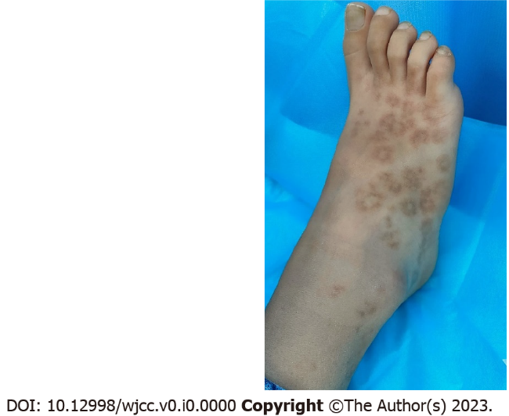
Figure 1 Macroscopic features of the lesion. The child presented red brownish annular or petaloid patches with various size, 1-3 cm in diameters can be observed on instep.
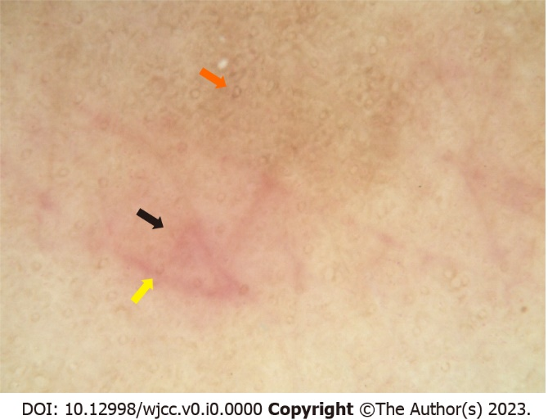
Figure 2 Dermatoscopic appearance of the lesion. The infiltration method was used (× 50). Dermascopy showed a large number of reticular or honeycomb pigmentation (orange arrow) in the center of the lesion, and lavender patches (black arrow) and a few focally distributed punctate blood vessels (yellow arrow) were seen on the edge of lesion.
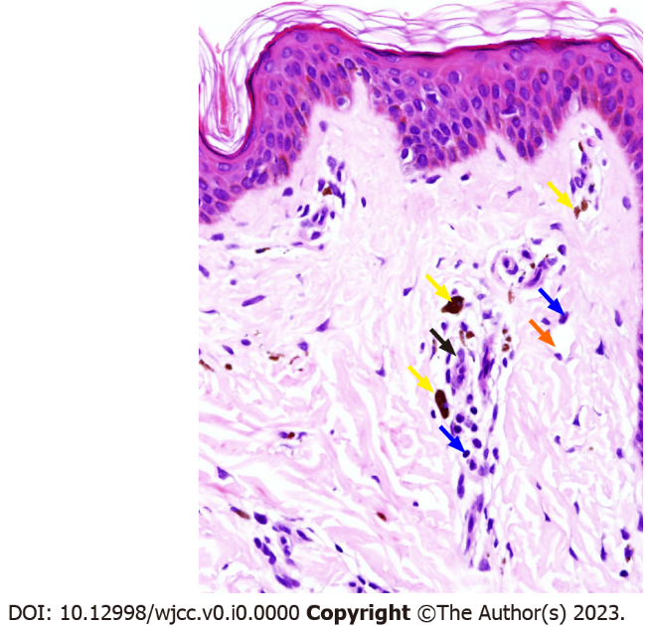
Figure 3 Histopathological findings. Histopathology showed hyperkeratosis, scattered vacuolar endothelial cells, infiltration of lymphocytes (blue arrows) and histocytes (black arrow) around blood vessels (orange arrow), and deposition of hemosiderin (yellow arrows) in papillary dermis (Hematoxylin eosin staining: Magnification × 400).

