Name of Journal: World Journal of Clinical Cases
Manuscript NO: 48197
Manuscript Type: CASE REPORT

Child with Wiskott–Aldrich syndrome underwent atypical immune reconstruction after umbilical cord blood transplantation: a case report

Li BH et al. Immune reconstruction after UCBT

Bo-Han Li, Shao-Yan Hu

Bo-Han Li, Shao-Yan Hu, Department of Hematology and Oncology, Children’s Hospital of Soochow University, Suzhou 215000, Jiangsu Province, China

ORCID number: Bo-Han Li (0000-0003-2952-146X); Shao-Yan Hu (0000-0002-3386-6957).

Author contributions: Li BH and Hu SY wrote and edited the final manuscript; both authors have read and approved the final manuscript.

Supported by National Natural Science Foundation of China, No. 81770193.

Informed consent statement: Written informed consent was obtained from the patient’s legal guardian(s) for publication of this case report and any accompanying images.

Conflict-of-interest statement: The authors declare that they have no conflicts of interest in relation to this manuscript.

CARE Checklist (2016) statement: The authors have read the CARE Checklist (2016), and the manuscript was prepared and revised according to the CARE Checklist (2016).

Open-access: This article is an open-access article that was selected by an in-house editor and fully peer-reviewed by external reviewers. It is distributed in accordance with the Creative Commons Attribution Non Commercial (CC BY-NC 4.0) license, which permits others to distribute, remix, adapt, build upon this work non-commercially, and license their derivative works on different terms, provided the original work is properly cited and the use is non-commercial. See: http://creativecommons.org/licenses/by-nc/4.0/

Manuscript source: Unsolicited manuscript

Corresponding author: Shao-Yan Hu, PhD, Chief Doctor, Department of Hematology and Oncology, Children’s Hospital of Soochow University, 92 Zhongnan Street, Suzhou 215000, Jiangsu Province, China. hsy139@126.com
Telephone: +86-512-13771870462

Received: April 17, 2019
Peer-review started: April 18, 2019
First decision: June 12, 2019
Revised: June 21, 2019
Accepted: July 20, 2019
Article in press:
Published online:

Abstract
BACKGROUND
Timely reconstitution of a donor-derived immune system is important for recovery and long-term survival of patients after allogeneic hematopoietic stem cell transplantation (HSCT). We describe a case of Wiskott–Aldrich syndrome (WAS) treated by umbilical cord blood transplantation (UCBT) with atypical immune reconstruction.

CASE SUMMARY
A 1-year-old Chinese male infant was diagnosed with WAS. WAS gene sequencing identified the mutation c.777 + 1G>A (IVS8). On August 8, 2017, he was admitted to our hospital for HSCT. We selected an unrelated Human leukocyte antigen 6/10-matched donor for UCBT. After HSCT, the immune reconstitution process was atypical, the lymphocytes reached 0.5 × 10⁹/L on day 23, and the neutrophils reached 0.5 × 10⁹/L on day 34. The patient’s recovery throughout the year was good.

CONCLUSION
An increase in lymphocytes (especially T cells) earlier than granulocytes may be a marker of a good prognosis in UCBT.

Key words: Umbilical cord blood transplantation; Wiskott–Aldrich syndrome; Immune reconstruction; Case report

© The Author(s) 2019. Published by Baishideng Publishing Group Inc. All rights reserved.

Core tip: The timely reconstitution of a donor-derived immune system is of utmost importance for the recovery and long-term survival of patients after hematopoietic stem cell transplantation. Here, we describe a case of Wiskott–Aldrich syndrome treated by umbilical cord blood transplantation with the atypical process of immune reconstitution. Our case revealed that an increase in the number of lymphocytes (especially T cells) earlier than granulocytes may be a marker of a good prognosis in patients. This experience will guide clinical scientists, especially hematologists, to deal with similar situations and encourage them to identify more processes that require immune reconstruction.

Li BH, Hu SY. Child with Wiskott–Aldrich syndrome underwent atypical immune reconstruction after umbilical cord blood transplantation: a case report. World J Clin Cases 2019; In press

INTRODUCTION
Wiskott–Aldrich syndrome (WAS) is a rare X-linked recessive immunodeficiency disorder. The clinical manifestations of WAS are thrombocytopenia and small platelets, eczema, and recurrent infection^{[1]}. The gene responsible for this syndrome is the WAS protein (WASP) gene. Hematopoietic cell transplantation is the only proven cure for WAS. The unrelated donor umbilical cord blood transplantation (UCBT) is a good option for patients that do not have a Human leukocyte antigen (HLA)-matched donor^{[2]}. The advantage of UCBT is that one can search and prepare umbilical cord blood on time without delay, and it has a low incidence and severity of graft versus host disease (GVHD)^{[3]}. However, slow hematopoietic reconstruction and increasing probability of engraftment failure prevent widespread use of UCBT^{[4]}. As a result, the patients who experience slow immune reconstitution are at high risk of infection. Innate immunity usually recovers within several weeks after transplantation. By contrast, adaptive immunity recovers more slowly^{[5-7]}. This delayed engraftment and immune reconstitution result in higher rates of early post-transplantation infection complications in UCBT^{[8,9]}. Therefore, identifying the mechanism that regulates immune reconstitution after transplantation, and developing strategies to enhance immune reconstitution after UCBT, will significantly improve the efficacy of UCBT. Here, we report a case of WAS in a 1-year-old Chinese male infant successfully treated by UCBT with atypical immune reconstruction. The reconstitution of adaptive immunity in this patient was earlier than that of innate immunity. Although the reconstitution of granulocytes was slow, the patient did not show serious infection during engraftment, and remained stable for 1 year after UCBT.

CASE PRESENTATION
Chief complaints
Fecal blood, diarrhea and thrombocytopenia over one year.

History of present illness
A 1-year-old Chinese male patient with WAS was admitted for UCBT. He presented with fecal blood, diarrhea and thrombocytopenia at age 4 d, and was admitted to the West China Second University Hospital of Sichuan University. Admission to our hospital for hematopoietic stem cell transplantation.

History of past illness
None.

Personal and family history
Nothing special.

Laboratory examinations
Complete blood count revealed that white blood cell (WBC) count was 13.64 × 10⁹/L, hemoglobin 99 g/L, platelet count 7 × 10⁹/L, and neutrophil count 3.53 × 10⁹/L. Bone marrow (BM) aspiration revealed that the granulocyte/erythrocyte ratio was 0.7:1, thromocytogenic megakaryocyte 15/50, and platelets were deficient. WAS gene sequencing identified the mutation c.777 + 1G>A (IVS8).

TREATMENT
We selected an unrelated HLA 6/10-matched donor for UCBT (Table 1). The conditioning regimen was busulfan 1.0 mg/kg day-9 to day-6; fludarabine 40 mg/m², day-5 to day-2; cyclophosphamide 60 mg/kg, day-5 to day-4; antithymocyte globulin (ATG) 2.5 mg/kg, qd, day-8 to day-5. Prophylaxis for GVHD was cyclosporin A (CSA, 6–8 mg/kg daily) and mycophenolate mofetil (MMF, 20 mg/kg/d). Heparin and alprostadil were used for preventing hepatic venous occlusive disease (VOD). Ganciclovir, acyclovir, micafungin and meropenem were used for preventing viral, fungal and bacterial infection, respectively. The details of drug use is shown in Table 2. The number of CD34⁺ cells was 4.7 × 10⁵/kg, and total nucleated cells (TNCs) 9.17 × 10⁷/kg. On day 6 after UCBT, granulocyte colony-stimulating factor was given to promote granulocyte recovery, and γ-globulin and composition blood transfusion (irradiated platelets) were used for supportive therapy.

OUTCOME AND FOLLOW-UP
On day 10, a new rash occurred on both earlobes. On day 11, the rash spread throughout the body, and methylprednisolone was given at 1g/kg daily. Complete blood count was monitored daily: WBC count reached 0.5 × 10⁹/L on day 22, lymphocytes reached 0.5 × 10⁹/L on day 23, and neutrophils reached 0.5 × 10⁹/L on day 34 (Figure 1A). Therefore, this patient presented with immune reconstitution, with lymphocytes first and neutrophils later. We analyzed another five patients who received UCBT, who all showed immune reconstitution with neutrophils first and lymphocytes later (Figure 1C and Table 3). T cells, especially CD8⁺ T cells, were the major lineage in the reconstituted lymphocytes (Figure 1D and 1E). Previous studies showed that dendritic cells (DCs) expressing Notch ligand DLL4 are critical for eliciting alloreactive T cell responses and inducing GVHD in mice^{[10-12]}. We also analyzed the reconstruction of DLL4⁺ DCs. Compared to healthy people, the percentage of DCs, ratio of plasmacytoid DCs (pDCs) and CD1c⁺ DCs, and expression of ligand DLL4 were similar (Figure 2). The levels of IgG, IgA and IgM returned to normal within 50 d after UCBT, suggesting recovery of humoral immunity (Figure 2C). The patient did not develop obvious GVHD or infection 12 mo after UCBT. The patient is currently under monthly monitoring. Except for CSA (1 mg/kg q12h), no additional treatment was used to prevent GVHD. The timeline is shown in Figure 3.

DISCUSSION
Delayed immune reconstitution limits the success of hematopoietic stem cell transplantation (HSCT). Here, we report a case showing an unusual pattern of immune reconstitution after UCBT, which was characterized by an increase in the number of lymphocytes earlier than granulocytes. The lymphocyte count peaked at day 23 after UCBT; however, granulocytes were engrafted (for clinical engraftment, the number of granulocytes is > 0.5 × 10⁹/L on the first day, and remains so for at least 3 consecutive days) at day 34. This patient did not develop infection or severe GVHD. We propose that there should be another definition of engraftment for lymphocytes, and ponder whether or not WBC engraftment should occur after HSCT.
UCBT has many advantages for treating WAS, as compared to other types of HSCT. For example, the acquisition of CB is easy, collection of CB is harmless, and the CB handling process, such as thawing, does not induce loss of cell proliferation^{[4,13-16]}. In addition, CB transplantation showed a lower risk of acute and chronic GVHD than other transplantation strategies using a different cell source^{[17,18]}. However, delayed immune reconstitution results in higher rates of early post-transplant infectious complications in UCBT^{[8,9]}.
The recovery of the immune system after transplantation in humans is an orderly and dynamic process^{[19]}. In general, innate immunity, namely phagocytes and natural killer lymphocytes, recovers in the first few weeks after transplantation. Then, the adaptive immune system, namely B and T lymphocytes, recovers, which may take months to years^{[7,9,16,20]}. Reconstitution of CD4⁺ T cells is later than that of CD8⁺ T cells, which in most cases also results in a long period of CD4⁺/CD8⁺ inversion after transplantation. Previous studies showed that de novo thymic generation of CD4⁺CD45RA⁺ primitive T cells is needed for the recovery of CD4⁺ T cells^{[21,22]}. Pang et al^{[23]} reported that in a non-acute GVHD group, CD3⁺ T lymphocytes gradually returned to normal after 2 mo, and the CD4/CD8 ratio was reversed. Here, we report that this patient showed an atypical immune reconstitution. His process of immune reconstitution was lymphocytes (mainly T cells) engrafted first, with granulocytes engrafted later. His lymphocyte ratio was at a high level at 35 d after UCBT, which was different from other WAS patients who underwent UCBT in our Center. The subsets of T cells in the present patient were mainly CD8⁺, and there was an inverse proportion. Previous studies showed an increased CD4⁺ ratio in some cases of increased immune abnormalities, such as autoimmune diseases and acute GVHD. An increase in the proportion of CD8⁺ T cells does not increase the risk of acute GVHD. We hypothesize that this patient with a high percentage of CD8⁺ T cells protected him from serious GVHD. The patient’s short tandem repeat (STR) in BM and PB was detected on a regular basis in our center. The STR of PB was 76.8% on day 14. The STR of BM was 62.3% on day 17. At this time, the number of cells was still low, and the donor cells had not yet been engrafted. This state may have helped the engraftment of donor lymphocytes. At 20–40 d, when lymphocytes suddenly increased, the STR in PB was 98.6% on day 24 and 98.1% in BM on day 27. The details of STR is shown in Table 4. This also means that the rapid growth of lymphocytes comes from donors. This rapid early growth of donor lymphocytes may not lead to severe GVHD, but can play a role against infection. However, its mechanism needs to be further studied.
The reconstitution of DCs after transplantation is significantly correlated with GVHD. Delayed DC recovery and lower DC numbers, especially of pDCs, are found in patients with acute and chronic GVHD^{[24]}. pDCs play an important role in HSCT immunomodulation^{[25]}. In the present case, we found that DCs recovered rapidly, suggesting that it is a favorable prognostic factor in predicting GVHD and infection. Recently, a new population of DLL4⁺ DCs has been identified. DLL4 is an important ligand of the Notch family^{[26]}. DLL4⁺ DCs can promote differentiation of Th1 and Th17 cells to a greater degree than DLL4⁻ DCs. A mouse model that received allogeneic DLL4⁺ DC-induced CD4⁺ T cells developed only minimal GVHD^{[10,12]}. In humans, less research has been performed on DLL4⁺ DCs. Human immature CD1c⁺ DCs and pDCs express low levels of DLL4, and they rapidly upregulate expression of DLL4 upon activation with the TLR7/8 agonist R848 (resiquimod) and/or the TLR4 agonist lipopolysaccharide (LPS). However, allogeneic HSCT recipients had 16-fold more DLL4⁺CD1c⁺ DCs than healthy donors^{[11,27]}. In this patient, we found rapid DC reconstitution, and each DC subset recovered to normal within 2 mo. In addition, we measured the population of DLL4⁺ DCs at day 27 and 37, day 90, and day 150 upon stimulation. We found that the expression of DLL4 on DCs was upregulated after resiquimod and LPS stimulation, and reached the same level as healthy people at 3 mo after transplantation. Therefore, successful DC reconstitution also indicates good prognosis.
Previous studies reported that humoral immunity usually takes 1 year to reach normal levels after HSCT, especially for IgG and IgA^{[21]}. In our case, we found that the levels of IgA, IgG and IgM recovered to normal within 2 mo after UCBT. The recovery of humoral immunity was faster than that reported in other studies. This special immune reconstitution may be a good prognostic indicator for UCBT.

CONCLUSION
This new way of immune reconstitution can provide a novel means to study immune reconstitution after UCBT. However, the mechanism of immune reconstitution, and whether it can be used as a marker of good prognosis, requires further investigation.
REFERENCES
1 Kaneko R, Yamamoto S, Okamoto N, Akiyama K, Matsuno R, Toyama D, Hoshino A, Imai K, Isoyama K. Wiskott-Aldrich syndrome that was initially diagnosed as immune thrombocytopenic purpura secondary to a cytomegalovirus infection. SAGE Open Med Case Rep 2018; 6: 2050313X17753788 [PMID: 29348920 DOI: 10.1177/2050313X17753788]
2 Shekhovtsova Z, Bonfim C, Ruggeri A, Nichele S, Page K, AlSeraihy A, Barriga F, de Toledo Codina JS, Veys P, Boelens JJ, Mellgren K, Bittencourt H, O'Brien T, Shaw PJ, Chybicka A, Volt F, Giannotti F, Gluckman E, Kurtzberg J, Gennery AR, Rocha V; Eurocord, Cord Blood Committee of Cellular Therapy and Immunobiology Working Party of the EBMT, Federal University of Parana, Duke University Medical Center and Inborn Errors Working Party of the EBMT. A risk factor analysis of outcomes after unrelated cord blood transplantation for children with Wiskott-Aldrich syndrome. Haematologica 2017; 102: 1112-1119 [PMID: 28255019 DOI: 10.3324/haematol.2016.158808]
3 Xu L, Chen H, Chen J, Han M, Huang H, Lai Y, Liu D, Liu Q, Liu T, Jiang M, Ren H, Song Y, Sun Z, Wang J, Wu D, Zhou D, Zou P, Liu K, Huang X. The consensus on indications, conditioning regimen, and donor selection of allogeneic hematopoietic cell transplantation for hematological diseases in China-recommendations from the Chinese Society of Hematology. J Hematol Oncol 2018; 11: 33 [PMID: 29495966 DOI: 10.1186/s13045-018-0564-x]
4 Luan C, Chen R, Chen B, Ding J, Ni M. Umbilical cord blood transplantation supplemented with the infusion of mesenchymal stem cell for an adolescent patient with severe aplastic anemia: a case report and review of literature. Patient Prefer Adherence 2015; 9: 759-765 [PMID: 26089653 DOI: 10.2147/PPA.S81509]
5 Storek J, Geddes M, Khan F, Huard B, Helg C, Chalandon Y, Passweg J, Roosnek E. Reconstitution of the immune system after hematopoietic stem cell transplantation in humans. Semin Immunopathol 2008; 30: 425-437 [PMID: 18949477 DOI: 10.1007/s00281-008-0132-5]
6 Mehta RS, Rezvani K. Immune reconstitution post allogeneic transplant and the impact of immune recovery on the risk of infection. Virulence 2016; 7: 901-916 [PMID: 27385018 DOI: 10.1080/21505594.2016.1208866]
7 Servais S, Hannon M, Peffault de Latour R, Socie G, Beguin Y. Reconstitution of adaptive immunity after umbilical cord blood transplantation: impact on infectious complications. Stem Cell Investig 2017; 4: 40 [PMID: 28607914 DOI: 10.21037/sci.2017.05.03]
8 Danby R, Rocha V. Improving engraftment and immune reconstitution in umbilical cord blood transplantation. Front Immunol 2014; 5: 68 [PMID: 24605111 DOI: 10.3389/fimmu.2014.00068]
9 de Koning C, Admiraal R, Nierkens S, Boelens JJ. Immune reconstitution and outcomes after conditioning with anti-thymocyte-globulin in unrelated cord blood transplantation; the good, the bad, and the ugly. Stem Cell Investig 2017; 4: 38 [PMID: 28607912 DOI: 10.21037/sci.2017.05.02]
10 Luo X, Xu L, Li Y, Tan H. Notch pathway plays a novel and critical role in regulating responses of T and antigen-presenting cells in aGVHD. Cell Biol Toxicol 2017; 33: 169-181 [PMID: 27770236 DOI: 10.1007/s10565-016-9364-7]
11 Meng L, Hu S, Wang J, He S, Zhang Y. DLL4+ dendritic cells: Key regulators of Notch Signaling in effector T cell responses. Pharmacol Res 2016; 113: 449-457 [PMID: 27639599 DOI: 10.1016/j.phrs.2016.09.001]
12 Mochizuki K, Meng L, Mochizuki I, Tong Q, He S, Liu Y, Purushe J, Fung H, Zaidi MR, Zhang Y, Reshef R, Blazar BR, Yagita H, Mineishi S, Zhang Y. Programming of donor T cells using allogeneic δ-like ligand 4-positive dendritic cells to reduce GVHD in mice. Blood 2016; 127: 3270-3280 [PMID: 27143255 DOI: 10.1182/blood-2015-05-644476]
13 Roura S, Pujal JM, Gálvez-Montón C, Bayes-Genis A. The role and potential of umbilical cord blood in an era of new therapies: a review. Stem Cell Res Ther 2015; 6: 123 [PMID: 26133757 DOI: 10.1186/s13287-015-0113-2]
14 Broxmeyer HE, Srour EF, Hangoc G, Cooper S, Anderson SA, Bodine DM. High-efficiency recovery of functional hematopoietic progenitor and stem cells from human cord blood cryopreserved for 15 years. Proc Natl Acad Sci U S A 2003; 100: 645-650 [PMID: 12518050 DOI: 10.1073/pnas.0237086100]
15 Mitchell R, Wagner JE, Brunstein CG, Cao Q, McKenna DH, Lund TC, Verneris MR. Impact of long-term cryopreservation on single umbilical cord blood transplantation outcomes. Biol Blood Marrow Transplant 2015; 21: 50-54 [PMID: 25262882 DOI: 10.1016/j.bbmt.2014.09.002]
16 Xie LN, Zhou F. Unexpected unrelated umbilical cord blood stem cell engraft in two patients with severe aplastic anemia that received immunosuppressive treatment: A case report and literature review. Exp Ther Med 2015; 10: 1563-1565 [PMID: 26622526 DOI: 10.3892/etm.2015.2698]
17 Munoz J, Shah N, Rezvani K, Hosing C, Bollard CM, Oran B, Olson A, Popat U, Molldrem J, McNiece IK, Shpall EJ. Concise review: umbilical cord blood transplantation: past, present, and future. Stem Cells Transl Med 2014; 3: 1435-1443 [PMID: 25378655 DOI: 10.5966/sctm.2014-0151]
18 Solh M. Haploidentical vs cord blood transplantation for adults with acute myelogenous leukemia. World J Stem Cells 2014; 6: 371-379 [PMID: 25258659 DOI: 10.4252/wjsc.v6.i4.371]
19 Bosch M, Khan FM, Storek J. Immune reconstitution after hematopoietic cell transplantation. Curr Opin Hematol 2012; 19: 324-335 [PMID: 22517587 DOI: 10.1097/MOH.0b013e328353bc7d]
20 Szabolcs P, Cairo MS. Unrelated umbilical cord blood transplantation and immune reconstitution. Semin Hematol 2010; 47: 22-36 [PMID: 20109609 DOI: 10.1053/j.seminhematol.2009.10.009]
21 Ogonek J, Kralj Juric M, Ghimire S, Varanasi PR, Holler E, Greinix H, Weissinger E. Immune Reconstitution after Allogeneic Hematopoietic Stem Cell Transplantation. Front Immunol 2016; 7: 507 [PMID: 27909435 DOI: 10.3389/fimmu.2016.00507]
22 Chang YJ, Zhao XY, Huang XJ. Immune reconstitution after haploidentical hematopoietic stem cell transplantation. Biol Blood Marrow Transplant 2014; 20: 440-449 [PMID: 24315844 DOI: 10.1016/j.bbmt.2013.11.028]
23 Pang N, Duan X, Jiang M, Qu J, Yuan H, Xu J, Cao H, Chen G. Reconstitution and clinical significance of T cell subsets in the early stage after related HLA-mismatched peripheral blood hematopoietic SCT without T-cell depletion in vitro. Int J Clin Exp Pathol 2015; 8: 8892-8901 [PMID: 26464630]
24 Nachbaur D, Kircher B. Dendritic cells in allogeneic hematopoietic stem cell transplantation. Leuk Lymphoma 2005; 46: 1387-1396 [PMID: 16194884 DOI: 10.1080/10428190500155603]
25 Auletta JJ, Devine SM, Waller EK. Plasmacytoid dendritic cells in allogeneic hematopoietic cell transplantation: benefit or burden? Bone Marrow Transplant 2016; 51: 333-343 [PMID: 26642333 DOI: 10.1038/bmt.2015.301]
26 Radtke F, Fasnacht N, Macdonald HR. Notch signaling in the immune system. Immunity 2010; 32: 14-27 [PMID: 20152168 DOI: 10.1016/j.immuni.2010.01.004]
27 Meng L, Bai Z, He S, Mochizuki K, Liu Y, Purushe J, Sun H, Wang J, Yagita H, Mineishi S, Fung H, Yanik GA, Caricchio R, Fan X, Crisalli LM, Hexner EO, Reshef R, Zhang Y, Zhang Y. The Notch Ligand DLL4 Defines a Capability of Human Dendritic Cells in Regulating Th1 and Th17 Differentiation. J Immunol 2016; 196: 1070-1080 [PMID: 26712946 DOI: 10.4049/jimmunol.1501310]

P-Reviewer: Xavier-Elsas P S-Editor: Cui LJ L-Editor: Filipodia E-Editor:

Specialty type: Medicine, research and experimental
Country of origin: China
Peer-review report classification
Grade A (Excellent): 0
Grade B (Very good): 0
Grade C (Good): C
Grade D (Fair): 0
Grade E (Poor): 0

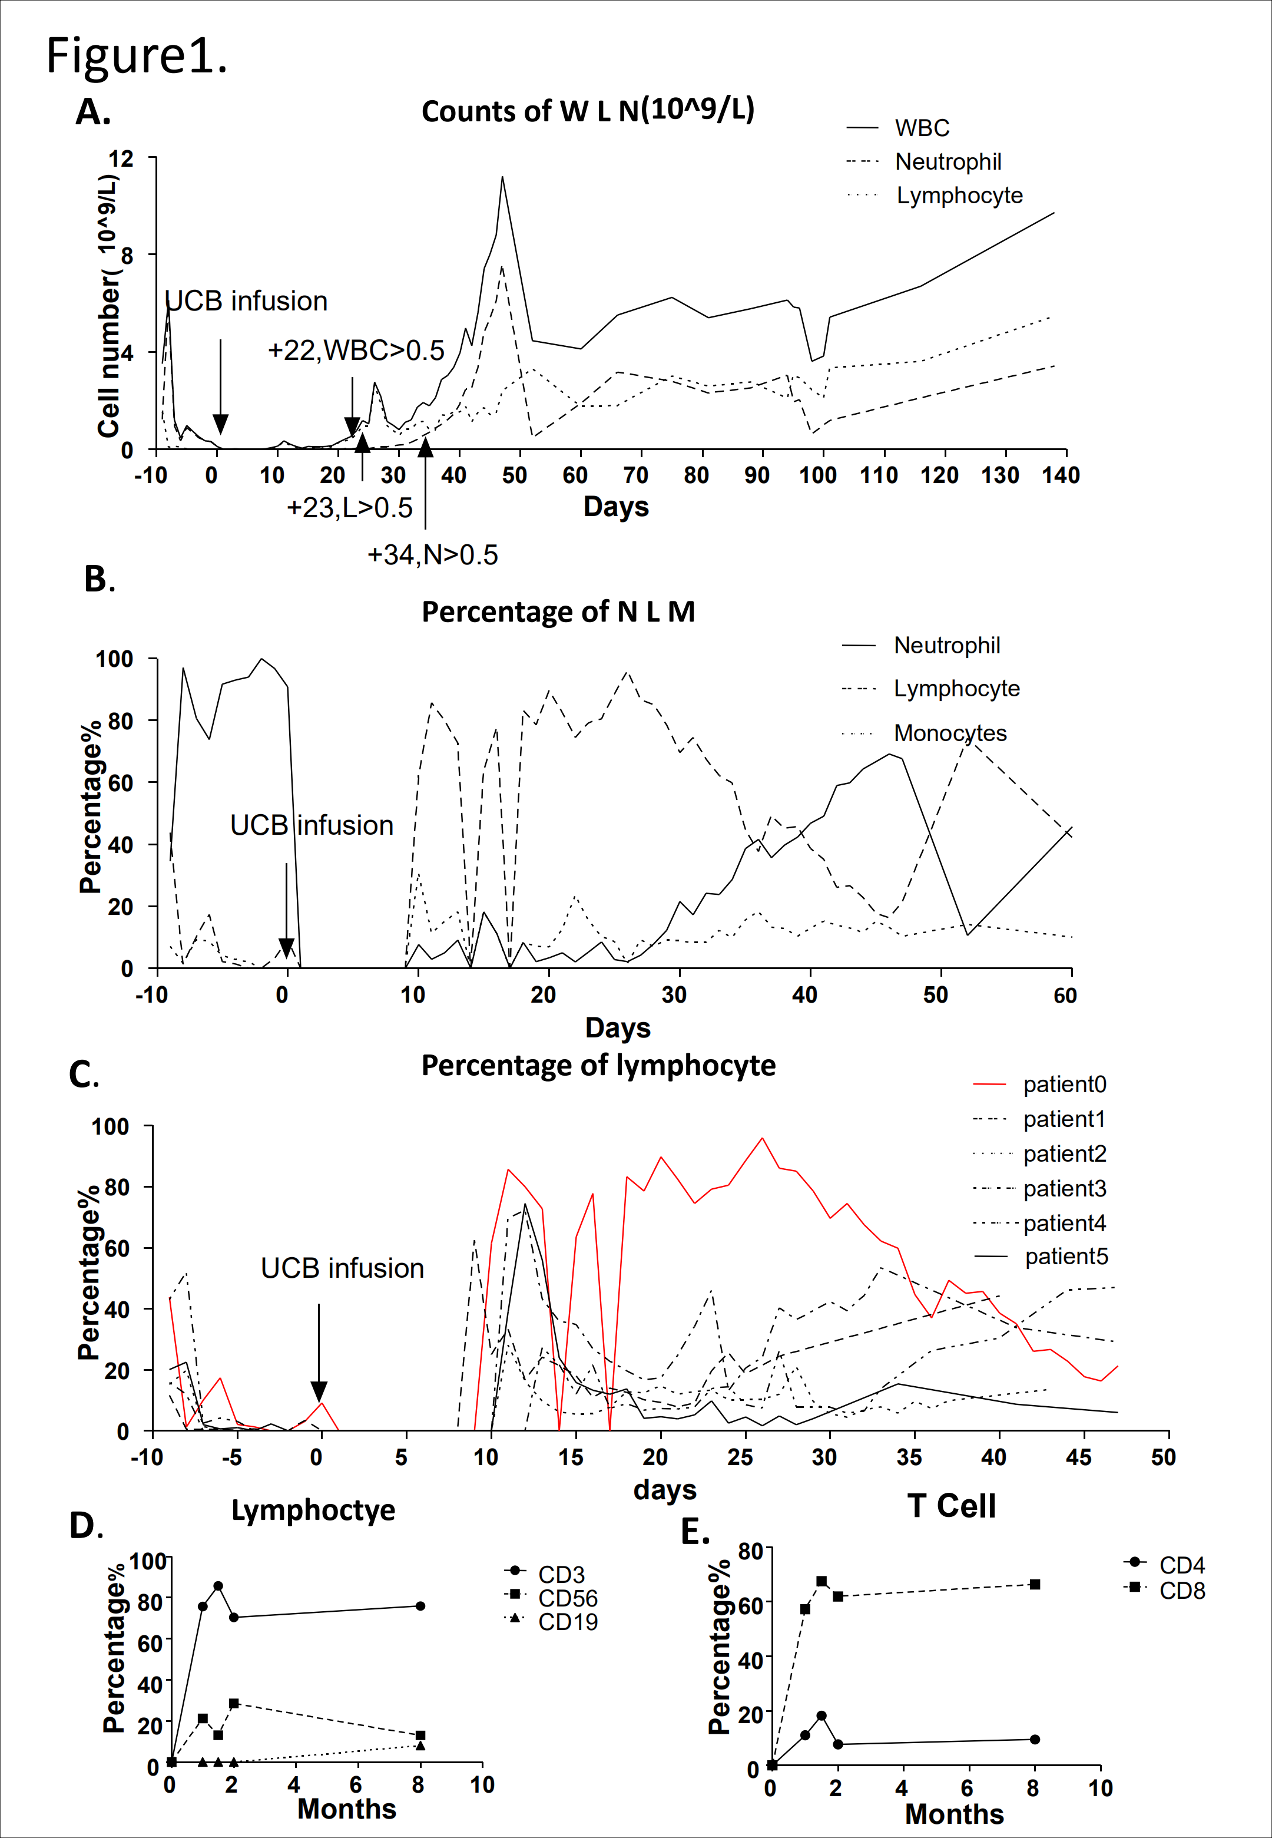
Figure 1 WBC changes after transplantation. A: Counts of WBCs, lymphocytes and neutrophils after UCB infusion. Counts of WBCs, lymphocytes and neutrophils changed and fluctuated near normal levels. WBC count reached 0.5 × 10⁹ on day 22, lymphocytes reached 0.5 × 10⁹ on day 23, and neutrophils reached 0.5 × 10⁹ on day 34; B: Percentage of neutrophils, lymphocytes and monocytes fluctuated near normal levels. The percentage of lymphocytes was high within 1 mo after transplantation; C: Changes in lymphocyte subsets after transplantation. The main subsets of lymphocytes in this patient were T cells; D: Changes in T cell subsets after transplantation. The main subgroup of T cells in this patient was CD4⁺ T cells; E: Percentage of lymphocytes from day −10 to day 50. After UCB infusion, percentage of lymphocytes changed and fluctuated near normal levels in different patients. UCB: Umbilical cord blood; WBC: White blood cell.

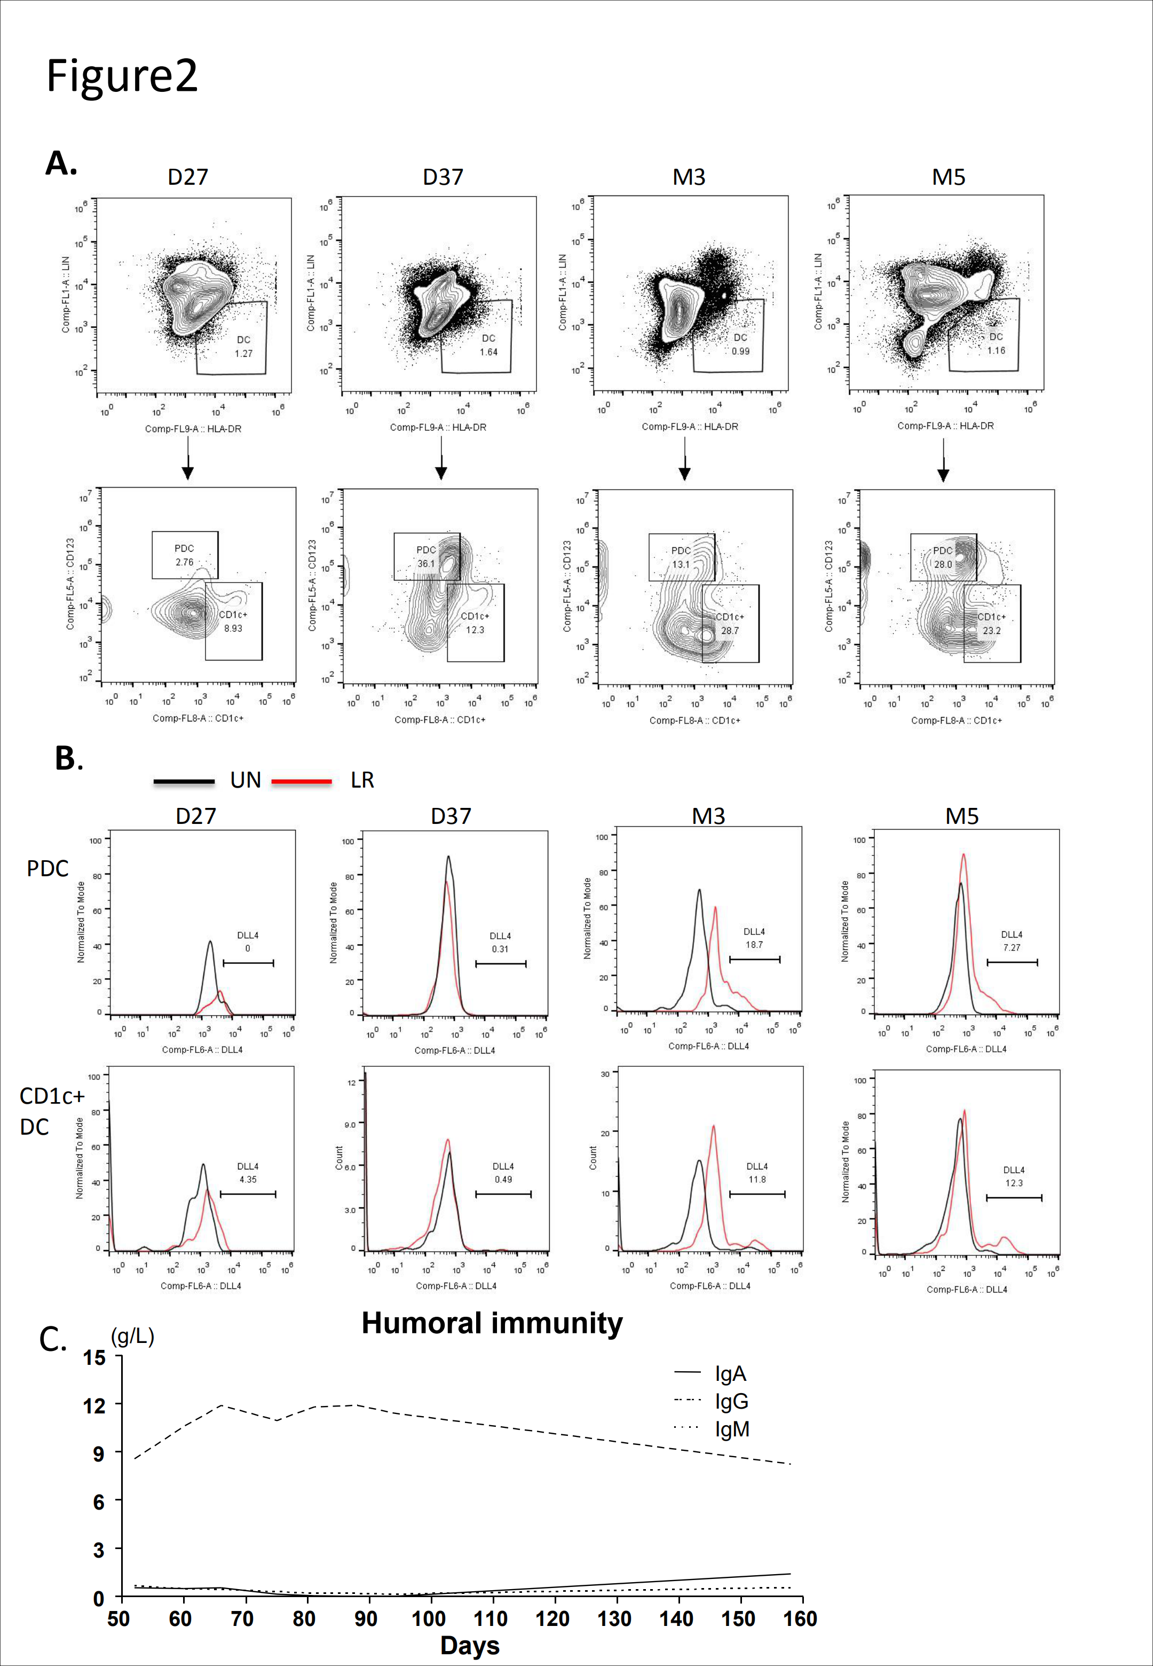
Figure 2 Reconstitution of DCs. A: Percentage of DCs and DC subsets day 27 to month 5. After UCB infusion, percentage of DCs, pDCs and CD1c⁺ DCs increased. DCs, lineage-HLA-DR⁺; plasmacytoid DCs, lineage-HLA-DR⁺CD123⁺; CD1c⁺ DCs, lineage-HLA-DR⁺CD1c⁺, detected by flow cytometry; B: DC changes after transplantation. Total DC reconstitution after transplantation; C: DC subset changes after transplantation. pDC and CD1c⁺ conventional DC reconstitution after transplantation; D: Delta-like protein 4 (DLL4⁺) DC changes after transplantation. After UCB infusion from day 27 to month 5, percentage of DLL4⁺ pDCs and DLL4⁺ CD1c⁺ DCs detected by flow cytometry after LPS (0.1 μg/mL) + R848 (0.1 μg/mL) stimulation for 24 h. DC: Dendritic cell; UCB: Umbilical cord blood.
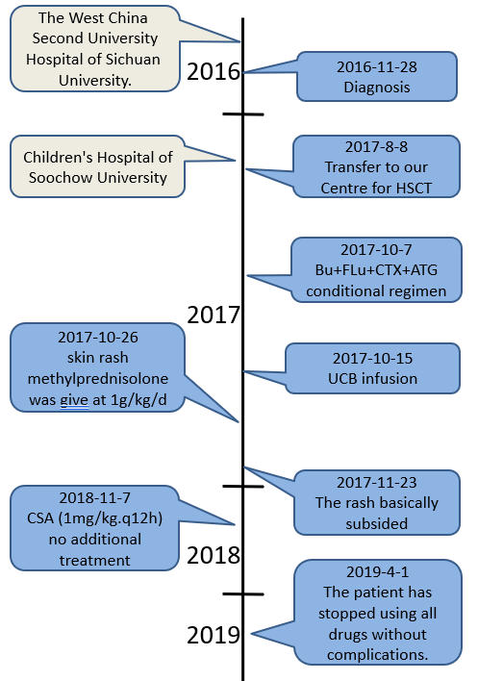
Figure 3 Timeline of interventions and outcomes.

Table 1 Details of human leukocyte antigen matching

 | Patient 0 | Patient 1 | Patient 2 | Patient 3 | Patient 4 | Patient 5
HLA-A(patient/donor) | 02:07 11:02 | 02:01 33:03 | 02:07 30:01 | 24:20 30:01 | 32:01 11:01 | 03:01 01:01
 | 02:07 24:02 | 02:06 33:03 | 02:07 30:01 | 24:20 31:01 | 32:01 02:06 | 03:01 32:01
HLA-B(patient/donor) | 54:01 40:02 | 40:06 58:01 | 13:02 46:01 | 13:02 40:01 | 44:03 48:01 | 27:05 57:01
 | 54:01 56:01 | 40:06 58:01 | 13:02 46:01 | 13:02 40:01 | 44:03 48:01 | 27:05 57:01
HLA-C(patient/donor) | 01:02 07:02 | 03:02 08:01 | 01:02 06:02 | 06:02 07:02 | 04:01 08:01 | 02:02 06:02
 | 01:02 07:02 | 03:02 08:01 | 01:02 06:02 | 06:02 07:02 | 04:01 08:01 | 02:02 06:02
HLA-DRB1(patient/donor) | 14:54 12:02 | 03:01 09:01 | 07:01 09:01 | 07:01 08:03 | 07:01 15:01 | 15:01 11:04
 | 14:55 12:02 | 03:01 09:01 | 07:01 09:01 | 07:01 08:03 | 07:01 15:01 | 15:01 10:01
HLA-DQB1(patient/donor) | 05:03 03:02 | 02:01 03:03 | 02:02 03:03 | 02:02 06:01 | 02:02 06:02 | 03:01 03:01
 | 05:03 03:01 | 02:01 03:03 | 02:02 03:03 | 02:02 06:01 | 02:02 05:03 | 05:01 06:02
Matches | 6/10 | 9/10 | 10/10 | 9/10 | 8/10 | 6/10
HLA: Human leukocyte antigen.

Table 2 Details of drug use
The conditioning regimen | Bu + FLu + CTX + ATG | BU 1.0 mg/kg, day-9 to day-6; FLu, 40 mg/m², day-5 to day-2; CTX, 60 mg/kg, day-5 to day-4; ATG 2.5 mg/kg, qd, day-8 to day-5
Prophylaxis for GVHD | CSA + MMF | CSA (6-8 mg/kg/d) and MMF (20 mg/kg/d).
Preventing hepatic VOD | Heparin and alprostadil
Preventing infection | Ganciclovir, acyclovir, micafungin and meropenem

Flu: Fludarabine; CTX: Cyclophosphamide; BU: Busulfan; ATG: Antithymocyte globulin; GVHD: Graft versus host disease; CSA: Cyclosporin A; MMF: Mycophenolate mofetil; VOD: Vein occlusion disease.

Table 3 Basic clinical parameters of five other umbilical cord blood transplantation patients
 | Patient 0 (case) | Patient 1 | Patient 2 | Patient 3 | Patient 4 | Patient 5
Age in yr | 1 | 4 | < 1 (8 m) | 1 | 5 | 2
Sex | Male | Male | Male | Male | Male | Male
Time for UCBT | 2017/10/15 | 2017/6/3 | 2018/6/8 | 2018/3/24 | 2017/7/7 | 2017/12/15
CD34 dose | 4.7 × 10⁵/kg | 2 × 10⁵/kg | 4.92 × 10⁵/kg | 2.4 × 10⁵5/kg | 4.55 × 10⁵/kg | 3.0 × 10⁵/kg
TNC | 9.17 × 10⁷/kg | 6.73 × 10⁷/kg | 15.3 × 10⁷/kg | 11.1 × 10⁷/kg | 6.26 × 10⁷/kg | 9.23 × 10⁷/kg
Conditional regimen | Bu + Flu + CTX + ATG | BU + Flu + CTX + ATG | BU + Flu + CTX + ATG | BU + Flu + CTX + ATG | BU + Flu + CTX + ATG | BU + Flu + CTX + ATG
HLA (/6) | 4/6 | 6/6 | 6/6 | 5/6 | 5/6 | 4/6
HLA (/10) | 6/10 | 9/10 | 10/10 | 9/10 | 8/10 | 6/10
Blood type (patient/donor) | B/B | A/O | B/B | O/O | O/O | A/AB
Neutrophil grafted time | D34 | D16 | D13 | D15 | D17 | D14
Lymphocytes>0.5 × 10⁹/L | D23 | D28 | D42 | D17 | D30 | D65
PLT grafted time | D66 | D28 | D29 | D30 | D33 | D27
Main complication | No | Hemorrhagic cystitis | Infection by Pneumocystis carinii | No | Intestinal infection | Leak syndrome, Hemorrhagic cystitis
Flu: Fludarabine; CTX: Cyclophosphamide; BU: Busulfan; ATG: Antithymocyte globulin.

Table 4 Details of short tandem repeats
Day | PB or BM | STR
14 | PB | 76.80%
24 | PB | 98.60%
31 | PB | 99.10%
38 | PB | 98.80%
45 | PB | 99.30%
52 | PB | 98.80%
60 | PB | 99.30%
66 | PB | 98.60%
75 | PB | 98.70%
102 | PB | 98.70%
17 | BM | 62.30%
26 | BM | 98.10%
43 | BM | 98.70%

STR: Short tandem repeat; PB: Peripheral blood; BM: Bone marrow.

