Name of Journal: World Journal of Clinical Cases
Manuscript NO: 60950
Manuscript Type: CASE REPORT

Diagnosis and spontaneous healing of asymptomatic renal allograft extra-renal pseudo-aneurysm: A case report

Xu RF et al. Renal allograft extra-renal pseudo-aneurysm

Rui-Fang Xu, En-Hui He, Zhan-Xiong Yi, Li Li, Jun Lin, Lin-Xue Qian

Rui-Fang Xu, En-Hui He, Zhan-Xiong Yi, Li Li, Lin-Xue Qian, Department of Ultrasound, Beijing Friendship Hospital, Capital Medical University, Beijing 100050, China

Jun Lin, Department of Urology, Beijing Friendship Hospital, Capital Medical University, Beijing 100050, China

Author contributions: Xu RF performed the ultrasonography examinations for the patient and contributed to manuscript drafting; He EH conducted the ultrasonography; Yi ZX and Li L analyzed the computed tomography images; Lin J was the patient’s surgeon; Qian LX was responsible for revision of the manuscript; All authors issued final approval for the version to be submitted.

Supported by the Funding from Beijing Municipal Administration of Hospitals’ Ascent Plan, No. DFL 20180102; and the Capital's Funds for Health Improvement and Research, No. 2020-4-20211.

Corresponding author: Lin-Xue Qian, DPhil, PhD, Chief Doctor, Director, Department of Ultrasound, Beijing Friendship Hospital, Capital Medical University, No. 95 Yong’an Road, Xicheng District, Beijing 100050, China. qianlinxue@outlook.com

Received: November 18, 2020
Revised: January 9, 2021
Accepted: February 10, 2021
Published online: June 6, 2021

Abstract
BACKGROUND
Transplant renal artery stenosis is a relatively frequent vascular complication after transplantation. However, extra-renal pseudo-aneurysms (EPSAs) are rare after transplantation; they can be life-threatening and usually need open surgical repair. We discuss the diagnosis and spontaneous healing of an asymptomatic renal allograft EPSA caused by renal artery anastomotic stenosis, which was diagnosed in a timely manner and managed by conservative treatments.

CASE SUMMARY
We present a 37-year-old male patient diagnosed with a renal allograft EPSA caused by renal artery anastomotic stenosis due to multiple atherosclerotic plaques with ultrasonographic examination 6 mo post transplantation. The stenosis rate of 90% and the EPSA were verified by computed tomography angiography. The diagnosis was further confirmed with digital subtraction angiography. Percutaneous transluminal angiography was conducted, and a metallic stent was successfully implanted at the stenosed site of the main renal artery trunk. No further intervention for the EPSA was undertaken due to the difficulty of stenting and the risk of bleeding; regular ultrasonographic follow-ups were recommended. The stenosis was significantly relieved immediately after stent implantation and the EPSA was healed spontaneously by completely filling with hypo-echoic thrombosis 8 mo after stenting.

CONCLUSION
Ultrasonography combined with a high-frequency linear probe can detect vascular complications post renal transplantation at an early stage and improve prognosis.

Key Words: Renal transplantation; renal artery stenosis; pseudo-aneurysm; ultrasonography; vascular complications; case report

©The Author(s) 2021. Published by Baishideng Publishing Group Inc. All rights reserved.

Xu RF, He EH, Yi ZX, Li L, Lin J, Qian LX. Diagnosis and spontaneous healing of asymptomatic renal allograft extra-renal pseudo-aneurysm: A case report. World J Clin Cases 2021; 9(16): 3943-3950 URL: https://www.wjgnet.com/2307-8960/full/v9/i16/3943.htm DOI: https://dx.doi.org/10.12998/wjcc.v9.i16.3943

Core Tip: Extra-renal pseudo-aneurysms (EPSAs) are rare post-kidney transplantation, which might be life-threatening and usually need open surgical repair or even nephrectomy. EPSA combined with, or more precisely, caused by transplant renal artery stenosis is rare. There is still no consensus for the treatment of EPSAs. We report the diagnosis and spontaneous healing of an asymptomatic renal allograft EPSA caused by renal artery anastomotic stenosis, which was diagnosed in a timely manner and managed by conservative treatments. The stenosis was relieved after stent implantation, and the EPSA was cured spontaneously by completely filling with hypo-echoic thrombosis 8 mo after stenting.

INTRODUCTION
Renal transplantation is one of the effective therapies for end-stage renal disease. With the improvement in immunosuppression in renal transplantation, there has been a significant decrease in premature graft loss and acute rejection in the past two decades^{[1,2]}. Vascular complications are common among renal transplantation patients, including thrombosis, stenosis, pseudo-aneurysm, arteriovenous fistula, and so on^{[3,4]}. Pseudo-aneurysms can be intra-renal or extra-renal (the renal graft artery trunk or iliac artery at the anastomosis site). Extra-renal pseudo-aneurysms (EPSAs) are usually rare and still without treatment consensus, which can lead to devastating consequences and could be fatal and sometimes may require renal graft nephrectomy^{[5,6]}. Transplant renal artery stenosis (TRAS) can happen at any time post transplantation, which usually occurs within 3 years post transplantation^{[7]}. The prevalence of TRAS and EPSAs is less than 1% and 1%-23%, respectively. EPSA combined with, or, more precisely, caused by TRAS is rare. We manifest the diagnosis and prognosis of an asymptomatic renal allograft EPSA caused by renal artery anastomotic stenosis, which was diagnosed in time and managed under conservative treatments.

CASE PRESENTATION
Chief complaints
A 37-year-old male patient presented to the ultrasound department for regular ultrasonographic follow-up, without complaints of specific discomforts.

History of present illness
The patient underwent allogeneic kidney transplantation (donation after cardiac death) because of IgA nephropathy, chronic renal insufficiency and uremia at our hospital 6 mo ago.

History of past illness
The patient was diagnosed with renal hypertension 10 years ago, and his blood pressure was stable after dialysis with medication administration. He was diagnosed with renal anemia 10 years ago and was treated with hemopoietin regularly. He was diagnosed with renal osteopathy 10 years ago, and his condition was stable with oral administration of calcium tablets.

Personal and family history
Personal and family history were unremarkable.

Physical examination
The patient’s body temperature was 36.3 ℃, heart rate was 90 bpm, respiratory rate was 18 breaths per minute, and blood pressure was 105/64 mmHg. One 15-cm oblique scar could be seen in the right lower abdomen. Arteriovenous fistula could be seen in the left forearm.

Laboratory examinations
The post-transplant serum creatinine fluctuated around 90 μmol/L during follow-ups. However, the creatinine at this time was 165.4 μmol/L, which was higher than the normal level.

Imaging examinations
Two artery trunks of the renal graft anastomosed with the side of the external iliac artery were detected during the ultrasonographic examination (1-5 MHz convex transducer, iuElite; Philips, Bothell, WA98021, United States) (Figure 1A and B). Color aliasing indicating high-velocity turbulent flow at the proximal site of the main renal artery trunk (donor portion) was detected, with peak systolic velocity (PSV) of 674 cm/s on pulsed-wave Doppler (PWD) (Figure 1C). The renal artery to external iliac artery PSV ratio was larger than 3:1, which further confirmed stenosis at the site. Stenosis at the proximal site of the main renal artery trunk (donor portion) was considered. Multiple hyper-echo plaques attached to the wall of the main renal artery trunk were detected after meticulous scanning with the high frequency 9-3 MHz linear probe (Figure 1D and E). The largest plaque of the proximal site of the main renal artery trunk close to the anastomosis was about 0.7 cm × 0.3 cm, and the plaque size of the middle segment of the main renal artery trunk was about 0.9 cm × 0.3 cm. The residual lumen at the proximal site of the main renal artery trunk was about 0.2 cm in diameter, and one 1.2 cm × 0.8 cm external protruding cystic structure was detected at the anastomotic site between the main renal artery trunk and the external iliac artery. Blood flow signals inside the cystic structure were visible in color Doppler flow imaging, showing as swirling pattern, and to-and-fro disorganized arterial spectrum was detected with PWD (Figure 2A and B). Hypo-echoic thrombus with thickness of 0.3 cm was observed inside the cystic structure, and an EPSA at the anastomotic site caused by renal artery atherosclerotic stenosis with thrombosis formed inside was considered (Figure 2C). The spectral waveform of the perforating area inside the renal allograft was observed, showing as prolonged acceleration time longer than 70 ms (Figure 2D). Stenosis rate of 90% at the proximal site of the main renal artery trunk accompanied with a pseudo-aneurysm at the anastomosis with the external iliac artery was confirmed by further computed tomography angiography and digital subtraction angiography (Figure 3).

FINAL DIAGNOSIS
An EPSA at anastomotic site caused by renal artery atherosclerotic stenosis with thrombosis formed inside was considered.

TREATMENT
After reviewing the benefits and risks of all treatment options, the physician and the patient decided to conduct percutaneous transluminal angiography. Balloon dilation was conducted at first and then a metallic stent of 6 mm × 20 mm was implanted at the proximal stenosed site of the main renal artery trunk successfully under angiography. Since the pseudo-aneurysm was at the anastomotic site, there was no adequate landing zone available for the placement of another stent due to the complexity of an anastomosis with a reconstructed main renal artery combined with the lower pole renal artery. According to our judgement, the pseudo-aneurysm might be the result of the high pressure caused by the severe stenosis and there was thrombosis formed inside the sac. Therefore, no further intervention was chosen according to the size of aneurysm and the danger of bleeding after stent implantation. We recommended close ultrasonographic follow-ups.

OUTCOME AND FOLLOW-UP
The stenosis was significantly relieved after stent implantation, manifested as the PSV of stenosed site decreasing to 255 cm/s (Figure 4A and B) and the disappearance of the prolonged acceleration time of the arterial spectral waveform inside the renal graft (Figure 4C and D). During regular ultrasonographic follow-ups, the lumen of the pseudo-aneurysm narrowed and was replaced by hypo-echoic thrombosis gradually. The pseudo-aneurysm was completely filled with hypo-echoic thrombosis 8 mo after stenting (Figure 4E and F).

DISCUSSION
TRAS is relatively common, compared with EPSAs, which occurs in less than 1% of patients^{[8]}. These are mostly the result of technical errors or infection, and frequently happen at the arterial anastomotic site. It might lead to renal graft dysfunction and/or uncontrolled post-transplant hypertension and even allograft loss^{[9,10]}.
The causes for TRAS are mostly technical, vascular clamps, vessel lesions during preservation, angulation or kinking of the artery. Stenosis can also occur due to donor or recipient atherosclerosis^{[11]}. The incidence of multiple renal arteries is about 17%-35% reported by autopsy studies, depending on the ethnic origin^{[12]}. The use of renal grafts with multiple renal arteries is quite common clinically, due to the donor shortage^{[13]}. Accessory arteries are usually ligated if the vascularizing area is less than 5%-10% of the kidney. The ligation of the lower pole renal artery should be avoided since it might lead to ureteral ischemia or necrosis. In our case, the lower pole renal artery and the main renal artery trunk were anastomosed with the external iliac artery, after the arteries were reconstructed with aortic patches when the graft was still on ice.
The treatment measures for TRAS include optical medical administration alone, surgical revascularization and percutaneous transluminal angioplasty with or without stenting^{[14]}. As a less invasive approach than surgery, percutaneous transluminal angioplasty with stenting has become the first-line option without the support of very strong evidence^{[15,16]}.
The etiology of EPSAs includes perivascular infection, degeneration, defective vascular reconstruction, iatrogenic damage, suture rupture, vessel wall ischemia or anastomotic leakage^{[6,17]}. EPSAs exclusively happen at the anastomotic site and are usually singular, due to defective vascular reconstruction. For donors with multiple renal arteries, even though aortic patches are frequently used to avoid individual reconstruction in deceased donor grafts, the incidence of vascular complications of recipients with multiple renal arteries is still significantly higher than those with single renal artery, 10.8% vs 8.1%^{[17]}. The reason might be the complexity of the anastomosis with a reconstructed renal artery combined with accessory arteries of small diameters. EPSAs are potentially devastating and might lead to graft loss due to rupture^{[18]}.
Patients with EPSAs post renal transplantation can be asymptomatic and be incidentally found by ultrasonography or computed tomography^{[19]}. Some patients present with anemia, fever, pulsatile masses, hypertension, renal function impairment, and abdominal pain, and few EPSAs are life-threatening due to acute rupture^{[17,19-21]}. Ultrasonography can be used to recognize most of the lesions, manifesting as simple or complex cysts. Color Doppler can show the intra-cystic blood flow and PWD can detect arterial waveforms^{[22]}. The creatinine during the follow-up at this time was 165.4 μmol/L, which was a little bit higher than normal. However, our patient did not present any symptoms or signs directly caused by EPSA. The EPSA in our case was not visible with the 1-5 MHz convex transducer at first. The plaques and EPSA were not found until the high frequency 3-9 MHz transducer was used, which indicates the importance of combination use of the low and high frequency probes to make an accurate diagnosis. We propose the scanning of the renal allograft with high a frequency linear probe whenever possible.
Even though EPSAs rupture can lead to life-threatening hemorrhage that needs urgent intervention and graft nephrectomy might be needed if the graft is jeopardized. The indications and options for treatment of EPSAs are still subject to debate at present^{[19]}. There is no identified diameter to predict the risk of EPSA rupture. Published reports^{[19,23]} recommend indications for repair as follows: symptomatic EPSAs, presence of infection, large size (diameter larger than 2.5 cm), progressive enlargement and signs of rupture. Treatments for EPSAs include open surgical repair, endovascular approach and ultrasound-guided thrombin injection. In the last decade, the endovascular approach has become more popular for EPSAs^{[19,24,25]}, which reduces the risk of rupture by excluding blood flow into the EPSAs with stent placement.
We assume that the cause of EPSA of our case was the high pressure caused by the severe stenosis of the main renal artery and the complexity and weakness of the anastomosis, especially by the former. Due to the difficulty of stenting at the EPSA site, its size, and the cause of EPSA, conservative closely monitoring was considered for the EPSA management. The prognosis turned out that our judgment was correct. Thrombosis filled in the EPSA sac gradually after the high pressure around the anastomosis decreased after the stenosis was relieved. However, this is only a case report, which needs accumulation of more cases.

CONCLUSION
EPSAs of renal transplantation are life threatening with the risk of rupture and might need graft nephrectomy when allograft function was devastated. We present a patient with an asymptomatic EPSA caused by para-renal artery anastomotic atherosclerotic stenosis, which was spontaneously relieved by removing the cause and close conservative observation. It is still on debate how, when and whether to treat EPSAs. Diagnosis of EPSAs as early as possible is important for a better prognosis, and scanning of the renal allograft with a high frequency linear probe might change the prognosis unexpectedly.

ACKNOWLEDGEMENTS
The language was edited by professor David Ari Rubenstein.

REFERENCES
1 Bruno S, Remuzzi G, Ruggenenti P. Transplant renal artery stenosis. J Am Soc Nephrol 2004; 15: 134-141 [PMID: 14694165 DOI: 10.1097/01.asn.0000099379.61001.f8]
2 Ghazanfar A, Tavakoli A, Augustine T, Pararajasingam R, Riad H, Chalmers N. Management of transplant renal artery stenosis and its impact on long-term allograft survival: a single-centre experience. Nephrol Dial Transplant 2011; 26: 336-343 [PMID: 20601365 DOI: 10.1093/ndt/gfq393]
3 Hagen G, Wadström J, Magnusson M, Magnusson A. Outcome after percutaneous transluminal angioplasty of arterial stenosis in renal transplant patients. Acta Radiol 2009; 50: 270-275 [PMID: 19235580 DOI: 10.1080/02841850902718763]
4 Ren Y, Xiong F, Kan X, Qian K, Cao Y, Chen L, Xiong B, Zhou G, Zheng C. Endovascular management of transplant renal artery stenosis: A single-center retrospective study. Catheter Cardiovasc Interv 2020; 95: 429-436 [PMID: 31802623 DOI: 10.1002/ccd.28624]
5 Sachdeva A, Bhatia N, Paul B, Kumar V. External iliac artery pseudoaneurysm complicating renal transplantation. J Assoc Physicians India 2013; 61: 752-753 [PMID: 24772737]
6 Shamsaeefar A, Nikeghbalian S, Kazemi K, Mansorian M, Motazedian N, Malekhosseini SA. Kidney Transplant From a Deceased Donor With Renal Artery Aneurysm: A Case Report. Exp Clin Transplant 2019; 17: 263-265 [PMID: 28411357 DOI: 10.6002/ect.2016.0158]
7 Hurst FP, Abbott KC, Neff RT, Elster EA, Falta EM, Lentine KL, Agodoa LY, Jindal RM. Incidence, predictors and outcomes of transplant renal artery stenosis after kidney transplantation: analysis of USRDS. Am J Nephrol 2009; 30: 459-467 [PMID: 19776559 DOI: 10.1159/000242431]
8 Dimitroulis D, Bokos J, Zavos G, Nikiteas N, Karidis NP, Katsaronis P, Kostakis A. Vascular complications in renal transplantation: a single-center experience in 1367 renal transplantations and review of the literature. Transplant Proc 2009; 41: 1609-1614 [PMID: 19545690 DOI: 10.1016/j.transproceed.2009.02.077]
9 Seratnahaei A, Shah A, Bodiwala K, Mukherjee D. Management of transplant renal artery stenosis. Angiology 2011; 62: 219-224 [PMID: 20682611 DOI: 10.1177/0003319710377076]
10 Kolli KP, LaBerge JM. Interventional Management of Vascular Renal Transplant Complications. Tech Vasc Interv Radiol 2016; 19: 228-236 [PMID: 27641457 DOI: 10.1053/j.tvir.2016.06.008]
11 Buturović-Ponikvar J. Renal transplant artery stenosis. Nephrol Dial Transplant 2003; 18 Suppl 5: v74-v77 [PMID: 12817078 DOI: 10.1093/ndt/gfg1054]
12 Taghizadeh Afshari A, Mohammadi Fallah MR, Alizadeh M, Makhdoomi K, Rahimi E, Vossoghian S. Outcome of Kidney Transplantation From Living Donors With Multiple Renal Arteries Versus Single Renal Artery. Iran J Kidney Dis 2016; 10: 85-90 [PMID: 26921750]
13 Giovanardi F, Nudo F, Lai Q, Garofalo M, Consolo A, Choppin De Janvry E, Arroyo Murillo GA, Ursi P, Stabile D, Melandro F, Berloco PB, Pretagostini R, Poli L. Surgical Technique Notes of Arterial Vascular Reconstruction During Kidney Transplantation: Personal Experience and Literature Review. Transplant Proc 2019; 51: 128-131 [PMID: 30661896 DOI: 10.1016/j.transproceed.2018.04.072]
14 Bull AS, Piovesan AC, Marchini GS, Yamaçake KGR, Antonopoulos IM, Falci R, Kanashiro H, Ebaid G, Carnevale FC, Messi G, Nahas WC. Outcomes of endovascular treatment of renal arterial stenosis in transplanted kidneys. Int Braz J Urol 2019; 45: 925-931 [PMID: 31268637 DOI: 10.1590/S1677-5538.IBJU.2018.0737]
15 Valle LGM, Cavalcante RN, Motta-Leal-Filho JM, Affonso BB, Galastri FL, Doher MP, Guimarães-Souza NK, Cavalcanti AKN, Garcia RG, Pacheco-Silva Á, Nasser F. Evaluation of the efficacy and safety of endovascular management for transplant renal artery stenosis. Clinics (Sao Paulo) 2017; 72: 773-779 [PMID: 29319724 DOI: 10.6061/clinics/2017(12)09]
16 Li CM, Shang T, Tian L, Zhang HK. Short-Term Outcomes Using a Drug-Coated Balloon for Transplant Renal Artery Stenosis. Ann Transplant 2018; 23: 75-80 [PMID: 29371586 DOI: 10.12659/aot.906658]
17 Nguan CY, Luke PP. Renal artery pseudoaneurysm of infectious etiology: a life-threatening complication after renal transplantation. Urology 2006; 68: 668-669 [PMID: 16979702 DOI: 10.1016/j.urology.2006.04.017]
18 Edwards JB, Wooster MD, Tanious A, Back MR. Management of Aortoiliac Aneurysms with Atypical Renal Artery Anatomy. Ann Vasc Surg 2019; 54: 110-117 [PMID: 30081157 DOI: 10.1016/j.avsg.2018.05.058]
19 Bracale UM, Carbone F, del Guercio L, Viola D, D'Armiento FP, Maurea S, Porcellini M, Bracale G. External iliac artery pseudoaneurysm complicating renal transplantation. Interact Cardiovasc Thorac Surg 2009; 8: 654-660 [PMID: 19289398 DOI: 10.1510/icvts.2008.200386]
20 Li Z, Li Y, Jing Z, Feng R. Endovascular Treatment for a True Aneurysm of the Transplant Renal Artery using Noncovered Stent-Assisted Coil Embolization. Ann Vasc Surg 2018; 51: 325.e5-325.e8 [PMID: 29758329 DOI: 10.1016/j.avsg.2018.02.023]
21 Kountidou CS, Stier K, Niehues SM, Lingnau A, Schostak M, Fuller TF, Lützenberg R. Successful repair of post-transplant mycotic aneurysm of iliac artery with renal graft preservation: a case report. Urology 2012; 80: 1151-1153 [PMID: 22999448 DOI: 10.1016/j.urology.2012.07.048]
22 Ardelean A, Mandry D, Claudon M. [Vascular complications following renal transplantation: diagnostic evaluation]. J Radiol 2011; 92: 343-357 [PMID: 21549890 DOI: 10.1016/j.jradio.2011.02.018]
23 Luzzio CC, Waclawik AJ, Gallagher CL, Knechtle SJ. Iliac artery pseudoaneurysm following renal transplantation presenting as lumbosacral plexopathy. Transplantation 1999; 67: 1077-1078 [PMID: 10221499 DOI: 10.1097/00007890-199904150-00026]
24 Patil VV, Roytman M, Ames S, Beckerman W, Lookstein RA. Endovascular Repair of Renal Artery Anastomotic Pseudoaneurysm Following Living Donor Kidney Transplant. Cardiovasc Intervent Radiol 2015; 38: 1640-1644 [PMID: 26037091 DOI: 10.1007/s00270-015-1136-x]
25 Haijie C, Fubo S, Xiaoying L, Ying Y, Zenghui P. Retrospective evaluation of the endovascular repair of the anastomotic pseudoaneurysm of the transplanted renal artery using the snorkel technique. Vascular 2020; 28: 475-480 [PMID: 32212915 DOI: 10.1177/1708538120910834]

Footnotes
Informed consent statement: Informed consent was obtained from the patient in the study.

Conflict-of-interest statement: The authors declare that they have no conflict of interest.

CARE Checklist (2016) statement: The authors have read the CARE Checklist (2016), and the manuscript was prepared and revised according to the CARE Checklist (2016).

Open-Access: This article is an open-access article that was selected by an in-house editor and fully peer-reviewed by external reviewers. It is distributed in accordance with the Creative Commons Attribution NonCommercial (CC BY-NC 4.0) license, which permits others to distribute, remix, adapt, build upon this work non-commercially, and license their derivative works on different terms, provided the original work is properly cited and the use is non-commercial. See: http://creativecommons.org/Licenses/by-nc/4.0/

Manuscript source: Unsolicited manuscript

Peer-review started: November 18, 2020
First decision: December 30, 2020
Article in press: February 10, 2021

Specialty type: Radiology, nuclear medicine and medical imaging
Country/Territory of origin: China
Peer-review report’s scientific quality classification
Grade A (Excellent): 0
Grade B (Very good): B, B
Grade C (Good): 0
Grade D (Fair): 0
Grade E (Poor): 0

P-Reviewer: Ali FE S-Editor: Zhang H L-Editor: Filipodia P-Editor: Li X

Figure Legends
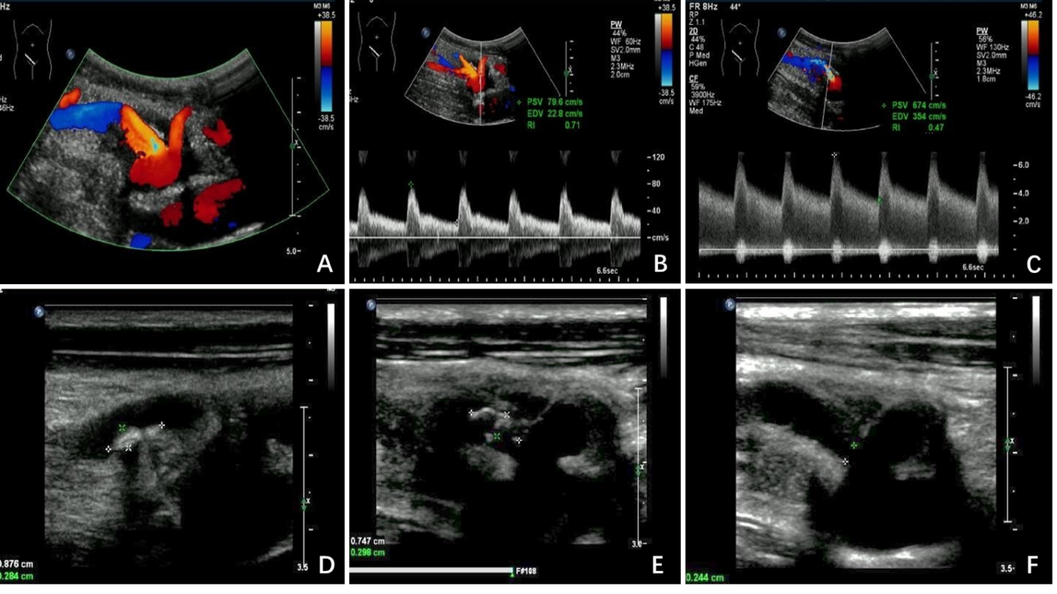
Figure 1 Ultrasonographic examination. A: Two artery trunks anastomosed with the side of the external iliac artery were detected; B: Peak systolic velocity (PSV) of the low pole artery was 79.6 cm/s; C: PSV of 674 cm/s with color aliasing at the proximal site of the main renal trunk was detected; D and E: Multiple hypo-echoic plaques attached to the wall of the main renal artery trunk was detected; F: The residual lumen at the proximal site of the main renal artery trunk was 0.2 cm in diameter.
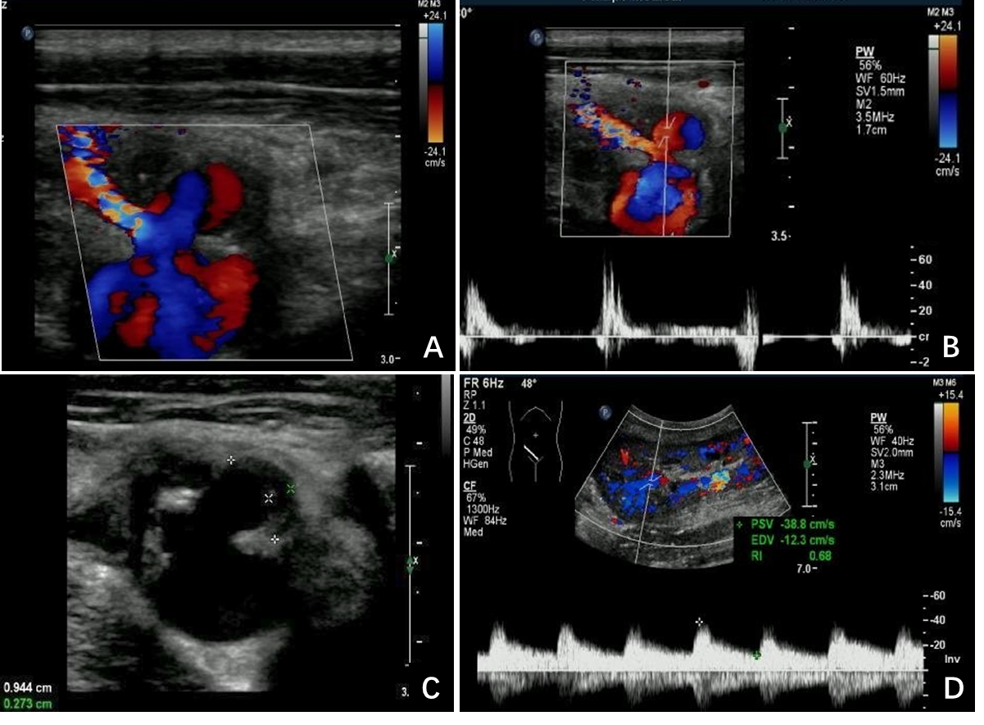
Figure 2 Extra-renal pseudo-aneurysm under ultrasonography. A: Blood flow signal showing as swirling pattern was visible; B: To-and-fro disorganized arterial spectrum was detected with pulsed-wave Doppler; C: Hypo-echoic thrombus with thickness of 0.3 cm was observed inside the cystic structure; D: Prolonged acceleration time was longer than 70 ms of the related area inside the graft.
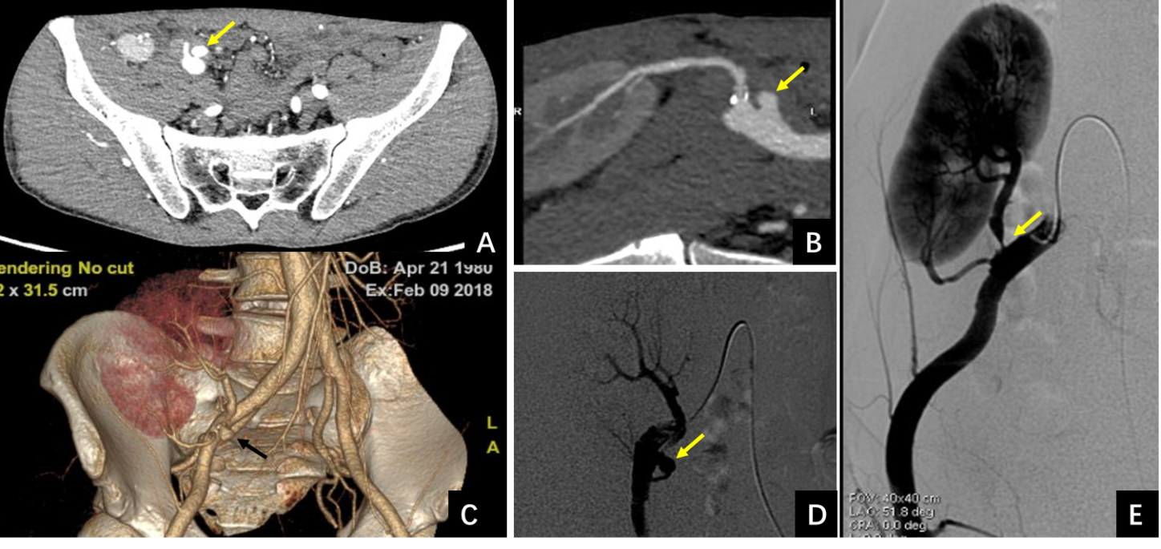
Figure 3 Computed tomography angiography and digital subtraction angiography manifestations of the extra-renal pseudo-aneurysm. A-C: Extra-renal pseudo-aneurysm (EPSA at the anastomotic site was seen by computed tomography angiography examination (orange arrows); D and E: Severe stenosis at the proximal site of the main renal artery trunk (E) with EPSA at the anastomosis with the external iliac artery (D) was confirmed by digital subtraction angiography examination (orange arrows).
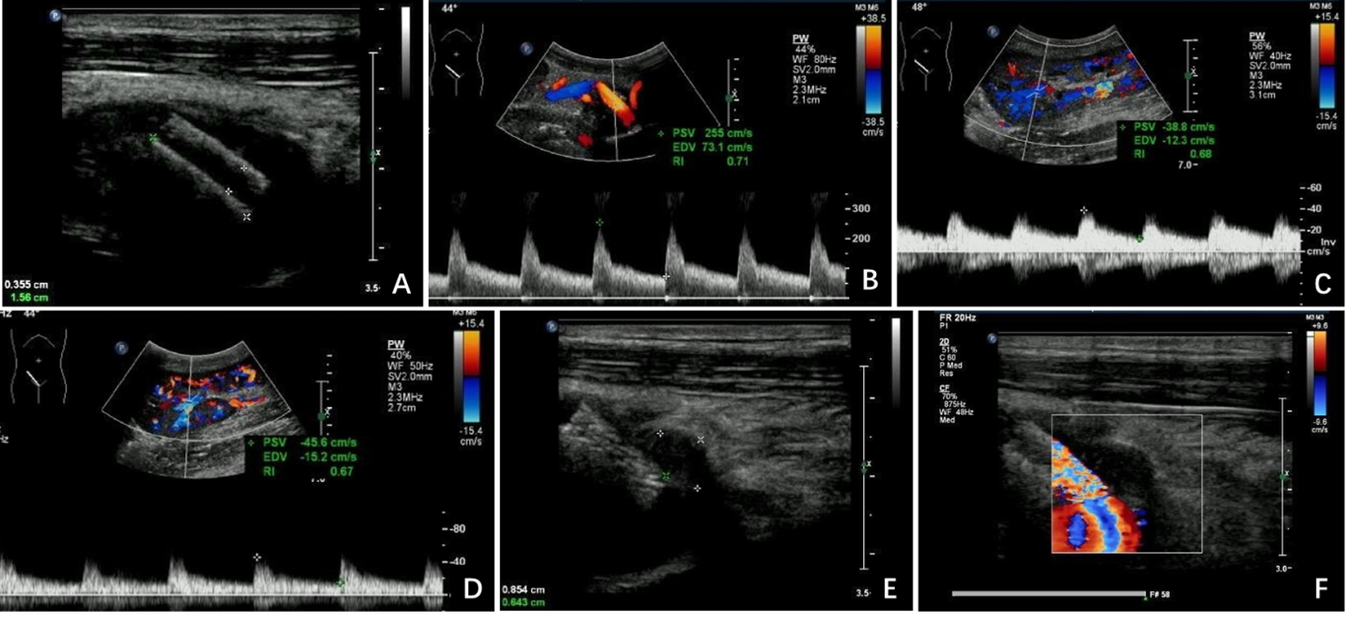
Figure 4 Ultrasonographic follow-ups post-treatment. A and B: Stent was detected at the proximal site the of the main renal artery trunk and the peak systolic velocity decreased to 255 cm/s after stent implantation; C and D: The prolonged acceleration time disappeared (D) compared with pre-treatment manifestation (C); E and F: The extra-renal pseudo-aneurysm was completely filled with hypo-echoic thrombosis 8 mo after stenting.

Published by Baishideng Publishing Group Inc
7041 Koll Center Parkway, Suite 160, Pleasanton, CA 94566, USA
Telephone: +1-925-3991568
E-mail: bpgoffice@wjgnet.com
Help Desk: https://www.f6publishing.com/helpdesk
https://www.wjgnet.com

© 2021 Baishideng Publishing Group Inc. All rights reserved.

