Name of Journal: World Journal of Gastrointestinal Oncology
Manuscript NO: 76544
Manuscript Type: ORIGINAL ARTICLE

Retrospective Study
Profiling of gene fusion involving targetable genes in Chinese gastric cancer

Liu ZH et al. Gene fusions in Chinese GC patients

Zhen-Hua Liu, Bo-Wen Zhu, Min Shi, Yu-Rong Qu, Xun-Jun He, Hong-Ling Yuan, Jie Ma, Wei Li, Dan-Dan Zhao, Zheng-Chuang Liu, Bao-Ming Wang, Chun-Yang Wang, Hou-Quan Tao, Tong-Hui Ma

Zhen-Hua Liu, Department of Medical Oncology, Fujian Medical University, Fuzhou 350001, Fujian Province, China

Bo-Wen Zhu, Min Shi, Yu-Rong Qu, Hong-Ling Yuan, Wei Li, Dan-Dan Zhao, Bao-Ming Wang, Chun-Yang Wang, Medical Center, Genetron Health (Beijing) Technology, Co. Ltd., Beijing 102200, China

Xun-Jun He, Department of Genetics and Genomic Medicine, Zhejiang Provincial People’s Hospital, Hangzhou 310000, Zhejiang Province, China

Xun-Jun He, Zheng-Chuang Liu, Hou-Quan Tao, Key Laboratory of Gastroenterology of Zhejiang Province, Zhejiang Provincial People’s Hospital, Hangzhou 310000, Zhejiang Province, China

Jie Ma, Department of Pathology, Zhejiang Provincial People's Hospital, Hangzhou 310000, Zhejiang Province, China

Zheng-Chuang Liu, Hou-Quan Tao, Department of Gastroenterology of Zhejiang Province, Zhejiang Provincial People’s Hospital, Hangzhou 310000, Zhejiang Province, China

Tong-Hui Ma, Department of Translational Medicine, Genetron Health (Beijing) Technology, Co. Ltd., Beijing 102200, China

Author contributions: Liu ZH and Ma TH designed the study and reviewed the manuscript; Liu ZH, Zhu BW, Shi M analyzed the clinical and gene fusions data and wrote the manuscript; He XJ, Ma J, Liu ZC, and Tao HQ provided clinical advice; Yuan HL, Li W, Zhao DD, Wang BM, and Wang CY reviewed the manuscript and provided advice; All authors have read and approved the final manuscript.

Corresponding author: Tong-Hui Ma, PhD, Director, Department of Translational Medicine, Genetron Health (Beijing) Technology, Co. Ltd., 1-2/F, Building 11, Zone 1, 8 Life Science Parkway, Changping District, Beijing 102200, China. tonghuima0818@sina.com

Received: March 30, 2022
Revised: June 14, 2022
Accepted: July 19, 2022
Published online:

Abstract
BACKGROUND
Approximately half of all new cases of gastric cancer (GC) and related deaths occur in China. More than 80% of patients with GC are diagnosed at an advanced stage, which results in poor prognosis. Although HER2-directed therapy and immune checkpoint inhibitors have been somewhat successful, new drugs are still needed for the treatment of GC. Notably, several gene fusion-targeted drugs have been approved by the United States Food and Drug Administration for solid tumors, including GC, such as larotrectinib for NTRK fusion-positive cancers and zenocutuzumab for NRG1 fusion-positive cancers. However, gene fusions involving targetable genes have not been well characterized in Chinese patients with GC.

AIM
To identify the profile of fusions involving targetable genes in Chinese patients with GC using clinical specimens and determine the distribution of patients with gene fusion variants among the molecular subtypes of GC.

METHODS
We retrospectively analyzed gene fusion events in tumor tissue samples from 954 Chinese patients with GC. Clinicopathological characteristics were obtained from their medical records. Genetic alterations, such as single nucleotide variants, indels, amplifications, and gene fusions, were identified using a targeted sequencing panel containing 825 genes. Fusions were validated by fluorescence in situ hybridization (FISH) using break-apart probes. The microsatellite instability (MSI) status was evaluated using MSIsensor from the targeted sequencing panel data. Tumor mutational burden (TMB) was calculated using the total number of nonsynonymous mutations divided by the total genomic targeted region. Chi-square analysis was used to determine the enrichment of gene fusions associated with the molecular subtypes of GC.

RESULTS
We found that 1.68% (16/954) of patients harbored 20 fusion events involving targetable genes. RARA fusions (n = 5) were the most common, followed by FGFR2, BRAF, MET, FGFR3, RET, ALK, EGFR, NTRK2, and NRG1 fusions. Two of the RARA fusions, EML4-ALK (E6:E20) and EGFR-SEPTIN14 (E7:E10), have been identified in other tumors but not in GC. Surprisingly, 18 gene fusion events were previously not reported in any cancer types. Twelve of the eighteen novel gene fusions included complete exons encoding functional domains of targetable genes, such as the tyrosine kinase domain of receptor tyrosine kinases and the DNA- and ligand-binding domains of RARA. Consistent with the results of detection using the targeted sequencing fusion panel, the results of FISH (fluorescence in situ hybridization) confirmed the rearrangement of FGFR2 and BRAF in tumors from patients 04 and 09, respectively. Genetic analysis indicated that the fusion genes were significantly enriched in patients with ERBB2 amplification (P = 0.02); however, there were no significant differences between fusion-positive and fusion-negative patients in age, sex, MSI status, and TMB.

CONCLUSION
We characterized the landscape of fusions involving targetable genes in a Chinese GC cohort and found that 1.68% of patients with GC harbor potential targetable gene fusions, which were enriched in patients with ERBB2 amplification. Gene fusion detection may provide a potential treatment strategy for patients with GC with disease progression following standard therapy.

Key Words: Gene fusion; Targetable genes; Gastric cancer; Chinese population; ERBB2 amplification

Liu ZH, Zhu BW, Shi M, Qu YR, He XJ, Yuan HL, Ma J, Li W, Zhao DD, Liu ZC, Wang BM, Wang CY, Tao HQ, Ma TH. Profiling of gene fusion involving targetable genes in Chinese gastric cancer. World J Gastrointest Oncol 2022; In press

Core Tip: The proportion of patients with gene fusions in Chinese patients with gastric cancer (GC) has not yet been characterized. In our analysis, we found that 1.68% of such patients harbor fusions involving targetable genes. Moreover, these fusion genes were enriched in patients with ERBB2 amplification. Our study indicates that gene fusion detection may provide a novel approach for GC therapy.

INTRODUCTION
Gastric cancer (GC) is the fifth most frequent cancer and the third leading cause of cancer deaths worldwide, with more than one million new cases and approximately 769000 deaths in 2020^{[1]}. The overall survival rate of patients with early stage disease is around 90% after surgical resection^{[2]}; however, more than 80% of patients with GC are diagnosed at an advanced stage in China, which limits the effectiveness of the treatment^{[3]}. Although chemotherapy has improved the survival of advanced-stage patients with GC, the objective response rate remains less than 40%, and the median overall survival is less than 12 mo^{[4]}. Nevertheless, new targeted therapies are capable of improving the objective response rate and overall survival of patients with GC expressing certain targets^{[5]}.
Approximately 13%-22% of GCs exhibit HER2 overexpression or amplification^{[6-8]}. The College of American Pathologists, the American Society for Clinical Pathology, and the American Society of Clinical Oncology recommend that all patients with advanced gastric adenocarcinoma should be tested for HER2 overexpression^{[9]}. Trastuzumab was approved by the United States Food and Drug Administration (FDA) in 2010 as first-line treatment in combination with chemotherapy for patients with HER2-positive GC. Microsatellite instability-high (MSI-H) tumors are considered a molecular subtype of gastric adenocarcinoma by The Cancer Genome Atlas (TCGA)^{[10]}. The incidence of MSI-H GC is 10%-20%^{[11]}. The NCCN guidelines recommend MSI testing as a standard test for all patients with GC. Regarding targeted therapy, the FDA has approved pembrolizumab (PD1 monoclonal antibody) for the treatment of all unresectable or metastatic solid tumors with MSI-H/dMMR (deficient DNA mismatch repair), including GC. Although drug treatments have shown success to some extent, the development of more targeted drugs is required.
With rapid advancements in the field of oncogenomics, gene fusions in cancer have received increasing attention. The FDA has approved larotrectinib (Vitrakvi) and entrectinib (Rozlytrek) for the first- or subsequent-line treatment of solid tumors with NTRK fusions, including GC^{[12,13]}. In 2021, the FDA accelerated the approval of the NRG1 inhibitor, zenocutuzumab (MCLA-128), in patients with pan-cancer harboring an NRG1 fusion. Apart from these fusion genes with approved drugs in pan-cancer, ALK fusions, such as EML4-ALK, TFG-ALK, and STRN-ALK, have been identified in the majority of tumors, including lung adenocarcinoma and colorectal cancer^{[14-16]}. For lung cancer and mesenchymal tumors, patients harboring an ALK fusion are highly responsive to crizotinib and ceritinib^{[17,18]}. Recently, a RAB10-ALK fusion was identified in a patient with GC^{[19]}, which indicates the possibility of future applications of ALK-TKIs (tyrosine kinase inhibitors) in these patients. Recent advances in next-generation sequencing (NGS) have contributed to a surge in the discovery of fusion genes, including BRAF; EGFR; FGFR1, 2, and 3; RET; and ROS1^{[20]}. Gene fusion detection can guide the development of targeted therapeutic strategies for patients with GC with disease progression after standard therapy. Notably, there is a lack of comprehensive data characterizing gene fusions involving targetable genes in GC, particularly in the Chinese population.

MATERIALS AND METHODS
Patients
This multicenter retrospective study included 1341 patients with GC admitted to Fujian Provincial Hospital (Fuzhou, China) and Zhejiang Provincial People’s Hospital (Hangzhou, China) between October 2015 and December 2021. The clinicopathological characteristics of the patients were retrieved from their medical records. Additionally, MSI status and tumor mutational burden (TMB) scores were extracted for statistical analysis. This study was approved by the Ethics Committee of the Fujian Provincial Hospital.

Mutational profiling
Mutational profiling of the Onco PanScan panel was performed by Genetron Health (Beijing) Co., Ltd. The coding regions of 825 cancer-related genes were analyzed. Genomic DNA was isolated from formalin-fixed paraffin-embedded (FFPE) tissue specimens with a minimum of 20% viable tumor nuclei. For sequencing, paired tumor and white blood cell DNA libraries were prepared using KAPA HyperPrep Kits (Roche, Germany). Libraries were quantified using Qubit fluorometer (Thermo Fisher Scientific, Waltham, MA, United States), and their quality was evaluated using Agilent 2100 Bioanalyzer (Agilent Technologies, Santa Clara, CA, United States). High-throughput sequencing was performed on Novaseq6000 platform (Illumina, United States). Paired-end reads from Illumina sequencing were processed using script bcl2fastq (v. 2.17.1.14) and aligned against the human genome reference build, GRCh37, using Burrows-Wheeler Aligner (BWA, version 0.7.13). Duplicate removal, local realignment, and base quality recalibration were performed using PICARD (http://broadinstitute.github.io/picard/) and the Genome Analysis Toolkit. Variant calling was performed using an in-house developed pipeline. Variants identified as germline variants were excluded, while single nucleotide variants (SNVs) and indels with allelic fractions of more than 5% and supported by more than 4 unique reads, amplification with a fold-change greater than 2.5 in more than 25% of regions covered, and gene fusions supported by more than 3 unique reads were included.
TMB was calculated using the total number of nonsynonymous mutations divided by the total genomic target region (2.13 Mb). MSI status was determined using MSIsensor from paired tumor-normal targeted sequence data, and 309 MSI sites were included in the panel of 825 cancer-related genes. An MSIsensor score below 10 defines microsatellite stability (MSS) status, while that above 50 defines MSI status. The prevalence of gene fusions involving a targetable gene and driver mutations was compared with the OrigiMed2020 and TCGA cohorts^{[21]}. Clinicopathological and genomic data were retrieved from the cBioPortal (https://www.cbioportal.org).

Fluorescence in situ hybridization
FFPE tissue sections (5 μm) were prepared on positively charged slides. After deparaffinizing and rehydrating, the slides were incubated with prewarmed 8% sodium thiocyanate in dH₂O at 80 °C and incubated for 30 min. FGFR2 (10q26) or BRAF (7q34) break-apart probes were placed on the slide, covered with a glass coverslip, and sealed with rubber cement. Hybridization was performed overnight at 37 °C. The slides were washed twice in 50% formamide at 47 °C for 2 min and then twice in 2X standard saline citrate at room temperature for 2 min. Nuclei were stained with DAPI as a counterstain. The slides were scanned using a 90i Nikon fluorescent microscope. For each probe, 200 nuclei were evaluated. The 5′ (red) and 3′ (green) signals separated by ≥ 2 signal diameters were considered split as positive.

Statistical analysis
All statistical analyses were performed using SPSS 24.0 software (IBM, Chicago, IL, United States). χ² or Fisher’s exact test was used to analyze the association between fusion alterations and driver mutations. A P value of < 0.05 was considered statistically significant.

RESULTS
Clinical characteristics of patients
We retrospectively analyzed 1341 Chinese patients with GC who underwent genetic analysis from multiple centers in China. Of these, 387 patients were excluded because gene fusion detection was not performed with the Onco PanScan panel using tumor tissue samples (Figure 1). Gene fusion events were detected in 20 patients; however, 4 patients without any gene fusions involving targetable genes were excluded. Finally, 16 patients with 20 fusion events involving targetable genes were included for further analysis. The clinical characteristics of 954 patients with GC are shown in Table 1. Of these patients, 310 (32.56%) were women and 644 (67.44%) were men, with a median age of 57 and 62, respectively, at diagnosis. There was no significant difference between targetable gene fusion-positive and -negative patients in age (P = 0.293), sex (P = 0.463), MSI status (P = 0.551), or TMB (P = 0.217) (Table 1).

The landscape of gene fusions involving targetable genes in Chinese patients with GC
To gain insight into fusion events in GC, we evaluated 954 patients with GC undergoing gene fusion analysis. In total, 20 patients harbored 24 gene fusions, 2 patients had double fusions (patient 01 and 02), and 1 patient (09) harbored triple fusions. RARA fusions (5/24, 17.8%) and FGFR family gene fusions (5/24, 17.8%) occurred most frequently in the cohort, followed by BRAF (3/24, 10.7%) and MET (2/24, 8.3%) (Figure 2A). ALK, RET, NTRK2, NRG1, and EGFR fusions were identified in one patient each. Remarkably, 20 of 24 (83.3%) fusions involved targetable genes (Table 2). RARA has been frequently reported as a 3′ fusion partner in acute promyelocytic leukemia^{[22]}. RARA was identified as a 5′ fusion partner in 4 patients and as a 3′ fusion partner in 1 patient; however, only the KRPAT9-RARA fusion was detected in patient 01 as the 3′ fusion partner including exons 3-9, which encodes a DNA-binding and a ligand-binding domain required for RARA transcription factor activity^{[22]}. Three BRAF fusions were identified in patient 09 as the 3′ fusion partner containing the complete tyrosine kinase domain, which was coded by exons 11-18. All FGFR2 and FGFR3 fusions were detected as 5′ fusion partners. Four FGFR2 fusions were consistent with other known activating FGFR2 fusions^{[23]}, which frequently occur with a breakpoint after exon 17 at the 3′ end of FGFR2 with a 3′ fusion partner. The kinase domain was retained in these fusion genes. In patient 10, the MET fusion involved the 5′ end of MET exon 7, thus retaining an intact MET kinase domain.
The frequency of fusion events involving the abovementioned 10 targetable genes in the TCGA GC cohort and another Chinese GC cohort (OrigiMed2020 cohort) were analyzed and compared with our patient data (Figure 2B). Neither our cohort nor the OrigiMed2020 cohort showed significant differences in the incidence of these gene fusions in Chinese patients. In two Chinese cohorts, EGFR fusions occurred less frequently. Fusions in MET, BRAF, RET, ALK, and NTRK2 were only identified in two Chinese cohorts; however, the differences in the incidence of these genes were not statistically significant.

Novel fusions involving targetable genes in GC
In total, 2 of 20 fusions involving the targetable genes, EML4-ALK and EGFR-SEPTIN14, were reported in other cancers, including non-small-cell lung cancer^{[24-26]}. The remaining 18 gene fusions were not reported in any cancer types. In total, 13 of 18 novel gene fusions contained the exon encoding a tyrosine kinase domain, such as exons 11-17 of FGFR2, exons 11-18 of BRAF, exons 12-19 of MET, and exons 16-21 of NTRK2 (Figure 3). All fusions involving FGFR2, BRAF, RET, and NTRK2 retained the kinase domain (Table 2). Furthermore, reads in Integrative Genomics Viewer plots supported these gene fusions. To verify these novel fusions, fluorescence in situ hybridization (FISH) was performed using break-apart probes. Because only two tumor tissue samples were available, only the FGFR2 and BRAF arrangement in patient 04 and 09, respectively, were confirmed by FISH.

Gene fusions are enriched in patients with ERBB2 amplification but not in those with high MSI and TMB
Because of the low frequency of gene fusions in patients with GC, we determined whether gene fusions are enriched in different molecular subtypes of GC, which may indicate the patients that could benefit from gene fusion detection. Fusions are mutually exclusive with other oncogenic mutations and are enriched in patients without driver mutations^{[27-29]}. In our cohort, the frequency of genetic alterations in oncogenic driver genes of GC, such as TP53, ARID1A, CDH1, and PIK3CA mutations and ERBB2 amplification, were comparable with those in the TCGA cohort (Supplementary Figure 1). There was no significant difference in the frequency of fusions involving targetable genes between patients with any alterations in all five driver genes and those without (Figure 4A). Notably, the fusion alteration frequency was significantly higher in patients with ERBB2 amplification than in those without ERBB2 amplification (Figure 4B, P = 0.01). To determine whether fusion alterations were enriched in other driver genes, TP53, ARID1A, CDH1, and PIK3CA were analyzed. There was no enrichment in fusion alterations for these genes (Supplementary Figure 2). Forty-six patients had the MSI-H phenotype. Of these, one patient with fusion genes exhibited MSI-H. There was no obvious difference in the incidence of gene fusions between patients with MSI-H and MSS (Figure 4C). Similarly, TMB scores were evaluated in targetable gene fusion-positive and -negative patients, but the results were not statistically significant (Figure 4D).

DISCUSSION
Structural gene rearrangements leading to gene fusions are common events that occur in solid tumors. Gene fusions have been considered oncogenic drivers in neoplasia for more than 30 years^{[30]}. Detection and characterization of gene fusions is important for clinical purposes^{[31]}. As the first large-scale study focusing on gene fusion events in Chinese patients with GC, we retrospectively analyzed 954 tumor specimens to identify fusions involving targetable genes and confirmed the occurrence of these fusions in GC.
In this study, 16 of 954 patients harbored 20 fusions involving targetable genes, the majority of which had not been previously reported, including FGFR2-PDE2A, STIM2-BRAF, OPALIN-RET, and ARHGAP10-NTRK2. However, we did not find any significant differences between the Chinese GC cohort (our cohort and OrigiMed2020 cohort) and the TCGA cohort. Fusions in BRAF, RET, ALK, and NTRK2 were detected in two Chinese cohorts but not in the TCGA cohort. This finding may have resulted from the small size of the TCGA cohort, which is prone to bias for gene fusions events because of the low occurrence rate in GC. A comparative study with a larger population is needed to identify differences in fusions involving targetable genes between races.
A major contribution of gene fusions to patients with tumor is the development of drugs that target fusion proteins encoded by these genes. The majority of advances in targeting gene fusions involve kinase domains that constitutively activate downstream signaling pathways^{[32]}. In this study, except RARA and NRG1 fusions, the 14 other fusions involving targetable genes included a receptor tyrosine kinase (RTK) gene, such as FGFR2/3, BRAF, MET, ALK, RET, NTRK2, and EGFR. Furthermore, most of all RTK gene fusions (13/14) completely retained the tyrosine kinase domain, which resulted in functional fusion proteins. We only verified the BRAF rearrangement in patient 09 and the FGFR2 rearrangement in patient 04 using FISH because of insufficient tumor specimens. These fusions were consistent with previously observed fusions^{[23]}; however, only 1 out of 5 RARA fusions contained exons 3-9, which encodes a DNA-binding and ligand-binding domain, which are required for RARA transcription factor activity. These results indicate that most patients with GC with fusions involving targetable genes may benefit from drugs that target fusions. However, patients in this retrospective study had not received targeted drug treatment; thus, we cannot determine whether they would have benefited from fusion-targeted drug therapy.
Interestingly, we also discovered 18 novel fusions with unreported partner genes or with an intergenic space. In other words, screening for known fusions in GC by FISH or polymerase chain reaction will likely miss most of the gene fusions that involve targetable genes. This is not conducive to patients with GC participating in clinical trials of fusion-targeted drugs in pan-cancer. Additionally, we found gene fusions enriched in patients with ERBB2 amplification. We did not confirm all fusions using FISH because of limited tumor tissue samples, nor could we identify gene fusions enriched in distinct molecular subtypes of GC. Moreover, the efficacy of fusion-targeted drugs in GC remains to be further validated in clinical trials. Despite these limitations, for patients who fail standard therapy, NGS-based novel gene fusion detection may provide a new treatment strategy and facilitate participation into clinical trials involving targeted therapy.

CONCLUSION
As the first large-scale study focusing on gene fusion events in Chinese patients with GC, we determined the frequency (16/954) of targetable gene fusions, and the majority of these fusions, including TES-MET, FGFR2-PDE2A, OPALIN-RET, STIM-BRAF, ARHGAP10-NTRK2, and EGFR-SEPTIN14, had not been previously described. These novel fusions completely retain a kinase domain. Additionally, we found gene fusions that were enriched in patients with ERBB2 amplification. Gene fusion detection may aid in the development of novel treatment strategies for patients with GC.

ARTICLE HIGHLIGHTS
Research background
With rapid advancements in oncogenomics, increasing attention has been focused on gene fusions in cancer. The Food and Drug Administration has approved several fusion-targeted drugs for the treatment of solid tumors, such as larotrectinib for NTRK fusion-positive cancers and Zenocutuzumab for NRG1 fusion-positive cancers. However, targetable gene fusions in Chinese patients with gastric cancer (GC) have not been well characterized.

Research motivation
To investigate the incidence of gene fusions involving targetable genes in Chinese patients with GC and explore a potential treatment strategy for patients with GC.

Research objectives
To explore the types and proportion of targetable gene fusions in Chinese patients with GC and determine the distribution of patients with gene fusions among the molecular subtypes of GC.

Research methods
This was a multicenter retrospective study that evaluated patients with GC. A total of 954 tumor tissue samples from patients with GC who underwent gene fusion detection were included. Genetic alterations, including SNVs, indels, amplifications, and gene fusions, were analyzed. The enrichment of gene fusions in the molecular subtypes of GC was explored.

Research results
Twenty fusions involving targetable genes were detected. Among them, 18 novel gene fusion events were previously not reported in other cancers. Owing to a limited number of tumor tissue samples, only BRAF and FGFR2 fusions were identified by fluorescence in situ hybridization. Additionally, we found that gene fusions were enriched in patients with ERBB2 amplification.

Research conclusions
Gene fusions involving targetable genes were characterized in Chinese patients with GC. Testing gene fusions may provide insight for the treatment of GC.

Research perspectives
A large study should be performed to further confirm the targetable gene fusions and identify whether gene fusions are enriched in distinct molecular subtypes of GC.

REFERENCES
1 Sung H, Ferlay J, Siegel RL, Laversanne M, Soerjomataram I, Jemal A, Bray F. Global Cancer Statistics 2020: GLOBOCAN Estimates of Incidence and Mortality Worldwide for 36 Cancers in 185 Countries. CA Cancer J Clin 2021; 71: 209-249 [PMID: 33538338 DOI: 10.3322/caac.21660]
2 Sexton RE, Al Hallak MN, Diab M, Azmi AS. Gastric cancer: a comprehensive review of current and future treatment strategies. Cancer Metastasis Rev 2020; 39: 1179-1203 [PMID: 32894370 DOI: 10.1007/s10555-020-09925-3]
3 Jin G, Lv J, Yang M, Wang M, Zhu M, Wang T, Yan C, Yu C, Ding Y, Li G, Ren C, Ni J, Zhang R, Guo Y, Bian Z, Zheng Y, Zhang N, Jiang Y, Chen J, Wang Y, Xu D, Zheng H, Yang L, Chen Y, Walters R, Millwood IY, Dai J, Ma H, Chen K, Chen Z, Hu Z, Wei Q, Shen H, Li L. Genetic risk, incident gastric cancer, and healthy lifestyle: a meta-analysis of genome-wide association studies and prospective cohort study. Lancet Oncol 2020; 21: 1378-1386 [PMID: 33002439 DOI: 10.1016/S1470-2045(20)30460-5]
4 Jemal A, Bray F, Center MM, Ferlay J, Ward E, Forman D. Global cancer statistics. CA Cancer J Clin 2011; 61: 69-90 [PMID: 21296855 DOI: 10.3322/caac.20107]
5 Patel TH, Cecchini M. Targeted Therapies in Advanced Gastric Cancer. Curr Treat Options Oncol 2020; 21: 70 [PMID: 32725377 DOI: 10.1007/s11864-020-00774-4]
6 Grillo F, Fassan M, Sarocchi F, Fiocca R, Mastracci L. HER2 heterogeneity in gastric/gastroesophageal cancers: From benchside to practice. World J Gastroenterol 2016; 22: 5879-5887 [PMID: 27468182 DOI: 10.3748/wjg.v22.i26.5879]
7 Abrahao-Machado LF, Scapulatempo-Neto C. HER2 testing in gastric cancer: An update. World J Gastroenterol 2016; 22: 4619-4625 [PMID: 27217694 DOI: 10.3748/wjg.v22.i19.4619]
8 Rüschoff J, Hanna W, Bilous M, Hofmann M, Osamura RY, Penault-Llorca F, van de Vijver M, Viale G. HER2 testing in gastric cancer: a practical approach. Mod Pathol 2012; 25: 637-650 [PMID: 22222640 DOI: 10.1038/modpathol.2011.198]
9 Bartley AN, Washington MK, Colasacco C, Ventura CB, Ismaila N, Benson AB 3rd, Carrato A, Gulley ML, Jain D, Kakar S, Mackay HJ, Streutker C, Tang L, Troxell M, Ajani JA. HER2 Testing and Clinical Decision Making in Gastroesophageal Adenocarcinoma: Guideline From the College of American Pathologists, American Society for Clinical Pathology, and the American Society of Clinical Oncology. J Clin Oncol 2017; 35: 446-464 [PMID: 28129524 DOI: 10.1200/JCO.2016.69.4836]
10 Cancer Genome Atlas Research Network. Comprehensive molecular characterization of gastric adenocarcinoma. Nature 2014; 513: 202-209 [PMID: 25079317 DOI: 10.1038/nature13480]
11 Cho J, Kang SY, Kim KM. MMR protein immunohistochemistry and microsatellite instability in gastric cancers. Pathology 2019; 51: 110-113 [PMID: 30497803 DOI: 10.1016/j.pathol.2018.09.057]
12 Scott LJ. Larotrectinib: First Global Approval. Drugs 2019; 79: 201-206 [PMID: 30635837 DOI: 10.1007/s40265-018-1044-x]
13 Frampton JE. Entrectinib: A Review in NTRK+ Solid Tumours and ROS1+ NSCLC. Drugs 2021; 81: 697-708 [PMID: 33871816 DOI: 10.1007/s40265-021-01503-3]
14 Soda M, Choi YL, Enomoto M, Takada S, Yamashita Y, Ishikawa S, Fujiwara S, Watanabe H, Kurashina K, Hatanaka H, Bando M, Ohno S, Ishikawa Y, Aburatani H, Niki T, Sohara Y, Sugiyama Y, Mano H. Identification of the transforming EML4-ALK fusion gene in non-small-cell lung cancer. Nature 2007; 448: 561-566 [PMID: 17625570 DOI: 10.1038/nature05945]
15 Roskoski R Jr. Anaplastic lymphoma kinase (ALK): structure, oncogenic activation, and pharmacological inhibition. Pharmacol Res 2013; 68: 68-94 [PMID: 23201355 DOI: 10.1016/j.phrs.2012.11.007]
16 Holla VR, Elamin YY, Bailey AM, Johnson AM, Litzenburger BC, Khotskaya YB, Sanchez NS, Zeng J, Shufean MA, Shaw KR, Mendelsohn J, Mills GB, Meric-Bernstam F, Simon GR. ALK: a tyrosine kinase target for cancer therapy. Cold Spring Harb Mol Case Stud 2017; 3: a001115 [PMID: 28050598 DOI: 10.1101/mcs.a001115]
17 Kwak EL, Bang YJ, Camidge DR, Shaw AT, Solomon B, Maki RG, Ou SH, Dezube BJ, Jänne PA, Costa DB, Varella-Garcia M, Kim WH, Lynch TJ, Fidias P, Stubbs H, Engelman JA, Sequist LV, Tan W, Gandhi L, Mino-Kenudson M, Wei GC, Shreeve SM, Ratain MJ, Settleman J, Christensen JG, Haber DA, Wilner K, Salgia R, Shapiro GI, Clark JW, Iafrate AJ. Anaplastic lymphoma kinase inhibition in non-small-cell lung cancer. N Engl J Med 2010; 363: 1693-1703 [PMID: 20979469 DOI: 10.1056/NEJMoa1006448]
18 Camidge DR, Bang YJ, Kwak EL, Iafrate AJ, Varella-Garcia M, Fox SB, Riely GJ, Solomon B, Ou SH, Kim DW, Salgia R, Fidias P, Engelman JA, Gandhi L, Jänne PA, Costa DB, Shapiro GI, Lorusso P, Ruffner K, Stephenson P, Tang Y, Wilner K, Clark JW, Shaw AT. Activity and safety of crizotinib in patients with ALK-positive non-small-cell lung cancer: updated results from a phase 1 study. Lancet Oncol 2012; 13: 1011-1019 [PMID: 22954507 DOI: 10.1016/S1470-2045(12)70344-3]
19 Wen Z, Xiong D, Zhang S, Liu J, Li B, Li R, Zhang H. Case Report: RAB10-ALK: A Novel ALK Fusion in a Patient With Gastric Cancer. Front Oncol 2021; 11: 645370 [PMID: 33692962 DOI: 10.3389/fonc.2021.645370]
20 Stransky N, Cerami E, Schalm S, Kim JL, Lengauer C. The landscape of kinase fusions in cancer. Nat Commun 2014; 5: 4846 [PMID: 25204415 DOI: 10.1038/ncomms5846]
21 Hoadley KA, Yau C, Hinoue T, Wolf DM, Lazar AJ, Drill E, Shen R, Taylor AM, Cherniack AD, Thorsson V, Akbani R, Bowlby R, Wong CK, Wiznerowicz M, Sanchez-Vega F, Robertson AG, Schneider BG, Lawrence MS, Noushmehr H, Malta TM; Cancer Genome Atlas Network, Stuart JM, Benz CC, Laird PW. Cell-of-Origin Patterns Dominate the Molecular Classification of 10,000 Tumors from 33 Types of Cancer. Cell 2018; 173: 291-304.e6 [PMID: 29625048 DOI: 10.1016/j.cell.2018.03.022]
22 De Braekeleer E, Douet-Guilbert N, De Braekeleer M. RARA fusion genes in acute promyelocytic leukemia: a review. Expert Rev Hematol 2014; 7: 347-357 [PMID: 24720386 DOI: 10.1586/17474086.2014.903794]
23 Fusco MJ, Saeed-Vafa D, Carballido EM, Boyle TA, Malafa M, Blue KL, Teer JK, Walko CM, McLeod HL, Hicks JK, Extermann M, Fleming JB, Knepper TC, Kim DW. Identification of Targetable Gene Fusions and Structural Rearrangements to Foster Precision Medicine in KRAS Wild-Type Pancreatic Cancer. JCO Precis Oncol 2021; 5 [PMID: 34250383 DOI: 10.1200/PO.20.00265]
24 Koivunen JP, Mermel C, Zejnullahu K, Murphy C, Lifshits E, Holmes AJ, Choi HG, Kim J, Chiang D, Thomas R, Lee J, Richards WG, Sugarbaker DJ, Ducko C, Lindeman N, Marcoux JP, Engelman JA, Gray NS, Lee C, Meyerson M, Jänne PA. EML4-ALK fusion gene and efficacy of an ALK kinase inhibitor in lung cancer. Clin Cancer Res 2008; 14: 4275-4283 [PMID: 18594010 DOI: 10.1158/1078-0432.CCR-08-0168]
25 Cantile M, Marra L, Franco R, Ascierto P, Liguori G, De Chiara A, Botti G. Molecular detection and targeting of EWSR1 fusion transcripts in soft tissue tumors. Med Oncol 2013; 30: 412 [PMID: 23329308 DOI: 10.1007/s12032-012-0412-8]
26 Zhu YC, Wang WX, Li XL, Xu CW, Chen G, Zhuang W, Lv T, Song Y. Identification of a Novel Icotinib-Sensitive EGFR-SEPTIN14 Fusion Variant in Lung Adenocarcinoma by Next-Generation Sequencing. J Thorac Oncol 2019; 14: e181-e183 [PMID: 31345345 DOI: 10.1016/j.jtho.2019.03.031]
27 Chou A, Fraser T, Ahadi M, Fuchs T, Sioson L, Clarkson A, Sheen A, Singh N, Corless CL, Gill AJ. NTRK gene rearrangements are highly enriched in MLH1/PMS2 deficient, BRAF wild-type colorectal carcinomas-a study of 4569 cases. Mod Pathol 2020; 33: 924-932 [PMID: 31792356 DOI: 10.1038/s41379-019-0417-3]
28 Wang Y, Xu Y, Wang X, Sun C, Guo Y, Shao G, Yang Z, Qiu S, Ma K. RET fusion in advanced non-small-cell lung cancer and response to cabozantinib: A case report. Medicine (Baltimore) 2019; 98: e14120 [PMID: 30653139 DOI: 10.1097/MD.0000000000014120]
29 Kobayashi M, Sakakibara T, Inoue A, Fukuhara T, Sasano H, Ichinose M, Nukiwa T. Effective enrichment strategy for EML4-ALK fusion gene screening in patients with non-small cell lung cancer. Respir Investig 2014; 52: 49-56 [PMID: 24388371 DOI: 10.1016/j.resinv.2013.06.003]
30 Mertens F, Johansson B, Fioretos T, Mitelman F. The emerging complexity of gene fusions in cancer. Nat Rev Cancer 2015; 15: 371-381 [PMID: 25998716 DOI: 10.1038/nrc3947]
31 Mitelman F, Johansson B, Mertens F. The impact of translocations and gene fusions on cancer causation. Nat Rev Cancer 2007; 7: 233-245 [PMID: 17361217 DOI: 10.1038/nrc2091]
32 Schram AM, Chang MT, Jonsson P, Drilon A. Fusions in solid tumours: diagnostic strategies, targeted therapy, and acquired resistance. Nat Rev Clin Oncol 2017; 14: 735-748 [PMID: 28857077 DOI: 10.1038/nrclinonc.2017.127]

Footnotes
Institutional review board statement: The study was reviewed and approved by the Fujian Provincial Hospital, Institutional Review Board (Approval No. K2022-03-101).

Informed consent statement: All study participants or their legal guardian provided informed written consent about personal and medical data collection prior to study enrolment.

Conflict-of-interest statement: All the authors report no relevant conflicts of interest for this article.

Data sharing statement: No additional data are available.

Open-Access: This article is an open-access article that was selected by an in-house editor and fully peer-reviewed by external reviewers. It is distributed in accordance with the Creative Commons Attribution NonCommercial (CC BY-NC 4.0) license, which permits others to distribute, remix, adapt, build upon this work non-commercially, and license their derivative works on different terms, provided the original work is properly cited and the use is non-commercial. See: https://creativecommons.org/Licenses/by-nc/4.0/

Provenance and peer review: Invited article; Externally peer reviewed.
Peer-review model: Single blind

Corresponding Author's Membership in Professional Societies: American Association for Cancer Research, No. 1070947.

Peer-review started: March 30, 2022
First decision: June 2, 2022
Article in press:

Specialty type: Oncology
Country/Territory of origin: China
Peer-review report’s scientific quality classification
Grade A (Excellent): 0
Grade B (Very good): B, B
Grade C (Good): 0
Grade D (Fair): 0
Grade E (Poor): 0

P-Reviewer: Goebel WS, United States; Park J, South Korea S-Editor: Gong ZM L-Editor: Filipodia P-Editor: Gong ZM

Figure Legends
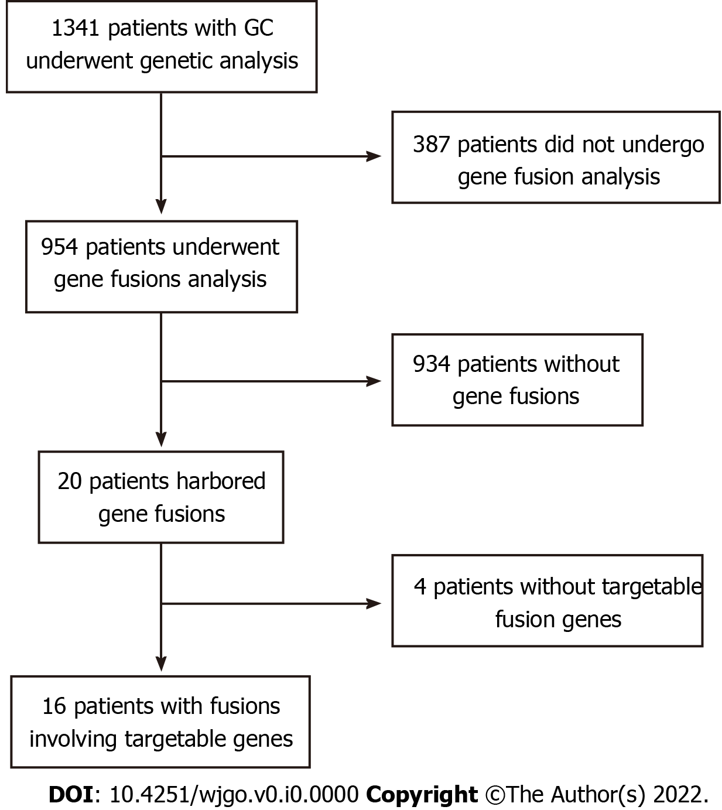
Figure 1 Flowchart of patient selection. GC: Gastric cancer.

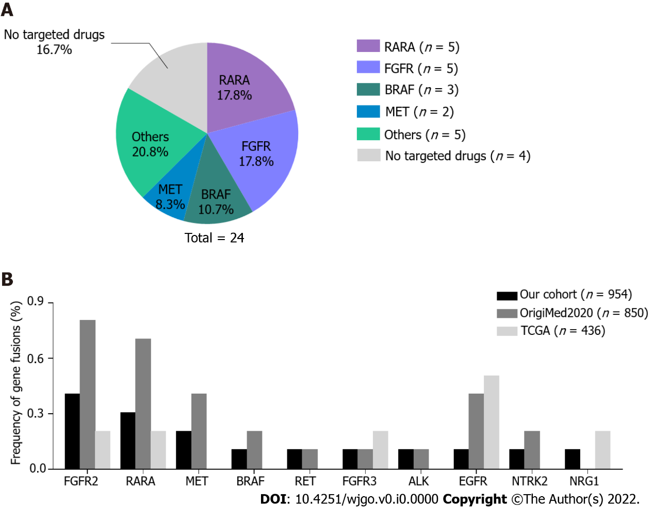
Figure 2 Profile of targetable gene fusions in gastric cancer. A: The types and proportion of 24 gene fusions. Others included targetable ALK, RET, NTRK2, NRG1, and EGFR fusions. Four fusions without targetable genes were excluded from the analysis; B. Comparison of gene fusion frequencies in our cohort and the OrigiMed2020 and The Cancer Genome Atlas (TCGA) cohorts. No statistical differences were found among the cohorts.

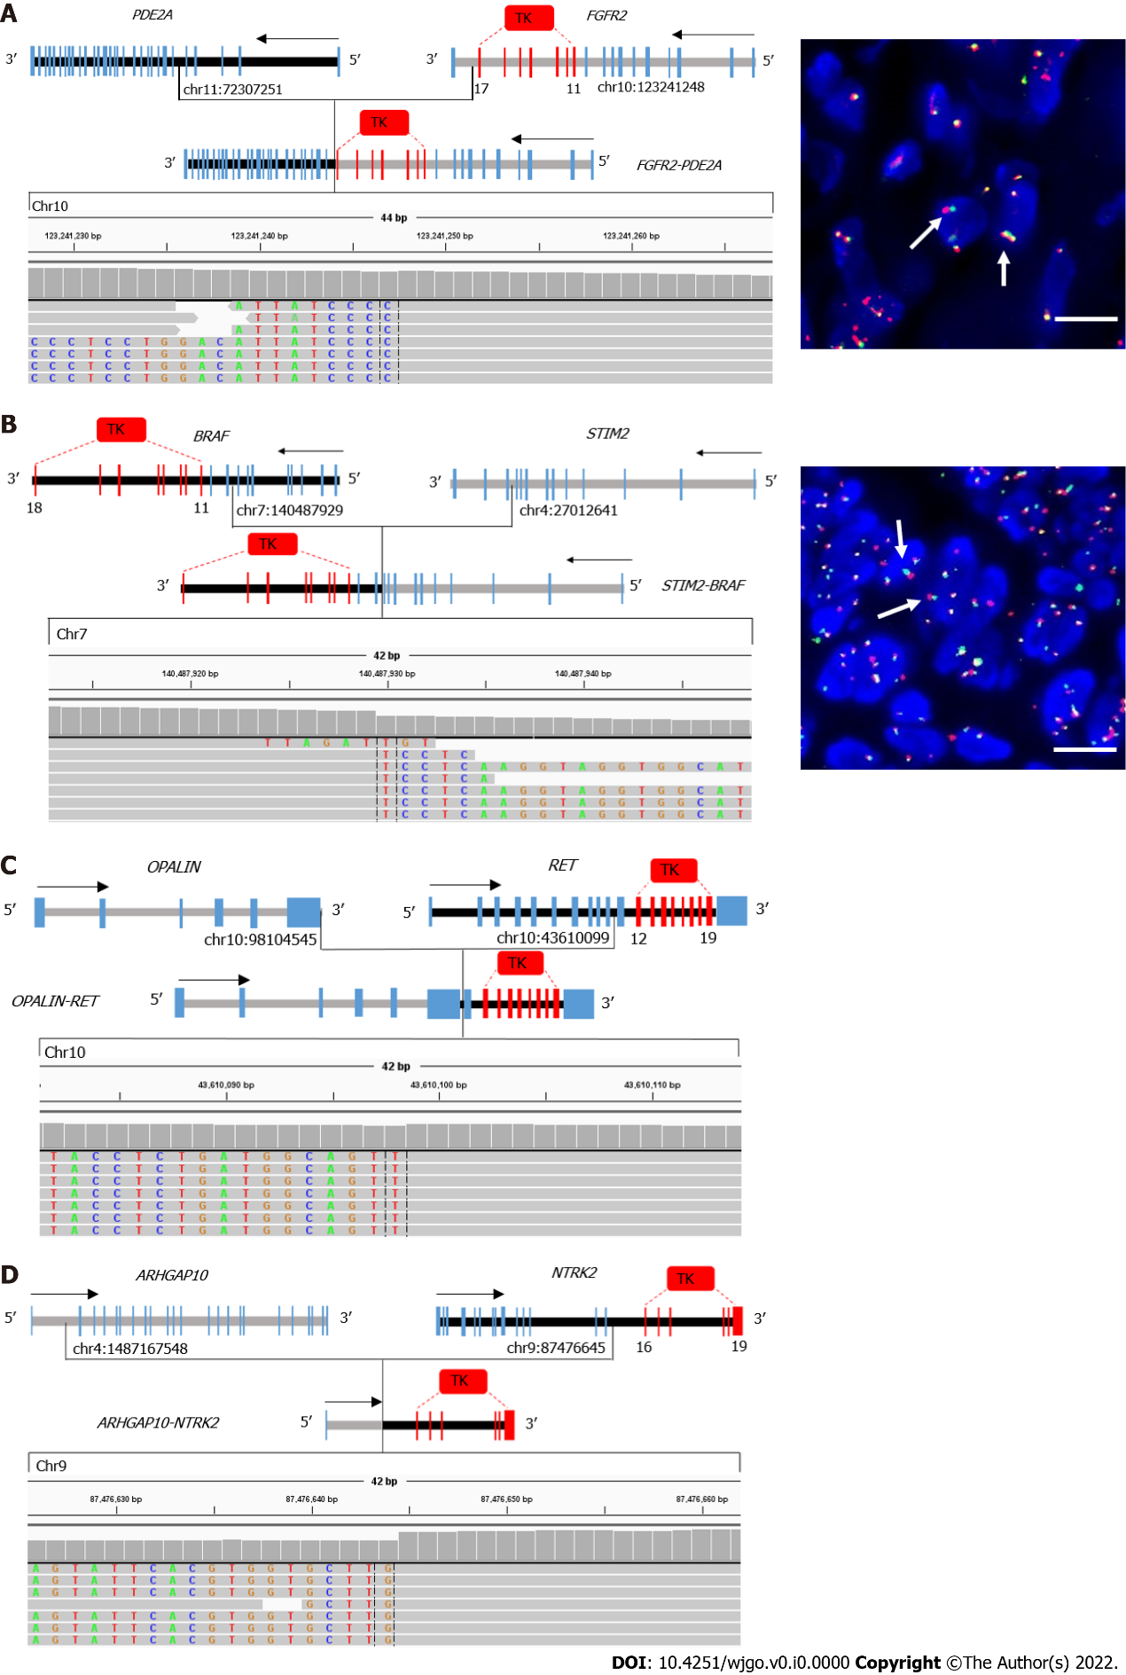
Figure 3 Examples of novel gene fusions involving targetable genes in gastric cancer. A-D: Schematic representation and Integrative Genomics Viewer screenshot of FGFR2-PED2A (A), STIM-BRAF (B), OPALIN-RET (C), and NTRK2-ARHGAP10 (D) are shown; A and B: FGFR2 and BRAF fusions were confirmed by fluorescence in situ hybridization using FGFR2 (10q26) or BRAF (7q34) break-apart probes. Red spot: 5′ Probe signal; Green spot: 3′ probe signal; Yellow spot: Target gene without rearrangement. Arrows indicate the cells with separate 5′ (red) and 3′ (green) signals. Bar: 100 μm. TK: Tyrosine kinase domain.

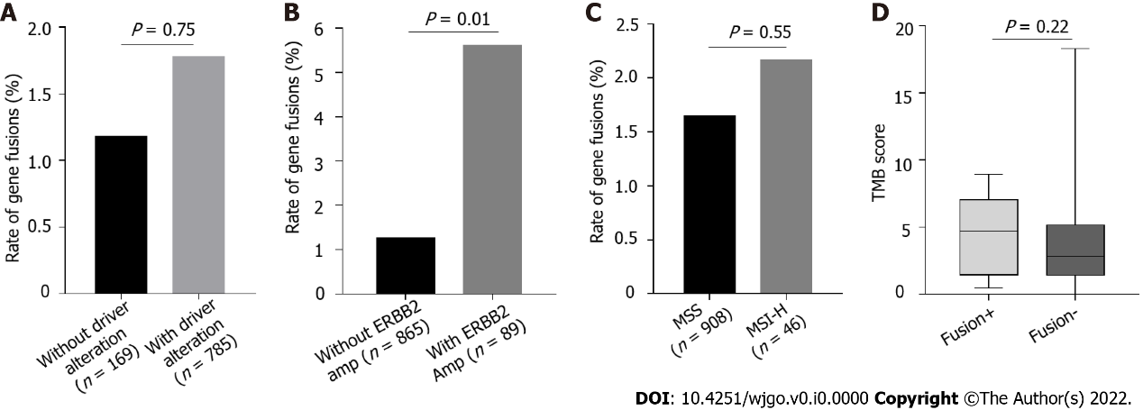
Figure 4 Enrichment of gene fusions in patients with gastric cancer with driver alterations. A: The incidence of gene fusions in patients with and without driver alterations were analyzed, P > 0.05; B: The incidence of gene fusions in patients with and without ERBB2 amplifications were analyzed, P < 0.05; C: The incidence of gene fusions in patients with microsatellite instability-high and microsatellite stability were analyzed, P > 0.05; D: Tumor mutational burden in targetable gene fusion-positive and -negative patients was compared, P > 0.05.
Table 1 Clinical characteristics in targetable gene fusion-positive and -negative patients
Variables | Total, n | Fusion involving targetable genes |  | P value
 |  | Positive, n (%) | Negative, n (%)
Sex |  |  |  | 0.293
Female | 310 | 3 (0.97) | 307 (99.03)
Male | 644 | 13 (2.02) | 631 (97.98)
Age, yr |  |  |  | 0.463
≤ 60 | 451 | 6 (1.56) | 445 (98.44)
> 60 | 503 | 10 (1.98) | 493 (98.01)
MSI status |  |  |  | 0.551
MSI-H | 46 | 1 (2.17) | 45 (97.93)
MSS | 908 | 15 (1.65) | 893 (98.35)
TMB |  |  |  | 0.217
Median TMB score | 2.92 | 5.63 | 2.83
Age, sex, microsatellite instability status, and tumor mutational burden between fusion-positive and -negative patients were compared. The one-tailed P value for Fisher’s exact test was calculated. MSI-H: Microsatellite instability-high; MSS: Microsatellite stability; TMB: Tumor mutational burden.

Table 2 List of gene fusions involving targetable genes in Chinese patients with gastric cancer and drugs under clinical trial or approved by the Food and Drug Administration
Patients ID | Fusion gene | 5' partner gene |  |  |  | 3' partner gene |  |  |  | Variant frequency, % | Functional domain is included or not | Targeted drugs
 |  | Gene name | Chromosome | Last observed exon | Breakpoint | Gene name | Chromosome | First observed exon | Breakpoint
Patient 01 | RARA-PGAP3 | RARA | 17 | 3 | 38504951 | PGAP3 | 17 | 8 | 37828020 | 24.1 | Partially include | Tamibarotene targeting RARA fusion²
Patient 01 | KRTAP9-7-RARA | KRTAP9-7 | 17 | downstream | 39437039 | RARA | 17 | 3 | 38499547 | 56.9 | Completely include | Tamibarotene targeting RARA fusion²
Patient 02 | RARA-KRT13 | RARA | 17 | 2 | 38491648 | KRT13 | 17 | 8 | 39657269 | 29.2 | Partially include | Tamibarotene targeting RARA fusion²
Patient 02 | RARA-ETV4 | RARA | 17 | 2 | 38499726 | ETV4 | 17 | 5 | 41621243 | 76 | Partially include | Tamibarotene targeting RARA fusion²
Patient 03 | RARA-IKZF3 | RARA | 17 | 2 | 38504120 | IKZF3 | 17 | 2 | 38009555 | 18.4 | Partially include | Tamibarotene targeting RARA fusion²
Patient 04 | FGFR2-PDE2A | FGFR2 | 10 | 17 | 123241248 | PDE2A | 11 | 7 | 72307251 | 1.4 | Completely include | Pemigatinib; Erdafitinib targeting FGFR fusion¹
Patient 05 | FGFR2-intergenic | FGFR2 | 10 | 17 | 123242196 | intergenic | 10 | - | 123394107 | 16.6 | Completely include | Pemigatinib; Erdafitinib targeting FGFR fusion¹
Patient 06 | FGFR2-intergenic | FGFR2 | 10 | 17 | 123240841 | intergenic | 10 | - | 122793842 | 4.2 | Completely include | Pemigatinib; Erdafitinib targeting FGFR fusion¹
Patient 07 | FGFR2-SHTN1 | FGFR2 | 10 | 17 | 123242528 | SHTN1 | 10 | 6 | 118709305 | 5.1 | Completely include | Pemigatinib; Erdafitinib targeting FGFR fusion¹
Patient 08 | FGFR3-PHTF2 | FGFR3 | 4 | 18 | 1808927 | PHTF2 | 7 | 11 | 77567982 | 3.3 | Completely include | Pemigatinib; Erdafitinib targeting FGFR fusion¹
Patient 09 | STIM2-BRAF | STIM2 | 4 | 11 | 27012641 | BRAF | 7 | 9 | 140487929 | 12.7 | Completely include | Selumetinib targeting BRAF fusion¹
Patient 09 | STIM2-BRAF | STIM2 | 4 | 11 | 27013243 | BRAF | 7 | 10 | 140486103 | 1.1 | Completely include | Selumetinib targeting BRAF fusion¹
Patient 09 | TBC1D19-BRAF | TBC1D19 | 4 | 4 | 26629603 | BRAF | 7 | 10 | 140486782 | 6.5 | Completely include | Selumetinib targeting BRAF fusion¹
Patient 10 | TES-MET | TES | 7 | 1 | 115867013 | MET | 7 | 2 | 116332227 | 0.7 | Completely include | Crizotinib targeting MET fusion¹
Patient 11 | MET-TES | MET | 7 | 21 | 116436166 | TES | 7 | 4 | 115889445 | 24.6 | Not include | Crizotinib targeting MET fusion¹
Patient 12 | EML4-ALK | EML4 | 2 | 6 | 29447382 | ALK | 2 | 20 | 42498662 | 3.5 | Completely include | Crizotinib; ceritinib targeting ALK fusion¹
Patient 13 | OPALIN-RET | OPALIN | 10 | 6 | 98104545 | RET | 10 | 11 | 43610099 | 5.46 | Completely include | Pralsetinib targeting RET fusion¹
Patient 14 | ARHGAP10-NTRK2 | ARHGAP10 | 4 | 1 | 148716754 | NTRK2 | 9 | 16 | 87476645 | 15.3 | Completely include | Larotrectinib targeting NTRK2 fusion¹
Patient 15 | NRG1-FDFT1 | NRG1 | 8 | 12 | 32617907 | FDFT1 | 8 | 8 | 11685375 | 8.9 | Partially include | MCLA-128 targeting NRG1 fusion²
Patient 16 | EGFR-SEPTIN14 | EGFR | 7 | 25 | 55269173 | SEPTIN14 | 7 | 10 | 55871179 | 9.6 | Completely include | Afatinib targeting EGFR fusion²
¹FDA-approved drugs targeting gene fusions.
²Drugs targeting gene fusions are under clinical trials.

