Name of Journal: World Journal of Gastrointestinal Endoscopy
Manuscript NO: 67172
Manuscript Type: REVIEW

Percutaneous endoscopic gastrostomy and jejunostomy: Indications and techniques

Fugazza A et al. Percutaneous endoscopic gastrostomy

Alessandro Fugazza, Antonio Capogreco, Annalisa Cappello, Rosangela Nicoletti, Leonardo Da Rio, Piera Alessia Galtieri, Roberta Maselli, Silvia Carrara, Gaia Pellegatta, Marco Spadaccini, Edoardo Vespa, Matteo Colombo, Kareem Khalaf, Alessandro Repici, Andrea Anderloni

Alessandro Fugazza, Antonio Capogreco, Rosangela Nicoletti, Leonardo Da Rio, Piera Alessia Galtieri, Roberta Maselli, Silvia Carrara, Gaia Pellegatta, Marco Spadaccini, Edoardo Vespa, Matteo Colombo, Kareem Khalaf, Alessandro Repici, Andrea Anderloni, Division of Gastroenterology and Digestive Endoscopy, Department of Gastroenterology, Humanitas Research Hospital - IRCCS, Rozzano 20089, Milan, Italy

Annalisa Cappello, Unit of Gastroenterology and Digestive Endoscopy, AUSL Bologna Bellaria-Maggiore Hospital, Bologna 40121, Italy

Kareem Khalaf, Department of Biomedical Sciences, Humanitas University, Pieve Emanuele 20072, Milan, Italy

Author contributions: Fugazza A, Capogreco A, and Cappello A drafted the manuscript; Rosangela Nicoletti R, Da Rio L, Galtieri PA, Maselli R, Carrara S, Pellegatta G, Spadaccini M, Vespa E, Colombo M, and Khalaf K contributed to the acquisition, analysis, or interpretation of data for the work; Repici A and Anderloni A contributed to the critical revision of the manuscript; All authors approved the final version to be published.

Corresponding author: Alessandro Fugazza, MD, Medical Assistant, Division of Gastroenterology and Digestive Endoscopy, Department of Gastroenterology, Humanitas Research Hospital - IRCCS, Via Manzoni 56, Rozzano 20089, Milan, Italy. alessandro.fugazza@humanitas.it

Received: April 17, 2021
Revised: August 3, 2021
Accepted: April 24, 2022
Published online:

Abstract
Nutritional support is essential in patients who have a limited capability to maintain their body weight. Therefore, oral feeding is the main approach for such patients. When physiological nutrition is not possible, positioning of a nasogastric, nasojejunal tube, or other percutaneous devices may be feasible alternatives. Creating a percutaneous endoscopic gastrostomy (PEG) is a suitable option to be evaluated for patients that need nutritional support for more than 4 wk. Many diseases require nutritional support by PEG, with neurological, oncological, and catabolic diseases being the most common. PEG can be performed endoscopically by various techniques, radiologically or surgically, with different outcomes and related adverse events (AEs). Moreover, some patients that need a PEG placement are fragile and are unable to express their will or sign a written informed consent. These conditions highlight many ethical problems that become difficult to manage as treatment progresses. The aim of this manuscript is to review all current endoscopic techniques for percutaneous access, their indications, postprocedural follow-up, and AEs.

Key Words: Percutaneous endoscopic gastrostomy; Enteral nutrition; Gastrostomy; Percutaneous endoscopic jejunostomy; Indications and techniques

Fugazza A, Capogreco A, Cappello A, Nicoletti R, Da Rio L, Galtieri PA, Maselli R, Carrara S, Pellegatta G, Spadaccini M, Vespa E, Colombo M, Khalaf K, Repici A, Anderloni A. Percutaneous endoscopic gastrostomy and jejunostomy: Indications and techniques. World J Gastrointest Endosc 2022; In press

Core Tip: Percutaneous endoscopic gastrostomy (PEG) represents the first choice for long-term enteral nutrition support. The aim of this manuscript is to provide a comprehensive overview of PEG placement, including indications, contraindications, preprocedural clinical assessment, endoscopic techniques, adverse events, and postprocedural follow-up. Furthermore, endoscopic procedures for jejunal nutrition are also addressed. In consideration with the increasing frequency with which PEG placements are requested, this review may be a useful tool for clinical guidance both for endoscopists and physicians in different fields, with a particular focus on appropriateness of the indications and safety of this procedure.

INTRODUCTION
Nutritional support is essential in patients who have a limited capability to maintain their body weight with a normal diet. In best practice, oral feeding is the main approach to choose for these patients^{[1]}. Many patients cannot consume food by mouth. In some cases, oral intake can even be dangerous for patients with neurological conditions or obstructive causes, although their gastrointestinal (GI) tract is functional^{[2]}. In these cases, physicians can support alimentary intake by positioning a nasogastric or nasojejunal tube or creating a direct access into the stomach through a percutaneous endoscopic gastrostomy (PEG)^{[3]}. This allows the maintenance of normal physiological activities of the GI tract in order to avoid alterations in the intestinal barrier functions and long-term complications related to intravenous nutritional support^{[4,5]}.
The choice between whether the feeding tubes are placed via oral route over a PEG needs to be evaluated case-by-case by a multidisciplinary team, considering there are multiple factors related to procedural indications, such as patient condition, clinical scenario, and risk of adverse events (AEs) for the patient. However, when the GI tract does not work properly, such as in cases of obstruction, intravenous nutritional support should be preferred.
Parenteral nutrition (PN) is a nutritional support therapy that is provided through the intravenous administration of nutrients such as glucose, electrolytes, amino acids, lipids, and vitamins. Moreover, PN can be associated with AEs and is poorly tolerated, especially in patients with heart failure, renal insufficiency, and diabetes mellitus^{[6]}. A recent systematic review with meta-analysis based on oncologic patients reported no differences between enteral nutrition (EN) and PN with regards to nutritional outcomes, with a higher incidence of infections in the PN group [risk ratio = 1.09, 95% confidence interval: 1.01-1.18; P = 0.03]^{[7]}. For these reasons, the recent European Society for Clinical Nutrition and Metabolism guidelines recommended administering total PN only when patients are unable to reach their nutritional outcomes with oral nutrition or EN^{[6]}. Although the benefit of percutaneous access for EN have been reported for a while, several controversies and major concerns still exist regarding these procedures and the related AEs. The aim of this manuscript is to review all current techniques for percutaneous access for EN, their indications, postprocedural follow-up, and AEs.

INDICATIONS
Nowadays, many diseases result in long-term reduction of caloric intake. For this reason, placement of a percutaneous endoscopic access is needed in order to improve nutritional conditions. Percutaneous endoscopic nutrition can be achieved by either a transgastric approach through PEG or a transjejunal approach, namely percutaneous endoscopic jejunostomy (PEJ).
Ever since the first endoscopic insertion of a gastrostomy^{[8]}, there has been a worldwide diffusion of these techniques and an increase in indications for this medical approach. A summary list of indications for PEG placement is reported in Table 1. However, nutritional support is often only necessary for a short period, such as less than 1 mo, in case of stroke with fast recovery, mild head trauma, acute pancreatitis, post-head and neck surgery, post-upper GI surgery, and other temporary diseases. In these patients, a nasogastric tube is easier to insert and to manage directly at bedside. On the other hand, some patients need nutritional support for longer periods of time.
In the recently published European Society of Gastrointestinal Endoscopy guidelines regarding endoscopic management of enteral tubes in adult patients, it is recommended to consider EN by percutaneous access when nutritional support is needed for more than 4 wk on a case-by-case basis^{[3]}. The 4-wk cut-off is arbitrary and has been chosen to avoid many AEs that are related to percutaneous access (e.g., infections). When indicated, the gastric route through a PEG is more desirable than the jejunal approach, due to its better tolerance, ease of procedure, and its possibility to be performed bedside^{[9]}. In the case of altered anatomy, delayed gastric emptying, gastric outlet obstruction, duodenal obstruction, severe gastroesophageal reflux, or increased risk of aspiration pneumonia, PEJ must be considered^{[9]}.

Benign diseases
Neurological diseases often need nutritional support, especially in patients that cannot consume food orally due to neurological injury. Specifically, dementia is a common disease that needs EN. Patients with dementia often cannot or will not swallow. This condition mainly occurs later in the course of the disease when patients are in an advanced stage^{[10]} and when they cannot express their will^{[11]}. Currently, studies about EN in patients with dementia are scarce. A systematic review regarding patients with final stage dementia did not show differences between EN and no nutritional support in terms of survival, quality of life, nutritional status, function, behavior, or psychiatric symptoms^{[12]}. For these reasons, the recently published European Society of Gastrointestinal Endoscopy guidelines recommend avoiding PEG placement in patients with advanced dementia, especially if they have a life expectancy of less than 4 wk^{[3]}.
Stroke is another common neurological cause of dysphagia, with an incidence of 23%-50%^{[13]}. Some patients recover slowly or do not have the capability to consume food through the oral route, leading to a high risk of aspiration pneumonia and low nutritional intake. Motor neuron diseases often involve varying swallowing functions^{[14]}. A recent cohort study on 957 patients (278 with PEG) affected by amyotrophic lateral sclerosis showed that PEG nutrition support improved overall survival expectancy (21 mo vs 15 mo, P < 0.001)^{[15]}. Moreover, dysphagia can be present after head injury with neurological damage. A review focused on randomized controlled trials of nutrition in patients with head injury showed that survival expectancy and disability were improved by early PN or EN^{[16]}. Patients with Parkinson’s disease can develop motor alteration like dysphagia, and EN should be considered due to the increased risk of aspiration pneumonia and difficulties in oral intake^{[17]}.
There is poor evidence to support PEG placement in patients with other benign diseases such as cerebral palsy, anorexia, frailty, burn patients, and hypercatabolic diseases, even though each case must be evaluated individually. Furthermore, cases of PEG placement are reported in patients with benign esophageal strictures such as caustic stricture, Zenker diverticulum, post endoscopic therapy (endoscopic mucosal resection, endoscopic submucosal dissection, radiofrequency ablation), and achalasia^{[18,19]}.

Malignant diseases
Head and neck malignancies can lead to dysphagia in 35%-50% of cases^{[20]}. The reported high-risk factors are hypopharyngeal localization, advanced neoplasia (T4), and combined chemoradiation. In these settings, the main indications for PEG are the onset of dysphagia, low nutritional intake, and loss of body weight^{[21]}. A recent published study evaluated 130 patients with a head-neck tumor who underwent chemoradiotherapy. Of these, only 69 patients received a prophylactic PEG placement. The authors showed that prophylactic PEG improved nutritional parameters and unexpected hospitalization^{[22]}. Esophageal cancer is another indication for EN if patients present symptoms of severe dysphagia and when palliation by placement of an endoscopic stent is not feasible^{[23]}. In general, all oncological diseases that imply hypercatabolism that is not compensated by oral intake may require EN by nasogastric tube or PEG^{[3]}.

Other indications
Other indications of PEG that are not for nutritional purposes have also been described. An endoscopic gastrostomy may be placed in patients with gastric outlet obstruction or intestinal strictures that cannot be managed through the usual endoscopic approach, by placement of an endoscopic stent, or creating an endoscopic ultrasound (EUS)-guided gastroentero-anastomoses^{[24-27]}. These conditions can benefit from gastric decompression by PEG^{[28]}. This technique aims to improve the patient’s symptoms and reduce GI distension. Primarily, it can be connected to an aspirator to quickly relieve symptoms. Later, it can be connected to a drop bag to improve compliance. This also allows patients to eat small quantities of food in order to guarantee a better quality of life, although some poor nutritional benefits may remain.
In a recent systematic review with 1194 cases, 90% of technique success rate had been reported. However, it showed minor AEs (leak 6.7%; peristomal infections 5.1%; device malfunction 2.8%, and dislodgement 2.1%) in 19.8% of patients and major AEs (2 deaths for sepsis and bleeding) in 1.9% of patients^{[29]}. Moreover, Baron et al^{[30]} described the use of a surgical gastrostomy (SG) as access for a duodenoscope in order to perform an endoscopic retrograde cholangiopancreatography^{[30]}. This technique can be used effectively in patients with biliary diseases and previous bariatric Roux-en-Y gastric bypass surgery^{[31]}.
A percutaneous intragastric trocar was designed to serve as a trocar for the endoscopist’s introduction of rigid laparoscopic instruments in order to better aid endoscopic therapeutic procedures. This device was placed following PEG placement and was successfully used in pigs to perform endoscopic submucosal dissection, full-thickness resections, and intragastric stapling^{[32]}. The PEG could also be used as an access route to perform combined antegrade and retrograde dilations in esophageal strictures that cause complete obstruction and are difficult to dilate with standard endoscopic techniques^{[18,33,34]}.

Pediatric indications
PEG is also indicated in the pediatric setting when there is a low nutritional intake, malabsorption, and dysphagia that leads to malnutrition^{[35]}. This procedure is considered safe in a pediatric population weighing less than 6 kg, with complex neurologic disability, congenital heart disease, cancer, or other complex medical comorbidities^{[36]}. Down syndrome is regarded as an indication for PEG placement in the pediatric setting when there is poor nutritional intake^{[37]}. Likewise, cerebral palsy may represent an indication for EN, but substantial evidence to support this indication is scarce^{[3]}. Other indications for PEG placement are congenital malformations, such as congenital heart failure, which can lead to chronic malnutrition^{[38]}. In a pediatric oncological setting, PEG placement results in improvement of body weight, malnutrition, and oncological outcome^{[39,40]}.

PRE-EVALUATION AND CONTRAINDICATIONS TO PEG PLACEMENT
All patients must be evaluated carefully prior to undergoing a PEG. A complete visit with medical history, physical examination, and current therapy must be completed^{[41]}. Observational studies showed that a multidisciplinary team can select patients that are suitable for PEG placement^{[42]}. Indeed, a gastroenterologist, a PEG specialist nurse, a dietician, and a speech and language therapist must evaluate the situation on a case-by-case basis. The time of observation of the patient by the nutritional team could require up to 7 d prior to deciding whether the procedure is appropriate or not. This period, defined as the “cooling-off period,” is reported as a high-risk phase, where 43% of patients pass away. For this reason, waiting a week could avoid inappropriate procedures in patients with a short life expectancy^{[43]}. However, there are some conditions that represent relative or absolute contraindications for PEG placement. The most common are reported in Table 2.
Recent peptic ulcer bleeding with high risk of rebleeding and hemodynamic and respiratory instability are considered relative contraindications^{[44]}. There are also controversial studies about PEG placement in patients with ascites. In a retrospective study of 29 patients with advanced cirrhosis, Baltz et al^{[45]} reported high mortality in patients with ascites who underwent PEG placement. Another case control study evaluated 583 cirrhotic patients, 107 of whom had ascites. It showed no difference in terms of mortality, infections, and bleeding after PEG insertion^{[46]}.
Furthermore, particular attention must be paid in patients with ventriculoperitoneal shunts (VPS). In a systematic review, a high incidence of infections and PEG malfunctions were reported (12% and 4%, respectively) in these patients^{[47]}. VPS infections are more frequently reported in cases of PEG placement before the shunt procedure (21.8%) or when a simultaneous PEG and VPS placement were performed (50.0%). For these reasons, the authors of this study suggest performing PEG placement 7-10 d after the VPS. Since many patients that require gastrostomy placement suffer from chronic constipation, which can predispose the transverse colon to move in front of the anterior gastric wall, enemas or a macrogol solution through a nasogastric tube should be given to decompress the colon and reduce the risk of colonic interposition during the endoscopic procedure (Figure 1).
Moreover, anatomical alterations of the abdominal wall (e.g., ostomy, scars, and adhesions) can make PEG insertion difficult. When these conditions are present, PEG placement must be carried out at least 2 cm away from the scar^{[44]}. PEG placement should not be performed in cases of fever, abdominal wall infection, or other signs of sepsis in order to reduce the risk of PEG site infection.
Additionally, PEG placement is considered a high bleeding risk procedure^{[3,48]}. Preprocedural blood tests, with platelet count and coagulation tests, should be done. Indeed, a platelet count < 50000 mm³ and an international normalized ratio > 1.5 are considered contraindications for PEG placement^{[48]}.
Moreover, home antiplatelet and anticoagulant therapy should be evaluated, as all patients are stratified in high or low thrombotic risk. Patients with low thrombotic risk who take antiplatelet (anti-P2Y12) should discontinue the medication 5 d prior to PEG placement. On the other hand, patients with a high thrombotic risk must continue cardioaspirin monotherapy, while other antiplatelet medications are to be assessed by a cardiologist. Traditional anticoagulants should be discontinued 2-5 d prior to the procedure, depending on patient comorbidities and renal function and should be replaced by low molecular weight heparin with an international normalized ratio below 1.5. New anticoagulant should be discontinued 2-3 d prior, based on the different drug subtypes and renal function^{[48]}. However, all antiplatelet and anticoagulant drugs should be resumed 2 d after PEG placement^{[48]}.

ENDOSCOPIC VS RADIOLOGIC VS SURGICAL
Gastrostomy tube placement can be performed by three different techniques: Endoscopic (PEG), radiologic, and surgical^{[49]}. Frequently, PEG is considered the standard procedure, but other techniques are often performed, mainly in patients that are unable to undergo the endoscopic approach^{[50,51]}. Several AEs were reported after all subtypes of gastrostomy placement^{[52,53]}. The most common AEs were device malfunction (52%) and infections (19%)^{[54]}. Some comparative studies on PEG vs radiologic gastrostomy (RG) reported results that were univocal. One meta-analysis of 5680 patients reported fewer major AEs in patients undergoing RG than in those undergoing PEG [success rate RG: 99.2% vs PEG: 95.7%, P < 0.001; major complications RG: 5.9% vs PEG: 9.4% vs SG: 19.9%, P < 0.001]^{[55]}.
Moreover, another systematic review and meta-analysis evaluated 934 PEG and 1093 RG, indicating that PEG was safer than RG^{[56]}. However, many studies report no statistical differences between these techniques^{[57,58]}. A retrospective study including 184068 patients comparing PEG, RG, and SG was recently published. The authors of this study reported that PEG was safer than RG and SG procedures. In particular, when compared to RG and SG, PEG showed a low rate of infections (RG: 1.28; P = 0.006 and SG: 1.61; P < 0.001), bleeding [odds ratio (OR) RG: 1.84; P = 0.002 and SG: 1.09; P < 0.001), perforation (OR RG: 1.90; P = 0.002 and SG: 6.65; P < 0.001), readmission (OR RG: 1.07; P = 0.002 and SG: 1.13; P = 0.01), and mortality (OR RG: 1.09; P = 0.01 and SG: 1.55; P < 0.001)^{[54]}. In conclusion, it is not clear which technique is better among the three mentioned above. Nevertheless, PEG seems to have a lower rate of AEs reported. Moreover, not all hospitals have tools and staff dedicated to performing these procedures. For this reason, it seems reasonable to use the safest method available in the facility.

PEG TECHNIQUES
Different endoscopic techniques for PEG placement have been proposed during the years, including the pull technique, the introducer technique, and the push technique.

Pull technique
The pull technique is the most used procedure for PEG placement^{[59]}. This technique was first described in 1980 by Gauderer et al^{[8]}. Two operators are needed: One to manage the endoscopic part of the procedure and one to manage the percutaneous site of the procedure. With the patient placed in the supine position, the abdomen is draped in a sterile fashion, and the gastroscope is inserted perorally into the stomach under conscious sedation or deep sedation. Gastric distension with endoscopic air insufflation brings the anterior gastric wall in contact with the abdominal wall. The lights in the room should be dimmed so that the puncture site can be localized on the abdominal wall by endoscopic transillumination and by clear endoscopic visualization of the indentation of the stomach by external palpation on the marked point.
Then, the “safe track technique”^{[60]} is performed by inserting a 25 G needle attached to a 10 mL syringe that is partially filled with saline solution at the marked point. If bubbles appear in the syringe while aspirating immediately before the needle passes into the stomach, there may be an intervening loop of bowel present. This maneuver could also be performed while withdrawing the needle. Once the puncture site is identified, local anesthesia is given and a skin incision with a surgical blade of 3-5 mm is made so that a 14 G trocar can be inserted under direct endoscopic visualization while keeping constant endoscopic air insufflation of the stomach. Endoscopically a snare, passed through the gastroscope, is looped around the sheath. A dedicated gastrostomy kit wire is then passed through the sheath and into the stomach. It is grasped by the snare and is brought out through the mouth, together with the endoscope.
Thereafter, the gastrostomy kit tube is attached to the wire, and they are pulled back together through the mouth, the esophagus, the stomach, and out through the cutaneous puncture site until the internal bumper reaches the anterior wall of the stomach. Finally, the external bumper must be fixed against the skin (Figure 2). The described technique can also be done by passing an ultra slim endoscope and the gastrostomy probe transnasally. This variant of the procedure has been described to be well tolerated even in non-sedated patients.

Introducer technique
The direct percutaneous technique, namely the introducer, was first described in 1984 by Russell et al^{[61]} and then revised by Brown et al^{[62]} in which the stomach is fastened to the abdominal wall with T-fastener sutures. In this technique, two operators are needed, and the gastrostomy site is identified in the same manner as in the “pull” technique. However, while maintaining full gastric endoscopic insufflation, a gastropexy is made by placing two to four T-fasteners circumferentially over the anterior abdominal wall under endoscopic guidance. Within the area between the T-fasteners lies the site for the gastrostomy tube placement^{[63]}. A horizontal incision is made at the identified site so that a trocar can be inserted, and a guidewire introduced into the stomach.
Then, the tract is dilated using dilators that are introduced over the guidewire. Finally, a gastrostomy balloon-type probe is placed over the guidewire through the dilator peel-away sheath and into the stomach (Figure 3). Using this technique, the gastrostomy probe is introduced directly from the exterior through the abdominal wall percutaneously, avoiding contamination of the probe during the passage in the upper digestive tract. This technique should be preferred in patients with esophageal strictures or head and neck cancer to reduce the risk of tumor seeding^{[3]}. In the literature, various cases of gastrostomy site metastasis in patients with upper aerodigestive tract malignancies have been reported, and a recent meta-analysis found that the incidence rate increases particularly in patients with advanced-stage disease^{[64,65]}.

Other percutaneous gastrostomy techniques
The “push method” or Sacks-Vine^{[66]} technique is similar to the “pull” method except that the gastrostomy probe is passed over a guidewire from the mouth to the cutaneous side of the gastrostomy. This requires that the tube needs to be much longer and is made of two pieces connected together with a small dilator. EUS-guided PEG placement has also been described^{[67,68]}. In the Baile-Maxía et al^{[67]}’s case series, a EUS target was created by filling a sterile glove with saline and was placed over the abdomen of the patient. A linear echoendoscope was passed perorally into the stomach and was positioned against the anterior gastric wall where the EUS target was identified. The abdominal wall was then punctured from inside the stomach with a 19 G needle, and a guidewire was advanced. The guidewire was tied to a string that was passed into the stomach and taken out through the mouth. The following passages are the same of the pull technique. This variation of the pull technique could be selected in obese patients or in patients with previous abdominal surgeries where transillumination could be absent.

AES
Aspiration
This is the most common periprocedural AE^{[69,70]}, which has been reported to be around 1%. Risk factors for aspiration are advanced age, need for sedation, and neurologic impairment^{[71]}.

Pneumoperitoneum
Transient subclinical pneumoperitoneum is commonly found after the procedure and generally does not have clinical relevance^{[72]}.

Injury to adjacent viscera
Under transillumination, if the indentation site is identified and the “safe track technique” is used during the PEG placement, there is a very low risk of injury to the organs adjacent to the anterior abdominal wall, such as colon or liver. If the patient presents severe postprocedural hypotension, liver laceration should be suspected, and urgent computed tomography scan is required. Transhepatic insertion of a gastrostomy tube is a rare and serious AE. Cases reported in the literature have been managed conservatively if the patient remained asymptomatic^{[73]} or surgically if a life-threatening complication such as severe hemorrhage occurred^{[74]}. Colonic injury can present a few days after the procedure, with leakage of the intestinal contents around the gastrostomy tube, abdominal pain, and fever^{[75]}. A computed tomography scan using a hydrosoluble contrast agent should be performed. If no leak into the peritoneal cavity is detected, then the complication can be managed with endoscopic closure of the fistulous tracts^{[76]}. If the patient develops generalized peritonitis, then surgical revision is mandatory. However, in most cases, a gastro-colonic-cutaneous fistula remains clinically silent until months after the gastrostomy placement the first implanted probe is removed, and the replacement tube is placed into the colon (Figure 4). Once nutritional feeding is resumed, diarrhea develops. If a new gastrostomy placement is needed, then laparoscopic gastrostomy should be considered^{[77,78]}.

Bleeding
Mild intraprocedural oozing from capillaries could be encountered during the procedure, but they are usually self-limiting or managed with endoscopic therapy. Major bleeding is a rare AE and is usually caused by the puncture of the left gastric or gastroepiploic arteries or one of their branches^{[79]}.

Wound infection
The systematic use of prophylactic antibiotic therapy has drastically reduced the incidence of this complication^{[80]}. It generally manifests in redness, edema, and leakage of pus from the gastrostomy site and is usually managed with systemic antibiotic therapy and local wound care (Figure 5). If not treated adequately it can result in necrotizing fasciitis, a rare but potentially fatal complication.

Granulation tissue
Re-epithelialization of gastric mucosa could cause the development of excessive granulation tissue at the gastrostomy site. Treatment consists of avoiding occlusive dressings, and if the mucosa causes persistent minor bleeding, then topical silver nitrate or argon plasma coagulation can be applied to the tissue^{[81]}.

Buried bumper syndrome
Buried bumper syndrome is defined by the migration of the internal bumper along the gastrostomy fistula tract. It is generally related to excessive traction from the outside of the internal bumper, which perpetuates over time, leading to a local tissue pressure necrosis and subsequent progressive migration of the internal bumper. To avoid this AE, it is recommended to keep the outer bumper loose from the skin and to periodically check that the gastrostomy tube remains easily rotatable. When the internal bumper has reached the subcutaneous plane, a bulging on the skin is visible at the gastrostomy site, which is hard to the touch, and the gastrostomy tube is not moveable. If, on the other hand, the internal bumper is in the gastric wall, the peristomal skin may appear regular, but the gastrostomy tube will still not be moveable.
Based on the depth of the buried bumper, different extraction techniques can be applied^{[82,83]}. When part of the internal bumper is still endoscopically visible, the buried bumper, after inserting a wire through the gastrostomy tube from the outside, can be effectively pushed back into the stomach with a dilator (e.g., Savary bougie size 15 Fr in 20 Fr gastrostomy tube). Totally or near-totally ingrown bumpers can be removed by cutting the overlying mucosa with an endoscopically guided application of electrosurgical current using a sphincterotome, a needle-knife, or a hook knife. In cases of clear extragastric localization, surgical treatment may be needed.
In a recent study, Costa et al^{[84]} reported the use of a novel endoscopic dedicated device, the Flamingo device, for buried bumper syndrome management. The Flamingo device is inserted over the guidewire into the stomach through the external insertion of a partially cut gastrostomy probe. The distal part of the Flamingo device is flexed to 180° using its dedicated handle, exposing the bowstring, sphincterotome-like cutting wire. External traction is then applied to the Flamingo device from the cutaneous side of the gastrostomy, pulling the flexed cutting wire toward the granulomatous tissue through direct endoscopic visualization until apposition is achieved, and the overgrown tissue is then incised.

Tube displacement
If probe removal occurs earlier than 4 wk after the gastrostomy placement, the fistula may not have consolidated. Therefore, a percutaneous replacement should not be attempted. After the probe removal, the patient must be placed under broad antibiotic coverage and must fast for at least 24 h. The placement of a new endoscopic gastrostomy should be scheduled after complete wound healing. In the case of a probe removal after 4 wk, the attempt to percutaneously place a replacement probe is indicated and should be done quickly because in the absence of a tube in the gastrostomy tract, the gastrocutaneous fistula tends to close spontaneously within 12-24 h^{[85]}. Our advice is that if a replacement probe is not available at the time of displacement, another tube (e.g., 18-20 Fr Foley catheter) should be placed temporarily as soon as possible in order to avoid the risk of closure of the fistulous tract.

Peristomal leakage of gastric content
This is generally linked to a patient’s clinical condition that led to a delayed gastric emptying, which may be due to either pre-existing conditions such as gastroparesis or to the presence of fecal impacts that alter intestinal transit leading to sub-occlusive symptoms. It can be managed by trying to improve gastric emptying with the use of prokinetics in order to reduce gastric secretions with the use of protein-protein interactions and to improve intestinal canalization with the periodic administration of macrogol through the gastrostomy tube. Local skin irritation can be prevented by stoma adhesive powder or zinc oxide application. When the condition does not resolve with the optimization of medical therapy, the positioning of a jejunal extension is indicated to prevent the feeding solution remaining in the stomach and for the gastric tube to be used as a drainage of gastric secretions to progressively reduce the peristomal leakage.

Gastrocutaneous fistula
Once the probe has been removed, the gastrostomy usually closes within 12-24 h. The nonclosure of the fistula is often caused by severe malnutrition and a reduced thickness of the fistulous tract. If the external bumper is positioned too close to the skin, the continuous compression of the skin leads to tissue ischemia with reduction of the thickness of the fistulous tract. When the thickness of the fistulous tract is 1-2 mm, the closure of the fistula by a secondary intervention becomes very difficult and it is often necessary to perform an endoscopic closure, using techniques similarly to GI perforation^{[86-90]} (Figure 6).

POST-PROCEDURAL CONSIDERATIONS
At the gastrostomy site, the PEG tube can be used for infusion after 12-24 h of placement. To start, begin with water followed by regular EN with progressive increase in the infusion rate. In the first 72 h, the external bumper must be fixed against the skin to allow adequate attachment of the abdominal wall to the gastric wall, which is fundamental for a correct maturation of the fistula. After 72 h the external bumper should be detached from the skin by at least 0.5-1.5 cm to avoid compression of the skin as the patient’s position changes. This compression would increase the risk of developing subcutaneous infections and, in the long term, would lead to ischemia of the wall itself, with a progressive reduction in the thickness of the fistula wall. At least 4 wk after the PEG creation, the gastrocutaneous fistula is considered to be fully consolidated. In very undernourished patients, the maturation of the fistula may take longer. The peristomal skin should be kept clean daily by using only mild soap and water, and the gastrostomy site should be left open without occlusive dressings, which may lead to peristomal skin maceration.

Enteral tube replacement
There are no exact evidence-based guidelines regarding the replacement of PEG tubes. Therefore, each center adopts its own protocol based on the management of these patients, which is very complex because they are generally very fragile and undernourished and may have neurological diseases that compromise their autonomy. We can certainly distinguish the timing of replacement of the first implanted probe based on the probe material^{[91]}. There are probes, generally those that can only be removed perorally, that are manufactured using resistant materials and remain functional even after 1 year or 2 years. On the other hand, there are probes which can be removed percutaneously using traction, which are made of more flexible materials. However, these tend to wear out more quickly over time. The deterioration of the probe becomes evident externally, which then corresponds to the deterioration of the internal bumper and becomes more rigid, compromising the flexibility necessary for removal by percutaneous traction. Therefore, the removable traction probes should be removed usually about 6 mo after placement at bedside without endoscopic control.
However, when the attempt of removal of this type of tube is made after many months, the percutaneous traction removal becomes more and more difficult, requiring a different approach. In this situation, the probe is removed by cutting the tube from the external skin margin and the internal bumper is left in the stomach. Endoscopic retrieval of the bumper in the stomach is recommended in patients at risk of intestinal occlusion^{[3]}. The balloon-type gastrostomy probes^{[92]}, which are applied during the procedure of direct percutaneous gastrostomy and are used as replacement after removal of the first implanted probes, have a balloon as an internal bumper. This balloon, after the percutaneous insertion of the tube and when the gastric cavity is reached, is filled with sterile water. The advantage of a balloon-type probe is that it can be easily removed by just deflating the internal balloon. The disadvantages are that they tend to wear out quite quickly over time and that they can be easily removed accidentally. The substitution of this type of probe should be made every 3-6 mo.

Follow-up of patients with a gastrostomy tube
The management of patients after gastrostomy placement varies according to local protocols. It is generally a multidisciplinary management that involves home care nursing, nutritional planning, and specialized medical support. Training courses are held for the relatives of the patients who will play a fundamental role in caring for these patients. The balloon type tubes can be easily replaced at home by dedicated staff with a low risk of AEs^{[93]}. The home management of these patients is essential because they are very fragile and, in most cases, not mobile or independent. Therefore, staying in the hospital is risky and difficult to manage^{[94]}.

PEG WITH JEJUNAL EXTENSION
Percutaneous endoscopic transgastric jejunostomy (PEG-J) is a gastrostomy with a jejunal extension tube. The jejunal extension tube can be positioned “beneath the scope,” grasped endoscopically with forceps in the stomach lumen, and dragged into the jejunum or “over the wire” that is advanced over an endoscopically or radiologically placed guidewire. The placement of the jejunal extension tube should be attempted in patients with gastrostomy feeding-related AEs, such as aspiration pneumonia due to gastroesophageal reflux of the gastric feed and uncontrolled peristomal leakage^{[9]}. The feeding solution can be administered from the jejunal extension tube, and the gastric tube can perform the gastric decompression function. PEG-J is also used in Parkinson’s disease patients for delivering the levodopa-carbidopa intestinal gel^{[95]}. In this case, the jejunal extension tube allows a continuous delivery of the drug into the small bowel^{[95]} (Figure 7). The disadvantages of these probes are that the jejunal extension tubes are usually long (median length of 55 cm) and small in diameter (median diameter of 9-10 Fr) and are more prone to occlusion, kinking, or dislocation^{[96]}. These tubes also have limited longevity and tend to wear out after 3-6 mo, especially if they are used as EN feeding devices.

DIRECT PEJ
Direct PEJ (DPEJ), described in 1996 by Shike et al^{[97]}, is an alternative method of EN feeding in patients that cannot undergo gastrostomy placement because of previous resection of the esophagus or stomach, or in patients with frequent clogging or migration of PEG-J extension. In these circumstances, DPEJ placement is performed using the same passages of the gastrostomy technique. Likewise, this technique is needed to achieve the proximal or medium jejunum under endoscopic visualization by a push enteroscopy, single-balloon or double-balloon enteroscopy, or underwater enteroscopy^{[98]}. The use of ultrasonography, fluoroscopy, or anchoring a needle to the jejunum can be used to facilitate correct placement. Jejunal probes placed through DPEJ are shorter and greater in diameter compared to jejunal tubes placed through PEG-J, making them less prone to tube dysfunction.
However, DPEJ is a challenging technique with a successful placement between 68% and 83%, which is highly variable based on local expertise. Endoscopic access up to the jejunum is not straightforward, and once obtained, the major difficulty is to identify the target jejunal puncture site. Serious periprocedural AEs have been reported, such as bowel perforation (up to 2.5%) and volvulus. A frequently reported post-procedure AE is peristomal leakage with fistula enlargement, which is aggravated by leakage of pancreatic juice and bile causing peristomal irritation and severe dermatitis^{[99,100]}. DPEJ is a useful technique in order to avoid the need for surgery when long-term nutritional jejunal access is needed. However, it is associated with a moderate or severe complication risk in up to about 10% of the cases, which physicians should be aware of (Figure 8).

FUTURE PERSPECTIVES
The data within this paper confirms that PEG placement is a safe procedure. The selection of patients requiring PEG will be of paramount importance to understanding which individuals may benefit more from this nutritional support than others, maximizing the outcomes, and reducing the AEs. Considering the complexity of these patients, a dedicated multidisciplinary team for pre- and post-procedural management are required for patient care. Moreover, the development of a home health care service for nutrition support and device management, consisting of a gastroenterologist, nurse, and nutritionist is fundamental to avoid patient transportation. In particular, the coronavirus disease 2019 outbreak has significantly impacted our clinical practice, and we have established infection prevention measures in order to protect both patients and personnel^{[101-104]}. Moreover, the pandemic definitively underlined the importance to reduce hospital visits, especially for such fragile patients^{[27]}. Currently, the main purpose of PEG placement is for nutritional support. However, other ingenious gastrostomy-related procedures have been described in the literature that are not for nutritional purposes, including gastric decompression in GI malignancies, access for endoscopic retrograde cholangiopancreatography in patient with surgically altered anatomy, and access of the trocar for therapeutic procedures. The introduction of dedicated devices into clinical practice for therapeutic procedures through a PEG will expand the possible indication for PEG placement.

CONCLUSION
PEG is a safe and effective procedure even if performed in fragile patients. The selection of patients and the creation of a dedicated team for pre- and post-procedural care is fundamental to obtain good outcomes and reduce AEs. Moreover, careful selection of the best approach used over the different endoscopic approaches is required. Finally, the stoma can be used not only for nutritional purposes but also as an access route for advanced endoscopic procedures.

REFERENCES
1 Welbank T, Kurien M. To PEG or not to PEG that is the question. Proc Nutr Soc 2021; 80: 1-8 [PMID: 32441238 DOI: 10.1017/S002966512000703X]
2 Kurien M, Penny H, Sanders DS. Impact of direct drug delivery via gastric access devices. Expert Opin Drug Deliv 2015; 12: 455-463 [PMID: 25288354 DOI: 10.1517/17425247.2015.966683]
3 Arvanitakis M, Gkolfakis P, Despott EJ, Ballarin A, Beyna T, Boeykens K, Elbe P, Gisbertz I, Hoyois A, Mosteanu O, Sanders DS, Schmidt PT, Schneider SM, van Hooft JE. Endoscopic management of enteral tubes in adult patients - Part 1: Definitions and indications. European Society of Gastrointestinal Endoscopy (ESGE) Guideline. Endoscopy 2021; 53: 81-92 [PMID: 33260229 DOI: 10.1055/a-1303-7449]
4 Buchman AL, Moukarzel AA, Bhuta S, Belle M, Ament ME, Eckhert CD, Hollander D, Gornbein J, Kopple JD, Vijayaroghavan SR. Parenteral nutrition is associated with intestinal morphologic and functional changes in humans. JPEN J Parenter Enteral Nutr 1995; 19: 453-460 [PMID: 8748359 DOI: 10.1177/0148607195019006453]
5 Braunschweig CL, Levy P, Sheean PM, Wang X. Enteral compared with parenteral nutrition: a meta-analysis. Am J Clin Nutr 2001; 74: 534-542 [PMID: 11566654 DOI: 10.1093/ajcn/74.4.534]
6 Pironi L, Boeykens K, Bozzetti F, Joly F, Klek S, Lal S, Lichota M, Mühlebach S, Van Gossum A, Wanten G, Wheatley C, Bischoff SC. ESPEN guideline on home parenteral nutrition. Clin Nutr 2020; 39: 1645-1666 [PMID: 32359933 DOI: 10.1016/j.clnu.2020.03.005]
7 Chow R, Bruera E, Chiu L, Chow S, Chiu N, Lam H, McDonald R, DeAngelis C, Vuong S, Ganesh V, Chow E. Enteral and parenteral nutrition in cancer patients: a systematic review and meta-analysis. Ann Palliat Med 2016; 5: 30-41 [PMID: 26841813 DOI: 10.3978/j.issn.2224-5820.2016.01.01]
8 Gauderer MW, Ponsky JL, Izant RJ Jr. Gastrostomy without laparotomy: a percutaneous endoscopic technique. J Pediatr Surg 1980; 15: 872-875 [PMID: 6780678 DOI: 10.1016/s0022-3468(80)80296-x]
9 McClave SA, DiBaise JK, Mullin GE, Martindale RG. ACG Clinical Guideline: Nutrition Therapy in the Adult Hospitalized Patient. Am J Gastroenterol 2016; 111: 315-34; quiz 335 [PMID: 26952578 DOI: 10.1038/ajg.2016.28]
10 Mitchell SL, Teno JM, Kiely DK, Shaffer ML, Jones RN, Prigerson HG, Volicer L, Givens JL, Hamel MB. The clinical course of advanced dementia. N Engl J Med 2009; 361: 1529-1538 [PMID: 19828530 DOI: 10.1056/NEJMoa0902234]
11 Jones B, Micklewright A, Hirst A, Glencorse C, Baxter J, Khair J. Annual BANS report 2008: Artificial nutrition support in the UK, 2000-2007. [cited 18 January 2021]. Available from: https://www.bapen.org.uk/pdfs/bans_reports/bans_report_08.pdf
12 Sampson EL, Candy B, Jones L. Enteral tube feeding for older people with advanced dementia. Cochrane Database Syst Rev 2009; 2009: CD007209 [PMID: 19370678 DOI: 10.1002/14651858.CD007209.pub2]
13 Singh S, Hamdy S. Dysphagia in stroke patients. Postgrad Med J 2006; 82: 383-391 [PMID: 16754707 DOI: 10.1136/pgmj.2005.043281]
14 Stavroulakis T, McDermott CJ. Enteral feeding in neurological disorders. Pract Neurol 2016; 16: 352-361 [PMID: 27152026 DOI: 10.1136/practneurol-2016-001408]
15 Bond L, Ganguly P, Khamankar N, Mallet N, Bowen G, Green B, Mitchell CS. A Comprehensive Examination of Percutaneous Endoscopic Gastrostomy and Its Association with Amyotrophic Lateral Sclerosis Patient Outcomes. Brain Sci 2019; 9 [PMID: 31487846 DOI: 10.3390/brainsci9090223]
16 Perel P, Yanagawa T, Bunn F, Roberts I, Wentz R, Pierro A. Nutritional support for head-injured patients. Cochrane Database Syst Rev 2006; 2006: CD001530 [PMID: 17054137 DOI: 10.1002/14651858.CD001530.pub2]
17 Umemoto G, Furuya H. Management of Dysphagia in Patients with Parkinson's Disease and Related Disorders. Intern Med 2020; 59: 7-14 [PMID: 30996170 DOI: 10.2169/internalmedicine.2373-18]
18 Fugazza A, Cappello A, Maselli R, Belletrutti P, Galtieri A, Pellegatta G, Repici A. Dual flexible endoscopic rendezvous approach for management of a Zenker's diverticulum with complete esophageal obstruction. Endoscopy 2019; 51: E259-E260 [PMID: 31071742 DOI: 10.1055/a-0894-4324]
19 Fugazza A, Repici A. Endoscopic Management of Refractory Benign Esophageal Strictures. Dysphagia 2021; 36: 504-516 [PMID: 33710389 DOI: 10.1007/s00455-021-10270-y]
20 Muoki DC. Decisional Conflict in Percutaneous Gastrostomy Tube Placement in Adults: An Integrative Review of the Literature. Gastroenterol Nurs 2020; 43: 355-362 [PMID: 33003022 DOI: 10.1097/SGA.0000000000000460]
21 Arends J, Bachmann P, Baracos V, Barthelemy N, Bertz H, Bozzetti F, Fearon K, Hütterer E, Isenring E, Kaasa S, Krznaric Z, Laird B, Larsson M, Laviano A, Mühlebach S, Muscaritoli M, Oldervoll L, Ravasco P, Solheim T, Strasser F, de van der Schueren M, Preiser JC. ESPEN guidelines on nutrition in cancer patients. Clin Nutr 2017; 36: 11-48 [PMID: 27637832 DOI: 10.1016/j.clnu.2016.07.015]
22 Brown TE, Banks MD, Hughes BGM, Lin CY, Kenny LM, Bauer JD. Comparison of Nutritional and Clinical Outcomes in Patients with Head and Neck Cancer Undergoing Chemoradiotherapy Utilizing Prophylactic vs Reactive Nutrition Support Approaches. J Acad Nutr Diet 2018; 118: 627-636 [PMID: 27986517 DOI: 10.1016/j.jand.2016.10.013]
23 Rodrigues-Pinto E, Ferreira-Silva J, Fugazza A, Capogreco A, Repici A, Everett S, Albers D, Schumacher B, Gines A, Siersema PD, Macedo G. Upper gastrointestinal stenting during the SARS-CoV-2 outbreak: impact of mitigation measures and risk of contamination for patients and staff. Endosc Int Open 2021; 9: E76-E86 [PMID: 33403239 DOI: 10.1055/a-1319-1201]
24 Troncone E, Fugazza A, Cappello A, Del Vecchio Blanco G, Monteleone G, Repici A, Teoh AYB, Anderloni A. Malignant gastric outlet obstruction: Which is the best therapeutic option? World J Gastroenterol 2020; 26: 1847-1860 [PMID: 32390697 DOI: 10.3748/wjg.v26.i16.1847]
25 Mussetto A, Fugazza A, Fuccio L, Triossi O, Repici A, Anderloni A. Current uses and outcomes of lumen-apposing metal stents. Ann Gastroenterol 2018; 31: 535-540 [PMID: 30174389 DOI: 10.20524/aog.2018.0287]
26 Fugazza A, Galtieri PA, Repici A. Using stents in the management of malignant bowel obstruction: the current situation and future progress. Expert Rev Gastroenterol Hepatol 2017; 11: 633-641 [PMID: 28325090 DOI: 10.1080/17474124.2017.1309283]
27 Fugazza A, Spadaccini M, Bramanti S, Castoro C, Repici A, Anderloni A. Endoscopic ultrasound-guided gastro-enteric anastomosis in the COVID era: May the pandemic emphasize the benefit? Dig Liver Dis 2021; 53: 8-10 [PMID: 33039324 DOI: 10.1016/j.dld.2020.09.014]
28 Vudayagiri L, Hoilat GJ, Gemma R. Percutaneous Endoscopic Gastrostomy Tube. 2021 Nov 7. In: StatPearls [Internet]. Treasure Island (FL): StatPearls Publishing; 2022 Jan– [PMID: 30570992]
29 Thampy S, Najran P, Mullan D, Laasch HU. Safety and Efficacy of Venting Gastrostomy in Malignant Bowel Obstruction: A Systematic Review. J Palliat Care 2020; 35: 93-102 [PMID: 31448682 DOI: 10.1177/0825859719864915]
30 Baron TH, Vickers SM. Surgical gastrostomy placement as access for diagnostic and therapeutic ERCP. Gastrointest Endosc 1998; 48: 640-641 [PMID: 9852460 DOI: 10.1016/s0016-5107(98)70052-5]
31 Choi EK, Chiorean MV, Coté GA, El Hajj II, Ballard D, Fogel EL, Watkins JL, McHenry L, Sherman S, Lehman GA. ERCP via gastrostomy vs. double balloon enteroscopy in patients with prior bariatric Roux-en-Y gastric bypass surgery. Surg Endosc 2013; 27: 2894-2899 [PMID: 23793801 DOI: 10.1007/s00464-013-2850-6]
32 Storm AC, Aihara H, Thompson CC. Novel intragastric trocar placed by PEG technique permits endolumenal use of rigid instruments to simplify complex endoscopic procedures. Gastrointest Endosc 2016; 84: 518-522 [PMID: 27108059 DOI: 10.1016/j.gie.2016.04.017]
33 Bueno R, Swanson SJ, Jaklitsch MT, Lukanich JM, Mentzer SJ, Sugarbaker DJ. Combined antegrade and retrograde dilation: a new endoscopic technique in the management of complex esophageal obstruction. Gastrointest Endosc 2001; 54: 368-372 [PMID: 11522984 DOI: 10.1067/mge.2001.117517]
34 Jayaraj M, Mohan BP, Mashiana H, Krishnamoorthi R, Adler DG. Safety and efficacy of combined antegrade and retrograde endoscopic dilation for complete esophageal obstruction: a systematic review and meta-analysis. Ann Gastroenterol 2019; 32: 361-369 [PMID: 31263358 DOI: 10.20524/aog.2019.0385]
35 Fröhlich T, Richter M, Carbon R, Barth B, Köhler H. Review article: percutaneous endoscopic gastrostomy in infants and children. Aliment Pharmacol Ther 2010; 31: 788-801 [PMID: 20102353 DOI: 10.1111/j.1365-2036.2010.04246.x]
36 McSweeney ME, Smithers CJ. Advances in Pediatric Gastrostomy Placement. Gastrointest Endosc Clin N Am 2016; 26: 169-185 [PMID: 26616903 DOI: 10.1016/j.giec.2015.09.001]
37 Poskanzer SA, Hobensack VL, Ciciora SL, Santoro SL. Feeding difficulty and gastrostomy tube placement in infants with Down syndrome. Eur J Pediatr 2020; 179: 909-917 [PMID: 31984440 DOI: 10.1007/s00431-020-03591-x]
38 Medoff-Cooper B, Ravishankar C. Nutrition and growth in congenital heart disease: a challenge in children. Curr Opin Cardiol 2013; 28: 122-129 [PMID: 23370229 DOI: 10.1097/HCO.0b013e32835dd005]
39 Parbhoo DM, Tiedemann K, Catto-Smith AG. Clinical outcome after percutaneous endoscopic gastrostomy in children with malignancies. Pediatr Blood Cancer 2011; 56: 1146-1148 [PMID: 21488164 DOI: 10.1002/pbc.22873]
40 Schmitt F, Caldari D, Corradini N, Gicquel P, Lutz P, Leclair MD, Podevin G. Tolerance and efficacy of preventive gastrostomy feeding in pediatric oncology. Pediatr Blood Cancer 2012; 59: 874-880 [PMID: 22492612 DOI: 10.1002/pbc.24161]
41 Heaney A, Tham TC. Percutaneous endoscopic gastrostomies: attitudes of general practitioners and how management may be improved. Br J Gen Pract 2001; 51: 128-129 [PMID: 11217626]
42 Abuksis G, Mor M, Plaut S, Fraser G, Niv Y. Outcome of percutaneous endoscopic gastrostomy (PEG): comparison of two policies in a 4-year experience. Clin Nutr 2004; 23: 341-346 [PMID: 15158297 DOI: 10.1016/j.clnu.2003.08.001]
43 Sanders DS, Carter MJ, D'Silva J, James G, Bolton RP, Willemse PJ, Bardhan KD. Percutaneous endoscopic gastrostomy: a prospective audit of the impact of guidelines in two district general hospitals in the United Kingdom. Am J Gastroenterol 2002; 97: 2239-2245 [PMID: 12358239 DOI: 10.1111/j.1572-0241.2002.05778.x]
44 Itkin M, DeLegge MH, Fang JC, McClave SA, Kundu S, d'Othee BJ, Martinez-Salazar GM, Sacks D, Swan TL, Towbin RB, Walker TG, Wojak JC, Zuckerman DA, Cardella JF; Society of Interventional Radiology; American Gastroenterological Association Institute; Canadian Interventional Radiological Association; Cardiovascular and Interventional Radiological Society of Europe. Multidisciplinary practical guidelines for gastrointestinal access for enteral nutrition and decompression from the Society of Interventional Radiology and American Gastroenterological Association (AGA) Institute, with endorsement by Canadian Interventional Radiological Association (CIRA) and Cardiovascular and Interventional Radiological Society of Europe (CIRSE). Gastroenterology 2011; 141: 742-765 [PMID: 21820533 DOI: 10.1053/j.gastro.2011.06.001]
45 Baltz JG, Argo CK, Al-Osaimi AM, Northup PG. Mortality after percutaneous endoscopic gastrostomy in patients with cirrhosis: a case series. Gastrointest Endosc 2010; 72: 1072-1075 [PMID: 20855067 DOI: 10.1016/j.gie.2010.06.043]
46 Al-Abboodi Y, Ridha A, Fasullo M, Naguib TH. Risks of PEG tube placement in patients with cirrhosis-associated ascites. Clin Exp Gastroenterol 2017; 10: 211-214 [PMID: 28979154 DOI: 10.2147/CEG.S142644]
47 Oterdoom LH, Marinus Oterdoom DL, Ket JCF, van Dijk JMC, Scholten P. Systematic review of ventricular peritoneal shunt and percutaneous endoscopic gastrostomy: a safe combination. J Neurosurg 2017; 127: 899-904 [PMID: 27911231 DOI: 10.3171/2016.8.JNS152701]
48 Veitch AM, Radaelli F, Alikhan R, Dumonceau JM, Eaton D, Jerrome J, Lester W, Nylander D, Thoufeeq M, Vanbiervliet G, Wilkinson JR, van Hooft JE. Endoscopy in patients on antiplatelet or anticoagulant therapy: British Society of Gastroenterology (BSG) and European Society of Gastrointestinal Endoscopy (ESGE) guideline update. Endoscopy 2021; 53: 947-969 [PMID: 34359080 DOI: 10.1055/a-1547-2282]
49 Yuan Y, Zhao Y, Xie T, Hu Y. Percutaneous endoscopic gastrostomy versus percutaneous radiological gastrostomy for swallowing disturbances. Cochrane Database Syst Rev 2016; 2: CD009198 [PMID: 26837233 DOI: 10.1002/14651858.CD009198.pub2]
50 Sutcliffe J, Wigham A, Mceniff N, Dvorak P, Crocetti L, Uberoi R. CIRSE Standards of Practice Guidelines on Gastrostomy. Cardiovasc Intervent Radiol 2016; 39: 973-987 [PMID: 27184363 DOI: 10.1007/s00270-016-1344-z]
51 Park SK, Kim JY, Koh SJ, Lee YJ, Jang HJ, Park SJ; Small Intestine and Nutrition Research Group of the Korean Association for the Study of Intestinal Diseases (KASID). Complications of percutaneous endoscopic and radiologic gastrostomy tube insertion: a KASID (Korean Association for the Study of Intestinal Diseases) study. Surg Endosc 2019; 33: 750-756 [PMID: 30132209 DOI: 10.1007/s00464-018-6339-1]
52 Lozoya-González D, Pelaez-Luna M, Farca-Belsaguy A, Salceda-Otero JC, Vazquéz-Ballesteros E. Percutaneous endoscopic gastrostomy complication rates and compliance with the American Society for Gastrointestinal Endoscopy guidelines for the management of antithrombotic therapy. JPEN J Parenter Enteral Nutr 2012; 36: 226-230 [PMID: 21868718 DOI: 10.1177/0148607111413897]
53 ASGE Standards of Practice Committee, Jain R, Maple JT, Anderson MA, Appalaneni V, Ben-Menachem T, Decker GA, Fanelli RD, Fisher L, Fukami N, Ikenberry SO, Jue T, Khan K, Krinsky ML, Malpas P, Sharaf RN, Dominitz JA. The role of endoscopy in enteral feeding. Gastrointest Endosc 2011; 74: 7-12 [PMID: 21704804 DOI: 10.1016/j.gie.2010.10.021]
54 Kohli DR, Kennedy KF, Desai M, Sharma P. Safety of endoscopic gastrostomy tube placement compared with radiologic or surgical gastrostomy: nationwide inpatient assessment. Gastrointest Endosc 2021; 93: 1077-1085.e1 [PMID: 32931781 DOI: 10.1016/j.gie.2020.09.012]
55 Wollman B, D'Agostino HB, Walus-Wigle JR, Easter DW, Beale A. Radiologic, endoscopic, and surgical gastrostomy: an institutional evaluation and meta-analysis of the literature. Radiology 1995; 197: 699-704 [PMID: 7480742 DOI: 10.1148/radiology.197.3.7480742]
56 Strijbos D, Keszthelyi D, Bogie RMM, Gilissen LPL, Lacko M, Hoeijmakers JGJ, van der Leij C, de Ridder R, de Haan MW, Masclee AAM. A Systematic Review and Meta-Analysis on Outcomes and Complications of Percutaneous Endoscopic Versus Radiologic Gastrostomy for Enteral Feeding. J Clin Gastroenterol 2018; 52: 753-764 [PMID: 29924079 DOI: 10.1097/MCG.0000000000001082]
57 Galletti R, Finocchiaro E, Repici A, Saracco G, Zanardi M. Comparison of complication rates between endoscopic and fluoroscopic percutaneous gastrostomies. Nutrition 2001; 17: 967-968 [PMID: 11744349 DOI: 10.1016/s0899-9007(01)00607-4]
58 Yang B, Shi X. Percutaneous endoscopic gastrostomy vs fluoroscopic gastrostomy in amyotrophic lateral sclerosis (ALS) sufferers with nutritional impairment: A meta-analysis of current studies. Oncotarget 2017; 8: 102244-102253 [PMID: 29254240 DOI: 10.18632/oncotarget.22288]
59 Gkolfakis P, Arvanitakis M, Despott EJ, Ballarin A, Beyna T, Boeykens K, Elbe P, Gisbertz I, Hoyois A, Mosteanu O, Sanders DS, Schmidt PT, Schneider SM, van Hooft JE. Endoscopic management of enteral tubes in adult patients - Part 2: Peri- and post-procedural management. European Society of Gastrointestinal Endoscopy (ESGE) Guideline. Endoscopy 2021; 53: 178-195 [PMID: 33348410 DOI: 10.1055/a-1331-8080]
60 Chang WK, Hsieh TY. Safety of percutaneous endoscopic gastrostomy in high-risk patients. J Gastroenterol Hepatol 2013; 28 Suppl 4: 118-122 [PMID: 24251717 DOI: 10.1111/jgh.12300]
61 Russell TR, Brotman M, Norris F. Percutaneous gastrostomy. A new simplified and cost-effective technique. Am J Surg 1984; 148: 132-137 [PMID: 6430111 DOI: 10.1016/0002-9610(84)90300-3]
62 Brown AS, Mueller PR, Ferrucci JT Jr. Controlled percutaneous gastrostomy: nylon T-fastener for fixation of the anterior gastric wall. Radiology 1986; 158: 543-545 [PMID: 2934763 DOI: 10.1148/radiology.158.2.2934763]
63 Chadha KS, Thatikonda C, Schiff M, Nava H, Sitrin MD. Outcomes of percutaneous endoscopic gastrostomy tube placement using a T-fastener gastropexy device in head and neck and esophageal cancer patients. Nutr Clin Pract 2010; 25: 658-662 [PMID: 21139132 DOI: 10.1177/0884533610385350]
64 Siu J, Fuller K, Nadler A, Pugash R, Cohen L, Deutsch K, Enepekides D, Karam I, Husain Z, Chan K, Singh S, Poon I, Higgins K, Xu B, Eskander A. Metastasis to gastrostomy sites from upper aerodigestive tract malignancies: a systematic review and meta-analysis. Gastrointest Endosc 2020; 91: 1005-1014.e17 [PMID: 31926149 DOI: 10.1016/j.gie.2019.12.045]
65 Wescott B, Seegmiller S, Mohamed Elfadil O, Schneckloth J, Hurt RT, Mundi MS. Seeding of Gastrostomy Tube Site in Patient With Squamous Cell Carcinoma of the Tongue: A Case Report. Nutr Clin Pract 2021; 36: 648-653 [PMID: 33615591 DOI: 10.1002/ncp.10606]
66 Foutch PG, Woods CA, Talbert GA, Sanowski RA. A critical analysis of the Sacks-Vine gastrostomy tube: a review of 120 consecutive procedures. Am J Gastroenterol 1988; 83: 812-815 [PMID: 3293431]
67 Baile-Maxía S, Medina-Prado L, Bozhychko M, Mangas-Sanjuan C, Ruiz F, Compañy L, Martínez J, Antonio Casellas J, Aparicio JR. Endoscopic ultrasound-guided percutaneous endoscopic gastrostomy. Dig Endosc 2020; 32: 984-988 [PMID: 32248573 DOI: 10.1111/den.13677]
68 Chaves DM, Kumar A, Lera ME, Maluf F, Artifon EL, Moura EG, Halwan B, Ishioka S, Sakai P. EUS-guided percutaneous endoscopic gastrostomy for enteral feeding tube placement. Gastrointest Endosc 2008; 68: 1168-1172 [PMID: 19028225 DOI: 10.1016/j.gie.2008.06.062]
69 Singh A, Gelrud A. Adverse events associated with percutaneous enteral access. Gastrointest Endosc Clin N Am 2015; 25: 71-82 [PMID: 25442959 DOI: 10.1016/j.giec.2014.09.003]
70 Anderloni A, Di Leo M, Barzaghi F, Semeraro R, Meucci G, Marino R, Amato L, Frigerio M, Saladino V, Toldi A, Manfredi G, Redaelli A, Feliziani M, De Roberto G, Boni F, Scacchi G, Mosca D, Devani M, Arena M, Massidda M, Zanoni P, Ciscato C, Casini V, Beretta P, Forti E, Salerno R, Caramia V, Bianchetti M, Tomba C, Evangelista A, Repici A, Soncini M, Maconi G, Manes G, Gullotta R. Complications and early mortality in percutaneous endoscopic gastrostomy placement in lombardy: A multicenter prospective cohort study. Dig Liver Dis 2019; 51: 1380-1387 [PMID: 31010743 DOI: 10.1016/j.dld.2019.03.024]
71 Iyer KR, Crawley TC. Complications of enteral access. Gastrointest Endosc Clin N Am 2007; 17: 717-729 [PMID: 17967377 DOI: 10.1016/j.giec.2007.07.007]
72 Wiesen AJ, Sideridis K, Fernandes A, Hines J, Indaram A, Weinstein L, Davidoff S, Bank S. True incidence and clinical significance of pneumoperitoneum after PEG placement: a prospective study. Gastrointest Endosc 2006; 64: 886-889 [PMID: 17140892 DOI: 10.1016/j.gie.2006.06.088]
73 Imam Z, Simons-Linares CR. Transhepatic Insertion of Percutaneous Endoscopic Gastrostomy Tube. Case Rep Gastrointest Med 2020; 2020: 4516032 [PMID: 32099694 DOI: 10.1155/2020/4516032]
74 Wiggins TF, Kaplan R, DeLegge MH. Acute hemorrhage following transhepatic PEG tube placement. Dig Dis Sci 2007; 52: 167-169 [PMID: 17171448 DOI: 10.1007/s10620-006-9446-0]
75 Guloglu R, Taviloglu K, Alimoglu O. Colon injury following percutaneous endoscopic gastrostomy tube insertion. J Laparoendosc Adv Surg Tech A 2003; 13: 69-72 [PMID: 12676027 DOI: 10.1089/109264203321235520]
76 Ligresti D, Barbuscio I, Granata A, Martino A, Amata M, Volpes R, Traina M. Endoscopic closure of gastrocolocutaneous fistula following percutaneous endoscopic gastrostomy, by OverStitch Endoscopic Suturing System. Endoscopy 2019; 51: E384-E385 [PMID: 31277081 DOI: 10.1055/a-0956-6792]
77 Nunes G, Paiva de Oliveira G, Cruz J, Santos CA, Fonseca J. Long-Term Gastrocolocutaneous Fistula after Endoscopic Gastrostomy: How Concerned Should We Be? GE Port J Gastroenterol 2019; 26: 441-447 [PMID: 31832501 DOI: 10.1159/000497248]
78 Rodrigues-Pinto E, Santos AL, Macedo G. Endoscopic closure of a colocutaneous fistula after placement of percutaneous endoscopic gastrostomy. Endoscopy 2020; 52: E187-E188 [PMID: 31816655 DOI: 10.1055/a-1063-6276]
79 Singh D, Laya AS, Vaidya OU, Ahmed SA, Bonham AJ, Clarkston WK. Risk of bleeding after percutaneous endoscopic gastrostomy (PEG). Dig Dis Sci 2012; 57: 973-980 [PMID: 22138961 DOI: 10.1007/s10620-011-1965-7]
80 Schrag SP, Sharma R, Jaik NP, Seamon MJ, Lukaszczyk JJ, Martin ND, Hoey BA, Stawicki SP. Complications related to percutaneous endoscopic gastrostomy (PEG) tubes. A comprehensive clinical review. J Gastrointestin Liver Dis 2007; 16: 407-418 [PMID: 18193123]
81 Toussaint E, Van Gossum A, Ballarin A, Arvanitakis M. Enteral access in adults. Clin Nutr 2015; 34: 350-358 [PMID: 25439396 DOI: 10.1016/j.clnu.2014.10.009]
82 Casper M, Lammert F. How to improve success rates of endoscopic management for buried bumper syndrome. QJM 2018; 111: 467-472 [PMID: 29660086 DOI: 10.1093/qjmed/hcy081]
83 Mueller-Gerbes D, Hartmann B, Lima JP, de Lemos Bonotto M, Merbach C, Dormann A, Jakobs R. Comparison of removal techniques in the management of buried bumper syndrome: a retrospective cohort study of 82 patients. Endosc Int Open 2017; 5: E603-E607 [PMID: 28670617 DOI: 10.1055/s-0043-106582]
84 Costa D, Despott EJ, Lazaridis N, Koukias N, Murino A. Minimally invasive endoscopic management of buried bumper syndrome by use of a novel dedicated resection device. VideoGIE 2019; 4: 366-368 [PMID: 31388613 DOI: 10.1016/j.vgie.2019.04.007]
85 Lynch CR, Fang JC. Prevention and management of complications of percutaneous endoscopic gastrostomy (PEG) tubes. Pract Gastroenterol 2004; 28: 66-76
86 Heinrich H, Gubler C, Valli PV. Over-the-scope-clip closure of long lasting gastrocutaneous fistula after percutaneous endoscopic gastrostomy tube removal in immunocompromised patients: A single center case series. World J Gastrointest Endosc 2017; 9: 85-90 [PMID: 28250901 DOI: 10.4253/wjge.v9.i2.85]
87 Gay-Chevallier S, Lupu A, Rivory J, Rostain F, Ponchon T, Saurin JC, Pioche M. Closure of non-healing gastrocutaneous fistula after percutaneous endoscopic gastrostomy by endoscopic submucosal dissection and over-the-scope clip. Endoscopy 2019; 51: E125-E126 [PMID: 30866016 DOI: 10.1055/a-0858-9796]
88 Brindley JH, Yip B, Vlachou E, Wylie P, Despott EJ. Successful endoscopic closure of a gastrocutaneous fistula using a 'Padlock Clip'. Endoscopy 2016; 48 Suppl 1: E115-E116 [PMID: 27008560 DOI: 10.1055/s-0042-103422]
89 Galtieri PA, Auriemma F, Maselli R, Fugazza A, Mangiavillano B, Belletrutti PJ, Repici A. Omental patch for closure of a cecal perforation during endoscopic resection of a laterally spreading tumor. Endoscopy 2019; 51: E237-E238 [PMID: 31071743 DOI: 10.1055/a-0885-9588]
90 Anderloni A, Bianchetti M, Mangiavillano B, Fugazza A, Di Leo M, Carrara S, Repici A. Successful endoscopic closure of iatrogenic duodenal perforation with the new Padlock Clip. Endoscopy 2017; 49: E58-E59 [PMID: 28135728 DOI: 10.1055/s-0042-124177]
91 Siau K, Troth T, Gibson E, Dhanda A, Robinson L, Fisher NC. How long do percutaneous endoscopic gastrostomy feeding tubes last? A retrospective analysis. Postgrad Med J 2018; 94: 469-474 [PMID: 30042184 DOI: 10.1136/postgradmedj-2018-135754]
92 Villela EL, Sakai P, Almeida MR, Moura EG, Faintuch J. Endoscopic gastrostomy replacement tubes: long-term randomized trial with five silicone commercial models. Clin Nutr 2014; 33: 221-225 [PMID: 23672806 DOI: 10.1016/j.clnu.2013.04.015]
93 Cominardi A, Lisotti A, Teci E, Mangano G, Fusaroli P. Elective home replacement of gastrostomy feeding tubes is safe and cost-effective. Has hospital referral become obsolete? Dig Liver Dis 2021; 53: 620-624 [PMID: 33384260 DOI: 10.1016/j.dld.2020.12.004]
94 Klek S, Hermanowicz A, Dziwiszek G, Matysiak K, Szczepanek K, Szybinski P, Galas A. Home enteral nutrition reduces complications, length of stay, and health care costs: results from a multicenter study. Am J Clin Nutr 2014; 100: 609-615 [PMID: 24965306 DOI: 10.3945/ajcn.113.082842]
95 Dam-Larsen S, Darkahi B, Glad A, Gleditsch D, Gustavsson L, Halttunen J, Johansson KE, Pischel A, Reiertsen O, Törnqvist B, Zebski H. Best practice in placement of percutaneous endoscopic gastrostomy with jejunal extension tube for continuous infusion of levodopa carbidopa intestinal gel in the treatment of selected patients with Parkinson's disease in the Nordic region. Scand J Gastroenterol 2015; 50: 1500-1507 [PMID: 26083798 DOI: 10.3109/00365521.2015.1055793]
96 Toh Yoon EW, Yoneda K, Nakamura S, Nishihara K. Percutaneous endoscopic transgastric jejunostomy (PEG-J): a retrospective analysis on its utility in maintaining enteral nutrition after unsuccessful gastric feeding. BMJ Open Gastroenterol 2016; 3: e000098 [PMID: 27486522 DOI: 10.1136/bmjgast-2016-000098]
97 Shike M, Latkany L, Gerdes H, Bloch AS. Direct percutaneous endoscopic jejunostomies for enteral feeding. Gastrointest Endosc 1996; 44: 536-540 [PMID: 8934158 DOI: 10.1016/s0016-5107(96)70005-6]
98 Fugazza A, Anderloni A, Paduano D, Badalamenti M, Maselli R, Carrara S, Gabbiadini R, Colombo M, Spadaccini M, Cappello A, Haber G, Repici A. Underwater cap-assisted endoscopic retrograde cholangiopancreatography in patients with surgically altered anatomy: a pilot study. Endoscopy 2021; 53: 927-931 [PMID: 33197940 DOI: 10.1055/a-1311-9779]
99 Maple JT, Petersen BT, Baron TH, Gostout CJ, Wong Kee Song LM, Buttar NS. Direct percutaneous endoscopic jejunostomy: outcomes in 307 consecutive attempts. Am J Gastroenterol 2005; 100: 2681-2688 [PMID: 16393220 DOI: 10.1111/j.1572-0241.2005.00334.x]
100 Nishiwaki S, Kurobe T, Baba A, Nakamura H, Iwashita M, Adachi S, Hatakeyama H, Hayashi T, Maeda T. Prognostic outcomes after direct percutaneous endoscopic jejunostomy in elderly patients: comparison with percutaneous endoscopic gastrostomy. Gastrointest Endosc 2021; 94: 48-56 [PMID: 33383037 DOI: 10.1016/j.gie.2020.12.036]
101 Repici A, Pace F, Gabbiadini R, Colombo M, Hassan C, Dinelli M; ITALIAN GI-COVID19 Working Group. Endoscopy Units and the Coronavirus Disease 2019 Outbreak: A Multicenter Experience From Italy. Gastroenterology 2020; 159: 363-366.e3 [PMID: 32283102 DOI: 10.1053/j.gastro.2020.04.003]
102 Repici A, Maselli R, Colombo M, Gabbiadini R, Spadaccini M, Anderloni A, Carrara S, Fugazza A, Di Leo M, Galtieri PA, Pellegatta G, Ferrara EC, Azzolini E, Lagioia M. Coronavirus (COVID-19) outbreak: what the department of endoscopy should know. Gastrointest Endosc 2020; 92: 192-197 [PMID: 32179106 DOI: 10.1016/j.gie.2020.03.019]
103 Kurihara H, Bisagni P, Faccincani R, Zago M. COVID-19 outbreak in Northern Italy: Viewpoint of the Milan area surgical community. J Trauma Acute Care Surg 2020; 88: 719-724 [PMID: 32267661 DOI: 10.1097/TA.0000000000002695]
104 Coimbra R, Edwards S, Kurihara H, Bass GA, Balogh ZJ, Tilsed J, Faccincani R, Carlucci M, Martínez Casas I, Gaarder C, Tabuenca A, Coimbra BC, Marzi I. European Society of Trauma and Emergency Surgery (ESTES) recommendations for trauma and emergency surgery preparation during times of COVID-19 infection. Eur J Trauma Emerg Surg 2020; 46: 505-510 [PMID: 32303798 DOI: 10.1007/s00068-020-01364-7]
Footnotes
Conflict-of-interest statement: All the authors declare that they have no competing interests related to the topic.

Open-Access: This article is an open-access article that was selected by an in-house editor and fully peer-reviewed by external reviewers. It is distributed in accordance with the Creative Commons Attribution NonCommercial (CC BY-NC 4.0) license, which permits others to distribute, remix, adapt, build upon this work non-commercially, and license their derivative works on different terms, provided the original work is properly cited and the use is non-commercial. See: https://creativecommons.org/Licenses/by-nc/4.0/

Provenance and peer review: Invited article; Externally peer reviewed
Peer-review model: Single blind

Peer-review started: April 17, 2021
First decision: July 27, 2021
Article in press:

Specialty type: Gastroenterology and hepatology
Country/Territory of origin: Italy
Peer-review report’s scientific quality classification
Grade A (Excellent): 0
Grade B (Very good): B, B
Grade C (Good): 0
Grade D (Fair): 0
Grade E (Poor): 0

P-Reviewer: Masaki S, Japan S-Editor: Wang JJ L-Editor: Filipodia P-Editor:
Figure Legends
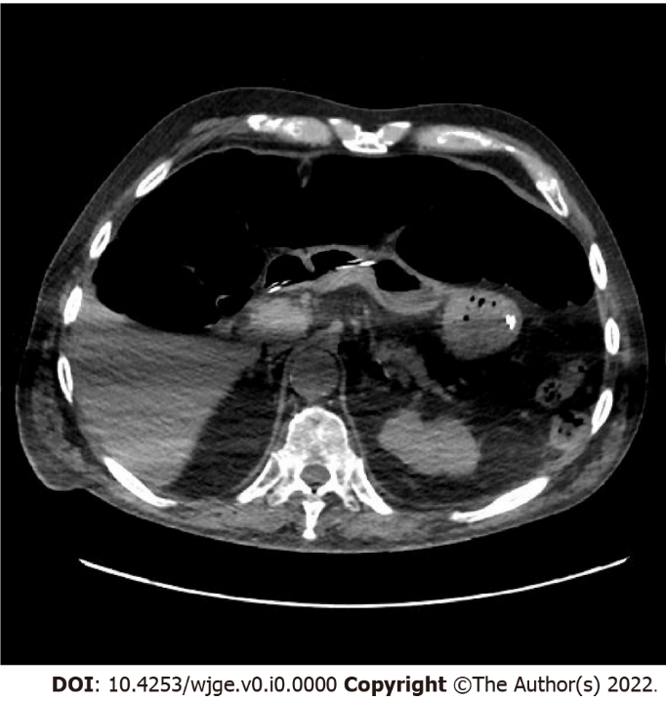
Figure 1 Case of percutaneous endoscopic gastrostomy failure. Subsequent computed tomography scan showed colonic interposition between the stomach with nasogastric tube and the anterior abdominal wall due to fecal stasis.

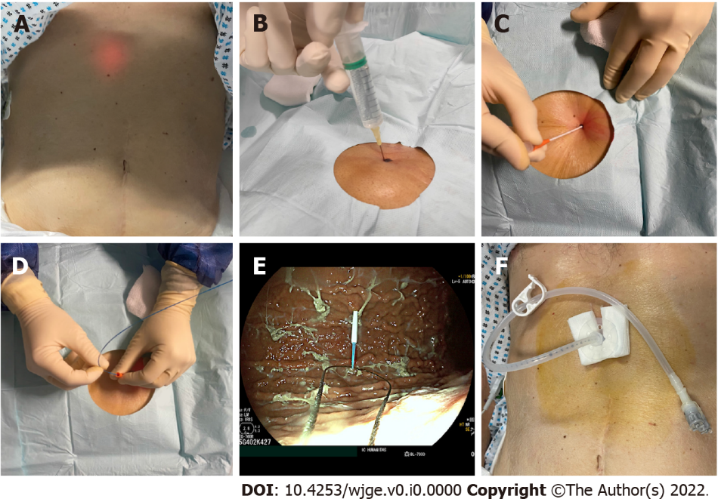
Figure 2 Steps of percutaneous endoscopic gastrostomy placement with “pull” technique. A: Location of the puncture site via transillumination; B: Avoidance of bowel interposition confirmed by the absence of bubbles at aspiration; C: Introduction of the trocar; D: Introduction of the guidewire; E: Grasping the guidewire with an endoscopic snare; F: Final result.
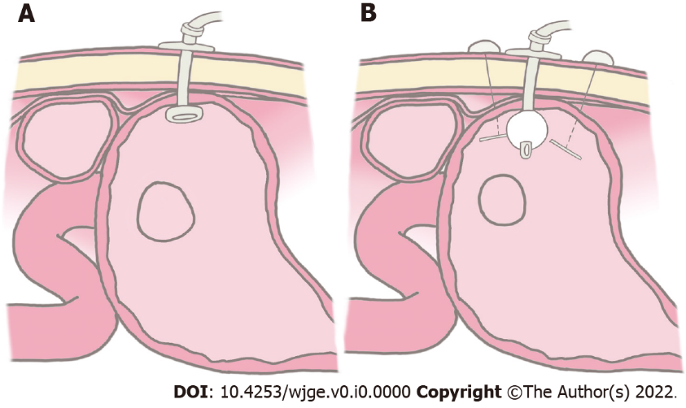
Figure 3 Graphic representation of percutaneous endoscopic gastrostomy placement technique. A: “Pull” technique; B: “Introducer” technique.

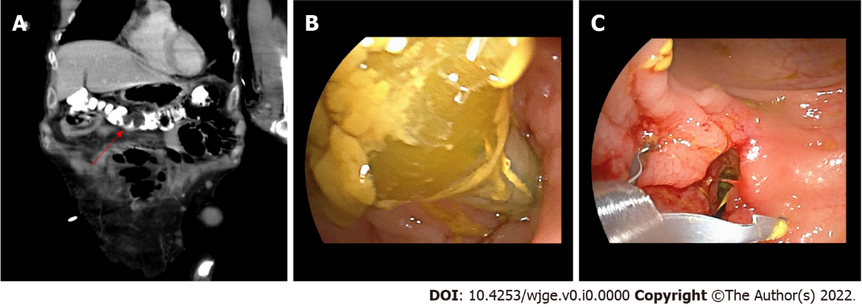
Figure 4 Percutaneous endoscopic gastrostomy displacement and development of colocutaneous fistula. A: Computed tomography scan image showing percutaneous endoscopic gastrostomy balloon located in the transverse colon (red arrow); B: Endoscopic view of the percutaneous endoscopic gastrostomy balloon within the colon; C: Endoscopic closure of the colonic fistulous orifice with clips.

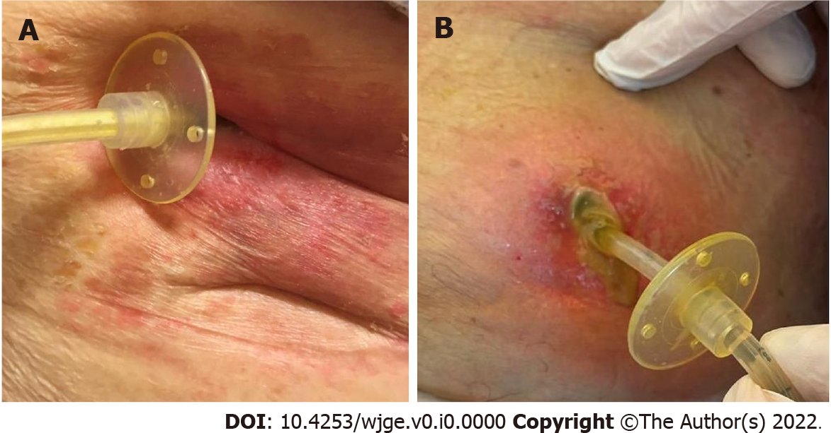
Figure 5 Wound infections. A: Superficial infection of the abdominal wall; B: Wound infection with abscess formation within the anterior abdominal wall.

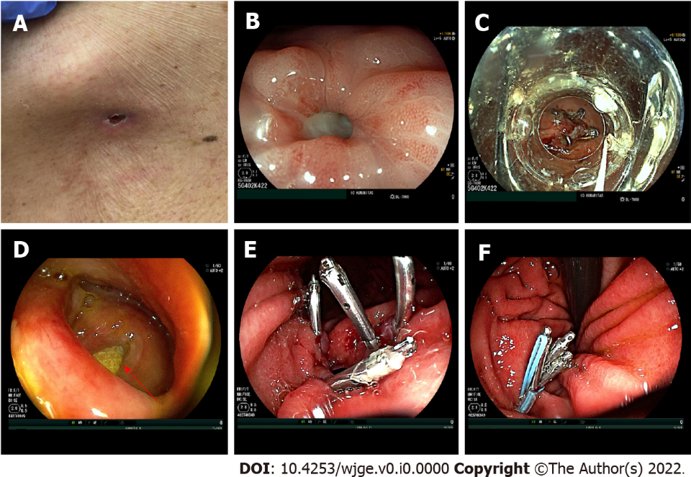
Figure 6 Gastrocutaneous fistula. A: External appearance of a gastrocutaneous fistula in the first case; B: Endoscopic appearance of the gastrocutaneous fistulous orifice; C: Endoscopic closure of the gastric fistulous orifice with an over-the-scope metal clip in the first case (OTSC – Ovesco Endoscopy AG, Tubingen, Germany); D: Endoscopic appearance of a large gastrocutaneous fistula, with detection of the gauze placed from the outside at the cutaneous end of the tract (red arrow) in the second case; E: Endoscopic placement of four metal clips at the margins of the fistulous orifice; F: Placement of an endoloop over the metal clips to achieve complete closure of the fistulous orifice.
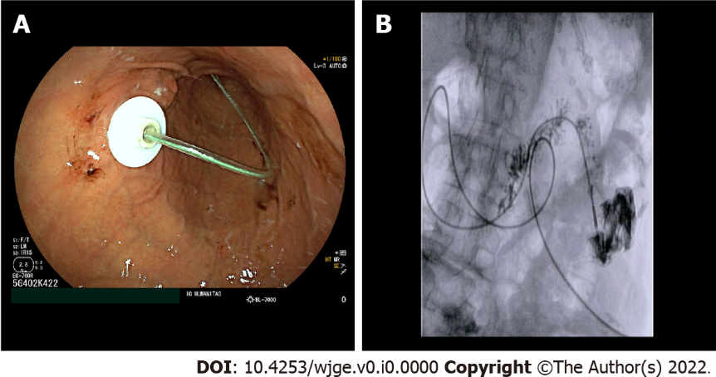
Figure 7 Percutaneous endoscopic transgastric jejunostomy placement. A: Endoscopic appearance of the percutaneous endoscopic transgastric jejunostomy with jejunal extension entering from the percutaneous endoscopic transgastric device towards the jejunum; B: Final fluoroscopic appearance of the percutaneous endoscopic transgastric jejunostomy with distal end of the jejunal extension into the proximal jejunum after injection of contrast medium.

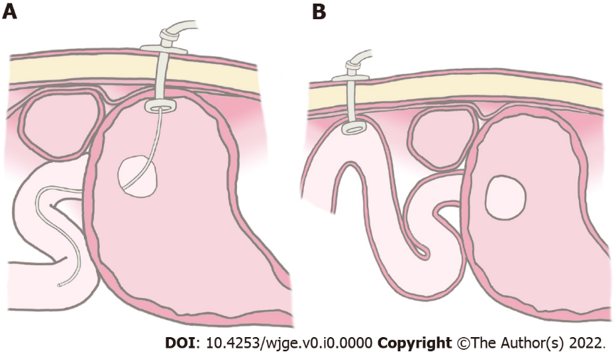
Figure 8 Graphic representation. A: Percutaneous endoscopic gastrostomy with jejunal extension; B: Direct percutaneous endoscopic jejunostomy.
Table 1 Indications for percutaneous endoscopic gastrostomy placement
Benign | Malignant | Pediatric
Neurological diseases and psychomotor retardation. Cerebrovascular disease. Motor neuron disease (amyotrophic lateral sclerosis). Multiple sclerosis. Parkinson’s disease. Dementia. Psychomotor retardation. Reduced level of consciousness. Head injury. Intensive care patients. Prolonged coma. Burns. Short bowel syndromes (Crohn’s disease). Facial surgery. Polytrauma. Benign esophageal strictures. Other causes of malnutrition (anorexia) | Cerebral tumor. Cancer with catabolic status. Head and neck cancer. Esophageal cancer. Gastric decompression | Cerebral palsy. Congenital anomaly (e.g., trachea esophageal fistula). Cystic fibrosis. Short bowel syndrome

Table 2 Contraindications to percutaneous endoscopic gastrostomy placement
Relative | Absolute
Peptic ulcer bleeding with high risk of rebleeding. Ascites. Ventriculoperitoneal shunts. Abdominal scars. Large intrathoracic hiatal hernia | Coagulation disorders (INR > 1.5, PTT > 50 s). Platelet count < 50000 mm³. Sign of sepsis. Peritonitis. Peritoneal carcinomatosis. Lack of a safe tract for percutaneous insertion. History of total gastrectomy
INR: International normalized ratio; PTT: Partial thromboplastin time.

