Name of Journal: World Journal of Clinical Cases
Manuscript NO: 81414
Manuscript Type: CASE REPORT

Closed loop ileus caused by a defect in the broad ligament: A case report

Zucal I et al. Internal hernia through the broad ligament

Isabel Zucal, Christian A Nebiker

Isabel Zucal, Christian A Nebiker, Department of General Surgery, Cantonal Hospital of Aarau, Aarau 5001, Switzerland

Author contributions: Zucal I and Nebiker CA performed the research, analyzed the data and wrote the manuscript; All authors have read and approved the final manuscript.

Corresponding author: Isabel Zucal, MD, Postdoc, Department of General Surgery, Cantonal Hospital of Aarau, Tellstrasse 25, Aarau 5001, Switzerland. isabel.zucal@ksa.ch

Received: November 8, 2022
Revised: December 23, 2022
Accepted: January 16, 2023
Published online: February 16, 2023

Abstract
BACKGROUND
Closed loop ileus caused by entrapment of bowel in a defect of the broad ligament is a rarity. Only a few cases have been reported in the literature.

CASE SUMMARY
We present the case of a 44-year-old, healthy patient with no prior history of abdominal surgery who developed a closed loop ileus due to an internal hernia secondary to a defect in the right broad ligament. She first presented to the emergency department with diarrhea and vomiting. As she had had no previous abdominal surgery, she was diagnosed with probable gastroenteritis and discharged. The patient subsequently returned to the emergency department due to a lack of improvement in her symptoms. Blood tests showed an elevated white blood cell count and a closed loop ileus was diagnosed on an abdominal computer tomography scan. Diagnostic laparoscopy revealed an internal hernia entrapped in a 2 cm large defect in the right broad ligament. The hernia was reduced and the ligament defect was closed using a running, barbed suture.

CONCLUSION
Bowel incarceration through an internal hernia may present with misleading symptoms and laparoscopy may reveal unexpected findings.

Key Words: Broad ligament; Ileus; Internal hernia; Laparoscopy; Case report

©The Author(s) 2023. Published by Baishideng Publishing Group Inc. All rights reserved.

Citation: Zucal I, Nebiker CA. Closed loop ileus caused by a defect in the broad ligament: A case report. World J Clin Cases 2023; 11(5): 1182-1187
URL: https://www.wjgnet.com/2307-8960/full/v11/i5/1182.htm
DOI: https://dx.doi.org/10.12998/wjcc.v11.i5.1182

Core Tip: In young patients with negative history of abdominal surgery presenting at the emergency department with nausea and vomiting, the initial differential diagnosis should include ileus. If an ileus is suspected, computer tomography and laparoscopy are the diagnostic tools of choice. Internal hernias are rare, especially those through the broad ligament, but they should be considered to avoid complications such as bowel necrosis. Because of the rarity of the conditions, there are no studies or long-term data on the best treatment option, but most authors describe a direct defect closure.

INTRODUCTION
Internal hernias are responsible for up to 4% of bowel obstruction in the emergency setting^{[1,2]}. Herniation of the bowel through the broad ligament has been reported to underlie 4%–7% of these cases^{[2-5]}. A computer tomography (CT) scan is the diagnostic tool of choice, however, the cause of bowel obstruction is usually not identified. In this regard, diagnostic laparoscopy plays a crucial role. Not only the area of bowel entrapment can be identified, but the hernia can be reduced, and the defect surgically closed.
The initial clinical presentation may be misleading and non-specific, as affected women have typically not had previous abdominal surgery^{[5]}. Here we present a case of a 44-year-old woman with closed loop ileus caused by a defect in the right broad ligament. The case was reported in accordance with the SCARE 2020 guidelines^{[6]}.

CASE PRESENTATION
Chief complaints
A 44-year-old female patient with sudden onset of abdominal pain was assigned to the surgical emergency department by the gynecological ward after exclusion of a gynecological pathology.

History of present illness
The pain was mainly localized in both lower abdominal quadrants and accompanied by nausea without vomiting.

History of past illness
History of past illness was negative.

Personal and family history
She was otherwise healthy, had two children via vaginal delivery, and had no history of abdominal operations.

Physical examination
On clinical examination, pain was found on palpation of the right lower abdominal quadrant without signs of peritonism.

Laboratory examinations
The blood tests showed an elevated white blood cell count (26 g/L) and normal C-reactive protein (CRP).

Imaging examinations
An ultrasound scan could not identify the appendix. However, distended bowel without peristalsis was seen in the right lower quadrant, possibly indicating a segmental obstruction. Because of a lack of previous abdominal operations, an ileus seemed unlikely and the patient was diagnosed with enteritis. She was scheduled for a control the next morning.

Further diagnostic work-up
Within 12 h, the patient was brought back to the emergency department by ambulance and had developed additional vomiting and diarrhea. A diffuse pain on palpation of the lower abdominal quadrants was elicited and stool samples were collected for microbiological analysis. The white blood cell count had fallen to 14 g/L, and the CRP had risen to 20 mg/L. Again, the patient was discharged with the diagnosis of enteritis. On the next day, the patient came to the emergency department again with constant vomiting and new bloody diarrhea. A CT of the abdomen was performed, and a closed loop obstruction was postulated. Moreover, ascites was observed. The CT findings are shown in Figure 1. The patient was scheduled for an emergency laparoscopy which detected herniation of the ileum into a 2 cm defect in the right broad ligament.

FINAL DIAGNOSIS
An internal hernia through the right broad ligament.

TREATMENT
The bowel was successfully reduced and presented no signs of bowel ischemia. Two strangulation marks were identified but appeared to be without transmural necrosis. The defect in the right broad ligament was closed by using a barbed running suture. The intraoperative findings and defect closure are shown in Figure 2. The nasogastric tube could be removed the day after surgery. Food was well tolerated, and the patient was discharged on the third postoperative day.

OUTCOME AND FOLLOW-UP
After discharge, no further clinical follow-up was planned in the surgical outpatient clinic and the patient did not present again to the emergency department.

DISCUSSION
Bowel obstruction caused by herniation through the broad ligament is very rare and may occur in healthy patients with no prior history of abdominal surgery. Symptoms including nausea, vomiting and paradoxical diarrhea may therefore be attributed to enteritis, as happened in our case. In a case reported by Agrawal et al^{[7]}, a ruptured ovarian cyst was suspected before the exploratory laparotomy was performed and an internal hernia through the broad ligament was detected^{[7]}. Such hernias usually manifest as closed loop obstruction on a CT scan^{[8,9]}, but the etiology is hard to detect. Thus, reaching the correct diagnosis may be delayed.
In the literature, only a few similar cases have been described. We were able to perform a laparoscopic hernia reduction and closure of the defect without complications. In other reported cases, the hernia had to be reduced via laparotomy^{[7-11]}. Although the bowel was hyperemic, there were no signs of bowel ischemia, so no bowel resection had to be performed. In contrast, in other reported cases, strangulated bowel had to be resected^{[10]}. In the case reported by Takahashi et al^{[9]}, the fallopian tube had to be removed due to necrosis^{[9]}. Hashimoto et al^{[8]} described recurrence of a broad ligament hernia in a 53-year-old woman 10 years after primary repair^{[8]}. In a case reported by Rodrigues et al^{[12]}, asymptomatic, internal broad ligament hernia was an incidental finding in an exploratory laparoscopy to recover a lost intrauterine device^{[12]}.
According to Cilley et al's classification^{[13]}, we report a type I hernia as the defect was located caudal to the round ligament in the broad ligament. A type II hernia would have been located in the mesovarium and mesosalpinx above the round ligament, and a type III hernia has been described as a defect through the meso-ligamentum teres uteri^{[13]}. Broad ligament defects and consecutive hernias can be congenital or acquired^{[14]}. Congenital defects arise from spontaneous rupture of congenital cysts in the broad ligament and are usually bilateral, whereas acquired defects may be secondary to delivery trauma, pregnancy, surgery, or inflammatory disease^{[9,14]}. Inspection of the contralateral broad ligament is important to avoid re-operation, however, guidelines on the optimal defect closure and long-term outcomes are missing.

CONCLUSION
A closed loop ileus due to an internal hernia in patients with a negative history of abdominal surgery may present with misleading symptoms. A CT scan is the diagnostic tool of choice to identify closed loop obstruction, but only laparoscopy can provide the correct diagnosis and treatment. Due to the rarity of broad ligament internal hernias, there is no consensus on the best surgical treatment. Observation of long-term outcomes of the reported cases with regards to hernia recurrence is needed.

REFERENCES
1 Zemour J, Coueffe X, Fagot H. Herniation of the broad ligament… And the other side? Int J Surg Case Rep 2019; 65: 354-357 [PMID: 31783233 DOI: 10.1016/j.ijscr.2019.11.024]
2 Ghahremani GG. Internal abdominal hernias. Surg Clin North Am 1984; 64: 393-406 [PMID: 6729672 DOI: 10.1016/s0039-6109(16)43293-7]
3 Martin LC, Merkle EM, Thompson WM. Review of internal hernias: radiographic and clinical findings. AJR Am J Roentgenol 2006; 186: 703-717 [PMID: 16498098 DOI: 10.2214/ajr.05.0644]
4 Fukuoka M, Tachibana S, Harada N, Saito H. Strangulated herniation through a defect in the broad ligament. Surgery 2002; 131: 232-233 [PMID: 11854708 DOI: 10.1067/msy.2002.113886]
5 Reyes N, Smith LE, Bruce D. Strangulated internal hernia due to defect in broad ligament: a case report. J Surg Case Rep 2020; 2020: rjaa487 [PMID: 33294168 DOI: 10.1093/jscr/rjaa487]
6 Agha RA, Franchi T, Sohrabi C, Mathew G, Kerwan A; SCARE Group. The SCARE 2020 Guideline: Updating Consensus Surgical CAse REport (SCARE) Guidelines. Int J Surg 2020; 84: 226-230 [PMID: 33181358 DOI: 10.1016/j.ijsu.2020.10.034]
7 Agrawal P, Grab JT IVs, Howe HR 3rd, Cross K. Ruptured Ovarian Cyst Masking Diagnosis of Hernia Through Broad Ligament of Uterus: A Case Report. J Investig Med High Impact Case Rep 2022; 10: 23247096221100500 [PMID: 35610939 DOI: 10.1177/23247096221100500]
8 Hashimoto Y, Kanda T, Chida T, Suda K. Recurrence hernia in the broad ligament of the uterus: a case report. Surg Case Rep 2020; 6: 288 [PMID: 33196861 DOI: 10.1186/s40792-020-01030-5]
9 Takahashi M, Yoshimitsu M, Yano T, Idani H, Shiozaki S, Okajima M. Rare Contents of an Internal Hernia through a Defect of the Broad Ligament of the Uterus. Case Rep Surg 2021; 2021: 5535162 [PMID: 34194864 DOI: 10.1155/2021/5535162]
10 Arif SH, Mohammed AA. Strangulated small-bowel internal hernia through a defect in the broad ligament of the uterus presenting as acute intestinal obstruction: A case report. Case Rep Womens Health 2021; 30: e00310 [PMID: 33868965 DOI: 10.1016/j.crwh.2021.e00310]
11 Ohno S, Chikaishi W, Sugimoto T, Komori S, Kawai M. An incarcerated internal hernia of the sigmoid colon through a defect in the broad ligament: A case report. Int J Surg Case Rep 2021; 85: 106169 [PMID: 34274757 DOI: 10.1016/j.ijscr.2021.106169]
12 Rodrigues F, Sarmento I, Tiago P. Asymptomatic internal hernia through a defect of broad ligament: a surprising finding in a laparoscopic surgery to recover a lost levonorgestrel-releasing intrauterine system. BMJ Case Rep 2015; 2015 [PMID: 25564646 DOI: 10.1136/bcr-2014-206804]
13 Cilley R, Poterack K, Lemmer J, Dafoe D. Defects of the broad ligament of the uterus. Am J Gastroenterol 1986; 81: 389-391 [PMID: 3706255]
14 Simstein NL. Internal herniation through a defect in the broad ligament. Am Surg 1987; 53: 258-259 [PMID: 3579036]

Footnotes
Informed consent statement: Informed written consent was obtained from the patient for publication of this report and any accompanying images.

Conflict-of-interest statement: All the authors report no relevant conflicts of interest for this article.

CARE Checklist (2016) statement: The authors have read the CARE Checklist (2016), and the manuscript was prepared and revised according to the CARE Checklist (2016).

Open-Access: This article is an open-access article that was selected by an in-house editor and fully peer-reviewed by external reviewers. It is distributed in accordance with the Creative Commons Attribution NonCommercial (CC BY-NC 4.0) license, which permits others to distribute, remix, adapt, build upon this work non-commercially, and license their derivative works on different terms, provided the original work is properly cited and the use is non-commercial. See: https://creativecommons.org/Licenses/by-nc/4.0/

Provenance and peer review: Unsolicited article; Externally peer reviewed.

Peer-review model: Single blind

Peer-review started: November 8, 2022
First decision: November 22, 2022
Article in press: January 16, 2023

Specialty type: Medicine, research and experimental
Country/Territory of origin: Switzerland
Peer-review report’s scientific quality classification
Grade A (Excellent): 0
Grade B (Very good): 0
Grade C (Good): C, C
Grade D (Fair): 0
Grade E (Poor): 0

P-Reviewer: Carannante F, Italy; Wang Y, China S-Editor: Li L L-Editor: A P-Editor: Li L

Figure Legends

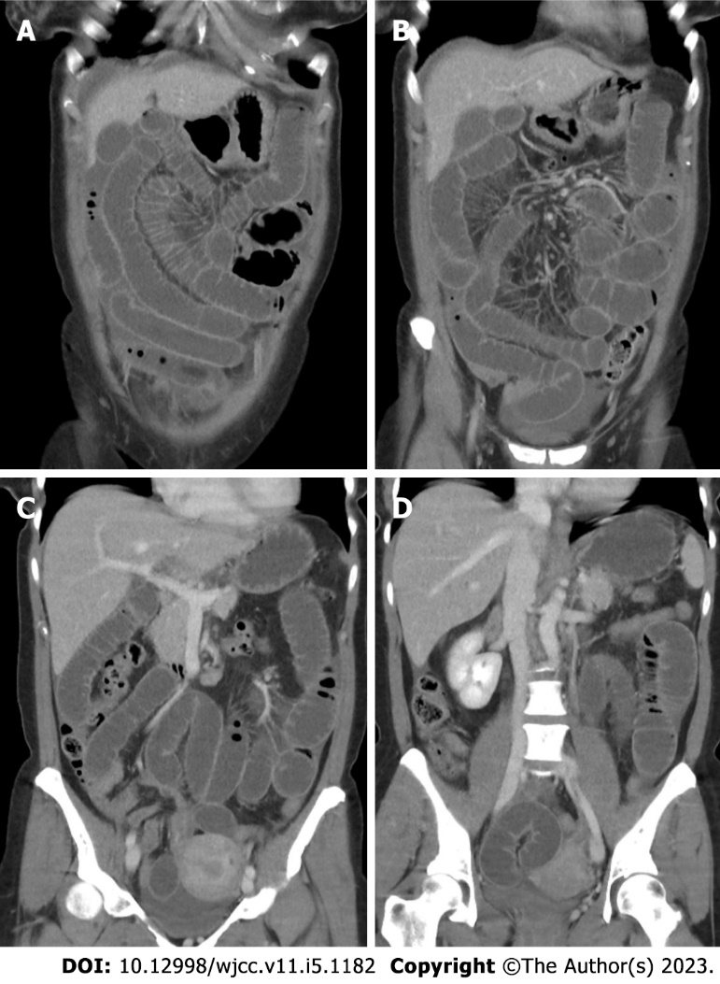
Figure 1 computer tomography scan of the abdomen. A: Small bowel distension is observed; B: The dilated small bowel indicates an obstruction; C: The site of change of intestinal caliber is located in the right lower quadrant; D: The cause of obstruction cannot be identified.

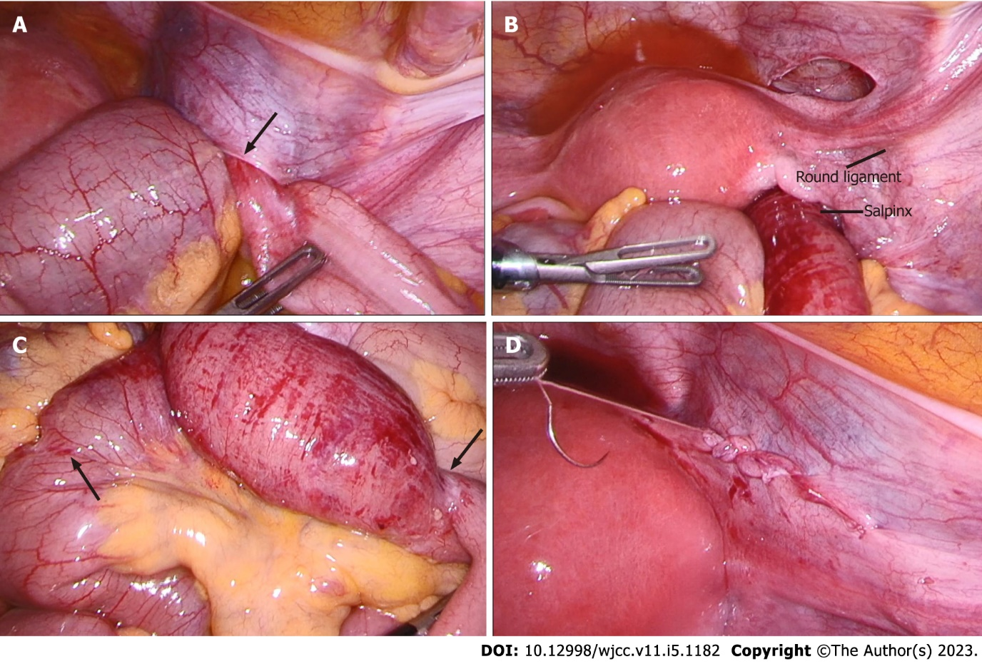
Figure 2 Intraoperative findings. A: Internal hernia is identified: small bowel incarceration through a defect in the right broad ligament of the uterus (arrow); B: Overview on the anatomy: The defect is caudal to the salpinx and round ligament of the uterus. According to the classification by Cilley et al^{[13]}, this classifies as a type I hernia; C: Strangulation marks are indicated by arrows and between which hyperemic bowel can be observed; D: Defect closure with a running suture.

Published by Baishideng Publishing Group Inc
7041 Koll Center Parkway, Suite 160, Pleasanton, CA 94566, USA
Telephone: +1-925-3991568
E-mail: bpgoffice@wjgnet.com
Help Desk: https://www.f6publishing.com/helpdesk
https://www.wjgnet.com

© 2023 Baishideng Publishing Group Inc. All rights reserved.

