Name of journal: World Journal of Gastroenterology
ESPS Manuscript NO: 12196
Columns: META-ANALYSIS

HIF-1α -1790G>A polymorphism significantly increased the risk of digestive tract cancer: A meta-analysis

Sun X et al. HIF-1α and digestive tract cancer risk

Xiao Sun, Ying-Di Liu, Wei Gao, Shao-Hua Shen, Meng Li

Xiao Sun, Ying-Di Liu, Wei Gao, Shao-Hua Shen, Meng Li, Department of Gastroenterology, Hainan Branch of PLA General Hospital, Sanya 572000, Hainan Province, China

Author contributions: Sun X, Liu Yd, and Gao W designed the study, analyzed the data and wrote the manuscript; Shen SH and Li M contributed to the databases searches, the selection of studies and discussions; Liu YD designed the study, contributed to the discussion and edited the manuscript as the corresponding author.

Correspondence to: Ying-Di Liu, MD, PhD, Department of Gastroenterology, Hainan Branch of PLA General Hospital, Haitangwan, Sanya 572000, Hainan Province, China. liuyingti@yeah.net
Telephone: +86-751-38831528 Fax: +86-898-38853390

Received: June 26, 2014 Revised: August 27, 2014
Accepted: September 29, 2014

Published online:
Abstract
AIM: To investigate the association between hypoxia-inducible factor-1α (HIF-1α) polymorphisms (-1772C>T and -1790G>A) and the risk of digestive tract cancer.

METHODS: A total of 13 eligible studies were retrieved from PubMed, EMBASE, and the China National Knowledge Infrastructure database. The odds ratios (ORs) and 95%CI were calculated to estimate the strength of the associations.

RESULTS: By pooling the eligible studies, we found that the HIF-1α -1772C>T polymorphism was not associated with a risk of developing digestive tract cancer (dominant comparison, OR = 1.156, 95%CI: 0.839-1.593, P_{heterogeneity} = 0.007), and no significant association was found in the Asian population or the Caucasian population. However, for the -1790G>A polymorphism, carriers of the variant -1790A allele had a significantly increased risk of digestive tract cancer compared with those with the wildtype -1790G allele (dominant comparison: OR = 3.252, 95%CI: 1.661-6.368, P_{heterogeneity} < 0.001). Additionally, this increased risk of digestive cancer was only detected in Asians; there was no significant association in Caucasians.

CONCLUSION: This meta-analysis demonstrates that the HIF-1α-1790G>A polymorphism is associated with a significantly increased risk of digestive tract cancer, and the -1772C>T polymorphism is not.

© 2014 Baishideng Publishing Group Inc. All rights reserved.

Key words: Hypoxia-inducible factor-1α; Digestive tract cancer; Polymorphisms; Cancer risk; Meta-analysis

Core tip: The functional polymorphisms of hypoxia-inducible factor-1α (HIF-1α) (-1772C>T and -1790G>A) have been extensively investigated; however, the relationship between HIF-1alpha polymorphisms and digestive tract cancer has remained unclear. In this work, we found that the HIF-1α -1772C>T polymorphism was not associated with the overall risk of developing digestive tract cancer (dominant comparison, OR = 1.156, 95%CI: 0.839-1.593, P_{heterogeneity} = 0.007). However, the variant -1790A allele significantly increased the risk of digestive tract cancer (OR = 3.252, 95%CI: 1.661-6.368, P_{heterogeneity} < 0.001).

Sun X, Liu YD, Gao W, Shen SH, Li M. HIF-1α -1790G>A polymorphism significantly increased the risk of digestive tract cancer: A meta-analysis. World J Gastroenterol 2014; In press

INTRODUCTION
Genetic polymorphisms are natural DNA sequence variations that occur in the healthy population with an expected frequency higher than 1%^{[1]}. Common genetic polymorphisms include single nucleotide polymorphisms, insertions, deletions, minisatellites and microsatellites. Approximately 90% of DNA polymorphisms are single nucleotide polymorphisms (SNPs). Functional SNPs in gene regulatory or coding sequences can alter gene expression or affect the function of proteins. SNPs are associated with inter-individual variation and diversity and have recently been considered as principal genetic elements involved in the development of complex diseases, such as cancer^{[2]}.
Hypoxia-inducible factor-1 (HIF-1) is a transcription factor complex that activates gene transcription, enhancing oxygen availability and allowing metabolic adaptation to hypoxia^{[3]}. HIF-1 is composed of two subunits, HIF-1α and HIF-1β. HIF-1alpha plays a critical role in adjusting oxygen levels, and it is involved in the processes of angiogenesis^{[4-6]} and cell proliferation^{[7,8]}. HIF-1alpha is expressed in many cancer cells as a result of oncogene expression and intratumoral hypoxia^{[9,10]}. Furthermore, it has been demonstrated that HIF-1alpha is an unfavorable prognostic factor in a variety of digestive tract cancers, such as pancreatic cancer and hepatocellular carcinoma^{[11-13]}.
The hypoxia inducible factor-1α (HIF-1α) gene is located on chromosome 14q21-24. Two common SNPs in the protein coding region of the HIF-1alpha gene have been widely investigated: the C-to-T substitution at -1772 (-1772C>T, P582S, or rs11549465) and the G-to-A substitution at -1790 (-1790G>A, A588T, or rs11549467). The -1772C>T polymorphism leads to a proline-to-serine substitution, and the -1790G>A polymorphism leads to an alanine-to-threonine substitution. Both the -1772C>T and -1790G>A polymorphisms are functional and located in the oxygen-dependent degradation domain, which is closely related to the N-terminal transactivation domain of HIF-1α^{[4,14]}. Therefore, these functional SNPs may affect the stability and trans-activating capacity of HIF-1α. Additionally, evidence also suggests that these functional SNPs could alter the susceptibility to various types of cancer. However, current studies have yielded conflicting results about HIF-1alpha polymorphisms and the risk of developing cancer of the digestive tract. For example, Kang and colleagues^{[15]} found that the -1772C>T polymorphism was associated with an increased risk of colorectal cancer; however, Li et al^{[16]} did not find any significant association with gastric cancer risk. Thus, this meta-analysis was performed to ascertain the relationship between the HIF-1alpha -1772C>T and -1790G>A polymorphisms and the susceptibility to cancer of the digestive tract.

MATERIALS AND METHODS
Selection of eligible studies
The eligible studies were obtained by searching online databases. In order to identify as many related articles as possible, PubMed, EMBASE, and the China National Knowledge Infrastructure (CNKI) were searched. Combinations of medical subheadings and the key words “HIF-1 alpha” or “hypoxia-inducible factor 1, α subunit” or “HIF1A” or “HIF-1α”, “polymorphism, single nucleotide” or “single nucleotide polymorphism” or “polymorphism” or “SNP”, and “neoplasms” or “cancer” or “tumor” were used to search the databases. Alternative spellings of these key words were also considered. The most recent research was performed on July 15, 2013, and there was no limitation on the research.

Inclusion and exclusion criteria
Studies were selected according to the following inclusion criteria: (1) case-control studies; (2) investigation of the association of HIF-1alpha polymorphisms (-1772C>T and -1790G>A) and the risk of developing digestive tract cancer; (3) cancer diagnosis by histopathology; and (4) studies providing detailed genotype frequencies. Studies without detailed genotype frequencies were excluded. The titles and abstracts of the records retrieved from the databases were screened, and the full-text papers were further evaluated to confirm eligibility. Two reviewers (Sun X and Liu Y) extracted the eligible studies independently according to the inclusion criteria. Disagreements between the two reviewers were discussed with another reviewer (LBH) until a consensus was achieved.

Data extraction
Data from the eligible studies were independently extracted by two reviewers (Sun X and Liu Y) using a predesigned data collection form. The following data were collected: name of the first author, year of publication, country where the study was carried out, ethnicity, cancer types, the source of the control, number of cases and controls, genotype frequency in the cases and controls. Ethnicity was categorized as Asian, Caucasian, or Latin American (Table 1). According to the source of control, the eligible studies were defined as hospital-based (HB) and population-based (PB). The sample size in the eligible studies was classified as either large (> 500) or small (< 500). Hardy-Weinberg equilibrium (HWE) in the controls was tested using the chi-squared test for goodness of fit, and P < 0.05 was considered as the absence of HWE. Two reviewers reached consensus on each item.

Statistical analysis
The strength of the association between the HIF-1α -1772C>T and -1790G>A polymorphisms and the risk of developing digestive tract cancer was measured by odds ratios (ORs) with 95%CI. The estimates of the pooled ORs were obtained by calculating a weighted average of the ORs from each study. A 95%CI was used for the test of statistical significance, and a 95%CI without an OR of 1 indicated a significantly increased or reduced cancer risk. The pooled ORs were calculated for allele comparison (A vs a), heterozygote comparison (Aa vs aa), and dominance modeling (AA/Aa vs aa) (A: the mutant allele, a: the wildtype allele; the -1772T and -1790A alleles were considered as mutant alleles). The combined genotype was reported by Kang et al^{[15]} and Knechtel et al^{[17]}; thus, only dominant comparison models were calculated for these 2 studies. Subgroup analyses were also conducted according to ethnicity, cancer types, source of control, and sample size. A sub-group analysis was not performed for subgroups containing less than 2 studies. Sensitivity analyses were performed to identify each individual study’s effect on the pooled results and test the reliability of the results.
The χ² test based on Q was used to check the statistical heterogeneity between studies, and the heterogeneity was considered significant when P < 0.10. The fixed-effects model (based on the Mantel-Haenszel method) and random-effects model (based on the DerSimonian-Laird method) were used to pool the data from different studies. The fixed-effects model was used when there was no significant heterogeneity; otherwise, the random-effects model was applied ^{[18]}. Meta-regression was performed to detect the source of heterogeneity. Publication bias was detected by Begg’s funnel plot and Egger’s linear regression test, and a P < 0.05 was considered significant ^{[19]}. To test the influence of publication bias, the fail-safe number was also calculated for P = 0.05 (Nfs_{0.05}) and P = 0.01 (Nfs_{0.01}) ^{[20]}. All statistical analyses were calculated with STATA software (version 10.0; StataCorp, College Station, Texas United States), and all P values are two-side.

RESULTS
Overview of eligible studies
According to our searching strategy, 558 records were retrieved and screened. After primary screening, 16 full-text papers were retrieved for further assessment of eligibility. Finally, 13^{[15-17,21-30]} eligible studies were included and 3 studies were excluded because they were not related to cancer risk^{[31,32]} or the HIF-1alpha -1772C>T and -1790G>A polymorphisms^{[33]}. The procedure for study selection is shown in Figure 1.
Of the 13 eligible studies, 2182 cancer patients and 3101 controls were enrolled. The baseline characteristics of the included studies are shown in Table 1. Six types of digestive tract cancer were investigated: oral cancer, esophageal cancer, gastric cancer, pancreatic cancer, hepatocellular carcinoma, and colorectal cancer. Most studies were carried out among Asian and Caucasian population, while only one study was performed in Latin America. The -1772C>T polymorphism was investigated in all studies, and the -1790G>A polymorphism was studied in 10 studies^{[16,17,21-28]}. For the -1772C>T polymorphism, the absence of HWE in controls was detected in 3 studies^{[21,22,27]}; however, no disequilibrium was detected for the -1790G>A polymorphism. In the control population, homozygotes for the variant -1772TT were detected in 4 studies^{[20,23,26,27]}, while the -1790AA genotype was not detected among the cancer cases.

Meta-analysis results
-1772C>T polymorphism by pooling all of the eligible studies, we found that the -1772C>T polymorphism was not associated with the risk of digestive tract cancer in any of the three comparison models (dominant comparison, OR = 1.156, 95%CI: 0.839-1.593, P_{heterogeneity} = 0.007, Figure 2). The meta-analysis results for -1772C>T polymorphism are shown in Table 2. Sub-group analyses were performed, and no significant association with the risk of digestive tract cancer was found among Asians or Caucasians in the HB studies. Because the date from 3 studies were not inconsistent with HWE, we performed sub-group analyses according to HWE, and no statistical association was found in any of the groups. In terms of cancer types, we found that only the variant -1772T allele was associated with a significantly increased risk of pancreatic cancer (OR = 1.753, 95%CI: 1.225-2.508, P_{heterogeneity} = 0.349), while no significant association was observed with oral cancer or colorectal cancer. Notably, sample size had a significant influence on the pooled results. As shown in Table 2, large studies suggested an increased risk, while small studies revealed no significant association.
Begg’s funnel plot (P = 0.373, Figure 3) and Egger’s linear regression test (P = 0.813) suggested that no publication bias affected the results. A sensitivity analysis also confirmed the stability of our results because no individual study affected the pooled results significantly (Figure 4). Due to the significant heterogeneity among the studies, a meta-regression was performed to identify the source of heterogeneity (for the dominant model), and the results suggested that ethnicity (P = 0.021), sample size (P = 0.002), and HWE (P < 0.001) were the sources of heterogeneity between the studies.

-1790G>A polymorphism
The results of the meta-analysis of the -1790G>A polymorphism are shown in Table 3. A pooled analysis of the 10 eligible studies revealed that the variant -1790A allele significantly increased the risk of digestive tract cancer, as observed in the dominant model (OR = 3.252, 95%CI: 1.661-6.368, P_{heterogeneity} < 0.001; Figure 5), the allele comparison (OR = 4.455, 95% CI: 1.938-10.241, P_{heterogeneity} < 0.001), and the heterozygote comparison. Next, stratified analyses were performed. As shown in Table 3, the source of control and the sample size did have a significant effect on the results. However, we only found a significantly increased risk in Asians, not in Caucasians. In Asians, the -1790G>A polymorphism was associated with increased susceptibility to cancers of the digestive tract, while there was no significant association was observed in Caucasians. As for the cancer types, the -1790G>A polymorphism increased the risk of oral cancer and pancreatic cancer, but not the risk of colorectal cancer (Table 3).
The results of Begg’s test (P = 0.05) and Egger’s test (P = 0.064) indicated the presence of significant publication bias. Additionally, the stability of our results was confirmed by the sensitivity analysis (Figure 4B). The fail-safe number was calculated to estimate the influence of publication bias. The value of the fail-safe number was large (Nfs0.05 = 359.34, Nfs0.01 = 172.98), which suggested that the publication bias was low and our result is reliable. Due to the significant heterogeneity among the studies, a meta-regression was performed to identify the source of the heterogeneity (for the dominant model). The results suggested that sample size (P = 0.002) and HWE (P < 0.001) were the sources of heterogeneity between studies.

DISCUSSION
The results of the present meta-analysis suggest that the -1772C>T polymorphism of the HIF-1alpha gene is not associated with the risk of digestive tract cancer; however, the -1790G>A polymorphism significantly increases the susceptibility to digestive tract cancer.
HIF-1α is a critical gene involved in the cellular response to hypoxia. By activation of various genes that are related to the regulation of angiogenesis, cell survival, apoptosis, and the proliferative response, HIF-1alpha has an important role in tumor progression and metastasis ^{[34, 35]}. In the presence of oxygen, HIF-1alpha is hydroxylated and degraded by the proteasome^{[36]}; however, in a hypnotic microenvironment, the HIF-1alpha protein accumulates^{[37]}. Studies have shown that HIF-1alpha is overexpressed in various digestive tract tumors, such as colon cancer, pancreatic cancer, stomach cancer, and esophageal cancer^{[9,38]}. The functional -1772C>T and -1790G>A polymorphisms of HIF-1alpha are associated with an increased trans-activation capacity of HIF-1alpha under normoxic and hypoxic conditions^{[4]}. Thus, these two SNPs may alter the risk of digestive tract cancer.
In this meta-analysis, we identified 13 eligible studies^{[15-17,21-30]} and found that the -1772C>T polymorphism was not associated with the risk of digestive tract cancer. Stratified analyses according to ethnicity, source of controls, and HWE did not find any differences between the sub-groups. The results suggested that the -1772C>T did not alter the overall risk of developing digestive tract cancer. However, the results of this meta-analysis did reveal that the -1790G>A polymorphism was associated with a significantly increased risk of digestive tract cancer, and an elevated susceptibility to cancer was also observed in the majority of the sub-groups. Specifically, we found that Asian carrier of the variant -1790A allele had an increased risk compared with Caucasians. The difference between ethnicities may be explained by differences in the genetic background, lifestyle, and environmental exposure between the groups^{[39]}. Additionally, the -1772C>T and -1790G>A polymorphisms had different impacts on the risk of developing a specific kind of cancer (Table 2 and Table 3), suggesting that HIF-1alpha polymorphisms may exert cancer type-specific effects.
Notably, significant heterogeneity was detected in this meta-analysis. Meta-regression and subgroup analyses were carried out to detect the source of this heterogeneity. For both -1772C>T and -1790G>A, ethnicity was the source of the heterogeneity. For -1772C>T, sample size and HWE also contributed to the observed heterogeneity. On the other hand, the sensitivity analysis confirmed the reliability and stability of our results. Additionally, no evidence of significant publication bias was not found by Egger’s test or Begg’s test.
As we were conducting this meta-analysis, an updated meta-analysis of HIF-1alpha polymorphisms was published^{[40]}. Compared with the updated meta-analysis, we focused exclusively on digestive tract cancer and included more eligible studies related to this type of cancer; Liu and Zhang only included studies before 2011^{[40]}. Because more eligible studies were included in our meta-analysis, we performed comprehensive sub-group analyses according to cancer type, sample size, HWE, and ethnicity. However, limitations of our meta-analysis should also be noted. First, although we performed a comprehensive meta-analysis, the number of relevant studies was limited and we could not perform sub-group analyses for each kind of digestive tract cancer. Second, the sample sizes in the included studies were relatively small. For the -1772C>T polymorphism, increased susceptibility was observed in large studies, while no significant association was found in small studies. Third, the genotype distribution of the controls was not in agreement with HWE in 3 studies on the -1772C>T polymorphism, although sub-group analysis demonstrated that the absence of HWE had no significant effect on the pooled results.
In summary, in this meta-analysis of 13 eligible studies, we found that the -1790G>A polymorphism of HIF-1alpha significantly increases the susceptibility to digestive tract cancer, while the -1772C>T polymorphism is not associated with significant risk. Further studies with larger sample sizes are warranted to validate these associations, particularly for the -1772C>T polymorphism.

COMMENTS
Background
Hypoxia-inducible factor-1 alpha (HIF-1α) is a critical regulator of oxygen levels, and it is involved in the process of angiogenesis. The C-to-T substitution at -1772 (-1772C>T, rs11549465) and the G-to-A substitution at -1790 (-1790G>A, rs11549467) are two common single nucleotide polymorphisms of HIF-1α.

Research frontiers
Previous association studies have reported the association between HIF-1 polymorphisms and the risk of digestive tract cancer. However, these studies have reported conflicting results, and the sample size was small in the majority of these studies. Therefore, we conducted this meta-analysis to address this issue.

Innovations and breakthroughs
Based on this meta-analysis, the HIF-1alpha -1772C>T polymorphism was not associated with the overall risk of digestive tract cancer (OR = 1.156, 95%CI: 0.839-1.593). However, the -1790G>A polymorphism significantly increased the risk of digestive tract cancer (OR = 3.252, 95% CI: 1.661-6.368).

Applications
These results highlighted that HIF-1alpha -1790G>A plays a role in digestive tract cancer, indicating that this point mutation may affect the transcription of HIF-1alpha. Further exploration of the mechanism will improve our understanding of the role and function of HIF-1alpha -1790G>A.

Terminology
Genetic polymorphisms are natural DNA sequence variations that can occur in the healthy population. Functional polymorphisms in gene regulatory or coding sequences may alter gene expression or the function of the encoded proteins. The -1790G>A polymorphism leads to an alanine-to-threonine substitution in the oxygen-dependent degradation domain, which is critical for the function of HIF-1α.

Peer review
The Authors investigated the association of HIF-1alpha polymorphisms and risk of digestive cancer. The meta-analysis of 13 studies showed that HIF-1alpha -1790G>A polymorphism is associated with a significantly increased risk of digestive tract cancer.

REFERENCES
1 Balasubramanian SP, Brown NJ, Reed MW. Role of genetic polymorphisms in tumour angiogenesis. Br J Cancer 2002; 87: 1057-1065 [PMID: 12402142 DOI: 10.1038/sj.bjc.6600625]
2 Rannala B. Finding genes influencing susceptibility to complex diseases in the post-genome era. Am J Pharmacogenomics 2001; 1: 203-221 [PMID: 12083968]
3 Le Mouël JL CJ, Narteau C. Multiple scale dynamo. Proc Natl Acad Sci U S A 1997; 94: 5510-5514 [PMID: 11038547]
4 Tanimoto K, Yoshiga K, Eguchi H, Kaneyasu M, Ukon K, Kumazaki T, Oue N, Yasui W, Imai K, Nakachi K, Poellinger L, Nishiyama M. Hypoxia-inducible factor-1alpha polymorphisms associated with enhanced transactivation capacity, implying clinical significance. Carcinogenesis 2003; 24: 1779-1783 [PMID: 12919954 DOI: 10.1093/carcin/bgg132]
5 Liang X, Yang D, Hu J, Hao X, Gao J, Mao Z. Hypoxia inducible factor-alpha expression correlates with vascular endothelial growth factor-C expression and lymphangiogenesis/angiogenesis in oral squamous cell carcinoma. Anticancer Res 2008; 28: 1659-1666 [PMID: 18630523]
6 Burkitt K, Chun SY, Dang DT, Dang LH. Targeting both HIF-1 and HIF-2 in human colon cancer cells improves tumor response to sunitinib treatment. Mol Cancer Ther 2009; 8: 1148-1156 [PMID: 19435875 DOI: 10.1158/1535-7163.MCT-08-0944]
7 Wang W, Xu GL, Jia WD, Wang ZH, Li JS, Ma JL, Ge YS, Xie SX, Yu JH. Expression and correlation of hypoxia-inducible factor-1alpha, vascular endothelial growth factor and microvessel density in experimental rat hepatocarcinogenesis. J Int Med Res 2009; 37: 417-425 [PMID: 19383236]
8 Sasabe E, Tatemoto Y, Li D, Yamamoto T, Osaki T. Mechanism of HIF-1alpha-dependent suppression of hypoxia-induced apoptosis in squamous cell carcinoma cells. Cancer Sci 2005; 96: 394-402 [PMID: 16053510 DOI: 10.1111/j.1349-7006.2005.00065.x]
9 Zhong H, De Marzo AM, Laughner E, Lim M, Hilton DA, Zagzag D, Buechler P, Isaacs WB, Semenza GL, Simons JW. Overexpression of hypoxia-inducible factor 1alpha in common human cancers and their metastases. Cancer Res 1999; 59: 5830-5835 [PMID: 10582706]
10 Koong AC, Mehta VK, Le QT, Fisher GA, Terris DJ, Brown JM, Bastidas AJ, Vierra M. Pancreatic tumors show high levels of hypoxia. Int J Radiat Oncol Biol Phys 2000; 48: 919-922 [PMID: 11072146]
11 Hoffmann AC, Mori R, Vallbohmer D, Brabender J, Klein E, Drebber U, Baldus SE, Cooc J, Azuma M, Metzger R, Hoelscher AH, Danenberg KD, Prenzel KL, Danenberg PV. High expression of HIF1a is a predictor of clinical outcome in patients with pancreatic ductal adenocarcinomas and correlated to PDGFA, VEGF, and bFGF. Neoplasia 2008; 10: 674-679 [PMID: 18592007]
12 Daskalow K, Pfander D, Weichert W, Rohwer N, Thelen A, Neuhaus P, Jonas S, Wiedenmann B, Benckert C, Cramer T. Distinct temporospatial expression patterns of glycolysis-related proteins in human hepatocellular carcinoma. Histochem Cell Biol 2009; 132: 21-31 [PMID: 19350262 DOI: 10.1007/s00418-009-0590-4]
13 Couvelard A, O'Toole D, Leek R, Turley H, Sauvanet A, Degott C, Ruszniewski P, Belghiti J, Harris AL, Gatter K, Pezzella F. Expression of hypoxia-inducible factors is correlated with the presence of a fibrotic focus and angiogenesis in pancreatic ductal adenocarcinomas. Histopathology 2005; 46: 668-676 [PMID: 15910598 DOI: 10.1111/j.1365-2559.2005.02160.x]
14 Jiang BH, Zheng JZ, Leung SW, Roe R, Semenza GL. Transactivation and inhibitory domains of hypoxia-inducible factor 1alpha. Modulation of transcriptional activity by oxygen tension. J Biol Chem 1997; 272: 19253-19260 [PMID: 9235919]
15 Kang MJ, Jung SA, Jung JM, Kim SE, Jung HK, Kim TH, Shim KN, Yi SY, Yoo K, Moon IH. Associations between single nucleotide polymorphisms of MMP2, VEGF, and HIF1A genes and the risk of developing colorectal cancer. Anticancer Res 2011; 31: 575-584 [PMID: 21378341]
16 Li K, Zhang Y, Dan Z, Wang Y, Ren ZC. Association of the hypoxia inducible factor-1alpha gene polymorphisms with gastric cancer in Tibetans. Biochem Genet 2009; 47: 625-634 [PMID: 19504235 DOI: 10.1007/s10528-009-9254-2]
17 Knechtel G, Szkandera J, Stotz M, Hofmann G, Langsenlehner U, Krippl P, Samonigg H, Renner W, Langner C, Dehchamani D, Gerger A. Single nucleotide polymorphisms in the hypoxia-inducible factor-1 gene and colorectal cancer risk. Mol Carcinog 2010; 49: 805-809 [PMID: 20572162 DOI: 10.1002/mc.20655]
18 Lau J, Ioannidis JP, Schmid CH. Quantitative synthesis in systematic reviews. Ann Intern Med 1997; 127: 820-826 [PMID: 9382404]
19 Egger M, Davey Smith G, Schneider M, Minder C. Bias in meta-analysis detected by a simple, graphical test. BMJ 1997; 315: 629-634 [PMID: 9310563]
20 Zhuo WL, Zhang YS, Wang Y, Zhuo XL, Zhu B, Cai L, Chen ZT. Association studies of CYP1A1 and GSTM1 polymorphisms with esophageal cancer risk: evidence-based meta-analyses. Arch Med Res 2009; 40: 169-179 [PMID: 19427967 DOI: 10.1016/j.arcmed.2009.01.003]
21 Alves LR, Fraga CA, Oliveira MV, Sousa AA, Jorge AS, Marques-Silva L, Santos SH, Jones KM, de Paula AM, Guimarães AL. High HIF-1α expression genotypes increase odds ratio of oral cancer. Head Neck Oncol 2012; 4: 87 [PMID: 23296286]
22 Ruiz-Tovar J, Fernandez-Contreras ME, Martín-Perez E, Gamallo C. Association of thymidylate synthase and hypoxia inducible factor-1alpha DNA polymorphisms with pancreatic cancer. Tumori 2012; 98: 364-369 [PMID: 22825513 DOI: 10.1700/1125.12406]
23 Wang X, Liu Y, Ren H, Yuan Z, Li S, Sheng J, Zhao T, Chen Y, Liu F, Wang F, Huang H, Hao J. Polymorphisms in the hypoxia-inducible factor-1α gene confer susceptibility to pancreatic cancer. Cancer Biol Ther 2011; 12: 383-387 [PMID: 21709439]
24 Shieh TM, Chang KW, Tu HF, Shih YH, Ko SY, Chen YC, Liu CJ. Association between the polymorphisms in exon 12 of hypoxia-inducible factor-1alpha and the clinicopathological features of oral squamous cell carcinoma. Oral Oncol 2010; 46: e47-e53 [PMID: 20656543 DOI: 10.1016/j.oraloncology.2010.04.009]
25 Hsiao PC, Chen MK, Su SC, Ueng KC, Chen YC, Hsieh YH, Liu YF, Tsai HT, Yang SF. Hypoxia inducible factor-1alpha gene polymorphism G1790A and its interaction with tobacco and alcohol consumptions increase susceptibility to hepatocellular carcinoma. J Surg Oncol 2010; 102: 163-169 [PMID: 20648588 DOI: 10.1002/jso.21539]
26 Chen MK, Chiou HL, Su SC, Chung TT, Tseng HC, Tsai HT, Yang SF. The association between hypoxia inducible factor-1alpha gene polymorphisms and increased susceptibility to oral cancer. Oral Oncol 2009; 45: e222-e226 [PMID: 19717330 DOI: 10.1016/j.oraloncology.2009.07.015]
27 Muñoz-Guerra MF, Fernández-Contreras ME, Moreno AL, Martín ID, Herráez B, Gamallo C. Polymorphisms in the hypoxia inducible factor 1-alpha and the impact on the prognosis of early stages of oral cancer. Ann Surg Oncol 2009; 16: 2351-2358 [PMID: 19449077 DOI: 10.1245/s10434-009-0503-8]
28 Fransén K, Fenech M, Fredrikson M, Dabrosin C, Söderkvist P. Association between ulcerative growth and hypoxia inducible factor-1alpha polymorphisms in colorectal cancer patients. Mol Carcinog 2006; 45: 833-840 [PMID: 16865676 DOI: 10.1002/mc.20209]
29 Ling TS, Shi RH, Zhang GX, Zhu H, Yu LZ, Ding XF. Common single nucleotide polymorphism of hypoxia-inducible factor-1alpha and its impact on the clinicopathological features of esophageal squamous cell carcinoma. Chin J Dig Dis 2005; 6: 155-158 [PMID: 16246222 DOI: 10.1111/j.1443-9573.2005.00223.x]
30 Kuwai T, Kitadai Y, Tanaka S, Kuroda T, Ochiumi T, Matsumura S, Oue N, Yasui W, Kaneyasu M, Tanimoto K, Nishiyama M, Chayama K. Single nucleotide polymorphism in the hypoxia-inducible factor-1alpha gene in colorectal carcinoma. Oncol Rep 2004; 12: 1033-1037 [PMID: 15492789]
31 Park SW, Chung NG, Hur SY, Kim HS, Yoo NJ, Lee SH. Mutational analysis of hypoxia-related genes HIF1alpha and CUL2 in common human cancers. APMIS 2009; 117: 880-885 [PMID: 20078552 DOI: 10.1111/j.1600-0463.2009.02550.x]
32 Koukourakis MI, Papazoglou D, Giatromanolaki A, Panagopoulos I, Maltezos E, Harris AL, Gatter KC, Sivridis E. C2028T polymorphism in exon 12 and dinucleotide repeat polymorphism in intron 13 of the HIF-1alpha gene define HIF-1alpha protein expression in non-small cell lung cancer. Lung Cancer 2006; 53: 257-262 [PMID: 16837101 DOI: 10.1016/j.lungcan.2006.05.025]
33 Frank B, Hoffmeister M, Klopp N, Illig T, Chang-Claude J, Brenner H. Single nucleotide polymorphisms in Wnt signaling and cell death pathway genes and susceptibility to colorectal cancer. Carcinogenesis 2010; 31: 1381-1386 [PMID: 20403915 DOI: 10.1093/carcin/bgq082]
34 Wang GL, Semenza GL. Purification and characterization of hypoxia-inducible factor 1. J Biol Chem 1995; 270: 1230-1237 [PMID: 7836384]
35 Carmeliet P, Dor Y, Herbert JM, Fukumura D, Brusselmans K, Dewerchin M, Neeman M, Bono F, Abramovitch R, Maxwell P, Koch CJ, Ratcliffe P, Moons L, Jain RK, Collen D, Keshert E. Role of HIF-1alpha in hypoxia-mediated apoptosis, cell proliferation and tumour angiogenesis. Nature 1998; 394: 485-490 [PMID: 9697772 DOI: 10.1038/28867]
36 Carroll VA, Ashcroft M. Targeting the molecular basis for tumour hypoxia. Expert Rev Mol Med 2005; 7: 1-16 [PMID: 15831177 DOI: 10.1017/S1462399405009117]
37 Dang CV, Semenza GL. Oncogenic alterations of metabolism. Trends Biochem Sci 1999; 24: 68-72 [PMID: 10098401]
38 Koukourakis MI, Giatromanolaki A, Skarlatos J, Corti L, Blandamura S, Piazza M, Gatter KC, Harris AL. Hypoxia inducible factor (HIF-1a and HIF-2a) expression in early esophageal cancer and response to photodynamic therapy and radiotherapy. Cancer Res 2001; 61: 1830-1832 [PMID: 11280732]
39 Hirschhorn JN, Lohmueller K, Byrne E, Hirschhorn K. A comprehensive review of genetic association studies. Genet Med 2003; 4: 45-61 [PMID: 11882781 DOI: 10.109700125817-200203000-00002]
40 Liu J, Zhang HX. 1790 G/A polymorphism, but not 1772 C/T polymorphism, is significantly associated with cancers: an update study. Gene 2013; 523: 58-63 [PMID: 23583797 DOI: 10.1016/j.gene.2013.03.129]

P-Reviewer: Sperti C, Sakata N S-Editor: Qi Y
L-Editor: E-Editor:

Figure 1 Flow chart of study selection.
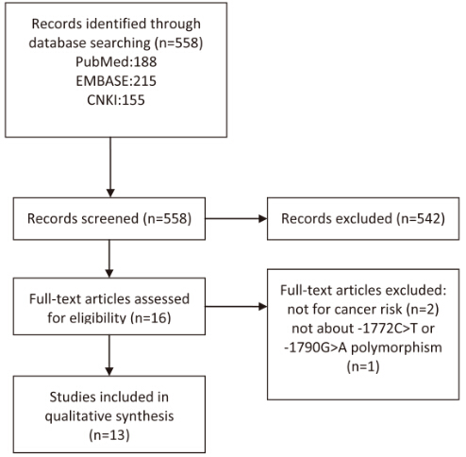

Figure 2 Forest plot of the -1772C>T polymorphism and the risk of digestive tract cancer. Dominant comparison: TT+CT vs CC.
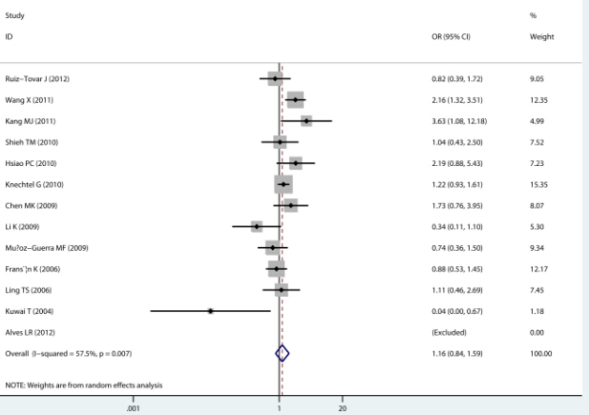

Figure 3 Begg’s funnel plot with pseudo 95% confidence limits.
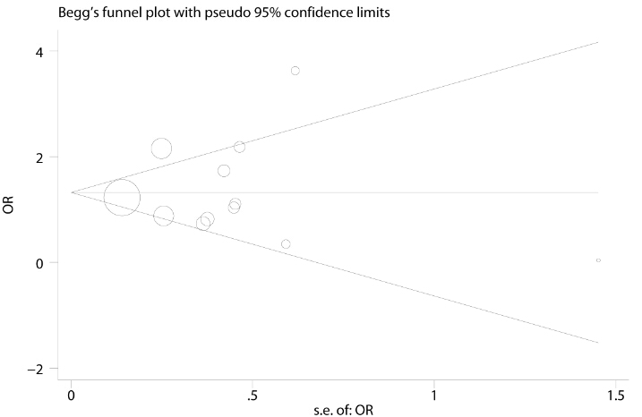

Figure 4 meta-analysis estimates, given named study is omitted (A, B).
A
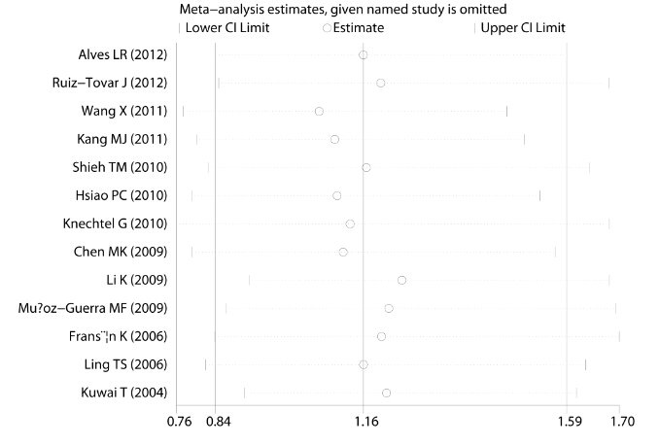
B
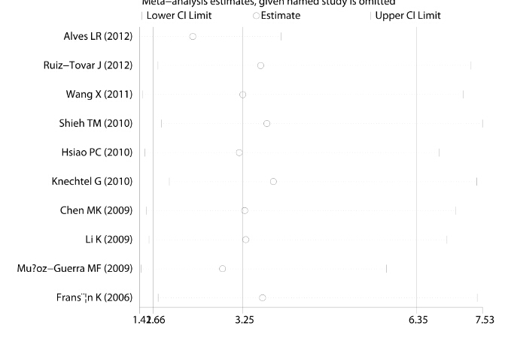

Figure 5 Forest plot of the -1790G>A polymorphism and the risk of digestive tract cancer. Dominant comparison: AA+GA vs GG.

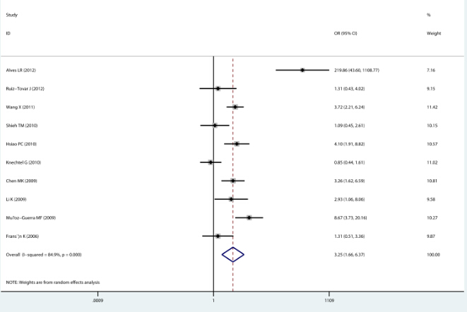

Table 1 Baseline characteristics of eligible studies
Author | Year | Country | Ethnicity | Control | Cancer Type | SNP | Cases | Controls
Alves et al^{[21]} | 2012 | Brazil | Latin America | HB | oral cancer | C1722T,G1790A | 40 | 88
Ruiz-Tovar et al^{[22]} | 2012 | Spain | Caucasian | PB | pancreatic cancer | C1722T,G1790A | 59 | 159
Wang et al^{[7]} | 2011 | China | Asian | HB | pancreatic cancer | C1722T,G1790A | 263 | 271
Kang et al^{[15]} | 2011 | Korea | Asian | HB | colorectal cancer | C1722T | 50 | 50
Shieh et al^{[24]} | 2010 | China | Asian | HB | oral cancer | C1722T,G1790A | 305 | 96
Hsiao et al^{[25]} | 2010 | China | Asian | HB | hepatocellular carcinoma | C1722T,G1790A | 102 | 347
Knechtel et al^{[17]} | 2010 | Austria | Caucasian | HB | colorectal cancer | C1722T,G1790A | 381 | 1209
Chen et al^{[26]} | 2009 | China | Asian | PB | oral cancer | C1722T,G1790A | 347 | 174
Li et al^{[16]} | 2009 | China | Asian | HB | gastric cancer | C1722T,G1790A | 87 | 106
Muñoz-Guerra et al^{[27]} | 2009 | Spain | Caucasian | PB | oral cancer | C1722T,G1790A | 155 | 139
Fransén et al^{[28]} | 2006 | Sweden | Caucasian | HB | colorectal cancer | C1722T,G1790A | 198 | 258
Ling et al^{[29]} | 2006 | China | Asian | PB | esophageal cancer | C1722T | 95 | 104
Kuwai et al^{[30]} | 2004 | Japan | Asian | PB | colorectal cancer | C1722T | 100 | 100

HB: Hospital-based studies; PB: Population-based studies.

Table 2 Meta-analysis results of -1772C>T polymorphism
 | Dominant Comparison |  | Allele Comparison |  | Heterozygote Comparison
 | OR(95% CI) | Phet | OR (95%CI) | Phet | OR (95% CI) | Phet
Overall | 1.156 (0.839-1.593) | 0.007 | 1.325 (0.846-2.076) | < 0.001 | 0.853 (0.502-1.450) | < 0.001
Ethnicity
Caucasian | 1.053 (0.842-1.317) | 0.381 | 1.075 (0.795-1.454) | 0.011 | 0.459 (0.174-1.211) | 0.06
Asian | 1.302 (0.748-2.266) | 0.007 | 1.169(0.667-2.049) | < 0.001 | 1.132 (0.628-2.040) | 0.009
Source of Control
HB | 1.314 (0.884-1.954) | 0.014 | 1.661 (0.755-3.656) | < 0.001 | 1.153 (0.633-2.099) | 0.009
PB | 0.898 (0.498-1.620) | 0.086 | 1.163 (0.698-1.938) | 0.089 | 0.482 (0.166-1.405) | 0.004
Cancer Types
OC | 1.063 (0.643-1.757) | 0.304 | 2.517 (0.705-8.980) | < 0.001 | 0.917 (0.444-1.895) | 0.135
PC | 1.388 (0.542-3.555) | 0.032 | 1.753 (1.225-2.508)¹ | 0.349 | 0.500 (0.018-14.015) | 0.001
CRC | 1.118 (0.573-2.182) | 0.015 | 0.262 (0.011-6.380) | 0.024 | 0.241 (0.011-5.509) | 0.027
HWE
No | 0.777 (0.466-1.296) | 0.832 | 3.221 (0.673-15.414) | < 0.001 | 0.250 (0.051-1.211) | 0.139
Yes | 1.260 (0.873-1.818) | 0.007 | 1.149 (0.723-1.826) | 0.009 | 1.091 (0.660-1.803) | 0.005
Sample size
Small | 0.958 (0.621-1.479) | 0.031 | 1.192 (0.680-2.089) | < 0.001 | 0.658 (0.362-1.197) | 0.007
Large | 1.569 (1.049-2.345) ¹ | 0.125 | 1.983 (1.325-2.969) ¹ | 0.867 | 1.994 (1.307-3.042) ¹ | 0.529
¹Significant association. OR: Odds ratio; Phet: P value of heterogeneity, HB: Hospital-based studies; PB: Population-based studies; OC: Oral cancer, PC: Pancreatic cancer; CRC: Colorectal cancer.

Table 3 Meta-analysis results of -1790G>A polymorphism

 | Dominant Comparison |  | Allele Comparison |  | Heterozygote Comparison
 | OR(95% CI) | Phet | OR(95% CI) | Phet | OR(95% CI) | Phet
Overall | 3.252 (1.661-6.368)¹ | < 0.001 | 4.455 (1.938-10.241)¹ | < 0.001 | 2.677 (1.677-4.273)¹ | < 0.001
Ethnicity
Caucasian | 1.882 (0.627-5.644) | < 0.001 | 2.881 (0.943-8.807) | 0.009 | 1.898 (0.411-8.761) | 0.002
Asian | 2.921 (1.909-4.470)¹ | 0.163 | 2.793 (1.877-4.158)¹ | 0.195 | 2.891 (1.890-4.422)¹ | 0.165
Source of Control
HB | 3.258 (1.331-7.977)¹ | < 0.001 | 4.904 (1.375-17.489)¹ | < 0.001 | 2.521 (1.526-4.167)¹ | 0.094
PB | 3.516 (1.340-9.229)¹ | 0.026 | 3.923 (1.894-8.128)¹ | 0.084 | 2.729 (0.823-9.053)¹ | 0.011
Cancer Types
OC | 7.919 (1.582-39.636)¹ | < 0.001 | 9.663 (1.312-71.149)¹ | < 0.001 | 3.165 (1.264-7.924) ¹ | 0.019
PC | 2.499 (0.929-6.726) | 0.098 | 3.030 (1.946-4.716)¹ | 0.418 | 1.611 (0.241-10.760) | 0.019
CRC | 0.971 (0.571-1.650) | 0.454
Sample Size
Small | 4.127 (1.511-11.267)¹ | < 0.001 | 4.976 (1.457-16.996)¹ | < 0.001 | 2.351 (1.180-4.682)¹ | 0.007
Large | 2.186 (0.863-5.537) | 0.001 | 3.313 (2.214-4.959)¹ | 0.969 | 3.492 (2.298-5.307)¹ | 0.69
¹Significant association. OR: Odds ratio; CI: Confidence intervals; Phet: P value of heterogeneity, HB: Hospital-based studies; PB: Population-based studies, OC: Oral cancer; PC: Pancreatic cancer; CRC: Colorectal cancer.

