Name of Journal: World Journal of Gastrointestinal Oncology
Manuscript NO: 39412
Manuscript Type: META-ANALYSIS

Robotic total meso-rectal excision for rectal cancer: A systematic review following the publication of the ROLARR trial

Jones K et al. Robotics for rectal resection

Katie Jones, Mohamed G Qassem, Parv Sains, Mirza K Baig, Muhammad S Sajid

Katie Jones, Mohamed G Qassem, Parv Sains, Muhammad S Sajid, Department of General and Laparoscopic Colorectal Surgery, Western Sussex Hospitals NHS Foundation Trust, Worthing Hospital, West Sussex BN11 2DH, United Kingdom

Mirza K Baig, Department of General and Laparoscopic Colorectal Surgery, Brighton and Sussex University Hospitals NHS Trust, the Royal Sussex County Hospital, Brighton, West Sussex BN2 5BE, United Kingdom

ORCID number: Katie Jones (0000-0001-8851-4257); Mohamed G Qassem (0000-0003-4775-6334); Parv Sains (0000-0002-9742-0815); Mirza K Baig (0000-0002-5559-0517); Muhammad S Sajid (0000-0002-7131-6366X).

Author contributions: Jones K contributed to literature search, data extraction, manuscript writing and approval; Qassem MG contributed to data extraction, data confirmation, manuscript writing and approval; Sains P contributed to data confirmation, data interpretation, manuscript writing and approval; Baig MK contributed to data interpretation, data confirmation, manuscript writing and approval; Sajid MS contributed to idea conception, literature search, study selection, data analysis, data interpretation, manuscript writing and approval.

Conflict-of-interest statement: None to declare.

PRISMA 2009 Checklist statement: The authors have read the PRISMA 2009 Checklist, and the manuscript was prepared and revised according to the PRISMA 2009 Checklist.

Open-Access: This article is an open-access article which was selected by an in-house editor and fully peer-reviewed by external reviewers. It is distributed in accordance with the Creative Commons Attribution Non Commercial (CC BY-NC 4.0) license, which permits others to distribute, remix, adapt, build upon this work non-commercially, and license their derivative works on different terms, provided the original work is properly cited and the use is non-commercial. See: http://creativecommons.org/licenses/by-nc/4.0/

Manuscript source: Invited manuscript

Correspondence to: Muhammad S Sajid, BM BCh, FCPS, FRCS (Ed), FRCS (Gen Surg), MBBS, MSc, Attending Doctor, Research Fellow, Surgeon, Department of General and Laparoscopic Colorectal Surgery, Western Sussex Hospitals NHS Foundation Trust, Worthing Hospital, Lyndhurst Road, Worthing, West Sussex BN11 2DH, United Kingdom. surgeon1wrh@hotmail.com

Telephone: +44-1273-696955
Fax: +44 -7891-667608

Received: April 16, 2018
Peer-review started: April 17, 2018
First decision: May 17, 2018
Revised: June 25, 2018
Accepted: June 28, 2018
Article in press:
Published online:
Abstract
AIM
To compare outcomes in patients undergoing rectal resection by robotic total meso-rectal excision (RTME) vs laparoscopic total meso-rectal excision (LTME).

METHODS
Standard medical electronic databases such as PubMed, MEDLINE, EMBASE and Scopus were searched to find relevant articles. The data retrieved from all types of included published comparative trials in patients undergoing RTME vs LTME was analysed using the principles of meta-analysis. The operative, post-operative and oncological outcomes were evaluated to assess the effectiveness of both techniques of TME. The summated outcome of continuous variables was expressed as standardized mean difference (SMD) and dichotomous data was presented in odds ratio (OR).

RESULTS
One RCT (ROLARR trial) and 27 other comparative studies reporting the non-oncological and oncological outcomes following RTME vs LTME were included in this review. In the random effects model analysis using the statistical software Review Manager 5.3, the RTME was associated with longer operation time (SMD, 0.46; 95%CI: 0.25, 0.67; z = 4.33; P = 0.0001), early passage of first flatus (P = 0.002), lower risk of conversion (P = 0.00001) and shorter hospitalization (P = 0.01). The statistical equivalence was seen between RTME and LTME for non-oncological variables like blood loss, morbidity, mortality and re-operation risk. The oncological variables such as recurrence (P = 0.96), number of harvested nodes (P = 0.49) and positive circumferential resection margin risk (P = 0.53) were also comparable in both groups. The length of distal resection margins was similar in both groups.

CONCLUSION
RTME is feasible and oncologically safe but failed to demonstrate any superiority over LTME for many surgical outcomes except early passage of flatus, lower risk of conversion and shorter hospitalization.

Key words: Single incision laparoscopic surgery; Multi-incision laparoscopic surgery; Colorectal cancer; Diverticular disease; Colorectal resections

© The Author(s) 2018. Published by Baishideng Publishing Group Inc. All rights reserved.

Core tip: The findings of this meta-analysis of one RCT and 27 case control studies on 5547 patients are consistent with the recently published ROLARR trial validating the feasibility and oncological safety of robotic total meso-rectal excision (RTME). However, RTME failed to demonstrate any superiority over laparoscopic total meso-rectal excision except reduced conversion rate.

Jones K, Qassem MG, Sains P, Baig MK, Sajid MS. Robotic total meso-rectal excision for rectal cancer: A systematic review following the publication of the ROLARR trial. World J Gastrointest Oncol 2018; In press

INTRODUCTION
Colorectal cancer has higher prevalence rate in the developed world and almost one third of cancers are diagnosed in the rectum^{[1-4]}. Total mesorectal excision (TME) performed either by open or laparoscopic technique is an accepted gold standard treatment of rectal cancer worldwide. Laparoscopic TME (LTME) has apparent advantages and considered a preferred mode of surgery due to less tissue trauma^{[5-11]}. Due to precision in dissection, stable base unit and better visualization in difficult areas like lower pelvis, the robotic TME (RTME) is also considered a possible alternative to LTME^{[12,13]}. RTME may potentially offer same advantages which LTME offers as reported in some studies. There have been several previous systematic reviews^{[14-21]} on LTME vs RTME; however, none since the ROLARR trial, a multi-centre randomised controlled trial comparing RTME to LTME, has published its results. In addition, several new comparative studies have also been reported which require combined statistical evaluation to generate up to date and better evidence.
Our study is an up to date meta-analysis of studies comparing RTME vs LTME including recently published ROLARR trial to be able to distinguish the potential advantages or disadvantages that robotics may play in the treatment of rectal cancer.

MATERIALS AND METHODS
Study suitability standards
Following are features of individual publications needed to qualify for inclusion in this systematic review as depicted in the following PICOS style: (1) Participants: Adult patients with histologically proven and MDT recommended resectable rectal cancer; (2) Intervention (Exposure): RTME; (3) Control: Patients with rectal cancer undergoing TME or rectal resection by laparoscopic approach; (4) Outcomes: Length of stay, operation time, blood loss, post-operative complications, mortality, positive circumferential resection margins, length of distal resection margins, lymph node harvesting, surgical site infections, time till first flatus, conversion rate, tumour recurrence and re-operation rate; (5) Study design: No restrictions were placed in study design. However, published studies should have reported comparison between two arms, those are RTME vs LTME. No studies were excluded based on the year of publication, publication centre, age or gender of the participants or publication language.

Electronic resources for studies selection
Four databases: PubMed, Ovid EMBASE, SCOPUS, and Cochrane Library were searched to find target studies. Four trial registries: ClinicalTrials.gov, European Clinical Trials Register, ISRCTN Register, and the International Clinical Trials Registry were examined. The literature exploration was performed until March 2018.

Search terms
For PubMed, the search was run by means of using MeSH words and by utilizing advanced search choice. The MeSH words “rectal cancer”, AND (“laparoscopic resection OR minimal invasive surgery resection OR robotic surgery resection OR total meso-rectal excision”) were used. Furthermore, an advanced study exploration was done using the terms “rectal resection”. Ovid, EMBASE and SCOPUS were searched with the same search terms as the PubMed advanced search. The Cochrane Library was searched using the term “rectal cancer”. Trial registries were all examined using the word “rectal cancer”.

Study selection
Two authors evaluated and studied initially titles and then abstracts, adding any curtained references into the Excel spreadsheet. The duplicate articles were excluded. Based upon the information given in the published abstracts, the initial decision of study inclusion or exclusion was made. The published article of the potentially includable studies was then evaluated. The conflicts about data, its accuracy and variability among extracting authors was sorted by agreement or by intercession of an experienced supervising consultant surgeon with had vast clinical and publication experience.

Data collection process
Data was independently collected by two reviewers into the electronic data collection forms of the Microsoft Excel spread sheet. The data items were agreed by the authors prior to commencing study selection. The data pertaining to the analysable outcomes was extracted in addition to the study citation, ethics committee approval, study registration and study quality indicators for all types of comparative studies. Once each author had completed data extraction, the data files were electronically compared and discrepancies in data entry were investigated and resolved.

Statistical analysis
The comparative efficacy of robotic surgery and conventional laparoscopic surgery for rectal resection was directly matched and pooled for each outcome of interest if there were at least two studies for each comparison. The odds ratio (OR) was estimated and pooled across studies using a random-effect model. Heterogeneity was assessed using Cochrane Q test and I² statistic. The statistical analysis of the data was conducted according to the guidelines provided by the Cochrane Collaboration including the use of RevMan 5.3® statistical software, and the use of forest plots for the graphical display of the combined outcomes^{[22-28]}.

RESULTS
Characteristics of selected studies
A total of 294 studies were identified from Scopus and MEDLINE and other standard medical electronic databases. Among them, 1 RCT and 27 non-randomized comparative (both retrospective and prospective case control) studies^{[29-56]} published until March 2018, were eligible for inclusion. The inclusion and exclusion pathway is described in PRISMA flow chart Figure 1.

Operative outcomes
All studies evaluated and reported the outcome of duration of operation. The duration of operation was longer (SMD, 0.20; 95%CI: -0.11, 0.52; z = 1.28; P = 0.20; Figure 2) in robotic surgery group, but with the clinical advantage of the reduced rate of conversion (OR, 0.40; 95%CI: 0.29, 0.55; z = 5.51; P = 0.00001; Figure 3) to open surgery. The reduced risk of conversion to laparotomy following RTME seems to be significantly advantageous in terms of the intensity of surgical trauma posed by laparotomy. There was similar risk of blood loss (SMD, 0.09; 95%CI: -0.14, 0.33; z = 0.76; P = 0.45; Figure 4) following both approaches of TME. Clinical and methodological heterogeneity [Tau² = 0.31, χ² = 367.50, df = 26, (P < 0.00001); I² = 93%] was noted in trials which was the basis for the random effects model analysis leading to the above outcomes.

Post-operative outcomes
The in-hospital stay (SMD, -0.15; 95%CI: -0.27, -0.03; z = 2.46; P = 0.01; Figure 5) and time to first flatus (SMD, -0.48; 95%CI: -0.79, -0.18; z = 3.09; P = 0.002; Figure 6) in patients undergoing RTME were shorter compared to LTME group. However, the post-operative morbidity (OR, 0.92; 95%CI: 0.75, 01.12; z = 0.83; P = 0.40; Figure 7), post-operative mortality (OR, 0.67; 95%CI: 0.28, 1.62; z = 0.89; P = 0.38; Figure 8) and re-operation rate (OR, 0.76; 95%CI: 0.50, 1.16; z = 1.29; P = 0.20; Figure 9) were statistically similar in both groups.

Oncological outcomes
Oncological safety is one of the most important surgical outcomes for any new surgical intervention because positive circumferential resection margins are directly associated with overall survival and disease free survival in rectal cancer patients. The risk of positive circumferential resection margins (OR, 0.91; 95%CI: 0.68, 1.22; z = 0.62; P = 0.53; Figure 10), length of distal resection margins (SMD, 0.00; 95%CI: -0.11, 0.11; z = 0.04; P = 0.97; Figure 11), and lymph node yield (SMD, 0.04; 95%CI: -0.07, 0.14; z = 0.69; P = 0.49; Figure 12) were statistically similar in both groups. Therefore, the risk of local and distant recurrence (OR, 1.10; 95%CI: 0.87, 1.39; z = 0.79; P = 0.43; Figure 13) was also found to be similar in both groups.

DISCUSSION
Colorectal cancer is the third most common cancer diagnosis internationally. The highest incidence of colorectal cancer is reported the Europe, North America and Australia^{[1]}. The highest incidence of colorectal cancer is in the anatomical area of rectum. In 2015 in the United Kingdom out of 41599 people diagnosed with colorectal cancer, 27% of these were located in the rectum. The incidence is slightly higher in men making up 32% of all colorectal cancer diagnoses compared to 23% for women^{[2]}. With the introduction of the total meso-rectal excision (TME), developed in 1989 by Professor Heald, survival rates and the rates of local recurrence have significantly improved^{[3,4]}. A TME is defined as an en bloc resection of the rectal tumour with endo-pelvic fascia to excise circumferential margins^{[5]}. The decision to undertake a TME is influenced by several factors including distance of the cancer from the anal verge, degree of invasion into the pelvic walls, presence of metastases to regional lymph nodes, the patient’s co-morbidities and the ability to withstand trans-abdominal surgery^{[6]}. LTME has risen to become the gold standard for rectal cancer suitable for surgical resection^{[7]}. Many trials including the COLOR II trial established that it gave similar oncological outcomes compared to an open approach^{[8,9]} and further studies showed it resulted in shorter length of stay, less pain and quicker resumption of normal diet^{[10,11]}. The main reason behind these proven advantages of the laparoscopic TME is the reduced surgical trauma and tissue handling compared to open TME. As the use of robotics in surgery becomes more commonplace in gynaecological and urological procedures, the question arises on whether it has a place in colorectal surgery. Specifically, a TME demands precise dissection in an area that is difficult to visualise and access. These difficult aspects of a TME could be improved upon by robotics which offers a direct angle entry view, a stable retraction platform and more movement of instrument freedom^{[12,13]}. Some studies have shown that robotic TME (RTME) results in shorter length of stay, whilst other studies have shown that there is no difference in hospital stay, oncological outcomes or rates of converting procedures to open. There is an argument that in terms of cost, the use of robotics is more expensive than laparoscopic instruments and the learning curve for surgeons is longer and requires more cases than for a LTME.
Based upon the findings of this largest ever series on the role of robotic surgery in rectal cancer resection, the RTME is certainly a feasible technique and oncologically safe surgical intervention but failed to demonstrate any superiority over LTME for many surgical outcomes. Mere advantage of robotic surgery was noted in only three post-operative outcomes, that is early passage of flatus, lower risk of conversion and shorter hospitalization. It seems like these advantages may not truly reflect into the routine use of RTME in rectal cancer surgery and therefore, the examination of current 28 studies to date did not designate a major value of RTME over LTME. Demonstration of this conclusion has already been reported in previously published meta-analyses^{[14-21,57]}.
These findings needs further evaluation on the background of recently published ROLARR^{[42]} trial. Among operative outcomes, current study indicates similar blood loss and longer duration of operation and these both outcomes are concordant with the findings of ROLARR^{[42]} trial. The risk of conversion to open surgery was found to be lower in RTME arm of current study. Similarly the risk of conversion was lower in RTME group (8.1%) compared to LTME group (12.2%) in the ROLARR^{[42]} trial but statistically it failed to demonstrate any significance. The length of hospital stay was similar between both groups in the ROLARR^{[42]} trial but current study shows significant reduction in the hospitalization time in patients undergoing RTME. Post-operative mortality, morbidity and re-operation rate were consistently similar in all included studies, current study and in the ROLARR^{[42]} trial. The oncological outcomes such as positive circumferential resection margins, length of distal resection margins, lymph node yield and recurrence rate were also not different. The publication of the ROLARR^{[42]} trials has answered several questions about the feasibility, safety and comparative equivalence of RTME and non-inferiority of LTME too. In addition, RTME seems to be relatively expensive^{[29,42,58,59]} and less cost-effective procedure and therefore routine use of this approach may not be justified for TME.
Authors frankly accept the major limitations of this study and the most apparent is the combined analysis of an RCT^{[42]} and 27 case control studies. Despite this limitation, the outcomes are almost matching with the conclusions of the only RCT^{[42]} published on this subject. Other confounding factors which can potentially be influencing the final outcome are diverse inclusion and exclusion criteria among included studies; variable post-operative follow up duration; lack of an agreed follow up screening pathways; presence and absence of the use of neoadjuvant chemoradiotherapy in the recruited population; use of variable diagnostic pathways in included studies and variable experience of the operating surgeons especially in the RTME group. More RCTs are needed to consolidate the findings of ROLARR trial^{[42]} and current study. Better outcomes and reduced cost may be anticipated in future trials due to the use of cost effective advanced technology and operating surgeons with extensive experience in robotic surgery. Until then the ROLARR trial and current study may provide the best possible evidence in this relatively innovative intervention for rectal cancer management.

ARTICLE HIGHLIGHTS
Research background
Robotic total meso-rectal excision (TME) is used at least for a decade to treat rectal cancer and the only evidence in favour of robotic TME was based on case control studies. Recently first ever RCT evaluating feasibility of robotic TME was published as ROLARR trial. This aims of this study was to strengthen the existing evidence on this technique which is mainly based upon the meta-analysis of case control studies and compare it with the results of ROLARR trial.

Research motivation
Although robotic TME is being presented a way forward for rectal resection but its superiority over laparoscopic TME is not proven yet. Most of the evidence was based upon the systematic review of case-controlled studies, the publication of ROLARR trial is an attempt to answer this question. Comparison between the findings of ROLARR trial and systematic review of case-controlled trials can guide the surgeons in future about role of robotic TME.

Research objectives
The objective of this systematic review is to strengthen the existing evidence on the role of robotics for TME technique which is mainly based upon the meta-analysis of case control studies and compare it with the results of recently published ROLARR trial reporting robotic TME vs laparoscopic TME.

Research methods
Standard medical databases were searched. RCTs and all types of comparative studies reporting the effectiveness of robotic TME vs laparoscopic TME in the management of rectal cancer were retrieved and their data was extracted. The extracted data was analyzed using the principles of meta-analysis to generate higher level of evidence. RevMan 5.3 was used for statistical analysis and GradePro was used to generate summary of evidence.

Research results
One RCT (ROLARR trial) and 27 other comparative studies reporting the non-oncological and oncological outcomes following robotic TME vs laparoscopic TME were included in this review. In the random effects model analysis using the statistical software Review Manager 5.3, the RTME was associated with longer operation time (SMD, 0.46; 95%CI: 0.25, 0.67; z = 4.33; P = 0.0001), early passage of first flatus (P = 0.002), lower risk of conversion (P = 0.00001) and shorter hospitalization (P = 0.01). The statistical equivalence was seen between robotic TME and laparoscopic TME for non-oncological variables like blood loss, morbidity, mortality and re-operation risk. The oncological variables such as recurrence (P = 0.96), number of harvested nodes (P = 0.49) and positive circumferential resection margin risk (P = 0.53) were also comparable in both groups. The length of distal resection margins was similar in both groups.

Research conclusions
Robotic TME is feasible and oncologically safe but failed to demonstrate any superiority over laparoscopic TME for many surgical outcomes except early passage of flatus, lower risk of conversion, lower conversion to laparotomy rate and shorter hospitalization.

Research perspectives
Robotic TME failed to demonstrate superiority over laparoscopic TME. Laparoscopic TME may continuously be used to treat rectal cancer. More RCTs are needed to consolidate the findings of ROLARR trial ^{[42]} and current study. Better outcomes and reduced cost may be anticipated in future trials due to the use of cost effective advanced technology and operating surgeons with extensive experience in robotic surgery. Until then the ROLARR trial and current study may provide the best possible evidence in this relatively innovative intervention for rectal cancer management.

REFERENCES
1 American Cancer Society. Key Statistics for Colorectal Cancer. Accessed on 2018 Aug 3. Available from: URL: https://www.cancer.org/cancer/colon-rectal-cancer/about/key-statistics.html
2 Cancer Research UK. Cancer incidence statistics. Available from: URL: http://www.cancerresearchuk.org/health-professional/cancer-statistics/incidence
3 Heald RJ, Ryall RD. Recurrence and survival after total mesorectal excision for rectal cancer. Lancet 1986; 1: 1479-1482 [PMID: 2425199 DOI: 10.1016/S0140-6736(86)91510-2]
4 Maurer CA, Renzulli P, Kull C, Käser SA, Mazzucchelli L, Ulrich A, Büchler MW. The impact of the introduction of total mesorectal excision on local recurrence rate and survival in rectal cancer: long-term results. Ann Surg Oncol 2011; 18: 1899-1906 [PMID: 21298350 DOI: 10.1245/s10434-011-1571-0]
5 Rodríguez-Luna MR, Guarneros-Zárate JE, Tueme-Izaguirre J. Total Mesorectal Excision, an erroneous anatomical term for the gold standard in rectal cancer treatment. Int J Surg 2015; 23: 97-100 [PMID: 26409653 DOI: 10.1016/j.ijsu.2015.09.047]
6 Monson JR, Weiser MR, Buie WD, Chang GJ, Rafferty JF, Buie WD, Rafferty J; Standards Practice Task Force of the American Society of Colon and Rectal Surgeons. Practice parameters for the management of rectal cancer (revised). Dis Colon Rectum 2013; 56: 535-550 [PMID: 23575392 DOI: 10.1097/DCR.0b013e31828cb66c]
7 Moran B, Karandikar S, Geh I. Association of Coloproctology of Great Britain &amp; Ireland (ACPGBI): Guidelines for the Management of Cancer of the Colon, Rectum and Anus (2017) - Introduction. Colorectal Dis 2017; 19 Suppl 1: 6-8 [PMID: 28632314 DOI: 10.1111/codi.13702]
8 Bonjer HJ, Deijen CL, Abis GA, Cuesta MA, van der Pas MH, de Lange-de Klerk ES, Lacy AM, Bemelman WA, Andersson J, Angenete E, Rosenberg J, Fuerst A, Haglind E; COLOR II Study Group. A randomized trial of laparoscopic versus open surgery for rectal cancer. N Engl J Med 2015; 372: 1324-1332 [PMID: 25830422 DOI: 10.1056/NEJMoa1414882]
9 Green BL, Marshall HC, Collinson F, Quirke P, Guillou P, Jayne DG, Brown JM. Long-term follow-up of the Medical Research Council CLASICC trial of conventional versus laparoscopically assisted resection in colorectal cancer. Br J Surg 2013; 100: 75-82 [PMID: 23132548 DOI: 10.1002/bjs.8945]
10 Kennedy RH, Francis EA, Wharton R, Blazeby JM, Quirke P, West NP, Dutton SJ. Multicenter randomized controlled trial of conventional versus laparoscopic surgery for colorectal cancer within an enhanced recovery programme: EnROL. J Clin Oncol 2014; 32: 1804-1811 [PMID: 24799480 DOI: 10.1200/JCO.2013.54.3694]
11 Chen W, Li Q, Qiu P, Jiang L, Fu Z, Fan Y, Li D, Liu P, Tang L. Comparison of perioperative outcomes between laparoscopic and open surgery for mid-low rectal cancer with total mesorectal excision following neoadjuvant chemoradiotherapy. J Cancer Res Ther 2016; 12: C199-C204 [PMID: 28230017 DOI: 10.4103/0973-1482.200600]
12 Mohd Azman ZA, Kim SH. A review on robotic surgery in rectal cancer. Transl Gastroenterol Hepatol 2016; 1: 5 [PMID: 28138573 DOI: 10.21037/tgh.2016.03.16]
13 Weaver KL, Grimm LM Jr, Fleshman JW. Changing the Way We Manage Rectal Cancer-Standardizing TME from Open to Robotic (Including Laparoscopic). Clin Colon Rectal Surg 2015; 28: 28-37 [PMID: 25733971 DOI: 10.1055/s-0035-1545067]
14 Cheong C, Kim NK. Minimally Invasive Surgery for Rectal Cancer: Current Status and Future Perspectives. Indian J Surg Oncol 2017; 8: 591-599 [PMID: 29203993 DOI: 10.1007/s13193-017-0624-7]
15 Trastulli S, Cirocchi R, Listorti C, Cavaliere D, Avenia N, Gullà N, Giustozzi G, Sciannameo F, Noya G, Boselli C. Laparoscopic vs open resection for rectal cancer: a meta-analysis of randomized clinical trials. Colorectal Dis 2012; 14: e277-e296 [PMID: 22330061 DOI: 10.1111/j.1463-1318.2012.02985.x]
16 Hu L, Yao L, Li X, Jin P, Yang K, Guo T. Effectiveness and safety of robotic-assisted versus laparoscopic hepatectomy for liver neoplasms: A meta-analysis of retrospective studies. Asian J Surg 2017 [PMID: 28912048 DOI: 10.1016/j.asjsur.2017.07.001]
17 Li X, Wang T, Yao L, Hu L, Jin P, Guo T, Yang K. The safety and effectiveness of robot-assisted versus laparoscopic TME in patients with rectal cancer: A meta-analysis and systematic review. Medicine (Baltimore) 2017; 96: e7585 [PMID: 28723798 DOI: 10.1097/MD.0000000000007585]
18 Xiong B, Ma L, Huang W, Zhao Q, Cheng Y, Liu J. Robotic versus laparoscopic total mesorectal excision for rectal cancer: a meta-analysis of eight studies. J Gastrointest Surg 2015; 19: 516-526 [PMID: 25394387 DOI: 10.1007/s11605-014-2697-8]
19 Wang Y, Zhao GH, Yang H, Lin J. A Pooled Analysis of Robotic Versus Laparoscopic Surgery for Total Mesorectal Excision for Rectal Cancer. Surg Laparosc Endosc Percutan Tech 2016; 26: 259-264 [PMID: 27213786 DOI: 10.1097/SLE.0000000000000263]
20 Ortiz-Oshiro E, Sánchez-Egido I, Moreno-Sierra J, Pérez CF, Díaz JS, Fernández-Represa JÁ. Robotic assistance may reduce conversion to open in rectal carcinoma laparoscopic surgery: systematic review and meta-analysis. Int J Med Robot 2012; 8: 360-370 [PMID: 22438060 DOI: 10.1002/rcs.1426]
21 Broholm M, Pommergaard HC, Gögenür I. Possible benefits of robot-assisted rectal cancer surgery regarding urological and sexual dysfunction: a systematic review and meta-analysis. Colorectal Dis 2015; 17: 375-381 [PMID: 25515638 DOI: 10.1111/codi.12872]
22 Higgins JPT, Green S (eds). Cochrane Handbook for Systematic Reviews of Interventions. Available from: URL: http://www.cochrane-handbook.org
23 Review Manager (RevMan) [Computer program]. Version 5.0. The Nordic Cochrane Centre, The Cochrane Collaboration: Copenhagen, 2008
24 DerSimonian R, Laird N. Meta-analysis in clinical trials. Control Clin Trials 1986; 7: 177-188 [PMID: 3802833 DOI: 10.1016/0197-2456(86)90046-2]
25 Demets DL. Methods for combining randomized clinical trials: strengths and limitations. Stat Med 1987; 6: 341-350 [PMID: 3616287 DOI: 10.1002/sim.4780060325]
26 Higgins JP, Thompson SG. Quantifying heterogeneity in a meta-analysis. Stat Med 2002; 21: 1539-1558 [PMID: 12111919 DOI: 10.1002/sim.1186]
27 Egger M, Smith GD, Altman DG, editors. Systematic reviews in healthcare. BMJ Publishing, London, 2006
28 Deeks JJ, Altman DG, Bradburn MJ. Statistical methods for examining heterogeneity and combining results from several studies in meta-analysis. Systemic reviews in health care: meta-analysis in context. 2nd edn. BMJ Publication group. Editor(s): In: Egger M, Smith GD, Altman DG, editors. London, 2001: 285-312 [DOI: 10.1002/9780470693926.ch15]
29 Allemann P, Duvoisin C, Di Mare L, Hübner M, Demartines N, Hahnloser D. Robotic-Assisted Surgery Improves the Quality of Total Mesorectal Excision for Rectal Cancer Compared to Laparoscopy: Results of a Case-Controlled Analysis. World J Surg 2016; 40: 1010-1016 [PMID: 26552907 DOI: 10.1007/s00268-015-3303-2]
30 Baek SJ, Kim SH, Cho JS, Shin JW, Kim J. Robotic versus conventional laparoscopic surgery for rectal cancer: a cost analysis from a single institute in Korea. World J Surg 2012; 36: 2722-2729 [PMID: 22855217 DOI: 10.1007/s00268-012-1728-4]
31 Baek JH, Pastor C, Pigazzi A. Robotic and laparoscopic total mesorectal excision for rectal cancer: a case-matched study. Surg Endosc 2011; 25: 521-525 [PMID: 20607559 DOI: 10.1007/s00464-010-1204-x]
32 Barnajian M, Pettet D 3rd, Kazi E, Foppa C, Bergamaschi R. Quality of total mesorectal excision and depth of circumferential resection margin in rectal cancer: a matched comparison of the first 20 robotic cases. Colorectal Dis 2014; 16: 603-609 [PMID: 24750995 DOI: 10.1111/codi.12634]
33 Bianchi PP, Ceriani C, Locatelli A, Spinoglio G, Zampino MG, Sonzogni A, Crosta C, Andreoni B. Robotic versus laparoscopic total mesorectal excision for rectal cancer: a comparative analysis of oncological safety and short-term outcomes. Surg Endosc 2010; 24: 2888-2894 [PMID: 20526623 DOI: 10.1007/s00464-010-1134-7]
34 Cho MS, Baek SJ, Hur H, Min BS, Baik SH, Lee KY, Kim NK. Short and long-term outcomes of robotic versus laparoscopic total mesorectal excision for rectal cancer: a case-matched retrospective study. Medicine (Baltimore) 2015; 94: e522 [PMID: 25789947 DOI: 10.1097/MD.0000000000000522]
35 Colombo PE, Bertrand MM, Alline M, Boulay E, Mourregot A, Carrère S, Quénet F, Jarlier M, Rouanet P. Robotic Versus Laparoscopic Total Mesorectal Excision (TME) for Sphincter-Saving Surgery: Is There Any Difference in the Transanal TME Rectal Approach? : A Single-Center Series of 120 Consecutive Patients. Ann Surg Oncol 2016; 23: 1594-1600 [PMID: 26714950 DOI: 10.1245/s10434-015-5048-4]
36 D'Annibale A, Pernazza G, Monsellato I, Pende V, Lucandri G, Mazzocchi P, Alfano G. Total mesorectal excision: a comparison of oncological and functional outcomes between robotic and laparoscopic surgery for rectal cancer. Surg Endosc 2013; 27: 1887-1895 [PMID: 23292566 DOI: 10.1007/s00464-012-2731-4]
37 de Jesus JP, Valadão M, de Castro Araujo RO, Cesar D, Linhares E, Iglesias AC. The circumferential resection margins status: A comparison of robotic, laparoscopic and open total mesorectal excision for mid and low rectal cancer. Eur J Surg Oncol 2016; 42: 808-812 [PMID: 27038996 DOI: 10.1016/j.ejso.2016.03.002]
38 Feroci F, Vannucchi A, Bianchi PP, Cantafio S, Garzi A, Formisano G, Scatizzi M. Total mesorectal excision for mid and low rectal cancer: Laparoscopic vs robotic surgery. World J Gastroenterol 2016; 22: 3602-3610 [PMID: 27053852 DOI: 10.3748/wjg.v22.i13.3602]
39 Law WL, Foo DCC. Comparison of short-term and oncologic outcomes of robotic and laparoscopic resection for mid- and distal rectal cancer. Surg Endosc 2017; 31: 2798-2807 [PMID: 27785627 DOI: 10.1007/s00464-016-5289-8]
40 Gorgun E, Ozben V, Costedio M, Stocchi L, Kalady M, Remzi F. Robotic versus conventional laparoscopic rectal cancer surgery in obese patients. Colorectal Dis 2016; 18: 1063-1071 [PMID: 27154266 DOI: 10.1111/codi.13374]
41 Ielpo B, Duran H, Diaz E, Fabra I, Caruso R, Malavé L, Ferri V, Nuñez J, Ruiz-Ocaña A, Jorge E, Lazzaro S, Kalivaci D, Quijano Y, Vicente E. Robotic versus laparoscopic surgery for rectal cancer: a comparative study of clinical outcomes and costs. Int J Colorectal Dis 2017; 32: 1423-1429 [PMID: 28791457 DOI: 10.1007/s00384-017-2876-7]
42 Jayne D, Pigazzi A, Marshall H, Croft J, Corrigan N, Copeland J, Quirke P, West N, Rautio T, Thomassen N, Tilney H, Gudgeon M, Bianchi PP, Edlin R, Hulme C, Brown J. Effect of Robotic-Assisted vs Conventional Laparoscopic Surgery on Risk of Conversion to Open Laparotomy Among Patients Undergoing Resection for Rectal Cancer: The ROLARR Randomized Clinical Trial. JAMA 2017; 318: 1569-1580 [PMID: 29067426 DOI: 10.1001/jama.2017.7219]
43 Kang J, Yoon KJ, Min BS, Hur H, Baik SH, Kim NK, Lee KY. The impact of robotic surgery for mid and low rectal cancer: a case-matched analysis of a 3-arm comparison--open, laparoscopic, and robotic surgery. Ann Surg 2013; 257: 95-101 [PMID: 23059496 DOI: 10.1097/SLA.0b013e3182686bbd]
44 Ramji KM, Cleghorn MC, Josse JM, MacNeill A, O'Brien C, Urbach D, Quereshy FA. Comparison of clinical and economic outcomes between robotic, laparoscopic, and open rectal cancer surgery: early experience at a tertiary care center. Surg Endosc 2016; 30: 1337-1343 [PMID: 26173546 DOI: 10.1007/s00464-015-4390-8]
45 Kim YS, Kim MJ, Park SC, Sohn DK, Kim DY, Chang HJ, Nam BH, Oh JH. Robotic Versus Laparoscopic Surgery for Rectal Cancer after Preoperative Chemoradiotherapy: Case-Matched Study of Short-Term Outcomes. Cancer Res Treat 2016; 48: 225-231 [PMID: 25779367 DOI: 10.4143/crt.2014.365]
46 Kim JC, Yu CS, Lim SB, Park IJ, Kim CW, Yoon YS. Comparative analysis focusing on surgical and early oncological outcomes of open, laparoscopy-assisted, and robot-assisted approaches in rectal cancer patients. Int J Colorectal Dis 2016; 31: 1179-1187 [PMID: 27080161 DOI: 10.1007/s00384-016-2586-6]
47 Kwak JM, Kim SH, Kim J, Son DN, Baek SJ, Cho JS. Robotic vs laparoscopic resection of rectal cancer: short-term outcomes of a case-control study. Dis Colon Rectum 2011; 54: 151-156 [PMID: 21228661 DOI: 10.1007/DCR.0b013e3181fec4fd]
48 Park JS, Choi GS, Lim KH, Jang YS, Jun SH. S052: a comparison of robot-assisted, laparoscopic, and open surgery in the treatment of rectal cancer. Surg Endosc 2011; 25: 240-248 [PMID: 20552367 DOI: 10.1007/s00464-010-1166-z]

P-Reviewer: Freha NA, Mastoraki A S-Editor: Ji FF L-Editor: E-Editor:

Specialty type: Oncology
Country of origin: United Kingdom
Peer-review report classification
Grade A (Excellent): 0
Grade B (Very good): B
Grade C (Good): C
Grade D (Fair): 0
Grade E (Poor): 0

Records screened
(n = 42)
Records after duplicates removed
(n = 170)

Included

Eligibility

Identification

Screening
Studies included in quantitative synthesis (meta-analysis)
(n = 28 studies on 5547 patients)
Full-text articles excluded, with reasons
(n = 14)
Causes:
Other reviews 5
Other technique reviews = 9
Full-text articles assessed for eligibility
(n = 28)
Studies included in qualitative synthesis
(n = 28)
Records excluded
(n = 128)
Causes: Irrelevant

Records identified through database searching
(n = 270)
Additional records identified through other sources
(n = 24)

Figure 1 PRISMA flow diagram.

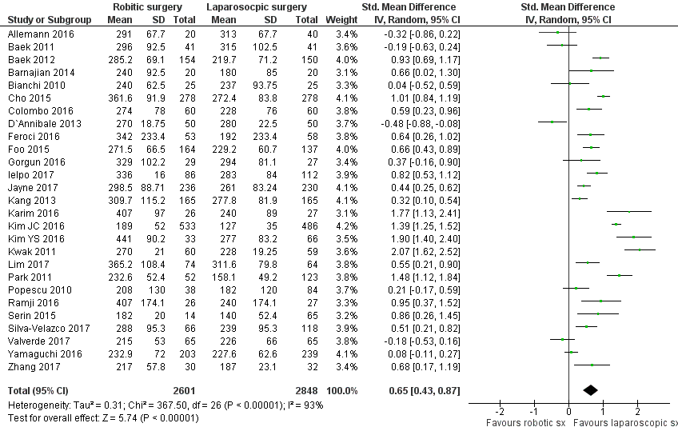

Figure 2 Forest plot for duration of operation following rectal resection by robotic surgery vs conventional laparoscopic surgery. Standardized mean difference is shown with 95%CIs.

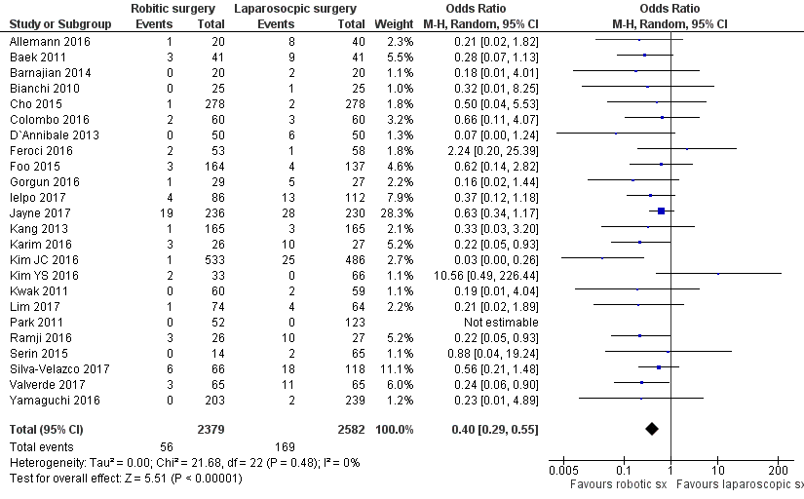

Figure 3 Forest plot for conversion following rectal resection by robotic surgery vs conventional laparoscopic surgery. Odds ratio is shown with 95%CIs.

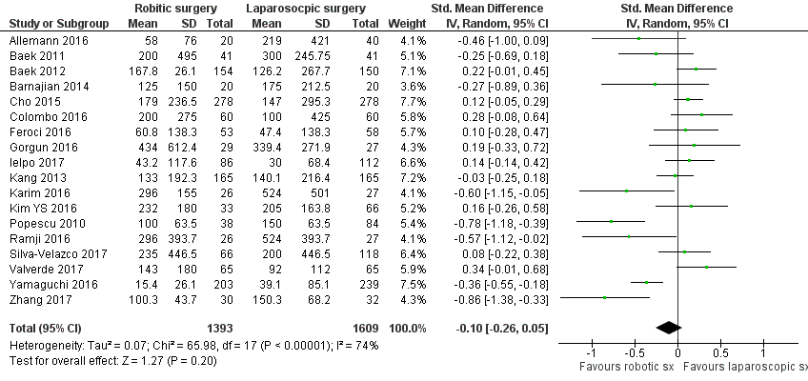

Figure 4 Forest plot for blood loss following rectal resection by robotic surgery vs conventional laparoscopic surgery. Standardized mean difference is shown with 95%CIs.

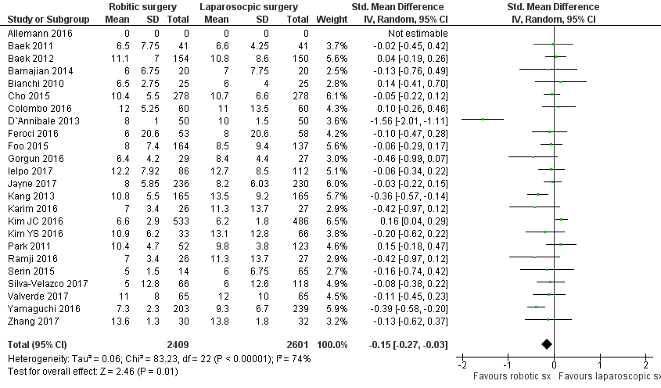
Figure 5 Forest plot for duration of hospital stay following rectal resection by robotic surgery vs conventional laparoscopic surgery. Standardized mean difference is shown with 95%CIs.

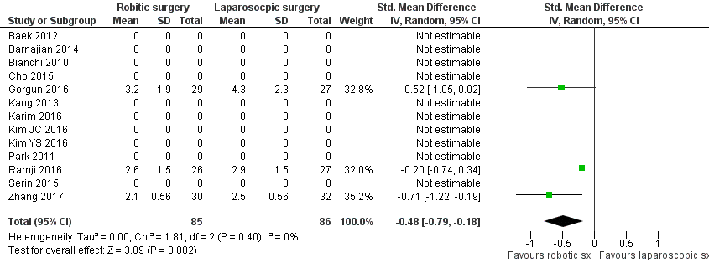

Figure 6 Forest plot for time to first flatus following rectal resection by robotic surgery vs conventional laparoscopic surgery. Standardized mean difference is shown with 95%CIs.

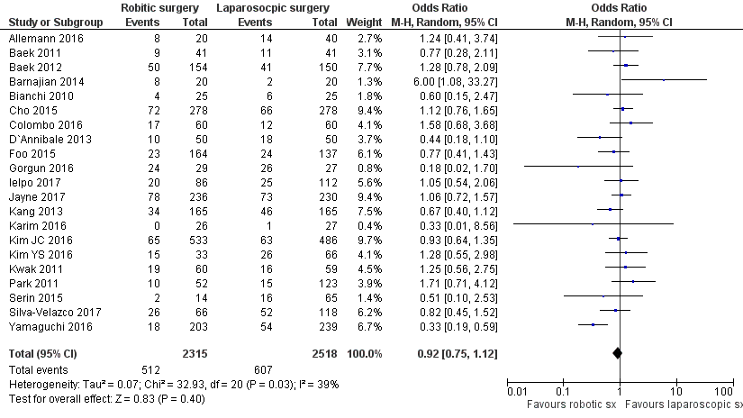

Figure 7 Forest plot for post-operative complications following rectal resection by robotic surgery vs conventional laparoscopic surgery. Odds ratio is shown with 95%CIs.

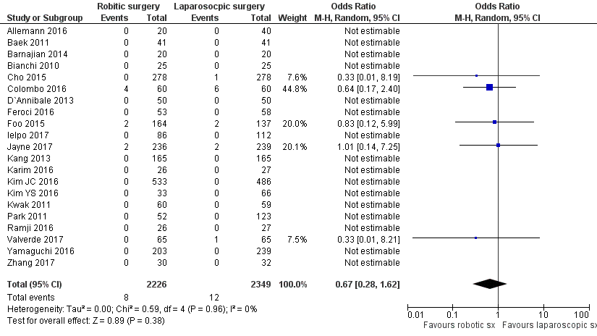

Figure 8 Forest plot for post-operative mortality following rectal resection by robotic surgery vs conventional laparoscopic surgery. Odds ratio is shown with 95%CIs.

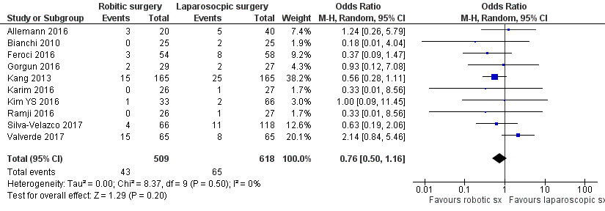
Figure 9 Forest plot for re-operation rate following rectal resection by robotic surgery vs conventional laparoscopic surgery. Odds ratio is shown with 95%CIs.

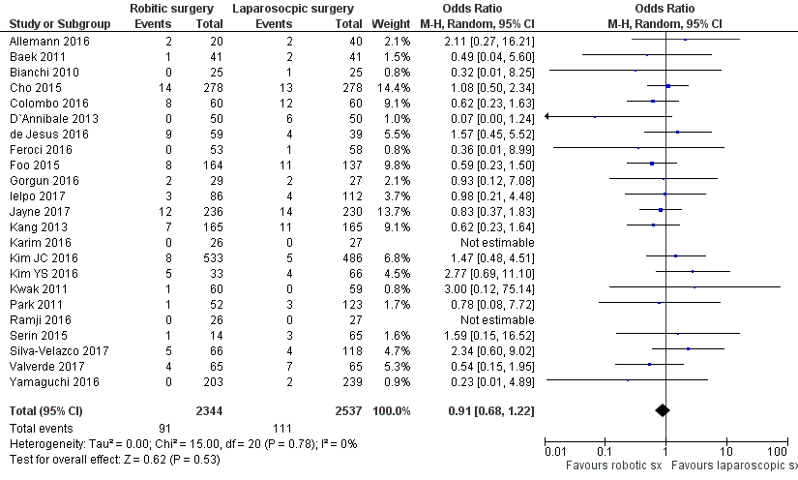
Figure 10 Forest plot for positive circumferential resection margins following rectal resection by robotic surgery vs conventional laparoscopic surgery. Odds ratio is shown with 95%CIs.

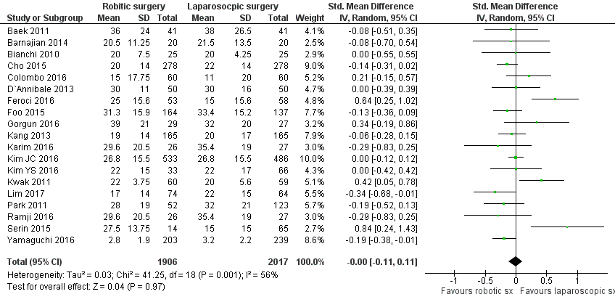
Figure 11 Forest plot for length of distal resection margin following rectal resection by robotic surgery vs conventional laparoscopic surgery. Standardized mean difference is shown with 95%CIs.

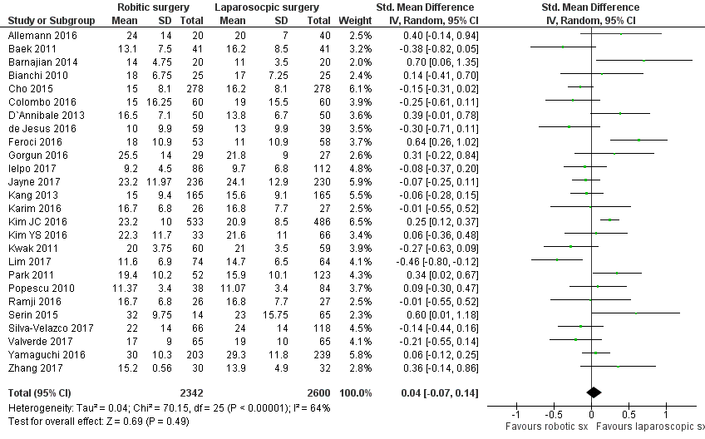

Figure 12 Forest plot for lymph node yield following rectal resection by robotic surgery vs conventional laparoscopic surgery. Standardized mean difference is shown with 95%CIs.

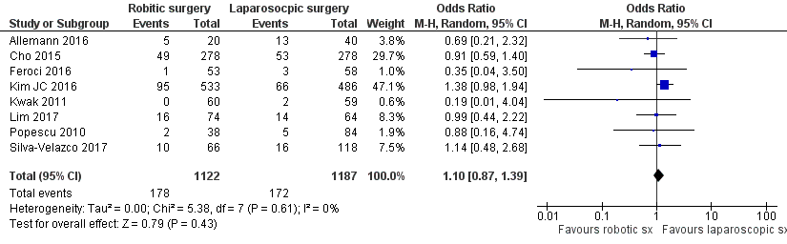

Figure 13 Forest plot for tumour recurrence following rectal resection by robotic surgery vs conventional laparoscopic surgery. Odds ratio is shown with 95%CIs.

