Name of journal: World Journal of Clinical Oncology
ESPS Manuscript NO: 7156
Columns: Original Article

Using shape contexts method for registration of contra lateral breasts in thermal images

Etehadtavakol M et al. Registration of contra lateral breasts in thermal images

Mahnaz Etehadtavakol, Eddie Yin-Kwee Ng, Niloofar Gheissari

Mahnaz Etehadtavakol, Medical Image and Signal Processing Research Center, Isfahan University of Medical Sciences, Isfahan University, Isfahan 81745-319, Iran

Eddie Yin-Kwee Ng, School of Mechanical and Aerospace Engineering, College of Engineering, Nanyang Technological University, Singapore 639798, Singapore

Niloofar Gheissari, Electrical and Computer Engineering Department, Isfahan University of Technology, Isfahan 84956, Iran

Author contributions: All authors contributed to this article.

Correspondence to: Eddie Yin-Kwee Ng, PhD, School of Mechanical and Aerospace Engineering, College of Engineering, Nanyang Technological University, 50 Nanyang Avenue, Singapore 639798, Singapore. mykng@ntu.edu.sg

Telephone: +65-65-67904455 Fax: +65-65-67911859

Received: November 5, 2013 Revised: May 30, 2014
Accepted: June 14, 2014

Published online:

Abstract

AIM: To achieve symmetric boundaries for left and right breasts boundaries in thermal images by registration.

METHODS: The proposed method for registration consists of two steps. In the first step, shape context, an approach as presented by Belongie and Malik was applied for registration of two breast boundaries. The shape context is an approach to measure shape similarity. Two sets of finite sample points from shape contours of two breasts are then presented. Consequently, the correspondences between the two shapes are found. By finding correspondences, the sample point which has the most similar shape context is obtained.

RESULTS: In this study, a line up transformation which maps one shape onto the other has been estimated in order to complete shape. The used of a thin plate spline permitted good estimation of a plane transformation which has capability to map unselective points from one shape onto the other. The obtained aligning transformation of boundaries points has been applied successfully to map the two breasts interior points. Some of advantages for using shape context method in this work are as follows: (1) no special land marks or key points are needed; (2) it is tolerant to all common shape deformation; and (3) although it is uncomplicated and straightforward to use, it gives remarkably powerful descriptor for point sets significantly upgrading point set registration. Results are very promising. The proposed algorithm was implemented for 32 cases. Boundary registration is done perfectly for 28 cases.

CONCLUSION: We used shape contexts method that is simple and easy to implement to achieve symmetric boundaries for left and right breasts boundaries in thermal images.

© 2014 Baishideng Publishing Group Co., Limited. All rights reserved.

Key words: Breast thermal images; Shape contexts; Registration; Cancer detection; Infrared

Core tip: Breast thermography has shown to be as non-invasive safe method to detect breast abnormalities. Comparison between two breast temperature distributions is helpful to identify irregularities. Since in many cases real thermal breast images do not have symmetric boundaries, a registration is needed. A registration shape context approach is applied in this work.

Etehadtavakol M, Ng EYK, Gheissari N. Using shape contexts method for registration of contra lateral breasts in thermal images. World J Clin Oncol 2014; In press

INTRODUCTION
Breast abnormalities are major concerns in health issues for women today. Identification of potentially malignant cells has a great significance for physician. Breast thermal imaging for early detection has an arguable history. With developing high sensitive infrared cameras besides great knowledge of advanced image processing and advanced computer algorithms have renewed attention to breast infrared imaging. The level of blood perfusion can affect the surface temperature that results infrared radiation emitted from skin breasts^{[1]}. By utilizing a sensitive infrared camera, the skin temperature changes can be captured. Since cancerous cells are hotter than normal cells, they are appeared as hot spots in thermal images^{[2]}. Usually healthy subjects are symmetric^{[3]}. Consequently, asymmetrical temperature patterns between two contra lateral breasts could be a sign of abnormality^{[4-12]}. In practice, most of the real IR breast images do not have symmetric boundaries. Hence, in order to compare the thermal distribution of two contra lateral breasts, a registration for two breasts is needed. In this work, first the shape context method is applied for registration of two contra lateral breasts boundaries. Then the obtained transformation function of boundaries points is utilized to transfer breasts interior points. The paper is organized as follows: The shape context method and the thin plate spline (TPS) are introduced in section 1. Section 2 explains dataset and describes the proposed algorithm steps. The experimental results are presented in section 3. Section 4 concludes the findings.

MATERIALS AND METHODS
Shape context
The shape context is an algorithm was proposed by Malik and Belongie in 2002^{[13]}. It is an approach to describe shapes in measuring shape alikeness and improving of point similarities. In this way, there are two objects, known and unknown. Assuming the shape of the known object is captured by points set $p=\left\{p_{1},⋯p_{n}\right\}$ and the unknown object by $q=\left\{q_{1},⋯q_{n}\right\}$. The expansion of relative places is vigorous, dense, and thoroughly differential descriptor. Hence, the coarse histogram of relative coordinates of n − 1 points are being left, for point pi, is described as the shape context of p_{i} which is expressed in Eq. (1)
$h_{i}\left(k\right)=\#\left\{q≠p_{i} :\left(q-p_{i}\right)∈bin(k)\right\}$ (1)
First, the correspondences between two shapes are found. A set of finite representative points from shape boundaries illustrates shapes. They are not required to be special points such as curvature extrema or landmarks, etc. The more samples are used, the better approximations to the underlying shape are obtained. Using the shape context, we outline the coarse expanding of the remaining of the shape regarding to a specified point on the shape by utilizing the shape context. By discovering similarities between two shapes, for each representative point on one shape, the representative point on the other shape that has the most sameness shape context will be ascertained. The calculation of a mapping function that transfers one shape onto the other is extended by given correspondences at representative points. Euclidean, affine, and regularized thin plate splines can be used for transformation. Aligning shapes can be considered as a measure of shape similarity. We are able to obtain the differences between two shapes by calculating a sum of fitting errors between similar points, in conjunction with an expression obtaining the magnitude of the mapping function.
Considering p_{i} a point on the known shape and q_{j} a point on the unknown shape. Supposing C(p_{i},q_{j}) is the cost of matching p_{i} with q_{j}. We represent shape contexts as histogram which is X² test statistics
$C\left(p_{i},q_{j}\right)=\frac{1}{2}\sum_{k=1}^{K}{\frac{{\left[h_{i}\left(k\right)-h_{j}\left(k\right)\right]}^{2}}{h_{i}\left(k\right)+h_{j}\left(k\right)}}$ (2)
where$h_{i}\left(k\right)$ and $h_{j}\left(k\right)$ show the k bin normalized histogram at $p_{i}$ and $q_{j }$respectively. It denotes the set of costs $C_{ij}$ between all pairs of points $p_{i}$on the known shape and $q_{j}$on the unknown shape. It is desired tominimize the total cost of matching expressed by Eq. (3)
$H\left(π\right)=\sum_{i}{C\left(p_{i},q_{π\left(i\right)}\right)}$(3)
where$π$ is a permutation. By using Hungarian technique it can be solved in O(N³) time. Examples of known object as well as unknown object with their point sets are shown in Figure 1A, Figure 1B respectively. Besides, the correspondences between the two shapes are depicted in Figure 2. Moreover, Figure 3 shows the alignment of two shapes after applying alignment transformation. By evaluating a finite set of similarities between points on two shapes, we obtain a plane transformation. In this work, TPS was used. In the following, a brief description of TPS is provided.

2.2 Thin Plate Spline (TPS)
Bookstein ^{[14]} realized the model changes in biological forms where TPS is the mostly powerful candidate. When working with shape contexts TRS is greatly preferable. It is applied to map randomly points from one shape to another. TPS is 2D generalization of the cubic spline. Supposing that position (x_{i},y_{i}) are not collinear and are all different. The Bending energy is minimized by the TPS interpolant f(x,y) and has the form I_{f}.
$I_{f}=\iint{{\left(\frac{∂^{2}f}{{∂x}^{2}}\right)}^{2}+2{\left(\frac{∂^{2}f}{∂x∂y}\right)}^{2}+{\left(\frac{∂^{2}f}{{∂y}^{2}}\right)}^{2}dxdy }$ (4)
where$U\left(r\right)$ is defined as Eq. (5)
$U\left(r\right)=r^{2}\log{r^{2}}$ (5)
In this work, thermal images, available from Thermal imaging lab in the San Francisco Bay Area^{[15]}, Ann Arbor thermography center^{[16]}, American College of Clinical Thermology^{[17]}, Sun State thermal imaging center in Australia^{[18]} , and Thermography of Iowa^{[19]} were studied^{[20]}.
From the Department of Diagnostic Radiology, Singapore General Hospital, some data were also collected^{[21]}. For imaging the room temperature was selected in the range of 20°C -22°C (within ± 0.1°C) in addition with humidity at 60% ± 5%. To stabilize and reduce basal metabolic rate, patients were required to rest at least 15 min. Since the vascularization is at basal level with least engorgement of blood vessels during the period of the 5th to 12th and 21th day after the onset of menstrual cycle, the patients were recommended to have examinations within these periods. The algorithm follows the following steps: (1) Randomly choosing a set of points of left breast boundaries as well as a set of points of right breast boundaries; (2) Evaluating similarities between points on two breasts boundaries; (3) Utilizing the similarities to obtain mapping function. The obtained mapping function is applied to map the interior points. In digital images, pixels are limited to set on a sampling grid, to occupy an integer lattice. Usually the output grid is not correlated with the integer lattice. However, the place of grid points may be any continuous values that are obtained by utilizing the mapping function. Consequently, an interpolation is required to fit a continuous surface through the data. Hence, non-integer places of output grid are attainable by sampling the continuous surface. The output image quality is very depended on the accuracy of interpolation; and (4) Determining the R,G,B amounts of the output grid by applying cubic spline properly.

RESULTS
The algorithm was implemented in 32 cases. It works perfectly for 28 cases. Implementations of the algorithm for two cases are shown in Figure 4 and Figure 5. Left breasts are shown in Figure 4A and Figure 5A as well as right breasts in Figure 4B and Figure 5B. Points set of boundaries of right breasts and points set of boundaries of left breasts are depicted in Figure 4D and Figure 5D. Unwarped boundaries are shown in Figure 4E and Figure 5E and warped boundaries in Figure 4F and Figure 5F respectively. The boundaries of two breasts after employing the mapping function are presented in Figure 4G and Figure 5G. Moreover interpolated left and right breasts giving the mapping of the interior points are shown in Figure 4H and Figure 5H.
In conclusion, we have proposed an approach to achieve symmetric boundaries for left and right breasts boundaries in thermal images. The algorithm is based on using shape contexts method. Then, to map the interior points of two breasts, the calculated mapping function of boundaries points is used. Some of advantages for using shape context method in this work are as follows: (1) no special land marks or key points are needed; (2) it is tolerant to all common shape deformation; and (3) although it is uncomplicated and straightforward to use, it gives remarkably powerful descriptor for point sets significantly upgrading point set registration. Results are very promising. The algorithm was implemented for 32 cases. It works perfectly for 28 cases.
In future work, we can use the two obtained symmetric breasts in thermal images to compare their thermal profiles by comparing some extracted features from contra lateral breasts in order to identify thermal dissimilarities.

COMMENTS
Background
Breast health is one of major concerns of women’s health today. Moreover safe modality can play an important role to identify breast irregularities. Breast thermography has shown that is a non-invasive, safe method to detect breast abnormalities.

Research frontiers
In practice, most of the real thermal breast images do not have symmetric boundaries. Hence, in order to compare thermal distribution of two breasts by comparing extracted features, a registration is needed.

Innovations and breakthroughs
Since symmetry usually indicates healthy subjects, asymmetrical temperature distribution between left breast and right breast could be a strong sign of abnormality. In practice, most of the real thermal breast images do not have symmetric boundaries. Therefore, in order to compare thermal distribution of two breasts by comparing extracted features, a registration is needed. In this work, a registration method based on shape context algorithm is introduced.

Applications
The study results suggest a registration method based on shape context algorithm for comparison between contra lateral breast temperature distributions.

Terminology
Shape context: an approach to measure shape similarity. First, two sets of finite sample points from shape contours of two breasts are introduced. Second, the correspondences between the two shapes are found. Third, by finding correspondences, the sample point which has the most similar shape context is obtained. Forth, an aligning transformation that maps one shape onto the other in order to complete shape is estimated.

Peer review
This article shows promising outcomes and it very technical and tough for common physicians.

REFERENCES
1 Ng EY, Acharya RU. Remote-sensing infrared thermography. IEEE Eng Med Biol Mag 2009; 28: 76-83 [PMID: 19150773]
2 Singh Y. Tumor angiogenesis: clinical implications. Nepal J Neurosci 2004; 1: 61–63
3 Uematsu S. Symmetry of skin temperature comparing one side of the body to the other. Int J Thermology 1985; 1: 4–7
4 Qi H, Kuruganti PT, Snyder WE. Detecting breast cancer from thermal infrared images by Asymmetry Analysis, Biomedical Engineering Handbook. CRC Press 2006; 27: 1–14
5 Diakides N, Bronzino JD. Medical infrared imaging. CRC Press 2008; Taylor & Francis Group
6 Tan TZ, Quek C, Ng GS, Ng EYK. A novel cognitive interpretation of breast cancer thermography with complementary learning fuzzy neural memory structure. Expert Syst App 2007; 33: 652–666
7 Frize M, Herry CH, Roberge R. Processing of thermal images to detect breast cancer: comparison with previous work, In proceedings of the second joint 24th annual conference and the annual fall meeting of the biomedical engineering society. IEEE EMBS/BMES Conference 2002; 2: 1159–1160
8 Jakubowska T, Wiecek B, Wysocki M, Drews Peszynski C. Thermal signatures for breast cancer screening comparative study, EMBS, 2003. Proceedings of the 25th Annual International Conference of the IEEE 2003; 2: 1117–1120
9 Schaefer G, Zavisek M, Nakashima T. Thermography based breast cancer analysis using statistical features and fuzzy classification. Pattern Recogn 2009; 42: 1133–1137 [DOI: 10.1016/j.patcog.2008.08.007]
10 Vinitha Sree S, Rajendra Acharya U, Ng EYK, Tan W. Breast Imaging Systems: A Review and Comparative Studies. J Mech Med Biol 2010; 10: 5-34 [DOI: 10.1142/S0219519410003277]
11 Ng EYK. A Review of Thermography as Promising Non-invasive Detection Modality for Breast Tumour. Int J Therm Sci 2009; 48: 849-855 [DOI: 10.1016/j.ijthermalsci.2008.06.015]
12 Belongie S, Malik J, Puzicha J. Shape Matching and object Recognition Using Shape Contexts. Ieee T Pattern Anal 2002; 24
13 Vardasca R, Ring EFJ, Plassmann P, Jones CD. Thermal symmetry of the upper and lower extremities in healthy subjects. Thermo Int 2012; 22: 53-60
14 Bookstien FL. Morphometric Tools for Landmark Data: Geometry and Biology, Cambridge Univ. Press, 1991
15 MII, Available from: http: //www.breastthermography.com/case_studies.htm (last accessed July 2009)
16 AAT, Available from: http: //aathermography.com (last accessed July 2009)
17 ACCT, Available from: www.thermologyonline.org/Breast/breast_thermography_what.htm(last accessed Jan. 2013)
18 ST Imaging, Available from: http: //www.stimaging.com.au/page2.html (last accessed Jan. 2013)
19 Available from: http: //www.thermographyofiowa.com/casestudies.htm (last accessed July 2009)
20 EtehadTavakol M, Ng EY, Lucas C, Sadri S, Gheissari N. Estimating the mutual information between bilateral breast in thermograms using nonparametric windows. J Med Syst 2011; 35: 959-967 [PMID: 20703681 DOI: 10.1007/s10916-010-9516-x]
21 Ng EYK, Chen Y, Ung LN, Fok SK, Wan ISY. Thermography as an indicator of breast blood perfusion, in: Proceedings of the 10th International Conference on Biomedical Engineering, Singapore, December, 6-9, 2000; 275-276

P-Reviewer: Hernanz F S-Editor: Song XX L-Editor: E-Editor:

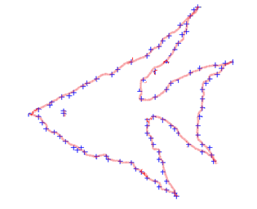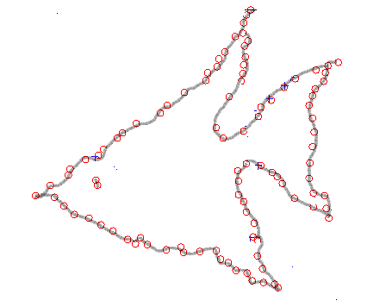
A B
Figure 1 An example of known and unknown objects as well as their points sets. A: Known object; B: Unknown object.

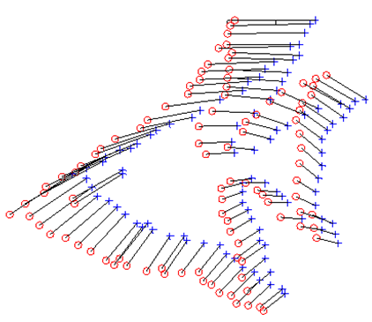
Figure 2 The correspondences between the two shapes.

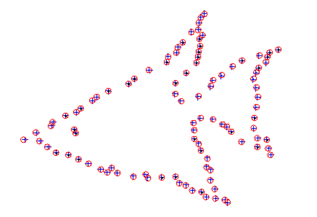
Figure 3 Alignment of the two shapes after applying alignment transformation.

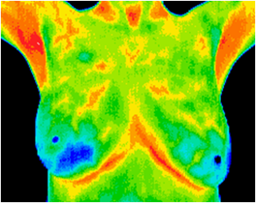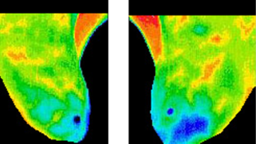
A B C

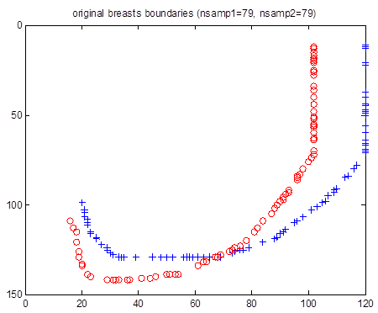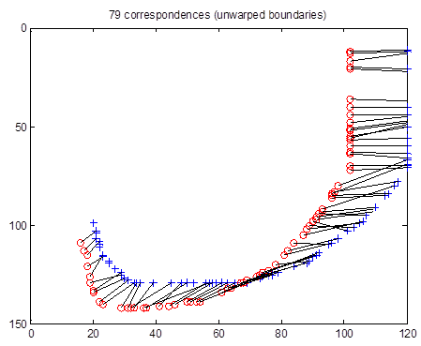
D E

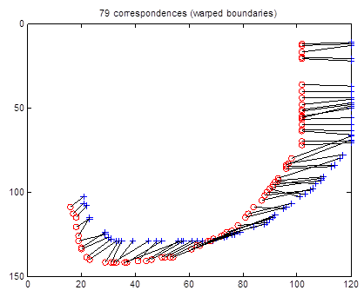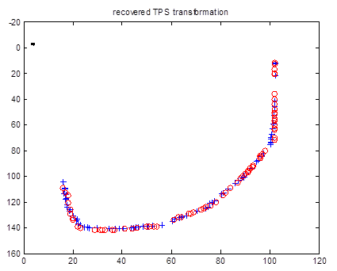
F G
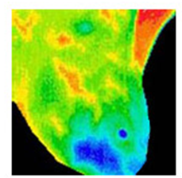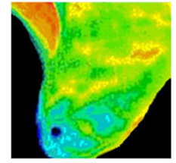
H left breast right breast
Figure 4 First sample. A: Original image; B: Left breast; C: Right breast; D: Points set of boundaries of right breast (+ in blue), points set of boundaries of left breast (o in red); E: Warped boundaries; F: Unwarped boundaries; G: Boundaries of two breasts after using the mapping function; H: Interpolated left and right breasts.

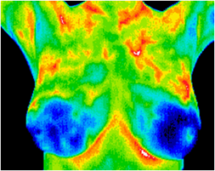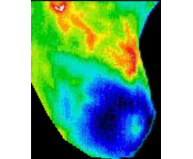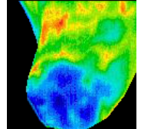
A B C

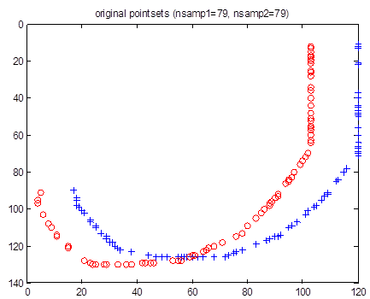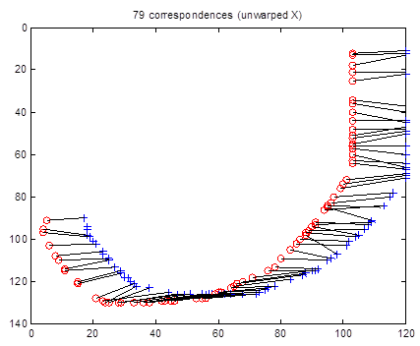
D E

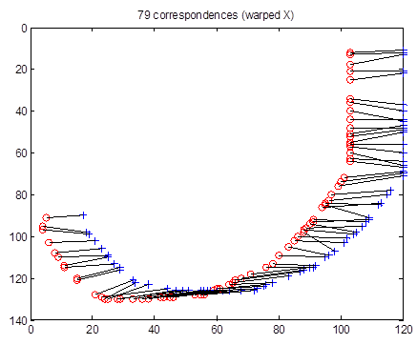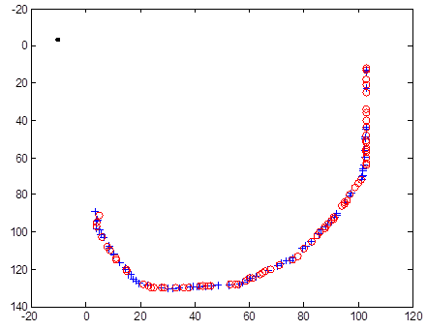
F G

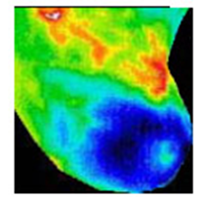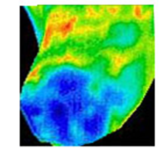
H
Figure 5 Second sample. A: Original image; B: Left breast; C: Right breast; D: Points set of boundaries of right breast (+ in blue), points set of boundaries of left breast (o in red); E: Warped boundaries; F: Unwarped boundaries; G: Boundaries of two breasts after using the mapping function; H: Interpolated left and right breasts.

