Name of Journal: World Journal of Stem Cells
Manuscript NO: 89244
Manuscript Type: ORIGINAL ARTICLE

Basic Study
Low-intensity pulsed ultrasound reduces alveolar bone resorption during orthodontic treatment via Lamin A/C-Yes-associated protein axis in stem cells

Wu T et al. LIPUS reduces bone resorption

Tong Wu, Fu Zheng, Hong-Yi Tang, Hua-Zhi Li, Xin-Yu Cui, Shuai Ding, Duo Liu, Cui-Ying Li, Jiu-Hui Jiang, Rui-Li Yang

Tong Wu, Fu Zheng, Hong-Yi Tang, Hua-Zhi Li, Xin-Yu Cui, Shuai Ding, Duo Liu, Jiu-Hui Jiang, Rui-Li Yang, Department of Orthodontics, Peking University School and Hospital of Stomatology, National Engineering Laboratory for Digital and Material Technology of Stomatology, Beijing Key Laboratory of Digital Stomatology, Beijing 100081, China

Cui-Ying Li, Department of Central Laboratory, Peking University School and Hospital of Stomatology, National Clinical Research Center for Oral Diseases & National Engineering Laboratory for Digital and Material Technology of Stomatology, Beijing Key Laboratory of Digital Stomatology, Beijing 100081, China

Co-first authors: Tong Wu and Fu Zheng.

Co-corresponding authors: Jiu-Hui Jiang and Rui-Li Yang.

Author contributions: Li CY, Jiang JH, and Yang RL were responsible for the study design and conduction; Jiang JH and Yang RL made equal contributions to the determination of study directions and the design of experimental methods, and they are the co-corresponding authors of this paper; Wu T and Zheng F contributed to the experimental implementation, data analysis, and manuscript writing equally; Tang HY, Li HZ, Cui XY, Ding S, and Liu D participated in some of the experiments; all authors approved the final version for submission.

Supported by the National Science and Technology Major Project of the Ministry of Science and Technology of China, No. 2022YFA1105800; the National Natural Science Foundation of China, No. 81970940.

Corresponding author: Rui-Li Yang, PhD, Professor, Department of Orthodontics, Peking University School and Hospital of Stomatology, National Engineering Laboratory for Digital and Material Technology of Stomatology, Beijing Key Laboratory of Digital Stomatology, No. 22 Zhongguancun South Avenue, Beijing 100081, China. ruiliyangabc@163.com

Received: October 26, 2023
Revised: December 30, 2023
Accepted: February 1, 2024
Published online:

Abstract
BACKGROUND
The bone remodeling during orthodontic treatment for malocclusion often requires a long duration of around two to three years, which also may lead to some complications such as alveolar bone resorption or tooth root resorption. Low-intensity pulsed ultrasound (LIPUS), a noninvasive physical therapy, has been shown to promote bone fracture healing. It is also reported that LIPUS could reduce the duration of orthodontic treatment; however, how LIPUS regulates the bone metabolism during the orthodontic treatment process is still unclear.

AIM
To investigate the effects of LIPUS on bone remodeling in an orthodontic tooth movement (OTM) model and explore the underlying mechanisms.

METHODS
A rat model of OTM was established, and alveolar bone remodeling and tooth movement rate were evaluated via micro-computed tomography and staining of tissue sections. In vitro, human bone marrow mesenchymal stem cells (hBMSCs) were isolated to detect their osteogenic differentiation potential under compression and LIPUS stimulation by quantitative reverse transcription-polymerase chain reaction, Western blot, alkaline phosphatase (ALP) staining, and Alizarin red staining. The expression of Yes-associated protein (YAP1), the actin cytoskeleton, and the Lamin A/C nucleoskeleton were detected with or without YAP1 small interfering RNA (siRNA) application via immunofluorescence.

RESULTS
The force treatment inhibited the osteogenic differentiation potential of hBMSCs; moreover, the expression of osteogenesis markers, such as type 1 collagen (COL1), runt-related transcription factor 2, ALP, and osteocalcin (OCN), decreased. LIPUS could rescue the osteogenic differentiation of hBMSCs with increased expression of osteogenic marker inhibited by force. Mechanically, the expression of LaminA/C, F-actin, and YAP1 was downregulated after force treatment, which could be rescued by LIPUS. Moreover, the osteogenic differentiation of hBMSCs increased by LIPUS could be attenuated by YAP siRNA treatment. Consistently, LIPUS increased alveolar bone density and decreased vertical bone absorption in vivo. The decreased expression of COL1, OCN, and YAP1 on the compression side of the alveolar bone was partially rescued by LIPUS.

CONCLUSION
LIPUS can accelerate tooth movement and reduce alveolar bone resorption by modulating the cytoskeleton-Lamin A/C-YAP axis, which may be a promising strategy to reduce the orthodontic treatment process.

Key Words: Low-intensity pulsed ultrasound; Bone resorption; Osteogenesis; Cytoskeleton-Lamin A/C-Yes-associated protein axis; Bone marrow mesenchymal stem cells; Orthodontic tooth movement

Wu T, Zheng F, Tang HY, Li HZ, Cui XY, Ding S, Liu D, Li CY, Jiang JH, Yang RL. Low-intensity pulsed ultrasound reduces alveolar bone resorption during orthodontic treatment via Lamin A/C-Yes-associated protein axis in stem cells. World J Stem Cells 2024; In press

Core Tip: Low-intensity pulsed ultrasound can promote local alveolar bone remodeling and reduce vertical alveolar bone resorption and consequent gingival recession by regulating the osteogenic ability of bone marrow mesenchymal stem cells by upregulating the expression and nuclear translocation of Yes-associated protein decreased by mechanical stress via affecting the cytoskeleton and nuclear skeleton.

INTRODUCTION
Orthodontic treatment for malocclusion usually lasts 2-3 years, which brings great challenges to patient compliance and increases the risk of many complications, such as alveolar bone resorption, gingivitis, and other destructive diseases of the periodontal supporting tissue^{[1]}. The alveolar bone loss caused by long-term orthodontic treatment may be due to imbalanced osteogenic and osteoclast activity.
Low-intensity pulsed ultrasound (LIPUS) usually refers to a pulse-emitted ultrasonic wave with an intensity between 30 and 100 mW/cm², which is a noninvasive physical mechanical energy source^{[2]}. It is delivered in the form of an acoustic wave and applied to tissue and cells to regulate biochemical functions^{[3]}. As revealed by several clinical trials and animal experiments in vivo, LIPUS can reduce the fracture healing time^{[4]} and effectively treat delayed fracture union^{[5]} and bone nonunion^{[6]}, and is safer and noninvasive than other treatments.
LIPUS has also gained attention in the field of orthodontics. In vivo, LIPUS can increase the distance of the teeth movement^{[7]}; a retrospective clinical study also showed that LIPUS reduced the duration of invisible treatment by an average of 49%^{[8]}. In a clinical study, buccal alveolar bone thickness and height did not respond to LIPUS during maxillary arch expansion^{[9]}. In a tooth movement model in rats, LIPUS application increased the number of osteoclasts on the compression side^{[10]}. The increased osteoclasts may lead to alveolar bone resorption and periodontal supporting tissue destruction. It is unclear whether LIPUS regulates alveolar bone remodeling.
Bone marrow mesenchymal stem cells (BMSCs), as bone marrow-derived stem cells, exhibit self-renewal capacity and multiple differentiation potential and can differentiate into multiple types of cells, tissues, and organs under proper conditions^{[11]}. LIPUS could regulate MSC growth^{[12]} and promote chondrogenesis of MSCs seeded on three-dimensionally (3D) printed scaffolds^{[13]}. Besides, MSCs encapsulated in hydrogels of certain stiffness show enhanced osteogenesis ability under LIPUS^{[14]}. Few studies have reported the effect of LIPUS on cells loaded in compression. Whether LIPUS could regulate the property of MSCs under compression force to control the alveolar bone remodeling during orthodontic treatment and the underlying mechanism need to be investigated.
Here, we show that LIPUS could accelerate the orthodontic tooth movement (OTM) and increase alveolar bone density and decreased vertical bone absorption via the Lamin A/C-Yes-associated protein (YAP) axis, suggesting that LIPUS is a promising strategy to accelerate the orthodontic treatment with little side effects.

MATERIALS AND METHODS
Cell culture
The human jawbone tissue sampling protocol gained approval from the Ethical Guidelines of Hospital of Stomatology, Peking University (No. PKUSSIRB-202385020) and was carried out after informed consent was obtained. BMSCs were isolated and cultured following the previously reported protocol^{[15]}. Briefly, we obtained a small piece of cortical bone located above the tooth crown, which required removal during the extraction of the donor’s impacted third molars. The bone was carefully sectioned using a scalpel and subsequently digested using collagenase type I (2 mg/mL; Worthington Biochem, Lakewood, NJ, United States) and dispase II (4 mg/mL; Roche Diagnostic, Indianapolis, IN, United States) for an hour at 37 °C. Single-cell suspensions from the jaw bone were subsequently acquired using 70-μm cell strainers (BD Bioscience, United States). Then, single cells were seeded onto 100-mm dishes at 1 to 1.5 × 10⁶ cells/mL. BMSCs were isolated and cultured following the previously reported protocol^{[15]}. BMSCs were cultivated in Minimum Essential Medium α (VivaCell, Shanghai, China) supplemented with 15% fetal bovine serum (Gibco, Grand Island, NY, United States) and 1% penicillin-streptomycin solution (Cytiva, Shanghai, China) at 37 °C with 5% CO₂, and the medium was changed at 3-d intervals. The expression of stem cell surface markers in BMSCs was characterized by flow cytometry according to the manufacturer’s protocol (BD Bioscience).

Transfection of small interfering RNA
Before transfection, the cell culture medium was changed to standard conditions without penicillin-streptomycin solution. The cells were then transfected with control small interfering RNA (siRNA) or YAP1 siRNA (Ribobio, Guangzhou, China) via a riboFECT™ CP Transfection Kit (Ribobio) in accordance with the manufacturer’s instructions. Quantitative reverse transcription-polymerase chain reaction (qRT-PCR), Western blotting, and immunofluorescence staining were subsequently performed to measure the knockdown rate.

Osteogenic differentiation, alkaline phosphatase activity, and alizarin red staining
BMSCs (1 × 10⁵/mL) were seeded onto 6-well plates and cultured until the cell confluence reached 70%-80% before the medium was changed to osteogenic differentiation medium supplemented with L-ascorbic acid (50 μg/mL; Sigma, Missouri, United States), β-glycerophosphate (10 mmol/L; Sigma), and dexamethasone (0.1 μM; Sigma). During osteogenic induction of stem cells, the induction differentiation medium was changed every 3 d.
After induction for 14 d, alkaline phosphatase (ALP) staining (Beyotime, Shanghai, China) were conducted in accordance with the protocol, and so did alizarin red staining (Sigma) after induction for 21 d. For the quantification of mineralization, we dissolved red matrix sediment in 10% cetyl-pyridinium chloride (Macklin, Shanghai, China), and the absorbance of the solution was measured to determine the degree of mineralization quantitatively^{[16]}.

Application of a compression force
Compression force was applied to the BMSCs to mimic stress during orthodontic movement^{[17]}. Briefly, a rounded glass sheet (30 mm in diameter) was placed over cell layers close to confluence in a 6-well plate. Stainless steel beads were placed above the glass sheet to adjust the static pressure to 1 g/cm². The cells were under static compression for 24 h.

LIPUS treatment
In this study, the LIPUS device was obtained from the Institute of Acoustics (Chinese Academy of Sciences, Beijing, China). The device has circular transducers with an area of 9.07 cm² to match the area of a well in a 6-well plate. The cells were stimulated with LIPUS following the following specifications: 1.5 MHz frequency, 0.2 pulse duration ratio, 30 mW/cm² incident intensity, and 1.0 kHz repetition rate. Stimulation was applied for 20 min every day in vivo and in vitro until the rats and cells were harvested, and the control group and force group were treated by pseudo-LIPUS. In vivo, the rats under anesthesia were placed at a constant location, after which the transducer was pressed against the side of the cheek closest to the maxillary first molar. In vitro, we attached the transducer to the bottom of the plate corresponding to the well^{[18]}.

qRT-PCR
After 7 d of osteogenic induction, we utilized TRIzol reagent (Invitrogen, California, United States) to extract total cellular RNA following the previous protocol^{[19]}. Table 1 displays all the primers used. cDNA synthesis kits (Takara Bio, Tokyo, Japan) were used to prepare first-strand cDNA from RNA through reverse transcription in accordance with the protocol. A ViiaTM 7 Real-time PCR System (Applied Biosystems, Washington, Rhode Island, United States) was used for qRT-PCR, which was carried out in triplicate.

Western blot analysis
After 7 d of osteogenic induction, RIPA buffer containing 1 mM phenylmethanesulfonyl fluoride (Solarbio, Beijing, China) was added for cell lysis, followed by centrifugation at 12000 × g for 20 min at 4 °C. Thereafter, the supernatant was quantified with a BCA assay (Beyotime). Total protein was added to loading buffer, and the mixture was subsequently boiled for 10 min at 100 °C. Thereafter, the samples were stored at -20 °C. Equal amounts of total protein (30 μg) were loaded on sodium dodecyl sulfate-polyacrylamide gels and separated prior to electroblotting onto polyvinylidene difluoride membranes (Millipore, Billerica, Massachusetts, United States). After blocking with 5% bovine serum albumin, the membranes were incubated overnight on a shaker at 4 °C. The primary antibodies used were rabbit anti-type 1 collagen (COL1) and anti-osteocalcin (OCN) (1:500; Abcam, Cambridge, Massachusetts, United States), rabbit anti-ALP (1:500; Invitrogen), and mouse anti-GAPDH (1:1000; ProteinTech, Cook, Illinois, United States). Finally, HRP-labeled secondary antibodies (Zsgb-Bio, Beijing, China) were added for another 1-h incubation, followed by visualization via enhanced chemiluminescence (NCM Biotech, Suzhou, China). ImageJ software was used for band intensity analysis.

Immunofluorescence staining
After 7 d of osteogenic induction, 4% paraformaldehyde (PFA) was added for 15 min to fix the cells, after which the cells were rinsed with phosphate buffered saline (PBS) three times prior to 10 min of permeabilization with 0.5% Triton X-100 and washing with PBS. Thereafter, 5% BSA was added to the block cells for an hour before they were incubated with primary antibodies (1:200; Abcam) against YAP1, Lamin A/C, and F-actin at 4 °C overnight. The cells were washed with PBS before further incubation with Alexa Fluor 488- and Alexa Fluor 594-labeled antibodies (1:200; Invitrogen) for one hour. Finally, medium containing DAPI was added to the mount cells after washing. Images were captured with an inverted confocal microscope (Olympus, Tokyo, Japan).

Rat model of OTM
Male SD rats (6 wk old) weighing 200 ± 20 g were obtained from Beijing Vital River Laboratory Animal Technology Co., Ltd. (Beijing, China) and housed under laboratory conditions (12 h light/dark cycle, 21 ± 2 °C, 50% humidity, ad libitum access to food and water). All animal protocols utilized in the present work were approved by the Ethics Committee for Animal Experiments at Peking University Health Science Center (No. LA2022288) and were designed to minimize animal pain or discomfort.
In total, 27 male rats were randomized to control (n = 3), force (day 7 and day 14) (n = 6 per group), or force + LIPUS group (day 7 and day 14) (n = 6 per group). Before establishing the experimental OTM model, each rat was administered pentobarbital sodium (40 mg/kg of body weight) for anesthesia. In those latter two groups, the OTM model was established as described in our previous study^{[20]}. A stainless steel ligation wire (0.025 mm in diameter; Tomy International, Inc., Tokyo, Japan) was used to ligate a closed-coil spring (Tomy International, Inc., Tokyo, Japan) to the maxillary first molar and incisor neck. The spring offers 50 g of force to move the maxillary first molar mesially. To enhance the retaining force and prevent the device from falling off, a 0.5 mm deep groove was made by a slow speed mill near the gingival margin of the maxillary incisor to accommodate the ligature wire, which was subsequently filled with flowing resin (3 M, Minnesota, United States). All animals were sacrificed with an overdose of pentobarbital sodium (150 mg/kg) for tissue collection.

Micro-computed tomography imaging and measurements
A microcomputed tomography scanner was used to scan maxillary samples at 8.82 μm resolution, 500 μA tube current, 60 kV tube voltage, and 1500 ms exposure time. Inveon Research Workplace software (Siemens, Munich, Germany) together with Mimics Research 21.0 software (Materialise, Leuven, Belgium) was used for raw data reconstruction. With respect to the reconstructed 3D model, the shortest distance from the first to second molar crown was considered the tooth movement distance (Figure 1B). A straight plane was made at the cementum-enamel boundary (CEJ) on the first molar’s distal buccal side, and the farthest distance between it and the parallel line tangent to alveolar crest resorption was measured to assess the reduction in alveolar bone height. In addition, Inveon Research Workplace software was used to evaluate the BV/TV, Tb.Th, Tb.N, Tb.Sp, and BS/BV in the chosen regions of interest (ROIs) (Figure 1C) by the reviewer, who was blinded to the groupings. All the samples were analyzed thrice to obtain the means.

Tissue processing
We set the experimental period at 7 and 14 d following the establishment of the tooth movement device. The rats were sacrificed with an overdose of pentobarbital sodium, after which the maxilla was dissected and immersed in 4% paraformaladehyde. For hematoxylin and eosin (HE), tartrate-resistant acid phosphatase (TRAP), and immunohistochemical staining, the trimmed tissues were decalcified with 5% ethylenediaminetetraacetic acid disodium for 15 d, followed by ethanol dehydration and paraffin embedding. Thereafter, the samples were cut into 5-μm vertical serial sections with a rotary microtome (RM2125RT, Leica, Heidelberger, Germany).

HE, TRAP, and immunohistochemical staining
Sections were stained with an HE staining kit (Sigma, Missouri, United States) or a TRAP staining kit (Solarbio, Beijing, China) following the protocols. Immunohistochemical staining was performed as follows. After xylene deparaffinization and ethanol rehydration, 0.125% trypsin and 20 μg/mL proteinase K solution were added to the sections, which were incubated at 37 °C for a 30-min period. Endogenous peroxidase activity was blocked with 3% H₂O₂ for a 30-min period at room temperature. The sections were subsequently washed with PBS, blocked with 5% BSA for an hour, and incubated with polyclonal anti-rabbit COL1 and OCN antibodies (1:200; Abcam) overnight at 4 °C, followed by another 1-h incubation with HRP-labeled secondary goat anti-rabbit IgG (Zsgb-Bio, Beijing, China) at room temperature. Diaminobenzidine (Zsgb-Bio) was used for visualization in accordance with the protocol. After hematoxylin counterstaining, gradient ethanol, and xylene dehydration, the sections were mounted using neutral resins.

Statistical analysis
The data are presented as the mean ± SD and were analyzed with GraphPad Prism 7 software (GraphPad, Inc., La Jolla, CA, United States). Every assay was carried out thrice. Student’s t test was used to evaluate intergroup differences, while one-way analysis of variance (ANOVA) with multiple comparisons was used to evaluate differences among multiple groups. P < 0.05 indicated statistical significance.

RESULTS
Orthodontic force treatment decreases alveolar bone height on the compression side
We detected the movement distance of the maxillary first molars on the 7th d and 14th d after force application and found that the movement distance increased with time under the effect of 50 g of force (P < 0.01, n = 3) (Figure 1A), suggesting that the rat OTM model was successfully constructed. Moreover, the distance between the alveolar crest and CEJ significantly increased on day 7 and day 14, showing that orthodontic force led to vertical resorption of alveolar bone beginning on day 7 (Figure 1B). We selected the alveolar bone mesial to the medial 1/3 of the first molar’s distal buccal root with a certain thickness as the ROI (Figure 1C). Micro-computed tomography results showed that at 7 and 14 d of tooth movement, the alveolar bone BV/TV and Tb.Th decreased after force application, while the BS/BV and Tb.Sp increased after force application (Figure 1C). This result showed that the bone density decreased on the compression side after orthodontic force treatment. HE staining and immunohistochemical staining revealed a decreased number of cells positive for the osteogenic markers COL1 and OCN in alveolar bone on the pressure side (Figure 1D and E), with a greater number of TRAP-positive cells on the pressure side near the alveolar bone edge (Figure 1F).

Osteogenic differentiation of BMSCs is inhibited by force treatment
Static pressure was used in vitro to simulate alveolar bone on the pressurized side. Compared to those in the control group, the osteogenic differentiation of the BMSCs in the force group was decreased, as evidenced by the ALP and alizarin red staining results (Supplementary Figure 1 and Figure 2A-D). Correspondingly, the expression levels of the osteogenesis-related markers ALP, COL1, runt-related transcription factor 2 (RUNX2), and OCN in the force group significantly decreased (Figure 2E and F) compared to the control ones, as detected by qRT-PCR and Western blot.

LIPUS induces osteogenic differentiation of BMSCs
The force treatment decreased the osteogenic differentiation of BMSCs, while LIPUS could rescue the impaired osteogenic differentiation of BMSCs caused by force treatment (Figure 3A-D), as shown by ALP and alizarin red staining. Moreover, the expression of ALP, COL1, RUNX2, and OCN was accordingly increased after LIPUS treatment compared with the force group, as assessed by qRT-PCR (Figure 3E) and Western blot (Figure 3F).

LIPUS decreases alveolar bone resorption in vivo
The movement distance of the first molar in the force + LIPUS group was greater than that of the force group on the 7th and 14th d after force application (P < 0.05) (Figure 4A-D). Moreover, the height of alveolar bone resorption was also reduced in the LIPUS treatment group (P < 0.05) (Figure 4E and F). ROI measurements of the corresponding sites indicated that the BV/TV and Tb.Th of the force + LIPUS group were higher than those of the force group, while the BS/BV and Tb.Sp were decreased (P < 0.05, n = 3) (Figure 4G-I), indicating that LIPUS promoted alveolar bone formation. Furthermore, the expression of COL1 and OCN was increased on the compressed side in the LIPUS treatment group compared with the force group (Figure 5A-D). However, no significant differences in TRAP-positive cell numbers were observed between the force group and the force + LIPUS group (Figure 5B and E).

LIPUS activates YAP1 signaling via Lamin A/C
To explore the role of LIPUS in regulating the cytoskeleton in BMSCs, we performed F-actin and Lamin A/C immunofluorescence co-staining in vitro. The results showed that the compressive force treatment downregulated the expression of F-actin, disrupted the cytoskeleton, and inhibited the Lamin A/C ratio in BMSCs, while LIPUS effectively reversed these changes (Figure 6A). Lamin A/C was reported to mediate the YAP1 nuclear localization by regulating nuclear stiffness^{[21,22]}. Next, we analyzed the expression of YAP1. The results showed that the expression of YAP1 was decreased by force treatment, whereas LIPUS restored the expression of YAP1 and increased the nuclear localization of YAP1, as shown by immunofluorescence staining and Western blot (Figure 6B and C). Consistently, the expression of YAP1 was decreased in the force group, while its expression was increased in the LIPUS treatment group in vivo, as analyzed by immunochemical staining (Figure 6D).

Knockdown of YAP1 blocks osteogenic differentiation of BMSCs induced by LIPUS
To verify the role of YAP1 on the property of BMSCs, we used YAP1 siRNA to treat BMSCs (Figure 7A), and the results showed that the expression of osteogenic differentiation-related markers ALP, COL1, RUNX2 and OCN increased by LIPUS treatment could be blocked by YAP1 siRNA treatment (Figure 7B and C). The osteogenic differentiation of BMSCs increased by LIPUS treatment could also be inhibited by YAP1 siRNA treatment, as assessed by ALP and alizarin red staining (Figure 7D and E). Our results demonstrated that LIPUS can accelerate tooth movement and reduce alveolar bone resorption by modulating the cytoskeleton-Lamin A/C-YAP axis (Figure 8).

DISCUSSION
The process of orthodontic treatment is a bone remodeling process. The force applied to drive tooth movement in some extent led to some adverse reactions, such as root resorption and bone mineral density decline. LIPUS has been reported to alleviate chondrocyte damage in temporomandibular disorders^{[23]}, reduce root resorption^{[24]}, and enhance bone remodeling^{[10]}. However, there is a lack of research on the effect of LIPUS on the aesthetic problem of gingival recession due to the loss of alveolar bone height during orthodontic treatment. Changes in alveolar bone morphology affect the aesthetic effect, safety, and stability^{[25]} of orthodontic treatment. Clinical studies have shown that alveolar bone height loss often leads to insufficient periodontal supporting tissue, decreased dental stability, and aesthetic problems in the anterior teeth^{[26]}. Our experiments showed that LIPUS could effectively ameliorate the aesthetic and health problems caused by alveolar bone height loss by reducing vertical alveolar bone resorption and improving the morphology of alveolar bone remodeling, and filled the research gap in the relevant field.
Clinical studies have used cone beam computed tomography to assess changes in periodontal bone mineral density during orthodontic treatment. On average, the alveolar bone mineral density decreases by 24% after 7 mo of orthodontic treatment, while the region with the largest reduction in bone mineral density seems to be related to the direction of tooth movement^{[27,28]}. Consistently, in the present study, we found that bone mineral density decreased at 7 and 14 d after stress. Mechanical stress can modulate osteoclasts and osteoblasts, thereby promoting bone reconstruction^{[29,30]}. Excessive compressive force can cause stem cell apoptosis^{[31]}, aggravate mitochondrial dysfunction, ATP consumption, and oxidative stress in stem cells^{[32]}, and inhibit the proliferation, colony formation, and migration of stem cells^{[33]}. Bone mineral density is positively correlated with OCN protein level^{[34]}. In our study, static pressure on BMSCs inhibited the mRNA and protein expression of osteogenic differentiation markers such as COL1 and OCN, which partly explained the reduction in alveolar bone mineral density around moving teeth under orthodontic force.
Previous studies have shown that LIPUS plays a role in bone metabolism and remodeling by regulating osteogenic and osteoclast activity^{[35-37]}. In our study, on day 7 and day 14, the number of osteoclasts in the force group was not significantly different from that in the force + LIPUS group, indicating that LIPUS may promote bone remodeling by promoting osteoclast activity but not by increasing the number of osteoclasts. As shown in numerous clinical trials and animal studies, LIPUS promotes osteogenesis, resulting in improved and quicker fracture healing^{[38,39]}. It can also stimulate condylar growth and increase mandibular ramus height in rabbits^{[40,41]}. LIPUS is effective in various cell processes, such as growth, differentiation^{[42,43]}, extracellular matrix formation, and mineralization of osteoblasts^{[44]}, and involves multiple signaling pathways, such as the hedgehog and TRPM7 pathways^{[45,46]}. In addition to osteoblasts, LIPUS can promote the differentiation of adipose-derived stromal cells^{[47]}, mesenchymal stem cells^{[48]}, periodontal ligament stem cells^{[49]}, and rat osteosarcoma cell lines^{[50]} and increase the expression of RUNX2 and COL1. LIPUS stimulation of BMSCs can enhance cell activity, promote osteogenic differentiation, and increase COL1 and OCN gene expression^{[51]}. To date, few reports have focused on the role of LIPUS in cellular functions under loading conditions. In our study, LIPUS increased COL1, RUNX2, and OCN expression at the mRNA and protein levels, and rescued the inhibitory effect of compression force on the osteoblastic differentiation of BMSCs, demonstrating a positive effect on alveolar bone remodeling during orthodontic processing at the cellular level.
The way that mechanical signals can be transmitted from the plasma membrane to the nucleus directly via the cytoskeleton is considered to be an important mechanical signal transduction pathway^{[52]}. The nucleus is considered a key mechanoreceptor that can directly influence chromatin organization, epigenetic modifications, and gene expression^{[53]}. Lamin A/C, as LMNA-encoded Lamin proteins, participate in nuclear mechanics^{[54]} and the transduction of mechanical signals^{[55,56]}, thereby regulating the fate of stem cells. The lincRNAs (linkers of cytoskeleton and nucleoskeleton) complex links Lamin A/C to the cytoskeleton, thereby mediating the transmission of mechanical signals from the cytoskeleton to the nucleus^{[57]}. The Lamin A level is known to increase during osteogenic differentiation of MSCs but decrease during adipogenic differentiation^{[58,59]}. In our study, Lamin A/C and F-actin were consistently downregulated after compression force application, and the cytoskeleton was more disordered under compression. To our knowledge, our study is the first to show that LIPUS increases Lamin A/C and F-actin expression and reorders the cytoskeleton under compression, thus reversing the decrease in osteogenesis of BMSCs induced by static force.
As a transcriptional coactivator protein, YAP1 is closely associated with changes in the mechanical state of cellular microenvironments^{[60]}. YAP1 can relocate to the nucleus from the cytoplasm, interact with the TEA domain^{[61]}, and promote transcription. In mechanical transduction, it is also a downstream signal for the assembly and contraction of actin filaments^{[62]}. Pressure can promote F-actin depolymerization and lead to cytoplasmic translocation of YAP1^{[63]}. YAP1 was found to participate in multiple cellular activities. For example, YAP1 was reported to be activated during inflammation in endothelial cells induced by lipopolysaccharide^{[64]} and was essential for epithelial cell proliferation^{[65]}. In the inflammatory microenvironment in periodontitis, YAP1 expression and nuclear translocation are decreased^{[66]}. In the force group, the YAP1 level decreased, while in the force + LIPUS group, the YAP1 level increased both in vitro and in vivo, suggesting that YAP1 exerts a crucial effect on the regulation of BMSC osteogenesis by mechanical force and LIPUS and might be a downstream effector of the cytoskeleton and nuclear skeleton.
This study has some limitations. Osteoblasts and osteoclasts jointly participate in the process of bone metabolism. This study mainly focused on the effect of LIPUS on the osteogenic function of stem cells, and whether LIPUS could regulate the crosstalk of osteoclasts and osteoblasts is unclear, which needs further investigation. In addition, the underlying mechanism of how LIPUS controls cytoskeleton changes remains unclear.

CONCLUSION
In summary, LIPUS can promote local alveolar bone remodeling, increase bone mineral density, and reduce vertical alveolar bone resorption and consequent gingival recession by regulating the osteogenic ability of BMSCs. In terms of mechanism, LIPUS upregulates the expression and nuclear translocation of YAP, which is decreased by mechanical stress through effects on the cytoskeleton and nuclear skeleton, thereby affecting the osteogenic differentiation of BMSCs.

ARTICLE HIGHLIGHTS
Research background
The bone remodeling during orthodontic treatment for malocclusion often requires a long duration, which also may lead to some complications such as alveolar bone resorption. Low-intensity pulsed ultrasound (LIPUS), a noninvasive physical therapy, has been shown to promote bone fracture healing and reduce the duration of orthodontic treatment; however, how LIPUS regulates the bone metabolism during the orthodontic treatment process is still unclear.

Research motivation
How to shorten the orthodontic treatment duration and reduce the side effects caused by orthodontic treatment such as alveolar bone resorption has become a very important clinical problem. LIPUS, as a non-invasive physical therapy, has been reported to promote the fracture healing process, and may also play a good role in orthodontic treatment.

Research objectives
This study was to investigate the effects of LIPUS on bone remodeling in an orthodontic tooth movement (OTM) model and explore the underlying mechanisms.

Research methods
We established a rat model of OTM, and alveolar bone remodeling and tooth movement rate were evaluated via micro-computed tomography and staining of tissue sections. In vitro, human bone marrow mesenchymal stem cells (hBMSCs) were isolated to detect their osteogenic differentiation potential under compression and LIPUS stimulation and to investigate the underlying mechanisms.

Research results
The force treatment inhibited the expression of osteogenesis markers and osteogenic differentiation potential of hBMSCs, which could be rescued by LIPUS treatment. Mechanically, the expression of LaminA/C, F-actin, and Yes-associated protein (YAP1) was downregulated after force application, which could be rescued by LIPUS treatment. Moreover, the osteogenic differentiation of MSCs increased by LIPUS treatment could be attenuated by YAP small interfering RNA treatment. Consistently, LIPUS increased alveolar bone density and decreased vertical bone absorption in vivo. The decreased expression of type 1 collagen, osteocalcin, and YAP1 on the compression side of the alveolar bone was partially rescued by the LIPUS treatment.

Research conclusions
By regulating the cytoskeleton-Lamin A/C-YAP axis, LIPUS can effectively accelerate tooth movement and reduce bone resorption. Therefore, LIPUS can be used as an effective auxiliary method for orthodontic treatment.

Research perspectives
These results may provide an adjunctive treatment strategy for orthodontic treatment and enrich the theoretical basis for LIPUS application.

REFERENCES
1 Kirschneck C, Fanghänel J, Wahlmann U, Wolf M, Roldán JC, Proff P. Interactive effects of periodontitis and orthodontic tooth movement on dental root resorption, tooth movement velocity and alveolar bone loss in a rat model. Ann Anat 2017; 210: 32-43 [PMID: 27838559 DOI: 10.1016/j.aanat.2016.10.004]
2 Hu B, Zhang Y, Zhou J, Li J, Deng F, Wang Z, Song J. Low-intensity pulsed ultrasound stimulation facilitates osteogenic differentiation of human periodontal ligament cells. PLoS One 2014; 9: e95168 [PMID: 24743551 DOI: 10.1371/journal.pone.0095168]
3 Liu Z, Xu J, E L, Wang D. Ultrasound enhances the healing of orthodontically induced root resorption in rats. Angle Orthod 2012; 82: 48-55 [PMID: 21787199 DOI: 10.2319/030711-164.1]
4 Chung SL, Pounder NM, de Ana FJ, Qin L, Sui Leung K, Cheung WH. Fracture healing enhancement with low intensity pulsed ultrasound at a critical application angle. Ultrasound Med Biol 2011; 37: 1120-1133 [PMID: 21640476 DOI: 10.1016/j.ultrasmedbio.2011.04.017]
5 Naruse K, Uchino M, Hirakawa N, Toyama M, Miyajima G, Mukai M, Urabe K, Uchida K, Itoman M. 4. The Low-Intensity Pulsed Ultrasound (LIPUS) Mechanism and the Effect of Teriparatide on Fracture Healing. J Orthop Trauma 2016; 30: S3 [PMID: 27441765 DOI: 10.1097/01.bot.0000489989.28108.21]
6 Zura R, Della Rocca GJ, Mehta S, Harrison A, Brodie C, Jones J, Steen RG. Treatment of chronic (>1 year) fracture nonunion: heal rate in a cohort of 767 patients treated with low-intensity pulsed ultrasound (LIPUS). Injury 2015; 46: 2036-2041 [PMID: 26052056 DOI: 10.1016/j.injury.2015.05.042]
7 Alazzawi MMJ, Husein A, Alam MK, Hassan R, Shaari R, Azlina A, Salzihan MS. Effect of low level laser and low intensity pulsed ultrasound therapy on bone remodeling during orthodontic tooth movement in rats. Prog Orthod 2018; 19: 10 [PMID: 29658096 DOI: 10.1186/s40510-018-0208-2]
8 Kaur H, El-Bialy T. Shortening of Overall Orthodontic Treatment Duration with Low-Intensity Pulsed Ultrasound (LIPUS). J Clin Med 2020; 9 [PMID: 32370099 DOI: 10.3390/jcm9051303]
9 Bahammam M, El-Bialy T. Effect of Low-Intensity Pulsed Ultrasound (LIPUS) on Alveolar Bone during Maxillary Expansion Using Clear Aligners. Biomed Res Int 2022; 2022: 4505063 [PMID: 35528174 DOI: 10.1155/2022/4505063]
10 Arai C, Kawai N, Nomura Y, Tsuge A, Nakamura Y, Tanaka E. Low-intensity pulsed ultrasound enhances the rate of lateral tooth movement and compensatory bone formation in rats. Am J Orthod Dentofacial Orthop 2020; 157: 59-66 [PMID: 31901282 DOI: 10.1016/j.ajodo.2019.01.027]
11 Berebichez-Fridman R, Montero-Olvera PR. Sources and Clinical Applications of Mesenchymal Stem Cells: State-of-the-art review. Sultan Qaboos Univ Med J 2018; 18: e264-e277 [PMID: 30607265 DOI: 10.18295/squmj.2018.18.03.002]
12 Xie S, Jiang X, Wang R, Xie S, Hua Y, Zhou S, Yang Y, Zhang J. Low-intensity pulsed ultrasound promotes the proliferation of human bone mesenchymal stem cells by activating PI3K/AKt signaling pathways. J Cell Biochem 2019; 120: 15823-15833 [PMID: 31090943 DOI: 10.1002/jcb.28853]
13 Aliabouzar M, Lee SJ, Zhou X, Zhang GL, Sarkar K. Effects of scaffold microstructure and low intensity pulsed ultrasound on chondrogenic differentiation of human mesenchymal stem cells. Biotechnol Bioeng 2018; 115: 495-506 [PMID: 29064570 DOI: 10.1002/bit.26480]
14 Assanah F, Grassie K, Anderson H, Xin X, Rowe D, Khan Y. Ultrasound-derived mechanical stimulation of cell-laden collagen hydrogels for bone repair. J Biomed Mater Res A 2023; 111: 1200-1215 [PMID: 36728346 DOI: 10.1002/jbm.a.37508]
15 Pettersson LF, Kingham PJ, Wiberg M, Kelk P. In Vitro Osteogenic Differentiation of Human Mesenchymal Stem Cells from Jawbone Compared with Dental Tissue. Tissue Eng Regen Med 2017; 14: 763-774 [PMID: 30603526 DOI: 10.1007/s13770-017-0071-0]
16 Zhan X, Li S, Cui Y, Tao A, Wang C, Li H, Zhang L, Yu H, Jiang J, Li C. Comparison of the osteoblastic activity of low elastic modulus Ti-24Nb-4Zr-8Sn alloy and pure titanium modified by physical and chemical methods. Mater Sci Eng C Mater Biol Appl 2020; 113: 111018 [PMID: 32487417 DOI: 10.1016/j.msec.2020.111018]
17 Wang J, Jiao D, Huang X, Bai Y. Osteoclastic effects of mBMMSCs under compressive pressure during orthodontic tooth movement. Stem Cell Res Ther 2021; 12: 148 [PMID: 33632323 DOI: 10.1186/s13287-021-02220-0]
18 Zhou J, Zhu Y, Ai D, Zhou M, Li H, Fu Y, Song J. Low-intensity pulsed ultrasound regulates osteoblast-osteoclast crosstalk via EphrinB2/EphB4 signaling for orthodontic alveolar bone remodeling. Front Bioeng Biotechnol 2023; 11: 1192720 [PMID: 37425367 DOI: 10.3389/fbioe.2023.1192720]
19 Sun Y, Wang H, Li Y, Liu S, Chen J, Ying H. miR-24 and miR-122 Negatively Regulate the Transforming Growth Factor-β/Smad Signaling Pathway in Skeletal Muscle Fibrosis. Mol Ther Nucleic Acids 2018; 11: 528-537 [PMID: 29858088 DOI: 10.1016/j.omtn.2018.04.005]
20 Xin J, Zhan X, Zheng F, Li H, Wang Y, Li C, Jiang J. The effect of low-frequency high-intensity ultrasound combined with aspirin on tooth movement in rats. BMC Oral Health 2023; 23: 642 [PMID: 37670292 DOI: 10.1186/s12903-023-03359-3]
21 Koushki N, Ghagre A, Srivastava LK, Molter C, Ehrlicher AJ. Nuclear compression regulates YAP spatiotemporal fluctuations in living cells. Proc Natl Acad Sci U S A 2023; 120(28):e2301285120. [PMID: 37399392 DOI: 10.1073/pnas.2301285120].
22 Elosegui-Artola A, Andreu I, Beedle AEM, Lezamiz A, Uroz M, Kosmalska AJ, Oria R, Kechagia JZ, Rico-Lastres P, Le Roux AL, Shanahan CM, Trepat X, Navajas D, Garcia-Manyes S, Roca-Cusachs P. Force Triggers YAP Nuclear Entry by Regulating Transport across Nuclear Pores. Cell 2017; 171: 1397-1410.e14 [PMID: 29107331 DOI: 10.1016/j.cell.2017.10.008]
23 Yang T, Liang C, Chen L, Li J, Geng W. Low-Intensity Pulsed Ultrasound Alleviates Hypoxia-Induced Chondrocyte Damage in Temporomandibular Disorders by Modulating the Hypoxia-Inducible Factor Pathway. Front Pharmacol 2020; 11: 689 [PMID: 32477144 DOI: 10.3389/fphar.2020.00689]
24 El-Bialy T, Farouk K, Carlyle TD, Wiltshire W, Drummond R, Dumore T, Knowlton K, Tompson B. Effect of Low Intensity Pulsed Ultrasound (LIPUS) on Tooth Movement and Root Resorption: A Prospective Multi-Center Randomized Controlled Trial. J Clin Med 2020; 9 [PMID: 32188053 DOI: 10.3390/jcm9030804]
25 Ahn HW, Moon SC, Baek SH. Morphometric evaluation of changes in the alveolar bone and roots of the maxillary anterior teeth before and after en masse retraction using cone-beam computed tomography. Angle Orthod 2013; 83: 212-221 [PMID: 23066654 DOI: 10.2319/041812-325.1]
26 Zheng Y, Zhu C, Zhu M, Lei L. Difference in the alveolar bone remodeling between the adolescents and adults during upper incisor retraction: a retrospective study. Sci Rep 2022; 12: 9161 [PMID: 35650260 DOI: 10.1038/s41598-022-12967-y]
27 Chang HW, Huang HL, Yu JH, Hsu JT, Li YF, Wu YF. Effects of orthodontic tooth movement on alveolar bone density. Clin Oral Investig 2012; 16: 679-688 [PMID: 21519883 DOI: 10.1007/s00784-011-0552-9]
28 Hsu JT, Chang HW, Huang HL, Yu JH, Li YF, Tu MG. Bone density changes around teeth during orthodontic treatment. Clin Oral Investig 2011; 15: 511-519 [PMID: 20393863 DOI: 10.1007/s00784-010-0410-1]
29 Carter DR. Mechanical loading histories and cortical bone remodeling. Calcif Tissue Int 1984; 36 Suppl 1: S19-S24 [PMID: 6430518 DOI: 10.1007/bf02406129]
30 Nomura S, Takano-Yamamoto T. Molecular events caused by mechanical stress in bone. Matrix Biol 2000; 19: 91-96 [PMID: 10842092 DOI: 10.1016/s0945-053x(00)00050-0]
31 Hu Y, Huang L, Shen M, Liu Y, Liu G, Wu Y, Ding F, Ma K, Wang W, Zhang Y, Shao Z, Cai X, Xiong L. Pioglitazone Protects Compression-Mediated Apoptosis in Nucleus Pulposus Mesenchymal Stem Cells by Suppressing Oxidative Stress. Oxid Med Cell Longev 2019; 2019: 4764071 [PMID: 31885796 DOI: 10.1155/2019/4764071]
32 Li Z, Chen S, Ma K, Lv X, Lin H, Hu B, He R, Shao Z. CsA attenuates compression-induced nucleus pulposus mesenchymal stem cells apoptosis via alleviating mitochondrial dysfunction and oxidative stress. Life Sci 2018; 205: 26-37 [PMID: 29746847 DOI: 10.1016/j.lfs.2018.05.014]
33 Liang H, Chen S, Huang D, Deng X, Ma K, Shao Z. Effect of Compression Loading on Human Nucleus Pulposus-Derived Mesenchymal Stem Cells. Stem Cells Int 2018; 2018: 1481243 [PMID: 30402107 DOI: 10.1155/2018/1481243]
34 Roomi AB, Mahdi Salih AH, Noori SD, Nori W, Tariq S. Evaluation of Bone Mineral Density, Serum Osteocalcin, and Osteopontin Levels in Postmenopausal Women with Type 2 Diabetes Mellitus, with/without Osteoporosis. J Osteoporos 2022; 2022: 1437061 [PMID: 35198139 DOI: 10.1155/2022/1437061]
35 Sasaki K, Takeshita N, Fukunaga T, Seiryu M, Sakamoto M, Oyanagi T, Maeda T, Takano-Yamamoto T. Vibration accelerates orthodontic tooth movement by inducing osteoclastogenesis via transforming growth factor-β signalling in osteocytes. Eur J Orthod 2022; 44: 698-704 [PMID: 36111523 DOI: 10.1093/ejo/cjac036]
36 Feres MFN, Kucharski C, Diar-Bakirly S, El-Bialy T. Effect of low-intensity pulsed ultrasound on the activity of osteoclasts: An in vitro study. Arch Oral Biol 2016; 70: 73-78 [PMID: 27341458 DOI: 10.1016/j.archoralbio.2016.06.007]
37 Rauner M, Sipos W, Pietschmann P. Osteoimmunology. Int Arch Allergy Immunol 2007; 143: 31-48 [PMID: 17191007 DOI: 10.1159/000098223]
38 Berber R, Aziz S, Simkins J, Lin SS, Mangwani J. Low Intensity Pulsed Ultrasound Therapy (LIPUS): A review of evidence and potential applications in diabetics. J Clin Orthop Trauma 2020; 11: S500-S505 [PMID: 32774018 DOI: 10.1016/j.jcot.2020.03.009]
39 He R, Zhou W, Zhang Y, Hu S, Yu H, Luo Y, Liu B, Ran J, Wu J, Wang Y, Chen W. Combination of low-intensity pulsed ultrasound and C3H10T1/2 cells promotes bone-defect healing. Int Orthop 2015; 39: 2181-2189 [PMID: 26169839 DOI: 10.1007/s00264-015-2898-0]
40 El-Bialy T, El-Shamy I, Graber TM. Growth modification of the rabbit mandible using therapeutic ultrasound: is it possible to enhance functional appliance results? Angle Orthod 2003; 73: 631-639 [PMID: 14719726 DOI: 10.1043/0003-3219(2003)073<0631:GMOTRM>2.0.CO;2]
41 Erdogan O, Esen E, Ustün Y, Kürkçü M, Akova T, Gönlüşen G, Uysal H, Cevlik F. Effects of low-intensity pulsed ultrasound on healing of mandibular fractures: an experimental study in rabbits. J Oral Maxillofac Surg 2006; 64: 180-188 [PMID: 16413888 DOI: 10.1016/j.joms.2005.10.027]
42 Li L, Yang Z, Zhang H, Chen W, Chen M, Zhu Z. Low-intensity pulsed ultrasound regulates proliferation and differentiation of osteoblasts through osteocytes. Biochem Biophys Res Commun 2012; 418: 296-300 [PMID: 22266313 DOI: 10.1016/j.bbrc.2012.01.014]
43 Man J, Shelton RM, Cooper PR, Landini G, Scheven BA. Low intensity ultrasound stimulates osteoblast migration at different frequencies. J Bone Miner Metab 2012; 30: 602-607 [PMID: 22752127 DOI: 10.1007/s00774-012-0368-y]
44 Tassinary JAF, Lunardelli A, Basso BS, Dias HB, Catarina AV, Stülp S, Haute GV, Martha BA, Melo DADS, Nunes FB, Donadio MVF, Oliveira JR. Low-intensity pulsed ultrasound (LIPUS) stimulates mineralization of MC3T3-E1 cells through calcium and phosphate uptake. Ultrasonics 2018; 84: 290-295 [PMID: 29182945 DOI: 10.1016/j.ultras.2017.11.011]
45 Matsumoto K, Shimo T, Kurio N, Okui T, Ibaragi S, Kunisada Y, Obata K, Masui M, Pai P, Horikiri Y, Yamanaka N, Takigawa M, Sasaki A. Low-intensity pulsed ultrasound stimulation promotes osteoblast differentiation through hedgehog signaling. J Cell Biochem 2018; 119: 4352-4360 [PMID: 28981158 DOI: 10.1002/jcb.26418]
46 Yao H, Zhang L, Yan S, He Y, Zhu H, Li Y, Wang D, Yang K. Low-intensity pulsed ultrasound/nanomechanical force generators enhance osteogenesis of BMSCs through microfilaments and TRPM7. J Nanobiotechnology 2022; 20: 378 [PMID: 35964037 DOI: 10.1186/s12951-022-01587-3]
47 Chen C, Zhang T, Liu F, Qu J, Chen Y, Fan S, Chen H, Sun L, Zhao C, Hu J, Lu H. Effect of Low-Intensity Pulsed Ultrasound After Autologous Adipose-Derived Stromal Cell Transplantation for Bone-Tendon Healing in a Rabbit Model. Am J Sports Med 2019; 47: 942-953 [PMID: 30870031 DOI: 10.1177/0363546518820324]
48 Costa V, Carina V, Fontana S, De Luca A, Monteleone F, Pagani S, Sartori M, Setti S, Faldini C, Alessandro R, Fini M, Giavaresi G. Osteogenic commitment and differentiation of human mesenchymal stem cells by low-intensity pulsed ultrasound stimulation. J Cell Physiol 2018; 233: 1558-1573 [PMID: 28621452 DOI: 10.1002/jcp.26058]
49 Li H, Deng Y, Tan M, Feng G, Kuang Y, Li J, Song J. Low-intensity pulsed ultrasound upregulates osteogenesis under inflammatory conditions in periodontal ligament stem cells through unfolded protein response. Stem Cell Res Ther 2020; 11: 215 [PMID: 32493507 DOI: 10.1186/s13287-020-01732-5]
50 Takayama T, Suzuki N, Ikeda K, Shimada T, Suzuki A, Maeno M, Otsuka K, Ito K. Low-intensity pulsed ultrasound stimulates osteogenic differentiation in ROS 17/2.8 cells. Life Sci 2007; 80: 965-971 [PMID: 17174343 DOI: 10.1016/j.lfs.2006.11.037]
51 Lim K, Kim J, Seonwoo H, Park SH, Choung PH, Chung JH. In vitro effects of low-intensity pulsed ultrasound stimulation on the osteogenic differentiation of human alveolar bone-derived mesenchymal stem cells for tooth tissue engineering. Biomed Res Int 2013; 2013: 269724 [PMID: 24195067 DOI: 10.1155/2013/269724]
52 Zhang B, Yang Y, Keyimu R, Hao J, Zhao Z, Ye R. The role of lamin A/C in mesenchymal stem cell differentiation. J Physiol Biochem 2019; 75: 11-18 [PMID: 30706289 DOI: 10.1007/s13105-019-00661-z]
53 Killaars AR, Walker CJ, Anseth KS. Nuclear mechanosensing controls MSC osteogenic potential through HDAC epigenetic remodeling. Proc Natl Acad Sci U S A 2020; 117: 21258-21266 [PMID: 32817542 DOI: 10.1073/pnas.2006765117]
54 Dahl KN, Kalinowski A. Nucleoskeleton mechanics at a glance. J Cell Sci 2011; 124: 675-678 [PMID: 21321324 DOI: 10.1242/jcs.069096]
55 Philip JT, Dahl KN. Nuclear mechanotransduction: response of the lamina to extracellular stress with implications in aging. J Biomech 2008; 41: 3164-3170 [PMID: 18945430 DOI: 10.1016/j.jbiomech.2008.08.024]
56 Martino F, Perestrelo AR, Vinarský V, Pagliari S, Forte G. Cellular Mechanotransduction: From Tension to Function. Front Physiol 2018; 9: 824 [PMID: 30026699 DOI: 10.3389/fphys.2018.00824]
57 Stroud MJ. Linker of nucleoskeleton and cytoskeleton complex proteins in cardiomyopathy. Biophys Rev 2018; 10: 1033-1051 [PMID: 29869195 DOI: 10.1007/s12551-018-0431-6]
58 Swift J, Ivanovska IL, Buxboim A, Harada T, Dingal PC, Pinter J, Pajerowski JD, Spinler KR, Shin JW, Tewari M, Rehfeldt F, Speicher DW, Discher DE. Nuclear lamin-A scales with tissue stiffness and enhances matrix-directed differentiation. Science 2013; 341: 1240104 [PMID: 23990565 DOI: 10.1126/science.1240104]
59 Bermeo S, Vidal C, Zhou H, Duque G. Lamin A/C Acts as an Essential Factor in Mesenchymal Stem Cell Differentiation Through the Regulation of the Dynamics of the Wnt/β-Catenin Pathway. J Cell Biochem 2015; 116: 2344-2353 [PMID: 25846419 DOI: 10.1002/jcb.25185]
60 La Verde G, Artiola V, Pugliese M, La Commara M, Arrichiello C, Muto P, Netti PA, Fusco S, Panzetta V. Radiation therapy affects YAP expression and intracellular localization by modulating lamin A/C levels in breast cancer. Front Bioeng Biotechnol 2022; 10: 969004 [PMID: 36091449 DOI: 10.3389/fbioe.2022.969004]
61 Piccolo S, Dupont S, Cordenonsi M. The biology of YAP/TAZ: hippo signaling and beyond. Physiol Rev 2014; 94: 1287-1312 [PMID: 25287865 DOI: 10.1152/physrev.00005.2014]
62 Dupont S, Morsut L, Aragona M, Enzo E, Giulitti S, Cordenonsi M, Zanconato F, Le Digabel J, Forcato M, Bicciato S, Elvassore N, Piccolo S. Role of YAP/TAZ in mechanotransduction. Nature 2011; 474: 179-183 [PMID: 21654799 DOI: 10.1038/nature10137]
63 Gao J, He L, Zhou L, Jing Y, Wang F, Shi Y, Cai M, Sun J, Xu H, Jiang J, Zhang L, Wang H. Mechanical force regulation of YAP by F-actin and GPCR revealed by super-resolution imaging. Nanoscale 2020; 12: 2703-2714 [PMID: 31950964 DOI: 10.1039/c9nr09452k]
64 Pavel M, Renna M, Park SJ, Menzies FM, Ricketts T, Füllgrabe J, Ashkenazi A, Frake RA, Lombarte AC, Bento CF, Franze K, Rubinsztein DC. Contact inhibition controls cell survival and proliferation via YAP/TAZ-autophagy axis. Nat Commun 2018; 9: 2961 [PMID: 30054475 DOI: 10.1038/s41467-018-05388-x]
65 Lin C, Yao E, Zhang K, Jiang X, Croll S, Thompson-Peer K, Chuang PT. YAP is essential for mechanical force production and epithelial cell proliferation during lung branching morphogenesis. Elife 2017; 6 [PMID: 28323616 DOI: 10.7554/eLife.21130]
66 Jian Z, Li Y, Zhang C, Zhong W, Ai D, He Y, Song J. Low-Intensity Pulsed Ultrasound Attenuates Periodontal Ligament Cells Apoptosis by Activating Yes-Associated Protein-Regulated Autophagy. Ultrasound Med Biol 2023; 49: 1227-1237 [PMID: 36878833 DOI: 10.1016/j.ultrasmedbio.2023.01.008]

Footnotes
Institutional review board statement: The study was approved by Ethical Guidelines of Hospital of Stomatology, Peking University (Approval No. PKUSSIRB-202385020).

Institutional animal care and use committee statement: All procedures involving animals were reviewed and approved by the Ethics Committee for Animal Experiments at Peking University Health Science Center (IACUC protocol number No. LA2022288).

Conflict-of-interest statement: All the authors report no relevant conflicts of interest for this article.

Data sharing statement: No additional data are available.

ARRIVE guidelines statement: The authors have read the ARRIVE guidelines, and the manuscript was prepared and revised according to the ARRIVE guidelines.

Open-Access: This article is an open-access article that was selected by an in-house editor and fully peer-reviewed by external reviewers. It is distributed in accordance with the Creative Commons Attribution NonCommercial (CC BY-NC 4.0) license, which permits others to distribute, remix, adapt, build upon this work non-commercially, and license their derivative works on different terms, provided the original work is properly cited and the use is non-commercial. See: https://creativecommons.org/Licenses/by-nc/4.0/

Provenance and peer review: Unsolicited article; Externally peer reviewed.
Peer-review model: Single blind

Peer-review started: October 26, 2023
First decision: December 17, 2023
Article in press:

Specialty type: Cell and tissue engineering
Country/Territory of origin: China
Peer-review report’s scientific quality classification
Grade A (Excellent): 0
Grade B (Very good): B
Grade C (Good): 0
Grade D (Fair): 0
Grade E (Poor): 0

P-Reviewer: Li SC, United States; Roomi AB, Iraq S-Editor: Wang JJ L-Editor: Wang TQ P-Editor:

Figure Legends
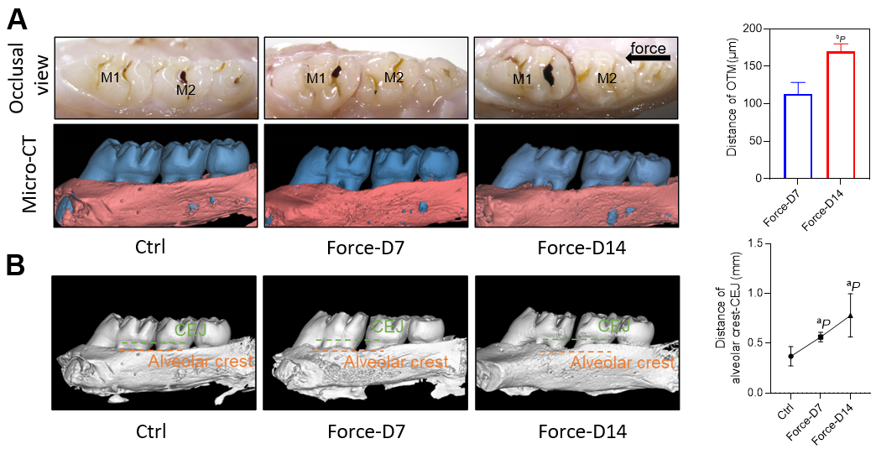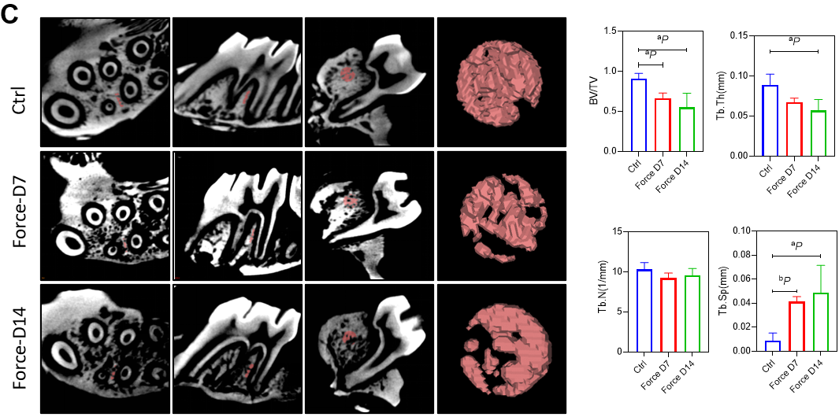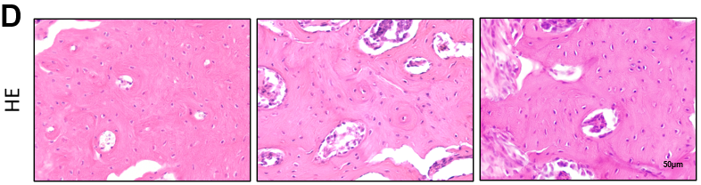
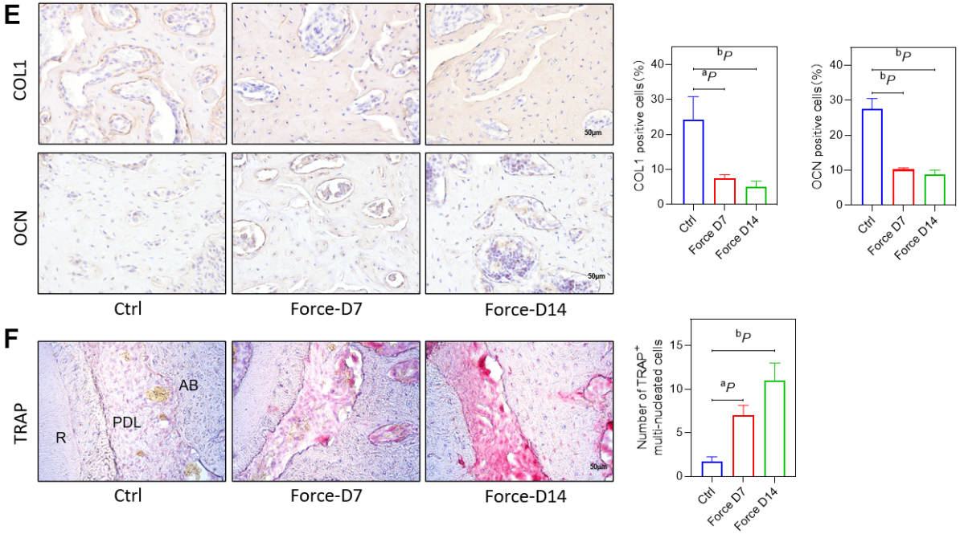
Figure 1 The bone density decreased, and the alveolar bone height decreased on the compression side. A: Representative pictures of the rat tooth movement model and 3D model images reconstructed with Mimics software (left) and the statistical diagram of the tooth movement distance (right); B: Representative images of 3D models reconstructed from micro-computed tomography images showing the distance from the alveolar crest to the cemento-enamel junction (left) and the corresponding statistical analysis (right); C: Representative region of interest (ROI) selection diagrams (left) and statistical analysis (right). A certain volume of alveolar bone on the compressed side of the middle 1/2 root of the distal buccal root of the first molar was selected for subsequent analysis. The statistical analysis of the BV/TV, Tb.Th, Tb.N, Tb.Sp and BS/BV values of the ROI region was performed with Siemens software; D: Representative images of hematoxylin and eosin staining; E: Representative images of immunohistochemical staining for type 1 collagen and osteocalcin (left) and quantitative analyses (right); F: Representative images of tartrate-resistant acid phosphatase (TRAP) staining (left) and counting of TRAP-positive multinuclear (> 3 nuclei) cells (right). ªP < 0.05 vs control group, ^{b}P < 0.01 vs control group. CEJ: Cementum-enamel boundary; HE: Hematoxylin and eosin; TRAP: Tartrate-resistant acid phosphatase; COL1: Type 1 collagen; OCN: Osteocalcin; CT: Computed tomography.

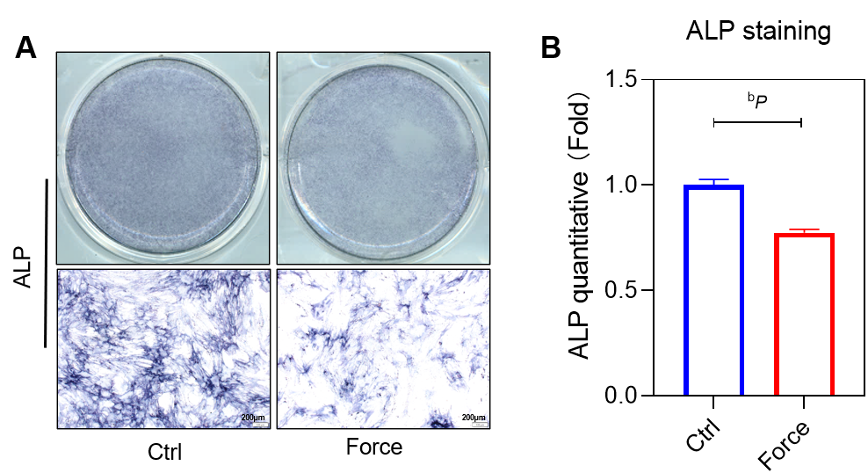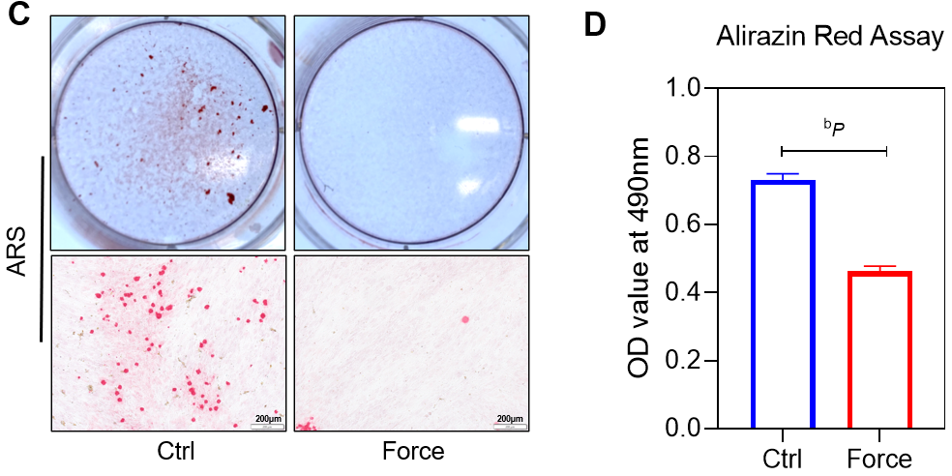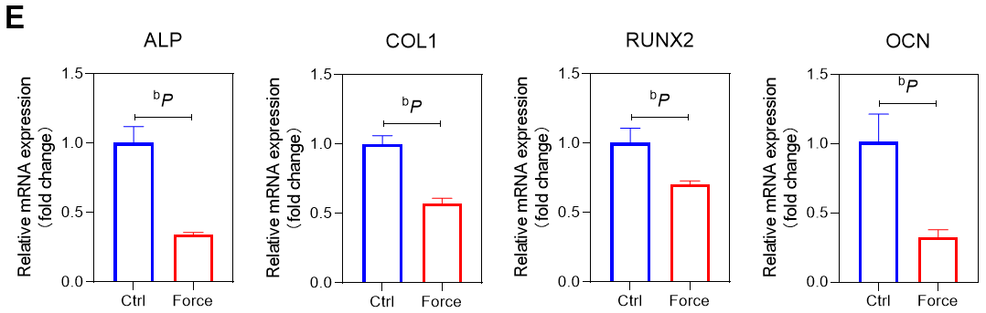
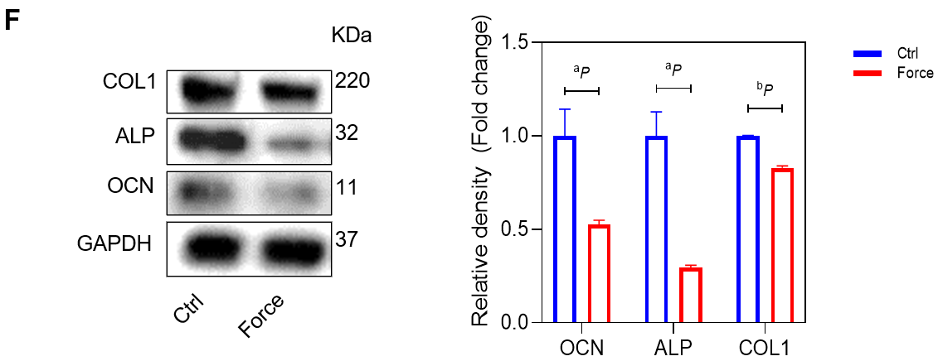
Figure 2 Static pressure inhibits the osteogenic differentiation of bone marrow mesenchymal stem cells in vitro. A and B: Representative alkaline phosphatase (ALP) staining images and statistical analysis; C and D: Representative alizarin red staining images and quantitative data from the alirazin red assay; E: mRNA expression of ALP, type 1 collagen (COL1), runt-related transcription factor 2, and osteocalcin (OCN) folded to control group by quantitative reverse transcription-polymerase chain reaction; F: COL1, ALP, and OCN protein expression in bone marrow mesenchymal stem cells analyzed by Western blotting (left), and the band intensities measured with ImageJ software (right). ªP < 0.05 vs control group, ^{b}P < 0.01 vs control group. ALP: Alkaline phosphatase; RUNX2: Runt-related transcription factor 2; COL1: Type 1 collagen; OCN: Osteocalcin; ARS: Alizarin red staining.

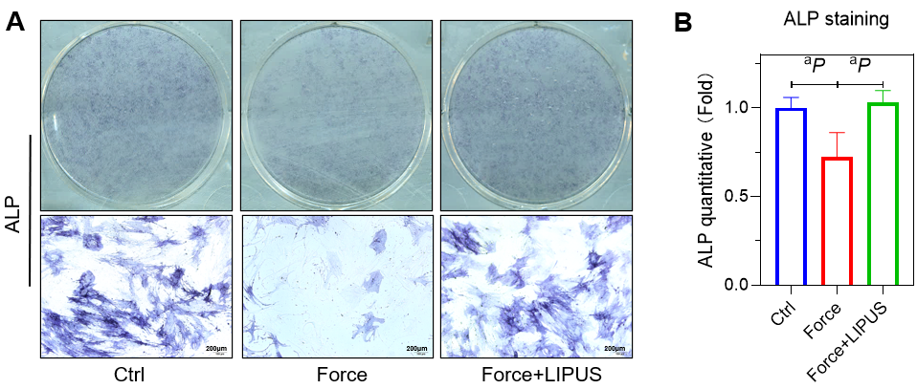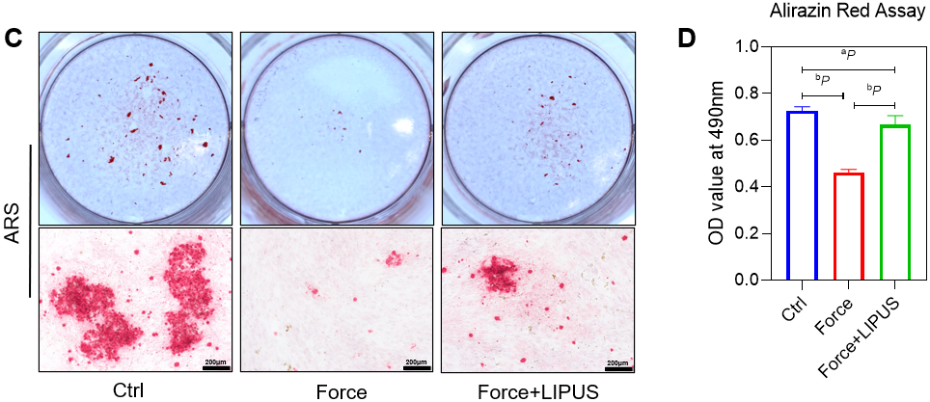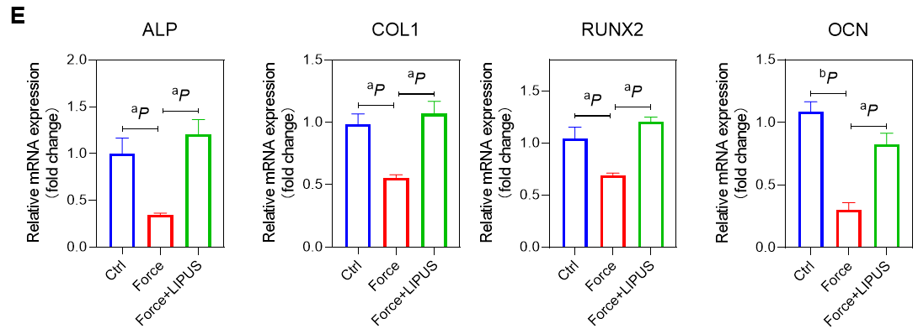
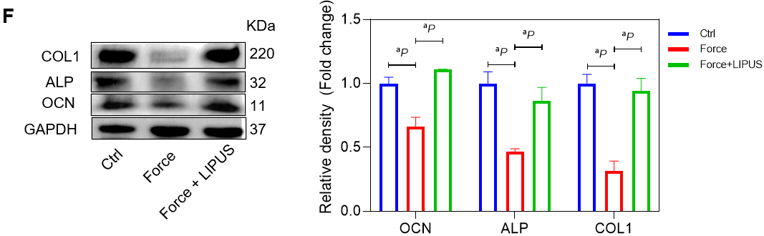
Figure 3 Low-intensity pulsed ultrasound promotes the osteogenesis of bone marrow mesenchymal stem cells. A and B: Representative alkaline phosphatase (ALP) staining images and statistical analysis; C and D: Representative alizarin red staining images and quantitative data from the alirazin red assay; E: mRNA expression of ALP, type 1 collagen (COL1), runt-related transcription factor 2, and osteocalcin (OCN) folded to control group by quantitative reverse transcription-polymerase chain reaction; F: COL1, ALP, and OCN protein expression in rat alveolar bone tissues analyzed via Western blotting (left), and the band intensities measured via ImageJ software (right). ªP < 0.05 vs control group, ^{b}P < 0.01 vs control group. ALP: Alkaline phosphatase; RUNX2: Runt-related transcription factor 2; COL1: Type 1 collagen; OCN: Osteocalcin; LIPUS: Low-intensity pulsed ultrasound; ARS: Alizarin red staining.

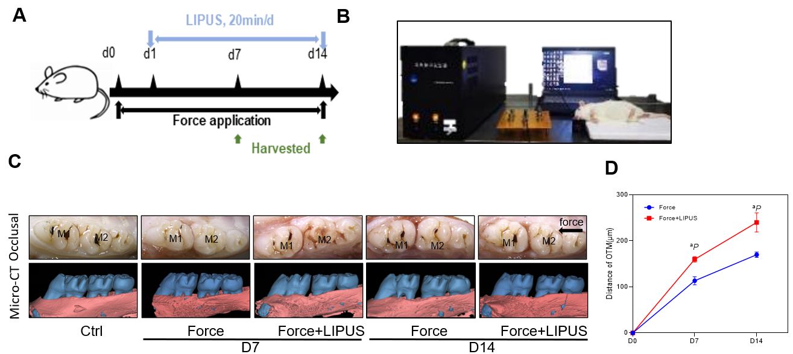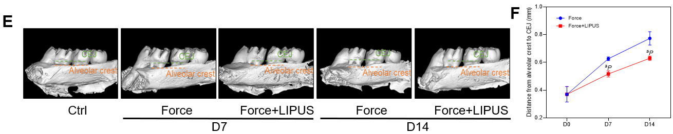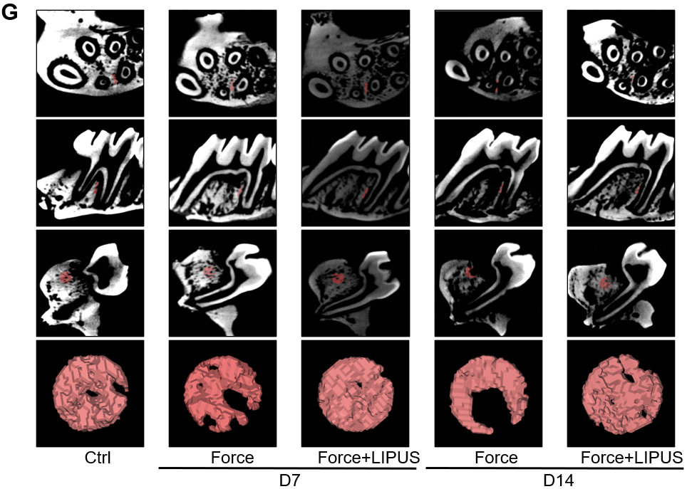
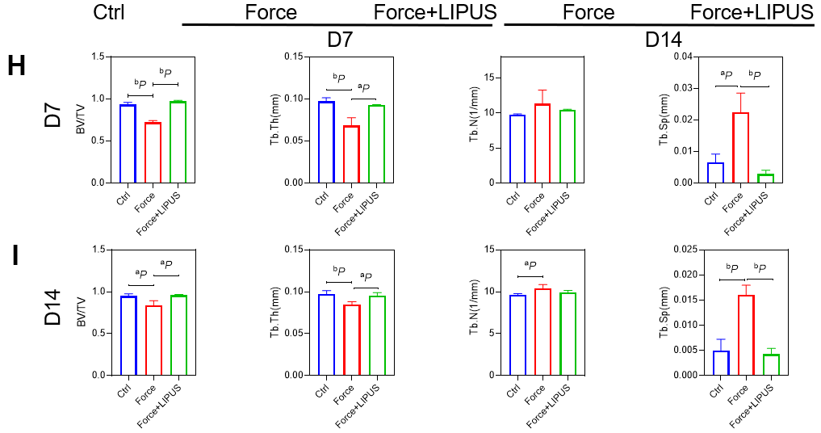
Figure 4 Low-intensity pulsed ultrasound accelerates tooth movement, inhibits alveolar bone resorption, and promotes bone formation. A: Schematic diagram of the animal experiment procedure. The orthodontic tooth movement model was established on day 0. From day 1 to the end point, the force + low-intensity pulsed ultrasound (LIPUS) group was stimulated with LIPUS for 20 min every day until the samples were harvested on days 7 and 14; B: Schematic representation of LIPUS stimulating the maxillary first molar at the corresponding position on the buccal side; C-F: Representative images (C) and 3D reconstructed model images (E). Tooth movement distances (D) and distances from the alveolar crest to the cementum-enamel boundary (F) were measured with Mimics software; G-I: Representative region of interest (ROI) region selection diagrams and statistical analysis of the BV/TV, Tb.Th, Tb.N, Tb.Sp, and BS/BV values of the ROI. ªP < 0.05 vs control group, ^{b}P < 0.01 vs control group. CT: Computed tomography; LIPUS: Low-intensity pulsed ultrasound.

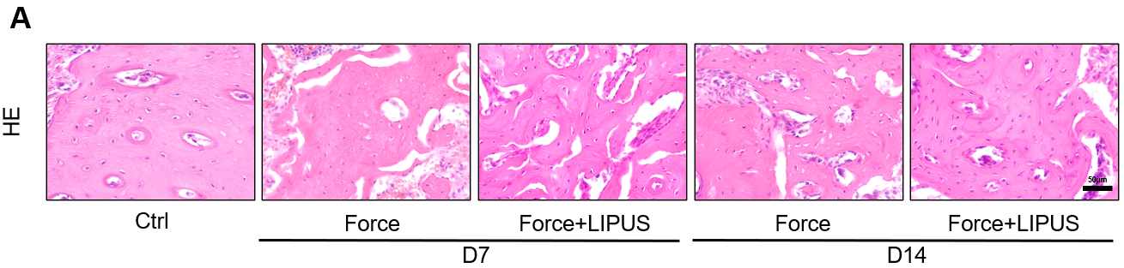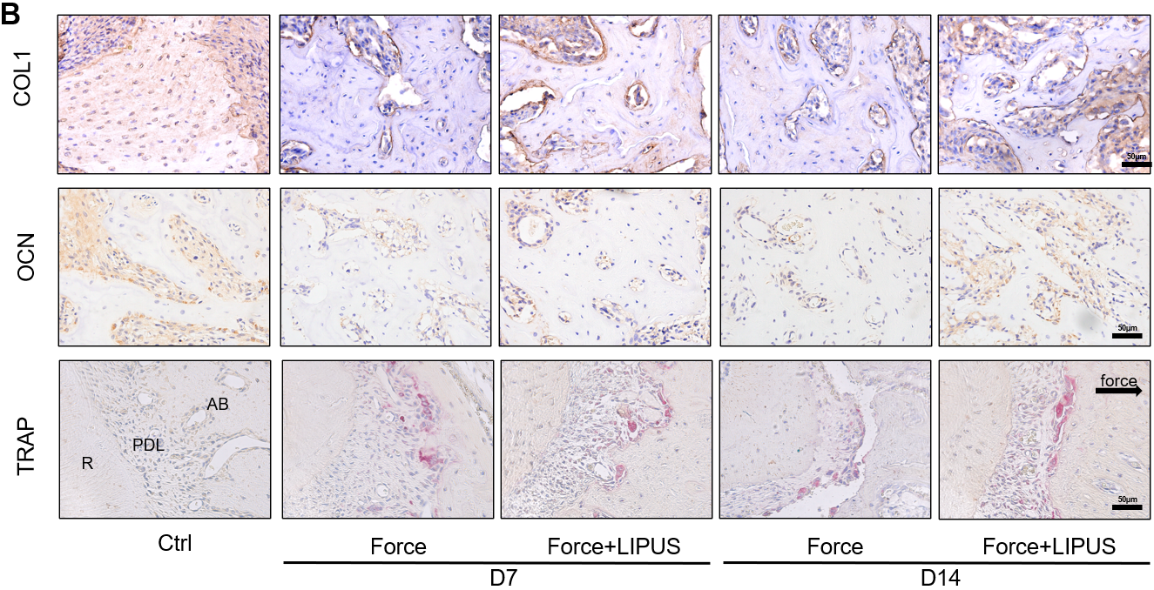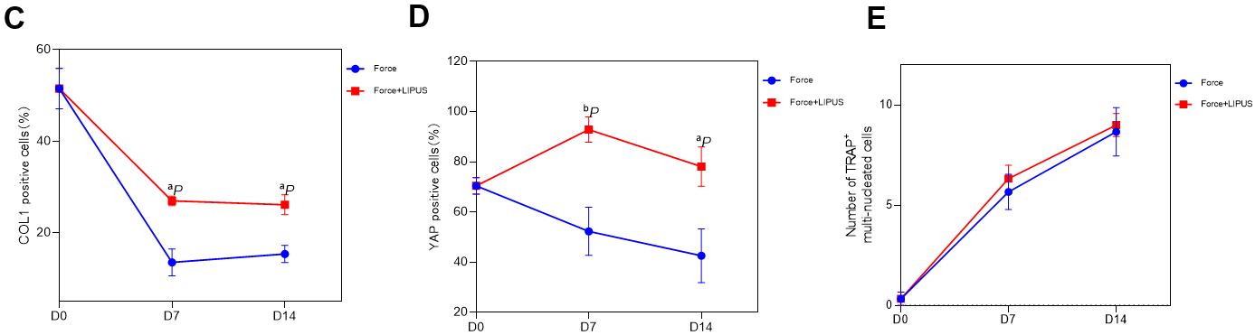
Figure 5 Low-intensity pulsed ultrasound promotes bone formation. A: Representative images of hematoxylin and eosin staining; B: Representative images of immunohistochemical staining for type 1 collagen and osteocalcin and tartrate-resistant acid phosphatase staining (TRAP); C-E: Statistical analyses of the immunohistochemical staining and TRAP staining results. ªP < 0.05 vs control group, ^{b}P < 0.01 vs control group. HE: Hematoxylin and eosin; TRAP: Tartrate-resistant acid phosphatase; COL1: Type 1 collagen; OCN: Osteocalcin; LIPUS: Low-intensity pulsed ultrasound.

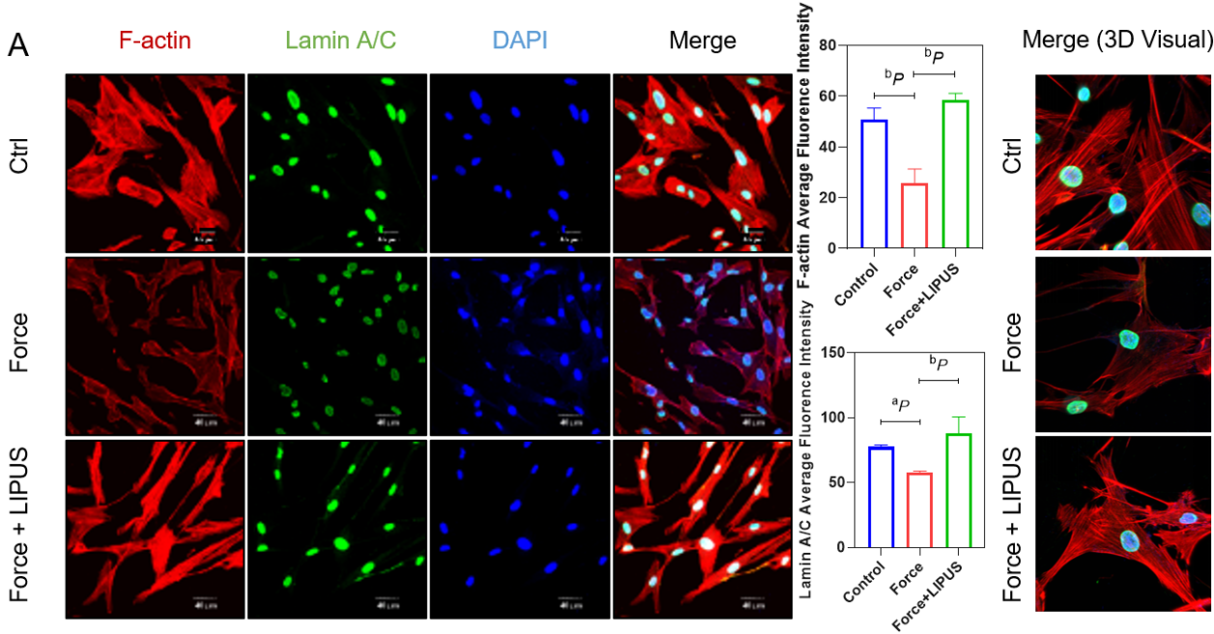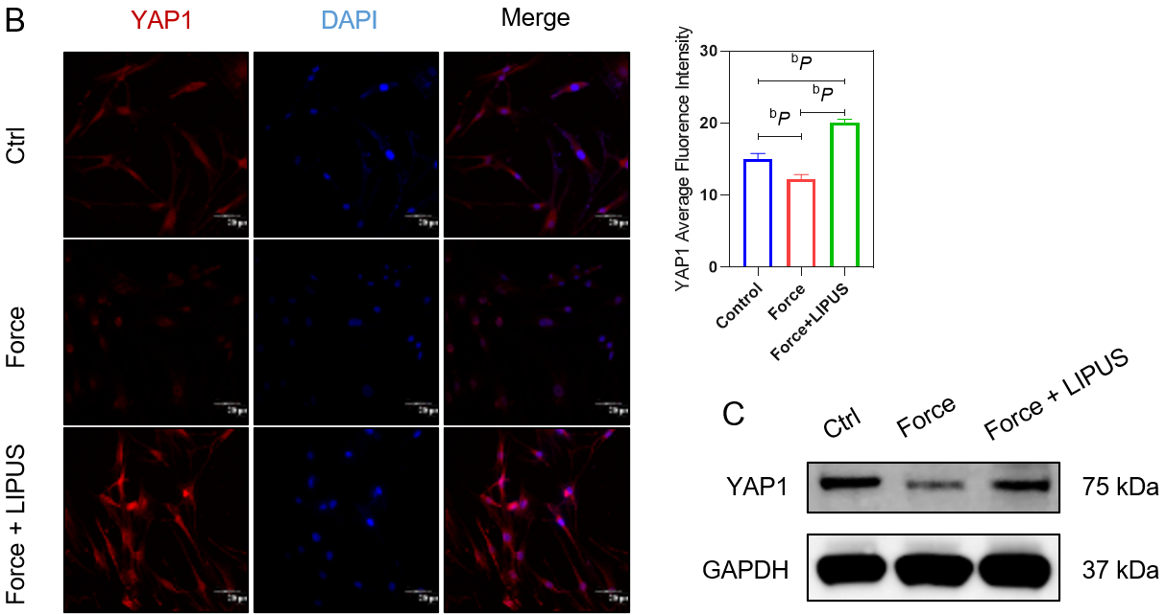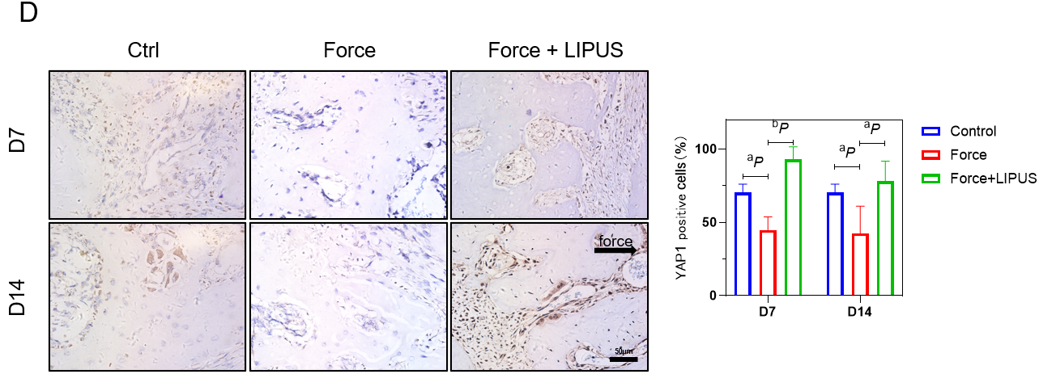
Figure 6 Low-intensity pulsed ultrasound reverses the stress-induced decrease in LaminA/C, F-actin, and Yes-associated protein expression. A: Representative immunofluorescence images of F-actin (red), LaminA/C (green), and DAPI (blue) staining (left) and statistical analyses (middle), as well as representative 3D merged images constructed with Imaris software (right); B: Representative immunofluorescence images of Yes-associated protein (YAP1) (red) and DAPI (blue) staining (left) and statistical analyses (right); C: YAP1 protein expression analyzed by Western blotting; D: Representative images of immunohistochemical staining for YAP1 (left) and statistical analysis (right). ªP < 0.05 vs control group, ^{b}P < 0.01 vs control group. LIPUS: Low-intensity pulsed ultrasound; YAP1: Yes-associated protein.

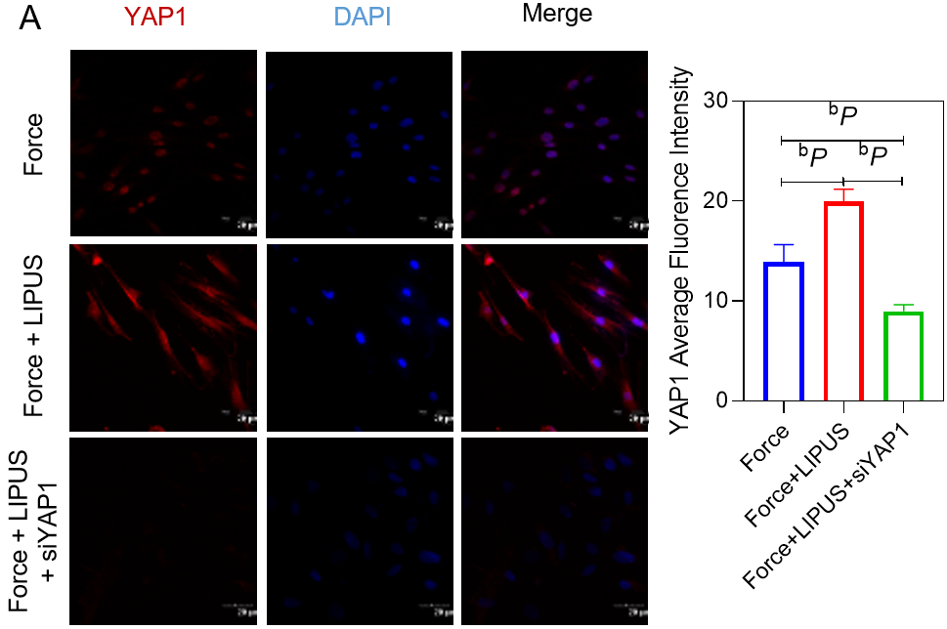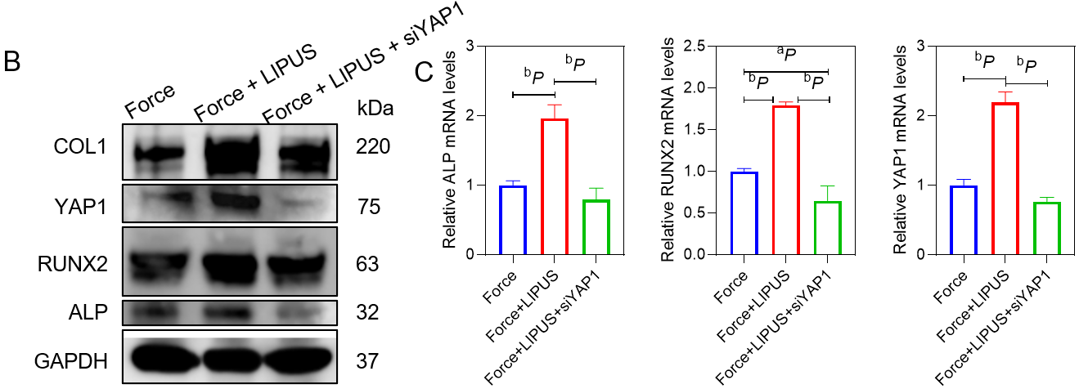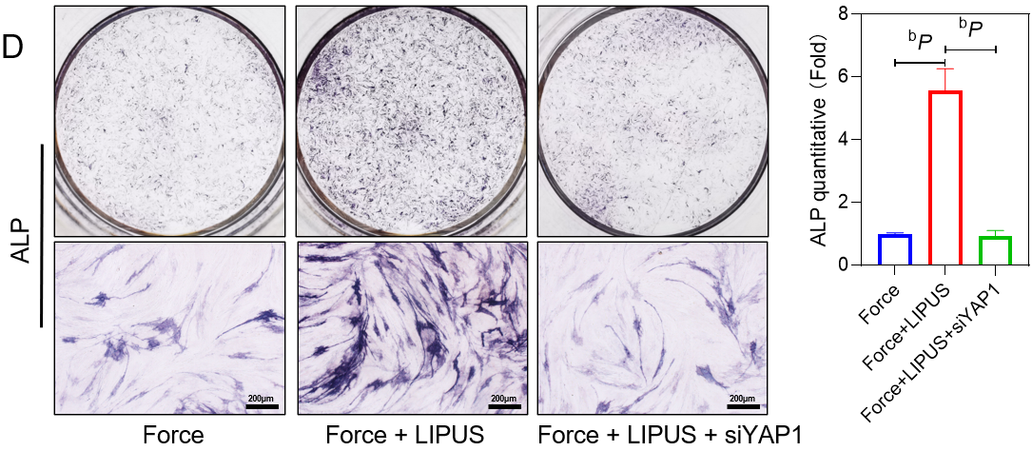
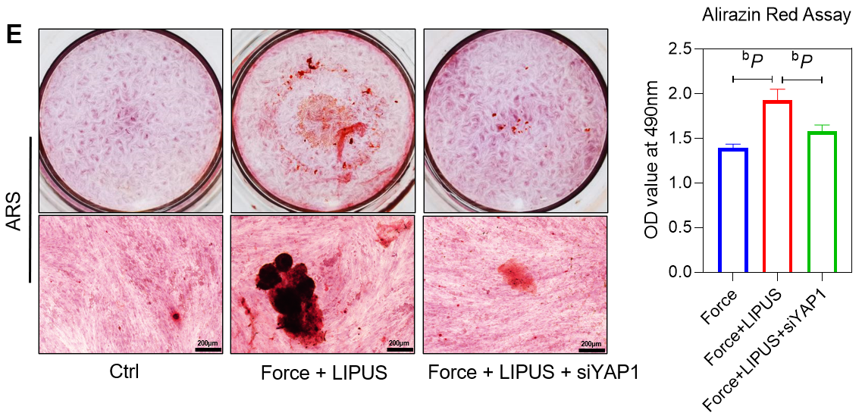
Figure 7 siYAP1 blocks the effect of low-intensity pulsed ultrasound-induced osteogenic differentiation of bone marrow mesenchymal stem cells. A: Representative immunofluorescence images of Yes-associated protein (YAP1) (red) and DAPI (blue) staining (left) and statistical analyses (right); B: Western blotting results for type 1 collagen, YAP1, runt-related transcription factor 2 (RUNX2), and alkaline phosphatase (ALP); C: mRNA expression of ALP, RUNX2, and YAP1 in the force group by quantitative reverse transcription-polymerase chain reaction; D and E: Representative ALP and alizarin red staining staining images and statistical analysis. ªP < 0.05 vs control group, ^{b}P < 0.01 vs control group. ALP: Alkaline phosphatase; COL1: Type 1 collagen; LIPUS: Low-intensity pulsed ultrasound; RUNX2: Runt-related transcription factor 2; YAP1: Yes-associated protein; ARS: Alizarin red staining.

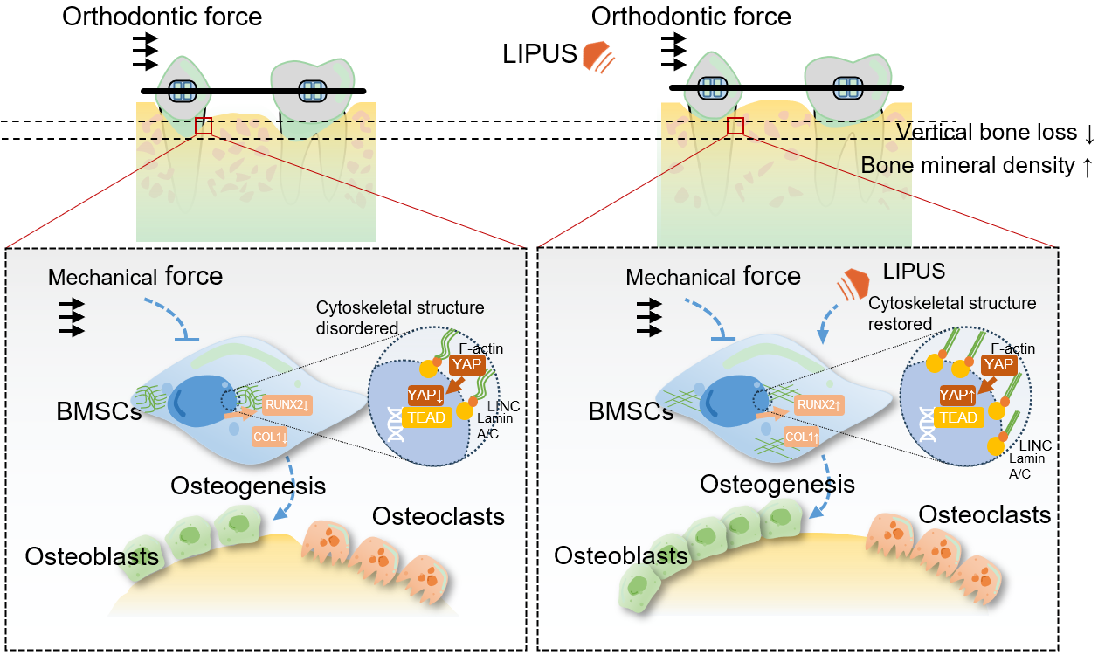
Figure 8 Putative mechanism of the effect of low-intensity pulsed ultrasound on alveolar bone during orthodontic treatment. Low-intensity pulsed ultrasound has little effect on osteoclast differentiation but may rescue osteogenic gene expression suppressed by static force and promote osteoblastic differentiation by reordering the cytoskeleton, upregulating the expression of F-actin and Lamin A/C, and increasing the nuclear translocation of Yes-associated protein 1, thereby contributing to alveolar bone homeostasis and morphology while accelerating tooth movement during orthodontic treatment. COL1: Type 1 collagen; LIPUS: Low-intensity pulsed ultrasound; RUNX2: Runt-related transcription factor 2; BMSC: Bone marrow mesenchymal stem cell; YAP1: Yes-associated protein.

Table 1 Primer sequences for quantitative reverse transcription-polymerase chain reaction
Gene | Primer sequence
GAPDH | Forward | TCATTGACCTCAACTACATG
 | Reverse | TCGCTCCTGGAAGATGGTGAT
RUNX2 | Forward | TGGTTACTGTCATGGCGGGTA
 | Reverse | TCTCAGATCGTTGAACCTTGCTA
ALP | Forward | ACTGGTACTCAGACAACGAGAT
 | Reverse | ACGTCAATGTCCCTGATGTTATG
COL1a1 | Forward | GTGCGATGACGTGATCTGTGA
 | Reverse | CGGTGGTTTCTTGGTCGGT
OCN | Forward | CACTCCTCGCCCTATTGGC
 | Reverse | CAGCAGAGCGACACCCTAGAC
YAP1 | Forward | AGAATCAGTCAGAGTGCTCCAGTG
 | Reverse | CGCAGCCTCTCCTTCTCCATC
ALP: Alkaline phosphatase; RUNX2: Runt-related transcription factor 2; COL: Collagen; OCN: Osteocalcin; YAP1: Yes-associated protein.

