Name of Journal: World Journal of Clinical Cases
Manuscript NO: 70289
Manuscript Type: CASE REPORT

Hemangioma in the lower labial vestibule of an eleven-year-old girl: A case report

Aloyouny AY et al. Hemangioma in the lower labial vestibule

Ashwag Yagoub Aloyouny, Afrah Jaber Alfaifi, Shahad Mohammed Aladhyani, Ahad Ali Alshalan, Hadeel Mohammed Alfayadh, Hend Mahmoud Salem

Ashwag Yagoub Aloyouny, Afrah Jaber Alfaifi, Hend Mahmoud Salem, Department of Basic Dental Science, Princess Nourah Bint Abdulrahman University, Riyadh 11671, Saudi Arabia

Shahad Mohammed Aladhyani, Oral Medicine Special Care Dentistry, Prince Sultan Military Medical City, Riyadh 12211, Saudi Arabia

Ahad Ali Alshalan, Hadeel Mohammed Alfayadh, Department of Dentistry, Ministry of Health, Riyadh 11176, Saudi Arabia

Author contributions: Aloyouny AY contributed to data collection, reviewed the literature, interpreted the data, manuscript drafting and revision; Salem H prepared the specimen in the pathology laboratory and analysed it under the microscope; Alfaifi AJ, Aladhyani SM, Alshalan AA, and Alfayadh HM contributed to data collection, and manuscript drafting.

Supported by the Deanship of Scientific Research at Princess Nourah Bint Abdulrahman University Through the Fast-Track Research Funding Program.

Corresponding author: Ashwag Yagoub Aloyouny, DDS, Doctor, Department of Basic Dental Science, Princess Nourah Bint Abdulrahman University, King Khalid International Rd, Riyadh 11671, Saudi Arabia. ayaloyouny@pnu.edu.sa

Received: July 31, 2021
Revised: October 30, 2021
Accepted: December 31, 2021
Published online: February 16, 2022

Abstract
BACKGROUND
Hemangioma is a vascular benign tumour of endothelial origin. It appears commonly in the first decade of life with increases incidence in females. Hemangioma is not common to happen in the oral cavity and it is extremely rare to appear in the labial vestibule.

CASE SUMMARY
We present a case of an 11-year-old girl who complained of a painful, slowly growing mass which was consistent with the capillary hemangioma in the left mandibular vestibule. Vascular tumor such as hemangioma in the mandibular vestibule is extremely rare; hence, the clinical definitive diagnosis is very challenging. Therefore, radiographic imaging and histopathologic analysis are crucial to reach to the final diagnosis for proper management.

CONCLUSION
Comprehensive clinical evaluation, proper diagnostic imaging and microscopic analysis of the mass establish a precise diagnosis of the hemangioma for better management.

Key Words: Capillary hemangioma; Vascular malformation; Labial vestibule; Childhood; Case report

©The Author(s) 2022. Published by Baishideng Publishing Group Inc. All rights reserved.

Citation: Aloyouny AY, Alfaifi AJ, Aladhyani SM, Alshalan AA, Alfayadh HM, Salem HM. Hemangioma in the lower labial vestibule of an eleven-year-old girl: A case report. World J Clin Cases 2022; 10(5): 1617-1622
URL: https://www.wjgnet.com/2307-8960/full/v10/i5/1617.htm
DOI: https://dx.doi.org/10.12998/wjcc.v10.i5.1617

Core Tip: Although hemangioma rarely occurs in the oral cavity, it should be considered in the diagnosis of a red-bluish isolated mass. In this case report, the patient presented with a painful, slowly growing mass in the left labial vestibule which resulted in asymmetry and swelling of the lower lip. The final diagnosis of the mass was consistent with capillary hemangioma in the mandibular vestibule. Early detection and treatment of oral masses is essential to avoid any complications.

INTRODUCTION
Hemangioma commonly appears early in life with increases incidence in females more than males. It usually gets smaller with time until it completely disappears. Mulliken et al^{[1]} (1982) published the novel classification of vascular lesion and the International Society for the Study of Vascular Anomalies (2018) has provided updated guidelines for vascular anomalies classification. Accordingly, the vascular anomalies have been classified into vascular malformations and vascular tumors. Vascular tumors include non-harmful, locally destructive, and malignant lesions, whereas vascular malformations include simple and combined malformations.
Hemangiomas are vascular benign tumours of endothelial origin, presenting clinically with varying sizes and shapes. In some cases, hemangioma could cause functional disability and disfiguring appearance, which may lead to psychological issues. Histologically, hemangioma has another classification, into either cavernous or capillary types.
Hemangioma is uncommon to occur in the oral cavity and it is extremely rare to appear in the labial vestibule. To our knowledge and based on the review of English literature (PubMed), this case is the first report of capillary hemangioma in the mandibular vestibule. In this report, we present an 11-year-old girl patient complaining of a slowly growing mass that caused labial swelling and asymmetry. The diagnosis was consistent with capillary hemangioma in the mandibular vestibule.

CASE PRESENTATION
Chief complaints
An 11-year-old healthy girl was referred to the oral and maxillofacial surgery clinic for evaluation of labial asymmetry and swelling.

History of present illness
The patient had a two-month-history of a slowly growing lesion in the left side of the lower labial vestibule accompanied with persistent mild pain. The patient and her parents reported no history of trauma at the site of the mass.

History of past illness
The patient was healthy and did not undergo any surgeries.

Personal and family history
The parents revealed no significant family history and no genetic abnormalities.

Physical examination
Physical and systemic examination: The patient was healthy and had only taken Tylenol 15 mg as needed for fever.

Extraoral examination: Extraoral examination showed lower lip asymmetry and swelling in the left side.

Intraoral examination: Intraoral examination showed a 2.0-1.5 cm, solitary, fluctuant, bluish, smooth, palpable submucosal mass, rubbery in consistency, tender, and blanch on pressure (positive diascopy test). The submucosal mass located in the left mandibular vestibule opposite to tooth number 32 and 33 (23 and 33, according to the FDI World Dental Federation Notation) (Figure 1).

Imaging examinations
A panoramic radiograph showed normal structures with no significant pathologic findings. Additionally, Color-Doppler-ultrasound was performed to confirm the nature of the lesion. The imaging interpretation revealed a slow-flow vascular lesion in the left lower vestibule and attached to the lower orbicularis oris muscle.

FINAL DIAGNOSIS
The final diagnosis was based on histopathological analysis. The histopathological diagnosis was consistent with capillary hemangioma in the labial vestibule (Figure 2).

TREATMENT
Complete surgical removal of the lesion to reduce the risk of the recurrence.

OUTCOME AND FOLLOW-UP
At two-, four- and eight-week-follow up, the site of the surgery healed well with no sign of bleeding, infection, and swelling. At one- and three-year- follow up, there was no recurrence of the lesion or complications noted. Additionally, the patient was in a good health.

DISCUSSION
In 1982, vascular anomalies were categorised into two main categories: Vascular malformations and vascular tumors. Hemangiomas are true neoplasms represented by increased rate and proliferation of endothelial cell turnover. On the other hand, vascular malformations are localised abnormality and disorganisation of the blood vessel caused by defects in vascular development^{[1-3]}. Simple vascular malformations are classified histologically, based on the vessel size, into capillary, venous, lymphatics, arteriovenous fistula, and arteriovenous malformations. Vascular lesions are further categorised into non-harmful, locally destructive, and malignant lesions^{[4]}. Namely, hemangioma is a neoplasm of endothelial origin which is commonly found in the early years of life and then the neoplasm regresses gradually with age^{[5]}. Intraoral and intramuscular hemangiomas are rare, dissimilar to cutaneous and subcutaneous hemangiomas. Oral hemangiomas could occur in more than 6% of infants and have high prevalence in female presenting 3:1 (female:male). Infants are more likely to develop oral hemangiomas if they fall in one of the following conditions; infants who are born to older mothers, twins or triplets, premature, or have low birth weight^{[6]}. Hemangioma is a common vascular benign tumor which falls under the category of benign vascular tumors and it is further divided into capillary and cavernous hemangioma^{[2]}.
Capillary hemangioma is a common lesion, but it rarely occurs in the oral cavity. According to Matsumoto et al^{[7]}, 45.2% of capillary hemangiomas occur on buccal mucosa, 35.5% on the tongue, and only a small percentage occur in the lip, gingiva and palate. Capillary hemangiomas are firm in consistency and have a limited history of symptoms. Although the exact cause of oral hemangioma is not fully understood, hormonal changes, embolic phenomenon and genetic mutations are believed to play an important role in the tumor development^{[8]}.
Hemangiomas are hypothesised to develop because of both angiogenesis and vasculogenesis through three different stages, as follows: Endothelial cell proliferation stage, rapid growth stage and spontaneous disappearance. Endothelial cell proliferation is stimulated by many factors, such as basic fibroblast growth factor, vascular endothelial growth factor and transforming growth factor-beta. Then, the quantity of endothelial cells is sustained, and each cell increases in size, leading to comprehensive enlargement of the structure size. At the end, spontaneous involution occurs when the endothelial cells are replaced by connective tissue, adipose, and fibroblast, and the number of small vessels decrease in quantity^{[9]}.
Hemangioma could be classified clinically as congenital or infantile (previously named strawberry or juvenile). Congenital hemangioma presents at birth and does not demonstrate proliferation stage. In contrast, infantile hemangioma may develop at the first months of the infant life and show a proliferative phase during the period of six to twelve months; then, most cases spontaneously regress between the age of six to nine years. High percentage of hemangiomas disappear completely in childhood, with < 20% carrying on to puberty^{[10,11]}. Oral hemangioma presents as a solitary, soft, fluctuant, compressible, smooth, red, or bluish submucosal mass. Significant variations may present based on the depth and site of the mass. Superficial masses are easy to visualise and may present as pedunculated, sessile, or lobulated and reddish in colour. In contrast to deeper masses, they appear as a dark blue discolouration recognisable from surrounding normal colour mucosa. It also reveals tenderness on palpation and blanch on compression with glass slide (positive diascopy test)^{[12]}. In this case, the differential diagnosis of the tumor was written down as vascular anomalies, including hemangioma, and vascular malformation, including venous, capillary, lymphatic and arterial malformations. Salivary gland tumor, mucocele and angioleiomyoma were also considered.
It is worth mentioning that vascular malformations, salivary gland tumor, mucocele and angioleiomyoma were all excluded because the lesion showed a slow-flow vascular lesion by using Colour-Doppler-ultrasound, which is highly consistent with hemangioma.
Histological analysis of vascular anomalies, including capillary hemangioma, is still the most acceptable and accurate method of diagnosis^{[3]}. Microscopic description of capillary hemangioma illustrates several dilated capillaries lined by endothelial cells, filled with blood, and surrounded by inflammatory infiltrate.
Hemangioma is mostly characterised by its benign feature and has high tendency of involution by itself over time. However, sometimes hemangioma requires intervention, especially in case of impairment in breathing, swallowing and speech. The first line of evaluation and diagnosis would be by Color-Doppler ultrasound imaging. This imaging modality is non-invasive, cost-effective and has no risk of radiation. If intraosseous lesion is anticipated, other imaging modalities could be useful for the diagnosis, such as a contrast-enhanced magnetic resonance imaging (MRI), computed tomography (CT), and angiography^{[13]}. A contrast-enhanced MRI and CT imaging identify the shape, size, and calcification of the tumor. The Color-Doppler ultrasound imaging modality was the suitable choice for the patient due to many factors, such as financial issues and the age of the patient^{[14]}.
Choosing a suitable method for managing hemangioma is based on multiple factors such as the aesthetic consideration, clinical nature, size, site, growth rate, accessibility, extent of the tumor, and age of the patient. Hemangioma could be managed by different ways; for instance, surgical excision of the tumor, embolization, electrosurgery, cryosurgery, laser, steroid injection, or sclerosing materials. In case of small oral hemangioma, the commonly used method is the total surgical excision of the whole mass to decrease the potential risk of recurrence^{[15]}. However, if the lesion is large and located in a significant part of the mouth, such as the tongue, in this case the surgical excision of the lesion would not be preferred, so as to avoid post-surgical complications in swallowing and speech. Sclerotherapy is recommended to manage large hemangiomas in the oral cavity in which 3% sodium tetradecyl sulfate or ethanolamine oleate is injected into the main vessels of the lesion to destroy the endothelial cells, leading to lesion destruction. Precautionary measures should be taken to avoid bleeding during the surgical procedure or afterward during recovery phase. In the present case, the tumor was excised surgically with a thin rim of the attached orbicularis oris muscle to decrease the risk of recurrence^{[16,17]}.

CONCLUSION
Although hemangioma rarely appears in the oral cavity, it should be considered in the diagnosis of a red-bluish isolated mass. Comprehensive clinical evaluation, proper diagnostic imaging and microscopic analysis of the mass establish a precise diagnosis of the hemangioma for better treatment.

REFERENCES
1 Mulliken JB, Glowacki J. Hemangiomas and vascular malformations in infants and children: a classification based on endothelial characteristics. Plast Reconstr Surg 1982; 69: 412-422 [PMID: 7063565 DOI: 10.1097/00006534-198203000-00002]
2 Merrow AC, Gupta A, Patel MN, Adams DM. 2014 Revised Classification of Vascular Lesions from the International Society for the Study of Vascular Anomalies: Radiologic-Pathologic Update. Radiographics 2016; 36: 1494-1516 [PMID: 27517361 DOI: 10.1148/rg.2016150197]
3 Larsen AK, Damsgaard TE, Hedelund L. [Classification of vascular anomalies]. Ugeskr Laeger 2018; 180 [PMID: 30187855]
4 Allen PW, Enzinger FM. Hemangioma of skeletal muscle. An analysis of 89 cases. Cancer 1972; 29: 8-22 [PMID: 5061701 DOI: 10.1002/1097-0142(197201)29:1<8::aid-cncr2820290103>3.0.co;2-a]
5 Kale US, Ruckley RW, Edge CJ. Cavernous haemangioma of the parapharyngeal space. Indian J Otolaryngol Head Neck Surg 2006; 58: 77-80 [PMID: 23120244 DOI: 10.1007/BF02907748]
6 Corrêa PH, Nunes LC, Johann AC, Aguiar MC, Gomez RS, Mesquita RA. Prevalence of oral hemangioma, vascular malformation and varix in a Brazilian population. Braz Oral Res 2007; 21: 40-45 [PMID: 17384854 DOI: 10.1590/s1806-83242007000100007]
7 Matsumoto N, Tsuchiya M, Nomoto S, Matsue Y, Nishikawa Y, Takamura T, Oki H, Komiyama K. CD105 expression in oral capillary hemangiomas and cavernous hemangiomas. J Oral Sci 2015; 57: 45-53 [PMID: 25807908 DOI: 10.2334/josnusd.57.45]
8 Marchuk DA. Pathogenesis of hemangioma. J Clin Invest 2001; 107: 665-666 [PMID: 11254664 DOI: 10.1172/JCI12470]
9 Greenberger S, Bischoff J. Pathogenesis of infantile haemangioma. Br J Dermatol 2013; 169: 12-19 [PMID: 23668474 DOI: 10.1111/bjd.12435]
10 George A, Mani V, Noufal A. Update on the classification of hemangioma. J Oral Maxillofac Pathol 2014; 18: S117-S120 [PMID: 25364160 DOI: 10.4103/0973-029X.141321]
11 Nayak SK, Nayak P. Intramuscular hemangioma of the oral cavity - a case report. J Clin Diagn Res 2014; 8: ZD41-ZD42 [PMID: 25302283 DOI: 10.7860/JCDR/2014/8305.4756]
12 da Silva WB, Ribeiro AL, de Menezes SA, de Jesus Viana Pinheiro J, de Melo Alves-Junior S. Oral capillary hemangioma: a clinical protocol of diagnosis and treatment in adults. Oral Maxillofac Surg 2014; 18: 431-437 [PMID: 24263242 DOI: 10.1007/s10006-013-0436-z]
13 Gianfranco G, Eloisa F, Vito C, Raffaele G, Gianluca T, Umberto R. Color-Doppler ultrasound in the diagnosis of oral vascular anomalies. N Am J Med Sci 2014; 6: 1-5 [PMID: 24678469 DOI: 10.4103/1947-2714.125852]
14 Ghanem AA, El Hadidi YN. Management of a Life Threatening Bleeding Following Extraction of Deciduous Second Molar Related to a Capillary Haemangioma. Craniomaxillofac Trauma Reconstr 2017; 10: 166-170 [PMID: 28523092 DOI: 10.1055/s-0037-1598102]
15 Barrón-Peña A, Martínez-Borras MA, Benítez-Cárdenas O, Pozos-Guillén A, Garrocho-Rangel A. Management of the oral hemangiomas in infants and children: Scoping review. Med Oral Patol Oral Cir Bucal 2020; 25: e252-e261 [PMID: 31967983 DOI: 10.4317/medoral.23329]
16 Bonet-Coloma C, Mínguez-Martínez I, Palma-Carrió C, Galán-Gil S, Peñarrocha-Diago M, Mínguez-Sanz JM. Clinical characteristics, treatment and outcome of 28 oral haemangiomas in pediatric patients. Med Oral Patol Oral Cir Bucal 2011; 16: e19-e22 [PMID: 20711165 DOI: 10.4317/medoral.16.e19]
17 Stuepp RT, Scotti FM, Melo G, Munhoz EA, Modolo F. Effects of sclerosing agents on head and neck hemangiomas: A systematic review. J Clin Exp Dent 2019; 11: e1033-e1044 [PMID: 31700578 DOI: 10.4317/jced.56143]

Footnotes
Informed consent statement: Informed written consent was obtained from the patient for publication of this case report and accompanying images.

Conflict-of-interest statement: The authors declare that they have no conflicts of interest.

CARE Checklist (2016) statement: The authors have read the CARE Checklist (2016) and have prepared and revised the manuscript accordingly.

Open-Access: This article is an open-access article that was selected by an in-house editor and fully peer-reviewed by external reviewers. It is distributed in accordance with the Creative Commons Attribution NonCommercial (CC BY-NC 4.0) license, which permits others to distribute, remix, adapt, build upon this work non-commercially, and license their derivative works on different terms, provided the original work is properly cited and the use is non-commercial. See: http://creativecommons.org/Licenses/by-nc/4.0/

Provenance and peer review: Unsolicited article; Externally peer reviewed.
Peer-review model: Single blind

Corresponding Author's Membership in Professional Societies: American Academy of Oral Medicine.

Peer-review started: July 31, 2021
First decision: October 22, 2021
Article in press: December 31, 2021

Specialty type: Dentistry, oral surgery and medicine
Country/Territory of origin: Saudi Arabia
Peer-review report’s scientific quality classification
Grade A (Excellent): 0
Grade B (Very good): 0
Grade C (Good): C, C
Grade D (Fair): 0
Grade E (Poor): 0

P-Reviewer: Feng J, Zhao GH S-Editor: Liu JH L-Editor: A P-Editor: Liu JH
Figure Legends
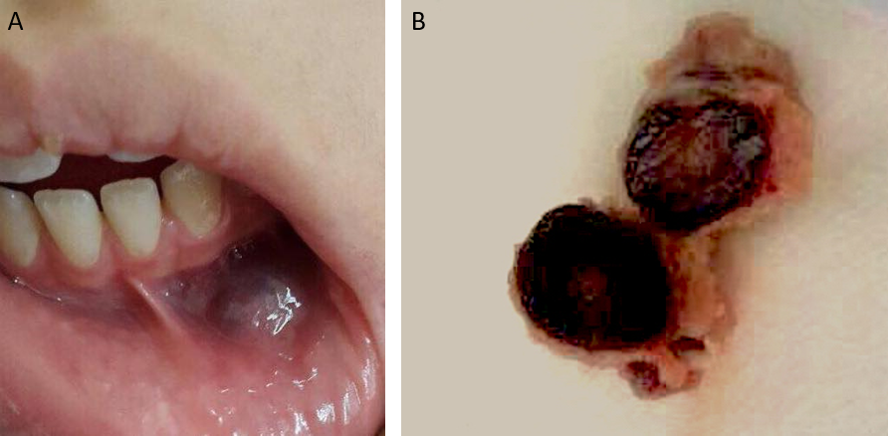
Figure 1 Intraoral examination and gross examination of the surgical specimen. A: Intraoral lesion measuring 2.0-1.5 cm, solitary, fluctuant, bluish, smooth, palpable submucosal mass located in the left mandibular vestibule; B: A single, solid mass, bluish in color, and rubbery in consistency.

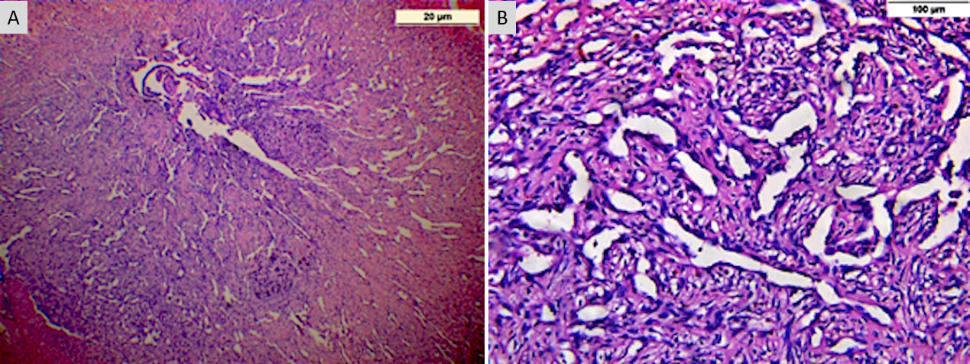
Figure 2 Histopathological analysis showed numerous thin-walled blood vessels with dilated blood vessel spaces, areas of hemorrhage and chronic inflammatory cell infiltrate which is consistent with capillary hemangioma in the labial vestibule. A: 20 μm; B: 100 μm.

Published by Baishideng Publishing Group Inc
7041 Koll Center Parkway, Suite 160, Pleasanton, CA 94566, USA
Telephone: +1-925-3991568
E-mail: bpgoffice@wjgnet.com
Help Desk: https://www.f6publishing.com/helpdesk
https://www.wjgnet.com

© 2022 Baishideng Publishing Group Inc. All rights reserved.

