Name of journal: World Journal of Gastroenterology
ESPS Manuscript NO: 24559
Manuscript Type: ORIGINAL ARTICLE

Basic Study
miR-106b promotes cancer progression in hepatitis B virus-associated hepatocellular carcinoma

Yen CS et al. miR-106b promotes HCC progression

Chia-Sheng Yen, Zhi-Ru Su, Yi-Ping Lee, I-Ting Liu, Chia-Jui Yen

Chia-Sheng Yen, Institute of Clinical Medicine, National Cheng Kung University, Tainan 70101, Taiwan

Chia-Sheng Yen, Department of General Surgery, Chi Mei Medical Center, Tainan 71004, Taiwan

Zhi-Ru Su, Yi-Ping Lee, I-Ting Liu, Chia-Jui Yen, Division of Hematology and Oncology, Department of Internal Medicine, National Cheng Kung University Hospital, College of Medicine, National Cheng Kung University, Tainan 70403, Taiwan

Author contributions: Yen CS and Yen CJ designed the study; Su ZR performed the experiments; Lee YP, Su ZR, Liu IT analyzed the data; Liu IT collected the clinical samples; Yen CS, Lee YP, Su ZR, Yen CJ drafted the manuscript.

Supported by National Cheng Kung University Hospital Research Fund, No. NCKUH-10103002.

Institutional review board statement: This study was reviewed and approved through the National Cheng Kung University Hospital Institutional Review Board.

Conflict-of-interest statement: The authors have no conflicts of interest to declare.

Data sharing statement: No additional data are available.

Open-Access: This article is an open-access article which was selected by an in-house editor and fully peer-reviewed by external reviewers. It is distributed in accordance with the Creative Commons Attribution Non Commercial (CC BY-NC 4.0) license, which permits others to distribute, remix, adapt, build upon this work non-commercially, and license their derivative works on different terms, provided the original work is properly cited and the use is non-commercial. See: http://creativecommons.org/licenses/by-nc/4.0/

Correspondence to: Chia-Jui Yen, MD, PhD, Associate Professor, Division of Hematology and Oncology, Department of Internal Medicine, National Cheng Kung University Hospital, College of Medicine, National Cheng Kung University, 138 Sheng-Li Road, Tainan 70403, Taiwan. yencj@mail.ncku.edu.tw
Telephone: +886-6-2353535-4620
Fax: +886-6-2752037

Received: January 27, 2016
Peer-review started: January 28, 2016
First decision: March 7, 2016
Revised: March 24, 2016
Accepted: April 7, 2016

Article in press:
Published online:

Abstract
AIM: To investigate the effect of miR-106b on tumor progression in hepatitis B virus (HBV)-associated hepatocellular carcinoma (HCC).

METHODS: A total of 120 patients who underwent liver resection for HCC at National Cheng Kung University Hospital were enrolled in the present study. MicroRNA (miRNA) array was first used to screen the miRNA expression profiles in HCC patients. The clinical records were retrospectively analyzed, and correlations with the miRNA expression profiles were evaluated. The mRNA expression levels of the miR-106b-25 cluster (miR-106b, miR-93 and miR-25), and MCM7 in tumor and non-tumor samples were quantitated using quantitative real-time reverse transcription-polymerase chain reaction (q-RT-PCR) analysis, and correlations in the levels of miR-106b, miR-93 and miR-25 expression were calculated. Kaplan-Meier overall and disease-free survival rates of HBV-associated HCC patients were analyzed using the log-rank test based on miR-106b expression. The comparison of the miR-106b expression levels in patients with different clinical outcomes was analyzed using Mann-Whitney U tests. Furthermore, a hepatitis B virus X protein (HBx) expression plasmid was transfected into Huh7 and Hep 3B cells. The expression levels of the miR-106b-25 cluster and MCM7 in HBx-expressing Huh7 and Hep 3B cells were detected using q-RT-PCR.

RESULTS: miRNA array screening showed that miR-106b and its cluster, miR-93 and miR-25 were up-regulated in HCC patients (P < 0.01). The value of miR-106b expression in HBV-associated HCC patients was significantly higher than that in HCV- (P < 0.05) or non-B/non-C- (P < 0.001) associated HCC patients. The expression of the miR-106b-25 cluster was significantly higher in tumor tissue (P < 0.001) and associated with the host gene, MCM7, in clinical specimens from HBV-associated HCC patients. Furthermore, the expression levels of miR-106b, miR-93 and miR-25 were positively correlated in HBV-associated HCC tissues (miR-106 vs miR-93, r = 0.75; miR-93 vs miR-25, r = 0.69; miR-106b vs miR-25, r = 0.33). The overall and disease-free survival curves showed that high-miR-106b expression was correlated with the poor prognosis of HBV-associated HCC. HCC differentiation was significantly correlated with miR-106b expression (P < 0.05). Lower miR-106b expression levels resulted in the well differentiation of HCC. Moreover, the expression of the miR106b-25 cluster and MCM7 was up-regulated in Huh7 and Hep 3B cells after transfection with the HBx expression plasmid.

CONCLUSION: The data obtained in the present study suggests that HBx enhances miR-106b transcription to promote tumor progression in HBV-associated HCC.

Key words: miR-106b; Hepatitis B virus; Hepatocellular carcinoma; Tumor progression; Hepatitis B virus X protein

© The Author(s) 2016. Published by Baishideng Publishing Group Inc. All rights reserved.

Core tip: The role of miR-106b in tumor progression of hepatitis B virus (HBV)-associated hepatocellular carcinoma (HCC) and how it be regulated are still unclear. In this study, we analyzed the expression levels of miR-106b in HBV-associated HCC tissues and correlated the data with clinical records of patients. Our results indicated that miR-106b expression was up-regulated and related with tumor progression in HBV-associated HCC. In addition, hepatitis B virus X protein may contribute to enhance the transcription of miR-106b. These findings provide potential diagnostic and therapeutic targets for HBV-associated HCC.

Yen CS, Su ZR, Lee YP, Liu IT, Yen CJ. miR-106b promotes cancer progression in hepatitis B virus-associated hepatocellular carcinoma. World J Gastroenterol 2016; In press
INTRODUCTION
Hepatocellular carcinoma (HCC) ranks among the 10 most common cancers in the world and is a major cause of cancer death in Southeast Asian countries^{[1,2]}. The carcinogenesis of HCC is a multi-factor, multi-step and complex process, associated with chronic and persistent hepatitis B virus (HBV) infection^{[3,4]}. Chronic hepatitis infection causes liver inflammation damage, subsequent fibrosis, liver cell regeneration and liver cell proliferation leading to the malignant transformation of the liver^{[5]}. Most HCC patients die as a result of the rapid tumor progression and hepatic resection or transplantation is the only potential curative treatment for HCC patients when the HCC is diagnosed early^{[6]}. However, the effective diagnostic and therapeutic targets remain unclear.
Several mechanisms of HBV-related tumorigenesis have been proposed^{[5]}. HBV X (HBx) protein has recently been implicated as an oncoprotein in HBV-related tumorigenesis and HCC progression^{[7,8]}. Previous studies have shown that HBx modulates cytoplasmic signal transduction pathways, such as Ras/Raf-1, through the transactivation of cellular signaling molecules to promote HCC proliferation^{[9]}.
MicroRNAs (miRNAs) are small non-protein coding gene (19–22 or 19–25 nucleotides) with important role in the regulation of gene expression at the post-transcriptional level^{[10]}. Studies have demonstrated that miRNA plays a role in the regulation of fundamental cellular processes, including development and proliferation, cell fate determination and apoptosis^{[10,11]}. Nearly 60% of human genes are controlled through miRNAs^{[11]}. Several studies have shown that miRNA might affect on numerous types of cancer, and the dysregulation of miRNA has been associated with certain cancer types^{[11-14]}. The dysregulated miRNA promotes or suppresses tumorigenesis through the down-regulation tumor suppressor gene or oncogene expression^{[15,16]}. The miR-106b-25 polycistron is located within intron 13 of the minichromosome maintenance protein 7 (MCM7) genes on chromosome 7q22.1^{[17]}. The results of previous sequence study indicated that miR-106b-25 is homologous with the known oncogene miR-17-92^{[18]}. Previous studies have shown that the miR-106-25 cluster is overexpressed as a group of oncogenic miRNAs in many cancer types including prostate cancer, breast cancer, and gastric cancer^{[14,19-21]}. MCM7, the host gene of the miR-106b-25 cluster, belongs to a family of the minichromosome maintenance (MCM) complex, comprising six replication proteins including MCM2, MCM3, MCM4, MCM5, MCM6 and MCM7 (termed MCM2-7). Previous studies have implicated MCM7 in the replication licensing and synthesis of DNA^{[22,23]}. The expression of MCM7 can be a prognostic indicator in diverse cancers, such as prostate cancer, ovarian cancer, endometrial cancer, etc^{[24-26]}. Moreover, the dysregulation of MCM7 might be involved in tumor development and associated with the miR-106b-25 cluster.
In the present study, we analyzed the expression levels of miR-106b in HBV-associated HCC tissues and correlated the data with the clinical records of patients to clarify the role of miR-106b in tumor progression and regulation in HBV-associated HCC. These results indicated that miR-106b expression is up-regulated and associated with tumor progression in HBV-associated HCC. In addition, HBx might enhance miR-106b transcription. Thus, these findings highlight a potential diagnostic marker and a therapeutic target for HBV-associated HCC.

MATERIALS AND METHODS
Patients and HCC tissue
A total of 120 patients who underwent liver resection for HCC at the National Cheng Kung University Hospital from September 2012 to July 2015 were enrolled in the present study. Informed consent regarding use of specimens for this research was obtained from all patients and all protocols were reviewed and approved through the National Cheng Kung University Hospital Institutional Review Board. The patients were regularly followed up at clinical visits every 1 to 3 mo after curative surgery. The patients included 94 (78%) males and 26 (22%) females ranging in the age from 34 to 90 years (mean age 61.6 years). The median follow-up time was 35 months (range, 1 to 118.8 mo). At the end of the follow-up, 25 patients had died of disease. HCC patients were divided into two study cohorts: 12 patients with distinct types of HCC were included in the 1st cohort to screen the miRNA expression profile using miRNA array, and the other 108 HBV-associated HCC patients were enrolled in the 2nd cohort for further analysis of the role of miR-106b in HBV-associated HCC. The characteristics of the HCC patients are listed in Table 1. The HCC tissue specimens were collected during surgery. The clinical records of the patients were retrospectively analyzed and correlated with the miRNA expression profiles. In the survival analysis, the mean of miR-106b level in adjacent non-tumor tissues was defined as the threshold (0.4 arbitrary unit from q-RT-PCR analysis). Samples with miR-106b expression levels higher than the threshold were classified into the “high-expression of miR-106b” group. Patients with levels lower than the threshold were classified into “low-expression of miR-106b” group. The overall and disease-free survival rates of patients were calculated using the Kaplan-Meier analysis.

Cells
Human hepatocellular carcinoma, Hep-3B 2.1-7 and Huh7 cells (American Type Culture Collection) were maintained in Dulbecco’s modified Eagle’s medium (DMEM, Hyclone) and minimum essential medium (MEM, Hyclone) containing 10% fetal bovine serum (FBS, GIBCO) and 100 IU of penicillin, 100 μg of streptomycin, and 0.25 μg of amphotericin B per milliliter, respectively. The cells were cultured in a humidified incubator with 5% CO₂ at 37 °C.

RNA extraction and real-time RT-PCR
Total RNA was extracted using the RNeasy Plus Mini Kit (QIAGEN) according to the manufacturer’s instructions. A total of 500 ng RNA was used to synthesize cDNA using a quantitative reverse transcription (RT) kit (Qiagen). The expression levels of miRNAs were analyzed using the TaqMan MicroRNA Assay Kit (Applied Biosystems) according to the manufacturer’s instructions. The mRNA levels of human GAPDH and MCM7 were detected using the validated specific primers/probes of TaqMan Gene Expression Assays (Thermo Fisher Scientific) and the TaqMan Universal PCR Master Mix (Thermo Fisher Scientific). Real-time PCR assays were performed using the StepOne Real-Time PCR System (Applied Biosystems). The signals for miRNAs and inducible cellular MCM7 mRNAs were normalized to a small nuclear RNA, RUN48 and the mRNA signal of the housekeeping gene, human GAPDH.

Plasmid and transfection
The HBx protein expression plasmid was isolated and purified using the Plasmid Midi Kit (Qiagen). The Plasmid was transiently transfected into Hep-3B 2.1-7 and Huh7 cells using HyfectTM DNA transfection reagent (LEADGENE) according to the manufacturer’s instructions. The expressions of HBx protein in the cell lines was confirmed using q-RT-PCR with HBx-specific primers/probe.

Statistical analysis
Statistical evaluation was completed using GraphPad Prism software version 5.01 (GraphPad, Inc., San Diego, CA, USA). The normal distribution of variables was assessed prior to selecting the tests to use for statistical analyses. The W value for the Shapiro-Wilk’s method and the D value for the Kolomogorove method were used in the tests for normality. The values of miRNAs and MCM7 mRNA were analyzed using either the nonparametric one-way analysis of variance or unpaired t test, and the survival rates were analyzed using log rank analysis. The correlation between the patient outcomes and the miR-106b expression profiles were analyzed using Mann-Whitney U tests. The results are expressed as the mean ± standard error of the means (SEM). A P value of less than 0.05 (P < 0.05, P < 0.01, P < 0.001) was considered significant.

RESULTS
miR-106b expression was up-regulated in HCC patients
Dysregulated miRNAs is a common characteristic of human tumors that could play an important role in oncogenesis or tumor suppression. To investigate the different miRNA expression profiles in HCC patients, we used miRNA array to analyze the miRNA expression patterns in 12 patients with distinct types of HCC including HBV-associated HCC, HCV-associated HCC, and non-B/non-C HCC in the 1st study cohort. The top 12 dysregulated miRNAs in HCC patients are listed in Figure 1A. miR-106b and the members of its associated cluster, miR-93 and miR-25 were up-regulated in HCC patients (Figure 1A). The value of miR-106b expression in HBV-associated HCC patients was significantly higher than that in HCV- (P < 0.05) or non-B/non-C- (P < 0.001) associated HCC patients (Figure 1B). Furthermore, the levels of miR-106b expression in the 12 patients were confirmed using q-RT-PCR. In most cases, the values of miR-106b in the tumor regions were higher than in non-tumor regions (Figure 1C). These results indicated that miR-106b was significantly up-regulated in the tumor regions of HCC patients, particularly HBV-associated HCC patients.

miR-106b-25 cluster was co-transcribed with its host gene, MCM7 in HBV-associated HCC
miR-106b is located in an intergenic region embedded within intron 13 of the MCM7 gene in chromosome 7q22.1. This miRNA belongs to a cluster comprising miR-93 and miR-25 (Figure 2A). To determine whether the miR-106b promoter transcribes the associated gene or this gene is co-transcribed with the host gene, MCM7, Mass array EpiTyper was performed to detect the methylation landscape of MCM7 in the 12 patients. The results demonstrated that only the promoter and 3’-UTR of MCM7 could be detected within the methylation landscape suggesting that miR-106b is also co-transcribed with its host gene, MCM7 in HCC (data not shown). To further confirm whether the expression of miR-106b is higher in the tumor tissues of HBV-associated HCC patients, we expanded the sample size to 108 patients and validated the miRNA levels through q-RT-PCR in the 2nd study cohort. The results showed that the miR-106b levels were significantly higher in tumor tissues compared with normal tissues (P < 0.001) and this phenomenon was observed in more than 70% of HBV-associated HCC patients (Figure 2B). In addition, the expression of miR-93 and miR-25 was significantly up-regulated in the tumor tissues of HBV-associated HCC patients (P < 0.001) (Figure 2C, D). The mRNA expression level of the MCM7 gene was also significantly increased in tumor regions compared with the adjacent non-tumor regions (P < 0.001) (Figure 2E). Furthermore, the expression of miR-106b, miR-93 and miR-25 showed a positive correlation in HBV-associated HCC tissues (miR-106 vs miR-93, r = 0.75; miR-93 vs miR-25, r = 0.69; miR-106b vs miR-25, r = 0.33) (Figure 3A-C). These results indicated that the miR106b-25 cluster is up-regulated in the tumor regions and co-transcribed with its host gene, MCM7 in HBV-associated HCC.

Up-regulation of miR-106b expression corresponds with decreased survival time in HBV-associated HCC patients
We further evaluated the relationship between the miR-106b expression and clinical outcomes in HBV-associated HCC patients; the patients were divided into two groups, high miR-106b expression and low miR-106b expression and the overall and disease-free survival rates in these two groups were analyzed. The data showed a negative correlation between the miR-106b expression level and survival time of HBV-associated HCC patients (Figure 4A, B). Relatively poor overall and disease-free survival rates were observed for the individuals in the high miR-106b expression group (overall survival in the 5th year: 65%; disease-free survival in the 5th year: 40%) compared with the low miR-106b expression group (overall survival in the 5th year: 93%; disease-free survival in the 5th year: 57%) (P < 0.05). These results demonstrated that poor prognosis is correlated with HBV-associated HCC patients with higher miR-106b expression.

miR-106b expression levels are correlated with HCC differentiation
The demographic and clinical features of patients were retrospectively analyzed and correlated with the miR-106b expression profiles to determine the specific features associated with miR-106b expression. HCC differentiation but not underlying liver disease, microvascular invasion, tumor number, tumor size, recurrence after surgery, and pathological staining were significantly correlated with miR-106b expression (Table 2). The miR-106b expression level in patients with well HCC differentiation (2.24 ± 0.44 a.u.) was significantly lower than that in patients with moderate (5.32 ± 1.00 a.u.) and poor HCC differentiation (4.85 ± 1.02 a.u.) (well vs moderate, P=0.0359; well vs poor, P=0.0145). These results indicated that low levels of miR-106b expression result in well HCC differentiation.

HBx promotes miR-106b expression in HCC cells
Next, we investigated the mechanism of how miR-106b expression is regulated in HBV-associated HCC. HBx protein is necessary for HBV replication and acts as a trans-activator for the modulation of the signaling pathways involved in the HBV replication and HCC development. To determine whether HBx protein contributes to the regulation of miR-106b expression in HBV-associated HCC, we used an HBx protein over-expression system. Huh7 and Hep 3B cells were transiently transfected with an HBx-expression plasmid, and subsequently the expression levels of the miR-106b-25 cluster and MCM7 were analyzed. The levels of miR-106b, miR-93, and miR-25 were significantly increased (all P < 0.05), peaking at 6 h post transfection in both Huh7 and Hep 3B cells (Figure 5A, B). The MCM7 mRNA levels were also gradually increased after 6 hours post transfection compared with the un-transfected control group in both Huh7 (P < 0.01) and Hep 3B (P < 0.05) cells (Figure 5C, D). These results suggested that the HBx protein might contribute to the up-regulation of the miR-106b-25 cluster and MCM7 in HBV-associated HCC.

DISCUSSION
HCC ranks as the third leading cause of cancer-related deaths worldwide with increasing cases in many countries^{[1,27]}. Increasing evidence has shown that many miRNAs are dysregulated in HCC and play a crucial role in the development of HCC by affecting cell proliferation, apoptosis, migration, etc^{[28]}. Therefore, the identification of a key miRNA associated with tumor progression in HCC could provide an accurate marker for diagnosis and a new direction for a novel therapeutic approach. In the present study, we found that miR-106b plays an important role in tumor progression in HBV-associated HCC.
Recent studies have demonstrated that several miRNAs are involved in the life cycle and infectious processes of HBV and HBV-associated liver diseases, including fibrosis, cirrhosis and HCC^{[29,30]}. Herein, we observed the up-regulation of the miR-106b-25 cluster in HCC, particularly in HBV-associated HCC. The expression of miR-106b, miR-93 and miR-25 was positively correlated in HBV-associated HCC tissues, consistent with the results of previous study showing a similar correction pattern in gastric cancer, suggesting the co-transcription of miR-106b-25 in biosynthesis^{[31]}. Interestingly, the correlation coefficients between each other were not consistent, indicating that additional mechanisms might be involved in the regulation of miRNA expression. Notably, the up-regulation of miR-106b but not miR-93 and miR-25 expression corresponds to decreased survival times, increased recurrence rates and HCC differentiation in HBV-associated HCC patients (data not shown). This effect might reflect the different biological functions of individual miRNAs. Previous studies have indicated that miR-106b and miR-93 directly target the cell-cycle inhibitor, CDKN1A (p21), and miR-25 inhibits cell apoptosis through the down-regulation of a the pro-apoptotic gene, BCL2L11 (Bim), in gastric cancer^{[31]}. Other studies have shown that miR-106b is not only involved in cell cycle inhibition but might also play an anti-apoptosis role in cancer cells^{[32]}. The data obtained in the present study, support the idea that miR-106b has a greater effect on promoting tumor progression compared with the other members in the same cluster.
However, HBV-associated protein regulates the expression of several miRNAs to assist with viral replication and survival and HCC development^{[33,34]}. In a previous study, we showed that HBx protein up-regulates mTOR signaling through IKKβ to increase cell proliferation and VEGF production in HCC^{[35]}. Furthermore, HBx protein is highly expressed in the cytoplasm of hepatocytes after HBV infection, thereby promoting tumorigenesis through the induction of mitochondrial dysfunction, involving several signaling pathways associated with tumorigenesis through the regulation of non-coding RNAs (ncRNAs) and epigenetic changes^{[8 34,36]}. The results of present study showed that HBx over-expression promoted the transcription of miR-106 in HCC cell lines. This finding might explain why miR-106b was remarkably up-regulated in HBV-associated HCC but not in other types of HCC. However, the precise regulatory mechanism of HBx in miR-106b expression should be further investigated.
Based on these results, the miR-106b-25 cluster was co-transcribed with its host gene, MCM7 in HBV-associated HCC. Previous studies have indicated that MCM proteins are involved in critical steps of DNA synthesis^{[37]}. MCM proteins bind to DNA replication origins during the initiation step, and subsequently the MCM proteins provide the helicase activity to unwind the template DNA ahead of the fork for DNA elongation. In primary gastric tumors and normal mucosa, the mRNA expression of MCM7 is precisely correlated with the expression of the miR-106b-25 cluster^{[18]}. The detailed regulatory mechanism between miR-106b-25 and MCM7 and whether MCM7 is involved in the miR-106b-mediated influence on HBV-associated HCC need to be further examined.
In conclusion, the results of present study indicate that miR-106b is up-regulated and co-transcribed with its host gene MCM7 in HBV-associated HCC. The up-regulation of miR-106b expression corresponds with a decrease in survival time, and an increase in the recurrence rate and HCC differentiation in HBV-associated HCC patients. Furthermore, HBx over-expression increased the RNA levels of the miR-106b-25 cluster and MCM7 in human hepatocellular carcinoma cell lines. These results suggest that HBx enhances the transcription of miR-106b to promote tumor progression in HBV-associated HCC. These findings provide a potential diagnostic marker and therapeutic target for HBV-associated HCC.

COMMENTS
Background
MicroRNAs (miRNAs) are involved in the progression of numerous types of cancers. Chronic hepatitis B virus (HBV) infection is one of the major risks for hepatocellular carcinoma (HCC), and through the regulation of miRNA expression, the virus promotes carcinogenesis in HCC.

Research frontiers
HBV infection not only induces liver inflammation but also produces viral oncoproteins to influence HCC progression. Previous studies have reported that many miRNAs are dysregulated in the HBV-associated HCC. However, the role of miRNA in tumor progression and regulation remains unclear. In the present study, the authors report that the hepatitis B virus X protein (HBx) protein enhances miR-106b expression to promote HCC progression.

Innovations and breakthroughs
Previous studies regarding the role of miRNA in tumors are limited in the use of correlation analyses and use small-scale cohort studies to address this issue. In addition, the function of the HBx protein in HCC progression is controversial. This work represents the first large-scale cohort study demonstrating that the miR-106b-25 cluster and its host gene, MCM7, are overexpressed in HBV-associated HCC. The results also suggest that the HBx protein enhances miR-106b transcription to promote tumor progression.

Applications
Because miR-106b is up-regulated in patients with HBV-associated HCC and correlates with poor disease outcome, these finding could provide a novel diagnostic marker and a therapeutic target for HBV-associated HCC.

Peer-review
In this manuscript the authors investigated the effect of miR-106b on tumor progression in HBV-associated HCC in a clinical model. This study provides evidence that enhanced transcription of miR-106b with its host gene MCM7 in HBV-associated HCC is associated with tumor progression and poor outcome. This study is well designed and the results are acceptable to draw the conclusions stated herein.
REFERENCES
1 Torre LA, Bray F, Siegel RL, Ferlay J, Lortet-Tieulent J, Jemal A. Global cancer statistics, 2012. CA Cancer J Clin 2015; 65: 87-108 [PMID: 25651787 DOI: 10.3322/caac.21262]
2 Seeff LB, Hoofnagle JH. Epidemiology of hepatocellular carcinoma in areas of low hepatitis B and hepatitis C endemicity. Oncogene 2006; 25: 3771-3777 [PMID: 16799618 DOI: 10.1038/sj.onc.1209560]
3 Fung J, Lai CL, Yuen MF. Hepatitis B and C virus-related carcinogenesis. Clin Microbiol Infect 2009; 15: 964-970 [PMID: 19874379 DOI: 10.1111/j.1469-0691.2009.03035.x]
4 Kremsdorf D, Soussan P, Paterlini-Brechot P, Brechot C. Hepatitis B virus-related hepatocellular carcinoma: paradigms for viral-related human carcinogenesis. Oncogene 2006; 25: 3823-3833 [PMID: 16799624]
5 Arbuthnot P, Kew M. Hepatitis B virus and hepatocellular carcinoma. Int J Exp Pathol 2001; 82: 77-100 [PMID: 11454100]
6 Buendia MA, Neuveut C. Hepatocellular carcinoma. Cold Spring Harb Perspect Med 2015; 5: a021444 [PMID: 25646384 DOI: 10.1101/cshperspect.a021444]
7 Kew MC. Hepatitis B virus x protein in the pathogenesis of hepatitis B virus-induced hepatocellular carcinoma. J Gastroenterol Hepatol 2011; 26 Suppl 1: 144-152 [PMID: 21199526 DOI: 10.1111/j.1440-1746.2010.06546.x]
8 Tian Y, Yang W, Song J, Wu Y, Ni B. Hepatitis B virus X protein-induced aberrant epigenetic modifications contributing to human hepatocellular carcinoma pathogenesis. Mol Cell Biol 2013; 33: 2810-2816 [PMID: 23716588 DOI: 10.1128/mcb.00205-13]
9 Doria M, Klein N, Lucito R, Schneider RJ. The hepatitis B virus HBx protein is a dual specificity cytoplasmic activator of Ras and nuclear activator of transcription factors. EMBO J 1995; 14: 4747-4757 [PMID: 7588604]
10 Kim VN. MicroRNA biogenesis: coordinated cropping and dicing. Nat Rev Mol Cell Biol 2005; 6: 376-385 [PMID: 15852042 DOI: 10.1038/nrm1644]
11 Lages E, Ipas H, Guttin A, Nesr H, Berger F, Issartel JP. MicroRNAs: molecular features and role in cancer. Front Biosci (Landmark Ed) 2012; 17: 2508-2540 [PMID: 22652795]
12 Park SM, Gaur AB, Lengyel E, Peter ME. The miR-200 family determines the epithelial phenotype of cancer cells by targeting the E-cadherin repressors ZEB1 and ZEB2. Genes Dev 2008; 22: 894-907 [PMID: 18381893 DOI: 10.1101/gad.1640608]
13 Wei X, Tan C, Tang C, Ren G, Xiang T, Qiu Z, Liu R, Wu Z. Epigenetic repression of miR-132 expression by the hepatitis B virus x protein in hepatitis B virus-related hepatocellular carcinoma. Cell Signal 2013; 25: 1037-1043 [PMID: 23376496 DOI: 10.1016/j.cellsig.2013.01.019]
14 Zeng Q, Jin C, Chen W, Xia F, Wang Q, Fan F, Du J, Guo Y, Lin C, Yang K, Li J, Peng X, Li X, Cao K. Downregulation of serum miR-17 and miR-106b levels in gastric cancer and benign gastric diseases. Chin J Cancer Res 2014; 26: 711-716 [PMID: 25561770 DOI: 10.3978/j.issn.1000-9604.2014.12.03]
15 Croce CM. Causes and consequences of microRNA dysregulation in cancer. Nat Rev Genet 2009; 10: 704-714 [PMID: 19763153 DOI: 10.1038/nrg2634]
16 He L, Thomson JM, Hemann MT, Hernando-Monge E, Mu D, Goodson S, Powers S, Cordon-Cardo C, Lowe SW, Hannon GJ, Hammond SM. A microRNA polycistron as a potential human oncogene. Nature 2005; 435: 828-833 [PMID: 15944707 DOI: 10.1038/nature03552]
17 Ivanovska I, Ball AS, Diaz RL, Magnus JF, Kibukawa M, Schelter JM, Kobayashi SV, Lim L, Burchard J, Jackson AL, Linsley PS, Cleary MA. MicroRNAs in the miR-106b family regulate p21/CDKN1A and promote cell cycle progression. Mol Cell Biol 2008; 28: 2167-2174 [PMID: 18212054 DOI: 10.1128/mcb.01977-07]
18 Petrocca F, Vecchione A, Croce CM. Emerging role of miR-106b-25/miR-17-92 clusters in the control of transforming growth factor beta signaling. Cancer Res 2008; 68: 8191-8194 [PMID: 18922889 DOI: 10.1158/0008-5472.CAN-08-1768]
19 McCann MJ, Rowland IR, Roy NC. The anti-proliferative effects of enterolactone in prostate cancer cells: evidence for the role of DNA licencing genes, mi-R106b cluster expression, and PTEN dosage. Nutrients 2014; 6: 4839-4855 [PMID: 25372501 DOI: 10.3390/nu6114839]
20 Yang TS, Yang XH, Chen X, Wang XD, Hua J, Zhou DL, Zhou B, Song ZS. MicroRNA-106b in cancer-associated fibroblasts from gastric cancer promotes cell migration and invasion by targeting PTEN. FEBS Lett 2014; 588: 2162-2169 [PMID: 24842611 DOI: 10.1016/j.febslet.2014.04.050]
21 Zhang R, Wang W, Li F, Zhang H, Liu J. MicroRNA-106b~25 expressions in tumor tissues and plasma of patients with gastric cancers. Med Oncol 2014; 31: 243 [PMID: 25218271 DOI: 10.1007/s12032-014-0243-x]
22 Facoetti A, Ranza E, Grecchi I, Benericetti E, Ceroni M, Morbini P, Nano R. Immunohistochemical evaluation of minichromosome maintenance protein 7 in astrocytoma grading. Anticancer Res 2006; 26: 3513-3516 [PMID: 17094475]
23 Zhou YM, Zhang XF, Cao L, Li B, Sui CJ, Li YM, Yin ZF. MCM7 expression predicts post-operative prognosis for hepatocellular carcinoma. Liver Int 2012; 32: 1505-1509 [PMID: 22784096 DOI: 10.1111/j.1478-3231.2012.02846.x]
24 Li SS, Xue WC, Khoo US, Ngan HY, Chan KY, Tam IY, Chiu PM, Ip PP, Tam KF, Cheung AN. Replicative MCM7 protein as a proliferation marker in endometrial carcinoma: a tissue microarray and clinicopathological analysis. Histopathology 2005; 46: 307-313 [PMID: 15720416 DOI: 10.1111/j.1365-2559.2005.02069.x]
25 Ota T, Clayton AC, Minot DM, Shridhar V, Hartmann LC, Gilks CB, Chien JR. Minichromosome maintenance protein 7 as a potential prognostic factor for progression-free survival in high-grade serous carcinomas of the ovary. Mod Pathol 2011; 24: 277-287 [PMID: 21076460 DOI: 10.1038/modpathol.2010.202]
26 Ren B, Yu G, Tseng GC, Cieply K, Gavel T, Nelson J, Michalopoulos G, Yu YP, Luo JH. MCM7 amplification and overexpression are associated with prostate cancer progression. Oncogene 2006; 25: 1090-1098 [PMID: 16247466 DOI: 10.1038/sj.onc.1209134]
27 Parkin DM, Bray F, Ferlay J, Pisani P. Global cancer statistics, 2002. CA Cancer J Clin 2005; 55: 74-108 [PMID: 15761078]
28 Mizuguchi Y, Takizawa T, Yoshida H, Uchida E. Dysregulated microRNAs in progression of hepatocellular carcinoma: A systematic review. Hepatol Res 2015 Oct 22; Epub ahead of print [PMID: 26490438 DOI: 10.1111/hepr.12606]
29 Lin L, Yin X, Hu X, Wang Q, Zheng L. The impact of hepatitis B virus x protein and microRNAs in hepatocellular carcinoma: a comprehensive analysis. Tumour Biol 2014; 35: 11695-11700 [PMID: 25286757 DOI: 10.1007/s13277-014-2658-6]
30 Mizuguchi Y, Takizawa T, Uchida E. Host cellular microRNA involvement in the control of hepatitis B virus gene expression and replication. World J Hepatol 2015; 7: 696-702 [PMID: 25866606 DOI: 10.4254/wjh.v7.i4.696]
31 Petrocca F, Visone R, Onelli MR, Shah MH, Nicoloso MS, de Martino I, Iliopoulos D, Pilozzi E, Liu CG, Negrini M, Cavazzini L, Volinia S, Alder H, Ruco LP, Baldassarre G, Croce CM, Vecchione A. E2F1-regulated microRNAs impair TGFbeta-dependent cell-cycle arrest and apoptosis in gastric cancer. Cancer Cell 2008; 13: 272-286 [PMID: 18328430 DOI: 10.1016/j.ccr.2008.02.013]
32 Kan T, Sato F, Ito T, Matsumura N, David S, Cheng Y, Agarwal R, Paun BC, Jin Z, Olaru AV, Selaru FM, Hamilton JP, Yang J, Abraham JM, Mori Y, Meltzer SJ. The miR-106b-25 polycistron, activated by genomic amplification, functions as an oncogene by suppressing p21 and Bim. Gastroenterology 2009; 136: 1689-1700 [PMID: 19422085]
33 Xu X, Fan Z, Kang L, Han J, Jiang C, Zheng X, Zhu Z, Jiao H, Lin J, Jiang K, Ding L, Zhang H, Cheng L, Fu H, Song Y, Jiang Y, Liu J, Wang R, Du N, Ye Q. Hepatitis B virus X protein represses miRNA-148a to enhance tumorigenesis. J Clin Invest 2013; 123: 630-645 [PMID: 23321675 DOI: 10.1172/JCI64265]
34 Zhang W, Lu Z, Kong G, Gao Y, Wang T, Wang Q, Cai N, Wang H, Liu F, Ye L, Zhang X. Hepatitis B virus X protein accelerates hepatocarcinogenesis with partner survivin through modulating miR-520b and HBXIP. Mol Cancer 2014; 13: 128 [PMID: 24886421 DOI: 10.1186/1476-4598-13-128]
35 Yen CJ, Lin YJ, Yen CS, Tsai HW, Tsai TF, Chang KY, Huang WC, Lin PW, Chiang CW, Chang TT. Hepatitis B virus X protein upregulates mTOR signaling through IKKβ to increase cell proliferation and VEGF production in hepatocellular carcinoma. PLoS One 2012; 7: e41931 [PMID: 22848663 DOI: 10.1371/journal.pone.0041931]
36 Zhang XD, Wang Y, Ye LH. Hepatitis B virus X protein accelerates the development of hepatoma. Cancer Biol Med 2014; 11: 182-190 [PMID: 25364579 DOI: 10.7497/j.issn.2095-3941.2014.03.004]
37 Bailis JM, Forsburg SL. MCM proteins: DNA damage, mutagenesis and repair. Curr Opin Genet Dev 2004; 14: 17-21 [PMID: 15108800 DOI: 10.1016/j.gde.2003.11.002]
P-Reviewer: Abbasoglu O, Rodriguez-Peralvarez M S-Editor: Yu J
L-Editor: E-Editor:

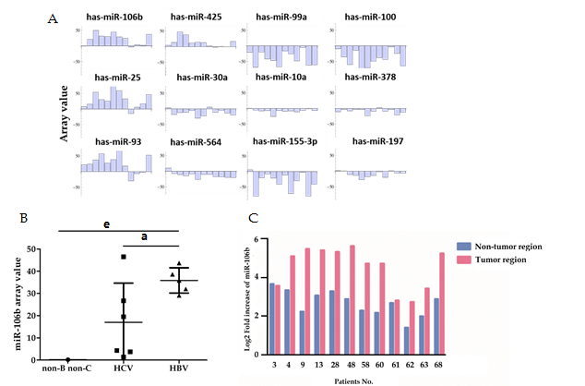
Figure 1 miRNA array analysis of the miRNA expression patterns in patients with distinct types of HCC (n = 12). A: The top 12 miRNAs significantly dysregulated in the tumor regions of hepatocellular carcinoma (HCC) patients based on statistical results (P < 0.01); B: miR-106b expression levels in tumor regions of patients with hepatitis B virus (HBV) -associated HCC, HCV-associated HCC, and non-B/non-C HCC; C: q-RT-PCR analysis of miR-106b expression values in the tumor and adjacent non-tumor regions of patients. Fold-increases were calculated after comparing the results with the miR-106b expression levels in normal liver samples. Data represent the mean ± SD. ªP < 0.05, ^{e}P < 0.001 vs HCV.

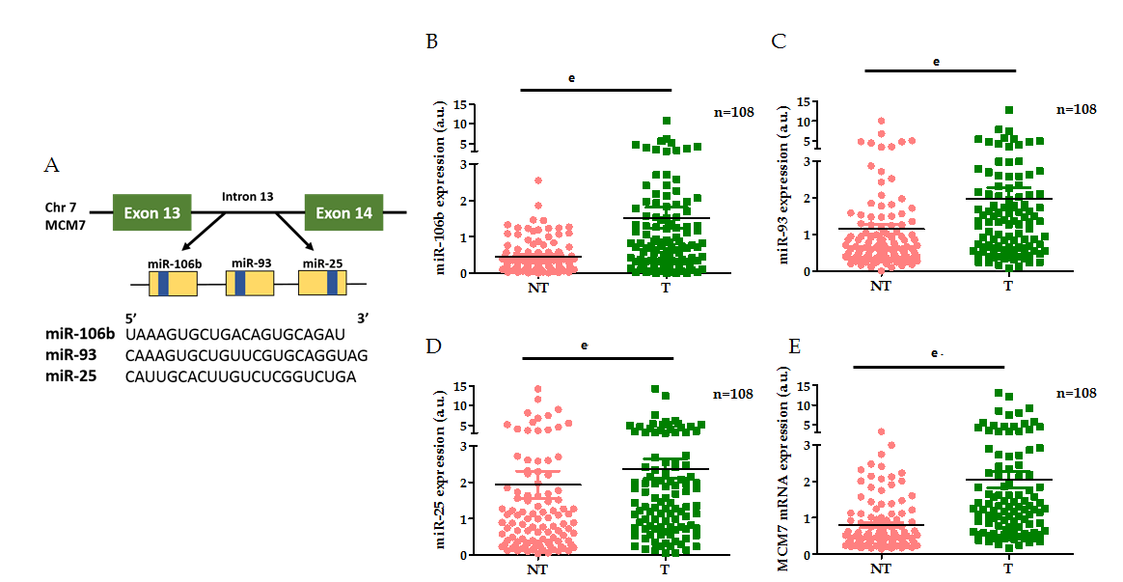
Figure 2 The mRNA expression levels of the miR-106b-25 cluster and MCM7 in tumor and non-tumor regions of hepatitis B virus-associated hepatocellular carcinoma patients (n = 108). A: Schematic representation of the miR-106b-25 cluster of miRNA (miR-106b, miR-93 and miR-25) within the 13th intron of the MCM7 gene. The yellow boxes represent pre-miRNAs. The blue boxes represent mature miRNAs; B-E: miR-106b (B), miR-93 (C), miR-25 (D), and MCM7 (E) expression levels in the tumor and non-tumor regions of hepatitis B virus (HBV)-associated hepatocellular carcinoma (HCC) patients, determined using q-RT-PCR. ^{e}P < 0.001 NT vs T. a.u.: arbitrary unit.

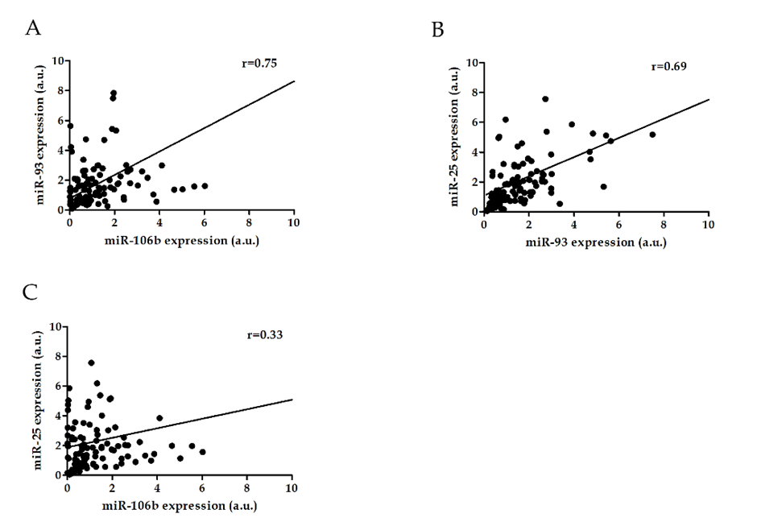
Figure 3 The correlation analysis miR-106b vs miR-93, miR-106b vs miR-25, and miR-93 vs miR-25 expression in tumor regions of patients with hepatitis B virus-associated hepatocellular carcinoma (n = 108). A: The correlation between miR-106b and miR-93 expression; B: The correlation between miR-106b and miR-25 expression; C: The correlation between miR-93 and miR-25 expression. Data represent the correlation coefficient (r). a.u.: arbitrary unit. HCC: Hepatocellular carcinoma; HBV: Hepatitis B virus.

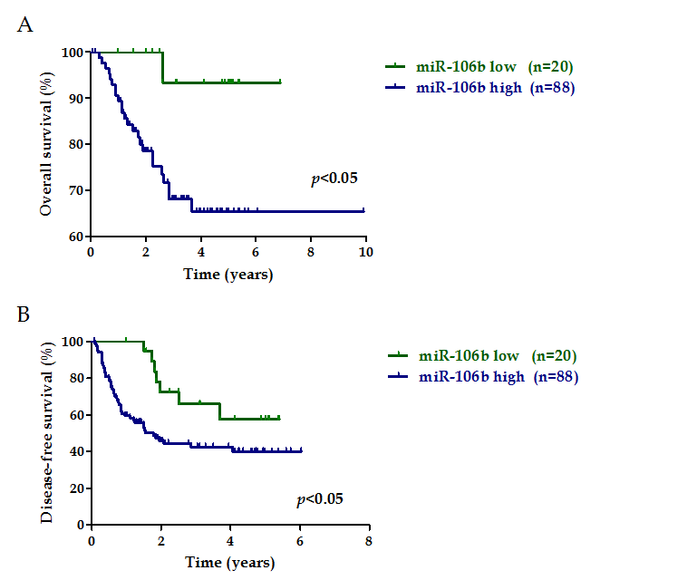
Figure 4 Kaplan-Meier overall and disease-free survival curve of patients with hepatitis B virus-associated hepatocellular carcinoma based on miR-106b expression (n = 108). Hepatitis B virus (HBV)-associated hepatocellular carcinoma (HCC) patients were divided into two groups including miR-106b low (n = 20) and miR-106b high (n = 88) groups based on the expression levels of miR-106b. A: Overall survival curve; B: Disease-free survival curve. Log-rank test was used for statistical analysis. P < 0.05 was considered significant.

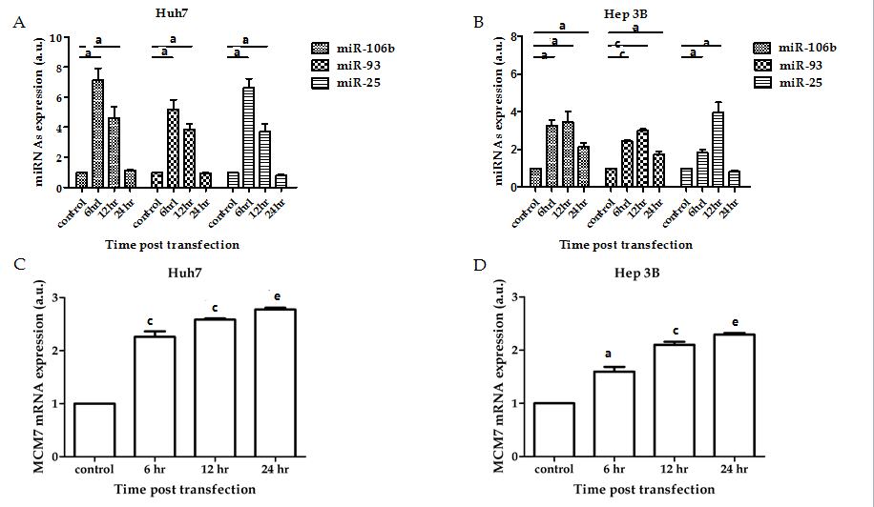
Figure 5 The mRNA expression levels of miR-106b-25 cluster and MCM7 in HBx-transfected hepatocellular carcinoma cell lines (n = 3). The hepatitis B virus X protein (HBx) protein expression plasmid was transiently transfected into Huh7 and Hep-3B cells. miR-106b, miR-93, miR-25, and MCM7 expression levels at 0 (control), 6, 12, and 24 h post transfection were detected using q-RT-PCR. A: miRNAs expression levels in HBx-transfected Huh7 cells; B: miRNAs expression levels in HBx-transfected Hep-3B cells; C: MCM7 expression levels in HBx-transfected Huh7 cells; D: MCM7 expression levels in HBx-transfected Hep-3B cells. Data represent the mean ± SD. ªP < 0.05, ^{c}P < 0.01, ^{e}P < 0.001 vs control. a.u.: arbitrary unit. HCC: Hepatocellular carcinoma.

Table 1 Characteristics of HCC patients in the present study¹
Characteristics | Patient numbers n (%)
 | 1st Cohort (n = 12) | 2nd Cohort (n = 108) | Total (n = 120)
Gender
Male | 8 (67) | 86 (80) | 94 (78)
Female | 4 (33) | 22 (20) | 26 (22)
Age (yr)
< 50 | 0 (0) | 15 (14) | 15 (13)
≥ 50 | 12 (100) | 93 (86) | 105 (87)
Viral infection
HBV  HCV  Non-B/Non-C | 5 (42)  6 (50)  1 (8) | 108 (100)  0 (0)  0 (0) | 113 (94)  6 (5)  1 (1)
HCC differentiation
Well | 1 (8) | 20 (19) | 21 (18)
Moderate  Poor  Unknown | 8 (67)  3 (25) | 76 (70)  11 (10)  1 (1) | 84 (70)  14 (11)  1 (1)
Pathological staging
Stage I | 1 (8) | 39 (36) | 40 (33)
Stage II  Stage III | 9 (75)  2 (17) | 51 (47)  18 (17) | 60 (50)  20 (17)
¹A total of 120 hepatocellular carcinoma (HCC) patients were divided into two cohorts. A total of 12 HCC patients with distinct types of HCC were included in the 1st cohort, and the remaining 108 hepatitis B virus (HBV)-associated HCC patients were enrolled in the 2nd cohort.

Table 2 Correlation analysis of clinical outcomes with miR-106b expression profiles (n = 108)¹
 | Patient numbers n (%) |  | P value | Significant²
Underlying liver disease |  |  | 0.3740 | NS
Liver cirrhosis | 39 (36)
Non-cirrhosis | 69 (64)
HCC differentiation
Well vs Moderate | 24 (22) vs 74 (69) |  | 0.0359 | ª
Well vs Poor | 24 (22) vs 9 (8) |  | 0.0145 | ª
Moderate vs Poor | 74 (69) vs 9 (8) |  | 0.2384 | NS
Unknown | 1
Microvascular invasion |  |  | 0.8558 | NS
Yes  No | 30 (28)  78 (72)
Tumor number |  |  | 0.7978 | NS
Single tumor | 87 (81)
> 1 tumor | 21 (19)
Tumor size (cm)^{c} |  |  | 0.8120 | NS
< 5 | 72 (67)
≥ 5 | 36 (33)
Recurrence after surgery |  |  | 0.6865 | NS
Yes  No | 58 (54)  50 (46)
Pathological staging
Stage I vs Stage II | 39 (36) vs 51 (47) |  | 0.9675 | NS
Stage I vs Stage III | 39 (36) vs 18 (17) |  | 0.6246 | NS
Stage II and Stage III | 51 (47) vs 18 (17) |  | 0.5753 | NS
 |  |  | Total patients, n = 108
¹The patient characteristics are summarized based on the clinical outcomes. Demographic and clinical features of patients were retrospectively analyzed and correlated with the miR-106b expression profiles; ²The correlation between miR-106b expression values and the patient numbers of each clinical outcome parameter were analyzed using Mann-Whitney U tests. ªP < 0.05 was considered significant; ³Tumor size represents the maximum diameter of the tumor nodule. The diameter of the largest nodule was 16 cm. NS: No significant difference; HCC: Hepatocellular carcinoma.

