Name of Journal: World Journal of Clinical Cases
Manuscript NO: 69503
Manuscript Type: ORIGINAL ARTICLE

Retrospective Cohort Study
Application of MAGnetic resonance imaging compilation in acute ischemic stroke

Wang Q et al. Synthetic MRI

Qi Wang, Gang Wang, Qiang Sun, Di-He Sun

Qi Wang, Gang Wang, Qiang Sun, Di-He Sun, Department of Radiology, The Stroke Hospital of Liaoning Province, Shenyang 110101, Liaoning Province, China

Author contributions: Wang Q and Wang G designed and coordinated the study; Sun Q and Sun HD treated the patients.

Supported by Wu Jieping Medical Foundation, No. 320.6750.2020-11-22.

Corresponding author: Gang Wang, MD, Doctor, Department of Radiology, The Stroke Hospital of Liaoning Province, No. 49 Xuesong Road, Sujiatun District, Shenyang 110101, Liaoning Province, China. 444966958@qq.com

Received: July 23, 2021
Revised: August 31, 2021
Accepted: October 25, 2021
Published online: December 16, 2021

Abstract
BACKGROUND
Synthetic magnetic resonance imaging (MRI) MAGnetic resonance imaging compilation (MAGiC) is a new MRI technology. Conventional T1, T2, T2-fluid-attenuated inversion recovery (FLAIR) contrast images, quantitative images of T1 and T2 mapping, and MAGiC phase sensitive inversion recovery (PSIR) Vessel cerebrovascular images can be obtained simultaneously through post-processing at the same time after completing a scan. In recent years, studies have reported that MAGiC can be applied to patients with acute ischemic stroke. We hypothesized that the synthetic MRI vascular screening scheme can evaluate the degree of cerebral artery stenosis in patients with acute ischemic stroke.

AIM
To explore the application value of vascular images obtained by synthetic MRI in diagnosing acute ischemic stroke.

METHODS
A total of 64 patients with acute ischemic stroke were selected and examined by MRI in the current retrospective cohort study. The scanning sequences included traditional T1, T2, and T2-FLAIR, three-dimensional time-of-flight magnetic resonance angiography (3D TOF MRA), diffusion-weighted imaging (DWI), and synthetic MRI. Conventional contrast images (T1, T2, and T2-FLAIR) and intracranial vessel images (MAGiC PSIR Vessel] were automatically reconstructed using synthetic MRI raw data. The contrast-to-noise ratio (CNR) values of traditional T1, T2, and T2-FLAIR images and MAGiC reconstructed T1, T2, and T2-FLAIR images in DWI diffusion restriction areas were measured and compared. MAGiC PSIR Vessel and TOF MRA images were used to measure and calculate the stenosis degree of bilateral middle cerebral artery stenosis areas. The consistency of MAGiC PSIR Vessel and TOF MRA in displaying the degree of vascular stenosis with computed tomography angiography (CTA) was compared.

RESULTS
Among the 64 patients with acute ischemic stroke, 79 vascular stenosis areas showed that the correlation between MAGiC PSIR Vessel and CTA (r = 0.90, P < 0.01) was higher than that between TOF MRA and CTA (r = 0.84, P < 0.01). With a degree of vascular stenosis > 50% assessed by CTA as a reference, the area under the receiver operating characteristic (ROC) curve of MAGiC PSIR Vessel [area under the curve (AUC) = 0.906, P < 0.01] was higher than that of TOF MRA (AUC = 0.790, P < 0.01). Among the 64 patients with acute ischemic stroke, 39 were scanned for traditional T1, T2, and T2-FLAIR images and MAGiC images simultaneously, and CNR values in DWI diffusion restriction areas were measured, which were: Traditional T2 = 21.2, traditional T1 = -6.7, and traditional T2-FLAIR = 11.9; and MAGiC T2 = 7.1, MAGiC T1 = -3.9, and MAGiC T2-FLAIR = 4.5.

CONCLUSION
The synthetic MRI vascular screening scheme for patients with acute ischemic stroke can accurately evaluate the degree of bilateral middle cerebral artery stenosis, which is of great significance to early thrombolytic interventional therapy and improving patients’ quality of life.

Key Words: Acute ischemic stroke; Magnetic resonance imaging; Magnetic resonance angiography; Computed tomography angiography; Phase sensitive inversion recovery

©The Author(s) 2021. Published by Baishideng Publishing Group Inc. All rights reserved.

Citation: Wang Q, Wang G, Sun Q, Sun DH. Application of MAGnetic resonance imaging compilation in acute ischemic stroke. World J Clin Cases 2021; 9(35): 10828-10837
URL: https://www.wjgnet.com/2307-8960/full/v9/i35/10828.htm
DOI: https://dx.doi.org/10.12998/wjcc.v9.i35.10828

Core Tip: This study evaluated the application value of vascular images obtained by synthetic magnetic resonance imaging in diagnosing acute ischemic stroke. Synthetic magnetic resonance imaging can obtain vascular images simultaneously as T2, T1, T2-fluid-attenuated inversion recovery and other contrast images. Compared with the results of computed tomography angiography examination, we found that the vascular images can be used to positively evaluate the degree of intracranial bilateral middle cerebral artery stenosis, which is of great significance to early thrombolytic interventional therapy and improving patients’ quality of life.

INTRODUCTION
Cerebrovascular disease is the second deadliest disease globally, and acute cerebrovascular disease also has a higher disability rate than any other single disease, which brings heavy burdens to society^{[1-4]}. In recent years, imaging has played an increasingly prominent key role in preventing and treating cerebrovascular disease^{[5]}. For example, in treating acute stroke, the treatment time window of some patients with macrovascular diseases can be extended by 6-24 h using image evaluation^{[6,7]}. The long-term survival rate and recurrence rate after acute ischemic stroke also vary significantly with the different causes of the first stroke. The5-year survival rate of small vessel disease is the highest in both males and females, and the 5-year recurrence rate is the lowest in female patients with small vessel disease and male patients with large vessel diseases^{[8]}. The traditional magnetic resonance imaging (MRI) technology, three-dimensional time-of-flight magnetic resonance angiography (3D TOF MRA), has been widely used in screening cerebrovascular diseases because of its advantages, including non-invasiveness, non-radiation, and no need to inject contrast media^{[9,10]}. However, in the imaging examination of patients with acute stroke, saving time can save the brain, so the shorter the examination process, the better the outcome. Traditional sequences such as T1, T2, T2-fluid-attenuated inversion recovery (FLAIR), TOF MRA, and diffusion-weighted imaging (DWI) require separate scanning, so it usually takes more than 10 min to complete all the examinations. Furthermore, 3D TOF MRA may overestimate the degree of vascular stenosis due to the hemodynamic changes in stenotic vessels.
MAGnetic resonance imaging compilation (MAGiC) is a newly emerging synthetic MRI technology. While completing one scan, the technician can acquire conventional T1, T2, T2-FLAIR, and other contrast images, quantitative T1 mapping and T2 mapping images, as well as MAGiC phase-sensitive inversion recovery (PSIR) Vessel cerebrovascular images simultaneously through post-processing, which significantly shortens the scanning time required for magnetic resonance examination^{[11-14]}. In recent years, some researchers reported that MAGiC can be used to reconstruct various contrast images that can be applied in patients with acute ischemic stroke, and T2 mapping images acquired by MAGiC can more accurately evaluate stroke onset time^{[15,16]}. However, studies evaluating the clinical application of intracranial vascular images acquired by MAGiC have not been reported.
This study aimed to compare the accuracy of MAGiC PSIR Vessel and TOF MRA in evaluating the stenosis degree of bilateral middle cerebral arteries, and to further explore the application value of MAGiC in acute ischemic stroke.

MATERIALS AND METHODS
General information
A total of 64 patients with acute ischemic stroke diagnosed at the neurology department of our hospital (The Stroke Hospital of Liaoning Province, Liaoning Province, China) from November 2020 to May 2021 were retrospectively analyzed (all conforming to the 2018 edition of Chinese Guidelines for Diagnosis and Treatment of Acute Ischemic Stroke), including 44 males and 20 females, aged from 41 to 78 years (average age: 58 years). Upon admission, all patients underwent multi-sequence brain MRI scanning (including DWI, TOF MRA, and MAGiC), and computed tomography angiography (CTA) scanning was performed within 3 d after MRI examination. The post-processing images of DWI, TOF MRA, synthetic MRI, and CTA were retrospectively analyzed. All patients signed an informed consent form before examinations.

Scanning equipment and parameters
In this study, a SIGNAPioneer 3.0T MR scanner (GE, USA) with a 21-channel head phased-array coil was used. The main scanning sequences are shown in Table 1.

Image post-processing and analysis
MAGiC original image and images (T1, T2, T2-FLAIR, T2 mapping, and MAGiC PSIR Vessel) automatically generated with the post-processing software supplied with the GE host after scanning were analyzed (Figure 1).
The 3D TOF MRA and MAGiC PSIR Vessel images were post-processed with Reformat software of GE ADW4.7 workstation. The consistency of the two examination methods with CTA in evaluating the degrees of intracranial vascular stenosis was investigated.
The degree of vascular stenosis was calculated as (1-diameter of the lumen at stenosis/diameter of the lumen of an adjacent normal blood vessel) × 100%.
With CTA vascular stenosis degree greater than 50% as the classification point, receiver operating characteristic (ROC) curves were plotted for the two examination methods to calculate the area under the curve (AUC).
The method for measuring contrast-to-noise ratio (CNR) values in DWI diffusion restriction areas of traditional T1, T2, and T2-FLAIR images as well as MAGiC T1, T2, and T2-FLAIR images was as follows: CNR = (mean intensity of stroke lesion - mean intensity of thalamus)/standard deviation of the thalamus.

Statistical analysis
All quantitative data were analyzed and processed with SPSS25.0 statistical software. With CTA as the control, the consistency and correlation of the two examination methods TOF MRA and MAGiC PSIR Vessel with CTA in evaluating the degree of vascular stenosis were evaluated by Bland-Altman plots and Spearman correlation analysis, respectively. The significant difference was set as P < 0.05.

RESULTS
Figure 2 and Figure 3 show the evaluation of intracranial vascular stenosis degree by 3D TOF MRA, MAGiC PSIR Vessel, and CTA. The correlation between MAGiC PSIR Vessel and CTA (r = 0.90, P < 0.01) was higher than that between TOF MRA and CTA (r = 0.84, P < 0.01). The area under the ROC curve of MAGiC PSIR Vessel (AUC = 0.906, P < 0.01) was higher than that of TOF MRA (AUC = 0.790, P < 0.01), as shown in Figure 4.
MAGiC-reconstructed multi-contrast images had reduced CNR values of DWI diffusion restriction areas than the traditional multi-contrast images (traditional T2 = 21.2, traditional T1 = -6.7, and traditional T2-FLAIR = 11.9; MAGiC T2 = 7.1, MAGiC T1 = -3.9, and MAGiC T2-FLAIR = 4.5; Figure 5). In addition, two experienced diagnosticians respectively evaluated whether the images obtained by the two methods could meet the clinical diagnostic requirements of stroke. The results showed that both methods could meet the clinical diagnostic requirements.

DISCUSSION
Synthetic MRI MAGiC is a quantitative MRI technique, which can generate a variety of conventional contrast images (T1, T2, T2-FLAIR, etc.), quantitative images (T1 mapping and T2 mapping), and intracranial vessel images (PSIR Vessel) simultaneously in a single scan by acquiring the T1 relaxation rate, T2 relaxation rate, and PD density value of tissues, and has been applied in many sites such as nerves and joints^{[17-26]}. Among them, research has been conducted on the application of T2 mapping in the nervous system, such as the evaluation of edema around tumors and showed epileptic lesions. In recent years, in the imaging diagnosis of stroke, many studies have been conducted to apply synthetic MRI imaging technology. For example, T2 mapping quantitative images acquired by MAGiC could more accurately evaluate stroke onset time^{[27-29]}.
MRI can provide important imaging evidence in the prevention, diagnosis, and treatment of cerebrovascular diseases. However, its long scanning time, especially in patients with hyperacute stroke, contradicts the clinical need to carry out treatment as soon as possible. For example, the evaluation of vascular stenosis degree in acute stroke is of great value in defining the etiology and responsible vessels and guiding the selection of subsequent clinical treatment regimens. However, traditional TOF MRA scanning usually takes 3 to 5 min; therefore, a vascular imaging technique with a shorter scanning time is needed in MRI examination. MAGiC PSIR Vessel intracranial blood vessel images are generated simultaneously with conventional T1, T2, and other contrast images, as well as T1 mapping, T2 mapping, and other quantitative images, which can be initially used for screening intracranial blood vessels without occupying additional scanning time. Its imaging principle is based on the use of difference in phase information between flowing blood flow and stationary tissues to image blood vessels, reducing the influence of hemodynamics on blood vessel imaging. In contrast, traditional TOF MRA imaging technology uses the enhancement effect of blood inflow to obtain blood vessel images, which will be affected by changes in hemodynamics. In the area of vascular stenosis, the degree of stenosis may be overestimated due to turbulent or slow blood flow^{[30-34]}. This study revealed that with CTA results as a reference, the area under ROC curve of MAGiC PSIR Vessel examination was higher than that of traditional TOF MRA examinations in patients with vascular stenosis greater than 50%. Some patients with vascular occlusion not displayed by TOF MRA only showed moderate to severe stenosis on MAGiC PSIR Vessel and CTA images. In terms of scanning time, the scanning time of MAGiC was about 4.5 min, and the scanning time of MAGiC combined with DWI was about 5 min, which was significantly less than that of the traditional scanning schemes of TOF MRA and DWI combined with T1, T2, and T2-FLAIR (usually more than 10 min), which is conducive to improving the MRI examination efficiency for patients with acute stroke and treatment window for clinical thrombolytic intervention as soon as possible.
To obtain a clear enough blood vessel display, the slice thickness of the MAGiC image was set at 1.6 mm, which made the CNR values of T1, T2, and T2-FLAIR images generated by MAGiC decrease compared with traditional images due to the influence of the decrease in image signal-to-noise ratio. However, the overall display of lesions could meet the diagnostic needs of stroke. In addition, the slices in the MAGiC image were thinner.
There were some limitations to this study. First, this is a retrospective study, and some patients needed to complete CTA and MRI examinations simultaneously, which might result in selection bias. Meanwhile, due to this reason, not all the patients could be scored by the National Institute of Health stroke scale. Second, the number of cases was relatively small, which was mainly because MRI is not widely used in the diagnosis and treatment of acute stroke in clinical departments, as it is considered that the scanning time of this technique is relatively long, which may delay the diagnosis and treatment time of patients. Third, this study did not evaluate the long-term outcomes of patients, e.g., the proportion of recurrent stroke in patients treated with vascular recanalization. The evaluation of long-term outcomes of patients can further clarify the relationships of vascular stenosis degree judgment with cerebrovascular recanalization treatment and stroke recurrence.

CONCLUSION
In conclusion, MAGiC can simultaneously obtain a variety of conventional contrast images (T1, T2, T2-FLAIR, etc.), intracranial vessel images (MAGiC PSIR Vessel), and both T2 and T1 relaxation time quantitative images (T2 mapping and T1 mapping) in one scan, which can accurately determine the onset time of stroke, preliminarily screen intracranial vessels, and further shorten the MRI examination time in patients with acute stroke, thereby guiding clinical thrombolytic intervention as early as possible and improve patients’ quality of life.

ARTICLE HIGHLIGHTS
Research background
Synthetic magnetic resonance imaging (MRI) MAGnetic resonance imaging compilation (MAGiC) is a new MRI technology. While completing one scan, the technician can acquire conventional T1, T2, T2-fluid-attenuated inversion recovery (FLAIR), and other contrast images, quantitative T1 mapping and T2 mapping images, as well as MAGiC phase-sensitive inversion recovery (PSIR) Vessel cerebrovascular images simultaneously through post-processing, which significantly shortens the scanning time required for MRI examination.

Research motivation
This study evaluated the application value of vascular images obtained by synthetic MRI in diagnosing acute ischemic stroke.

Research objectives
We hypothesized that the synthetic MRI vascular screening scheme can evaluate the degree of cerebral artery stenosis in patients with acute ischemic stroke.

Research methods
The contrast-to-noise ratio (CNR) values of traditional T1, T2, and T2-FLAIR images and MAGiC reconstructed T1, T2, and T2-FLAIR images in DWI diffusion restriction areas were measured and compared. MAGiC PSIR Vessel and time-of-flight magnetic resonance angiography (TOF MRA) images were used to measure and calculate the stenosis degree of bilateral middle cerebral artery stenosis areas. The consistency of MAGiC PSIR Vessel and TOF MRA in displaying the degree of vascular stenosis with computed tomography angiography was compared.

Research results
Magnetic resonance imaging can provide important imaging evidence in the prevention, diagnosis, and treatment of cerebrovascular diseases. However, its long scanning time, especially in patients with hyperacute stroke, contradicts the clinical need to carry out treatment as soon as possible. MAGiC PSIR Vessel images are generated simultaneously with conventional T1, T2, and other contrast images, as well as T1 mapping, T2 mapping, and other quantitative images, which can be initially used for screening intracranial blood vessels without occupying additional scanning time.

Research conclusions
MAGiC can simultaneously obtain a variety of conventional contrast images (T1, T2, T2-FLAIR, etc.), intracranial vessel images (MAGiC PSIR Vessel), and both T2 and T1 relaxation time quantitative images (T2 mapping, T1 mapping) in one scan, which can accurately determine the onset time of stroke, preliminarily screen intracranial vessels, and further shorten the magnetic resonance imaging examination time in patients with acute stroke.

Research perspectives
The evaluation of long-term outcomes of patients can further clarify the relationships of vascular stenosis degree judgment with cerebrovascular recanalization treatment and stroke recurrence.

ACKNOWLEDGEMENTS
We would like to thank Mr. Fei Bie for MRI technical support.

REFERENCES
1 Mehanna R, Jankovic J. Movement disorders in cerebrovascular disease. Lancet Neurol 2013; 12: 597-608 [PMID: 23602779 DOI: 10.1016/S1474-4422(13)70057-7]
2 Katan M, Luft A. Global Burden of Stroke. Semin Neurol 2018; 38: 208-211 [PMID: 29791947 DOI: 10.1055/s-0038-1649503]
3 Smith EE, Saposnik G, Biessels GJ, Doubal FN, Fornage M, Gorelick PB, Greenberg SM, Higashida RT, Kasner SE, Seshadri S; American Heart Association Stroke Council; Council on Cardiovascular Radiology and Intervention; Council on Functional Genomics and Translational Biology; and Council on Hypertension. Prevention of Stroke in Patients With Silent Cerebrovascular Disease: A Scientific Statement for Healthcare Professionals From the American Heart Association/American Stroke Association. Stroke 2017; 48: e44-e71 [PMID: 27980126 DOI: 10.1161/STR.0000000000000116]
4 Smajlović D. Strokes in young adults: epidemiology and prevention. Vasc Health Risk Manag 2015; 11: 157-164 [PMID: 25750539 DOI: 10.2147/VHRM.S53203]
5 Mair G, Wardlaw JM. Imaging of acute stroke prior to treatment: current practice and evolving techniques. Br J Radiol 2014; 87: 20140216 [PMID: 24936980 DOI: 10.1259/bjr.20140216]
6 Nogueira RG, Jadhav AP, Haussen DC, Bonafe A, Budzik RF, Bhuva P, Yavagal DR, Ribo M, Cognard C, Hanel RA, Sila CA, Hassan AE, Millan M, Levy EI, Mitchell P, Chen M, English JD, Shah QA, Silver FL, Pereira VM, Mehta BP, Baxter BW, Abraham MG, Cardona P, Veznedaroglu E, Hellinger FR, Feng L, Kirmani JF, Lopes DK, Jankowitz BT, Frankel MR, Costalat V, Vora NA, Yoo AJ, Malik AM, Furlan AJ, Rubiera M, Aghaebrahim A, Olivot JM, Tekle WG, Shields R, Graves T, Lewis RJ, Smith WS, Liebeskind DS, Saver JL, Jovin TG; DAWN Trial Investigators. Thrombectomy 6 to 24 Hours after Stroke with a Mismatch between Deficit and Infarct. N Engl J Med 2018; 378: 11-21 [PMID: 29129157 DOI: 10.1056/NEJMoa1706442]
7 Albers GW, Marks MP, Kemp S, Christensen S, Tsai JP, Ortega-Gutierrez S, McTaggart RA, Torbey MT, Kim-Tenser M, Leslie-Mazwi T, Sarraj A, Kasner SE, Ansari SA, Yeatts SD, Hamilton S, Mlynash M, Heit JJ, Zaharchuk G, Kim S, Carrozzella J, Palesch YY, Demchuk AM, Bammer R, Lavori PW, Broderick JP, Lansberg MG; DEFUSE 3 Investigators. Thrombectomy for Stroke at 6 to 16 Hours with Selection by Perfusion Imaging. N Engl J Med 2018; 378: 708-718 [PMID: 29364767 DOI: 10.1056/NEJMoa1713973]
8 Rücker V, Heuschmann PU, O'Flaherty M, Weingärtner M, Hess M, Sedlak C, Schwab S, Kolominsky-Rabas PL. Twenty-Year Time Trends in Long-Term Case-Fatality and Recurrence Rates After Ischemic Stroke Stratified by Etiology. Stroke 2020; 51: 2778-2785 [PMID: 32811383 DOI: 10.1161/STROKEAHA.120.029972]
9 Wheaton AJ, Miyazaki M. Non-contrast enhanced MR angiography: physical principles. J Magn Reson Imaging 2012; 36: 286-304 [PMID: 22807222 DOI: 10.1002/jmri.23641]
10 Anzalone N, Scomazzoni F, Castellano R, Strada L, Righi C, Politi LS, Kirchin MA, Chiesa R, Scotti G. Carotid artery stenosis: intraindividual correlations of 3D time-of-flight MR angiography, contrast-enhanced MR angiography, conventional DSA, and rotational angiography for detection and grading. Radiology 2005; 236: 204-213 [PMID: 15955853 DOI: 10.1148/radiol.2361032048]
11 Blystad I, Warntjes JBM, Smedby Ö, Lundberg P, Larsson EM, Tisell A. Quantitative MRI for analysis of peritumoral edema in malignant gliomas. PLoS One 2017; 12: e0177135 [PMID: 28542553 DOI: 10.1371/journal.pone.0177135]
12 Hagiwara A, Hori M, Yokoyama K, Takemura MY, Andica C, Tabata T, Kamagata K, Suzuki M, Kumamaru KK, Nakazawa M, Takano N, Kawasaki H, Hamasaki N, Kunimatsu A, Aoki S. Synthetic MRI in the Detection of Multiple Sclerosis Plaques. AJNR Am J Neuroradiol 2017; 38: 257-263 [PMID: 27932506 DOI: 10.3174/ajnr.A5012]
13 Granberg T, Uppman M, Hashim F, Cananau C, Nordin LE, Shams S, Berglund J, Forslin Y, Aspelin P, Fredrikson S, Kristoffersen-Wiberg M. Clinical Feasibility of Synthetic MRI in Multiple Sclerosis: A Diagnostic and Volumetric Validation Study. AJNR Am J Neuroradiol 2016; 37: 1023-1029 [PMID: 26797137 DOI: 10.3174/ajnr.A4665]
14 Jung Y, Gho SM, Back SN, Ha T, Kang DK, Kim TH. The feasibility of synthetic MRI in breast cancer patients: comparison of T₂ relaxation time with multiecho spin echo T₂ mapping method. Br J Radiol 2018: 20180479 [PMID: 30215550 DOI: 10.1259/bjr.20180479]
15 Duchaussoy T, Budzik JF, Norberciak L, Colas L, Pasquini M, Verclytte S. Synthetic T2 mapping is correlated with time from stroke onset: a future tool in wake-up stroke management? Eur Radiol 2019; 29: 7019-7026 [PMID: 31139971 DOI: 10.1007/s00330-019-06270-0]
16 Li CW, Hsu AL, Huang CC, Yang SH, Lin CY, Shieh CC, Chan WP. Reliability of Synthetic Brain MRI for Assessment of Ischemic Stroke with Phantom Validation of a Relaxation Time Determination Method. J Clin Med 2020; 9 [PMID: 32545907 DOI: 10.3390/jcm9061857]
17 Chimowitz MI, Lynn MJ, Howlett-Smith H, Stern BJ, Hertzberg VS, Frankel MR, Levine SR, Chaturvedi S, Kasner SE, Benesch CG, Sila CA, Jovin TG, Romano JG; Warfarin-Aspirin Symptomatic Intracranial Disease Trial Investigators. Comparison of warfarin and aspirin for symptomatic intracranial arterial stenosis. N Engl J Med 2005; 352: 1305-1316 [PMID: 15800226 DOI: 10.1056/NEJMoa043033]
18 McGarry BL, Jokivarsi KT, Knight MJ, Grohn OHJ, Kauppinen RA. Magnetic Resonance Imaging Protocol for Stroke Onset Time Estimation in Permanent Cerebral Ischemia. J Vis Exp 2017; 2017 [PMID: 28979652 DOI: 10.3791/55277]
19 Seiler A, Lauer A, Deichmann R, Nöth U, You SJ, Pfeilschifter W, Singer OC, Pilatus U, Wagner M. Complete Restitution of the Ischemic Penumbra after Successful Thrombectomy : A Pilot Study Using Quantitative MRI. Clin Neuroradiol 2019; 29: 415-423 [PMID: 29460141 DOI: 10.1007/s00062-018-0675-3]
20 Drake-Pérez M, Delattre BMA, Boto J, Fitsiori A, Lovblad KO, Boudabbous S, Vargas MI. Normal Values of Magnetic Relaxation Parameters of Spine Components with the Synthetic MRI Sequence. AJNR Am J Neuroradiol 2018; 39: 788-795 [PMID: 29496723 DOI: 10.3174/ajnr.A5566]
21 Namer IJ, Waydelich R, Armspach JP, Hirsch E, Marescaux C, Grucker D. Contribution of T2 relaxation time mapping in the evaluation of cryptogenic temporal lobe epilepsy. Neuroimage 1998; 7: 304-313 [PMID: 9626671 DOI: 10.1006/nimg.1998.0331]
22 Jackson GD, Connelly A, Duncan JS, Grünewald RA, Gadian DG. Detection of hippocampal pathology in intractable partial epilepsy: increased sensitivity with quantitative magnetic resonance T2 relaxometry. Neurology 1993; 43: 1793-1799 [PMID: 8414034 DOI: 10.1212/wnl.43.9.1793]
23 Gonçalves FG, Serai SD, Zuccoli G. Synthetic Brain MRI: Review of Current Concepts and Future Directions. Top Magn Reson Imaging 2018; 27: 387-393 [PMID: 30516691 DOI: 10.1097/RMR.0000000000000189]
24 Kumar NM, Fritz B, Stern SE, Warntjes JBM, Lisa Chuah YM, Fritz J. Synthetic MRI of the Knee: Phantom Validation and Comparison with Conventional MRI. Radiology 2018; 289: 465-477 [PMID: 30152739 DOI: 10.1148/radiol.2018173007]
25 Hagiwara A, Warntjes M, Hori M, Andica C, Nakazawa M, Kumamaru KK, Abe O, Aoki S. SyMRI of the Brain: Rapid Quantification of Relaxation Rates and Proton Density, With Synthetic MRI, Automatic Brain Segmentation, and Myelin Measurement. Invest Radiol 2017; 52: 647-657 [PMID: 28257339 DOI: 10.1097/RLI.0000000000000365]
26 Sanoussi S, Comet C, Kaefer K, Attou R, De Bels D, Gazagnes MD, Honoré PM, Redant S. Can Magnetic Resonance Imaging make the Differential Diagnosis between Cerebral Ischemia and Epilepsy? J Transl Int Med 2019; 7: 123-125 [PMID: 32010596 DOI: 10.2478/jtim-2019-0025]
27 Andica C, Hagiwara A, Hori M, Kamagata K, Koshino S, Maekawa T, Suzuki M, Fujiwara H, Ikeno M, Shimizu T, Suzuki H, Sugano H, Arai H, Aoki S. Review of synthetic MRI in pediatric brains: Basic principle of MR quantification, its features, clinical applications, and limitations. J Neuroradiol 2019; 46: 268-275 [PMID: 30853545 DOI: 10.1016/j.neurad.2019.02.005]
28 Ryu KH, Baek HJ, Moon JI, Choi BH, Park SE, Ha JY, Jeon KN, Bae K, Choi DS, Cho SB, Lee Y, Heo YJ. Initial clinical experience of synthetic MRI as a routine neuroimaging protocol in daily practice: A single-center study. J Neuroradiol 2020; 47: 151-160 [PMID: 30951770 DOI: 10.1016/j.neurad.2019.03.002]
29 Chougar L, Hagiwara A, Takano N, Andica C, Cohen-Adad J, Warntjes M, Maekawa T, Hori M, Koshino S, Nakazawa M, Abe O, Aoki S. Signal Intensity within Cerebral Venous Sinuses on Synthetic MRI. Magn Reson Med Sci 2020; 19: 56-63 [PMID: 30956274 DOI: 10.2463/mrms.mp.2018-0144]
30 Igase K, Igase M, Matsubara I, Sadamoto K. Mismatch between TOF MR Angiography and CT Angiography of the Middle Cerebral Artery may be a Critical Sign in Cerebrovascular Dynamics. Yonsei Med J 2018; 59: 80-84 [PMID: 29214780 DOI: 10.3349/ymj.2018.59.1.80]
31 Dündar TT, Aralaşmak A, Özdemir H, Seyithanoğlu MH, Uysal Ö, Toprak H, Kitiş S, Özek E, Alkan A. Comparison of TOF MRA, Contrast-Enhanced MRA and Subtracted CTA from CTP in Residue Evaluation of Treated Intracranial Aneurysms. Turk Neurosurg 2017 [PMID: 29131233 DOI: 10.5137/1019-5149.JTN.21113-17.2]
32 Tomura N, Kokubun M, Horiuchi K, Watanabe Z. Comparison of TOF-MRA and silent scan-MRA in depicting cerebral arteries in patients with Moyamoya disease. Acta Radiol 2019; 60: 1321-1328 [PMID: 30682891 DOI: 10.1177/0284185118824782]
33 Zhang J, Ding S, Zhao H, Sun B, Li X, Zhou Y, Wan J, Degnan AJ, Xu J, Zhu C. Evaluation of chronic carotid artery occlusion by non-contrast 3D-MERGE MR vessel wall imaging: comparison with 3D-TOF-MRA, contrast-enhanced MRA, and DSA. Eur Radiol 2020; 30: 5805-5814 [PMID: 32529567 DOI: 10.1007/s00330-020-06989-1]
34 Cirillo M, Scomazzoni F, Cirillo L, Cadioli M, Simionato F, Iadanza A, Kirchin M, Righi C, Anzalone N. Comparison of 3D TOF-MRA and 3D CE-MRA at 3T for imaging of intracranial aneurysms. Eur J Radiol 2013; 82: e853-e859 [PMID: 24103356 DOI: 10.1016/j.ejrad.2013.08.052]

Footnotes
Institutional review board statement: The study was reviewed and approved for publication by our Institutional Reviewer.

Informed consent statement: All study participants or their legal guardian provided informed written consent about personal and medical data collection before study enrollment.

Conflict-of-interest statement: All the authors have no conflict of interest related to the manuscript.

Data sharing statement: No additional data are available.

STROBE statement: The authors have read the STROBE Statement checklist of items, and the manuscript was prepared and revised according to the STROBE Statement-checklist of items.

Open-Access: This article is an open-access article that was selected by an in-house editor and fully peer-reviewed by external reviewers. It is distributed in accordance with the Creative Commons Attribution NonCommercial (CC BY-NC 4.0) license, which permits others to distribute, remix, adapt, build upon this work non-commercially, and license their derivative works on different terms, provided the original work is properly cited and the use is non-commercial. See: https://creativecommons.org/Licenses/by-nc/4.0/

Manuscript source: Unsolicited manuscript

Peer-review started: July 23, 2021
First decision: August 19, 2021
Article in press: October 25, 2021

Specialty type: Radiology, Nuclear Medicine and Medical Imaging
Country/Territory of origin: China
Peer-review report’s scientific quality classification
Grade A (Excellent): 0
Grade B (Very good): 0
Grade C (Good): C
Grade D (Fair): 0
Grade E (Poor): 0

P-Reviewer: Battaglini D S-Editor: Wang JL L-Editor: Wang TQ P-Editor: Wang JL

Figure Legends
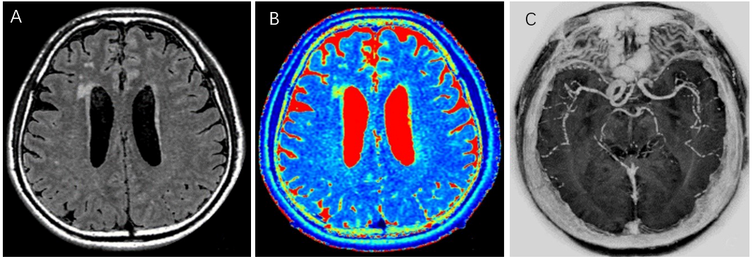
Figure 1 A 61-year-old man with transient ischemic attack. Automatic image reconstruction from MAGnetic resonance imaging compilation (MAGiC) raw data. A: MAGiC T2-fluid-attenuated inversion recovery (left); B: MAGiC T2 mapping (middle); C: MAGiC phase sensitive inversion recovery Vessel (right).

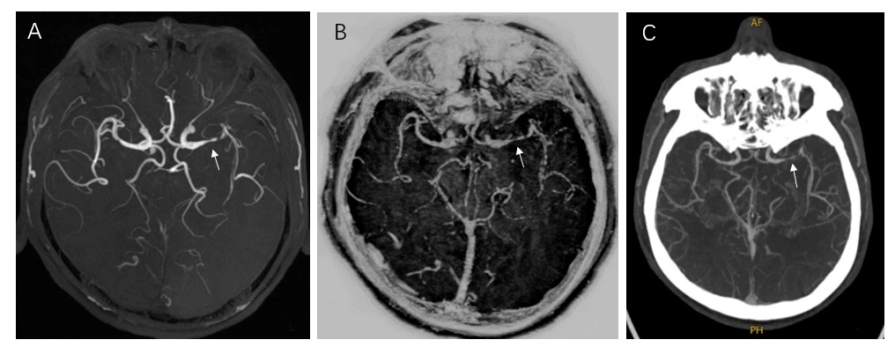
Figure 2 A 49-year-old man with bilateral lacunar cerebral infarction. A: Three-dimensional time-of-flight magnetic resonance angiography (left); B: MAGnetic resonance imaging compilation phase sensitive inversion recovery Vessel (middle); C: Computed tomography angiography (right). All three examination methods showed severe local stenosis of the left middle cerebral artery (arrows).

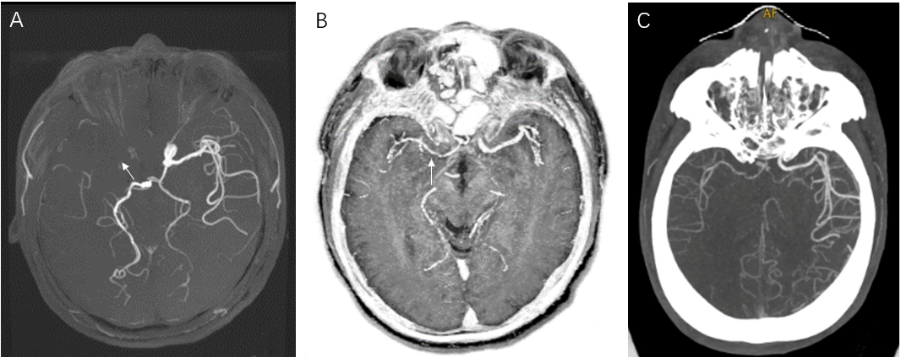
Figure 3 A 53-year-old man with right cerebral infarction. A: The right middle cerebral artery was not shown in three-dimensional time-of-flight magnetic resonance angiography (left); B: MAGnetic resonance imaging compilation phase sensitive inversion recovery Vessel (middle); and C: Computed tomography angiography (right). Both the latter two showed mild and moderate stenosis of the local lumen of the right middle cerebral artery (arrows).

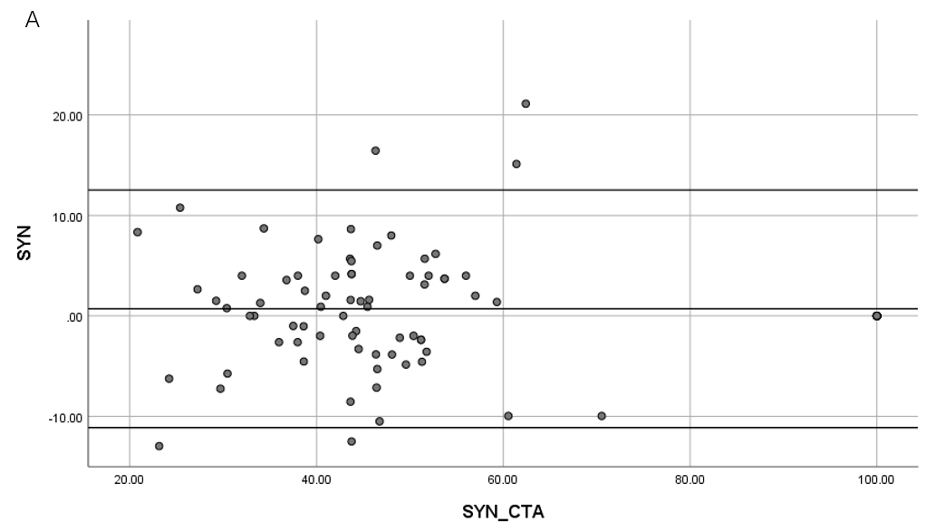
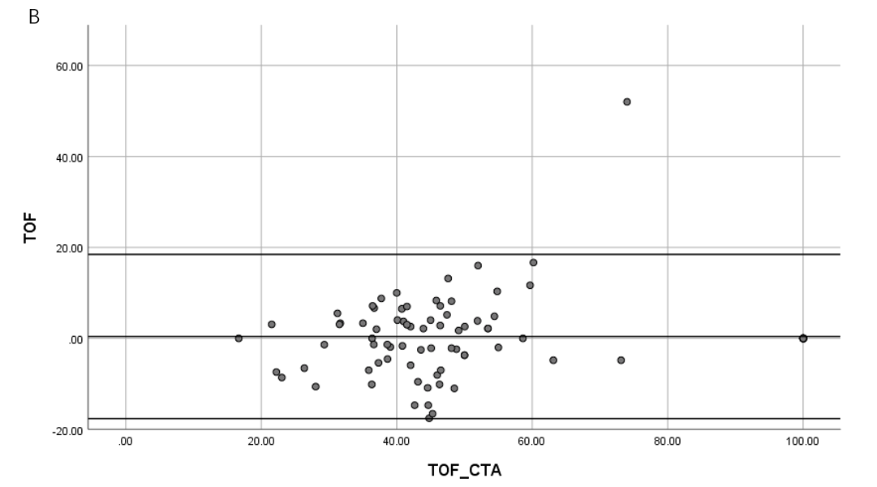
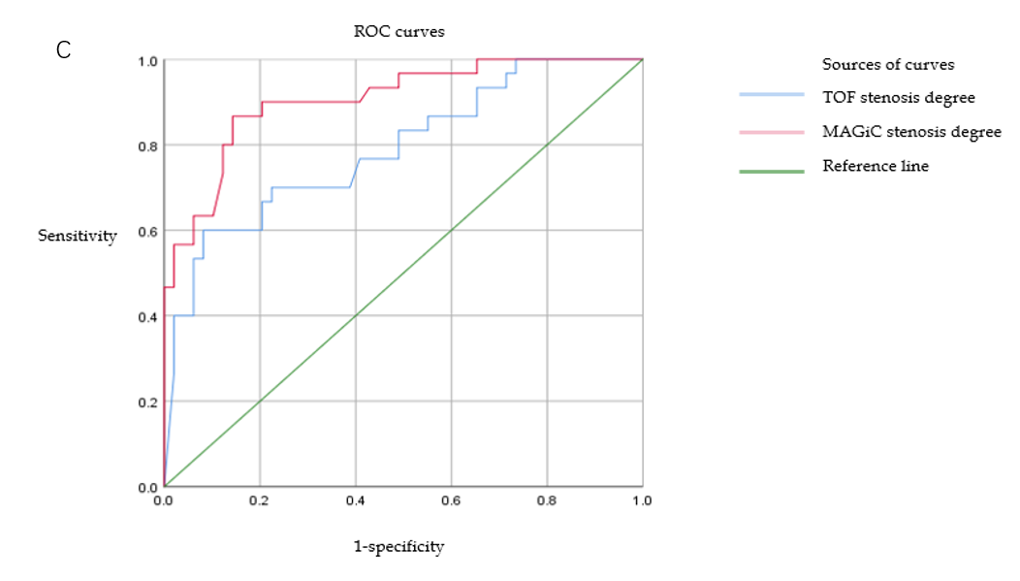
Figure 4 Bland-Altman and receiver operating characteristic curve evaluation of vascular stenosis degrees obtained by MAGnetic resonance imaging compilation phase-sensitive inversion recovery Vessel and time-of-flight magnetic resonance angiography. A: MAGnetic resonance imaging compilation-computed tomography angiography; B: Time-of-flight magnetic resonance angiography; C: Receiver operating characteristic curves. TOF: Time-of-flight; CTA: Computed tomography angiography; ROC: Receiver operating characteristic.

Figure 5 Contrast-to-noise ratio values of diffusion-weighted imaging diffusion restriction areas of MAGnetic resonance imaging compilation-reconstructed multi-contrast images and traditional multi-contrast images. 1: T2-weighted image; 2: T1-weighted image; 3: T2-fluid-attenuated inversion recovery-weighted image.

Table 1 3.0T magnetic resonance skull scanning sequences and parameters
 | Slice thickness (mm) | Matrix (mm) | TR (ms) | TE (ms) | Acquisition time (min) | FOV (cm)
DWI | 5 | 130 × 160 | 4221 | 80.2 | 0:34 | 24
TOF MRA | 1.4 | 384 × 224 | 19 | 3.4 | 3:32 | 24
Synthetic MRI (MAGiC) | 1.6 | 320 × 192 | 7365 | 12.9/90.1 | 4:25 | 24
MAGiC: MAGnetic resonance imaging compilation; TOF MRA: Time-of-flight magnetic resonance angiography; DWI: Diffusion weighted imaging (b value = 1000); TR: Repetition time; TE: Echo time; FOV: Field of view.

Published by Baishideng Publishing Group Inc
7041 Koll Center Parkway, Suite 160, Pleasanton, CA 94566, USA
Telephone: +1-925-3991568
E-mail: bpgoffice@wjgnet.com
Help Desk: https://www.f6publishing.com/helpdesk
https://www.wjgnet.com

© 2021 Baishideng Publishing Group Inc. All rights reserved.

