Name of journal: World Journal of Gastroenterology
ESPS Manuscript NO: 26352
Manuscript Type: ORIGINAL ARTICLE

Observational Study
Low expression of ARID1A correlates with poor prognosis in intrahepatic cholangiocarcinoma

Yang SZ et al. Low-expressed ARID1A and intrahepatic cholangiocarcinoma

Song-Zhu Yang, An-Qiang Wang, Juan Du, Jian-Tao Wang, Wei-Wei Yu, Qing Liu, Yan-Fang Wu, Shu-Guang Chen

Song-Zhu Yang, Jian-Tao Wang, Wei-Wei Yu, Qing Liu, Yan-Fang Wu, Department of Hepatobiliary Surgery, Yantaishan Hospital, 91 Jiefang Road, Yantai, Shandong 264001, China

Juan Du, Department of Health Management, The General Hospital Rocket Forces of the Chinese People’s Liberation Army, Beijing 100088, China

An-Qiang Wang, Shu-Guang Chen, Department of Surgery, Peking Union Medical College Hospital, Chinese Academy of Medical Sciences and Peking Union Medical College, Beijing 100730, China

Author contributions: Yang SZ and Wang AQ contributed equally to this work; Yang SZ, Wang AQ, Du J and Chen SG designed the research; Yang SZ, Wang AQ, Du J, Wang JT, Yu WW, Liu Q, and Wu YF performed the research; Yu WW and Liu Q contributed new reagents/analytic tools; Yang SZ, Wang JT, Wu YF and Chen SG analyzed the data; and Yang SZ, Wang AQ and Chen SG wrote the paper.

Institutional review board statement: The study was reviewed and approved by the Yantaishan Hospital Institutional Review Board.

Informed consent statement: All study participants, or their legal guardian, provided informed written consent prior to study enrollment.

Conflict-of-interest statement: All authors have no conflict of interest to disclosure.

Data sharing statement: No additional data are available.

Open-Access: This article is an open-access article which was selected by an in-house editor and fully peer-reviewed by external reviewers. It is distributed in accordance with the Creative Commons Attribution Non Commercial (CC BY-NC 4.0) license, which permits others to distribute, remix, adapt, build upon this work non-commercially, and license their derivative works on different terms, provided the original work is properly cited and the use is non-commercial. See: http://creativecommons.org/licenses/by-nc/4.0/

Manuscript source: Unsolicited manuscript

Correspondence to: Shu-Guang Chen, MD, Professor, Department of Surgery, Peking Union Medical College Hospital, 1 Shuaifuyuan, Wangfujing, Dongcheng District, Beijing 100730, China. pumchcsg@163.com
Telephone: +86-10-69155200
Fax: +86-10-69155201

Received: April 5, 2016
Peer-review started: April 6, 2016
First decision: May 12, 2016
Revised: May 13, 2016
Accepted: June 2, 2016
Article in press:
Published online:

Abstract
AIM: To investigate the relationship between ARID1A expression and clinicopathologic parameters, and its prognostic value for patients with intrahepatic cholangiocarcinoma (IHCC).

METHODS: We assessed ARID1A protein and mRNA expression in IHCC tissues and paracarcinomatous (PC) tissues from 57 patients with IHCC, using western blot and quantitative real-time reverse transcription polymerase chain reaction, respectively. We used Fisher’s exact and χ² tests to analyze relationships between clinicopathological parameters and ARID1A expression, and the Kaplan-Meier method and Cox regression to analyze survival.

RESULTS: The mean ARID1A protein level in IHCC tissues was 1.16±0.36 relative units (RU), which was significantly lower than that in PC tissues (1.26 ± 0.21 RU, P < 0.01) and NL tissues (1.11 ± 0.31, P < 0.001). The mean ARID1A mRNA level in IHCC tissues (1.20 ± 0.18) was also lower than that in PC tissues (1.27 ± 0.15, P < 0.001) and normal liver tissues (1.15 ± 0.34, P < 0.001). Low ARID1A expression was significantly associated with tumor nodule, vein invasion and recurrence. Median overall survival (OS) and disease-free survival (DFS) for the low ARID1A expression group was 15.0 and 7.0 mo, which were significantly shorter than those for the high ARID1A expression group at 25.0 and 22.0 mo (OS: P < 0.01; DFS: P < 0.001). Low ARID1A expression was significantly associated with worse OS (HR = 3.967, 95%CI: 1.299-12.118, P = 0.016) in multivariate analyses.

CONCLUSION: Low expressed ARID1A is associated with poor prognosis in patients with IHCC. ARID1A may be a candidate prognostic biomarker in IHCC.

Key words: Intrahepatic Cholangiocarcinoma; Progression; Prognosis; ARID1A; Biomarker

© The Author(s) 2016. Published by Baishideng Publishing Group Inc. All rights reserved.

Core tip: We investigated the relationship between ARID1A expression and clinicopathologic parameters, and its prognostic value for patients with intrahepatic cholangiocarcinoma (IHCC). We examined ARID1A protein and mRNA expression in IHCC and paracarcinomatous (PC) tissue from 57 patients with IHCC. The mean ARID1A protein and mRNA expression levels in IHCC tissues were significantly lower than those in PC tissues and normal liver tissues. Low ARID1A expression was significantly associated with tumor nodule, vein invasion and recurrence. Low ARID1A expression was significantly associated with worse overall survival in multivariate analyses. ARID1A may be a candidate prognostic biomarker in IHCC.

Yang SZ, MD, Wang AQ, Wang JT, Yu WW, Liu Q, Wu YF, Chen SG. Low Expression of ARID1A Correlates with Poor Prognosis in Intrahepatic Cholangiocarcinoma. World J Gastroenterol 2016; In press

INTRODUCTION
Primary liver cancer (PLC) is the fifth most common cancer, with about 600000 annual deaths^{[1,2]}. Intrahepatic cholangiocarcinomas (IHCC) accounts for 5%-10% of all PLCs in western countries^{[3,4]}, matched with the hepatocellular carcinoma (HCC), which accounts for about 90% of all PLCs^{[5]}. IHCCs, a rare malignant tumor arising from the biliary tract, is aggressive and related with a very poor prognosis^{[6]}. In Asian countries, the incidence of IHCC is much higher than the incidence worldwide^{[7]}. Although the incidence of IHCC is relatively low, it has been progressively and significantly increasing over the last 30 years^{[8]}. Presently, surgical resection is the only option for treating IHCC. Although surgery improves the median survival compared with conservative therapy alone (1.8 months), the outcome is still poor, with a postoperative median survival of 12.2 months^{[9,10]}. Thus to help develop diagnostic methods for enhanced therapeutic outcome, information of the somatic mutations that contribute to the oncogenesis of IHCC is an important first step.
The AT-rich interactive domain 1A (ARID1A) protein (BAF250) is a member of the switching defective/ sucrose non-fermenting (SWI/SNF) complexes, which function as ATP-dependent chromatin remodelers^{[11,12]}. The ARID1A gene is located at chromosome 1p36, which is related to the regulation of many cellular processes including proliferation, DNA repair, development, differentiation, and tumor suppression^{[13]}. Absence of ARID1A protein or gene expression has been found in the precursor stage of clear cell carcinoma of the ovary, ovarian endometrioid adenocarcinoma, breast cancer and colorectal cancer and correlates with tumor progression in these cancers^{[14-17]}. These findings indicate that ARID1A may be a tumor-suppressor gene.
Although correlations between ARID1A gene mutation and ARID1A protein expression with clinicopathologic parameters and prognosis in HCC have been recently reported^{[18]}, no study has examined its correlation with IHCC. Here, we investigated ARID1A gene and protein expression in surgically resected IHCC tumors to observe whether its expression status could be a prognostic biomarker for IHCC.

MATERIALS AND METHODS
Patients and tissue specimens
IHCC and adjacent paracarcinomatous (PC) liver specimens from 57 IHCC patients and normal liver tissues from 19 hepatic hemangioma patients (controls) were collected in the operation room. Samples were instantly frozen in liquid nitrogen and stored in −80°C until testing. PC tissues were hepatic tissue collected 2–5 cm away from the tumor edge. All patients underwent surgery in the Department of Hepatobiliary Surgery, Yantaishan Hospital, from January 2012 to June 2013. Diagnoses were defined by pathological examination. The study protocol was approved by the Ethics Committee of the Yantaishan Hospital. Informed consent was obtained from each patient.
We collected clinicopathologic parameters, including age, gender, liver function, tumor size, tumor number, histopathological classification, vessel invasion, recurrence, and survival time of patient. Vessel invasion was observed during pathological examination, which indicated tumor infiltration in the portal vein and/or hepatic vein. We monitored recurrence by ultrasound, computed tomography scan, and magnetic resonance imaging.

Western blot analysis
IHCC and PC tissues were homogenized and treated with RIPA lysis buffer (Dingguo, Beijing, China), and protein samples were resolved on a 4%–12% acrylamide gradient gel. Samples were transferred to a polyvinylidene fluoride membrane using the iBlot fast transfer electric transfer (Invitrogen, IL, United States). Membranes were blocked at room temperature for 1 h in 5% milk, and incubated with primary antibodies against ARID1A or GAPDH (1:1000, Abcam, MA, United States) at 4 °C overnight. Membranes were then washed with TBST three times, followed by incubation with appropriate secondary antibodies (1:8000, Abcam, MA, United States) at room temperature for 2 h. TBST three times, and exposed to film using the ECL kit (Pierce, CA, United States). ARID1A-specific signals were quantified from X-ray films using a scanner with BandScan 4.30 densitometry software, and expressed as integrated intensity units relative to GAPDH signals^{[19]}. The results were analyzed by physicians in a blinded manner.

Quantitative real-time reverse transcription-polymerase chain reaction
Total RNA was extracted from IHCC and PC tissues with Trizol. The retroviral reverse transcriptase kit (Takara, Tokyo, Japan) was used to synthesize cDNA with the reaction conditions of 37 °C for 60 min and 95 °C for 3 min. Primers were as follow: sense: 5′- TTAACTCCAGCCACCAAAATGAAC-3′ and antisense: 5′- ATAGAGGCGATAGAGGTCCAGAGG-3′ for the ARID1A gene; and sense: 5′-GAAGGTGAAGGTCGGAGTC -3′ and antisense: 5′-GAAGATGGTGATGGGATTTC -3′ for GAPDH. Real-time polymerase chain reaction (PCR) was performed with the 7500 real-time quantitative PCR instrument (Applied Biosystems, CA, United States) using the following conditions: 95 °C for 15 s, 60 °C for 30 s, and 72 °C for 30 s for 40 cycles. Data were normalized using the GAPDH housekeeping gene and were expressed as 2^{−ΔCt}.

Patient follow-up
We obtained follow-up data after discharge for all 57 IHCC patients by direct communication with the patients or their relatives, or by reviewing hospital records. Disease-free survival (DFS) was measured from the date of hepatectomy until tumor recurrence. Overall survival (OS) was measured from the date of hepatectomy until death or the last follow-up point. The last follow-up evaluation was censored on August 31, 2015, or up to the time of death.

Statistical analysis
Quantitative values are presented as mean ± standard deviation or median (range). The Student’s t-test was used to evaluate differences in ARID1A protein and mRNA expression between IHCC and PC tissues. Fisher’s exact and χ² tests were used to analyze the correlation between ARID1A expression level and clinicopathologic parameters in patients with IHCC. Survival curves were plotted by the Kaplan-Meier method and compared using the log-rank test. Survival data were evaluated using Cox proportional hazards model. All tests were two-tailed; P < 0.05 was considered significant. The SPSS package 17.0 (SPSS Inc., Chicago, IL, United States) was used for all analyses. The statistical methods of this study were reviewed by Prof. Xiaoqing Liu from Peking Union Medical College Hospital.

RESULTS
Patient characteristics
The mean age of the IHCC patients was 55.1 ± 9.3 years, and 68.4% (39/57) were male. The mean age of the controls was 51.2 ± 6.6 years, and 57.9% (11/19) were male. Forty patients with IHCC had at least one tumor nodule larger than 3 cm. Tumors were well differentiated in 22 patients, and moderately or poorly differentiated in 17 and 18 patients. The median follow-up time was 20 mo (range: 2–28 mo). IHCC recurred in 33 patients over a median recurrence time of 15.0 mo. During the follow-up, 30 patients died, with a mean survival time of 19.0 ± 6.4 mo.

ARID1A protein and mRNA expression in IHCC and PC tissues
The mean ARID1A protein level in IHCC tissues was 1.16 ± 0.36relative units (RU). This was significantly lower than that in PC tissues (1.26 ± 0.21 RU, P < 0.01) and normal liver (NL) tissues (1.11 ± 0.31, P < 0.001) (Figure 1). The mean ARID1A mRNA level in IHCC tissues (1.20±0.18) was also lower than that in PC tissues (1.27 ± 0.15, P < 0.001) and NL tissues (1.15 ± 0.34, P < 0.001). (Figure 2)

Correlations between ARID1A expression and clinicopathological features
We next divided the IHCC tissues according to ARID1A expression. IHCC tissues with ARID1A protein expression lower than that in NL tissues were defined as low expression tumors. Among the 57 total IHCC cases, 19 cases showed ARID1A low expression and 38 cases showed ARID1A high expression. The correlations of ARID1A mRNA and protein expression with clinicopathological parameters are shown in Table 1. Low ARID1A expression was significantly associated with tumor nodule, vein invasion and recurrence.
ARID1A protein expression in IHCC tissues with multiple tumor nodules was significantly lower (n = 18, 0.93 ± 0.34 RU) than in those with solitary tumor nodules (n = 39, 1.27 ± 0.32, P < 0.001). ARID1A mRNA expression in IHCC tissues with multiple tumor nodule (n = 18, 1.13 ± 0.17) was also lower than in those with solitary tumor nodule (1.23 ± 0.16, P < 0.05).
ARID1A protein expression in IHCC tissues with vein invasion was significantly lower (n = 24, 0.93 ± 0.33 RU) than in those without vein invasion (n = 33, 1.33 ± 0.28, P < 0.001). ARID1A mRNA expression in IHCC tissues with vein invasion (1.18 ± 0.18) was also lower than in those without vein invasion (1.21 ± 0.17), although without statistical significance.
ARID1A protein levels in IHCC tissues from patients who experienced recurrence during the follow-up (n = 33, 1.00 ± 0.33) were significantly lower than in those without recurrence (n = 24, 1.39 ± 0.27, P < 0.001). ARID1A mRNA levels in IHCC tissues with recurrence (1.20 ± 0.17) were also lower than that in those without recurrence (1.25 ± 0.21), although without statistical significance.

Association of ARID1A expression with prognosis
Kaplan-Meier survival curves and log-rank tests showed that low ARID1A protein expression in IHCC tissues was associated with poor prognosis. The median OS for the low ARID1A expression group was 15.0 mo, which was significantly shorter than that of the high ARID1A expression group at 25.0 mo (P < 0.01; Figure 3A). The median DFS rates for low ARID1A expression and high ARID1A expression groups were 7.0 mo and 22.0 mo, respectively (P < 0.001; Figure 3B). Furthermore, multivariate analysis using the Cox proportional hazards model indicated that ARID1A expression levels, tumor nodule and vein invasion were an independent predictor of DFS in patients with IHCC (Table 2). However, ARID1A expression level was the only independent predictor of OS in a multivariate analysis. Low ARID1A expression was significantly associated with worse OS in patients with IHCC compared with high ARID1A expression (HR = 3.967, 95%CI: 1.299-12.118, P = 0.016, Table 2).

DISSCUSION
ARID1A/BAF250 is a component of the SWI/SNF family complexes and is extensively expressed in different human tissues^{[14,20,21]}. The SWI/SNF chromatin remodeling complexes are recurrently mutated in various carcinomas^{[22]}. Mutations in several subunits of these complexes have been identified, including in BAF 180, SNF5, BRM/SWI2-related genes, as same as ARID1A^{[22,23]}. ARID1A/BAF250 provides SNF/SWI complex specificity and facilitates protein-protein or protein-DNA molecule interactions. Knockdown of ARID1A gene causes cell cycle arrest in osteoblasts cells, and previous studies have demonstrated a correlation of ARID1A loss and tumorigenesis^{[11]}. Together this supports a potential tumor suppressor function of ARID1A and suggests that ARID1A plays an important role in tumorigenesis and tumor progression.
Guichard et al^{[24]} performed high-resolution copy-number analysis on 125 tumor tissues of patients with HCC and whole-exome sequencing on 24 of these tumors. The author found new recurrent modifications in four genes (ARID1A, RPS6KA3, NFE2L2 and IRF2) that had not been formerly described in HCC. In Fujimoto’s research^{[25]}, the entire genomes of 27 HCCs were sequenced and analyzed. Twenty-five were associated with hepatitis B or C virus infections, including two groups of multicentric tumors. Statistical and functional analyses showed that ARID1A, ARID1B, ARID2, MLL and MLL3 genes were mutated in about 50% of the tumors. Huang et al^{[18]} showed that ARID1A was mutated in 13% HBV-associated HCC specimens. These studies suggested that ARID1A may be involved in advanced HCC.
IHCC is the second most common primary liver cancer after HCC, accounting for 5%–10% of all cholangiocarcinomas^{[26]}. The origin of IHCC is normally demarcated as grade II intrahepatic bile duct epithelium^{[27,28]}. The prognosis and the mortality rate of IHCC is ppoor, as IHCCis usually diagnosed at terminal stages because of absence of appropriate methods for early diagnosis, and surgical treatment only extends the postoperative median survival to 12.2 mo^{[9,10]}. Hence, better understanding of the somatic mutations that contribute to the oncogenesis of IHCC is critical for the development of diagnostic strategies. Through exome sequencing of 32 patients with IHCC, Jiao et al^{[29]} found many inactivating mutations in various chromatin-remodeling genes (PBRM1, ARID1A and BAP1) and activating mutations in one of these genes was observed in nearly half of all cancers sequenced. Zou et al^{[30]} sequenced carcinoma tissues and paracarcinous tissues in a large cohort of 103 patients with IHCC in China and found that IHCC-specific somatic mutation is correlated with liver inflammation, fibrosis and cirrhosis. The authors identified 25 mutated genes with eight possible driver genes, including KRAS, TP53, IDH1, ARID1A, PTEN, ECE2, EPPK1 and FYN. We observed that ARID1A may be a key point for the oncogenesis of IHCC. However, whether ARID1A status impacts clinical behavior has not been clear. We promoted this retrospective study to investigate the relationship between ARID1A expression and clinicopathologic parameters, and its predictive value for IHCC prognosis.
We found lower ARID1A protein in IHCC tumor tissues compared with PC tissues of patients with IHCC and NL tissues of hepatic hemangioma patients. We also observed significant difference between the expression level of ARID1A mRNA in IHCC samples and PC tissues.
An important result of the current study was that ARID1A protein expression was associated with tumor nodule, vein invasion and tumor recurrence status. These factors are highly correlated with invasion and metastasis of IHCC. Our results indicate that more invasive tumors have lower ARID1A protein expression, suggesting that ARID1A has a suppressive function in IHCC. ARID1A protein expression was not related with sex, age, liver function, tumor size, and tumor differentiation.
Many studies have examined the relevance of ARID1A mutation or protein loss to survival in several carcinomas, although the findings were varied. ARID1A mutation or protein loss was a predictor of worse prognosis in cervical carcinoma^{[31]}, and gastric cancer^{[21]}. Other studies found no association between ARID1A mutation or protein loss and survival in endometrial clear-cell carcinoma^{[32]}, and ovarian clear cell adenocarcinoma^{[33]}. Other reports suggested that ARID1A mutation or protein loss may be related to survival in endometrial carcinoma^{[20]} and gastric cancer^{[21]}. Our study is the first to explore the relationship between ARID1A expression and IHCC survival. OS and DFS were significantly shorted in the low ARID1A expression group than that of the high ARID1A expression group. These associations need to be verified and the mechanisms clarified in future investigations. In univariate analyses, ARID1A expression, tumor nodule, vein invasion) and recurrence status were found to be significant prognostic factors. In multivariate analysis, all of the above factors were independent prognostic factors of DFS, while only ARID1A expression was an independent prognostic factor of OS. Together our findings suggest that ARID1A may be a candidate prognostic biomarker in IHCC.
This is the first investigation of the correlations between ARID1A gene and protein expression with clinicopathologic features of IHCC. Expressions of ARID1A protein and mRNA of IHCC tissues were lower than that of PC tissues. ARID1A protein levels in IHCC tissues from patients with recurrence during follow-up were significantly lower than in those without recurrence. IHCC tissues with vein invasions had significantly lower ARID1A protein levels than those without vein invasions. ARID1A protein expression in IHCC tissues were correlated with OS and DFS. Based on our results showing low ARID1A expression in IHCC, we speculate that the manipulation of ARID1A expression in IHCC patients might have therapeutic implications. However, ARID1A functions and mechanisms of regulation in normal and IHCC tissues remain unclear and require further study.

COMMENTS
Background
Primary liver cancer (PLC) is the fifth most common cancer, with about 600000 annual deaths. Intrahepatic cholangiocarcinomas (IHCC) accounts for 5%-10% of all PLCs in western countries, matched with the hepatocellular carcinoma (HCC), which accounts for about 90% of all PLCs.

Research frontiers
The authors investigated ARID1A gene and protein expression in surgically resected IHCC tumors to observe whether its expression status could be a prognostic biomarker for IHCC.

Innovations and breakthroughs
This is the first investigation of the correlations between ARID1A gene and protein expression with clinicopathologic features of IHCC. Expressions of ARID1A protein and mRNA of IHCC tissues were lower than that of paracarcinomatous (PC) tissues.

Peer-review
This study is very interesting. In this study, the authors investigated the relationship between ARID1A expression and clinicopathologic parameters, and its prognostic value for patients with IHCC. The ARID1A protein and mRNA expression in IHCC tissue and PC tissue from 57 patients with IHCC were assessed. The authors found that the low expressed ARID1A is associated with poor prognosis in patients with IHCC, and ARID1A may be a candidate prognostic biomarker in IHCC.

REFERENCES
1 Miao R, Luo H, Zhou H, Li G, Bu D, Yang X, Zhao X, Zhang H, Liu S, Zhong Y, Zou Z, Zhao Y, Yu K, He L, Sang X, Zhong S, Huang J, Wu Y, Miksad RA, Robson SC, Jiang C, Zhao Y, Zhao H. Identification of prognostic biomarkers in hepatitis B virus-related hepatocellular carcinoma and stratification by integrative multi-omics analysis. J Hepatol 2014; 61: 840-849 [PMID: 24859455 DOI: 10.1016/j.jhep.2014.05.025]
2 Zhang H, Zhu C, Zhao Y, Li M, Wu L, Yang X, Wan X, Wang A, Zhang MQ, Sang X, Zhao H. Long non-coding RNA expression profiles of hepatitis C virus-related dysplasia and hepatocellular carcinoma. Oncotarget 2015; 6: 43770-43778 [PMID: 26540467 DOI: 10.18632/oncotarget.6087]
3 Aljiffry M, Abdulelah A, Walsh M, Peltekian K, Alwayn I, Molinari M. Evidence-based approach to cholangiocarcinoma: a systematic review of the current literature. J Am Coll Surg 2009; 208: 134-147 [PMID: 19228515 DOI: 10.1016/]
4 Wan X, Zhao H. New avenues to treatment of liver cirrhosis. Sci China Life Sci 2014; 57: 1049-1050 [PMID: 25231841 DOI: 10.1007/s11427-014-4751-x]
5 Chan SL, Johnson PJ, Mo F, Berhane S, Teng M, Chan AW, Poon MC, Lai PB, Yu S, Chan AT, Yeo W. International validation of the Chinese university prognostic index for staging of hepatocellular carcinoma: a joint United Kingdom and Hong Kong study. Chin J Cancer 2014; 33: 481-491 [PMID: 25223914 DOI: 10.5732/cjc.014.10133]
6 Ferlay J, Shin HR, Bray F, Forman D, Mathers C, Parkin DM. Estimates of worldwide burden of cancer in 2008: GLOBOCAN 2008. Int J Cancer 2010; 127: 2893-2917 [PMID: 21351269 DOI: 10.1002/ijc.25516]
7 Lo RC, Ng IO. Hepatocellular tumors: immunohistochemical analyses for classification and prognostication. Chin J Cancer Res 2011; 23: 245-253 [PMID: 23359751 DOI: 10.1007/s11670-011-0245-6]
8 Shaib YH, Davila JA, McGlynn K, El-Serag HB. Rising incidence of intrahepatic cholangiocarcinoma in the United States: a true increase? J Hepatol 2004; 40: 472-477 [PMID: 15123362 DOI: 10.1016/j.jhep.2003.11.030]
9 Shaib Y, El-Serag HB. The epidemiology of cholangiocarcinoma. Semin Liver Dis 2004; 24: 115-125 [PMID: 15192785 DOI: 10.1055/s-2004-828889]
10 Soares KC, Kamel I, Cosgrove DP, Herman JM, Pawlik TM. Hilar cholangiocarcinoma: diagnosis, treatment options, and management. Hepatobiliary Surg Nutr 2014; 3: 18-34 [PMID: 24696835 DOI: 10.3978/j.issn.2304-3881.2014.02.05]
11 Nagl NG, Patsialou A, Haines DS, Dallas PB, Beck GR, Moran E. The p270 (ARID1A/SMARCF1) subunit of mammalian SWI/SNF-related complexes is essential for normal cell cycle arrest. Cancer Res 2005; 65: 9236-9244 [PMID: 16230384 DOI: 10.1158/0008-5472.CAN-05-1225]
12 Wang X, Nagl NG, Wilsker D, Van Scoy M, Pacchione S, Yaciuk P, Dallas PB, Moran E. Two related ARID family proteins are alternative subunits of human SWI/SNF complexes. Biochem J 2004; 383: 319-325 [PMID: 15170388 DOI: 10.1042/BJ20040524]
13 Ho L, Crabtree GR. Chromatin remodelling during development. Nature 2010; 463: 474-484 [PMID: 20110991 DOI: 10.1038/nature08911]
14 Wiegand KC, Shah SP, Al-Agha OM, Zhao Y, Tse K, Zeng T, Senz J, McConechy MK, Anglesio MS, Kalloger SE, Yang W, Heravi-Moussavi A, Giuliany R, Chow C, Fee J, Zayed A, Prentice L, Melnyk N, Turashvili G, Delaney AD, Madore J, Yip S, McPherson AW, Ha G, Bell L, Fereday S, Tam A, Galletta L, Tonin PN, Provencher D, Miller D, Jones SJ, Moore RA, Morin GB, Oloumi A, Boyd N, Aparicio SA, Shih IeM, Mes-Masson AM, Bowtell DD, Hirst M, Gilks B, Marra MA, Huntsman DG. ARID1A mutations in endometriosis-associated ovarian carcinomas. N Engl J Med 2010; 363: 1532-1543 [PMID: 20942669 DOI: 10.1056/NEJMoa1008433]
15 Ayhan A, Mao TL, Seckin T, Wu CH, Guan B, Ogawa H, Futagami M, Mizukami H, Yokoyama Y, Kurman RJ, Shih IeM. Loss of ARID1A expression is an early molecular event in tumor progression from ovarian endometriotic cyst to clear cell and endometrioid carcinoma. Int J Gynecol Cancer 2012; 22: 1310-1315 [PMID: 22976498 DOI: 10.1097/IGC.0b013e31826b5dcc]
16 Samartzis EP, Samartzis N, Noske A, Fedier A, Caduff R, Dedes KJ, Fink D, Imesch P. Loss of ARID1A/BAF250a-expression in endometriosis: a biomarker for risk of carcinogenic transformation? Mod Pathol 2012; 25: 885-892 [PMID: 22301703 DOI: 10.1038/modpathol.2011.217]
17 Mao TL, Ardighieri L, Ayhan A, Kuo KT, Wu CH, Wang TL, Shih IeM. Loss of ARID1A expression correlates with stages of tumor progression in uterine endometrioid carcinoma. Am J Surg Pathol 2013; 37: 1342-1348 [PMID: 24076775 DOI: 10.1097/PAS.0b013e3182889dc3]
18 Huang J, Deng Q, Wang Q, Li KY, Dai JH, Li N, Zhu ZD, Zhou B, Liu XY, Liu RF, Fei QL, Chen H, Cai B, Zhou B, Xiao HS, Qin LX, Han ZG. Exome sequencing of hepatitis B virus-associated hepatocellular carcinoma. Nat Genet 2012; 44: 1117-1121 [PMID: 22922871 DOI: 10.1038/ng.2391]
19 Sun Y, Yang H, Mao Y, Xu H, Zhang J, Li G, Lu X, Sang X, Zhao H, Zhong S, Huang J, Zhang H. Increased Golgi protein 73 expression in hepatocellular carcinoma tissue correlates with tumor aggression but not survival. J Gastroenterol Hepatol 2011; 26: 1207-1212 [PMID: 21443671 DOI: 10.1111/j.1440-1746.2011.06733.x]
20 Allo G, Bernardini MQ, Wu RC, Shih IeM, Kalloger S, Pollett A, Gilks CB, Clarke BA. ARID1A loss correlates with mismatch repair deficiency and intact p53 expression in high-grade endometrial carcinomas. Mod Pathol 2014; 27: 255-261 [PMID: 23887303 DOI: 10.1038/modpathol.2013.144]
21 Wang DD, Chen YB, Pan K, Wang W, Chen SP, Chen JG, Zhao JJ, Lv L, Pan QZ, Li YQ, Wang QJ, Huang LX, Ke ML, He J, Xia JC. Decreased expression of the ARID1A gene is associated with poor prognosis in primary gastric cancer. PLoS One 2012; 7: e40364 [PMID: 22808142 DOI: 10.1371/journal.pone.0040364]
22 Wilson BG, Roberts CW. SWI/SNF nucleosome remodellers and cancer. Nat Rev Cancer 2011; 11: 481-492 [PMID: 21654818 DOI: 10.1038/nrc3068]
23 Yang X, Li M, Liu Q, Zhang Y, Qian J, Wan X, Wang A, Zhang H, Zhu C, Lu X, Mao Y, Sang X, Zhao H, Zhao Y, Zhang X. Dr.VIS v2.0: an updated database of human disease-related viral integration sites in the era of high-throughput deep sequencing. Nucleic Acids Res 2015; 43: D887-D892 [PMID: 25355513 DOI: 10.1093/nar/gku1074]
24 Guichard C, Amaddeo G, Imbeaud S, Ladeiro Y, Pelletier L, Maad IB, Calderaro J, Bioulac-Sage P, Letexier M, Degos F, Clément B, Balabaud C, Chevet E, Laurent A, Couchy G, Letouzé E, Calvo F, Zucman-Rossi J. Integrated analysis of somatic mutations and focal copy-number changes identifies key genes and pathways in hepatocellular carcinoma. Nat Genet 2012; 44: 694-698 [PMID: 22561517 DOI: 10.1038/ng.2256]
25 Fujimoto A, Totoki Y, Abe T, Boroevich KA, Hosoda F, Nguyen HH, Aoki M, Hosono N, Kubo M, Miya F, Arai Y, Takahashi H, Shirakihara T, Nagasaki M, Shibuya T, Nakano K, Watanabe-Makino K, Tanaka H, Nakamura H, Kusuda J, Ojima H, Shimada K, Okusaka T, Ueno M, Shigekawa Y, Kawakami Y, Arihiro K, Ohdan H, Gotoh K, Ishikawa O, Ariizumi S, Yamamoto M, Yamada T, Chayama K, Kosuge T, Yamaue H, Kamatani N, Miyano S, Nakagama H, Nakamura Y, Tsunoda T, Shibata T, Nakagawa H. Whole-genome sequencing of liver cancers identifies etiological influences on mutation patterns and recurrent mutations in chromatin regulators. Nat Genet 2012; 44: 760-764 [PMID: 22634756 DOI: 10.1038/ng.2291]
26 Cardinale V, Bragazzi MC, Carpino G, Torrice A, Fraveto A, Gentile R, Pasqualino V, Melandro F, Aliberti C, Bastianelli C, Brunelli R, Berloco PB, Gaudio E, Alvaro D. Cholangiocarcinoma: increasing burden of classifications. Hepatobiliary Surg Nutr 2013; 2: 272-280 [PMID: 24570958 DOI: 10.3978/j.issn.2304-3881.2013.10.02]
27 Choi SB, Kim KS, Choi JY, Park SW, Choi JS, Lee WJ, Chung JB. The prognosis and survival outcome of intrahepatic cholangiocarcinoma following surgical resection: association of lymph node metastasis and lymph node dissection with survival. Ann Surg Oncol 2009; 16: 3048-3056 [PMID: 19626372 DOI: 10.1245/s10434-009-0631-1]
28 Miwa S, Miyagawa S, Kobayashi A, Akahane Y, Nakata T, Mihara M, Kusama K, Soeda J, Ogawa S. Predictive factors for intrahepatic cholangiocarcinoma recurrence in the liver following surgery. J Gastroenterol 2006; 41: 893-900 [PMID: 17048054 DOI: 10.1007/s00535-006-1877-z]
29 Jiao Y, Pawlik TM, Anders RA, Selaru FM, Streppel MM, Lucas DJ, Niknafs N, Guthrie VB, Maitra A, Argani P, Offerhaus GJ, Roa JC, Roberts LR, Gores GJ, Popescu I, Alexandrescu ST, Dima S, Fassan M, Simbolo M, Mafficini A, Capelli P, Lawlor RT, Ruzzenente A, Guglielmi A, Tortora G, de Braud F, Scarpa A, Jarnagin W, Klimstra D, Karchin R, Velculescu VE, Hruban RH, Vogelstein B, Kinzler KW, Papadopoulos N, Wood LD. Exome sequencing identifies frequent inactivating mutations in BAP1, ARID1A and PBRM1 in intrahepatic cholangiocarcinomas. Nat Genet 2013; 45: 1470-1473 [PMID: 24185509 DOI: 10.1038/ng.2813]
30 Zou S, Li J, Zhou H, Frech C, Jiang X, Chu JS, Zhao X, Li Y, Li Q, Wang H, Hu J, Kong G, Wu M, Ding C, Chen N, Hu H. Mutational landscape of intrahepatic cholangiocarcinoma. Nat Commun 2014; 5: 5696 [PMID: 25526346 DOI: 10.1038/ncomms6696]
31 Cho H, Kim JS, Chung H, Perry C, Lee H, Kim JH. Loss of ARID1A/BAF250a expression is linked to tumor progression and adverse prognosis in cervical cancer. Hum Pathol 2013; 44: 1365-1374 [PMID: 23427874 DOI: 10.1016/ j.humpath.2012.11.007]
32 Fadare O, Gwin K, Desouki MM, Crispens MA, Jones HW, Khabele D, Liang SX, Zheng W, Mohammed K, Hecht JL, Parkash V. The clinicopathologic significance of p53 and BAF-250a (ARID1A) expression in clear cell carcinoma of the endometrium. Mod Pathol 2013; 26: 1101-1110 [PMID: 23524907 DOI: 10.1038/modpathol.2013.35]
33 Yamamoto S, Tsuda H, Takano M, Tamai S, Matsubara O. PIK3CA mutations and loss of ARID1A protein expression are early events in the development of cystic ovarian clear cell adenocarcinoma. Virchows Arch 2012; 460: 77-87 [PMID: 22120431 DOI: 10.1007/s00428-011-1169-8]

P-Reviewer: Higuchi K, Ryan EM, Okada S S-Editor: Qi Y
L-Editor: E-Editor:

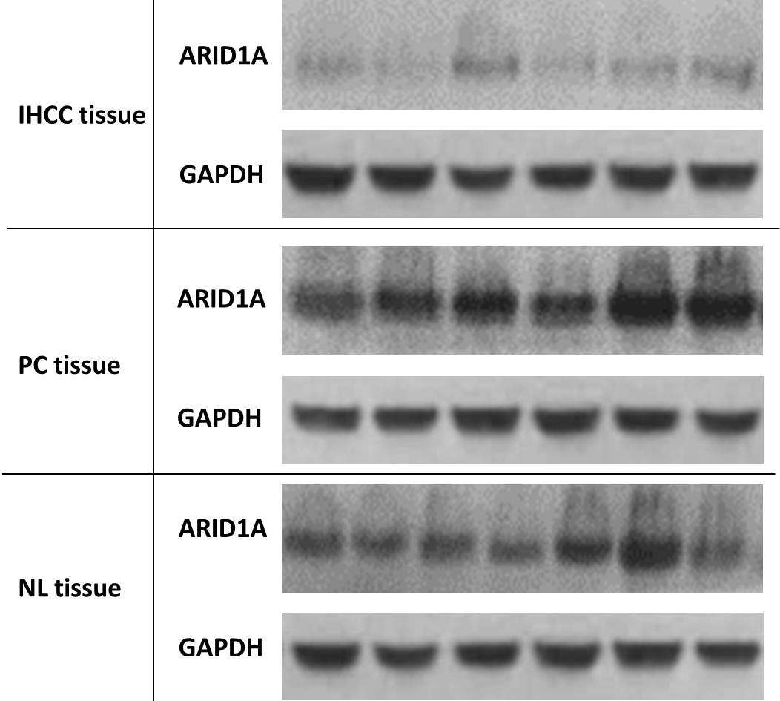Figure 1 ARID1A protein expression in intrahepatic cholangiocarcinoma patients. Western blotting for ARID1A expression in intrahepatic cholangiocarcinoma (IHCC) tissues PC tissues and NL tissues. GAPDH was used as the internal loading control. IHCC: Intrahepatic cholangiocarcinoma; PC: Paracarcinomatous; NL: Normal liver.
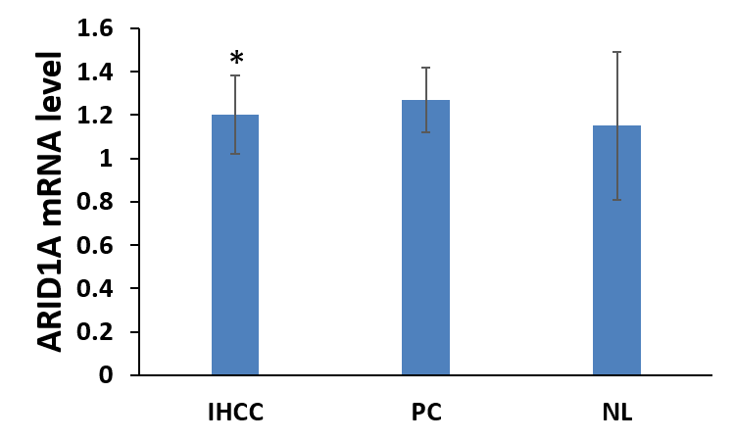
c
Figure 2 ARID1A mRNA level in intrahepatic cholangiocarcinoma patients. IHCC: Intrahepatic cholangiocarcinoma; PC: Paracarcinomatous; NL: Normal liver. ^{c}P < 0.001 vs PC and NL.

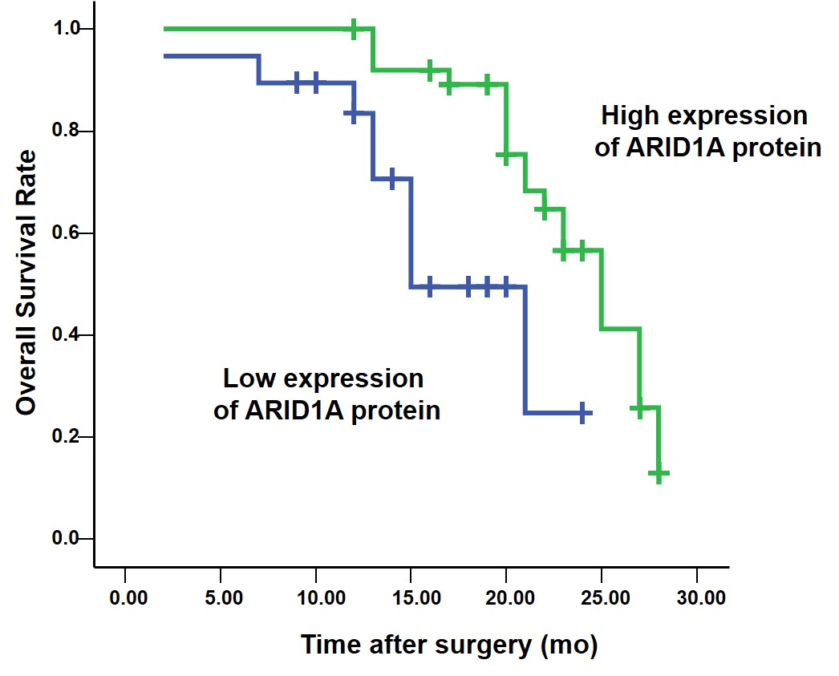
A 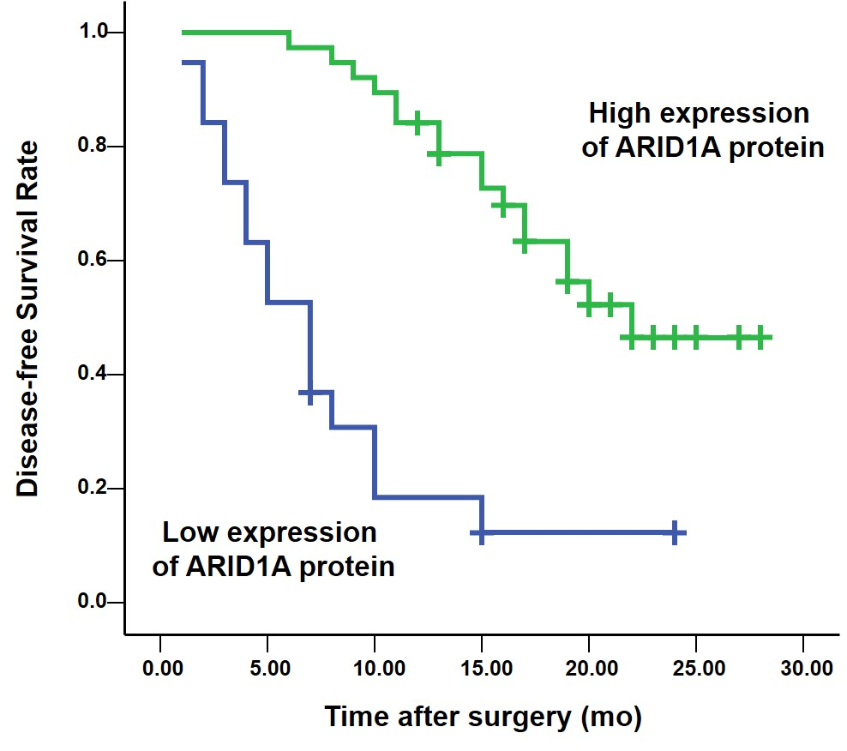
B
Figure 3 Overall survival (A) and disease-free survival (B) of patients with intrahepatic cholangiocarcinoma after surgical resection according to ARID1A protein expression in intrahepatic cholangiocarcinoma tissues (P < 0.01; log-rank test).

Table 1 Clinicopathological features of patients with IHCC and correlation between protein expression of ARID1A and clinicopathological parameters

Characteristics | ARID1A |  | P value
 | Low expression  n = 19 | High expression  n = 38
Age |  |  | 0.703
< 50 | 7 | 16
≥ 50 | 12 | 22
Sex |  |  | 0.546
Female | 7 | 11
Male | 12 | 27
Child- classification |  |  | 0.500
A | 15 | 34
B | 4 | 4
Differentiation |  |  | 0.546
Well | 10 | 12
Moderately | 4 | 13
Poorly | 5 | 13
Tumor size (cm) |  |  | 0.306
> 3 | 15 | 25
≤ 3 | 4 | 13
Tumor nodule |  |  | < 0.001
Solitary | 7 | 32
Multiple | 12 | 6
Vein invasion |  |  | 0.004
Positive | 13 | 11
Negative | 6 | 27
Recurrence status |  |  | 0.004
Yes | 16 | 17
No | 3 | 21

Table 2 Multivariate analysis of OS and disease-free survival on ARID1A protein expression in patients with intrahepatic cholangiocarcinoma (Cox proportional hazards model)

Prognostic factors | Overall survival |  |  | Disease-free survival
 | Hazard ration  (95%CI) | P vaule |  | Hazard ration  (95%CI) | P vaule
Tumor nodule
Solitary vs Multiple | 0.292 (0.093-0.914) | 0.034 |  | 1.092 (0.328-3.639) | 0.886
Vein invasion
Positive vs Negative | 0.181 (0.079-0.413) | < 0.001 |  | 1.207 (0.509-2.859) | 0.669
ARID1A expression
Low vs High | 7.240 (2.281-22.980) | < 0.001 |  | 3.967 (1.299-12.118) | 0.016

