Name of journal: World Journal of Gastroenterology
ESPS Manuscript NO: 11101
Columns: ORIGINAL ARTICLE

Differential gene-expression profiling of gastric intraepithelial neoplasia and early-stage adenocarcinoma

Xu X et al. Expression-differentiated gastric precancerous/cancerous lesions

Xue Xu, Yu Liu, Wei-Xun Zhou, Ying-Cai Ma, Gui-Jun Fei, Ning An, Yuan Li, Xi Wu, Fang Yao, Shu-Jun Cheng, Lin Feng, Xing-Hua Lu

Xue Xu, Gui-Jun Fei, Xi Wu, Fang Yao, Xing-Hua Lu, Department of Gastroenterology, Peking Union Medical College Hospital, Chinese Academy of Medical Science and Peking Union Medical College, Beijing 100730, China

Yu Liu, Ning An, Shu-Jun Cheng, Lin Feng, State Key Laboratory of Molecular Oncology, Cancer Institute Hospital, Peking Union Medical College, Chinese Academy of Medical Sciences, Beijing 100021, China

Wei-Xun Zhou, Yuan Li, Department of Pathology, Peking Union Medical College Hospital, Chinese Academy of Medical Science and Peking Union Medical College, Beijing 100730, China

Ying-Cai Ma, Department of Gastroenterology, Qinghai Provincial People’s Hospital, Xining 810007, Qinghai Province, China

Xue Xu, Ning An, Graduate School of Peking Union Medical College and Chinese Academy of Medical Science, Beijing 100730, China

Author contributions: Xu X carried out most of the experiments and participated in drafting the manuscript; Lu XH and Cheng SJ were leaders of the project, who conceived, initiated, and designed the study; Feng L contributed to the designation of all experiments and revised the manuscript; Wu X, Yao F, Lu XH, Ma YC and Fei GJ collected all of the patient samples and contributed to the designation of the experiments; Fei GJ and Xu X collected patient clinical data; An N and Xu X contributed to the RNA preparation; Feng L performed array hybridization with assistance from Xu X and An N; Xu X participated in the bioinformatics analyses with the guidance of Feng L and Liu Y; Xu X performed the real time qPCR and immunohistochemical staining experiments and statistical analysis with assistance from Feng L and Liu Y; Zhou WX and Li Y carried out most of the pathological diagnosis and immunohistochemical evaluation; Lu XH and Cheng SJ supervised the project. All of the authors read and approved the final manuscript.

Supported by the specific grants of Public-Funded Projects in the Health Industry, Grant 200902002

Correspondence to: Xing-Hua Lu, Department of Gastroenterology, Peking Union Medical College Hospital, Chinese Academy of Medical Science and Peking Union Medical College, Shuai Fu Yuan 1, Dongcheng District, Beijing 100730, China. lxhbj2000@aliyun.com

Telephone: +86-10-69155016 Fax: +86-10-69155016
Received: May 4, 2014 Revised: June 5, 2014
Accepted: June 14, 2014

Published online:

Abstract
AIM: To investigate the differentiated whole genome expression profilings of gastric high- and low-grade intraepithelial neoplasia and early-stage adenocarcinoma.

METHODS: Gastric specimens from an upper magnifying chromoendoscopic targeted biopsy were collected from March 2010 to May 2013. The whole genome expression profiling was performed on 19 low-grade intraepithelial neoplasia (LGIN), 20 high-grade intraepithelial neoplasia (HGIN), 19 early-stage adenocarcinoma (EGC), and 19 chronic gastritis tissue samples using Agilent 4 × 44K Whole Human Genome microarrays. Differentially expressed genes between different types of lesions were identified using an unpaired t-test and corrected with the Benjamini and Hochberg false discovery rate algorithm. A gene ontology (GO) enrichment analysis was performed using the GeneSpring software GX 12.6. The differentially expressed gene was verified using a real-time TaqMan® PCR assay with independent tissue samples, including 26 LGIN, 15 HGIN, 14 EGC, and 20 chronic gastritis. The expression of G₀S₂ were further validated by immunohistochemical staining (IHC) in 24 LGIN, 40 HGIN, 30 EGC and 61 chronic gastritis specimens.

RESULTS: The gene expression patterns of the LGIN and HGIN tissues were distinct. There were 2521 significantly differentially expressed transcripts in HGIN, with 951 upregulated and 1570 downregulated. A GO enrichment analysis demonstrated that the most striking overexpressed transcripts in HGIN compared with LGIN were in the category of metabolism, defense response, and nuclear factor κB (NF-κB) cascade. While the vast majority of transcripts barely altered the expression in HGIN and EGC tissues, only 38 transcripts were upregulated in EGC. A GO enrichment analysis revealed that the alterations of the immune response were most prominent in the progression from HGIN to EGC. It is worth noting that compared with LGIN, 289 transcripts expressed at higher levels both in HGIN and EGC. A characteristic gene, G₀/G₁ switch 2 (G₀S₂) was one of the 289 transcripts and related to metabolism, the immune response, and the NF-κB cascade and whose expression was validated in independent samples through real-time TaqMan® PCR and immunohistochemical staining. In real-time PCR analysis, the expression of G₀S₂ was elevated both in HGIN and EGC compared with that in LGIN (P < 0.01 and P < 0.001, respectively). In IHC analysis, G₀S₂ immunoreactivity was detected in the cytoplasmic of neoplastic cells, but was undetectable in chronic gastritis cells. The G₀S₂ expression in HGIN was higher than that of LGIN (P = 0.012, χ² = 6.28) and EGC (P = 0.008, χ² = 6.94).

CONCLUSION: The clear biological distinction between gastric high-and low-grade intraepithelial neoplasia are identified, which provides molecular evidence for their clinical application.

© 2014 Baishideng Publishing Group Inc. All rights reserved.

Key words: Gastric early-stage adenocarcinoma; High-and low-grade intraepithelial neoplasia; G₀/G₁ switch 2; Whole genome expression microarray; Quantitative real-time PCR; Immunohistochemical staining

Core tip: This is the first study to perform a comprehensive detection of the gene expression profilings of gastric low-grade and high-grade intraepithelial neoplasia and early-stage adenocarcinoma. This study collected precious samples to report the clear distinction of the gene expression profiles between gastric low-grade and high-grade intraepithelial neoplasia, thus providing molecular evidence for their different clinical application. The characteristic upregulated genes during gastric early carcinogenesis were involved in metabolism and the immune response and nuclear factor-κB pathway, whose expression was validated in independent samples through real-time TaqMan® polymerase chain reaction and immunohistochemical staining.

Xu X, Liu Y, Zhou WX, Ma YC, Fei GJ, An N, Li Y, Wu X, Yao F, Cheng SJ, Feng L, Lu XH. Differential gene-expression profiling of gastric intraepithelial neoplasia and early-stage adenocarcinoma. World J Gastroenterol 2014; In press

INTRODUCTION
Gastric cancer is the fourth most prevalent malignant disease and the second most common cause of cancer-related deaths worldwide. Early gastric cancer (EGC) is confined to the mucosa and submucosa of the stomach with or without lymph node metastasis. The 5-year survival rates between advanced-stage and early-stage gastric cancer are extremely different (10% and 90%, respectively)^{[1]}. Unlike advanced-stage patients, patients with early-stage gastric cancer and precancerous lesions usually have no symptoms. Precancerous lesions are histological abnormalities and are more likely to occur with cancer. According to the WHO Classification of tumors of the digestive system^{[2]}, the terminology of low-grade intraepithelial neoplasia/dysplasia (LGIN) and high-grade intraepithelial neoplasia/ dysplasia (HGIN) is recommended for gastric precancerous lesions. Enhanced endoscopy increases the detection of asymptomatic gastric cancer or precancerous lesions for early intervention. Though they have a high incidence, Japan and South Korea have a low mortality-to-incidence ratio (0.43/0.35) that benefits from a population-based screening program^{[3]}. Therefore, early detection and an appropriate diagnosis of gastric intraepithelial neoplasia and early-stage cancer are associated with improved outcomes for patients. Furthermore, it is important to understand more about these stages both clinically and biologically.
In the Correa cascade of multi-step gastric carcinogenesis^{[4]}, an inflammation-metaplasia-dysplasia-carcinoma sequence indicates that dysplasia may be a critical point for malignant transformation. A cohort study demonstrated that 24.9% of patients with severe dysplasia and 2.1% of patients with mild-to-moderate dysplasia received a diagnosis of gastric cancer within 1 year of follow-up after the initial diagnosis^{[5]}. Most patients harboring lesions that are classified as high-grade dysplasia are at high risk of either synchronous invasive carcinoma or its rapid development^{[6]}. Based on the potential transition between and morphological similarity of dysplasia and carcinoma, the hypothesis that they are biologically related is reasonable. Previous studies of the genomic copy number aberration (CNAs) of gastric precancerous lesions and carcinoma in situ (CIS) have provided the most prominent 8q gain, which was detected most frequently in both HGIN and CIS but was undetected in the LGIN using array comparative genomic hybridization^{[7]}. Therefore, evidence has shown that molecular variations in gastric carcinogenesis have already appeared in precancerous lesions or EGC.
According to the revised Vienna classification of gastrointestinal epithelial neoplasia, the clinical management of endoscopic follow up is recommended for category 3 (LGIN), while endoscopic or surgical local resection is recommended for category 4 (HGIN). LGIN and HGIN apparently have different clinicopathological characteristics; however, little is known about their biological characteristics. Previous gene expression profiling studies on gastric precancerous lesions did not detail the differences between LGIN and HGIN.
In this study, the gene expression profiling of gastric high-and low-grade intraepithelial neoplasia and early-stage adenocarcinoma are investigated to explore the molecular alteration in the malignant progression of gastric neoplasia. The clear distinction of the gene expression profiles between HGIN and LGIN are identified, thus providing molecular evidence for their different clinical application. The microarray data were validated by quantitative real-time PCR in an independent group of patients, and followed by immunohistochemical staining. Interestingly, characteristic upregulated genes during gastric early carcinogenesis were involved in metabolism and the immune response and nuclear factor κB (NF-κB) pathway.

MATERIALS AND METHODS
Patients and frozen tissue samples
The subjects were recruited from Peking Union Medical College Hospital (PUMCH) and Qinghai Provincial People’s Hospital, totaling 137 samples and 15 samples, respectively, between March 2010 and May 2013. Gastric specimens from an upper magnifying chromoendoscopic targeted biopsy were collected. The samples used for pathological diagnosis and for this experiment in each patient were very similar. According to the WHO Classification of Tumors of the Digestive System, the samples can be grouped into 4 categories: LGIN (8148/0), HGIN (8148/2), EGC (8140/3), and the chronic gastritis group.
The pathological diagnosis of chronic gastritis was based on the Sydney classification and considered as controls. EGC are confined to the mucosa or submucosa by surgery or ESD (endoscopic submucosal dissection) after the biopsy. This study consisted of a discovery phase and a validation phase with 77 and 75 tissue samples, respectively. In the discovery phase, gene expression profiling was performed on 19 LGIN, 20 HGIN, 19 EGC, and 19 chronic gastritis tissue samples using microarrays. In the validation phase, independent tissue samples from 26 LGIN, 15 HGIN, 14 EGC, and 20 chronic gastritis patients were used in a real-time TaqMan® PCR assay (Applied Biosystems, CA, United States). The clinicopathological characteristics of the patients in the different groups were evaluated in terms of gender and age. The inclusion criteria included voluntary participation in this study with informed consent and a definite pathological diagnosis by two pathologists. The two pathologists review all cases from two different hospitals according to the same criterion and agree with all the diagnosis. This study was approved by Ethics Committee of PUMCH and also received institutional approval; the experiments were carried out in accordance with the World Medical Association Declaration of Helsinki Ethical Principles for Medical Research^{[8]}.

Formalin-fixed tissue samples
Formalin-fixed paraffin-embedded blocks of 155 specimens were obtained from patients who underwent endoscopic submucosal dissection (ESD) in the department of gastroenterology or underwent gastrectomy in the department of general surgery at PUMCH between September 2010 to September 2013. The patients’ ages ranged from 39-78 years with a mean of 56 years. The patients’ male-to-female (M/F) ratio was 1.47. The pathological diagnosis of 61 chronic gastritis was based on the Sydney classification. A total of 94 neoplasia were diagnosed on hematoxylin and eosin (HE) according to the WHO Classification of Tumors of the Digestive System, with 24 specimens were classified as LGIN, 40 specimens were classified as HGIN, and 30 specimens were classified as EGC.

RNA preparation
The samples were stored in RNAlater® Solution immediately after biopsy during the upper endoscopy. The samples were incubated in RNAlater® Solution overnight at 4°C and then transferred to -80°C. The total RNA was extracted using the RNeasy Mini Kit (Qiagen, MD, United States). The concentration was measured by ND-1000 UV-VIS spectrophotometry (NanoDrop Technologies, DE, United States). The quality of the purified RNA (RNA integrity number, RIN) was detected using the RNA 6000 LabChip Kit and Agilent 2100 Bioanalyzer (Agilent, CA, United States). The RNA samples with an A_{260/280} ratio greater than 1.8 and an RIN greater than 6.5 were included.

Gene expression microarray analysis
The sample labeling, hybridization, washing, and scanning steps were performed at the Cancer Institute and Chinese Academy of Medical Science according to the manufacturer’s instructions. Initially, 100 ng total RNA was added to the reaction to generate 1.65 μg Cy3-labeled cRNA using the Low Input Quick Amp Labeling Kit (Agilent). Then, the cRNA was hybridized to an Agilent 4 × 44K Whole Human Genome microarray. After hybridization, the slides were washed and then scanned with the Agilent G2505B Microarray Scanner System. The fluorescent intensities of the scanned images were extracted and preprocessed with the Agilent Feature Extraction Software (v. 9.1). The microarray data were submitted to NCBI’s Gene Expression Omnibus database (GSE55696). Data normalization, quality control, principal component analysis, and filter by flags were performed using the GeneSpring software GX 12.6 (Agilent Technologies), and only the detected flags were acceptable.

Real-time quantitative PCR
First, 500 ng total RNA was reverse transcribed using SuperScript™ IIReverse Transcriptase, and cDNA was produced. The gene expression was analyzed on the MX3005P™ QPCR System (Stratagene) using TaqMan® Gene Expression Assay probes for G₀S₂ (Hs00274783_s1) and POLR2A (Hs00172187_m1) according to the manufacturer’s protocol (Applied Biosystems, CA, United States). The PCR program was initiated for 2 min at 50°C and 10 min at 95°C before 45 thermal cycles, each for 15 seconds at 95°C and 1 min at 60°C. The gene expression levels of G₀S₂ were assessed relative to those of POLR2A. The equation -^{ΔCT}G₀S₂ = –(^{CT}G₀S₂ - ^{CT}POLR2A) represents the expression level of G₀S₂. That is, a greater -^{ΔCT}G₀S₂ values indicates a higher level of G₀S₂ expression.

Immunohistochemical staining
Immunohistochemical analysis included polyclonal antibody for G₀S₂(Novus, CO, United States; dilution 1:100). Briefly, paraffin blocks were cut into 3-μm thickness sections. These sections were deparaffinized in xylene and rehydrated in a descending ethanol-to-water gradient series. Endogenous peroxidase was blocked by exposure to 3% H₂O₂ for 10 min. For antigen retrieval, sections were subjected to microwave heat in citrate buffer (pH 9.0) with ebullition for 5 min. After cooling to room temperature, sections were incubated with a polyclonal antibody for G₀S₂ at room temperature for 2 h. Anti-rabbit immunoglobulin G labeled with biotin (OriGene Technologies, Beijing, China) was used as a secondary antibody for the detection of primary antibodies and was incubated for 30 min at room temperature. The tissue sections were ready for chromogen reaction with 0.02% diaminobenzidine, and then were counterstained with hematoxylin. All samples were processed under the same conditions. Human seminiferous ducts cells in testis tissue served as positive control following the manufacturer’s protocol.
All immunostained slides were evaluated independently by two pathologists (Zhou WX and Li Y). The percentage of G₀S₂ positive cells was calculated and scored as follows: score 0 = undetectable staining and from 1% to 29% of positive cells; 1 = from 30% to 59% of positive cells; 2 = from 60% to 89% of positive cells; 3 ≥ 89% of positive cells. The intensity of cytoplasmic staining was also evaluated for G₀S₂ and scored from 1 to 3 (from low, through medium to high). For statistical analysis, multipling the percentage and intensity scores provided a composite expression score (0-9). A composite score of 1-4 was classified as negative and 5-9 was ranked as positive.

Statistical analysis
The statistical analyses of the gene expression microarray data were performed using an unpaired t-test and corrected with the Benjamini and Hochberg FDR (false discovery rate) algorithm. The statistical significance was assessed at P < 0.05 to identify genes that were differentially expressed between different types of lesions and to perform a gene ontology (GO) enrichment analysis using the GeneSpring software GX 12.6. Hierarchical clustering was performed using R (http://www.r-project.org/). The SPSS (v. 18.0) software was used for the statistical analysis of the clinical features, of the qPCR results, and of the IHC results. The chi-square test was used to compare the categorical variables. Regarding the numerical variables, comparisons of parameters between the 2 groups were made using an unpaired t-test, and those among 4 groups were performed using one-way ANOVA followed by LSD (least significant difference). P < 0.05 was considered statistically significant.

RESULTS
Clinical characteristics of enrolled patients
In total, 152 tissue samples were randomly divided into 2 sets, with no significant differences with respect to age (P = 0.14), gender (P = 0.48), or other clinicopathological features; the sets were used in the discovery and validation phases. The clinical characteristics of all patients are summarized in Table 1. The average age of the patients was 57.76 ± 9.30 years. Regarding the EGC group, the 2 sets show no significant differences in terms of the depth of invasion (P = 0.31) or differentiation (P = 0.56) (Table 2).

HGIN and LGIN are biologically distinct
The whole genomic expression profiles of 19 LGIN and 20 HGIN were analyzed. The transcripts whose expression level differed significantly between LGIN and HGIN were explored. In total, 2521 significantly differentially expressed transcripts (951 upregulated and 1570 downregulated in HGIN) were identified and may be involved in the development of HGIN.
To identify the functionally relevant gene clusters, a GO enrichment analysis of the 951 and 1570 above-mentioned transcripts was performed. There were no enriched GO terms among the 1570 downregulated transcripts. The enriched GO terms in the 951 upregulated transcripts were associated with metabolism, the defense response, and the NF-κB cascade, which are shown in Table 3. It was hypothesized that the upregulated transcripts contributed the most relevant functions and processes. The biological distinctions between HGIN and LGIN were primarily involved in metabolism, the defense response, and the NF-κB cascade (Table 3).

The molecular differences between HGIN and EGC are not significant
Gene expression analyses were performed in 20 HGIN and 19 EGC to reveal the molecular differences between these tissues. Unlike the remarkable distinction between HGIN and LGIN, there were only 58 differentially expressed transcripts between HGIN and EGC, including 38 upregulated and 20 downregulated transcripts in EGC. No GO term was enriched based on the 20 downregulated transcripts. Although the expression differences between HGIN and EGC were not great, it is worth noting that the GO enrichment analysis result of 38 upregulated transcripts was relatively prominent in the progression from HGIN to EGC. The molecular differences between HGIN and EGC mainly focused on the immune response, as shown in Table 4.

Comparison with LGIN indicates that some of the alterations associated with HGIN are retained in EGC
When compared with LGIN, among the 951 upregulated genes in HGIN, 289 transcripts (Figure 1) were expressed at a similarly high level in EGC and were involved in the GO enrichment analysis. Indeed, the 289 transcripts could separate both HGIN and EGC from the LGIN class. The heat map in Figure 2 shows their clear separation. These transcripts that were overexpressed compared with LGIN were not only so in HGIN but were also overexpressed at similar or even higher levels in EGC. In terms of the GO enrichment, some of the alterations associated with HGIN compared with LGIN, such as metabolism, the defense response, and the NF-κB cascade, are still retained in EGC.

Significant variation of G₀S₂ in HGIN and early-stage adenocarcinoma vs LGIN within a microarray analysis
G₀S₂ was related to metabolism, the defense response, and the NF-κB cascade and was overexpressed in both HGIN and EGC compared with LGIN.
As shown in Table 5, the expression level of G₀S₂ in gastric EGC tissue was 6.00-fold higher than that in gastric LGIN tissue (unpaired t-test with FDR correction Pcorr < 0.001) (Table 5). The expression level of G₀S₂ in gastric HGIN tissue was 3.28-fold higher than that in gastric LGIN tissue (Pcorr < 0.05).
Between HGIN and early-stage adenocarcinoma, the expression differences of G₀S₂ were not statistically significant (Pcorr > 0.05). However, the expression of EGC was 1.83 fold higher than that of HGIN (Figure 3).
Compared with gastritis, the overexpression of G₀S₂ in HGIN and EGC was statistically significant (Pcorr < 0.01). The difference between LGIN and gastritis was not statistically significant.
The expression of G₀S₂ was relatively increased in the malignant lesions than in the benign lesions (Figure 3).

Independent validation in quantitative real-time PCR analysis
To validate the above results, qPCR of G₀S₂ was performed to quantify the RNA levels in independent tissue samples. The expression of G₀S₂ was elevated in HGIN and early-stage adenocarcinoma compared with that in LGIN, which was identical to the microarray results (Figure 4). Compared with LGIN, the difference in G₀S₂ expression was significant both in EGC and HGIN (P < 0.001 and P < 0.01, respectively) (Figure 4). Similarly, compared with gastritis, the difference in G₀S₂ expression was significant in EGC and HGIN (P < 0.001 and P < 0.05, respectively).

Validation in IHC analysis
G₀S₂ immunoreactivity was detected in the cytoplasmic of neoplastic cells, but was undetectable (Figure 5A) in chronic gastritis cells (gastritis vs LGIN, P = 0.005; gastritis vs HGIN, P < 0.001; gastritis vs EGC, P = 0.004). The expression rates of G₀S₂ were 12.5% in LGIN (Figure 5B), 42.5% in HGIN (Figure 5C), and 13.3% in EGC (Figure 5D). The G₀S₂ expression in HGIN was higher than that of LGIN (P = 0.012, χ² = 6.28) and EGC (P = 0.008, χ² = 6.94)(Table 6).
In conclusion, HGIN and LGIN are biologically distinct, the expression of G₀S₂ is significantly elevated in HGIN and EGC compared with that in LGIN. As a NF-κB cascade-and metabolism-related gene, G₀S₂ may be of considerable interest in the malignant transformation of gastric intraepithelial neoplasia.

DISCUSSION
According to the Vienna classification of gastrointestinal epithelial neoplasia, patients with HGIN or carcinoma (CIS, suspicious, intramucosal, or submucosal invasion) should receive resection (endoscopic or surgical). For patients with LGIN, endoscopic resection or follow up is indicated^{[9]}. There is evidence that genetic factors are related to gastric cancer and relevant precancerous lesions^{[10]}. Gastric precancerous lesions are currently distinguished into LGIN and HGIN. Several large-scale follow-up studies have revealed that patients with HGIN are at a higher risk for developing gastric carcinoma than are patients with LGIN. In this study, the gene expression profiles of gastric LGIN, HGIN, and EGC tissue were analyzed. There were 951 significantly upregulated transcripts and 1570 significantly downregulated transcripts in HGIN compared with LGIN. However, there were no enriched GO terms among the 1570 downregulated transcripts when a GO enrichment analysis was performed. Similarly, there were 38 upregulated and 20 downregulated transcripts in EGC compared with HGIN and no GO term was enriched based on the 20 downregulated transcripts. It was supposed that the transcripts contributed most to gastric early carcinogenesis were upregulated along with the progress from LGIN, through HGIN to EGC. The gene expression patterns between HGIN and LGIN were distinct, and the enriched GO terms in the above-mentioned 951 differentially expressed transcripts were associated with metabolism, the defense response, and the NF-κB cascade. Similarly, the differences of gene expression profiling between EGC and LGIN were significant with the parallel enriched GO terms. Presumably, the biological similarities between HGIN and EGC were prominent when compared with LGIN. However, the molecular differences between HGIN and EGC was not significant and the involved function of their differentially expressed transcripts were mainly focused on the immune response.
The genes that are involved in metabolism, the defense response, and the NF-κB cascade were not only upregulated in HGIN compared with LGIN but were also upregulated at similar or even higher expression levels in EGC. A characteristic gene related to metabolism, the immune response, and the NF-κB cascade, G₀S₂, was subsequently validated in independent samples using a qPCR test and an IHC test. Although the microarray analysis and qPCR analysis showed the G₀S₂ expression was higher in EGC and HGIN than in LGIN, the immunohistochemical staining results showed the expression rate of G₀S₂ was higher in HGIN but similar in LGIN and EGC. The expression level of mRNA and immunohistochemical staining may be not the same.
G₀S₂ is located on chromosome 1 of the genome and encodes a small basic protein of 103 amino acids. G₀S₂ is related to the re-entry of cells from the G₀ phase to the G₁ phase of the cell cycle, implying that the G₀S₂ gene has a cell proliferative function. Previous studies have indicated that G₀S₂ is highly induced through NF-κB following tumor necrosis factor-α treatment^{[11]}. G₀S₂ is a novel target gene of PPARs (peroxisome proliferator-activated receptors, α, β/β, and γ), which are mainly involved in lipid metabolism^{[12,13]}. Activation of PPARγ inhibits cell growth and induces apoptosis in gastric cancer cells. G₀S₂ is an inhibitor of adipose triglyceride lipase and decreases lipolysis^{[14-17]}. G₀S₂ is a positive regulator of oxidative phosphorylation^{[18]}. G₀S₂ was upregulated in inflammatory processes, was involved in T cell quiescence, and inhibited proliferation of T cells. Inhibition of MAPK, PI3K, mTOR and Ca²⁺/calcineurin pathways abrogated G₀S₂ gene suppression^{[19-21]} .
NF-κB transcription factors and its signaling pathway play a key role in controlling the immune response^{[22-24]}. NF-κB provides a mechanistic link between inflammation and cancer^{[25-27]}. NF-κB controls the ability of pre-neoplastic and malignant cells to resist apoptosis-based tumor-surveillance mechanisms, which is crucial for the clinical development of NF-κB inhibitors as cancer therapeutics^{[28]}. The alterations in certain aspects of lipid metabolism were involved in tumorigenesis, including the synthesis and degradation of lipids that contribute to energy homeostasis and the abundance of lipids with signaling functions^{[29-32]} .
Previous studies with HGIN and LGIN were mostly based on several known genes^{[33,34]}, such as p53, Her-2, and E-cadherin^{[35]}. Until now, few studies have focused on gastric intraepithelial neoplasia, especially from the aspect of the whole genome expression profile.
The microarray approach has been widely applied to the investigation of advanced gastric cancer. However, advanced gastric cancer has a worse prognosis and greater heterogeneity with its progression. Several studies have revealed that genetic alterations begin in the early stages of cancer and even in precancerous lesions. Early studies using CGH arrays suggested that an 8q gain in HGIN may play a pivotal role in the development of gastric carcinoma^{[7]}. However, the gene expression levels and functions associated with the copy number status of 8q were not detailed. Much less is known in terms of a comparison among the expression profiles of LGIN, HGIN, and EGC due to the difficulties of early detection and biopsy. Based on the clinicopathological finding and a clear research design, this study collected samples of LGIN, HGIN, and EGC to perform a comprehensive detection of their expression profiles at a whole-genome level. Through this study of gene expression profiles, the biological basis of the clinical differences between HGIN and LGIN was determined.
Despite the limitation that including more samples in each group would be better, this large-scale experiment opens the door for further research into precancerous lesions. The asymptomatic characteristics, atypical histology, and lack of specific biomarkers in^{[10,36]} precancerous lesions make them difficult to diagnose early and accurately. Moreover, the performance of the gene in immunohistochemistry experiments may be useful for early detection of gastric epithelial neoplasia, and the clinical application for the auxiliary diagnosis of atypical lesions is promising. Furthermore, the gene function-related research requires future study.
In summary, the microarray analysis in this study identified differences in the gene expression between LGIN and HGIN. The obvious molecular distinction between LGIN and HGIN was almost identical with the clinical practice. Metabolism, the immune response, and the NF-κB cascade appear to be important processes underlying malignant transformation.

ACKNOWLEDGEMENTS
We are grateful to all of the patients for their participation and to the physicians at the Peking Union Medical College Hospital and the Qinghai Provincial People’s Hospital for their cooperation.

COMMENTS
Background
Early detection and an appropriate diagnosis of gastric intraepithelial neoplasia and early-stage cancer are associated with improved outcomes for patients. It is important to understand more about these stages both clinically and biologically. However, little is known about their biological characteristics due to the difficulties of early detection and biopsy.

Research frontiers
Low-grade intraepithelial neoplasia (LGIN), high-grade intraepithelial neoplasia (HGIN) apparently have different clinicopathological characteristics. Previous gene expression profiling studies on gastric precancerous lesions did not detail the differences between LGIN and HGIN. Based on the potential transition between and morphological similarity of dysplasia and carcinoma, the hypothesis that they are biologically related is reasonable.

Innovations and breakthroughs
This is the first study to perform a comprehensive detection of the gene expression profilings of gastric low-grade and high-grade intraepithelial neoplasia and early-stage adenocarcinoma. The characteristic upregulated genes during gastric early carcinogenesis were involved in metabolism and the immune response and nuclear factor-κB (NF-κB) pathway, whose expression was validated in independent samples through real-time TaqMan® PCR and immunohistochemical staining.

Applications
This study collected precious samples to report the clear distinction of the gene expression profiles between gastric low-grade and high-grade intraepithelial neoplasia, thus providing molecular evidence for their different clinical application. G₀S₂ was identified as a potential marker to differentiate gastric low-grade and high-grade intraepithelial neoplasia.

Terminology
NF-κB transcription factors and its signaling pathway play a key role in controlling the immune response. NF-κB provides a mechanistic link between inflammation and cancer. NF-κB controls the ability of pre-neoplastic and malignant cells to resist apoptosis-based tumor-surveillance mechanisms, which is crucial for the clinical development of NF-κB inhibitors as cancer therapeutics. G₀S₂ is related to the re-entry of cells from the G₀ phase to the G₁ phase of the cell cycle. G₀S₂ is an inhibitor of adipose triglyceride lipase and decreases lipolysis, and is a positive regulator of oxidative phosphorylation.

Peer review
This manuscript presents an interesting differential gene expression profiling of gastric LGIN, HGIN and early gastric cancer, and try to explore the molecular alteration in the malignant progression of gastric neoplasia. From their microarray data, authors identified G₀S₂, a putative lymphocyte G₀/G₁ switch gene product as a potential marker to differentiate low grade neoplastic lesion from high grade lesion in the stomach.

REFERENCES
1 Butte JM, Torres J, Viviani P, Duarte I, Crovari F, Guzmán S, Cabrera R, Pedemonte J, Llanos O. [Long term survival of patients operated for early gastric cancer]. Rev Med Chil 2008; 136: 1424-1430 [PMID: 19301773]
2 Bosman FT, Carneiro F, Hruban RH, Theise ND. WHO classification of tumours of the digestive system: World Health Organization, 2010
3 Shen L, Shan YS, Hu HM, Price TJ, Sirohi B, Yeh KH, Yang YH, Sano T, Yang HK, Zhang X, Park SR, Fujii M, Kang YK, Chen LT. Management of gastric cancer in Asia: resource-stratified guidelines. Lancet Oncol 2013; 14: e535-e547 [PMID: 24176572 DOI: 10.1016/s1470-2045(13)70436-4]
4 Correa P. A human model of gastric carcinogenesis. Cancer Res 1988; 48: 3554-3560 [PMID: 3288329]
5 de Vries AC, van Grieken NC, Looman CW, Casparie MK, de Vries E, Meijer GA, Kuipers EJ. Gastric cancer risk in patients with premalignant gastric lesions: a nationwide cohort study in the Netherlands. Gastroenterology 2008; 134: 945-952 [PMID: 18395075 DOI: 10.1053/j.gastro.2008.01.071]
6 Dinis-Ribeiro M, Areia M, de Vries AC, Marcos-Pinto R, Monteiro-Soares M, O'Connor A, Pereira C, Pimentel-Nunes P, Correia R, Ensari A, Dumonceau JM, Machado JC, Macedo G, Malfertheiner P, Matysiak-Budnik T, Megraud F, Miki K, O'Morain C, Peek RM, Ponchon T, Ristimaki A, Rembacken B, Carneiro F, Kuipers EJ. Management of precancerous conditions and lesions in the stomach (MAPS): guideline from the European Society of Gastrointestinal Endoscopy (ESGE), European Helicobacter Study Group (EHSG), European Society of Pathology (ESP), and the Sociedade Portuguesa de Endoscopia Digestiva (SPED). Endoscopy 2012; 44: 74-94 [PMID: 22198778 DOI: 10.1055/s-0031-1291491]
7 Uchida M, Tsukamoto Y, Uchida T, Ishikawa Y, Nagai T, Hijiya N, Nguyen LT, Nakada C, Kuroda A, Okimoto T, Kodama M, Murakami K, Noguchi T, Matsuura K, Tanigawa M, Seto M, Ito H, Fujioka T, Takeuchi I, Moriyama M. Genomic profiling of gastric carcinoma in situ and adenomas by array-based comparative genomic hybridization. J Pathol 2010; 221: 96-105 [PMID: 20217874 DOI: 10.1002/path.2686]
8 World Medical Association Declaration of Helsinki: ethical principles for medical research involving human subjects. JAMA 2013; 310: 2191-2194 [PMID: 24141714 DOI: 10.1001/jama.2013.281053]
9 Dixon MF. Gastrointestinal epithelial neoplasia: Vienna revisited. Gut 2002; 51: 130-131 [PMID: 12077106]
10 Leja M, Wex T, Malfertheiner P. Markers for gastric cancer premalignant lesions: where do we go? Dig Dis 2012; 30: 268-276 [PMID: 22722551 DOI: 10.1159/000336990]
11 Welch C, Santra MK, El-Assaad W, Zhu X, Huber WE, Keys RA, Teodoro JG, Green MR. Identification of a protein, G0S2, that lacks Bcl-2 homology domains and interacts with and antagonizes Bcl-2. Cancer Res 2009; 69: 6782-6789 [PMID: 19706769 DOI: 10.1158/0008-5472.CAN-09-0128]
12 Fucci A, Colangelo T, Votino C, Pancione M, Sabatino L, Colantuoni V. The role of peroxisome proliferator-activated receptors in the esophageal, gastric, and colorectal cancer. PPAR Res 2012; 2012: 242498 [PMID: 22991505 DOI: 10.1155/2012/242498]
13 Takahashi N, Okumura T, Motomura W, Fujimoto Y, Kawabata I, Kohgo Y. Activation of PPARgamma inhibits cell growth and induces apoptosis in human gastric cancer cells. FEBS Lett 1999; 455: 135-139 [PMID: 10428487]
14 Schweiger M, Paar M, Eder C, Brandis J, Moser E, Gorkiewicz G, Grond S, Radner FP, Cerk I, Cornaciu I, Oberer M, Kersten S, Zechner R, Zimmermann R, Lass A. G0/G1 switch gene-2 regulates human adipocyte lipolysis by affecting activity and localization of adipose triglyceride lipase. J Lipid Res 2012; 53: 2307-2317 [PMID: 22891293 DOI: 10.1194/jlr.M027409]
15 Das SK, Eder S, Schauer S, Diwoky C, Temmel H, Guertl B, Gorkiewicz G, Tamilarasan KP, Kumari P, Trauner M, Zimmermann R, Vesely P, Haemmerle G, Zechner R, Hoefler G. Adipose triglyceride lipase contributes to cancer-associated cachexia. Science 2011; 333: 233-238 [PMID: 21680814 DOI: 10.1126/science.1198973]
16 Kusakabe M, Kutomi T, Watanabe K, Emoto N, Aki N, Kage H, Hamano E, Kitagawa H, Nagase T, Sano A, Yoshida Y, Fukami T, Murakawa T, Nakajima J, Takamoto S, Ota S, Fukayama M, Yatomi Y, Ohishi N, Takai D. Identification of G0S2 as a gene frequently methylated in squamous lung cancer by combination of in silico and experimental approaches. Int J Cancer 2010; 126: 1895-1902 [PMID: 19816938 DOI: 10.1002/ijc.24947]
17 Kusakabe M, Watanabe K, Emoto N, Aki N, Kage H, Nagase T, Nakajima J, Yatomi Y, Ohishi N, Takai D. Impact of DNA demethylation of the G0S2 gene on the transcription of G0S2 in squamous lung cancer cell lines with or without nuclear receptor agonists. Biochem Biophys Res Commun 2009; 390: 1283-1287 [PMID: 19878646 DOI: 10.1016/j.bbrc.2009.10.137]
18 Kioka H, Kato H, Fujikawa M, Tsukamoto O, Suzuki T, Imamura H, Nakano A, Higo S, Yamazaki S, Matsuzaki T, Takafuji K, Asanuma H, Asakura M, Minamino T, Shintani Y, Yoshida M, Noji H, Kitakaze M, Komuro I, Asano Y, Takashima S. Evaluation of intramitochondrial ATP levels identifies G0/G1 switch gene 2 as a positive regulator of oxidative phosphorylation. Proc Natl Acad Sci U S A 2014; 111: 273-278 [PMID: 24344269 DOI: 10.1073/pnas.1318547111]
19 Yamada T, Lee PH, Burns A, Lacorazza D. G0S2, an early response gene, regulates quiescence in naive T cells. J Immunol 2011; 186: 104-110
20 Heckmann BL, Zhang X, Xie X, Liu J. The G0/G1 switch gene 2 (G0S2): regulating metabolism and beyond. Biochim Biophys Acta 2013; 1831: 276-281 [PMID: 23032787 DOI: 10.1016/j.bbalip.2012.09.016]
21 Kim JY, Tillison K, Lee JH, Rearick DA, Smas CM. The adipose tissue triglyceride lipase ATGL/PNPLA2 is downregulated by insulin and TNF-alpha in 3T3-L1 adipocytes and is a target for transactivation by PPARgamma. Am J Physiol Endocrinol Metab 2006; 291: E115-E127 [PMID: 16705060 DOI: 10.1152/ajpendo.00317.2005]
22 Li Q, Verma IM. NF-kappaB regulation in the immune system. Nat Rev Immunol 2002; 2: 725-734 [PMID: 12360211 DOI: 10.1038/nri910]
23 Karin M, Greten FR. NF-kappaB: linking inflammation and immunity to cancer development and progression. Nat Rev Immunol 2005; 5: 749-759 [PMID: 16175180 DOI: 10.1038/nri1703]
24 Naugler WE, Karin M. NF-kappaB and cancer-identifying targets and mechanisms. Curr Opin Genet Dev 2008; 18: 19-26 [PMID: 18440219 DOI: 10.1016/j.gde.2008.01.020]
25 Bollrath J, Greten FR. IKK/NF-kappaB and STAT3 pathways: central signalling hubs in inflammation-mediated tumour promotion and metastasis. EMBO Rep 2009; 10: 1314-1319 [PMID: 19893576 DOI: 10.1038/embor.2009.243]
26 Baud V, Karin M. Is NF-kappaB a good target for cancer therapy? Hopes and pitfalls. Nat Rev Drug Discov 2009; 8: 33-40 [PMID: 19116625 DOI: 10.1038/nrd2781]
27 Grivennikov SI, Greten FR, Karin M. Immunity, inflammation, and cancer. Cell 2010; 140: 883-899 [PMID: 20303878 DOI: 10.1016/j.cell.2010.01.025]
28 Karin M. Nuclear factor-kappaB in cancer development and progression. Nature 2006; 441: 431-436 [PMID: 16724054 DOI: 10.1038/nature04870]
29 Santos CR, Schulze A. Lipid metabolism in cancer. FEBS J 2012; 279: 2610-2623 [PMID: 22621751 DOI: 10.1111/j.1742-4658.2012.08644.x]
30 Hanahan D, Weinberg RA. Hallmarks of cancer: the next generation. Cell 2011; 144: 646-674 [PMID: 21376230 DOI: 10.1016/j.cell.2011.02.013]
31 Cairns RA, Harris IS, Mak TW. Regulation of cancer cell metabolism. Nat Rev Cancer 2011; 11: 85-95 [PMID: 21258394 DOI: 10.1038/nrc2981]
32 Muñoz-Pinedo C, El Mjiyad N, Ricci JE. Cancer metabolism: current perspectives and future directions. Cell Death Dis 2012; 3: e248 [PMID: 22237205 DOI: 10.1038/cddis.2011.123]
33 Testino G. Gastric precancerous changes: carcinogenesis, clinical behaviour immunophenotype study and surveillance. Panminerva Med 2006; 48: 109-118 [PMID: 16953148]
34 Lin LL, Huang HC, Juan HF. Discovery of biomarkers for gastric cancer: a proteomics approach. J Proteomics 2012; 75: 3081-3097 [PMID: 22498886 DOI: 10.1016/j.jprot.2012.03.046]
35 Zheng ZH, Sun XJ, Ma MC, Hao DM, Liu YH, Sun KL. [Studies of promoter methylation status and protein expression of E-cadherin gene in associated progression stages of gastric cancer]. Yi Chuan Xue Bao 2003; 30: 103-108 [PMID: 12776596]
36 Rugge M, Capelle LG, Cappellesso R, Nitti D, Kuipers EJ. Precancerous lesions in the stomach: from biology to clinical patient management. Best Pract Res Clin Gastroenterol 2013; 27: 205-223 [PMID: 23809241 DOI: 10.1016/j.bpg.2012.12.007]

P-Reviewers: Raggi C, Shi XY, Xu R S-Editor: Gou SX L-Editor: E-Editor:

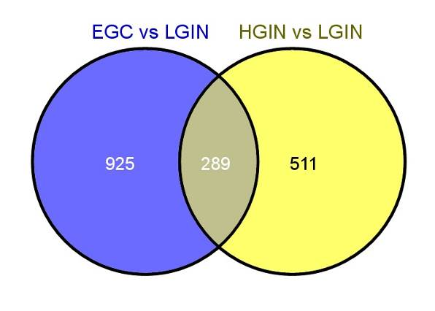
Figure 1 All of the transcripts that were statistically significant both in gastric early-stage adenocarcinoma vs low-grade intraepithelial neoplasia and high-grade intraepithelial neoplasia vs low-grade intraepithelial neoplasia and were involved in the Gene Ontology enrichment analysis. LGIN: Low-grade intraepithelial neoplasia; EGC: Early-stage adenocarcinoma; HGIN: High-grade intraepithelial neoplasia.
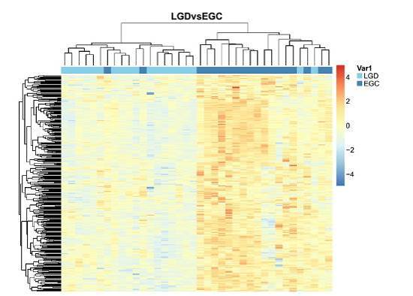
A
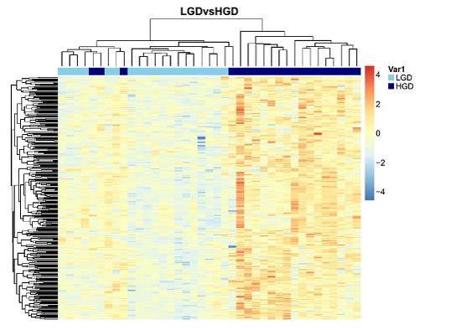
B
Figure 2 Unsupervised cluster analysis of gastric low-grade intraepithelial neoplasia and early-stage adenocarcinoma (A), low-grade intraepithelial neoplasia and high-grade intraepithelial neoplasia (B) tissue samples with the 289 differentially expressed transcripts. The transverse blue bar indicates the histopathological type of the tissue samples: A: Light blue, low-grade intraepithelial neoplasia (LGIN); Dark blue, early-stage adenocarcinoma (EGC); B: Light blue, LGIN; Dark blue, high-grade intraepithelial neoplasia (HGIN). Each column represents a sample, and each row represents a transcript. The expression abundance from low levels to high levels is shown in colors from blue to red.

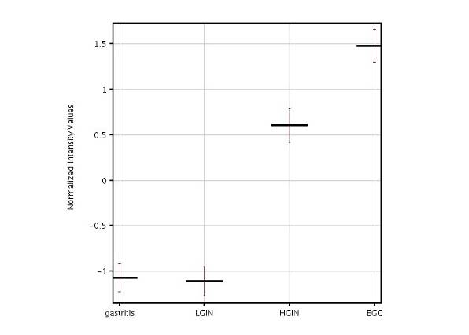
Figure 3 G₀S₂ expression is increased in gastric high-grade intraepithelial neoplasia and early-stage adenocarcinoma in the microarray. The G₀S₂ mRNA expression in gastric high-grade intraepithelial neoplasia (HGIN), tissue shows a statistically significant elevation compared with that of low-grade intraepithelial neoplasia (LGIN). No statistically significant difference in G₀S₂ expression was found between HGIN and early-stage adenocarcinoma (EGC). The results are expressed as the mean ± SE.

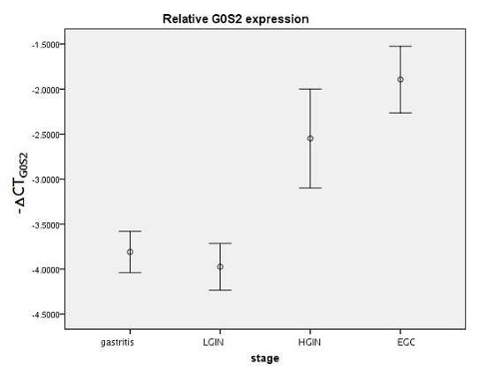
Figure 4 G₀S₂ expression was validated by quantitative polymerase chain reaction in the independent samples. The results are shown as the mean ± SE. -^{△CT}G₀S₂ represents the expression level of G₀S₂. The differences of -^{△CT}G₀S₂ in the 4 groups [low-grade intraepithelial neoplasia (LGIN), high-grade intraepithelial neoplasia (HGIN), early-stage adenocarcinoma (EGC) and gastritis] were compared using an analysis of variance (one-way ANOVA). A test for the homogeneity of variances shows P = 0.105, indicating that the variances are equal. The mean difference between LGIN and HGIN was statistically significant (P = 0.004). The mean difference between LGIN and EGC was statistically significant (P < 0.001).

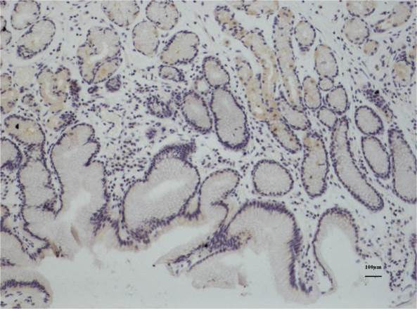
A
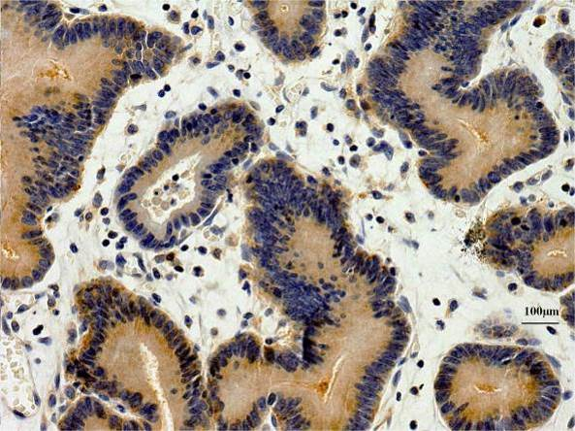
B
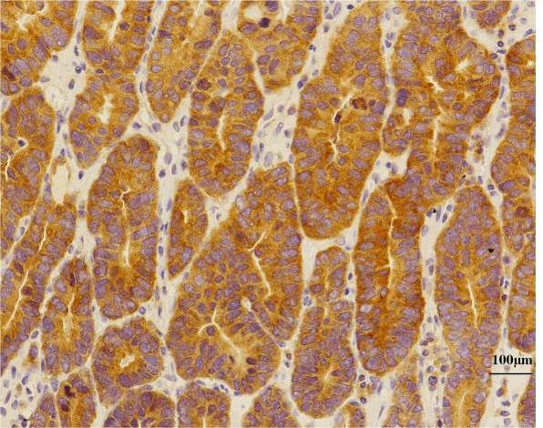
C
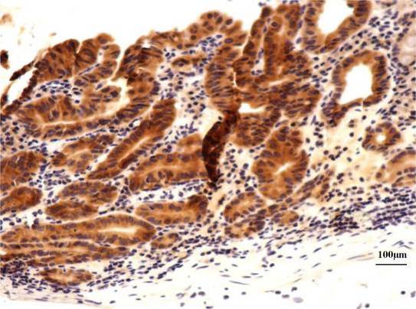
D
Figure 5 Representative immunohistochemistry for G₀S₂ in gastric samples. Representative samples are shown from G₀S₂ (A) chronic gastritis tissues with negative expression, and G₀S₂ (B) low-grade intraepithelial neoplasia tissues with low expression, G₀S₂ (C) high-grade intraepithelial neoplasia tissues with medium expression, and G₀S₂(D) early-stage adenocarcinoma tissues with high expression (Bar represents 100 μm).

Table 1 Clinical characteristics of all of the patients
 | Discovery phase  (n = 77) | Validation phase  (n = 75) | P value
Gender |  |  | 0.48
Male | 46 | 49
Female | 31 | 26
Age (yr) |  |  | 0.14
mean ± SE (range) | 58.87 ± 9.13 (36-78) | 56.61 ± 9.39 (36-79)

Table 2 Clinicopathological characteristics of early-stage gastric carcinoma
 | Discovery phase (n = 19) | Validation phase (n = 14) | P value
Depth of invasion |  |  | 0.31
Tunica mucosa | 6 | 2
Muscularis mucosae | 8 | 5
Submucosa | 5 | 7
Differentiation |  |  | 0.56
Well | 5 | 4
Moderate | 4 | 5
Poor | 10 | 5

Table 3 Enriched Gene Ontology terms of the upregulated transcripts in high-grade intraepithelial neoplasia compared with low-grade intraepithelial neoplasia
GO accession | GO term | P value | Genes involved
GO:0043170|GO:0043283 | Macromolecule metabolic process | 4.01E-09 | 272
GO:0044260|GO:0034960 | Cellular macromolecule metabolic process | 3.84E-09 | 247
GO:0006952|GO:0002217|GO:0042829 | Defense response | 9.44E-08 | 63
GO:0005515|GO:0045308 | Protein binding | 1.09E-07 | 358
GO:0044422 | Organelle part | 3.35E-07 | 292
GO:0044428 | Nuclear part | 4.51E-07 | 145
GO:0044446 | Intracellular organelle part | 4.17E-07 | 288
GO:0070013 | Intracellular organelle lumen | 5.50E-06 | 144
GO:0043122 | Regulation of I-κB kinase/NF-κB cascade | 6.79E-06 | 21
GO:0043123 | Positive regulation of I-κB kinase/NF-κB cascade | 9.53E-06 | 18
NF-κB: Nuclear factor κB.

Table 4 Enriched Gene Ontology categories of the upregulated transcripts in early-stage gastric carcinoma compared with high-grade intraepithelial neoplasia
GO accession | GO term | P value | Genes involved
GO:0050776 | Regulation of the immune response | 2.27E-08 | 9
GO:0050851 | Antigen receptor-mediated signaling pathway | 4.24E-07 | 5
GO:0002429 | Immune response-activating cell surface receptor signaling pathway | 5.82E-07 | 5
GO:0050863 | Regulation of T cell activation | 6.90E-07 | 6
GO:0002768 | Immune response-regulating cell surface receptor signaling pathway | 7.10E-07 | 5
GO:0050778 | Positive regulation of the immune response | 3.23E-07 | 7
GO:0002684 | Positive regulation of the immune system process | 3.92E-07 | 8
GO:0001772 | Immunological synapse | 1.95E-06 | 3
GO:0051249 | Regulation of lymphocyte activation | 2.53E-06 | 6
GO:0042102 | Positive regulation of T cell proliferation | 2.81E-06 | 4

Table 5 Statistical results of the differential expression of G₀S₂ among tissue samples in the microarray data
T test unpaired of G0S2 | P value (corr) | P value | FC (abs) | Direction | Probe name | Gene symbol description
HGIN vs LGIN | 0.021 | 0.001 | 3.28 | Up in HGIN | A_23_P74609 | Homo sapiens G₀/G₁ switch 2 (G₀S₂), mRNA NM_015714
EGC vs LGIN | < 0.001 | < 0.001 | 6 | Up in EGC
HGIN vs Gastritis | 0.005 | 0.001 | 3.19 | Up in HGIN
EGC vs Gastritis | < 0.001 | < 0.001 | 5.83 | Up in EGC
EGC vs HGIN | 0.463 | 0.103 | 1.83 | Up in EGC
LGIN vs Gastritis | 0.946 | 0.927 | 1.03 | Down in LGIN
LGIN: Low-grade intraepithelial neoplasia; EGC: Early-stage adenocarcinoma; HGIN: High-grade intraepithelial neoplasia.

Table 6 Statistical results of the differential expression of G₀S₂ among tissue samples in immunohistochemical staining data n (%)
 | G₀S₂ < 5 (n = 131) | G₀S₂ ≥ 5 (n = 24) | Pearson χ² of 4 groups
Gastritis (n = 61)¹⁻³ | 61 (100.0) | 0 (0) | P < 0.001
LGIN (n = 24) | 21 (87.5) | 3 (12.5)
HGIN (n = 40)^{4,5} | 23 (57.5) | 17 (42.5)
EGC (n = 30) | 26 (86.7) | 4 (13.3)
¹Compared with low-grade intraepithelial neoplasia (LGIN), P = 0.005; ²Compared with high-grade intraepithelial neoplasia (HGIN), P<0.001; ³Compared with early-stage adenocarcinoma (EGC), P = 0.004; ⁴Compared with LGIN, P = 0.012; ⁵Compared with EGC, P = 0.008.

