Name of Journal: World Journal of Clinical Cases
Manuscript NO: 75560
Manuscript Type: CASE REPORT

Traumatic giant cell tumor of rib: A case report

Chen YS et al. Giant cell tumor of the rib

Ying-Shian Chen, Hon-We Kao, Hsin-Ya Huang, Tsai-Wang Huang

Ying-Shian Chen, Department of Surgery, Taichung Armed Forces General Hospital, Taichung 41168, Taiwan

Ying-Shian Chen, Tsai-Wang Huang, Department of Surgery, Tri-Service General Hospital, National Defense Medical Center, Taipei 11490, Taiwan

Hon-We Kao, Department of Pathology, Tungs’ Taichung Metroharbor Hospital, Taichung 43503, Taiwan

Hsin-Ya Huang, Department of Surgery, Changhua Christian Hospital, Changhua 50006, Taiwan

Author contributions: Chen YS analyzed the data and wrote the manuscript; Kao HW provided the histopathology description and image; Huang TW designed and directed the study; all authors contributed to the review.

Corresponding author: Tsai-Wang Huang, Doctor, PhD, Doctor, Department of Surgery, Tri-Service General Hospital, National Defense Medical Center, No. 325 Section 2 Chenggong Road, Neihu District, Taipei 11490, Taiwan. chi-wang@yahoo.com.tw

Received: March 2, 2022
Revised: June 6, 2022
Accepted: July 18, 2022
Published online:

Abstract
BACKGROUND
Giant cell tumor (GCT) of the anterior rib origin is extremely rare. We report the first case of trauma-induced GCT of the rib.

CASE SUMMARY
A 22-year-old female developed a mass over the right anterior chest wall with pain 3 mo after a falling injury with blunt trauma of the right chest wall. Chest computed tomography (CT) showed a tumor originating from the right 6th rib with bony destruction, and a CT-guided needle biopsy revealed a GCT. We completely resected the tumor with chest wall and performed reconstruction. The pathological diagnosis was GCT of the bone. Twelve months after surgery, no signs of recurrence were observed.

CONCLUSION
GCT of the rib after trauma has not been reported. Meticulous history-taking and image evaluation are essential for the differential diagnosis of unusual chest wall tumors.

Key Words: Chest wall tumor; Giant cell tumor; Trauma; Rib; Bone neoplasm; Case report

Chen YS, Kao HW, Huang HY, Huang TW. Traumatic giant cell tumor of rib: A case report. World J Clin Cases 2022; In press

Core Tip: We report the first case of trauma-induced giant cell tumor of the anterior rib.

INTRODUCTION
Giant cell tumor (GCT) of the bone accounts for approximately 3%-5% of all primary bone tumors. Occurrence in the ribs, especially the anterior rib, is extremely rare^{[1]}. GCT is generally a benign tumor; however, it can progress locally, underscoring the need for a long-term resolution. Risk factors are generally unknown, although Paget disease and Noonan syndrome as risk factors have been reported^{[2,3]}. GCT of the rib after trauma has not been reported. Herein, we report the first case of trauma-induced rib GCT with rapid progression in a young female patient. We aim to raise awareness among clinicians about this pathology and possible risk factor of GCT.

CASE PRESENTATION
Chief complaints
A 22-year-old woman, complaining of right chest pain that had persisted for about 3 mo, was referred from the thoracic surgery clinic to the inpatient department.

History of present illness
A 22-year-old female patient complained of right chest pain, which began after a fall injury (3 mo before admission). Chest radiography after the trauma showed no remarkable abnormality (Figure 1A). Despite appropriate analgesia, no sufficient pain relief had been achieved.

History of past illness
The patient had no significant prior medical history.

Personal and family history
The patient had no relevant personal or family history.

Physical examination
A palpable mass was detected over the inframammary line. The mass was 5 cm in size, hard in consistency, tender, and adherent to profound planes (unmovable).

Laboratory examinations
Findings from laboratory examinations were unremarkable.

Imaging examinations
Chest radiography revealed an opacity in the right lower chest wall, with bony destruction (Figure 1B). Computed tomography (CT) indicated a 5-cm tumor in the right anterior chest wall, with destruction of the right 6th rib (Figure 2). Whole-body bone scan revealed increased uptake in the 5th-7th ribs (Figure 3).

FINAL DIAGNOSIS
Histopathology indicated scattered multinucleated giant cells, intermixed with hypercellular spindle to ovoid tumor cells with moderate pleomorphism and extension to the skeletal muscle and bone tissue (Figure 4), consistent with a GCT.

TREATMENT
The patient underwent surgery with excision of the chest wall tumor. Grossly, the tumor was located at the 6th rib without invasion to the adjacent structure. The tumor was a soft mass lesion, intermingled with a yellow and black area of 5.5 cm³ × 5.5 cm³ × 5 cm³ in size (Figure 5). The tumor was excised from the 5th-7th ribs, with a free margin. The defect was reconstructed primarily.

OUTCOME AND FOLLOW-UP
The surgery was successful, without complications. No signs of recurrence were observed at the 12-mo follow-up.

DISCUSSION
GCT of the bone is a benign but locally aggressive tumor. The meta-epiphyses of the long bones are most affected. Moreover, the most common locations, in decreasing order, are the distal femur, proximal tibia, distal radius, and sacrum^{[4]}. This type of tumor rarely involves the ribs, accounting for only 1% of all cases reported. When located in the rib, most tumors involve the posterior arc of the rib, having an epiphyseal location^{[5]}. Although the histogenesis and pathogenesis of GCT remain incompletely clarified, mononuclear stromal cells are believed to be the neoplastic component of GCT. These cells produce substances that can prevent or regulate osteoclastogenesis, including osteoprotegerin ligands, which function as a secreted natural negative regulator of the receptor activator of nuclear factor-kappa B^{[6]}.
For the case presented herein, GCT developed in 3 mo in the anterior ribs following trauma. Although no fracture or bony destruction was initially detected, we assume that the physical damage had induced the stromal cells to produce certain substances. Of note, few cases in the literature have a trauma history. In one such case, GCT developed in the distal ulna 1 year after a scaphoid fracture^{[7]}. Another case had GCT located in the first metacarpal bone following a traumatic event^{[8]}. In the present case, rapid progression with pain symptom mimicked bony malignancy.
The therapeutic strategy for GCT in most patients with potentially completely resectable tumors is surgery. Although GCT of the anterior ribs is rare, the location is relatively excisable, potentially increasing the rate of complete resection which will result in a favorable prognosis. Preoperative tissue evidence from needle biopsy may be helpful but is optional, as surgical resection is indicated regardless of whether the tumor is malignant. Intra-operative pathological consultation may be sufficient to guide the surgical management of each case.

CONCLUSION
Traumatic GCT of the ribs is rare. The manifestation of GCT mimics a malignant bone tumor. Differential diagnoses include metastasis to bone, chondroblastoma, clear cell chondrosarcoma, aneurysmal bone cysts, and lymphoma. Meticulous history-taking, image evaluation, and histological confirmation are essential for the differential diagnosis of unusual chest wall tumors.

REFERENCES
1 Dehghan A, Moaddab AH, Eskandarlou M, Moeeni A. Anterior chest wall giant cell tumor. Gen Thorac Cardiovasc Surg 2010; 58: 39-41 [PMID: 20058142 DOI: 10.1007/s11748-009-0463-8]
2 Cosso R. Giant cell tumor in a case of Paget's disease of bone: an aggressive benign tumor exhibiting a quick response to an innovative therapeutic agent. Clinical cases in mineral and bone metabolism: the official journal of the Italian Society of Osteoporosis, Mineral Metabolism, and Skeletal Diseases 2010 [DOI: 10.1385/BMM:1:2:145]
3 Bufalino A, Carrera M, Carlos R, Coletta RD. Giant cell lesions in noonan syndrome: case report and review of the literature. Head Neck Pathol 2010; 4: 174-177 [PMID: 20383758 DOI: 10.1007/s12105-010-0178-2]
4 Sobti A, Agrawal P, Agarwala S, Agarwal M. Giant Cell Tumor of Bone - An Overview. Arch Bone Jt Surg 2016; 4: 2-9 [PMID: 26894211]
5 Heo W, Kang DK, Min HK, Jun HJ, Hwang YH. Giant cell tumor arising from anterior arc of the rib. Korean J Thorac Cardiovasc Surg 2013; 46: 377-379 [PMID: 24175276 DOI: 10.5090/kjtcs.2013.46.5.377]
6 Salerno M, Avnet S, Alberghini M, Giunti A, Baldini N. Histogenetic characterization of giant cell tumor of bone. Clin Orthop Relat Res 2008; 466: 2081-2091 [PMID: 18543051 DOI: 10.1007/s11999-008-0327-z]
7 Langer F. Giant cell tumor associated with trauma. Clin Orthop Relat Res 1982; 164: 245-248 [DOI: 10.1097/00003086-198204000-00043]
8 Al-Kindi H, George M, Malhotra G, Al-Muzahmi K. An uncommon presentation of giant cell tumor. Oman Med J 2011; 26: 359-361 [PMID: 22125733 DOI: 10.5001/omj.2011.88]

Footnotes
Informed consent statement: Informed written consent was obtained from the patient for publication of this report and any accompanying images.

Conflict-of-interest statement: All authors report no relevant conflict of interest for this article.

CARE Checklist (2016) statement: The authors have read the CARE Checklist (2016), and the manuscript was prepared and revised according to the CARE Checklist (2016).

Open-Access: This article is an open-access article that was selected by an in-house editor and fully peer-reviewed by external reviewers. It is distributed in accordance with the Creative Commons Attribution NonCommercial (CC BY-NC 4.0) license, which permits others to distribute, remix, adapt, build upon this work non-commercially, and license their derivative works on different terms, provided the original work is properly cited and the use is non-commercial. See: https://creativecommons.org/Licenses/by-nc/4.0/

Provenance and peer review: Unsolicited article; Externally peer reviewed.
Peer-review model: Single blind

Peer-review started: March 2, 2022
First decision: April 19, 2022
Article in press:

Specialty type: Surgery
Country/Territory of origin: Taiwan
Peer-review report’s scientific quality classification
Grade A (Excellent): 0
Grade B (Very good): B
Grade C (Good): C
Grade D (Fair): 0
Grade E (Poor): 0

P-Reviewer: Isac S, Romania; Malekzadegan A, Iran S-Editor: Wu YXJ L-Editor: A P-Editor: Wu YXJ

Figure Legends
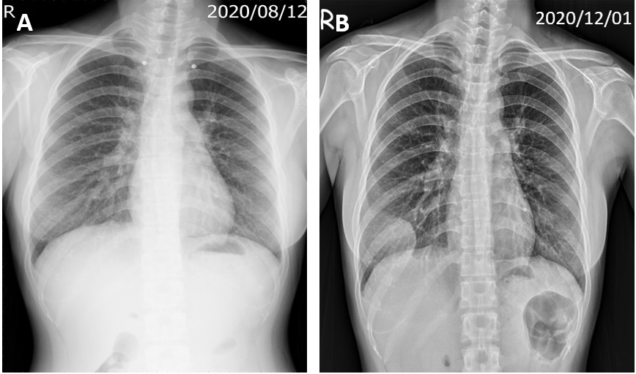
Figure 1 Chest X-ray findings. A: Initial chest film after the trauma revealed no fracture of the rib or mass lesion; B: Chest film at 3 mo after the trauma revealed a 5.1 cm, partially circumscribed mass-like opacity in the right lower chest wall, with adjacent rib destruction.
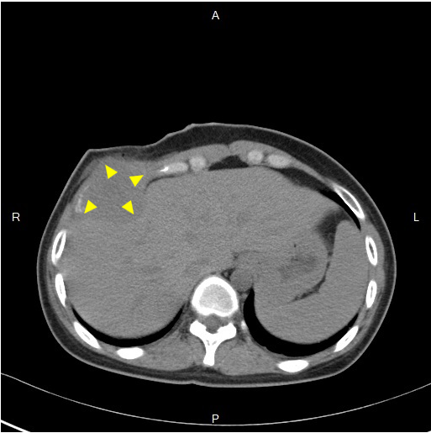
Figure 2 Chest computed tomographic scan showed a 5-cm tumor at the right anterior chest wall, with destruction of the right 6th rib.
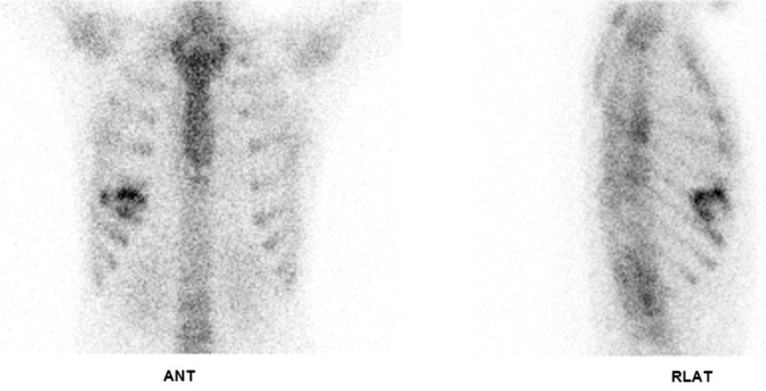
Figure 3 Whole-body bone scan showed increased uptake in the right 5th to 7th ribs.
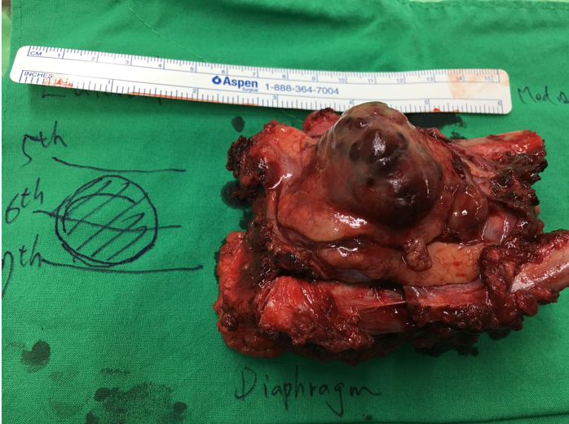
Figure 4 Histopathology findings. A: Many osteoclast-like giant cells were distributed throughout the tumor, with scattered oval to spindle mononuclear cells in the background (hematoxylin and eosin); B: The mononuclear cells uniformly showed nuclear staining for H3F3A expression (immunohistochemical stain of H3F3A). Original magnification: × 400.
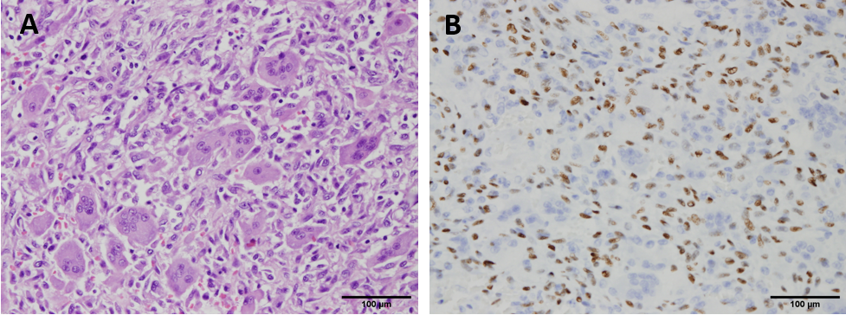
Figure 5 Gross specimen after surgical resection.

