Name of Journal: World Journal of Clinical Cases
Manuscript NO: 76992
Manuscript Type: LETTER TO THE EDITOR

A rare cause of acute abdomen after a Good Friday

Pante L et al. Acute abdomen after a Good Friday

Leticia Pante, Luísa Gailhard Brito, Miguel Franciscatto, Eduardo Brambilla, Jonathan Soldera

Leticia Pante, Luísa Gailhard Brito, School of Medicine, Universidade de Caxias so Sul, Caxias do Sul 95070-560, Brazil

Miguel Franciscatto, Proctology, Hospital Geral de Caxias do Sul, Caxias do Sul 95070-560, Brazil

Eduardo Brambilla, Jonathan Soldera, Clinical Gastroenterology, Universidade de Caxias do Sul, Caxias do Sul 95070-560, RS, Brazil

Author contributions: Pante L, Brito LG, Franciscatto M, Brambilla E, and Soldera J contributed in writing and reviewing the final manuscript; Soldera J also contributed for study supervision.

Corresponding author: Jonathan Soldera, MD, MSc, Associate Professor, Staff Physician, Clinical Gastroenterology, Universidade de Caxias do Sul, Rua Francisco Getúlio Vargas, 1130, Caxias do Sul 95070-560, RS, Brazil. jonathansoldera@gmail.com

Received: April 10, 2022
Revised: June 13, 2022
Accepted: August 15, 2022
Published online: September 16, 2022

Abstract
Small bowel perforation caused by an ingested fish bone is rare but can involve the appendix or Meckel’s diverticulum. We report the case of a 25-year-old man who presented to the emergency department with acute abdomen caused by perforation of a Meckel’s diverticulum with a fish bone ingested in a Good Friday.

Key Words: Fish bone; Foreign body; Small bowel perforation; Meckel diverticulum

©The Author(s) 2022. Published by Baishideng Publishing Group Inc. All rights reserved.

Citation: Pante L, Brito LG, Franciscato M, Brambilla E, Soldera J. A rare cause of acute abdomen after a Good Friday. World J Clin Cases 2022; 10(26): 9539-9541
URL: https://www.wjgnet.com/2307-8960/full/v10/i26/9539.htm
DOI: https://dx.doi.org/10.12998/wjcc.v10.i26.9539

Core Tip: We report the case of a 25-year-old man who presented to the emergency department with acute abdomen caused by perforation of a Meckel’s diverticulum with a fish bone ingested in a Good Friday.

TO THE EDITOR
In our hospital in Brazil, after the Good Friday of 2020, we admitted a 25-year-old male patient who presented with severe abdominal pain in the right lower quadrant. He had signs of peritoneal irritation on physical examination. A computed tomography (CT) scan showed pneumoperitoneum and a hyperdense structure in the ileal wall (Figure 1). This imaging finding went unnoticed until the patient underwent exploratory laparotomy, which revealed a Meckel’s diverticulum perforated by a fish bone 30 cm above the ileocecal valve (Figure 2). Diverticulectomy was performed and the patient was discharged after a few days. He later reported having eaten fish on Good Friday, a Christian holiday in which Brazilians generally eat fish instead of poultry or red meat.
Meckel’s diverticulum is often an asymptomatic condition. Nevertheless, 4.2% to 16.9% of patients are likely to become symptomatic^{[1-3]}. There is a wide range of complications associated with this disease, such as acute or chronic abdominal pain, anemia, gastrointestinal bleeding, obstruction, and perforation^{[1,3]}. Although most of these complications are not rare, small bowel perforation caused by an ingested fish bone is a rare finding, occurring in less than 1% of patients^{[2]}, because, in most cases of ingested foreign bodies, the object will pass through the gastrointestinal tract without any complications^{[4]}.
Perforation may occur in any part of the gastrointestinal tract, but cases involving the appendix or Meckel’s diverticulum are rare. In this setting, approximately 300 cases of a Meckel’s diverticulum perforated by a swallowed foreign body have been reported^{[3]}. Surprisingly, we found one case similar to ours published in the World Journal of Gastroenterology in 2014^{[1]}.
The preoperative diagnosis of perforation of the Meckel’s diverticulum by foreign body can be challenging given the broad spectrum of differential diagnoses. In addition, patients do not always recall ingesting the foreign body, and fish bones are not easily detected on radiographs or CT scans^{[2,3]}. The perforated Meckel’s diverticulum may also mimic acute appendicitis, acute diverticulitis, and colitis^{[4]}. In the case presented here, the patient complained of severe abdominal pain in the right lower quadrant, similar to that of acute appendicitis.
Imaging is essential to determine the correct diagnosis prior to surgery. Radiography is not a reliable means to detect a fish bone, because it lacks sensitivity for the aerodigestive tract^{[4]}. Although abdominal ultrasound is useful in identifying a foreign body based on high reflectivity and variable posterior shadowing, CT is the imaging modality of choice for the detection of foreign bodies and other acute abdomen conditions^{[4]}.
In a similar context, other radiological features of fish bone perforation were described in a case report published in 2022, such as thickening of the intestinal wall, fatty deposits, intestinal ileus, ascites, localized pneumoperitoneum, intra-abdominal abscess, and a linear hyperdense structure in the abdominal cavity within the gastrointestinal tract or a parenchymal organ, often surrounded by inflammation^{[4]}. Therefore, the combination of a detailed medical history with imaging and ancillary testing (ultrasound and abdominal CT) is crucial in cases of acute abdomen that may require surgery^{[5,6,7]}.
Treatment includes exploratory laparotomy when the diagnosis of acute abdomen has been made. In addition, diverticulectomy and colectomy may be necessary to minimize complications. It is of paramount importance to explore the entire abdominal cavity intraoperatively, especially in the absence of an explanation for the clinical findings^{[1,5,6,8]}.
Therefore, bone-induced perforation should be suspected when the CT scan shows a hyperdense structure in the bowel wall, whether with signs of perforation or not.

REFERENCES
1 Choi Y, Kim G, Shim C, Kim D, Kim D. Peritonitis with small bowel perforation caused by a fish bone in a healthy patient. World J Gastroenterol 2014; 20: 1626-1629 [PMID: 24587641 DOI: 10.3748/wjg.v20.i6.1626]
2 Shahid F, Abdalla SO, Elbakary T, Elfaki A, Ali SM. Fish Bone Causing Perforation of the Intestine and Meckel's Diverticulum. Case Rep Surg 2020; 2020: 8887603 [PMID: 33014507 DOI: 10.1155/2020/8887603]
3 Gonçalves A, Almeida M, Malheiro L, Costa-Maia J. Meckel's diverticulum perforation by a fish bone: A case report. Int J Surg Case Rep 2016; 28: 237-240 [PMID: 27744259 DOI: 10.1016/j.ijscr.2016.08.026]
4 Kolleri JJ, Abdirahman AM, Khaliq A, Abu-Dayeh A, Sajid S, Mirza S, Haider A. A Case Report on Fish Bone Perforating Meckel's Diverticulum Mimicking Appendicitis. Cureus 2022; 14: e22693 [PMID: 35371722 DOI: 10.7759/cureus.22693]
5 Li SH, Wu GY, Lin XD, Wen ZQ, Huang MT, Yu SP, Zhang H. Lower gastrointestinal tract bleeding caused by dieulafoy-like lesion synchronous meckel diverticulum: A rare case report. World J Clin Cases 2015; 3: 970-972 [PMID: 26601102 DOI: 10.12998/wjcc.v3.i11.970]
6 Chohan TA, Tabook SA, Elmukashfi E, Sakroon SM. Acute Appendicitis or ...is it Meckel’s Diverticulitis? Oman Med J 2010; 25: 10
7 Canelas AL, Neto AN, Rodrigues AL, Meguins LC, Rolo DF, Lobato MF. Perforation of Meckel's diverticulum by a chicken bone mimicking acute appendicitis. Case report. G Chir 2009; 30: 476-478 [PMID: 20109374]
8 Bidarmaghz B, McGregor H, Raufian K, Tee CL. Perforation of the Meckel's diverticulum with a chicken bone: a case report and literature review. Surg Case Rep 2019; 5: 15 [PMID: 30707313 DOI: 10.1186/s40792-019-0577-x]

Footnotes
Conflict-of-interest statement: The authors declare no conflict of interest regarding the subject of this paper.

Open-Access: This article is an open-access article that was selected by an in-house editor and fully peer-reviewed by external reviewers. It is distributed in accordance with the Creative Commons Attribution NonCommercial (CC BY-NC 4.0) license, which permits others to distribute, remix, adapt, build upon this work non-commercially, and license their derivative works on different terms, provided the original work is properly cited and the use is non-commercial. See: https://creativecommons.org/Licenses/by-nc/4.0/

Provenance and peer review: Unsolicited article; Externally peer reviewed.
Peer-review model: Single blind
Corresponding Author's Membership in Professional Societies: Federação Brasileira De Gastroenterologia; GEDIIB.

Peer-review started: April 10, 2022
First decision: May 11, 2022
Article in press: August 15, 2022

Specialty type: Gastroenterology and hepatology
Country/Territory of origin: Brazil
Peer-review report’s scientific quality classification
Grade A (Excellent): 0
Grade B (Very good): 0
Grade C (Good): C
Grade D (Fair): D
Grade E (Poor): 0

P-Reviewer: Martino A, Italy; Wang S S-Editor: Ma YJ L-Editor: Filipodia CL P-Editor: Ma YJ

Figure Legends
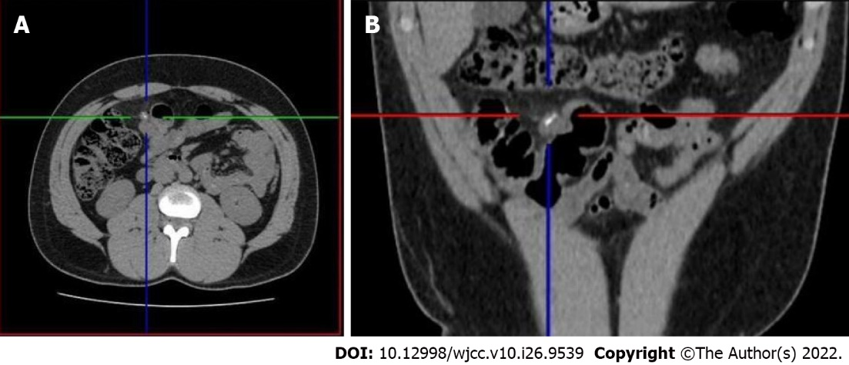
Figure 1 Computed tomography. A: Axial; B: Coronal; Pneumoperitoneum and a hyperdense image in the ileal wall.

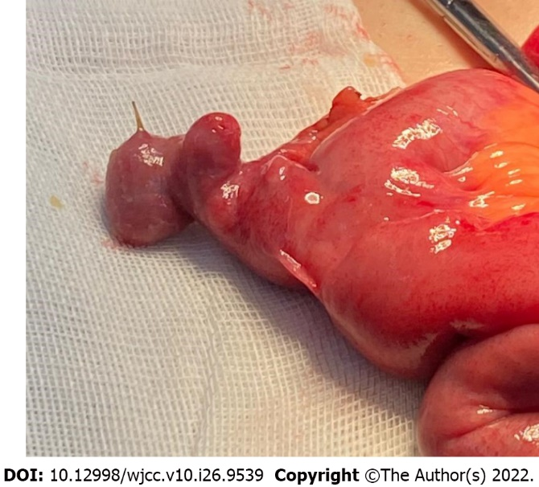
Figure 2 Surgical specimen. Perforated Meckel diverticulum by a fishbone 30 cm above the ileocecal valve.

Published by Baishideng Publishing Group Inc
7041 Koll Center Parkway, Suite 160, Pleasanton, CA 94566, USA
Telephone: +1-925-3991568
E-mail: bpgoffice@wjgnet.com
Help Desk: https://www.f6publishing.com/helpdesk
https://www.wjgnet.com

© 2022 Baishideng Publishing Group Inc. All rights reserved.

