Name of Journal: World Journal of Clinical Cases
Manuscript NO: 88858
Manuscript Type: META-ANALYSIS

Impact of angiotensin-converting enzyme inhibitors or angiotensin receptor blockers on the mortality in sepsis: A meta-analysis

Yang DC et al. ACEIs or ARBs on the mortality in sepsis

Deng-Can Yang, Jian Xu, Li Jian, Yi Yu

Deng-Can Yang, Department of Anesthesiology, The Central Hospital of Shaoyang, Shaoyang 422000, Hunan Province, China

Jian Xu, Li Jian, Department of Critical Care Medicine, The Second Affiliated Hospital of Guangzhou University of Chinese Medicine, Guangzhou 510006, Guangdong Province, China

Yi Yu, Department of Critical Care Medicine, Guangdong Provincial Hospital of Traditional Chinese Medicine, Guangzhou 510006, Guangdong Province, China

Author contributions: Jian L and Yu Y designed the study; Yang DC conducted the literature search and data analysis; Xu J drafted the manuscript; Yu Y, Xu J, and Li J revised the manuscript; All authors read and approved the final manuscript.

Supported by the Guangdong Bureau of Traditional Chinese Medicine, No. 20232049; the Guangdong Bureau of Traditional Chinese Medicine, No. 20222065; the National Natural Science Foundation of China, No. 82104989.

Corresponding author: Yi Yu, MD, Doctor, Department of Critical Care Medicine, Guangdong Provincial Hospital of Traditional Chinese Medicine, Daxuecheng Neihuan Xilu 55#, Guangzhou 510006, Guangdong Province, China. 1191922959@qq.com

Received: October 12, 2023
Revised: November 29, 2023
Accepted: December 5, 2023
Published online: December 26, 2023

Abstract
BACKGROUND
The effect of angiotensin-converting enzyme inhibitors (ACEIs) or angiotensin receptor blockers (ARBs) on the mortality of patients with sepsis is not well characterized.

AIM
To elucidate the association between prior ACEI or ARB exposure and mortality in sepsis.

METHODS
The PubMed, EMBASE, Web of Science, and Cochrane Library databases were searched for all studies of premorbid ACEI or ARB use and sepsis mortality until November 30 2019. Two reviewers independently assessed, selected, and abstracted data from studies reporting ACEIs or ARBs, sepsis, and mortality. The primary extracted data consisted of premorbid ACEI or ARB exposure, mortality, and general patient data. Two reviewers independently assessed the risk of bias and quality of evidence.

RESULTS
A total of six studies comprising 281238 patients with sepsis, including 49799 cases with premorbid ACEI or ARB exposure were eligible for analysis. Premorbid ACEIs or ARBs exposure decreased the 30-d mortality in patients with sepsis. Moreover, the use of ACEIs or ARBs was associated with approximately a 6% decreased risk of 30-d mortality.

CONCLUSION
The results of this systematic review suggest that ACEI or ARB exposure prior to sepsis may be associated with reduced mortality. Further high-quality cohort studies and molecular mechanism experiments are required to confirm our results.

Key Words: Sepsis; Mortality; Angiotensin-converting enzyme inhibitors; Angiotensin receptor blockers

©The Author(s) 2023. Published by Baishideng Publishing Group Inc. All rights reserved.

Citation: Yang DC, Xu J, Jian L, Yu Y. Impact of angiotensin-converting enzyme inhibitors or angiotensin receptor blockers on the mortality in sepsis: A meta-analysis. World J Clin Cases 2023; 11(36): 8498-8506
URL: https://www.wjgnet.com/2307-8960/full/v11/i36/8498.htm
DOI: https://dx.doi.org/10.12998/wjcc.v11.i36.8498

Core Tip: To explore the potential relationship between the effect of premorbid angiotensin-converting enzyme inhibitor (ACEI) or angiotensin receptor blocker (ARB) on mortality in sepsis. We extracted data from 6 studies. The results of this systematic review suggest that ACEI or ARB exposure prior to sepsis may be associated with reduced mortality. This may have some guiding significance for the treatment of coronavirus disease 2019.

INTRODUCTION
Sepsis is a syndrome that involves physiological, pathological, and biochemical abnormalities resulting from a host response to an infection, and represents a major public health concern^{[1]}. Sepsis is a "worldwide medical problem" that endangers human health and is associated with three main characteristics: (1) High incidence; (2) high mortality; and (3) high treatment cost. More than 19 million people suffer from sepsis every year worldwide, with a fatality rate greater than 25%^{[2]}.
As sepsis progresses after an infection, an imbalance of the pro-inflammatory and anti-inflammatory response develops^{[3]}. The guidelines associated with development of the sepsis pathophysiology suggest: Early fluid resuscitation, antibiotic treatment, control of infection sources, use of vasoactive agents, corticosteroids, blood products, immunoglobulins, blood purification as treatment options^{[2]}. Although the guidelines for the diagnosis and treatment of sepsis have been revised several times, the monitoring index does not fully reflect the overall situation and dynamic changes of the patients, treatment is associated with a lag period, and the mortality rate remains high^{[4]}. Therefore, it is important to accurately identify potential patients who are at a high risk of sepsis and to take specific intervention measures to reduce the mortality of such patients. Such supplement to the previous treatment programs and may improve the prognosis of sepsis patients.
Several studies have suggested that the use of angiotensin-converting enzyme inhibitors (ACEIs) or angiotensin receptor blockers (ARBs) may represent a therapeutic option for patients with sepsis^{[5,6]}. Moreover, ACEIs and ARBs have been shown to exert anti-inflammatory effects to attenuate the chronic inflammation^{[7]}. However, the benefit of using ACE inhibitors or ARBs remains controversial^{[5,8]}. Moreover, there are no published systematic reviews on the effects of premorbid ACEI or ARB exposure on sepsis mortality. Thus, this study sought to investigate sepsis mortality in patients with prior ACEI and ARB exposure.

MATERIALS AND METHODS
Search strategy
This study followed the Meta-analysis Of Observational Studies in Epidemiology guidelines^{[9]}. A literature search of relevant published studies that analyzed the association between the sepsis, mortality, and ACEIs or ABBs was conducted on 27 March 2020. We used the PubMed (http://www.ncbi.nlm.nih.gov/pubmed/), EMBASE (http://www.embase.com/), Web of Science (http://wokinfo.com/), and Cochrane Library (http://www.thecochranelibrary.com/) databases to identify articles using the following terms: “hypotensor”; “antihypertensive”; “ACEIs”; “captopril”; “enalapril”; “sirapley”; “benazepril”; “petitopril”; “ramipril”; “ARBs”; “losartan”; “irbesartan”; “valsartan”; “telmisartan”; “sepsis”; “toxic shock”; “sepsis shock”; and “mortality”. In addition, the reference lists in each of the studies were reviewed to identify additional studies. The language of the studies was limited to English, and we did not search for unpublished literature.

Study selection criteria
A study was included in the analysis if: (1) It was a case-control or cohort study was conducted; (2) it was an original human clinical trial (independence among studies) that evaluated the association between premorbid ACEI or ARB exposure and sepsis mortality; and (3) it provided sufficient data [e.g., to calculate the relative risk (RR), odds ratio (OR), or hazard ratio (HR)]; and (4) the (Newcastle-Ottawa Scale, NOS) score value was ≥ 5. We excluded studies that contained overlapping data.

Data extraction
The data extracted from the selected articles included: the first author’s name; year of publication; study population; total number of cases; RRs or ORs with 95% confidence intervals (CIs); Newcastle-Ottawa Scale (NOS); and adjustments made in the studies (Table 1). Some publications separate reported ORs for ACEI-related sepsis mortality and ARB-related sepsis mortality. In these cases, the ORs were separately extracted.

Statistical analysis
The strength of the association between premorbid ACEI or ARB exposure and susceptibility to sepsis mortality was reported using ORs and 95%CIs. ACEIs or ARBs were defined as captopril, enalapril, benazepril, fosinopril, ramipril, losartan, valsartan, and candesartan. When the data was adjusted and crude ORs were provided, the most adjusted ORs were extracted. If the article provided an HR, it was converted to an OR using the appropriate formula^{[10]}. We used an I² test and Q-statistic to detect any possible heterogeneity between the studies, as a quantitative measure of any inconsistencies among the studies^{[11]}. In addition, we clarified the percentage of the total variation across the studies that was due to heterogeneity rather than by chance using the I²-statistic. Pooled ORs and 95%CIs were calculated using a random-effects model^{[12]}.
All statistical analyses for the meta-analysis were performed using STATA version 12.0 (United States, College Station, TX 77845). Statistical significance was established at a threshold of P ≤ 0.05. All reported P values were obtained from two-sided statistical tests. Egger’s and Begger’s regression models were used to evaluate the potential publication bias^{[11]}.

RESULTS
The process used to select the studies for analysis is outlined in Figure 1. A total of 48 potentially relevant records were reviewed, of which six articles, which included 49799 cases that met the inclusion criteria were included in the meta-analysis^{[5,8,13-16]} (Table 1). A total of 42 studies were subsequently excluded because they used a combined intervention, were duplicated reports, or were of relatively low quality. All of the six selected articles were cohort studies.
Three studies were conducted in Asia and three studies were conducted in other regions (Europe and America). Two studies presented the mortality separately for ACEIs and ARBs. The NOS was 7 and 6 in four and two studies, respectively (Table 2). The mortality data for both ACEIs and ARBs were individually extracted. The results from the six studies were inconsistent: two pool results reported that premorbid ACEI or ARB use was associated with a significant reduction in sepsis mortality, whereas the other four studies reported no association. The analysis of the six studies yielded a combined risk estimate of (OR: 0.94; 95%CI: 0.91–0.97; P = 0.001) with a heterogeneity value (I²) of 94.6% for 30-d mortality (Figure 2). We conducted a meta-regulation test and found that the geographical area was associated with 25.49% reduction in heterogeneity across the six studies (Figures 3 and 4). We further evaluated the role of (ACEIs, ARBs, and ACEIs/ARBs) in a meta-regulation test, which was associated with a 35.13% reduction in heterogeneity across the six studies.
Due to differences in the geographic area (Asian or non-Asian countries), NOS (7 or 6), and prior exposure (ACEIs, ARBs, and ACEIs/ARBs) between the studies, we conducted further subgroup analyses to determine the effect of these factors in our analyses (Table 2). We obtained a statistically protective effect in Asian population (OR: 0.94; 95%CI: 0.91–0.98), ACEIs (OR: 0.94, 95%CI: 0.89–0.99), ARBs (OR: 0.84, 95%CI: 0.79 – 0.88), NOS of 6 (OR: 0.88; 95%CI: 0.85–0.91), in a non-Asian population (OR: 0.91; 95%CI: 0.74–1.09), NOS of 7 (OR: 1.31; 95%CI: 1.24–1.39), and ACEIs/ARBs (OR: 1.31; 95%CI: 1.23–1.39).
Based on Egger’s and Begger’s regression models, there was no evidence of publication bias (Figures 5) regarding prior ACEI or ARB exposure and mortality in sepsis. The Egger’s funnel plot and Begger linear regression test revealed a P value > 0.05.

DISCUSSION
This is the first systematic review examining the role of premorbid ACEI or ARB exposure on mortality outcomes in patients with sepsis. Patients receiving ACEIs or ARBs prior to developing sepsis were associated with a 6% reduction in 30-day mortality compared with those who did not receive any ACEIs or ARBs. We further conducted subgroup analyses to determine the effect of the geographic area (Asian or non-Asian countries), NOS (7 or 6), and prior exposure (ACEIs, ARBs, and ACEIs/ARBs) in our analyses (Table 2). We obtained a statistically protective effect in the Asian population (OR: 0.94; 95%CI: 0.91–0.98), ACEIs (OR: 0.94; 95%CI: 0.89–0.99), ARBs (OR: 0.84; 95%CI: 0.79–0.88), and a NOS of 6 (OR: 0.88; 95%CI: 0.85–0.91). The results of a meta-regulation test (Figures 3 and 4) revealed that the geographical area and treatment were associated with 60.62% reduction in heterogeneity across the studies.
One cause of the differences in the outcomes between population may be lifestyle and environmental factors associated with Asian and non-Asian populations^{[17-19]}. Compared with European and American populations, Asian populations have a relatively healthy diet and a lower prevalence of chronic diseases (e.g., diabetes and coronary heart disease)^{[20-22]}, which have a substantial impact on the prognosis of sepsis.
ACE inhibitors and ARBs reduce blood pressure by vasodilation, decreasing angiotensin II formation, and kallikrein degradation to reduce sodium and water retention^{[23]}. These effects can also decrease the glomerular filtration rate (GFR) since angiotensin II plays a critical role in the maintenance of GFR, especially during hypovolemia or hypotension^{[24,25]}. In the guidelines for sepsis treatment, the maintenance of a certain tissue perfusion pressure is necessary; however, the use of ACE inhibitors and ARBs appear to be contrary to the recommended treatment guidelines for sepsis. Moreover, ACE inhibitors and ARBs have not been recommended as a therapeutic drug in previous septic diagnosis and treatment guidelines. In addition to the effect of lowering blood pressure, both ACE inhibitors and ARBs also have anti-inflammatory effects, which can reduce plasma cytokine and nitric oxide concentrations^{[26]}. In septic animal models, although ACE inhibitors have been demonstrated to reduce organ damage through the NF-kB signaling pathway^{[27]}, conflicting data exist regarding to whether an angiotensin II blockade improves survival in animal models^{[28,29]}. Moreover, a clinical study of patients hospitalized with sepsis reported that the prior use of ARBs was associated with improved survival^{[8]}.
Our findings have potential clinical implications. Clinical medical providers should be able to identify who is at a high-risk of sepsis as early as possible and guide the course of treatment following the initial screening. Combined with our meta-analysis, the use of ACEIs or ARBs can improve the prognosis of sepsis patients, and the comparison of the effect of ACEIs and ARBs on the prognosis of sepsis is presently not supported by any data. Therefore, if patients treated with ACEIs cannot tolerate their adverse reactions, they can continue to use ARBs. It is recommended that ACEIs or ARBs be abandoned only if the adverse effects are severely intolerable^{[30]}.
This study analyzed data from six observational studies and included a larger population and range of trials compared to that previous studies, with the largest number of cases analyzed to date. We conformed to the specifications throughout the entire meta-analysis process and we also simultaneously conducted a publication bias detection. The obtained results are robust and the included analysis was free from obvious publication bias. Moreover, this meta-analysis has a high standard for the quality of the included literature, and thus meets a high quality standard.
There are a few limitations regarding this study that should be noted. First, when selecting appropriate literature, only studies written in English were included; however, a large portion of the articles that were included in our study were performed in Asia, where the official language is not English. Second, it was challenging to predict the effect of misclassification of cohort studies for the results. In addition, the systematic confounding or the risk of bias cannot easily be ruled out in observation studies. Since there was heterogeneity across the studies, we performed a regression analysis to explain the source of such heterogeneity. The observed differences may be due to the differences in the geographical area of the studies. Specifically, differences in the study geographical area and prior treatment (ACEIs, ARBs, and ACEIs/ARBs) may have contributed to the heterogeneity observed in our results (Figure 4). Besides, the practice of ACEI and ARB in the clinic are related to disease conditions like hypertension, which might also influence the prognosis of sepsis. Besides, other factors like age may also bring bias. In this analysis, the comparison between the dose and course of treatment of ACEIs or ARBs and the prognosis of sepsis were not included due to the lack of data provided in the original studies.

CONCLUSION
In summary, the findings of this systematic review suggests that exposure to ACEIs or ARBs prior to an episode of sepsis could have a role in reducing sepsis mortality; however, additional evidence is required to clarify whether premorbid ACEIs or ARBs can reduce sepsis mortality, as well as the associated mechanism. Therefore, further high-quality cohort studies and molecular mechanism experiments are required to confirm our results.

ARTICLE HIGHLIGHTS
Research background
Sepsis is a syndrome that involves physiological, pathological, and biochemical abnormalities resulting from a host response to an infection, and represents a major public health concern.
Therefore, it is important to accurately identify potential patients who are at a high risk of sepsis and to take specific intervention measures to reduce the mortality of such patients. Several studies have suggested that the use of angiotensin-converting enzyme inhibitors (ACEIs) or angiotensin receptor blockers (ARBs) may represent a therapeutic option for patients with sepsis.

Research motivation
The effect of ACEI or ARB on the mortality of patients with sepsis is not well characterized.

Research objectives
To elucidate the association between prior ACEI or ARB exposure and mortality in sepsis.

Research methods
This study followed the Meta-analysis Of Observational Studies in Epidemiology (MOOSE) guidelines. A literature search of relevant published studies that analyzed the association between the sepsis, mortality, and ACEIs or ABBs was conducted on 27 March 2020. We used the PubMed (http://www.ncbi.nlm.nih.gov/pubmed/), EMBASE (http://www.embase.com/), Web of Science (http://wokinfo.com/), and Cochrane Library (http://www.thecochranelibrary.com/) databases to identify articles using the following terms: “hypotensor”; “antihypertensive”; “ACEIs”; “captopril”; “enalapril”; “sirapley”; “benazepril”; “petitopril”; “ramipril”; “ARBs”; “losartan”; “irbesartan”; “valsartan”; “telmisartan”; “sepsis”; “toxic shock”; “sepsis shock”; and “mortality”. In addition, the reference lists in each of the studies were reviewed to identify additional studies. The language of the studies was limited to English, and we did not search for unpublished literature.

Research results
A total of 48 potentially relevant records were reviewed, of which six articles, which included 49799 cases that met the inclusion criteria were included in the meta-analysis. A total of 42 studies were subsequently excluded because they used a combined intervention, were duplicated reports, or were of relatively low quality. All of the six selected articles were cohort studies.

Research conclusions
The findings of this systematic review suggests that exposure to ACEIs or ARBs prior to an episode of sepsis could have a role in reducing sepsis mortality.

Research perspectives
However, additional evidence is required to clarify whether premorbid ACEIs or ARBs can reduce sepsis mortality, as well as the associated mechanism. Therefore, further high-quality cohort studies and molecular mechanism experiments are required to confirm our results.

REFERENCES
1 Liang L, Moore B, Soni A. National Inpatient Hospital Costs: The Most Expensive Conditions by Payer, 2017. 2020 Jul 14. In: Healthcare Cost and Utilization Project (HCUP) Statistical Briefs [Internet]. Rockville (MD): Agency for Healthcare Research and Quality (US); 2006 Feb- [PMID: 32833416]
2 Singer M, Deutschman CS, Seymour CW, Shankar-Hari M, Annane D, Bauer M, Bellomo R, Bernard GR, Chiche JD, Coopersmith CM, Hotchkiss RS, Levy MM, Marshall JC, Martin GS, Opal SM, Rubenfeld GD, van der Poll T, Vincent JL, Angus DC. The Third International Consensus Definitions for Sepsis and Septic Shock (Sepsis-3). JAMA 2016; 315: 801-810 [PMID: 26903338 DOI: 10.1001/jama.2016.0287]
3 van der Poll T, van de Veerdonk FL, Scicluna BP, Netea MG. The immunopathology of sepsis and potential therapeutic targets. Nat Rev Immunol 2017; 17: 407-420 [PMID: 28436424 DOI: 10.1038/nri.2017.36]
4 Iwashyna TJ, Ely EW, Smith DM, Langa KM. Long-term cognitive impairment and functional disability among survivors of severe sepsis. JAMA 2010; 304: 1787-1794 [PMID: 20978258 DOI: 10.1001/jama.2010.1553]
5 Dial S, Nessim SJ, Kezouh A, Benisty J, Suissa S. Antihypertensive agents acting on the renin-angiotensin system and the risk of sepsis. Br J Clin Pharmacol 2014; 78: 1151-1158 [PMID: 24803383 DOI: 10.1111/bcp.12419]
6 Mortensen EM, Nakashima B, Cornell J, Copeland LA, Pugh MJ, Anzueto A, Good C, Restrepo MI, Downs JR, Frei CR, Fine MJ. Population-based study of statins, angiotensin II receptor blockers, and angiotensin-converting enzyme inhibitors on pneumonia-related outcomes. Clin Infect Dis 2012; 55: 1466-1473 [PMID: 22918991 DOI: 10.1093/cid/cis733]
7 Podowski M, Calvi C, Metzger S, Misono K, Poonyagariyagorn H, Lopez-Mercado A, Ku T, Lauer T, McGrath-Morrow S, Berger A, Cheadle C, Tuder R, Dietz HC, Mitzner W, Wise R, Neptune E. Angiotensin receptor blockade attenuates cigarette smoke-induced lung injury and rescues lung architecture in mice. J Clin Invest 2012; 122: 229-240 [PMID: 22182843 DOI: 10.1172/JCI46215]
8 Mortensen EM, Restrepo MI, Copeland LA, Pugh JA, Anzueto A, Cornell JE, Pugh MJ. Impact of previous statin and angiotensin II receptor blocker use on mortality in patients hospitalized with sepsis. Pharmacotherapy 2007; 27: 1619-1626 [PMID: 18041882 DOI: 10.1592/phco.27.12.1619]
9 Stroup DF, Berlin JA, Morton SC, Olkin I, Williamson GD, Rennie D, Moher D, Becker BJ, Sipe TA, Thacker SB. Meta-analysis of observational studies in epidemiology: a proposal for reporting. Meta-analysis Of Observational Studies in Epidemiology (MOOSE) group. JAMA 2000; 283: 2008-2012 [PMID: 10789670 DOI: 10.1001/jama.283.15.2008]
10 Tierney JF, Stewart LA, Ghersi D, Burdett S, Sydes MR. Practical methods for incorporating summary time-to-event data into meta-analysis. Trials 2007; 8: 16 [PMID: 17555582 DOI: 10.1186/1745-6215-8-16]
11 Begg CB, Mazumdar M. Operating characteristics of a rank correlation test for publication bias. Biometrics 1994; 50: 1088-1101 [PMID: 7786990 DOI: 10.2307/2533446]
12 DerSimonian R, Laird N. Meta-analysis in clinical trials revisited. Contemp Clin Trials 2015; 45: 139-145 [PMID: 26343745 DOI: 10.1016/j.cct.2015.09.002]
13 Hsieh MS, How CK, Hsieh VC, Chen PC. Preadmission Antihypertensive Drug Use and Sepsis Outcome: Impact of Angiotensin-Converting Enzyme Inhibitors (ACEIs) and Angiotensin Receptor Blockers (ARBs). Shock 2020; 53: 407-415 [PMID: 31135703 DOI: 10.1097/SHK.0000000000001382]
14 Lai CC, Wang YH, Wang CY, Wang HC, Yu CJ, Chen L; on the behalf of Taiwan Clinical Trial Consortium for Respiratory Diseases (TCORE). Risk of Sepsis and Mortality Among Patients With Chronic Obstructive Pulmonary Disease Treated With Angiotensin-Converting Enzyme Inhibitors or Angiotensin Receptor Blockers. Crit Care Med 2019; 47: e14-e20 [PMID: 30303835 DOI: 10.1097/CCM.0000000000003475]
15 Kim J, Kim YA, Hwangbo B, Kim MJ, Cho H, Hwangbo Y, Lee ES. Effect of Antihypertensive Medications on Sepsis-Related Outcomes: A Population-Based Cohort Study. Crit Care Med 2019; 47: e386-e393 [PMID: 30688717 DOI: 10.1097/CCM.0000000000003654]
16 Wiewel MA, van Vught LA, Scicluna BP, Hoogendijk AJ, Frencken JF, Zwinderman AH, Horn J, Cremer OL, Bonten MJ, Schultz MJ, van der Poll T; Molecular Diagnosis and Risk Stratification of Sepsis (MARS) Consortium. Prior Use of Calcium Channel Blockers Is Associated With Decreased Mortality in Critically Ill Patients With Sepsis: A Prospective Observational Study. Crit Care Med 2017; 45: 454-463 [PMID: 28079604 DOI: 10.1097/CCM.0000000000002236]
17 Turana Y, Tengkawan J, Soenarta AA. Asian management of hypertension: Current status, home blood pressure, and specific concerns in Indonesia. J Clin Hypertens (Greenwich) 2020; 22: 483-485 [PMID: 31680397 DOI: 10.1111/jch.13681]
18 Poon LHJ, Yu CP, Peng L, Ewig CL, Zhang H, Li CK, Cheung YT. Clinical ascertainment of health outcomes in Asian survivors of childhood cancer: a systematic review. J Cancer Surviv 2019; 13: 374-396 [PMID: 31055708 DOI: 10.1007/s11764-019-00759-9]
19 Wang Y, Allen KJ, Suaini NHA, Peters RL, Ponsonby AL, Koplin JJ. Asian children living in Australia have a different profile of allergy and anaphylaxis than Australian-born children: A State-wide survey. Clin Exp Allergy 2018; 48: 1317-1324 [PMID: 30025179 DOI: 10.1111/cea.13235]
20 Vang ZM, Sigouin J, Flenon A, Gagnon A. Are immigrants healthier than native-born Canadians? A systematic review of the healthy immigrant effect in Canada. Ethn Health 2017; 22: 209-241 [PMID: 27809589 DOI: 10.1080/13557858.2016.1246518]
21 Snijder MB, Galenkamp H, Prins M, Derks EM, Peters RJG, Zwinderman AH, Stronks K. Cohort profile: the Healthy Life in an Urban Setting (HELIUS) study in Amsterdam, The Netherlands. BMJ Open 2017; 7: e017873 [PMID: 29247091 DOI: 10.1136/bmjopen-2017-017873]
22 Crowe R, Stanley R, Probst Y, McMahon A. Culture and healthy lifestyles: a qualitative exploration of the role of food and physical activity in three urban Australian Indigenous communities. Aust N Z J Public Health 2017; 41: 411-416 [PMID: 28616872 DOI: 10.1111/1753-6405.12623]
23 Williams GH. Converting-enzyme inhibitors in the treatment of hypertension. N Engl J Med 1988; 319: 1517-1525 [PMID: 3054561 DOI: 10.1056/NEJM198812083192305]
24 Brown T, Gonzalez J, Monteleone C. Angiotensin-converting enzyme inhibitor-induced angioedema: A review of the literature. J Clin Hypertens (Greenwich) 2017; 19: 1377-1382 [PMID: 28994183 DOI: 10.1111/jch.13097]
25 Chen JY, Kang N, Juarez DT, Yermilov I, Braithwaite RS, Hodges KA, Legorreta A, Chung RS. Heart failure patients receiving ACEIs/ARBs were less likely to be hospitalized or to use emergency care in the following year. J Healthc Qual 2011; 33: 29-36 [PMID: 21733022 DOI: 10.1111/j.1945-1474.2010.00124.x]
26 Gullestad L, Aukrust P, Ueland T, Espevik T, Yee G, Vagelos R, Frøland SS, Fowler M. Effect of high- versus low-dose angiotensin converting enzyme inhibition on cytokine levels in chronic heart failure. J Am Coll Cardiol 1999; 34: 2061-2067 [PMID: 10588224 DOI: 10.1016/S0735-1097(99)00495-7]
27 Hagiwara S, Iwasaka H, Hidaka S, Hasegawa A, Koga H, Noguchi T. Antagonist of the type-1 ANG II receptor prevents against LPS-induced septic shock in rats. Intensive Care Med 2009; 35: 1471-1478 [PMID: 19529910 DOI: 10.1007/s00134-009-1545-x]
28 Wan L, Langenberg C, Bellomo R, May CN. Angiotensin II in experimental hyperdynamic sepsis. Crit Care 2009; 13: R190 [PMID: 19948019 DOI: 10.1186/cc8185]
29 Laesser M, Oi Y, Ewert S, Fändriks L, Aneman A. The angiotensin II receptor blocker candesartan improves survival and mesenteric perfusion in an acute porcine endotoxin model. Acta Anaesthesiol Scand 2004; 48: 198-204 [PMID: 14995942 DOI: 10.1111/j.0001-5172.2004.00283.x]
30 Ishigami T, Uchino K, Umemura S. ARBs or ACEIs, that is the question. Hypertens Res 2006; 29: 837-838 [PMID: 17345782 DOI: 10.1291/hypres.29.837]

Footnotes
Conflict-of-interest statement: All the authors declare that they have no competing interests.

PRISMA 2009 Checklist statement: The authors have read the PRISMA 2009 Checklist, and the manuscript was prepared and revised according to the PRISMA 2009 Checklist.

Open-Access: This article is an open-access article that was selected by an in-house editor and fully peer-reviewed by external reviewers. It is distributed in accordance with the Creative Commons Attribution NonCommercial (CC BY-NC 4.0) license, which permits others to distribute, remix, adapt, build upon this work non-commercially, and license their derivative works on different terms, provided the original work is properly cited and the use is non-commercial. See: https://creativecommons.org/Licenses/by-nc/4.0/

Provenance and peer review: Unsolicited article; Externally peer reviewed.
Peer-review model: Single blind

Peer-review started: October 12, 2023
First decision: November 28, 2023
Article in press: December 5, 2023

Specialty type: Medicine, general and internal
Country/Territory of origin: China
Peer-review report’s scientific quality classification
Grade A (Excellent): 0
Grade B (Very good): B, B
Grade C (Good): 0
Grade D (Fair): 0
Grade E (Poor): 0

P-Reviewer: Ghimire R, Nepal S-Editor: Liu JH L-Editor: A P-Editor: Xu ZH
Figure Legends
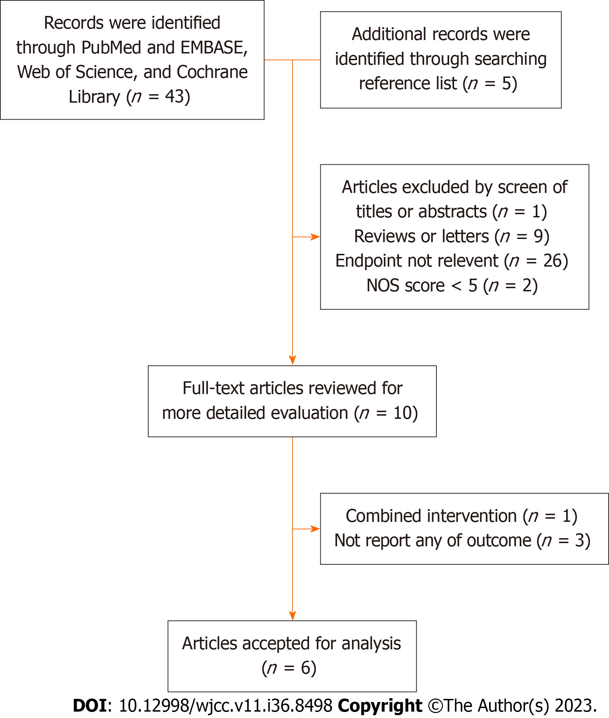
Figure 1 Search strategy and selection of studies for inclusion in the meta-analysis.
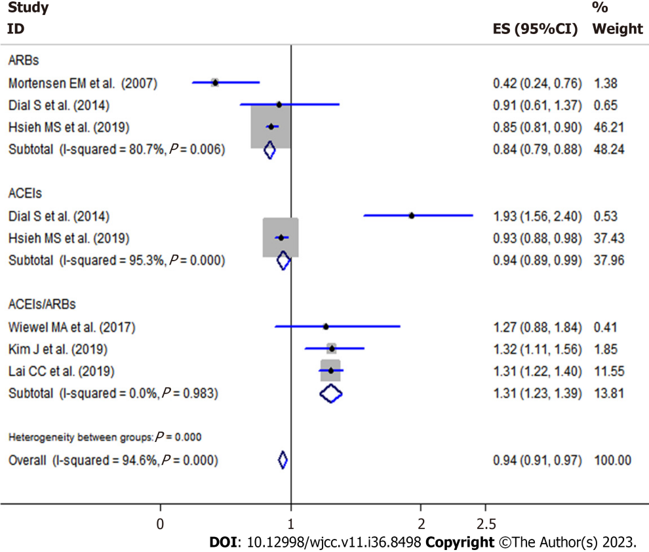
Figure 2 Random-effects meta-analysis between premorbid angiotensin-converting enzyme inhibitors or angiotensin receptor blockers exposure, and mortality in patients with sepsis.
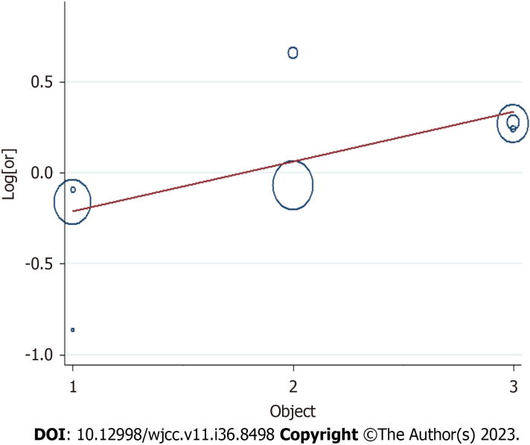
Figure 3 Sensitivity analysis of all included studies.
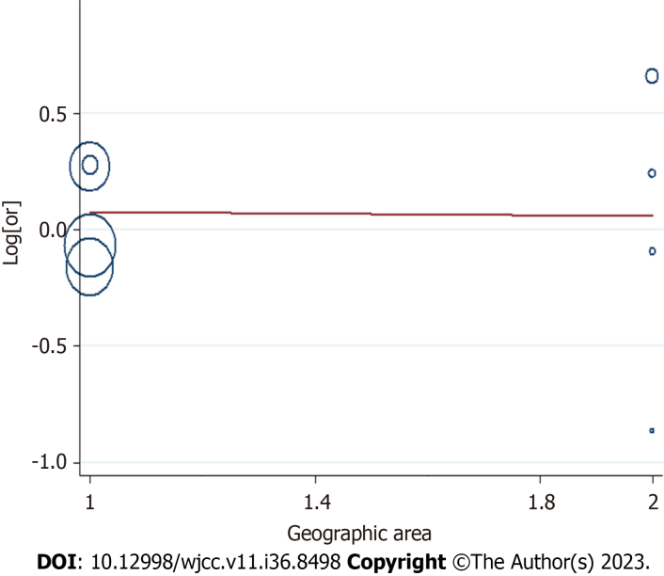
Figure 4 Meta-regulation of premorbid angiotensin-converting enzyme inhibitors or angiotensin receptor blockers exposure and mortality in patients with sepsis.
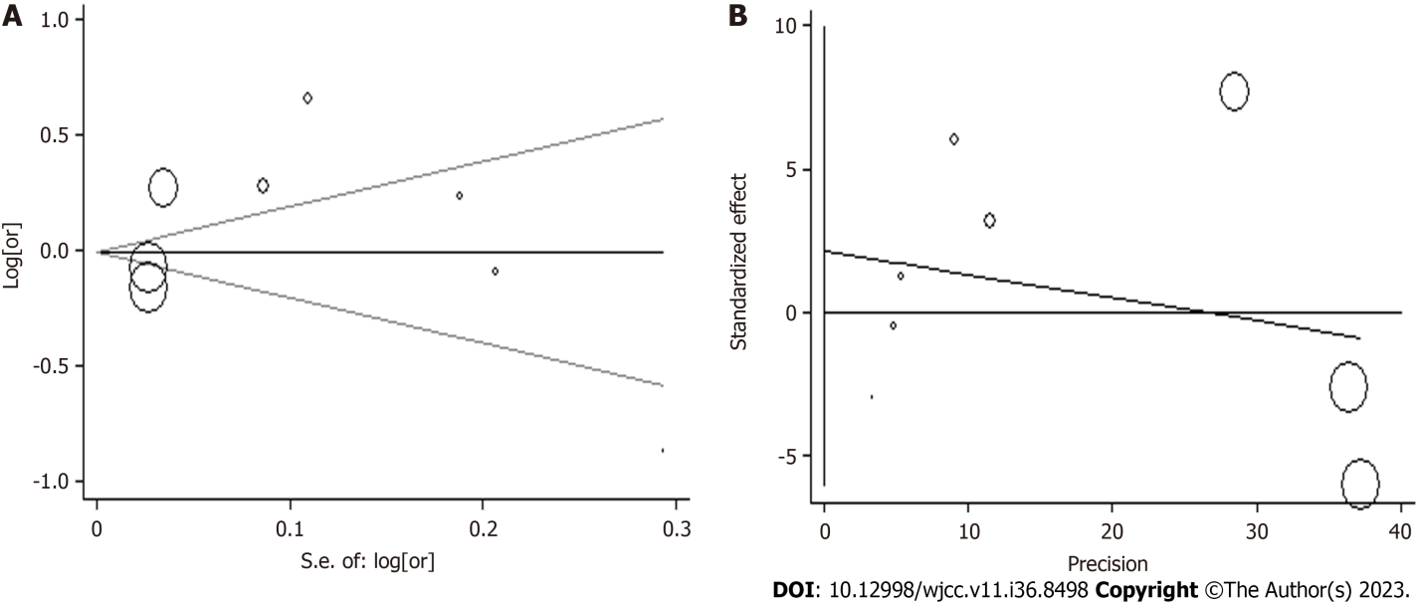
Figure 5 Publication bias among the selected studies. A: Begg’s funnel plot assessing; B: Egger’s funnel plot.
Table 1 Characteristics of the studies included in the meta-analysis
Ref. | Population and country | No. of cases | Study type | Adjustment OR (95%CI) | Adjustment | NOS
Mortensen EM et al^{[15]}, 2007 | 3018; United States | 547 | Cohort | ARBs: 0.42 (0.24-0.76) | Age, history of myocardial infarction, heart failure, stroke, peripheral vascular disease, chronic lung disease, dementia, and moderate liver disease | 6
Dial et al^{[16]}, 2014 | 21615; United Kingdom | 1965 | Cohort | ACEIs: 1.93 (1.56-2.40) | Age, gender, BMI, ever smoking, blood pressure, alcohol abuse, comorbidity, medication | 7
 |  |  |  | ARBs: 0.91(0.61-1.37)
Wiewel et al^{[17]}, 2017 | 6994; Netherlands | 1483 | Cohort | ACEIs/ARBs: 1.27 (0.88-1.84) | Age, gender, Acute Physiology and Chronic Health Evaluation IV score, race, weight, comorbidity and medication | 7
Kim et al^{[18]}, 2019 | 4549; South Korea | 673 | Cohort | ACEIs/ARBs: 1.32 (1.11-1.56) | Age, gender, comorbidity (heart failure, ischemic heart disease, asthma, chronic renal disease, diabetes, cerebrovascular disease, and solid tumor) | 7
Lai et al^{[19]}, 2019 | 21502; China | 11918 | Cohort | ACEIs/ARBs: 1.31 (1.22-1.40) | Age, gender, comorbidities, medication | 7
Hsieh et al^{[20]}, 2020 | 223560; China | 33213 | Cohort | ACEIs: 0.93 (0.88-0.98) | Age, gender, insurance premium, urbanization level and comorbidity | 6
 |  |  |  | ARBs: 0.85 (0.81-0.90)
ACEI: Angiotensin-converting enzyme inhibitors; ARB: Angiotensin receptor blocker; BMI: Body mass index; OR: Odds ratio; NOS: Newcastle-ottawa scale.

Table 2 Stratified analysis of the premorbid calcium channel blockers and mortality of sepsis according to study characteristics
Group | No. of studies | OR (95%CI) | P_{heterogeneity} | I² (%)
Geographic area
Non-Asia | 4 | 0.91 (0.74-1.09) | 0 | 94.6
Asia | 4 | 0.94 (0.91-0.98) | 0 | 96.7
Object
ACEIs | 2 | 0.94 (0.89-0.99) | < 0.01 | 95.3
ARBs | 3 | 0.84 (0.79-0.88) | 0.006 | 80.7
ACEIs/ARBs | 3 | 1.31 (1.23-1.39) | 0.983 | 0
NOS
6 | 3 | 0.88 (0.85-0.91) | 0 | 88.6
7 | 5 | 1.31 (1.24-1.39) | 0.013 | 68.4
ACEI: Angiotensin-converting enzyme inhibitors; ARB: Angiotensin receptor blocker; OR: Odds ratio; NOS: Newcastle-ottawa scale.

Published by Baishideng Publishing Group Inc
7041 Koll Center Parkway, Suite 160, Pleasanton, CA 94566, USA
Telephone: +1-925-3991568
E-mail: bpgoffice@wjgnet.com
Help Desk: https://www.f6publishing.com/helpdesk
https://www.wjgnet.com

© 2023 Baishideng Publishing Group Inc. All rights reserved.

