Name of Journal: World Journal of Diabetes
ESPS Manuscript NO: 29074
Manuscript Type: Evidence-Based Medicine

Fuzzy expert system for diagnosing diabetic neuropathy

Rahmani Katigari et al. Expert system for diagnosing diabetic neuropathy

Meysam Rahmani Katigari, Haleh Ayatollahi, Mojtaba Malek, Mehran Kamkar Haghighi

Meysam Rahmani Katigari, Haleh Ayatollahi, Mehran Kamkar Haghighi, Department of Health Information Management, School of Health Management and Information Sciences, IRAN University of Medical Sciences, Tehran 1996713883, Iran

Mojtaba Malek, Associate Professor in Endocrinology, Division of Endocrinology and Metabolism, Research Center of Firoozgar Hospital, IRAN University of Medical Sciences, Tehran 1593747811, Iran

Author contributions: All authors contributed to this manuscript.

Supported by the Iran University of Medical Sciences, No. 541.

Conflict-of-interest statement: There are no conflicts of interest arising from this work.

Data sharing statement: No further data are available.

Open-Access: This article is an open-access article which was selected by an in-house editor and fully peer-reviewed by external reviewers. It is distributed in accordance with the Creative Commons Attribution Non Commercial (CC BY-NC 4.0) license, which permits others to distribute, remix, adapt, build upon this work non commercially, and license their derivative works on different terms, provided the original work is properly cited and the use is non-commercial. See:
http://creativecommons.org/licenses/by-nc/4.0/

Manuscript source: Invited manuscript

Correspondence to: Haleh Ayatollahi, Assistant Professor in Medical Informatics, Department of Health Information Management, School of Health Management and Information Sciences, IRAN University of Medical Sciences, No. 6, Shahid Yasami St., Vali-e-Asr St., Tehran 1996713883, Iran. ayatollahi.h@iums.ac.ir
Telephone: +98-21-88794301
Fax: +98-21-88794301

Received: July 27, 2016
Peer-review started: July 29, 2016
First decision: September 8, 2016
Revised: October 12, 2016
Accepted: December 1, 2016
Article in press:
Published online:

Abstract
AIM
To design a fuzzy expert system to help detect and diagnose the severity of diabetic neuropathy.

METHODS
The research was completed in 2014 and consisted of two main phases. In the first phase, the diagnostic parameters were determined based on the literature review and by investigating specialists’ perspectives (n = 8). In the second phase, 244 medical records related to the patients who were visited in an endocrinology and metabolism research centre during the first six months of 2014 and were primarily diagnosed with diabetic neuropathy, were used to test the sensitivity, specificity, and accuracy of the fuzzy expert system.

RESULTS
The final diagnostic parameters included the duration of diabetes, the score of a symptom examination based on the Michigan questionnaire, the score of a sign examination based on the Michigan questionnaire, the glycolysis haemoglobin level, fasting blood sugar, blood creatinine, and albuminuria. The output variable was the severity of diabetic neuropathy which was shown as a number between zero and 10, had been divided into four categories: absence of the disease, (the degree of severity) mild, moderate, and severe. The interface of the system was designed by using ASP.NET and the system function was tested in terms of sensitivity (true positive rate) (89%), specificity (true negative rate) (98%), and accuracy (a proportion of true results, both positive and negative) (93%).

CONCLUSION
The system designed in this study can help specialists and general practitioners to diagnose the disease more quickly to improve the quality of care for patients.

Key words: Expert systems; Fuzzy logic; Artificial intelligence; Diabetes mellitus; Diabetes complications; Diabetic neuropathies

© The Author(s) 2016. Published by Baishideng Publishing Group Inc. All rights reserved.

Core tip: In this study, an expert system was designed for diagnosing diabetic neuropathy. This system can help specialists to diagnose the disease more quickly by using the most common diagnostic parameters. Even general practitioners can use this system in remote areas to improve the quality of care for patients with diabetes. With it, patients will no longer need to undertake complex procedures, and the care plan can be applied at the right time.

Katigari MR, Ayatollahi H, Malek M, Haghighi MK. Fuzzy expert system for diagnosing diabetic neuropathy. World J Diabetes 2016; In press

INTRODUCTION
One of the biggest challenges currently experienced by healthcare organizations is the increasing burden of chronic diseases posing serious threats to public health in developing countries^{[1]}. Diabetes is one of the world’s most common and costly chronic diseases, and the number of patients suffering from diabetes has been showing an increasing trend in many countries^{[2]}. This can be attributed to population growth, aging, urbanization, prevalence of obesity, and a sedentary lifestyle^{[2,3]}. Long-term complications of diabetes develop gradually and might be disabling or life-threatening—for example, vascular and tissue injuries caused by the progression of diabetes can lead to serious complications, such as retinopathy, nephropathy, cardiovascular disease, cerebrovascular disease, peripheral vascular disease, metabolic disease, and diabetic foot ulcer^{[4,5]}. However, the most common complication of diabetes is impairment of the peripheral neural system, which is known as diabetic neuropathy and a major problem with different signs and symptoms. Compared with other diabetes complications, it is one of the first reasons for hospitalizing patients with diabetes^{[6]}. The severity of pain, decreased or lack of sensation, increased risk of foot ulceration, and amputation are the consequences of diabetic neuropathy^{[7]}.
Diabetic peripheral neuropathy is usually seen in more than 10% of patients with Type II diabetes. Early diagnosis and treatment is the first step to reduce the incidence of foot ulcers and amputations^{[8]}. The main cost of this disease is related to organ amputation. The risk of lower extremity amputation in patients is significantly high in case of this disease. Nevertheless, almost 85% of amputations are preventable by early detection of the disease, early intervention, good control of diabetes, and patient education^{[9]}. Moreover, several studies show that neuropathy may negatively affect the quality of life for patients with diabetes^{[10,11]}.
Owing to the high prevalence of neuropathy among patients with diabetes, it is necessary to conduct annual screening and further evaluation as well as to devise a plan for managing the disease. However, one of the major problems associated with the diagnosis of diabetic neuropathy is the lack of a reliable clinical scale for grading the severity of the disease^{[12]}. A variety of methods are used to detect peripheral neuropathy. These include the nerve conduction velocity test, the vibration perception threshold, the monofilament test, the clinical neuropathy examination, the Toronto clinical scoring system, and the Michigan neuropathy screening instrument (MNSI)^{[13]}. Other than clinical examination, laboratory tests, such as haemoglobin A1c (HbA1c) level, fasting blood sugar (FBS), and oral glucose tolerance test (OGTT), along with risk factors like age, sex, renal disease, and smoking need to be considered^{[14]}.
It is notable that the boundary between illness and health is not clear in diabetic neuropathy, and it is difficult to express clinical diagnosis as the lack of or the existence of the disease. Since the disease develops on a continuous basis, two-valued logic cannot be used to express this continuity anymore^{[6]}. Therefore, new methods for diagnosing the disease have been considered^{[15]}. Among these methods, special attention has been paid to the development of information technology applications, decision support systems, and fuzzy expert systems^{[16,17]}. The fuzzy expert system is a new version of expert systems that uses fuzzy logic for data processing. In a fuzzy expert system, the inference is conducted by a set of membership functions and fuzzy rules rather than by the rules of two-valued logic^{[18]}. The Fuzzy expert systems are used to describe uncertain phenomena because real-world phenomena are much more complex than an exact and absolute description^{[19,20]}. The ability to implement human science through specific linguistic concepts and fuzzy rules, non-linearity, adaptability of these systems, and the level of accuracy are the most important features of these systems^{[21]}. Although fuzzy expert systems have been designed for different purposes in the healthcare setting, only a few studies have focused on the use of these systems with regard to the diagnosis of diabetic neuropathy^{[22]}.

MATERIALS AND METHODS
Objective
To design a fuzzy expert system to categorize the severity of diabetic neuropathy based on clinical examinations and results of laboratory tests.

Setting, design, and sample size
This study was completed in 2014. The study consisted of two main phases. In the first phase, the parameters required for the diagnosis of diabetic neuropathy were determined on the basis of the literature review^{[23,24]}. These parameters formed a questionnaire to investigate specialists’ views about the importance of each of them. In the second phase, the system was tested by using real data. In the first phase, eight endocrinologists participated in the study. Owing to the limited number of specialists, no sampling method was applied in this phase. In the second phase, 244 medical records were identified from a database located in an endocrinology and metabolism research centre. These records were related to those patients who visited the centre during the first six months of 2014 and who were primarily diagnosed with diabetic neuropathy.

Methods for data collection and distribution
The questionnaire was distributed among the specialists by one the researchers (MRK), and their views on the importance of the diagnostic parameters were investigated. In second phase, a form was used to extract the required data from the medical records.

Development of the questionnaire
As noted before, the questionnaire was designed based on the literature review^{[23,24]}. It comprised two parts: the first part included the specialists’ demographic information, such as age, gender, and work experience; the second part was designed based on a five-point Likert scale (5=very important, 4=important, 3=relatively important, 2=less important, 1=unimportant) and consisted of 15 questions to identify the degree of importance of each diagnostic parameter. The face and content validity of the questionnaire was approved by experts in the field of endocrinology. Its reliability was confirmed by using the test-retest method (α=0.9).

Statistical analysis
A data analysis was performed by using SPSS (version 20.0) software, and parameters with a mean score of less than three were excluded to facilitate the process of writing fuzzy rules. To test the system, the sensitivity, specificity, and accuracy of the fuzzy expert system were measured and compared with the final diagnosis recorded in the database. Cohen's kappa coefficient and the receiver operating characteristic (ROC) curve were used to report data.

Participants and recruitment
Before conducting the research, the approval of an institutional review board was obtained. In the first phase, the target population comprised endocrinologists working in an endocrinology and metabolism research centre. They were contacted by one of the researchers (MRK) and the research facilitator (MM), and were invited to take part in the study. Their participation in the research was completely voluntary. Regarding the medical records, patient identities were excluded and only the required data was extracted so that it can be used in the process of evaluation.

RESULTS
Participants
As noted before, the first part of the questionnaire included the participants’ demographic information. According to the results, most of the participants were men (n = 5, 62.5%) aged between 30–50 years. The highest frequency (n = 3, 37.5%) was related to the age group of 46–50 years and the specialists with more than 16 years of work experience.

Diagnostic parameters for diagnosing diabetic neuropathy
The second part of the questionnaire was related to the diagnostic parameters required for diagnosing diabetic neuropathy. This part included the duration of diabetes, the symptom assessment based on Michigan Neuropathy Screening Instrument (MNSI), the sign examination based on MNSI, and the related laboratory tests. Table 1 presents the specialists’ views in relation to the importance of the aforementioned diagnostic parameters.
As Table 1 shows, from the specialists’ point of view, the most important diagnostic parameters were the duration of diabetes (4.88 ± 0.35), the glycolysis haemoglobin level (4.50 ± 0.75), and the score of the sign examination based on the Michigan questionnaire (4.38 ± 0.51). The lowest degree of importance (2.13 ± 0.83) was related to the amount of phosphorus in blood. After determining the diagnostic parameters of diabetic neuropathy, the semantic network of the expert system was drawn (Figure 1).

Designing a fuzzy expert system
As can be seen in the above figure, the ultimate goal, namely diagnosing diabetic neuropathy, is shown in the centre, and the diagnostic parameters are in the leaf nodes. In order to design the fuzzy expert system, all input variables were fuzzified based on membership functions. The system had seven input variables: the duration of diabetes, the score of the symptom examination based on the Michigan questionnaire, the score of the sign examination based on the Michigan questionnaire, the glycolysis haemoglobin level, fasting blood sugar, blood creatinine, and albuminuria. The system also had one output variable, which was the severity of diabetic neuropathy. The rules of the expert system were written based on the semantic network, consulting a specialist, and giving the same weight to all rules. The inference engine of the system was designed by using the Mamdani inference method. Figure 2 provides an overview of the fuzzy inference architecture of the system.
Finally, the graphical user interface of the expert system was designed by using Active Server Page. Network Enabled Technology (ASP.NET). It is an open-source server-side web application framework designed for web development to produce dynamic web pages (Figure 3). The input variables, such as the duration of diabetes, the results of laboratory tests, and scores obtained from the Michigan questionnaire, could be entered into the system manually either in the textual or in the numerical format based on the user’s choice. The output variable, namely the severity of the disease, which was shown as a number between zero and 10, had been divided into four categories: absence of the disease, (the degree of severity) mild, moderate, and severe. Figure 4 shows the risk of diabetic neuropathy based on the scores obtained from the Michigan questionnaire.
According to Figure 4, by increasing the scores obtained from the Michigan questionnaire, the severity of diabetic neuropathy will increase accordingly.

System function evaluation
The system was tested by using real data. In total, the records of 244 patients with diabetic neuropathy were identified. However, 31 records were excluded due to the incompleteness of clinical data. The remaining records (n = 213) included 118 patients who were diagnosed with diabetic neuropathy, while diagnosis was ruled out for the rest (n = 95). The system function was tested in terms of sensitivity (true positive rate), specificity (true negative rate), and accuracy (proportion of the true results, both positive and negative), which were 89%, 98%, and 93%, respectively.
Finally, the system’s output was compared with the final diagnoses made by the specialists and recorded in the patients’ records. These diagnoses were made by using the nerve conduction velocity test, the vibration perception threshold, the monofilament test, and the clinical neuropathy examination. The comparison was conducted by using the Kappa coefficient and the K value was 0.6. According to Landis and Koch, a Kappa value between 0.4 and 0.75 shows a fair to good agreement^{[25]}. Therefore, the system designed in this study showed a fair to good level of similarity between the system’s function and the specialists’ diagnoses. The receiver operating characteristic (ROC) curve presents the results of testing the system (Figure 5).
As can be seen in the above figure, the receiver operating characteristic (ROC) curve is ideal. It is close to the high point of the square that represents an appropriate function of the system.

DISCUSSION
As mentioned before, one of the most common long-term complications of diabetes mellitus is diabetic neuropathy. In order to control this complication, it is important to diagnose it both accurately and timely^{[10]}. Although there are a variety of methods to detect the disease, it is difficult to diagnose it at the very early stage^{[13]}. Therefore, the use of IT applications, such as fuzzy expert systems, is suggested.
In the present study, seven diagnostic parameters-the duration of diabetes, the symptom assessment, the sign examination based on the MNSI, the glycolysis haemoglobin level, fasting blood sugar, blood creatinine, and albuminuria-were considered as input variables, and the severity of diabetic neuropathy was considered as an output variable. These variables were selected based on the specialists’ perspectives and the literature review. Similarly, the knowledge and experience of four experts in the field of diabetic neuropathy was investigated in the study conducted by Picon et al^{[22]} to determine the diagnostic parameters and to design a knowledge-based system. In their research, four inputs variables included symptom, the sign assessment based on the Michigan questionnaire, the glycolysis haemoglobin level, and the duration of diabetes. The output of the system classified the severity of diabetic neuropathy in three categories: mild, moderate, and severe. In contrast with the study of Picon et al^{[22]} the number of input variables increased in the current research and laboratory test results were included to improve the accuracy of diagnosis. Similarly, Neshat et al’s study^{[26]} considered six input variables and one output variable to diagnose liver disorders. To diagnose heart ailments, Adeli and Neshat^{[27]} used 12 input variables and considered the diagnosis of heart diseases as the output variable.
In the present study, values between zero and 10 were considered for the output variable, which was the severity of diabetic neuropathy. An increase in the value of output variable showed the level of severity for diabetic neuropathy.
In the current study, the fuzzy sets and membership functions for each of the seven input variables and the output variable were finalized after consulting a specialist. This approach can help eliminate the rules that could be covered by other rules, and finally, 76 rules were used to design the system. Similarly, Doost Hosseini et al^{[28]} consulted doctors to reduce the number of rules to an appropriate number. In another study, Zolnoori et al^{[29]} developed a fuzzy expert system for diagnosing asthma. Given that the patients' records were incomplete, an indirect approach was used to develop the system’s knowledge base. In this approach, the researchers reviewed books and scientific papers, and also conducted structured and unstructured interviews with doctors and patients. Having analysed the data, the most important variables useful for diagnosing asthma were identified.
In the present study, the system interface was designed by using ASP.NET rather than matrix laboratory (MATLAB). In fact, web-based applications have more flexibility and can be used by multiple users at the same time. Ease of use is another feature of these systems, which, in turn, can increase the work efficiency.
In this study, the output of the system was divided into four categories: the absence of the disease, mild, moderate, and severe. In contrast, Picon et al^{[22]} classified the severity of neuropathy into three categories: mild, moderate, and severe. Moreover, the specificity and sensitivity of the system were not reported in their study. In the current study, the specificity of the system was 98%, which shows a high level of system performance. Also, there was a relatively good agreement between the system’s function and the diagnoses recorded by the specialists. Although other methods of diagnosis were not considered in the current study, the specificity and sensitivity of the system highly suggested that such a system could help physicians to diagnose the disease more quickly by using parameters like results of laboratory tests.
In the current study, the main aim was to develop an expert system for diagnosing diabetic neuropathy. Therefore, the clinical effectiveness of the system was not evaluated due to resource restrictions. Conducting evaluation studies after implementing the system in the actual healthcare setting would help determine the impact of the system on the health status of patients.
In conclusion, an expert system was designed for diagnosing diabetic neuropathy in this study. As diabetic neuropathy is a chronic disease that may have serious consequences, early diagnosis of the disease is important to control it. The system designed in the current study could help specialists to diagnose the disease more quickly by using the most common diagnostic parameters. General practitioners can use such a system in remote areas to improve the quality of care for patients with diabetes. With it, the disease can be diagnosed more easily and quickly. There is no need to undertake complex procedures, and the care plan can be applied at the right time. Further research is suggested to increase the number of variables to improve the accuracy, sensitivity, and specificity of the system. Moreover, the feasibility of using this method in daily clinical practice and its impact on the efficiency and cost-effectiveness compared to those of other methods need to be investigated in future studies.

COMMENTS
Background
One of the major problems associated with the diagnosis of diabetic neuropathy is the lack of reliable clinical scale for grading the severity of the disease. A variety of methods, such as the nerve conduction velocity test, the vibration perception threshold, and the monofilament test, are used to detect the peripheral neuropathy. In addition to clinical examination, laboratory tests and risk factors of the disease such as age, sex, renal disease, and smoking need to be considered.

Research frontiers
Since the disease usually develops on a continuous basis, two-valued logic cannot be used to express this continuity any more. Therefore, new methods for diagnosing the disease have been considered. Among these methods, the development of information technology applications, decision support systems, and fuzzy expert systems have received special attention.

Innovations and breakthroughs
In order to diagnose diabetic neuropathy, clinical examinations as well as results of laboratory tests like the haemoglobin A1c (HbA1c) level, fasting blood sugar (FBS), and the oral glucose tolerance test (OGTT) should be considered. In this study, information technology was used to design a fuzzy expert system to diagnose the severity of diabetic neuropathy based on clinical examinations and laboratory tests.

Applications
The system designed in the current study can help specialists to diagnose the disease more quickly by using the most common diagnostic parameters. General practitioners, too, can use it in remote areas to improve the quality of care for patients with diabetes. With it, the disease can be diagnosed more easily and quickly. There is no need to undertake complex procedures, and the care plan can be applied at the right time.

Terminology
The fuzzy expert system is a new version of expert systems that uses fuzzy logic for data processing. A fuzzy expert system is used to describe uncertain phenomena because the real-world phenomena are much more complex than an exact and absolute description. The most common complication of diabetes is impairment of the peripheral neural system, which is known as diabetic neuropathy.

Peer-review
This is interesting and important paper for diagnosis of diabetic complications. The paper is well-written and focused.
REFERENCES
- Nolte E, McKee M. Caring for people with chronic conditions: A health system perspective. England: Open University Press; 2008:1-245
- Seino Y, Nanjo K, Tajima N, Kadowaki T, Kashiwagi A, Araki E, Ito C, Inagaki N, Iwamoto Y, Kasuga M, Hanafusa T, Haneda M, Ueki K. Report of the committee on the classification and diagnostic criteria of diabetes mellitus. J Diabetes Investig 2010; 1: 212-228 [PMID: 24843435 DOI: 10.1111/j.2040-1124.2010.00074.x]
- Mehri A, Hasani-Ranjbar S, Larijani B, Abdollahi M. A systematic review of efficacy and safety of Urtica dioica in the treatment of diabetes. Int J Pharmacol 2011; 7: 161-170 [DOI: 10.3923/ijp.2011.161.170]
- Simon GE, Katon WJ, Lin EH, Ludman E, VonKorff M, Ciechanowski P, Young BA. Diabetes complications and depression as predictors of health service costs. Gen Hosp Psychiatry 2005; 27: 344-351 [PMID: 16168795 DOI: 10.1016/j.genhosppsych.2005.04.008]
- Svensson M, Eriksson JW, Dahlquist G. Early glycemic control, age at onset, and development of microvascular complications in childhood-onset type 1 diabetes: a population-based study in northern Sweden. Diabetes Care 2004; 27: 955-962 [PMID: 15047655 DOI: 10.2337/diacare.27.4.955]
- Gordois A, Scuffham P, Shearer A, Oglesby A, Tobian JA. The health care costs of diabetic peripheral neuropathy in the US. Diabetes Care 2003; 26: 1790-1795 [PMID: 12766111 DOI: 10.2337/diacare.26.6.1790]
- Larejani B, Zahedi F. Epidemiology of diabetes mellitus in Iran. Iranian Journal of Diabetes and Metabolism 2001; 1: 1-8
- Liu F, Bao Y, Hu R, Zhang X, Li H, Zhu D, Li Y, Yan L, Li Y, Lu J, Li Q, Zhao Z, Ji Q, Jia W. Screening and prevalence of peripheral neuropathy in type 2 diabetic outpatients: a randomized multicentre survey in 12 city hospitals of China. Diabetes Metab Res Rev 2010; 26: 481-489 [PMID: 20661939 DOI: 10.1002/dmrr.1107]
- Cheer K, Shearman C, Jude EB. Managing complications of the diabetic foot. BMJ 2009; 339: b4905 [PMID: 19955124 DOI: 10.1136/bmj.b4905]
- Vinik AI, Park TS, Stansberry KB, Pittenger GL. Diabetic neuropathies. Diabetologia 2000; 43: 957-973 [PMID: 10990072 DOI: 10.1007/s001250051477]
- Said G. Diabetic neuropathy--a review. Nat Clin Pract Neurol 2007; 3: 331-340 [PMID: 17549059 DOI: 10.1038/ncpneuro0504]
- Bostani A, Homayuonfar H. The Relationship between NCS Findings and Toronto Clinical Scoring System of Neuropathy in Diabetic Polyneuropathy. Journal of Kermanshah University of Medical Sciences 2006
- Rahman M, Griffin SJ, Rathmann W, Wareham NJ. How should peripheral neuropathy be assessed in people with diabetes in primary care? A population-based comparison of four measures. Diabet Med 2003; 20: 368-374 [PMID: 12752485 DOI: 10.1046/j.1464-5491.2003.00931.x]
- Ziegler D, Rathmann W, Dickhaus T, Meisinger C, Mielck A. Neuropathic pain in diabetes, prediabetes and normal glucose tolerance: the MONICA/KORA Augsburg Surveys S2 and S3. Pain Med 2009; 10: 393-400 [PMID: 19207236 DOI: 10.1111/j.1526-4637.2008.00555.x]
- Toloie Ashlaqi A, Mohsen Taheri S. Designing an expert system for suggesting the blood cancer treatment. Journal of Health Administration 2010; 13: 41-50
- Wei HY, Lu CS, Lin TH. Exploring the P2 and P3 ligand binding features for hepatitis C virus NS3 protease using some 3D QSAR techniques. J Mol Graph Model 2008; 26: 1131-1144 [PMID: 18024210 DOI: 10.1016/j.jmgm.2007.10.005]
- Riazi H, Larijani B, Langarizadeh M, Shahmoradi L. Managing diabetes mellitus using information technology: a systematic review. J Diabetes Metab Disord 2015; 14: 49 [DOI: 10.1186/s40200-015-0174-x]
- Riahi-Madvar H, Ayyoubzadeh SA, Khadangi E, Ebadzadeh MM. An expert system for predicting longitudinal dispersion coefficient in natural streams by using ANFIS. Expert Syst Appl 2009; 36: 8589-8596 [DOI: 10.1016/j.eswa.2008.10.043]
- Keshwani DR, Jones DD, Meyer GE, Brand RM. Rule-based Mamdani-type fuzzy modeling of skin permeability. Appl Soft Comput 2008; 8: 285-294 [DOI: 10.1016/j.asoc.2007.01.007]
- Saritas I, Ozkan IA, Allahverdi N, Argindogan M. Determination of the drug dose by fuzzy expert system in treatment of chronic intestine inflammation. J Intell Manuf 2009; 20: 169-176 [DOI: 10.1007/s10845-008-0226-x]
- Sadoughi F, Sheikhtaheri A, Meidani Z, Shahmoradi L. Management information system (concepts, structure, development and evaluation). Tehran: Jafari, 2011
- Picon AP, Ortega NR, Watari R, Sartor C, Sacco IC. Classification of the severity of diabetic neuropathy: a new approach taking uncertainties into account using fuzzy logic. Clinics (Sao Paulo) 2012; 67: 151-156 [PMID: 22358240 DOI: 10.6061/clinics/2012(02)10]
- Crawford F, Anandan C, Chappell FM, Murray GD, Price JF, Sheikh A, Simpson CR, Maxwell M, Stansby GP, Young MJ, Abbott CA, Boulton AJ, Boyko EJ, Kastenbauer T, Leese GP, Monami M, Monteiro-Soares M, Rith-Najarian SJ, Veves A, Coates N, Jeffcoate WJ, Leech N, Fahey T, Tierney J. Protocol for a systematic review and individual patient data meta-analysis of prognostic factors of foot ulceration in people with diabetes: the international research collaboration for the prediction of diabetic foot ulcerations (PODUS). BMC Med Res Methodol 2013; 13: 22 [PMID: 23414550 DOI: 10.1186/1471-2288-13-22]
- Boulton AJ, Vinik AI, Arezzo JC, Bril V, Feldman EL, Freeman R, Malik RA, Maser RE, Sosenko JM, Ziegler D. Diabetic neuropathies: a statement by the American Diabetes Association. Diabetes Care 2005; 28: 956-962 [PMID: 15793206 DOI: 10.2337/diacare.28.4.956]
- Landis JR, Koch GG. A review of statistical methods in the analysis of data arising from observer reliability studies (Part II). Stat Neerl 1975; 29: 151-161 [DOI: 10.1111/j.1467-9574.1975.tb00259.x]
- Neshat M, Yaghobi M, Naghibi M, Esmaelzadeh A. Fuzzy Expert System Design for Diagnosis of liver disorders. Knowledge Acquisition and Modeling; International Symposium on Azad University of Mashhad Iran: IEEE; 2008: 252-256 [DOI: 10.1109/kam.2008.43]
- Adeli A, Neshat M. A fuzzy expert system for heart disease diagnosis. Proceedings of international multi conference of engineers and computer scientists. Hong Kong: Citeseer; 2010
- DoostHoseini E, Hassanpour-ezatti M, Navidi H, Abachi T. A Fuzzy expert system for prescribing atorvastatin optimum dose. Koomesh 2011; 13: Pe43-Pe49
- Zolnoori M, Zarandi MH, Moin M. Application of intelligent systems in asthma disease: designing a fuzzy rule-based system for evaluating level of asthma exacerbation. J Med Syst 2012; 36: 2071-2083 [PMID: 21399914 DOI: 10.1007/s10916-011-9671-8]

P-Reviewer: Ido Y, Pastromas S S-Editor: Kong JX L-Editor: E-Editor:

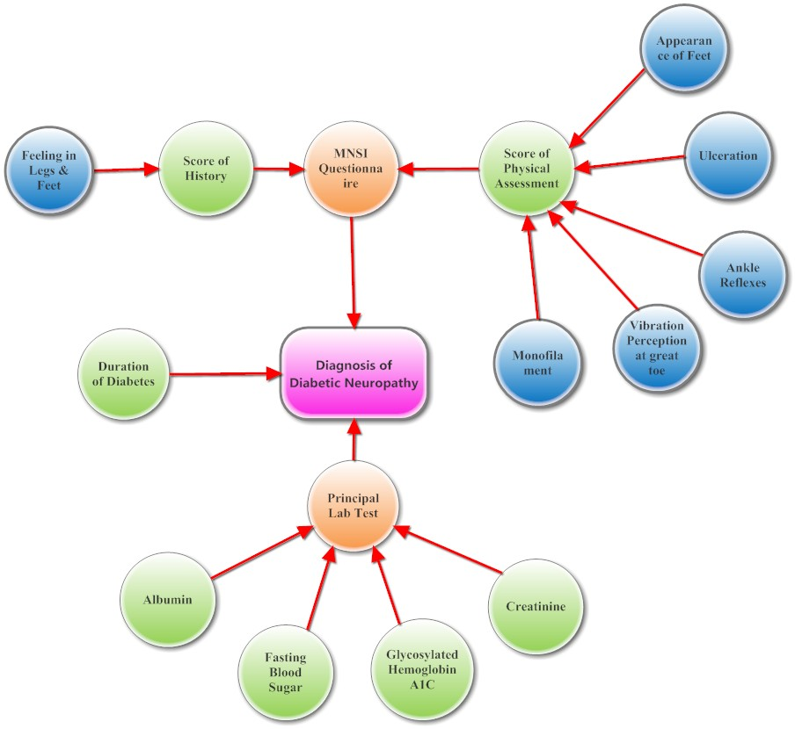
Figure 1 The semantic network of the expert system.

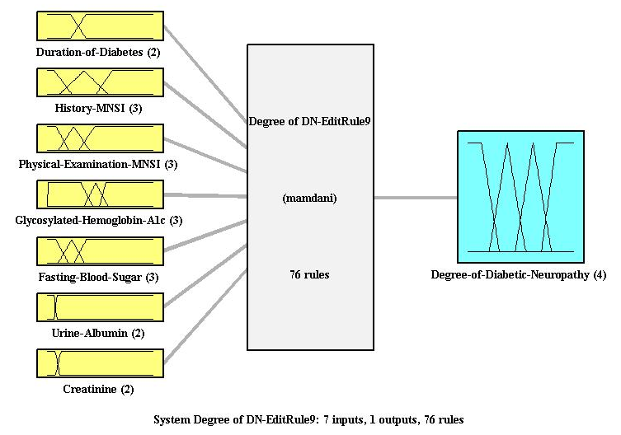
Figure 2 An overview of the fuzzy inference architecture of the system.

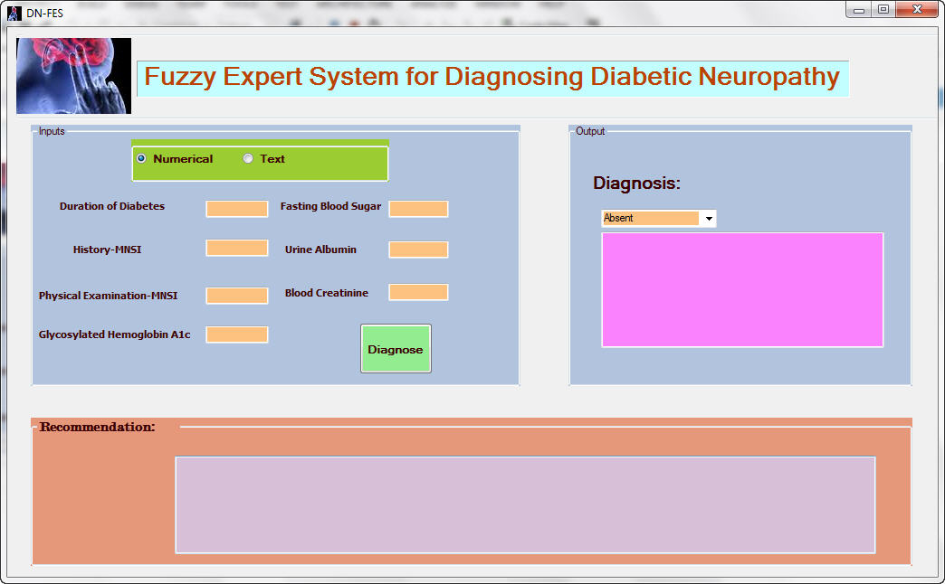
Figure 3 The graphical user interface of the fuzzy expert system.

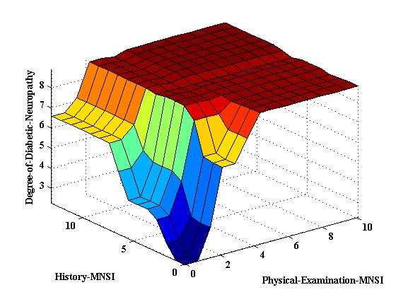
Figure 4 The risk of diabetic neuropathy based on the scores of the Michigan Neuropathy Screening Instrument questionnaire.

Figure 5 The receiver operating characteristic curve.
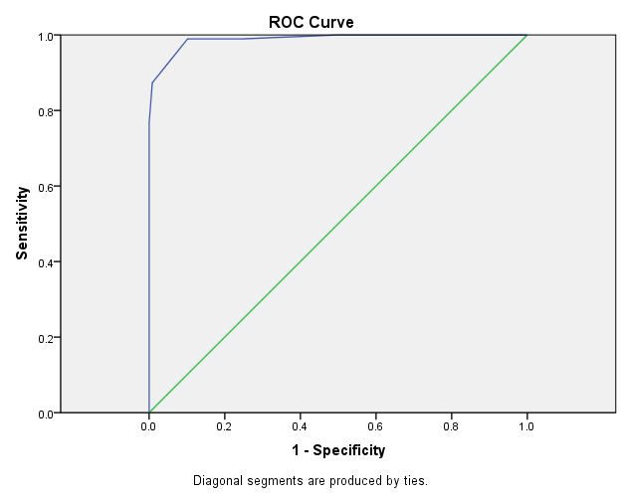

Table 1 The degree of importance of the diagnostic parameters for diagnosing diabetic neuropathy from the specialists’ perspectives
Mean ± SD | Very important  (5) | Important (4) | Relatively important (3) | Less important (2) | Unimportant (1) | Degree of importance
4.88 ± 0.35 | 7 (87.5%) | 1 (12.5%) | 0 | 0 | 0 | Duration of diabetes
4.13 ± 0.64 | 2 (25%) | 5 (62.5%) | 1 (12.5%) | 0 | 0 | Symptom assessment based on MNSI
4.38 ± 0.51 | 3 (37.5%) | 5 (62.5%) | 0 | 0 | 0 | Sign examination based on MNSI
4.50 ± 0.75 | 5 (62.5%) | 2 (25%) | 1 (12.5%) | 0 | 0 | HbA1c
2.38 ± 0.74 | 0 | 0 | 4 (50%) | 3 (37.5%) | 1 (12.5%) | CBC
4.25 ± 046 | 2 (25%) | 6 (75%) | 0 | 0 | 0 | FBS
2.52 ± 092 | 0 | 1 (12.5%) | 3 (37.5%) | 3 (37.5%) | 1 (12.5%) | ESR
2.50 ± 1.06 | 0 | 2 (25%) | 1 (12.5%) | 4 (50%) | 1 (12.5%) | Oral GTT
3.88 ± 0.99 | 2 (25%) | 4 (50%) | 1 (12.5%) | 1 (12.5%) | 0 | Albuminuria
2.63 ± 1.18 | 0 | 2 (25%) | 3 (37.5%) | 1 (12.5%) | 2 (25%) | TSH
2.88 ± 1.35 | 0 | 4 (50%) | 1 (12.5%) | 1 (12.5%) | 2 (25%) | B12 Vitamin
2.38 ± 0.91 | 0 | 1 (12.5%) | 3 (37.5%) | 3 (37.5%) | 1 (12.5%) | BUN
3.50 ± 0.75 | 0 | 5 (62.5%) | 2 (25%) | 1 (12.5%) | 0 | BCr
2.50 ± 1.06 | 0 | 1 (12.5%) | 4 (50%) | 1 (12.5%) | 2 (25%) | Calcium
2.13 ± 0.83 | 0 | 0 | 3 (37.5%) | 3 (37.5%) | 2 (25%) | Phosphorus
BCr: Blood Creatinine; BUN: Blood urea nitrogen; TSH: Thyroid-stimulating hormone; GTT: Glucose tolerance test; ESR: Erythrocyte sedimentation rate; MNSI: Michigan Neuropathy Screening Instrument; HbA1c: Hemoglobin A1c; CBC: Complete blood count; FBS: Fasting blood sugar.

