Name of Journal: World Journal of Clinical Cases
Manuscript NO: 86312
Manuscript Type: CASE REPORT

Collision tumor of primary malignant lymphoma and adenocarcinoma in the colon diagnosed by molecular pathology: A case report and literature review

Jiang et al. Collision lymphoma and adenocarcinoma in CRCs

Meng Jiang, Xiao-Ping Yuan

Meng Jiang, School of Medicine, Sun Yat-sen University, Shenzhen 518107, Guangdong Province, China

Xiao-Ping Yuan, Department of Radiology, Sun Yat-sen Memorial Hospital, Sun Yat-sen University, Guangzhou 510120, Guangdong Province, China

Author contributions: All the authors contributed to manuscript writing and editing, and data collection; Jiang M performed statistical analysis and drafted the manuscript; Yuan XP performed the literature review and revised the manuscript; All authors have read and approved the final manuscript.

Supported by National College Students Innovation and Entrepreneurship Training Program, No. 202110558154; College Students Innovation and Entrepreneurship Training Program of Sun Yat-sen University, No. 202211534; and No. 202311516.

Corresponding author: Xiao-Ping Yuan, MD, Director, Doctor, Department of Radiology, Sun Yat-sen Memorial Hospital, Sun Yat-sen University, No. 107 Yanjiang West Road, Guangzhou 510120, Guangdong Province, China. yuanxp@mail.sysu.edu.cn

Received: June 17, 2023
Revised: August 15, 2023
Accepted: August 21, 2023
Published online:

Abstract
BACKGROUND
Collision tumors of primary malignant lymphoma and adenocarcinoma in the colon are rare. Primary diffuse large B-cell lymphoma (DLBCL)–adenocarcinoma collision tumors are especially rare.

CASE SUMMARY
A 74-year-old woman presented with abdominal pain of 1 mo duration. Biopsy under colonoscopy revealed adenocarcinoma of the ascending colon. Subsequently, the patient underwent laparoscopic radical resection of right colon cancer with lymph node dissection. A collision tumor was found incidentally through postoperative pathological sampling. Genetic analysis showed a collision tumor of DLBCL with germinal center B-cell subtype and TP53 mutation, and adenocarcinoma arising in a tubulovillous adenoma in the colon, with BRAF mutation and mutL homolog 1 promoter methylation. The patient died 3 mo after surgery. To our knowledge, this is the 23rd reported case of collision tumor of colorectal adenocarcinoma and lymphoma. The mean age of the 23 patients was 73 years. The most common site was the cecum. There were 15 cases with follow-up data including 11 living and four dead with a 3-year overall survival rate of 71.5%.

CONCLUSION
Based on pathological and genetic analysis, surgery combined with chemotherapy or chemoradiotherapy may have good therapeutic effects for collision tumor.

Key Words: Collision tumor; Colorectal adenocarcinoma; Primary colonic lymphoma; Molecular pathological analysis; Case report

Jiang M, Yuan XP Collision tumor of primary malignant lymphoma and adenocarcinoma in the colon diagnosed by molecular pathology: A case report and literature review. World J Clin Cases 2023; In press

Core Tip: Coexisting of primary diffuse large B-cell lymphoma (DLBCL) and adenocarcinoma in the colon are extremely rare. Here, we report a case of collision tumor of primary DLBCL, not otherwise specified with germinal center B-cell subtype and TP53 mutation, and adenocarcinoma arising in a tubulovillous adenoma in the colon, with BRAF mutation and mutL homolog 1 promoter methylation. Definite diagnosis is usually difficult until pathological confirmation. Based on pathological examination and genetic analysis, surgery combined with dose-adjusted chemotherapy or chemoradiotherapy may have good therapeutic effects.

INTRODUCTION
Colorectal cancers (CRCs) are malignant epithelial tumors originating in the large bowel with glandular or mucinous differentiation, and are the second most common cancer in women and the third most common in men^{[1]}. Adenocarcinoma is the most common malignant tumor of the colon, while primary malignant lymphoma is relatively rare. Two or more distinct tumors of different cell lineages that independently occur in the same space or organ and combine to form one mass are defined as collision tumors^{[1,2]}. Collision tumors of primary malignant lymphoma and adenocarcinoma in the colon are rare. To the best of our knowledge, only 22 cases have been described in the literature^{[3-24]}. Here, we report a case of collision tumor of primary diffuse large B-cell lymphoma (DLBCL), not otherwise specified (NOS) with germinal center B-cell (GCB) subtype and TP53 mutation, and adenocarcinoma arising in a tubulovillous adenoma in the colon, with BRAF mutation and mutL homolog 1 (MLH1) promoter methylation. We also present a review of the literature.

CASE PRESENTATION
Chief complaints
A 74-year-old woman presented with abdominal pain of 1 mo duration and was referred to Sun Yat-Sen Memorial Hospital, in March 2018.

History of present illness
She presented with abdominal pain of 1 mo duration.

History of past illness
She mentioned a loss of 8 kg over the previous 6 mo and had anemia. Hypertension was confirmed for many years.

Personal and family history
The patient denied any family history of malignant tumors.

Physical examination
Upon physical examination, no peripheral lymphadenopathy or hepatosplenomegaly was found. A mass was noted in the right lower quadrant.

Laboratory examinations
Blood examination showed an increase in carbohydrate antigen 125, carbohydrate antigen 19-9 level, and a decrease in lymphocyte proportion and count, hemoglobin, and total protein (Table 1). Serum lactate dehydrogenase was elevated (538 U/L, normal 108-252 U/L). Blood detection for syphilis, hepatitis B virus, hepatitis C virus and human immunodeficiency virus was negative or normal.

Imaging examinations
Hypertensive heart disease was diagnosed by color sonography. Chest radiography showed no evidence of metastasis in the lung. Contrast-enhanced computed tomography revealed bowel wall thickening with contrast enhancement at the cecum, but no lymph node or organ metastasis and a negative scan of the liver and spleen. Colonoscopy revealed a tumor of the ascending colon, which was confirmed as adenocarcinoma on biopsy.

FURTHER DIAGNOSTIC WORK-UP
The patient underwent laparoscopic radical resection of right colon cancer with lymph node dissection.
Pathological analysis was performed on a formalin-fixed section of the intestine with omentum (including ileum, cecum and ascending colon). The lengths of the three portions were 6 cm, 11 cm and 22 cm, respectively; and the circumferences were 2.5 cm, 8 cm and 6 cm. A circumferential ulcerative mass a size of 11 cm × 7.5 cm × 10 cm was seen on the cecal mucosa adjacent to the ileocecal valve (Figure 1). Macroscopically, the mass appeared to consist of two tumors. The cut surface of the mass with crater-like appearance was gray, soft, fish-like, with a necrotic-appearing central area, whereas the remaining polypoid part of the mass was hard and grayish-white. A cross-section demonstrated that these two tumors formed a union, and it was impossible to determine grossly the borderline of the two tumors. Adjacent to the tumor, a 0.6-cm polypoid mass was found in the ascending colon. The appendix was 5 cm long, 0.8 cm in diameter, and the volume of the omentum was 15 cm × 15 cm × 1.5 cm. Nine lymph nodes varying in size from 0.1 cm to 1.2 cm were isolated from the specimen. Microscopy showed that the tumor had two components that were adjacent to each other but independent (Figure 2). One component was a moderately differentiated adenocarcinoma with a mucinous component arising in a tubulovillous adenoma (Figure 3A), which invaded the muscularis propria with pushing borders (Figure 3B). The other component was distributed from the mucosal lamina to the subserous layer. The medium-to-large lymphocytes grew diffusely, with uniform morphology, frequent mitosis, and obvious atypia (Figure 3C). There was no intramural and extramural vascular, lymphatic or perineural invasion. The surgical cut margins and the appendix were free of tumors and all lymph nodes lacked tumor dissemination. Histological examination of the 0.6-cm polypoid mass in the ascending colon showed a tubular adenoma.
Immunohistochemistry revealed that the adenocarcinoma strongly expressed cytokeratin (CK) (Figure 3D), CK20, caudalrelated homeobox transcription factor 2 and mutS homolog 6, but was negative for mutS homolog 2, MLH1 and postmeiotic segregation increased 2. Immunohistochemistry of the atypical lymphocytes was strongly and diffusely positive for paired-box 5, cluster of differentiation 20 (CD20) (Figure 3E), CD79, CD10, B-cell lymphoma (Bcl)-6, multiple myeloma oncogene-1 and lambda, and negative for kappa, Bcl2, cyclinD1, CD5, CD21, CD23, CD38, CD138, CD3 (Figure 3F), CD56, anaplastic lymphoma kinase, terminal deoxynucleotidyl transferase and CK. The MIB-1 labeling index was approximately 80%. Expression of C-myc was detected in 30% of these atypical lymphocytes. P53-positive immunoreactivity was 90%. In situ hybridization was negative for Epstein–Barr virus (EBV)-encoded small RNA.
Mutational analysis of BRAF was restricted to the V600E alteration. BRAF mutations were detected from formalin-fixed paraffin-embedded sections using the Snapshot mutation detection platform. MLH1 promoter methylation was performed by quantitative real-time polymerase chain reaction. Adenocarcinoma had BRAF mutation and MLH1 promoter methylation. IgH gene rearrangement study showed that the B-cell rearrangement was positive (polymerase chain reaction + fragment analysis). Fluorescence in situ hybridization of the atypical lymphocytes identified no translocations of IGH/BCL2, IGH/MYC, IGH/CCND1 and no break-apart rearrangement of BCL6. TP53 mutations were found by the AmpliChip p53 Research Test (Roche Molecular Systems), which is a microarray-based assay that detects mutations in exons 2–11.

FINAL DIAGNOSIS
The morphological, immunohistochemical and molecular pathological findings confirmed the diagnosis of collision tumor of primary DLBCL, NOS with GCB subtype and TP53 mutation, and adenocarcinoma arising in a tubulovillous adenoma in the colon, with BRAF mutation and MLH1 promoter methylation. The colon adenocarcinoma was staged as T2N0M0 according to the American Joint Committee on Cancer Tumor–Node–Metastasis staging system^{[25]}. Postoperative positron emission tomography–computed tomography scan revealed that there was no metastasis to the lymphoid system or bone marrow, which was confirmed by a bone marrow biopsy. DLBCL was stage I_{E} with bulky disease, according to the revised staging system for malignant lymphoma based on the Lugano classification^{[26,27]}. The Eastern Cooperative Oncology Group performance status^{[28]} of the patient was 2. The International Prognostic Index (IPI) of the National Comprehensive Cancer Network^{[29]} score was 5, which indicated that the patient was in the high–intermediate risk of survival group.

TREATMENT
The patient underwent laparoscopic radical resection of right colon cancer with lymph node dissection.

OUTCOME AND FOLLOW-UP
The symptoms rapidly progressed and the patient died 3 mo after the initial diagnosis of collision tumor of primary malignant lymphoma and adenocarcinoma in the colon.

LITERATURE REVIEW
There are few reports of colonic adenocarcinoma in collision with primary colorectal lymphoma^{[3-24]}. The clinicopathological characteristics of the present case and 22 previous cases with collision tumors of primary colorectal lymphoma and adenocarcinoma are reviewed.
This type of tumor mostly occurs in older people. The age of the patients ranged from 43 to 86 years, with a mean of 73 years. Most of the patients were > 60 years old (21/22) and the male-to-female ratio was 1.3 to 1. In all cases, anemia, multiple colon polyps, and inflammatory bowel disease were the most common diseases in past medical history. Most cases had symptoms associated with colorectal adenocarcinoma (20/23). The most common site of lesions was the cecum (7/23). The histological morphology of tumors could be roughly divided into three types^{[14]}. Thirteen cases were in the most common type, which was carcinoma and lymphoma are in the same tumor and the two types of tumor cells are mixed and grow crosswise. Seven cases and our case were in the second type, with carcinoma and lymphoma in the same tumor and independently. Third, the two tumor components are in separate tumors, and the two tumors are adjacent or close to each other.
Most of the adenocarcinoma components were moderately differentiated (18/21), and there were two well-differentiated and one poorly differentiated adenocarcinoma. Among 16 patients with available histopathological staging of adenocarcinoma, there were seven, four, three, one and one in stages I, IIA, IIIB, IIIC and IV, respectively. Three cases showed adenocarcinoma arising in a villous adenoma. There was a large tubulovillous adenoma containing invasive adenocarcinoma in two cases. The most common histological subtypes of the lymphoma were B-cell lymphomas, such as DLBCL (9 cases), and only one case was peripheral T-cell lymphoma. Among 20 patients with an available histopathological staging of lymphoma, there were seven, three and 10 in stages I, II and IV, respectively. Sixteen of 19 patients had an intermediate or high-risk IPI score, and three had a low or intermediate-risk IPI score^{[28-31]}. Thus, > 50% of cases were stage IV and 84.2% of cases had intermediate or high-risk IPI scores in lymphoma components.
There were 15 cases with follow-up data, including 11 alive and four dead (3 died of malignant lymphoma and 1 of nontumor causes), and survival time ranged from 1 to 48 mo. Three-year overall survival rate was 71.5%. According to Kaplan–Meier survival analysis, the overall survival rate of patients who underwent surgery combined with chemotherapy or radiotherapy was higher than that of surgery alone, although the difference was not significant due to the small sample size (0.8333 vs 0.514). This suggested that adjuvant radiotherapy or chemotherapy combined with surgery had survival benefits. Seven patients underwent surgery alone and six underwent surgery in combination with chemotherapy [4 R-CHOP (rituximab, cyclophosphamide, doxorubicin, vincristine and prednisone); 1 FOLFOX (folinic acid, fluorouracil and oxaliplatin) to R-CHOP; 1 FOLFOX]; two received surgery in combination with chemotherapy and radiotherapy (1 R-CHOP; 1 R-CHOP to FOLFOX); and five received R-CHOP chemotherapy only, among eight patients who received chemotherapy. Among three patients who died from malignant lymphoma progression, two underwent surgery alone and one received surgery combined with chemotherapy (FOLOFX and R-CHOP). Whether lymphoma was a preference factor in the patient’s prognosis remains unclear, due to the lack of large sample data^{[6]}.

DISCUSSION
Collision colorectal adenocarcinoma and lymphoma are rare and only a few cases have been reported in the literature^{[3-24]}. Although rectal magnetic resonance imaging could detect different morphology and signal intensity in each tumor, pathological identification of the two components is the only way to make the correct diagnosis^{[4,32]}. Pathologists should be aware of the existence of collision tumors for two reasons^{[4,8]}. The first reason is that the presence of lymphocytes in the vicinity of colonic carcinomas is common, but these cells are not always reactive. A different appearance from that of the other on gross resection specimen and/or an extensive or monotonous infiltrate should alert pathologists to carefully assess its morphology, immunophenotype and clonality to confirm or exclude a coexisting lymphoma. The second reason is any effacement of the architecture of lymph nodes from a resection specimen with a known colonic carcinoma needs a closer look to exclude the possibility of an underlying lymphoma.
Primary colonic lymphoma and adenocarcinoma might be attributed to the advanced age of the patient^{[8]}. The development of DLBCL in one case with a medical history of rheumatoid arthritis was determined to be driven by EBV, with immunosuppression being the underlying cause^{[24]}.
Microsatellite instability (MSI) drives one of the key mechanisms of oncogenesis in CRC and the presence of MSI is important in two main scenarios^{[33]}. Firstly, in BRAF wild-type cases, MSI confers a good prognosis, and CRCs that are microsatellite stable in the context of BRAF mutation usually have poor prognosis. The present case with BRAF mutation and mismatch repair (MMR) had survival time of only 3 mo. Drugs targeting the BRAF gene may bring hope for the treatment of such collision tumors. Secondly, the presence of MSI is important in the context of cancer immunotherapy. More recently, studies have reported significant responses of MSI cancers (CRCs and others) to programmed death ligand 1 inhibitor in patients who failed conventional therapy^{[34,35]}. In the large intestine, the most common type of lymphoma is DLBCL (> 50%), followed by extranodal marginal zone lymphoma, follicular lymphoma, mantle cell lymphoma and Burkitt’s lymphoma. The incidence of large intestinal lymphoma has increased over the years, attributable to acquired or iatrogenic immunodeficiency^{[36]}. Patients with immunodeficiency are more prone to develop lymphoma. Although the influence of one cancer on the other is largely unknown, certain proneoplastic cytokines that are released by tumor cells have paracrine activities^{[18]}. One could envision a situation whereby one tumor type is secreting transforming growth factor b, not only cloaking the source tumors but also any adjacent disparate tumors. One tumor type might benefit from its collision counterpart via the stimulation of angiogenesis^{[18]}. The loss of MMR and resulting MSI are contributing factors to this association between carcinoma and lymphoid infiltration. The presence of lymphoma may help developing adenocarcinoma evade the immune system^{[20]}. Therefore, immunotherapy with MMR benefits both adenocarcinoma and lymphoma. EBV is an established risk factor for lymphoma and may also increase the risk of adenocarcinoma^{[7,24]}.
A therapeutic dilemma exists in deciding the course of treatment in patients with collision adenocarcinoma and lymphoma^{[5]}. There is agreement that surgical treatment alone is effective for localized disease, while combined chemotherapy is the mainstay for disseminated disease. The treatment of collision tumors requires simultaneous treatment of the two tumor components; mainly surgical resection combined with radiotherapy and chemotherapy^{[15]}. For the adenocarcinoma component, if it is well-differentiated, there is no need to perform radiotherapy and chemotherapy for cancer after resection. If there is lymph node or even distant metastasis, adjuvant radiotherapy and chemotherapy can be carried out after surgery if the physical condition allows. For the lymphoma component, the corresponding radiotherapy and chemotherapy regimen is added according to the different subtypes. However, the order of treatment can be a source of debate because it has not been established which tumor should be treated first^{[16]}. Although three of 23 cases died due to malignant lymphoma, there have been so few reports of cases with collision tumors composed of both neoplasms that it has not been possible to confirm whether lymphoma was a preference factor in prognosis^{[6]}. It is inferred that the prognosis of patients with collision tumor depends on the more aggressive histological grade and stage of the two collision components, and is also closely related to comprehensive and appropriate treatment^{[15]}.

CONCLUSION
Based on pathological examination and genetic analysis, surgery combined with dose-adjusted chemotherapy or chemoradiotherapy may have good therapeutic effects for collision tumor of lymphoma–adenocarcinoma, but additional case studies are needed for confirmation.

REFERENCES
1 Siegel RL, Wagle NS, Cercek A, Smith RA, Jemal A. Colorectal cancer statistics, 2023. CA Cancer J Clin 2023; 73: 233-254 [PMID: 36856579 DOI: 10.3322/caac.21772]
2 WHO Classiﬁcation of Tumours Editorial Board. Digestive system tumours. WHO Classification of Tumors. 5th ed, vol. 1. Lyon: IARC press; 2019
3 Mannweiler S, Dinges HP, Beham-Schmid C, Hauser H, Starlinger M, Regauer S. Colliding / concomitant tumors of the intestine: report of 3 cases. Pathol Oncol Res 2003; 9: 188-192 [PMID: 14530814 DOI: 10.1007/BF03033736]
4 Sahasrabudhe N, Khirwadkar N, Prescott R. Synchronous adenocarcinoma and marginal zone B-cell lymphoma of the colon: A case report. Diagnostic Histopathology 2009; 15: 318-322 [DOI: 10.1016/j.mpdhp.2009.03.005]
5 Devi P, Pattanayak L, Samantaray S. Synchronous adenocarcinoma and mucosa-associated lymphoid tissue lymphoma of the colon. Saudi J Gastroenterol 2011; 17: 69-71 [PMID: 21196657 DOI: 10.4103/1319-3767.74455]
6 Shigeno T, Fujimori K, Tsuruta F, Nozawa Y, Nagaya T, Maejima T. Ileocecal collision tumor composed of adenocarcinoma and primary malignant lymphoma. Clin J Gastroenterol 2011; 4: 79-84 [PMID: 26190710 DOI: 10.1007/s12328-011-0206-0]
7 Chang H, Chuang WY, Shih LY, Tang TC. Collision in the colon: concurrent adenocarcinoma and diffuse large B-cell lymphoma in the same tumour. Acta Clin Belg 2011; 66: 302-304 [PMID: 21938987 DOI: 10.2143/ACB.66.4.2062573]
8 Argyropoulos T, Foukas P, Kefala M, Xylardistos P, Papageorgiou S, Machairas N, Boltetsou E, Machairas A, Panayiotides IG. Simultaneous occurrence of colonic adenocarcinoma and MALT lymphoma: A series of three cases. World J Gastrointest Oncol 2012; 4: 89-93 [PMID: 22532883 DOI: 10.4251/wjgo.v4.i4.89]
9 Lin HH, Jiang JK, Lin JK. Collision tumor of low-grade B-cell lymphoma and adenocarcinoma with tuberculosis in the colon: a case report and literature review. World J Surg Oncol 2014; 12: 147 [PMID: 24885098 DOI: 10.1186/1477-7819-12-147]
10 Sathya G, Ramkumar G, Ganesh P, Jeevan Kumar S. Collision tumour of sigmoid colon--a rare presentation. Trop Gastroenterol 2014; 35: 120-122 [PMID: 25470878 DOI: 10.7869/tg.194]
11 Velu AR, Srinivasamurthy BC, Nagarajan K, Sinduja I. Colonic adenocarcinoma, mucosa associated lymphoid tissue lymphoma and tuberculosis in a segment of colon: A case report. World J Gastrointest Oncol 2014; 6: 377-380 [PMID: 25232463 DOI: 10.4251/wjgo.v6.i9.377]
12 Kus T, Aktas G, Kalender ME, Sari I, Ulker E, Camci C. Collision tumor consisting of primary follicular lymphoma and adenocarcinoma in the cecum: A case report and literature review. Oncol Lett 2016; 11: 2801-2805 [PMID: 27073555 DOI: 10.3892/ol.2016.4310]
13 Soto AR, Vazquez EG, Grigg-Gutierrez NM, Magno-Pagatzaurtundua P, Cáceres W, Toro DH. Conundrum of a Large Bowel Neoplasm: Collision Tumor. ACG Case Rep J 2018; 5: e13 [PMID: 29484306 DOI: 10.14309/crj.2018.13]
14 Kim SH. Collsion Tumor of Adenocarcinoma and Diffuse Large B-cell Lymphoma in the Rectum: a Case Report and Literature Review. Investing Magn Reson Imaging 2019; 23: 374-380 [DOI: 10.13104/imri.2019.23.4.374]
15 Bao L, Feng X, Wang T, Xing F. Collision tumor of carcinoma and lymphoma in the cecum: case report and review of literature. Int J Clin Exp Pathol 2020; 13: 2907-2915 [PMID: 33284884]
16 Kataoka J, Nitta T, Ota M, Fujii K, Ishii M, Senpuku S, Ueda Y, Tsuchimoto Y, Takeshita A, Miyatake J, Ishibashi T. Collision Tumor Comprising Primary Malignant Lymphoma and Adenocarcinoma in the Ascending Colon. Case Rep Gastroenterol 2021; 15: 379-388 [PMID: 33976615 DOI: 10.1159/000513972]
17 Lin YS, Hamilton AER, Henderson C, Farzin M. Tiny but Mighty: Collision Tumor of a Superficial Adenocarcinoma Arising From a Tubulovillous Adenoma with Associated Low-Grade Follicular Lymphoma. Int J Surg Pathol 2021; 29: 759-763 [PMID: 33619998 DOI: 10.1177/1066896921995942]
18 Schep D, Van Koughnett JA, Velker V, Correa RJM. Synchronous colonic B cell lymphoma and adenocarcinoma in an elderly patient treated with R-mini-CHOP followed by resection. BMJ Case Rep 2022; 15 [PMID: 35508353 DOI: 10.1136/bcr-2020-236989]
19 Zapata Palomino M, Caicedo-Holguín I, Pardo S, Mera AT, Gómez AP, Zorrilla JO. Case report: Tumor collision in the colon, adenocarcinoma - lymphoma. Int J Surg Case Rep 2022; 98: 107573 [PMID: 36380539 DOI: 10.1016/j.ijscr.2022.107573]
20 Hopster D, Smith PA, Nash JR, Elders K, Poston GJ. Synchronous multiple lymphomatous polyposis and adenocarcinomata in the large bowel. Postgrad Med J 1995; 71: 443 [PMID: 7567744 DOI: 10.1136/pgmj.71.837.443]
21 Padmanabhan V, Trainer TD. Synchronous adenocarcinoma and mantle cell lymphoma of the colon. Arch Pathol Lab Med 2003; 127: E64-E66 [PMID: 12562254 DOI: 10.5858/2003-127-e64-SAAMCL]
22 Eshra A, Al-Hendal A, Al Enezi M, Al-Mishaan M, Abo Dief W. One patient, two lymphomas, three primaries. Gulf J Oncolog 2010: 39-43 [PMID: 20601338]
23 Sasaki S, Hatanaka K, Sahara N, Uekusa T, Hirayama K, Shirahata A, Ishimaru M. Collision tumor of primary malignant lymphoma and adenocarcinoma in the colon: report of a case. Surg Today 2010; 40: 975-981 [PMID: 20872204 DOI: 10.1007/s00595-009-4166-7]
24 Yu JR, Huang Q, Hou P, Lai JP. Collision tumor of colonic adenocarcinoma and EBV-driven large B-cell lymphoma: a case report and review of literature. Cancer Treatment Communications 2015; 3: 7-12 [DOI: 10.1016/j.ctrc.2014.12.002]
25 Edge S, Byrd DR, Compton CC, Fritz AG, Greene FL, Trotti A. American Joint Committee on Cancer (AJCC) Cancer Staging Manual. 7th edition. Springer, New York, NY, 010 pp143
26 Cheson BD, Fisher RI, Barrington SF, Cavalli F, Schwartz LH, Zucca E, Lister TA; Alliance, Australasian Leukaemia and Lymphoma Group; Eastern Cooperative Oncology Group; European Mantle Cell Lymphoma Consortium; Italian Lymphoma Foundation; European Organisation for Research; Treatment of Cancer/Dutch Hemato-Oncology Group; Grupo Español de Médula Ósea; German High-Grade Lymphoma Study Group; German Hodgkin's Study Group; Japanese Lymphorra Study Group; Lymphoma Study Association; NCIC Clinical Trials Group; Nordic Lymphoma Study Group; Southwest Oncology Group; United Kingdom National Cancer Research Institute. Recommendations for initial evaluation, staging, and response assessment of Hodgkin and non-Hodgkin lymphoma: the Lugano classification. J Clin Oncol 2014; 32: 3059-3068 [PMID: 25113753 DOI: 10.1200/JCO.2013.54.8800]
27 Ricard F, Cheson B, Barrington S, Trotman J, Schmid A, Brueggenwerth G, Salles G, Schwartz L, Goldmacher G, Jarecha R, Narang J, Broussais F, Galette P, Liu M, Bajpai S, Perlman E, Gillis J, Smalberg I, Terve P, Zahlmann G, Korn R. Application of the Lugano Classification for Initial Evaluation, Staging, and Response Assessment of Hodgkin and Non-Hodgkin Lymphoma: The PRoLoG Consensus Initiative (Part 1-Clinical). J Nucl Med 2023; 64: 102-108 [PMID: 35835580 DOI: 10.2967/jnumed.122.264106]
28 International Non-Hodgkin's Lymphoma Prognostic Factors Project. A predictive model for aggressive non-Hodgkin's lymphoma. N Engl J Med 1993; 329: 987-994 [PMID: 8141877 DOI: 10.1056/NEJM199309303291402]
29 Zhou Z, Sehn LH, Rademaker AW, Gordon LI, Lacasce AS, Crosby-Thompson A, Vanderplas A, Zelenetz AD, Abel GA, Rodriguez MA, Nademanee A, Kaminski MS, Czuczman MS, Millenson M, Niland J, Gascoyne RD, Connors JM, Friedberg JW, Winter JN. An enhanced International Prognostic Index (NCCN-IPI) for patients with diffuse large B-cell lymphoma treated in the rituximab era. Blood 2014; 123: 837-842 [PMID: 24264230 DOI: 10.1182/blood-2013-09-524108]
30 Thieblemont C, Cascione L, Conconi A, Kiesewetter B, Raderer M, Gaidano G, Martelli M, Laszlo D, Coiffier B, Lopez Guillermo A, Torri V, Cavalli F, Johnson PW, Zucca E. A MALT lymphoma prognostic index. Blood 2017; 130: 1409-1417 [PMID: 28720586 DOI: 10.1182/blood-2017-03-771915]
31 Solal-Céligny P, Roy P, Colombat P, White J, Armitage JO, Arranz-Saez R, Au WY, Bellei M, Brice P, Caballero D, Coiffier B, Conde-Garcia E, Doyen C, Federico M, Fisher RI, Garcia-Conde JF, Guglielmi C, Hagenbeek A, Haïoun C, LeBlanc M, Lister AT, Lopez-Guillermo A, McLaughlin P, Milpied N, Morel P, Mounier N, Proctor SJ, Rohatiner A, Smith P, Soubeyran P, Tilly H, Vitolo U, Zinzani PL, Zucca E, Montserrat E. Follicular lymphoma international prognostic index. Blood 2004; 104: 1258-1265 [PMID: 15126323 DOI: 10.1182/blood-2003-12-4434]
32 Zhao X, Zhang G, Li CH. Collision carcinoma of the rectum involving neuroendocrine carcinoma and adenocarcinoma: A case report. World J Clin Cases 2021; 9: 4789-4796 [PMID: 34222449 DOI: 10.12998/wjcc.v9.i18.4789]
33 Dudley JC, Lin MT, Le DT, Eshleman JR. Microsatellite Instability as a Biomarker for PD-1 Blockade. Clin Cancer Res 2016; 22: 813-820 [PMID: 26880610 DOI: 10.1158/1078-0432.CCR-15-1678]
34 Le DT, Durham JN, Smith KN, Wang H, Bartlett BR, Aulakh LK, Lu S, Kemberling H, Wilt C, Luber BS, Wong F, Azad NS, Rucki AA, Laheru D, Donehower R, Zaheer A, Fisher GA, Crocenzi TS, Lee JJ, Greten TF, Duffy AG, Ciombor KK, Eyring AD, Lam BH, Joe A, Kang SP, Holdhoff M, Danilova L, Cope L, Meyer C, Zhou S, Goldberg RM, Armstrong DK, Bever KM, Fader AN, Taube J, Housseau F, Spetzler D, Xiao N, Pardoll DM, Papadopoulos N, Kinzler KW, Eshleman JR, Vogelstein B, Anders RA, Diaz LA Jr. Mismatch repair deficiency predicts response of solid tumors to PD-1 blockade. Science 2017; 357: 409-413 [PMID: 28596308 DOI: 10.1126/science.aan6733]
35 Le DT, Uram JN, Wang H, Bartlett BR, Kemberling H, Eyring AD, Skora AD, Luber BS, Azad NS, Laheru D, Biedrzycki B, Donehower RC, Zaheer A, Fisher GA, Crocenzi TS, Lee JJ, Duffy SM, Goldberg RM, de la Chapelle A, Koshiji M, Bhaijee F, Huebner T, Hruban RH, Wood LD, Cuka N, Pardoll DM, Papadopoulos N, Kinzler KW, Zhou S, Cornish TC, Taube JM, Anders RA, Eshleman JR, Vogelstein B, Diaz LA Jr. PD-1 Blockade in Tumors with Mismatch-Repair Deficiency. N Engl J Med 2015; 372: 2509-2520 [PMID: 26028255 DOI: 10.1056/NEJMoa1500596]
36 Gustafsson BI, Siddique L, Chan A, Dong M, Drozdov I, Kidd M, Modlin IM. Uncommon cancers of the small intestine, appendix and colon: an analysis of SEER 1973-2004, and current diagnosis and therapy. Int J Oncol 2008; 33: 1121-1131 [PMID: 19020744 DOI: 10.3892/ijo_00000101]

Footnotes
Informed consent statement: Informed written consent was obtained from her family members to publish this case report and any accompanying images.

Conflict-of-interest statement: All the authors declare that they have no conflict of interest to disclose.

CARE Checklist (2016) statement: The authors have read the CARE Checklist (2016), and the manuscript was prepared and revised according to the CARE Checklist (2016).

Open-Access: This article is an open-access article that was selected by an in-house editor and fully peer-reviewed by external reviewers. It is distributed in accordance with the Creative Commons Attribution NonCommercial (CC BY-NC 4.0) license, which permits others to distribute, remix, adapt, build upon this work non-commercially, and license their derivative works on different terms, provided the original work is properly cited and the use is non-commercial. See: https://creativecommons.org/Licenses/by-nc/4.0/

Provenance and peer review: Unsolicited article; Externally peer reviewed.
Peer-review model: Single blind

Peer-review started: June 17, 2023
First decision: August 4, 2023
Article in press:

Specialty type: Gastroenterology and hepatology
Country/Territory of origin: China
Peer-review report’s scientific quality classification
Grade A (Excellent): 0
Grade B (Very good): B
Grade C (Good): C
Grade D (Fair): 0
Grade E (Poor): 0

P-Reviewer: Alkhatib AJ, Jordan; Arumugam VA, India S-Editor: Liu JH L-Editor: A P-Editor: Liu JH
Figure Legends
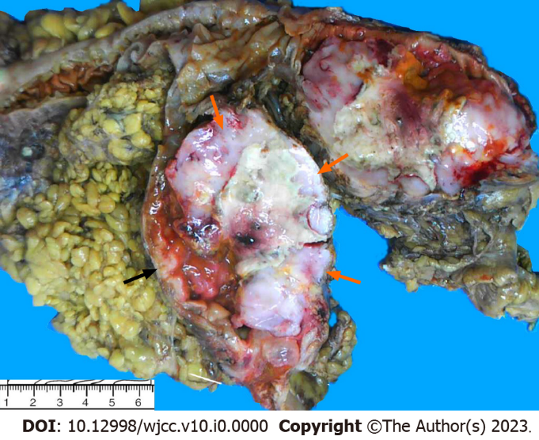
Figure 1 Macroscopic examination. The resected specimen presented as a circumferential ulcerative mass on the cecal mucosa adjacent to the ileocecal valve. The mass appeared to be comprised of two tumors. The upper-right portion of the mass had a crater-like appearance with a necrotic-appearing central area (orange arrow), whereas the remaining part of the mass had a polypoid, hard and grayish-white aspect (black arrow).

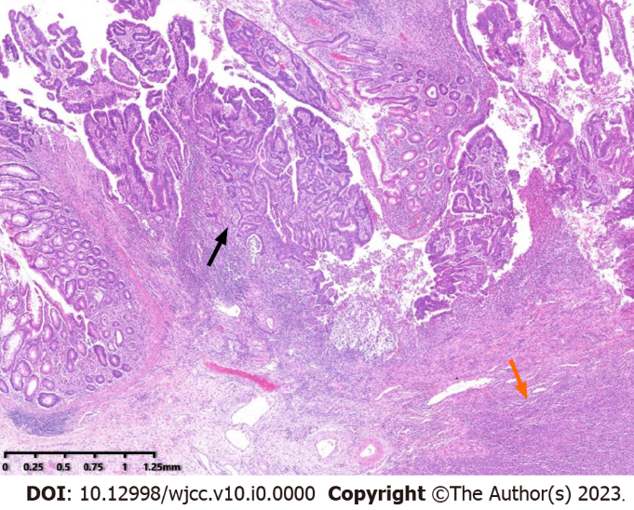
Figure 2 Low power view of the mass. Microscopic examination disclosed that the tumor was composed of two components, adjacent to each other but relatively independent and showing infiltrative glands (black arrow) with underlying lymphoid proliferation (orange arrow) (Hematoxylin and eosin, original magnificent 20×).

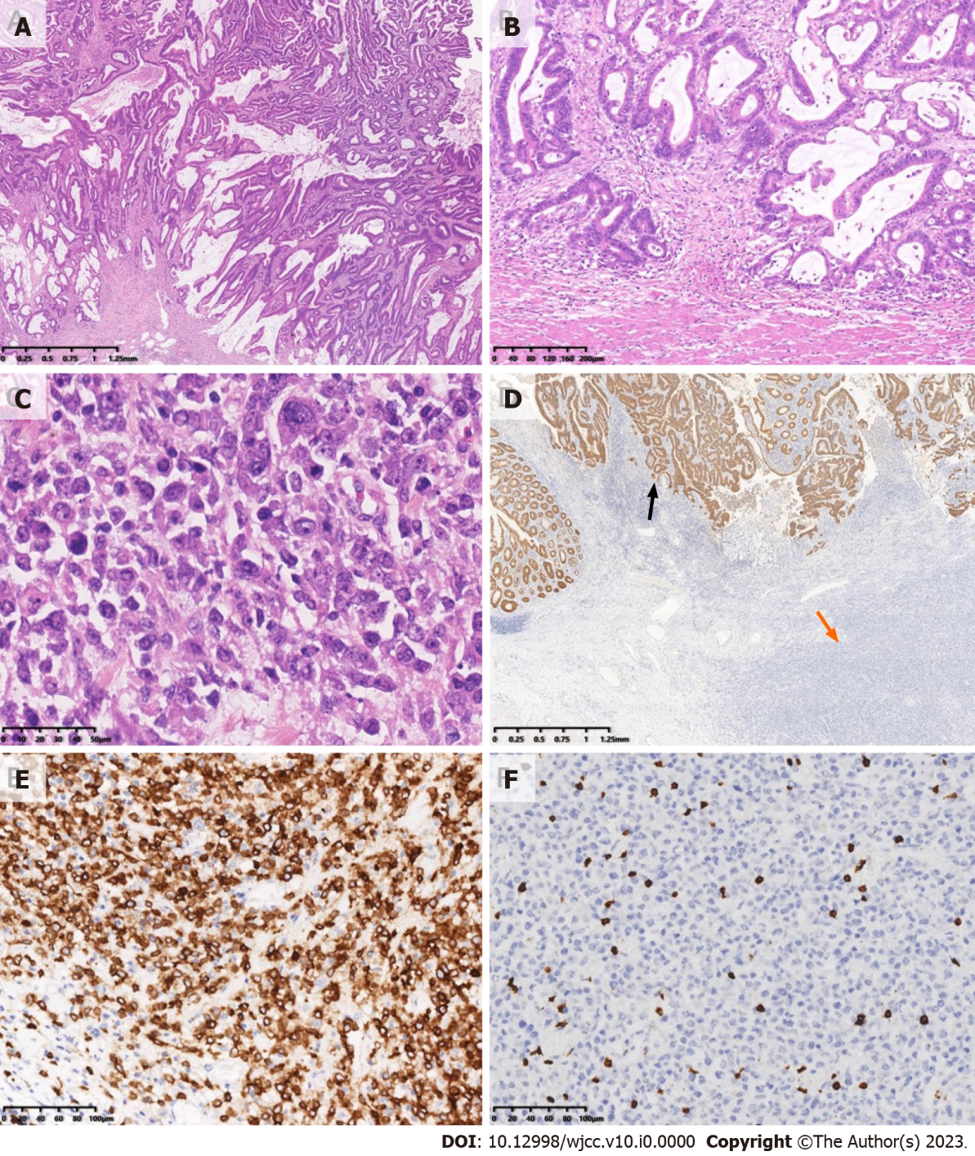
Figure 3 Microscopic examination and immunohistochemistry. A: Histopathology of one component of the mass was a moderately differentiated adenocarcinoma having a mucinous component arising from a tubulovillous adenoma (top) (Hematoxylin and eosin (HE), original magnification 20×); B: Adenocarcinoma invaded the muscularis propria (HE, original magnification 100×); C: The other component was diffusely medium-to-large lymphocytes, with uniform morphology, frequent mitosis and obvious cell atypia (HE, original magnification 400×); D: Immunohistochemistry of adenocarcinoma was strongly positive for cytokeratin (black arrow), while the atypical lymphocytes were negative (orange arrow) (EnVision method, original magnification 20×); E: Immunohistochemistry of the atypical lymphocytes was strongly and diffusely positive for CD20 (EnVision method, original magnification 200×); F: Immunohistochemistry of the atypical lymphocytes was negative for CD3 (EnVision method, original magnification 200×).

Table 1 Laboratory data on admission
Item | Detection value | Unit | Normal range
White blood cell count | 8.25 | ×10⁹/L | 3.50-9.50
Red cell count | 3.80 | ×10¹²/L | 3.80-5.10
Hemoglobin | 98 | g/L | 115-150
Platelet count | 163 | ×10⁹/L | 125-350
Lymphocyte proportion | 5.2 | % | 20.0-50.0
Lymphocyte count | 0.43 | ×10⁹/L | 1.10-3.20
Alanine aminotransferase | 5 | U/L | 7-40
Total bilirubin | 30.8 | µmol/L | 3.4-22.2
Direct bilirubin | 10.8 | µmol/L | 0.0-3.4
Indirect bilirubin | 20.0 | µmol/L | 3.4-18.8
Serum sodium | 133.1 | mmol/L | 137.0-147.0
Serum calcium | 1.88 | mmol/L | 2.10-2.60
Cystatin C | 1.40 | mg/L | 0.51-1.09
β-Hydroxybutyric acid | 0.56 | mmol/L | 0.02-0.30
High-density lipoprotein cholesterol | 0.65 | mmol/L | 0.80-1.96
Apolipoprotein A1 | 0.74 | g/L | 1.00-1.60
Apolipoprotein E | 51.7 | mg/L | 27.0-49.0
Prealbumin | 0.06 | g/L | 0.18-0.40
Total protein | 48.2 | g/L | 65.0-85.0
Albumin | 23.8 | g/L | 40.0-55.0
Albumin–globulin ratio | 1.0 |  | 1.2-2.4
Phosphocreatine kinase | 20 | U/L | 26-174
Lactate dehydrogenase | 538 | U/L | 108-252
Highly sensitive C-reactive protein | 104.30 | mg/L | 0.00-3.00
Cholinesterase | 2730 | U/L | 5300-12900
Leucylaminopeptidase | 17.5 | U/L | 20.0-60.0
Retinol binding protein | 15.0 | mg/L | 25.0-70.0
Serum iron | 4.1 | µmol/L | 7.0-32.0
Total iron binding capacity | 23.0 | µmol/L | 45.0-75.0
Unsaturated iron binding capacity | 18.9 | µmol/L | 31.0-51.0
Transferrin | 1.27 | g/L | 1.90-3.80
Adenosine deaminase | 21.1 | U/L | 0.0-15.0
Superoxide dismutase | 94 | U/mL | 129-216
Carcinoembryonic antigen | 1.5 | ng/mL | ≤ 5
Alpha-fetoprotein | 1.6 | ng/mL | ≤ 25
Carbohydrate antigen 72-4 | 2.8 | U/mL | ≤ 7
Carbohydrate antigen 125 | 109.3 | U/mL | ≤ 35
Carbohydrate antigen 19-9 | 40.5 | U/mL | ≤ 34

