Name of Journal: World Journal of Cardiology
Manuscript NO: 78556
Manuscript Type: META-ANALYSIS

Potential for sodium-glucose cotransporter-2 inhibitors in the management of metabolic syndrome: A systematic review and meta-analysis

Olagunju A et al. Sodium-glucose cotransporter-2 inhibitors in syndrome-x

Abdulbaril Olagunju, Naser Yamani, Dorothy Kenny, Martina Mookadam, Farouk Mookadam, Samuel Unzek

Abdulbaril Olagunju, Dorothy Kenny, Internal Medicine, Creighton University School of Medicine, Phoenix, AZ 85013, United States

Martina Mookadam, Department of Family Medicine, Mayo Clinic, Scottsdale, AZ 85260, United States

Naser Yamani, Farouk Mookadam, Samuel Unzek, Cardiology, Heart Center, University of Arizona College of Medicine-Phoenix, Banner University Medical Center, Phoenix, AZ 85006, United States

Author contributions: Olagunju A, Mookadam M and Mookadam F designed the research; Olagunju A, Kenny D, Yamani N performed the research; Olagunju A, Kenny D, Yamani N, Mookadam M, Mookadam F and Unzek S analysed the data; Olagunju A, Kenny D, Yamani N and Mookadam F wrote the paper.

Corresponding author: Abdulbaril Olagunju, MD, Doctor, Internal Medicine, Creighton University School of Medicine, 350 W Thomas Road, Phoenix, AZ 85013, United States. ab.dapoola@gmail.com

Received: July 3, 2022
Revised: September 17, 2022
Accepted: October 27, 2022
Published online:

Abstract
BACKGROUND
Landmark trials have established the benefits of sodium-glucose cotransporter-2 inhibitors (SGLT2-Is) in cardiovascular disease including heart failure with reduced and preserved ejection fraction and renal diseases regardless of the presence of diabetes mellitus. However, studies evaluating the role of SGLT2-Is in metabolic syndrome (MetS) are limited.

AIM
This study primarily aimed to evaluate the impact of SGLT2-Is on the components of MetS.

METHODS
Two independent reviewers and an experienced librarian searched Medline, Scopus and the Cochrane central from inception to December 9, 2021 to identify placebo controlled randomized controlled trials that evaluated the impact of SGLT2-Is on the components of MetS as an endpoint. Pre- and post-treatment data of each component were obtained. A meta-analysis was performed using the RevMan (version 5.3; Copenhagen: The Nordic Cochrane Center, The Cochrane Collaboration).

RESULTS
Treatment with SGLT2-Is resulted in a decrease in fasting plasma glucose (–18.07 mg/dL; 95%CI: -25.32 to –10.82), systolic blood pressure (–1.37 mmHg; 95%CI: -2.08 to –0.65), and waist circumference (–1.28 cm; 95%CI: -1.39 to –1.18) compared to placebo. The impact on high-density lipoprotein cholesterol was similar to placebo (0.01 mg/dL; 95%CI: -0.05 to 0.07).

CONCLUSION
SGLT2-Is have a promising role in the management of MetS.

Key Words: Metabolic syndrome; Sodium-glucose cotransporter 2 inhibitors; Dapagliflozin; Empagliflozin; Cardiovascular disease

Olagunju A, Yamani N, Kenny D, Mookadam M, Mookadam F, Unzek S. Potential for sodium-glucose cotransporter-2 inhibitors in the management of metabolic syndrome: A systematic review and meta-analysis. World J Cardiol 2022; In press

Core Tip: This meta-analysis of randomized, placebo-controlled trials aimed to evaluate the impact of dapagliglozin and empagliflozin on metabolic syndrome as defined by the National Cholesterol Education Program Adult Treatment Panel III. In doing so, it highlighted a statistically significant improvement in fasting plasma glucose, systolic blood pressure and waist circumference. The effect of dapagliflozin and empagliflozin on high-density lipoprotein cholesterol was similar to that of placebo. In addition to its primary aim, this study also highlighted an improvement in other cardiometabolic parameters including hemoglobin A1C, uric acid and body weight in patients that received dapagliflozin and empagliflozin.

INTRODUCTION
Sodium-glucose cotransporter-2 inhibitors (SGLT2-Is) are a relatively novel and revolutionary class of medications that reduce the reabsorption of glucose from the proximal tubules in the kidneys^{[1-4]}. Their glycosuric effect led to their initial use in the management of patients with type 2 diabetes mellitus (DM)^{[1-4]}. However, recent large, randomized control trials (RCTs) have highlighted the extension of their benefits to cardiovascular diseases (CVD) including heart failure with reduced and preserved ejection fraction and renal diseases regardless of the presence of DM^{[5-15]}. However, to date, studies on the impact of SGLT2-Is in the management of metabolic syndrome (MetS) and its components remain inadequate. Metabolic syndrome is an emerging pandemic^{[16-19]}. Its prevalence has risen from approximately 25% to 38% between the early 1990s to 2010s in the United States^{[16-19]}. The prevalence has increased by 29.1% in people aged 40-60 years^{[16-19]}. It has been defined according to the National Cholesterol Education Program (NCEP) Adult Treatment Panel (ATP) III as the presence of 3 of 5 entities: (1) Waist circumference (WC) ≥ 102 cm in men and ≥ 88 cm in females; (2) Serum triglycerides (TGL) ≥ 150 mg/dL or on drug treatment for hypertriglyceridemia; (3) Serum high-density lipoprotein (HDL) cholesterol < 40 mg/dL in males and < 50 mg/dL; (4) Blood pressure (BP) ≥ 130/85 mmHg or on drug treatment for hypertension (HTN); (5) Fasting plasma glucose (FPG) ≥ 100 mg/dL or on drug treatment for elevated blood glucose^{[20]}. A growing body of evidence exists supporting the association of MetS with the development and progression of CVD^{[17-20]}. In a meta-analysis by Mottillo et al^{[19]} a 2-fold increase in the risk of CVD and CV mortality in patients with MetS was noted. DM is a component of the MetS and affords a 2-4-fold increase in CVD Risk^{[21]}. Hence, there is an urgent need to improve the management of MetS, which currently ranges from lifestyle interventions such as physical activity and caloric restriction through dietary modification to pharmacological and surgical approaches that address components of the MetS^{[4]}. The primary aim of this study is to evaluate the impact of the SGLT2-Is on the MetS parameters noted in NCEP ATP III criteria. The secondary aim is to highlight the effect of SGLT2-Is on other cardiometabolic parameters including hemoglobin A1C (HbA1c), body weight (BW) and uric acid (UA). This study is derived from placebo controlled RCTs that have evaluated the impact of these medications on CVD and its risk factors, as well as reported pre/post treatment values of MetS components.

MATERIALS AND METHODS
Data sources and searches
Two authors independently searched the electronic library database in Medline, Scopus and the Cochrane central from inception to December 9, 2021, using the following keywords: SGLT2-I, metabolic, cardiometabolic, TGL, FPG, BP, HDL, waist, abdominal, circumference, lipids, waist-to-height ratio, hypertriglyceridemia, HTN, MetS, RCT, random allocation, randomly allocated, random, and allocated randomly. Additionally, different combinations of these keywords were applied in each database search. The search was extended to ClinicalTrials.gov. An independent search was also conducted by a qualified librarian using similar search terms.

Study selection
The eligible studies were RCTs, allocated patients to an SGLT2-I group (that received either Dapagliflozin or Empagliflozin) or a placebo group, reported baseline and post-treatment values ≥ 1 component of MetS, had a treatment duration 6 mo and were published in the English language. Studies not meeting these criteria were excluded. Disagreements on study selection were either resolved by consensus or by Farouk Mookadam. The study adhered to the preferred reporting items for systematic reviews and meta-analyses (PRISMA) reporting guideline^{[22]} (PRISMA checklist).

Data extraction
Extracted data included duration of follow-up, sample size and dose of dapagliflozin and empagliflozin studied. Demographic and biomarker characteristics extracted at baseline and follow up included mean age, gender, race, DM, mean WC, FPG, TGL, HDL, systolic BP (SBP), diastolic BP (DBP), HbA1C, BW and UA.

Quality assessment
The methodologic quality of the RCTs was assessed using the Jadad score. Points were allocated for randomization, blinding and accountability of the study participants, with a total score range from 0 to 5^{[23]} (Table 1).

Outcomes
The primary outcomes of this study are post-treatment changes in WC, FPG, TGL, HDL, and BP. The secondary outcomes are post-treatment changes in BW, HbA1C and UA.

Statistical analysis
All outcome data were reported as mean with standard deviation and were converted to conventional units. Data analysis was performed using the RevMan (version 5.3; Copenhagen: The Nordic Cochrane Center, The Cochrane Collaboration). The forest plots of the above outcomes were visually represented after pooling the mean differences using the random-effects model. Heterogeneity was assessed with the I² test. Post-hoc subgroup analyses including doses and/or SGLT2-I type were performed if there was significant heterogeneity.

RESULTS
Search results and study inclusion
The initial literature search identified a total of 2636 potentially relevant studies, 14 of which were gathered from ClinicalTrials.gov. After excluding 1042 duplicates, a total of 1594 studies were screened. Of these, 235 studies were selected for abstract and/or full text review. An additional 217 studies were excluded either because they did not meet the above inclusion criteria, precursors of long-term studies, had a cross-over design or had no published results. A total of 18 studies^{[5,15,24-39]} were eligible for meta-analysis (Figure 1). Of these, 3 studies reported WC^{[30,33,36]}, 9 reported FPG^{[24-27,29,30,34-36,39]}, 4 reported TGL^{[5,30,35,38]}, 3 reported HDL^{[34,37,38]}, 7 reported SBP^{[12,15,28,29,33,35,36]} and 6 reported DBP^{[24,26,28,33,35,39]} (Table 2 and 3).

Participant characteristics
A total of 26427 patients were included in the analysis. The SGLT2-I group comprised a total of 15914 patients. Of these, 7355 patients received dapagliflozin and 8559 received empagliflozin. The placebo group comprised a total of 10513 patients (Table 2 and 3). 59.4% were men. Among studies with reported data, 75% were White, 19.9% were Asian and 4.8% were Black. The mean treatment duration was 79 wk. The mean age in the SGLT2-I group was 53.4 years, and 54.8 years in the placebo group. The vast majority (78.6%) were DM patients. The baseline and post-treatment values of MetS components and the cardiometabolic variables are presented in Tables 3 and 4.

SGLT2-Is and FPG: Nine RCTs in which a total of 1474 patients received SGLT2-Is were analyzed. The random effect model demonstrated a mean reduction in FPG of –18.07 mg/dL (95%CI: -25.32 to –10.82; I²=99%) (Figure 2A). The significant heterogeneity persisted after a subgroup analysis based on dose of SGLT2-Is (2.5 mg vs 10 mg). 463 participants received the 2.5 mg dose which had a similar impact as placebo on FPG: -1.45 mg/dL (95%CI: -8.73 to 5.82; I² = 71%) (Figure 2B). The 10 mg dose resulted in a higher reduction in mean FPG of –30.02 mg/dL (95%CI: -38.97 to –21.08; I² = 87%) (Figure 2B).

SGLT2-Is and BP: The analysis for SBP included a total of 6662 participants from seven RCTs. There was a modest mean reduction in SBP of –1.37 mmHg (95%CI: -2.08 to –0.65, I² = 85%) (Figure 3A). A subsequent post-hoc analysis based on SGLT2-I type demonstrated the empagliflozin RCTs were responsible for the high heterogeneity. The mean reduction noted with empagliflozin was not statistically significant: -0.70 mmHg (95%CI: 1.72 to 0.32; I² = 97%). Dapagliflozin use was associated with a higher mean SBP reduction of -2.03 mmHg (95%CI: -2.83 to –1.24; I² = 8%) (Figure 3B). The analysis of 6 RCTs that comprised 1018 total patients demonstrated no reduction in DBP with SGLT2-I use compared to placebo: -0.50 mmHg (-1.76 to 0.75; I² = 97%) (Figure 4).

SGLT2-Is and WC: A total of 378 patients from 3 RCTs received an SGLT2-I. The random effect model highlighted a mean reduction in WC of –1.28 cm (95%CI: -1.39 to –1.18; I² = 0%) (Figure 5).

SGLT2-Is and HDL: A total of 1080 patients from 3 RCTs were analyzed for the impact of SGLT2-Is on HDL. There was no significant difference in post-treatment HDL between the SGLT2-I and placebo groups: 0.01 mg/dL (95%CI: -0.05 to 0.07; I² = 100%) (Figure 6).

SGLT2-Is and TGL: TGL levels pre or post treatment were not reported in all the trials. Hence this component of the MetS could not be analyzed in this meta-analysis.

SGLT2-Is and other cardiometabolic parameters: HbA1C, BW and UA.

SGLT2-Is resulted in a modest mean reduction in HbA1C: -0.68% (95%CI: -0.88 to –0.48; I² = 89%) (Figure 7A). A subgroup analysis based on doses (2.5 mg and 10 mg) demonstrated no change in heterogeneity and statistical significance. Both the 2.5 mg and 10 mg doses of SGLT2-I resulted in a statistically significant improvement in A1C (Figure 7B). There was a reduction in mean BW of –1.79 kg (95%CI: -2.07 to -1.51; I² = 97%) with SGLT2-I use (Figure 8A). This improvement in BW was noted regardless of SGLT2-I dose. The subgroup analysis based on dose and SGLT2-I type could not highlight the potential cause of the significant heterogeneity (Figures 8B and C). UA decreased with the use of SGLT2-I: -1.03 mg/dL (95%CI: -1.14 to –0.93; I² = 98%) (Figure 9A). This reduction was greater within the dapagliflozin subgroup: -4.52 mg/dL (95%CI: -8.96 to –0.08; I² = 100%) vs –0.20 mg/dL (95%CI: -0.51 to 0.12; I² = 88%) the empagliflozin subgroup. The impact on UA also appears to be dose-dependent: -1.05 mg/dL (95%CI: -1.98 to –0.12; I² = 99%) with 10 mg and –0.18 mg/dL (95%CI: -1.4 to 1.05; I² = 0%) (Figures 9B and C). Table 4 provides a summary of the placebo adjusted treatment effect of SGLT2-Is on metabolic parameters: HbA1C, BW and UA.

DISCUSSION
This meta-analysis of 18 placebo controlled RCTs was designed to primarily evaluate the impact of SGLT2-Is on the components of the MetS as defined by the NCEP ATP III criteria. In addition, it evaluated their impact on other cardiometabolic parameters including HbA1c, BW and UA. The major findings include: (1) An improvement in MetS components (FPG, WC and BP) in the SGLT2-I group compared to the placebo group, and (2) an improvement in HbA1c, BW and UA in the SGLT2-I group compared to the placebo group.
Previous meta-analyses^{[40-50]} that evaluated the cardiometabolic effects of SGLT2-Is have only included at most four of the five components of MetS. Teo et al^{[40]} evaluated WC, BP, FPG; Cho et al^{[49]} analyzed WC, BP, HDL and Zaccardi et al^{[47]} evaluated FPG, BP, HDL and TGL. In addition, the results of these studies have been inconsistent. While our study aimed to evaluate all components, we only had enough data for four components (FPG, BP, WC and HDL) owing to our inclusion criteria. In contrast to these studies^{[42,43,50]}, our study did not highlight a significant improvement in HDL with the use of SGLT2-Is. The reason behind this might be an inadequate statistical power; this study analyzed only 3 RCTs owing to the inclusion criteria compared to 47, 5 & 15 RCTs by Sánchez-García et al^{[41]}, Chen et al^{[42]}, and Shi et al^{[50]} respectively. This study also evaluated the effect of low-dose SGLT2-Is on HDL, however it is unlikely this played a role in the outcome as the analysis by Chen et al^{[45]} demonstrated a dose-independent impact. While this study has a higher mean treatment duration of 79 wk compared to prior meta-analyses which have a mean duration of 29 wk^{[40-50]}, the magnitude of the improvement in FPG, WC and BP appear similar between this study and its counterparts. This might suggest that SGLT2-Is have a ceiling effect on the components of MetS.
A high heterogeneity is noticed across all outcomes except for WC. This could be related to the differences in baseline diabetic medications taken by the patients, different doses, inclusion of more than one type of SGLT2-I and differences in the severity of hyperglycemia among the patients. However, the subgroup analysis for FPG based on dose revealed a significantly elevated heterogeneity with all doses evaluated. This study could not adjust for the differences in baseline diabetic medications and severity of hyperglycemia because these were universally different across the included RCTs, and a patient level meta-analysis would be needed for this. The heterogeneity associated with the SBP outcome in the empagliflozin subgroup may be due to the significant difference in sample size between the analyzed RCTs. A further sub-analysis based on the sample size was not completed because there were only 2 studies in the empagliflozin subgroup for SBP. The difference in efficacy between both SGLT2-Is on SBP appears to be largely due to the significant difference in the number of RCTs that constitute both SGLT2-I subgroup (2 RCTs in the empagliflozin subgroup vs 5 RCTs in the dapagliflozin subgroup). The small number of RCTs in the empagliflozin subgroup is due to this study’s inclusion criteria. The differences between the patients' baseline antihypertensives could also be contributory to the high heterogeneity in the empagliflozin subgroup for SBP. The significant difference in treatment duration between the studies that evaluated DBP might explain the significant heterogeneity associated with the 10 mg dose of dapagliflozin. Inadequate power might explain the lack of statistical significance in the reduction of DBP.
The mechanism by which SGLT2-Is lead to improvement in the components of MetS and other cardiometabolic parameters have been partially elucidated^{[1,51-55]}. The glucosuria, osmotic diuresis and natriuresis induced by the inhibition of SGLT-2 and the sodium hydrogen exchanger appears to play an important role in the improvement of FPG, HTN and HbA1c^{[51,52]}. Their impact on HTN also stems from their ability to reduce arterial stiffness and endothelial dysfunction^{[51-53]}. Furthermore, the improvement in UA noted with SGLT2-Is has been associated with the upregulation of the glucose transporter 9, a major urate transporter that secretes UA in the proximal kidney^{[1,53]}. Interestingly, SGLT2-Is' cardiometabolic benefits have been linked to modification of certain genes involved in homeostasis^{[51,55]}. These include a potential upregulation of Angiotensin 1-7 which leads to improvement in HTN and arterial stiffness^{[51]}. The upregulation of genes involved in lipid metabolism including peroxisome proliferator-activated receptor alpha, acetyl-CoA carboxylase, fibroblast growth factor 21 and adenosine monophosphate-activated protein kinase have been associated with the improvement in TGL, HDL and BW^{[50]}. SGLT2-Is have also been associated with increased levels of glucagon-like peptide 1, which is known to slow gastric emptying and reduce weight gain^{[54]}.
Perhaps through the improvement in MetS components, the combination of the above mechanisms might explain the improvement in CV mortality and heart failure hospitalization associated with SGLT2-Is in landmark trials^{[1-4,6,7,9-13]}. In addition to its role in CVD, MetS is an independent risk factor in the development of DM^{[55,56]}. Patients with MetS are approximately three to five times more likely to develop type 2 DM^{[55,56]}. This highlights the complex yet incompletely understood connection between MetS, type 2 DM and CVD. Although the improvement in MetS components in this study appears to be modest, our findings anticipate a possible role for SGLT2-Is in the management of MetS. Hence, it highlights the need for RCTs to evaluate the impact of SGLT2-Is on MetS compared with current management modalities including lifestyle modification.

Limitations
The findings of this study should be interpreted cautiously bearing several limitations. First, the mean baseline HDL and DBP of included RCTs did not meet threshold values for MetS. This is likely because our primary objective was mostly a derivative of the secondary outcomes of the included RCTs. Second, owing to our inclusion criteria, only two of the included RCTs recruited patients without DM which limits the external validity of our study. Furthermore, we did not conduct a patient level analysis in those without DM. Third, this study limited its analysis to only dapagliflozin or empagliflozin and did not thoroughly compare the efficacy of both. Fourth, the improvement in MetS components noted by our analysis might be confounded by other medications taken by the RCTs’ participants. Therefore, our analysis could not quantify the absolute effect of SGLT2-Is. This might imply the need for the evaluation of SGLT2-Is as a first line pharmacotherapy in treatment of MetS components. Additionally, MetS has multiple causes besides sedentary lifestyle, and unhealthy eating; it is usually heterogenous in its presentation due to the different possible combinations of its components; this study did not address these in its analysis. Lastly, not all included RCTs are open labelled and hence the risk of bias could not be reliably assessed by the Cochrane risk of bias tool.

CONCLUSION
SGLT2-Is were associated with an improvement in all components of MetS. There appears to be a role for their use in the management of patients with MetS regardless of the presence of DM and HF. Prospective studies are needed to further evaluate the role of SGLT2-Is in patients with MetS either as first-line agents and/or add-on pharmacotherapy. This study, to the best of our knowledge, is the first to fully explore a possible role for SGLT2-Is in the management of MetS.

ARTICLE HIGHLIGHTS
Research background
According to the National Cholesterol Education Program Adult Treatment Panel III, metabolic syndrome is defined by the presence of three of five of the following: (1) Waist circumference (WC) ≥ 102 cm in men and ≥ 88 cm in females; (2) Serum triglycerides ≥ 150 mg/dL or on drug treatment for hypertriglyceridemia; (3) Serum high-density lipoprotein cholesterol < 40 mg/dL in males and < 50 mg/dL; (4) Blood pressure (BP) ≥ 130/85 mmHg or on drug treatment for hypertension; (5) Fasting plasma glucose (FPG) ≥ 100 mg/dL or on drug treatment for elevated blood glucose.

Research motivation
The growing prevalence of MetS, its association with the development of cardiovascular diseases (CVD) and the need to complement the therapeutic effect of lifestyle modification were the reasons behind conducting this study.

Research objectives
To evaluate the effect of SGLT2-Is on MetS using data derived from randomized, placebo-controlled trials.

Research methods
A search of Medline, Scopus and the Cochrane central from inception to December 9, 2021 to identify randomized controlled trials (RCTs) that have evaluated the impact of SGLT2-Is on CVD and its risk factors, as well as reported pre/post treatment values of MetS components.

Research results
SGLT2-Is resulted in a decrease in FPG, systolic BP and WC.

Research conclusions
Further studies are needed to evaluate the use of SGLT2-Is as the first-line phamacotherapy in the management of MetS.

Research perspectives
This meta-analysis has highlighted the impact of SGLT2-Is on MetS using data from RCTs that have evaluated the impact of SGLT2-Is on CVD and its risk factors, as well as reported pre/post treatment values of MetS components. In an attempt to improve the management of MetS, we hope this study will be a precursor for future prospective studies that will establish the use of SGLT2-Is in the treatment of MetS.

REFERENCES
1 Inzucchi SE, Zinman B, Wanner C, Ferrari R, Fitchett D, Hantel S, Espadero RM, Woerle HJ, Broedl UC, Johansen OE. SGLT-2 inhibitors and cardiovascular risk: Proposed pathways and review of ongoing outcome trials. Diab Vasc Dis Res 2015; 12: 90-100 [PMID: 25589482 DOI: 10.1177/1479164114559852]
2 Vasilakou D, Karagiannis T, Athanasiadou E, Mainou M, Liakos A, Bekiari E, Sarigianni M, Matthews DR, Tsapas A. Sodium-glucose cotransporter 2 inhibitors for type 2 diabetes: A systematic review and meta-analysis. Ann Intern Med 2013; 159: 262-274 [PMID: 24026259 DOI: 10.7326/0003-4819-159-4-201308200-00007]
3 Bhattarai M, Salih M, Regmi M, Al-Akchar M, Deshpande R, Niaz Z, Kulkarni A, Siddique M, Hegde S. Association of Sodium-Glucose Cotransporter 2 Inhibitors With Cardiovascular Outcomes in Patients With Type 2 Diabetes and Other Risk Factors for Cardiovascular Disease: A Meta-analysis. JAMA Netw Open 2022; 5: e2142078 [PMID: 34985519 DOI: 10.1001/jamanetworkopen.2021.42078]
4 Joseph JJ, Deedwania P, Acharya T, Aguilar D, Bhatt DL, Chyun DA, Di Palo KE, Golden SH, Sperling LS; American Heart Association Diabetes Committee of the Council on Lifestyle and Cardiometabolic Health; Council on Arteriosclerosis, Thrombosis and Vascular Biology; Council on Clinical Cardiology; and Council on Hypertension. Comprehensive Management of Cardiovascular Risk Factors for Adults With Type 2 Diabetes: A Scientific Statement From the American Heart Association. Circulation 2022; 145: e722-e759 [PMID: 35000404 DOI: 10.1161/CIR.0000000000001040]
5 Zinman B, Wanner C, Lachin JM, Fitchett D, Bluhmki E, Hantel S, Mattheus M, Devins T, Johansen OE, Woerle HJ, Broedl UC, Inzucchi SE; EMPA-REG OUTCOME Investigators. Empagliflozin, Cardiovascular Outcomes, and Mortality in Type 2 Diabetes. N Engl J Med 2015; 373: 2117-2128 [PMID: 26378978 DOI: 10.1056/NEJMoa1504720]
6 Neal B, Perkovic V, Mahaffey KW, de Zeeuw D, Fulcher G, Erondu N, Shaw W, Law G, Desai M, Matthews DR; CANVAS Program Collaborative Group. Canagliflozin and Cardiovascular and Renal Events in Type 2 Diabetes. N Engl J Med 2017; 377: 644-657 [PMID: 28605608 DOI: 10.1056/NEJMoa1611925]
7 Perkovic V, Jardine MJ, Neal B, Bompoint S, Heerspink HJL, Charytan DM, Edwards R, Agarwal R, Bakris G, Bull S, Cannon CP, Capuano G, Chu PL, de Zeeuw D, Greene T, Levin A, Pollock C, Wheeler DC, Yavin Y, Zhang H, Zinman B, Meininger G, Brenner BM, Mahaffey KW; CREDENCE Trial Investigators. Canagliflozin and Renal Outcomes in Type 2 Diabetes and Nephropathy. N Engl J Med 2019; 380: 2295-2306 [PMID: 30990260 DOI: 10.1056/NEJMoa1811744]
8 Wiviott SD, Raz I, Bonaca MP, Mosenzon O, Kato ET, Cahn A, Silverman MG, Zelniker TA, Kuder JF, Murphy SA, Bhatt DL, Leiter LA, McGuire DK, Wilding JPH, Ruff CT, Gause-Nilsson IAM, Fredriksson M, Johansson PA, Langkilde AM, Sabatine MS; DECLARE–TIMI 58 Investigators. Dapagliflozin and Cardiovascular Outcomes in Type 2 Diabetes. N Engl J Med 2019; 380: 347-357 [PMID: 30415602 DOI: 10.1056/NEJMoa1812389]
9 Cannon CP, Pratley R, Dagogo-Jack S, Mancuso J, Huyck S, Masiukiewicz U, Charbonnel B, Frederich R, Gallo S, Cosentino F, Shih WJ, Gantz I, Terra SG, Cherney DZI, McGuire DK; VERTIS CV Investigators. Cardiovascular Outcomes with Ertugliflozin in Type 2 Diabetes. N Engl J Med 2020; 383: 1425-1435 [PMID: 32966714 DOI: 10.1056/NEJMoa2004967]
10 Bhatt DL, Szarek M, Pitt B, Cannon CP, Leiter LA, McGuire DK, Lewis JB, Riddle MC, Inzucchi SE, Kosiborod MN, Cherney DZI, Dwyer JP, Scirica BM, Bailey CJ, Díaz R, Ray KK, Udell JA, Lopes RD, Lapuerta P, Steg PG; SCORED Investigators. Sotagliflozin in Patients with Diabetes and Chronic Kidney Disease. N Engl J Med 2021; 384: 129-139 [PMID: 33200891 DOI: 10.1056/NEJMoa2030186]
11 Bhatt DL, Szarek M, Steg PG, Cannon CP, Leiter LA, McGuire DK, Lewis JB, Riddle MC, Voors AA, Metra M, Lund LH, Komajda M, Testani JM, Wilcox CS, Ponikowski P, Lopes RD, Verma S, Lapuerta P, Pitt B; SOLOIST-WHF Trial Investigators. Sotagliflozin in Patients with Diabetes and Recent Worsening Heart Failure. N Engl J Med 2021; 384: 117-128 [PMID: 33200892 DOI: 10.1056/NEJMoa2030183]
12 Solomon SD, McMurray JJV, Claggett B, de Boer RA, DeMets D, Hernandez AF, Inzucchi SE, Kosiborod MN, Lam CSP, Martinez F, Shah SJ, Desai AS, Jhund PS, Belohlavek J, Chiang CE, Borleffs CJW, Comin-Colet J, Dobreanu D, Drozdz J, Fang JC, Alcocer-Gamba MA, Al Habeeb W, Han Y, Cabrera Honorio JW, Janssens SP, Katova T, Kitakaze M, Merkely B, O'Meara E, Saraiva JFK, Tereshchenko SN, Thierer J, Vaduganathan M, Vardeny O, Verma S, Pham VN, Wilderäng U, Zaozerska N, Bachus E, Lindholm D, Petersson M, Langkilde AM; DELIVER Trial Committees and Investigators. Dapagliflozin in Heart Failure with Mildly Reduced or Preserved Ejection Fraction. N Engl J Med 2022; 387: 1089-1098 [PMID: 36027570 DOI: 10.1056/NEJMoa2206286]
13 Packer M, Anker SD, Butler J, Filippatos G, Pocock SJ, Carson P, Januzzi J, Verma S, Tsutsui H, Brueckmann M, Jamal W, Kimura K, Schnee J, Zeller C, Cotton D, Bocchi E, Böhm M, Choi DJ, Chopra V, Chuquiure E, Giannetti N, Janssens S, Zhang J, Gonzalez Juanatey JR, Kaul S, Brunner-La Rocca HP, Merkely B, Nicholls SJ, Perrone S, Pina I, Ponikowski P, Sattar N, Senni M, Seronde MF, Spinar J, Squire I, Taddei S, Wanner C, Zannad F; EMPEROR-Reduced Trial Investigators. Cardiovascular and Renal Outcomes with Empagliflozin in Heart Failure. N Engl J Med 2020; 383: 1413-1424 [PMID: 32865377 DOI: 10.1056/NEJMoa2022190]
14 Heerspink HJL, Stefánsson BV, Correa-Rotter R, Chertow GM, Greene T, Hou FF, Mann JFE, McMurray JJV, Lindberg M, Rossing P, Sjöström CD, Toto RD, Langkilde AM, Wheeler DC; DAPA-CKD Trial Committees and Investigators. Dapagliflozin in Patients with Chronic Kidney Disease. N Engl J Med 2020; 383: 1436-1446 [PMID: 32970396 DOI: 10.1056/NEJMoa2024816]
15 Anker SD, Butler J, Filippatos G, Ferreira JP, Bocchi E, Böhm M, Brunner-La Rocca HP, Choi DJ, Chopra V, Chuquiure-Valenzuela E, Giannetti N, Gomez-Mesa JE, Janssens S, Januzzi JL, Gonzalez-Juanatey JR, Merkely B, Nicholls SJ, Perrone SV, Piña IL, Ponikowski P, Senni M, Sim D, Spinar J, Squire I, Taddei S, Tsutsui H, Verma S, Vinereanu D, Zhang J, Carson P, Lam CSP, Marx N, Zeller C, Sattar N, Jamal W, Schnaidt S, Schnee JM, Brueckmann M, Pocock SJ, Zannad F, Packer M; EMPEROR-Preserved Trial Investigators. Empagliflozin in Heart Failure with a Preserved Ejection Fraction. N Engl J Med 2021; 385: 1451-1461 [PMID: 34449189 DOI: 10.1056/NEJMoa2107038]
16 Moore JX, Chaudhary N, Akinyemiju T. Metabolic Syndrome Prevalence by Race/Ethnicity and Sex in the United States, National Health and Nutrition Examination Survey, 1988-2012. Prev Chronic Dis 2017; 14: E24 [PMID: 28301314 DOI: 10.5888/pcd14.160287]
17 Hirode G, Wong RJ. Trends in the Prevalence of Metabolic Syndrome in the United States, 2011-2016. JAMA 2020; 323: 2526-2528 [PMID: 32573660 DOI: 10.1001/jama.2020.4501]
18 Isomaa B, Almgren P, Tuomi T, Forsén B, Lahti K, Nissén M, Taskinen MR, Groop L. Cardiovascular morbidity and mortality associated with the metabolic syndrome. Diabetes Care 2001; 24: 683-689 [PMID: 11315831 DOI: 10.2337/diacare.24.4.683]
19 Mottillo S, Filion KB, Genest J, Joseph L, Pilote L, Poirier P, Rinfret S, Schiffrin EL, Eisenberg MJ. The metabolic syndrome and cardiovascular risk a systematic review and meta-analysis. J Am Coll Cardiol 2010; 56: 1113-1132 [PMID: 20863953 DOI: 10.1016/j.jacc.2010.05.034]
20 Li X, Zhai Y, Zhao J, He H, Li Y, Liu Y, Feng A, Li L, Huang T, Xu A, Lyu J. Impact of Metabolic Syndrome and It's Components on Prognosis in Patients With Cardiovascular Diseases: A Meta-Analysis. Front Cardiovasc Med 2021; 8: 704145 [PMID: 34336959 DOI: 10.3389/fcvm.2021.704145]
21 Bertoluci MC, Rocha VZ. Cardiovascular risk assessment in patients with diabetes. Diabetol Metab Syndr 2017; 9: 25 [PMID: 28435446 DOI: 10.1186/s13098-017-0225-1]
22 Liberati A, Altman DG, Tetzlaff J, Mulrow C, Gøtzsche PC, Ioannidis JP, Clarke M, Devereaux PJ, Kleijnen J, Moher D. The PRISMA statement for reporting systematic reviews and meta-analyses of studies that evaluate healthcare interventions: explanation and elaboration. BMJ 2009; 339: b2700 [PMID: 19622552 DOI: 10.1136/bmj.b2700]
23 Berger VW, Alperson SY. A general framework for the evaluation of clinical trial quality. Rev Recent Clin Trials 2009; 4: 79-88 [PMID: 19463104 DOI: 10.2174/157488709788186021]
24 Bailey CJ, Morales Villegas EC, Woo V, Tang W, Ptaszynska A, List JF. Efficacy and safety of dapagliflozin monotherapy in people with Type 2 diabetes: A randomized double-blind placebo-controlled 102-week trial. Diabet Med 2015; 32: 531-541 [PMID: 25381876 DOI: 10.1111/dme.12624]
25 Bailey CJ, Gross JL, Hennicken D, Iqbal N, Mansfield TA, List JF. Dapagliflozin add-on to metformin in type 2 diabetes inadequately controlled with metformin: A randomized, double-blind, placebo-controlled 102-week trial. BMC Med 2013; 11: 43 [PMID: 23425012 DOI: 10.1186/1741-7015-11-43]
26 Rosenstock J, Vico M, Wei L, Salsali A, List JF. Effects of dapagliflozin, an SGLT2 inhibitor, on HbA(1c), body weight, and hypoglycemia risk in patients with type 2 diabetes inadequately controlled on pioglitazone monotherapy. Diabetes Care 2012; 35: 1473-1478 [PMID: 22446170 DOI: 10.2337/dc11-1693]
27 Wilding JP, Woo V, Rohwedder K, Sugg J, Parikh S; Dapagliflozin 006 Study Group. Dapagliflozin in patients with type 2 diabetes receiving high doses of insulin: Efficacy and safety over 2 years. Diabetes Obes Metab 2014; 16: 124-136 [PMID: 23911013 DOI: 10.1111/dom.12187]
28 Kohan DE, Fioretto P, Johnsson K, Parikh S, Ptaszynska A, Ying L. The effect of dapagliflozin on renal function in patients with type 2 diabetes. J Nephrol 2016; 29: 391-400 [PMID: 26894924 DOI: 10.1007/s40620-016-0261-1]
29 Virtual Meeting. [accessed 2022 January 23]. In: EASD.Easd.org [Internet]. Available from: https://www.easd.org/virtualmeeting/home.html#!resources/two-year-efficacy-and-safety-of-dapagliflozin-for-patients-with-type-2-diabetes-mellitus-and-a-history-of-cardiovascular-disease--2 EASD.Easd.org Published 2022
30 Jabbour SA, Hardy E, Sugg J, Parikh S; Study 10 Group. Dapagliflozin is effective as add-on therapy to sitagliptin with or without metformin: A 24-week, multicenter, randomized, double-blind, placebo-controlled study. Diabetes Care 2014; 37: 740-750 [PMID: 24144654 DOI: 10.2337/dc13-0467]
31 McMurray JJV, Solomon SD, Inzucchi SE, Køber L, Kosiborod MN, Martinez FA, Ponikowski P, Sabatine MS, Anand IS, Bělohlávek J, Böhm M, Chiang CE, Chopra VK, de Boer RA, Desai AS, Diez M, Drozdz J, Dukát A, Ge J, Howlett JG, Katova T, Kitakaze M, Ljungman CEA, Merkely B, Nicolau JC, O'Meara E, Petrie MC, Vinh PN, Schou M, Tereshchenko S, Verma S, Held C, DeMets DL, Docherty KF, Jhund PS, Bengtsson O, Sjöstrand M, Langkilde AM; DAPA-HF Trial Committees and Investigators. Dapagliflozin in Patients with Heart Failure and Reduced Ejection Fraction. N Engl J Med 2019; 381: 1995-2008 [PMID: 31535829 DOI: 10.1056/NEJMoa1911303]
32 Qin Y, Gastaldelli A, Abdul-ghani M, Adams J, Ali A, Eletrebi M, Martinez R, Triplitt C, Deferonzo R, Cersosimo E. 245-OR: Glucose Production and Utilization following Oral Glucose Load in Type 2 Diabetes Patients Treated with Dapagliflozin Alone and in Saxagliptin Combination. Diabetes 2019; 68: 245-OR [DOI:10.2337/db19-245-or]
33 Bolinder J, Ljunggren Ö, Johansson L, Wilding J, Langkilde AM, Sjöström CD, Sugg J, Parikh S. Dapagliflozin maintains glycaemic control while reducing weight and body fat mass over 2 years in patients with type 2 diabetes mellitus inadequately controlled on metformin. Diabetes Obes Metab 2014; 16: 159-169 [PMID: 23906445 DOI: 10.1111/dom.12189]
34 Matthaei S, Bowering K, Rohwedder K, Sugg J, Parikh S, Johnsson E; Study 05 Group. Durability and tolerability of dapagliflozin over 52 wk as add-on to metformin and sulphonylurea in type 2 diabetes. Diabetes Obes Metab 2015; 17: 1075-1084 [PMID: 26212528 DOI: 10.1111/dom.12543]
35 Brown AJM, Gandy S, McCrimmon R, Houston JG, Struthers AD, Lang CC. A randomized controlled trial of dapagliflozin on left ventricular hypertrophy in people with type two diabetes: The DAPA-LVH trial. Eur Heart J 2020; 41: 3421-3432 [PMID: 32578850 DOI: 10.1093/eurheartj/ehaa419]
36 Sone H, Kaneko T, Shiki K, Tachibana Y, Pfarr E, Lee J, Tajima N. Efficacy and safety of empagliflozin as add-on to insulin in Japanese patients with type 2 diabetes: A randomized, double-blind, placebo-controlled trial. Diabetes Obes Metab 2020; 22: 417-426 [PMID: 31692244 DOI: 10.1111/dom.13909]
37 Rosenstock J, Jelaska A, Zeller C, Kim G, Broedl UC, Woerle HJ; EMPA-REG BASALTM trial investigators. Impact of empagliflozin added on to basal insulin in type 2 diabetes inadequately controlled on basal insulin: A 78-week randomized, double-blind, placebo-controlled trial. Diabetes Obes Metab 2015; 17: 936-948 [PMID: 26040302 DOI: 10.1111/dom.12503]
38 Rosenstock J, Jelaska A, Frappin G, Salsali A, Kim G, Woerle HJ, Broedl UC; EMPA-REG MDI Trial Investigators. Improved glucose control with weight loss, lower insulin doses, and no increased hypoglycemia with empagliflozin added to titrated multiple daily injections of insulin in obese inadequately controlled type 2 diabetes. Diabetes Care 2014; 37: 1815-1823 [PMID: 24929430 DOI: 10.2337/dc13-3055]
39 List JF, Woo V, Morales E, Tang W, Fiedorek FT. Sodium-glucose cotransport inhibition with dapagliflozin in type 2 diabetes. Diabetes Care 2009; 32: 650-657 [PMID: 19114612 DOI: 10.2337/dc08-1863]
40 Teo YH, Teo YN, Syn NL, Kow CS, Yoong CSY, Tan BYQ, Yeo TC, Lee CH, Lin W, Sia CH. Effects of Sodium/Glucose Cotransporter 2 (SGLT2) Inhibitors on Cardiovascular and Metabolic Outcomes in Patients Without Diabetes Mellitus: A Systematic Review and Meta-Analysis of Randomized-Controlled Trials. J Am Heart Assoc 2021; 10: e019463 [PMID: 33625242 DOI: 10.1161/JAHA.120.019463]
41 Sánchez-García A, Simental-Mendía M, Millán-Alanís JM, Simental-Mendía LE. Effect of sodium-glucose co-transporter 2 inhibitors on lipid profile: A systematic review and meta-analysis of 48 randomized controlled trials. Pharmacol Res 2020; 160: 105068 [PMID: 32652200 DOI: 10.1016/j.phrs.2020.105068]
42 Chen MB, Wang H, Cui WY, Xu HL, Zheng QH. Effect of SGLT inhibitors on weight and lipid metabolism at 24 wk of treatment in patients with diabetes mellitus: A systematic review and network meta-analysis. Medicine (Baltimore) 2021; 100: e24593 [PMID: 33578559 DOI: 10.1097/MD.0000000000024593]
43 Li D, Wu T, Wang T, Wei H, Wang A, Tang H, Song Y. Effects of sodium glucose cotransporter 2 inhibitors on risk of dyslipidemia among patients with type 2 diabetes: A systematic review and meta-analysis of randomized controlled trials. Pharmacoepidemiol Drug Saf 2020; 29: 582-590 [PMID: 32124527 DOI: 10.1002/pds.4985]
44 Yang L, Zhang L, He H, Zhang M, An Z. Efficacy and Safety of Sodium-Glucose Cotransporter 2 Inhibitors in East Asians with Type 2 Diabetes: A Systematic Review and Meta-Analysis. Diabetes Ther 2019; 10: 1921-1934 [PMID: 31376072 DOI: 10.1007/s13300-019-0674-7]
45 Chen J, Fan F, Wang JY, Long Y, Gao CL, Stanton RC, Xu Y. The efficacy and safety of SGLT2 inhibitors for adjunctive treatment of type 1 diabetes: A systematic review and meta-analysis. Sci Rep 2017; 7: 44128 [PMID: 28276512 DOI: 10.1038/srep44128]
46 Yang Y, Chen S, Pan H, Zou Y, Wang B, Wang G, Zhu H. Safety and efficiency of SGLT2 inhibitor combining with insulin in subjects with diabetes: Systematic review and meta-analysis of randomized controlled trials. Medicine (Baltimore) 2017; 96: e6944 [PMID: 28538386 DOI: 10.1097/MD.0000000000006944]
47 Zaccardi F, Webb DR, Htike ZZ, Youssef D, Khunti K, Davies MJ. Efficacy and safety of sodium-glucose co-transporter-2 inhibitors in type 2 diabetes mellitus: systematic review and network meta-analysis. Diabetes Obes Metab 2016; 18: 783-794 [PMID: 27059700 DOI: 10.1111/dom.12670]
48 Zheng H, Liu M, Li S, Shi Q, Zhang S, Zhou Y, Su N. Sodium-Glucose Co-Transporter-2 Inhibitors in Non-Diabetic Adults With Overweight or Obesity: A Systematic Review and Meta-Analysis. Front Endocrinol (Lausanne) 2021; 12: 706914 [PMID: 34484120 DOI: 10.3389/fendo.2021.706914]
49 Cho YK, Kim YJ, Jung CH. Effect of Sodium-Glucose Cotransporter 2 Inhibitors on Weight Reduction in Overweight and Obese Populations without Diabetes: A Systematic Review and a Meta-Analysis. J Obes Metab Syndr 2021; 30: 336-344 [PMID: 34897070 DOI: 10.7570/jomes21061]
50 Shi FH, Li H, Shen L, Fu JJ, Ma J, Gu ZC, Lin HW. High-dose sodium-glucose co-transporter-2 inhibitors are superior in type 2 diabetes: A meta-analysis of randomized clinical trials. Diabetes Obes Metab 2021; 23: 2125-2136 [PMID: 34048142 DOI: 10.1111/dom.14452]
51 Muskiet MH, van Raalte DH, van Bommel EJ, Smits MM, Tonneijck L. Understanding EMPA-REG OUTCOME. Lancet Diabetes Endocrinol 2015; 3: 928-929 [PMID: 26590679 DOI: 10.1016/S2213-8587(15)00424-6]
52 van Bommel EJ, Muskiet MH, Tonneijck L, Kramer MH, Nieuwdorp M, van Raalte DH. SGLT2 Inhibition in the Diabetic Kidney-From Mechanisms to Clinical Outcome. Clin J Am Soc Nephrol 2017; 12: 700-710 [PMID: 28254770 DOI: 10.2215/CJN.06080616]
53 Bonora BM, Avogaro A, Fadini GP. Extraglycemic Effects of SGLT2 Inhibitors: A Review of the Evidence. Diabetes Metab Syndr Obes 2020; 13: 161-174 [PMID: 32021362 DOI: 10.2147/DMSO.S233538]
54 Szekeres Z, Toth K, Szabados E. The Effects of SGLT2 Inhibitors on Lipid Metabolism. Metabolites 2021; 11 [PMID: 33535652 DOI: 10.3390/metabo11020087]
55 Shin JA, Lee JH, Lim SY, Ha HS, Kwon HS, Park YM, Lee WC, Kang MI, Yim HW, Yoon KH, Son HY. Metabolic syndrome as a predictor of type 2 diabetes, and its clinical interpretations and usefulness. J Diabetes Investig 2013; 4: 334-343 [PMID: 24843675 DOI: 10.1111/jdi.12075]
56 Regufe VMG, Pinto CMCB, Perez PMVHC. Metabolic syndrome in type 2 diabetic patients: A review of current evidence. Porto Biomed J 2020; 5: e101 [PMID: 33299950 DOI: 10.1097/j.pbj.0000000000000101]

Footnotes
Conflict-of-interest statement: All the authors report no relevant conflicts of interest for this article.

PRISMA 2009 Checklist statement: The authors have read the PRISMA 2009 Checklist, and the manuscript was prepared and revised according to the PRISMA 2009 Checklist.

Open-Access: This article is an open-access article that was selected by an in-house editor and fully peer-reviewed by external reviewers. It is distributed in accordance with the Creative Commons Attribution NonCommercial (CC BY-NC 4.0) license, which permits others to distribute, remix, adapt, build upon this work non-commercially, and license their derivative works on different terms, provided the original work is properly cited and the use is non-commercial. See: https://creativecommons.org/Licenses/by-nc/4.0/

Provenance and peer review: Unsolicited article; Externally peer reviewed.

Peer-review model: Single blind

Peer-review started: July 3, 2022
First decision: August 22, 2022
Article in press:

Specialty type: Cardiac and cardiovascular systems
Country/Territory of origin: United States
Peer-review report’s scientific quality classification
Grade A (Excellent): 0
Grade B (Very good): B
Grade C (Good): C, C
Grade D (Fair): D
Grade E (Poor): 0

P-Reviewer: Cheng H, China; Jarema MM, Poland; Said MA, Saudi Arabia S-Editor: Liu XF L-Editor: A P-Editor: Liu XF
Figure Legends
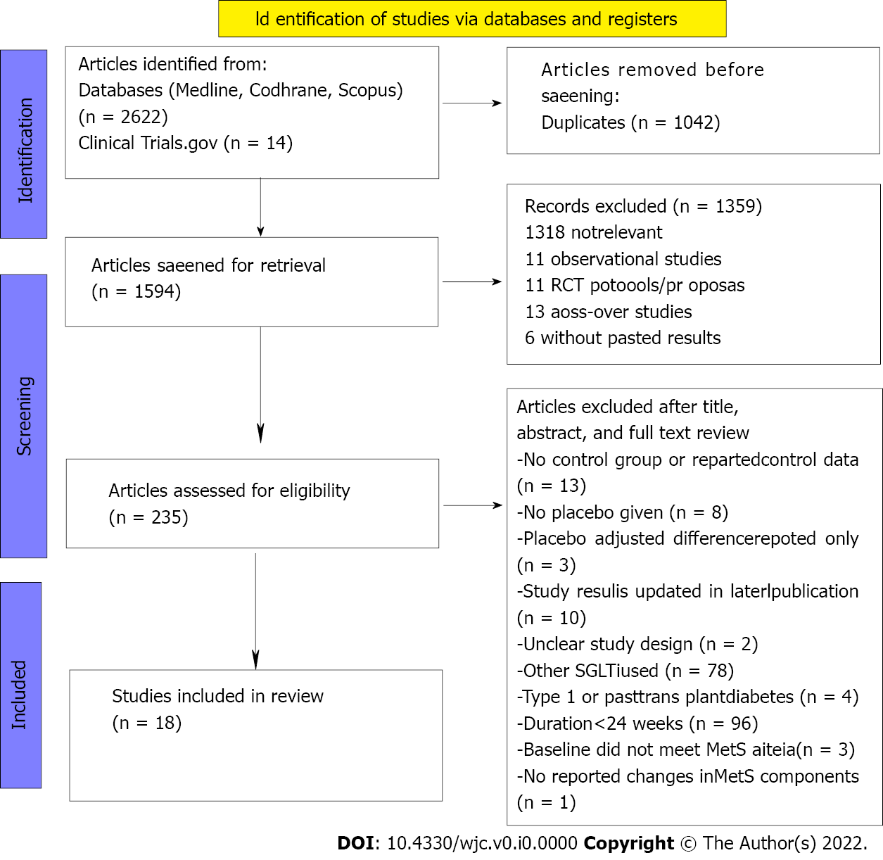
Figure 1 PRISMA flow diagram showing outcomes of databases and registers search.

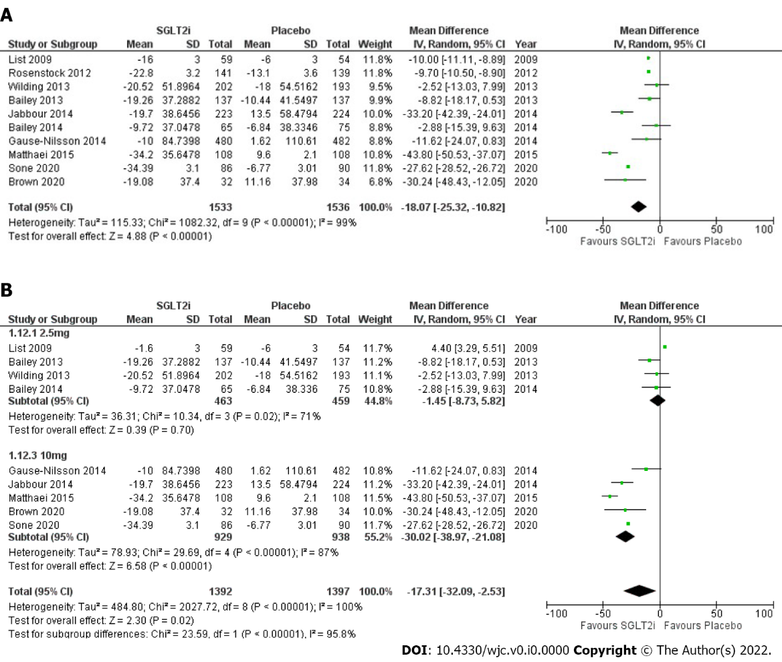
Figure 2 Forest plot. A: Highlighting impact of SGLT2-I on FPG compared to placebo; and B: SGLT2-I dose subgroup analysis performed for FPG. SGLT2-I: Sodium-glucose cotransporter 2 inhibitor; FPG: Fasting plasma glucose.
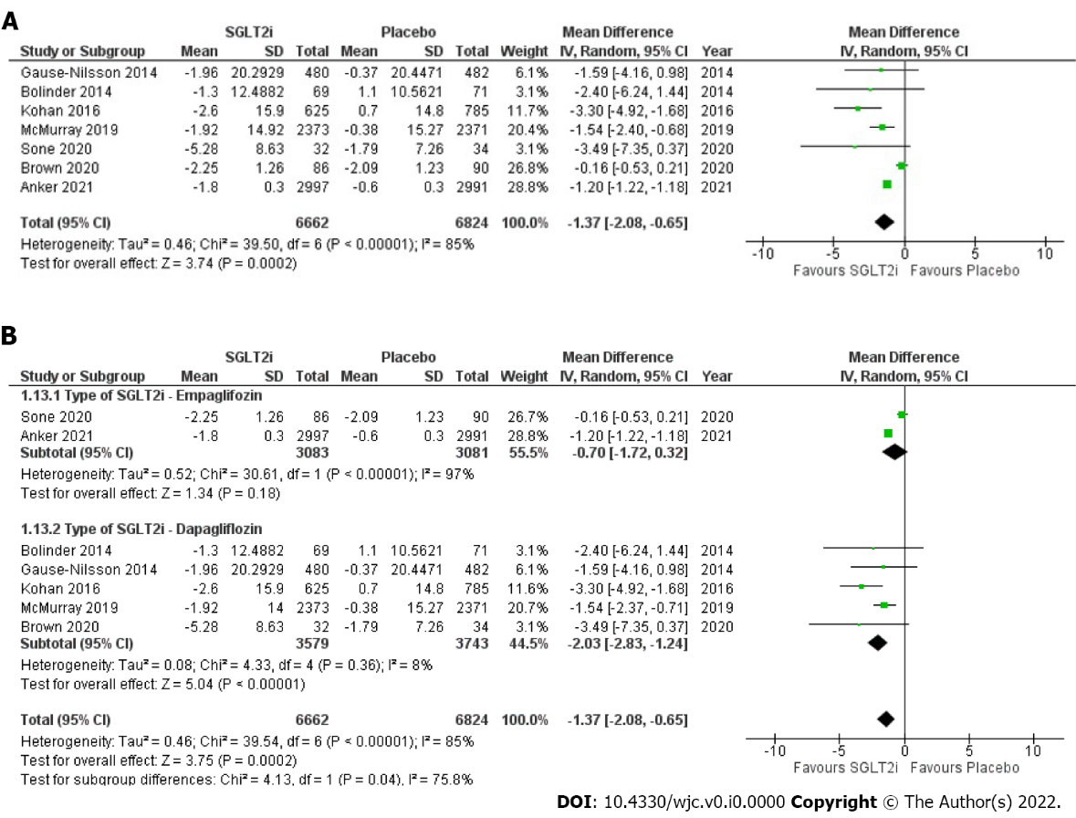
Figure 3 Forest plot. A: Highlighting impact of SGLT2-I on SBP compared to placebo; B: SGLT2-I Type subgroup analysis performed for SBP. SGLT2-I: Sodium-glucose cotransporter 2 inhibitor; SBP: Systolic blood pressure.
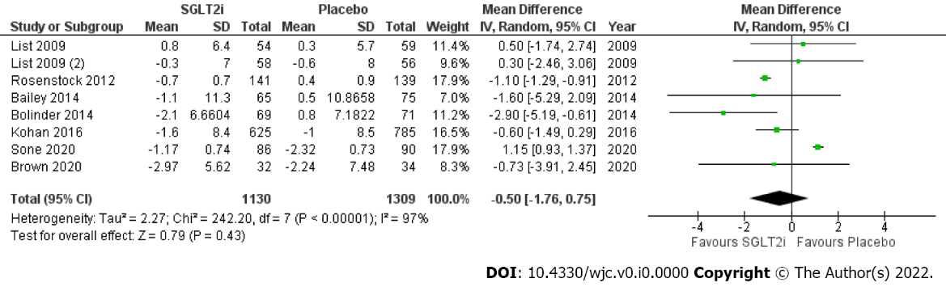
Figure 4 Forest plot highlighting impact of SGLT2-I on DBP compared to placebo. SGLT2-I: Sodium-glucose cotransporter 2 inhibitor; DBP: Diastolic blood pressure.
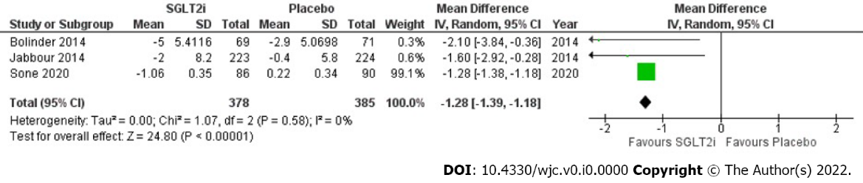
Figure 5 Forest plot highlighting impact of SGLT2-I on WC compared to placebo. SGLT2-I: Sodium-glucose cotransporter 2 inhibitor; WC: Waist circumference.
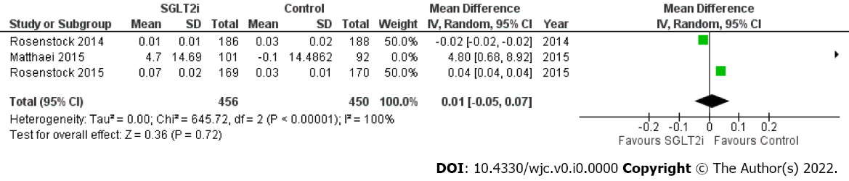
Figure 6 Forest plot highlighting the absence of significant impact of SGLT2-I on HDL compared to placebo. SGLT2-I: Sodium-glucose cotransporter 2 inhibitor; HDL: High-density lipoprotein.
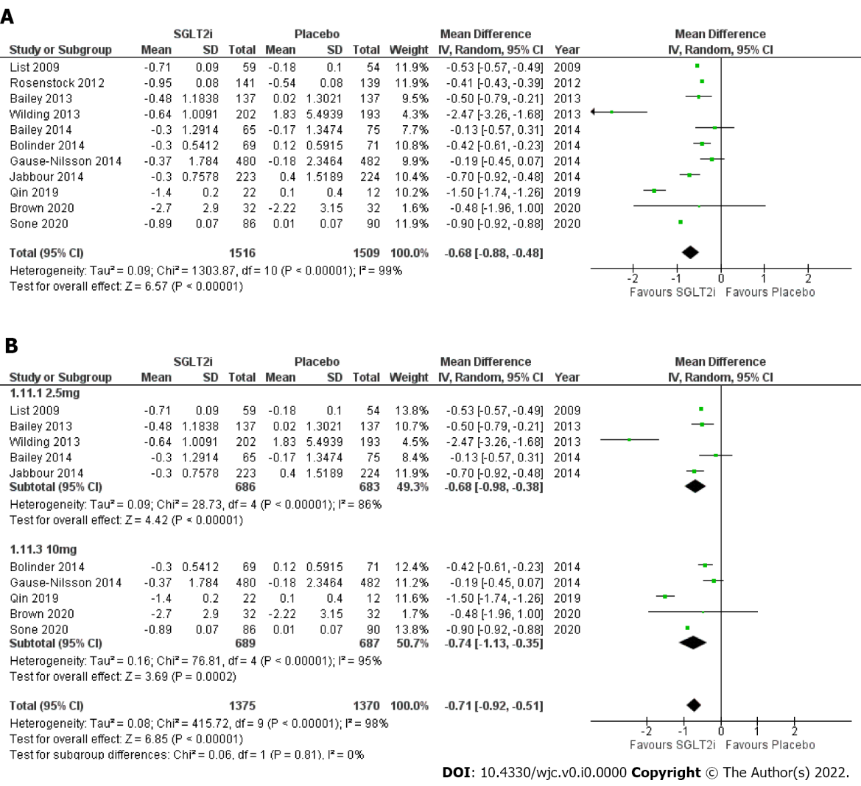
Figure 7 Forest plot. A: Highlighting impact of SGLT2-I on HgbA1C compared to placebo; B: SGLT2-I Dose subgroup analysis performed for HgbA1C. SGLT2-I: Sodium-glucose cotransporter 2 inhibitor.

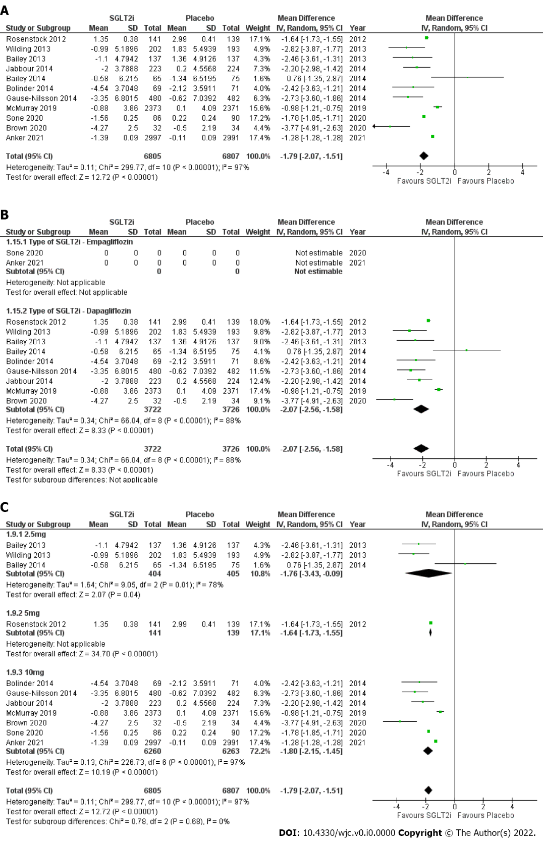
Figure 8 Forest plot. A: Highlighting impact of SGLT2-I on BW compared to placebo; B: SGLT2-I Type subgroup analysis performed for BW; C: SGLT2-I Dose subgroup analysis performed for BW. SGLT2-I: Sodium-glucose cotransporter 2 inhibitor; BW: Body weight.
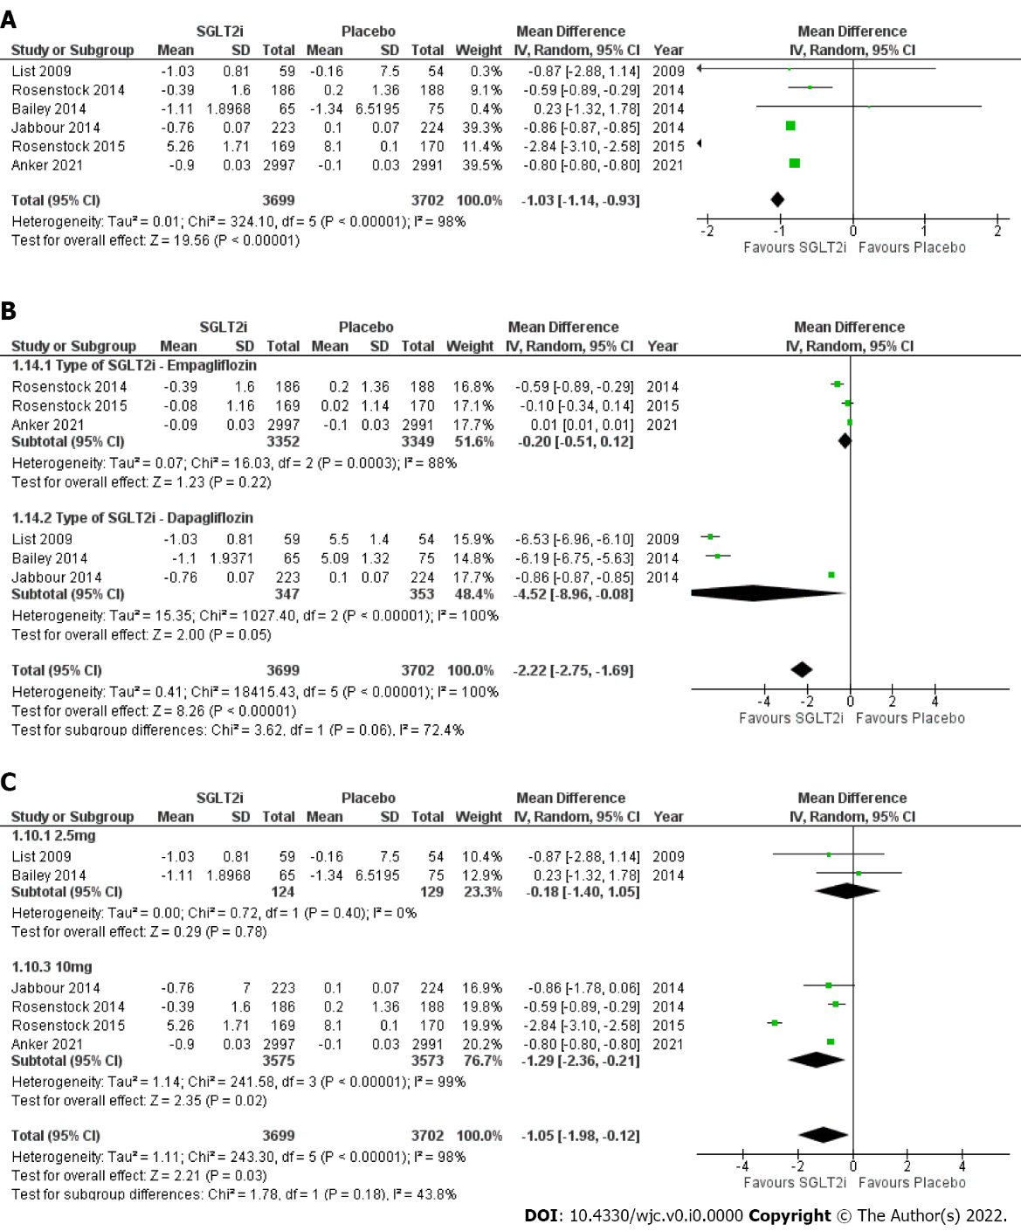
Figure 9 Forest plot. A: Highlighting impact of SGLT2-I on UA compared to placebo; B: SGLT2-I Type subgroup analysis performed for UA; C: SGLT2-I Dose subgroup analysis performed for UA. SGLT2-I: Sodium-glucose cotransporter 2 inhibitor; UA: uric acid.

Table 1 Jadad score of included studies; U means unclear
Study | Randomization | Blinding | Accountability | Jadad score
Bailey 2014 | 2 | 1 | 1 | 4
Bailey 2013 | 1 | 1 | 1 | 3
Rosenstock 2012 | 1 | 1 | 1 | 3
Wilding 2014 | 2 | 2 | 1 | 5
Matthaei 2015 | 2 | 1 | 1 | 4
Jabbour 2014 | 1 | 1 | 1 | 3
Anker 2021 | 2 | 2 | 1 | 5
Sone 2020 | 2 | 1 | 1 | 4
Bolinder 2014 | 2 | 2 | 1 | 5
Rosenstock 2015 | 2 | 1 | 1 | 4
Rosenstock 2014 | 2 | 1 | 1 | 4
Kohan 2014 | 1 | 1 | 1 | 3
Zinman 2015 | 2 | 1 | 1 | 3
Brown 2020 | 1 | 1 | 1 | 3
Qin 2019 | 1 | U | U | 1
Gause-Nilsson 2014 | 1 | U | U | 1
List 2009 | 1 | 1 | 1 | 3
McMurray 2019 | 2 | 2 | 1 | 5

Table 2 Characteristics of included studies. Data reported as mean (SD); ¹ - 5 for 48 wk, 10 for 56 wk
 |  |  |  | Treatment group |  | Placebo group | Participants (n) |  | Mean age (y) |  | Race (n)
Study | Duration (wk) | %male | %DM | SGLT2-I | Other therapy | Other therapy | SGLT2-I | Placebo | SGLT2-I | Placebo | White | Asian | Black
Bailey 2013 | 102 |  | 100% | DAPA (2.5) | Metformin | Metformin | 137 | 137 | 55.0 (9.3) | 53.7 (10.3)
 |  |  |  | DAPA (5) | Metformin |  | 137 |  | 54.3 (9.4)
 |  |  |  | DAPA (10) | Metformin |  | 135 |  | 52.7 (9.9)
Bailey 2014 | 102 |  | 100% | DAPA (2.5) | Metformin | Metformin | 65 | 75 | 53.0 (11.7) | 52.7 (10.3)
 |  |  |  | DAPA (5) | Metformin |  | 64 |  | 52.6 (10.9)
 |  |  |  | DAPA (10) | Metformin |  | 70 |  | 50.6 (10.0)
Bolinder 2014 | 102 | 55.6% | 100% | DAPA (10) |  | Placebo only | 69 | 71 | 60.6 (8.2) | 60.8 (6.9) | 140 | NR | NR
Brown 2020 | 52 | 57.6% | 100% | DAPA (10) |  | Placebo only | 32 | 34 | 64.25 (7.01) | 66.74 (6.62)
Gause-Nilsson 2014 | 104 |  | 100% | DAPA (10) | Insulin | Insulin | 480 | 482
Jabbour 2014 | 48 | 54.8% | 100% | DAPA (10) | Sitagliptin, metformin | Sitagliptin, metformin | 223 | 224 | 54.8 (10.4) | 55.0 (10.2) | 332 | 4 | 17
Kohan 2016 | 102 |  |  | DAPA (2.5) |  | Placebo only | 625 | 785 | 57.5 (9.9) | 56.9 (10.2)
 |  |  |  | DAPA (5) |  |  | 767 |  | 56.5 (10.1)
 |  |  |  | DAPA (10) |  |  | 859 |  | 56.0 (9.9)
List 2009 | 12 |  | 100% | DAPA (2.5) |  | Placebo only | 59 | 54 | 55 (11) | 53 (11)
 |  |  |  | DAPA (5) |  | Metformin | 58 | 56 | 55 (12) | 54 (9)
 |  |  |  | DAPA (10) |  |  | 47 |  | 54 (9)
 |  |  |  | DAPA (20) |  |  | 59 |  | 55 (10)
 |  |  |  | DAPA (50) |  |  | 56 |  | 53 (10)
Matthaei 2015 | 52 | 49.2% | 100% | DAPA (10) |  | Placebo only | 108 | 108 | 61.1 (9.7) | 60.9 (9.2) | 206 | NR | NR
McMurray 2019 | 72 | 77% | 45% | DAPA (10) |  | Placebo only | 2373 | 2371 | 66.2 (11.0) | 66.5 (10.8) | 3333 | 1116 | 226
Qin 2019 | 16 |  | 100% | DAPA (10) |  | Placebo only | 22 | 12
 |  |  |  | DAPA (10) | Saxagliptin |  | 22
Rosenstock 2012 | 48 |  | 100% | DAPA (5) | Pioglitazone | Pioglitazone | 141 | 139 | 53.2 (10.9) | 53.5 (11.4)
 |  |  |  | DAPA (10) | Pioglitazone |  | 140 |  | 53.8 (10.4)
Wilding 2013 | 104 |  | 100% | DAPA (2.5) | Insulin, existing OAD | Insulin, existing OAD | 202 | 193 | 59.8 (7.6) | 58.8 (8.6)
 |  |  |  | DAPA (5/10)¹ | Insulin, existing OAD |  | 211 |  | 59.3 (7.9)
 |  |  |  | DAPA (10) | Insulin, existing OAD |  | 194 |  | 59.3 (8.8)
Anker 2021 | 112 | 55% | 49% | EMPA (10) |  | Placebo only | 2997 | 2991 | 71.8 (9.3) | 71.9 (9.6) | 4542 | 824 | 258
Sone 2020 | 52 | 72.6% | 100% | EMPA (10) |  | Placebo only | 86 | 90 | 58.3 (10.0) | 59.1 (10.7) | NR | 266 | NR
 |  |  |  | EMPA (25) |  |  | 90 |  | 58.6 (9.5)
Rosenstock 2015 | 78 | 56% | 100% | EMPA (10) |  | Placebo only | 169 | 170 | 58.6 (9.8) | 58.1 (9.4) | 343 | 98 | 48
 |  |  |  | EMPA (25) |  |  | 155 |  | 59.9 (10.5)
Rosenstock 2014 | 52 | 45% | 100% | EMPA (10) |  | Placebo only | 186 | 188 | 56.7 (8.7) | 55.3 (10.1) | 531 | NR | 19
 |  |  |  | EMPA (25) |  |  | 189 |  | 58.0 (9.4)
Zinman 2015 | 220 | 71.5% | 100% | EMPA (10) |  | Placebo only | 2345 | 2333 | 63.0 (8.6) | 63.2 (8.8) | 5081 | 1517 | 357
 |  |  |  | EMPA (25) |  |  | 2342 |  | 63.2 (8.6)
NR: Not reported; OAD: Oral antidiabetic drugs; SGLT2-I: Sodium-glucose cotransporter 2 inhibitor; DM: Diabetes mellitus

Table 3 Baseline values for the MetS components; * No baseline data reported for Gause-Nilsson 2014, Qin 2019; ¹ – 5 mg for 48 wk, 10 for 56 wk; empty spaces represent unreported values.
 |  | Waist circumference (cm) |  | Triglyceride (mg/dL) |  | HDL (mg/dL) |  | SBP (mm Hg) |  | DBP (mm Hg) |  | Fasting plasma glucose
Paper | SGLT2-I (daily dose, mg) | SGLT2-I | Placebo | SGLT2-I | Placebo | SGLT2-I | Placebo | SGLT2-I | Placebo | SGLT2-I | Placebo | SGLT2-I | Placebo
Bailey 2013 | DAPA (2.5) |  |  |  |  |  |  | 126·6 (14·5) | 127·7 (14·6) | 79·5 (8·7) | 80·9 (9·0) | 161.3±43 | 165.42 (46.44)
 | DAPA (5) |  |  |  |  |  |  | 126·9 (14·3) |  | 80·8 (8·5) |  | 169.0±49
 | DAPA (10) |  |  |  |  |  |  | 126·0 (15·9) |  | 79·0 (10·2) |  | 155.9±38.7
Bailey 2014 | DAPA (2.5) | 105.6 (14.9) | 103.2 (13.8) |  |  |  |  | 129.3 (16.1) | 124.7 (16.3) | 79.1 (7.9) | 81.0 (9.5) | 163.8±48.6 | 160.2 (41.4)
 | DAPA (5) | 104.3 (11.7) |  |  |  |  |  | 124.7 (15.3) |  | 81.6 (8.9) |  | 162±45
 | DAPA (10) | 108.1 (13.2) |  |  |  |  |  | 125.1 (16.4) |  | 80.2 (8.6) |  | 167.4±41.4
Bolinder 2014 | DAPA (10) | 105.6 ± 10.1 | 104.5 ± 12.3 |  |  |  |  | 136.1± 13.8 | 133.3± 13.7 | 80.6± 8.0 | 80.4± 8.3 | 147.6±25.2 | 149.4 ± 25.2
Brown 2020 | DAPA (10) |  |  |  |  |  |  | 137.25 ± 7.5 | 136.15 ± 9.11 | 79.16 ± 8.63 | 77.79 ± 8.25 | 140.4±63 | 144.9 ± 54.0
Jabbour 2014 | DAPA (10) |  |  |  |  |  |  |  |  |  |  | 162.2 (36.8) | 163.0 (34.5)
Kohan 2016 | DAPA (2.5) |  |  |  |  |  |  | 133.1 (17.2) | 130.8 (15.8) | 79.8 (9.3) | 79.6 (9.0)
 | DAPA (5) |  |  |  |  |  |  | 130.5 (16.2) |  | 79.5 (8.9)
 | DAPA (10) |  |  |  |  |  |  | 131.1 (16.3) |  | 79.1 (9.3)
List 2009 | DAPA (2.5) |  |  |  |  |  |  | 127 ± 14 | 126 ± 16 | 78 ± 8 | 77 ± 8 | 145 ± 34 | 150 ± 46
 | DAPA (5) |  |  |  |  |  |  | 126 ± 13 | 126 ± 13 | 76 ± 8 | 78 ± 8 | 153 ± 48 | 143 ± 33
 | DAPA (10) |  |  |  |  |  |  | 127 ± 16 |  | 77 ± 8 |  | 148 ± 38
 | DAPA (20) |  |  |  |  |  |  | 127 ± 15 |  | 77 ± 8 |  | 149 ± 41
 | DAPA (50) |  |  |  |  |  |  | 126 ± 16 |  | 77 ± 9 |  | 153 ± 42
Matthaei 2015 | DAPA (10) |  |  | 185.9±123.9 | 177.1±79.7 | 46.44±11.6 | 46.4±11.6 | 134.5 ±12.6 | 136.4 ±14.2 | 80.4 ±9.2 | 81.6 ±7.9 | 167.4 ±43.3 | 180.2 ±43.1
McMurray 2019 | DAPA (10) |  |  |  |  |  |  |  |  | 72.5± 13.2
Rosenstock 2012 | DAPA (5) |  |  |  |  |  |  |  |  |  |  | 168.6+/-52.1 | 160.7+/-47.0
 | DAPA (10) |  |  |  |  |  |  |  |  |  |  | 164.9+/-46.3
Wilding 2013 | DAPA (2.5) | 109.7 (13.4) | 110.2 (14.5) |  |  |  |  |  |  |  |  | 180±59.4 | 171 (57.6)
 | DAPA (5/10)¹ | 109.3 (13.4) |  |  |  |  |  |  |  |  |  | 185.4±59.4
 | DAPA (10) | 109.6 (12.5) |  |  |  |  |  |  |  |  |  | 172.8±54
Anker 2021 | EMPA (10) |  |  |  |  |  |  | 131.8±15.6 | 131.9±15.7 | 78
Rosenstock 2015 | EMPA (10) |  |  | 175.23±14.2 | 158.5±7.97 | 46.1±0.77 | 46±0.77 | 132.4 ± 15.5 | 133.9 ± 16.3 | 78.4 ± 9.2 | 78.6 ± 10.9 | 138.6±52.2 | 142.2 ± 46.8
 | EMPA (25) |  |  | 162.8±0.8 |  | 46.1±0.78 |  | 132.8 ± 15.1 |  | 77.9 ± 10.2 |  | 145.8±25
Rosenstock 2014 | EMPA (10) |  |  | 171.7±8.85 | 178.9±12.4 | 46.1±0.79 | 45.2±0.77 | 134.2 ± 16.4 | 132.6 ± 15.8 | 79.5 ± 8.5 | 78.2 ± 8.8 | 158.9±46.8 | 151.38 ± 45.72
 | EMPA (25) |  |  | 169.9±7.08 |  | 46.4±0.77 |  | 132.9 ± 14.2 |  | 78.7 ± 8.5 |  | 149.2±48.6
Sone 2020 | EMPA (10) | 93.3 ± 8.8 | 93.8 ± 9.6 |  |  |  |  | 134.2 ± 14.6 | 135.7 ± 14.0 | 80.1 ± 10.2 | 79.6 ± 8.7 | 168.8 ± 43.1 | 159.1 ± 38.5
 | EMPA (25) | 93.1 ± 8.3 |  |  |  |  |  | 136.3 ± 14.3 |  | 80.0 ± 10.6 |  | 156.1 ± 37.7
Zinman 2015 | EMPA (10) | 104.9 | 105.1 | 168.4 ± 2.67 | 170.7 ±2.53 | 44.7 ± 0.25 | 44.0 ± 0.24 | 134.9 ± 16.8 | 135.8 ± 17.2 | 76.6 ± 9.8 | 76.8 ± 10.1
 | EMPA (25) | 104.9 |  | 172.6 ±2.27 |  | 44.5 ± 0.25 |  | 135.6 ± 17.0 |  | 76.6 ± 9.7
HDL: High-density lipoprotein; DBP: Diastolic blood pressure; SBP: Systolic blood pressure; SGLT2-I: Sodium-glucose cotransporter 2 inhibitor

Table 4 Baseline data for HbA1C, BW, and UA; *No baseline data available for McMurray 2019, Qin 2019, or Gause-Nilsson 2014; ¹ 5 for 48 wk, 10 for 56 wk
 |  | Body weight (kg) |  | Hemoglobin A1c (%) |  | Uric acid (mg/dL)
Paper | SGLT2-I (daily dose, mg) | SGLT2-I | Placebo | SGLT2-I | Placebo | SGLT2-I | Placebo
Bailey 2013 | DAPA (2.5) | 84.90 (17.77) | 87.74 (19.24) | 7.99 (0.90) | 8.12 (0.96)
 | DAPA (5) | 84.73 (16.26) |  | 8.17 (0.96)
 | DAPA (10) | 86.28 (17.53) |  | 7.92 (0.82)
Bailey 2014 | DAPA (2.5) | 90.8 (22.8) | 88.8 (19.0) | 7.92 (0.90) | 7.84 (0.87) | 5.92 (1.42) | 5.09 (1.32)
 | DAPA (5) | 87.6 (17.1) |  | 7.86 (0.94) |  | 5.55 (1.44)
 | DAPA (10) | 94.2 (18.7) |  | 8.01 (0.96) |  | 5.67 (1.44)
Bolinder 2014 | DAPA (10) | 92.1 (14.1) | 90.9 (13.7) | 7.19 (0.44) | 7.16 (0.53)
Brown 2020 | DAPA (10) | 91.58 (14.62) | 91.48 (14.13) | 7.8 (3.17) | 7.66 (3.08)
Jabbour 2014 | DAPA (10) | 91.0 (21.6) | 89.2 (20.9) | 7.9 (0.8) | 8.0 (0.8)
Kohan 2016 | DAPA (2.5) |  |  | 8.17 (0.86) | 8.12 (0.92)
 | DAPA (5) |  |  | 8.27 (0.95)
 | DAPA (10) |  |  | 8.11 (0.93)
List 2009 | DAPA (2.5) | 90 (20) | 89 (18) | 7.6 (0.7) | 7.9 (0.9) | 5.5 (1.2) | 5.5 (1.4)
 | DAPA (5) | 89 (17) |  | 8.0 (0.9) |  | 5.2 (1.3)
 | DAPA (10) | 86 (17) |  | 8.0 (0.8) |  | 5.5 (1.2)
 | DAPA (20) | 88 (18) |  | 7.7 (0.9) |  | 5.3 (1.3)
 | DAPA (50) | 92 (19) |  | 7.8 (1.0) |  | 5.6 (1.4)
Matthaei 2015 | DAPA (10) | 88.6 (17.6) | 90.1 (16.2) | 8.08 (0.91) | 8.24 (0.87)
Rosenstock 2012 | DAPA (5) | 87.8 (20.7) | 86.4 (21.3) | 8.40 (1.03) | 8.34 (1.00)
 | DAPA (10) | 84.8 (22.2) |  | 8.37 (0.96)
Wilding 2013 | DAPA (2.5) | 93.0 (16.7) | 94.5 (19.8) | 8.46 (0.78) | 8.47 (0.77)
 | DAPA (5/10)¹ | 93.3 (17.4) |  | 8.62 (0.89)
 | DAPA (10) | 94.5 (16.8) |  | 8.57 (0.82)
Anker 2021 | EMPA (10)
Sone 2020 | EMPA (10) | 73.3 (11.5) | 74.0 (11.3) | 8.8 (0.7) | 8.7 (0.7)
 | EMPA (25) | 72.2 (11.4) |  | 8.7 (0.7)
Rosenstock 2015 | EMPA (10) | 91.6 (20.1) | 90.5 (22.5) | 8.3 (0.8) | 8.2 (0.8) | 5.26 (1.71) | 5.5 (2.1)
 | EMPA (25) | 94.7 (20.7) |  | 8.3 (0.8) |  | 5.63 (2)
Rosenstock 2014 | EMPA (10) | 96.7 (17.9) | 95.5 (17.5) | 8.39 (0.74) | 8.33 (0.72) | 5.48 (2.13) | 5.5 (2.0)
 | EMPA (25) | 95.9 (17.3) |  | 8.29 (0.72) |  | 5.56 (2.07)
Zinman 2015 | EMPA (10) | 85.9 (18.8) | 86.6 (19.1) | 8.07 (0.86) | 8.08 (0.84) | 5.9 | 6
 | EMPA (25) | 86.5 (19.0) |  | 8.06 (0.84) |  | 5.98
SGLT2-I: Sodium-glucose cotransporter 2 inhibitor; BW: Body weight; UA: Uric acid

