Name of Journal: World Journal of Clinical Cases
Manuscript NO: 90317
Manuscript Type: ORIGINAL ARTICLE

Clinical Trials Study
Allogeneic mesenchymal stem cells may be a viable treatment modality in cerebral palsy

Boyali O et al. Stem cell treatment in cerebral palsy

Osman Boyalı, Serdar Kabatas, Erdinç Civelek, Omer Ozdemir, Yeliz Bahar-Ozdemir, Necati Kaplan, Eyüp Can Savrunlu, Erdal Karaöz

Osman Boyalı, Serdar Kabatas, Erdinç Civelek, Omer Ozdemir, Department of Neurosurgery, University of Health Sciences Turkey, Gaziosmanpaşa Training and Research Hospital, Istanbul 34360, Turkey

Serdar Kabatas, Center for Stem Cell & Gene Therapy Research and Practice, University of Health Sciences Turkey, Istanbul 34360, Turkey

Yeliz Bahar-Ozdemir, Department of Physical Medicine and Rehabilitation, Health Sciences University Sultan Abdulhamid Han Training and Research Hospital, Istanbul 34668, Turkey

Necati Kaplan, Department of Neurosurgery, Istanbul Rumeli University, Çorlu Reyap Hospital, Tekirdağ 59860, Turkey

Eyüp Can Savrunlu, Department of Neurosurgery, Nevşehir State Hospital, Nevşehir 50300, Turkey

Erdal Karaöz, Center for Regenerative Medicine and Stem Cell Research & Manufacturing (LivMedCell), Liv Hospital, Istanbul 34340, Turkey

Erdal Karaöz, Department of Histology and Embryology, Istinye University, Faculty of Medicine, İstanbul 34010, Turkey

Erdal Karaöz, Center for Stem Cell and Tissue Engineering Research and Practice, Istinye University, Istanbul 34340, Turkey

Author contributions: Boyali O, Civelek E, and Kabatas S contributed to concept; Osman Boyali, Kabatas S, and Savrunlu EC contributed to design; Boyali O, Kabatas S, and Karaoz E contributed to supervision; Civelek E, Kabatas S, Savrunlu EC, and Kaplan N contributed to analysis and/or interpretation; Boyali O, Kabatas S, Civelek E, Savrunlu EC, Ozdemir O, and Ozdemir YB contributed to literature search; Boyali O, Civelek E, Kabatas S, Kaplan N, Savrunlu EC, Ozdemir YB, and Karaoz E contributed to writing; Boyali O, Civelek E, Kabatas S, and Ozdemir O contributed to critical reviews.

Corresponding author: Osman Boyalı, MD, Neurosurgeon, Department of Neurosurgery, University of Health Sciences Turkey, Gaziosmanpaşa Training and Research Hospital, Karayolları Mahallesi, Osmanbey Caddesi 616. Sokak No. 10 Gaziosmanpaşa, Istanbul 34360, Turkey. drosmanboyali@gmail.com

Received: November 29, 2023
Revised: January 11, 2024
Accepted: February 28, 2024
Published online:

Abstract
BACKGROUND
Cerebral palsy (CP) describes a group of disorders affecting movement, balance, and posture. Disturbances in motor functions constitute the main body of CP symptoms. These symptoms surface in early childhood and patients are affected for the rest of their lives. Currently, treatment involves various pharmacotherapies for different types of CP, including antiepileptics for epilepsy and Botox A for focal spasticity. However, none of these methods can provide full symptom relief. This has prompted researchers to look for new treatment modalities, one of which is mesenchymal stem cell therapy (MSCT). Despite being a promising tool and offering a wide array of possibilities, mesenchymal stem cells (MSCs) still need to be investigated for their efficacy and safety.

AIM
To analyze the efficacy and safety of MSCT in CP patients.

METHODS
Our sample consists of four CP patients who cannot stand or walk without external support. All of these cases received allogeneic MSCT six times as 1 × 10⁶/kg intrathecally, intravenously, and intramuscularly using umbilical cord-derived MSCs (UC-MSC). We monitored and assessed the patients pre- and post-treatment using the Wee Functional Independence Measure (WeeFIM), Gross Motor Function Classification System (GMFCS), and Manual Ability Classification Scale (MACS) instruments. We utilized the Modified Ashworth Scale (MAS) to measure spasticity.

RESULTS
We found significant improvements in MAS scores after the intervention on both sides. Two months: Right χ² = 4000, P = 0.046, left χ² = 4000, P = 0.046; four months: Right χ² = 4000, P = 0.046, left χ² = 4000, P = 0.046; 12 months: Right χ² = 4000, P = 0.046, left χ² = 4000, P = 0.046. However, there was no significant difference in motor functions based on WeeFIM results (P > 0.05). GMFCS and MACS scores differed significantly at 12 months after the intervention (P = 0.046, P = 0.046). Finally, there was no significant change in cognitive functions (P > 0.05).

CONCLUSION
In light of our findings, we believe that UC-MSC therapy has a positive effect on spasticity, and it partially improves motor functions.

Key Words: Cerebral palsy; Mesenchymal stem cell; Transplantation; Wharton’s jelly; Muscle spasticity

Boyalı O, Kabatas S, Civelek E, Ozdemir O, Bahar-Ozdemir Y, Kaplan N, Savrunlu EC, Karaöz E. Allogeneic mesenchymal stem cells may be a viable treatment modality in cerebral palsy. World J Clin Cases 2024; In press

Core Tip: Cerebral palsy (CP) describes a group of non-progressive disorders affecting movement, balance, posture, and motor function. Research suggests that stem cell therapy may be a new treatment option in CP. We monitored four CP patients who underwent mesenchymal stem cell therapy (MSCT) for 12 months and analyzed treatment efficacy. MSCT resulted in significantly improved Modified Ashworth Scale, Gross Motor Function Classification System, and Manual Ability Classification System scores.

INTRODUCTION
Cerebral palsy (CP) describes a group of disorders affecting movement, balance, posture, and motor functions. These symptoms surface in early childhood and patients are affected for the rest of their lives^{[1,2]}. While motor dysfunctions constitute the main body of CP symptoms, patients often suffer from other pathologies such as epilepsy, musculoskeletal diseases, and cognitive, perceptive, communicative, sensory, and behavioral disorders^{[3]}. Research reports the incidence rate of CP as 0.15%-0.25% in developed countries^{[4]}. Given the complex etiology (perinatal stroke, gestational age, low birth weight, birth complications, etc.) and symptom variations, CP comprises a wide spectrum^{[5,6]}. This has led researchers to try various treatment modalities^{[1,7]}. Currently, treatment involves physical therapy and comprehensive rehabilitation (neurodevelopmental and reflex locomotion treatment), as well as various pharmacotherapies for different types of CP (baclofen, diazepam, etc. for generalized spasticity; Botox A for focal spasticity; antiepileptics for epilepsy)^{[1,8]}. However, known treatment methods can provide partial symptom relief at best, prompting a continuous search for new treatment modalities^{[9]}.
Stem cell therapy (SCT) is a novel treatment option that has been researched in over 250 studies involving a wide variety of disorders. Accordingly, SCT boasts significant potential and versatility and is promising for ameliorating CP symptoms^{[10-12]}.
The therapeutic efficacy of mesenchymal SCT (MSCT) is evaluated based on its anti-inflammatory effects, neuroregeneration, and neural protection. According to early studies, the mechanism of action of MSCT involves stem cells migrating to the stroke area, differentiating into functional cells, and interacting with cells in the penumbra, providing regeneration of the damaged area. Recent research has focused on other effects, including paracrine interactions, mitochondrial transfer, and extracellular vesicle secretion^{[13]}. The paracrine interactions occur through a variety of different mechanisms associated with mesenchymal stem cells (MSCs), including their cytoprotective, provasculogenic, anti-inflammatory, and metabolic effects^{[14]}.
One study focused on the neuroprotective activity of MSCs and reported a lower count of apoptotic neurons after intravenous treatment in a stroke model created in female rats. The stem cells migrated to the injury site, increased the expression of basic fibroblast growth factor (bFGF), and promoted endogenous proliferation, providing functional recovery and showcasing their anti-apoptotic activities^{[15]}. Another study on rats using a stroke model reported reduced infarct area and improved function after using human-derived MSCs. The authors observed higher expressions of numerous neurotrophic factors in the experimental group of rats after MSC transplantation, even in rat-derived neurotrophic factors such as vascular endothelial growth factor (VEGF), epidermal growth factor, and bFGF^{[16]}.
Many researchers have reported the anti-inflammatory activity of MSCs through paracrine mechanisms. Huang et al^{[17]} found that interleukin (IL)-6 and VEGF had an important role in the anti-inflammatory activity of MSCs in vitro. The anti-inflammatory activity of IL-6 occurs through its inhibitory effect on tumor necrosis factor α and IL-1^{[17]}. The roles of IL-6 in this mechanism have been supported by other studies. MSC implantation increases IL-6 production through resident neuronal stem cells NFkB activation, independent of the PI3/Akt pathway, thus reducing apoptosis and providing neuroprotection^{[18]}. Jung et al^{[19]} observed that IL-6 injection increased phosphorylated STAT-3 and Mn-SOD levels and protected cells from oxidative stress^{[19]}.
Given this variety of mechanisms of action, MSCT offers a new treatment perspective not only in CP, but also in many central nervous system disorders such as hypoxic ischemic encephalopathy, Alzheimer’s disease, stroke, Parkinson’s disease, multiple sclerosis, and spinal cord injury^{[20,21]}.
Lee et al^{[22]} examined a murine model of Alzheimer’s disease and found that human umbilical cord-derived MSCs (UC-MSC) inhibited the release of pro-inflammatory cytokines from microglia and reduced apoptosis and amyloid plaques, contributing to functional recovery^{[22]}. Kim et al^{[23]} conducted a phase I clinical trial with Alzheimer’s disease patients where they administered MSCs by stereotactic brain infusion at two different doses in a single round (3 × 10⁶ cells/60 μL and 6 × 10⁶ cells/60 μL). The authors encountered no serious side effects at either dose. However, their results include limitations of not including a sham group and being an open label trial^{[23]}.
One study used the experimental autoimmune encephalitis (EAE) model, which is the most common model in animal research on multiple sclerosis; the authors found that treatment reduced inflammatory infiltrates and demyelination^{[12]}. Other clinical trials on EAE have also shown some clinical improvements and have deemed EAE as a safe and effective model^{[24]}.
In 2012, Lalu et al^{[25]} published a meta-analysis on the possible risks of MSCT and highlighted that no statistically significant side effects were involved other than transient fever^{[25]}. Similarly, another meta-analysis published in 2021 revealed that, despite the expanding patient population in the intervening years, the only side effect that could be associated with MSCT was transient fever. Transient fever is more common in women and less common in the North American population. Despite the tumorigenic potential of MSCs, only one malignancy was detected in the entire population and it was not associated with stem cell application. This meta-analysis also shed light on some trials that reported other side effects such as vascular disorders, urticaria/dermatitis, dizziness/headache, diarrhea, infection, death, anemia, metabolic and nutritional disorders, nausea, seizure, and vomiting. However, none of these side effects was significantly correlated with MSCT^{[26]}.
In the present research, we monitored four CP patients who underwent MSCT for 12 months and analyzed treatment efficacy.

MATERIALS AND METHODS
This was a multi-center, longitudinal, open-label phase I trial. Our sample included four CP patients with severe disability (inability to mobilize without assistance), aged between one and nine years, under home nursing care and assistance. None of these patients could stand or walk without external support. Table 1 summarizes the demographic data of these patients. Our inclusion criteria were as follows: Being under 18 years of age, having no chronic disease (i.e., cancer, kidney, heart/hepatic failure), having an estimated life expectancy of > 12 months, and showing no significant change in neurological or functional status despite three months of conservative treatment (e.g., physical rehabilitation and botulinum toxin injection). The exclusion criteria were as follows: Being recently diagnosed with severe infection (meningitis, etc.), liver/kidney/heart failure, sepsis, or skin infection at the IV infusion site, or hepatitis B/C/HIV, having a history of uncontrolled seizure disorder, presenting certain laboratory results (white blood cell count ≥ 15000/μL, platelet count ≤ 100000/μL, serum aspartate aminotransferase and serum alanine aminotransferase > 3 × upper limit of normal, creatinine > 1.5 × upper limit of normal), or having participated in an another stem cell trial.
The study protocol was approved by the local Ethics Committee. We obtained the informed consent of each participant and/or their caregivers in written form. The trial was conducted in accordance with the principles of the Declaration of Helsinki.

Intervention procedure
Ethical information and donor consent: The present study was approved by the medical ethics committee of the authors’ institution (protocol No. 56733164-203-E.3178). Umbilical Cords (UCs) were obtained from the Good Manufacturing Practices facility of LivMedCell (Istanbul, Turkey). In accordance with the approval of an institutional regulatory board (LivMedCell); the donors donated UCs after being informed of the aim of the current study and gave their informed consent in written form.

Processing and quality control of UCs: The UCs were washed with phosphate-buffered saline (Invitrogen/Gibco, Paisley, United Kingdom). Before removing blood vessels, the tissue samples were cut into 5-10 mm³ pieces as explants. These explants were placed in dishes and cultured under humanized culture conditions at 37 °C with 5% CO₂ until the cells displaced. The resulting cells were collected when they reached 70% to 80% confluence and subjected to characterization tests at Passage 3^{[27]}. Quality control and assurance was performed by the Pharmaceuticals and Medical Devices Agency.

Determination of UC-MSCs by flow cytometry: Expressed surface antigens were analyzed by flow cytometry, which revealed that cells were consistently positive for CD44, CD73, CD90, and CD105 and negative for hematopoietic lineage markers of CD34, CD45, and human leukocyte antigen DR2 (Figure 1). Telomerase activity was stable in culture conditions with a large and flat cellular morphology^{[27]}.

Cell differentiation and karyotyping: We identified some stem cell expressions and the differentiation markers of TERT, SOX2, POU5F1, CD44, ZFP42, VIM, ICAM1, THY1, VCAM1, BMP2, RUNX-1, and NES. Differentiation analyses confirmed that these cells had a trilineage (chondrocytes, osteoblasts, and adipocytes) differentiation capacity^{[27]}. Karyotyping studies revealed no numerical or structural chromosomal abnormalities.

In vitro adipogenic differentiation and oil red O staining: To induce adipogenic differentiation, cells from Passage 3 (3000 cells/cm²) were seeded onto coated type I collagen coverslips (BD Biosciences) in 6-well plates. The adipogenic medium Dulbecco’s Modified Eagle’s Medium, Low Glucose (DMEM-LG, Invitrogen) was supplemented with 10% FBS (Invitrogen/Gibco), 0.5 mmol/L isobutyl-methylxanthine (IBMX-Sigma-Aldrich), 10⁻⁶ M dexamethasone (Sigma-Aldrich, Fluka Chemie AG, Buchs, Switzerland), 0.02% insulin (Invitrogen/Gibco), 200 µM indomethacin (Sigma-Aldrich), and 1% penicillin-streptomycin (Invitrogen/Gibco) for three weeks. The medium was replaced twice a week. Intracellular lipid droplets indicating adipogenic differentiation were confirmed by oil red O (Sigma-Aldrich) staining with 0.5% oil red O in methanol. The cells were then allowed to dry completely and mounted in a mounting medium.

In vitro osteogenic differentiation and Alizarin red S staining: Cells from Passage 3 (3000 cells/cm²) were seeded onto type I collagen-coated coverslips (BD Biosciences) in 6-well plates. The osteogenic medium DMEM-LG (Invitrogen) was supplemented with 10⁻⁸ M dexamethasone (Sigma-Aldrich), 50 µg/mL ascorbate-2- phosphate (Wako Chemicals, Richmond, VA, United States), 10 mmol/L b-glycerophosphate (Sigma-Aldrich), 1% penicillin-streptomycin, and 10% FBS (Invitrogen/Gibco) for three weeks. The medium was replaced twice a week. At the end of the third week, osteogenic differentiation was assessed by staining with Alizarin Red (Sigma-Aldrich, Fluka Chemie AG, Buchs, Switzerland). The medium was discarded and the cells were washed with PBS. Cells were incubated with ethanol for 5 min at room temperature and then allowed to dry completely. Cells were washed with distilled water and stained with alizarin red solution comprising 2% alizarin red S for one minute. Stained cells were dehydrated in acetone (20 dips), fixed in acetone–xylene (1:1) solution (20 dips), cleared with xylene (20 dips), and then allowed to dry completely and mounted in a mounting medium.

In vitro chondrogenic differentiation and Alcian blue staining: In the chondrogenesis mechanism, high cell density and cell-cell interaction play an important role. Therefore, for chondrogenic differentiation, cells were seeded as droplets onto type I collagen-coated coverslips (BD Biosciences) in 6-well plates. The medium was added after the cells adhered to the coverslips. The cells were incubated in chondrogenic medium Dulbecco’s Modified Eagle’s Medium, High (4.5 g/L) Glucose (DMEM-HG, Invitrogen) supplemented with 100 nM dexamethasone (Sigma-Aldrich), 50 µg/mL ascorbate-2-phosphate (Wako Chemicals, Richmond, VA, United States), 10 ng/mL transforming growth factor-beta 1 (TGF-β1, Peprotech, Rocky Hill, NJ, United States), 1% sodium pyruvate (Invitrogen), 50 mg/mL ITS (Sigma-Aldrich), 40 µg/mL proline (Sigma-Aldrich), 1% penicillin-streptomycin, and 10% FBS (Invitrogen/Gibco) for three weeks. The medium was replaced twice a week. Cells were fixed with formaldehyde for 10 min at room temperature, washed with distilled water, and then allowed to dry completely. Chondrogenic differentiation was confirmed by Alcian Blue (Abcam) staining. The cells were allowed to dry completely and mounted in a mounting medium (Figure 2).

Pre-transfer process: Final UC-MSCs preparations before implantation were collected from Passage 3 and maintained in normal saline at final concentrations of 1 × 10⁶ in 3 mL, 1 × 10⁶ in 20 mL, and 1 × 10⁶ in 30 mL.

Transfer of UC-MSCs and operational procedures: Before starting the treatment, we performed a multidisciplinary approach with a team of pediatricians, pediatric neurologists, neurosurgeons, anesthesia and reanimation specialists, and physical medicine and rehabilitation specialists. Prior to implantation, we evaluated the patients for contraindications to sedoanalgesia or general anesthesia^{[13]}. Intrathecal (IT) administration was performed with a 22-gauge spinal needle through the lumbar 3/4 vertebra. For intravenous (IV) administration, 1 × 10⁶ cells/kg were administered with 250 cc isotonic slow infusion in 60 min intramuscularly (IM) and the patients stayed in the hospital for one day. After these applications, movement restrictions were applied for two days, and the patients’ relatives were warned to avoid water contact around the injection sites.

Rehabilitation procedure
On the third day of application, we initiated an intense physiotherapy and exercise program. A rehabilitation session included warm-up, neck-trunk stabilization, and postural control exercises. Exercises were performed in a pool three days a week; stretching exercises were practiced for a longer time for extremities with severe spasticity. We also included exercises to improve fine motor skills^{[8,28]}.

Patient assessment: We categorized the patients according to their functional levels using the Gross Motor Function Classification System (GMFCS) and the Manual Ability Classification System (MACS). MACS describes how children with CP use their hands during daily activities. We used the Modified Ashworth Scale (MAS) to evaluate spasticity and the Wee Functional Independence Measure (WeeFIM) scale to assess quality of life in terms of independence in daily activities^{[27]}.
Patient assessment took place preoperatively and postoperatively (one week, one month, two months, four months, and 12 months). Postoperative improvement in neurological and functional evaluations based on GMFSC, MAS, and WeeFIM scores was accepted as treatment success.

Statistical analysis: We used the Friedman Test to measure the changes in WeeFIM, MAS, GMFCS, and MACS scores after the intervention. We chose this nonparametric test as the number of obtained data was not sufficient for parametric tests. All analyses were carried out using SPSS 22 (IBM Corp., Armonk, NY, United States).

RESULTS
Case series presentation
Case 1: The first case was a one-year-old female diagnosed with CP due to hypoxia at birth. Before treatment, case 1 had a WeeFIM score of 18, a MAS score of 14 (both sides), a GMFCS score of five, and a MACS score of five. The patient received allogeneic MSCT six times as 1 × 10⁶/kg IT, IV, and IM using UC-MSCs. Four months after the treatment, her WeeFIM cognitive score increased by one and her MAS score (both sides) decreased by one. Moreover, her GMFCS and MACS scores went down to three. The patient showed no side effects after the second and third applications, except subfebrile fever, which lasted approximately 12 h and regressed with cold application.

Case 2: The second case was a four-year-old male diagnosed with CP due to hypoxia that developed secondary to bleeding during tonsillectomy approximately one year before our trial. Before treatment, the patient had a WeeFIM score of 18, a MAS score of 21 (both sides), a GMFCS score of five, and a MACS score of five. This case had severe spasticity. He received allogeneic MSCT six times as 1 × 10⁶/kg IT, IV, and IM using UC-MSCs. His WeeFIM score did not change after the intervention, but his MAS score started to decrease from the first postoperative week, eventually reaching 18 on both sides. His GMFCS and MACS scores decreased to three. This patient showed no side effects during the entire follow-up period.

Case 3: This was a nine-year-old male diagnosed with CP due to cardiac arrest of unknown cause 11 months after birth. Before treatment, this case had a WeeFIM score of 18, a MAS score of 28 (both sides), a GMFCS score of five, and a MACS score of five. Aside from limb spasticity, the patient demonstrated significant truncal spasticity and had an extensor posture. He received allogeneic MSCT six times as 1 × 10⁶/kg IT, IV, and IM using UC-MSCs. His WeeFIM score did not change after the intervention, but his MAS score went down by three points (both sides) at four months. The patient showed no improvement in GMFCS and MACS scores. Similarly, this case did not experience any side effects after three applications, other than subfebrile fever, which regressed within approximately 12 h with cold application.

Case 4: The final case was a nine-year-old male diagnosed with CP that developed due to hypoxia during birth. Before treatment, he had a WeeFIM score of 48, a MAS score of 17 (both sides), a GMFCS score of four, and a MACS score of four. He underwent allogeneic MSCT six times as 1 × 10⁶/kg IT, IV, and IM using UC-MSCs. This patient showed a significant increase of 32 points in his WeeFIM motor score and a decrease of two points in his MAS score (both sides) starting from the second month. Also, his GMFCS and MACS scores went down to two points after the intervention. Regarding side effects, the patient only suffered temporary pain in the injection sites after the application.

Wee functional independence measure
Figure 3A shows the changes in WeeFIM motor and cognitive subtests at different times. Accordingly, these scores did not show a statistically significant change between preoperative and postoperative periods (P = 0.42).

Modified Ashworth scale
Table 2 lists the changes in the patients’ mean MAS scores at different times. Accordingly, MAS scores for both sides decreased significantly after the intervention (two months: Right χ² = 4000, P = 0.046, left χ² = 4000, P = 0.046; four months: Right χ² = 4000, P = 0.046, left χ² = 4000, P = 0.046; 12 months: Right χ² = 4000, P = 0.046, left χ² = 4000, P = 0.046).

Gross motor function classification system and manual ability classification system
Figure 3B presents our patients’ GMFCS and MACS scores at different times. Accordingly, there were some statistically significant changes in these scores between preoperative and postoperative measurements. To determine the cut-off times for significant improvement, we compared the preoperative results with each follow-up period individually. For GMFCS, preoperative and postoperative first week scores were the same for all cases. While GMFCS scores showed some decrease after the first week, these changes were not statistically significant compared to the baseline measurements (one month: χ² = 2000, P = 0.157; two months: χ² = 3000, P = 0.083; four months: χ² = 3000, P = 0.083). However, GMFCS scores at 12 months were significantly lower than baseline (χ² = 4000, P = 0.046). In other words, the GMFCS scores of our cases continued to decrease after the first week of intervention, but this improvement was only statistically significant at 12 months. MACS scores followed a similar trend. There was no difference between preoperative and postoperative first week measurements. Then, there were insignificant improvements up to the fourth month (one month: χ² = 2000, P = 0.157; two months: χ² = 3000, P = 0.083; four months: χ² = 3000, P = 0.083). Again, MACS scores at 12 months were significantly lower than baseline (χ² = 4000, P = 0.046). Thus, the MACS scores of our cases continued to go down after the first week of treatment, but this change was only statistically significant at the one-year mark after the intervention.

DISCUSSION
CP is a group of disorders affecting movement, balance, and posture. UC-MSCs have been researched for CP treatment, albeit with limited or inconclusive clinical evidence regarding their benefits. One randomized study investigated the safety and efficacy of UC-MSC transplantation in CP patients and observed improvement in gross motor and functions after treatment combined with rehabilitation^{[14]}. Other researchers have emphasized that the recovery of cerebral metabolic activity may be crucial for the development of brain functions in CP patients and the therapeutic window, transfusion route, and dosage are key for reference in clinical practice^{[29]}. We believe that our findings can constitute a similar reference.
One trial focused on motor functions after treatment with allogeneic umbilical cord blood (AlloCB) in 91 children diagnosed with CP due to hypoxic-ischemic encephalopathy, stroke, or periventricular leukomalacia^{[30]}. The authors used the Gross Motor Function Measure-66 and Peabody Developmental Motor Scale, Second Edition to measure motor functions. Accordingly, treatment with AlloCB and UC-MSC proved safe. They observed no significant change in motor functions at six months after treatment and AlloCB was associated with greater increases in Gross Motor Function Measure-66 scores at the one year mark^{[30]}.
We performed neurological and functional evaluations using GMFSC, MAS, and WeeFIM at different times up to 12 months after treatment. Based on WeeFIM scores, we observed a significant improvement in spasticity (P = 0.046) but no significant difference in motor functions (P > 0.05). GMFSC scores revealed improvement (P = 0.046), but there was no significant change in cognitive functions (P > 0.05).
UC-MSCs are a new and promising treatment modality for CP^{[8]}. We observed no complications in any of our cases during one year of monitoring after six applications. Similarly, previous research reported no serious side effects^{[16-18]}. Symptoms such as lower back pain and a mild increase in temperature were observed as minor side effects due to IT applications^{[31-33]}. UC-MSCs release neurotrophic factors and increase muscle mass, displaying neuroprotective and neuro-regenerative activities on cognitive functions^{[8,34,35]}. UC-MSCs have facilitated neuron regeneration in Parkinson’s disease and stroke models in animals^{[36]}. In addition, UC-MSCs have demonstrated positive effects on central and peripheral nervous systems^{[37]}. Some clinical trials applied rehabilitation in their control groups to measure the therapeutic efficacy of SCT combined with rehabilitation. In these studies, patients who received SCT showed significant improvement compared to those who received rehabilitation only^{[38]}. However, further research is warranted to clarify whether the combination of SCT and rehabilitation can yield better therapeutic effects than SCT alone. Previous studies also made use of MAS to measure muscle tone, one of the key symptoms of CP. Accordingly, researchers reported serious improvement after UC-MSC transplantation^{[39,40]}. Only a few clinical studies noted improvement in fine motor movements such as pinching small objects and hand-eye coordination after using fetal brain-derived neural progenitor cells^{[8,41,42]}.
According to a systematic review that listed all findings after cell therapy in CP and the measurement tools used, 2066 participants have undergone various cell therapy interventions in 54 trials^{[43]}. Movement and posture were the most frequently reported outcome categories, followed by safety, although quality of life and various common comorbidities and complications associated with CP have rarely been reported^{[43]}.
We observed significant improvements in spasticity and motor functions in our sample, which is compatible with some studies in the relevant literature^{[44-46]} and conflicting with others^{[8]}. Our patients displayed no difference in cognitive functions after therapy, but Vaquero et al^{[44]} reported a significant improvement in the cognitive skills of patients with spinal cord injury after treatment. We associate this conflicting result with the low number of cases in our sample^{[44]}.
One of the limitations in the current study was the small group of subjects of the same race and of a wide age range. Also, we did not include a control group of volunteer CP patients who did not receive UC-MSC therapy. However, we believe that our data can make notable contributions to the existing literature.

CONCLUSION
In conclusion, UC-MSC transplantation yielded improvements in spasticity and motor functions at 12 months after treatment in CP patients. No clear improvement was gained in cognitive skills. Future randomized controlled trials with larger samples can illuminate the advantages and limitations of UC-MSC therapy.

ARTICLE HIGHLIGHTS
Cerebral palsy (CP) describes a group of nonprogressive disorders affecting movement, posture, and motor functions. It occurs in early childhood and persists until the end of life. Currently, the treatment of CP involves numerous modalities, such as various surgical treatments (selective dorsal rhizotomy, selective peripheral neurotomy, etc.), pharmacotherapies for generalized spasticity, Botox A for focal spasticity, and antiepileptics for epilepsy.

Research motivation
Current modalities can only provide partial symptom relief, which warrants research into new methods. One novel option for treating CP is mesenchymal stem cell therapy.

Research objectives
We aimed to investigate the efficacy and safety of mesenchymal stem cell therapy in CP cases.

Research methods
Our sample consisted of four patients who were unable to stand or walk without external support. All cases received allogeneic mesenchymal stem cell therapy six times as 1 × 10⁶/kg intrathecally, intravenously, and intramuscularly using umbilical cord-derived mesenchymal stem cells. We monitored the patients before and after the treatment using the Wee Functional Independence Measure, the Gross Motor Function Classification System, the Manual Ability Classification Scale, and the Modified Ashworth Scale.

Research results
Spasticity measures showed significant improvement in both sides after the intervention. There was no significant change in motor functions or cognitive functions. Gross motor function and manual ability measures differed statistically significantly at 12 months after treatment compared to baseline values.

Research conclusions
In light of our findings, umbilical cord-derived mesenchymal stem cell therapy shows positive effects on spasticity and partial improvement in motor functions.

Research perspectives
In this study, we demonstrated that allogeneic mesenchymal stem cell application via intrathecal, intramuscular and intravenous routes is safe and effective in cerebral palsy patients. The effectiveness of this treatment protocol should be evaluated at a higher level of evidence by conducting randomized, double-blind, case-control studies with a high number of participants in the future.

REFERENCES
1 Sadowska M, Sarecka-Hujar B, Kopyta I. Cerebral Palsy: Current Opinions on Definition, Epidemiology, Risk Factors, Classification and Treatment Options. Neuropsychiatr Dis Treat 2020; 16: 1505-1518 [PMID: 32606703 DOI: 10.2147/NDT.S235165]
2 Bax M, Goldstein M, Rosenbaum P, Leviton A, Paneth N, Dan B, Jacobsson B, Damiano D; Executive Committee for the Definition of Cerebral Palsy. Proposed definition and classification of cerebral palsy, April 2005. Dev Med Child Neurol 2005; 47: 571-576 [PMID: 16108461 DOI: 10.1017/S001216220500112X]
3 Surveillance of Cerebral Palsy in Europe. Surveillance of cerebral palsy in Europe: a collaboration of cerebral palsy surveys and registers. Surveillance of Cerebral Palsy in Europe (SCPE). Dev Med Child Neurol 2000; 42: 816-824 [PMID: 11132255 DOI: 10.1017/s0012162200001511]
4 Paneth N, Hong T, Korzeniewski S. The descriptive epidemiology of cerebral palsy. Clin Perinatol 2006; 33: 251-267 [PMID: 16765723 DOI: 10.1016/j.clp.2006.03.011]
5 Korzeniewski SJ, Slaughter J, Lenski M, Haak P, Paneth N. The complex aetiology of cerebral palsy. Nat Rev Neurol 2018; 14: 528-543 [PMID: 30104744 DOI: 10.1038/s41582-018-0043-6]
6 Christine C, Dolk H, Platt MJ, Colver A, Prasauskiene A, Krägeloh-Mann I; SCPE Collaborative Group. Recommendations from the SCPE collaborative group for defining and classifying cerebral palsy. Dev Med Child Neurol Suppl 2007; 109: 35-38 [PMID: 17370480 DOI: 10.1111/j.1469-8749.2007.tb12626.x]
7 Lu D, Mahmood A, Wang L, Li Y, Lu M, Chopp M. Adult bone marrow stromal cells administered intravenously to rats after traumatic brain injury migrate into brain and improve neurological outcome. Neuroreport 2001; 12: 559-563 [PMID: 11234763 DOI: 10.1097/00001756-200103050-00025]
8 Okur SÇ, Erdoğan S, Demir CS, Günel G, Karaöz E. The Effect of Umbilical Cord-derived Mesenchymal Stem Cell Transplantation in a Patient with Cerebral Palsy: A Case Report. Int J Stem Cells 2018; 11: 141-147 [PMID: 29699386 DOI: 10.15283/ijsc17077]
9 Koman LA, Smith BP, Shilt JS. Cerebral palsy. Lancet 2004; 363: 1619-1631 [PMID: 15145637 DOI: 10.1016/S0140-6736(04)16207-7]
10 Jiao Y, Li XY, Liu J. A New Approach to Cerebral Palsy Treatment: Discussion of the Effective Components of Umbilical Cord Blood and its Mechanisms of Action. Cell Transplant 2019; 28: 497-509 [PMID: 30384766 DOI: 10.1177/0963689718809658]
11 Fan HC, Ho LI, Chi CS, Cheng SN, Juan CJ, Chiang KL, Lin SZ, Harn HJ. Current proceedings of cerebral palsy. Cell Transplant 2015; 24: 471-485 [PMID: 25706819 DOI: 10.3727/096368915X686931]
12 Jantzie LL, Scafidi J, Robinson S. Stem cells and cell-based therapies for cerebral palsy: a call for rigor. Pediatr Res 2018; 83: 345-355 [PMID: 28922350 DOI: 10.1038/pr.2017.233]
13 Zhuang WZ, Lin YH, Su LJ, Wu MS, Jeng HY, Chang HC, Huang YH, Ling TY. Mesenchymal stem/stromal cell-based therapy: mechanism, systemic safety and biodistribution for precision clinical applications. J Biomed Sci 2021; 28: 28 [PMID: 33849537 DOI: 10.1186/s12929-021-00725-7]
14 Gnecchi M, Danieli P, Malpasso G, Ciuffreda MC. Paracrine Mechanisms of Mesenchymal Stem Cells in Tissue Repair. Methods Mol Biol 2016; 1416: 123-146 [PMID: 27236669 DOI: 10.1007/978-1-4939-3584-0_7]
15 Chen J, Li Y, Katakowski M, Chen X, Wang L, Lu D, Lu M, Gautam SC, Chopp M. Intravenous bone marrow stromal cell therapy reduces apoptosis and promotes endogenous cell proliferation after stroke in female rat. J Neurosci Res 2003; 73: 778-786 [PMID: 12949903 DOI: 10.1002/jnr.10691]
16 Wakabayashi K, Nagai A, Sheikh AM, Shiota Y, Narantuya D, Watanabe T, Masuda J, Kobayashi S, Kim SU, Yamaguchi S. Transplantation of human mesenchymal stem cells promotes functional improvement and increased expression of neurotrophic factors in a rat focal cerebral ischemia model. J Neurosci Res 2010; 88: 1017-1025 [PMID: 19885863 DOI: 10.1002/jnr.22279]
17 Huang P, Gebhart N, Richelson E, Brott TG, Meschia JF, Zubair AC. Mechanism of mesenchymal stem cell-induced neuron recovery and anti-inflammation. Cytotherapy 2014; 16: 1336-1344 [PMID: 24927715 DOI: 10.1016/j.jcyt.2014.05.007]
18 Rose-John S. IL-6 trans-signaling via the soluble IL-6 receptor: importance for the pro-inflammatory activities of IL-6. Int J Biol Sci 2012; 8: 1237-1247 [PMID: 23136552 DOI: 10.7150/ijbs.4989]
19 Jung JE, Kim GS, Chan PH. Neuroprotection by interleukin-6 is mediated by signal transducer and activator of transcription 3 and antioxidative signaling in ischemic stroke. Stroke 2011; 42: 3574-3579 [PMID: 21940958 DOI: 10.1161/STROKEAHA.111.626648]
20 Martínez-Morales PL, Revilla A, Ocaña I, González C, Sainz P, McGuire D, Liste I. Progress in stem cell therapy for major human neurological disorders. Stem Cell Rev Rep 2013; 9: 685-699 [PMID: 23681704 DOI: 10.1007/s12015-013-9443-6]
21 Sherman LS, Romagano MP, Williams SF, Rameshwar P. Mesenchymal stem cell therapies in brain disease. Semin Cell Dev Biol 2019; 95: 111-119 [PMID: 30922957 DOI: 10.1016/j.semcdb.2019.03.003]
22 Lee HJ, Lee JK, Lee H, Carter JE, Chang JW, Oh W, Yang YS, Suh JG, Lee BH, Jin HK, Bae JS. Human umbilical cord blood-derived mesenchymal stem cells improve neuropathology and cognitive impairment in an Alzheimer's disease mouse model through modulation of neuroinflammation. Neurobiol Aging 2012; 33: 588-602 [PMID: 20471717 DOI: 10.1016/j.neurobiolaging.2010.03.024]
23 Kim HJ, Seo SW, Chang JW, Lee JI, Kim CH, Chin J, Choi SJ, Kwon H, Yun HJ, Lee JM, Kim ST, Choe YS, Lee KH, Na DL. Stereotactic brain injection of human umbilical cord blood mesenchymal stem cells in patients with Alzheimer's disease dementia: A phase 1 clinical trial. Alzheimers Dement (NY) 2015; 1: 95-102 [PMID: 29854930 DOI: 10.1016/j.trci.2015.06.007]
24 Zappia E, Casazza S, Pedemonte E, Benvenuto F, Bonanni I, Gerdoni E, Giunti D, Ceravolo A, Cazzanti F, Frassoni F, Mancardi G, Uccelli A. Mesenchymal stem cells ameliorate experimental autoimmune encephalomyelitis inducing T-cell anergy. Blood 2005; 106: 1755-1761 [PMID: 15905186 DOI: 10.1182/blood-2005-04-1496]
25 Lalu MM, McIntyre L, Pugliese C, Fergusson D, Winston BW, Marshall JC, Granton J, Stewart DJ; Canadian Critical Care Trials Group. Safety of cell therapy with mesenchymal stromal cells (SafeCell): a systematic review and meta-analysis of clinical trials. PLoS One 2012; 7: e47559 [PMID: 23133515 DOI: 10.1371/journal.pone.0047559]
26 Wang Y, Yi H, Song Y. The safety of MSC therapy over the past 15 years: a meta-analysis. Stem Cell Res Ther 2021; 12: 545 [PMID: 34663461 DOI: 10.1186/s13287-021-02609-x]
27 Kabatas S, Civelek E, Savrunlu EC, Kaplan N, Boyalı O, Diren F, Can H, Genç A, Akkoç T, Karaöz E. Feasibility of allogeneic mesenchymal stem cells in pediatric hypoxic-ischemic encephalopathy: Phase I study. World J Stem Cells 2021; 13: 470-484 [PMID: 34136076 DOI: 10.4252/wjsc.v13.i5.470]
28 Xie J, Jiang L, Li Y, Chen B, Li F, Jiang Y, Gao D, Deng L, Lv X, Ma X, Yin G, Yao D, Xu P. Rehabilitation of motor function in children with cerebral palsy based on motor imagery. Cogn Neurodyn 2021; 15: 939-948 [PMID: 34790263 DOI: 10.1007/s11571-021-09672-3]
29 Gu J, Huang L, Zhang C, Wang Y, Zhang R, Tu Z, Wang H, Zhou X, Xiao Z, Liu Z, Hu X, Ke Z, Wang D, Liu L. Therapeutic evidence of umbilical cord-derived mesenchymal stem cell transplantation for cerebral palsy: a randomized, controlled trial. Stem Cell Res Ther 2020; 11: 43 [PMID: 32014055 DOI: 10.1186/s13287-019-1545-x]
30 Sun JM, Case LE, McLaughlin C, Burgess A, Skergan N, Crane S, Jasien JM, Mikati MA, Troy J, Kurtzberg J. Motor function and safety after allogeneic cord blood and cord tissue-derived mesenchymal stromal cells in cerebral palsy: An open-label, randomized trial. Dev Med Child Neurol 2022; 64: 1477-1486 [PMID: 35811372 DOI: 10.1111/dmcn.15325]
31 Wang L, Ji H, Zhou J, Xie J, Zhong Z, Li M, Bai W, Li N, Zhang Z, Wang X, Zhu D, Liu Y, Wu M. Therapeutic potential of umbilical cord mesenchymal stromal cells transplantation for cerebral palsy: a case report. Case Rep Transplant 2013; 2013: 146347 [PMID: 23533920 DOI: 10.1155/2013/146347]
32 Mehta T, Feroz A, Thakkar U, Vanikar A, Shah V, Trivedi H. Subarachnoid placement of stem cells in neurological disorders. Transplant Proc 2008; 40: 1145-1147 [PMID: 18555135 DOI: 10.1016/j.transproceed.2008.03.026]
33 Rengasamy M, Gupta PK, Kolkundkar U, Singh G, Balasubramanian S, SundarRaj S, Chullikana A, Majumdar AS. Preclinical safety & toxicity evaluation of pooled, allogeneic human bone marrow-derived mesenchymal stromal cells. Indian J Med Res 2016; 144: 852-864 [PMID: 28474622 DOI: 10.4103/ijmr.IJMR_1842_15]
34 Cruz-Martinez P, Pastor D, Estirado A, Pacheco-Torres J, Martinez S, Jones J. Stem cell injection in the hindlimb skeletal muscle enhances neurorepair in mice with spinal cord injury. Regen Med 2014; 9: 579-591 [PMID: 25372077 DOI: 10.2217/rme.14.38]
35 Wei CC, Lin AB, Hung SC. Mesenchymal stem cells in regenerative medicine for musculoskeletal diseases: bench, bedside, and industry. Cell Transplant 2014; 23: 505-512 [PMID: 24816447 DOI: 10.3727/096368914X678328]
36 Snyder EY, Yoon C, Flax JD, Macklis JD. Multipotent neural precursors can differentiate toward replacement of neurons undergoing targeted apoptotic degeneration in adult mouse neocortex. Proc Natl Acad Sci USA 1997; 94: 11663-11668 [PMID: 9326667 DOI: 10.1073/pnas.94.21.11663]
37 Sankar V, Muthusamy R. Role of human amniotic epithelial cell transplantation in spinal cord injury repair research. Neuroscience 2003; 118: 11-17 [PMID: 12676132 DOI: 10.1016/S0306-4522(02)00929-6]
38 Lv ZY, Li Y, Liu J. Progress in clinical trials of stem cell therapy for cerebral palsy. Neural Regen Res 2021; 16: 1377-1382 [PMID: 33318421 DOI: 10.4103/1673-5374.300979]
39 Nguyen LT, Nguyen AT, Vu CD, Ngo DV, Bui AV. Outcomes of autologous bone marrow mononuclear cells for cerebral palsy: an open label uncontrolled clinical trial. BMC Pediatr 2017; 17: 104 [PMID: 28403842 DOI: 10.1186/s12887-017-0859-z]
40 Nguyen TL, Nguyen HP, Nguyen TK. The effects of bone marrow mononuclear cell transplantation on the quality of life of children with cerebral palsy. Health Qual Life Outcomes 2018; 16: 164 [PMID: 30107811 DOI: 10.1186/s12955-018-0992-x]
41 Sharma A, Sane H, Gokulchandran N, Kulkarni P, Gandhi S, Sundaram J, Paranjape A, Shetty A, Bhagwanani K, Biju H, Badhe P. A clinical study of autologous bone marrow mononuclear cells for cerebral palsy patients: a new frontier. Stem Cells Int 2015; 2015: 905874 [PMID: 25788947 DOI: 10.1155/2015/905874]
42 Luan Z, Liu W, Qu S, Du K, He S, Wang Z, Yang Y, Wang C, Gong X. Effects of neural progenitor cell transplantation in children with severe cerebral palsy. Cell Transplant 2012; 21: S91-S98 [PMID: 22507684 DOI: 10.3727/096368912X633806]
43 Finch-Edmondson M, Paton MCB, Honan I, Karlsson P, Stephenson C, Chiu D, Reedman S, Griffin AR, Morgan C, Novak I. Are We Getting It Right? A Scoping Review of Outcomes Reported in Cell Therapy Clinical Studies for Cerebral Palsy. J Clin Med 2022; 11 [PMID: 36555936 DOI: 10.3390/jcm11247319]
44 Vaquero J, Zurita M, Rico MA, Bonilla C, Aguayo C, Fernández C, Tapiador N, Sevilla M, Morejón C, Montilla J, Martínez F, Marín E, Bustamante S, Vázquez D, Carballido J, Rodríguez A, Martínez P, García C, Ovejero M, Fernández MV; Neurological Cell Therapy Group. Repeated subarachnoid administrations of autologous mesenchymal stromal cells supported in autologous plasma improve quality of life in patients suffering incomplete spinal cord injury. Cytotherapy 2017; 19: 349-359 [PMID: 28089079 DOI: 10.1016/j.jcyt.2016.12.002]
45 Broughton BR, Lim R, Arumugam TV, Drummond GR, Wallace EM, Sobey CG. Post-stroke inflammation and the potential efficacy of novel stem cell therapies: focus on amnion epithelial cells. Front Cell Neurosci 2012; 6: 66 [PMID: 23335880 DOI: 10.3389/fncel.2012.00066]
46 Lindvall O, Kokaia Z. Recovery and rehabilitation in stroke: stem cells. Stroke 2004; 35: 2691-2694 [PMID: 15459434 DOI: 10.1161/01.STR.0000143323.84008.f4]

Footnotes
Institutional review board statement: The present study was approved by the medical ethics committee of the authors' institution, No. 56733164-203-E.3178.

Clinical trial registration statement: Due to local legal restrictions, separate permission was obtained from the Turkish Ministry of Health for each patient included in the study, and therefore clinical trial registration could not be obtained.

Informed consent statement: All study participants or their legal guardian provided informed written consent regarding personal and medical data collection prior to study enrolment.

Conflict-of-interest statement: All the authors report no relevant conflicts of interest for this article.

Data sharing statement: No additional data are available.

CONSORT 2010 statement: The authors have read the CONSORT 2010 statement, and the manuscript was prepared and revised according to the CONSORT 2010 statement.

Open-Access: This article is an open-access article that was selected by an in-house editor and fully peer-reviewed by external reviewers. It is distributed in accordance with the Creative Commons Attribution NonCommercial (CC BY-NC 4.0) license, which permits others to distribute, remix, adapt, build upon this work non-commercially, and license their derivative works on different terms, provided the original work is properly cited and the use is non-commercial. See: https://creativecommons.org/Licenses/by-nc/4.0/

Provenance and peer review: Invited article; Externally peer reviewed.

Peer-review model: Single blind

Peer-review started: November 29, 2023
First decision: December 12, 2023
Article in press:

Specialty type: Medicine, research and experimental
Country/Territory of origin: Turkey
Peer-review report’s scientific quality classification
Grade A (Excellent): 0
Grade B (Very good): B
Grade C (Good): C, C
Grade D (Fair): D
Grade E (Poor): 0

P-Reviewer: Cooper KM, United States; Isac S, Romania; Zhou X, China S-Editor: Li L L-Editor: Webster JR P-Editor:

Figure Legends
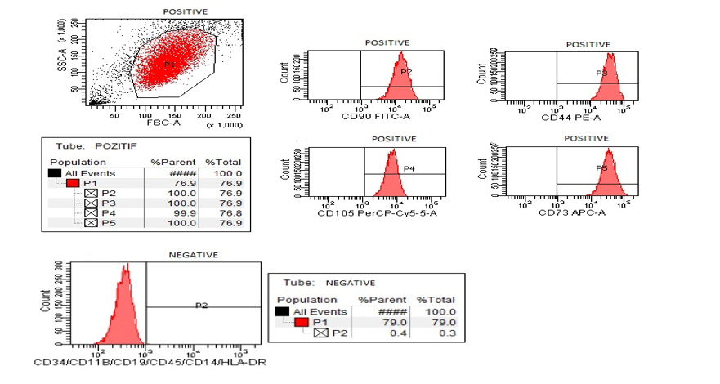
Figure 1 Wharton’s Jelly–derived mesenchymal stem cell flow cytometry, positive marker values (CD90, CD105, CD73 and CD44) are above 95%. Negative marker values (CD45, CD34, CD19, CD11B, human leukocyte antigen-DR and CD14) are below 2%. HLA: Human leukocyte antigen.

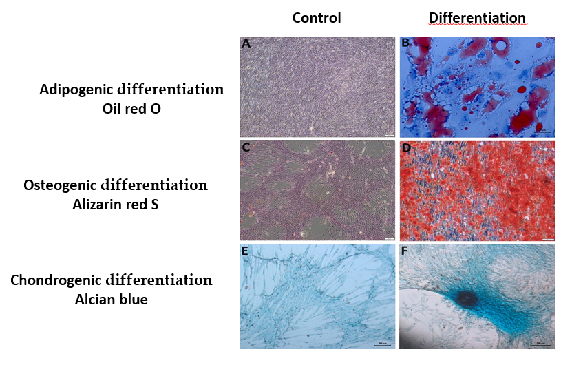
Figure 2 Detection of the differentiation potential of Wharton’s Jelly–derived-mesenchymal stem cells. A and B: Wharton's Jelly Derived-mesenchymal stem cells (WJ-MSCs) were cultured without adipogenic induction and cultured for 3 wk in adipogenic differentiation medium. Adipogenic differentiation was evidenced by the formation of lipid vacuoles with oil red O staining; C and D: WJ-MSCs were cultured without osteogenic induction and cultured for 3 wk in osteogenic differentiation medium. Osteogenic differentiation was evidenced by the detection of calcium deposits with Alizarin red staining; E and F: WJ-MSCs were cultured without chondrogenic induction and cultured for 3 wk in chondrogenic differentiation medium. Chondrogenic differentiation was evidenced with Alcian blue staining.

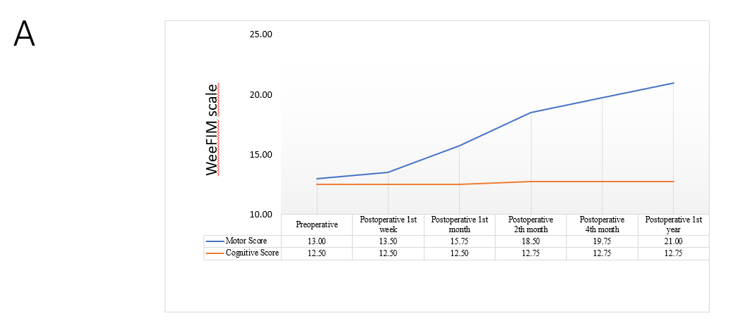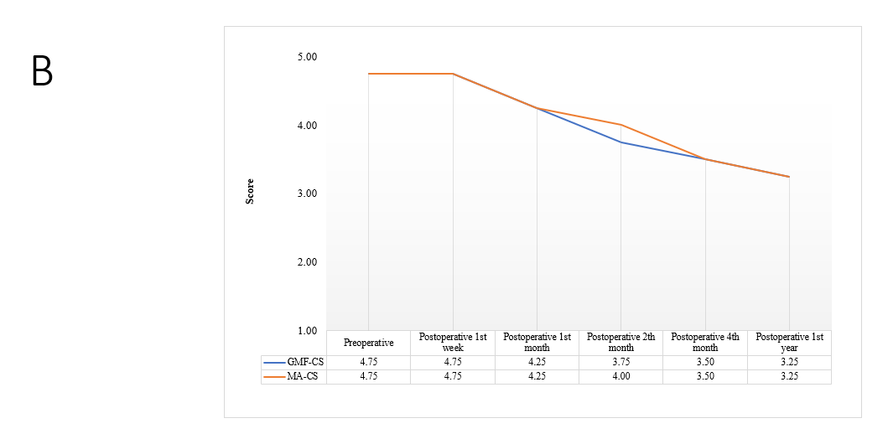
Figure 3 Change observed in the pre-test and post-test averages. A: Change observed in the pre-test and post-test averages of the patients' Wee functional independence measure motor score and cognitive score values; B: Change observed in the pre-test and post-test averages of the patients' Gross motor function classification system and manual ability classification system values. WeeFIM: Wee functional independence measure motor; GMF-CS: Gross motor function classification system; MA-CS: Manual ability classification system.

Table 1 Patient characteristics
 |  | Frequency | %
Age, yr | 1 | 1 | 25.0
 | 4 | 1 | 25.0
 | 9 | 2 | 50.0
Sex | Female | 1 | 25.0
 | Male | 3 | 75.0
Etiology of cerebral palsy | Hypoxia during birth | 2 | 50.0
 | Hypoxia with bleeding in the surgical field after tonsillectomy operation | 1 | 25.0
 | Cardiac arrest | 1 | 25.0
Comorbidity | None | 4 | 100.0
Cerebral palsy duration and first transplantation | 1 year | 1 | 25.0
 | 13 months | 1 | 25.0
 | 7 years | 1 | 25.0
 | 9 years | 1 | 25.0

Table 2 The change in the pre- and post-transplantation mean scores of the modified Ashworth scale
 |  | n | Mean | SD | Mean rank | χ² | df | P value
Right | Preoperative | 4 | 20.00 | 6.06 | 5.50 | 17.414 | 5 | 0.004
 | Postoperative 1-wk | 4 | 19.75 | 6.02 | 5.13
 | Postoperative 1-month | 4 | 19.00 | 5.48 | 3.88
 | Postoperative 2-month | 4 | 18.25 | 5.74 | 2.75
 | Postoperative 4-month | 4 | 17.75 | 5.25 | 1.88
 | Postoperative 1-year | 4 | 17.75 | 5.25 | 1.88
Left | Preoperative | 4 | 20.00 | 6.06 | 5.38 | 17.368 | 5 | 0.004
 | Postoperative 1-wk | 4 | 19.75 | 6.02 | 5.00
 | Postoperative 1-month | 4 | 19.50 | 6.35 | 4.25
 | Postoperative 2-month | 4 | 18.25 | 5.74 | 2.63
 | Postoperative 4-month | 4 | 17.75 | 5.25 | 1.88
 | Postoperative 1-year | 4 | 17.75 | 5.25 | 1.88

