Name of Journal: World Journal of Hepatology
Manuscript NO: 81027
Manuscript Type: MINIREVIEWS

May 2022 acute hepatitis outbreak, is there a role for COVID-19 and other viruses?

Elbeltagi R et al. May 2022 acute hepatitis outbreak

Reem Elbeltagi, Mohammed Al-Beltagi, Nermin Kamal Saeed, Adel Salah Bediwy, Osama Toema

Reem Elbeltagi, Department of Medicine, The Royal College of Surgeons in Ireland - Bahrain, Busiateen 15503, Muharraq, Bahrain

Mohammed Al-Beltagi, Osama Toema, Department of Pediatrics, Faculty of Medicine, Tanta University, Tanta 31511, Al Gharbia, Egypt

Mohammed Al-Beltagi, Department of Pediatrics, University Medical Center, King Abdulla Medical City, Arabian Gulf University, Dr. Sulaiman Al Habib Medical Group, Manama 26671, Bahrain

Nermin Kamal Saeed, Department of Pathology, Microbiology Section, Salmaniya Medical Complex, Manama 12, Bahrain

Nermin Kamal Saeed, Department of Microbiology, Royal College of Surgeons in Ireland - Bahrain, Busaiteen 15503, Muharraq, Bahrain

Adel Salah Bediwy, Department of Chest Diseases, Faculty of Medicine, Tanta University, Tanta 31527, Al Gharbia, Egypt

Adel Salah Bediwy, Department of Chest Diseases, University Medical Center, King Abdulla Medical City, Arabian Gulf University, Dr. Sulaiman Al Habib Medical Group, Manama 26671, Bahrain

Author contributions: Elbeltagi R, Al-Beltagi M, Saeed NK, Bediwy AS, Toema O collected the data and wrote and revised the manuscript.

Corresponding author: Mohammed Al-Beltagi, MBChB, MD, MSc, PhD, Academic Editor, Chairman, Consultant Physician-Scientist, Professor, Researcher, Department of Pediatrics, Faculty of Medicine, Tanta University, Al Bahr Street, Tanta 31511, Al Gharbia, Egypt. mbelrem@hotmail.com

Received: October 21, 2022
Revised: January 6, 2023
Accepted: March 14, 2023
Published online:

Abstract
There has been an increasing number of reported cases of acute hepatitis of unknown origin in previously healthy children since first reported on March 31, 2022. This clinical syndrome is identified by jaundice and markedly elevated liver enzymes with increased aspartate transaminase and/or alanine aminotransaminase (greater than 500 IU/L). We conducted an inclusive literature review with respect to acute hepatitis outbreaks in children using the search terms acute hepatitis, outbreak, children, severe acute respiratory syndrome coronavirus 2 (SARS-CoV-2), coronavirus disease 2019 (COVID-19), and adenovirus. According to the cumulative data presented in four main studies, the median age is 4 years, with a male predominance (1.3:1). Jaundice was the most common clinical manifestation (69%), followed by vomiting (63%), anorexia (52.9%), diarrhea (47.2%), abdominal pain (39%), pyrexia (33.3%), pale stool (30%), and dark urine (30%). Coryza and lethargy were reported in 16.6%, while pruritus was reported in 2% of cases. Acute liver failure was observed in 25% of cases. The exact mechanism of this acute hepatitis outbreak is still not entirely clear. Adenoviruses and SARS-CoV-2 were detected in a significant number of patients. Coinfection with adenovirus and SARS-CoV-2 could be a possible underlying mechanism. However, other possible infections and mechanisms must be considered in the pathogenesis of this condition. Acute hepatitis of unknown origin in children has been a serious problem since the start of the COVID-19 pandemic but has not yet been sufficiently addressed. Many questions remain regarding the underlying mechanisms leading to acute liver failure in children, and it is likely that extensive future research is needed.

Key Words: Acute hepatitis of unknown origin; Children; Adenovirus; SARS-CoV-2; COVID-19; Hepatic failure

Elbeltagi R, Al-Beltagi M, Saeed NK, Bediwy AS, Toema O. May 2022 acute hepatitis outbreak, is there a role for COVID-19 and other viruses? World J Hepatol 2023; In press

Core Tip: There has been an increasing number of acute hepatitis of unknown origin in children since first reported on March 31, 2022. The exact mechanism of this acute hepatitis outbreak is still unclear. Still, the increased detection rate of adenoviruses and severe acute respiratory syndrome coronavirus 2 (SARS-CoV-2) may imply a key role for these viruses in the pathogenesis of this childhood condition. Coinfection with adenovirus and SARS-CoV-2 could also play a role, but comprehensive research is still needed to reach an exact mechanism. Until an aetiology is uncovered, the focus should be placed on the prevention of this syndrome in children via the use of proper hygiene.

INTRODUCTION
Since it was first reported on March 31, 2022, in Scotland, and with the recent increase in the reported cases since April 15, 2022, in the United Kingdom, a reason for acute hepatitis of unknown origin in previously healthy children has not been clearly defined. There is speculation as to whether this phenomenon represents a true increase in the number of cases or if it is an inflated statistic due to increased awareness and reporting. By the last week of April 2022, there were 169 cases of acute hepatitis of unknown origin in children aged 1 mo to 16 years reported from 11 countries, including The United Kingdom, Spain, Israel, The United States, Denmark, Ireland, Netherlands, Italy, Norway, France, Romania, and Belgium^{[1]}. By the end of May 2022, the number of reported cases increased to 746, reported from 36 countries in 4 continents, mainly Europe and America (Figure 1)^{[2]}.
The clinical syndrome caused by acute hepatitis is identified by jaundice and markedly elevated liver enzymes, with increases in aspartate transaminase (AST) and/or alanine aminotransaminase (ALT) to greater than 500 IU/L. These findings may be preceded by gastrointestinal symptoms such as abdominal pain, vomiting, and diarrhoea. Fever is also reported in a few cases, but most affected children are afebrile. Furthermore, many patients experience more severe complications, such as liver failure^{[3]}. Most hepatotropic viruses that cause acute hepatitis, such as hepatitis A, B, C, D, and E viruses, are not detected in acute hepatitis of unknown origin. About 10% of cases require liver transplantation, with 1 fatal case being reported. Despite most cases being reported from Europe, Israel, and The United States, there is no link between traveling to any specific country and developing the syndrome^{[4]}.
The exact mechanism of this type of acute hepatitis outbreak is still not known. However, adenovirus is reported in 74 cases, severe acute respiratory syndrome coronavirus 2 (SARS-CoV-2) in 20 cases, and coinfection in 19 cases. Meanwhile, data from The United Kingdom and the Netherlands show an increase in adenovirus infection in the community concurrently with the rise in the number of cases of acute hepatitis of unknown origin^{[5]}. Although there is some evidence for the role of adenovirus with or without SARS-CoV-2 coinfection in the aetiology of this syndrome, other factors, such as immunopathogenesis and non-infection-related factors, could play a role. This review aims to shed light on the understanding of this syndrome^{[6]}.

METHODlogy
We conducted an inclusive literature review by searching various electronic databases for reports on acute hepatitis outbreaks in children. Databases searched included PubMed, Embase, Cumulative Index to Nursing and Allied Health Literature, Web of Science, Cochrane Library, Scopus, Library and Information Science Abstracts, Google search, and the National Library of Medicine catalogue. The search included reports published before August 31, 2022. Search terms utilized included acute hepatitis, outbreak, children, SARS-CoV-2, coronavirus disease 2019 (COVID-19), and adenovirus. Reference lists were inspected, and citation searches were also done on the included studies. We included open access papers published in English. Figure 2 shows a flow chart of the reviewed articles. We reviewed 260 articles concerned with acute hepatitis of unknown aetiology outbreaks in children; information from 52 was included in this review.

Clinical Spectrum of Acute Hepatitis of Unknown Cause in Children
The World Health Organization (WHO) has classified cases of severe acute hepatitis of unknown origin in children occurring during the current outbreak into three categories: (1) Confirmed; (2) Probable; and (3) Epi-linked. As there are no well-defined diagnostic criteria for this clinical entity, the probable case definition is the most widely used. Probable cases are those which present with manifestations of acute hepatitis with elevated serum aminotransferase levels of greater than 500 IU/L and without evidence of infection with hepatitis A-E viruses. The patient population is defined as children aged 16 years or younger as of October 1, 2021, with the youngest reported patient being 1 mo old. An epi-linked case is defined as a patient of any age presenting with acute hepatitis who has had a history of close contact with a probable case since October 1, 2021, and has no evidence of hepatitis A-E virus infection^{[7]}. Three-quarters of reported cases in European countries are younger than age 5, as many studies have been focused on children younger than 10 years^{[8]}. According to cumulative data presented in 4 main studies (2 from The United Kingdom and 2 from The United States), the median age of presentation is 4 years, with a male predominance (1.3:1). Jaundice is the commonlyommon reported clinical manifestation (69%), followed by vomiting (63%), anorexia (52.9%), diarrhoea (47.2%), abdominal pain (39%), pyrexia (33.3%), pale stool (30%), and dark urine (30%). Coryza and lethargy are reported in 16.6%, while pruritus is reported in 2% of cases. Acute liver failure is reported in 25% of these cases. See Table 1 for an overview of these data^{[9-12]}.
Kelgeri et al^{[9]} found that in 44 cases of childhood acute hepatitis of unknown origin, hepatitis most commonly resolved. However, progression to fulminant liver failure requiring liver transplantation is reported in 14% of these cases. This finding underscores the severity of this condition and emphasizes the importance of recognizing its potential outcomes. In affected children, a prodromal phase is typically indicated by biochemical testing. Ultrasound findings of gallbladder wall thickening, pericholecystic fluid, mesenteric lymphadenopathy, and mild hepatosplenomegaly indicate a potential viral aetiology. If these findings are present, an extensive viral workup is required, especially if infection with an adenovirus is suspected. Laboratory tests essential to the diagnosis of suspected acute hepatitis of unknown origin are summarized in Table 2.

GUT-LIVER AXIS AND HEPATIC DISEASES
The gut microbiome affects various essential processes, including immunological, structural, metabolic, and neurological functions. For this reason, gut microbiome status can considerably impact physical and mental health. The gut is colonized by over 1000 microbial species, a process that starts in utero and continues after birth in an ongoing, complex, dynamic manner to promote gut maturation and development^{[13]}. Although the number of microbial species in the gut microbiota of children and adolescents mirrors that of adult, the relative abundance of species varies. In children and adolescents, there are more abundant Faecalibacterium spp., Bifidobacterium spp., and subspecies of Lachnospiraceae^{[14]}. In addition, fungi and viruses are also present in the gut. Virobiota of the gut include bacteriophages that can infect prokaryotic cells, viruses that can infect eukaryotic host cells, and virus-derived genetic particles embedded in host chromosomes; the term “virome” refers to the entire complement of viral genetic elements found in the human genome^{[15]}.
In the oro- and nasopharyngeal areas, bacteriophages, coronaviruses, herpes viruses, adenoviruses, respiratory syncytial viruses, picornaviruses, influenza A viruses, and other uncharacterized eukaryotic viruses are frequently encountered. Common gastrointestinal viruses include bacteriophages, adenoviruses, caliciviruses, parvoviruses, picornaviruses, papillomaviruses, astroviruses, plant viruses, and other uncharacterized eukaryotic viruses^{[16]}. Some eukaryotic DNA viruses, such as anelloviruses, herpesviruses, human bocavirus, and adenoviruses, and some RNA viruses, such as picobirnaviruses and parechoviruses can continue shedding for months. For this reason, these viruses form a significant fraction of the typical human virome due to their capacity for persistent infection^{[17]}. Unfortunately, human adenoviruses in the gut can be reactivated and cause persistent infection, leading to serious morbidity and mortality, especially in immunosuppressed patients (e.g., children with hematopoietic disorders)^{[18]}.
The liver-gut microbiome axis, which also includes virobiota, is a bidirectional pathway in which portal veins transport gut-derived products directly from the gut to the liver, and bile and antibodies produced in the liver are transported back to the gut (Figure 3). Gut microbiome products preserve the immune homeostasis of the intestine and liver. Conversely, some microbial-derived metabolites such as ethanol, trimethylamine, short-chain fatty acids, and secondary bile acids may play a role in liver disease. Meanwhile, liver diseases such as cirrhosis can induce significant changes to the gut microbiome due to impairment of the vascular, epithelial, and immune barriers of the intestine^{[19]}. Accordingly, gut dysbiosis can induce an abnormal mucosal immune response and lead to homeostatic imbalance. This resulting imbalance causes microbes and immune cells to migrate to the liver, provoking inflammation and associated hepatic injury, and may also influence neoplastic processes^{[20,21]}.

Adenovirus Hepatotropic effects
Adenoviruses are medium-sized, nonenveloped, double-stranded DNA viruses. They are named for their first isolation from the adenoid in 1953. Adenoviruses are widespread viruses that classically trigger mild cold- or flu-like disease, pneumonia, conjunctivitis, and acute gastroenteritis in all age groups throughout the year^{[22]}. Adenoviruses are not typically hepatotropic in immunocompetent children. However, they can still cause hepatitis in children with liver stem cell transplantation, immunosuppressed children (e.g., with severe combined immune deficiency), and children receiving chemotherapy for solid malignant neoplasms.
The species C adenoviruses are the most commonly implicated in adenovirus-associated hepatitis, with type 5 being the most frequently encountered^{[23]}. Furthermore, human species F adenoviruses (e.g., types 40 and 41) are well-known causes of paediatric gastroenteritis. Chhabra et al^{[24]} showed that F adenovirus type 41 is more widespread than type 40 in the setting of viral gastroenteritis in children younger than 5 years. Despite mainly causing respiratory infections, adenoviruses can produce transient nonspecific "reactive hepatitis" findings in children during an active infection, with AST and ALT levels used as markers of hepatitis severity^{[25]}. Adenovirus infection can be diagnosed by direct antigen detection (in blood, stool, or respiratory samples), polymerase chain reaction (PCR) amplification, virus culture and isolation, and serology. Specimens are ideally collected within 1 week of symptom onset. Positive serology is expected in most children by the age of 4 years, but a 4-fold or more increase in the titre of adenovirus-specific antibodies is considered evidence of a recent infection. Adenovirus typing can be performed with molecular tests, and is essential from an epidemiological point of view^{[26]}. When performing adenovirus molecular testing in suspected cases of acute hepatitis of unknown cause, whole blood samples instead of serum or plasma should be used as it has a higher viral yield^{[12]}.
Out of 74 cases of acute hepatitis of unknown aetiology with detected adenovirus, 18 patients were identified by molecular tests as serotype F41, and a few others were serotype F40^{[27]}. This finding may indicate that enteric adenoviral infection may be related to hepatic infection by means of the gut-liver axis, a topic that warrants further research^{[28]}. The low viral load in the clinical samples necessitated PCR amplification of part of the viral hexon gene followed by Sanger sequencing for the detection of adenoviruses. However, notably, children presenting with acute hepatic failure had a high viral load. Importantly, there are also intratypic genetic variations in adenoviruses of serotype F type 41^{[29]}. A study at an Alabama hospital in August 2022 showed three different strains of adenovirus serotype F41, observed in 5 patients with acute hepatitis of unknown aetiology. This finding may indicate a low probability with regard to an outbreak being caused by a specific adenovirus serotype^{[30]}.
Meanwhile, serotyping data obtained from 4 adenovirus-positive patients in the European cohort showed 2 with serotype F41, 1 with serotype F40, and 1 with a serotype of "other." This supports the potential of adenovirus to negatively affect the liver after reaching it through the gut-liver axis. This adenovirus pathogenicity could be attributed to the development of mutations that promote hepatotropism, but this hypothesis needs to be confirmed by whole genome sequencing to detect any such mutation^{[28]}. Despite being isolated from a significant number of children with acute hepatitis of unknown origin, the exact role of adenoviruses in the pathogenicity of this condition still needs to be confirmed. Infection with adenoviruses is usually mild and resolves spontaneously. However, the infection can be associated with high morbidity and mortality in immunocompromised children, particularly those with allogeneic stem cell transplants. Although adenoviruses have been widely studied, there is currently no anti-adenoviral treatment approved by the United States Food and Drug Administration. As of this review, cidofovir and ribavirin are the only antiviral drugs used as first-line therapy to treat adenoviral infections. Brincidofovir has no nephrotoxicity and has better bioavailability than cidofovir, but this drug is no longer manufactured^{[31,32]}.

Coronaviruses Hepatotropic effects
Despite pulmonary symptoms being the dominant finding in the clinical presentation of COVID-19, SARS-CoV-2 may also affect other organs such as the liver^{[33]}. The liver is affected by 14%–53% of SARS-CoV-2 infections, regardless of preexisting liver disease^{[34]}. SARS-CoV-2 accesses the liver via binding angiotensin-converting enzyme-2 receptors, which are strongly expressed on cholangiocytes, minimally expressed on hepatocytes, and absent on Kupffer cells^{[35]}. COVID-19-associated liver injury could be related to immune-mediated damage with a severe inflammatory response to SARS-CoV-2 infection, direct cytotoxicity due to active viral replication inside the liver cells (Figure 4), COVID-19-associated anoxic liver damage, drug-associated liver injury, or reactivation of preexisting liver infections (e.g., Hepatitis B)^{[30]}. SARS-CoV-2 infection can also activate autoimmune hepatitis via systemic immune hyperstimulation, molecular mimicry, or both^{[31]}.
Meanwhile, few cases of autoimmune hepatitis have been reported after SARS-CoV-2 vaccination, and those that have been reported all showed complete remission with steroid therapy^{[36]}. Crisan et al^{[37]} showed that patients who presented with elevated liver enzymes and abnormal chemistries on arrival were more likely to have worse disease and poorer outcome. The presence of fibrosis in hospitalized patients with COVID-19 is associated with increased mortality. Therefore, regular monitoring of liver function should be standard for all COVID-19 patients, and serological testing for specific hepatotropic viruses (e.g., Hepatitis B or C according to the local epidemiological status) should be strongly considered^{[38]}.
Figure 4 shows the effects of COVID-19 infection on the liver, which is first evidenced by increased liver enzymes. The virus reaches the liver from the gut-liver-lung axis, which may be re-shed back to the gut through the bile. These effects are mediated through the impact of hypoxia, systemic venous congestion, immune-mediated hepatic damage by inflammatory mediators induced by SARS-CoV-2 infection, the direct hepatic cytopathic effect of SARS-CoV-2, and the hepatotoxic effects of some medications used to treat SARS-CoV-2 infection such as azithromycin, chloroquine, lopinavir, ritonavir, and tocilizumab. Hepatic damage can also result from SARS-CoV-2 reactivation of pre-existing liver diseases such as hepatitis B or C^{[39,40]}.

synergism between SARS-CoV-2 and adenovirus
Many studies have shown an increased incidence of adenovirus among children infected with SARS-CoV-2. Coinfection with SARS-CoV-2 and adenovirus may also occur. Mohammadi et al^{[41]} showed that the rate of SARS-CoV-2 and adenovirus coinfection is 1.1%, and all cases had mild respiratory disease. Another study from The United States showed a 0.4% rate of SARS-CoV-2 and adenovirus coinfection, being the third most common coinfection after rhinovirus/enterovirus and influenza A viruses^{[42]}. Another study from the United Kingdom showed a 2% rate of coinfection with SARS-CoV-2 and adenovirus which increased the odds of death by 1.22^{[43]}. Finally, a study from China found a slightly higher coinfection rate of 2.8%, associated with a worse diagnosis than bacterial coinfection^{[44]}.

Epstein-Barr virus as a possible cause
Epstein-Barr virus (EBV) is a member of the herpesvirus family. It causes a heterogeneous group of infections in children and adults with a classic presentation (infectious mononucleosis) or other atypical presentations. Baker et al^{[12]} showed that EBV was identified in 6 out of 9 children with acute hepatitis of unknown cause, verified using molecular methods. However, due to the absence of IgM, these cases could represent the reactivation of an old EBV infection and not a primary infection. However, EBV was reported to cause acute hepatitis in adults as well. García-Martínez et al^{[45]} reported coinfection of SARS-CoV-2 and EBV in a 19-year-old woman who presented with pyrexia and bilateral eyelid and hemifacial swelling and was found to have splenomegaly, cervical lymphadenopathy, and elevated AST and ALT. In addition, Nadeem et al^{[46]} described the reactivation of an EBV infection in a 62-year-old man attributed to coinfection with SARS-CoV-2. This patient was also found to have elevated AST and ALT. Despite these cases, the role of EBV in the pathogenesis of hepatitis is unclear, as many other confounding factors were present.

Questions need to be answered
Although both adenoviruses and SARS-CoV-2 are not typically hepatotropic viruses and rarely cause acute hepatitis in immunocompetent patients, coinfection with both viruses may produce significant effects on the liver and induce an acute hepatitis-like syndrome. Many questions remain, and further research may lead to key information regarding acute hepatitis of unknown origin. As there is an increased rate of autoimmune diseases after COVID-19 and its vaccines^{[47]}, could acute hepatitis of unknown cause be a COVID-19 immune-triggered reaction? Could this syndrome be caused by new variants of either adenovirus or SARS-CoV-2? Could coinfection with SARS-CoV-2 and adenoviruses trigger aggravated inflammatory responses affecting a sensitized liver and consequently induce acute hepatitis? Could acute hepatitis be a local form of the multisystem inflammatory syndrome, as described by Cantor et al^{[47]}? Could adenoviruses serve as a vector for SARS-CoV-2, easing the entry of SARS-CoV-2 in hepatocytes? Could this syndrome of acute hepatitis be related to other undiscovered microbial or non-microbial agents? Other aetiologies cannot be ignored. Despite being isolated from cases with acute hepatitis of unknown cause, the role of adenoviruses in the pathogenesis of this syndrome is not yet proven. We must strive to answer these questions and better define the correlation between SARS-CoV-2 and adenovirus infection and the development of this syndrome.

Treatment
Treatment of acute hepatitis of unknown cause in children is mainly symptom-based, supporting the recovery of liver function and treating complications as they arise. Cidofovir can be used when adenovirus infection is suspected, particularly in children with an organ transplant or severe viremia^{[48,49]}. When multisystem inflammatory syndrome in children (MIS-C) is suspected to cause acute hepatitis, the treatment protocol is the same as the management of MIS-C^{[47]}. Liver transplantation is indicated in children with acute fulminant hepatic failure refractory to aggressive therapy^{[50]}. A summary of the treatment of acute hepatitis of unknown cause is illustrated in Figure 5.

prevention
As SARS-CoV-2, adenoviruses, EBV, and other viruses are strongly suspected as potential mediators of acute hepatitis of unknown cause, appropriate hand hygiene and regular surface disinfection are essential to reduce viral spread. Hand and respiratory hygiene manoeuvres can reduce the spread of nonenveloped viruses such as adenoviruses^{[51]}. Moreover, it is key that healthcare professionals know the signs and symptoms of hepatitis in children. In suspected cases, clinicians should order serum ALT and AST transaminase testing to ensure efficient detection of cases as early as possible.

CONCLUSION
There has been an increasing number of acute hepatitis of unknown origin in children since first reported on March 31, 2022. The exact aetiology of this condition in children, which was observed to increase in prevalence during the COVID-19 pandemic, is still unclear. Despite adenoviruses and SARS-CoV-2 being isolated from some patients with acute hepatitis of unknown cause, the role of these viruses in the pathogenesis of this syndrome is not yet proven. Coinfection with SARS-CoV-2 and other viruses may relate to the pathogenesis of this condition. However, many questions remain and will require comprehensive research to better understand this correlation. Until a better understanding is reached, emphasis must be placed on preventing the development of acute hepatitis in children by using proper hygiene (e.g. hand washing, frequent surface disinfection) to reduce viral spread. Treatment of acute hepatitis of unknown cause in children is mainly symptom-based, supporting liver recovery and treating complications as they arise.

ACKNOWLEDGEMENTS
We thank the anonymous referees and editors for their valuable suggestions.

REFERENCES
1 Gao SH, Gong MC, Song HM. Acute severe hepatitis of unknown origin in children: considerations from the perspective of immunology. World J Pediatr 2022; 18: 529-532 [PMID: 35768757 DOI: 10.1007/s12519-022-00580-y]
2 World Health Organization. Disease Outbreak News; Multi-Country – Acute, severe hepatitis of unknown origin in children. [cited 23 April 2022]. Available from: https://www.who.int/emergencies/disease-outbreak-news/item/2022-DON376
3 Zhang LY, Huang LS, Yue YH, Fawaz R, Lim JK, Fan JG. Acute Hepatitis of Unknown Origin in Children: Early Observations from the 2022 Outbreak. J Clin Transl Hepatol 2022; 10: 522-530 [PMID: 35836761 DOI: 10.14218/JCTH.2022.00281]
4 Mogul DB, Ling SC, Murray KF, Schwarzenberg SJ, Rudzinski ER, Schwarz KB. Characteristics of Hepatitis B Virus-associated Hepatocellular Carcinoma in Children: A Multi-center Study. J Pediatr Gastroenterol Nutr 2018; 67: 437-440 [PMID: 30063586 DOI: 10.1097/MPG.0000000000002093]
5 Khader S, Foster I, Dagens A, Norton A, Sigfrid L. Severe acute hepatitis of unknown aetiology in children-what is known? BMC Med 2022; 20: 280 [PMID: 35906650 DOI: 10.1186/s12916-022-02471-5]
6 Hanson PJ, Liu-Fei F, Ng C, Minato TA, Lai C, Hossain AR, Chan R, Grewal B, Singhera G, Rai H, Hirota J, Anderson DR, Radio SJ, McManus BM. Characterization of COVID-19-associated cardiac injury: evidence for a multifactorial disease in an autopsy cohort. Lab Invest 2022; 102: 814-825 [PMID: 35437316 DOI: 10.1038/s41374-022-00783-x]
7 Mücke MM, Zeuzem S. The recent outbreak of acute severe hepatitis in children of unknown origin - what is known so far. J Hepatol 2022; 77: 237-242 [PMID: 35533802 DOI: 10.1016/j.jhep.2022.05.001]
8 Indolfi G, Czubkowski P, Fitzpatrick E, Gonzales E, Gupte G, Mancell S, Mozer-Glassberg Y, Nicastro E, Norman J, Stephenne X, Zellos A, Samyn M. Acute Hepatitis of Unknown Etiology Among Young Children: Research Agenda by the ESPGHAN Hepatology Committee. J Pediatr Gastroenterol Nutr 2022; 75: 543-548 [PMID: 35848740 DOI: 10.1097/MPG.0000000000003567]
9 Kelgeri C, Couper M, Gupte GL, Brant A, Patel M, Johansen L, Valamparampil J, Ong E, Hartog H, Perera MTPR, Mirza D, van Mourik I, Sharif K, Hartley J. Clinical Spectrum of Children with Acute Hepatitis of Unknown Cause. N Engl J Med 2022; 387: 611-619 [PMID: 35830627 DOI: 10.1056/NEJMoa2206704]
10 Cates J, Baker JM, Almendares O, Kambhampati AK, Burke RM, Balachandran N, Burnett E, Potts CC, Reagan-Steiner S, Kirking HL, Sugerman D, Parashar UD, Tate JE; Hepatitis of Unknown Etiology Group. Interim Analysis of Acute Hepatitis of Unknown Etiology in Children Aged <10 Years - United States, October 2021-June 2022. MMWR Morb Mortal Wkly Rep 2022; 71: 852-858 [PMID: 35771734 DOI: 10.15585/mmwr.mm7126e1]
11 Marsh K, Tayler R, Pollock L, Roy K, Lakha F, Ho A, Henderson D, Divala T, Currie S, Yirrell D, Lockhart M, Rossi MK, Phin N. Investigation into cases of hepatitis of unknown aetiology among young children, Scotland, 1 January 2022 to 12 April 2022. Euro Surveill 2022; 27 [PMID: 35426362 DOI: 10.2807/1560-7917.ES.2022.27.15.2200318]
12 Baker JM, Buchfellner M, Britt W, Sanchez V, Potter JL, Ingram LA, Shiau H, Gutierrez Sanchez LH, Saaybi S, Kelly D, Lu X, Vega EM, Ayers-Millsap S, Willeford WG, Rassaei N, Bullock H, Reagan-Steiner S, Martin A, Moulton EA, Lamson DM, St George K, Parashar UD, Hall AJ, MacNeil A, Tate JE, Kirking HL. Acute Hepatitis and Adenovirus Infection Among Children - Alabama, October 2021-February 2022. MMWR Morb Mortal Wkly Rep 2022; 71: 638-640 [PMID: 35511732 DOI: 10.15585/mmwr.mm7118e1]
13 Saeed NK, Al-Beltagi M, Bediwy AS, El-Sawaf Y, Toema O. Gut microbiota in various childhood disorders: Implication and indications. World J Gastroenterol 2022; 28: 1875-1901 [PMID: 35664966 DOI: 10.3748/wjg.v28.i18.1875]
14 Ihekweazu FD, Versalovic J. Development of the Pediatric Gut Microbiome: Impact on Health and Disease. Am J Med Sci 2018; 356: 413-423 [PMID: 30384950 DOI: 10.1016/j.amjms.2018.08.005]
15 Luganini A, Gribaudo G. Retroviruses of the Human Virobiota: The Recycling of Viral Genes and the Resulting Advantages for Human Hosts During Evolution. Front Microbiol 2020; 11: 1140 [PMID: 32547531 DOI: 10.3389/fmicb.2020.01140]
16 Duerkop BA, Hooper LV. Resident viruses and their interactions with the immune system. Nat Immunol 2013; 14: 654-659 [PMID: 23778792 DOI: 10.1038/ni.2614]
17 Lecuit M, Eloit M. The Viruses of the Gut Microbiota. Microbiota Gastrointest Pathophysiol 2017; 179-183 [DOI: 10.1016/b978-0-12-804024-9.00021-5]
18 Kosulin K, Geiger E, Vécsei A, Huber WD, Rauch M, Brenner E, Wrba F, Hammer K, Innerhofer A, Pötschger U, Lawitschka A, Matthes-Leodolter S, Fritsch G, Lion T. Persistence and reactivation of human adenoviruses in the gastrointestinal tract. Clin Microbiol Infect 2016; 22: 381.e1-381.e8 [PMID: 26711435 DOI: 10.1016/j.cmi.2015.12.013]
19 Albillos A, de Gottardi A, Rescigno M. The gut-liver axis in liver disease: Pathophysiological basis for therapy. J Hepatol 2020; 72: 558-577 [PMID: 31622696 DOI: 10.1016/j.jhep.2019.10.003]
20 Yang X, Lu D, Zhuo J, Lin Z, Yang M, Xu X. The Gut-liver Axis in Immune Remodeling: New insight into Liver Diseases. Int J Biol Sci 2020; 16: 2357-2366 [PMID: 32760203 DOI: 10.7150/ijbs.46405]
21 Wu X, Tian Z. Gut-liver axis: gut microbiota in shaping hepatic innate immunity. Sci China Life Sci 2017; 60: 1191-1196 [PMID: 28840534 DOI: 10.1007/s11427-017-9128-3]
22 Gray GC, Erdman DD. Adenovirus Vaccines. Plotkin's Vaccines 2018; 121-133.e8 [DOI: 10.1016/b978-0-323-35761-6.00010-9]
23 Zheng N, Wang Y, Rong H, Wang K, Huang X. Human Adenovirus Associated Hepatic Injury. Front Public Health 2022; 10: 878161 [PMID: 35570934 DOI: 10.3389/fpubh.2022.878161]
24 Chhabra P, Payne DC, Szilagyi PG, Edwards KM, Staat MA, Shirley SH, Wikswo M, Nix WA, Lu X, Parashar UD, Vinjé J. Etiology of viral gastroenteritis in children <5 years of age in the United States, 2008-2009. J Infect Dis 2013; 208: 790-800 [PMID: 23757337 DOI: 10.1093/infdis/jit254]
25 Oh JS, Choi JS, Lee YH, Ko KO, Lim JW, Cheon EJ, Lee GM, Yoon JM. The Relationships between Respiratory Virus Infection and Aminotransferase in Children. Pediatr Gastroenterol Hepatol Nutr 2016; 19: 243-250 [PMID: 28090469 DOI: 10.5223/pghn.2016.19.4.243]
26 Lion T. Adenovirus infections in immunocompetent and immunocompromised patients. Clin Microbiol Rev 2014; 27: 441-462 [PMID: 24982316 DOI: 10.1128/CMR.00116-13]
27 do Nascimento LG, Fialho AM, de Andrade JDSR, de Assis RMS, Fumian TM. Human enteric adenovirus F40/41 as a major cause of acute gastroenteritis in children in Brazil, 2018 to 2020. Sci Rep 2022; 12: 11220 [PMID: 35780169 DOI: 10.1038/s41598-022-15413-1]
28 Kajon AE, St George K. Mysterious cases of acute hepatitis in children: is adenovirus still a lead suspect? Emerg Microbes Infect 2022; 11: 1787-1789 [PMID: 35763594 DOI: 10.1080/22221751.2022.2095933]
29 Liu L, Qian Y, Jia L, Dong H, Deng L, Huang H, Zhao L, Zhu R. Genetic diversity and molecular evolution of human adenovirus serotype 41 strains circulating in Beijing, China, during 2010-2019. Infect Genet Evol 2021; 95: 105056 [PMID: 34481061 DOI: 10.1016/j.meegid.2021.105056]
30 Gutierrez Sanchez LH, Shiau H, Baker JM, Saaybi S, Buchfellner M, Britt W, Sanchez V, Potter JL, Ingram LA, Kelly D, Lu X, Ayers-Millsap S, Willeford WG, Rassaei N, Bhatnagar J, Bullock H, Reagan-Steiner S, Martin A, Rogers ME, Banc-Husu AM, Harpavat S, Leung DH, Moulton EA, Lamson DM, St George K, Hall AJ, Parashar U, MacNeil A, Tate JE, Kirking HL. A Case Series of Children with Acute Hepatitis and Human Adenovirus Infection. N Engl J Med 2022; 387: 620-630 [PMID: 35830653 DOI: 10.1056/NEJMoa2206294]
31 Waye MMY, Sing CW. Antiviral Drugs for Human Adenoviruses. Pharmaceuticals (Basel) 2010; 3: 3343–3354 [DOI: 10.3390/ph3103343]
32 Salmona M, Feghoul L, LeGoff J. [Which drugs to treat Adenovirus infections?]. Virologie (Montrouge) 2021; 25: 43-56 [PMID: 33650496 DOI: 10.1684/vir.2021.0883]
33 Wiśniewska H, Skonieczna-Żydecka K, Parczewski M, Niścigorska-Olsen J, Karpińska E, Hornung M, Jurczyk K, Witak-Jędra M, Laurans Ł, Maciejewska K, Socha Ł, Leonciuk A, Bander D, Karasińska-Cieślak M, Aksak-Wąs B, Wawrzynowicz-Syczewska M. Hepatotropic Properties of SARS-CoV-2-Preliminary Results of Cross-Sectional Observational Study from the First Wave COVID-19 Pandemic. J Clin Med 2021; 10 [PMID: 33572429 DOI: 10.3390/jcm10040672]
34 Sun J, Aghemo A, Forner A, Valenti L. COVID-19 and liver disease. Liver Int 2020; 40: 1278-1281 [PMID: 32251539 DOI: 10.1111/liv.14470]
35 Hamming I, Timens W, Bulthuis ML, Lely AT, Navis G, van Goor H. Tissue distribution of ACE2 protein, the functional receptor for SARS coronavirus. A first step in understanding SARS pathogenesis. J Pathol 2004; 203: 631-637 [PMID: 15141377 DOI: 10.1002/path.1570]
36 Floreani A, De Martin S. COVID-19 and Autoimmune Liver Diseases. J Clin Med 2022; 11 [PMID: 35628807 DOI: 10.3390/jcm11102681]
37 Crisan D, Avram L, Grapa C, Dragan A, Radulescu D, Crisan S, Grosu A, Militaru V, Buzdugan E, Stoicescu L, Radulescu L, Ciovicescu F, Jivanescu DB, Mocan O, Micu B, Donca V, Marinescu L, Macarie A, Rosu M, Nemes A, Craciun R. Liver Injury and Elevated FIB-4 Define a High-Risk Group in Patients with COVID-19. J Clin Med 2021; 11 [PMID: 35011894 DOI: 10.3390/jcm11010153]
38 Wong GL, Wong VW, Thompson A, Jia J, Hou J, Lesmana CRA, Susilo A, Tanaka Y, Chan WK, Gane E, Ong-Go AK, Lim SG, Ahn SH, Yu ML, Piratvisuth T, Chan HL; Asia-Pacific Working Group for Liver Derangement during the COVID-19 Pandemic. Management of patients with liver derangement during the COVID-19 pandemic: an Asia-Pacific position statement. Lancet Gastroenterol Hepatol 2020; 5: 776-787 [PMID: 32585136 DOI: 10.1016/S2468-1253(20)30190-4]
39 Sarkesh A, Daei Sorkhabi A, Sheykhsaran E, Alinezhad F, Mohammadzadeh N, Hemmat N, Bannazadeh Baghi H. Extrapulmonary Clinical Manifestations in COVID-19 Patients. Am J Trop Med Hyg 2020; 103: 1783-1796 [PMID: 32940201 DOI: 10.4269/ajtmh.20-0986]
40 Scarpellini E, Fagoonee S, Rinninella E, Rasetti C, Aquila I, Larussa T, Ricci P, Luzza F, Abenavoli L. Gut Microbiota and Liver Interaction through Immune System Cross-Talk: A Comprehensive Review at the Time of the SARS-CoV-2 Pandemic. J Clin Med 2020; 9 [PMID: 32756323 DOI: 10.3390/jcm9082488]
41 Mohammadi M, Bid-Hendi S, Baghershiroodi M, Chehrazi M, Yahyapour Y, Gouranourimi A, Sadeghi F. Detection of human adenovirus among Iranian pediatric hospitalized patients suspected of COVID-19: epidemiology and comparison of clinical features. Infez Med 2022; 30: 563-569 [PMID: 36482963 DOI: 10.53854/liim-3004-11]
42 Hazra A, Collison M, Pisano J, Kumar M, Oehler C, Ridgway JP. Coinfections with SARS-CoV-2 and other respiratory pathogens. Infect Control Hosp Epidemiol 2020; 41: 1228-1229 [PMID: 32616098 DOI: 10.1017/ice.2020.322]
43 Swets MC, Russell CD, Harrison EM, Docherty AB, Lone N, Girvan M, Hardwick HE; ISARIC4C Investigators, Visser LG, Openshaw PJM, Groeneveld GH, Semple MG, Baillie JK. SARS-CoV-2 co-infection with influenza viruses, respiratory syncytial virus, or adenoviruses. Lancet 2022; 399: 1463-1464 [PMID: 35344735 DOI: 10.1016/S0140-6736(22)00383-X]
44 Ma L, Wang W, Le Grange JM, Wang X, Du S, Li C, Wei J, Zhang JN. Coinfection of SARS-CoV-2 and Other Respiratory Pathogens. Infect Drug Resist 2020; 13: 3045-3053 [PMID: 32922049 DOI: 10.2147/IDR.S267238]
45 García-Martínez FJ, Moreno-Artero E, Jahnke S. SARS-CoV-2 and EBV coinfection. Med Clin (Engl Ed) 2020; 155: 319-320 [PMID: 32953993 DOI: 10.1016/j.medcle.2020.06.010]
46 Nadeem A, Suresh K, Awais H, Waseem S. Epstein-Barr Virus Coinfection in COVID-19. J Investig Med High Impact Case Rep 2021; 9: 23247096211040626 [PMID: 34428954 DOI: 10.1177/23247096211040626]
47 Cantor A, Miller J, Zachariah P, DaSilva B, Margolis K, Martinez M. Acute Hepatitis Is a Prominent Presentation of the Multisystem Inflammatory Syndrome in Children: A Single-Center Report. Hepatology 2020; 72: 1522-1527 [PMID: 32810894 DOI: 10.1002/hep.31526]
48 Florescu DF, Schaenman JM; AST Infectious Diseases Community of Practice. Adenovirus in solid organ transplant recipients: Guidelines from the American Society of Transplantation Infectious Diseases Community of Practice. Clin Transplant 2019; 33: e13527 [PMID: 30859626 DOI: 10.1111/ctr.13527]
49 Siew JX, Seah XFV, Chew YR, Thoon KC, Chong CY, Yung CF, Maiwald M, Len Y, Li J, Kam KQ, Nadua K, Tanugroho R, Tan NWH. Epidemiology of Adenovirus Infections and Outcomes of Cidofovir Treatment in Severely Ill Children. Pediatr Infect Dis J 2020; 39: 907-913 [PMID: 32404785 DOI: 10.1097/INF.0000000000002726]
50 Squires JE, Alonso EM, Ibrahim SH, Kasper V, Kehar M, Martinez M, Squires RH. North American Society for Pediatric Gastroenterology, Hepatology, and Nutrition Position Paper on the Diagnosis and Management of Pediatric Acute Liver Failure. J Pediatr Gastroenterol Nutr 2022; 74: 138-158 [PMID: 34347674 DOI: 10.1097/MPG.0000000000003268]
51 Lynch JP 3rd, Kajon AE. Adenovirus: Epidemiology, Global Spread of Novel Serotypes, and Advances in Treatment and Prevention. Semin Respir Crit Care Med 2016; 37: 586-602 [PMID: 27486739 DOI: 10.1055/s-0036-1584923]

Footnotes
Conflict-of-interest statement: All authors declare that they have no competing interests.

Open-Access: This article is an open-access article that was selected by an in-house editor and fully peer-reviewed by external reviewers. It is distributed in accordance with the Creative Commons Attribution NonCommercial (CC BY-NC 4.0) license, which permits others to distribute, remix, adapt, build upon this work non-commercially, and license their derivative works on different terms, provided the original work is properly cited and the use is non-commercial. See: https://creativecommons.org/Licenses/by-nc/4.0/

Provenance and peer review: Invited article; Externally peer reviewed.
Peer-review model: Single blind

Peer-review started: October 21, 2022
First decision: January 3, 2023
Article in press:

Specialty type: Gastroenterology and hepatology
Country/Territory of origin: Egypt
Peer-review report’s scientific quality classification
Grade A (Excellent): 0
Grade B (Very good): 0
Grade C (Good): C, C
Grade D (Fair): D
Grade E (Poor): 0

P-Reviewer: Bernabe-Ortiz JC, Peru; Naderi D, Iran S-Editor: Liu GL L-Editor: Filipodia P-Editor: Liu GL
Figure Legends
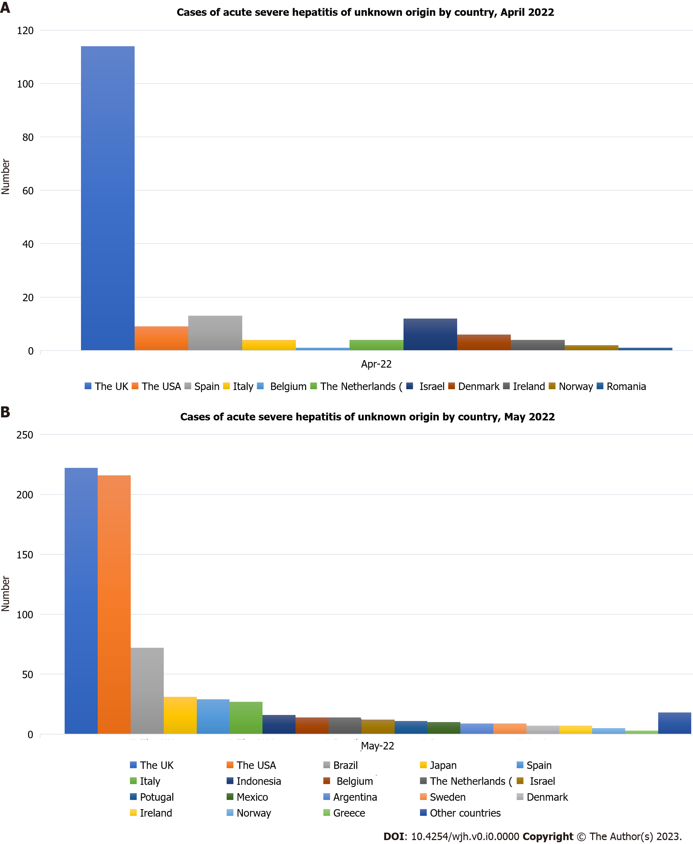
Figure 1 Reported cases of acute hepatitis syndrome of unknown aetiology in children. A: April 2022; B: May 2022. Apr: April; The UK: The United Kingdom; The USA: The United States of America.
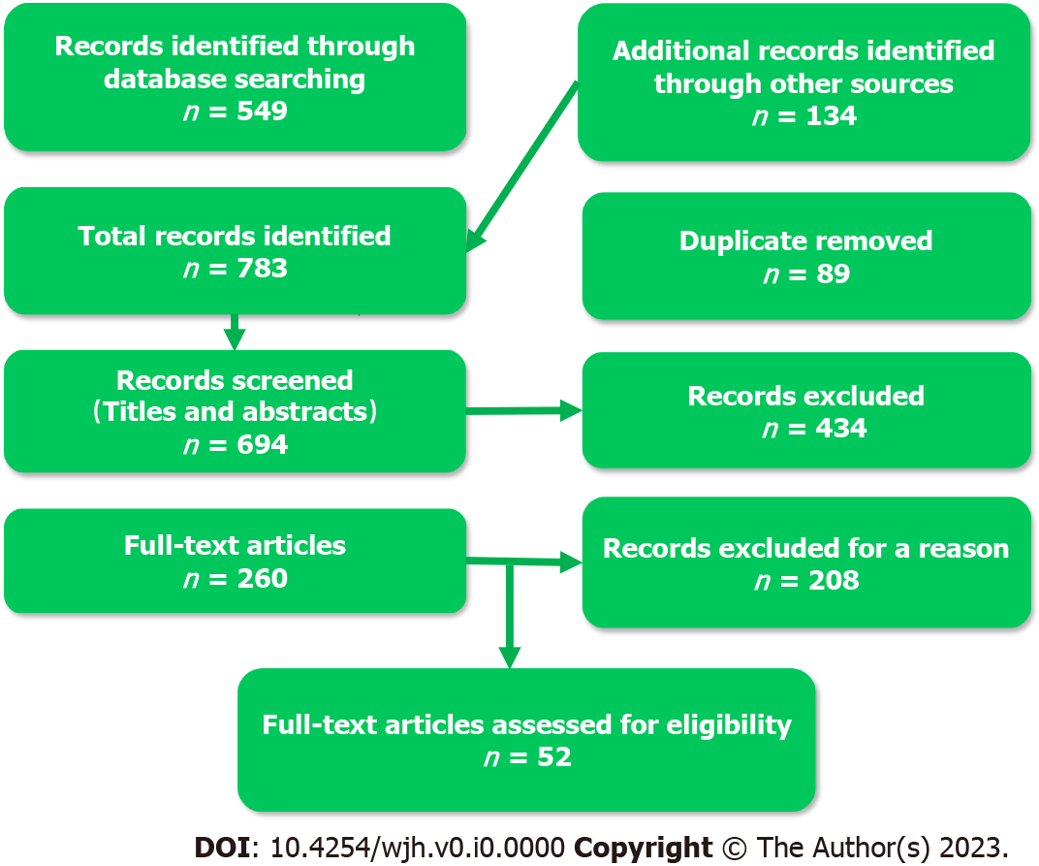
Figure 2 Flow chart of studies included in this review.

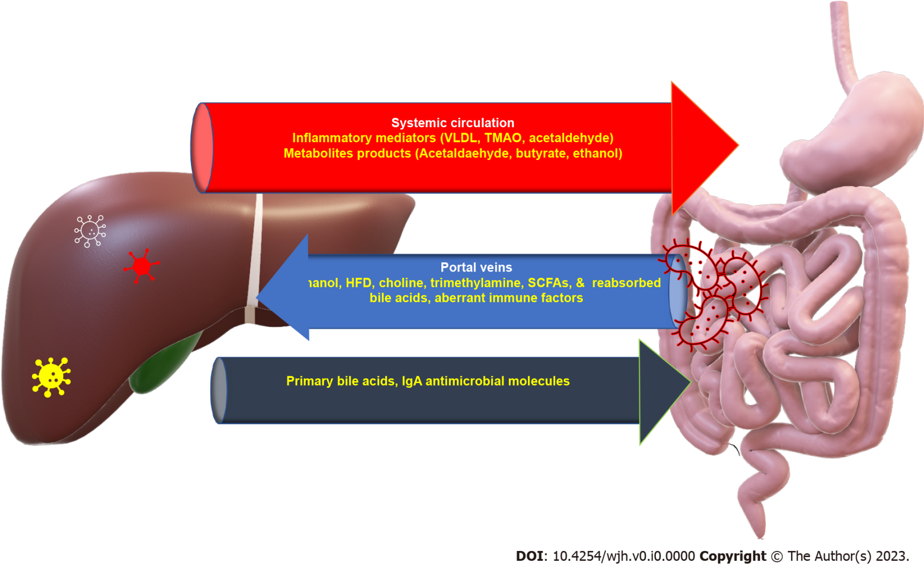
Figure 3 Gut-liver axis. Mutual effects of the gut and liver through systemic and portal circulation and biliary enterohepatic circulation. HFD: High-fat diet; IgA: Immunoglobulin A; SCFAs: Short-chain fatty acids; TMAO: Trimethylamine N-oxide; VLDL: Very-low-density lipoprotein.
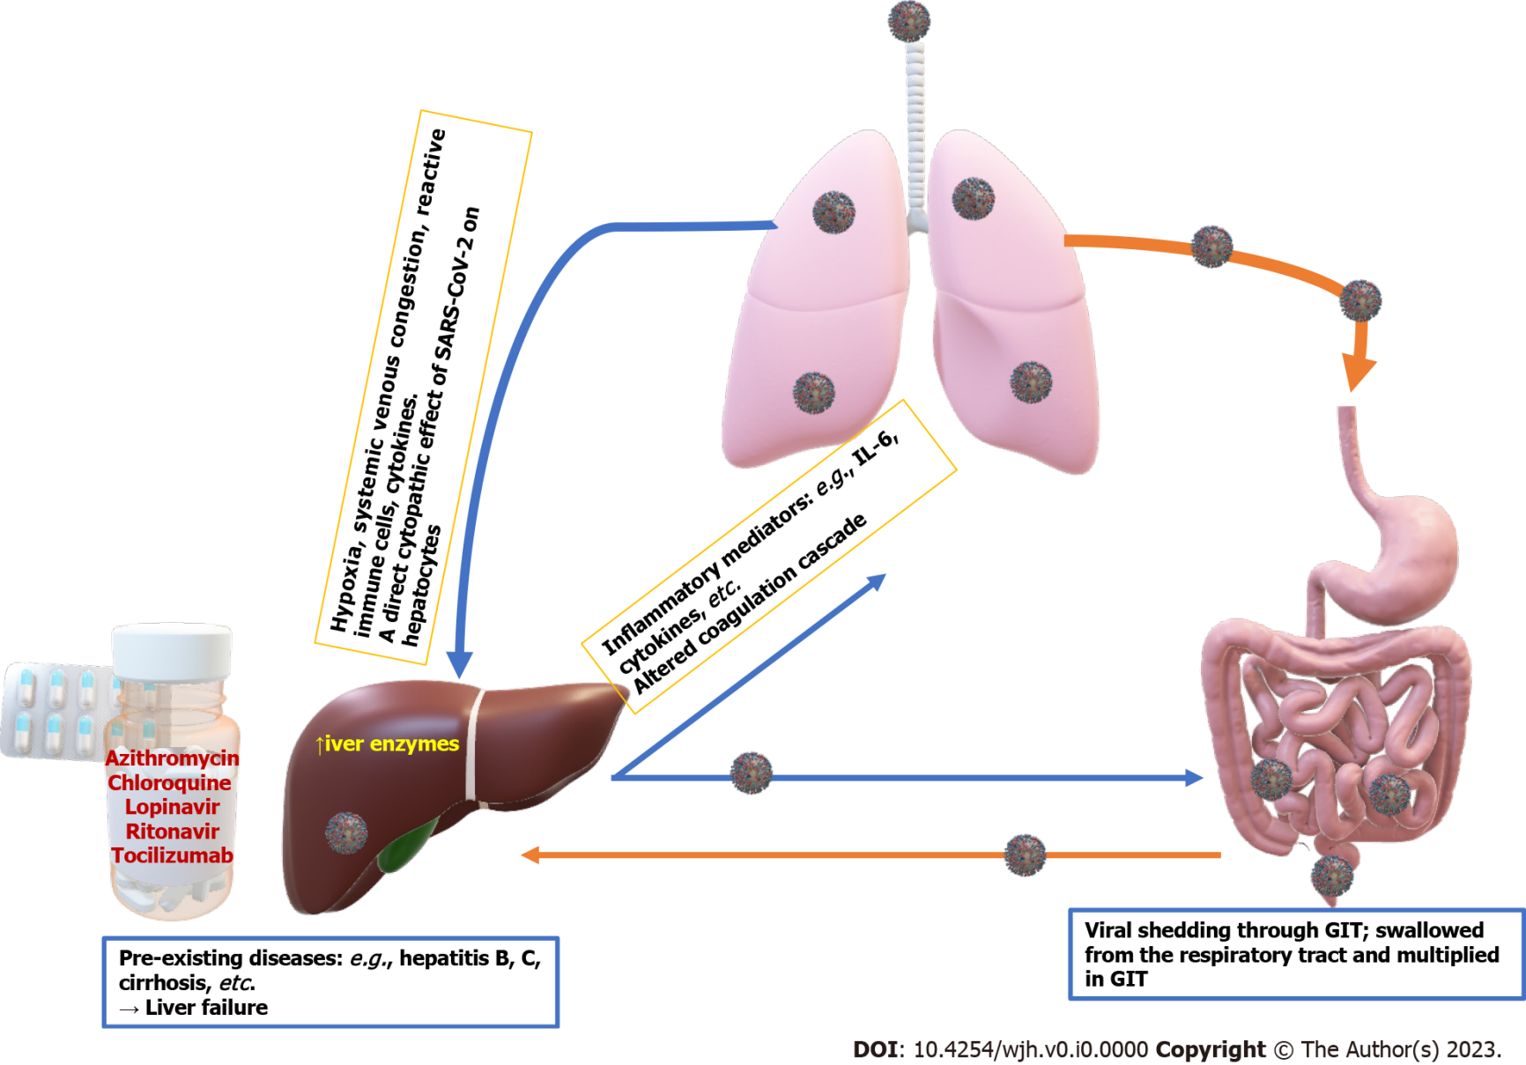
Figure 4 Effect of coronavirus disease 2019 infection on the liver as indicated by increased liver enzymes. The virus reaches the liver from the gut-liver-lung axis and may be re-shed back to the gut through the bile. These effects are mediated through the impact of hypoxia, systemic venous congestion, immune-mediated hepatic damage by inflammatory mediators induced by severe acute respiratory syndrome coronavirus-2 infection (SARS-CoV-2), the direct hepatic cytopathic effect of SARS-CoV-2, and the hepatotoxic effects of some medications used to treat SARS-CoV-2 infection such as azithromycin, chloroquine, lopinavir, ritonavir, and tocilizumab. GIT: Gastrointestinal tract; IL-6: Interleukin 6.

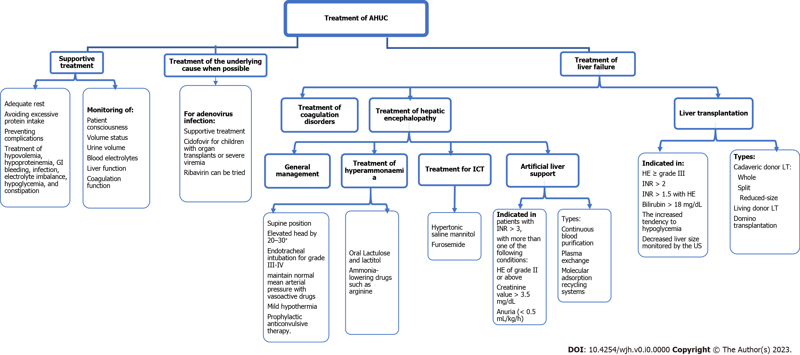
Figure 5 Summary of the treatment of acute hepatitis of unknown cause. AHUC: Acute hepatitis of unknown cause; GI: Gastrointestinal; HE: Hepatic encephalopathy; ICT: Increased intracranial tension.

Table 1 Clinical data from various studies, n (%)
Ref. | Kelgeri et al^{[9]}, 2022 | Cates et al^{[10]}, 2022 | Marsh et al^{[11]}, 2022 | Baker et al^{[12]}, 2022 | Cumulative data
Demographic data
Country | UK | USA | Scotland, UK | Alabama, USA
Number of patients | 44 | 296 | 13 | 9 | 362
Age (yr), median (range) | 4 (1-7) | 2.2 (0–9.7) | 3.9 (3-5) | 2 (1.66-5.7) | 3 (0-9.7)
Male/female ratio | 0.83:1 | 1.42:1 | 1.2:1 | 0.28:1 | 1.3:1
Clinical findings
Jaundice | 41 (93) | 71/123 (57.7) | 8/9 (88.9) | 8/9 (88.9) | 128/185 (69)
Vomiting | 24 (54) | 76/123 (61.8) | 4/4 (100) | 7/9 (77.8) | 113/180 (63)
Diarrhoea | 14 (32) | 61/123 (49.6) | 4/4 (100) | 6/9 (66.7) | 85/180 (47.2)
Pale stools | 13 (30) | / | / | / | 13/44 (30)
Abdominal pain | 12 (27) | 48/123 (39.0) | 7/9 (77.8) | / | 69/176 (39)
Lethargy | 10 (23) | 15/123 (12.2) | 4/4 (100) | 1/9 (11.1) | 30/180 (16.6)
Dark urine | 6 (14) | 44/123 (35.8) | / | / | 50/167 (30.0)
Coryza | 6 (14) | 20/123 (16.3) | / | 3/9 (33.3) | 29/176 (16.5)
Pyrexia | 4 (9) | 51/123 (41.5) | 0/4 (0) | 5/9 (55.6) | 60/180 (33.3)
Pruritus | 1 (2) | / | / | / | 1/44 (2.0)
Anorexia |  | 65/123 (52.9) | / | / | 65/123 (52.9)
Acute live failure | 6 (14) | 37/123 (30.1) | / | 1/9 (11.1) | 44/176 (25)
UK: The United Kingdom; USA: The United States of America.

Table 2 Suggested workup in the diagnosis of acute hepatitis of unknown aetiology
Item |  | Sample test
History |  | To be taken according to WHO for case definition, probable or confirmed case. History of traveling to high-risk areas endemic to hepatitis viruses, exposure to a local outbreak, household contact, sharing personal items with an infected person, attendance at day-cares, history of transfusion-dependent illness, or exposure to tattoos and/or body piercing using nonsterile techniques
Clinical examination |  | Low-grade fever, fatigue, anorexia, nausea, vomiting, enlarged and tender liver with/without splenomegaly, jaundice, abdominal pain, dark urine, pale or clay-coloured stool
Liver Functions |  | Total bilirubin, conjugated bilirubin, liver enzymes (alanine aminotransferase, aspartate aminotransferase, alkaline phosphatase, and gamma-glutamyl transferase), albumin, and prothrombin time
Liver biopsy |  | Staining with haematoxylin and eosin in selected cases
Imaging studies |  | Usually not required; may be needed to rule out biliary obstruction and other aetiologies for elevated liver enzymes and to exclude complications such as cirrhosis and hepatocellular carcinoma. Abdominal ultrasound: Shows enlarged liver with decreased (acute) or increased (chronic) echogenicity, brighter portal vein, periportal oedema, gallbladder wall thickening, and ascites. CT findings of acute hepatitis are nonspecific: Hepatomegaly, gallbladder wall thickening, periportal oedema, and ascites
Tests for autoimmune hepatitis |  | Autoantibodies such as ANAs and anti-SMAs
Detecting viral causes of hepatitis | Serology | Antibodies against Hepatitis A-E, Epstein-Barr virus, cytomegalovirus, HIV, varicella, adenovirus, SARS-CoV-2 (anti-S and anti-N antibodies)
 | Culture | Blood: Adenovirus, cytomegalovirus, Epstein-Barr virus, herpes simplex virus, influenza viruses. Rectal Swab: Adenovirus, rotavirus, enteroviruses
 | PCR | Blood: For hepatitis A, C, E, adenovirus, cytomegalovirus, enteroviruses, Epstein-Bar virus, Parechovirus, Herpes simplex virus, HHV 6 and 7. Throat Swab: Respiratory virus screening by multiplex assay (including Adenovirus, Influenza, Parainfluenza, Respiratory Syncytial Virus, Rhinovirus, Human bocavirus 1-3, Human metapneumovirus, Enteroviruses, SARS-CoV-2, etc.). Stool: For enteric viruses screening by multiplex assay (including Norovirus, Enteroviruses, Rotavirus, Astrovirus, Sapovirus)
Detecting bacterial causes of hepatitis | Serology | Antibodies against: Brucella spp., Bartonella henselae, Borrelia burgdorferi (when epidemiologically appropriate)
 | Culture | Blood: Routine procedures for bacterial pathogens, when clinically applicable. Throat Swab: Streptococcus group A. Stool: Salmonella, Shigella, Campylobacter, E. coli 0157. Urine: Routine procedures for bacterial pathogens, when clinically applicable
 | PCR | Stool or rectal swab: Enteric bacterial pathogens. Urine: Leptospira spp
Toxicological screening |  | Blood and urine by different methods, including mass spectrometry: Drugs (e.g., acetaminophen, antibiotics, antiepileptics, herbal medicines) or toxins (e.g., carbon tetrachloride)
Metabolic work-up |  | Ceruloplasmin; 24 h of urinary copper excretion; Celiac disease screening; Urine organic acid profile; Plasma amino acids; Plasma acylcarnitine; Whole exome and mitochondrial gene examination to rule out other inborn metabolic disorders that can cause liver injury; Other metabolic work-up according to the clinical scenario
ANA: Antinuclear antibody; CT: Computerized tomography; HIV: Human immunodeficiency virus; HHV: Human herpesvirus; PCR: Polymerase chain reaction; SARS-CoV-2: Severe acute respiratory syndrome coronavirus-2; SMA: Smooth muscle antibody; WHO: World Health Organization.

