Name of Journal: World Journal of Gastrointestinal Surgery
Manuscript NO: 48660
Manuscript Type: MINIREVIEWS

History of pseudomyxoma peritonei from its origin to the first decades of the twenty first century

Morera-Ocon FJ et al. History of pseudomyxoma peritonei

Francisco J Morera-Ocon, Clara Navarro-Campoy

Francisco J Morera-Ocon, Department of General Surgery, Hospital General de Requena, Valencia 46340, Spain

Clara Navarro-Campoy, Department of Gynecolgy and Obstetrics, Hospital 9 Octubre, Valencia 46340, Spain

ORCID number: Francisco J Morera-Ocon (0000-0002-7378-5086); Clara Navarro-Campoy (0000-0003-3727-3312).

Author contributions: Morera-Ocon FJ designed the study and collected the reference articles, revised the surgical experience and the patient’s clinical data, and wrote the manuscript; Navarro-Campoy C collaborated in the writing of the paper, with emphasis in the gynecological aspects of the text.

Conflict-of-interest statement: No potential conflicts of interest relevant to this article were reported.

Open-Access: This article is an open-access article which was selected by an in-house editor and fully peer-reviewed by external reviewers. It is distributed in accordance with the Creative Commons Attribution Non Commercial (CC BY-NC 4.0) license, which permits others to distribute, remix, adapt, build upon this work non-commercially, and license their derivative works on different terms, provided the original work is properly cited and the use is non-commercial. See: http://creativecommons.org/licenses/by-nc/4.0/

Manuscript source: Unsolicited manuscript

Corresponding author: Francisco J Morera-Ocon, MD, PhD, Surgical Oncologist, Department of General Surgery, Hospital General de Requena, Paraje Casablanca s/n, Valencia 46340, Spain. fmoreraocon@gmail.com
Telephone: +34-96-2339180
Fax: +34-962304523

Received: May 2, 2019
Peer-review started: May 9, 2019
First decision: June 12, 2019
Revised: July 25, 2019
Accepted: August 6, 2019
Article in press:
Published online:

Abstract
Pseudomyxoma peritomei (PMP) is a disease wrapped up in misunderstanding and controversies. The terminology of that disease becomes ambiguous unless knowledge about the etimology is offered. Pseudomyxoma stands for pseudomucin, a term used to design a type of mucin. PMP was first described in a case of a woman alleged to have a ruptured pseudomucinous cystadenoma of the ovary, an old term now in disuse to refer to ovarian cysts. Today we know that in the majority of cases the origin for PMP is an appendiceal neoplasm, often of low grade histology. Ovarian tumors as important etiology of pseudomyxoma remain recognized coming to the end of the second decade of 2000’s, even if this notion is completely wrong. Its classification is maintained under discussion, and experts’ panels strive for consensus. Malignancy of PMP is another point in discussion, and as it is shown in this review that discussion has a long-standing historical reason. Surgery is the main type of treatment for PMP, and the only therapy with potential curative option.

Key words: Pseudomyxoma peritonei; Pseudomucin; Appendiceal neoplasm; Hyperthermic intraperitoneal chemotherapy

© The Author(s) 2019. Published by Baishideng Publishing Group Inc. All rights reserved.

Core tip: The fact that Pseudomyxoma peritonei is an orphan disease explains a certain ignorance about this nosologic entity. It continues to be involved in controversy, starting with its classification. It is thought that mucinous cystadenocarcinoma of the ovary is an important etiology for genesis of Pseudomyoma. Nevertheless, this statement is completely wrong. This review is aimed at providing-clarifications around some of the misconceptions surrounding this disease, and explaining the historical sources from which such misconceptios have been drawn.

Morera-Ocon FJ, Navarro-Campoy C. History of pseudomyxoma peritonei from its origin to the first decades of the twenty first century. World J Gastrointest Surg 2019; In press

INTRODUCTION
The National Library of medicine terminology defines Pseudomyxoma Peritonei (PMP) as “A condition characterized by poorly-circumscribed gelatinous masses filled with malignant mucin-secreting cells”, definition which may be considered correct. The definition follows explaining the etiologies: “Forty-five percent of pseudomyxomas arise from the ovary, usually in a mucinous cystadenocarcinoma (cystadenocarcinoma, mucinous), which has prognostic significance. PMP must be differentiated from mucinous spillage into the peritoneum by a benign mucocele of the appendix (Segen, Dictionary of Modern Medicine, 1992)”, statements that is wrong. It has been demonstrated that PMP arises from appendiceal neoplasms, rarely from other tumors such as neoplasms from colon, urachus, or pancreas; and mucocele is a terminology which bears a great amount of ambiguity. So, this definition needs to be amended.
Today the knowledge about etiology and epidemiology of PMP has been elucidated, even if some points keep a certain ambiguity. Nevertheless, the Peritoneal Surface Oncology Group International (PSOGI) endeavored to clarify concepts about PMP, and published a consensus for classification of PMP and associated appendiceal neoplasia in 2016^{[1]}.
This manuscript deals with the history of this rare disease, from the origin of the terminology to the current notions that have been elucidated.

ORIGIN OF THE TERM
Myxoma refers to a benign tumor of connective tissue containing mucous material, the most common primary tumor of the heart. This histology is not related at all with that pertaining to what is call PMP. The term pseudomyxoma in PMP stands for pseudomucin. The prefix myxo-, Latin form for muxa from the Greek, and meaning mucus, use to be employed when mucus was present in the nosological condition. The term “Pseudomyxoma peritonei” was introduced by Werth^{[2]} in 1884 when he described a case of a woman with gelatinous masses in the peritoneal cavity from alleged ruptured pseudomucinous cystadenoma of the ovary, and which he found to be pseudomucin instead of mucin. The term pseudomucin was originally used to describe the content of the locules present in ovarian pseudomucinous cystadenoma, which was thought to differ from mucin. Mucin and pseudomucin were known as composed of glycoproteins, and they were differentiated by certain physical characters^{[3,4]}. Years later Frankel^{[5]} recovered the term for describing a case in a man with ruptured cyst of mucinous content from the cecal appendix, the second traditional etiology for PMP, and the terminology became established in the medical literature.
Several descriptions of the disease were reported thereafter. The cause of the disease was identified in rupture of a pseudomucinous ovarian cystoma, the bursting of the appendix vemicularis, or sometimes it was thought that simultaneous process of disease was going on in the two organs, so two distinct causes were responsible in the same clinical case^{[6]}.
In classical descriptions two theories were proposed for explaining the condition of PMP. A German gynecologist, discussed the hypothesis that the epithelial cells from the lining of the ruptured cyst were transplanted to the peritoneum, where they took root and continued to secrete gelatinous material^{[7]}. This theory of implantation had to be confronted with the theory of inflammation, where the gelatinous material irritates the peritoneum and causes it to react increasingly to further production of similar masses^{[8]}. Unquestionably, it is the former theory the one which has remained, but both were considered plausible even until the late 1950’s.
What it was the real nature of the condition named Pseudomucinous Cystadenoma of the ovary, or Pseudomucinous cystadenomata is not clear. The expression was still employed in the 1950’s^{[9,10]}, less frequently in the 1970’s^{[11]} and absolutely abandoned today. This former terminology could encompass the mucinous cystadenoma of the ovary but also the metastatic secondary tumors. Currently the mucinous tumors of the ovary are classified in cystadenoma, borderline tumor, mucinous carcinoma, and a new entity named seromucinous tumors^{[12]}. None of them, as stated, are origin of PMP.
Pseudomucin and paramucin are terms in disuse, and mucin is the remaining nomenclature. Mucins, or MUC glycoproteins, are a family of high molecular weight, glycosylated proteins, divided into membrane-associated type and secreted type. The secreted MUC type are subdivided into gel-forming and non-gel-forming subtypes^{[13,14]}. In PMP, mucin around tumor cells allows them to disseminate and redistribute within the peritoneal cavity. MUC2, a gel-forming mucin, is the most common type of mucin found in PMP gelatinous matter, and is associated with appendiceal neoplasms^{[15]}.
In brief, Pseudomyxoma refers to the production of mucus free in the peritoneal cavity or in cystic gelatinous masses. The etimology of Pseudo-myxoma derives from pseudomucin, being pseudomucin an obsolete terminology in molecular biology.

ETIOLOGY OF PMP
PMP is a clinical syndrome arising most commonly from the intraperitoneal spread of a mucinous appendiceal neoplasm^{[16]} (supplemental digital content, video). Studies based on immunohistochemical analysis and molecular biology have demonstrated the appendiceal origin of nearly all cases of PMP, being ovarian involvement a secondary feature^{[17]}.
Mucocele is not a histopathological diagnosis but as in PMP terminology, it is a clinical description. It was first recognized as a pathological entity by Rokitansky in 1842, who described it under the term “hydrops of the appendix”. Later, Virchow also described the mucocele and considered it a colloid degeneration of the appendix.
When PMP is originated from the appendix, which it is in most cases, the primary lesion of PMP is not a mucocele of the appendix. Instead, the etiology is a mucinous neoplasm of the appendix, which may occasionally show the appearance of mucocele.
The ovary as a significant etiology of PMP has been refuted. PMP does not arise from mucinous epithelial ovarian carcinoma^{[18]}. When mucinous ovarian lesions are present in PMP, better recognition by pathologist of histological features help distinguish between primary mucinous ovarian tumors and tumors which are metastatic to the ovary. The only retained origin from ovarian tumor is the infrequent case of PMP arising from a mature ovarian cystic teratoma^{[19,20]}.
In our experience, over some 100 appendiceal mucinous tumors with peritoneal spread, clinical PMP (i.e., increase in abdominal girth) was present in less of 20% of the cases. Between the etiologies of the clinical PMP presentation of our series, the origin was appendiceal in all but one rectal cancer, 2 colon cancers, and one urachal cancer. A woman of 37 years was operated on of a ruptured giant mucinous cystadenoma of the pancreas (Figure 1) and was referred to us because of residual peritoneal lesions which did not cause a clinical PMP. This picture may be debatable when allocating the case under PMP diagnose, but it was a gelatinous belly with epithelial cells into the peritoneum. Ovarian tumor was not responsible in any case of our series. Nevertheless, more than half of the female patients referred to us with peritoneal metastases from mucinous appendiceal neoplasm had previously been operated on with the misdiagnosis of primary ovarian cancer.
In spite of all this data, it is difficult to erase the concept of ovarian origin in this pathology, concept being strengthened by the first historical reports and kept until the earlies 2000’s.

CLASSIFICATIONS
The first classification of this disease that we have found is attributed to Oscar Polano^{[6]} , who in 1901 divided the condition into two classes: the cystadenoma mucinosum peritonei simplex, representing simple superficial metastasis produce by implantation; and the cystadenoma malignum pseudomucinosum peritonei, with sharply progressive and destructive character. Almost 100 years later the classification of Ronnett et al^{[21]}, and later the classification of Bradley et al^{[22]} share striking similarities with that of Polano, keeping the ambiguous features that turn the PMP in an elusive condition to define.
A variety of different classifications have been proposed, leading to confusion among this condition. PMP still appears as a histologic diagnosis in the 2010 World Health Organization classification of tumors of the digestive system^{[23]}, even it is defined as a description of the macroscopic appearance of mucinous ascites.
It is said that PMP has been classified according to the histology of the peritoneal disease rather than the primary tumor. When metastases from colorectal cancer are found in liver or lung, the classification of the condition continuous to be colorectal adenocarcinoma stage IV with specific site metastases. When those metastases are involving the peritoneum, the adenocarcinoma continuous to be stage IV with peritoneal metastases. Confusion may originate from the persistent effort in classifying PMP as a distinct condition from the originating cancer. When a mucinous appendiceal neoplasm has metastasized to the peritoneum it is a stage IVa mucinous appendiceal neoplasm, and may or may not acquire the PMP appearance.
This issue probably emerges from the classic questioning of the malignancy of mucinous appendiceal neoplasms. In historical medical literature it was thought that “the condition is not malignant in the sense that a carcinoma has developed, but is malignant clinically in that the condition tends toward the death of the patient”. Opinions from several authors revisited by Krivsky^{[6]} in his review in 1917 were in the same line of reasoning, such as “According to the pseudomyxoma of peritoneum is in the pathological sense benign, but clinically is not an innocent disease etc. Much the same opinion considering the pseudomyxoma of the peritoneum arising from the appendix to be a benign process. Bailey says that ‘there is no record to my knowledge of malignancy following a pseudomucin cyst of the appendix, but by the plastic peritonitis and mechanical interference which follow such an extravasation equally dangerous conditions may develop’”.
Today, peritoneal involvement of a mucinous neoplasm of the appendix is considered a malignant disease, and systemic metastases may occur. In our series we found two patients having systemic lung metastases from low-grade appendiceal mucinous tumors (Figure 2), distinct from pleural metastases which may arise the suspicion of dissemination from diaphragmatic surfaces, mainly during surgical procedure. This kind of metastases have been describe by others^{[24]}.
To dispel controversies in the PMP classifications, the PSOGI published a consensus for classification of PMP and associated appendiceal neoplasia. They arrive at this terminology for the peritoneal disease component: low-grade mucinous carcinoma peritonei, high-grade mucinous carcinoma peritonei, and high-grade mucinous carcinoma peritonei with signet ring cells. Broadly, there are not so much differences between this classification and that of Ronnet or even, that of Polano’s. It maintains the problem of classifying the syndrome rather than the original tumor. This classification not considers that PMP origin may be in other malignancies such as colorectal cancers, fact which nullify any effort of classifying PMP as a distinct pathological condition.

TREATMENT
In the article stated that “the only correct treatment of this disease is the removal of the ruptured cystoma by surgical operation and of the colloid matter which has escaped from it into the peritoneum”. This assertion has not changed in our days. PMP is a surgical disease, with no indication for systemic chemotherapy as in other abdominal malignant conditions. Systemic Chemotherapy should only be considered for patients who have no other options^{[25]}.
It had been proposed that radiotherapy should be offered to patients with PMP, and it has been eventually employed until the 1990’s^{[26]}. Nevertheless, this therapeutic option is not currently considered.
The natural selection in PMP therapeutic armamentarium kept surgery as the most reliable treatment to cure or prolong survival in those patients. Nevertheless, it was not until the coming of the cytoreductive surgery (CRS) concept, coupled with the administration of hyperthermic intraperitoneal chemotherapy (HIPEC), that this surgical treatment took its principal role in the management of PMP. The procedure of CRS was based in complete removal of the visible disease employing peritonectomy techniques, based on the redistribution phenomenom. This phenomenom was hypothesized by Paul Sugarbaker^{[27]} in the 1990’s, and means that large amounts of tumor will be found at some predetermined anatomic sites within the abdominal cavity, sparing other sites. The anatomic sites target of this redistribution event are the greater omentum which the highest extend being the omental cake (Figure 3), the undersurface of the right diaphragm, the Douglas pouch, the Morison pouch, the left colonic gutter, and the Treitz ligament. The limitation for complete CRS is the massive involvement of the small bowel, mainly due to iterative procedures with creation of scars where tumors infiltrate.
Even when the tumor volume is high, the cytoreduction may result in benefit for overall survival^{[28]}.
The introduction of chemotherapy agents locally applied into the peritoneum goes back to the experience reported by Economou et al^{[29]} in 1957. This author employed nitrogen mustard in 36 patients with tumor of breast, colon, rectum, and stomach, and injected the agent into a branch of the portal vein, or was left in the peritoneal cavity at the end of the operation, or both.
Spratt in the 1980’s renewed the practice of intraperitoneal chemotherapy, and Sugarbaker^{[27]} developed it in the 1990’s.
Nevertheless, the PMP is usually derived from cells of low-grade malignancy, with poor aggressive behavior in terms of growth rate and systemic metastasis, so theoretically they show poor response to chemotherapy agents which the mechanism of action is over cellular cycle. This raise doubts of the effect of HIPEC in the treatment of this pathology. Another question to solve is the effect of the hyperthermic component of the therapy, which has demonstrated a direct effect on cytolysis.
In the rare cases when PMP originates in mucinous colon adenocarcinoma, the cytotoxic drugs may enhance the radically of the procedure. Nevertheless, the PROGIDIGE 7 randomized trial, a multicenter French study analyzing the effect of Oxaliplatin as HIPEC drug in colon cancer showed nor benefits in the median overall survival when compared with CRS only. However, the impressive mean overall survival of more than 40 mo in each branch of the study must be emphasized (results in ASCO 2018)^{[30]}.

CONCLUSION
The etymology of PMP derives from the presence of mucin and mucin neoplastic cells spreading in the peritoneal cavity. The origin of the disease is a leaking or ruptured neoplasm of the appendix in the majority of cases. When mucinous metastases in the peritoneal cavity are thought to arise from an ovarian neoplasm, appendiceal and gastrointestinal mucinous adenocarcinoma must be rule out. The cytoreductive techniques described in the CRS/HIPEC procedure has become of extreme value in the management of patients with manifest PMP.

ACKNOWLEDGEMENTS
I would like to thank Professor Bruno Camps for sharing those years throughout this difficult surgical procedures which are cytoreductive surgery of peritoneal carcinomatosis, at the Hospital Clinico UNiversitrio de Valencia.

REFERENCES
1 Carr NJ, Cecil TD, Mohamed F, Sobin LH, Sugarbaker PH, González-Moreno S, Taflampas P, Chapman S, Moran BJ; Peritoneal Surface Oncology Group International. A Consensus for Classification and Pathologic Reporting of Pseudomyxoma Peritonei and Associated Appendiceal Neoplasia: The Results of the Peritoneal Surface Oncology Group International (PSOGI) Modified Delphi Process. Am J Surg Pathol 2016; 40: 14-26 [PMID: 26492181 DOI: 10.1097/PAS.0000000000000535]
2 Werth K. Klinische und anatomische Untersuchungen zur Lehre von den Bauchgeschwülsten und der Laparotomie. Arch Gynecol Obstet 1884; 84: 100-118 [DOI: 10.1007/BF01837425]
3 Maki M. Biochemical studies on carbohydrates. The Tohoka J Exp Med 1952; 55: 311-331 [DOI: 10.1620/tjem.55.311]
4 Reagan JW. Histopathology of ovarian pseudomucinous cystadenoma. Am J pathol 1949; 25: 689-707
5 Frankel E. Uher das sogenaute pseudomyxoma peritonei. Med Wochenschr 1901; 48: 965-970
6 Krivsky LA. On the pseudomyxoma peritonei. BJGO 1921; 28: 204-227 [DOI: 10.1111/j.1471-0528.1921.tb07782.x]
7 Weaver CH. Mucocele of the appendix with Pseudomucinous Degeneration. Ame J Surg 1937; 36: 523-526 [DOI: 10.1016/S0002-9610(37)90763-3]
8 Jorgensen MB. Ruptured mucocele of the appendix with pseudomyxoma peritonei, simulating pseudomucinous cystadenoma of the ovary. Cal Med 1949; 70: 46-47
9 Towers RP. A note on the origin of the pseudomucinous cystadenoma of the ovary. J Obstect Gynaecol Br Emp 1956; 63: 253-54 [DOI: 10.1111/j.1471-0528.1956.tb05477.x]
10 SHAW ES. Ruptured multilocular pseudomucinous cystadenoma of the ovary with pleural effusion. Am J Surg 1953; 86: 107-111 [PMID: 13058078 DOI: 10.1016/0002-9610(53)90310-9]
11 Loung KC. Pseudo-Meigs' syndrome associated with a pseudomucinous cystadenoma. Postgrad Med J 1970; 46: 631-632 [PMID: 5488225 DOI: 10.1136/pgmj.46.540.631]
12 Meinhold-Heerlein I, Fotopoulou C, Harter P, Kurzeder C, Mustea A, Wimberger P, Hauptmann S, Sehouli J. The new WHO classification of ovarian, fallopian tube, and primary peritoneal cancer and its clinical implications. Arch Gynecol Obstet 2016; 293: 695-700 [PMID: 26894303 DOI: 10.1007/s00404-016-4035-8]
13 Gum JR Jr. Mucin genes and the proteins they encode: structure, diversity, and regulation. Am J Respir Cell Mol Biol 1992; 7: 557-564 [PMID: 1449803 DOI: 10.1165/ajrcmb/7.6.557]
14 Rose MC, Voynow JA. Respiratory tract mucin genes and mucin glycoproteins in health and disease. Physiol Rev 2006; 86: 245-278 [PMID: 16371599 DOI: 10.1152/physrev.00010.2005]
15 O'Connell JT, Hacker CM, Barsky SH. MUC2 is a molecular marker for pseudomyxoma peritonei. Mod Pathol 2002; 15: 958-972 [PMID: 12218214 DOI: 10.1097/01.MP.0000026617.52466.9F]
16 Ansari N, Chandrakumaran K, Dayal S, Mohamed F, Cecil TD, Moran BJ. Cytoreductive surgery and hyperthermic intraperitoneal chemotherapy in 1000 patients with perforated appendiceal epithelial tumours. Eur J Surg Oncol 2016; 42: 1035-1041 [PMID: 27132072 DOI: 10.1016/j.ejso.2016.03.017]
17 Szych C, Staebler A, Connolly DC, Wu R, Cho KR, Ronnett BM. Molecular genetic evidence supporting the clonality and appendiceal origin of Pseudomyxoma peritonei in women. Am J Pathol 1999; 154: 1849-1855 [PMID: 10362811 DOI: 10.1016/S0002-9440(10)65442-9]
18 Perren TJ. Mucinous epithelial ovarian carcinoma. Ann Oncol 2016; 27 Suppl 1: i53-i57 [PMID: 27141073 DOI: 10.1093/annonc/mdw087]
19 Pranesh N, Menasce LP, Wilson MS, O'Dwyer ST. Pseudomyxoma peritonei: unusual origin from an ovarian mature cystic teratoma. J Clin Pathol 2005; 58: 1115-1117 [PMID: 16189164 DOI: 10.1136/jcp.2004.025148]
20 McKenney JK, Soslow RA, Longacre TA. Ovarian mature teratomas with mucinous epithelial neoplasms: morphologic heterogeneity and association with pseudomyxoma peritonei. Am J Surg Pathol 2008; 32: 645-655 [PMID: 18344868 DOI: 10.1097/PAS.0b013e31815b486d]
21 Ronnett BM, Zahn CM, Kurman RJ, Kass ME, Sugarbaker PH, Shmookler BM. Disseminated peritoneal adenomucinosis and peritoneal mucinous carcinomatosis. A clinicopathologic analysis of 109 cases with emphasis on distinguishing pathologic features, site of origin, prognosis, and relationship to "pseudomyxoma peritonei". Am J Surg Pathol 1995; 19: 1390-1408 [PMID: 7503361 DOI: 10.1097/00000478-199512000-00006]
22 Bradley RF, Stewart JH 4th, Russell GB, Levine EA, Geisinger KR. Pseudomyxoma peritonei of appendiceal origin: a clinicopathologic analysis of 101 patients uniformly treated at a single institution, with literature review. Am J Surg Pathol 2006; 30: 551-559 [PMID: 16699309 DOI: 10.1097/01.pas.0000202039.74837.7d]
23 Carr NJ, Sobin LH. Adenocarcinoma of the appendix. In: Bosman FT, Carneiro F, Hruban RH, Theise ND,eds. WHO classification of tumors of the digestive system. Lyon: IARC; 2010: 122-125
24 Kitai T. Pulmonary metastasis from pseudomyxoma peritonei. Gastroenterol Res Pract 2012; 2012: 690256 [PMID: 22844275 DOI: 10.1155/2012/690256]
25 Morera Ocon FJ, Camps Vilata B. Systemic chemotherapy in appendeal adenocarcinomas with peritoneal metastases. Is it worth it? AMS 2019; 2: 3-9 [DOI: 10.22307/2603.8706.2019.02.002]
26 Gough DB, Donohue JH, Schutt AJ, Gonchoroff N, Goellner JR, Wilson TO, Naessens JM, O'Brien PC, van Heerden JA. Pseudomyxoma peritonei. Long-term patient survival with an aggressive regional approach. Ann Surg 1994; 219: 112-119 [PMID: 8129481 DOI: 10.1097/00000658-199402000-00002]
27 Sugarbaker PH. Pseudomyxoma peritonei. A cancer whose biology is characterized by a redistribution phenomenon. Ann Surg 1994; 219: 109-111 [PMID: 8129480 DOI: 10.1097/00000658-199402000-00001]
28 Delhorme JB, Elias D, Varatharajah S, Benhaim L, Dumont F, Honoré C, Goéré D. Can a Benefit be Expected from Surgical Debulking of Unresectable Pseudomyxoma Peritonei? Ann Surg Oncol 2016; 23: 1618-1624 [PMID: 26678404 DOI: 10.1245/s10434-015-5019-9]
29 Economou SG, Mrazek R, Mcdonald G, Slaughter D, Cole WH. The intraperitoneal use of nitrogen mustard at the time of operation for cancer. Ann N Y Acad Sci 1958; 68: 1097-1102 [PMID: 13627760 DOI: 10.1111/j.1749-6632.1958.tb42669.x]
30 Quenet F, Elias D, Roca L, Goere D, Ghouti L, Pocard M, Facy M, Arvieux C, Lorimier G, Pezet D, Marchal F, Loi V, Meeus P, De Forges H, Stanbury T, Paineau J, Glehen O. UNICANCER phase III trial of hyperthermic intra-peritoneal chemotherapy (HIPEC) for colorectal peritoneal carcinomatosis (PC): PRODIGE 7. J Clin Oncol 2018; 36 suppl: LBA3503-LBA3503 [DOI: 10.1200/JCO.2018.36.18_suppl.LBA3503]

P-Reviewer: Isik A, Rubbini M, Vagholkar KR S-Editor: Cui LJ L-Editor: E-Editor:

Specialty type: Gastroenterology and hepatology
Country of origin: Spain
Peer-review report classification
Grade A (Excellent): A
Grade B (Very good): 0
Grade C (Good): C, C
Grade D (Fair): 0
Grade E (Poor): 0

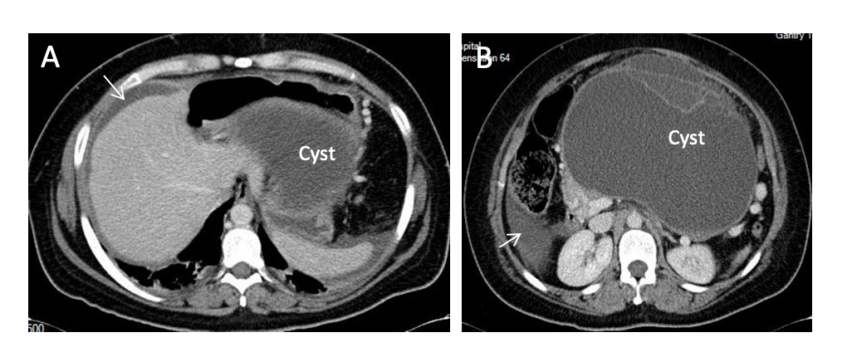
Figure 1 A woman of 37 years was operated on of a ruptured giant mucinous cystadenoma of the pancreas. A: Computed tomography slide showing free mucinous ascites (arrows) and the dome of the pancreatic cystic lesion (mucinous cystadenoma with focal adenocarcinoma) in retrogastric area; B: Peritoneal fluid in right paracolic gutter (arrow) and corporal cystic lesion with septa.

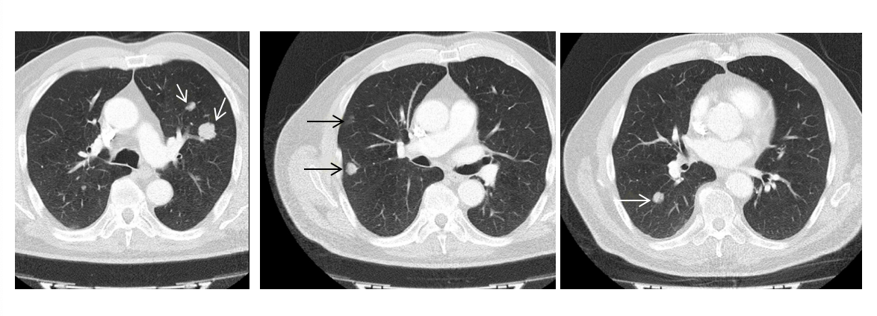
Figure 2 Thoracic computed tomography slides with bilateral nodular metastases (arrows) from a low grade appendiceal mucinous neoplasm.

A B
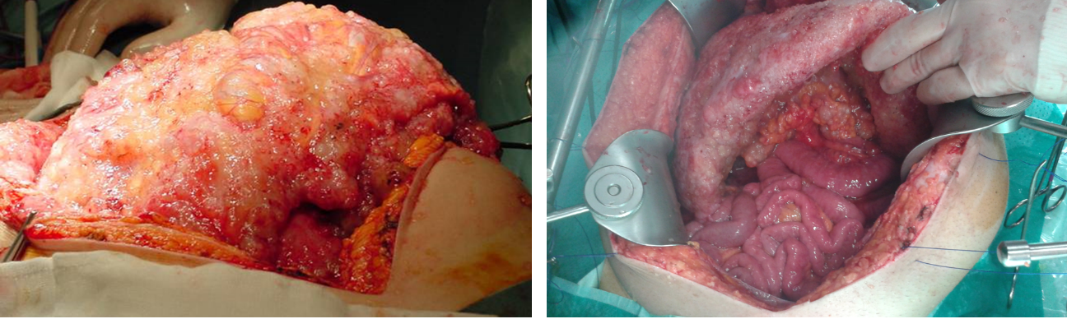
Figure 3 Two forms of omental cake in two patients with peritoneal dissemination of low grade appendiceal mucinous neoplasm. Note sparing of the small bowel in the right picture.

