Name of Journal: World Journal of Clinical Cases
Manuscript NO: 89256
Manuscript Type: CASE REPORT

Multiple paradoxical embolisms caused by central venous catheter thrombus passing through a patent foramen ovale: A case report

Li JD et al. Paradoxical embolism

Jian-Duan Li, Nian Xu, Qiang Zhao, Biao Li, Li Li

Jian-Duan Li, Nian Xu, Qiang Zhao, Biao Li, Li Li, Department of Cardiology, Guangzhou Red Cross Hospital of Jinan University, Guangzhou 510235, Guangdong Province, China

Co-first authors: Jian-Duan Li and Nian Xu.

Author contributions: Li JD contributed to conceptualization and investigation, and manuscript writing; Xu N contributed to Investigation and editing; Li JD and Xu N contribute equally to this study, they share co-first author; Zhao Q contributed to investigation and resources; Li B contributed to resources and editing; Li L contributed to conceptualization and editing; all authors have read and approved the final manuscript.

Supported by Natural Science Foundation of Guangdong Province, No. 2021A1515011267; and Guangzhou Municipal Science and Technology Bureau, No. 2023A03J0984.

Corresponding author: Li Li, MD, Chief Doctor, Department of Cardiology, Guangzhou Red Cross Hospital of Jinan University, No. 396 Tongfu Middle Road, Haizhu District, Guangzhou 510235, Guangdong Province, China. lilygs@ext.jnu.edu.cn

Received: October 25, 2023
Revised: December 27, 2023
Accepted: January 15, 2024
Published online:

Abstract
BACKGROUND
To date, this is the first case of a paradoxical embolism (PDE) that concurrently manifested in the coronary and lower limb arteries and was secondary to a central venous catheter (CVC) thrombus via a patent foramen ovale (PFO).

CASE SUMMARY
Here, we report a case of simultaneous coronary and lower limb artery embolism in a PFO patient carrier of a CVC. The patient presented to the hospital with acute chest pain and lower limb fatigue. Doppler ultrasound showed a large thrombus in the right internal jugular vein, precisely at the tip of the CVC. Transthoracic and transesophageal echocardiography confirmed the existence of a PFO, with inducible right-to-left shunting by the Valsalva maneuver. The patient was administered an extended course of anticoagulation therapy, and then the CVC was successfully removed. Percutaneous PFO closure was not undertaken. There was no recurrence during follow-up.

CONCLUSION
Thus, CVC-associated thrombosis is a potential source for multiple PDE in PFO patients.

Key Words: Paradoxical embolism; Central venous catheter; Patent foramen ovale; Acute myocardial infarction; Case report

Li JD, Xu N, Zhao Q, Li B, Li L. Multiple paradoxical embolisms caused by central venous catheter thrombus passing through a patent foramen ovale: A case report. World J Clin Cases 2024; In press

Core Tip: Paradoxical coronary embolism is a rare cause of acute myocardial infarction. Here, we report a case of simultaneous coronary and lower limb artery embolism in a patent foramen ovale (PFO) patient carrier of a central venous catheter (CVC). CVC-associated thrombosis is a potential source for paradoxical embolisms in PFO patients. Meanwhile, transesophageal echocardiography can help us detect PFOs more accurately.

INTRODUCTION
Paradoxical embolism (PDE) is a clinical condition characterized by a thromboembolism that originates in the right heart or venous vasculature and travels through an intracardiac or pulmonary shunt into the systemic circulation^{[1]}. The clinical presentation is diverse and potentially life-threatening. In this case, we present a patient with a patent foramen ovale (PFO) who suffered from acute myocardial infarction (AMI) and lower limb arterial embolism resulting from a PDE caused by a central venous catheter (CVC)-associated thrombosis.

CASE PRESENTATION
Chief complaints
A 72-year-old female presented to the hospital with acute chest pain and lower limb weakness.

History of present illness
Six days ago, the patient had a CVC implanted for a lumbar disc operation. 6 h before admission, the patient experienced sudden chest pain during the rehabilitation training without shortness of breath or palpitations.

History of past illness
The patient had a medical history of hypertension for 4 years.

Personal and family history
No relevant disorders were identified.

Physical examination
Blood pressure was 145/70 mmHg, heart rate was 65 beats/min, respiratory rate was 20 breaths/min. Lower limb weakness, without pale and pain and the skin temperature was normal. The pulsation of bilateral dorsal foot arteries was weakened.

Laboratory examinations
The patient’s cardiac biomarkers were elevated, with a high-sensitivity troponin-T level of 0.688 µg/L and a creatine kinase level of 525.3 U/L.

Imaging examinations
ECG showed sinus rhythm and an ST-segment elevation of 0.1-0.2 mm in the inferior (II, III, and aVF) leads. Emergent coronary angiography (CAG) revealed an acute total occlusion at the proximal segment of right coronary artery (RCA) (Figure 1A), with normal blood flow of the left coronary artery (Figure 1B). After opening the RCA with balloon angioplasty, the repeat angiography revealed a smooth vascular wall without evidence of atherosclerotic plaque (Figure 1C) but the thrombus shattered and moved into the distal of the RCA (Figure 1C). After reperfusion, the patient was administered cardiovascular secondary prevention medication and low-molecular-weight heparin. Doppler ultrasound revealed thrombotic occlusions in the left anterior tibial artery and the right popliteal artery without any evidence of venous thrombosis.

Laboratory examinations
The patient’s cardiac biomarkers were elevated, with a high-sensitivity troponin-T level of 0.688 µg/L and a creatine kinase level of 525.3 U/L.

FURTHER DIAGNOSTIC WORK-UP
A large thrombus (18 mm × 15 mm × 13 mm) at the tip of the CVC was detected by ultrasound (Figure 2A). A transthoracic echocardiogram initially showed suspicion for a PFO accompanied by mild pulmonary hypertension (Figure 2B). This preliminary diagnosis was subsequently corroborated through an agitated saline contrast examination conducted via transesophageal echocardiography (TEE). In resting conditions, the TEE with saline contrast revealed no evidence of a right-to-left shunt (Figure 2C). Furthermore, the induction of a right-to-left shunt across the intra-atrial septum (grade 2) was successfully achieved by applying a Valsalva maneuver (Figure 2D).

FINAL DIAGNOSIS
Combined with the patient’s medical history, the final diagnosis was Paradoxical coronary and lower limb arteries embolism caused by CVC-associated thrombosis passing through a PFO.

TREATMENT
On the basis of the guideline-based medical therapy for STEMI, the patient was administered an extended course of anticoagulation therapy, specifically low-molecular-weight heparin for seven days, followed by a regimen of apixaban, dosed at 15 mg daily. Before discharge, the CVC was successfully removed.

OUTCOME AND FOLLOW-UP
A follow-up examination conducted two months postdischarge, which included CAG and Doppler ultrasound, indicated successful resolution of the thrombus in the distal region of the RCA (Figure 1D), bilateral limb arteries, and superior vena cava.

DISCUSSION
The PFO has been identified as a potential source of PDE since the late 19th century and is now recognized as the most common intracardiac shunt in PDE cases^{[1,2]}. The most common sites of PDE are the extremities, accounting for 49% of cases, followed by the cerebrum at 37%. The coronary, renal, or splenic arteries are less frequently affected^{[3,4]}. Instances of PDE resulting in multiple arterial embolisms are rare. Simultaneously, myocardial and renal infarction resulting from a PDE through a PFO was reported^{[5]}. Islam et al^{[6]} reported a case of PDE through a PFO involving the left upper extremity, brain, and coronary artery. However, there have been no reported cases of simultaneous myocardial infarction and lower limb thrombi due to a PDE caused by a CVC-associated thrombosis. This highlights the complexity and variability of PDE and underscores the need for continued research and understanding.
Acute myocardial infarction (AMI) is often precipitated by coronary atherosclerosis. Despite presenting several risk factors for atherosclerosis, the patient in this case demonstrated a different pathogenesis of AMI. Emergency CAG revealed a thrombotic occlusion in the RCA. After opening the RCA with balloon angioplasty, a repeat angiography of the RCA revealed a smooth vascular wall without evidence of atherosclerotic plaque. Her intact left coronary artery also excluded the presence of coronary atherosclerosis. Hence, we considered that the total occlusion of the RCA is caused by acute thromboembolism rather than chronic due to plaque. Evidence of acute thrombosis was also found in the Doppler ultrasound of the lower limb arteries, where the thrombi had completely disappeared after anticoagulation therapy.
In most cases, the elevated right atrial pressure is secondary to an acute process, such as the Valsalva maneuver, coughing or acute pulmonary embolism with cor-pulmonale or right-sided strain. This permits paradoxical emboli to easily cross the PFO from the right to the left atrium and enter the arterial circulation. Paradoxical emboli have the potential to traverse any branch of the coronary artery via anterograde blood flow, thereby precipitating an AMI. Furthermore, these emboli can disseminate to various organs, including peripheral arteries, resulting in widespread arterial embolisms. In this case, the presence of a small PFO and right-to-left shunting was confirmed through transesophageal echocardiography (TEE) and an agitated saline contrast examination. As reported, TEE is the gold standard because it can offer superior sensitivity and precision in detecting atrial anomalies and intracardiac shunts compared to transthoracic echocardiogram^{[7]}.
CVC-associated thrombosis constitutes 10% of all deep venous thrombosis (DVTs) in adults and 50%-80% of DVTs among children^{[8]}. In this case, Doppler ultrasound showed the presence of a large thrombus at the tip of the CVC. Brain infarction caused by a CVC-originated paradoxical thrombus was previously reported^{[9,10]}. CVC-associated thrombosis risk factors include catheter material and size, duration of placement, hereditary disorders or hypercoagulable states, blood flow stagnation, and potential endothelial damage from corrosive drugs^{[8,11]}. The most likely risk factor for this case of CVC-associated thrombosis was the extended duration of the CVC placement and potential infection. As suggested by Citla et al^{[8]}, it is necessary to continue anticoagulant therapy for at least three months after catheter removal. The EAPCI advises that patients over 65 years of age should be evaluated for PFO closure on an individual basis^{[12]}. In this instance, percutaneous PFO closure was not undertaken due to the PFO’s relatively small size and the potential for eliminating and preventing CVC-associated thrombosis, which was considered the source of the PDE. Considering the patient’s personal preferences, a pharmacological treatment approach was selected.

CONCLUSION
CVC-associated thrombosis is a potential source for PDE in PFO patients. Examinations for PFO and CVC in unexplained thrombotic events are important to look for possible sources of embolism. Furthermore, TEE can help us detect PFOs more accurately.

REFERENCES
1 Windecker S, Stortecky S, Meier B. Paradoxical embolism. J Am Coll Cardiol 2014; 64: 403-415 [PMID: 25060377 DOI: 10.1016/j.jacc.2014.04.063]
2 Hargreaves M, Maloney D, Gribbin B, Westaby S. Impending paradoxical embolism: a case report and literature review. Eur Heart J 1994; 15: 1284-1285 [PMID: 7982433 DOI: 10.1093/oxfordjournals.eurheartj.a060667]
3 Ward R, Jones D, Haponik EF. Paradoxical embolism. An underrecognized problem. Chest 1995; 108: 549-558 [PMID: 7634897 DOI: 10.1378/chest.108.2.549]
4 Loscalzo J. Paradoxical embolism: clinical presentation, diagnostic strategies, and therapeutic options. Am Heart J 1986; 112: 141-145 [PMID: 3728270 DOI: 10.1016/0002-8703(86)90692-7]
5 Garachemani A, Eshtehardi P, Meier B. Paradoxical emboli through the patent foramen ovale as the suspected cause of myocardial and renal infarction in a 48-year-old woman. Catheter Cardiovasc Interv 2007; 70: 1010-1012 [PMID: 17563099 DOI: 10.1002/ccd.21214]
6 Islam MA, Khalighi K, Goldstein JE, Raso J. Paradoxical embolism-report of a case involving four organ systems. J Emerg Med 2000; 19: 31-34 [PMID: 10863115 DOI: 10.1016/s0736-4679(00)00178-5]
7 Belkin RN, Pollack BD, Ruggiero ML, Alas LL, Tatini U. Comparison of transesophageal and transthoracic echocardiography with contrast and color flow Doppler in the detection of patent foramen ovale. Am Heart J 1994; 128: 520-525 [PMID: 8074014 DOI: 10.1016/0002-8703(94)90626-2]
8 Citla Sridhar D, Abou-Ismail MY, Ahuja SP. Central venous catheter-related thrombosis in children and adults. Thromb Res 2020; 187: 103-112 [PMID: 31981840 DOI: 10.1016/j.thromres.2020.01.017]
9 Batsis JA, Craici IM, Froehling DA. Central venous catheter thrombosis complicated by paradoxical embolism in a patient with diabetic ketoacidosis and respiratory failure. Neurocrit Care 2005; 2: 185-188 [PMID: 16159064 DOI: 10.1385/NCC:2:2:185]
10 Petrea RE, Koyfman F, Pikula A, Romero JR, Viereck J, Babikian VL, Kase CS, Nguyen TN. Acute stroke, catheter related venous thrombosis, and paradoxical cerebral embolism: report of two cases. J Neuroimaging 2013; 23: 111-114 [PMID: 21281383 DOI: 10.1111/j.1552-6569.2010.00568.x]
11 Jacobs BR. Central venous catheter occlusion and thrombosis. Crit Care Clin 2003; 19: 489-514, ix [PMID: 12848317 DOI: 10.1016/s0749-0704(03)00002-2]
12 Pristipino C, Sievert H, D'Ascenzo F, Louis Mas J, Meier B, Scacciatella P, Hildick-Smith D, Gaita F, Toni D, Kyrle P, Thomson J, Derumeaux G, Onorato E, Sibbing D, Germonpré P, Berti S, Chessa M, Bedogni F, Dudek D, Hornung M, Zamorano J; Evidence Synthesis Team; Eapci Scientific Documents and Initiatives Committee; International Experts. European position paper on the management of patients with patent foramen ovale. General approach and left circulation thromboembolism. Eur Heart J 2019; 40: 3182-3195 [PMID: 30358849 DOI: 10.1093/eurheartj/ehy649]

Footnotes
Informed consent statement: Informed written consent was obtained from the patient for publication of this report and any accompanying images.

Conflict-of-interest statement: All the authors declare that they have no conflict of interest to disclose.

CARE Checklist (2016) statement: The authors have read the CARE Checklist (2016), and the manuscript was prepared and revised according to the CARE Checklist (2016).

Open-Access: This article is an open-access article that was selected by an in-house editor and fully peer-reviewed by external reviewers. It is distributed in accordance with the Creative Commons Attribution NonCommercial (CC BY-NC 4.0) license, which permits others to distribute, remix, adapt, build upon this work non-commercially, and license their derivative works on different terms, provided the original work is properly cited and the use is non-commercial. See: https://creativecommons.org/Licenses/by-nc/4.0/

Provenance and peer review: Unsolicited article; Externally peer reviewed.
Peer-review model: Single blind

Peer-review started: October 25, 2023
First decision: December 15, 2023
Article in press:

Specialty type: Cardiac & cardiovascular systems
Country/Territory of origin: China
Peer-review report’s scientific quality classification
Grade A (Excellent): 0
Grade B (Very good): 0
Grade C (Good): 0
Grade D (Fair): D
Grade E (Poor): 0

P-Reviewer: Jha AK, United States S-Editor: Liu JH L-Editor: A P-Editor:
Figure Legends
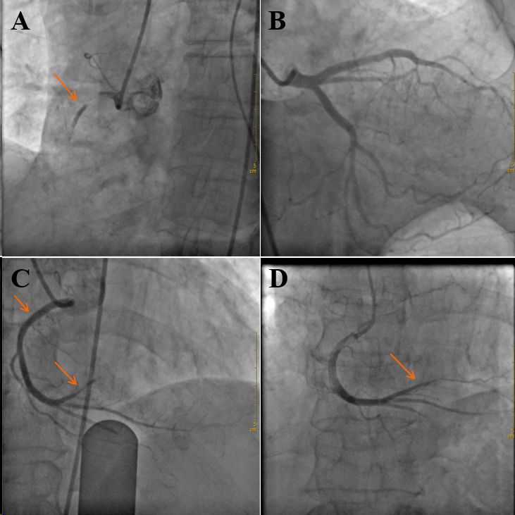
Figure 1 Coronary angiography. A: Emergent coronary angiography (CAG) revealed a total occlusion in the proximal segment of the right coronary artery (RCA); B: CAG revealed no significant atherosclerotic lesions in the left main, left anterior descending and left circumflex; C: After percutaneous coronary intervention (PCI), repeat angiography revealed the result of thrombolysis in myocardial infarction (TIMI) 3 blood flow in RCA. Thrombus were observed in the first posterior descending artery and posterior lateral artery; D: Two months after PCI, CAG showed TIMI 3 blood flow in the distal region of the RCA without signs of thrombus.
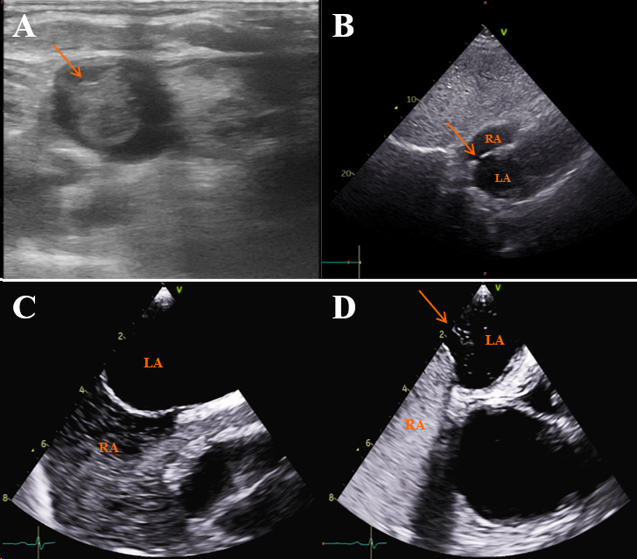
Figure 2 Imaging examination of central venous catheter associated thrombosis and patent foramen ovale. A: Doppler ultrasound of the right internal jugular vein showing a large thrombus (18 mm × 15 mm × 13 mm) at the tip of the central venous catheter; B: Transthoracic echocardiogram showing a suspicious patent foramen ovale (PFO); C: In resting conditions, transesophageal echocardiography (TEE) with saline contrast showing no evidence of a right-to-left shunt; D: TEE following saline contrast clearly demonstrates the presence of bubbles in the left atrium, with Valsalva indicating the presence of a moderate right-to-left shunt at the atrial level through a PFO. RA: Right atrium; LA: Left atrium.

