Name of Journal: World Journal of Hepatology
Manuscript NO: 67493
Manuscript Type: CASE REPORT

focal nodular hyperplasia associated with a giant hepatocellular adenoma: A case report and review of literature

Gaspar-Figueiredo S et al. Simultaneous benign liver tumors

Sérgio Gaspar-Figueiredo, Amaniel Kefleyesus, Christine Sempoux, Emilie Uldry, Nermin Halkic

Sergio Gaspar-Figueiredo, Amaniel Kefleyesus, Emilie Uldry, Nermin Halkic, Department of Visceral Surgery, Lausanne University Hospital, Lausanne 1011, Switzerland

Christine Sempoux, Department of Pathology, Lausanne University Hospital, Lausanne 1011, Switzerland

Author contributions: Gaspar-Figueiredo S and Kefleyesus A performed the literature review, collected all the data related to the case report, and recorded/edited the video-vignette related to the case report; Sempoux C did the anatomopathological examination/appraisal; Halkic N and Uldry E did the surgical appraisal; all authors have read and approved the final manuscript.

Corresponding author: Nermin Halkic, MD, PhD, Chief Doctor, Professor, Department of Visceral Surgery, Lausanne University Hospital, Rue du Bugnon 46, Lausanne 1011, Switzerland. nermin.halkic@chuv.ch

Received: April 25, 2021
Revised: June 15, 2021
Accepted: August 31, 2021
Published online: October 27, 2021

Abstract
BACKGROUND
Focal nodular hyperplasia (FNH) and hepatocellular adenoma (HCA) are well-known benign liver lesions. Surgical treatment is usually chosen for symptomatic patients, lesions more than 5 cm, and uncertainty of diagnosis.

CASE SUMMARY
We described the case of a large liver composite tumor in an asymptomatic 34-year-old female under oral contraceptive for 17-years. The imaging work-out described two components in this liver tumor; measuring 6 cm × 6 cm and 14 cm × 12 cm × 6 cm. The multidisciplinary team suggested surgery for this young woman with an unclear HCA diagnosis. She underwent a laparoscopic left liver lobectomy, with an uneventful postoperative course. Final pathological examination confirmed FNH associated with a large HCA. This manuscript aimed to make a literature review of the current management in this particular situation of large simultaneous benign liver tumors.

CONCLUSION
The simultaneous presence of benign composite liver tumors is rare. This case highlights the management in a multidisciplinary team setting.

Key Words: Liver; Focal nodular hyperplasia; Hepatocellular adenoma; Composite tumor; Video vignette; Case report

©The Author(s) 2021. Published by Baishideng Publishing Group Inc. All rights reserved.

Citation: Gaspar-Figueiredo S, Kefleyesus A, Sempoux C, Uldry E, Halkic N. Focal nodular hyperplasia associated with a giant hepatocellular adenoma: A case report and review of literature. World J Hepatol 2021; 13(10): 1450-1458
URL: https://www.wjgnet.com/1948-5182/full/v13/i10/1450.htm
DOI: https://dx.doi.org/10.4254/wjh.v13.i10.1450

Core Tip: Focal nodular hyperplasia and hepatocellular adenoma (HCA) are frequent but non-malignant tumors. There is rarely indication for surgery. Combination of these two masses is a very unusual situation. Their diagnosis is mainly based on radiology. Oral contraception is a risk factor for HCA. Malignant transformation of HCA is the predominant argument for surgery. All these cases, especially composite tumors, must be discussed in a multidisciplinary team.

INTRODUCTION
Focal nodular hyperplasia (FNH) has become a pretty well-known disease in the past two decades. It is defined by a benign hyperplasic nodule with a central scar, appearing in the normal liver parenchyma, and is composed of normal hepatocytes in a multinodular structure^{[1]}. Its incidence is between 0.6%-3%, predominantly affecting females patients (80%-90%) in their third or fourth decade. The pathophysiology is thought to be due to an increased arterial flow that leads to secondary hepatocellular hyperplasia^{[2,3]}. The correlation with oral contraceptives (OCs) is unproven but very likely, given that OCs are taken almost exclusively by women (sex ratio 9:1) and the proven correlation between OCs and change in lesion size^{[4,5]}.
Hepatocellular adenoma (HCA) is a benign lesion with a malignant potential between 4% and 8%, according to recent works of Farges et al^{[6]} and Sempoux et al^{[7]}. It classically arises in a noncirrhotic liver, in young females with an OC background. However, the understanding of HCA has evolved dramatically and we now know that it can also develop in patients with non-alcoholic steatohepatitis, certain vascular malformations, or alcoholic cirrhosis. Moreover, there are a wide variety of subtypes of this complex disease, making it very difficult to establish treatment guidelines^{[8-10]}.
In this present article, we aimed to describe the detailed management of a rare simultaneous case of FNH and HCA and a brief review of the literature.

CASE PRESENTATION
Chief complaints
A 34-year-old woman in general good health, with a medical history of oral contraceptives (desogestrel, ethinylestradiol) for 17 years consulted her general practitioner (GP) for a check-up.

History of present illness
She was completely asymptomatic.

History of past illness
She had no past illness.

Personal and family history
The patient had no past medical history except a knee orthopedic surgery 1 year before, had a stable weight with normal body mass index (21.1 kg/m²) and no familial medical history.

Physical examination
During the examination, her GP found a mobile and palpable abdominal mass of more than 10 cm in diameter, with no skin bulging at the Valsalva's maneuver (Figure 1).

Laboratory examinations
The blood exams were normal, except for an elevation in alkaline phosphate level of 519 U/L (normal range = 36-108). Tumoral markers were normal.

Imaging examinations
Abdominal ultrasound revealed an aspecific giant mass next to the left hepatic lobe. A computed tomography (CT scan) revealed a double mass attached to the left lobe of the liver. The first one had the typical characteristics of FNH and the second one of uncertain dignity. Further magnetic resonance imaging (MRI) confirmed a 6 cm x 6 cm mass suggestive of FNH in the inferior part of segment III. This 6 cm lesion was right next to a second one measuring 14 cm × 12 cm × 6 cm which dignity was unclear. The differential diagnosis was between an HCA, a hepatocellular carcinoma (fibrolamellar variant), or an atypical FNH (Figures 2-5).

FINAL DIAGNOSIS
The pathologist’s report confirmed the diagnosis of 6 cm FNH resected with good margin and showed a non-beta-catenin–mutated HCA (inflammatory subtype with more risk of malignant transformation) (Figure 6).

TREATMENT
Indication for surgery was retained during a multidisciplinary team (MDT) meeting as the first option for definitive diagnosis and treatment.
The surgery was completed without complication. We summarize hereafter the key points of the minimally invasive procedure. After inserting 4 trocars for the laparoscopy (para-umbilical, right and left flank, subxiphoid) and staying away from the large dual mass which limited the range movements, we performed an ultrasound confirming a pedunculated mass (FNH) highly vascularized attached to segment III and a second component pedunculated between segment II and III. The mass showed no adhesion with the segment IV and the gallbladder allowing a left lobectomy. Dissection was performed with ultrasonic shears (Ultracision Harmonic, Ethicon Inc., NJ, United States) and transsection was completed with a 60mm stapler (tri-staple vascular cartridge, Endo-GIA, Medtronic, Minneapolis, MN, United States). We extracted the specimen with both lesions through a suprapubic (Pfannenstiel) incision. The operative time was 122 min. Blood loss was minimal (50 mL) (Video 1).
The postoperative course was uneventful and the patient was discharged on postoperative day 3.

OUTCOME AND FOLLOW-UP
The MDT meeting proposed a 1-year MRI follow-up with oral contraceptive discontinuation.
One month after surgery, the patient was good without any complaint, her scar evolution was satisfactory and there was no sign of an early incisional hernia.

DISCUSSION
The interest of this case lies in the simultaneous discovery of 2 adjacent but pathologically different benign liver lesions: the first one (FNH) without a strong indication for surgery and the second one requiring surgery because of its uncertain diagnosis.
FNH has no recognized risk of malignant transformation or bleeding and usually has an uneventful course. Therapeutic abstention is usually recommended for asymptomatic patients with a definitive diagnosis^{[11]}. Surgical management is reserved for symptomatic patients or with diagnosis uncertainty despite a complete workup^{[12,13]}. Twelve cases of spontaneous rupture of FNH are described and considering these extremely rare events, conservative treatment is the actual well-established standard of care [English-language literature until 2019; NCBI.gov with terms “spontaneous; rupture; FNH]. Close follow-up is however recommended for FNH more than 5 cm. Some authors advocate for upfront surgery with FNH larger than 5 cm^{[14-16]}. However, we do not recommend a surgical resection in our daily practice but advocate for a close follow-up strategy. In the present case report, the diagnosis of FNH of the segment III lesion was radiologically typical and in the absence of the HCA component, a 1-year MRI follow-up would have been recommended.
On the contrary, the risk of malignant transformation of HCA is 4%-5%. As reported by Sempoux et al^{[7]}, risk factors for complications of HCA (bleeding or malignant transformation) are the size (> 5 cm), male gender, activating mutation in β-catenin, and specific clinical background (glycogen storage disease, androgens, vascular diseases). The resulting recommendations for surgery are based on initial size (> 5 cm), imaging or histological signs of malignancy, size progression after OC discontinuation, and male patients. Selected patients and those who are not fit for surgery can benefit from embolization^{[17-19]}. When the diagnosis cannot be achieved with imaging, a percutaneous biopsy or resection may be required^{[20]}.
Moreover, Bröker et al^{[21]} 2012 advocated the surgery for adenoma greater than 5 cm with patients who had planned a pregnancy. Our patient didn’t have a pregnancy plan but size and uncertainty of diagnosis were our principal arguments for surgery.
We made a literature review of the simultaneous cases of FNH and HA. Although there is some case reports in the eighties, the article was not available for consulting^{[22-25]}. Table 1 summarizes the other cases with enough data.
Case 1 was operated on because of the lack of obvious radiological evidence^{[26]}. The authors of case 2 don’t clearly explain the indication for the operative procedure but they interestingly explain the possible same pathophysiological etiology for 4 different simultaneous hepatic masses^{[27]}.
Shih et al^{[28]} made a left hepatectomy for a case with common features between FNH and HA and operate for the uncertainty of diagnosis.
The French group of Laurent et al^{[29]} found in their records 5 over 30 patients operated for “benign hepatocytic nodules" with simultaneous HNF and adenoma. All of them went under surgery when the radiology reports an HA or unidentified mass. The diagnosis of FNH was already known at the time of the surgical procedure except for one case where the FNH was too small^{[29]}.
Concerning the surgical technique, the laparoscopic approach is relatively recent. Unfortunately, Shih et al^{[28]} didn’t report this in their paper although they did the same procedure for a similar patient. Despite the lack of high-level evidence data (randomized control trials, meta-analysis), current literature about laparoscopic vs open liver surgery for benign tumors suggests an advantage for the minimal-invasive technique^{[30,31]}. On the other hand, evidence for laparoscopic malign liver resection is much more consistent. Furthermore, safety, feasibility, and long-term results confirmed the advantages of laparoscopy for malign liver tumors^{[32-34]}.

CONCLUSION
We hereby report a laparoscopic resection of a macro-adenoma associated with focal nodular hyperplasia. The review of the literature shows that the simultaneous presence of these two masses is rare and that every case must be discussed in a multidisciplinary board. Factors like age, pregnancy wish, size, and uncertainty of diagnosis must be considered for shared decision in the setting of a multidisciplinary team. The laparoscopic approach should be preferred as much as possible.

ACKNOWLEDGEMENTS
We thank Dr. Giulia Piazza for her graphic representation of the case (Figure 2) which she has kindly drawn and for her courtesy in publishing it.

REFERENCES
1 Rebouissou S, Bioulac-Sage P, Zucman-Rossi J. Molecular pathogenesis of focal nodular hyperplasia and hepatocellular adenoma. J Hepatol 2008; 48: 163-170 [PMID: 17997499 DOI: 10.1016/j.jhep.2007.10.003]
2 Fukukura Y, Nakashima O, Kusaba A, Kage M, Kojiro M. Angioarchitecture and blood circulation in focal nodular hyperplasia of the liver. J Hepatol 1998; 29: 470-475 [PMID: 9764996 DOI: 10.1016/s0168-8278(98)80067-6]
3 Gaiani S, Piscaglia F, Serra C, Bolondi L. Hemodynamics in focal nodular hyperplasia. J Hepatol 1999; 31: 576 [PMID: 10488724 DOI: 10.1016/s0168-8278(99)80057-9]
4 Giannitrapani L, Soresi M, La Spada E, Cervello M, D'Alessandro N, Montalto G. Sex hormones and risk of liver tumor. Ann N Y Acad Sci 2006; 1089: 228-236 [PMID: 17261770 DOI: 10.1196/annals.1386.044]
5 Fukahori S, Kawano T, Obase Y, Umeyama Y, Sugasaki N, Kinoshita A, Fukushima C, Yamakawa M, Omagari K, Mukae H. Fluctuation of Hepatic Focal Nodular Hyperplasia Size with Oral Contraceptives Use. Am J Case Rep 2019; 20: 1124-1127 [PMID: 31358723 DOI: 10.12659/AJCR.916398]
6 Farges O, Ferreira N, Dokmak S, Belghiti J, Bedossa P, Paradis V. Changing trends in malignant transformation of hepatocellular adenoma. Gut 2011; 60: 85-89 [PMID: 21148580 DOI: 10.1136/gut.2010.222109]
7 Sempoux C, Balabaud C, Bioulac-Sage P. Pictures of focal nodular hyperplasia and hepatocellular adenomas. World J Hepatol 2014; 6: 580-595 [PMID: 25232451 DOI: 10.4254/wjh.v6.i8.580]
8 Calderaro J, Nault JC, Balabaud C, Couchy G, Saint-Paul MC, Azoulay D, Mehdaoui D, Luciani A, Zafrani ES, Bioulac-Sage P, Zucman-Rossi J. Inflammatory hepatocellular adenomas developed in the setting of chronic liver disease and cirrhosis. Mod Pathol 2016; 29: 43-50 [PMID: 26516697 DOI: 10.1038/modpathol.2015.119]
9 Bioulac-Sage P, Sempoux C, Balabaud C. Hepatocellular adenoma: Classification, variants and clinical relevance. Semin Diagn Pathol 2017; 34: 112-125 [PMID: 28131467 DOI: 10.1053/j.semdp.2016.12.007]
10 Blanc JF, Frulio N, Chiche L, Sempoux C, Annet L, Hubert C, Gouw AS, de Jong KP, Bioulac-Sage P, Balabaud C. Hepatocellular adenoma management: call for shared guidelines and multidisciplinary approach. Clin Res Hepatol Gastroenterol 2015; 39: 180-187 [PMID: 25434466 DOI: 10.1016/j.clinre.2014.10.003]
11 Ashby PF, Alfafara C, Amini A, Amini R. Spontaneous Rupture of a Hepatic Adenoma: Diagnostic Nuances and the Necessity of Followup. Cureus 2017; 9: e1975 [PMID: 29492364 DOI: 10.7759/cureus.1975]
12 Navarro AP, Gomez D, Lamb CM, Brooks A, Cameron IC. Focal nodular hyperplasia: a review of current indications for and outcomes of hepatic resection. HPB (Oxford) 2014; 16: 503-511 [PMID: 24127684 DOI: 10.1111/hpb.12169]
13 Jung JM, Hwang S, Kim KH, Ahn CS, Moon DB, Ha TY, Song GW, Jung DH. Surgical indications for focal nodular hyperplasia of the liver: Single-center experience of 48 adult cases. Ann Hepatobiliary Pancreat Surg 2019; 23: 8-12 [PMID: 30863802 DOI: 10.14701/ahbps.2019.23.1.8]
14 Kinoshita M, Takemura S, Tanaka S, Hamano G, Ito T, Aota T, Koda M, Ohsawa M, Kubo S. Ruptured focal nodular hyperplasia observed during follow-up: a case report. Surg Case Rep 2017; 3: 44 [PMID: 28315131 DOI: 10.1186/s40792-017-0320-4]
15 Velíšková M, Vlk R, Halaška MJ, Minajev G, Krejčí T, Rob L. [Rupture of focal nodular hyperplasia in the 37th week of pregnanacy - case report]. Ceska Gynekol Summer; 81: 218-221 [PMID: 27882766]
16 Li T, Qin LX, Ji Y, Sun HC, Ye QH, Wang L, Pan Q, Fan J, Tang ZY. Atypical hepatic focal nodular hyperplasia presenting as acute abdomen and misdiagnosed as hepatocellular carcinoma. Hepatol Res 2007; 37: 1100-1105 [PMID: 17608671 DOI: 10.1111/j.1872-034X.2007.00164.x]
17 Dokmak S, Paradis V, Vilgrain V, Sauvanet A, Farges O, Valla D, Bedossa P, Belghiti J. A single-center surgical experience of 122 patients with single and multiple hepatocellular adenomas. Gastroenterology 2009; 137: 1698-1705 [PMID: 19664629 DOI: 10.1053/j.gastro.2009.07.061]
18 van Vledder MG, van Aalten SM, Terkivatan T, de Man RA, Leertouwer T, Ijzermans JN. Safety and efficacy of radiofrequency ablation for hepatocellular adenoma. J Vasc Interv Radiol 2011; 22: 787-793 [PMID: 21616431 DOI: 10.1016/j.jvir.2011.02.024]
19 Karkar AM, Tang LH, Kashikar ND, Gonen M, Solomon SB, Dematteo RP, D' Angelica MI, Correa-Gallego C, Jarnagin WR, Fong Y, Getrajdman GI, Allen P, Kingham TP. Management of hepatocellular adenoma: comparison of resection, embolization and observation. HPB (Oxford) 2013; 15: 235-243 [PMID: 23374365 DOI: 10.1111/j.1477-2574.2012.00584.x]
20 European Association for the Study of the Liver (EASL). EASL Clinical Practice Guidelines on the management of benign liver tumours. J Hepatol 2016; 65: 386-398 [PMID: 27085809 DOI: 10.1016/j.jhep.2016.04.001]
21 Bröker ME, Ijzermans JN, van Aalten SM, de Man RA, Terkivatan T. The management of pregnancy in women with hepatocellular adenoma: a plea for an individualized approach. Int J Hepatol 2012; 2012: 725735 [PMID: 23320183 DOI: 10.1155/2012/725735]
22 Reichlin B, Stalder GA, Rüedi T, Bianchi L. [Co-occurring liver cell adenoma and focal nodular hyperplasia due to contraceptives. Case report]. Schweiz Med Wochenschr 1980; 110: 873-874 [PMID: 6250211]
23 Bartók I, Decastello A, Csikós F, Nagy I. Focal nodular hyperplasia of the liver and hepatic cell adenoma in women on oral contraceptives. Hepatogastroenterology 1980; 27: 435-440 [PMID: 6259038]
24 Defrance R, Zafrani ES, Hannoun S, Saada M, Fagniez PL, Métreau JM. [Association of hepatocellular adenoma and focal nodular hyperplasia of the liver in a woman on oral contraceptives]. Gastroenterol Clin Biol 1982; 6: 949-950 [PMID: 6295869]
25 Tajada M, Nerín J, Ruiz MM, Sánchez-Dehesa M, Fabre E. Liver adenoma and focal nodular hyperplasia associated with oral contraceptives. Eur J Contracept Reprod Health Care 2001; 6: 227-230 [PMID: 11848652]
26 Dimitroulis D, Charalampoudis P, Lainas P, Papanikolaou IG, Kykalos S, Kouraklis G. Focal nodular hyperplasia and hepatocellular adenoma: current views. Acta Chir Belg 2013; 113: 162-169 [PMID: 24941710 DOI: 10.1080/00015458.2013.11680905]
27 Di Carlo I, Urrico GS, Ursino V, Russello D, Puleo S, Latteri F. Simultaneous occurrence of adenoma, focal nodular hyperplasia, and hemangioma of the liver: are they derived from a common origin? J Gastroenterol Hepatol 2003; 18: 227-230 [PMID: 12542613 DOI: 10.1046/j.1440-1746.2003.02840.x]
28 Shih A, Lauwers GY, Balabaud C, Bioulac-Sage P, Misdraji J. Simultaneous occurrence of focal nodular hyperplasia and HNF1A-inactivated hepatocellular adenoma: a collision tumor simulating a composite FNH-HCA. Am J Surg Pathol 2015; 39: 1296-1300 [PMID: 26274031 DOI: 10.1097/PAS.0000000000000477]
29 Laurent C, Trillaud H, Lepreux S, Balabaud C, Bioulac-Sage P. Association of adenoma and focal nodular hyperplasia: experience of a single French academic center. Comp Hepatol 2003; 2: 6 [PMID: 12812524 DOI: 10.1186/1476-5926-2-6]
30 Wabitsch S, Kästner A, Haber PK, Benzing C, Krenzien F, Andreou A, Kamali C, Lenz K, Pratschke J, Schmelzle M. Laparoscopic Versus Open Liver Resection for Benign Tumors and Lesions: A Case Matched Study with Propensity Score Matching. J Laparoendosc Adv Surg Tech A 2019; 29: 1518-1525 [PMID: 31670608 DOI: 10.1089/lap.2019.0427]
31 Schmelzle M, Krenzien F, Schöning W, Pratschke J. Laparoscopic liver resection: indications, limitations, and economic aspects. Langenbecks Arch Surg 2020; 405: 725-735 [PMID: 32607841 DOI: 10.1007/s00423-020-01918-8]
32 Jiang S, Wang Z, Ou M, Pang Q, Fan D, Cui P. Laparoscopic Versus Open Hepatectomy in Short- and Long-Term Outcomes of the Hepatocellular Carcinoma Patients with Cirrhosis: A Systematic Review and Meta-Analysis. J Laparoendosc Adv Surg Tech A 2019; 29: 643-654 [PMID: 30702362 DOI: 10.1089/lap.2018.0588]
33 Yin Z, Fan X, Ye H, Yin D, Wang J. Short- and long-term outcomes after laparoscopic and open hepatectomy for hepatocellular carcinoma: a global systematic review and meta-analysis. Ann Surg Oncol 2013; 20: 1203-1215 [PMID: 23099728 DOI: 10.1245/s10434-012-2705-8]
34 Cipriani F, Rawashdeh M, Stanton L, Armstrong T, Takhar A, Pearce NW, Primrose J, Abu Hilal M. Propensity score-based analysis of outcomes of laparoscopic versus open liver resection for colorectal metastases. Br J Surg 2016; 103: 1504-1512 [PMID: 27484847 DOI: 10.1002/bjs.10211]

Footnotes
Informed consent statement: Informed written consent was obtained from the patient for publication of this report and any accompanying images.

Conflict-of-interest statement: All authors declare no conflicts-of-interest related to this article.

CARE Checklist (2016) statement: The authors have read the CARE Checklist (2016), and the manuscript was prepared and revised according to the CARE Checklist (2016).

Open-Access: This article is an open-access article that was selected by an in-house editor and fully peer-reviewed by external reviewers. It is distributed in accordance with the Creative Commons Attribution NonCommercial (CC BY-NC 4.0) license, which permits others to distribute, remix, adapt, build upon this work non-commercially, and license their derivative works on different terms, provided the original work is properly cited and the use is non-commercial. See: http://creativecommons.org/Licenses/by-nc/4.0/

Manuscript source: Unsolicited manuscript

Peer-review started: April 25, 2021
First decision: June 4, 2021
Article in press: August 31, 2021

Specialty type: Gastroenterology and hepatology
Country/Territory of origin: Switzerland
Peer-review report’s scientific quality classification
Grade A (Excellent): A
Grade B (Very good): 0
Grade C (Good): 0
Grade D (Fair): 0
Grade E (Poor): 0

P-Reviewer: Beraldo RF S-Editor: Gong ZM L-Editor: A P-Editor: Guo X

Figure Legends
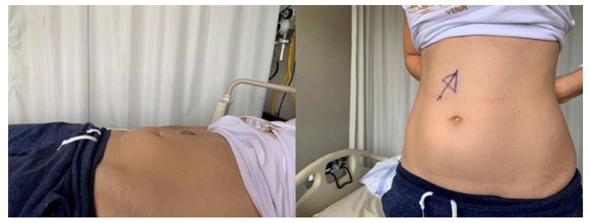
Figure 1 Pre-operative patient’s supine and stand-up picture – no external signs of tumor.
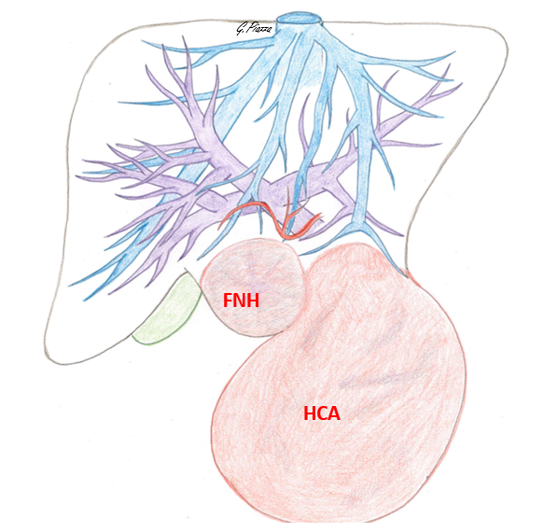
Figure 2 Preoperative drawing – tumor and liver major vessels’ relationship (credits: Dr. Giulia Piazza). FNH: Focal nodular hyperplasia; HCA: Hepatocellular adenoma.
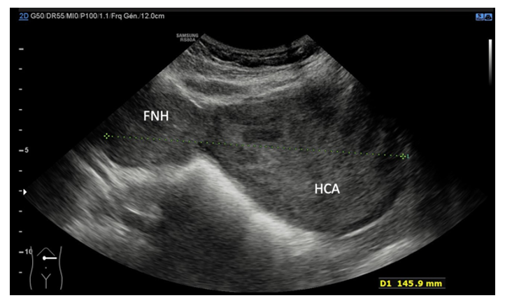
Figure 3 Ultrasonography with a sagittal view of focal nodular hyperplasia and hepatocellular adenoma. D1: Greater axis length. FNH: Focal nodular hyperplasia; HCA: Hepatocellular adenoma.
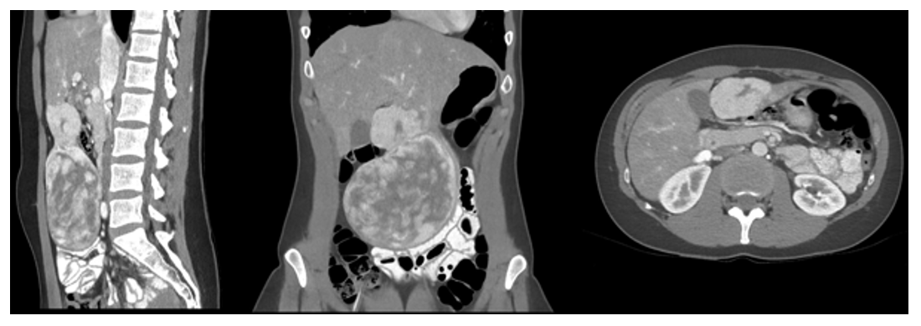
Figure 4 Computed tomography late portal phase, with a multiplanar reconstruction of focal nodular hyperplasia and hepatocellular adenoma.
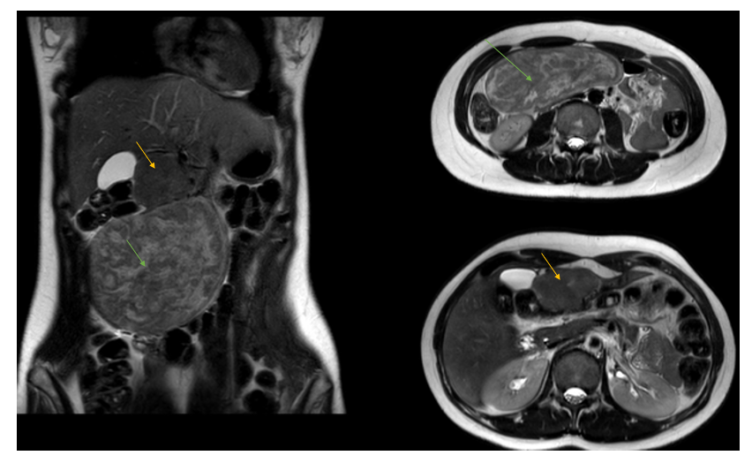
Figure 5 Magnetic resonance imaging – T2 sequence. Yellow arrow: Focal nodular hyperplasia; Green arrow: Hepatocellular adenoma.
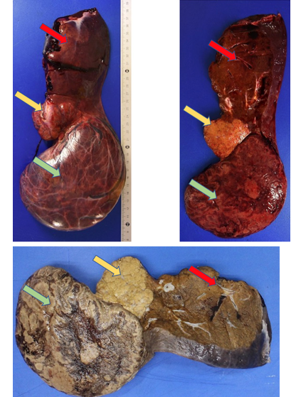
Figure 6 Anatomopathological pictures (top: fresh sample; bottom: formalin-fixed sample), sagittal section plane. Yellow arrow: Focal nodular hyperplasia; Green arrow: Hepatocellular adenoma; Orange arrow: Left liver (segment II).

Table 1 Summary of current literature review
No. | Ref. | Sex, age | OC | Pathology - Size (cm) | Location (segment) | Symptoms | Treatment
#1 | Dimitroulis et al^{[26]}, 2012 | F, 18 yr | No | FNH – 2.5 | S3 | RUQ pain | Wedge resection
 |  |  |  | HA – 6 | S5-6 |  | Lt S5-6
#2 | Di Carlo et al^{[27]}, 2003 | F, 25 yr | No | FNH – < 5 | S4 | RUQ pain | En bloc (+ gallbladder)
 |  |  |  | HA – NA | S4 |  | Enucleation
 |  |  |  | HH – > 4 | S2 |  | Enucleation
 |  |  |  | HCy – NA | S5 |  | En bloc (+ gallbladder)
#3 | Shih et al^{[28]}, 2015 | F, 40 yr | Yes | FNH – 6 | III | Abdominal pain | LH
 |  |  |  | HA – 9.5 & small ones (max 1.5 cm) | III for the largest, small ones on both lobes
#4 | Laurent et al^{[29]}, 2003 | F, 45 yr | Yes | FNH – 1 | S3 | Fatigue | Lt S3 segmentectomy + wedge
 |  |  |  | HA – NA | S7 |  | Lt RH
 |  | F, 40 yr | Yes | FNH – 5 | S6 | None | Biopsy
 |  |  |  | FNH – 4 | S7 |  | Biopsy
 |  |  |  | NA – 3 | Left lobe |  | Lt LH
 |  |  |  | HA – 3 | Left lobe |  | Lt LH
 |  | F, 38 yr | Yes | HA surrounded by FNH –13 | Right lobe | None | Lt RH
 |  | F, 29 yr | Yes | HA – 5 × 1 | S1 (bleeding), S2, 3, 7, 8 | Abdominal pain + shock | Lt LH + S1
 |  |  |  | FNH – 1 | S6
 |  | F, 41 yr | Yes | HA – 1 | RL | Abdominal pain | Lt RH
 |  |  |  | FNH – 1 | RL
#5 | Our case-report | F, 38 yr | Yes | 6 × 6  14 × 12 × 6 | S3 | None | Ls LL
FNH: Focal nodular hyperplasia; HA: Hepatic adenoma; HCy: Hepatic hydatid cyst; HH: Hepatic hemangioma; RL: Right lobectomy; LH: Left hepatectomy; LH: Left hepatectomy; LL Left lobectomy; RUQ: Right upper quadrant; Lt: Laparotomy; Ls: Laparoscopic; F: Female; OC: Oral contraception.

Published by Baishideng Publishing Group Inc
7041 Koll Center Parkway, Suite 160, Pleasanton, CA 94566, USA
Telephone: +1-925-3991568
E-mail: bpgoffice@wjgnet.com
Help Desk: https://www.f6publishing.com/helpdesk
https://www.wjgnet.com

© 2021 Baishideng Publishing Group Inc. All rights reserved.

